SINGLE-USE PLASTIC BAN
Options to replace single-use plastic
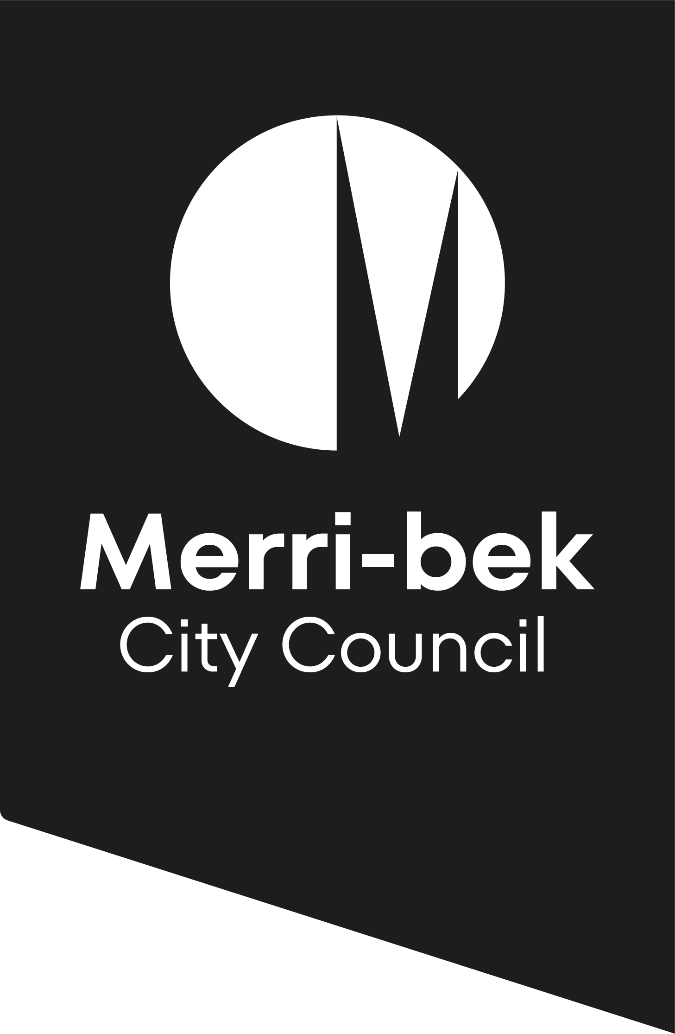

The Victorian Government is banning the sale and supply of some single-use plastic items from February 2023. Plastic pollution harms our health, wildlife and the environment. By banning these items, we will reduce plastic pollution, creating a healthier environment now and for years to come.
Alternatives to single-use plastic
The table below provides a list of various alternatives that can be used to replace the banned items.
When deciding what items to use:
- Always consider if you can avoid the item first, and then whether reusable options can be used.
- When you need to provide a single-use item, preference items certified by the Forest Stewardship Council (FSC).
- To view a list of suppliers, see our Supplier information sheet
Thanks for helping to keep our streets and waterways clean.
Product | Reusable option | Single-use alternative | Tips for success
Straws | - Provide reusable straws for dine in customers (metal, silicone)  - Note, plastic straws will still be made available for medical or disability needs | - Paper, bamboo or wheat straws | - Quality paper straws last longer and the dye doesn’t run  - Sell reusable straws to encourage re-use
Cutlery | - Provide reusable cutlery for dine in | - Forest Stewardship certified (FSC) bamboo or wooden cutlery | - Ask customers if they need cutlery before providing  - Encourage customers to BYO cutlery for takeaway food
Plates | - Provide reusable plates for dine in  - Encourage customers to BYO container for takeaway food* | - Forest Stewardship certified (FSC) paper plate | - Offer a discount for customers who supply BYO containers
Drink stirrers | - Provide metal teaspoons | - Forest Stewardship certified drink stirrers or sticks (FSC)
Expanded polystyrene food containers | - Encourage customers to BYO food container* | - Aluminium  - FSC certified cardboard tray  - Carboard container lined with commercially compostable plastic (e.g.: BioPak items) | - Encourage customers to BYO food container*  - Offer a discount for customers who supply BYO containers
Expanded polystyrene drink cups | - Encourage customers to BYO cup | - Carboard ‘coffee’ cup lined with commercially compostable plastic (e.g.: BioPak items)  - Carboard ‘coffee’ cup lined with oil-based plastic | - Encourage customers to BYO cup  - Offer a discount for customers who bring a BYO cup
Cotton bud sticks | - Sell reusable silicone ‘cotton’ swabs | - Sell cotton buds with paper or bamboo stick
* For a guideline to accepting reusables, see our BYO food containers guide and guidance from Sustainability Victoria

