A quick guide to


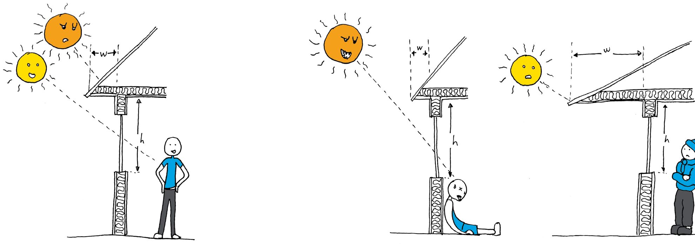
sustainable design principles

1) Northern glazing

High glazing ratio

N
Low glazing ratio
2) Northern eaves

Summer N

High glazing ratio

Winter
Summer

Winter

Low glazing ratio
High glazing ratio

Buildings should have a high glazing ratio on their northern face to maximise solar energy and minimise glazing on the south side to reduce heat losses.

Building eaves should be designed so their width ‘w’ equals 45% of the window height ‘h’.

3) Thermal mass

N

Winter sun

Winter sun
4) Space conditioning

Northern glazing

Thermal mass

Living areas

Thermal mass

Southern glazing

Unconditioned
stairwell Doors closed

Comfortable upstairs and down
Excessive heat upstairs

Difficult to heat downstairs

No separation of floors

Thermal mass should be positioned to collect heat from the winter sun, while being protected from the summer sun.
Separated floors can be heated or cooled evenly and independently, minimising energy use.
Other habitable areas should also be separated from each other to ensure low use areas are not heated or cooled unnecessarily.

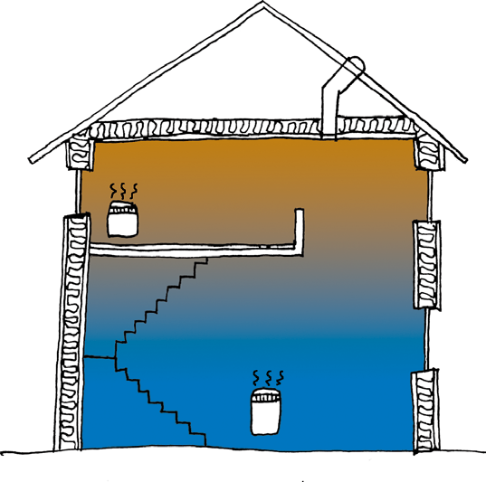
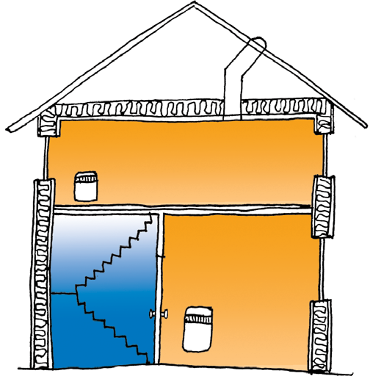
5) Home layout

Living areas N

Garage Bedrooms

Houses should be laid out so that living areas receive the most warmth from the winter sun, while being protected from the hot summer sun.


The SDAPP roll out project is funded through the Victorian Government’s Sustainability Fund under the Victorian Local Sustainability Accord.










Disclaimer: These principles have been developed for southern Australia and apply only to locations between 30°S
and 40°S. They should be used only as a guide. For more detailed information we recommend using Your Home Technical Manual, available online at www.yourhome.gov.au/technical.
Every effort has been made to ensure information is true and accurate at the

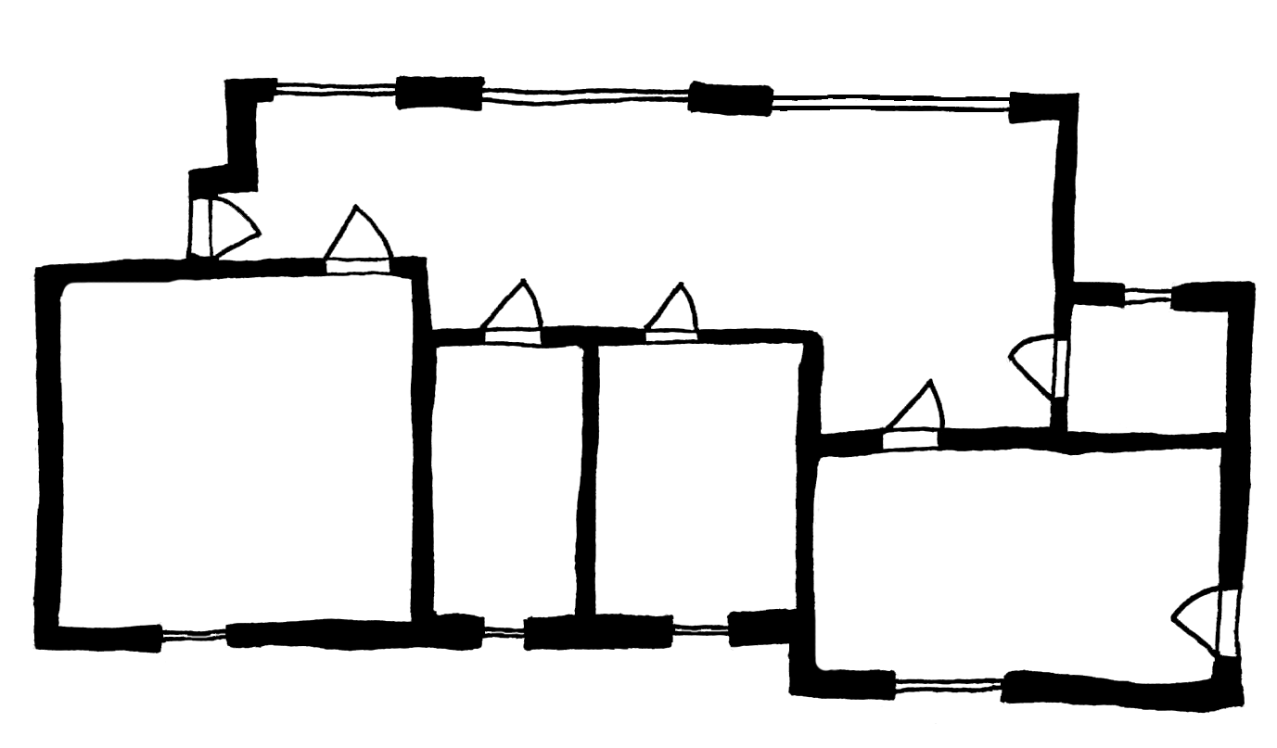
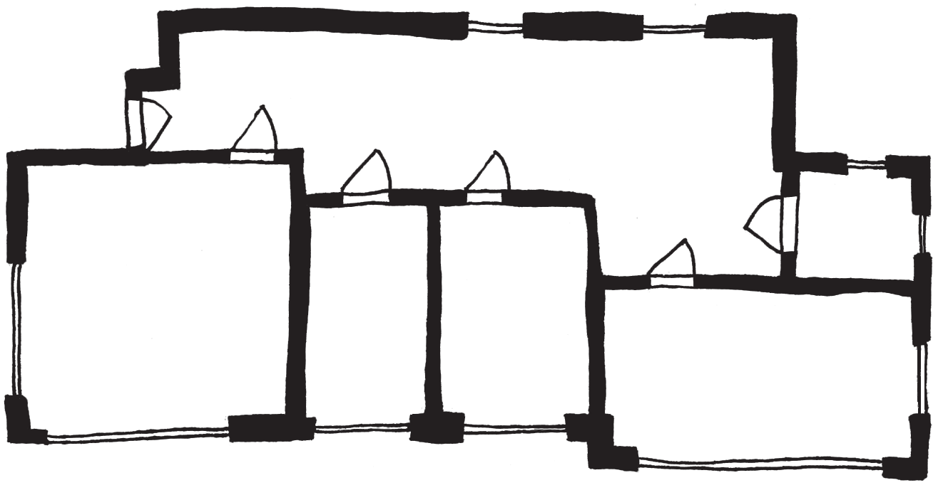
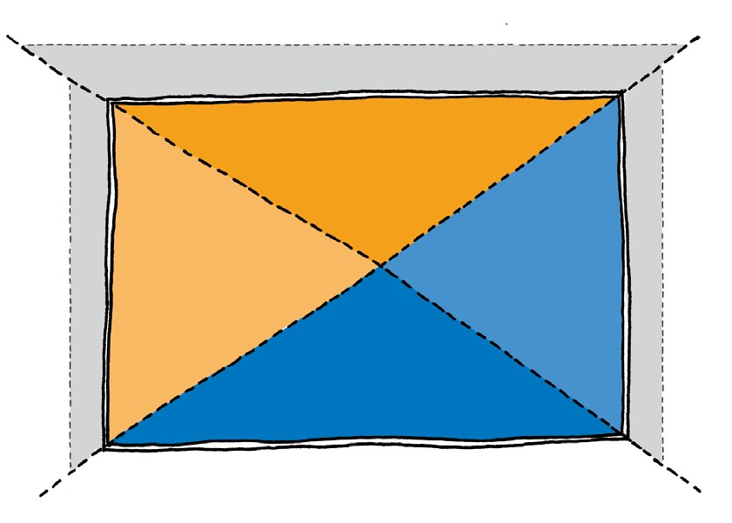
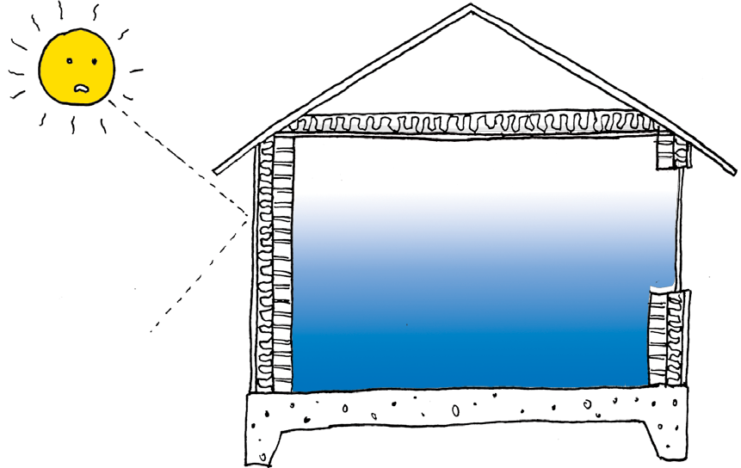
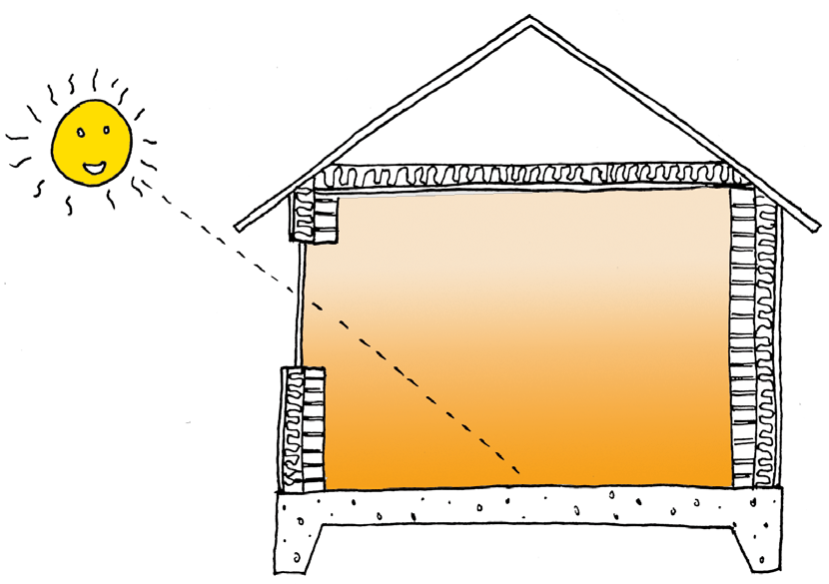
Unoccupied areas (laundry, bathroom)
Garages should be orientated to the west.
Moreland Energy Foundation
www.mefl.com.au T 03 9385 8585
time of publication.
Produced by the Moreland Energy
Foundation, December 2011.

