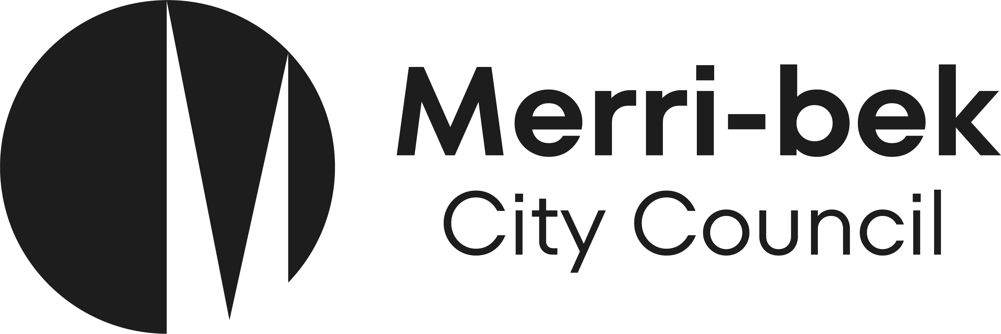 | 2023/24

Request for concession (medical condition)

I am the owner of the property listed below and request Merri-bek City Council to provide a concession waste charge as outlined below:

Full name:* ....................................................................................................................................

Property address for new bin(s):* ................................................................................…….

Mailing address (if different from above): ...............................................................................................…

Mobile phone number:*............................................Email:…………………………............................
Rate Assessment Number (from rates notice): …............................

Does someone living at the above listed property have a medical condition that requires extra general rubbish capacity? (please tick)

Name of person with medical condition*

Please attach supporting letter from your doctor or registered health practitioner. This is a requirement to be eligible for the concession.


Concessions apply to general rubbish bins only. Please indicate the general rubbish bin size/s and the corresponding concession charge that you wish to apply for:
Capacity | Full charge | Concession Charge | Bin description | Concession being applied for (please tick)
160 litres | $374.75 | $187.38 | 2 x 80 litres
200 litres | $408.82 | $204.41 | 1 x 120 litre & 1 x 80 litre
240 litres | $476.96 | $238.48 | 2 x 120 litres
240 litres | $476.96 | $238.48 | 1 x 240 litres

The waste charge is itemised on your annual rates notice.
I acknowledge that:
- Adjustments made to the waste charge will be pro rata from the time of changing the bin size and application of concession.
- The above listed property is permitted one bin size changeover per financial year. Any other bin size changeovers in the 2023/24 financial year will incur a one-off changeover fee, per bin, of $69.45.
- I will notify Council to remove the bin if the property is sold, or the concession no longer applies.
- The bin(s) remain(s) the property of Merri-Bek City Council, and that the bin(s) must be removed when no longer required.

...................................................................... Date ….. / …..… / ……..
(Signature of property owner)

Requests to change the size of your bin are processed weekly. Please continue to use your general rubbish bin. The changeover will be scheduled the next business day after your weekly collection (scheduled 5am–4pm).

If you have supplied a mobile phone number a text message will be sent the day before the change or delivery is scheduled.

Return instructions:
- Scan and email to: waste@merri-bek.vic.gov.au. Attention – Waste Services; or
- Mail to: Locked Bag 10, Brunswick VIC 3056. Attention – Waste Services

Privacy statement:
Merri-bek City Council is committed to protecting your privacy in accordance with the Privacy and Data Protection Act 2014 (Vic) and the Health Records Act 2001 (Vic). The personal information requested on this form is being collected by Merri-bek City Council for ‘Request for concession – large family’ or any other directly related purpose. The personal information will not be disclosed to any other external party without your consent, unless required or authorised by law. You can gain access to your personal information you have provided to Merri-bek City Council and if you wish to alter it, please contact Council’s Privacy Officer via telephone on 9240 1111 or email at Privacyofficer@merri-bek.vic.gov.au.

