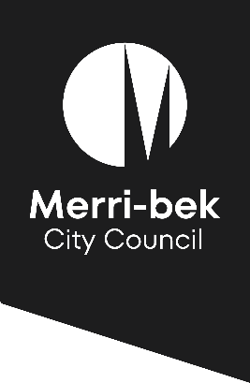
Public Interest Disclosures (Whistle-blower) Guideline 2

HOW DO I MAKE A PUBLIC INTEREST DISCLOSURE?

Encouraging employees to report wrongdoing
Council is committed to fostering an ethical, transparent culture. In pursuit of this, Council encourages the disclosure of information about suspected wrongdoing within the organisation so that it can be properly assessed, investigated and action taken. Council’s senior management is also committed to recognising the value to Council of Public Interest Disclosures and the proper management of such disclosures.
There is a duty that is implied by law in employee / employer relationships, often referred to as the duty of good faith and fidelity, owed by the employee to advance and protect the employer’s interests. For Council this includes the employees ensuring the employer is told about misconduct in a timely way and so the employer has an opportunity to take corrective action.

Who do I make a Public Interest Disclosure to?
The Public Interest Disclosure Act requires a Public Interest Disclosure to be made to a ‘Permitted Person’ or an ‘Investigating Entity’, as follows:
Permitted Persons
- Public Interest Disclosures Coordinator, Yvonne Callanan (Manager Governance and Strategy) can be contacted on 9350 8782 or ycallanan@merri-bek.vic.gov.au
- Public Interest Disclosures Officers
  - Tracey McLean, Human Resources Business Partner who can be contacted on 9240 1189 or tmclean@merri-bek.vic.gov.au
  - Sophie Barison, Unit Manager Integrity, Risk and Resilience who can be contacted on 9240 1134 or sbarison@merri-bek.vic.gov.au
- CEO Cathy Henderson can be contacted on 9240 1190 or chenderson@merri-bek.vic.gov.au
- Direct / indirect manager or supervisor of discloser
  - All leadership positions are responsible for ensuring good governance and ethical conduct of staff and contractors and can be contacted in person, via phone or email through your usual communication channels.
Investigating Entities
- the Independent Broad-based Anti-Corruption Commission (IBAC) Telephone: 1300 735 135 / Website: www.ibac.vic.gov.au
- the Victorian Ombudsman Telephone: (03) 9613 6222 / Website: www.ombudsman.vic.gov.au
- Integrity Oversight Committee;
- The Victorian Local Government Inspectorate;
- the Chief Municipal Inspector;
- the Victorian Information Commissioner.
*Note: IBAC is the appropriate agency to receive Public Interest Disclosures relating to Council. IBAC will assess if the matter should be referred to another agency.

How do I make a Public Interest Disclosure (PID)?
A Public Interest Disclosure can be made in person, by telephone or in writing (letter, memo, email or SMS). You are encouraged to make a report in writing as this can help to avoid any confusion or misinterpretation. If a report is made verbally, the person receiving the report must make a comprehensive record of the disclosure and ask the person making the disclosure to sign this record. The receiving staff member should keep a copy of this record. If you are concerned about being seen making a report, ask to meet in a discreet location away from the workplace or arrange to meet out of hours. A request to meet on an evening or weekend away from the workplace will always be accommodated.
Council’s preferred approach is that a Public Interest Disclosure is made directly to a PID Officer or the PID Coordinator (as detailed at section 2). Another employee receiving a PID must refer it to the PID Coordinator to ensure that it is appropriately addressed in compliance with the Public Interest Disclosure Act.
Employees or Councillors may alternatively choose to make a PID directly to IBAC as an external investigating entity.
Public Interest Disclosures about a Councillor must be reported directly to IBAC.
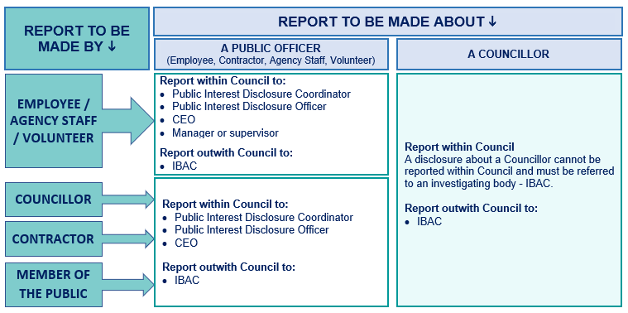

When will a report be protected?
Council will support any staff who report wrongdoing in accordance with the Public Interest Disclosure Policy. Council will treat a report as a public interest disclosure when it meets the requirements under the Public Interest Disclosure Act. These requirements are:
- the person making the disclosure must honestly believe on reasonable grounds that the information shows or tends to show wrongdoing; and
- the report must be made to a ‘permitted person’ or ‘investigating authority’.
Even if a report is not dealt with as a public interest disclosure, Council will consider each matter and make every attempt to protect the staff member making the report from any form of reprisal.

How will a discloser be protected?
The protection of a discloser is outlined in the Public Interest Disclosure Act, and includes:
- immunity from liability (s.39);
- protection from defamation (s.41);
- protection from detrimental action (s.43);
- reasonable management action not prevented (s.44):
- protection from reprisal (s.45)
- protection from damages and/or reinstatement (s.46)
- protection from Council's vicarious liability for detrimental action (s.48)
- protection from transfer of employment (s.51)

How will a disclosure be treated confidentially?
The Public Interest Disclosure Act requires information about the identity of a discloser and the content of a public interest disclosure to be kept confidential.
To maintain confidentiality, and in accordance with Council’s Public Interest Disclosure Policy, Council will:
- remind staff that if they make a disclosure they should keep it confidential;
- limit the number of people who can be made aware of the discloser’s identity, or information that could identify the discloser;
- ensure they have a secure electronic or paper filing system for the receipt, storage, assessment and notification of public disclosures;
- develop a risk management plan for every disclosure to manage the risk of confidentiality breaches.
Council is committed to keeping your identity, and the fact you have reported wrongdoing, confidential. However, there may be situations where this may not be possible or appropriate. We will discuss with you whether it is possible to keep your report confidential. If confidentiality cannot be maintained, we will develop a plan to support and protect you from risk of reprisal. You will be involved in developing this plan.

Can I remain anonymous?
You may make a complaint anonymously. If you choose this option, you will need to report it directly to IBAC. Personal information will not be available to anyone, including IBAC. However, if you choose to make a complaint anonymously, any investigation by IBAC or another agency may be limited. This is because they cannot contact you to obtain more information or discuss the matter with you.

Sanctions for making false or misleading disclosures
It is important that all staff are aware that it is a criminal offence under the Public Interest Disclosures Act to wilfully make a false or misleading statement when reporting wrongdoing.

Refer to the Public Interest Disclosures Policy for further information.

