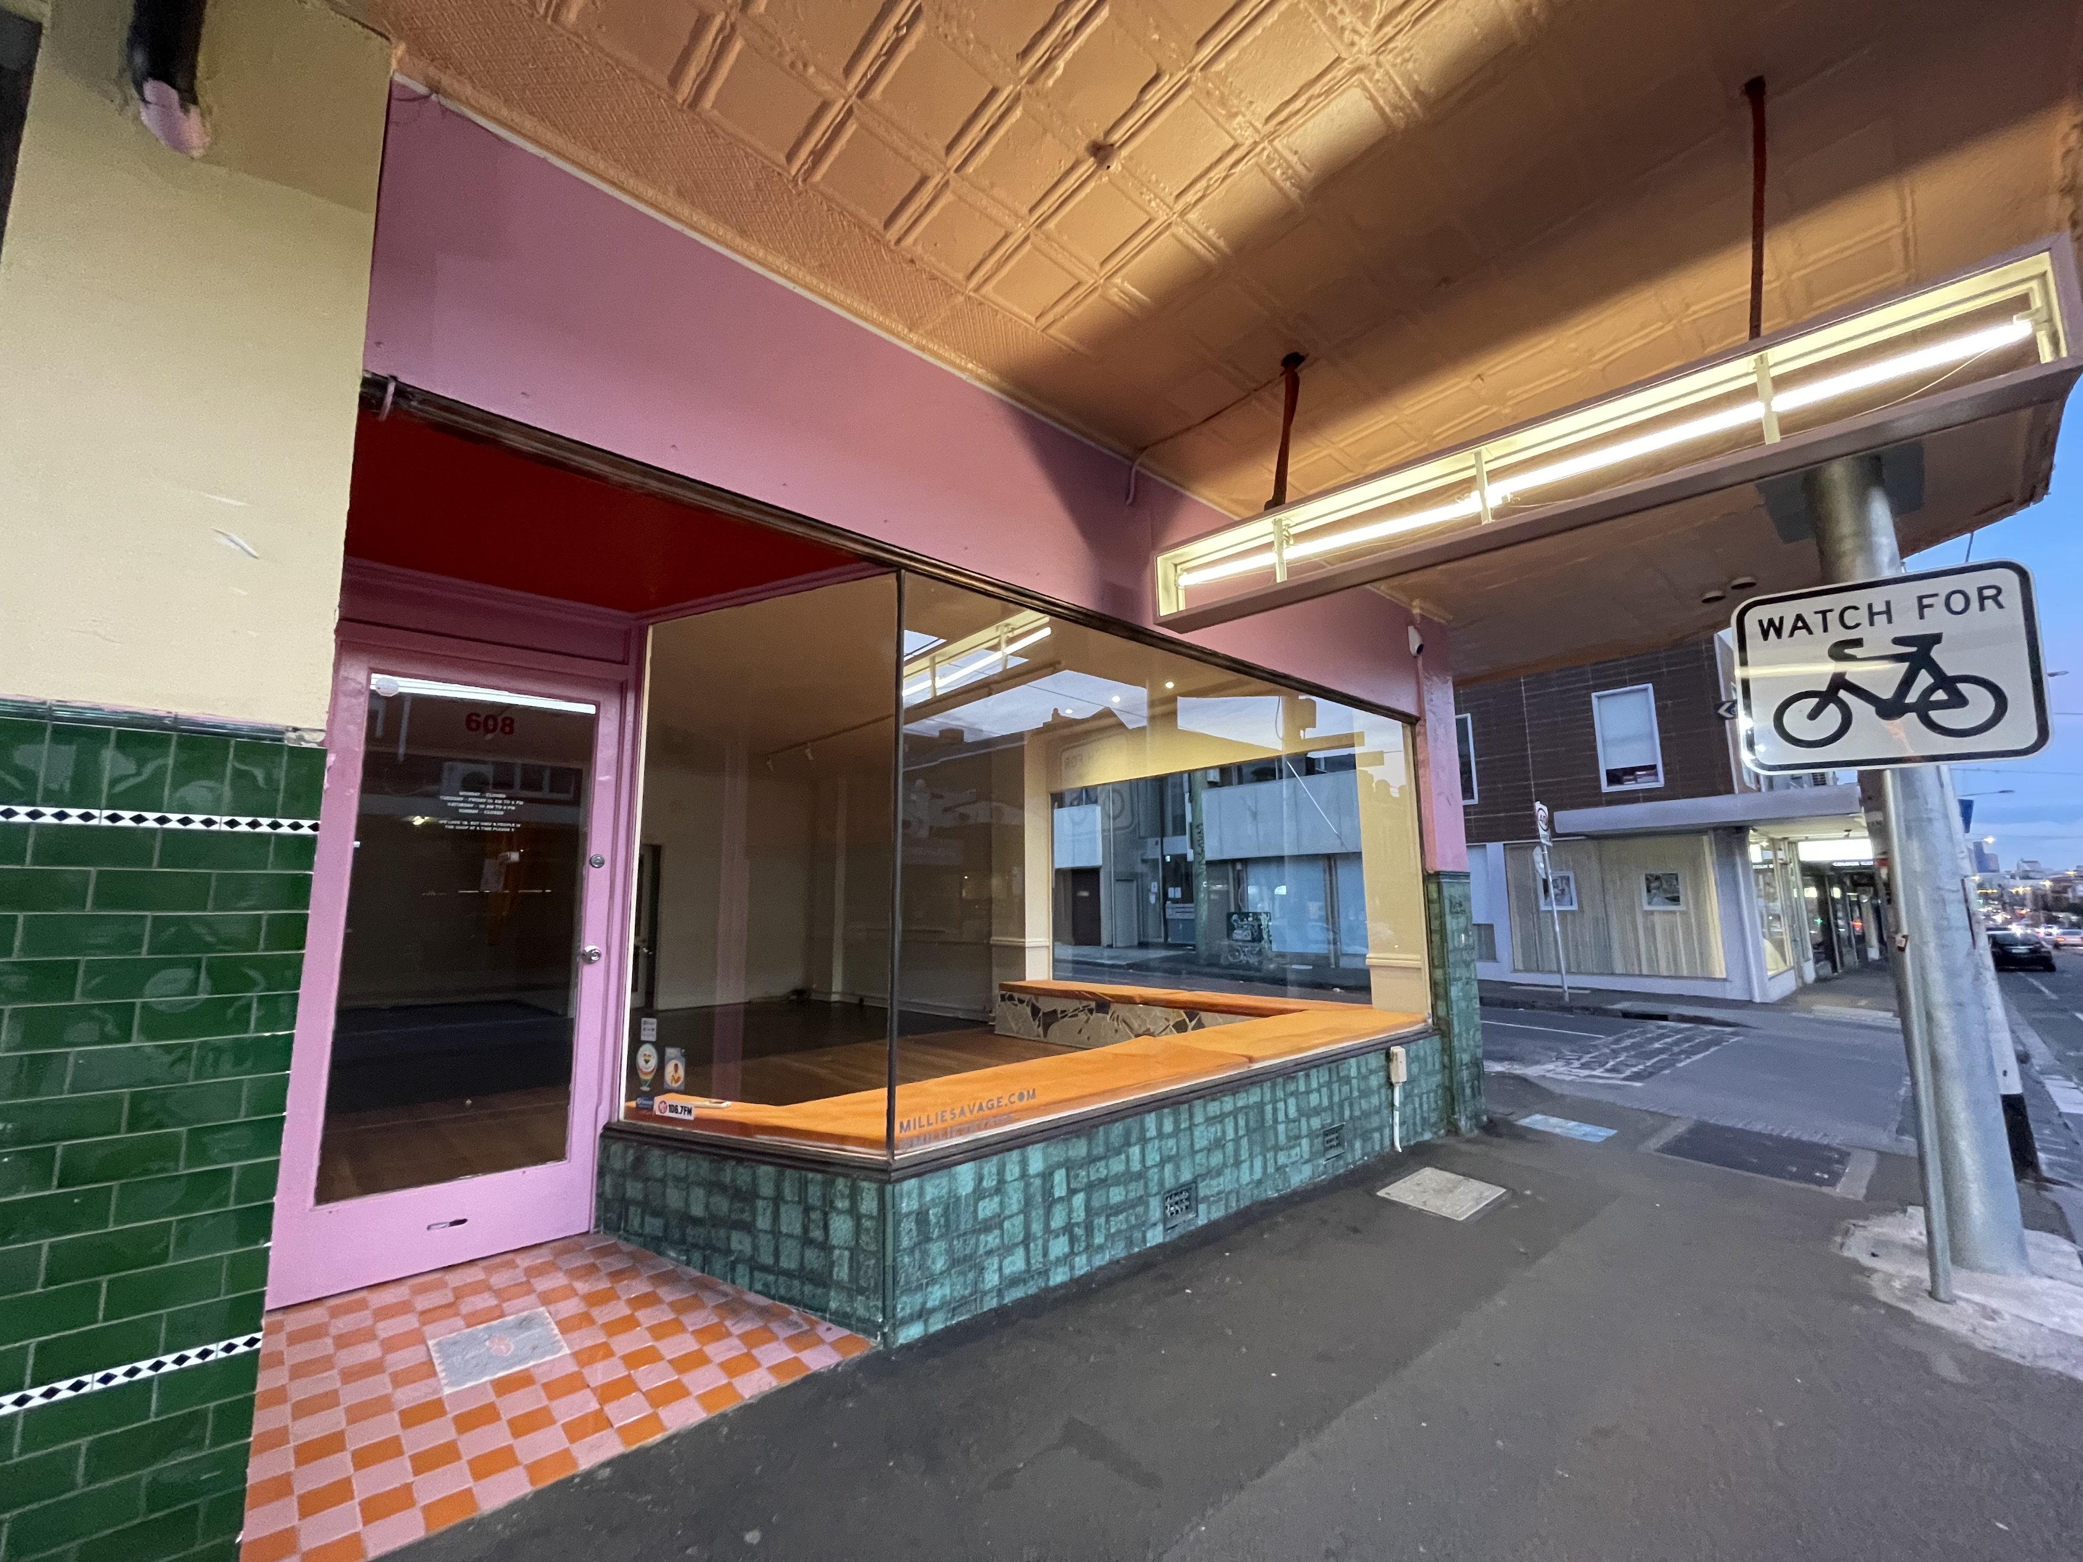f
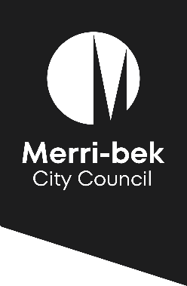
Merri-bek Vacant Shop Grant Program

Funding Guidelines
October 2022

Contents
Grants overview 3
Eligibility requirements 3
Who cannot apply? 4
Funding 4
What can be funded? 4
What won’t be funded? 5
Assessment criteria 5
Application Process 6
How to apply 6
Timeline and key dates 7
Keeping Council informed about issues 7
Reimbursement of grant funds 7
Additional important information 8
Lobbying and canvassing 8
Conflicts of interest 8
Letters of support 8
Meeting the timeline 8
Contact 8

Grants overview

Merri-bek City Council aims to support businesses and reinvigorate local shopping strips through its Vacant Shop Grant Program.
The Merri-bek Vacant Shop Grant Program provides grants to subsidise items such as:
- rent,
- internal fitout and improvement costs,
- shopfront or external improvements (including works or furniture purchases to support outdoor entertaining)
for businesses, creatives and entrepreneurs that enter into a lease for a vacant ground floor, street-facing space within a shopping strip located in the City of Merri-bek.
The objectives of the vacant shop program are aligned with the themes in the Council Plan 2021-25 and include to:
- Rejuvenate and activate Merri-bek’s shopping strips and reduce vacancy rates, with a focus on shopping strips with the highest vacancy rates
- Fill vacant shops
- Help entrepreneurs and home-based businesses to move their operation into a shopfront
- Support the growth of businesses in Merri-bek’s shopping strips
Council has allocated $100,000 to the Vacant Shop Grant Program in the 2022-2023 financial year and grants of $5,000 or $10,000 are available.
Applicants are not automatically eligible for a grant. An online grant application must be fully completed, and all relevant supplementary evidence provided. Council will assess the application and advise the applicant of their success or otherwise.
The Vacant Shop Grants Program will accept applications up to 1 May 2023 unless all funds have been allocated prior to this date.

Eligibility requirements
Grants must be applied for in the name of the lessee (unless the lessee is a business) or a signatory to the lease, provided as part of the application.

To apply for a grant you must:
- Be the lessee of, or a signatory to, a retail or commercial lease signed on or after 24 October 2022, for a ground floor, vacant, street facing shop in a Merri-bek shopping strip;
- Have evidence that you have applied for all permits and/or registrations required to operate your business model at the shop;
- Have an Australian Business Number (ABN);
- Have Public Liability Insurance with a minimum coverage of $10 million or be auspiced by an organisation with at least $10m Public Liability Insurance; and
- Comply with all terms and conditions included in the funding agreement.

Who cannot apply?
To ensure grant funding aligns with Council’s values and vision, there are some things that these grants will not support:
- Businesses or organisations that are political organisations or that have a political purpose, government departments, agencies, foundations or grant making bodies, or those that have a primary focus on fundraising.
- Businesses, organisations or an activity that denigrates, excludes or offends parts of the community.
- Businesses that may negatively impact the health and wellbeing of the community.
- Businesses or organisations that are electronic gaming machine (EGM) venue operators or sports betting companies.
- Applicants that have outstanding acquittals, debts or financial disputes with Merri-bek City Council, that are not being negotiated or have not been approved by Council.

Funding

Grants
Two levels of grants are available:
- $5,000 grant – to assist in opening a pop-up shop or short-term business. Applicants to this stream must have signed a lease for a period of at least 3 months but less than 12 months
- $10,000 grant - to assist in opening and operating a retail, hospitality or professional service business. Applicants for this grant must have signed a lease of at least 12 months.
GST will be paid in addition to the grant (if applicable).
Only one grant will be awarded per lease.
A single business may apply for grants for up to two locations, however preference will be given to businesses who have not yet received a grant from this program.
Consistent with the program objectives, Council reserves the right to apply its discretion in awarding funds and prioritise applications that will best lead to a reduction in the overall shop vacancy rate in Merri-bek.

What can be funded?
Grants can be used (subject to relevant permits and approvals):
- To subsidise rent.
- For physical, internal works that improve the premises or allow the business to set up in the space.
- For shopfront improvements (window promotion, new signage, shopfront painting, tiling etc)
- For external improvements (including outdoor dining furniture, other signage, etc).

What won’t be funded?
- Payment of wages or salaries.
- Other operating costs such as rates or utilities.
- Expenses that are part of the organisation’s annual or regular program/activities or a duplication of an existing service or an ongoing activity (e.g. subscriptions to industry groups; ongoing advertising and social media promotions, etc.).
- Applications that fail to meet eligibility.
- Applications seeking funding to cover outstanding loans or debts.
- Activities and/or works on the premises that have been completed prior to the grant application being approved.
- Expenses that are not related to, or necessary for the premises.
- Activities or works that do not adhere to any pandemic restrictions imposed by the State and/or Federal Governments.
- Activities that have not been approved by Council.

Assessment criteria
Applications must meet the requirements outlined in the ‘Eligibility Requirements’ section of this document to proceed to assessment.
Submissions will be assessed and awarded based on the order they are received by Council.
Applications will be assessed against the following criteria:
Grant amount | Selection Criteria
$5K grants  (Must address selection criteria 1-5) | - Demonstrates reasonable research and planning has been undertaken to ensure the Product and Service Offering will be successful for the duration of the lease. (20%)  - Demonstrates the operation will be open to the public at the premises for at least 5 hours a day, 4 days a week (20%)  - Demonstrates how customers or the public will be encouraged to visit the shop. (20%)  - Includes an itemised schedule of costs that clearly details how the grant will be spent by 1 June 2023 and meet ‘What will be funded’. (20%)  - Demonstrates how it is intended that the operation will be funded for the duration of the lease (20%)
$10K grants  (Must address selection criteria 1-5) | - Demonstrates past capacity operating this or another like business and/or has conducted reasonable research and planning to ensure the successful operation for the duration of the lease. (25%)  - Demonstrates the operation will be open to the public at the premises for at least 5 hours a day, 4 days a week (20%)  - Demonstrates how customers or the public will be encouraged to visit the shop. (15%)  - Includes an itemised schedule of costs that clearly details how the grant will be spent by 1 June 2023 and meet ‘What will be funded’. (20%)  - Demonstrates through the business plan and provision of Profit and Loss statements how it is intended that the operation will be funded for the duration of the lease (20%)

In awarding grant funds to applicants, Council will make all reasonable efforts to assure itself that the recipient business is likely to be a successful and viable business venture for the lifespan of the lease. This is to ensure that grant funds are utilised in a manner that is most likely to achieve a long-term solution to the problem of high vacancy rates that negatively impact the vibrancy of Merri-bek’s shopping strips. If Council cannot be confident, based on the information submitted by an applicant, that a business is likely to be viable over at least the duration of the lease period, Council reserves the right to ask the applicant to provide further information and/or decline the application.

Application Process

How to apply
Only applications submitted online through SmartyGrants will be accepted.
- Read these ‘Merri-bek Vacant Shop Grant Program Guidelines’.
- Check your eligibility to apply for a grant (‘Eligibility Requirements’ section in this document).
- Familiarise yourself with the questions you will be asked, and the documents you will be required to provide in the ‘Merri-bek Vacant Shop Grant Application Form’ by previewing the online form.
- Access the application form online at SmartyGrants.
- Complete the online application form and attach all supporting documentation (eg. signed lease, business plan, financial statements, insurance certificates of currency and permits/registrations (if applicable))
- Submit your application online.

If you do not receive an email confirming the submission of your application, then you should assume that your submission has NOT been submitted.
Technical support for using SmartyGrants: Contact the SmartyGrants support desk 9am - 5pm Monday to Friday on 03 9320 6888 or by email service@smartygrants.com.au

Timeline and key dates
Date | Activity
24 October 2022 | Applications open  - You will receive a SmartyGrants generated email acknowledging your online submission.  - You will be notified of the assessment of your application within 3 to 4 weeks of submission.  - Conditional acceptance of an application may be offered pending further information or evidence (e.g. permit/registration approvals, insurance certificate).  - Applicants will be advised by email of their application success or otherwise.  Successful applicants will be advised and:  - Sent a funding agreement for completion and signing; and  - Requested to provide bank account details.
1 May 2023 (11.59pm) | Applications will close on this date unless funds have been expended prior.
1 June 2023 | Final invoices / evidence of payment of approved grant related expenses, must be received by Council for reimbursement, by this date.
19 June 2023 | Final grant reimbursement payments made by Council.

Keeping Council informed about issues
From the date of submission until one month following the final payment by Council to reimburse grant related expenses, successful applicants must make Council aware in writing as soon as possible, of any issues relating to the business, its Directors, its staff and/or the grant that could compromise Council’s reputation.

Applicants must also advise Council in writing, if they become aware of issues that relate to the delay of approved works or expenses that may impact the applicant’s ability to provide invoices/evidence of Council approved expenses by 1 June 2023.

Reimbursement of grant funds
The Merri-bek Vacant Shop Grants are a reimbursement of Council approved expenses that support an applicant to set up and/or operate an activity or business from a ground floor, vacant, street facing premises in a Merri-bek shopping strip.
All expenditure for which the applicant is seeking reimbursement of, through grant funding must be documented and evidenced to Council’s satisfaction by 1 June 2023.
Council can make between 1 and 3 separate reimbursement payments to each applicant.
Council will review the evidence and if approved, will reimburse the applicant the approved amount (plus GST if applicable) through an electronic funds transfer to the applicant’s nominated bank account.
Council reserves the right to reject reimbursement of expenses paid by the applicant if they are not for approved grant related expenses or if evidence of payment is not provided.

Additional important information

Lobbying and canvassing
- Canvassing or lobbying Councillors or Council employees in relation to a grant application, is prohibited. Any application submitted by an applicant that lobbies or canvasses a Councillor or Council employee in relation to their application will be deemed ineligible.

Conflicts of interest
- Council employees or Councillors are not permitted to directly submit an application for funding.
- Applicants are advised that if a member of the assessment panel becomes aware that they may have a conflict with an application, they will formally declare the conflict and remove themselves from the assessment of that application.

Letters of support
Council employees or Councillors cannot provide letters of support for any application.

Meeting the timeline
Council must receive all invoice(s)/evidence of payment of pre-approved grant related expenses by 1 June 2023, for reimbursement.
Grant recipients must advise Council immediately they become aware of issues that relate to the delay of approved works or expenses that may impact the recipient’s ability to provide invoices/evidence of Council approved expenses by 1 June 2023.
In order to be confident that grant funds will be expended and acquitted in line with the aforementioned timelines, Council reserves the right to request up to two progress reports during the grant payment period.

Contact
For all queries related the Merri-bek Vacant Shop Grants:
Phone: Council’s Business Hotline on 8311 4131
Email: business@merri-bek.vic.gov.au
The subject of the email must be: ‘Merri-bek Vacant Shop Grants Query’

