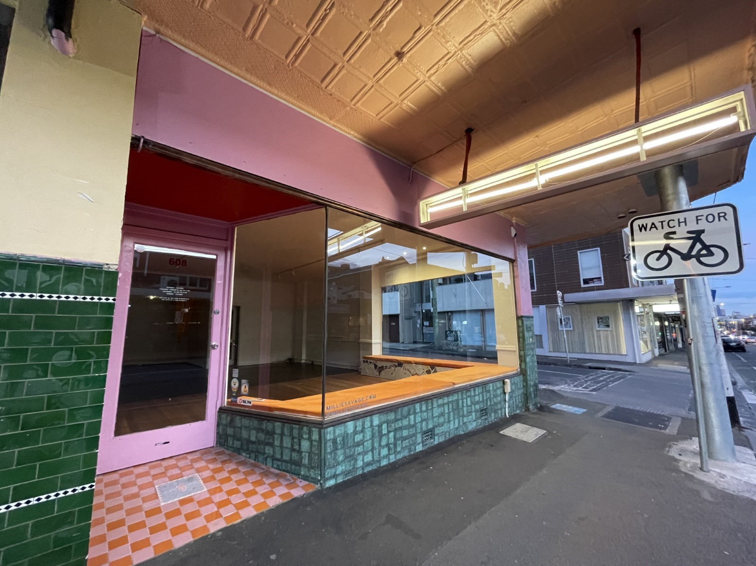

Merri-bek Vacant Shop Grant Program.
  - $10k Gant Business Plan

$10k Grant Applicant’s Business Plan

1.0 The business

1.1 Business name (registered or proposed name).

1.2 Australian business number (ABN)

2.0 Your plan

2.1 What date do you plan to commence trading from the shop?

2.2 What products and/or services do you sell?

2.3 Your pricing strategy

(Example: xx sold at cost of production & distribution plus a 50% mark-up

2.4 What are your planned days and hours of operation?

(You must be open to the public at least 4 days a week and 5 hours a day)?

2.5 Describe your target market and how you will attract them to the shop.

2.6 Outline your business goals for the duration of the lease.

2.7 Outline in dot points the research and planning you have done to operate the business at this shop

2.8 The history of this business

(How long has the business been operating and where from (eg, online, Farmer's Market, pop-up markets)?

3.0 Staff
Example: casual employee | Example: 2

3.1 List the staff roles that you will need to operate the business at the shop.

4.0 Promotional plan

Provide a plan indicating how you will promote your business including how you aim to attract customers and the public to the shop. You can provide a basic plan of all promotional activities including social media and the scheduled activity dates
Describe activity and promotion platform or method | Planned date | Notes
Eg A frame outside shop | All days of operation | Will be professionally developed

5.0 Systems and technology
List the digital systems (including product name) you will use to operate your business.
[Examples: accounting software (Xero), POS terminal (Square)]

6.0 Business risk assessment
Identify the risks that could impact your business and what you will do to protect it.
Rimpact description | Likelihood | What we’ll do to reduce this risk
[Example: Pandemic causes closure of our retail outlet.] | Select level | [Example: Strengthen online sales/e-commerce.]
[Example: Computer theft results in loss of financial records.] | Select level | [Example: Use cloud storage for business records.]
 | Select level
 | Select level
 | Select level

7.0 Forecast expenses and profit
Outline how you will fund the operation for the duration of the lease.
Provide a projected profit and loss for the first year of operation in the shop.
 |  | Quarter 1  (Add dates) | Quarter 2  (Add dates) | Quarter 3  (Add dates) | Quarter 4  (Add dates)
 | Forecast Expenses | $ | $ | $ | $
 | Forecast Profit | $ | $ | $ | $
Expected sources of revenue | [Examples: shopfront coffee sales, online sales, wholesale distribution]
Expected expenses | [Examples: production costs, travel, rent, advertising]

8.0 Financial Statements
Attach the following to your online Vacant Shop Grants Application:
- This completed Business Plan
- Profit and loss statements for 2021-2022 and current Year to Date; and
- Balance sheet (if available).

