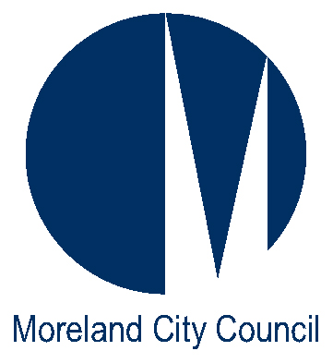
Postal Address
Locked Bag 10
Moreland Victoria 3058

Phone: 9240 1111
Fax: 9240 1205

Request For

DRAINAGE CONNECTION PERMIT

ENGINEERING SERVICES
(Section 9 & 11 of Moreland City Council’s Environmental & Civic Assets Local Law 2014)

PROPERTY DETAILS
Lot No ………… (if street number not known)

PROPERTY No …..…… STREET …….…………………………………………………… SUBURB .…….……………..……

LEGAL POINT OF DISCHARGE:
Has a legal point of discharge been applied for? Yes No If Yes, Permit No ………………

APPLICANT DETAILS

YOUR NAME ………………………………………….………… COMPANY NAME ………………….…………………………………...

POSTAL ADDRESS …………………………………………………………………………………………………………………………………….

TELEPHONE Nos: (Work) ………………….……………… (Home) ………………….………………

(Mobile) ………………….……………… (Fax) ………….………………

I, the applicant, agree that the information provided herein is true, and accurately describes the development proposal for the subject site and that I have read and fully understand all pertinent text on this form (front and back). | SIGNATURE…………………………………………….…  DATE: / /

PLEASE REFER TO FURTHER INFORMATION PROVIDED ON THE BACK OF THIS FORM.
Citizens Service Office Use Only:
DISTRIBUTION: | Receipt No.:
 | Date:
Engineering Services | CSO name:

INFORMATION TO APPLICANTS

- The department will respond to the applicant, normally within 5 working days.
- Where the applicant requests a faxed reply, the department will send the response to the nominated fax number. If no fax number is provided, responses will be mailed out. Where the applicant chooses to pick up the information (from the Coburg Civic Centre), Council will notify the applicant by phone when it is ready.
- The application will not be processed until payment is made in full.
- Works undertaken in the Road Reserve or Council Easement require the appropriate permits to be obtained from Council at the relevant fees.
- The applicant (or his/her representatives, assessors or assigns) shall be responsible to communicate and coordinate all proposed constructed works with the applicable private property owner(s) located directly adjacent to the nature strip areas and/or other Council road reserve areas such that compatible land uses are achieved by all parties (i.e. – future driveway crossovers, ingress-egress, proposed utility easements, etc.)
- The connection must be carried out in the manner specified in the Legal Point of Discharge.
- This permit will be fulfilled when Council officers confirm that the connection has been implemented correctly. This will usually involve a site inspection prior to backfilling and may require the permit holder to have a camera inserted into the pipe under Council supervision. Contact Council’s depot (8311 4300) two business days prior to the connection being made, to book an inspection.

HOW TO PAY
In person
- Payments can be made between the hours of 8:30am and 5:00pm Monday to Friday, at Citizens Service Centres by cash, cheque or money order, EFTPOS, VISA, MasterCard, or Bankcard.
- Citizens Service Centres are located at:-
- Moreland Civic Centre
90 Bell Street, Coburg

- Brunswick Citizens Service Centre
233 Sydney Road, Brunswick

- Glenroy Citizens Service Centre
796N Pascoe Vale Road, Glenroy
By mail
- Cheques or money orders, made payable to “ Moreland City Council” can be sent to:-

- Moreland City Council
Locked Bag 10
Moreland 3058

