Council MEETING AGENDA

Wednesday 10 December 2025

Commencing 6.30 pm

Bunjil (Council Chamber), Merri-bek Civic Centre,
90 Bell Street, Coburg



Acknowledgement of the traditional custodians of the City of Merri-bek
Merri-bek City Council acknowledges the Wurundjeri Woi Wurrung people as the Traditional Custodians of the lands and waterways in the area now known as Merri-bek, and pays respect to their elders past, present, and emerging, as well as to all First Nations communities who significantly contribute to the life of the area.

Information about Council Meetings
These notes have been developed to help people better understand Council meetings. All meetings are conducted in accordance with Council’s Governance Rules.
WELCOME The Mayor, who chairs the meeting, formally opens the meeting.
APOLOGIES Where a Councillor is not present, their absence is noted in the minutes of the meeting. Council may also approve leaves of absence in this part of the meeting.
DISCLOSURES OF CONFLICTS INTERESTS A Councillor has a duty to disclose any direct or indirect financial or other interests, they may have in any matter to be considered by Council that evening.
CONFIRMATION OF MINUTES The minutes of the previous meeting are put before Council to confirm the accuracy and completeness of the record.
ACKNOWLEDGEMENTS AND OTHER MATTERS At each Council Meeting provision of 10 minutes will be made in the Agenda for the Mayor and Councillors to acknowledge and recognise achievements of local individuals and organisations; and raise matters considered important to Council.
PETITIONS Council receives petitions from citizens on various issues. Council formally accepts petitions at Council meetings.
PUBLIC QUESTION TIME This is an opportunity (30 minutes), for citizens of Merri-bek to raise questions with Councillors.
COUNCIL REPORTS Council officers prepare detailed reports, which are considered by Councillors and a Council position is adopted on the matters considered. The Mayor can invite firstly Councillors, secondly Officers, and then citizens in attendance to identify Council reports which should be given priority by the meeting and considered in the early part of the meeting.
NOTICES OF MOTION A motion which has been submitted to the Chief Executive Officer no later than 12 pm (noon) 10 business days prior to the meeting which is intended to be included in the agenda. The motion should outline the policy, financial and resourcing implications.
NOTICE OF RESCISSION A Councillor may propose a motion to rescind a resolution of the Council, provided the previous resolution has not been acted on, and a notice is delivered to the CEO or delegate setting out the resolution to be rescinded and the meeting and date when the resolution was carried. If a motion for rescission is lost, a similar motion may not be put before the Council for at least one month from the date it was last lost, unless the Council resolves that the notice of motion be re-listed at a future meeting.
FORESHADOWED ITEMS This is an opportunity for Councillors to raise items proposed to be submitted as Notices of Motion at future meetings.
URGENT BUSINESS The Chief Executive Officer or Councillors, with the approval of the meeting, may submit items of Urgent Business (being a matter not listed on the agenda) but requiring a prompt decision by Council.
CONFIDENTIAL BUSINESS Whilst all Council meetings of Council are open to the public, Council has the power under the Local Government Act 2020 to close its meeting to the public in certain circumstances which are noted where appropriate on the Council Agenda. Where this occurs, members of the public leave the Council Chamber or Meeting room while the matter is being discussed.
CLOSE OF MEETING The Mayor will formally close the meeting and thank all present.
NEXT MEETING DATE The next Council meeting is proposed to be held on Wednesday 11 February 2026 commencing at 6.30 pm, in Bunjil (Council Chamber), Merri-bek Civic Centre, 90 Bell Street, Coburg. The next Planning and Related Matters meeting will be held on Wednesday 17 December 2025 commencing at 6.30 pm.

WELCOME
APOLOGIES/LEAVE OF ABSENCE
Cr Miles has sought a leave of absence for the period 18 December 2025 to 1 February 2026 (inclusive).
1. DISCLOSURES OF CONFLICTS OF INTEREST
2. MINUTE CONFIRMATION
The minutes of the Council Meetings held on the 12 November and 19 November 2025 be confirmed.
3. ACKNOWLEDGEMENTS AND OTHER MATTERS
4. Petitions
5. PUBLIC QUESTION TIME
6. ITEM TO BE TABLED UNDER THE LOCAL GOVERNMENT ACT 2020
In accordance with section 147(4) of the Local Government Act 2020, a copy of the Arbiter's determination and statement of reasons in the matter of Cr Oscar Yildiz and Cr Adam Pulford is tabled (Attached) and will be recorded in the Minutes of this meeting.
7. Council Reports
7.1 Places for People Plan - Draft For Engagement 22
7.2 Support for public housing statement 29
7.3 Suburb Boundary Realignment - Barina Road, Glenroy/Oak Park 35
7.4 Financial Management Report for the period ended 31 October 2025 40
7.5 Governance Report - December 2025 - Cyclical Report 45
7.6 Contract Extension: Contract SS-08-2020 Banking and Financial Services State Purchasing Contract 52
7.7 Contract Variation: RFT-2025-1 Dunstan Reserve Childcare Centre Expansion 58
7.8 Contract Award: RFT-2025-46 West Street Shopping Strip Renewal Project 62
7.9 Contract award: RFT-2025-48 Road Reconstruction Northumberland Road, Pascoe Vale (Fawkner Road to Longview Street) 68
7.10 Contract Award: RFT-2025-49 Road Reconstruction Jersey Street, Coburg (O’Hea Street to Gaffney Street) 73
8. Notices of Motion
8.1 Retain the former Coburg North TAFE site for skills, innovation and job creation 78
8.2 Venues for Councillor Workshops 80
8.3 Mobile coverage for Optus network in Brunswick 81
9. Notice of Rescission
Nil
10. Foreshadowed Items
11. URGENT BUSINESS
12. Confidential Business
12.1 Procurement matters
Pursuant to section 3(1)(g)(ii) of the Local Government Act 2020 this report has been designated as confidential because it relates to private commercial information, being information provided by a business, commercial or financial undertaking that if released, would unreasonably expose the business, commercial or financial undertaking to disadvantage.
12.2 Amendment to a Section 173 Agreement on former Council land
Pursuant to section 3(1)(g)(ii) of the Local Government Act 2020 this report has been designated as confidential because it relates to private commercial information, being information provided by a business, commercial or financial undertaking that if released, would unreasonably expose the business, commercial or financial undertaking to disadvantage.
12.3 Contract RFT-2025-09 Allard Park Adjustment
Pursuant to section 3(1)(g)(ii) of the Local Government Act 2020 this report has been designated as confidential because it relates to private commercial information, being information provided by a business, commercial or financial undertaking that if released, would unreasonably expose the business, commercial or financial undertaking to disadvantage.
12.4 Property Matters
Pursuant to section 3(1)(a) of the Local Government Act 2020 this report has been designated as confidential because it relates to Council business information, being information that would prejudice the Council's position in commercial negotiations if prematurely released.

INTERNAL ARBITRATION PROCESS – DETERMINATION AND STATEMENT OF REASONS
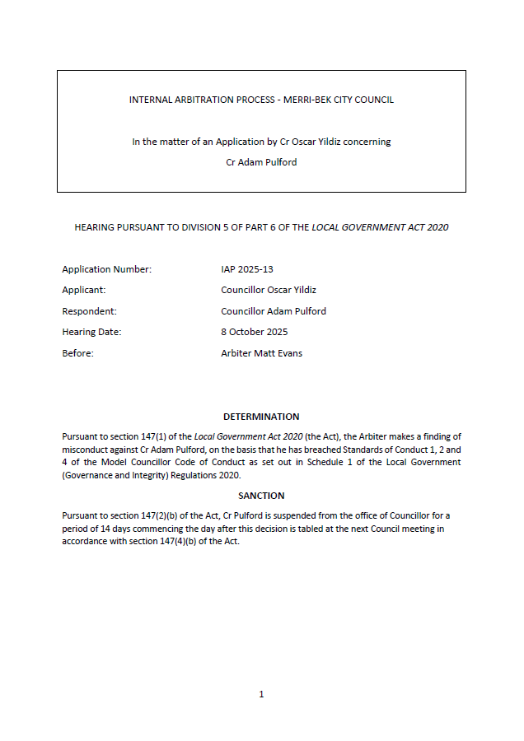

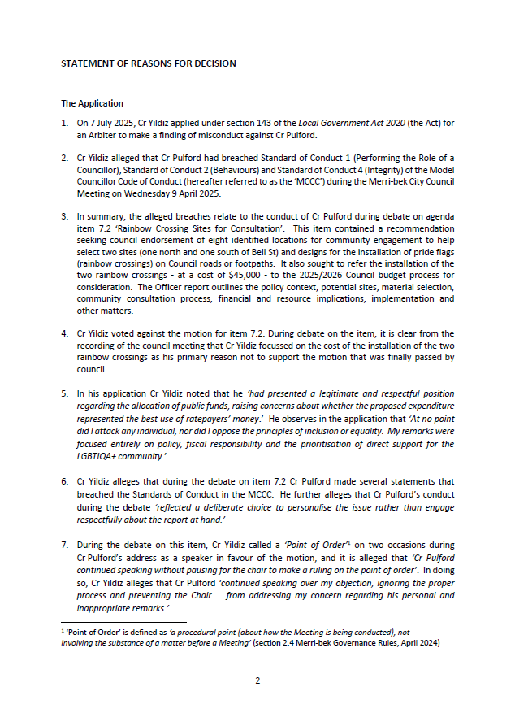

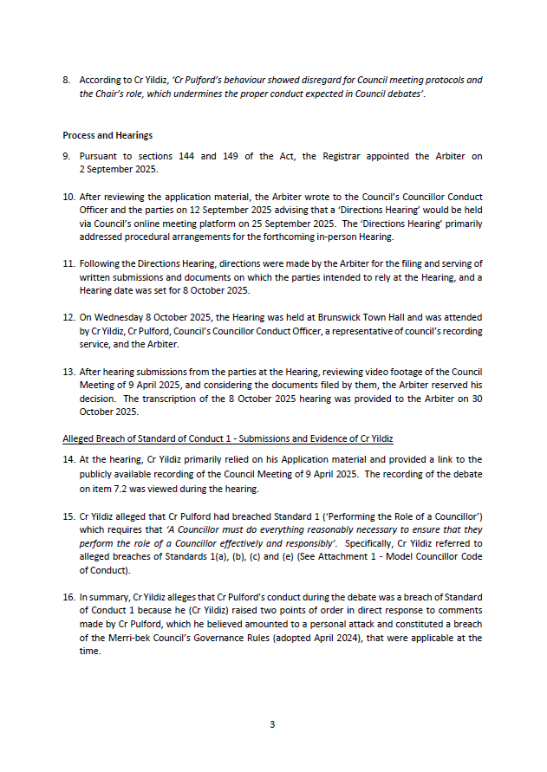

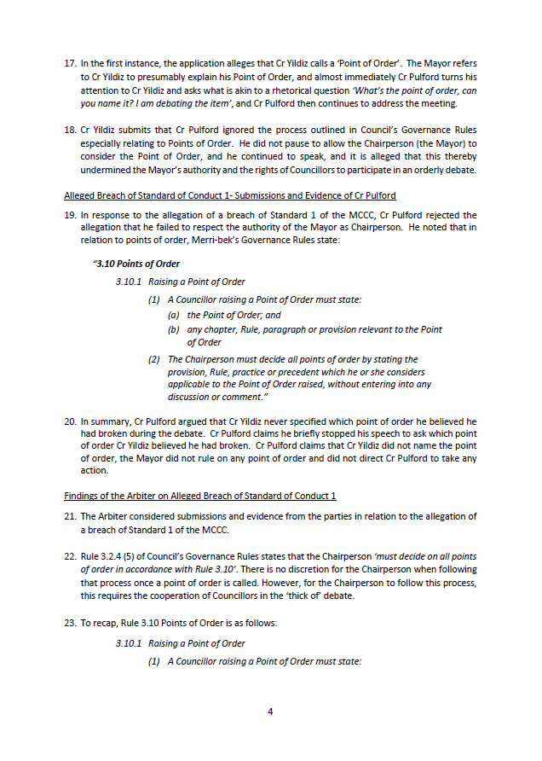

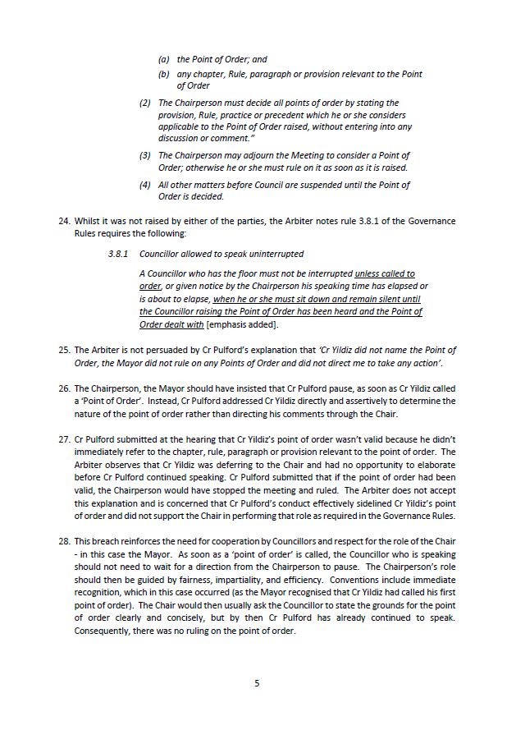

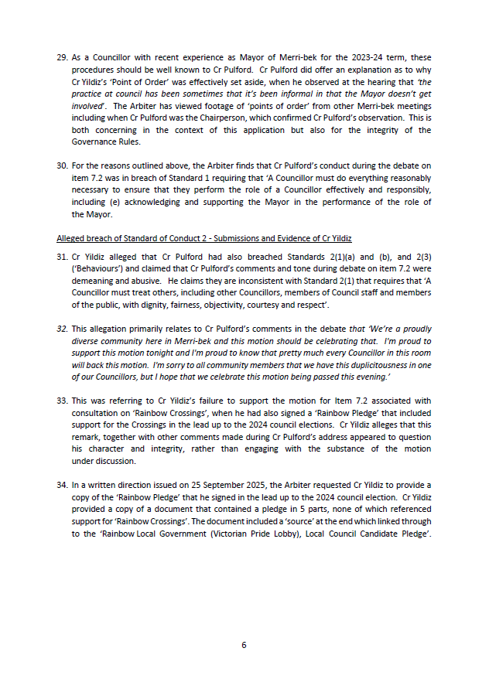

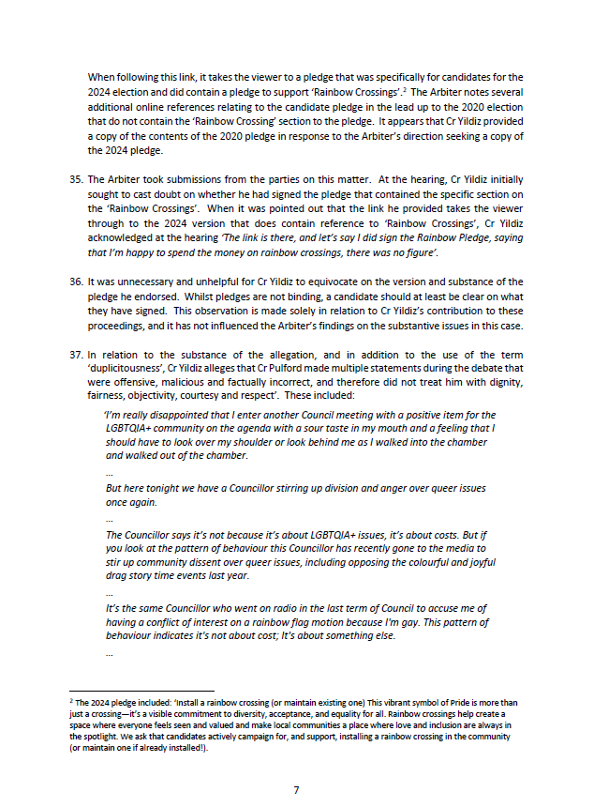

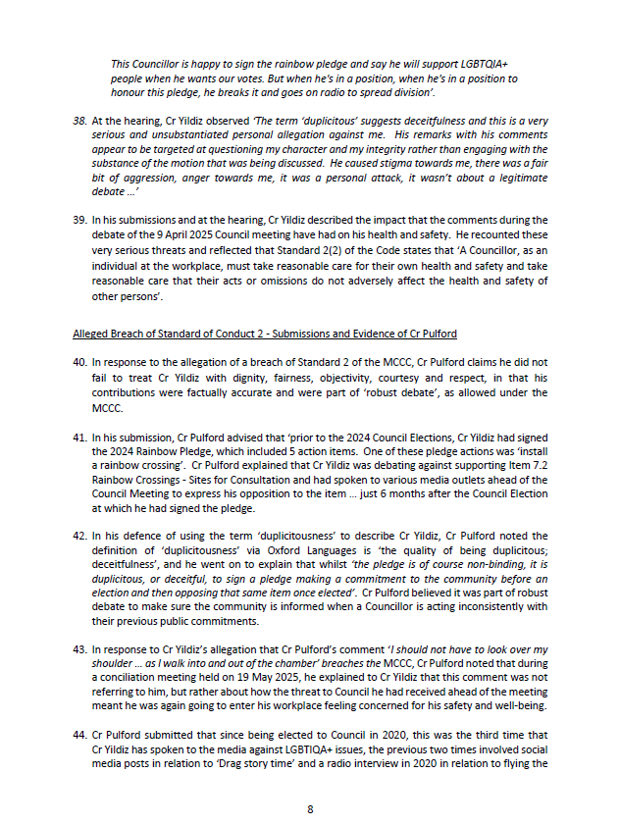

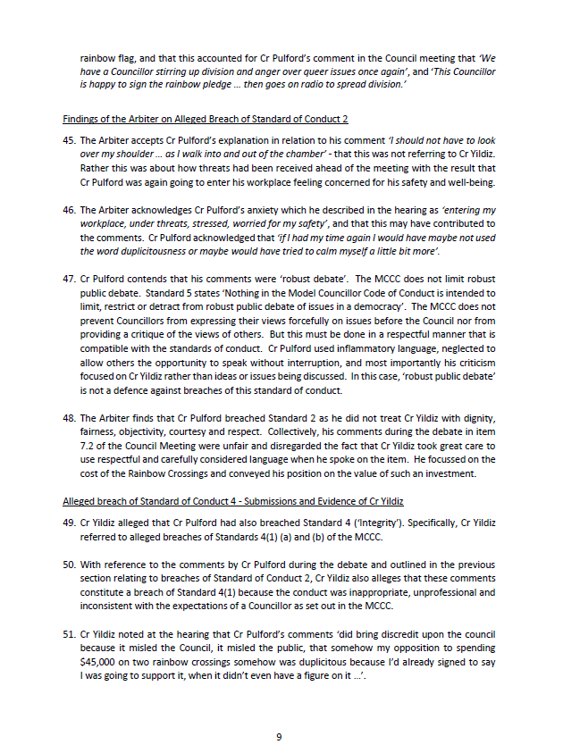

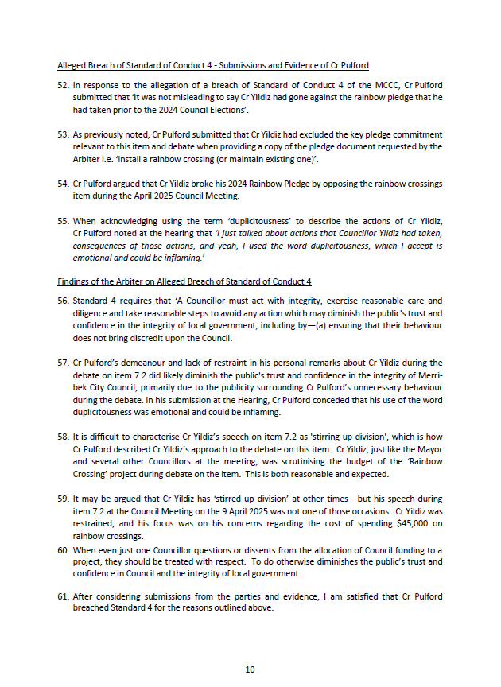

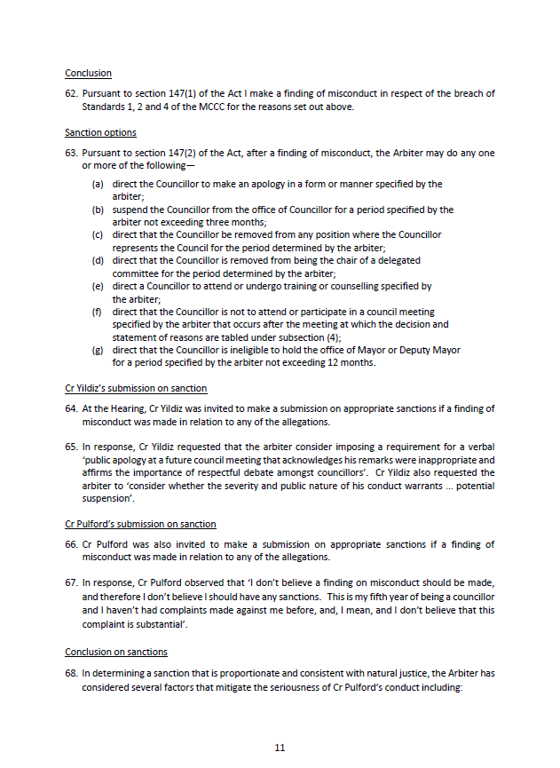

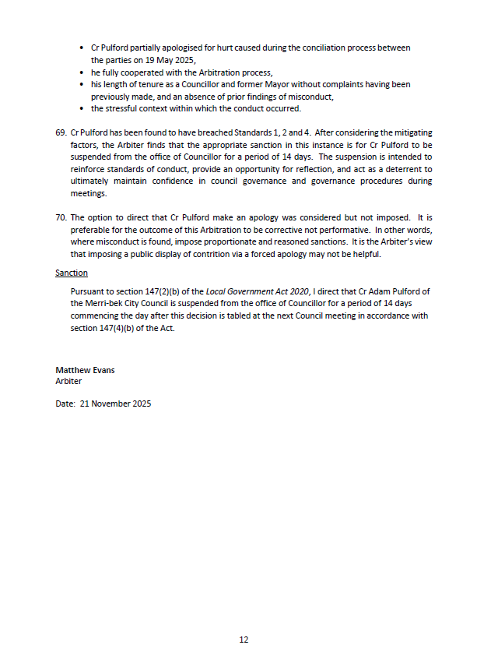

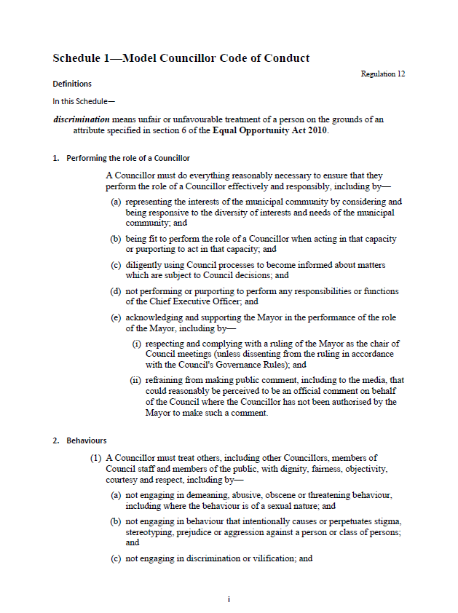

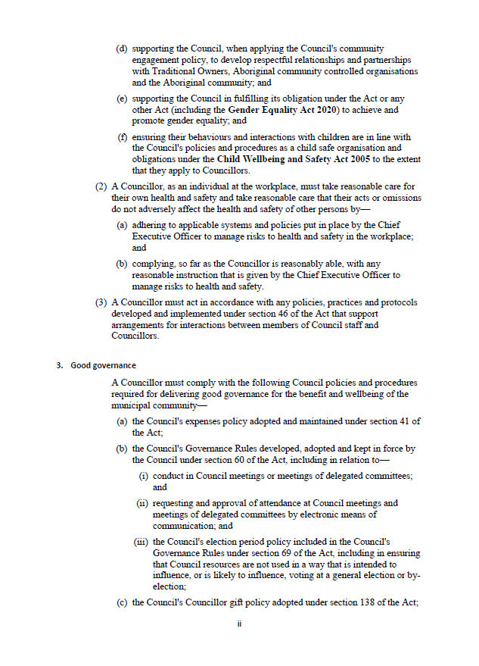

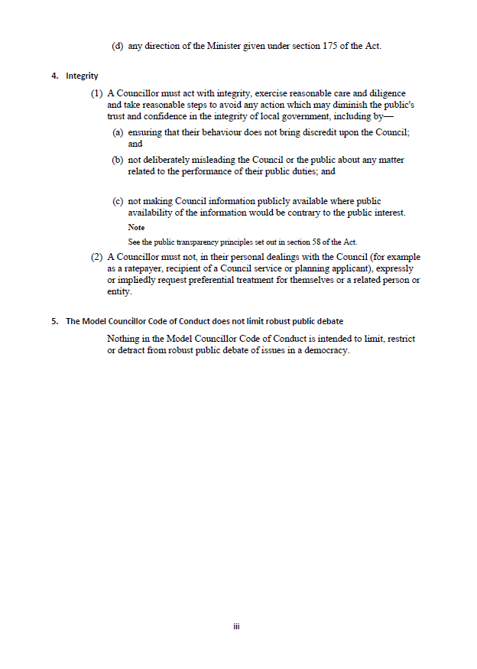

7. Council Reports
7.1 Places for People Plan - Draft For Engagement
Director Place and Environment, Pene Winslade
City Design and Economy

Officer Recommendation
That Council:
1. Endorses the draft Places for People Plan (Attachment 1) for community engagement for five weeks from February to March 2026.
2. Receives a further report at the May 2026 Council meeting with a final version of the Places for People Plan, updated following community feedback, and a community engagement report that outlines the feedback received and how this feedback influenced the final version of the Places for People Plan.

REPORT

Executive Summary
The draft Places for People Plan (the draft plan) is Council’s plan to enhance the vibrancy, sustainability and liveability of the public realm in Merri-bek’s activity centres.
The plan has two key objectives:
1. Define and outline our approach to the improvement of the public realm in our activity centres.
2. Identify priority civic space and streetscape projects to be delivered through Council’s forward capital works program.
The plan will guide Council’s future investment in the public realm, identifying opportunities for new and improved civic spaces, and as a result, and addressing key challenges to maximise the benefits of civic space. It sits alongside and complements Council’s two other significant public realm plans: the Streets For People plan which focuses on Merri-bek’s streets and transport infrastructure; and the Open Space Strategy Action Plan which is focused on how we plan, deliver and maintain outdoor spaces in Merri-bek.
The draft plan outlines key actions for each of the Major Activity Centres of Brunswick, Coburg and Glenroy, based on detailed place analysis that considers types of civic spaces and where they are best located. The draft plan identifies criteria to be used to prioritise actions for future implementation based on community and economic impact, strategic alignment, environmental benefit, and ease of deliverability.
For Merri-bek’s twelve Neighbourhood and 43 Local Activity Centres, assessment criteria have also been developed to help prioritise upgrades at a centre level, based on the centre character, condition and constraints.
Community engagement will seek feedback on the draft plan, proposed actions and prioritisation method.

Previous Council decisions
Adoption of New Merri-bek Open Space Strategy – 10 April 2024
That Council:
1. Endorses as final the Merri-bek Open Space Strategy (Attachment 1) and associated Action Plan (Attachment 2), with the following changes to the Action Plan:
a) Insert a new action for 2024/25 in the Action Plan under Direction 1: Providing parks close to home and enhancing existing open spaces after action 1.9 to “Prepare a municipal-wide view of priority of gap areas in addition to the suburb by suburb view, in preparation for the refresh of the Park Close to Home Framework”
b) Amend action 1.10 listed for 2025 to 2029 under Direction 1: Providing parks close to home and enhancing existing open spaces so that it reads “Refresh the Park Close to Home Framework to guide land acquisition and prioritisation of projects across Merri-bek, taking into account the Open Space Background Technical Report, the Merri-bek Strategic Property Framework, consideration of the Merri-bek Planning Scheme and ensuring the framework is practical to apply.”
c) Insert a new action for 2024/25 in the Action Plan under Enabling Actions after action 6.8 to “Develop and present to Council principles and a procedure to govern the management of the Public Resort and Recreation Land Fund so that it holds adequate funding to support significant strategic property purchases.”

1. Policy context
The public realm describes all the publicly owned space that is available for the community to rest, play, move and gather. It includes our streets, civic spaces, and open spaces, with some overlap in the way these spaces function and are used, as illustrated in the diagram to the right.
Places for People focuses on the improvement of our civic spaces and streetscapes in activity centres. Improvement to our streets is addressed in the Streets for People Plan and improvement to our open spaces in the Open Space Strategy and Action Plan.
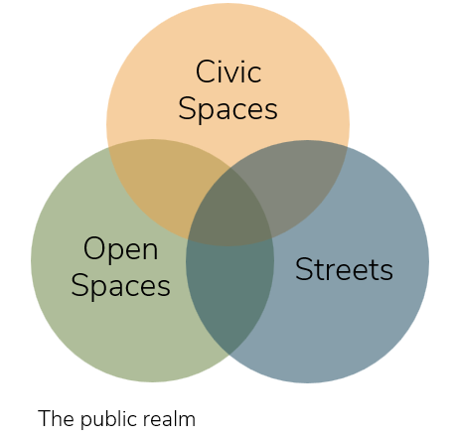
Streets for People Plan
Streets for People is Merri-bek’s plan to create more safe, accessible, healthy, liveable and inclusive streets for everyone. The plan identifies a number of streets prioritised for Streets for People upgrades, and outlines how they will be delivered. It also establishes a prioritisation approach to consider future opportunities. These streets play an important function in connecting people to the activity centres, and making it easier, safer and more pleasant for people to travel to these centres.
Open Space Strategy Action Plan
The Merri-bek Open Space Strategy provides direction for the future provision, planning, design and management of Merri-bek’s open space network. It identifies challenges such as increased pressure on existing open spaces, with growing resident and worker populations, and underserviced areas that are lacking in open space. In some instances, new and improved civic spaces will help address gaps in the open space network, providing valuable new public space for the dense and growing populations in our major activity centres.
Shopping Strip Renewal Program
The Shopping Strip Renewal Program 2015–2025 (SSRP) delivered a series of local economic development initiatives and urban design improvements to enhance business performance and activate public spaces in Merri-bek’s twelve neighbourhood shopping strips. There have been substantial public realm upgrades delivered in five Neighbourhood Activity Centres as well as direct investment and support programs to enhance business activity in these centres. Places for People will replace and expand the SSRP in guiding public realm investment in neighbourhood shopping strips.
Council Plan 2025-2029
The Council plan sets out Council’s and community’s vision for the future. Key objectives and strategies related to this report include:
Strategic Objective 3 – Beautiful and liveable city
Create safe, accessible streets and public spaces that support vibrant communities, active travel, rest and relaxation, and community pride, while ensuring development and growth are well managed and local character is celebrated, ensuring Merri-bek is a welcoming, liveable, and connected place for all.
3.1 Build new and revitalised local parks that promote access to open space close to home, catering for all needs and abilities.
3.2 Ensure clean, safe, and inviting spaces and vibrant places, promoting responsible and civic engagement and greater neighbourhood pride, usage, and social connections.
3.7 Design, approve and develop public places that and promote universal access and personal safety for all.

2. Background
The draft Places for People Plan (the draft plan) is Council’s plan to enhance the vibrancy, sustainability and liveability of the public realm in Merri-bek’s activity centres. The draft plan was developed in response to Action 2.11 of the Merri-bek Open Space Strategy Action Plan:
‘Prepare a Civic Spaces Action Plan for Brunswick, Coburg and Glenroy Activity centres which:
- Develops key principles and criteria to guide the location of civic spaces in Merri-bek’s key activity centres in a place-based way and complementary with the Streets for People approach in Council’s Transport Strategy.
- Identifies locations for new or improved civic spaces to inform future land acquisition and capital works plans’.
The draft plan has evolved to consider Neighbourhood Activity Centres and Local Activity Centres as well as the Major Activity Centres listed above. The draft plan will guide Council’s future investment in the public realm, identifying opportunities for new and improved civic spaces, and as a result, and addressing key challenges to maximise the benefits of civic space.
Benefits of civic spaces and streets
Civic spaces and streets provide residents and visitors with places to gather, rest, connect with others, and engage in the social and cultural life of our municipality. In Merri-bek, we require more and higher-quality civic spaces to meet the needs of the growing population, support our local economy, respond to climate change, and address the lack of public spaces in our activity centres.
In addition to addressing these key challenges, civic spaces provide numerous benefits to the community and the environment, these include:
• Engendering a sense of community belonging, ownership and civic pride.
• Improving community health and well-being through social connection and connection to nature and the outdoors.
• Benefitting the local and cultural economy by attracting visitors and providing space for activation.
• Contributing to a centre’s identity and unique sense of place.
• Facilitating a range of events and activities, encouraging outdoor activity.
• Environmental benefits include stormwater capture, reuse and infiltration through integrated water management, expanded tree canopy cover, increased biodiversity and urban cooling.
Past planning
Past public realm capital works programming in Merri-bek’s major activity centres has been based on the Structure Plans, which are dated (from between 2009 to 2012) and which, due to their ambitious and long-term view, have been delivered only in part.
More recent strategic planning for the centres has been focussed primarily on land use and built form controls, rather than the public realm. Places for People brings a refreshed view to the structure plans for these centres, taking into account recent developments and how these have shaped opportunities and constraints, including the Level Crossing Removal Project and the State Government Activity Centre program.

3. Issues

Community impact
The draft plan proposes changes to some public spaces and streets, to provide more space for social gathering, resting, playing and greening within our activity centres.
The projects identified in the plan will increase the greening of our activity centres and contribute to a more pleasant environment and experience for the community visiting and working in the activity centres.
Through the future implementation of each project, there will be extensive stakeholder engagement to inform the specific elements and design of each space to meet the needs of the community.

Climate emergency and environmental sustainability implications
The projects identified in the draft plan will help to address climate emergency and improve climate resilience in the public realm by:
• Increasing permeable surfaces and stormwater infiltration.
• Capturing, treating and reusing stormwater as a valuable resource.
• Increased planting and vegetation to support biodiversity in the city.
• New canopy tree planting for enhanced shade and urban cooling benefits.

Economic sustainability implications
The draft plan proposes new and upgraded civic spaces located to support economic activity. Pleasant, usable and welcoming spaces will attract more people to visit and stay in our activity centres for longer, which will benefit local businesses. These projects will also provide additional outdoor space which businesses can utilise for trading and seating, which further activates our streetscapes.
The proposed prioritisation criteria in the draft plan includes the economic impacts of individual projects. This will consider the level of activation delivered by a project, as well as the number of businesses and residents in the surrounding area.
An analysis of economic activity across Merri-bek’s activity centres has informed the recommended distribution of capital investment in public realm improvements, to provide a commensurate and equitable approach to project allocation. A summary of the economic analysis is provided in Appendix 2 of the draft plan.
Public realm improvements to neighbourhood and local centres aren’t the only Council investment that supports economic activity. There are many other important services and operations critical to businesses such as waste management and street cleansing.
Merri-bek’s Economic Development Action Plan also outlines the numerous ways in which Council supports local businesses. These programs and activities are cost effective ways to directly benefit businesses and will require continued funding into the future, in parallel with the capital works program.

Human Rights consideration
The implications of this report have been assessed in accordance with the requirements of the Charter of Human Rights and Responsibilities and Gender Equality Act 2020.
Under the Gender Equality Act 2020 Council has a duty to promote gender equality in policies, programs and services with a direct and significant impact on the community. This includes gender impact assessments which consider how our plan will:
• meet the needs of people of different genders
• address gender inequality
• promote gender equality.
An intersectional-lens Gender and Equity Impact Assessment has been undertaken for the draft plan and the assessment will be provided to the Human Rights Commission at the next submission date.

4. Community consultation and engagement
The development and adoption of the Merri-bek Open Space Strategy involved extensive community engagement during 2023 and 2024 to understand community uses and priorities relating to open space, including civic spaces. Key findings from that engagement have influenced the development of the draft plan. These include:
• There is pressure on existing open spaces as the population grows.
• Demand for more space to socialise, especially for girls and women, that is not in traditional open space or sporting settings but in more urban spaces.
• A need for seating and shade/shelter from sun and rain, over playgrounds, picnic and rest areas.
• Demand more trees and planting to improve biodiversity and provide more green space.
• Demand for spaces for diverse activities and programming.
Forthcoming activities
Engagement and communications activities for the draft plan in early 2026 will include:
• Conversations Merri-bek project page.
• Social media posts including in-language ads.
• A short survey (available digitally on Conversations Merri-bek, in several languages other than English, and in hard copy format at all public-facing council facilities and upon request).
• Visits to relevant community advisory committee and reference groups.
• Briefing Merri-bek Community Connectors to facilitate feedback from CALD communities.
• Pop-up events in Brunswick, Coburg, Glenroy and Fawkner which will be promoted on the Conversations Merri-bek page and at the locations when times, dates and locations are confirmed.
Affected persons rights and interests
Officers recommend a public exhibition period for the draft plan to allow all affected community members the opportunity to provide feedback on the draft plan. Changes to the document will then be considered that directly address the ideas or concerns of all affected persons before the Plan is finalised and presented to Council for adoption at the May 2026 Council meeting.

5. Officer declaration of Conflict of Interest
Council officers involved in the preparation of this report have no conflict of interest in this matter.

6. Financial and resources implications
The draft plan has been developed using inhouse resources.
The existing Five Year Capital Works Program includes a budget for activity centre public realm works. It is intended that the implementation of the draft plan be delivered through and within this existing budget, with allocation of priority projects to be considered annually through the development of the capital works program, and endorsed by Council through the adoption of the annual budget.
The activity centre capital works program is largely funded through Council rates, with some supplementation from grants when available. Council officers will continue to pursue funding opportunities, where projects align with grant objectives.
Some recommendations in the draft plan align with Open Space Strategy and Park Close to Home actions to address open space gap areas. Where these aligned projects involve land acquisition and creation of new urban parks, they may be funded through the Open Space Reserve.
The Victorian Government Activity Centres Program has also prompted discussion on funding the community infrastructure needs of the Brunswick and Coburg activity centres slated to receive significant new development and population growth. As outlined in Merri-bek’s Submission to the Activity Centre Program, Council acknowledges the need for more housing, jobs and open space around our major activity and transport hubs, and notes this must be matched with adequate investment from the State Government in infrastructure and services that enhances liveability and supports vibrant, resilient communities.
The Victorian Government has signalled it intends to introduce an Activity Centres Infrastructure Contributions Plan model for the sixty Activity Centres prioritised in its reforms (this includes Brunswick and Coburg). Council will continue to advocate for a model that aligns with Merri-bek’s local priorities and delivery processes.

7. Implementation
Community feedback will be sought on the draft Places for People Plan from February to March 2026.
Following review and analysis of feedback, a report detailing the findings of the engagement and how it influenced changes to the final plan will be presented to Council in May 2026.

Attachment/s
1 | Draft Places for People Plan | D25/622333

7.2 Support for public housing statement
Director Place and Environment, Pene Winslade
City Design and Economy

Officer recommendation
That Council:
1. Writes to the Victorian Minister for Housing to acknowledge the Standing together for public housing: Call for support, September 2025 statement (Statement) (Attachment 1) and advise that Council:
a) Supports Request 1, including the commission and public release of structural assessments for all public housing towers, and the construction of replacement public housing nearby or on the same estate before any resident relocation.
b) Broadly supports the State utilising suitable surplus land to deliver social and affordable housing, and the adoption of more inclusionary zoning that mandates the provision of social and affordable housing in private developments.
2. Provides a copy of the letter to the Standing Together for Public Housing campaign authors.

REPORT

Executive summary
The Victorian Government’s 2023 announcement regarding the demolition and future redevelopment of all 44 of Melbourne’s high rise public housing towers by 2050 has prompted public debate about the future of public housing in Victoria.
In July 2025 a group of housing academics, workers and advocates published the United Housing Statement, since renamed Standing together for public: Call for support, September 2025 (Statement) (Attachment 1). The Statement includes three requests to the Victorian Government relating to the assessment, future use and renewal of public housing assets:
1. Release of information about the physical conditions of all public housing towers proposed for demolition, and that any new facilities be built on the same sites.
2. All surplus state land to be used to build more public housing.
3. Introduce mandatory public housing in new multi-unit developments on private land.
The Statement has since received support from several advocacy groups, housing, health and legal organisations, housing focussed university groups and one Council.
Merri-bek has a well-established policy framework that supports increasing the supply of public, community and affordable housing. This report responds to Council’s resolution of 10 September 2025, which sought an assessment of the alignment between the Statement and Merri-bek’s existing policy positions. Officer analysis concludes:
1. Request 1 is consistent with Council’s longstanding advocacy, including Council’s March 2025 submission to the Victorian Parliamentary Inquiry into the public housing tower redevelopment program.
2. Request 2 is not aligned with Council policy as it requires all surplus government land to be used exclusively for public housing. This may result in unintended consequences for other potential high value uses; and many surplus sites are not suitable for housing. Council’s current policy position is to advocate for public housing, community housing managed by Not-for-Profit registered agencies, and other forms of affordable housing.
3. Request 3 is partially aligned with existing policy as Council has long supported mandatory inclusionary planning contributions.
It is proposed that Council acknowledges the Statement by writing to the Minister for Housing outlining its support for the first request.

Previous Council decisions
Notice of Motion - Support for public Housing Statement - 10 September 2025
That Council receives a report on the implications of signing the United Housing Sector Statement with the report to address the alignment with Merri-bek’s existing policies in relation to the three demands of the statement:

a) Commission and release detailed evaluations of the structural conditions of all the towers. If and when a strong case is made for demolition, build replacement public housing nearby or elsewhere on the estate first, and relocate the tenants when complete.

b) End all ‘surplus’ public land sales and use that land to build more public housing.

c) Introduce inclusionary zoning on private land for a mandatory component of public housing.

1. Policy context
Merri-bek’s policy framework supports increasing the supply of public, community and affordable housing, and strengthening partnerships with Victorian Government and registered housing providers.
Council Plan 2025-29
The Merri-bek Council Plan 2025-29 has the following strategy, initiatives and priorities relevant to the recommendation:
Strategy
Support the housing and wellbeing needs of all in the community particularly those on lower incomes to have access housing in Merri-bek.
Initiatives and priorities
2.15 Partnering with government and housing providers to develop accessible, inclusive housing, including First Peoples on Council land including in Central Coburg and other locations, as well as advocating for more public and community housing
2.16 Advocate for more social and affordable housing stock. Including crisis, transitional and permanent housing options through planning policy, partnerships and direct engagement with developers and by supporting local responses to homelessness
Merri-bek Planning Scheme
Key sections are specific to the recommendation include:
Clause 16 (Housing)
Planning for housing should include the provision of land for affordable housing.
Clause 16.01-2L (Housing Affordability Merri-bek)
Encourage developments to include affordable housing to be owned and managed by a registered housing association, registered housing provider or the Director of Housing.
Affordable Housing Action Plan 2022-26
The Affordable Housing Action Plan 2022-26 has the following points relating to housing provision, providers and partnership opportunities.
1.1 Facilitate affordable housing provision in planning permit applications
- Negotiate affordable housing to be provided as part of large development projects
1.5 Support registered housing providers and other non-profit housing projects
- Assist registered housing agencies and non-profit affordable housing in navigating their projects through the planning system
2.3 Explore partnership opportunities with Homes Victoria, other state agencies, residential developers and housing providers
- Work with Homes Victoria, registered housing providers, Not For Profit organisations, philanthropy and private organisations to partner on affordable housing developments and renewal projects, including Crisis/Emergency Accommodation, Transitional Housing and Housing First housing models.

2. Background
Policy context
State Government context
On 20 September 2023 the Victorian Government released its Victoria's Housing Statement: The Decade Ahead 2024-2034 (Housing Statement), which included a decision to demolish all high-rise public housing towers in metropolitan Melbourne by 2050. An uplift of at least 10% in social housing across the 44 sites was promised.
The Housing Statement promised to “unlock surplus government land” and proposed that 45 sites across the state will enable 9000 new homes to be built with at least ten per cent of these “affordable homes”.
Currently surplus State government land is subject to significant and competing policy pressures. Not all surplus land is suitable for residential use – the State’s surplus land register contains many sites in remote or industrial locations. For surplus sites that could be suitable for residential purposes, three are often a range of high value uses to consider – including hospitals, educational facilities and recreational spaces.
Council policy context
Council closely monitors housing need in Merri-bek. Currently there is a gap of over 4,000 affordable housing dwellings across the municipality. Council supports increasing public, community and affordable housing in Merri-bek to meet this gap.
Following the Victorian Government’s release of the Housing Statement, Council expressed concern that the proposed social housing uplift may not meet local need and encouraged that lower-impact renovation and retrofit options be considered for older residents, including those at 351 Barkly Street, Brunswick.
On 12 March 2025 Council endorsed a submission to the Victorian Parliament’s Inquiry into the redevelopment of Melbourne’s public housing towers. The submission made a number of recommendations, including asking the State government to:
• Halt the demolition program until a transparent, evidence-based assessment is completed.
• Publicly release all supporting information, including engineering reports used to justify demolishing the 44 towers rather than renovating them.
Council’s broader housing advocacy, guided by the Affordable Housing Action Plan 2022–26, focuses on increasing public, community and affordable housing through partnerships with the State and registered housing providers.
Council also has a long-held position calling for mandatory social and affordable housing development contributions through inclusionary zoning mechanisms. Consistent with M9, MAV and other local governments, Council advocates for contributions that deliver public housing, community housing and affordable housing for lower-income households.
Council examples of high value use of surplus Victorian Government land
Council supports the use of suitable surplus Victorian Government land for public, community and affordable housing. Council also supports other high value uses. For example, Council has previously acquired surplus Victorian Government land to deliver important community infrastructure, such as Harmony Park (a former TAFE site) and the Glenroy Community Hub (a former primary school). These are illustrated below.
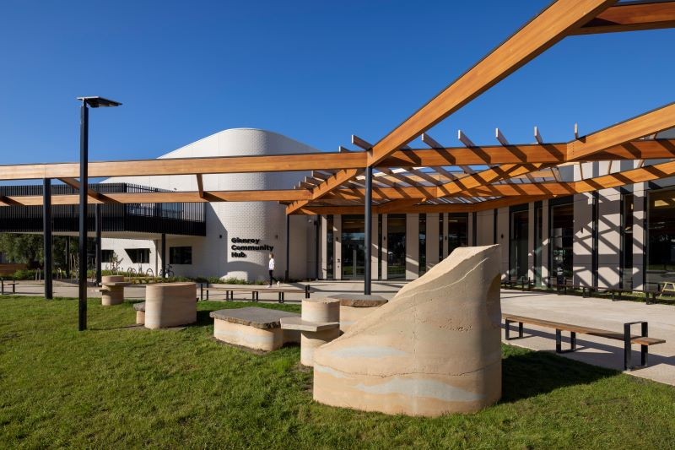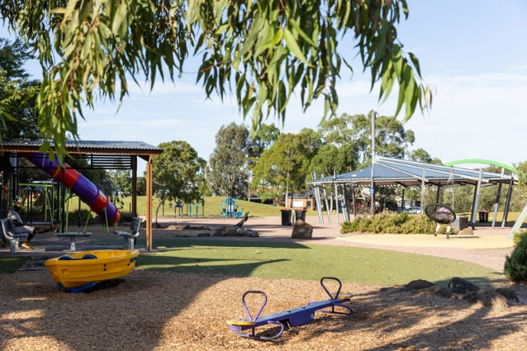
Image 1: Glenroy Community Hub Image 2: Harmony Park
The statement: Standing together for public housing – call for support
In July 2025, a group of housing academics, workers and advocates released the United Housing Statement, now renamed Standing together for public housing: Call for support, September 2025 (the Statement) (Attachment 1).
The Statement includes three requests to the Victorian Government relating to the assessment, future use and renewal of public housing assets:
1. Request 1: Commission and release detailed evaluations of the structural conditions of all the towers. If and when a strong case is made for demolition, build replacement public housing nearby or elsewhere on the estate first, and relocate the tenants when complete.
2. Request 2: End all ‘surplus’ public land sales and use that land to build more public housing.
3. Request 3: Introduce a mandatory component of public housing in new multi-unit developments on private land.
Other support for Statement
Based on published information, a range of small organisations, academics, grassroots housing advocacy groups and some prominent individuals have publicly supported the Statement. The City of Yarra’s support was authorised by officers.
The Victorian Public Tenants Association, as the peak body representing public housing residents, has not supported the Statement. The Community Housing Industry Association Victoria (CHIA Vic) and all but two smaller CHPs have also not supported the Statement.

Issues
Assessing the statement
Officers have assessed each of the three requests in the Statement with regard existing policy positions.
Request 1 is consistent with Council’s current policy position, most recently stated in the Council-endorsed submission to the Victorian Parliament’s Inquiry into the redevelopment of Melbourne’s public housing towers which was endorsed by Council on 12 March 2025.
Request 2 is not currently supported by Council policy. It would create a new policy and advocacy position seeking that the Victorian Government require all surplus land to be used exclusively for the purpose of delivering public housing.
Firstly, this may result in unintended consequences for other high value uses of public land. For example, Merri-bek Council has previously acquired surplus State government land to deliver public facilities such as the Glenroy Community Hub. Additionally, officers note, not all surplus sites will be suitable for residential uses.
Secondly, not all surplus State government land is suitable for housing. Surplus land is published for sale on the State government’s website. While much is suitable for housing, a significant volume is in remote and regional locations, or in industrial or otherwise tricky sites.
Thirdly, Council’s current policy position (as set out in the current Council Plan 2025-29, the Affordable Housing Action Plan 2022-26, and endorsed advocacy submissions) is to advocate for public housing, community housing managed by Not-for-Profit registered agencies, and other forms of affordable housing. Council does not limit its advocacy to public housing alone.
Community housing is a significant contributor to the provision of quality secure homes to families in Merri-bek and many community housing providers have a track record of working collaboratively with Council. Exemplary projects delivered by Community Housing Providers (CHP) include the Reynard St Townhouse project (Women’s Property Initiatives), newly completed cooperative housing at Wilson Avenue (Common Equity Housing), and Pascoe Vale social housing (Housing Choices and Aboriginal Housing Victoria).
CHPs are subject to more detailed and transparent regulatory reporting than Homes Victoria-run public housing. Performance reporting on measures such as resident satisfaction, repair resolution time and vacancy levels is published for each CHP by the Housing Registrar annually. The report of the Social Housing Regulatory Review in 2022 identified multiple areas for improvement in the management and regulation of both public and community housing and broadly recommended a consistent approach across the social housing sector. In late 2024 the Victorian Government published its response and supported the bulk of the review’s recommendations.
Request 3 is inconsistent with Merri-bek policy. Council has had a long-held position calling for mandatory social and affordable housing development contributions through the planning system. However, Council’s policy position supports inclusionary contributions to deliver public housing, community housing managed by registered not-for-profit agencies, and genuinely affordable housing for households not eligible for social housing. Homes Victoria does not work with private developers to include public housing in new developments.
This approach plays out in Merri-bek where CHPs are delivering social housing in private developments. In Merri-bek in 2024–25, planning permits were issued for new developments that included 389 affordable dwellings; all the social housing within this provision will be owned by CHPs, backed by government funding.
Officer recommendation summary
In summary, officer analysis finds the Statement is partially aligned with Council’s existing policies.
1. Request 1 aligns with Council’s longstanding advocacy for transparent structural assessments and replacement public housing to be delivered before any resident relocation.
2. Request 2 does not align with Council policy, as surplus government land may also be required for other essential public uses and for a mix of public, community and affordable housing.
3. Request 3 does not align, though Council supports mandatory inclusionary contributions that deliver public, community and affordable housing—not public housing alone.
Officers recommend that Council acknowledge the Statement, support Request 1, and provide qualified support for Requests 2 and 3 in line with adopted policy positions.
Human Rights consideration
The implications of this report have been assessed in accordance with the requirements of the Charter of Human Rights and Responsibilities. The report is in line with these requirements.

4. Community consultation and engagement
This report considers existing policy positions such as the Council Plan 2025-29 and the Affordable Housing Action Plan 2022-26 for which there was community consultation processes before adoption by Council.

5. Officer declaration of Conflict of Interest
Council officers involved in the preparation of this report have no conflict of interest in this matter.

6. Financial and resources implications
The work to prepare a letter can be undertaken within existing staff resourcing.

7. Implementation
An advocacy letter will be drafted from the Mayor to the Minister for Housing, and forwarded to the authors of the United Housing Statement.

Attachment/s
1 | Standing Together for Public Housing (United Housing Statement) | D25/570343

7.3 Suburb Boundary Realignment - Barina Road, Glenroy/Oak Park
Director Business Transformation, Sue Vujcevic
Financial Services

Officer Recommendation
That Council authorises the realignment of the Oak Park/Glenroy suburb boundary to incorporate properties at 26, 28 and 30 Barina Road, Glenroy, into the suburb of Oak Park.

REPORT

Executive Summary
The need for a minor realignment of a suburb boundary has emerged due to the subdivision of land on parcels previously attributed to Waterloo Road Glenroy. The new land parcels front and are addressed to Barina Road. Aside from the three highlighted properties/parcels in Glenroy, the remainder of Barina Road sits within Oak Park. The current and proposed suburb boundary realignment is indicated in the maps in the background and issues sections of this report.
This recommendation is independent of any current or future planning processes or decisions, and the owners of all three affected properties are in support of the amendment. There is no budget impact of this report.
As the naming and numbering authority, Council is responsible for the maintenance of suburb boundaries. The proposed re-alignment is the most effective solution, which will include the entirety of Barina Road within the suburb of Oak Park.

Previous Council Decisions
Proposed suburb boundary realignment between Glenroy and Oak Park – 26 August 2002
Council resolve:
1. To adopt the boundary between Glenroy and Oak Park as shown in Attachment 1 of the report.
2. That all people who made a submission and all owners and residents of Victoria Street, Charlotte Street, Barina Road, Rhodes Parade (west of Watt Street) and the Oaks Estate be notified in writing of the decision made by Council.
3. To notify the Geographic Place Names Committee and other relevant authorities of the realignment of the Suburb Boundary between Glenroy and Oak Park.

1. Policy Context
Merri-bek Council is a Naming Authority under the Geographic Place Names Act 1998 (the Act) and is the first point of contact for adding or changing names for places, features and roads within the municipality.
The Naming rules for places in Victoria 2022 (The Naming Rules), are the statutory guidelines provided for under section 5 of The Act that provide standardised naming conventions and clear naming procedures. Any naming proposal must conform to these guidelines.
Once assessed the proposal is assessed against ‘The Naming Rules’ including Australian Standards AS NZS 4819-2011 Rural and Urban Addressing (The Standards). If approved the proposal will be forwarded to the Registrar of Geographic Names for consideration. The relevant sections of ‘The Standards’ and ‘The Naming Rules’ are shown below.
Under ‘The Naming Rules’ applications should assess and address any impact to the United Nations Group of Experts on Geographical Names resolutions, Sustainable Development Goals and Victorian Aboriginal Affairs Framework goals, where relevant.
AS NZS 4819-2011 Rural and Urban Addressing
Section 3.4.2 Review of localities
Boundaries of localities in areas that are subject to development should be reviewed and amended where appropriate.
Official Naming Rules for Places in Victoria
Section 5.2.1
5. If a property is situated on a corner and the block is subdivided with one or more of the new properties accessed from a road generally being addressed to a different locality, the locality boundary should be changed to incorporate the new subdivided properties.
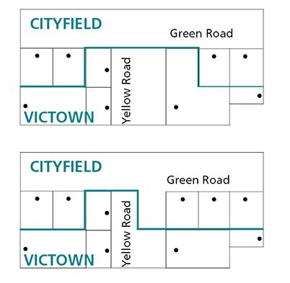

2. Background
In seeking to formally define suburb boundaries for the first time, the Geographic Place Name Committee in January 1997, provided proposed suburb boundaries for Council’s consideration. On 19 May 1999 Council adopted these suburb boundaries.
In 2002 residents received letters confirming their new official addresses. However, many residents along the Oak Park and Glenroy border objected to their Glenroy address on the basis they were always known as Oak Park. As historical recognition was a major consideration for the boundaries, community consultation was undertaken, and community support was received for an amendment to the boundary that included all properties in Charlotte Street, Victoria Street, Barina Road and Rhodes Parade to be included in Oak Park. This was subsequently approved at the 19 August 2002 Council meeting.
Development has since occurred on a block facing Waterloo Road Glenroy, creating three new properties that front and are addressed to Barina Road. The current suburb boundary is shown in the map below. As the current suburb boundary outlines below, their land parcels are in Glenroy. These three new properties are currently addressed to Barina Road Glenroy while existing properties to Barina Road Oak Park.
Current boundary
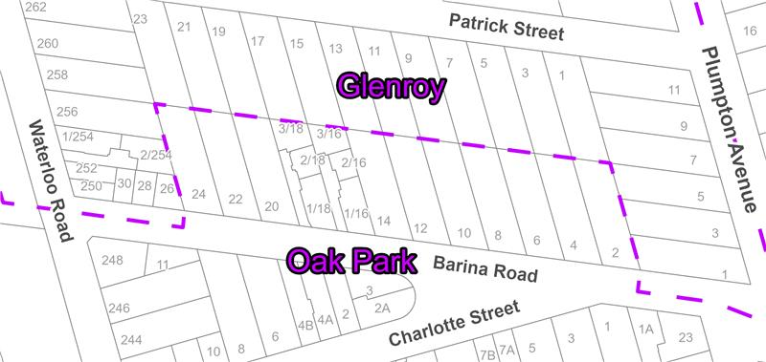
Relevant Building Permits
252 Waterloo Road, Glenroy Property Applications:
• MPS/2010/13, Development of the land for three dwellings (two double storey dwellings to the rear of existing dwelling).
• Occupancy Permit for 2 rear dwellings received February 2013. Registration at Land Use Victoria 15/02/2014.
• Property Applications: PBS/2018/268, Construction of Three attached double storey dwelling.
• Property Applications: SP/2018/215, 3 lot subdivision - Registered at Land Use Victoria 30/08/2023.
The owners of all three new properties (26, 28 and 30 Barina Road) have contacted Council citing Council’s responsibility as maintainer of the boundaries; to request integration with the rest of the street into Oak Park.
‘The Standards’ and ‘The Naming Rules’ both require suburb boundaries are reviewed and amended where appropriate. Section 5.2.1 of ‘The Naming Rules’ states:
‘If a property is situated on a corner and the block is subdivided with one or more of the new properties accessed from a road generally being addressed to a different locality, the locality boundary should be changed to incorporate the new subdivided properties’
Proposed Boundary
In accordance with Section 5.2.1 of ‘The Naming Rules’ it is recommended is to amend the locality boundary to incorporate the new subdivided properties into the suburb of the road they are accessed from.
Council officers have assessed that this proposal meets all relevant statutory requirements including the following:
• Conforms to the statutory requirements in Section 5.2 of ‘The Naming Rules’.
• Since the locality names remain unchanged, all naming conventions are being properly followed.
• The locality boundaries sit wholly within Merri-bek municipality therefore Council does not need to consult with neighbouring municipalities.
• The amendment is a small realignment, no impact has been made to United Nations Group of Experts on Geographical Names resolutions, Sustainable Development Goals, or Victorian Aboriginal Affairs Framework goals.
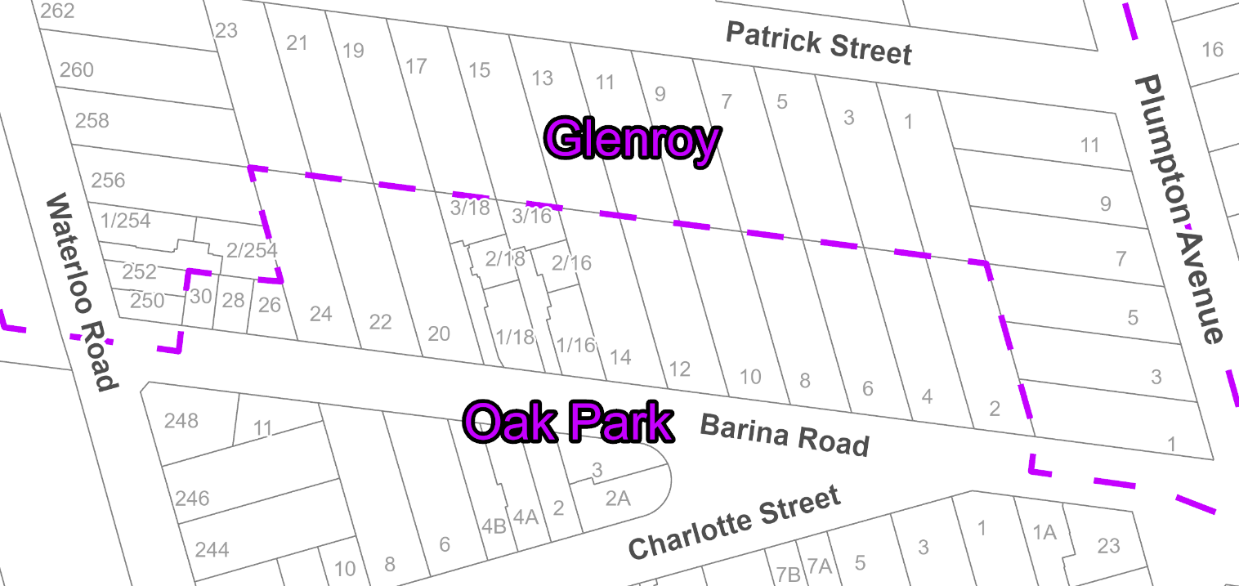
Once Council resolves to realign the boundary, the request will be submitted to the Geographic Names Victoria Registrar for finalisation and gazettal, and the Land Victoria maps will be amended. After this occurs updated addressing can be issued to the property owners and Barina Road will be wholly included in Oak Park.

3. Issues
To issue the new address in Oak Park with the rest of the street, Council is required to meet the guidelines in the Official Naming Rules for Places in Victoria and AS NZS 4819-2011 Rural and Urban Addressing. The parcel itself must sit in the named suburb.
By realigning the boundary as per officer recommendations, council will bring the Barina Road fully into Oak Park as per Section 5.2.1 of the Official Naming Rules for Places in Victoria.

Community impact
No other members of the community are affected by the suburb boundary adjustment.
There is a possibility of further requests for realignment from neighbouring streets, impacted by new development and the 2002 resolution to include Charlotte Street, Victoria Street, Barina Road and Rhodes Parade into Oak Park. Any changes to suburb boundaries around these streets would require a separate process, being out of scope of this consultation and report.

Climate emergency and environmental sustainability implications
There are no climate emergency implications associated with this report.

Economic sustainability implications
There are no economic sustainability implications related to the report.

Legal and risk considerations
The recommendations in this report comply with the requirements of the Geographic Place Names Act 1998 and the Naming rules for places in Victoria 2022.

Human Rights Consideration
The implications of this report have been assessed in accordance with the requirements of the Charter of Human Rights and Responsibilities and there are no implications associated with this report.

4. Community Consultation and Engagement
Council's Community Engagement Policy 2024 requires community engagement when community impact is anticipated. Considering this proposed boundary realignment has a negligible impact on the community, nor can the realignment be influenced significantly by the community; the identified affected persons have been contacted directly.
A public notice was displayed on Conversations Merri-bek for 60 days and letters were sent to directly affected residents and ratepayers as well as those residents and ratepayers in properties adjacent to the proposed new boundaries. This was done in accordance with ‘The Naming Rules’.
Affected persons rights and interests
Before making a decision that affects a person’s rights, Council must identify whose rights may be directly affected and provide an opportunity for that person (or persons) to convey those views regarding the effect on their rights and consider those views.
Impacted ratepayers and residents at 26, 28, and 30 Barina Road Glenroy were directly contacted via email and letters. Letters were also sent to all ratepayers and residents of adjacent properties to the new suburb boundary line inviting submissions.
A public notice was published on the Conversations Merri-bek Page, inviting submissions for 60 days exceeding the minimum 30 days as required by ‘The Naming Rules’. Support was received from all three owners of directly impacted properties, and no objections were received.

5. Officer Declaration of Conflict of Interest
Council officers involved in the preparation of this report have no conflict of interest in this matter.

6. Financial and Resources Implications
There are no financial implications of this report. The lodgement to Geographic Names Victoria and re-issuing of street numbers reflecting the suburb boundary change can be completed with the current resources in the Financial Services budget.

7. Implementation
Should Council support the recommendation of this report, Council officers will submit the resolution to Geographic Names Victoria Registrar for finalisation and gazettal whereby the Land Victoria maps are amended.
Once complete, the address of the three impacted properties will be updated to Oak Park, and other relevant government departments, Yarra Valley Water and Australia Post notified.

Attachment/s
There are no attachments for this report.

7.4 Financial Management Report for the period ended 31 October 2025
Director Business Transformation, Sue Vujcevic
Financial Services

Officer Recommendation
That Council notes the Financial Management Report for the period ending 31 October 2025, at Attachment 1 to this report.

REPORT

Executive Summary
This report presents the Financial Management Report for the financial year to date period ending 31 October 2025. A detailed financial review was undertaken across the organisation at the end of September 2025. The results of this review are included in this report as the Full Year Revised Forecast.
The 31 October 2025 Income Statement shows that Council has recorded a surplus of $144.7 million, $1.6 million higher than the year-to-date budget of $143.1 million, as a result of higher overall revenue. This difference is considered largely timing in nature. As set out in the issues section of this report, operating surplus funds do not convert to immediately available cash to Council. The accounting surplus includes items such as non-cash contributions, capital grants and is used to fund items such as loan repayments, the rates funded capital works program and transfers (savings) via reserves.
Council has spent $13.6 million on capital expenditure, which is tracking below the year-to-date (YTD) budget of $14.8 million, with $80.3 million budget remaining.

Previous Council Decisions
2025-26 First Quarter Financial Report – 12 November 2025

That Council,
1. Notes the 2025-26 First Quarter Financial Report for the period ending 30 September 2025, including operating performance and capital performance at Attachment 1.
2. Notes the status of the capital works program for 2025-26.
3. Notes the increase to the full-year forecast for operating income of $9.2 million and the increase to operating expenditure of $6.0 million arising from the 2025-26 First Quarter Financial Review.
4. Approves a decrease of $2.7 million to the transfer to the Significant Projects Reserve (to $1.8 million) in 2025-26 to fund additional expenditure relating to the Elevate Transformation Program and the bring forward of the Coburg basketball feasibility study. This reduction will be offset by a corresponding increase to the reserve in the 2026-2030 budget.
5. Endorses the full-year capital expenditure forecast of $102.9 million, arising from the 2025-26 First Quarter Financial Review.
6. Carries forward the following capital project funding to the 2026-27 Capital Works Program:
a) Fully or partially grant funded projects to be carried forward if the funding is secured and received this financial year:
• AG Gillon Stormwater Harvesting - $1,000,000
• Coburg Bluestone Cottage Complex Redevelopment - $611,324.
b) Rates funded projects:
• Bin Purchases (waste charge funded) - $2,258,519
• West Street Neighbourhood Streetscape - $1,000,000
• DeChene Reserve - Gender Inclusive Facilities - $700,421
• Coburg Outdoor Pool - 8 X 15 Toddlers Pool - $175,000
• Fawkner Library Upgrade Works - $70,000.
7. Brings forward the following capital project funding to the 2025-26 Capital Works Program:
• Brunswick Early Years Hub (grant funded) - $261,663
• Coburg Olympic Pool - Repainting - $135,000
• Balfe Park Sportsfield Redevelopment - $50,000.
8. Approves funding for the following new projects in the 2025-26 Capital Works Program:
• Fawkner Netball Club Roof (grant funded) - $4,560,000
• Jukes Rd & William St, Fawkner - Priority Crossing (grant funded) - $437,000
• Blackspot Project - Intersection of Widford St & View St, Glenroy (grant funded) - $263,900
• Raised Crossing - Everett St & Moreland Rd (SLRSP) (grant funded) - $184,000
• Electric Vehicle Chargers (externally funded) - $170,000 (previously budgeted as operating)
• Emergency Road Works - Ivy St, Brunswick - $104,010
• Blackspot Project - Intersection of Albert St & Wilkinson St, Brunswick (grant funded) - $57,330
• Brunswick Bowls Club - $16,646
• Albion St/Lillian St Rectification - $15,000
• Glenroy Community Hub - Electrical Works - $10,815
• Coburg Lake Bridge Rectification Works - $10,620.
9. Approves additional funding for the following existing projects in the 2025-26 Capital Works Program:
• Mitchell Parade Retaining Walls (grant funded) - $1,068,852
• Drainage, Moama Crescent and Jhonson Street - Hot Spot No 21 - $381,650
• Victoria St - Streets for People (grant funded) - $374,000
• York Street Park Close to Home (reserve funded) - $265,374
• Rehabilitation, Moonee Pde from Jewel to Union - $245,000
• Wombat Crossings - Barrow St & Blair St, Coburg - $200,000
• Brunswick City Baths Repainting & Renewal - $174,345
• Road Reconstruction, Katawa Grove from Cooraminta to Dead End - $168,000
• 40 km/h Rollout - Traffic Calming - $100,000
• South Street - Engeny Hot Spot No 12 - $99,404
• Richards Reserve Natural Turf Renewal - $85,485
• South Street from Jensen to West, Road Reconstruction - $82,866
• Fawkner Leisure Centre Redevelopment - $55,195
• South Street from Dickinson to Everitt, Road Reconstruction - $51,421
• Park Renewal - Soudan St (reserve funded) - $48,599
• Building Maintenance - Capital Purchases - $28,138
• Fallon St From Union to Collier Both Carriageways - $16,889
• Park Renewal - Beccles / Oulton Reserve (reserve funded) - $12,974
• Tyson Street from Jukes Rd to Denys Street, Road Reconstruction - $12,028
• Mobile Phone Purchases - $15,408
• Shade Sail Installation - Anne Sgro Child Care (grant funded) - $6,302.
10. Notes savings realised from the following existing projects in the 2025-26 Capital Works Program:
• Road Reconstruction, O’Hea Street from Lonsdale St to Clifton Grove - $548,786
• Road Reconstruction, O’Hea Street from Montefiore St to Lonsdale St - $425,878
• Road Reconstruction, O’Hea Street from Sussex St to Bishop St - $356,397
• Road Reconstruction, O’Hea Street from Bishop St to Montefiore St - $350,514
• Road Reconstruction, Dalgety Street from Hope to Whitby - $325,000
• Road Reconstruction, Devon Street from View to Oak - $300,000
• Park Renewal, Cox Reserve, including playground upgrade (reserve funded) - $227,239
• School Active Travel and Safety Infrastructure - $200,000
• Road Reconstruction, Garden Street from Belfast to Glenlyon (both Carriageways) - $165,237
• Road Safety and Amenity Improvements Program - $143,000
• Wombat Crossing - Albion to Melville - $115,000
• Coburg North Sports Hub Upgrades - $95,755
• Patterson Street from Tinning to Albion, Road Reconstruction - $26,760
• Parker Reserve - Baseball - Change Room & Refurbishment - $25,000
• Snell Gve-Public Toilet-Snell Gve, Oak Park - $15,859
• Fawkner Community Hall - CB Smith Reserve - $7,000.
2024-25 Financial Statements and Performance Statements – 10 September 2025
That Council, in accordance with the recommendations of the Audit and Risk Committee, and having considered Council’s Financial and Performance Statements for 2024-25 Statements at Attachments 1 and 2 to this report:
1. Approves ‘in principle’ the Financial and Performance Statements 2024-25.
2. Authorises the Mayor, Cr Helen Davidson, Deputy Mayor, Cr Helen Politis, and the Chief Executive Officer, Cathy Henderson, to certify the Financial and Performance Statements for 2024-25 in their final form.
3. Carries forward the $473,339 of tied operating funding that were not spent as of 30 June 2025.
4. Carries forward the $32,410,329 of capital project funds into the 2025/26 Capital Works Program.
5. Authorises the Principal Accounting Officer to implement any minor administrative changes to the Financial and Performance Statements for 2024-25 if recommended by the Auditor-General upon final review, for approval by the Chief Executive Officer.

1. Policy Context
The 2025-2029 Budget was adopted by Council on 23 June 2025. The Budget sets out the resources required to deliver the Council Plan, services and Capital Works Program for the 2025-26 financial year.
This report supports Council’s continuing commitment to open and accountable management of the financial resources of Merri-bek on behalf of its ratepayers.

2. Background
The Financial Management Report at Attachment 1 provides Council’s financial statements for the year to date (YTD) period ended 31 October 2025. The actual results are compared to the budget in the Executive Summary and compared to the revised forecast in all other parts of the report, which include carry forwards from 2025-26 and the outcome of the First Quarter Financial Review.

Relevant Council Plan action, strategy, policy, or resolution

This report supports Council’s continuing commitment to open and accountable management of the financial resources of Merri-Bek on behalf of its ratepayers.

3. Issues/Discussion
Council ended October 2025 with a surplus operating result of $144.7 million which is $0.8 million (1%) more than the year to date (YTD) forecast of $143.8 million.
It is important to note that the $144.7 million operating surplus does not convert to immediately available cash to Council. The accounting surplus includes items such as non-cash contributions, capital grants and is used to fund items such as loan repayments, the rates funded capital works program and transfers (savings) via reserves.
As described above, significant amounts of surplus are restricted by legislation or must be used for future infrastructure investment.
Significant variance explanations are provided below to clarify where the current YTD variances are expected to be a timing or permanent difference by 30 June 2026. A timing variance is a current difference between actual result and forecast which is expected to be resolved before the end of the financial year. A permanent variance is a current difference between actual result and forecast which will continue to the end of the financial year.
The main items contributing to the overall variance are:

Revenue
• User Fees ended $0.9 million (28%) unfavourable primarily due to the timing of the issuing of Environmental Health registrations.

Expenditure
• There was no expenditure that was favourable or unfavourable that reached the reportable threshold for the 4 months ends October. Expenditure has been on track since the budget was phased in July and rephased at Quarter 1 forecast in October.

Key Definitions
Surplus – is reported based on the Australian Accounting Standards and includes all operating income and expenditure recognised in the financial period, including gifted subdivisional assets (non-monetary), developer contributions and grants towards capital works projects. It is important to note that the surplus is not a cash surplus. It does not convert to immediately available cash for Council. Significant amounts of the surplus are restricted by legislation and must be used for future infrastructure investment.
Adjusted underlying surplus – is the surplus for the year adjusted for non-recurrent capital grants and contributions. It is an accepted measure of financial sustainability as it is not impacted by non-recurring or once-off items of revenue and expenses that can often mask the operating results.
Unrestricted result – this is the net funding result after considering the funding requirements to meet loan principal repayments and transfers to and from reserves.

Capital Projects – Capital Expenditure
Council has spent $13.6 million on capital expenditure year to date which is tracking $4.0 million (23%) below the YTD forecast of $17.6 million, with $89.3 million (87%) of the revised budget remaining.

Cash
Council’s cash assets were $94.5 million as at 31 October 2025. This is a $1.6 million decrease on 30 June 2025 cash levels.
Cash fluctuates frequently over the year due to a number of factors, mainly due to the timing of when the rates instalments fall due.

Solvency Assessment
Council officers have reviewed Council’s liquidity (Current Assets divided by Current Liabilities), and the revised forecast is 1.9. The Victorian Auditor General’s Office (VAGO) recommends that this ratio be 1.5 or higher. This is a positive result and shows that Council is solvent.

Human Rights Consideration
The implications of this report have been assessed in accordance with the requirements of the Charter of Human Rights and Responsibilities. There are no Human Rights impacts.

4. Community Consultation and Engagement
Community consultation and engagement was not required for this report as it reflects the performance against the budget and delivery of the capital works program.
Affected persons rights and interests
Before making a decision that affects a person’s rights, Council must identify whose rights may be directly affected and provide an opportunity for that person (or persons) to convey those views regarding the effect on their rights and consider those views. There are no individual rights or interests affected.

5. Officer Declaration of Conflict of Interest
Council officers involved in the preparation of this report have no conflict of interest in this matter.

6. Financial and Resources Implications
The overall corporate objective is to deliver the 2025-26 budget with the best possible outcome for Council and the community, and in line with the approved revised forecast targets.

7. Implementation.
The financial position of Council will continue to be monitored and managed. The progress of the capital works program will continue to be monitored and managed.

Attachment/s
1 | Council Monthly Financial Management Report - October 2025 | D25/611006

7.5 Governance Report - December 2025 - Cyclical Report
Director Business Transformation, Sue Vujcevic
Governance and Strategy

Officer Recommendation
That Council:
1. Notes the Records of Meetings, at Attachment 1 to this report.
2. Notes responses to a question taken on notice during Public Question Time at the 8 October Council meeting, provided as Attachment 2.
3. Sets the dates and times for Council meetings in 2026 as outlined in this report and designates those meetings indicated for consideration of Planning and Related Matters in accordance with the Governance Rules.
4. Sets the date and time for the election of the Mayor for 2026/27 as 18 November 2026 at 6.30 pm.
5. Appends the schedule of Council meetings to the minutes and publishes it on the Council website.
6. Appoints Portfolio Councillors, known as ‘Councillors Responsible For…’, for the 2025/26 Mayoral year as follows:
Arts and Culture | Cr
Climate and Nature | Cr
Early Years and Young People | Cr
Economic Development | Cr
Human Rights and Multiculturalism | Cr
Multiculturalism | Cr
Older Persons | Cr
Sport and Recreation | Cr
Transport and Getting Around | Cr
Urban Planning | Cr
Women (Gender Equality) | Cr
7. Appoints Councillors to internal, advisory groups, network and external committees for the 2025/26 Mayoral year as follows:
Internal Committees
Audit and Risk Committee | Cr  Cr  Cr
CEO Employment and Remuneration Matters Committee | All Councillors
Central Coburg Oversight Committee | Mayor (Chair)  Cr/s
Activity Centres Advisory Group | Cr (Chair)  Cr/s
Merri-bek Community Recognition Committee (Merri-bek Awards) | Cr  Cr  Cr
External Committees
Friends of Aileu Community Committee | Cr
Merri Creek Management Committee | Cr  Cr (substitute)
Metropolitan Transport Forum | Cr  Cr
Municipal Association of Victoria (Representative) | Cr  Cr (substitute)
M9 Committee | Mayor
Northern Alliance for Greenhouse Action (NAGA) Executive | Cr  Cr (substitute)
Northern Councils Alliance | Mayor; and  Cr (substitute)
8. Appoints Councillors to advisory committees and reference groups for the 2025/26 Mayoral year as follows:
Advisory Committees
Merri-bek Arts Advisory Committee | Cr (Chair)
Environmental Sustainability and Climate Resilience Advisory Committee | Cr (Chair)
First Peoples Advisory Committee | Cr (co-Chair)
Liveability Advisory Committee | Cr (Chair)
Health, Wellbeing and Social Inclusion Advisory Committee
Reference Groups
Strategic Transport Reference Group | Cr (Chair)
Older Persons Reference Group | Cr
Disability Reference Group | Cr
Gender Equality Reference Group | Cr
LGBTIQA+ Reference Group | Cr
9. Notes the Domestic Animal Management Plan 2021-2025 - Year 4 Annual Review and Evaluation at Attachment 3 to this report.

REPORT

Executive Summary
The Governance report is prepared as a monthly standing report to Council which provides a single reporting platform for a range of statutory compliance, transparency, and governance related matters.
This Governance report includes:
• Records of Meetings, with a recommendation that Council notes the records.
• A response to a Public Question Time item taken on notice at the 8 October 2025 Council meeting, with a recommendation that Council notes the responses.
• Adoption of the Council Meeting Dates for 2026.
• Appointments to Portfolios, Internal Committees, Advisory Committees, Reference Groups and other External Bodies.
• A review and evaluation of the Domestic Animal Management Plan 2021-2025 – Year 4 actions.

Previous Council Decisions
Governance Report – December 2024 – Cyclical Report - Domestic Animal Management Plan 2021-2025 – Year 3 Annual Review – 11 December 2024
That Council:
…
4. Notes the Domestic Animal Management Plan 2021-2025 - Year 3 Annual Review and Evaluation at Attachment 4 to this report.

…
1. Policy Context
The Local Government Act 2020 (the Act) and the Governance Rules set out the requirements for keeping and reporting records of meetings held under the auspices of Council.
Council’s Governance Rules contains provisions which enable the Chairperson to take a question On Notice, with a considered written response being provided to the questioner, in circumstances including where the question requires information that is either not available or accessible at the time of that meeting, or where the time allowed for Public Question Time has elapsed.
The development of a Domestic Animal Management Plan is a requirement of the Domestic Animals Act 1994. Council adopted a Domestic Animal Management Plan for the period 2021-2025 at its November 2021 Council meeting (Council Report 7.2 Domestic Animal Management Plan 2021-2025). It is also a requirement of the Domestic Animals Act 1994 that the Domestic Animal Management Plan is reviewed annually.

2. Background
The Governance Report is prepared as a monthly report to Council to provide a single reporting platform for a range of statutory compliance, transparency, and governance related matters.
In accordance with best practice principles and good governance practice, and to ensure compliance with the requirements of the Act, this report incorporates matters including reporting of Advisory Committees, records of meetings held under the auspice of Council, items relating to the delegation of Council powers and duties, and policy and strategy reporting.

3. Issues
Records of Meetings held under the auspice of Council
Records of matters discussed at meetings organised or hosted by Merri-bek that involve Councillors and Council officers are kept in accordance with the Governance Rules.
Meeting Records must include meeting attendees, including organisations represented by external presenters; the title of matters discussed; and any conflicts of interests disclosed and whether the declarant of a conflict of interests recused themselves from the meeting.
Some examples include Councillor Briefings, meetings with residents/developers/ clients/organisations/Government departments/statutory authorities and consultations.
Records of Meetings received since the previous Council Meeting are presented at Attachment 1 as follows:
• Councillor Briefing – 10 November 2025
• Councillor Briefing – 17 November 2025
• Audit and Risk Committee – 18 November 2025
• Planning Briefing – 24 November 2025
• Councillor Briefing – 1 December 2025.

Responses to Questions taken On Notice at Council meetings
At Council Meetings, questions are taken On Notice during Public Question Time, where persons submitting questions are not in attendance or where the maximum allowable time for public questions has elapsed.
Questions taken On Notice are provided with a written response following the meeting for which they are submitted and reported to Council at the next practicable meeting. The questions are recorded in the meeting minutes.
The response to a question taken On Notice at Attachment 2 to this report relates to a question from 8 October 2025 Council meeting regarding Pascoe Vale Outdoor Pool.

Adoption of Council Meeting Dates 2026
Council’s Governance Rules provide that Council fixes the date, time and place of all Council meetings for the following calendar year, including meetings designated for Planning and Related Matters.
Council by resolution, or the Chief Executive Officer, may change the date, time or place of, or cancel, any Council meeting which has been fixed, or schedule an additional Council meeting and must provide notice of the change to the public.
The proposed Council Meeting Schedule for the period January to December 2026 has been prepared (refer to table below) to enable Council to effectively carry out its decision-making functions for the year. The schedule includes the times and dates for Council meetings and Council meetings designated for consideration of Planning and Related Matters.
Meetings are generally held on a Wednesday evening in Bunjil (Council Chamber) at the Merri-bek Civic Centre.
The election of the Mayor must be held on a day that is as close to the end of the one-year term as is reasonably practicable. It is proposed that the next meeting to elect the Mayor be held Wednesday 18 November 2026.
Meeting | Time | 2026 Meeting Date
Council Meeting | 6.30 pm | Wednesday 11 February  Wednesday 11 March  Wednesday 8 April  Wednesday 13 May  Wednesday 10 June  Wednesday 8 July  Wednesday 12 August  Wednesday 9 September  Wednesday 14 October  Wednesday 11 November  Wednesday 9 December
Council Meeting - Planning and Related Matters | 6.30 pm | Wednesday 28 January  Wednesday 25 February  Wednesday 25 March  Wednesday 22 April  Wednesday 27 May  Wednesday 24 June  Wednesday 22 July  Wednesday 26 August  Wednesday 23 September  Wednesday 28 October  Wednesday 25 November  Wednesday 16 December
Council Meeting - Mayoral election | 6.30 pm | Wednesday 18 November
Appointments to Portfolios, Internal Committees, Advisory Committees, Reference Groups and other External Bodies
Each year, Council appoints Councillors to the roles of ‘Councillor Responsible For…’ and to Council convened networks, internal, advisory and external committees, and networks and external boards who have sought a Council representative for the Mayoral year.
For the 2025/2026 year, the Early Years and Young People portfolios have been combined, as have Human Rights and Multiculturalism (Social Cohesion), to create more strategic, integrated and efficient approaches. This consolidation enables coordinated service delivery and policy development under shared strategies, improving outcomes while reducing fragmentation.
Combining Early Years and Young People recognises their shared developmental, safety, wellbeing and education needs. It allows for a consistent and holistic approach that better supports transitions between life stages and aligns programs across different age groups.
The integration of Human Rights and Multiculturalism strengthens collective efforts around diversity, inclusion and social harmony. This coordinated approach enhances leadership, reduces duplication, aligns resources with shared goals, and facilitates unified advocacy and outcome measurement across connected communities and themes.
This report seeks appointments of those roles and representatives for the 2025/26 Mayoral Year. If required, Council may resolve to change the appointments during the year.
Domestic Animal Management Plan 2021-2025 – Year 4 Review and Evaluation
The Domestic Animal Management Plan guides Council’s management of dogs and cats for the period of 2021-2025 and was designed to guide Council in its services to the community, increasing the likelihood of animals being reunited with their owners, encouraging responsible pet ownership, reducing the potential for nuisance caused by dogs and cats, and reducing the number of cats and dogs in shelters.
The Plan is principally an internally focused document that outlines the services, programs and policies the Council has developed and demonstrates how the requirements of the Domestic Animals Act 1994 are administered to manage dog and cat issues within the community.
It is a requirement of the Domestic Animals Act 1994 that the Plan is reviewed annually. The review and evaluation of the Year 4 objectives is a means of informing Council of the progress of the implementation of the 4-year Plan. The Plan contains 46 actions for Year 4 (December 2024 - November 2025) of which all have been completed.
The Domestic Animal Management Plan 2021–2025 has concluded, and the new Domestic Animal Management Plan 2025–2029 was adopted by Council at its November 2025 meeting
The Domestic Animal Management Plan 2021-2025 Year 4 Annual Review and Evaluation is included as Attachment 3 to this report.

Human Rights Consideration
The implications of this report have been assessed in accordance with the requirements of the Charter of Human Rights and Responsibilities Act 2006.

4. Community consultation and engagement
Advisory committees provide a valuable communication and consultation link between the organisation, Councillors, Council and the community.

5. Officer Declaration for a Conflict of Interests
Council officers involved in the preparation of this report have no conflicts of interest in the matters contained therewith.

6. Financial and Resources Implications
There are no financial implications associated with this report.

7. Implementation
Governance activity, including reports of Committees to Council, Records of Meetings and Community Question Time items will continue to be reported to Council monthly.
Subject to Council’s decision the next steps include:
• The schedule of Council meeting dates being published in Council’s minutes and on Council’s website.
• Council officers will formally advise the relevant Internal Committees, Advisory Committees, Reference Groups and other External Bodies of their appointed Councillor representative for the 2025-2026 Mayoral year.
• Providing a copy of the Domestic Animal Management Plan 2021-2025 Year 4 Annual Review and Evaluation and Council resolution to the Secretary Department Energy, Environment and Climate Action.
• Publishing an evaluation of implementation of the Year 4 DAMP actions in the Council Annual Report.

Attachment/s
1 | Records of Meetings - December 2025 | D25/632105
2 | Responses to questions taken On Notice - December 2025 | D25/636908
3 | Merri-bek Domestic Animal Management Plan Year 4 Annual Review and Evaluation 2021-2025 | D25/642951

7.6 Contract Extension: Contract SS-08-2020 Banking and Financial Services State Purchasing Contract
Director Business Transformation, Sue Vujcevic
Financial Services

Officer Recommendation
That Council:
1. Authorises the Chief Executive Officer to extend the current contract with Westpac Banking Corporation (Westpac) (Contractor) under the State Purchasing contract SS-08-2020 for transactional banking services (Contract):
i. For a further two-year (2) term commencing 1 October 2026.
ii. For a maximum spend under the life of the contract of $2,900,000 (excluding GST).
2. Notes that one further two-year option is available to extend under this contract and will not be entered into without further resolution from Council.
3. Notes there are currently no fossil-fuel free banking institutions that can meet Council’s transactional banking needs.
4. Notes that the recommendation to continue engaging Westpac Banking Corporation partially does not align with the Environmental section of the Environment, Social and Governance (ESG) Procurement Considerations under Council’s Procurement Policy 2025–2029.
5. Notes it will terminate the engagement with the Westpac Banking Corporation if it changes/reduces its public commitment to reduce thermal coal exposure to zero by 2030.
6. Notes it has committed through the Investment Policy to invest a minimum of 70 per cent of all short and long-term investments in green investments.

REPORT

Executive Summary
In November 2021, Council endorsed Westpac Banking Corporation (Westpac) as the preferred service provider to manage Council’s transactional banking services. Council’s current agreement with Westpac commenced on 1 October 2021 and is due to expire on 30 September 2026.
Officers recommend extending the contract for a further two years to 30 September 2028. The review of panel providers showed negligible differences in transactional costs. However, the costs and risks associated with transitioning to a new provider are significant, with estimated external costs of up to $95,000 plus unbudgeted internal resourcing costs. Maintaining the arrangement with Westpac is therefore considered the lowest cost and risk option for Council.
This recommendation acknowledges that the banks appointed by the State Panel banks do not fully align with Council’s Procurement Policy 2025–2029 and the objectives of the Fossil Fuel Divestment Strategy 2015–2025. To mitigate this, Council has consistently met its commitment to ensure that at least 70 per cent of all term deposits are held as green investments. The continuation of transactional services with Westpac does not affect these investment commitments.
Council will also maintain oversight of Westpac’s commitments to phasing out thermal coal exposure, with a clear position that the contract will be terminated should the bank reduce or withdraw from its stated divestment commitments.

Previous Council Decisions
Banking and Financial Services State Purchase Contract –10 November 2021
That Council:
1. Authorises the Chief Executive Officer to engage Westpac Banking Corporation (Westpac) (Contractor) under the State Purchasing contract SS-08-2020 for transactional banking services (Contract):
i. For a variable amount not to exceed $1,300,000 (excluding GST)
ii. For a term commencing 1 October 2021 for an initial period of five (5) years.
2. Notes that a further two by two-year option to extend are available under this contract and will not be entered into without further resolution from Council.
3. Notes that the recommendation to engage Westpac Banking Corporation does not comply with the council’s commitment to “excluding from future contracts, tenders or business dealings any companies involved in the Adani mine and associated rail infrastructure projects; and will be excluding from future contracts, tenders or business dealings from any companies involved in developing new coal mines.” as required by the Council approved Procurement Policy 2021-2025.
4. Notes that Moreland will terminate the engagement with the Westpac Banking Corporation if it changes/reduces its public commitment to reduce thermal coal exposure to zero by 2030.
5. Notes that Council has committed through the Fossil Fuel Divestment Strategy to actively invest with fossil free financial institutions within the Investment Policy parameters and is consistently meeting the required target that ensures that a minimum of 70per cent of all term deposits held are a green investment.
…
Fossil Fuel Divestment Options – 11 February 2015

That Council:
…

2. Adopts a positive screening approach for Council’s investment with financial institutions:

a) Actively invest with fossil free financial institutions within the Merri-bek City Council Investment Policy parameters;

b) Advocate for fossil free financial institutions to improve their credit rating and financial rate of return;

c) Work with large banks to improve their CSR and fossil free performance.
…
Fossil Fuel Divestment – 8 October 2014

That Council:

1. Commits to not directly invest in any company for whom the extraction, production, refining, or distribution of fossil fuels forms a core part of their business strategy, nor in any company whose principal business involves providing infrastructure or services to companies previously mentioned.

2. Affirms its decision to limit the current financial services contract to three years and deny any automatic renewals to the present provider (the Commonwealth Bank) if it has not divested from Fossil Fuels at the expiry of the initial three-year term.
…
1. Policy Context

Procurement Policy 2025-2029

The Procurement Policy 2025–2029 was approved at the Council Meeting in June 2025.
As per the policy, Council aims to enhance achievement of the Council’s objectives such as sustainable and socially responsible procurement, supporting local economies and obtaining value for money, leading to a better result in the provision of goods, services and works for the benefit of the community
The report considers the ability for the commitment to be met given the prevalence of indirect banking services to organisations in the Fossil Fuel Industry.
Fossil Fuel Divestment Strategy 2015–2025
Merri-bek City Council is concerned about the impact of the fossil fuel industry on greenhouse gas emissions. In addition, Council recognises the role of financial institutions in financing new fossil fuel projects in Australia.
This Strategy guides how Council invests its funds to ensure that it does not support the fossil fuel industry directly and influences investment by financial institutions away from the fossil fuel industry.
The Strategy outlines four specific strategic goals:
1. Continue to maintain ZERO direct investments (e.g. shares) in companies that finance fossil fuel projects
2. Actively invest with non-fossil fuel aligned Authorised Deposit-taking Institutions (ADIs) within the Merri-bek City Council Investment Policy parameters
3. Advocate for fossil free financial institutions to improve their credit rating and financial rate of return
4. Work with large banks to improve their CSR and fossil free performance
The report considers the ability for the objectives of the Divestment Strategy to be met given the prevalence of indirect banking services to organisations in the Fossil Fuel Industry.
Council has continued to advocate and work with our current and previous banking service providers to highlight the importance of this issue. It should be noted that all of the Major Banks have committed to the phasing out of services but are not yet fully divested at this time.
Local Government Act 2020

This report is in keeping with Council’s commitment to accountability and sound financial management. It also addresses the requirement under Section 109(1) of the Local Government Act 2020 which requires Council to conduct a public tender for goods, services and works where once-off or ongoing cumulative spend over the life of the contract is expected to exceed $350,000 (incl GST).

2. Background
The Council's current services agreement with Westpac for the provision of banking services commenced on 1 October 2021. Rather than conducting a new competitive tender process, the Council opted to engage Westpac under the terms of the State Purchasing Contract – SPC SS-08-2020, which was concluded by the Victorian State Government. Banking Service required of Council include:
• cash management
• account management services
• council payment services
• receipting services
• Other banking services (not defined)
• Over-counter payment (added September 2017).
This followed a previous extension of Contract 620T until 30 September 2021.
The Victorian State Government (Department of Treasury and Finance, DTF) concluded the tender process for its Banking and Financial Services State Purchase Contract (SPC) in mid-August 2021. Following a competitive procurement process, the Commonwealth Bank of Australia (CBA), National Australia Bank (NAB) and Westpac Banking Corporation (Westpac) were appointed as the preferred panel of suppliers.
The contract was intended for five years, commencing 1 October 2021 and concluding on 30 September 2026.
The tender complies with section 109(1) of the Local Government Act 2020. However, the successful suppliers do not comply with elements of the Merri-bek Procurement Policy 2025–2029 and the objectives outlined in the Fossil Fuel Divestment Strategy 2015–2025.

3. Issues

Due to the complex nature of Council’s transactional banking requirements, Council is recommending the appointment of a banking institution that does not comply with elements of the Merri-bek 2025-2029 Procurement Policy and objectives outlined in the Fossil Fuel Divestment Strategy 2015-2025.
While Suncorp Bank, Bendigo and Adelaide Bank, and Bank of Queensland (BOQ) align with the policy objectives, none are able to deliver transactional banking services at the level of complexity required by Council.
Table 1: Assessment of Fossil Fuel Compliance as reported on the Market Forces Website
Bank | Last Published Fossil Fuel Statement per Market Forces Website
ANZ Group  Non-compliant | Committed $2.6 billion in finance to fossil fuels in 2023, with a total of $35 billion committed since 2016. Its policy is criticized for having loopholes that allow the financing of companies with fossil fuel expansion plans until at least October 2025.
National Australia Bank (NAB)  Non-compliant | NAB committed $2.4 billion in finance to fossil fuels in 2023. As of September 2024, NAB reported a total fossil fuel exposure of $4 billion, although it has been criticised for not disclosing its exposure across the full fossil fuel value chain, including coal terminals and gas pipelines. From October 2025, NAB has stated it will require Paris-aligned transition plans from its fossil fuel clients. However, until that time, it remains open to financing new coal, oil and gas projects.
Westpac  Non-compliant | Committed over AU$1 billion in finance to fossil fuels in 2023. Its total reported fossil fuel exposure is $9.2 billion (as of September 2024). Like its peers, Westpac is under pressure to close loopholes in its lending policy.
Commonwealth Bank (CBA)  Non-compliant | Committed $853.2 million in finance to fossil fuels in 2023. CBA implemented a 2024 policy update that has restricted its lending to fossil fuel expansion in a "huge win." However, Market Forces states remaining loopholes mean it continues to finance climate-wrecking expanders like Glencore.
Macquarie Bank  Non-compliant | Committed $1.3 billion in finance to fossil fuels in 2023. The bank is criticized for its increased oil and gas lending and for quitting the UN-convened Net Zero Banking Alliance in early 2025. Its latest reported exposure (FY23) was $2 billion (oil and gas/coal).
Suncorp Bank  Compliant | No record of funding fossil fuel projects since 2016. The bank's position is: "We don't lend to coal, gas or oil extraction or fossil fuel electricity generation."
Bendigo and Adelaide Bank  Compliant | No record of funding fossil fuel projects since 2016 (Funding: $0 in 2023). Its explicit commitment is: "Our Bank does not and will not provide finance directly to projects or large scale electricity generation in the following sectors: Coal; Coal seam gas; Crude Oil; Natural gas; Native forest logging."
Bank of Queensland (BOQ)  Compliant | No record of funding fossil fuel projects since 2016 (Funding: $0 in 2023). BOQ states that its lending portfolio has minimal exposure to fossil fuel extraction equipment and no exposure to fossil fuel power generation.
ING (International with Australian Retail Presence)  Non-compliant | ING is listed among the major international banks with a retail presence in Australia that provided finance to fossil fuels in 2023. It formed part of the group of international banks that collectively provided AU$66.2 billion in fossil fuel finance globally during that year. ING continues to fund expansion projects in coal, oil and gas.
Heritage Bank  Non-compliant | No record of funding fossil fuel projects since 2016. Its statement notes that as a mutual bank, it does not lend directly to large corporate entities in the fossil fuel sector. However, it lacks transparency in emissions reporting and does not have a fossil fuel exclusion policy, leaving room for improvement in its sustainability practices.
The three banks in the State Purchase Contract (SPC) have made the below climate statements:
Table 2: Public statements of Climate Targets as reported on the Market Forces Website.
Bank | Last published Climate promises per Market Forces Website
Commonwealth Bank of Australia | We are committed to playing our part in limiting climate change in line with the goals of the Paris Agreement and supporting the responsible global transition to net zero emissions by 2050
National Australia Bank | We are aligning our business with the goals of the Paris Agreement: to keep global warming to less than two degrees Celsius, striving for no more than 1.5 degrees Celsius above pre-industrial levels and supporting a just transition to a net zero emissions economy by 2050.
Westpac | We are committed to managing our business in alignment with our support for the Paris Climate Agreement and the need to transition to a net zero emissions economy by 2050.
Costs associated with Transition to a new banking provider
There are considerable costs and risk that need to be managed if and when the Council transitions to a new banking provider. Majority of these costs will relate to configuration changes to the systems that generate payment files and direct debit services. These systems include Payroll, NAV (Finance system) and Pathway.
The estimated costs of transition to a new transactional banking provider could be as high as $95,000 (external costs).

Social / Environmental / Local Implications
The Westpac services will be used for our transactional everyday banking. Surplus funds are invested in line with Council’s investment policy.
Council has committed through the Fossil Fuel Divestment Strategy to actively invest with fossil free financial institutions within the Investment Policy parameters.
Currently, Council has committed to ensuring that a minimum of 70% of all term deposits held are a green investment.

Human Rights Consideration
The implications of this report have been assessed in accordance with the requirements of the Charter of Human Rights and Responsibilities.

4. Community consultation and engagement
This report has been prepared based on information provided by managers and reviewed by the Chief Financial Officer.

5. Officer Declaration of Conflict of Interest
Council officers involved in the preparation of this report have no conflict of interest in this matter.

6. Financial and Resources Implications
The funds required to action this resolution is included in the adopted budget as part of normal banking services.
At the time of preparing the report, the contract spend to date (1 October 2021 – 31 October 2025) was $1,288,000 (excluding GST). This report is seeking a maximum spend of $2.9 million which allows approximately $1.6 million for the remaining life of the contract, including this extension and the potential second extension option.
A review of the costs associated with all panel service providers found that the difference in transactional costs between them was negligible compared with the costs of transitioning. When factoring in the additional costs involved in switching providers, the recommendation to maintain the relationship with Westpac represents the lowest-cost option.

7. Implementation
The below outlines the next steps for Council Officers:
• Council to continue the contract arrangement (SS-08-2020) with Westpac for an additional two-year term, maintaining transactional banking services on a business-as-usual basis.
• Council will continue to meet (and aim to exceed) the investment commitments through the Fossil Fuel Divestment Strategy ensuring that a minimum of 70 per cent of all term deposits are held in a green investment.

Attachment/s
There are no attachments for this report.

7.7 Contract Variation: RFT-2025-1 Dunstan Reserve Childcare Centre Expansion
Acting Director City Infrastructure, Greg Rodwell
Capital Works Planning and Delivery

Officer Recommendation
That Council:
1. Approves an increase in the total contract sum for Contract RFT-2025-1 Dunstan Reserve Childcare Centre Expansion from $2,467,079 to $2,720,848 (excluding GST), for additional scope of works that arose during construction, noting that:
a) This proposed variation of $253,769 (excluding GST) relates to:
• Minor design changes required by relevant authorities
• Additional temporary works required to maintain kindergarten operations
• Additional works to the existing building due to latent conditions
• Known but not yet costed variations due to latent conditions
b) The increase of $253,769 will bring the variation allowance to a total of 10.3 per cent of the contract value
c) The contract variation is within the approved project budget of $3,643,400 in the current capital works program.
2. Authorises the Chief Executive Officer to do all things necessary to approve the contract variation and related documentation as identified in point 1.

REPORT

Executive Summary
In August 2025, Council awarded the Contract RFT-2025-1 Dunstan Reserve Childcare Centre Expansion to Notion Partners for a lump sum of $2,467,079 (excluding GST).
Construction commenced on 7 October 2025 and is scheduled for completion in June 2026.
This report seeks Council approval for a contract variation valued at $253,769 (excl GST), addressing latent conditions, additional kindergarten operational requirements, and minor design changes required by relevant requirements. The key factor to the variation is a result of the significant amount of termite damage to the existing building found during the demolition stage. This amount includes some known variations which officers have reviewed and several additional issues identified but have not yet been fully costed.
The proposed variations do not exceed the total project budget amount of $3,643,400.

Previous Council Decisions
RFT-2025-1 Dunstan Reserve Childcare Centre Expansion – 13 August 2025
That Council:
1. Authorises the Chief Executive Officer to:
a) Make a formal offer to Notion Partners - ABN 30 328 629 266 (Contractor) to award to the Contractor contract RFT-2025-1 Dunstan Reserve Childcare Centre Expansion (Contract) on the following terms and otherwise subject to and in accordance with paragraph 1(b) of this Resolution for the lump sum of $2,467,079.00 (excluding GST).
b) Negotiate and finalise the terms of the Contract between Council and the Contractor provided that:
i. the terms specified in paragraph 1(a) of this Resolution shall not be altered without a further Resolution of Council; and
ii. other than terms referred to in paragraph 1(a) of this Resolution, the terms of the Contract are acceptable to the Chief Executive Officer.
2. Conditional on acceptance of the Contract by the Contractor in accordance with the terms of this Resolution:
a) Authorises the Chief Executive Officer to do all things necessary to execute the Contract and any required documentation for the Contract; and
b) Advises all tenderers of Council's decision in relation to the Contract.

1. Policy Context
This report is in keeping with Council’s commitment to accountability and sound financial management. Contract variations exceeding Council’s delegation to the CEO require Council approval.

2. Background
In August 2025, Council approved the award of Contract RFT-2025-1 Dunstan Reserve Childcare Centre Expansion to Notion Partners for a contract sum of $2,467,079 (excluding GST).
Construction commenced on 7 October 2025 and is scheduled for completion in June 2026.
During construction, a number of minor changes to the work were required in response to latent conditions, authority requirements and kindergarten operational requirements. Notably, the presence of live termites and a significant amount of termite damage to the existing building were discovered during the demolition. Additional work is required to rectify the existing building issues.
This report seeks approval for a variation to the contract to rectify the issues and complete the remaining works associated with this project.
Details of variations for Contract RFT-2025-1
Item | Cost (GST excl)
Original contract sum RFT-2025-1 (incl provisional) | $2,467,079
Variation requested – including anticipated variations (10.3% of original contract sum) | $253,769
Proposed total contract sum RFT-2025-1- | $2,720,848

3. Issues
There have been four main types of issues leading to variations for Contract RFT-2025-1:
Minor design changes due to authority requirements
Melbourne Water’s flood zone approval, building over easement approval and planning permit were required for the project. Several minor changes to the design were made post tender to satisfy authority requirements.
These changes include:
• Arborist supervision to excavation works.
• Minor adjustment to veranda size.
• Replacement of standard concrete footpath next to the car park with permeable concrete.
Additional temporary works to maintain kindergarten operations
Dunstan Reserve Childcare Centre will remain fully operational for the duration of construction. A waiver licence from the Department of Education is required to ensure the kindergarten remains safe and functional throughout the works
Notion Partners is required to undertake additional temporary works, including:
• Power, water and sewer connections for the temporary children’s toilet facility.
• Construction of compliant steps with balustrades to the temporary buildings.
• Provision of internet services to the portable kindergarten office.
• Provide an additional gate and fencing at the temporary kindergarten entry.
• Relocation of the security pad and system to the temporary office.
Additional scope of work due to latent condition
Live termites and significant termite damage were discovered in the existing building during demolition. In accordance with engineering instructions, the builder installed temporary propping to stabilise the structure. Additional termite investigation, treatment and replacement of termite-damaged building elements are required to be undertaken.
Beyond termite-related issues, the builder has identified other defects within the existing building. Additional rectification works are required to address structural issues and to install roof insulation.
Given the staged delivery of the project, further termite damage may be discovered as new areas become accessible. This will be reassessed when children are relocated to the new kindergarten room.
Other known but not yet costed variations
Several additional issues have been identified but have not yet been fully costed. These include insufficient roof insulation and minor structural issues within the existing building, and additional arborist supervision requirements. These items have been included in this variation to prevent delays and expedite the construction process.
The cost increases are summarised in the table below:
Type of Variation | Variation Amount (excl GST)
Minor design changes due to authority requirements | $6,353
Additional temporary works to maintain kindergarten operations | $15,916
Additional scope of work due to latent condition | $181,500
Other known but not yet costed variation | $50,000
Total | $253,769

Social / Environmental / Local Implications
The Dunstan Reserve Childcare Centre Expansion project will benefit local families by providing a new kindergarten room with additional student places.
Notion has committed to engaging the locally based organisation Youthworx to assist with the project and has also sourced signage and PPE from the Indigenous-owned company Panku Safety Solutions Pty Ltd. Additionally, Notion has made a deliberate effort to foster an inclusive work environment by employing an individual recovering from a stroke.

Human Rights Consideration
The implications of this report have been assessed in accordance with the requirements of the Charter of Human Rights and Responsibilities.

4. Community Consultation and Engagement
The community consultation and engagement process for the kindergarten expansion project was completed during the early design phase. This report seeks approval for a financial variation to a Council-approved contract and does not require further community consultation or engagement.

5. Declaration of Conflict of Interest
Council Officers, external consultants and all other parties involved in the preparation of this report have no conflict of interest in this matter.

6. Financial and Resources Implications
The proposed contract variation as recommended by the officers will take the total value of the contract to $2,720,848 (GST exclusive).
The total approved budget for this project in the Capital works plan is $3,643,400 (GST exclusive). The additional funds required for the proposed contract variation are within the approved project budget.
Budget and Expenditure | Amount (excluding GST)
Approved Capital Works Budget | $3,643,400
Less
Project expenditure to date (excl Construction Contract) | $270,000
Total Available Budget | $3,373,400
Less
Original contract sum | $2,467,079
Recommended contract variation (10.3% of contract sum) | $253,769
Committed cost (design, superintendent, authority) | $150,000
Provision for unforeseen costs | $150,000
Other costs outside of the current contract | $352,552

7. Implementation and Timeline
Upon Council’s approval of the contract variation, the variation will be executed, and project works will continue. Construction is expected to be completed in June 2026, subject to the identification of any further latent conditions. A subsequent 12-month defect liability period will apply.

Attachment/s
There are no attachments for this report.

7.8 Contract Award: RFT-2025-46 West Street Shopping Strip Renewal Project
Director Place and Environment, Pene Winslade
City Design and Economy

Officer Recommendation
That Council:
1. Authorises the Chief Executive Officer to:
a) Make a formal offer to Multipro Civil Pty Ltd (Contractor) to award the Contractor contract RFT-2025-46 for the West Street Shopping Strip Improvement (Contract) on the following terms and otherwise subject to and in accordance with paragraph 1(b) of this Resolution:
i. For the maximum lump sum of $1,705,503 plus provisional sums of $255,000, totalling $1,960,503 (all figures excluding GST).
b) Negotiate and finalise the terms of the Contract between Council and the Contractor provided that:
i. The terms specified in paragraph 1(a) of this Resolution shall not be altered without a further Resolution of Council; and
ii. Other than terms referred to in paragraph 1(a) of this Resolution, the terms of the Contract are acceptable to the Chief Executive Officer.
2. Conditional on acceptance of the Contract by the Contractor in accordance with the terms of this Resolution:
a) Authorises the Chief Executive Officer to do all things necessary to execute the Contract and any required documentation for the Contract; and
b) Advises all tenderers of Council's decision in relation to the Contract.
3. Endorses, in accordance with the Road Management Act 2004, the removal of eleven car parking spaces from the West Street Shopping Strip to facilitate the essential safety improvements associated with the project.

REPORT

Executive summary
This report seeks the appointment of the preferred contractor, Multipro Civil Pty Ltd, for the construction of the West Street Shopping Strip Improvement in Hadfield.
Council undertook the design for streetscape and public realm improvements during 2023-24 through multiple stages of community, trader and stakeholder engagement, as part of the Shopping Strip Renewal Program. The resulting plan will deliver significant community benefit including pedestrian safety and access upgrades, new street furniture, landscaping and tree planting. While every effort has been made to retain carparking numbers at the shopping strip, some essential safety improvements result in the need to remove eleven car parking spaces. The total project budget over multiple years, including design is $2.4 million.
A request for tender was released on 20 September 2025. The tender closed on 22 October 2025, and six conforming tenders were received. The tenders were evaluated, and Multipro Civil Pty Ltd has been identified as the preferred tenderer, achieving the highest score through the evaluation process and representing best value for money for Council.
The tender complies with Section 109(1) of the Local Government Act 2020.

Previous Council decisions

West Street Shopping Strip Streetscape Renewal Project, Round 2 Engagement Outcomes – 14 February 2024
That Council:
1. Notes the outcomes of the Round 2 Community engagement activities.
2. Endorses the proposed next steps to develop a final concept plan.

West Street Shopping Strip Streetscape Renewal Project – 20 June 2023
That Council:
1. Notes the outcomes of the Round 1 Community Engagement activities and the findings of the Traffic and Parking Study.
2. Endorses the proposed next steps to develop a concept plan for renewal works, with Round 2 engagement outcomes provided in a future report to Council expected December 2023.

1. Policy Context
Merri-bek Procurement Policy
This report is in keeping with Council’s commitment to accountability and sound financial management. It also addresses Section 109(1) of the Local Government Act 2020 which requires Council to conduct a public tender for goods, services and works where once-off or ongoing cumulative spend over the life of the contract is expected to exceed $350,000 (incl GST), and Council’s Procurement Policy.
Council Plan
The project supports the implementation of multiple themes and strategic objectives of the Council Plan 2025–2029 including:
Theme 1: Care for nature and climate resilience
1.1 Cool our city through planting and protecting canopy trees, increasing permeable surfaces, greening and beautifying our public and open spaces and optimising water capture and re-use to support plant growth.
Theme 3: Beautiful and liveable city
3.3 Ensure clean, safe, and inviting spaces and vibrant places, promoting responsible and civic engagement and greater neighbourhood pride, usage, and social connections.
3.7 Design, approve and develop public places that and promote universal access and personal safety for all.
Theme 4: Thriving economy and culture
4.2 Invest in great public spaces and streetscapes so they are accessible, clean, safe, and appealing and support vibrant activity centres and precincts and strengthen community connections.
4.3 Revitalise local shopping precincts by beautifying streetscapes, activating local community events, removing graffiti, installing public art, and improving amenity to create beautiful, accessible centres
Shopping Strip Renewal Policy
The upgrade for West Street Shopping Strip is part of Council’s Shopping Strip Renewal Policy 2015 - 2025 (SSRP). The policy guides Council with key priorities and focuses on improving public realm infrastructure, to support business performance, and to activate the public spaces within local shopping strips.

2. Background
The purpose of the report is to award a tender for construction of West Street Shopping Strip Improvement to the preferred contractor, Multipro Civil Pty Ltd.
West Street shopping strip plays an important role as a busy neighbourhood hub to the surrounding suburbs of Hadfield and Glenroy, providing a mix of local goods and services. The improvement works will deliver pedestrian safety and access upgrades, new street furniture, landscaping and tree planting to improve the amenity, vitality and sustainability of the shopping strip.
Tender process
The tender was released on 20 September 2025. It was also advertised in The Age newspaper. The tender period closed on 22 October 2025, and six conforming tenders were received from the following contractors:
• CDN Constructors Pty Ltd
• Cole Civil Pty Ltd
• Evergreen Pty Ltd
• Kaizen Pty Ltd
• Multipro Civil Pty Ltd
• TDL Contractors Pty Ltd
Tenders were evaluated in accordance with Council’s Procurement Policy and the approved Procurement and Probity Plan developed for this project. Tender evaluation criteria included cost, capacity, capability, social, economic and environmental sustainability considerations.
In assessing the tenders, consideration was given to the following predefined evaluation criteria:
Evaluation Criteria | Weighting
Risk/Compliance | Pass/fail
Price | 40%
Capability, Experience & Past Performance | 15%
Works Program and Methodology | 15%
Quality | 15%
Customer Service | 5%
Social Sustainability | 2.5%
Economic Sustainability | 2.5%
Environmental Sustainability | 5%
Membership of the tender evaluation panel was as follows.
Title | Speciality | Role
Unit Manager Urban Design | Project Manager (Chair) | Full voting
Senior Urban Designer | Generalist | Full voting
Senior Transport Engineer | Transport | Full voting
Principal Urban Designer | Generalist | Advisory
Senior Procurement Partner | Procurement | Advisory
The tender evaluation process identified Multipro Civil Pty Ltd as the preferred tenderer based on the results of the evaluation matrix, included within the Tender Recommendation Report, and attached as Confidential Attachment 1.
Interviews and reference checks were undertaken with the two highest scoring tenderers, Multipro Civil Pty Ltd and Kaizen Pty Ltd. Following this process Multipro Civil Pty Ltd was the preferred tenderer.
Multipro Civil Pty Ltd have previously undertaken civil works for Merri-bek and other Councils and successfully delivered the works to a high standard.

3. Issues
Collaboration
Section 109(2) of the Local Government Act 2020 requires that any Council report that recommends entering into a procurement agreement must include information about any opportunities for collaboration with other Councils or public bodies.
Under this contract there are no such opportunities as it is a locally based stand-alone public space construction project for which the onsite construction services are not provided by other Councils or public bodies.
Community impact
The project will enhance the amenity and accessibility of the West Street shopping strip, benefiting the local community and all visitors. Additional space for seating, gathering and outdoor dining will provide opportunities for more social interaction and connection. Combined, these will enhance the local identity and sense of place for West Street Shopping Strip.
Multipro Civil Pty Ltd contribute to the community through sponsorship of sports clubs and volunteering labour and plants to a Land Care group. Additional labour and suppliers will be sourced locally to the project wherever possible.
Climate emergency and environmental sustainability implications
The project incorporates passive irrigation, using kerb inlets to direct stormwater to garden bed areas. The planting of canopy trees will contribute to a reduction in the urban heat island effect.
Multipro Civil Pty Ltd has an Environmental Management Policy in place. Sustainability initiatives currently implemented in their offices include solar panels and battery storage, and GPS efficiency tracking of plant and operations. All materials demolished and removed from the site will be separated, sorted and recycled, and recycled products will be use in the new construction wherever possible.
Economic sustainability implications
Shopping strip improvements will support the economic vibrancy of the West Street shopping strip, making it a more attractive and pleasant place for people to visit and linger. The project has also included some direct business support initiatives, including enhancements to ten shopfronts, completed in early 2025.
The construction period will mean some disruption for businesses, but careful phasing of works and direct communication with the traders will aim to minimise this impact.
Multipro Civil Pty Ltd is based in the NCA and works with multiple sub-contractors / suppliers also based in Merri-bek.
Parking reduction
During the two rounds of community engagement which shaped the design for the works, the importance of car parking to the function of the West Street shopping strip was a key concern. As a result, every effort was made throughout the design process to retain carparking to the greatest extent possible, while balancing the basic safety and accessibility needs of the community.
The Parking Study undertaken in March 2023 found that while parking within West Street’s service road is at capacity at peak times, there is parking capacity in nearby side streets, requiring a short walk to the shops.
The Draft Concept Plan showed a reduction of six carparks to incorporate space for safe pedestrian crossings. Through the detailed design phase, a Road Safety Audit was conducted and Department of Transport and Planning approval sought. This led to a requirement that a further five spaces be removed to meet sightline and offset requirements, resulting in a total reduction of eleven carparking spaces.
Under the Road Management Act 2004, Council is responsible for parking, except for clearways on arterial roads. Council’s approval is required to remove or modify parking associated with these works.
Human Rights consideration
The implications of this report have been assessed in accordance with the requirements of the Charter of Human Rights and Responsibilities.

4. Community consultation and engagement
The design for the West Street Shopping Strip Improvement project has been shaped by two rounds of extensive community and stakeholder engagement during 2023 and 2024. The results of this engagement, documenting community priorities and feedback were reported to Council in June 2023 and February 2024. The Final Plan for the works is provided in Attachment 2.
Communications
During construction there will be frequent communication to nearby residents, shoppers and businesses on the timing and progress of works. This will consist of signs on site and letterbox drops to keep stakeholders informed of the construction program.
Multipro Civil Pty Ltd will communicate directly with impacted businesses and traders to minimise disruption caused by the works.

5. Officer declaration of Conflict of Interest
Council officers involved in the preparation of this report have no conflict of interest in this matter.

6. Financial and resources implications
A budget of $2.43 m was allocated to this project over six years (2021-22 to 2026-27), with 2025-26 being the fifth year. A total of $0.744 m has been expended on design over the five years. The remaining allocated budget is $2.1 m in 2025-26. The total construction cost is estimated at $1.951 m (excluding GST).
The table below shows the breakdown of the project budget for the works.
Element | $ (excluding GST)
2021-22 actuals (design) | $65,624
2022-23 actuals (design) | $25,185
2023-24 actuals (design) | $97,756
2024-25 actuals (design) | $118,534
2025-26 revised forecast (construction) | $1,121,000
2026-27 adopted budget carry forward into 2026-27 (construction) | $1,000,000
Total allocated budget | $2,428,098
Funding source
Council | $2,428,098
Total funding source | $2,428,098
Less
Actual spend to date | $319,493
Expected expenditure for Melbourne Water asset survey | $8,000
Expected expenditure for Telstra asset adjustment works | $75,000
Expected expenditure for Yarra Valley Water fire hydrant works | $20,000
Recommended tender award RFT-2025-46 West Street Shopping Strip Improvement Tender Lump sum amount | $1,705,503
Recommended tender award RFT-2025-46 West Street Shopping Strip Improvement Provisional sum | $255,000
Allocation for unforeseen circumstances and/or latent condition | $45,102
One year (52 weeks) of landscape maintenance is included in the Fixed Lump Sum. After this establishment period, the maintenance responsibilities will be handed over to Council. There will be a slight increase in ongoing maintenance requirements for the shopping strip compared to current services, which relate to:
• A larger area of garden bed requiring maintenance
• An increase in the amount of seating / street furniture requiring maintenance
Other services will remain consistent with current programs, including waste collection and street cleansing.

7. Implementation
It is proposed that the CEO be authorised to do all things necessary to execute the contract and any other required documentation.
Works are planned to commence in January 2026 and anticipated to be complete by September 2026.

Attachment/s
1 | RFT-2025-46 - Tender Recommendation Report  Pursuant to section 3(1)(g)(ii) of the Local Government Act 2020 this attachment has been designated as confidential because it relates to private commercial information, being information provided by a business, commercial or financial undertaking that if released, would unreasonably expose the business, commercial or financial undertaking to disadvantage. | D25/607591
2 | West Street Shopping Strip Improvement - Final Plan, September 2025 | D25/554045

7.9 Contract award: RFT-2025-48 Road Reconstruction Northumberland Road, Pascoe Vale (Fawkner Road to Longview Street)
Acting Director City Infrastructure, Greg Rodwell
Capital Works Planning and Delivery

Officer Recommendation
That Council:
1. Authorises the Chief Executive Officer to:
a) Make a formal offer to MJ Construction Group Pty Ltd and ACN 092 432 730 (Contractor) to award the Contractor contract RFT-2025-48 Road Reconstruction Northumberland Road, Pascoe Vale (Fawkner Road to Longview Street) (Contract) on the following terms and otherwise subject to and in accordance with paragraph 1(b) of this Resolution:
i. For the total Contract value of $857,557.00 (excluding GST), comprising of fixed lump sum of $670,467.00 (excluding GST) and provisional amount of $187,090.00 (excluding GST).
b) Negotiate and finalise the terms of the Contract between Council and the Contractor provided that:
i. the terms specified in paragraph 1(a) of this Resolution shall not be altered without a further Resolution of Council; and
ii. other than terms referred to in paragraph 1(a) of this Resolution, the terms of the Contract are acceptable to the Chief Executive Officer,
2. Conditional on acceptance of the Contract by the Contractor in accordance with the terms of this Resolution:
a) Authorises the Chief Executive Officer to do all things necessary to execute the Contract and any required documentation for the Contract; and
b) Advises all tenderers of Council's decision in relation to the Contract.
Refers the budget savings of $353,393.00 to the quarterly review process.

REPORT

Executive Summary
The road reconstruction of Northumberland Road, Pascoe Vale (Fawkner Road to Longview Street), has been included in the 2025–2026 Capital Works Program under the Roads and Carparks Program. The project forms part of Council’s current Development Contributions Plan (DCP).
The scope of works includes the installation of underground drainage pipes and associated pits, reconstruction of the existing concrete kerb and channel, vehicle crossings, footpaths, and drainage upgrade.
Following the tender evaluation process, MJ Construction Group Pty Ltd has been identified as the preferred tenderer based on the strength of their submission. Subject to contract award on 10 December 2025, the contractor has confirmed readiness to commence offsite preparatory works from 19 January 2026. The construction of this project will commence after the completion of the Devon Road reconstruction.
MJ Construction Group has successfully delivered projects of similar scale and complexity for Merri-bek and other councils, with strong performance outcomes. Onsite construction is scheduled to begin in late January 2026 and is expected to be completed over a three-month period by mid-April 2026 (weather permitting). The works will be delivered in two distinct sections to minimise disruption to residents and local traffic.
The tender complies with section 109(1) of the Local Government Act 2020.

Previous Council Decisions
There has been no prior Council decision in relation to this specific contract or project.

1. Policy Context
This report is in keeping with Council’s commitment to accountability and sound financial management. It also addresses the requirement under section 109(1) of the Local Government Act 2020 which requires Council to adhere to its Procurement Policy when entering into contracts for the purchasing of goods or services, or the carrying out of works. Council adopted the Procurement Policy on 11 June 2025 which sets the threshold for conducting a public tender for goods, services and works where once-off or ongoing cumulative spend over the life of the contract is expected to exceed $350,000 (incl GST).

2. Background
The purpose of the report is to award a tender to a suitably qualified contractor to undertake the Road Reconstruction of Northumberland Road, Pascoe Vale (Fawkner Road to Longview Street) as per the detailed drawings and specifications.
The tender was advertised via Council Procurement portal on 20 September 2025, inviting tenderers via the e-tender portal from suitably experienced contractors to undertake the works.
Tender was released on 20 September 2025 and closed at 2pm on Tuesday 14 October 2025, with tenders received from following 8 contractors. All 8 tenderers were deemed conforming.
 | Tenderers | ABN
1 | ADP Constructions Pty Ltd | 46 118 588 097
2 | CDN Construction Pty Ltd | 62 884 294 341
3 | Merlo Civil and Concreting | 18 150 942 920
4 | GP Bluestone Pty Ltd | 21 664 700 435
5 | Kaizen Civil Pty Ltd | 18 619 423 068
6 | MJ Construction Group Pty Ltd | 56 092 432 730
7 | Melbourne Civil Works - Salah | 28 347 242 302
8 | TDL Contractors | 76 091 395 210
Tender Evaluation
The tenders were evaluated in accordance with Council’s Procurement Policy, at the time of tendering and in accordance with the approved Procurement Evaluation and Probity Plan for this project.
The tender evaluation criteria included cost, work program, working methodology, capability, capacity, experience and past performance, complete project management plan, customer service, social, environmental, and economic sustainability considerations.
The conforming tender submissions were evaluated in accordance with Council’s Procurement Policy, at the time of tendering.
The following is a breakdown of the Evaluation Criteria applicable to this procurement project.
Criteria | Weighting
Cost | 45%
Work Program | 3%
Work Methodology and Staging Plan | 4%
Capability | 4%
Experience and Past Performance | 4%
Capacity | 5%
Complete Project Management Plan | 10%
Customer Service | 7%
Social Sustainability | 5%
Economic Sustainability | 4%
Environmental Sustainability | 4%
Environmentally sustainable construction Options | 5%
Total Scores | 100%
The membership of the tender evaluation panel was as follows.
Title | Generalist or Nominated Speciality | Full Voting / Advisory Member
Team Leader Roads Projects | Engineering Services (Chair) | Full Voting
Project Engineer Roads and Drainage | Engineering Services | Full Voting
Project Engineer – Asset Management | Generalist | Full Voting
Senior Procurement Partner | Procurement | Procurement Compliance
Further details of tender evaluation are shown in the Tender Recommendation Report (Confidential Attachment 1).

3. Issues
Collaboration
Note that section 109(2) of the Local Government Act 2020 requires that any report to the Council that recommends entering into a procurement agreement must include information in relation to any opportunities for collaboration with other councils or public bodies which may be available.
Under this contract there are no opportunities to collaborate with other Councils or public bodies because it is a local stand-alone road re-construction and drainage project for which there is a healthy local market of contractors.

Social Implications
MJ Construction have implemented a Social Procurement Policy, along with Equal Employment Opportunity (EEO) and Modern Slavery Policies. These policies reflect the company’s commitment to fostering a diverse and inclusive workforce by employing individuals from varied social, political, and cultural backgrounds.

Local Implications
MJ Construction are in Reservoir within the Northern Councils Alliance (NCA) area. Demonstrating a strong commitment to supporting the local economy, MJ Construction regularly engages local suppliers in its operations and has identified three local businesses to be involved in the upcoming Northumberland Road, Road Reconstruction project.

Environmental Implications
MJ Construction have established processes to recycle and reuse waste materials wherever possible and actively incorporates recycled products into their projects. For the Northumberland Street Road Reconstruction, the company will ensure that all excavated spoil, concrete, and asphalt are transported to appropriate recycling facilities. Additionally, they have mentioned that they will use tip truck to carry material both ways, making the process more efficient and reducing environmental impact.

Human Rights Consideration
The implications of this report have been assessed in accordance with the requirements of the Charter of Human Rights and Responsibilities.

4. Consultation / Recommendation from Management
As part of the design phase, community consultation was carried out in June 2025 via a letter drop to property owners and residents, along Northumberland Road, Pascoe Vale (Fawkner Road to Longview Street). Several residents expressed their support for the proposed works, and their feedback has been carefully considered in the final road design.
Prior to the commencement of construction, further notifications will be issued to the community through another letter drop by both the Contractor and Council to ensure clear communication and awareness.

5. Declaration of Conflict of Interest
One conflict of interest was declared by a voting member of the evaluation panel. This was assessed, in alignment with the Procurement Evaluation and Probity Plan and triaged accordingly.

6. Financial and Resources Implications
A total budget of $1,270,950.00 has been allocated in Council Capital Works Program for the financial year of 2025/26 for the Road Reconstruction Works of Northumberland Road, Pascoe Vale (Fawkner Road to Longview Street).
In this case there may be contract variations required due to latent conditions outside of Council’s and Contractor’s control.
The table below shows the breakdown of the 2025/26 budget for the entire works.
Project Name (Roads Reconstruction) | Allocated Budget (Excluding GST)
Road Reconstruction Northumberland Road, Pascoe Vale (Fawkner Road to Longview Street) | $1,270,950.00
Total Budget | $1,270,950.00
Less
Recommended contract award RFT-2025-28 Road Reconstruction Northumberland Road, Pascoe Vale (Fawkner Road to Longview Street) | $857,557.00
Provision for latent conditions or unforeseen costs | $60,000.00
Savings to be referred to quarterly forecast process | $353,393.00

7. Implementation and Timeline

It is proposed that the Chief Executive Officer be authorised to do all things necessary to execute the contract/s and any other required documentation.
The contract will commence as soon as possible following Council endorsement by 10 December 2025.
Construction works are planned to commence in late January 2026 immediately after completion of roadworks on Devon Road.

Attachment/s
1 | CONFIDENTIAL - RFT-2025-48 Tender Recommendation Report  Pursuant to section 3(1)(g)(ii) of the Local Government Act 2020 this attachment has been designated as confidential because it relates to private commercial information, being information provided by a business, commercial or financial undertaking that if released, would unreasonably expose the business, commercial or financial undertaking to disadvantage. | D25/620828

7.10 Contract Award: RFT-2025-49 Road Reconstruction Jersey Street, Coburg (O’Hea Street to Gaffney Street)
Acting Director City Infrastructure, Greg Rodwell
Capital Works Planning and Delivery

Officer Recommendation
That Council:
1. Authorises the Chief Executive Officer to:
a) Make a formal offer to GP Bluestone Pty Ltd, ACN 604 987 519 (Contractor) to award the Contractor contract RFT-2025-49 Road Reconstruction Jersey Street, Coburg (O’Hea Street to Gaffney Street) (Contract) on the following terms and otherwise subject to and in accordance with paragraph 1(b) of this Resolution:
i. For the total Contract value of $808,050.00 (excluding GST), comprising of fixed lump sum of $642,600.00 (excluding GST) and provisional amount of $165,450.00 (excluding GST).
b) Negotiate and finalise the terms of the Contract between Council and the Contractor provided that:
i. the terms specified in paragraph 1(a) of this Resolution shall not be altered without a further Resolution of Council; and
ii. other than terms referred to in paragraph 1(a) of this Resolution, the terms of the Contract are acceptable to the Chief Executive Officer,
2. Conditional on acceptance of the Contract by the Contractor in accordance with the terms of this Resolution:
a) Authorises the Chief Executive Officer to do all things necessary to execute the Contract and any required documentation for the Contract; and
b) Advises all tenderers of Council's decision in relation to the Contract.
3. Refers the budget savings of 306,920.00 to the quarterly review process.

REPORT

Executive Summary
The road reconstruction of Jersey Street, Coburg (O’Hea Street to Gaffney Street), has been included in the 2025–2026 Capital Works Program under the Roads and Carparks Program. The project forms part of Council’s current Development Contributions Plan (DCP).
The scope of works includes the installation of underground drainage pipes and associated pits, reconstruction of the existing concrete kerb and channel, vehicle crossings, footpaths, and drainage upgrade.
Following the tender evaluation process, GP Bluestone Pty Ltd has been identified as the preferred tenderer based on the strength of their submission. Subject to contract award on 10 December 2025, the contractor has confirmed readiness to commence offsite preparatory works from 11 February 2026. The construction of this project will commence after the road reconstruction work on O’Hea Street is completed past Jersey Street intersection.
GP Bluestone Pty Ltd has successfully delivered projects of similar scale and complexity for Merri-bek and other councils, with strong performance outcomes. Onsite construction is scheduled to begin in early February 2026 and is expected to be completed over a 14 week period by mid-May 2026 (weather permitting). The works will be delivered in two distinct sections to minimise disruption to residents and local traffic.
The tender complies with section 109(1) of the Local Government Act 2020.

Previous Council Decisions
There has been no prior Council decision in relation to this specific contract or project.

1. Policy Context
This report is in keeping with Council’s commitment to accountability and sound financial management. It also addresses the requirement under section 109(1) of the Local Government Act 2020 which requires Council to adhere to its Procurement Policy when entering into contracts for the purchasing of goods or services, or the carrying out of works. Council adopted the Procurement Policy on 11 June 2025 which sets the threshold for conducting a public tender for goods, services and works where once-off or ongoing cumulative spend over the life of the contract is expected to exceed $350,000 (incl GST).

2. Background
The purpose of the report is to award a tender to a suitably qualified contractor to undertake the Road Reconstruction of Jersey Street, Coburg (O’Hea Street to Gaffney Street) as per the detailed drawings and specifications.
The tender was advertised via Council Procurement portal on 20 September 2025, inviting tenderers via the e-tender portal from suitably experienced contractors to undertake the works.
The tender was released on 20 September 2025 and closed at 2pm on Tuesday 14 October 2025, with tenders received from the following 12 contractors. All 12 tenderers were deemed conforming.
 | Tenderers | ABN
1 | ADP Constructions Pty Ltd | 46 118 588 097
2 | CDN Construction Pty Ltd | 62 884 294 341
3 | Merlo Civil and Concreting | 18 150 942 920
4 | GP Bluestone Pty Ltd | 21 664 700 435
5 | Kaizen Civil Pty Ltd | 18 619 423 068
6 | MJ Construction Group Pty Ltd | 56 092 432 730
7 | New Horizon Construction Pty Ltd | 293 6054 3618
8 | Presta & Sons Pty Ltd | 88 089 320 918
9 | Presta Construction Group Pty Ltd | 55 096 137 745
10 | Melbourne Civil Works – Salah | 283 472 423 02
11 | SME Earth Moving Pty Ltd | 21 673 232 570
12 | TDL Contractors | 76 091 395 210
Tender Evaluation
The tenders were evaluated in accordance with Council’s Procurement Policy, at the time of tendering and in accordance with the approved Procurement Evaluation and Probity Plan for this project.
The tender evaluation criteria included cost, work program, working methodology, capability, capacity, experience and past performance, complete project management plan, customer service, social, environmental, and economic sustainability considerations.
The conforming tender submissions were evaluated in accordance with Council’s Procurement Policy, at the time of tendering.
The following is a breakdown of the Evaluation Criteria applicable to this procurement project.
Criteria | Weighting
Cost | 45%
Work Program | 3%
Work Methodology and Staging Plan | 4%
Capability | 4%
Experience and Past Performance | 4%
Capacity | 5%
Complete Project Management Plan | 10%
Customer Service | 7%
Social Sustainability | 5%
Economic Sustainability | 4%
Environmental Sustainability | 4%
Environmentally sustainable construction Options | 5%
Total Scores | 100%
The membership of the tender evaluation panel was as follows.
Title | Generalist or Nominated Speciality | Full Voting / Advisory Member
Team Leader Road Projects | Engineering Services (Chair) | Full Voting
Project Engineer Roads and Drainage | Engineering Services | Full Voting
Asset System Administrator | Generalist | Full Voting
Senior Procurement Partner | Procurement | Procurement Compliance
Further details of tender evaluation are shown in the Tender Recommendation Report (Confidential Attachment 1).

3. Issues
Collaboration
Note that section 109(2) of the Local Government Act 2020 requires that any report to the Council that recommends entering into a procurement agreement must include information in relation to any opportunities for collaboration with other councils or public bodies which may be available.
Under this contract there are no opportunities to collaborate with other Councils or public bodies because it is a local stand-alone road reconstruction and drainage project for which there is a healthy local market of contractors.

Social Implications
GP Bluestone have implemented a Social Procurement Policy, along with Equal Employment Opportunity (EEO) and Modern Slavery Policies. These policies reflect the company’s commitment to fostering a diverse and inclusive workforce by employing individuals from varied social, political, and cultural backgrounds.

Local Implications
GP Bluestone are in Coburg. Demonstrating a strong commitment to supporting the local economy, GP Bluestone regularly engages local suppliers in its operations and has identified three local businesses to be involved in the upcoming Jersey Street Road Reconstruction project.

Environmental Implications
GP Bluestone have established processes to recycle and reuse waste materials wherever possible and actively incorporates recycled products into their projects. For the Jersey Street Road Reconstruction, the company will ensure that all excavated spoil, concrete, and asphalt are transported to appropriate recycling facilities. Additionally, they have mentioned that they will use tip truck to carry material both ways, making the process more efficient and reducing environmental impact.

Human Rights Consideration
The implications of this report have been assessed in accordance with the requirements of the Charter of Human Rights and Responsibilities.

4. Consultation / Recommendation from Management
As part of the design phase, community consultation was carried out in June 2025 via a letter drop to property owners and residents, along Jersey Street, Coburg (O’Hea Street to Gaffney Street). Several residents including Coburg North Primary School expressed their support for the proposed works, and their feedback has been carefully considered in the final road design.
Prior to the commencement of construction, further notifications will be issued to the community through another letter drop by both the Contractor and Council to ensure clear communication and awareness.

5. Declaration of Conflict of Interest
One conflict of interest was declared by a voting member of the evaluation panel. This was assessed, in alignment with the Procurement Evaluation and Probity Plan and triaged accordingly.

6. Financial and Resources Implications
A total budget of $1,174,970.00 has been allocated in Council Capital Works Program for the financial year of 2025/26 for the Road Reconstruction Works of Jersey Street, Coburg (O’Hea Street to Gaffney Street).
In this case there may be contract variations required due to latent conditions outside of Council’s and Contractor’s control.
The table below shows the breakdown of the 2025/26 budget for the entire works.
Project Name (Roads Reconstruction) | Allocated Budget (Excluding GST)
Road Reconstruction Jersey Street, Coburg (O’Hea Street to Gaffney Street) | $1,174,970.00
Total Budget | $1,174,970.00
Less
Recommended contract award RFT-2025-49 Road Reconstruction Jersey Street, Coburg (O’Hea Street to Gaffney Street) | $808,050.00
Provision for latent conditions or unforeseen costs | $60,000.00
Savings to be referred to quarterly forecast process | $306,920.00

7. Implementation and Timeline
It is proposed that the Chief Executive Officer be authorised to do all things necessary to execute the contract/s and any other required documentation.
The contract will commence as soon as possible following Council endorsement by 10 December 2025.
Construction works are planned to commence in mid-February 2026 immediately after the road reconstruction work on O’Hea Street is completed past Jersey Street intersection.

Attachment/s
1 | CONFIDENTIAL - RFT-2025-49 Tender Recommendation Report  Pursuant to section 3(1)(g)(ii) of the Local Government Act 2020 this attachment has been designated as confidential because it relates to private commercial information, being information provided by a business, commercial or financial undertaking that if released, would unreasonably expose the business, commercial or financial undertaking to disadvantage. | D25/619702

8. Notices of Motion
8.1 Retain the former Coburg North TAFE site for skills, innovation and job creation
Cr Helen Politis

At its meeting on 12 November 2025, Council deferred consideration of this Notice of Motion to enable a meeting to occur between the TAFE Site Stakeholders Group and interested Councillors and a Council officer.

Motion
That Council:
1. Notes the officer submission to the Victorian government in relation to the former Coburg North TAFE site advocating to maintain industrial zoning for the site.
2. Writes to the Federal Minister for Industry and Innovation advising of Council’s submission, and seeking the Federal Government’s active support of any industries seeking help to establish innovative industries and job hubs at this site.

1. Background
Cr Politis’ background:
The former Coburg North TAFE site once supported the development of many trades, skills and jobs but has laid dormant and unused for many years. With planned densification this strategic site is well placed to become a hub for learning, creating and job creation. In addition the need to be able to locally develop, produce and upcycle for our needs is becoming increasingly apparent, especially in view of recent disruptions to global supply chains. Creating more jobs where people can work close to where they live is also becoming an environmental, economic and quality of life imperative.
The State government has declared this site surplus and is undertaking an EOI process seeking suggestions for the future use of the site. Council is lodging a submission to this EOI emphasising the critical importance that this site is developed to support Coburg’s economy, skills and jobs – consistent with State government planning policy, Council policy, and the surrounding commercial and industrial uses.
This motion seeks Council’s support to advocate to the Federal government to support any job-creating industry proposals that will ensure a skills, innovation and jobs hub is created towards a vibrant and liveable municipality and a brighter future for Merri-bek and its citizens.

2. Policy context
Officer’s comments:
This Notice of Motion is broadly consistent with Council strategies and policies, as it supports the retention and fostering of industrial and commercial uses in a location where this is a high priority in the Merri-bek Planning Scheme as well as the State Government’s industrial land strategy (MICLUP – Melbourne Industrial and Commercial Land Use Plan).
The state government has recently sought EOIs and submissions in relation to the former TAFE site in Coburg North, which are surplus to the State Government’s requirements. Submissions closed on 9 November 2025.
Council officers have lodged a short submission that is consistent with existing Council policy and decisions, emphasising the importance of commercial and industrial uses in this location. Council’s letter also notes potential interest in part of the site by the Merri Community Shed, as a location for skills-based learning, training and community connection (aligned with a Council decision in March 2025 to explore relocation options for the shed).
Following its EOI process, if the State government makes the site available for a next generation of industrial and commercial uses, the Federal Government’s support for businesses seeking to operate from the site could play an important role in supporting and enabling this use.

3. Financial implications
Officer’s comments:
An advocacy letter can be completed with existing budget.

4. Resources implications
Officer’s comments:
An advocacy letter can be completed with existing staffing.

8.2 Venues for Councillor Workshops
Cr Sue Bolton

Motion
That Council holds all Councillor workshops at locations in Melbourne, and preferably locations in Merri-bek.

1. Background
Cr Bolton’s background:
Merri-bek Council usually holds a councillor workshop each year for budget and other planning. The workshop involves councillors and the senior council managers, including the CEO.
There has been a tradition at the Merri-bek Council to hold these councillor workshops at conference venues outside Melbourne. Usually the councillors and council managers stay for a whole weekend, especially as the locations are usually a long distance from Melbourne.
There is no practical reason for holding these workshops outside Melbourne, other than to hold them in a more pleasant surroundings. There are a couple of reasons why these workshops should be held at a Melbourne location and preferably a Merri-bek location:
• We are in a cost-of-living crisis. Merri-bek should be leading by example and not spending on such conference venues.
• Holding the workshops in Melbourne, and preferably Merri-bek, makes it easier for councillors to support community activities because there wouldn’t be so much time spent travelling to the workshops.

2. Policy Context
Officer’s comments:
The annual strategic workshop for Councillors, focused on the annual budget and Council Plan, is typically the only Councillor workshop conducted outside Melbourne and held over a weekend. While no formal decisions are made during this workshop, it serves as a platform for briefings and discussions on key topics.

3. Financial Implications
Officer’s comments:
The annual strategic workshop for Councillors held either within Melbourne, locally or outside Melbourne will generally incur similar costs for catering and venue staffing.
However, workshops held offsite, typically at a conference venue, may include additional accommodation expenses.

4. Resources Implications
Officer’s comments:
Hosting an annual workshop at a Council venue eliminates external hire fees but requires additional staff at weekend penalty rates.
External venues, local or outside Melbourne, shift expenses to accommodation and travel while reducing some staff overtime.

8.3 Mobile coverage for Optus network in Brunswick
Cr Adam Pulford

Motion
That Council writes to Optus:
1. Asking whether a mobile tower for their network was removed in the past 12 months in central Brunswick;
2. Informing Optus that local residents and workers have reported very poor mobile data signal in and around Brunswick Baths; and
3. Requesting information on Optus’s plans to improve coverage in Merri-bek.

1. Background
Cr Pulford ’s background:
Despite being in inner Melbourne, there is limited mobile coverage on the Optus network in central Brunswick. There have been many reports of people not being able to use mobile data in the heart of Brunswick, particularly in and around Brunswick Baths. Earlier this year, there was a flyer-circulated by local community members saying an Optus mobile tower had been removed at or near 10 Dawson Street, Brunswick. If accurate, this could explain the current poor coverage. With many people depending on their phones and data for their work, to get around and live their lives, we need quality mobile and mobile data coverage across Merri-bek. This Notice of Motion seeks to write to Optus to find out whether a mobile tower was removed, pass on community reports of poor coverage and ask what their plans are to improve signal in Brunswick.

2. Policy Context
Officer’s comments:
Writing to Optus supports Council’s commitment to advocating for infrastructure and services that meet the needs of our community. Council plays a key role in representing residents and businesses on issues that affect their daily lives, including access to reliable digital connectivity. Mobile coverage is now an essential service for work, safety, and social connection, and gaps in coverage undermine equity and liveability. By raising community concerns directly with Optus and seeking clarity on their plans, Council is fulfilling its responsibility to ensure Merri-bek remains a connected, accessible, and inclusive municipality.

3. Financial Implications
Officer’s comments:

An advocacy letter can be completed with existing budget.

4. Resources Implications
Officer’s comments:
An advocacy letter can be completed with existing resources.

