Council MEETING AGENDA

Wednesday 13 August 2025

Commencing 6.30 pm

Bunjil (Council Chamber), Merri-bek Civic Centre, 90 Bell Street, Coburg



Acknowledgement of the traditional custodians of the City of Merri-bek
Merri-bek City Council acknowledges the Wurundjeri Woi Wurrung people as the Traditional Custodians of the lands and waterways in the area now known as Merri-bek, and pays respect to their elders past, present, and emerging, as well as to all First Nations communities who significantly contribute to the life of the area.

Information about Council Meetings
These notes have been developed to help people better understand Council meetings. All meetings are conducted in accordance with Council’s Governance Rules.
WELCOME The Mayor, who chairs the meeting, formally opens the meeting.
APOLOGIES Where a Councillor is not present, their absence is noted in the minutes of the meeting. Council may also approve leaves of absence in this part of the meeting.
DISCLOSURES OF CONFLICTS INTERESTS A Councillor has a duty to disclose any direct or indirect financial or other interests, they may have in any matter to be considered by Council that evening.
CONFIRMATION OF MINUTES The minutes of the previous meeting are put before Council to confirm the accuracy and completeness of the record.
ACKNOWLEDGEMENTS AND OTHER MATTERS At each Council Meeting provision of 10 minutes will be made in the Agenda for the Mayor and Councillors to acknowledge and recognise achievements of local individuals and organisations; and raise matters considered important to Council.
PETITIONS Council receives petitions from citizens on various issues. Council formally accepts petitions at Council meetings.
PUBLIC QUESTION TIME This is an opportunity (30 minutes), for citizens of Merri-bek to raise questions with Councillors.
COUNCIL REPORTS Council officers prepare detailed reports, which are considered by Councillors and a Council position is adopted on the matters considered. The Mayor can invite firstly Councillors, secondly Officers, and then citizens in attendance to identify Council reports which should be given priority by the meeting and considered in the early part of the meeting.
NOTICES OF MOTION A motion which has been submitted to the Chief Executive Officer no later than 12 pm (noon) 10 business days prior to the meeting which is intended to be included in the agenda. The motion should outline the policy, financial and resourcing implications.
NOTICE OF RESCISSION A Councillor may propose a motion to rescind a resolution of the Council, provided the previous resolution has not been acted on, and a notice is delivered to the CEO or delegate setting out the resolution to be rescinded and the meeting and date when the resolution was carried. If a motion for rescission is lost, a similar motion may not be put before the Council for at least one month from the date it was last lost, unless the Council resolves that the notice of motion be re-listed at a future meeting.
FORESHADOWED ITEMS This is an opportunity for Councillors to raise items proposed to be submitted as Notices of Motion at future meetings.
URGENT BUSINESS The Chief Executive Officer or Councillors, with the approval of the meeting, may submit items of Urgent Business (being a matter not listed on the agenda) but requiring a prompt decision by Council.
CONFIDENTIAL BUSINESS Whilst all Council meetings of Council are open to the public, Council has the power under the Local Government Act 2020 to close its meeting to the public in certain circumstances which are noted where appropriate on the Council Agenda. Where this occurs, members of the public leave the Council Chamber or Meeting room while the matter is being discussed.
CLOSE OF MEETING The Mayor will formally close the meeting and thank all present.
NEXT MEETING DATE The next Council meeting will be held on Wednesday 10 September 2025 commencing at 6.30 pm, in the Bunjil (Council Chamber), Merri-bek Civic Centre, 90 Bell Street, Coburg. The next Planning and Related Matters meeting will be held on Wednesday 27 August 2025 commencing at 6.30 pm.

WELCOME
1. APOLOGIES/LEAVE OF ABSENCE
Cr Pulford has sought a leave of absence from 24 August to 20 September 2025 (inclusive).
2. DISCLOSURES OF CONFLICTS OF INTEREST
3. MINUTE CONFIRMATION
The minutes of the Council Meeting held on 9 July 2025 be confirmed.
4. ACKNOWLEDGEMENTS AND OTHER MATTERS
5. Petitions
6. PUBLIC QUESTION TIME
7. Council Reports
7.1 Streets for People Plan 7
7.2 Shared E-Bike Scheme For Merri-bek (Update) 25
7.3 Road Management Plan Review and Proposed Amendments 40
7.4 Amendment C196more - Introduction of Special Building Overlay Schedule 2 - Decision Gateway 3 - Consideration of Panel Report and Decision on the Amendment 45
7.5 North West Building Phoenix Street and Brunswick Baths Gym Expansion Options 52
7.6 Brunswick LXRP Memorandum of Understanding 58
7.7 Main Street and O'Hea Street intersection recent crash history and recommendations for safety improvements 67
7.8 Council Advisory Committee Review 77
7.9 Draft Asset Plan for Public Exhibition 83
7.10 Draft Merri-bek City Council 10-year Financial Plan 2025-2035 87
7.11 Year 4 Council Action Plan 2024-25 - Fourth Quarter Performance Report 90
7.12 Governance Report - August 2025 - Cyclical Report 97
7.13 Contract Award: Municipal Association of Victoria (MAV) MAV-MS8014-25 Mailing Services 102
7.14 Contract Award: RFT-P-2024-6 Provision of Drainage, CCTV Surveys, Drain Cleaning and Associated Works/Services 106
7.15 Contract Award: RFT-2025-1 Dunstan Reserve Childcare Centre Expansion 111
7.16 Contract Award RFT-P-2025-1 - Provision of Bluestone, Paving and Retaining Wall Maintenance Services 116
7.17 Contract Award: RFT-P-2025-3 Panel of Building Maintenance Services Providers 120
7.18 Contract Award: RFT-P-2025-4 Supply of Meat and/or Fish 127
7.19 Contract Award:RFT-P-2025-5 Supply of Fruit and Vegetables 132
7.20 Contract Award: RFT-2025-9 Allard Park Sports Field Upgrade 137
7.21 Contract Award: RFT-2025-10 Retaining Wall Reconstruction at Mitchell Parade, Pascoe Vale South 143
7.22 Contract Award: RFT-2025-24 Road Reconstruction Katawa Grove, Brunswick (Cooraminta Street to dead end) and Drainage Along Cooraminta Street (Blyth Street to Katawa Grove) 148
7.23 Waste Collection Update: Southern Collection Area Contract Matters 529T and Fortnightly Rubbish Timing 153
8. Notices of Motion
8.1 John Englart Recognition 160
9. Notice of Rescission
Nil
10. Foreshadowed Items
11. URGENT BUSINESS
12. Confidential Business
12.1 Future Contract Extension for RFT 2021-203 Management of Council's Aquatic and Leisure Services 2026–2029
Pursuant to section 3(1)(g)(ii) of the Local Government Act 2020 this report has been designated as confidential because it relates to private commercial information, being information provided by a business, commercial or financial undertaking that if released, would unreasonably expose the business, commercial or financial undertaking to disadvantage.

7. Council Reports
7.1 Streets for People Plan
Director Place and Environment, Pene Winslade
City Design and Economy

Officer Recommendation
That Council:
1. Notes the findings of the community engagement on the draft Streets for People Plan, and thanks the community for their feedback.
2. Adopts the Streets for People Plan (Attachment 1), including the Streets for People network, the high priority projects list, and the Streets for People process for design, community engagement, and delivery.
3. Advocates to the State Government to:
a) Make improvements to Elm Grove and Urquhart Street in the Coburg Civic and Pentridge area or negotiate changes in the responsible authority for roads in this area, with a goal of moving the state road designation from Elm and Urquhart Streets to Pentridge Boulevard.
b) Make improvements for people walking and riding along the length of Boundary Road, Pascoe Street, and Rhodes Parade, in Pascoe Vale.
c) Design and deliver the Craigieburn Line shared path project in collaboration with Council.
4. Notes the findings of the investigation into turning roads into parks.
5. Authorises the Director Place and Environment to make minor changes to the policy document for publication, as required.

REPORT

Executive summary
The Moving Around Merri-bek Transport Strategy introduced the Streets for People Framework as a new way for designing improvements to streets in Merri-bek. The Framework ensures a more holistic design in transport projects. The Streets for People Plan is the way to implement the framework, where a network of streets across the municipality have been identified for future improvements, and a process for designing and delivering improvements has been set out.
The draft Streets for People Plan was exhibited for community consultation from 28 March until 18 May 2025. Respondents were asked to provide feedback on the proposed network of streets, a list of high-priority projects that had been identified, and the proposed Streets for People process for design and delivery of projects.
Feedback from this community engagement period has been considered and incorporated into the Streets for People plan where suitable. Updates to the Plan include new streets added to the network, additional projects added to the high priority projects list, and some changes to the design considerations.
The high priority projects are:
• Barrow Street, Coburg – Bell Street to Stewart Street
• Stewart Street, Brunswick – Sydney Road to Merri Creek
• Clovelly Avenue, Glenroy West – Glenroy Station to Moonee Ponds Creek
• Union Street, Brunswick – Moonee Ponds Creek to Syndey Road
• John Street, Brunswick East – Albert Street to Capital City Trail
• Ewing Street, Brunswick – Glenlyon Road to Brunswick Road
• Glenroy Road, Glenroy – Glenroy Station to West Street
• Shaftsbury Street, Coburg – O’Hea Street to Tinning Street
• Roma Street, Fawkner – Sydney Road to Merri Creek

Previous Council decisions
Streets for People Plan – Consultation Approach – 12 March 2025
That Council:
1. Amends the draft Streets for People Plan (Attachment 1) to include the words “Improve connection to Coburg High School” with respect to the rationale for corridor 2.”
2. Endorses the draft Streets for People Plan (Attachment 1) as amended for community engagement for five weeks from Friday 28 March until Sunday 4 May 2025, including pop-up sessions in Brunswick, Coburg North and Glenroy and specifically writes to principals of secondary schools and primary schools in Merri-bek inviting them to engage with Council on the Streets for People Plan.
3. Receives a further report at the July 2025 Council meeting with a final version of the Streets for People Plan and a community engagement report that outlines the feedback received and how this feedback influenced the final version of the Streets for People Plan.
Turning Roads Into Parks – 11 December 2024
That Council receives a report in mid-2025 that:
1. Outlines how Council could close certain sections of roads or narrow existing wide roads in our city to create new parks and open space to help reach our A Park Close to Home and safer streets targets.
2. Includes potential locations this may be possible in Merri-bek informed by the relevant Council teams and interested community groups and local residents.
3. Is informed by other Councils’ and agencies’ experiences of closing roads to turn into parks or open spaces.
Moving Around Merri-bek – Final Transport Strategy For Adoption – 13 March 2024
That Council:
1. Endorses the final Transport Strategy Moving Around Merri-bek (Attachment 1) and associated Action Plan (Attachment 2)
2. Refers to the 2024/25 Budget Process funding requests for the following two Action Plan items:
…
b) $130,000 for development of a Streets for People plan.
…

1. Policy context

Moving Around Merri-bek Strategy (2024)
The Moving Around Merri-bek Strategy was adopted at the March 2024 Council Meeting. The Strategy seeks to ensure all actions impacting the council’s transport network contribute to objectives aligned to the values of Safe, Accessible, Sustainable, Healthy, Liveable, and Inclusive. The Streets for People Framework is a key component of our transport strategy, guiding the way we make changes to our streets. The Streets for People Plan contributes to delivering on the following components of Moving Around Merri-bek (2024):
• Create streets where everyone feels safe.
• Reduce the frequency and severity of crashes on our roads.
• Create a transport system in Merri-bek that allows everyone to meet their daily needs and to fully participate in our community.
• Reduce air and noise pollution generated from vehicles.
• Create streets and public spaces that encourage physical activity and socialisation amongst local communities.
• Improve access to shops, services and employment for our local community.
• Work collaboratively with our community and stakeholders to improve our transport system.
• Work to make our streets and public spaces are safe for all people and inclusive of all genders, backgrounds, and abilities.

Council Plan 2021-2025
The Council plan sets out Council’s and community’s vision for the future. Key objectives and strategies related to this report include:
Strategic Objective 2: To contribute to the health, safety, and security of everyone living in our diverse community and to increase safe, accessible, physically active and enjoyable ways to get around Merri bek, especially via walking, cycling and public transport:
2.1 Build safe, accessible and high-quality bike and pedestrian infrastructure to create links between areas of high pedestrian and cycling demand
2.2 Scope and implement suburb based active transport (bike and pedestrian) improvements (prioritising Fawkner, Gowanbrae, Hadfield, Oak Park, Pascoe Vale and Glenroy)
2.5 Facilitate substantially increased use of active transport in the community through targeted programs which include a focus on children, young people, families and older people
2.6 Collaborate with the community to improve pedestrian and cycling infrastructure on a case-by-case basis

Zero Carbon Merri-bek
Council’s Zero Carbon Merri bek 2040 Framework outlines the community vision and strategic directions for the transition to zero carbon in Merri-bek by 2040. In 2019/20, transport was recorded to contribute 17 per cent of all carbon emissions in the Merri-bek local government area and 13 per cent were from private motor vehicles. The 2040 vision for Sustainable Transport includes:
• Most people choose to walk or cycle to get around locally because its healthy, free, safe and convenient
• Merri-bek is known for its pedestrian and cycle-friendly streetscapes.
This overarching Framework informed 5-yearly action plans to drive the transition to zero emissions including:
• Investing in infrastructure to support active travel and public transport
• Reallocate space used for private vehicle travel and parking to support sustainable transport use and other purposes.
In addition, Council resolved in December 2021 to adopt an interim target towards the Zero Carbon by 2040 goal of a reduction of emissions by 75 per cent by 2030.

2. Background
The Streets for People Plan is Merri-bek’s plan to create more safe, accessible, healthy, liveable and inclusive streets for everyone. While there are many great streets across Merri-bek, there are parts of the street network that can be stressful, uncomfortable and at times unsafe for people to use. As our city grows, more pressure will be put onto our streets, and it is critical that our streets are adapted in thoughtful and inclusive ways to improve the quality of life in Merri-bek.
Council’s Moving Around Merri-bek strategy, adopted in March 2024, introduced the Streets for People Framework as a way to achieve more holistic and rigorous streetscape planning and design, and the create better streets for everyone. The associated Action Plan for the strategy included an item to develop a Streets for People Plan that identifies the role different streets play in our network and guides Council’s future investment in our streets. Figure 1 below shows how the Framework (that is outlined in Moving Around Merri-bek) relates to the Streets for People Plan (presented as part of this report), and individual Streets for People corridor projects.

Figure 1 Relationship between Streets for People Framework, Plan, and Corridor Projects
The Streets for People Plan includes:
1. Identification of a network of Streets for People corridors that will be the focus of future improvements to the street network in Merri-bek
2. Identification of ‘high priority’ Streets for People projects, that will be the focus of improvements of the next 5 years
3. Examples of the types of design treatments that could be expected on Streets for People corridors
4. An outline of the process that officers will undertake to design and deliver improvements to the Streets for People corridors, including:
a. community engagement
b. use of Movement and Place and Healthy Streets frameworks in planning and design
c. monitoring and evaluation.
In March 2025, Council endorsed the draft Streets for People Plan for community engagement. Officers sought feedback on the draft plan for seven weeks between 28 March and 18 May 2025. A total of 165 people completed a survey, 4 submissions from community groups were received, three pop-up engagement events were held, and officers attended a variety of reference group meetings. The feedback received through the community engagement period has informed updates to the final Streets for People Plan. More details on the community engagement methodology, activities, and results can be found in Section 4 of this report, below.

3. Issues

Streets for People network
The primary feature of the Streets for People Plan is the introduction of a network of Streets for People corridors. This network will be a long-term strategic guide that helps to focus Council’s investment in creating better streets for all people to meet their needs locally.
The network was developed using 3 criteria. They are:
1. Connectivity: Streets for People corridors need to help people connect with key local destinations in their areas.
2. Amenity: Streets for People corridors should help focus efforts to improve the amenity of local areas and make it safer and easier for residents meet their local needs by sustainable transport modes.
3. Deliverability: Streets for People corridors need to be on streets where changes are possible and take advantage of other project opportunities.
Additionally, feedback gathered through the community engagement period has been considered and, where appropriate, incorporated into the final Streets for People network. Figure 2 below shows a map of the final Streets for People network.
More details about the Streets for People network and criteria can be found at the final Streets for People Plan (Attachment 1). A summary of the changes made to the Streets for People network following community engagement can be found in Table 1 below.

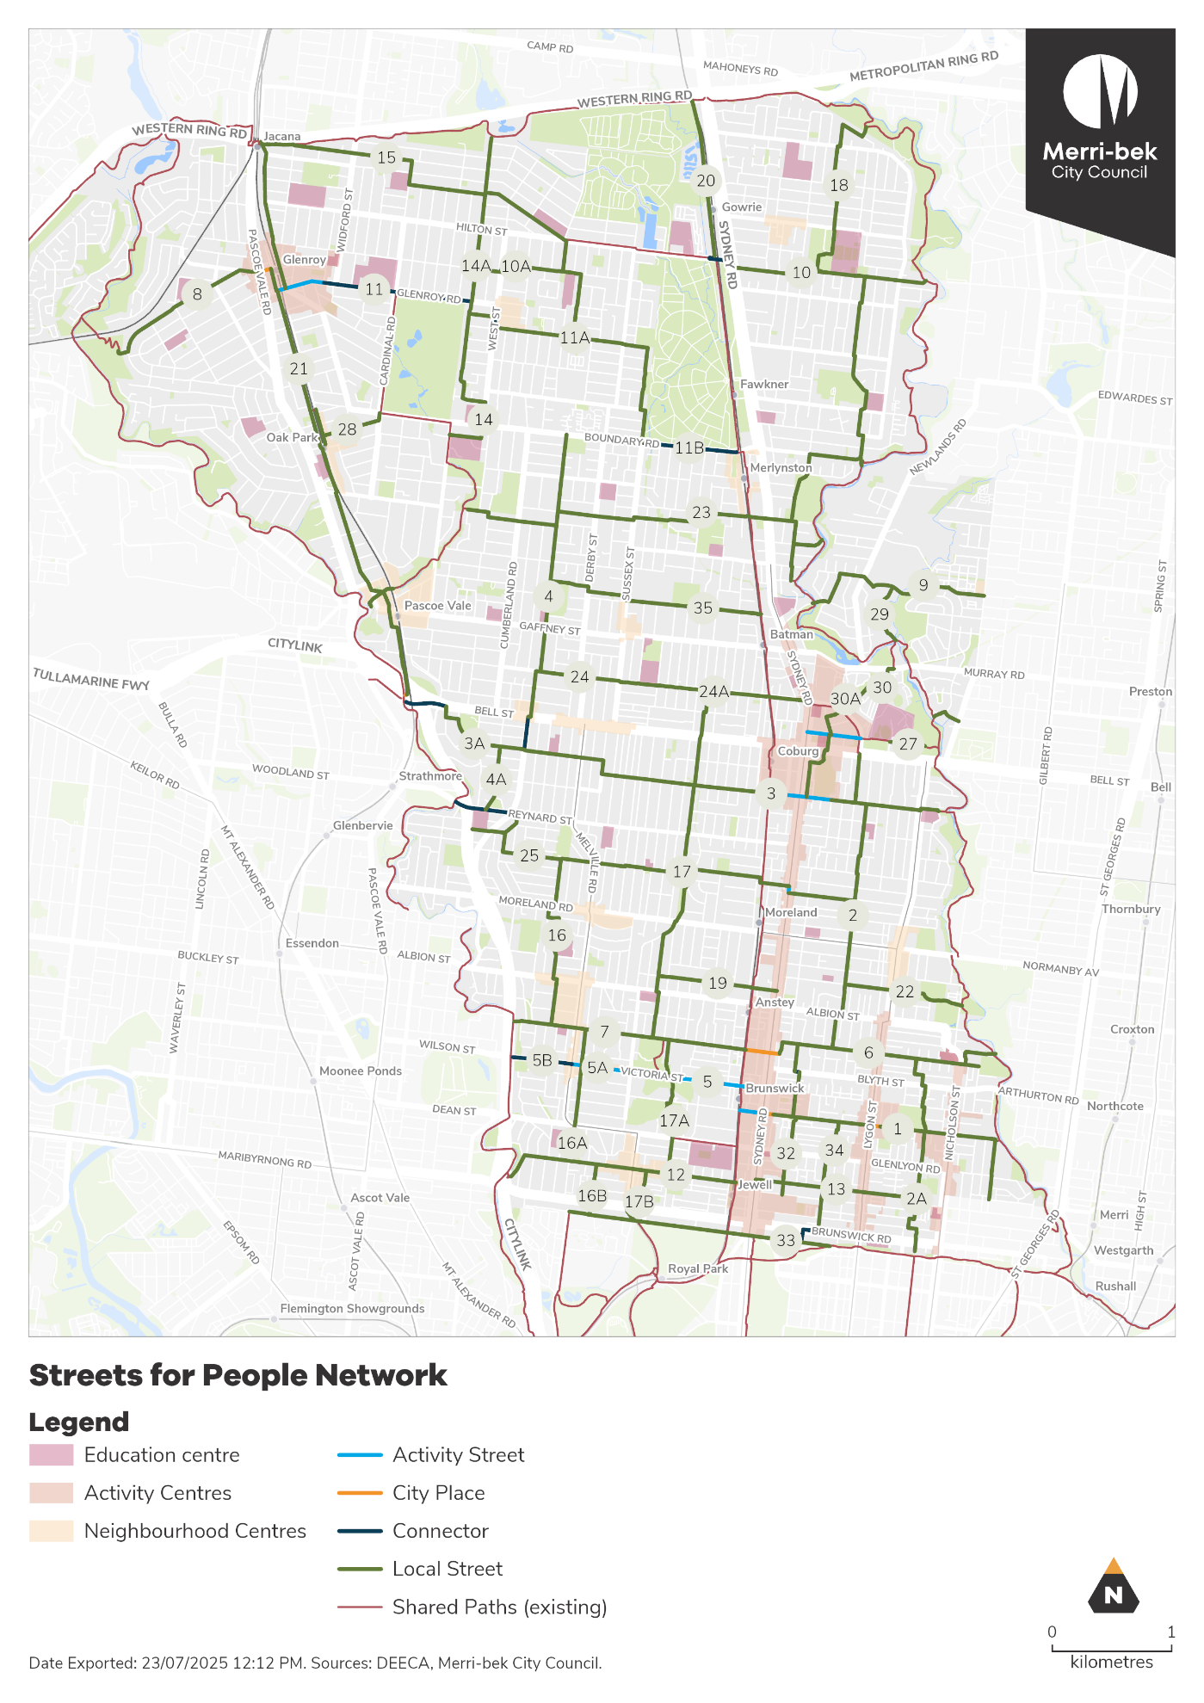
Figure 2 Streets for People network

Table 1 Summary of changes to Streets for People network
Street | Suburb | SfP# | Change and Rationale
Minnie Street | Brunswick | 32A | Add Minnie Street and north section of Ewing Street, to support Ewing St as SfP corridor, and
North Street | Hadfield | 10A | North St between Regent St and Valencia St as a more direct option between Fawkner and Glenroy, comparted to Everard St. Provided as alternative option to Hilton St due to feasibility concerns.
Goff Street | Coburg | 27 | Forms part of a Strategic Cycling Corridor, and connection into Darebin. Improves connections from Preston to Coburg, and Coburg High School.
Elm Grove | Coburg | 30 | Updated to include as part of link between Murray Road and Coburg Activity Centre, including Russell St and Elm Grove. Noting Elm Grove is a DTP managed road.
Westbourne Street | Brunswick West | 17 | Recommend re-aligning the 'Brunswick West Shimmy Route' between Hope St and Albion St to Westbourne St to run along the primary school, with potential for better signal location at Albion St.
Tanderum Drive | Coburg | 30 | Updated to include as part of link between Murray Road and Coburg Activity Centre, including Russell St and Elm Grove.
Russell Street | Coburg | 30 | Updated to include as part of link between Murray Road and Coburg AC, including Russell St and Elm Grove.
O’Hea Street | Coburg North | 24 | Updated so that O’Hea St between York Ave and Pentridge Blvd all shown as SfP corridor, not just the proposed new section between Sussex St and Irvine St.
Charles Street | Coburg North | 35 | Additional east-west SfP corridor in Coburg North to address large distance between O’Hea St and Shorts Rd.
Parker Reserve | Fawkner | 18 | Include link through Parker Reserve between Keady St and Derby St (Route 18) – in line with Council resolution on Fawkner Transport Study implementation
Curie Avenue | Pascoe Vale South | 28 | Remove section on Rhodes Pde on DTP road and avoid large 5-leg roundabout by re-routing along Curie Ave to Oak Park Station

High priority projects
Table 2 below outlines the projects that have been identified as high priority, that are proposed to be designed and delivered over the next 5 years. Projects have been identified as high priority based on their alignment with time-sensitive projects, such as the level crossing removal project, or due to their strategic importance provided in the ‘rationale’ column of the table.
Table 2 High priority Streets for People projects
Corridor # | Project | Project rationale
2 | Barrow Street, Coburg – Bell Street to Stewart Street | Improve connection to Coburg High School, Merri-bek Primary School, and St Bernards Primary School.  Align with Yarra Valley Water M4 pipeline upgrade on Barrow Street.
6 | Stewart Street, Brunswick – Sydney Road to Merri Creek | Sequence to align with Hope Street project (already in design) to a deliver a ‘Creek to creek’ Streets for People corridor through Brunswick.
8 | Clovelly Avenue, Glenroy West - Glenroy Station to Moonee Ponds Creek | Create a safe connection between Gowanbrae, Moonee Ponds Creek and Glenroy Activity Centre. Improve connection to Glenroy West Primary School (existing Ride and Stride School (Glenroy West Primary)
12 | Union Street, Brunswick – Moonee Ponds Creek to Syndey Road | Align with Level Crossing Removal Project.
2A | John Street, Brunswick East – Albert Street to Capital City Trail | Improve connection to Capital City Trail and major active transport commuter routes, with existing strong demand.
34 | Ewing Street, Brunswick – Glenlyon Road to Brunswick Road | Improve access to Barkly Square, Capital City Trail, Brunswick Primary School and Princes Hill Primary School.
11 | Glenroy Road, Glenroy – Glenroy Station to West Street | Connect to Glenroy College and Glenroy Activity Centre
17 | Shaftsbury Street, Coburg – O’Hea Street to Tinning Street | Improve connection between Streets for People Corridors
10 | Roma Street, Fawkner – Sydney Road to Merri Creek | Identified in Fawkner Transport Study as high priority project
Table 3 below summarised the changes made to the high priority projects following community engagement.
Table 3 Summary of changes to high priority projects
Corridor # | Project | Change | Rationale
2A | John Street, Brunswick East – Albert Street to Capital City Trail | Added | Align with upcoming road renewal and roundabout reconstruction works
34 | Ewing Street, Brunswick – Glenlyon Road to Brunswick Road | Added | Strong community support through community engagement
17 | Shaftsbury Street, Coburg – O’Hea Street to Tinning Street | Added | Strong community support through community engagement
29 | Edgards Creek Trail – Merri Creek to Ronal Street bridge | Moved to planned project | Project is in design in 2025/26 financial year for future years capital works budget
27 | Urquhart Street – Sydney Road to Pentridge Boulevard | Moved to planned projects | Project is in design in 2025/26 financial year for future years capital works budget
30 | Oriley Road, Coburg– Murray Road to Coburg High School | Moved to planned projects | Project is in design in 2025/26 financial year with Edgars Creek Trail project for future years capital works budget

The Streets for People process
The Streets for People Plan includes the recommended process for identifying, designing and delivering Streets for People projects in future. The process exhibited for community engagement has not been significantly altered in the final version of The Plan. The proposed Streets for People process is summarised below in Figure 3. The process was generally well supported through the community engagement phase, with feedback received about speeding up the process, and engagement methods.
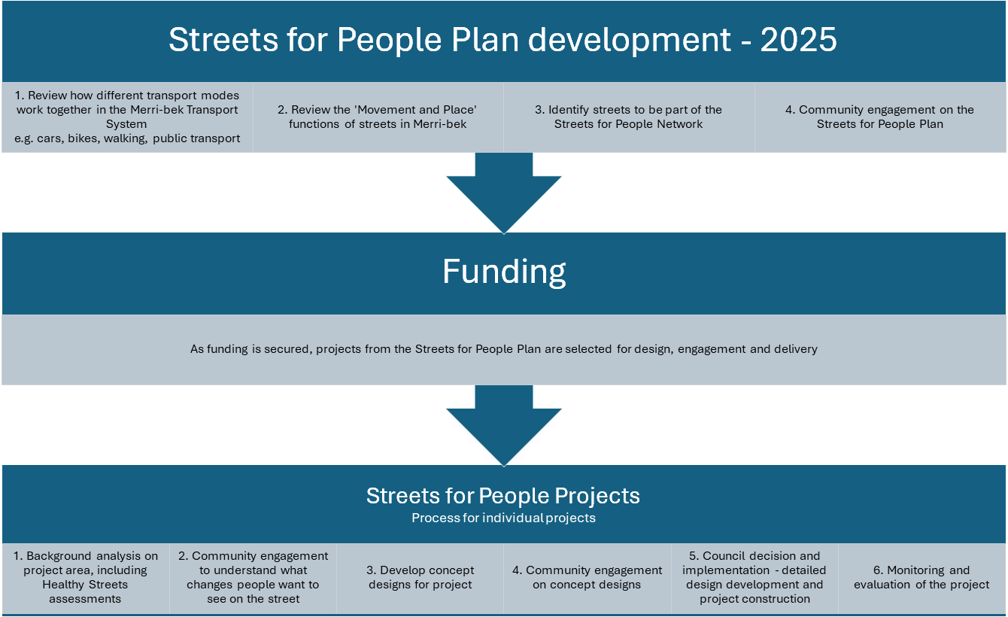
Figure 3 The Streets for People process
It is recommended that the community engagement steps in the Streets for People process supersede previous community engagements on transport projects, such as the Future Bike Lane Project Engagement Process (March 2022). It is important to ensure that we have a clear and consistent approach for community engagement on all Streets for People projects. The process outlined in the Streets for People plan is aligned with Council’s Community Engagement Policy (2024), the community engagement principles of the Local Government Act 2020, and best practice community engagement, and will allow for meaningful engagement on projects in a timely manner. In the process summarised in Figure 3 above, Step 2 – ‘aspirational community engagement’ is only recommended for ‘Corridor’ projects, where the scope and impact of a project is expected to be more significant.

Other changes to the Plan following consultation
There are some other smaller changes to the Streets for People Plan following community and stakeholder consultation. These changes are predominantly about specifying elements to be considered through the design stages.

Access to community infrastructure
Important local destinations and community infrastructure, such as schools, kindergarten, childcare centres, and leisure centres, have been a key focus in identifying the Streets for People network, but not all facilities are located directly on the network. The Streets for People Plan has been updated to ensure that the design of Streets for People corridors considers access to nearby community infrastructure that is not directly on the corridor.
The Community Infrastructure Plan 2022-2032 has been included as a key reference document, and accessibility to community infrastructure by active and sustainable transport modes has been included as a measure for monitoring the Streets for People Plan.

Street lighting and wayfinding
The Streets for People Plan includes examples of the types of design treatments that would be expected on different types of streets. Street lighting is often included with other treatments but has been added as an important design element for healthy and safe streets. A lack of street lighting was identified as a concern by the youth committee in Fawkner, the Older Peoples Reference Group, general survey respondents, as well as through the Gender and Equity Impact Assessment. As such it has been included as a stand-alone typical design treatment for all street type in the Plan.
Wayfinding signage is important on active transport routes, and was included in the draft Streets for People Plan. The Plan has been updated to ensure that new wayfinding signage includes opportunities for Wurundjeri Woi Wurrung knowledge sharing where appropriate.

Naming new assets
While the implementation of the Streets for People Plan is not expected to result in significant amounts of new streets or places that need naming, the Plan has been updated to ensure that new assets are named in accordance with the Naming Merri-bek Places Policy (2013), and takes into consideration Aboriginal names where appropriate, based on input from Wurundjeri Woi Wurrung elders.

Common suggestions that were not included in the final plan
All feedback about the project received through the community engagement activities and processes has been considered. However, not all suggestions for updates to the Streets for People Plan have been incorporated into the final plan. Table 4 below provides an overview of some of the most common suggestions received that have not resulted in changes to the plan, and the rationale for them not being incorporated.
Table 4 Summary of suggestions for updates not incorporated into the plan
Street | Suburb | Suggestion | Rationale
Albion Street | Brunswick, Brunswick West | Include as a SfP corridor and high priority | Significant feasibility concerns to appropriate improvements. Traffic cannot be reduced or rerouted, due to bus route. Officers will recommend other road safety improvements, such as speed limit reductions and more traffic management devices. Hope Street and Stewart Street therefore the preferred east-west option in this area, and should be made to be the primary active transport link.
Glenlyon Road | Brunswick | Include as a SfP corridor | Feasibility investigations into making Glenlyon Road a SfP corridor indicate that required improvements would be unviable. Albert Street is recommended as the preferred east-west SfP corridor and active transport link in this area.
Murray Road | Pascoe Vale, Coburg | Include as a SfP corridor | Managed by DTP. Council to advocate for improvements.
Sydney Road | Brunswick | Include as a SfP corridor | Managed by DTP. Council will continue to advocate for accessible tram stops along the corridor, which has potential for significant streetscape improvements to make the street more people focused.
Lygon Street | Brunswick East | Include as a SfP corridor | Significant constraints, including the need for accessible tram stops and multiple stakeholders, makes Lygon Street unviable as a SfP corridor currently. The required works to develop a masterplan and deliver streetscape improvements for Lygon Street goes beyond the scope of a SfP project.
Derby Street | Pascoe Vale | Include as a SfP corridor instead of Landells Road | Derby Street, along with Sussex St and Cumberland Road, plays an important north-south traffic function through Pascoe Vale. To deliver SfP improvements would cause significant impacts to traffic function, and residential on-street parking in the area. Landells Road is preferred as the north-south SfP corridor in the area, as improvements can be less cost-intensive, with minimal impact to parking in the area. It is noted that officers do not expect that protected bike lanes would form part of the design treatments for Landells Road.
De Carle Street | Brunswick, Coburg | Include as a SfP corridor | Council decision in April 2025 not to deliver protected bike lanes, and instead focus improvement efforts on Barrow Street as the preferred north-south SfP corridor in the area.
Grantham Street | Brunswick West | Include as a SfP corridor | Managed by DTP. Council to advocate for accessible tram stops which could potentially have significant streetscape improvement opportunities.
Breese Street and Ovens Street | Brunswick | Include as a SfP corridor | Does not meet the ‘connectivity’ criteria in the SfP Plan. However, existing design project for Breese Street precinct is underway, utilising the SfP Framework.
Boundary Road | Coburg North | Include as a SfP corridor | Managed by DTP. Council to continue to advocate for improvements for people walking and riding.

Advocacy
The Streets for People Plan will impact some of Council’s advocacy priorities to the state government in relation to transport. The main advocacy actions related to the Streets for People Plan are:
• Elm Grove and Urquhart Street: Identified as a Streets for People corridor but currently managed by DTP. Advocacy will be required to get DTP to make changes to these streets, or for Council to take control of managing them.
• Boundary Road: Small sections of Boundary Road are identified on the Streets for People network. Improving this section will require investment from DTP and collaboration with the Fawkner Cemetery. Council has previously advocated for safer bicycle infrastructure on Boundary Road, Pascoe Street, and Rhodes Parade, and these efforts should continue.
• New or upgraded traffic signals: Making improvements to crossings of busy roads will be a key focus of Streets for People projects. As many of the busier roads are managed by DTP, advocacy will be required to work with DTP to install and upgrade traffic signals. Officers are currently working with a consultant on a report that will make recommendations on how best to work with DTP to improve signalised intersections for people walking, and where new signals are needed on DTP managed roads, which was an action of the Moving Around Merri-bek Action Plan 2024-25. This report well help Council to have a consistent approach for advocacy for new and upgraded traffic signals, but advocacy will occur on a project-by-project basis.
• Small scale bus network reforms: Through thorough investigation of streets on the Streets for People network, some recommendations may arise for small scale reforms to the bus network. These reforms will complement Council’s existing advocacy position on broader bus reform for Melbourne’s northern region and will be done on a project-by-project basis.
• Craigieburn Line Shared Path: It is recommended that Council, together with Whittlesea City Council, advocate for state government support to deliver the Craigieburn Line shared path from the Moonee Valley Creek to Broadmeadows, rather than Council delivering the project in small, disconnected pieces.

Open space opportunities and road closures – “Turning Roads into Parks”
One of the typical design treatments identified in The Plan that would be suitable for Local Streets and City Places is road closures (or “modal filters”). These treatments seek to limit through vehicle traffic on local streets, whilst maintaining access for local residents and people walking and riding. They are a cost-effective way to significantly improve safety and amenity for all road users on local streets.
On 11 December 2024, Council resolved to receive a report outlining how road space could be reallocated to create new parks and open space to reach open space targets and support the Park Close to Home project. A key tenet of the Streets for People Plan is aiming for more holistic and integrated outcomes through transport projects. As such, officers, have looked at where there is overlap between the proposed Streets for People network and gaps in access to open space across the municipality.
Officers have undertaken some investigation and mapping to highlight potential opportunities where multiple Council objectives could be achieved through a strategic road closure to complement a Park Close to Home project. The mapping is shown in Figure 4 below. Whilst specific areas of the network were identified as higher priority opportunities, it is noted that interventions nearby to these areas would also see the co-benefits realised. This mapping is intended to help inform decision making, and not necessarily to be used as to suggest specific locations for road closures to accommodate new open spaces. It is also noted that the ‘open space gap analysis’ mapping is due to be updated, so the areas identified as priority areas may change.
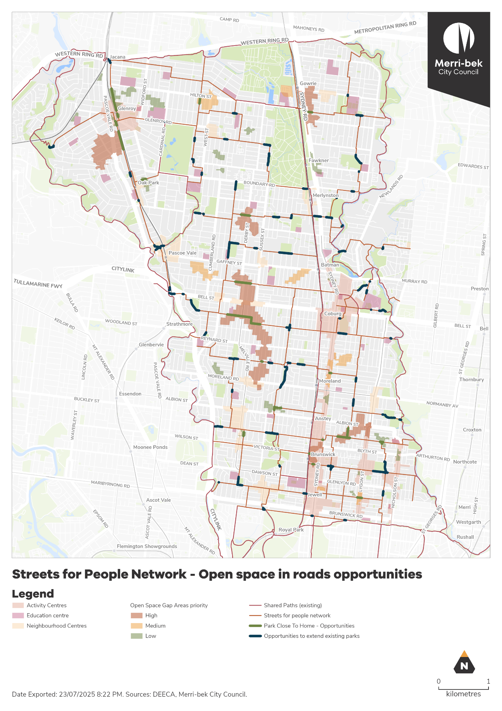
Figure 4 Opportunities for new open spaces in road reserves on the Streets for People network.
Converting road space into parks is not uncommon. An example in Merri-bek is at Victoria Street and Bellevue Street Coburg, where road was closed to create a local park. Similarly, the State Government plans to convert the existing road closure at The Avenue and De Carle Street in Coburg into additional parkland as part of the old TAFE site redevelopment. Officers will continue to work together to identify appropriate opportunities, and to strategically locate them so that multiple benefits can be achieved.

Community impact
The Streets for People Plan proposes changes to the way some streets operate in Merri-bek to make walking and riding safer and more attractive. This may result in changes to the way people use a given street. The Plan shows the streets we will consider for changes in the future and our approach to working with the community on each street. The ‘process’ section of the Plan details the steps we will take to work with the community to develop plans for a given street. This is done to ensure that changes to the street make the street safer and more attractive for people who walk and ride along the street and that the amenity for businesses and residents on that street are improved as well.

Climate emergency and environmental sustainability implications
Transport emissions are the second largest source of emissions in Victoria and are set to become the largest source in the coming years.
Reducing transport emissions and the effects of climate change is a key focus of the transport strategy. Council aims to reduce transport emissions by providing infrastructure that enables people to use zero emission transport modes such as walking and cycling, by supporting our community to switch to electric vehicles, by advocating to the State Government for improvements to public transport infrastructure and services, and by supporting increased densities in activity centres and around transport hubs.
Delivering on a connected network of walking and cycling corridors, as outlined in the Streets for People Plan, will provide opportunities for more people to choose low and zero emission transport modes for their local trips and support community efforts to reduce their transport emissions.

Economic sustainability implications
The Streets for People Plan details Merri-bek’s approach to enhancing the liveability and accessibility of activity centres and local destinations. This is reflected in the application of Movement and Place and the Healthy Streets approach to selecting projects and the strategic objectives that inform the design process. The Streets for People Plan will therefore improve accessibility and patronage of local businesses by enhancing the safety, comfort and amenity of local trips that support the local economy.

Human Rights consideration
The implications of this report have been assessed in accordance with the requirements of the Charter of Human Rights and Responsibilities, and the assessment has found that none of the 12 rights outlined in the Charter of Human Rights will be adversely impacted by the Streets for People Plan. The Plan will contribute toward the right to freedom of movement (section 12), by creating safer and more liveable streets for people to comfortably move around Merri-bek.
The Transport Team undertook thorough community engagement with a broad spectrum of the community, including older people, younger people, culturally and linguistically diverse people, and people with disabilities, to ensure that the Streets for People Plan would not infringe on any person’s rights.

Gender and equity impact assessment
Under the Gender Equality Act 2020 Council has a duty to promote gender equality in new or revised policies/ programs and services with a direct and significant impact on the community. The tool that we are asked to use are gender impact assessments and the Act requires us to demonstrate how our recommendations and actions will:
• meet the needs of people of different genders
• address gender inequality, and
• promote gender equality.
A Gender and Equity Impact Assessment has been undertaken for the Streets for People Plan. A gender lens has been applied to the development of the Plan and will be applied to all Streets for People projects, and the Assessment will be provided to the Human Rights Commission at the next submission date. The ways The Plan has been shaped by the Gender and Equity Impact Assessment were:
• applying a gender lens to the proposed typical street design elements for each street type, ensuring new infrastructure will meet the needs of people of all genders,
• including street lighting as a design element for all street types,
• and specifically ensuring that priority groups that may be underrepresented in general community engagement activities and are expected to be impacted by Streets for People projects are targeted for feedback through consultation on individual projects

4. Community consultation and engagement

Community and stakeholder engagement process
A seven week period of community engagement was held, where the draft Streets for People Plan was exhibited for public feedback from 28 March until 18 May 2025. The purpose of this round of community and stakeholder engagement was to understand community perceptions of the draft Streets for People Plan and to identify potential changes to be incorporated in the final plan. This was done to ensure the plan best meets the needs of the Merri-bek community.
Specifically feedback was sought on:
1. The proposed network of Streets for People corridors
2. The identified high-priority projects
3. The proposed design process for Streets for People projects
Feedback was primarily gathered through an online survey hosted on the Conversations Merri-bek Platform. General drop-in sessions were held in Glenroy, Coburg North, and Brunswick, to give people an opportunity to provide feedback face-to-face.
Officers also attended a number of community reference groups and advisory committees, including the Older Persons Reference Group, the Sustainable Transport Advisory Committee, a youth committee in Fawkner, and the Merri-bek Community Connectors group.
Key stakeholders such as the Department of Transport and Planning, all neighbouring councils, all schools in Merri-bek, and the Merri-bek Bicycle Users Group were notified and invited to provide feedback.

Who we heard from and what we heard
We received 165 survey responses, spoke to approximately 70 people at the pop-up engagement events, received four group submissions, and received nine feedback emails from individuals.
Of the survey respondents, 50 per cent reported to be a woman or a girl, two per cent stated they were non-binary, and 42 per cent reported to be a man or a boy. There was a relatively representative age distribution amongst survey respondents, however people under 25 were underrepresented. Brunswick (32 per cent), Coburg (19 per cent), and Brunswick West (13 per cent) were the most common suburbs where respondents lived, with feedback from people from all Merri-bek suburbs, except Gowanbrae.
A wide range of suggestions and feedback were received. Some of the highlights and most common suggestions were:
• Support for Union Street, Brunswick as a high priority project
• Support for Shaftsbury Street, Coburg as a corridor and suggestion that it be made a high priority
• Suggestion that Derby Street, Pascoe Vale South, be considered as a corridor instead of Landells Street
• Suggestion that Albion Street, Brunswick and Brunswick West be included as a Streets for People corridor
• General support for the proposed Streets for People design and engagement process
• Suggestion that project design and delivery should be done faster
More detailed analysis of the results can be found in the Community and Stakeholder Engagement Report (Attachment 2).

Affected persons rights and interests
Before making a decision that affects a person’s rights, Council must identify whose rights may be directly affected and provide an opportunity for that person (or persons) to convey those views regarding the effect on their rights and consider those views.
The Streets for People Plan has an impact on the way people move around Merri-bek. As such, the draft Plan was publicly exhibited for community feedback for a period of 7 weeks, to allow all potential affected community members an opportunity to provide input. Demographic groups in the community who are often underrepresented in online surveys were targeted, such as older people, younger people, and culturally and linguistically diverse members of the community.

Communications
A communications plan was developed and delivered to notify community members of the Streets for People Plan and invite them to provide their feedback. The main communication methods were:
• Emails sent to 4,746 people who have registered interest in Merri-bek transport projects
• An article in Merri-bek Community News, which was delivered to all Merri-bek households
• An article in My Merri-bek e-newsletter
• English language posters and fliers displayed at key Council facilities, including Neighbourhood Houses
• Translated posters and fliers displayed at key Council facilities, including Neighbourhood Houses in Italian, Arabic, Greek, Turkish and Simplified Chinese
• Targeted social media advertising campaign on Facebook and Instagram to Merri-bek community members
• Targeted translated social media advertising campaign in Italian, Arabic, Greek, Turkish and Simplified Chinese
• Distribution of translated Streets for People Plan summary document and survey through Merri-bek Connectors program

5. Officer declaration of Conflict of Interest
Council officers involved in the preparation of this report have no conflict of interest in this matter.

6. Financial and resources implications
The recommendations of this report can be carried out with the existing budget and resourcing allocated in the 2025-26 Council Budget. However, the implementation of the Streets for People Plan will be on ongoing process including significant and varied capital works. Therefore, these recommendations will affect future council budgets in that the Streets for People Plan will guide where budget for transport infrastructure is allocated.
For 2025-26, there is currently $80,000 allocated for design of ‘Streets for People Priority Projects’. It is intended that this funding be used to undertake concept design and community engagement on one or two of the high priority projects.
Council funding decisions about individual projects will be made in the context of the Council Budget. Officers will seek external funding opportunities to supplement Council budgets.
Should Council wish to pursue a faster implementation of the Streets for People Plan and more significant change to Merri-bek streetscapes in future years, additional internal resourcing will be required, as well as additional funding for capital works delivery.

7. Implementation
Subject to Council’s decision, implementation of the strategy can commence immediately. Implementing the strategy is a long-term and ongoing process. The implementation steps that will be taken in the 2025/26 financial year are as follows:
1. Officers to notify respondents to the survey of the Council decision and of any changes to the Plan following consultation via the Conversations Merri-bek website.
2. Finalised documents to be uploaded to Council’s corporate website and Conversations Merri-bek webpage.
3. Officers will begin the design process for at least one of the high priority projects, beginning with Barrow Street, Coburg (Bell Street to Stewart Street).
4. Officers to work with relevant stakeholders on the recommended advocacy actions.

Attachment/s
1 | Streets for People Plan - Report | D25/385912

7.2 Shared E-Bike Scheme For Merri-bek (Update)
Director Place and Environment, Pene Winslade
City Design and Economy

Officer Recommendation
That Council:
1. Notes the results of community engagement related to a shared e-bike scheme.
2. Delegates authority to the CEO to finalise and sign a multi-council Memorandum of Understanding for selecting shared e-bike operator(s).
3. Receives a report for a decision to allow a shared scheme in Merri-bek once the outcome of the joint procurement proceedings is known.

REPORT

Executive summary
Shared mobility schemes in Melbourne have continued to develop since commencing in December 2020. Recent developments have seen e-scooter operations exit the City of Yarra. Since the removal of scooters in City of Melbourne, and now Yarra, the City of Port Phillip is the only Melbourne council with e-scooters remaining in their municipality. Shared e-bikes continue to operate in the Cities of Melbourne, Yarra, Port Phillip, and Stonnington.
Officers undertook five weeks of community consultation (including six weekends) on the proposed approach to bringing shared e-bikes to Merri-bek. Community engagement included a Conversations Merri-bek webpage, an online survey and pin point map, social media campaign, stakeholder discussions, and two face-to-face sessions. The page received 3,382 views and there were 135 survey responses received during the engagement period. Overall, respondents supported the introduction of a shared e-bike scheme and were overwhelmingly supportive of a designated parking zone approach.
In June 2024, a Shared Mobility Stakeholder Panel was established with members made up from community groups, Trader’s Associations, Council’s existing reference groups and advisory committees. The panel has met monthly or bi-monthly to provide officers feedback on the proposed approach and design for shared mobility in Merri-bek.
Officers have continued to participate in a joint council working group with representatives from Cities of Port Phillip, Melbourne, Yarra, Darebin, Stonnington, and Merri-bek. This will continue through the remainder of the year, led by Port Phillip staff who will draft the joint procurement and contract documents.
The joint procurement process will need to broadly align each council’s governance and procurement timelines. A Memorandum of Understanding (MOU) is being developed that will seek to align procurement processes without binding Council to enter into any contractual agreement with the selected operator(s). It is hoped that a new agreement between one or more of the prospective councils and a selected operator(s) will be in place before the end of 2025. Once this is in place, officers will return to Council with a recommended proposal for endorsement.
Previous Council decisions
Shared E-Bike and E-Scooter Community Engagement Approach – 12 February 2025
That Council:
1. Notes current trends in shared mobility (e-bikes and e-scooters) and the changing policy landscape in neighbouring local government areas.
2. Endorses wider community consultation including options for "other comments" to enable broad observations to be conveyed as well as the parking approach and proposed staged rollout of shared mobility to occur in May 2025 with the following amendments:
a) A drop-in session to be held in Coburg as well as Brunswick, with flexibility for additional sessions if the weather restricts attendance.
b) The consultation to extend for 5 weeks and 6 weekends (from 25 April to 1 June).
c) Should the project progress to stage 2 or 3, that consultation and drop in sessions be held in Glenroy and Fawkner.
3. Extends the period for a further report to Council to August 2025 instead of April 2025 for a decision on enabling a shared mobility scheme that considers the feedback obtained during the community consultation and with specific other stakeholder groups.
Shared e-bike and e-scooter (e-scooters) Update - June 2024
That Council:
1. Approves in principle Merri-bek’s participation in the development of an inter-council shared e-bike and e-scooter procurement process, in order to influence the form of future Agreements, but noting that participation does not tie Merri-bek to signing any Agreement.
2. Expresses its strong preference for any further e-scooter scheme in Merri-bek to adopt a designated parking approach, that restricts shared e-bike and e-scooter parking to specific locations and considers options for compliance and enforcement
3. Establishes a Stakeholder Reference Group on Shared e-bike and e-scooter made up of suitable representatives from the community including community groups, Council’s current reference groups and Advisory Committees to first meet within 3 months and continue until any operator has been in place for 12 months or a Council decision is made not to participate
4. Seeks a report to Council in February 2025 seeking endorsement to consult on a draft Framework for shared e-bike and e-scooter in Merri-bek that benefits from Stakeholder Reference Group input as well as inviting expert advice from Vision Australia, formal advocacy groups for aged and disability access and risk experts, to come back for final adoption
5. Seeks a report to Council in April 2025 for a decision on enabling a shared e-bike and e-scooter trial, with a designated parking approach that restricts parking to specific locations so that shared e-bike and e-scooter devices do not impact pedestrian accessibility consistent with the intent of the Framework for shared e-bike and e-scooter in Merri-bek.
6. Notes that there are both expenditure and revenue implications from pursuing shared e-bike and e-scooter schemes, with required staffing resources expected to be offset through the collection of fees from operators, and
7. Refers the initial resource need of $78,397 to the final 2024/25 Budget.
Electric Scooter Trial in Moreland – 12 May 2021
That Council:
1. Notes its former resolution (NOM66/19) to request the State Government facilitate the safe and legal use of electric scooters on roads and bike lanes, and to receive a report on the merits of a Council-led trial of e-scooters in Moreland following the conclusion of a trial that was to occur in the City of Port Phillip.
2. Notes that no trial of e-scooters has occurred in the City of Port Phillip to date, and that the State Government has invited Council to submit an expression of interest to participate in a trial of e-scooters to occur in two metropolitan and one regional local government areas.
3. Approves an expression of interest to be made for Council seeking to participate in the State Government trial of e-scooters.
4. Subject to Moreland being selected as trial area by the State Government, receives a further report prior to commencing a trial and partnering with an e-scooter provider, including the considerations for a further report as detailed in NOM66/19.
5. Notes that if Council is not successful in being selected for the trial, that the report required in NOM66/19 will be expanded to include the results for this broader trial (when available) noting the trail is anticipated to be in place for 12 months commencing in the Spring of 2021.
Notice of Motion - Electric Scooters - Updating the Regulatory Framework – 11 December 2019

That Council:
1. Writes to the Secretary of the Department of Transport Paul Younis and the Minister for Roads and Road Safety Hon. Jaala Pulford MP seeking a review of the regulatory framework for electric scooters to ensure the public can travel on electric scooters on roads and bike lanes legally.
2. Receives a report assessing the merits of conducting a Council-led trial of electric scooters in the City of Moreland with particular reference to:
a) Geographically defined areas of the City of Moreland to conduct any such trial where the benefits of micro-mobility are best able to be assessed;
b) Parameters of an open and competitive Expression of Interest process to award a permit to electric scooter operators for any such trial;
c) Numbers of permits to issue to operators for any such trial, with reference to comparable trials proposed or underway;
d) The duration of any such trial;
e) A sufficient number of electric scooters to be deployed in the City of Moreland to allow for Council officers to sufficiently assess the potential benefits of micro-mobility across the totality of the municipality; and
f) Consideration to the trial of electric scooters in the City of Port Phillip.
g) safety aspects and impacts e-scooters have for all users on footpaths, particularly more vulnerable users such as older people, people living with disabilities and children.
h) speed limits for electric scooters on shared paths
3. Council receives the report work once the City of Port Phillip trial of electric scooters is completed and available to utilise and build upon.

1. Policy context

Moving Around Merri-bek 2024
The Moving Around Merri-bek Strategy was adopted in March 2024. The Strategy seeks to ensure all actions impacting the councils transport network contribute to objectives aligned to the values of Safe, Accessible, Sustainable, Healthy, Liveable, and Inclusive.
Moving Around Merri-bek supports the future provision of shared e-bike and e-scooter services, stating that “We will undertake a feasibility study to determine whether shared e-bike and e-scooter is suitable for Merri-bek, and what policies may be needed to reduce footpath parking and riding by users.”
The Moving Around Merri-bek Action Plan states that potentially by August 2024, Council will have “determined its position on allowing e scooter hire schemes in Merri-bek, following the completion of the State Government trial in April 2024” and “as applicable, progressed implementation of e scooter hire schemes in Merri-bek.”

Zero Carbon Merri-bek
Zero Carbon Merri-bek outlines Council’s framework for reducing our emissions. It has three pillars:
• Efficient and 100% renewably powered energy
• Active and zero emissions transport
• Circular economy with zero waste
Shared e-bike and e-scooter services align with the second pillar of Zero Carbon Merri-bek. Surveys conducted by operators have found that around 28 per cent of e-scooter trips in metropolitan areas and up to 40 per cent of trips in Ballarat replaced a vehicle trip on the riders’ most recent e-scooter ride.

Council Plan 2021-2025
The Council Plan sets out Council’s and community’s vision for the future. Key objectives and strategies related to this report include:
2. To contribute to the health, safety, and security of everyone living in our diverse community and to increase safe, accessible, physically active and enjoyable ways to get around Merri-bek, especially via walking, cycling and public transport.
• 2.1. Build safe, accessible, and high-quality bike and pedestrian infrastructure to create links between areas of high pedestrian and cycling demand, especially the Coburg to Glenroy bike path.
• 2.5. Facilitate substantially increased use of active transport in the community through targeted programs which include a focus on children, young people, families and older people.
• 2.6. Collaborate with the community to improve pedestrian and cycling infrastructure on a case-by-case basis.

2. Background
In February Council endorsed the development of a framework to enable a shared mobility scheme in Merri-bek, and a five week community engagement. Previous Council decisions in June 2024 approved Merri-bek’s participation in the development of an inter-council shared mobility (e-bike and e-scooter) procurement process, however noting that participation does not tie Merri-bek to signing any agreement. The inter-council working group is comprised of representatives from the Cities of Melbourne, Yarra, Darebin, Port Phillip, Stonnington, and Merri-bek.
Discussions with officers from other councils on a potential joint procurement are ongoing and advice on the structure of a multi-council contract has been provided to all councils by Maddocks. The proposed arrangement would see all the prospective councils signing an MOU before agreeing on an operator (or operators) and entering into the agreement with bespoke schedules relevant to their own municipalities.
The February 2025 decision sought an update report at the August 2025 meeting. Some further time is needed to confirm the position of neighbouring councils, most notably the Cities of Melbourne and Yarra. Currently, it is anticipated that one or more of the prospective councils will have an agreement in place by December 2025.
Officers will continue working with other prospective councils to provide further detail of what fees and costs can be expected for a shared e-bike scheme in Merri-bek, once the new agreement with operators is known.

Stakeholder panel
In June 2024 Council resolved to establish a shared e-bike and e-scooter Stakeholder Panel made up of suitable representatives from the community including community groups, Council’s current reference groups and advisory committees.
Panel meetings have occurred on a monthly or bi-monthly basis as required. Should shared e-bike services be endorsed, panel meetings would continue for up to twelve months following commencement of operations, to work through emergent issues.
The Panel includes:
• A walking advocate
• A representative from Merri-bek BUG
• A representative from Walk-on Merri-bek
• Sydney Road Trader Association representatives
• A representative from the Age Friendly Reference Group
• A representative from the Disability Reference Group (who is vision-impaired)
• A representative from the Human Rights Advisory Committee (who also lives with disability)

3. Issues

Key concern: parking
There is significant concern within the Shared Mobility Stakeholder Panel that the introduction of shared e-bikes could reduce footpath accessibility and safety, via errant parking. There is strong support within the group for shared e-bike parking to use on-street parking bays exclusively, to mitigate this risk.
Other council areas initially used a ‘free-floating’ strategy where shared e-bikes and e-scooters can generally park on any footpath, within the street furniture zone. This approach does not prevent errant parking and may also lead to illegal footpath riding incidents, as shared e-bike users start and finish their trip by transitioning from the road to the footpath to find a suitable parking location.
As shared scheme operations have evolved, Councils and operators have begun deploying shared e-bike and e-scooter parking bays (see Figure 1) on footpaths with sufficient space by using geo-fencing, line marking and Bluetooth beacons to delineate shared e-bike and e-scooter parking areas. This has reduced parking issues with reports of increased compliance with parking controls.
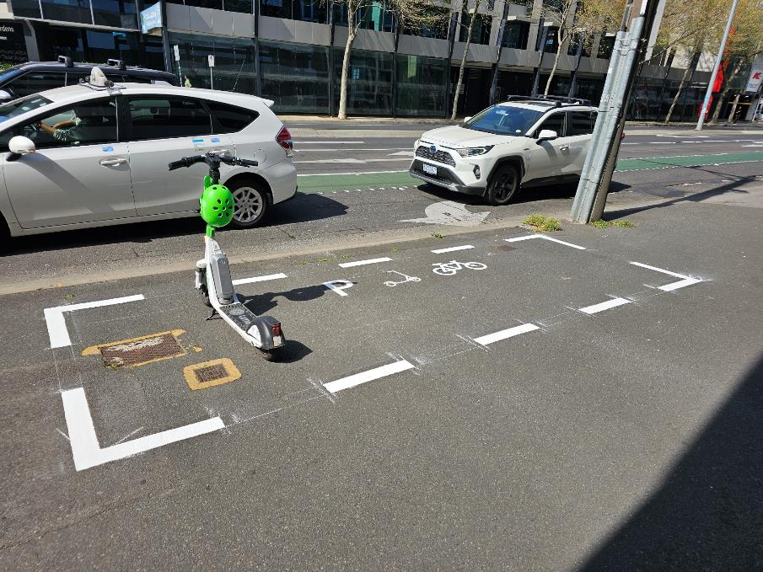
Figure 1 Footpath parking bay in the City of Yarra (Source: Yarra City Council)
Figure 2 is a digital mock-up of a potential footpath parking bay in Merri-bek, using space that is clear of the footpath and road.
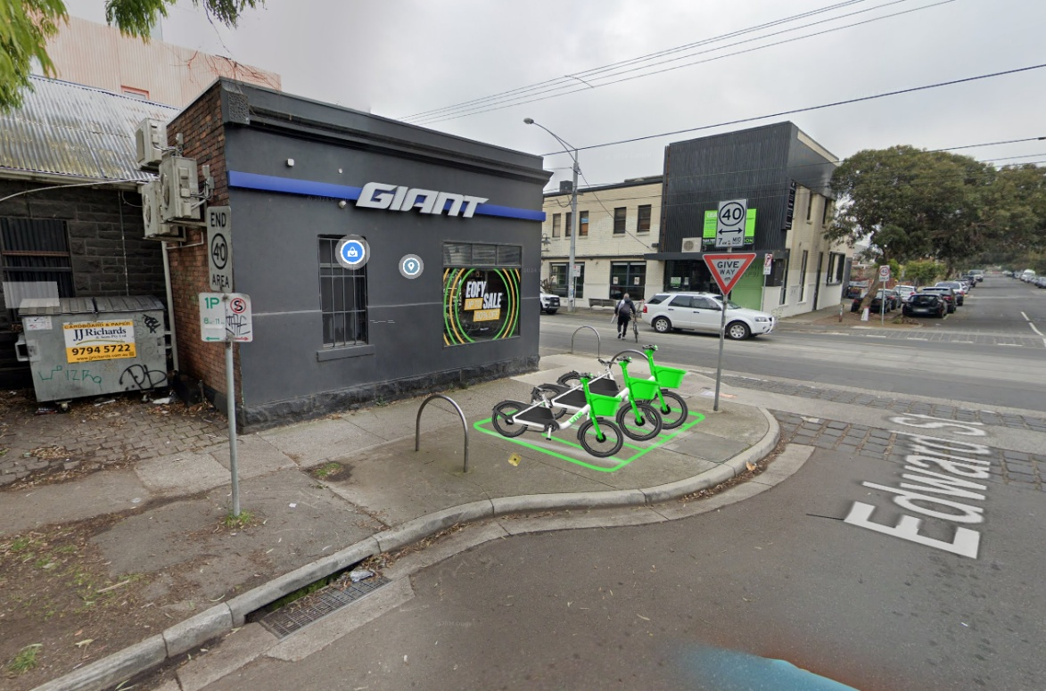
Figure 2 A digital illustration of a prospective footpath parking bay on Edward St, Brunswick East using high-visibility line marking and Bluetooth beacons
The approach largely favoured by the panel is the conversion of road space for shared e-bike parking (Figure 3).
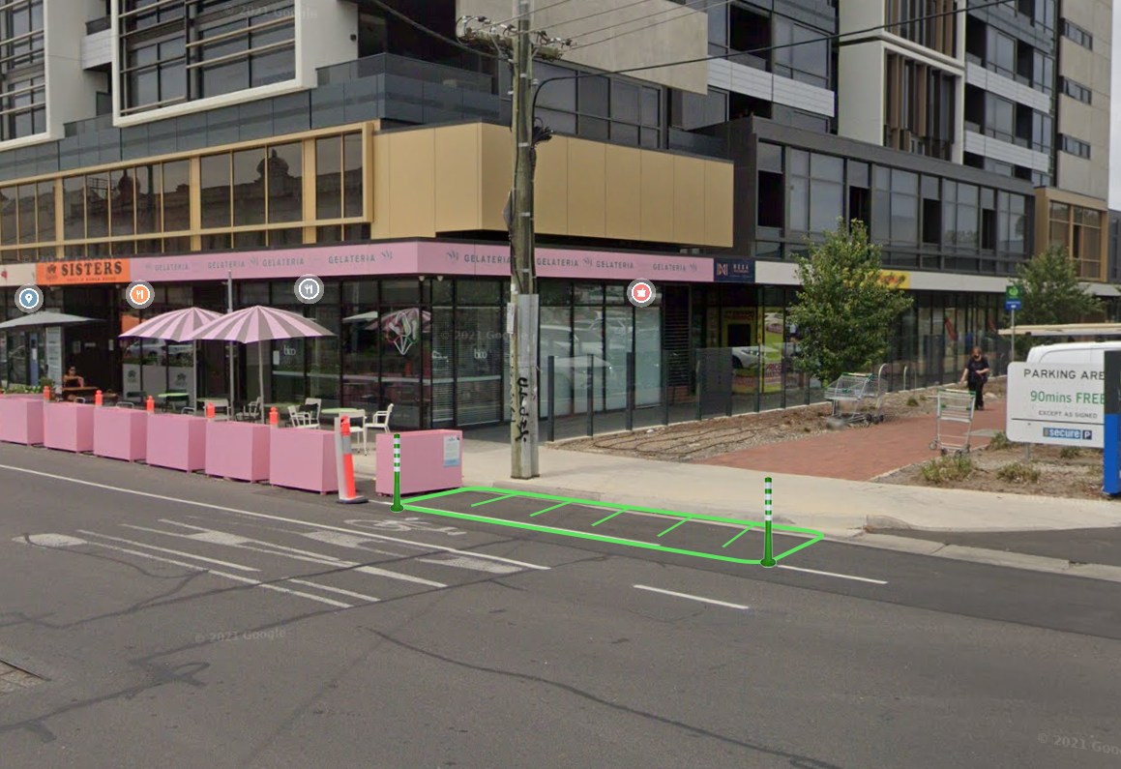
Figure 3 Digital illustration of on-street parking bay with line marking and flexible bollards
The proposed designated parking approach for Merri-bek would predominantly focus on providing dedicated on-street parking bays, particularly in activity centres. These bays would use a combination of line marking, bike hoops, bluetooth beacons, and signage in addition to geo-fencing to restrict bike parking to the provided bays.
Virtual parking pins (Figure 4) are the third type of dedicated parking that will be utilised in addition to physically marked parking bays installed both within the roadway and on footpaths. Virtual parking pins have zero cost to implement and allows Council to quickly respond to changing demand, such as when an event may be taking place.
Virtual parking bays are recommended in quieter parts of the municipality in off-street locations such as nature strips or open space areas where parked bikes will not impact on footpath access.
A summary of the parking options is shown in Table 1.
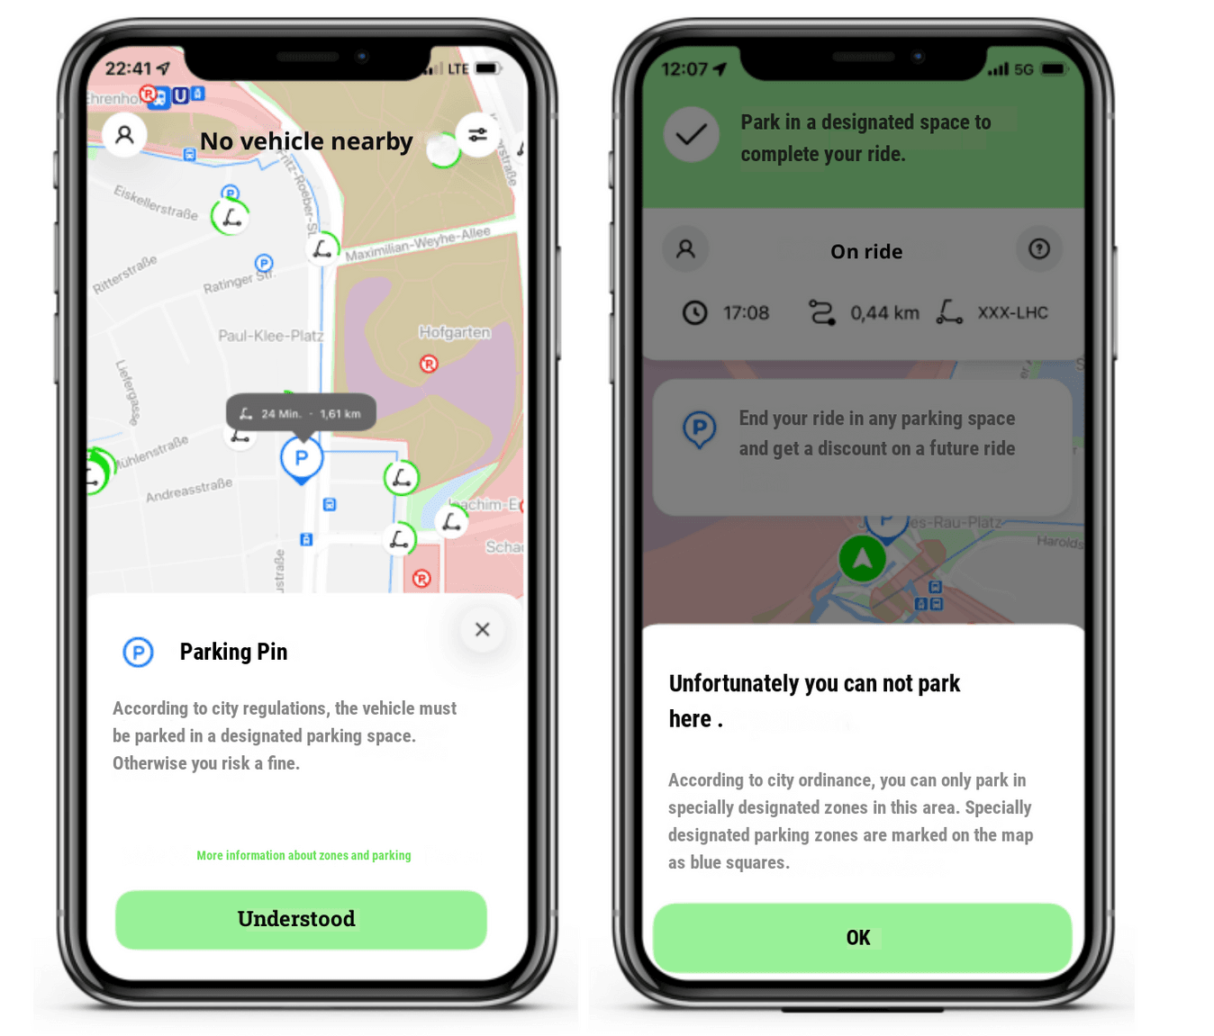
Figure 4 Virtual Parking Pin on Lime's platform (Source: Lime Micromobility)
Table 1 Shared e-bike parking typology
Parking type | Benefits | Where it is appropriate
On-footpath parking bay  (Figure 2) | Provides dedicated space without reallocating on-street car parking | Where sufficient footpath width is available  Adjacent to key civic destinations (leisure centres, libraries, railway stations)
On-street parking bay  (Figure 3) | Keeps bikes and scooters from cluttering the footpath  Encourages riders to ride on the road or bike path. | Streets with limited footpath space  Activity centres
Parking pin  (Figure 4) | Allows council and operators to quickly respond to changing parking demand  Zero cost to implement | Nature strip, open space, Where sufficient footpath width is available  In quieter parts of the municipality  During events

Operation zones (staged rollout)
Operational zones are the boundaries where shared e-bike and e-scooter devices can operate. Devices stop working when they pass a boundary and riders are notified to return the device back within the operating zone.
A staged rollout is proposed. It allows council and operators to mitigate issues or concerns whilst the scheme is at a smaller scale before expanding the available service area. User demand and movement patterns will emerge over time and provide council with insights that will inform the rollout of future operating areas, parking bays and fleet size.
The proposed approach to a shared mobility scheme in Merri-bek, shown in Figure 5, is to begin in Brunswick South where it is expected the majority of trips will be generated. The Phase 1 operating area effectively extends the existing boundary for e-bike trips to and from the City of Melbourne and City of Yarra municipalities and aligns with the proposed City of Darebin shared mobility trial operating area.
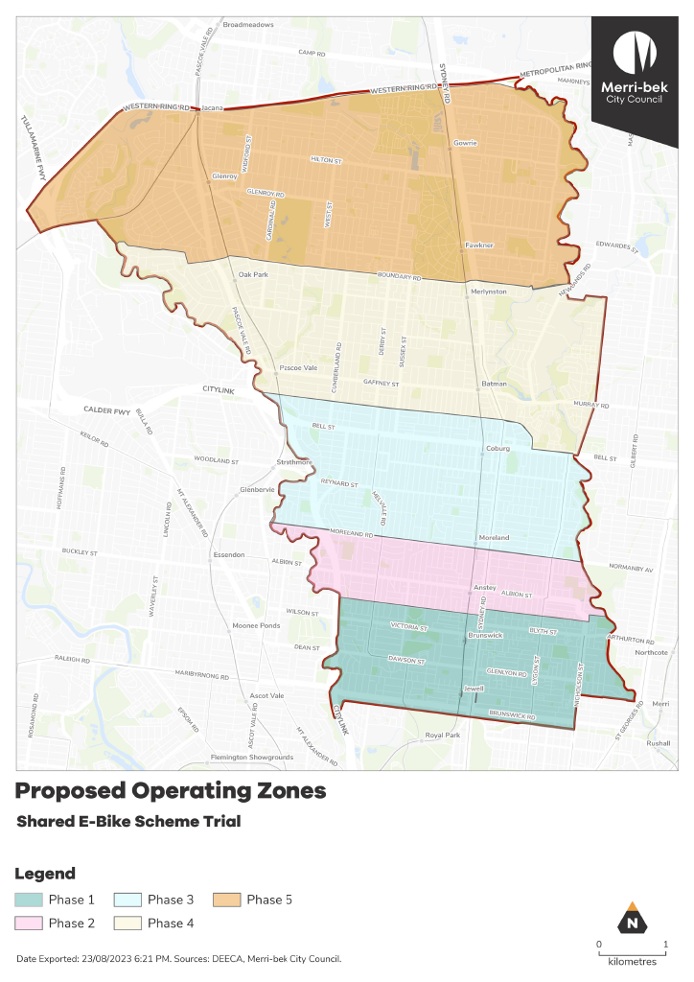
Figure 5 Map indicating potential phased operating zones
The Phase 1 trial operating area would be in place for a minimum of twelve months to allow for evaluation of the scheme in its early stage. After evaluating the outcomes of Phase 1, it is proposed to roll out Phases 2 and 3 within 24 months to increase the scheme’s usability for residents in those areas. It is recommended that a full review of the scheme and contract terms are undertaken at this point before any further potential expansion into the Phase 4 and Phase 5 operating areas.

Economic sustainability implications
A future shared mobility scheme will include a fee structure for shared mobility providers to operate in Merri-bek. Over time, it is expected revenue from these fees will exceed staff resources and material costs to implement the scheme.

Human rights consideration
The implications of this report have been assessed in accordance with the requirements of the Charter of Human Rights and Responsibilities and improving access to transport options is seen to improve the Right to the freedom of movement.
Council has sought input from Council’s disability and social cohesion staff, and consulted with Merri-bek’s Disability Reference Group and the broader disability and pedestrian community to ensure that a prospective shared mobility scheme does not infringe on others ability to freely move and access premises.

4. Community consultation and engagement
Community consultation was provided via a Conversations Merri-bek webpage which opened for submissions on 9 May and ran for 5 weeks and 6 weekends until 16 June. Two pop-up sessions were held in-person, one at Coburg Farmers Market on Saturday 10 May and one at Michelle Guglielmo Park in Brunswick on Saturday 17 May.
A social media advertising campaign was run and posters on community noticeboards promoted The Conversations Merri-bek page. The page received 3,382 views and there were 135 survey responses received during the engagement period.
Community members were invited to respond to a short survey about the proposal and were able to use an interactive drop-pin map for location specific comments. Hard copies of maps detailing the proposed operating zones and parking bay locations along with information pamphlets were distributed at pop-up events.
Community members consulted on and able to influence the following aspects of the project:
• Locations of bike parking bays
• Slow and no-go zone locations
• Council’s approach to shared mobility
Community members were advised about (but not able to influence):
• The selection of an e-bike operator
• The need for dedicated parking bays
• The inclusion of e-scooters in the scheme

Survey results
This section details community feedback from the survey which was completed by 135 people.
Survey Question 1: “To what extent do you support the introduction of shared e-bikes into Merri-bek?”
There was largely positive sentiment towards the introduction of shared e-bikes into Merri-bek with approximately 46 per cent of respondents strongly supporting and thirteen per cent supporting the introduction (see Figure 6). Approximately twelve per cent of respondents opposed to a shared e-bike scheme and nineteen per cent strongly opposed. Less than ten per cent responded that they neither supported nor opposed a shared e-bike scheme in Merri-bek.
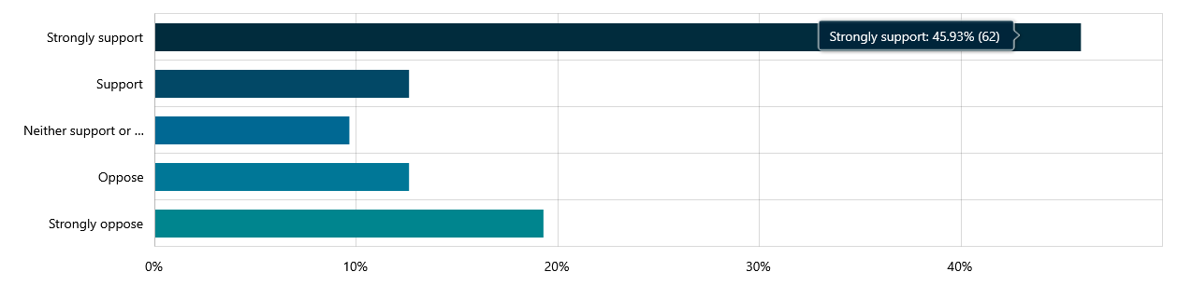
Figure 6: To what extent do you support the introduction of shared e-bikes into Merri-bek?
Survey Question 2: “What are your thoughts on the proposed phased operating zones for Merri-bek’s shared e-bike trial?”
This open-ended question sought insight on sentiment about the proposed phasing of the scheme.
Responses to this free text question were assigned a sentiment value (Positive, Negative, Mixed, Neutral or Unclassified). Unclassified responses provided feedback which did not relate to phased operating areas.
As shown in Figure 7 most respondents answered positively towards the proposed phased rollout of operating zones. Negative sentiment responses mostly raised concerns about shared mobility generally or were disappointed with the limited size of the Phase 1 operating area.
The desire to see a rapid expansion of the operating areas was a common theme that emerged when reviewing the responses to this question (25 responses total). Many respondents were supportive of the phased approach but commented that the Phase 1 operating area was too small and could extend further north. Another issue frequently raised was the desire for continuity between council boundaries so residents can make trips into other municipalities.
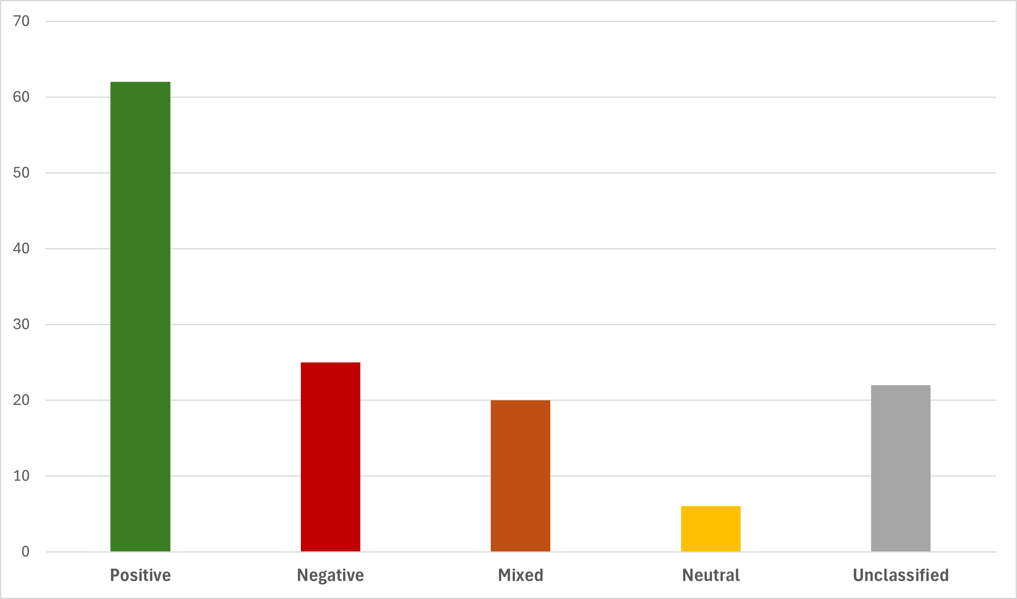
Figure 7: Respondents’ sentiment for the proposed phased operating areas
Survey Question 3: “To what extent do you support mandatory parking requirements for e-bikes?”
There was majority support for any shared e-bike scheme to use mandatory parking arrangements, shown in Figure 8. Approximately 62 per cent of respondents were strongly supportive with a further eighteen per cent supportive.
Approximately eleven per cent of responses indicated they “neither support or oppose” mandated parking and less than ten per cent indicating opposition.
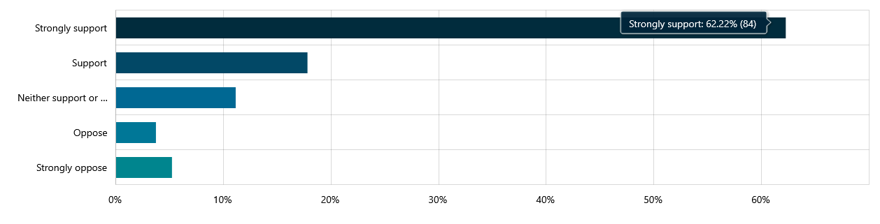
Figure 8: To what extent do you support mandatory parking requirements for e-bikes?
Survey Question 4: drop pin map analysis
In the online survey, community members were able to provide location-based feedback via an interactive drop-pin map of the Merri-bek municipal area (Figure 9). There were 215 individual pins placed on the map during the engagement period, the in the Phase 1 operating area. Community members provided feedback on locations where they believed there should be a designated parking bay, a slow zone, a no-go zone or general shared scheme feedback.
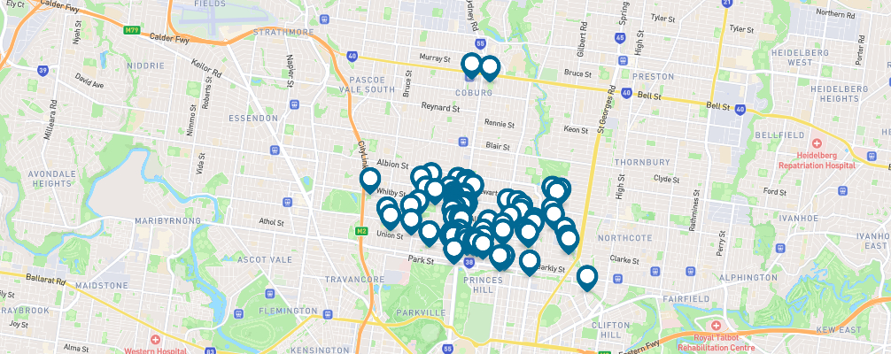
Figure 9 Results of interactive drop-pin map from the Conversations Merri-bek webpage
The location-based feedback has been valuable to understand where community members would find it convenient to travel to or highlight areas where they would like additional parking bays or control measures such as slow zones and no-go zones. Many respondents placed pins close by to bus stops, tram stops and train stations. Many also commented that a shared scheme with parking hubs near public transport would suit their regular travel patterns around Merri-bek and their work commutes.
Survey Question 5: “To what extent would you support the introduction of shared e-scooters into Merri-bek?”
The response to shared e-scooters was very different from e-bikes, with a majority of respondents opposing e-scooters. Figure 10 shows that 36 per cent of respondents “Strongly oppose” e-scooters, and fifteen per cent “oppose”. Fifteen per cent of respondents “neither supported or opposed” this idea, 22 per cent “strongly supported” it, and ten per cent said they “Support” e-scooters.
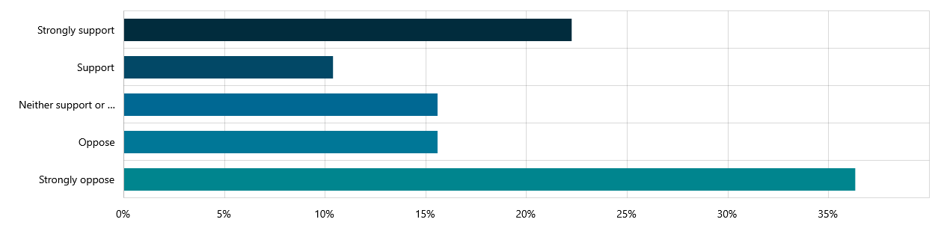
Figure 10: To what extent would you support the introduction of shared e-scooters into Merri-bek?
Survey Question 6: “If Merri-bek introduced a shared e-bike AND e-scooter scheme, which device would you be more likely to use?”
Approximately 42 per cent of all respondents indicated they would prefer to ride an e-bike, as shown in Figure 11. Just over five per cent of respondents indicated they would be more likely to ride an e-scooter and approximately thirteen per cent indicated they would be likely to use both e-bikes and e-scooters equally. Approximately 37 per cent of respondents indicated they would be unlikely to use either bikes or scooters.
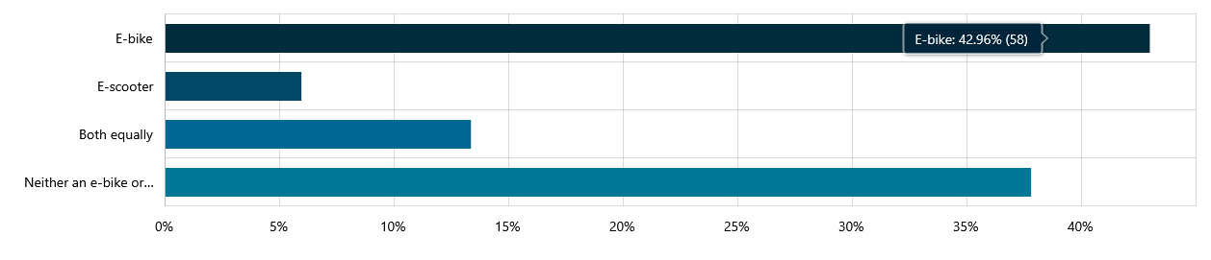
Figure 11: If Merri-bek introduced a shared e-bike AND e-scooter scheme, which device would you be more likely to use?
Respondent demographics
Data about survey respondents is based on demographic information respondents were happy to provide. However it is not mandatory to provide demographic information.
The majority of respondents to this survey filled out personal information about their gender, age and postcode locations and a summary of this information is shared in this report. Demographics for which only a small sample of respondents provided information (such as language spoken at home or disability status), analysis has not been included, though the importance of their feedback is acknowledged and staff have carefully considered their individual responses to each question in the survey.
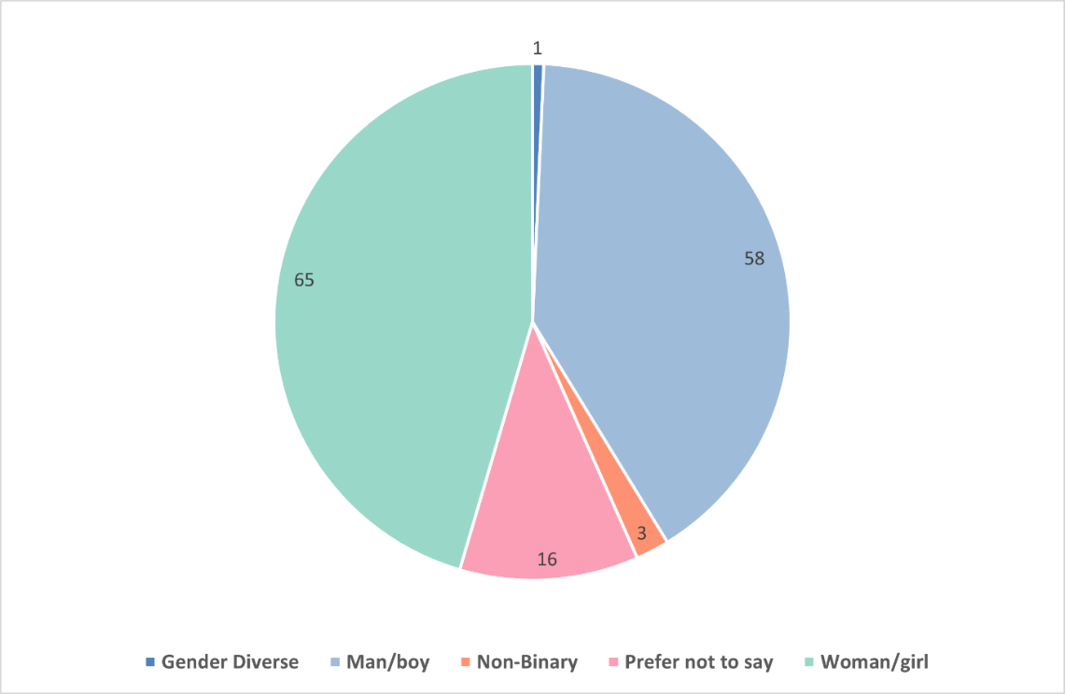
High level demographic information on the survey respondents is provided in Figure 12, Figure 13 and Figure 14.
Figure 12: survey respondents’ gender profile data

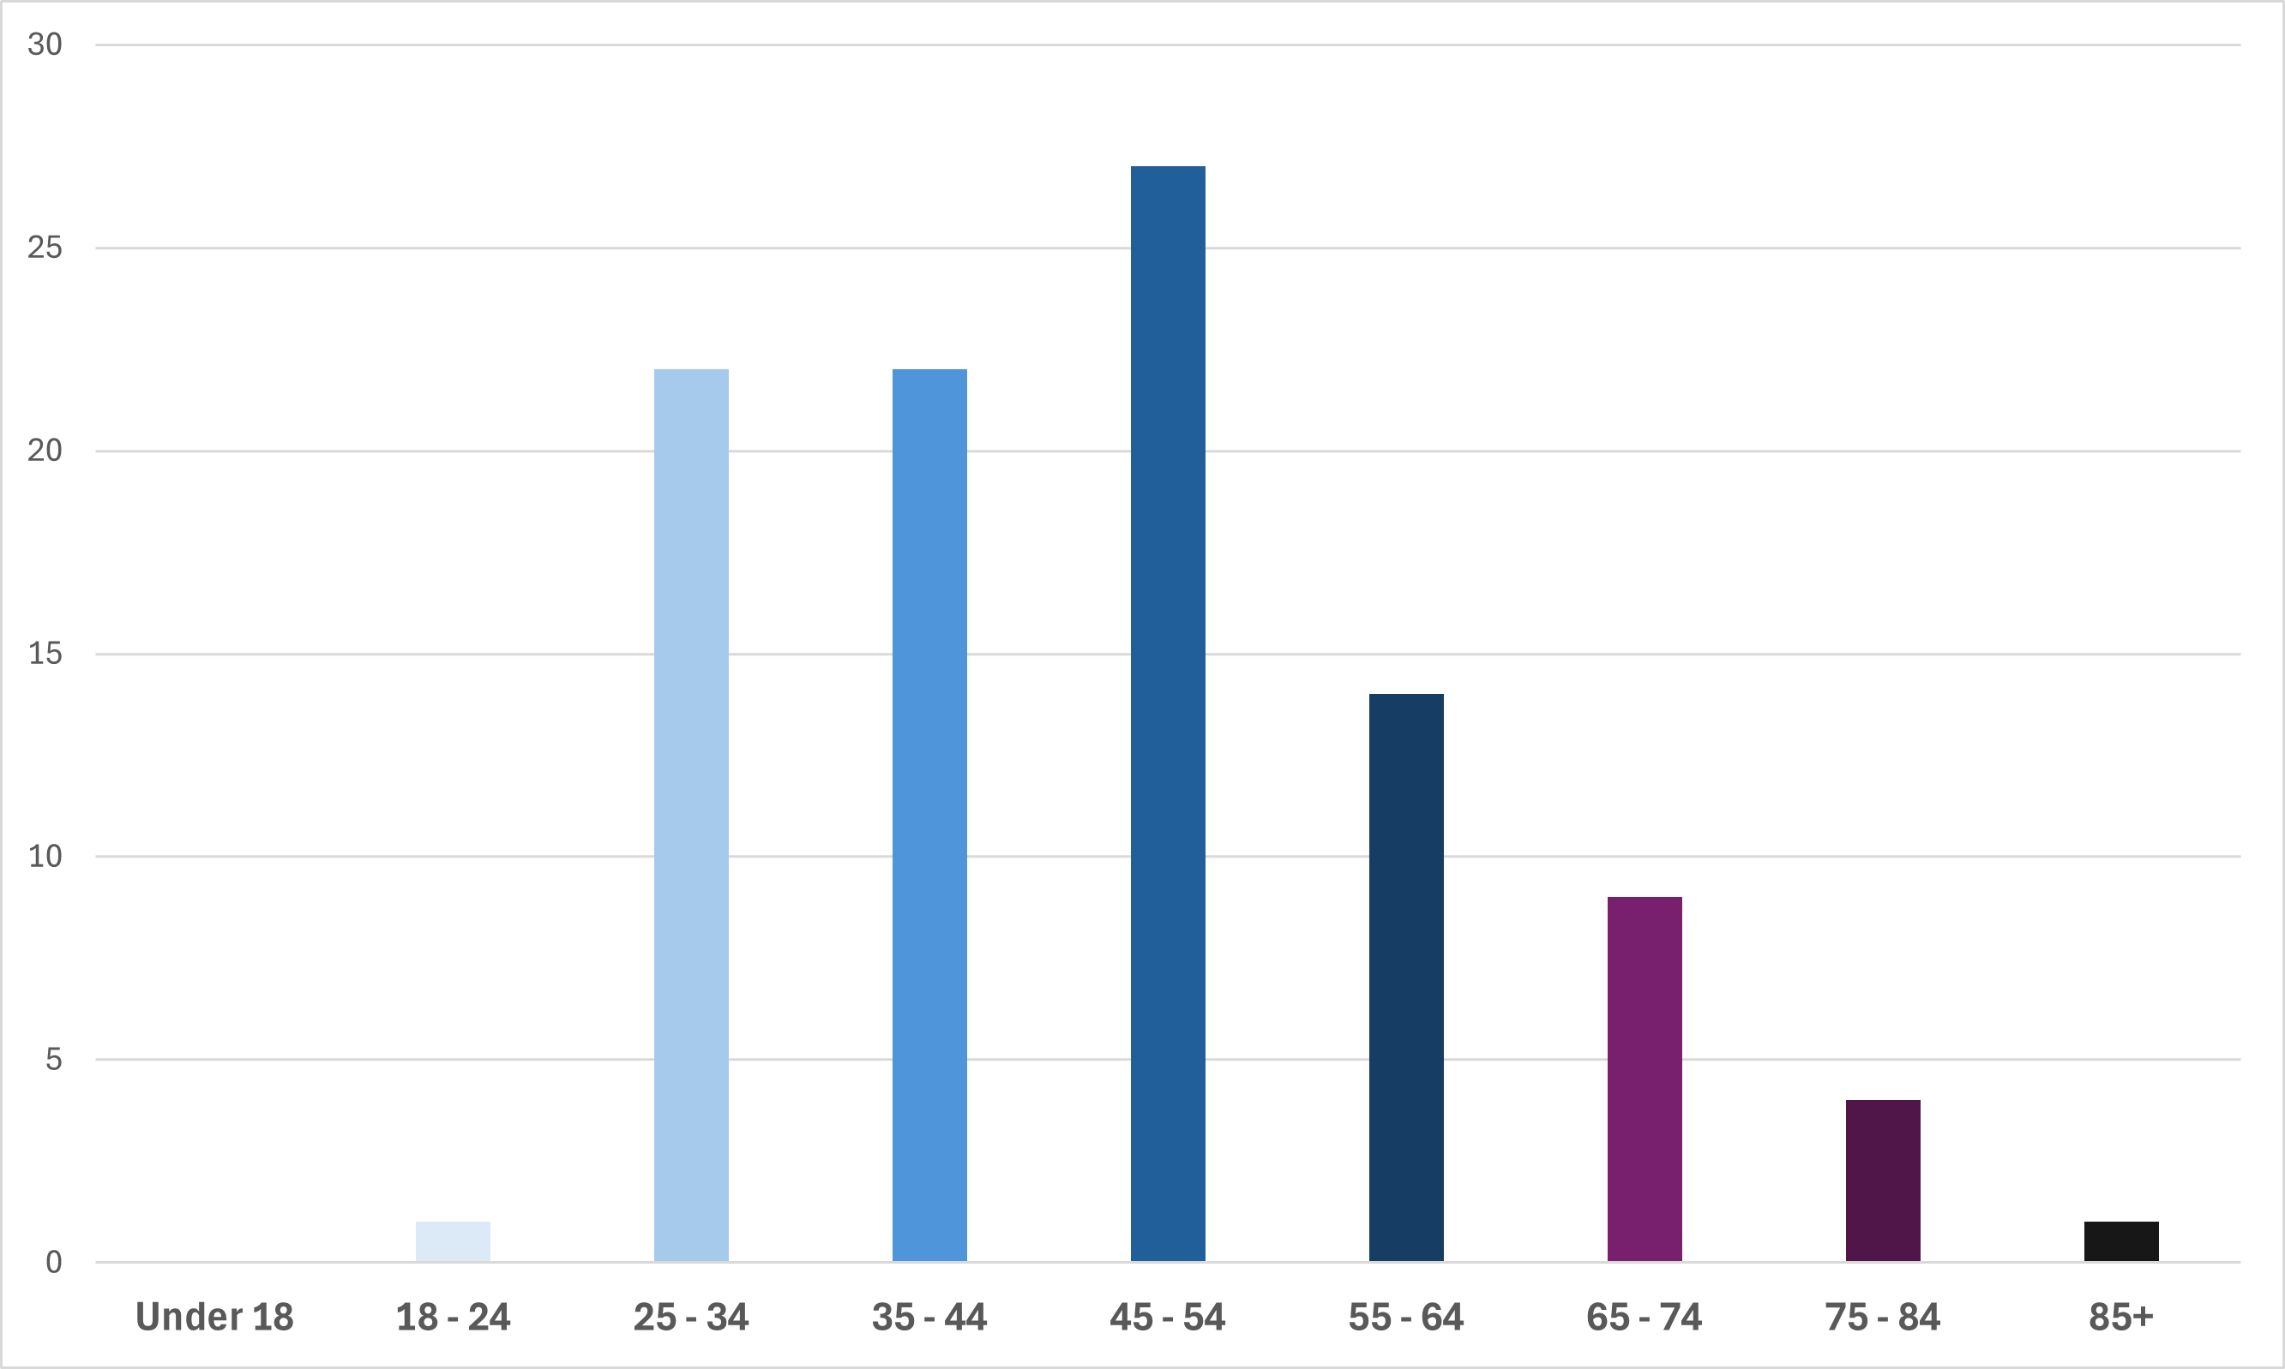
Figure 13 Chart displaying survey respondents age data
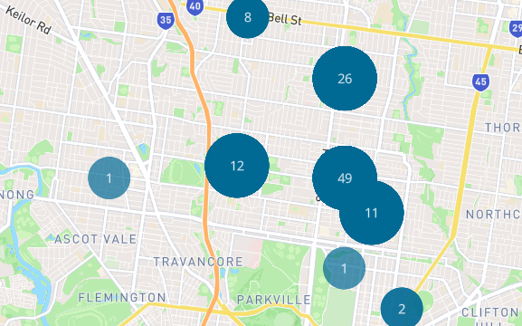
Figure 14: Heatmap data displaying survey respondents’ postcode information

5. Officer declaration of Conflict of Interest
Council officers involved in the preparation of this report have no conflict of interest in this matter.

6. Financial and resources implications
A future shared e-bike scheme will include a fee structure for shared e-bike providers to operate in Merri-bek. Over time, it is predicted that revenue from the fees will offset staff resources and material costs to implement the scheme and generate surplus revenue for Council.
The financial implications of implementing and managing a shared e-bike scheme will be further explored and reported back to Council in a future report.

7. Implementation
Subject to Council’s decision, staff will continue working with the other prospective councils on a multi-council MOU and procurement of operator(s) for a new shared e-bike scheme.
The Shared Mobility Stakeholder Panel meetings will continue on a monthly or bi-monthly basis until a Council decision (estimated December 2025). Should shared e-bike services be endorsed, meetings would continue for approximately 12 months following commencement of operations to support implementation.
Officers will continue to develop operational procedures for the management of shared e-bikes ahead of a future decision to begin operations in Merri-bek.

Attachment/s
There are no attachments for this report.

7.3 Road Management Plan Review and Proposed Amendments
Director City Infrastructure, Anita Curnow
Capital Works Planning and Delivery

Officer Recommendation
That Council:
1. Endorses the proposed amendments to the Road Management Plan as outlined in Attachment 1, in accordance with Section 41 of the Road Management Act 2004.
2. Publishes a notice of the proposed amendments to the Road Management Plan in the Victoria Government Gazette and a local newspaper in accordance with the provisions of the Road Management (General) Regulations 2016 stating
a) The purpose and general purport of the proposed amendments to the Road Management Plan.
b) What road infrastructure or road related infrastructure or classes of roads or pathways will be affected by the proposed amendments.
c) Where the written report can be obtained or inspected that summaries the proposed amendment.
d) That any person can make a submission in respect of the proposed amendments within 28 days of the public notice being published.
e) Those submissions can be made through Conversations Merri-bek webpage or in hard copy.

REPORT

Executive Summary
The Road Management Plan 2021 was reviewed in accordance with the provisions of the Road Management Act 2004 and Road Management (General) Regulations 2016. This involved stakeholder engagement supported by consultation on specific user group needs.
A summary report on the findings and proposed amendments to the Road Management Plan has been prepared (Attachment 1) for public notice and provided for Council consideration.

Previous Council Decisions
Footpath Capital Works and Maintenance Plan – 12 March 2025
That Council:
1. Refers to the 2025/26 budget process the reinstatement of an allocation of $2 million for renewal of footpaths and bike paths each year, escalated by the rate cap each year after 2025/26.
2. Notes that the Council’s Road Management Plan will be reviewed by 31 October 2025 in accordance with the requirement of the Road Management (General) Regulations 2016 which includes review of intervention levels and response time to address the identified hazards.
3. Requests officers to ensure the review of the Road Management Plan refers to trip hazard guidelines in schools and aged care sites, and that the community consultation is broad enough to capture submissions from members of the community with mobility issues

1. Policy Context
Where a Council has adopted a Road Management Plan, the Road Management (General) Regulations 2016 require a review of the plan within the period referred to in section 90(3) of the Local Government Act 2020. As such, a review of the current Plan is required by 31 October 2025.
The Road Management Plan defines a minimum level of service for Council’s maintenance of the local road and pathway network.
The Municipal Association of Victoria (MAV) circulated a template identifying benchmark intervention standards and response times. This serves as a general guide to all councils.

2. Background
The purpose of the Road Management Plan is to demonstrate that Council, as the road authority, is responsibly managing the road and pathways assets under its control to a reasonable standard. In doing so, Council must specify reasonable, achievable and affordable intervention standards and inspection regimes.
The review of the Road Management Plan has identified several defect types where amendments may be appropriate to intervention levels and/or inspection regimes and some adjustments to the defect types. As such, a public notice in accordance with the Road Management (General) Regulation 2016 is required.

3. Issues
In reviewing the plan, amendments have been proposed that aligned with the MAV recommendations and in some cases, have higher levels of service that what MAV recommends.
Officers propose the following more frequent proactive inspections in the Road Management Plan (See Table 1 of Attachment 1):
• addition of night-time inspections to check visibility in the dark of road signs and linemarking
• more frequent daytime inspections so that all roads paths and retaining walls over 1.0 metre are inspected at least once every 24 months, down from 37 months for several categories
• improvements in the frequency of inspections for link roads (for road defects) and High Use 1 paths (for path defects) from 13 months to 6 months
• reduction in the time between inspections for access roads with shimmies
The following earlier intervention levels (hazard definitions) have been proposed in the review of the Road Management Plan (See ‘Change in intervention level’ column of Tables 2 to 6 of Attachment 1):
• Potholes in roads are defined as a hazard when the diameter is 300mm (reduced from 400mm)
• Depressions and deformations in roads are defined as a hazard when the repression is 50mm deep (reduced from 100mm)
Officers propose the following quicker response times after a hazard is identified in the Road Management Plan (See ‘Change in response time’ column of Tables 2 to 6 of Attachment 1):
• Pothole and depression hazards on Link and Collector Roads to be responded to in 2 weeks and 3 weeks respectively down from 30 days
• Missing pieces of pathway / potholes responded to on High Use 1 paths in 2 weeks down from 30 days
• A significant improvement in response time across all road and path categories for missing pit lids (1, 5 or 10 days down from 30 days for roads and 1 or 4 days down from 30 days for paths)
• Missing pieces of pathway / potholes responded to on High Use 1 paths in 2 weeks down from 30 days
Through the review, the following new items are proposed to be introduced into the Road Management Plan (Blue shaded items in Tables 3, 5 and 6 of Attachment 1):
• overhanging vegetation (canopy clearance) for both roads and paths
• vegetation clearance that obstructs sight distance for both roads and shared paths
• cracking perpendicular to path of travel on pathways
• loose and unstable pavers on pathways
• missing tactiles tiles on pathways
In addition to these new items, there is also proposed a new intervention for vertical displacement within pathways (generally referred to as trip hazards) in High Use footpaths. Trip hazards for these H1 and H2 path categories are now proposed in two tiers – those over 30mm, warranting response within 4 weeks (the current service level), and those between 25mm and 30mm, to be marked for response within 6 months. The latter is a proposed new inclusion in the Road Management Plan.
In aligning to the MAV template Road Management Plan and for other practical reasons, a small number of additional changes are proposed, representing a lower level of service. These are shaded in the Tables of Attachment 1 peach (for reduced level of service) and pink (items removed from the Road Management Plan):
• the inspection frequency for level 2 bridge inspections alter to ‘as needed’ given there was a mismatch between a 3-yearly cycle for review in the Plan and a 4-yearly cycle for review in our Asset Management condition assessments (Table 1)
• increased response time for signage issues in Constructed Lanes, noting that this is in the context of reduced response times for the higher order roads (Table 4)
• increased response time for damaged or missing guard rail for lower-order roads (Table 4)
• removal of kerb and channel and water pooling (not in the MAV benchmark template) (Table 4)
• altered definition of undulations on footpaths from 30mm over a 1.2m straight edge to 75mm over a 1.5m straight edge to align with the MAV definition (Table 5)
• increased response time for undulations in standard footpaths and for dislodged / missing pieces of footpath from 30 days to 8 weeks, noting that this is in the context of reduced response times for the High Use H1 paths (Table 5)

Road and footpath categories
It is noted that in addition to changes in the inspection frequencies, response times and intervention levels, there have been changes made to the descriptions of categories and allocation roads and pathways to these categories.
The category of a road or pathway often influences the inspection regimes and response times applicable. The higher the priority, the more frequent the inspections and quicker the response times.
The road and footpath hierarchies have been adjusted to align with the Moving Around Merri-bek Transport Strategy.
The road classifications are Link, Collector, Access and Right of Way (Constructed Laneways), which also maps to the MAV template.
The footpath classifications designate all activity centres and shopping strips as High Use 1 category. High Use 2 category will include the Streets for People network and this will be progressively updated in Council’s asset management system. The remaining pathway network is in the Standard category.
These adjustments to the categories see an overall upward movement in the length of path defined as High Use 2, which is a further increase in level of service from the Road Management Plan.

Community impact
The Road Management Plan has a significant impact on the movement of people, regardless of the mode of movement. The proposed amendments to the Road Management Plan have identified several areas where the intervention level needs to be introduced and/or improved and at the same time the response time and inspection regime needs to be strengthened.
The proposed addition of a defect definition of 25mm to 30mm vertical displacement (trip hazard) on a path with its own response regime will mean that if a hazard doesn’t quite meet the 30mm intervention level for a more urgent response, it will still be addressed within 6 months. In practice, we will program responding to these lesser level defects on High Use (H1 and H2) paths together, meaning many of these will be addressed in less than 6 months. This will result in an improved, more consistent approach with fewer sites that continue to be reported but fall just under the intervention level.
The Road Management Plan has also identified some defects, where Council could reasonably reduce the level of service, without having a significant impact on people’s mobility.

Climate emergency and environmental sustainability implications
The proposed amendment to the Road Management Plan is proposed after careful consideration of the environmental impacts. One of the notable amendments is the introduction of overhanging vegetation clearance on trafficable portion of the road. The intervention level for the overhanging vegetation is set to make sure that mature trees are protected whilst ensuring safe passage of majority of vehicles.

Legal and risk considerations
The Road Management Plan identifies the responsibilities, maintenance standards and inspection regimes required to manage civil liability and must demonstrate that Council, as the road authority, is managing the road and pathway assets under its control in a reasonable manner. The review has considered input from stakeholders and MAV. Furthermore, benchmarking across similar Councils was undertaken as a part of the review.

Human Rights Consideration
The implications of this report have been assessed in accordance with the requirements of the Charter of Human Rights and Responsibilities and more specifically to the right to freedom of movement. Having considered the scope of the amendments proposed to the Road Management Plan, the rights of freedom of movement is not considered to be negatively impacted.

4. Community consultation and engagement
The review has been done following consultation with both internal and external stakeholders. The proposed amendment will be publicly advertised for feedback and will be promoted through Council’s social media channels.
A page dedicated to Road Management Plan amendments will be launched through Conversations Merri-bek seeking feedback on the proposed amendments. The statutory public exhibition period is for 4 weeks and is planned to commence as soon as possible.
Engagement will remain open for 4 weeks following statutory notification through publication in Victoria Government Gazette, local newspaper, Council website and social media platforms.

Communications
The public exhibition will be promoted through Council’s social media platform, local newspaper and through email communication with reference groups and advocacy groups.

5. Officer Declaration of Conflict of Interest
Council officers involved in the preparation of this report have no conflict of interest in this matter.

6. Financial and Resources Implications
A key part of the consideration of changes to the inspection regime, intervention levels, response times and the addition and removal of items into the Road Management Plan has been Council’s ability to meet these requirements within existing budgets. In some cases where better levels of service are identified (for example missing pit lids), our regime is already at the levels we are now proposing, so it made sense to align the Road Management Plan with our current risk-based practice.
Council has dedicated three staff to the road inspections function, this was set at two for most of the period of the current Road Management Plan and so the more frequent inspections can be addressed without a further increase in resources. The inspection regime will focus on a wider range of items during inspections, covering those ‘new’ items identified.
The introduction of night time inspections will require internal allocation within the relevant budgets, as a focused activity usually conducted over winter months.
The proposed Road Management Plan amendments are expected to be within existing budget and resource allocations. Opportunities for improving efficiency in the inspections and response regime will continue to be identified and harnessed.

7. Implementation
Subject to Council endorsement of the proposed amendment and the review report, the public notice will be published through Victoria Government Gazette, local newspaper, Council website and an engagement page will be launched through Conversations Merri-bek. This will be communicated through Council’s social media platforms.
The final plan will be presented to Council at October Council meeting for adoption.

Attachment/s
1 | Road Management Plan Review Report July 2025 | D25/397795

7.4 Amendment C196more - Introduction of Special Building Overlay Schedule 2 - Decision Gateway 3 - Consideration of Panel Report and Decision on the Amendment
Director Place and Environment, Pene Winslade
City Design and Economy

Officer Recommendation
That Council:
1. Considers the publicly released Planning Panel Report for Merri-bek Planning Scheme Amendment C196more – Special Building Overlay Schedule 2 (Amendment) under section 26 of the Planning and Environment Act 1987 (Vic) (Act).
2. Adopts the Amendment in accordance with section 29(1) of the Act, as exhibited with the changes recommended by the Planning Panel and discussed at Section 3 of this report and shown in Attachments 4 to 7.
3. Authorises the Director Place and Environment, following adoption of the Amendment, to finalise the Amendment documentation in accordance with Council’s resolution, including any administrative or formatting changes to the amendment documentation and mapping required to give effect to Council’s resolution.
4. Submit the adopted Amendment together with the prescribed information to the Minister for Planning for approval, in accordance with section 31(1) of the Act.
5. Write to all submitters to the Amendment, the Building and Plumbing Commission, local building surveyors and Melbourne Water, to advise of this Council resolution.
6. Designates the Amendment Special Building Overlay Schedule 2 (SBO2) map in Attachment 5, under Regulation 5(2) of the Building Regulations 2018, to replace the previously designated map.

REPORT

Executive Summary
Amendment C196more (Amendment) proposes to apply a Special Building Overlay Schedule 2 (SBO2) to properties identified within areas where Council is the local drainage authority. This is separate from the existing Special Building Overlay Schedule 1 (SBO1) map in the Merri-bek Planning Scheme, which applies to areas where Melbourne Water is the main drainage authority.
The Amendment will support more informed decision-making by identifying land in Merri-bek subject to overland flows and guiding the assessment of planning permit applications. It will also assist licensed building surveyors, who must consider the mapped area when assessing building permit applications.
In December 2023, Council resolved to seek authorisation from the Minister for Planning to prepare the Amendment, following detailed technical work by specialist engineering firm Engeny (now part of the Egis group). Authorisation was granted in March 2024. The Amendment was publicly exhibited in May and June 2024, with information sent to approximately 10,000 landowners. A follow-up letter was mailed to affected properties in October 2024.
A proactive and comprehensive approach was taken during the exhibition of the Amendment, including direct engagement with submitters to resolve concerns where possible. A total of 94 submissions were received, with six later withdrawn, and three expressing support.
An independent Planning Panel Hearing was held over two days on 12 and 13 June 2025, with only two submitters requesting to be heard. A copy of the Panel report is provided at Attachment 1. The report has also been shared with all submitters and is available on Council’s website under Amendment C196.
The Panel concluded in their report that “the Amendment has strong policy support, will deliver a net community benefit, and should be progressed.” It also supported the recommended changes to the SBO2 map, as proposed by Engeny’s expert witness. These recommendations align with those outlined in the Council Report dated 12 February 2025.
In line with the Panel’s report, officers recommend that Council adopt the Amendment as exhibited, subject to the changes outlined in the Panel’s report. Further details on these changes are provided in Section 3 of this report. Once adopted, the Amendment will be submitted to the Minister for Planning for approval.

Previous Council Decisions
Amendment C196more - Introduction of Special Building Overlay Schedule 2 - Decision Gateway 2 - consideration of submissions and request for a Planning Panel – 14 August 2024
That Council:
1. Defers Council’s consideration of referring Amendment C196more to the Planning Panel to consider the introduction of Special Building Overlay Schedule 2 until February 2025 to allow consideration of late submissions.
2. Sends a further letter to owners whose properties are proposed to be added to the Stormwater Flood Map, which advises property owners they can request a site inspection if they are concerned there is a reason their property should not have been added to the map.
3. Ensures that the letter indicates how people can access this information in other languages, including interpreter and accessibility options for people who have learning difficulties, cognitive disabilities, literacy or other issues that impede their ability to understand the communication from council.
4. Notes that additional funding may need to be sought through the Quarterly Budget Review, to cover the costs of a further mailout and any further site inspections.
Stormwater mapping – consultation response and Amendment C196 – 6 December 2023
That Council:
1. Notes the 2023 Amended Stormwater Map in Attachment 1 that has been designated under the Building Regulations 2018.
2. Endorses the Merri-bek City Council Creating the Local Drainage Authority’s Stormwater Map Technical Report as shown in Attachment 1. This report outlines the rationale and evidence which underpins the proposed planning scheme changes.
3. Using its powers as a Planning Authority under ss 8A and 8B of the Planning and Environment 1987, seeks authorisation from the Minister for Planning to prepare Merri-bek Planning Scheme Amendment C196 as shown in Attachments 4, 5, and 6 to this report.
4. Following receipt of the Minister’s authorisation, exhibits the Amendment in accordance with Section 19 of the Planning and Environment Act 1987 and as outlined in the Consultation section of this report.
5. Using its powers as a Planning Authority under s 23(1) of the Planning and Environment 1987, requests that the Minister for Planning appoint an independent Panel to consider submissions to Merri-bek Planning Scheme Amendment C196.
6. Authorises the Director Place and Environment to:
a) Make changes to the Amendment based on conditions imposed in any authorisation granted by the Minister for Planning and make minor changes.
b) Refer any late submissions to the Independent Panel.
c) Give direction on issues that arise during the Panel hearing in response to expert evidence and submissions if required, so long as any further changes are generally in accordance with Merri-bek City Council Creating the Local Drainage Authority’s Stormwater Map Technical Report.
Amendment C196more – introduction of Special Building Overlay Schedule 2 – Decision Gateway 2 – consideration of submissions and request for a Planning Panel – 12 February 2025
That Council:
1. Using its powers as a Planning Authority under s23(1) of the Planning and Environment 1987, requests that the Minister for Planning appoint an Independent Planning Panel to consider submissions to Merri-bek Planning Scheme Amendment C196more.
2. Endorses the responses to submissions as set out in Attachment 1 to this report to form the basis of Council’s submission to an Independent Planning Panel.
3. Refers any late submission to the Independent Planning Panel.
4. Authorises the Director Place and Environment to make minor changes to Amendment C196more and to give direction on issues that arise during the Panel hearing in response to expert evidence and submissions, if required, so long as any further changes are generally in accordance with Merri-bek City Council Creating the Local Drainage Authority’s Stormwater Map Technical Report.

1. Policy Context
The Council Plan 2021-2025 recognises the importance of responding to the climate emergency and supporting the community to adapt and build climate resilience. This includes severe storms.
The Council Action Plan 2023-2024 has Action 148 to complete stormwater modelling. Council’s endorsed 2022 Planning Scheme Review indicates this modelling will be used to prepare a stormwater map for only Council’s drainage areas, where it is the local drainage authority.
The Merri-bek Planning Scheme has strategies in Clause 13.03-1S to identify land affected by the 1 in 100-year (100-year) storm event, so appropriate land development in mapped areas can happen.
The 100-year storm event is the engineering, planning and environmental standard for producing stormwater flood maps and is technically referred to as the 1% Annual Exceedance Probability (AEP) storm event. Such storms are expected to occur at least once in 100 years.
The Victorian Government’s Planning Practice Note 12: Applying the flood provisions in planning schemes (PPN12) advises that the Special Building Overlay (SBO) is the appropriate planning tool for including a map for urban stormwater overland flows in planning schemes.
Regulation 5(2) of the Building Regulations 2018 enables Council to designate land where water collects or where surface water normally or occasionally flows. This includes urban areas impacted by severe storm events. Designating land allows reference to stormwater mapping information on property information certificates and prompts licensed building surveyors to consider this information before they issue a building permit.

2. Background
In 2018, Council began work to model and map its local drainage catchments for a 100-year storm event. These catchments are separate from the regional drainage catchment in Merri-bek, where Melbourne Water is the main drainage authority. Melbourne Water is also the regional Floodplain Management Authority.
All technical work for Council’s modelling and mapping was done by a specialist engineering firm, Engeny and has involved Melbourne Water. This specialist firm has delivered similar maps for other councils and Melbourne Water and has provided expert evidence at Special Building Overlay (SBO) Planning Panel hearings.
Council’s initial 100-year stormwater map (initial map) was prepared in 2021 and then shared and discussed with affected landowners. It was then designated for use by building surveyors under the Building Regulations 2018. After this designation, the initial map was used by Council to inform building surveyors of building floor level requirements.
An amended map was released in September 2023, when a second round of consultation was done. This consultation responded to questions and included another map review process before the amended map was designated for use under the Building Regulations 2018 in November 2023.
Amendment C196more
In December 2023, Council resolved to seek authorisation to prepare Amendment C196more, which proposes to apply Special Building Overlay Schedule 2 (SBO2) to properties near local stormwater drains within Council-managed catchments. The Amendment is underpinned by technical work undertaken by Engeny.
Following authorisation by the Minister for Planning in March 2024, Amendment C196more was publicly exhibited from 16 May to 17 June 2024. Arising from a Council resolution on 14 August 2024, an additional letter was sent to affected landowners on 28 October 2024. This letter gave a further opportunity for affected landowners to respond to the Amendment.
In total, 94 submissions were received. Six were withdrawn, and three were supportive.
In February 2025, Council resolved to refer the Amendment and the 85 submissions to an independent Planning Panel (Planning Panels Victoria). The key matters raised in submissions were:
• Administrative matters
• Drainage infrastructure upgrade
• Drainage infrastructure maintenance
• Land development
• Insurance
• Land values
• Mapping
• SBO provisions
In response to submissions questioning the proposed SBO2 map, Council engaged Engeny to undertake a targeted review of the mapping for the affected and surrounding properties. This involved site visits and additional technical assessment to verify the accuracy of the mapping in these areas.
The locations reviewed are shown in Attachment 2, and a list of properties with their review outcomes is provided in Attachment 3. Based on this review, recommendations were made to either revise, retain, or remove the SBO2 mapping for each property.
All stormwater modelling and mapping was prepared and reviewed by Engeny in accordance with relevant guidelines and specifications.
Planning Panel Hearing
An independent Planning Panel Hearing to consider the Amendment and submissions received was held over two days, on 12 and 13 June 2025. Only two submitters requested to be heard.
At the hearing, Council was represented by Maddocks Lawyers. Engeny appeared as Council’s expert witness and presented evidence on the technical work undertaken to prepare and review the SBO2 map. This included recommendations to revise or remove the overlay for specific properties, where justified by the assessment.

3. Issues
The Panel recommended that the Amendment be adopted as exhibited, subject to the changes described in the Panel’s report. These changes align with the mapping review recommendations prepared by Engeny, as detailed in Attachment 3.
The Panel found that the Amendment is well-founded and strategically justified. It supported the expert witness recommendations made by Engeny regarding final changes to the SBO2 map. These changes were previously referenced in the Council Report dated 12 February 2025.
The following table gives a summary of the Panel’s recommendations, with a response. A copy of the Panel report is in Attachment 1.
Officer recommendation
In line with the Panel’s report, officers recommend that Council adopt the Amendment as exhibited, subject to the changes outlined in the Panel’s report (refer to Table 1).
Table 1: Panel recommendations and Officer response
Recommendation (summary) | Officer Response
That Council adopt Amendment C196more with the map review changes recommended by the Engeny expert witness (see Attachment 3). | The updated SBO2 map in Attachment 5 is aligned with this Panel recommendation.
The Panel’s recommendations have informed the preparation of the final version of Amendment C196more, as detailed in the following attachments:
• Attachment 4 for the updated 2025 Engeny Technical Report. This report underpins the technical merits of the SBO2 map. The exhibited version has been updated to include commentary and results from the Engeny map review process. The report’s appendices are available from the Council’s website at Amendment C196.
• Attachment 5 for the final SBO2 map. Any changes to the exhibited map, to produce the final map, are aligned with the map review results listed in Attachment 3.
• Attachment 6 for the final SBO2 Schedule’s written provisions for Clause 44.05 in the Planning Scheme. There is no change to the exhibited SBO2 Schedule’s provisions.
• Attachment 7 for the updated list of Planning Scheme maps at Clause 72.02, and an updated list of Planning Scheme Background Documents at Clause 72.08. The only change between the exhibited and final versions is an updated reference in the list of Background Documents to reflect the final 2025 Engeny Technical Report.

Legal and risk considerations
Merri-bek City Council
Council must produce, share, and use stormwater maps for its local drainage catchments, where it is the local drainage authority. This includes updating the Merri-bek Planning Scheme to include the final map for the SBO2 planning tool.
Council’s exhibited SBO2 stormwater map was designated under the Building Regulations in 2023. Arising from public exhibition and a further map review process that was discussed at the C196more Panel Hearing, Council can now redesignate its post-exhibition map under the Building Regulations 2018. Doing this ensures that building permit decision-making can consider the “best available” map.
Melbourne Water
Melbourne Water has responsibility for:
• Regional urban (main) drainage catchments: These are covered by the Special Building Overlay Schedule 1 (SBO1) in the Planning Scheme. Council officers understand that Melbourne Water is currently preparing updates to its SBO1 map and intends to undertake separate consultation, followed by a future planning scheme amendment.
• Rivers and creeks: Areas subject to riverine flooding are covered by the Land Subject to Inundation Overlay (LSIO) in the Planning Scheme. The timing of Melbourne Water’s review and update of the LSIO is currently unknown.

Human Rights Consideration
The implications of this report have been assessed by the requirements of the Charter of Human Rights and Responsibilities.
The Amendment has a positive impact by:
• Reducing uncertainty for land affected by 100-year stormwater overland flows in Council’s local drainage areas where it is the local drainage authority.
• Enabling affected people to be aware of the mapping and give input on several occasions, before the final SBO2 was prepared.
• The future introduction of an SBO2 does not deprive any party of any legal or proprietary interest in land, or the ability to use and develop that land following the planning regulatory framework. Rather, the SBO2 enables safer land development for 100-year storm impacts within the city’s local drainage areas.

4. Community consultation and engagement
A proactive approach was taken during the exhibition of the Amendment by liaising with submitters and resolving their concerns, where possible. This approach was triggered by sending letters to all affected owners and occupiers. This included a language translation brochure. Then, upon receipt of submissions:
• Sending an acknowledgment email, with contact details, to each submitter.
• Providing a further email to give preliminary feedback. This enabled further explanation of the SBO2 proposal, and to answer submitter questions.
• Responding to telephone enquiries to explain the purpose of the proposed amendment. This included the use of interpreter services when needed.
• Face-to-face meetings with landowners. This included the use of interpreter services when needed.
• Site inspections with Engeny for those submitters requesting an SBO2 map review. These inspections gave another opportunity for discussions with submitters. An online language translator was used to help convey information when needed.
• Sharing the outcome of mapping reviews with submitters.

5. Officer Declaration of Conflict of Interest
Council officers involved in the preparation of this report have no conflict of interest in this matter.

6. Financial and Resource Implications
Costs associated with managing this Amendment and its planning panel process are being met within available budgets.
Council has had resources in place since 2021 to operate the report and consent process for building permits, triggered when the initial stormwater map was designated for use.
When the SBO2 is introduced into the Planning Scheme, landowners wishing to develop their land will either need a planning permit or a report and consent under the building regulations, depending on the works proposed.
The resources required to handle applications under the SBO2 can be met within the resources of the City Development Branch.

7. Implementation
A council resolution that supports the officer recommendations will enable:
• The final C196more Amendment to be packaged and sent to the Minister for Planning for approval, to inform the issuing of planning permits.
• The final SBO2 map to be designated under the Building Regulations, to inform the issuing of building permits.
• Submitters, local building surveyors, Building and Plumbing Commission (previously known as the Victorian Building Authority) and Melbourne Water to be informed of Council’s decision.
• Ongoing contact with the Department of Transport and Planning will encourage a timely outcome for C196more’s gazettal and inclusion in the Planning Scheme by the Victorian Government.

Attachment/s
1 | C196 Panel Report | D25/364746
2 | Map showing the location of map reviews for properties | D25/348548
3 | List of map reviews for properties | D25/348546
4 | Engeny Technical Report (changes highlighted) | D25/345202
5 | Final SBO2 maps | D25/348547
6 | Schedule 2 to Clause 44.05 (new schedule) | D25/348552
7 | Schedules to Clause 72.02 and 72.08 (changes highlighted) | D25/348553

7.5 North West Building Phoenix Street and Brunswick Baths Gym Expansion Options
Director Community, Eamonn Fennessy
Cultural Development

Officer Recommendation
That Council:
1. Endorses the implementation of works ($900,000) to the ground floor of the North West building in 2026/2027 to enable affordable arts use, within existing budget;
2. Endorses the re-allocation of current year funding ($150,000) to the concept design of an expansion of the Brunswick Baths gym;
3. Refers the budget implications of this report, including the future construction costs of the expansion of the Brunswick Baths gym (currently unfunded), to the 2026-2030 budget process for consideration.

REPORT

Executive Summary

This report outlines future use options for the North West building at 33 Saxon Street and the expansion of the Brunswick Baths gym, in response to growing community demand, operational pressures, and the current state of the existing buildings.

Following further detailed assessment and scoping of a number of options, it is recommended that Council proceed with works to the ground floor of the North West building in 2026/2027 in order to enable affordable arts use. These works are achievable within existing budget allocations for the North West building. It is also recommended that Council proceed to undertake a concept design for a future expansion of the Brunswick Baths gym, factoring in a proposed future relocation of the outdoor activity zone into the ‘hard yard’ next door in Balam Balam Place.

The current adopted budget includes $150,000 in the current year (2025/2026) and $2,350,000 in 2026/2027. This report is proposing to utilise the current year funding to complete a concept design of the expansion of the Brunswick Baths gym as well as partially utilising 2026/2027 funding for the North West building works. The remaining budget implications of this report, including future construction costs of a future expansion of the Brunswick Baths gym, is being recommended for consideration as a part of 2026-2030 budget process for consideration.

Previous Council Decisions
Land adjacent to Brunswick Baths - Options for Future - 10 July 2024
That Council:
1. Notes the information provided in this report which outlines the comparative benefits, risks, costs and community impact of use options including:
a) Expansion of Brunswick Baths Health Club
b) Destination arts venue
c) Making space (affordable arts)
2. Defers a decision on the future use of the North West building until early 2025, in the new Council term.
3. To inform this decision, receives a report in early 2025 on options and indicative costs for a future expansion of the Brunswick Baths Health Club within the current facility footprint and in particular gym operations to cater for future service growth and demand.
Land adjacent to Brunswick Baths - Options for Future - 13 March 2024
That Council:
1. Notes that the endorsed concept plan for the 33 Saxon Street hub identified the footprint of the North West building (fronting onto Phoenix Street) as being for potential use for future expansion of Brunswick Baths.
2. Acknowledges that if the North West building is not retained for future aquatics and leisure purposes, the likely best use of the site would be an arts related usage which preferably also increases activation of the site.
3. Commissions cost estimates for repurposing the building for arts use, and for Brunswick Baths Health Club (gym) use.
4. Undertakes a targeted market sounding during April 2024 to investigate if there are destination arts tenancies who can provide capital investment to repurpose and activate the building.
5. Receives a report in June 2024 that outlines the comparative benefits, risks, costs and community impact of Aquatics and Leisure or arts and culture usage including the options of:
a) Expansion of Brunswick Baths Health Club extension
b) Destination arts venue
c) Making space (affordable arts).

1. Policy Context
This report aligns with the Merri-bek Council Plan 2021–2025 objectives relating to healthy, inclusive, and resilient communities.
The proposed expansion of the Brunswick Baths gym aligns with Merri-bek City Council’s Aquatic and Leisure Strategy 2018–2038, which sets overarching direction for the provision of high-quality, sustainable, and accessible leisure infrastructure across the municipality.
The strategy highlights the need to respond to population growth, particularly in Brunswick and other inner-urban areas where demand for indoor health and fitness services is projected to increase significantly over the coming decades.
Key objectives of the strategy that support the proposed gym expansion include:
• Objective 1.3: Optimise the use of existing infrastructure through upgrades and redevelopment where appropriate.
• Objective 3.1: Expand indoor health and fitness services in locations with high current and projected demand.
• Objective 4.3: Progressively plan for the transition of aquatic and leisure centres away from gas toward energy-efficient alternatives.
The Aquatic and Leisure Strategy 2018–2038 recommended opportunities to expand areas that reach capacity within Brunswick Baths. The Strategy highlighted the need to monitor usage and performance of the facility and consider opportunities to do this in the short term (0-5 years). This was delayed pending Balam Balam Place development. A review of the Aquatic and Leisure Strategy will be undertaken in the latter half of 2025.
Expanding the gym within the existing Brunswick Baths footprint also supports Council’s Zero Carbon Merri-bek targets by allowing for integrated design that includes electrification infrastructure such as heat pumps. In doing so, the proposal supports long-term environmental goals while addressing current operational capacity issues, safety constraints, and service demand in one of Council’s highest-use leisure facilities.
The retention of the North West building for arts and community use aligns with the 2023-2030 Arts and Culture Strategy, which sets a vision for Merri-bek to be a place where creativity and culture thrive.
The strategy commits to supporting increased access to spaces and finding for artists and creatives to make, collaborate and present work. The strategy priorities of creation, connection and investment ensure that the municipality champions arts and cultural activity, fosters connection between artists, audiences and community and invests in the creative community and generates opportunities for artists and the creative sector.

2. Background
Council purchased the former school site at 33 Saxon Street Brunswick in 2010. In 2012, 800sqm of the site was annexed and subdivided to become part of the redeveloped Brunswick Baths, with the old sports hall becoming a gym and the basketball court for the Baths.
The remainder of the site was retained and temporarily activated as an affordable arts precinct known as Siteworks whilst longer term plans were considered. Once a Community Needs Assessment and Strategic Framework had been developed, plans were made to redevelop the site to provide a long-term use of affordable arts and community spaces.
The old school building to the north-west of the site (the North West building) was originally considered for demolition to maximise the amount of open space in the precinct. However, after a detailed assessment of the building condition it was determined that it was not yet at end of life, and it would be good practice from an embodied energy perspective to retain it. Retaining the building was also thought to represent an opportunity for future expansion of the Brunswick Baths facility due to its adjacency.
The concept plan for Balam Balam Place endorsed by Council at its November 2021 meeting notes the North West buildings ‘potential for future Baths expansion’'. During the Balam Balam Place development the building was delivered as a cold shell but remains non-operational without a certificate of occupancy.
In July 2024 Council considered a range of possible uses for the site, the benefits, risks, costs and community impact of use options including:
a) Expansion of Brunswick Baths gym
b) Destination arts venue
c) Making space (affordable arts).
Council deferred a decision on the future use of the North West building until 2025, in the new Council term. To inform this decision, Council requested a report in early 2025 on options and indicative costs for a future expansion of the Brunswick Baths gym within the current facility footprint and in particular considering the need for gym operations to cater for future service growth and demand.
This report presents updated findings and financial assessments for these future use options.

3. Issues

Community impact
The current gym at Brunswick Baths provides 352 square meters of floor space for over 3,600 members. This is well below industry standards. Current demand significantly exceeds capacity, resulting in service limitations and user dissatisfaction. In July 2024 Council received a petition from approximately 400 people to strongly consider allocation of the North West building for an expansion of the gym space based on community interest.
In parallel, there is ongoing demand for accessible, affordable creative making and rehearsal spaces in Brunswick. Many artists and arts organisations have approached Balam Balam Place operators and Council to express interest in such spaces within the North West building. There is also significant need from Balam Balam Place tenant, Blak Dot Gallery, for space for printmaking and other workshops and residencies that cannot be delivered within the existing infrastructure at Balam Balam Place.
Proposed Brunswick Baths Gym Expansion
Officers explored undertaking a gym extension into the ground floor of the North West building, which is not recommended due to building compliance and title constraint issues. Brunswick Baths and the North West building sit on separate land titles, creating legal and planning complexities and limiting infrastructure integration. Additionally, the building fabric is not suitable in its current state structurally to support a gym.
While repurposing the North West building for gym expansion would offer some short-term capacity relief for existing users, it provides limited long-term value due to size limitations, structural compliance, building integrity, the above-mentioned title constraints and the high cost to upgrade and maintain.
Instead, redevelopment on the existing outdoor activity zone adjacent to the Brunswick Baths gym is identified as the preferred long-term solution to address capacity, safety, and future electrification requirements for the Brunswick Baths. Further scoping has identified an opportunity to re-locate the existing outdoor activity zone at Brunswick Baths into the hard landscaped area of Balam Balam Place (currently a 'hard yard’ asphalted area that gets little use but is retained to provide crane pad access for the Baths).
The April 2025 Council Report ‘Phasing Out Gas in Councils Aquatic and Leisure Centres’ highlighted an opportunity to consider the requirements for Brunswick Baths to move to an all-electric facility. As part of the proposed gym expansion the spatial and structural requirements to house the heat pumps has also been considered.
High-level estimated costs for the Brunswick Baths expansion works are $5.8 million, subject to revision once a concept design process is undertaken. The design will include a spatial allocation for future electrification infrastructure.
Proposed retention of North West building
Structural rectification works valued at $300,000 have been undertaken to the North West building during the construction of Balam Balam Place. Officers have scoped the further works needed to bring the North West building to a habitable standard to obtain an occupancy permit and to enable its use. These works, to be undertaken on the ground floor only, include electrical wiring, installation of toilets and some other plumbing, the introduction of an external wall, and heating in two rooms. The upper floor would not be updated. The estimated costs for these works would be up to $900,000.
Once updated, the North West building could be allocated to TPT (the operators of Balam Balam Place) as part of their Balam Balam Place management until February 2030 in line with their current lease, subject to negotiation of a variation to their contract. TPT could activate and hire the venue or its rooms out for affordable/messy arts usage, enabling community members to book through the same system as other spaces at Balam Balam Place, opening up more areas for community hire at a variety of rates, and enabling a seamless user experience across the site.
Following this initial period, Council could determine future uses of the North West building, including maintaining it within the Balam Balam Place contract, leasing it to another community group, or considering further redevelopment.

Climate emergency and environmental sustainability implications

Retaining and reusing the North West building is environmentally preferable to demolition.

Brunswick Baths currently contributes 10 per cent of Council’s corporate gas emissions, primarily to enable year-round pool heating. Transitioning the facility to an all-electric operation is an important strategic priority that will require significant future investment.

A challenge with electrification of the baths is ensuring adequate, ventilated, outdoor spaces for a large volume of heat pumps on a very constrained site. Redevelopment of the gym will enable integration of heat pump infrastructure onto a structurally suitable roof and help achieve Council’s zero carbon ambitions.

Legal and risk considerations
The North West building and Brunswick Baths are located on separate land titles, which presents challenges for infrastructure integration, legal compliance, and asset management. The North West building also has unresolved structural issues on the upper floor and contains known asbestos.

Human Rights Consideration

This report has been reviewed under the Charter of Human Rights and Responsibilities. No rights are negatively impacted by the proposed recommendations. A gender equity and accessibility lens has been applied in the assessment of community needs and infrastructure outcomes.

4. Community consultation and engagement
Community consultation on both the expansion of the Brunswick Baths gym and North West building has occurred through multiple avenues:
• A 2022 survey of 145 Brunswick Baths members on services offered including the gym.
• Ongoing customer feedback to the YMCA and Council regarding the gym including overcrowding concerns.
• A petition signed in 2024 by over 400 community members supporting gym expansion.
The need for affordable making and production spaces was a key community concern during the Arts and Culture Strategy consultation in 2023, particularly as rents increase and warehouses are increasingly developed for housing.
Blak Dot Gallery and TPT have identified a need on site at Saxon Street for messy making space, rehearsal and performance space and a space for artist residencies that is not being met by the new building.
A targeted engagement process will follow any Council decision to confirm implementation priorities and inform stakeholders of the endorsed direction.
Affected persons rights and interests There are no direct impacts on individual rights. Broader community stakeholders will be consulted further during implementation.
Communications A communications and engagement plan will be prepared following Council's decision, to support effective information sharing and implementation planning with affected stakeholders and service providers.

5. Officer Declaration of Conflict of Interest
Council officers involved in the preparation of this report have no conflict of interest in this matter.

6. Financial and Resources Implications
There is currently capital works budget allocated to the North West building totalling $2,500,000; $150,000 in the current 2025/2026 financial year and $2,350,000 in the 2026/2027 financial year.
The below table show the proposed indicative investment to achieve the outcomes recommended in this report:
Item | Amount  (excluding GST)
2025-26 capital works program allocation (Balam Balam Place North West Building - Phoenix Street) | $150,000
2026-27 capital works program allocation (Balam Balam Place North West Building - Phoenix Street) | $2,350,000
Total allocated budget | $2,500,000
Proposed allocation
2025-26 capital work program (Concept design for Brunswick Baths expansion) | $150,000
2026-27 capital works program (works Balam Balam Place North West Building - Phoenix Street) | $900,000
Total | $1,050,000
For future budget consideration (2026-2030)
Construction costs – expansion of Brunswick Baths Gym into the outdoor training zone, including structural provision for future electrification requirements, and relocation of the outdoor activity zone to Balam Balam Place | $5,800,000 (indicative costings)
This report is recommending to utilise $1,050,000 of the funding currently allocated in the adopted budget (Balam Balam Place North West Building - Phoenix Street). The remaining implications are being recommended for consideration as a part of the 2026-2030 budget process.

Attachment/s
There are no attachments for this report.

7.6 Brunswick LXRP Memorandum of Understanding
Director Place and Environment, Pene Winslade
City Development

Officer Recommendation
That Council:
1. Delegates to the Chief Executive Officer the power to negotiate and execute a Memorandum of Understanding (MOU) in accordance with the draft MOU at Attachment 1, including:
a) Negotiating future funding for Council to engage resources to support the work that will be required in responding to the design and delivery of the Brunswick LXRP, should the project proceed.
b) Negotiating future handover of any newly created assets for Council operation and maintenance, should the project proceed.

REPORT

Executive Summary
The Victorian Government’s Brunswick Level Crossing Removal Project plans to elevate the Upfield Rail Line, removing eight level crossings between Park Street, Parkville, and Albion Street, Brunswick. Initially set for completion in 2027, the project timeline was revised in mid-2024, with level crossings now expected to be removed in 2030.
The State Government funds, designs, and delivers level crossing projects. Council’s role is to advocate for the community and ensure the project delivers long-term community benefits.
To support this, LXRP has provided Council with a draft Memorandum of Understanding (MOU), which is a standard process for level crossing removal projects in Victoria. A similar MOU was completed to support the successful Coburg and Glenroy level crossing projects. The MOU has a number of purposes. From Council’s perspective, a completed MOU would:
• Facilitate collaboration, allowing Council officers to provide feedback on plans, and advocate for Council’s priorities for the community.
• Set out a process for the government to estimate and fund Council resources required to undertake work required during LXRP delivery.
• Ensure a structured handover and ongoing maintenance of public spaces beneath the elevated rail. This helps to ensure good design and maintenance of public spaces.
The MOU does not limit Council’s ability to advocate for the best outcomes for the community. Officers engaged by Council, even if funded through the MOU, remain fully independent in representing Council and community interests.
If approved, the CEO will execute the MOU, which will enable Council to engage with project implementation more quickly when the government confirms it is ready to progress.

Previous Council decisions
Upfield Corridor Urban Design Framework (LXRP) – Stage 1 – 10 July 2024
That Council:
1. Endorses the Stage 1 of the Upfield Corridor Urban Design Framework (Attachment 1).
2. Notes that the Chief Executive Officer will write to the CEO of the Level Crossing Removal Project to advise of Council’s endorsement of the Stage 1 Upfield Corridor Urban Design Framework and providing them a copy to inform future design considerations for the Brunswick level crossing removals project.
3. Endorses a staged approach to the completion of the Upfield Corridor Urban Design Framework, with work on Stage 2 (the final stage), including further community engagement, to commence once plans for the Brunswick level crossing removals project have been released by the State Government.
4. Notes the community engagement detailed in Section 4 of this report and thanks the community for their participation in this engagement.
Brunswick Level Crossing Removals Position Paper - 12 April 2023
That Council:
1. Notes the extensive engagement program that has been carried out to seek the views of the local community about the Brunswick Level Crossing Removals Project, and the feedback that has been received through this program which is summarised in this report
2. Thanks the community groups, individuals, businesses and agencies that took part in the engagement program, for sharing their valuable perspectives on the project
3. Adopts the document titled Reshaping Brunswick (Attachment 1) as Council’s advocacy position on the project subject to the following changes:
a) On page 13 of Reshaping Brunswick, at the end of the final paragraph, add the following: The Merri-bek Human Rights Policy also provides flexibility for Council to consider future needs of priority area, groups and issues and the framework of an age and lifespan lens. Older people also constitute a group whose perspective will be included in Council dealings with level Crossing Removal Project team throughout the design and delivery of the project.
b) Update Reshaping Brunswick to create an advocacy position that Council believes that three stations should be rebuilt as part of the works to this part of the Upfield Line, whilst also minimising the bulk of the project infrastructure of and any negative impacts on homes adjacent to the rail line, local amenity, sunlight, trees or heritage fabric, including:
i. Adding to page 18 under the heading “What we ask of the Department of Transport and Planning” A commitment to the retention of the current number of 3 stations.
ii. Adding to page 18 under the heading “What we ask of Level Crossing Removal Project’ two additional dot points: Retention of 3 stations on this section of the Upfield Line and Minimisation of visual bulk of station and platforms.
iii. Deleting the diagram on page 19.
iv. Making any other updates to the paper to clarify this advocacy position.
c) On page 22 of Reshaping Brunswick under the heading “Step 1: Over the next 12 months”, include disability, seniors, and residents’ groups in the list of stakeholders to work with to develop a shared vision and key moves for the revitalisation of Sydney Road.
d) On page 25 of Reshaping Brunswick, under the heading “What we ask of the Department of Transport and Planning” include after “long term actions”, with key priorities as below:
i. Insert a new dot point as follows: Install temporary separated bike lanes prior to the Upfield bike path being closed for construction. There is no safe or practical north/south alternative, therefore making temporary separated bike lanes a priority for the safety of all cyclists displaced from the Upfield line including school age and younger children in childcare and kindergarten. A higher risk Sydney Rd or backstreets of construction and congestion is not a safe alternative. Separated bike lanes means that solutions will need to be found for delivery for premises without rear access, assessment of needs and strategy for people with restricted mobility reliant on parking access along Sydney Rd, and stops for replacement buses.
ii. From “As a minimum, upgrade key Sydney Road tram stops now before the works start so that they are accessible to people with a disability before the only other form of accessible public transport is disrupted.” delete “As a minimum.”
e) One page 26 of Reshaping Brunswick under the heading “What we ask of the Level Crossing Removal Project”, add to the end of bullet point 5 Merri-bek Age Friendly Reference Group, Brunswick Residents Network and other community, disability, aged and residents groups.
f) On page 29 of Reshaping Brunswick under the heading “What we ask of the Level Crossing Removal Project”, add the following additional dot point:
Guarantee that work with higher levels of noise does not occur between 10pm and 7am.
g) On page 35 of Reshaping Brunswick:
i. Under the heading “What we ask of the Level Crossing Removal Project”, add Consult the council's Disability Reference Group about public transport access during the construction phase, and access to the new stations as part of the design phase.
ii. Under the heading “What we ask of the Department of Transport and Planning”, add the dot points Provide a Disability Access Plan and advertise this via disability, seniors groups and State Government and Council media and Provision of free taxi vouchers for those with a disability who are impacted
iii. Under the heading “What we ask of Public Transport Victoria”, add a new dot point: Increase service levels of trams on Sydney Road, Lygon Street and Melville Road; East-West bus routes; and Upfield Train Replacement Buses both in evenings as well as daytime, to help accommodate increased passengers and mitigate the impact of traffic delays.
h) On page 57 of Reshaping Brunswick add the additional dot points:
i. Conduct a safety audit at crossing intersections for pedestrians and cyclists; and
ii. Carry out a Safety Audit at pedestrian and cyclist crossings a month after the removal of the boom gates to ensure that the crossings are safe.
iii. On page 58 of Reshaping Brunswick add the additional dot point: Increase the frequency of Upfield Services post completion of project, by duplication of Upfield line, not by shunting of trains near Coburg, and increasing the transport disadvantage and car reliance for northern Merri-bek residents.
4. Writes to and seeks meetings with the relevant state government Ministers to highlight Council’s position and seek their response to the Council and community aspirations for the project set out in Reshaping Brunswick.
5. Endorse the Council commitments set out in Reshaping Brunswick, including the development of a new Urban Design Framework for Brunswick that takes account of the elevated rail, a localised Traffic Impact Assessment, and a partnership approach to the revitalisation of Sydney Road.
Elevated Rail Through Brunswick - Council's Response to State Government Project - 7 December 2022
That Council:
1. Notes the work to identify initial issues and opportunities (captured in Attachment 1) presented by the removal of 8 level crossings and the elevation of the rail line in Brunswick, as announced in September 2022 by the State Government.
2. Endorses the approach to community engagement outlined in this paper, to seek the views of the Merri-bek community in relation to this major project, including as stakeholders in the Community Engagement process Disability Advocacy Groups such as Disability Resources Disabled Motorist Australia, Pedestrian Groups Walk on Moreland, and Older Persons Advocacy groups.
3. Notes that the findings from this engagement will form the basis for a position paper outlining the community’s vison and priorities for this project, both in its delivery phase, and in its outcomes, and that this position paper will form the basis for advocacy to the State Government throughout their delivery of the project
4. Notes the concerns and issues raised by community members at a public meeting held on Sunday 13 November 2022 at Brunswick Town Hall attended by 24 people, as outlined in the document circulated on 7 December 2022.
5. Notes the large community meeting held by Brunswick Residents Network on Monday 5 December 2022 attended by over 50 people, demonstrating the significant community interest in this project and the need for meaningful community consultation.
6. Acknowledges the growing community concern about the possibility of two new stations instead of three, and seeks information from the Level Crossing Removal Project to assist community understanding and inform Council’s advocacy position.
7. Endorses the establishment of a Brunswick – Upfield Rail Corridor Roundtable co-chaired by Cr Panopoulos, Mayor and Cr Tapinos, and a Government MP to be convened as required to address specific thematic needs, with a flexible membership that brings together local community members and relevant experts at key points to explore issues as the development of the Upfield Corridor Community Vision progresses.
8. Requires that nominees seeking to participate in the Brunswick – Upfield Rail Corridor Roundtable must be able to demonstrate:
a) Strong community networks and linkages or willingness to build these connections;
b) An ability to represent a broad range of views that reflect the diversity of the community;
c) A willingness to contribute positively to meetings in a fair and unbiased manner;
d) An ability to look beyond personal interests for the benefit of the community and residents of the City of Merri-bek;
e) A demonstrated commitment to participative and consultative processes; and
f) Endorsement by their own organisation (if applicable).
Notice of Motion - Brunswick Level Crossings Removal Consultation Process – 9 November 2022
That Council:
1. Advocates to the State Government that the Brunswick Level Crossing Removal project should proceed under the standard planning process with notification and review and a planning panel which enables members of the community to make submissions.
2. Notes it will receive a report in December 2022 responding to a Notice of Motion raised in October 2022 relating to the elevated rail project and the preparation of an Upfield Corridor Vision.
3. Receive a further report in early 2023 seeking to address the following issues:
a) How Merri-bek Council will liaise with relevant community organisations, the Level Crossing Removal Project and the Department of Transport to ensure effective and ongoing community engagement.
b) An outline of timelines, especially for the closure of the Upfield Shared Path and recommendations for alternative routes.
c) Implications for movement and safety on Sydney Road in the light of increased numbers of cyclists and an increased number of buses given that the Upfield Shared Path and the Upfield Train Line will be closed.
d) Plans for how people with mobility issues will access public transport during the closure of the Upfield Train Line.
e) In consideration of safe cycling options, If protected lanes are recommended, proposals around the management of deliveries to businesses and dwellings without rear lane access, and disability access.
f) Protection of heritage areas, open space, trees and community gardens.
g) Storage of Level Crossing Removal Project and Department of Transport equipment during the construction phase.
h) Noise attenuation and noise reduction during construction and the hours during which noisy construction is likely to occur.
i) Strategies to maintain reliable public transport service to commuters north of the proposed works, e.g. Will train service still connect between Coburg and Upfield Stations.
4. Organises and hosts a public meeting at Brunswick Town Hall, inviting the participation of LXRP and Department of Transport, with the purpose and opportunity for presentation and information by LXRP, Department of Transport and Council, and community questions and comments. A date for the meeting to be proposed in the February 2023 report if not held prior to this.
Notice of Motion - Elevated Rail and the Upfield Corridor Vision – Brunswick – 12 October 2022
That Council:
1. Welcomes the announcement of the elevation of the Upfield line in Brunswick removing 8 level crossings from Albion Street in Brunswick to Park Street in Parkville and write to the Premier Dan Andrews, the Minister for Transport Infrastructure, Jacinta Allan thanking them for the investment in Brunswick and offering to collaborate and work together with the LXRP to realise the best possible community outcome from the removal of the crossings.
2. Receives a report about developing a Strategic Plan for the Upfield Corridor in consultation with the local community which includes the following:
a) An Upfield Corridor Community Vision for the land beneath the elevated rail including opportunities for more open space, cycling paths, tree plantings, urban sports infrastructure, public art, increased amenity, and more pedestrianised spaces. Identification of council and state-owned land within the corridor; and, in particular adjacent to the railway which could be incorporated into the community vision.
b) A Strategy to protect and interpret the railway’s cultural and historical objects, materials and buildings of the Upfield line with a focus also on social history, identifying the people who worked on the railway line and finding interpretive methods to tell their story.
c) A Strategy to identify the future population needs, including but not limited to community facilities and public realm improvements with more activation, safety-measures, open-space and parklets; where possible, more pedestrianisation and beautification of walkways, laneways, and small streets; including an assessment and costing of streetscape improvements and further pedestrianisation and beautification works on (i) Breese Street and Anstey Precinct (ii) Saxon Street and (iii) Wilson Avenue, when construction works are completed.
d) A Strategy to increase street plantings and green open space in the corridor recognising the increased future population growth and high-density development requiring mitigating against the heat island affect –refers the importance of future planning in the corridor to the ‘Open Space Review’ and the review of ‘A Park Close to Home’
e) Recommendation for the most effective forms of community engagement to:
i. help build Council’s advocacy position in the early stages of the project
ii. identify a list of key stakeholders for early engagement
iii. consider the establishment of a Reference Group
3. Acknowledges that, while the elevation of the railway line Albion Street, Brunswick, to Park Street, Parkville, is welcome, urges the Victorian Government to take the opportunity to duplicate the Upfield Line beyond Gowrie Station, to enable the much needed increased services along the length of the line.

1. Policy context
The project is a major infrastructure investment in the heart of Brunswick that will create new open spaces and community assets and transform the way people move around. This project intersects with numerous Council plans and policies.

2021-25 Council Plan
The relevant themes are:
• Moving and living safely
• Vibrant spaces and places
• An environmentally proactive Council.

Reshaping Brunswick
Council undertook extensive community consultation on the Brunswick level crossing in 2022 and 2023, to prepare for the original delivery timeframe. The summary report Reshaping Brunswick was the result of hundreds of conversations with the people of Brunswick in 2022 and 2023. The Brunswick community described a corridor of leafy, cool, green, biodiverse, usable spaces, precincts and paths that work for people of all ages, stages, backgrounds, abilities and interests. They also wanted the project to have a galvanising impact on broader revitalisation, to address longstanding local problems, and to create better connected, better managed and more equitable ways of moving around in the broader transport network.

Upfield Corridor Urban Design Framework – Stage 1
Stage 1 of the Upfield Corridor Urban Design Framework was endorsed by Council in July 2024 in response to the announcement of the project. It includes concept plans for reimagining streets that terminate at or run parallel to the rail corridor and that could be upgraded alongside the project. The concept plans demonstrate opportunities for increased tree planting to reduce the urban heat island effect, new open spaces for residents and visitors, and active transport connections to the future cycling and pedestrian paths beneath the elevated rail line.

Other relevant plans:
• Moving Around Merri-bek (2024)
• Merri-bek Open Space Strategy (2024)
• Urban Heat Island Effect (UHIE) Action Plan 2016-2025 and Cooling the Upfield Corridor 2018-2029
• Urban Forest Strategy 2017-2027
• Integrated Water Management Plan 2040

2. Background
In September 2022, the Victorian Government announced plans to elevate the Upfield Rail Line to remove eight level crossings between Park Street, Parkville, and Albion Street, Brunswick (the project). Initially, these level crossings were set for removal by 2027; however, in mid-2024, the timeline for removal was revised to 2030.
In October 2024, the Level Crossing Removal Project (LXRP) released proposed station locations and commenced its first phase of community consultation; a report summarising this process is pending. A revised project timeline was also provided (subject to change):
• 2025-26 – Site investigations and planning
• 2027-28 – Release of early concept designs, LXRP-led community consultation, and further consultation on refined designs
• 2029 – Early works begin
• 2030 – Major construction, level crossings removed, and new stations open
• 2031 – Community spaces open
Council's role in this project is one of advocacy, working to maximise the long-term benefits for the community. While the project is funded, designed, and delivered by the State Government through the LXRP, Council represents community interests and provides feedback to the State. In April 2023, following an extensive community engagement process, Council adopted Reshaping Brunswick, its position paper on the project.
The municipality has already seen two successful level crossing removal projects, one in Coburg (between Bell Street and Moreland Road) and another in Glenroy. These projects have now been completed with new open spaces and community infrastructure handed over to Council for ongoing management.

3. Issues
Purpose of the MOU
The MOU is designed to foster a collaborative relationship between Council and LXRP, supporting regular meetings between officers and the sharing of information. This creates the most effective platform for Council officers to advocate for Council’s advocacy outcomes, and to have input on design, technical and other advice in the best interests of the community.

Impact on advocacy outcomes
The MOU will not impact Council’s ability to advocate for the community in relation to the project.
Reshaping Brunswick is Council’s current advocacy position in relation to the Brunswick level crossing removal project. It welcomes the level crossing, and outlines approximately 120 requests, covering infrastructure and open space design, transport and access improvements, and managing construction impacts on residents, businesses, and movement throughout Brunswick. These requests are based on extensive community engagement and reflect the community’s priorities and expectations. This work may be updated once the State government confirms the outcomes of its community engagement and the final location of stations.

Future maintenance of assets
The MOU provides a framework for Council and LXRP to collaborate on the management and maintenance of infrastructure and public realm improvements delivered by LXRP within the municipality.
A key function of the MOU is to facilitate the structured handover of assets to Council at project completion. With the necessary experience and workforce, Council is well-placed to maintain these assets to a high standard for the benefit of the community.
Without an MOU, responsibility for maintaining the area beneath the elevated rail would remain with the State Government and its leaseholder, Metro Trains Melbourne (MTM), with rail operations and safety as the main considerations.
Additionally, in the absence of an MOU, open space design may be driven by MTM’s need to minimise maintenance requirements rather than maximising functionality and community benefit. This would significantly undermine Council’s objectives for Reshaping Brunswick.
The MOU’s collaborative approach has already proven successful in the Coburg and Glenroy level crossing removal projects, ensuring assets were handed over in good condition. This included replacing failed plantings, removing graffiti, topping up playground tan bark, refreshing line markings, and repairing cracked concrete, avoiding immediate maintenance costs to Council.

Confidentiality and limitations on public announcements
The existence of the MOU, its purpose of fostering collaboration and its framework for funding Council resources and handing over assets is public. The full MOU remains a confidential document. Neither the MOU nor any confidentiality requirements prevent Council or its delegated officers from advocating strongly for the outcomes the community wants from this project. Council is also free to comment on any information about the project once the LXRP releases the information into the public domain.
Overall, it is considered the benefits of signing the MOU and being able to influence the project outweigh potential limitations as a result of confidentiality requirements.
Human Rights consideration
The implications of this report have been considered in accordance with the requirements of the Charter of Human Rights and Responsibilities, including the right to freedom of expression (Section 15), which encompasses the freedom to seek, receive and share information. The Charter allows for lawful limitations on rights where these are reasonable and proportionate. Potential confidentiality obligations arising from the MOU are considered appropriate, as they relate to information still under development and do not prevent future opportunities for public engagement once plans are more advanced and shared publicly by the LXRP.

4. Community consultation and engagement
Community consultation and engagement are not appropriate given the confidentiality requirements of the MOU.

5. Officer Declaration of Conflict of Interest
Council officers involved in the preparation of this report have no conflict of interest in this matter.

6. Financial and resources implications
If the MOU is executed, Council will need to dedicate some resources to support project delivery – to attend meetings, provide technical information, arrange Council permits, and so on. The MOU provides a mechanism for the LXRP to fund these resources, with the workload and funding to be determined when the project is ready to recommence.
As a result, the impact of the MOU should be cost- and budget-neutral for Council.

7. Implementation
Subject to Council’s decision, Council officers will finalise the MOU in accordance with Attachment 1, to be executed by the CEO. The final signed MOU will be forwarded to the CEO of the LXRP for execution. Delegation is sought for the CEO to make and accept minor amendments that don’t change the underlying intent of the MOU, in the event they are needed.
Action to implement the MOU would commence on the guidance of LXRP (if the project proceeds in 2028, this might begin in the 2026-27 financial year).

Attachment/s
1 | LXRP and Merri-bek Draft Brunswick MOU  Pursuant to section 3(1)(g)(ii) of the Local Government Act 2020 this attachment has been designated as confidential because it relates to private commercial information, being information provided by a business, commercial or financial undertaking that if released, would unreasonably expose the business, commercial or financial undertaking to disadvantage. | D25/403516
2 | Draft letter to Merri-bek CEO on Brunswick MOU  Pursuant to section 3(1)(g)(ii) of the Local Government Act 2020 this attachment has been designated as confidential because it relates to private commercial information, being information provided by a business, commercial or financial undertaking that if released, would unreasonably expose the business, commercial or financial undertaking to disadvantage. | D25/403518

7.7 Main Street and O'Hea Street intersection recent crash history and recommendations for safety improvements
Director Place and Environment, Pene Winslade
City Design and Economy

Officer Recommendation
That Council:
1. Notes the findings of the recorded crash review at the Main Street and O’Hea Street intersection, where there have been seven crashes recorded since July 2015, six of which involve a person walking or riding.
2. Endorses minor infrastructure upgrades to the intersection including road narrowing, and ‘zebra’ line-marking and associated signage, subject to approval from the Department of Transport and Planning.
3. Advocates to the relevant State Government agencies for improvements to the O’Hea Street level crossing for people riding bikes.

REPORT

Executive Summary
The intersection of Main Street and O’Hea Street in Coburg has been a source of road safety concern for over ten years, particularly for people walking and riding. The intersection is adjacent to the Upfield Line level crossing and has the O’Hea Street two-way bike path on its south side.
Concerns were raised about the intersection recently by community members through consultation on a proposed extension to the O’Hea Street bike path in April 2024. Following this consultation, Council resolved to receive a report investigating the recent crash history at the intersection and identifying opportunities for improvement.
An assessment of the available crash data from the site shows that Main Street has been a ‘hot spot’ for crashes along O’Hea Street, with seven crashes recorded at the intersection over the past ten years. Six out of seven of those crashes involved a person walking or riding.
Officers have considered a number of options to make improvements to the intersection, noting significant constraints in the proximity to the rail crossing, as well as the presence of a bus route on Main Street. Officers recommend improving line-marking and signage to give unambiguous priority to people walking at the site, which are the changes that Council can make to improve safety. Officers also recommend further advocacy to relevant State government stakeholders to make improvements to the level crossing to address core safety issues for people riding bikes.

Previous Council Decisions
O’Hea Street Bike Lane Extension – 12 June 2024
That Council:
…
4. Receive a report on the number of crashes at the Main Street / O’Hea St intersection which recommends further steps to make this intersection safer for cyclists, skaters and pedestrians.
…

1. Policy context

Moving Around Merri-bek Strategy (2024)
The Moving Around Merri-bek Strategy was adopted at the March 2024 Council Meeting. The Strategy seeks to ensure all actions impacting the council’s transport network contribute to objectives aligned to the values of Safe, Accessible, Sustainable, Healthy, Liveable, and Inclusive. Investigating safety improvements to the O’Hea Street and Main Street intersection contributes to delivering on the following components of Moving Around Merri-bek (2024):
• Create streets where everyone feels safe.
• Reduce the frequency and severity of crashes on our roads.
• Create a transport system in Merri-bek that allows everyone to meet their daily needs and to fully participate in our community.
• Create streets and public spaces that encourage physical activity and socialisation amongst local communities.
• Improve access to shops, services and employment for our local community.
• Work to make our streets and public spaces are safe for all people and inclusive of all genders, backgrounds, and abilities.

Council Plan 2021-2025
The Council plan sets out Council’s and community’s vision for the future. Key objectives and strategies related to this report include:
Strategic Objective 2: To contribute to the health, safety, and security of everyone living in our diverse community and to increase safe, accessible, physically active and enjoyable ways to get around Merri bek, especially via walking, cycling and public transport:
2.1 Build safe, accessible and high-quality bike and pedestrian infrastructure to create links between areas of high pedestrian and cycling demand
2.2 Scope and implement suburb based active transport (bike and pedestrian) improvements (prioritising Fawkner, Gowanbrae, Hadfield, Oak Park, Pascoe Vale and Glenroy)
2.5 Facilitate substantially increased use of active transport in the community through targeted programs which include a focus on children, young people, families and older people
2.6 Collaborate with the community to improve pedestrian and cycling infrastructure on a case-by-case basis

2. Background
The intersection of Main Street and O’Hea Street in Coburg has been the focus of road safety concerns for a number of years. The intersection is a T-intersection, with O’Hea Street running east-west and Main Street intersecting to the south. It currently features a raised threshold across Main Street to manage vehicle speeds at the intersection, a rail level crossing to the east, a two-way off-road bike path on either side, and a footpath, shown in Figure 1 below. The intersection is also used by the Route 527 bus and provides road connection to the signalised intersection of Bell Street, Main Street, and Hudson Street. The bike path and footpath are generally well used, particularly by families and students commuting to Coburg North Primary School and Coburg High School.
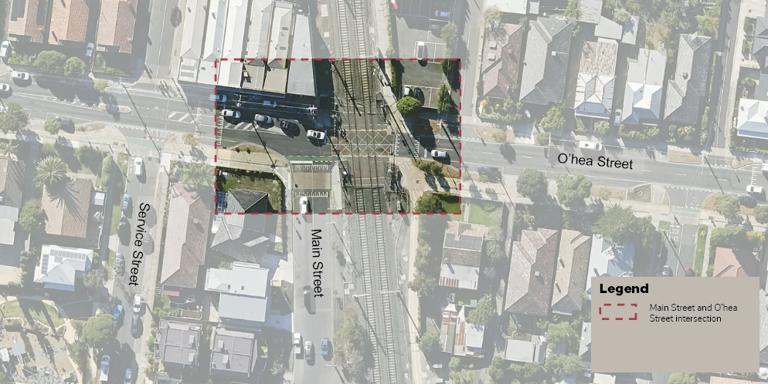
Figure 1 Site context
The road safety concerns typically relate to conflicts between people walking and riding east-west on O’Hea Street and vehicles entering or exiting Main Street. Over the past ten years, there have been multiple efforts made to improve road user safety at the intersection. These include:
• Installing a raised threshold in 2019 to manage vehicle speeds and make it more comfortable for people crossing
• Removing the right-turn only lane from O’Hea Street at Main Street in 2019
• Installing a speed hump on the west approach on O’Hea Street in 2019
• Writing to the Department of Transport and Planning (DTP) and VicTrack in 2020 and 2024 to request improvements be made to the level crossing to allow people on bikes to cross on the south side of the level crossing
• Writing to DTP in 2024 to request DTP to fully signalise the level crossing, providing safe north-south crossing points on both sides of the Upfield Line
• Requesting support and permission from DTP in 2024 to install ‘zebra’ line marking across the raised threshold to give people walking clear priority at the crossing
• Unsuccessfully advocating for O’Hea Street to be included in the Coburg Level Crossing Removal Project
Whilst there has been some reduction in the frequency of crashes occurring at the site since 2019, road safety concerns, particularly for people walking and riding at the intersection, persist.
An extension to the bike path from Sussex Street to Irvine Street is scheduled to be constructed this financial year, and this project is anticipated to increase the volumes of people walking and riding on the O’Hea Street paths. Through the community consultation process about the proposed extension in April 2024, safety concerns for people walking and riding along the existing O’Hea Street path at the Main Street intersection were raised again. As a result, Council resolved to receive a report on the crash history of the site and further recommendations to mitigate the safety issues.
Additionally, Council has received funding from the TAC for safety analysis of all 15 of the priority crossings along the existing O’Hea Street bike path. This project is just beginning, however the Main Street intersection has been excluded from the project, as it has unique challenges which are discussed below.

3. Issues

Crash history
An analysis of the recorded crash history along O’Hea Street between Sussex Street and Sydney Road for the past 10 years has been undertaken by officers. Figure 2 below shows a map of recorded crashes along the corridor between July 2015 and June 2023. Notably, the highest concentration of crashes is at the Main Street intersection, where a total of seven crashes have been recorded through DTP’s Road Crash Information System (RCIS). Of those seven crashes, six involved a person walking or riding. Only crashes where police or emergency services have attended, or been made aware of the crash, are included in this database, so the actual number of crashes in this location may be higher than what is shown. Officers are also aware that near misses occur at this location, as we regularly receive customer requests relating to this site.
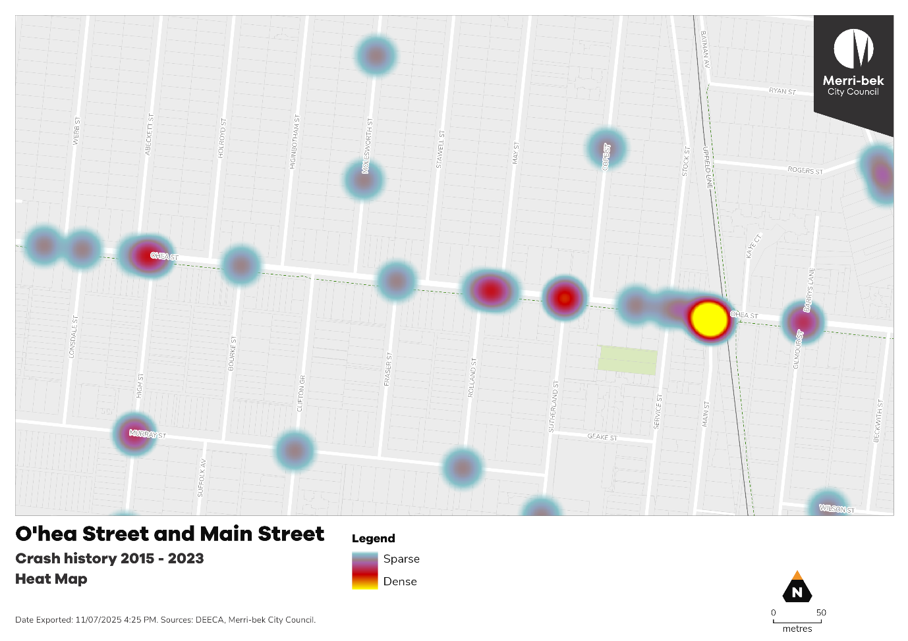
Figure 2 Heat map of recorded crashes on O’Hea Street between July 2015 and June 2023. Source: DTP 2025.

Crash trends
Based on the above analysis, as well as reviewing police reports of the recorded crashes, some trends have been identified in the crashes at the Main Street and O’Hea Street intersection. Five out of the seven crashes recorded at the intersection were very similar in nature. In these instances, a person was riding eastbound on the bike path towards the railway line and collided with a north-bound vehicle while crossing over Main Street.

Unclear priority
This trend highlights a potential issue with the existing layout of the intersection, as there appears to be confusion and uncertainty about which road users have priority at the crossing.
The crossing is not a priority crossing, so northbound vehicles do not have to give way to people walking across the crossing. However, according to the Victorian Road Rules, all vehicles turning from O’Hea Street onto Main Street, heading southbound, must give way to all people walking across the crossing. As the westbound bike lane is in front of the ‘STOP’ line, northbound vehicles must give way to people riding westbound. But there is no eastbound bike lane provided on this side of the road, so northbound vehicles are not expected to give way to people riding eastbound. This is further confused, as the crossing is coloured yellow, which is generally used for shared path crossings, where people walking and riding have priority.

Constraints on making significant improvements to the crossing
A simple solution would be to convert the existing raised threshold into a shared priority crossing, giving people walking and riding priority to cross at all times. This would be consistent with the other 15 crossings along the O’Hea Street bike path. However, the main factor that has led to the inconsistent existing layout is the fact that this intersection is adjacent to the Upfield Line level crossing, and currently people riding bike eastbound are not able to cross the rail line on the south side of O’Hea Street.

Level crossing
In order for the crossing over Main Street to be made into a priority crossing, people riding bikes in both directions would need to be able to continue riding over the railway line. For people riding westbound, there is a currently a dedicated bike lane that is sufficient for this purpose. However, for people riding eastbound, they are expected to cross the road further west at Service Street where there is no protection or priority, and then ride along the north of O’Hea Street, before making a second, unprotected crossing back to the path on the east side of the rail line, as shown in Figure 3 below.
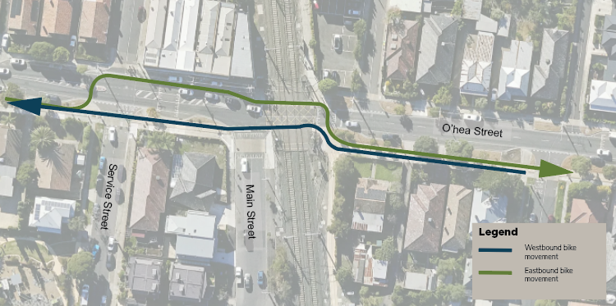
Figure 3 Designated paths of travel for people on bikes across the rail crossing
As this is an undesirable, indirect, and not particularly safe movement, many people riding bikes opt to continue eastbound on the bike path and ride the wrong way on the bike lane over the railway line or use the pedestrian level crossing. Below in Figure 4 is a screenshot from Google Maps, showing a person on a bike riding the wrong way on the bike path and bike lane. This is an indication that the current infrastructure arrangement is not meeting the needs of the people using the facility.
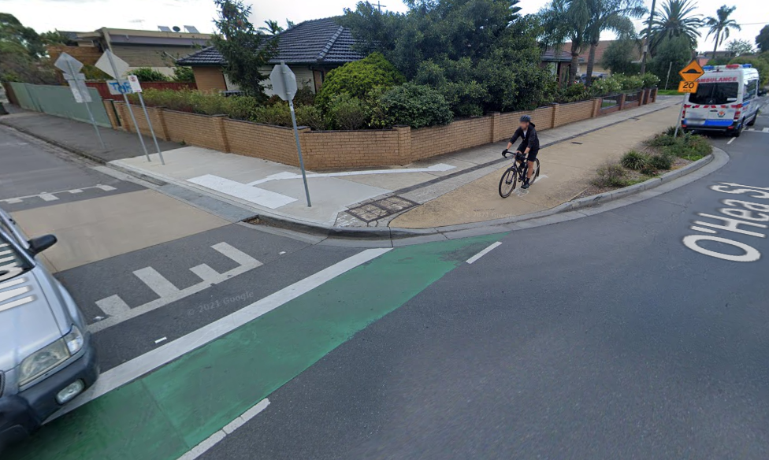
Figure 4 Person on bike riding the wrong way on the O’Hea Street bike path
It is understood that the reason for this indirect designated path for people on bikes may relate to VicTrack’s design standards restricting the use of bikes on pedestrian level crossings. Council has previously sought to work with VicTrack (the land and rail infrastructure owner) and Metro Trains Melbourne (the rail authority) to develop a design solution that would allow eastbound riders to legally and safely cross the rail line on the south side of the street.
Officers will continue to advocate to state agencies to allow an at-grade bike crossing in this location, but acknowledge this may not be successful. Other advocacy considerations should include removal of the O’Hea Street level crossing at some point in the future.

Restricting vehicle movements at the intersection
Another potential solution to significantly reduce crash risk at the Main Street intersection would be to either fully or partially restrict vehicle movements in and out of Main Street at O’Hea Street. This would separate people walking from vehicle traffic and would remove any conflicts with vehicles for westbound people on bikes. However, the issues with eastbound people on bikes discussed above would remain.
This option is currently not possible, as the Route 527 bus uses Main Street. The 527 bus route is relatively indirect, and it may be that this route could be reviewed if the State government proceeds with a northern suburbs bus network reform.
Additionally, the traffic signals at the intersection of Main Street and Bell Street are a significant generator of traffic. Restricting traffic movements through the north of Main Street would have to be considered in the context of the signalised intersection at Bell Street and Main Street. Both of these options are likely to be longer term considerations.

Short term recommendations
Acknowledging the significant constraints, there are some smaller improvements that could be pursued in the short term. The proposed treatments are shown in Figure 5 below.
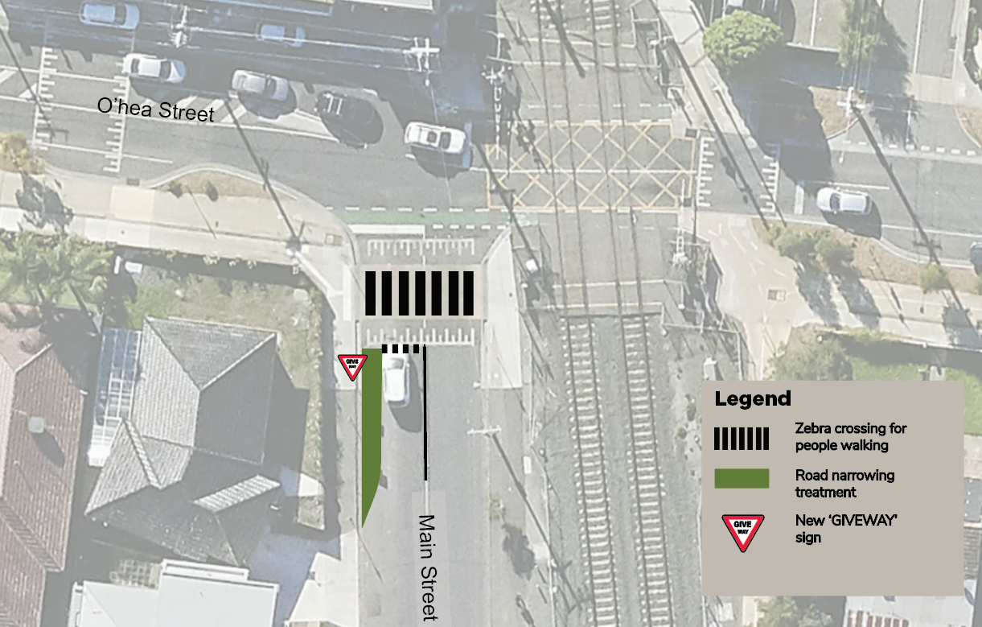
Figure 5 Proposed short term intersection improvements
It is recommended that Council continue to seek permission from DTP to install zebra line-marking and associated signage across the Main Street crossing. This would provide unambiguous priority for people walking across the intersection. It should be noted that this would not resolve the issues for people riding bikes eastbound, who would continue to not have priority to cross the intersection while riding. A road safety audit may also be required.
The crossing could be further improved by looking at opportunities to narrow the northbound lane of Main Street. This could either be done with line marking, kerb build outs, or potentially with in-road tree pits or low-level garden beds (subject to feature and level surveys, overland water flows, drainage infrastructure, and swept path analysis and any other consideration raised through detailed design). It is recommended that officers investigate this, and if suitable, deliver the works from Council’s annual Road Safety program.

Long term recommendations
Officers recommend a number of longer-term advocacy solutions to fully resolve the issue. These are:
• Advocate to state government, VicTrack, and MTM to allow people on bikes to use the pedestrian level crossing at O’Hea Street
• Continue to advocate for full signalisation of the intersection, including the Upfield shared path crossing on the east side of the rail line
• Continue advocating for DTP to deliver bus reform in the area. If Route 527 is reformed and no longer uses Main Street, investigate a partial or full road closure at Main Street

Other options considered and not recommended
Officers also explored an additional option to improve safety of all road users in the area, without changing any of the existing designated paths of travel. Figure 6 below shows a design treatment that includes:
• Zebra line-marking on existing raised threshold for pedestrian priority at all times
• Maintaining westbound bike movements
• Installing new priority crossing west of Service Street for people riding eastbound to cross O’Hea Street
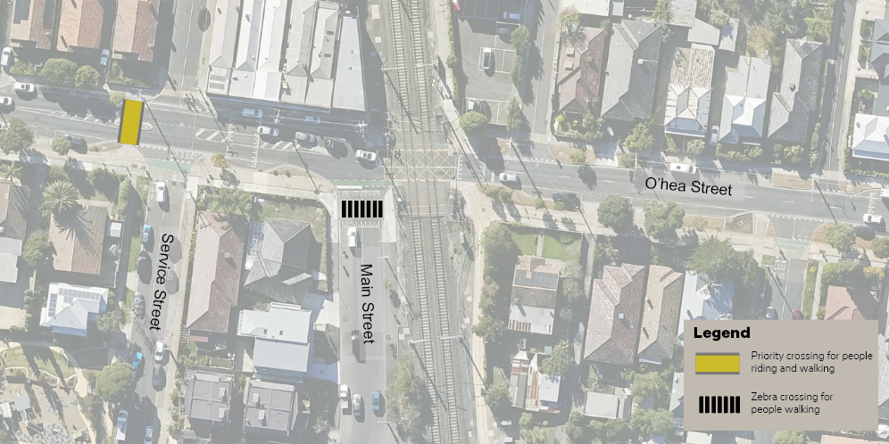
Figure 6 Alternate option (not recommended)
This option would improve safety for people walking at Main Street and would provide a safer and more desirable option for people riding eastbound to cross to the north of O’Hea Street. However, it is likely that people riding eastbound would still prefer to stay on the south side of O’Hea Street, as this would avoid crossing the road a second time east of the rail line.
It is also not guaranteed that the proposed priority crossing would be supported by DTP and Victrack given its proximity to the level crossing, as there may be potential for traffic to queue back into level crossing while waiting for people to make the crossing.
Officers also considered formalising the raised threshold on Main Street as a priority crossing for people riding and walking by making it a yellow priority crossing with give way line-marking and signs. This could be done cost-effectively using line-marking and signage to meet the standards, without addressing the issue of eastbound people on bikes crossing the rail line. This would give unambiguous priority to all people walking and riding at the intersection, regardless of direction.
However, this would result in a situation where people riding eastbound would arrive at the rail line with no legal place to ride further. While it is noted that this is already happening regularly, by formalising this, there is a risk to Council for facilitating potentially unsafe movements at the level crossing.
Given the issues with these two options, officers do not recommend pursuing either approach at this stage.

Community impact
The recommendations of this report are intended to contribute towards improving safety and liveability of the streets surrounding the Main Street and O’Hea Street intersection. Before any changes are made to the street, all impacted residents and businesses will be notified of the proposed changes, and have an opportunity to have any concerns heard.

Climate emergency and environmental sustainability implications
Transport emissions are the second largest source of emissions in Victoria and are set to become the largest source in the coming years.
Reducing transport emissions and the effects of climate change is a key focus of the transport strategy. Council aims to reduce transport emissions by providing infrastructure that enables people to use zero emission transport modes such as walking and cycling, by supporting our community to switch to electric vehicles, by advocating to the State Government for improvements to public transport infrastructure and services, and by supporting increased densities in activity centres and around transport hubs.
Improving important active transport connections, such as along the O’Hea Street bike path, will provide opportunities for more people to choose low and zero emission transport modes for their local trips and support community efforts to reduce their transport emissions.

Economic sustainability implications
Improving the safety of all road users at the O’Hea Street and Main Street intersection will make the site more attractive and accessible to more people. As such, it is expected that the improvements will positively impact the local businesses on O’Hea Street.

Human Rights Consideration
The implications of this report have been assessed in accordance with the requirements of the Charter of Human Rights and Responsibilities, and the assessment has found that the recommendation will not have any adverse impacts any persons human rights. Specifically, the right to freedom of movement (section 12) is expected to be improved for people, particularly those walking in the area.

4. Community consultation and engagement

Previous community consultation
In April 2024, we held community engagement on proposed extension of the O’Hea Street bike path between Sussex Street and Irvine Street. Through this round of consultation, we asked respondents about how they felt about the existing bike path on O’Hea Street. Approximately 15% of respondents specifically mentioned concerns related to the Main Street intersection, and 33% mentioned concerns about drivers not giving way at the side street crossings in general.
Affected persons rights and interests
Before making a decision that affects a person’s rights, Council must identify whose rights may be directly affected and provide an opportunity for that person (or persons) to convey those views regarding the effect on their rights and consider those views. The recommendations of this report are not expected to directly affect any persons rights.

Communications
Before any proposed changes are made, residents and businesses nearby the works will be notified via letter of the upcoming works.

5. Officer declaration of Conflict of Interest
Council officers involved in the preparation of this report have no conflict of interest in this matter.

6. Financial and resources implications
The recommendation in this report includes minor capital works, predominantly comprised of line-marking and new signs. It is anticipated that this would cost up to $20,000. Whilst this hasn’t been specifically forecast for in the 2025-26 capital works program, it will be able to be delivered with the existing Transport – Road Safety budget designated to mitigate speeding and road safety issues.
Additionally, the officer time required to advocate to the relevant bodies for improvements will be covered with existing resources.

7. Implementation
Subject to Council’s decision, officers will follow up with DTP to get in principle support for the zebra crossing line-marking and signs. If a road safety audit is required by DTP, officers will commission this, implement any recommendations of the audit, and deliver the works.
Officers will begin discussions again with DTP, VicTrack and MTM to better understand why the crossing can’t be adapted to allow for people on bikes to use it and discuss potential outcomes.

Attachment/s
There are no attachments for this report.

7.8 Council Advisory Committee Review
Director Business Transformation, Sue Vujcevic
Governance and Strategy

Officer Recommendation
That Council:
1. Endorses the proposal to establish the following Advisory Committees and reference groups to support the delivery of its strategic directions and objectives, together with relevant Terms of References as provided in Attachment 1:
a) Environmental Sustainability and Climate Resilience Advisory Committee.
b) Health, Wellbeing and Social Inclusion Advisory Committee; supported by the following Reference Groups:
i) Gender Equality Reference Group
ii) LGBTIQA+ Reference Group (established as part of the LGBTIQA+ Action Plan)
iii) Disability Reference Group
iv) Older Persons Reference Group.
c) Liveability Advisory Committee; supported by a Strategic Transport Reference Group.
d) Merri-bek Arts Advisory Committee
e) First Peoples Advisory Committee.
2. Initiates a public engagement process to invite applications for membership for the newly established Council Advisory Committees.
3. Receives a report at its October 2025 Council meeting detailing the outcomes of the application process and appoint members and Councillors accordingly.

REPORT

Executive Summary
Council is committed to putting the community and its customers first.
The Community Engagement Policy was adopted by Council on the 9 December 2020, superseding Council’s Community Engagement and Public Participation Policy 2018. It supports Council’s integrated strategic planning and reporting framework required under the Local Government Act 2020 (the Act) and meets Council’s legislative requirements for community engagement which is a key focus for local government.
Council’s Advisory Committees are an important network of stakeholders who are regularly engaged to provide detailed feedback on Council’s operations and decisions that may affect specific communities. Council’s Advisory Committees play a key role in providing early advice to Council about significant strategies and policies that impact the community.
The outcome of the Advisory Committee Review seeks to establish five Advisory Committees, each aligned to a Strategic Direction in the Council Plan 2025–2029, to ensure:
• advice is aligned with Council’s key priorities;
• governance is streamlined and efficient;
• engagement compliments the requirements of the Act; and
• committees reflect good governance and responsible resource management.

Previous Council Decisions
Review of Council’s Advisory Committees – 11 August 2021
That Council:
1. Note the findings of a recent review undertaken of Council’s Advisory Committees.
2. Endorse the proposal to establish the following Advisory Committees by November 2021:
a) Sustainable Transport Advisory Committee
b) Environmental Sustainability Advisory Committee
c) Human Rights and Inclusion Advisory Committee
d) Moreland Arts Advisory Committee
3. Endorse the proposal for Council officers to review Reference Groups and Working Groups with a view to refreshing or establishing these by December 2021.
4. Endorse that Council officers implement process improvements to enable better quality coordination of Advisory Committees.

1. Policy Context
The Advisory Committee review enhances Council’s commitment to integrated strategic planning and community engagement, as required under the Act.
The establishment of five Advisory Committees, each aligned to a Strategic Direction within the draft Council Plan 2025–2029, to ensure advice is aligned with Council’s key priorities, directions and increases Council’s strategic oversight.

2. Background
Council’s current Advisory Committees and Reference Groups have played an important role in advising on key policies, emerging issues and investments. The current model was developed to align with the themes included in Council Plan 2021 – 2025, to effectively assist Council in achieving its planned objectives.
The existing Advisory Committees and Reference Groups structure consists of the following:
• Human Rights and Inclusion Advisory Committee
• Environmental Sustainability Advisory Committee
• Merri-bek Arts Advisory Committee
• Sustainable Transport Advisory Committee
• First Nations Advisory Committee
• Gender Equality Reference Group
• LGBTIQA+ Reference Group
• Disability Reference Group
• Older Persons (Age Friendly) Reference Group
• Affordable Housing Reference Group
• Heritage and Local History Reference Group.

3. Issues
Council officers have undertaken a review of the current Advisory Committees and Reference Groups to assess their alignment with the draft Council Plan 2025–2029. The review identified a clear opportunity to streamline and strengthen the advisory framework to better reflect contemporary governance expectations and legislative requirements.
While existing structures have served their intended purpose, feedback and legislative reforms point to the need for a more focused and strategic model. The introduction of the Local Government Act 2020 marked a significant shift in Council operations, particularly in how Councils engage with communities. Unlike the 1989 Act, the new Act mandates the adoption of a Community Engagement Policy, requiring Councils to engage on key statutory matters (such as the Council Plan, Financial Plan, Asset Plan and major policies). This ensures engagement is now carried out through structured, fit-for-purpose mechanisms.
Notwithstanding the above, Council’s Engagement Policy provides that Advisory Committees play a key role in providing early advice to Council about significant strategies and policies that impact the community.
Council seeks to align its advisory structure with the five strategic directions of the draft Council Plan, ensuring that community and expert input remains high quality, targeted and strategically integrated.
It is recommended Council establish five Advisory Committees, each aligned to a Strategic Direction in the Council Plan 2025–2029, to ensure advice is aligned with Council’s key priorities; governance is streamlined and efficient; engagement compliments the requirements of the Act; and committees reflect good governance and responsible resource management.
The revised Committees will provide community-informed and expert advice on each strategic direction; operate under clearly defined Terms of Reference aligned to Council’s objectives; avoid duplication of statutory engagement under the Community Engagement Policy; and enable broad representation through purpose-driven engagement.
This structure supports more targeted and integrated decision-making, reduces administrative burden, and increases Council’s strategic oversight.
Proposed Structure:
a) Strategic Alignment and Integration
Each Committee will focus on one of the five strategic directions, ensuring coordinated advice that supports cross-disciplinary approaches.
Committees will help inform initiatives that span multiple policy areas and objectives.
b) Efficient and Effective Governance
Limiting to five Committees avoids fragmentation and supports deeper, more meaningful engagement.
Reduces duplication and administrative costs while enhancing impact.
Committees will draw on sector expertise, community insights and stakeholder input to advise, monitor progress, and support implementation of key Council initiatives.
Based on the draft Council Plan 2025–2029, it is recommended Council establish the following five Advisory Committees to support delivery of its strategic directions and objectives:
1. Theme: Care for Nature and Climate Resilience
Proposed Committee: Environmental Sustainability and Climate Resilience Advisory Committee
Focus: Advise on biodiversity, greening, water management, climate adaptation, emissions reduction and circular economy initiatives. This committee may include local environmental groups, climate experts and community representatives to ensure strong community engagement and technical input into Council’s environmental strategies.
Replaces existing committees, reference and working groups:
• Environmental Sustainability Advisory Committee
2. Theme: Healthy and Inclusive Communities
Proposed Committee: Health, Wellbeing and Social Inclusion Advisory Committee
Focus: Guide actions on public health, mental wellbeing, active living, social connection, accessibility and equity. Membership may include health professionals, community service providers, representatives from diverse cultural and demographic groups, and people with lived experience of disability or disadvantage.
Replaces existing committees, reference and working groups:
• Human Rights and Inclusion Advisory Committee
It is further recommended that Council retain the following existing reference groups to deliver priorities under this theme:
• Gender Equality Reference Group
• LGBTIQA+ Reference Group
• Disability Reference Group
• Older Persons Reference Group
Retaining these reference groups is highly valuable, as they ensure Council’s decisions, services and initiatives are shaped by the real-life experiences of those they impact most.
Their insights help Council respond to current and emerging community needs, amplify underrepresented voices, and promote inclusion and fairness across all areas of work. This lived experience is not only vital for meaningful engagement but is also recognised as best practice in inclusive local government across Victoria.
3. Theme: Beautiful and Liveable City
Proposed Committee: Liveability Advisory Committee
Focus: Provide advice on urban planning, affordable and social housing, public realm improvements, transport accessibility and placemaking. This committee may bring together architects, urban planners, housing advocates and residents to ensure projects enhance liveability and inclusivity.
Replaces existing committees, reference and working groups:
• Sustainable Transport Advisory Committee
• Affordable Housing Reference Group
• Heritage and Local History Reference Group
However, it is recommended to retain and transition the Sustainable Transport Advisory Committee into the Strategic Transport Reference Group and place it under the new Liveability Advisory Committee.
By doing so, the transport reference group can focus more closely on providing specialised community insights and lived experience relating to transport needs, while benefiting from strategic alignment with related areas such as land use, sustainability, accessibility and public space planning. This transition promotes more coordinated, holistic advice that reflects how transport interacts with other key urban factors, enhancing Council’s ability to plan effectively and inclusively.
In addition, as a reference group rather than a standalone committee, the transport group can be more agile and engaged in continuous dialogue with both the strategic oversight committee and the community, ensuring that lived experience and diverse perspectives remain central to transport-related policy and project development within the broader urban planning context.
4. Theme: Thriving Economy and Culture
Retain existing Committee: Merri-bek Arts Advisory Committee
Merri-bek Arts Advisory Committee to continue focussing on Merri-bek’s role as a vibrant creative and cultural destination within Melbourne, enhancing local community cohesion and inclusion. The Committee advises Council on annual arts and creative industry priorities, fosters community engagement and participation through diverse networks, and provides recommendations on acquisitions for the Merri-bek’s Art Collection. It also serves as a vital channel for reflecting the community’s artistic interests and perspectives to Council and its staff.
5. Theme: Theme: Engaging and Responsible Council
An overarching Advisory Committee is not recommended due to legislative responsibilities and expert guidance available through Audit and Risk Committee as well as established policies and best practice guidelines.
However, it is recommended to retain the existing committee:
• First People Advisory Committee
Council continues to retain the ability to establish short-term working groups or reference groups under each committee as needed for specific projects, without diluting the strategic focus of its Advisory Committee structure.
Working groups and reference groups for specific projects, can also serve as an opportunity to ensure proper and/or targeted representation and advice is available (as required) on specific topics and projects.
Administrative improvements have been identified, particularly regarding quorum requirements, the ability to convene meetings if the Councillor Chair is unavailable and setting a maximum tenure for membership. In particular, the Co-Chair model within the First Nations Advisory Committee has proven effective and is recommended for continuation.
These considerations will be incorporated into new Terms of Reference, which will be finalised in consultation with convenors. These changes are intended to enhance the effectiveness, flexibility, and clarity of our advisory structures moving forward.

Community impact
The outcomes of the Advisory Committee Review will enable a more focused contribution from the various Committees and improved engagement between council and the community.

Climate emergency and environmental sustainability implications
The Advisory Committee Review will enable the Committees to contribute and support Council’s climate emergency and environmental sustainability directions.

Economic sustainability implications
The Advisory Committee Review will enable the Committees to contribute and support Council’s economic sustainability directions.

Legal and risk considerations
The Advisory Committee Review is in accordance with the Local Government Act 2020 and particularly Council’s Community Engagement Policy.

Human Rights Consideration
The implications of this report have been assessed in accordance with the requirements of the Charter of Human Rights and Responsibilities.
Advisory Committees, the community and those affected by decisions and actions will continue to have the opportunity to contribute to decision making and participate in the process.

4. Community consultation and engagement
The Local Government Act 2020 empowers Councils with the authority to establish committees as needed to support their governance functions. As the intention of this review is to ensure that Council Advisory Committees are strategically aligned with the Council Plan - which has already undergone extensive community consultation - additional community consultation is not considered necessary for this process.
Affected persons rights and interests
There are no adverse impacts on the rights and interests of affected persons in relation to this report.

5. Officer Declaration of Conflict of Interest
Council officers involved in the preparation of this report have no conflict of interest in this matter.

6. Financial and Resources Implications
The outcomes of this review have no financial or resources implications as they are contained within the existing budget allocations.

7. Implementation
Pending Council endorsement of the Advisory Committee structure and Terms of Reference, officers will commence the recruitment process for external members to the Advisory Committees which will then be presented to Council in October 2025 for endorsement and confirmation of appointments.

Attachment/s
1 | Proposed Terms of Reference - Advisory Committees 2025 | D25/402523

7.9 Draft Asset Plan for Public Exhibition
Director City Infrastructure, Anita Curnow
Capital Works Planning and Delivery

Officer Recommendation
That Council:
1. Endorses the draft Asset Plan 2025-2035, provided as Attachment 1 to this report, for the purpose of community exhibition.
2. Invites feedback on the draft Asset Plan 2025-2035 for the public exhibition period, from 15 August 2025 until 12 September 2025.
3. Makes the draft Asset Plan 2025-2035 available on the Council website and hard copies available at the three civic centres and all libraries.

REPORT

Executive Summary
The Local Government Act 2020 (the Act) requires Council to develop, adopt and maintain a 10-year Asset Plan for maintenance, acquisition, disposal and management of Council-managed assets. A review of the Asset Plan must be completed by 31 October in the year following a General Council election.
Council’s $1.9 billion portfolio of assets has been built up progressively over many decades. Assets such as roads and drainage provide the building blocks of our way of life, while others add to the quality of life by facilitating recreation, arts, culture, health and educational activities. Our assets are also integral to us achieving our zero carbon, water management and social inclusion goals, and support local business and economic development.
The Act requires the Asset Plan to be developed and reviewed through deliberative engagement process in accordance with Council’s engagement policy. The draft Asset Plan has been developed in line with Council’s deliberative engagement practices and have drawn from the engagement outputs from the deliberative panel formed as a part of the Council Plan and Community Vision review.

Previous Council Decisions
There have been no previous Council decisions on the draft Asset Plan.

1. Policy Context
The draft Asset Plan is integrated with the broader Council planning framework that aligns closely with the Community Vision, Council Plan and the draft Long Term Financial Plan. These alignments ensure that the asset management decisions support our overall strategic objectives and are compliant with legislative requirements.

2. Background
Pursuant to Section 92 of the Local Government Act 2020 (the Act), Council must develop, adopt and keep in force an Asset Plan in accordance with Council’s deliberative engagement practices. The plan must encompass information on maintenance, renewal, expansion, acquisition, disposal and decommissioning of assets for which Council is responsible. Council must review the Asset Plance in accordance with its deliberative engagement practices and adopt the Asset Plan by 31 October in the year following a general election.
The draft Asset Plan (Attachment 1) covers Transport Infrastructure, Buildings & Facilities, Stormwater Infrastructure and Open Space.
Below is a snapshot from the draft Asset Plan summarising the current state of Council’s infrastructure assets.
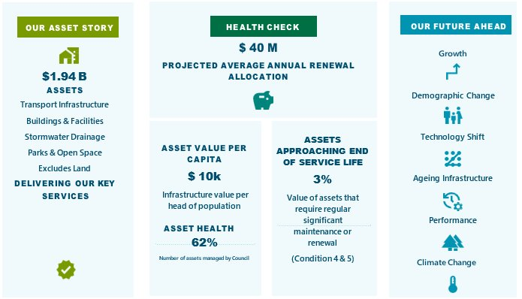
Our Assets | $ 913M    Transport Infrastructure | $ 330M    Stormwater Drainage | $ 231M    Open Space | $ 470M    Buildings & Facilities

3. Issues

Community impact
The draft asset plan is an overarching document that lays a strategic framework for how Council’s financial investment decisions are made to provide optimum level of service to the Community by the utilisation of Council’s physical assets.

Climate emergency and environmental sustainability implications
The scope of capital projects included in the draft Asset Plan for each asset class will account for both emissions abatement and climate adaptation.
Emissions reduction is achieved by building projects incorporating costs for sustainable design to promote energy efficiency and use of green energy. Use of recycled materials in construction and minimising demolition also reduce the carbon footprint of our asset programs and create opportunities around the circular economy.
Climate risk considerations impact significantly on the design of assets. For example, rather than replace like-with-like, officers will review drainage capacity as drains are replaced to accommodate more severe storm events and reconsider selection of materials based on their performance at higher temperatures given the hotter summers we’re experiencing. These challenges are reflected in the forthcoming Climate Risk Strategy which will work hand-in-hand with the Asset Plan.

Economic sustainability implications
The Asset Plan is a key document that sets a strategic framework for financial investment decision making to provide optimum level of service to the community by utilisation of assets. The life cycle model of asset from acquisition through to disposal/renewal and inclusion of maintenance costs is a representation of how sustainable our asset management practices are.

Legal and risk considerations
The draft Asset Plan is prepared in accordance with the requirements of the Local Government Act 2020. Whilst there are no significant risks associated in adopting the reviewed Asset Plan, there are reasonable risks if an Asset Plan is not reviewed, such as non-compliance with the requirements of the Act and lack of strategic framework guiding financial investment decisions for asset sustainability.

Human Rights Consideration
The implications of this report have been assessed in accordance with the requirements of the Charter of Human Rights and Responsibilities. The adoption of the draft Asset Plan does not violate the Victorian Human Rights Charter.
For the Asset Plan as a whole, a Gender Impact Assessment is not deemed required. However, it is noted that for some asset categories, strategies guiding their prioritisation and scoping and individual category asset management plans will need to be developed with the insights gained through Gender Impact Assessments.

4. Community consultation and engagement
The draft Asset Plan has been developed in line with Council’s Deliberative Engagement practices and has drawn from the engagement outputs from the deliberative panel formed as a part of the Council Plan and Community Vision review.
Section 5 of the draft Asset Plan (Attachment 1) provides details of the community engagement approach and outcomes of the engagement in relation to Asset Plan.

Affected persons rights and interests
Before making a decision that affects a person’s rights, Council must identify whose rights may be directly affected and provide an opportunity for that person (or persons) to convey those views regarding the effect on their rights and consider those views.
The development and public exhibition of the draft Asset Plan has not affected any persons’ rights and interests to the best knowledge of Council officers.

Communications
Assuming Council resolves to proceed to exhibition for the draft Asset Plan it will be made available online for community to provide comment and feedback. In addition, physical copies of the plans will be located at customer facing Council facilities to make the draft available to the community to read and provide feedback. Officers will also use social media to make sure that draft reaches as many members of the community as possible. Officers will respond to enquiries from any residents seeking to engage in languages other than English or through a discussion rather than written feedback.

5. Officer Declaration of Conflict of Interest
Council officers involved in the preparation of this report have no conflict of interest in this matter.

6. Financial and Resources Implications
The adoption and implementation of the draft Asset Plan has no direct financial and resource implications. The plan sets out the financial projection in capital and maintenance cost in each asset classes, which is in accordance with the draft Long Term Financial Plan. The Asset Plan, once adopted, must be reviewed by 31 October in the year following a general election of the Council. The cost to achieve the 31 October 2029 milestone will depend on the level of engagement to be undertaken and additional technical support provided and would mostly be incurred in 2028/29 and therefore considered as the 2028/29 budget is prepared.

7. Implementation
This Council report is seeking resolution to exhibit the draft Asset Plan for community feedback over a period of 4 weeks. After the public exhibition period, Council officers will review all feedback received and recommend subsequent changes to the Asset Plan. The proposed final Asset Plan and summary of community feedback will be reported to Council at the October 2025 Council Meeting.

Attachment/s
1 | Merri-bek Draft Asset Plan | D25/397787

7.10 Draft Merri-bek City Council 10-year Financial Plan 2025-2035
Director Business Transformation, Sue Vujcevic
Finance Management

Officer Recommendation
That Council:
1. Endorses the draft 10-year Financial Plan 2025-2035, at Attachment 1 to this report, for the purpose of community exhibition.
2. Invites feedback on the draft 10-year Financial Plan 2025-2035 for the public exhibition period, from 15 August 2025 until 12 September 2025.
3. Makes the draft 10-year Financial Plan 2025-2035 available on the Council website and hard copies available at the three civic centres and all libraries.

REPORT

Executive Summary
The Local Government Act 2020 requires each Council to prepare a Financial Plan covering a minimum period of 10-years following each Council election. The draft 10-year Financial Plan 2025-2035 (the draft Financial Plan) covers the periods 2025-26 to 2034-35.
The purpose of this report is to seek Council endorsement of the draft Financial Plan (shown at Attachment 1) for public exhibition to receive community feedback.
The draft Financial Plan is one of a number of integrated documents that have been developed to provide a robust and transparent system of financial management aligned to the longer-term aspirations for Merri-bek and as expressed in the newly refreshed Community Vision and Council Plan.
The draft Financial Plan is an important document as it sets out broadly how Council can fund essential services and projects in coming years. The draft Financial Plan is a decision-making tool to identify Council’s current and projected financial capacity to meet Council’s future needs in providing services and facilities to the community based on the goals and aspirations of the draft Council Plan. The long-term outlook for Council displays prudent financial management.

Previous Council Decisions
Nil.
1. Policy Context
In accordance with section 91 of the Local Government Act 2020, Council must:
a) Develop, adopt and keep in force a Financial Plan for at least the next 10 financial years in accordance with its deliberative engagement practices.
The Financial Plan must be prepared in accordance with Council’s deliberative engagement practices by 31 October in the year following a general election.

2. Background
The draft Financial Plan looks at the assumptions and budget parameters that have been applied to the 4-Year budget and extends these out into years 5 to 10 in order to give a long-term view of Council’s financial viability and outcomes.
Each year the 10-Year Financial Plan will be reviewed and updated to reflect the circumstances of Council at the time, and any proposed changes will be considered for adoption by Council as a part of the annual budget process.
Under the Local Government Act 2020, and in accordance with Council’s Community Engagement Policy, Council is required to prepare the Financial Plan in accordance with its deliberative engagement practices in future years.
The draft Financial Plan is included as Attachment 1 to this report.

3. Issues
The preparation of a 10-year Financial Plan generates improved information to guide Council’s decisions about the need, timing and priority of proposed expenditure. Key financial indicators are also used to monitor Council’s long-term financial sustainability are in line with established benchmarks.
The draft Financial Plan seeks to ensure we have the financial capacity to continue to provide service levels which meet the needs of our community in a financially sustainable way by:
• Maintaining a modest operating surplus over the life of the Financial Plan whilst spending on renewal and upgrade of community assets.
• Striving to continually improve the way that we deliver our existing and future services and proactively seeking out savings without affecting service delivery levels to the community.
• Monitoring our asset condition data and prioritising the renewal of community infrastructure and facilities.
• Addressing the increasing costs, environmental impacts and potential service changes to council waste services. This includes the investigation of a transition to a four-bin service to reduce waste to landfill and improve the quality of recyclables.
• Monitoring and planning for the ongoing demand for new infrastructure driven by growth, changes in demographics, and increasing community expectations via the development of a comprehensive and evidence driven Asset Management Plan that is discussed and supported by the community.
• Saving for significant investment in placemaking projects (such as the Coburg library and piazza project). Placemaking projects capitalise on a community's assets, inspiration, and potential, with the intention of creating public spaces that promote people's health, happiness, and wellbeing'.
• Saving for the ‘Parks close to home’ strategies that will utilise a large proportion of the broader open space reserve funding to fill open space gaps across Merri-bek. Not only creating and improving access to open space in the area but ensuring new parks and locations are sought opportunistically each year.
• Saving for significant investment in aquatic projects including the Coburg Leisure Centres redevelopment. Upgrading and maintaining Aquatic and Leisure Facilities as outlined in the Moreland Aquatic and Leisure Strategy. Unlike general building infrastructure, Council’s six facilities aquatic infrastructure have a life cycle of approximately 50 years and significant ongoing investment is required. Investment in this strategy reinforces Council’s commitment to improving the health and wellbeing of residents by providing infrastructure and services that support good health outcomes;
• Maximise external contributions in relation to Development and Open Space Contributions Reserve.
• Ensuring that our debt and interest profile remains at a level that is low enough to guarantee our capacity to service and repay this debt into the future.
• Operating within the key financial indicators and benchmarks to ensure we maintain a sound financial position.
• Advocate strongly within the sector to secure funding where possible and strive to increase sustainable opportunities to diversify Council’s revenue base.
In summary, Merri-bek Council is committed to ensuring the responsible and the maximum allocation of funds to initiatives to progress the ongoing and future needs of the local community.

Human Rights Consideration
The implications of this report have been assessed in accordance with the requirements of the Charter of Human Rights and Responsibilities.

4. Community consultation and engagement
Council launched its engagement program in November 2024 with consultation on the Budget 2025-2029 where over 40 ideas were submitted and over 1,000 people participated. Earlier this year deliberative engagement commenced to realise the Community’s vision for the future of Merri-bek.
Deliberative workshops were held over 3 days in February on the Community Vision and priorities for strategic plans. Over 60 residents, representative of the Merri-bek community, refreshed our Community Vision and provided an insight into what is important to the Merri-bek community.
Councillors also participated in three workshop sessions during January to May to formulate and consolidate Council Plan priorities to inform all other strategic documents. A review and analysis was also undertaken of all significant community engagement projects undertaken by Council in the last 4 years.
The draft Community Vision and draft Council Plan 2025-2029 was out for community consultation from 25 June 2025 to 22 July 2025. The next stage of the engagement process involves the draft Asset Management Plan and draft 10- Year Financial Plan to go on public exhibition from 15 August 2025 until 12 September 2025.
Submitters have the opportunity to talk about their feedback directly with Council on the draft Community Vision and draft Council Plan at a session to be held 29 July 2025.

5. Officer Declaration of Conflict of Interest
Council officers involved in the preparation of this report have no conflict of interest in this matter.

6. Financial and Resources Implications
Costs associated with the preparation of the draft Financial Plan, including the cost of public exhibition, are funded from the 2024-25 operating budget allocations.

7. Implementation
Subject to Council’s decision, the draft Financial Plan will be placed on public exhibition period from 15 August 2025 until 12 September 2025. Submissions will be invited via Conversations Merri-bek online portal and in writing for the 28 days.
Following consideration of feedback received through the public exhibition process, a final Financial Plan will be presented for Council consideration for adoption at the Council Meeting on Wednesday 8 October 2025.

Attachment/s
1 | Draft 10-year Financial Plan (2025-2035) | D25/231913

7.11 Year 4 Council Action Plan 2024-25 - Fourth Quarter Performance Report
Director Business Transformation, Sue Vujcevic
Governance and Strategy

Officer Recommendation
That Council:
1. Notes the Year 4 Council Action Plan 2024-25 – Fourth Quarter Performance Report (provided as Attachment 1) and the achievements to date in delivering against the Council Plan 2021-25.
2. Endorses the following action to be withdrawn from the Council Action Plan 2024-25 as outlined in the issues section of this report; these actions will be considered as actions for the 2025/26 Council Action Plan.
a) Action 209: Commence construction of Brunswick Early Years Centre
b) Action 215: Commence construction on the West Street streetscape renewal project
a) Action 216: Progress construction of the Wheatsheaf Road Glenroy streetscape improvement project.

REPORT

Executive Summary
The Fourth Quarter Performance Report (provided as Attachment 1) provides an overview of Council’s performance through the delivery of the Council Plan 2021-25, specifically the Year 4 Council Action Plan 2024-25.
The status of the 64 actions is as follows:

• 95% (61 action) closed (achieved)

• 5% (3 actions) withdrawn (on hold or remove).
The Year 4 Council Action Plan in the fourth quarter shows that 95% of actions were completed in delivering the final year action plan for the overarching 2021-25 Council Plan.
With the completion of this Council Action Plan, this report provides the final update on the implementation of the Council Plan 2021-25. Over the past four years, Council has successfully delivered 357 individual actions that have all significantly contributed to achieving the strategic objectives of the plan through the delivery of the strategies, initiatives and priorities as outlined in the Council Plan 2021-25.
Some of the key initiatives have included the development of new Open Space and Transport strategies, the opening of major capital projects such as Glenroy Hub, Fawkner Leisure Centre, and Balam Balam Place in Brunswick.

Overall, through the Council Plan 2021-25 and across the five strategic themes, Council has:

• delivered on improvements to our shopping strips;

• supported a vibrant arts and culture scene, and a popular festival program;

• implemented numerous economic development activities to support local businesses;

• strengthened community engagement and improved customer service; and

• consistently advocated for enhanced community outcomes, ensuring Merri-bek remains a great place to live, work and play.
Endorsement is sought to withdraw the following actions, due to external partnerships delays that are impacting the delivery of these actions, and these actions will be considered for future Council Action Plans.

• Action 209: Commence construction of Brunswick Early Years Centre

• Action 215: Commence construction on the West Street streetscape renewal project.

• Action 216: Progress construction of the Wheatsheaf Road Glenroy streetscape improvement project.
This report also highlights the overall progress of delivering initiatives as outlined in the Council Plan 2021-25.
Previous Council Decisions
Year 4 Council Action Plan 2023-24 – Third Quarter Performance Report – 14 May 2025
That Council:
1. Notes the Year 4 Council Action Plan 2024-25 – Third Quarter Performance Report (provided as Attachment 1) and the achievements to date in delivering against the Council Plan 2021-25.
2. Endorses the following actions to be placed on hold from Council Action Plan 2024-25 as outlined in section three of this report.
a) Place on hold Action 215: Commence construction on the West Street streetscape renewal project
b) Place on hold Action 216: Progress construction of the Wheatsheaf Road Glenroy streetscape improvement project.
Year 4 Council Action Plan 2023-24 – Second Quarter Performance Report – 12 February 2025
That Council:
1. Notes the Year 4 Council Action Plan 2024-25 – Second Quarter Performance Report (provided as Attachment 1) and the achievements to date in delivering against the Council Plan 2021-25
2. Notes the remaining action from the Council Action Plan 2023-24 has been delivered.
Year 4 Council Action Plan 2023-24 – First Quarter Performance Report – 11 December 2024
That Council:
1. Notes the Year 4 Council Action Plan 2024-25 – First Quarter Performance Report (provided as Attachment 1) and the achievements to date in delivering against the Council Plan 2021-25
2. Notes one action from the Council Action Plan 2023-24 has been delivered and there is one remaining action ‘not achieved’.

1. Policy Context
In accordance with sections 88 and 90 of the Local Government Act 2020, Council adopted its Community Vision 2021-31 and Council Plan 2021-25 in October 2021.
The Year 4 Council Action Plan 2024-25 supports the implementation of the Council Plan 2021-25 for the fourth and final financial year of the 4-year period and included specific actions to be undertaken that were resourced through the 2024-25 annual budget (included in the 2024-28 budget).
This report supports Council’s continuing commitment to sustainable, equitable and transparent management of funds on behalf of ratepayers, key stakeholders and the broader community.

2. Background
The purpose of the third quarter performance report is to provide a status update on delivery against Council Action Plan 2024-25 as at 30 June 2025. These are outlined in the table below in section three of this report.

3. Issues
Council Action Plan Performance 2024-25
Of the 64 actions, 95% have been achieved in the final year of the action plan for the overarching 2021-25 Council Plan.
Some key highlights across the five strategic themes include:
Theme 1: Council made significant progress across its environmental initiatives. The Zero Carbon Merri-bek Action Plan 2020-2025 concluded, with the council achieving or exceeding 10 targets. Community engagement was strong, with events such as Women’s Environmental Leadership Australia Stories of Change and World Environment Day drawing over 150 participants.
Infrastructure developments included finalising contracts for Brunswick’s Community Battery, with delivery expected by October 2025, and completing the Dunstan Reserve stormwater harvesting system, pending power reconnection. Urban forest strategy efforts added 85 new tree plots in high-heat and tricky-to-plant areas, and community-focused initiatives such as plastic-free festivals and the ongoing Solar and Thermal Subsidies Program further exemplify Merri-bek’s commitment to sustainability.
The Ride & Stride program held bike checks at seven schools, repairing over 200 bikes, donating 17 bikes to children, and providing helmets and locks. Regular Open Streets events and free bike education sessions continued, with the Wheel Sisters program supporting 22 women in Glenroy and Fawkner to learn to ride. Additionally, 45 women and gender-diverse residents gained bike maintenance skills, with high confidence and participation levels, highlighting Merri-bek’s ongoing commitment to active, inclusive transport solutions.
Theme 2: Council has made significant strides in advocating for improved transport infrastructure, engaging with the Victorian government, including a meeting in May with the Minister’s advisor and departmental representatives, to support the $7.05 million Northern Rail Plan and advocate for the duplication, extension, and electrification of the Upfield line to Wallan. The Mayor, as Chair of the Northern Council Alliance, publicly reinforced this advocacy in June media reports.
The Victorian Budget allocated new Sunday bus services for route 536, improving access for residents. The council also contributed to Infrastructure Victoria’s 30-year strategy, emphasising key priorities such as rail upgrades, bus reform, tram extensions, cycling networks, and pedestrian safety. All planned roads and footpath projects for the year were completed, including the Upfield Shared Path section and South Street Zebra Crossing. Engagement activities included final design work for streetscape upgrades and cycling infrastructure, with the draft Transport Action Plan scheduled for community consultation in September and finalisation by December 2025.
Theme 3: Council has continued to advance its social, environmental, and community priorities. Key capital projects include the Dunstan Reserve Child Care Centre, with a 22-place kindergarten expansion, and the completion of the Northwest Brunswick Kindergarten design, with construction expected by the end of 2025. Planning is underway for the redevelopment of HE Kane Kindergarten and Volga Street Maternal and Child Health Centre, scheduled to start in 2026, as well as the Dawson Street Children’s Co-operative, which aims to add six licensed kindergartens by 2029.
Community initiatives supported over 80 participants in the Refugee and Migrant Business Development Series and engaged 20 residents in the Democracy Lab, fostering civic participation. The Anti-Racism Support Booklet, developed in partnership with neighboring councils, will be distributed soon to support over 400 residents.
Disability inclusion efforts included launching a Women and Gender Diverse Network, responding to more than 50 requests, and hosting community events. The Council also strengthened its response to discrimination against LGBTIQA+ residents, with over 200 community members participating. The Climate Risk Foundational Action Plan was successfully completed, meeting all targets, with the new Climate Emergency Action Plan 2025-2030 scheduled for adoption in September. The Homelessness Action Plan continues to operate effectively through programs like Functional Zero.
Theme 4: Over the past three months, Council has made important progress in housing, economic development, community engagement, and heritage initiatives. In March, the sale of land at 2-12 Wilkinson Street was finalised, supporting the construction of 39 social housing units in partnership with Haven Home Safe. Council continued advocacy efforts through submissions to the State Government’s Activity Centres Program and engagement with the Council Alliance for Sustainable Built Environments.
Economic initiatives included three business skills workshops, totalling 13 for the year, and support for local businesses to list on the online directory. The final Merri-bek Trails Guide and the inaugural Tourism Roundtable fostered collaboration among tourism operators. The ‘Love Sydney Road Street Show’ attracted over 55 business owners, providing practical shopfront enhancement advice.
Heritage actions from the Heritage and Local History Implementation Plan have been completed, including the launch of a queer history audio tour and documentation of First Nations history at the Ballert Moorroop site. Engagement with the Coburg Historical Society and Wurunderji Council informed design concepts and commemorations of Aboriginal history. Community events like Dinotastic and Eid celebrations enhanced local vibrancy.
Theme 5: Council strengthened its advocacy efforts by engaging regularly with local MPs, advocacy partners, and candidates, securing over $9 million in Federal funding for key projects. Council also made submissions to important policy and infrastructure strategies, including proposals to Infrastructure Victoria and the State Government’s Activity Centres program. Engagement with multicultural communities and initiatives like Conversations Merri-bek and Community Connectors continued to improve inclusivity. Additionally, ongoing work aimed to enhance customer experience, with online complaint training set for rollout from July 2025.
Detailed updates for the fourth quarter’s performance are shown in Attachment 1.
Withdrawn (On hold or remove)
Three actions are proposed to be either placed on hold or withdrawn from the 2024–25 Council Action Plan. These actions are being recommended for withdrawal because they could not be delivered due to factors beyond the Council’s control. They will be reconsidered for inclusion in the Council Action Plan 2025/26.
Detailed updates are presented in the table below.
Action # | Action Description and Update | Directorate
209 | Commence construction of Brunswick Early Years Centre  It is proposed to withdraw this action from the current Council Action Plan, as it could not be achieved due to factors outside of the Council’s control. However, it will be reconsidered for inclusion in the 2025/26 Council Action Plan.  Action Update: The project has been delayed due to the review processes undertaken by the State Government. It has subsequently been confirmed that the completion date for the project has been revised from January 2027 to January 2028, one year later than initially anticipated; therefore, this action was unable to be completed on time.  This rescheduling can be accommodated as the existing services will remain operational until the new Centre is open and may be considered as a future Council Action Plan item. | Community
215 | Commence construction on the West Street streetscape renewal project  It is proposed to withdraw this action from the current Council Action Plan, as it was delayed by factors outside of Council’s control. It remains an important priority and will be considered for inclusion in the 2025-26 Council Action Plan.  Action Update: The project reached detailed design phase but has a delayed design schedule as a result of changing requirements from Melbourne Water. Pending resolution of Melbourne Water policy changes, a tender is now anticipated in the second half 2025, with construction expected to commence in 2025-26. | Place and Environment
216 | Progress construction of the Wheatsheaf Road Glenroy streetscape improvement project  It is proposed to withdraw this action from the current Council Action Plan, as it was delayed by factors outside of Council’s control it. It remains an important priority and will be considered for inclusion in the 2025-26 Council Action Plan.  Action Update: Works are still on hold pending final approvals from the Department of Planning and Transport. Work is ongoing seeking to resolve the proposed alignment of the drainage infrastructure and underground services; rescoping may be required. | Place and Environment

Community impact
Community impact is addressed throughout the Council Plan 2021-25 but primarily under strategic objective 5: To build community trust through encouraging participation, evidence-based decision making, stewardship of resources and being accessible and responsive.

Climate emergency and environmental sustainability implications
Climate emergency and environmental sustainability implications are addressed throughout the Council Plan 2021-25 but primarily under strategic objectives 1, 2 and 3:
1. To strive for maximum protection of people, plants and animals through leading an urgent response to the climate emergency and a regeneration of our natural environment.
2. To contribute to the health, safety, and security of everyone living in our diverse community and to increase safe, accessible, physically active and enjoyable ways to get around Merri-bek, especially via walking, cycling and public transport.
3. To support Merri-bek to become a more inclusive, connected, healthy and caring community through providing equitable access to community facilities and services and facilitating local partnerships and programs.

Economic sustainability implications
Economic sustainability implications are addressed throughout the Council Plan 2021-25 but primarily under strategic objective 4: To create welcoming, unique spaces and places across Merri-bek that attract and connect everyone, improving access to community facilities and affordable housing and encouraging vibrant artistic, social and economic activity.

Legal and risk considerations
The Merri-bek Community Vision 2021-31 and Merri-bek Council Plan 2021-25 and processes associated with the development of these documents have been undertaken in accordance with the requirements of the Local Government Act 2020 and the Public Health and Wellbeing Act 2008.

Human Rights Consideration
The implications of this report have been assessed in accordance with the requirements of the Charter of Human Rights and Responsibilities.

4. Community consultation and engagement
Community consultation and engagement was not required for this report as it reflects the performance against the Council Plan 2021 – 25.
Advice was sought from officers across Council to provide the performance updates.
Affected persons rights and interests
Before making a decision that affects a person’s rights, Council must identify whose rights may be directly affected and provide an opportunity for that person (or persons) to convey those views regarding the effect on their rights and consider those views. There are no individual rights or interests affected.

5. Officer Declaration of Conflict of Interest
Council officers involved in the preparation of this report have no conflict of interest in this matter.

6. Financial and Resources Implications
All actions documented in the Council Action Plan 2024-25 were resourced through the 2023-24 annual budget (included in the 2024-28 Budget).

7. Implementation
The Year 4 Council Action Plan 2024-25 fourth quarter performance results will be made available on Council’s website.

Attachment/s
1 | Council Action Plan Report Q4 2024-25 | D25/360240

7.12 Governance Report - August 2025 - Cyclical Report
Director Business Transformation, Sue Vujcevic
Governance and Strategy

Officer Recommendation
That Council:
1. Notes the summary of minutes from the Friends of Aileu Community Committee held 17 June 2025, at Attachment 1 to this report.
2. Notes the Records of Meetings, at Attachment 2 to this report.
3. Notes the summary of minutes from the Audit and Risk Committee held 3 June 2025, at Attachment 3 to this report.
4. Endorses the following motions (provided as Attachment 4) for submission to the next Municipal Association of Victoria State Council meeting:
a) Emergency Services and Volunteer Fund
b) Keep in-home aged care services in Council hands
c) Protect the future of our public pools.
5. Approves attendance of the Mayor, Cr Davidson to attend the Northern Councils Alliance Mayor and CEO advocacy visit to Parliament in Canberra, 26-28 August 2025, at a cost of approximately $1,500 (including GST), and notes the Chief Executive Officer, Cathy Henderson will also be attending.
6. Notes the attendance of the Mayor, Cr Davidson at the Mayoral Taskforce Supporting Asylum Seekers Delegation in Canberra from 2 to 3 September 2025, with all associated costs covered by the Mayoral Taskforce.
7. Approves membership for Cr Iwasaki to the Ecological Society of Australia at a cost of $120.
8. Approves interstate travel and registration for Cr Iwasaki to attend the Ecological Society of Australia Conference in Adelaide from 23 to 28 November 2025, at an estimated total cost of $3,000 (inclusive of GST, travel, accommodation, and registration). Noting that expenses will be covered by the Mayor and Councillor Support budget, and that membership fee reduces the conference registration from $1,045 (non-member rate) to $845.

REPORT

Executive Summary
The Governance report is prepared as a monthly standing report to Council which provides a single reporting platform for a range of statutory compliance, transparency, and governance related matters.
This Governance report includes:
• A summary of the minutes of the Friends of Aileu Community Committee held 17 June 2025.
• Records of Meetings, with a recommendation that Council notes the records.
• A summary of minutes from the Audit and Risk Committee meeting held 3 June 2025.
• Councillor initiated proposed motions for Council’s consideration and endorsement to the Municipal Association of Victoria State Council meeting, on the following topics:
- Emergency Services and Volunteer Fund
- Keep in-home aged care services in Council hands
- Protect the future of our public pools.
• Proposed attendance of the Mayor, Cr Davidson at the Northern Councils Alliance advocacy delegation to Parliament in Canberra in August 2025.
• Proposed attendance of the Mayor, Cr Davidson at the Mayoral Taskforce supporting Asylum Seekers Delegation in Canberra in September 2025.
• Proposed attendance of Cr Iwasaki at the Ecological Society of Australia Conference in Adelaide in November 2025 (including membership).

Previous Council Decisions
Governance Report – July 2024 – Cyclical Report (Northern Councils Alliance advocacy visit to Canberra) - 10 July 2024
That Council:
…
9. Approves attendance of Mayor Adam Pulford at the Northern Councils Alliance Mayor and CEO advocacy visit to Canberra in August 2024, at a cost of up to $1,200, and notes CEO Cathy Henderson will also be attending.
…
1. Policy Context
Reports from Advisory Committees to Council are provided in accordance with the Terms of Reference.
The Local Government Act 2020 (the Act) and the Governance Rules set out the requirements for keeping and reporting records of meetings held under the auspices of Council.
The Municipal Association of Victoria (MAV) is the legislated peak body for local government in Victoria. Council appoints a representative to the MAV to participate at, amongst other things, the two State Council Meetings held annually, and vote in accordance with Council’s policy positions.
The Councillor Support, Expenses and Resources Policy states that interstate travel by a Councillor should be by Council resolution via a Council report.

2. Background
The Governance Report is prepared as a monthly report to Council to provide a single reporting platform for a range of statutory compliance, transparency, and governance related matters.
In accordance with best practice principles and good governance practice, and to ensure compliance with the requirements of the Act, this report incorporates matters including reporting of Advisory Committees, records of meetings held under the auspice of Council, items relating to the delegation of Council powers and duties, and policy and strategy reporting.

3. Issues
Advisory Committee minutes
A summary of the minutes of the Advisory Committees is provided at Attachment 1 for Council’s information:
• Friends of Aileu Community Committee held 17 June 2025.
Records of Meetings held under the auspice of Council
Records of matters discussed at meetings organised or hosted by Merri-bek that involve Councillors and Council officers are kept in accordance with the Governance Rules.
Meeting Records must include meeting attendees, including organisations represented by external presenters; the title of matters discussed; and any conflicts of interests disclosed and whether the declarant of a conflict of interest recused themselves from the meeting.
Some examples include Councillor Briefings, meetings with residents/developers/ clients/organisations/Government departments/statutory authorities and consultations.
Records of Meetings received since the previous Council Meeting are presented at Attachment 2 as follows:
• Councillor Briefing – 2 June 2025
• Councillor Briefing – 30 June 2025
• Councillor Briefing – 7 July 2025
• Councillor Briefing – 14 July 2025
• Planning Briefing – 21 July 2025
• Central Coburg Oversight Committee – 23 July 2025
• Councillor Briefing – 28 July 2025
• Hearing of Submissions – Draft Community Vision and Draft Council Plan 2025-2029 – 29 July 2025
• Central Coburg Oversight Committee – 30 July 2025
• Councillor Briefing – 4 August 2025.
Audit and Risk Committee minutes
A summary of the minutes from the Audit and Risk Committee meeting held 3 June 2025 is provided at Attachment 3.
Municipal Association of Victoria State Council Meeting
The Municipal Association of Victoria (MAV) State Council meets twice a year to consider matters of state-wide significance.
At its meeting in December 2024, Council appointed Cr Pulford, with the Mayor, Cr Davidson as substitute, as Merri-bek’s representative to the MAV.
Motions
Motions must have state-wide significance or relevance across the Victorian local government sector and be related to current issues within the City of Merri-bek. Motions already adopted by the State Council remain active until they are completed, and the MAV has advised motions seeking the same outcomes as have been previously adopted will not be considered as complying with the criteria.
The State Council Meeting is scheduled for Friday 10 October 2025. Councils must submit motions no later than midnight on Monday 11 August 2025 or delayed Council resolutions by Wednesday 20 August 2025.
The proposed motions have been prepared based on suggestions from Councillors and are provided in Attachment 4, for Council’s consideration and endorsement in relation to:
• Emergency Services and Volunteer Fund
• Keep in-home aged care services in Council hands
• Protect the future of our public pools.
Northern Councils Alliance Mayor and CEO advocacy trip – Canberra, August 2025
Merri-bek City Council is a participating member of the Northern Councils Alliance, an alliance of 7 municipalities in Melbourne’s north working together to advocate for projects that will improve services for residents and business in the region. The Alliance has scheduled an advocacy visit to Canberra on 26-28 August 2025, and this report seeks the approval of the Mayor, Cr Davidson to attend.
A key advocacy priority being pursued by the Northern Council Alliance in Canberra is the Upfield Duplication and Extension.
Several key topics will be addressed in the area of transport, the delivery of the Upfield rail extension to Wallan, supporting improved bus connectivity and promoting active transport options, precinct development that drives job growth, inclusive employment opportunities, the outer North Hospital and ending family violence.
Mayoral Taskforce supporting Asylum Seekers Delegation – Canberra, September 2025
The Mayoral Taskforce supporting Asylum Seekers Delegation in Canberra is a taskforce, comprising over 40 Australian local governments, aiming to ensure that people seeking asylum receive fair treatment and opportunities to rebuild their lives. The taskforce will specifically highlight the plight of individuals with short-term visas who lack work rights, access to healthcare, and adequate housing.
Travel and accommodation expenses for the Mayor, Cr Davidson is being met by the Mayoral Taskforce.
Conference of the Ecological Society of Australia – Adelaide, November 2025
The Ecological Society of Australia’s conference theme is ‘Biodiversity on the brink – Bold actions for a resilient future.’ The ecological world around us is facing critical change. Biodiversity is truly on the brink. But positive change can still make a difference, and bold actions can help protect a resilient future.
The conference will explore the fresh ideas and bold decisions needed to deliver sustainable solutions that are now more important than ever.
Ecological Society Australia 2025 will highlight the important science of ecology in Australia – across all its varied forms – and offer valuable opportunities to collaborate and strengthen the connections between theory, research, policy and measurable real-world outcomes.
Attendance at this conference aligns with the objectives of the Councillor Support Expenses and Resources Policy, as Cr Iwasakis’s participation directly relates to their climate responsibility portfolio.
The maximum cost of attending the conference is $1,045 however, this can be reduced, if a $120 membership fee to the Ecological Society of Australia’s is endorsed by Council.

Human Rights Consideration
The implications of this report have been assessed in accordance with the requirements of the Charter of Human Rights and Responsibilities Act 2006.

4. Community consultation and engagement
Advisory committees provide a valuable communication and consultation link between the organisation, Councillors, Council and the community.

5. Officer Declaration for a Conflict of Interests
Council officers involved in the preparation of this report have no conflicts of interest in the matters contained therewith.

6. Financial and Resources Implications
Expenses associated with travel, accommodation, and registration for the August Canberra visit will be met from the annual budget allocation. Registration costs for the September Canberra visit will likewise be funded through the same budget provision.
Expenses associated with Cr Iwasaki’s travel, accommodation and registration for the November Adelaide visit will be met from the annual budget allocation.

7. Implementation
Subject to Council’s decision, next steps include:
• Proposed motions will be submitted for the MAV State Council meeting in October 2025.
• The Mayor, Cr Davidson will represent Council (alongside the Chief Executive Office), Cathy Henderson, at the Northern Councils Alliance Mayor and CEO advocacy visit to Parliament in Canberra in August 2025.
• The Mayor, Cr Davidson will represent Council alongside the Chief Executive Officer, Cathy Henderson, at the Mayoral Taskforce supporting Asylum Seekers Delegation in Canberra in September 2025.
• Cr Iwasaki will represent Council at the Conference of the Ecological Society of Australia in Adelaide in November 2025.

Attachment/s
1 | Report from Advisory Committee to Council - August 2025 | D25/395452
2 | Records of Meetings - August 2025 | D25/395484
3 | Summary of Audit and Risk Committee minutes 3 June 2025 | D25/360275
4 | Proposed Motions - MAV State Council - October 2025 | D25/397716

7.13 Contract Award: Municipal Association of Victoria (MAV) MAV-MS8014-25 Mailing Services
Director Business Transformation, Sue Vujcevic
Information Technology

Officer Recommendation
That Council:
1. Approves opting into a Collaborative Procurement Arrangement with Municipal Association of Victoria (MAV) contract MAV-MS8014-25 for the Provision of Digital Mail Services (Contract):
a) For an amount not exceeding $5,000,000 excluding GST; and
b) For an initial contract term of three (3) years with a further two (2) by three (3) year extension options commencing 1 August 2025.
2. Authorises the Chief Executive Officer to do all things necessary to execute the Contract and any required documentation for the Contract; and
3. Authorises the Chief Executive Officer to exercise the option to extend contracts in accordance with the provisions within the Contract; and
4. Advises Municipal Association of Victoria of its decision on this matter.

REPORT

Executive Summary
The purpose of this report is to recommending opting into contract no MAV-MS8014-25 for mailing services. The current Municipal Association of Victoria (DM8014) contract is due to expire on 31 July 2025.
The scope of the tender for mailing services included the following services:
• Category One – Direct Mail Services
• Category Two – Unaddressed Mail/Mail Delivery
Direct Mail Services involve the physical delivery of promotional or transactional materials, like letters, brochures, or catalogues, directly to a recipient’s mailbox.
Unaddressed mail, also known as letterbox drops or unaddressed advertising, refer to the delivery of materials to residential and business addresses without specific recipient names or addresses.
Council is seeking Category One - Direct Mail Services only. The Municipal Association of Victoria (MAV) conducts the tender on behalf of councils. The tender was advertised on 7 April 2025, closing on 1 May 2025. The proposed contract term is three (3) years from 1 August 2025 to 31 July 2028 with an option to extend for two (2) additional periods of three (3) years.

The tender complies with Section 109(1) of the Local Government Act 2020.

Previous Council Decisions
Digital Mail (Printing and Postage Services) MAV Contract DM8014 - 13 April 2022
That Council authorises the Chief Executive Officer to:
1. Approve and appoint the use of the Municipal Association of Victoria (MAV) panel for the provision of Digital Mail Services contract #DM8014 which expires in July 2025.
2. Do all things necessary to engage the services and execute any other required documentation.

1. Policy Context
This report is in keeping with Council’s commitment to accountability and sound financial management. It also addresses the requirement under Section 109(1) of the Local Government Act 2020 which requires Council to conduct a public tender for goods, services and works where once-off or ongoing cumulative spend over the life of the contract is expected to exceed $350,000 (incl GST) as well as comply with the policy commitments contained in the Procurement Policy.

2. Background
The purpose of this report is to recommending opting into contract no MAV-MS8014-25 for Mailing services under Category One – Direct Mail Services.
The MAV contract (MAV-MS8014-25) includes the following services:
• Enables Council staff to send digital documents to an external provider who handles printing, sorting, folding, inserting, and mailing.
• Helps reduce the time spent on manual mail preparation, allowing staff to focus on higher-value tasks.
• Supports remote working by allowing mailouts to be completed from any location.
• Offers better oversight of mail activity through detailed reports and dashboards.
• Minimises errors by automating steps that were previously done manually.
Other councils using a digital mail service include Casey City Council, City of Melbourne, Kingston City Council, Glen Eira City Council, Brimbank City Council and Stonnington City Council.
As this is common requirement for councils, MAV considered it as a suitable area where the market could be approached on behalf of a large number of councils. The expected outcome was a better price for councils and reduced effort in responding to multiple tenders for providers.
Municipal Association of Victoria (MAV) invited tenders from qualified suppliers to be part of a panel of providers for Digital Mail Services commencing 1 August 2025 and ending 30 July 2028 with an option to extend for a further two (2) periods of three (3) years. The tender was advertised via Tenderlink on 7 April 2025. The tender closed 24 days after the advertised date at 5.00pm AEDT on 1 May 2025 with 8 submissions received.
Tender submissions were evaluated through a thorough process, involving a qualitative assessment against selection criteria, pricing analysis and ongoing risk assessment, the MAV Tender Evaluation Panel has shortlisted 5 suppliers for the Mailing Services panel. Detailed evaluation criteria and weighting are provided in the following table:
Criteria | Weighting
Ability to meet the specifications | 22%
Capability and capacity | 22%
Customer service & performance management | 20%
Organisational expertise (case studies and referees) | 16%
Social & sustainable procurement | 20%
Total | 100%
As outlined in Confidential Attachment 1 MAV-MS8014-25 Digital Mail Services (Member Report), MAV has outlined the procurement process and evaluation.

3. Issues

Collaboration
Note that section 109(2) of the Local Government Act 2020 requires that any report to the Council that recommends entering into a procurement agreement must include information in relation to any opportunities for collaboration with other councils or public bodies, Procurement Australia, or MAV that may be available.
This is a Collaborative Procurement Arrangement with Municipal Association of Victoria (MAV).

Community impact
Improved timeliness and accuracy of postal services through the automation of manual processes have been achieved through use of the direct mail.

Climate emergency and environmental sustainability implications
Digital mail providers use high-volume, high-efficiency printers located across Australia. Mail is sent electronically to the printer closest to the delivery address which reduces the distance the item needs to physically travel, reducing emissions due to transportation. By outsourcing the digital mail service, Council can reduce the number and size of its fleet of printers, reducing the amount of electricity consumed and eWaste generated.

Economic sustainability implications
The usage cost for direct mail includes postage, materials and handling. Based on financial modelling performed internally, direct mail services will deliver an economic savings to Council when the costs of maintaining the service and equipment in house are considered.

Legal and risk considerations
Through the MAV tender process, suppliers appointed by Municipal Association of Victoria (MAV) confirms that it complies with all relevant legislation.
By automating processes that were previously done manually, the risk of incorrectly addressed mail is reduced, preventing data breaches which erode confidence in Council’s services.

Human Rights Consideration
The implications of this report have been assessed in accordance with the requirements of the Charter of Human Rights and Responsibilities and no issues were identified.

4. Consultation and engagement
MAV consulted all member councils involved by public tender and evaluation. A Council staff representative from Moorabool Council was part of the panel.

5. Officer Declaration of Conflict of Interest
Council officers involved in the preparation of this report have no conflict of interest in this matter.

6. Financial and Resources Implications
By using a digital mail service, Council has an opportunity to continue to reduce the number and size of its printer fleet. It also avoids the need to purchase folding machines, which are used intensively for short periods but sit idle most of the time.
All areas using the service have reported a reduction in time spent on administrative tasks which is being used to improve the way they deliver services.
The exact cost to Council is dependent upon the volume and method used for payment. Regardless of the method used, the cost is likely to be less than Merri-bek City Council could have achieved if the tender had been conducted in isolation. The use of the Municipal Association of Victoria (MAV) panel for the provision of Digital Mail Services contract will be funded from existing operational budgets.
Table 1: Estimated spend
Year | Estimate Budget Value ($ excluding GST)
2025-2026 | $447,855
2026-2027 | $470,248
2027-2028 | $493,760
2028-2029 | $518,448
2029-2030 | $544,371
2030-2031 | $571,589
2031-2032 | $600,169
2032-2033 | $630,177
2033-2034 | $661,686
Total | $4,938,303

7. Implementation
Following Council approval, Council officers will opt-in to the new panel arrangement using the MAV - Vendor Panel portal. Suppliers will receive confirmation of the opt-in via email.

Attachment/s
1 | MAV-MS8014-25 Tender Recommendation Report.docx  Pursuant to section 3(1)(g)(ii) of the Local Government Act 2020 this attachment has been designated as confidential because it relates to private commercial information, being information provided by a business, commercial or financial undertaking that if released, would unreasonably expose the business, commercial or financial undertaking to disadvantage. | D25/356308

7.14 Contract Award: RFT-P-2024-6 Provision of Drainage, CCTV Surveys, Drain Cleaning and Associated Works/Services
Director City Infrastructure, Anita Curnow
City Services

Officer Recommendation
That Council:
1. Authorises the Chief Executive Officer to:
a) Make a formal offer to:
Veolia Environmental Services (Australia) Pty Ltd | ABN 20 051 316 584
Total Drain Cleaning Services Pty Ltd | ABN 17 130 467 346
ASG Industrial Pty Ltd | ABN 70 628 475 052
Patriot Tankers Pty Ltd | ABN 58 133 136 400
to award to the Contractors contract RFT-P-2024-6 for the Provision of Drainage, CCTV Surveys, Drain Cleaning and Associated Works/Services (Contract) on the following terms and otherwise subject to and in accordance with paragraph 1(b) of this Resolution:
i. for a supply contract – for the servicing and maintenance of the Stormwater Drain Cleaning, CCTV and other associated works within the municipality to complement and assist council current drainage maintenance program which is operated by the Street Cleansing Unit; and
ii. for an estimate contract value of $837,000 (excluding GST) for the 3-year fixed term, the total contract value including options to extend (1 x 2 years) is $1,395,000 (excluding GST).
b) Negotiate and finalise the terms of the Contract between Council and the Contractor provided that:
i. the terms specified in paragraph 1(a) of this Resolution shall not be altered without a further Resolution of Council; and
ii. other than terms referred to in paragraph 1(a) of this Resolution, the terms of the Contract are acceptable to the Chief Executive Officer.
2. Conditional on acceptance of the Contract by the Contractor in accordance with the terms of this Resolution:
a) Authorises the Chief Executive Officer to do all things necessary to execute the Contract and any required documentation for the Contract;
b) Authorises the Chief Executive Officer to exercise the option(s) to extend contracts in accordance with the provisions within the Contract;
c) Authorise the Chief Executive Officer to accept new panel contractor(s) during the contract term subject to the same public tender/evaluation process as adopted for the original panel contractors, to ensure we can maintain a range of suitable suppliers to meet Council’s needs, providing the total contract amount to remain as paragraph 1 (a); and
d) Advises all tenderers of Council's decision in relation to the Contract.

REPORT

Executive Summary
The purpose of the report is to award a tender to a panel of providers for the provision of Drainage, CCTV Surveys, Drain Cleaning and Associated works/services. Council owns 495.8 km of pipes, 20,842 pits and 23 Gross Pollutant traps (GPT’s) within its boundaries, of these approximately 410 km of pipes and 14,572 Pits are within road reserves.
The contracts provide street drainage, CCTV surveys, drain cleaning and associated works/services to the entire municipality as required. The current contract expired on the 30 June 2024, currently services have been provided on a quote basis.
The tender complies with section 109(1) of the Local Government Act 2020.

Previous Council Decisions
None.

1. Policy Context
This report is in keeping with Council’s commitment to accountability and sound financial management. It also addresses the requirement under section 109(1) of the Local Government Act 2020 which requires Council to conduct a public tender for goods, services and works where once-off or ongoing cumulative spend over the life of the contract is expected to exceed $350,000 (incl GST) as well as the policy commitments contained in the Procurement Policy.

2. Background
The purpose of the report is to award a tender to a panel of providers for the provision of Drainage, CCTV Surveys, Drain Cleaning and Associated works/services.
The contract provides street drainage, CCTV surveys, drain cleaning and associated works/services to the entire municipality as required. The current contract expired on the 30 June 2024, currently services have been provided on a quote basis.
The tender was advised via Council Procurement portal on 27 November 2024, inviting tenderers via the e-tender portal from suitably experienced contracts to undertake the works. Council officers also emailed all providers that have existing relationships with Merri-bek City Council to advise them of this tender opportunity via the Procurement Portal. Eight conforming tenders were received.
Tenderers Name | ABN Numbers
Veolia Environmental Services (Australia) Pty Ltd | ABN 20 051 316 584
Total Drain Cleaning Services Pty Ltd | ABN 17 130 467 346
ASG Industrial Pty Ltd | ABN 70 628 475 052
Patriot Tankers Pty Ltd | ABN: 58 133 136 400
AME Group | ABN 53 665 485 512
Leading Civil Solutions | ABN 94 652 891 864.
QEST Infrastructure | ABN 52 647 783 837
TDM Pipeline Solutions Pty Ltd | ABN 80 654 325 863

Tender Evaluation
The tenders were evaluated in accordance with Council’s Procurement Policy, at the time of tendering and in accordance with the approved Procurement Evaluation and Probity Plan for this project.
The tender evaluation criteria included cost, capacity, capability, and social / environmental / local considerations. Tenderers were asked to answer a number of questions which cover the consideration of the evaluation criteria.
Detailed evaluation criteria and weighting are provided in the following table:
Criteria | Weighting
Price | 40%
Capability of the tenderer to provide the goods and services or works | 25%
Capacity of the tenderer to provide the goods and/or services and/or work | 25%
Social Sustainability | 4%
Economic Sustainability | 3%
Environmental Sustainability | 3%
Total | 100%
The membership of the tender evaluation panel was as follows.
Title and/or company | Project Mgr/ Generalist or Nominated Speciality | Full Voting / Advisory Member
Unit Manager Street Cleansing | Generalist | Full
Unit Manager City Works | Generalist | Full
Senior Project Drainage Engineer | Nominated Specialist | Full
Team Leader Response Services | Generalist | Full
Senior Procurement Partner | Procurement | Advisory

3. Issues
All tenders were evaluated in accordance with the approved Procurement Evaluation and Probity Plan for this contract.
The Officer Recommendation is to allow the Chief Executive Officer to approve new suppliers, as required, to ensure we maintain a number of suppliers over the life of the contract to meet council’s needs and address circumstances which may arise, such as contractors that cease their operations during the term of the contract. This would be subject to the same public tender/evaluation process as adopted by the original evaluation panel, to ensure we maintain a suitable range of suppliers to meet Council’s needs. The ability to bring on new suppliers also enables Council to potentially increase the number of contractors who align with our Procurement Policy environmental, social and economic objectives e.g. provide opportunities to business such as refugee businesses, social benefit suppliers etc. Any additional suppliers added to the panel would not change the overall maximum spend amount.

Collaboration
Note that section 109(2) of the Local Government Act 2020 requires that any report to the Council that recommends entering into a procurement agreement must include information in relation to any opportunities for collaboration with other councils or public bodies which may be available.
Under this contract there are no opportunities to collaborate with other Councils or public bodies because it is a local stand-alone road re-construction and drainage project for which there is a healthy local market of contractors.

Interviews
Interviews were deemed not necessary. No further clarifications were made.

Options
The cost to Council of appointing the recommended panel for the provision Drainage, CCTV Surveys, Drain Cleaning and Associated works/services, ensures that council meets in obligations for maintenance and cleaning of drains, alleviating issues that would be related to neglecting this infrastructure that could lead to litigation from affected residents.
The preferred panel of tenderers are being recommended due to their experience in providing the required services, previous services provided to council and successful reference checks conducted by our council officers.

Social / Environmental / Local Implications
Tenderers were required to demonstrate their social / environmental and economic initiatives. Some of the recommended tenderers initiatives are outlined below:
• 3% aboriginal and Torres Strait Islander workforce participation, $2m spend per year of goods and services supplied by Aboriginal and Torres Strait Islander suppliers, and at least five community partnerships across Australia
• Initiatives underway for women’s equality and safety, including Women in Leadership programs, WEDO global community to connect women, gender diverse Parental Leave Framework, gender diversity targets at a global and Australia level (30% of women in leadership roles)
• Job Creation: ASG employs a diverse workforce, including local workers and disadvantaged groups, creating employment opportunities and driving economic growth
• Resource recovery and reuse/ Waste minimisation, ensures all waste materials, including plastics, metals, and construction debris, are sorted and sent for recycling where possible, reducing landfill contributions. Reuse water during jetting operations.

Human Rights Consideration
The implications of this report have been assessed in accordance with the requirements of the Charter of Human Rights and Responsibilities.

4. Consultation / Recommendation from Management
Street Cleansing as the leading service unit for this tender process consulted with Engineering Services and City Works in respect to this tender and representatives were included on the tender evaluation panel.

5. Declaration of Conflict of Interest
Council Officers, external consultants and all other parties involved in the preparation of this report have no conflict of interest in this matter.

6. Financial and Resources Implications
The estimated spend in this area is approximately $270,000 annually which comes out of the street cleansing budget.

7. Implementation and Timeline
It is proposed that the Chief Executive Officer be authorised to do all things necessary to execute the contracts and any other required documentation, including the execution of the future optional contract extension(s).
The contracts will commence as soon as possible following Council endorsement.

Attachment/s
1 | Drainage - Tender Recommendation Report  Pursuant to section 3(1)(g(ii)) of the Local Government Act 2020 this attachment has been designated as confidential because it relates to private commercial information, being information provided by a business, commercial or financial undertaking that if released, would unreasonably expose the business, commercial or financial undertaking to disadvantage. | D25/390541

7.15 Contract Award: RFT-2025-1 Dunstan Reserve Childcare Centre Expansion
Director City Infrastructure, Anita Curnow
Capital Works Planning and Delivery

Officer Recommendation
That Council:
1. Authorises the Chief Executive Officer to:
a) Make a formal offer to Notion Partners - ABN 30 328 629 266 (Contractor) to award to the Contractor contract RFT-2025-1 Dunstan Reserve Childcare Centre Expansion (Contract) on the following terms and otherwise subject to and in accordance with paragraph 1(b) of this Resolution for the lump sum of $2,467,079.00 (excluding GST).
b) Negotiate and finalise the terms of the Contract between Council and the Contractor provided that:
i. the terms specified in paragraph 1(a) of this Resolution shall not be altered without a further Resolution of Council; and
ii. other than terms referred to in paragraph 1(a) of this Resolution, the terms of the Contract are acceptable to the Chief Executive Officer.
2. Conditional on acceptance of the Contract by the Contractor in accordance with the terms of this Resolution:
a) Authorises the Chief Executive Officer to do all things necessary to execute the Contract and any required documentation for the Contract; and
b) Advises all tenderers of Council's decision in relation to the Contract.

REPORT

Executive Summary
The Dunstan Reserve Childcare Centre Expansion project aims to expand the existing kindergarten and upgrade the existing amenity to accommodate increasing population needs including the State’s expansion of 3-year-old kindergarten programs.
The proposed kindergarten will provide additional 22 student places and will be compliant with current standards. The design has been finalised and approved by key stakeholders.
A public tender was released on 1 February 2025 and closed on 28 February. Seven tender submissions were received.
Tender evaluation was undertaken by Tender Evaluation Team. Interviews were conducted with shortlisted tenderers, and Best and Final Offer (BAFO) requested. Notion Partners has been identified as the preferred service provider based on a set of predefined evaluation criteria, which considered a balance of cost, capacity, capability, and risk.
The tender complies with section 109(1) of the Local Government Act 2020.
Previous Council Decisions
There is no prior decision relating to this contract.

1. Policy Context

This report is in keeping with Council’s commitment to accountability and sound financial management. It also addresses the requirement under section 109(1) of the Local Government Act 2020 which requires Council to conduct a public tender for goods, services and works where once-off or ongoing cumulative spend over the life of the contract is expected to exceed $300,000 (incl GST) as well as the policy commitments contained in the Procurement Policy at the time of tendering. The cumulative spend threshold has since been revised to $350,000 (incl GST).

2. Background
The purpose of the report is to award a tender for the construction of Dunstan Reserve Childcare Centre Expansion.
Dunstan Reserve Childcare (managed by Moreland Community Child Care Centres) is a not-for-profit Childcare Centre in Brunswick West. With the increasing population and higher demand, the centre requires an expansion to accommodate the needs.
The scope of work includes: a new 3-year-old kindergarten room, new landscaped play area, children’s bathroom to accommodate the new kindergarten room, accessible ramp to connect the new kindergarten room to the existing building, alteration to the existing building to provide more staff toilets, and improvements to the staff room, office and kitchen.
The design has been finalised and approved by key stakeholders.
The tender was advertised in The Age newspaper on 1 February 2025. It closed at 3pm on 28 February and 7 tenders were received.
Tenderer Name | ABN Number
Constructive Group | 40 102 865 074
FIMMA Constructions | 22 101 232 320
Izza Group | 96 635 258 972
Notion Partners | 30 328 629 266
Salisbury Construction | 52 667 621 909
Simbuilt | 86 140 288 080
Site Clean Management Services | 33 097 739 412
The tenders were evaluated in accordance with Council’s Procurement Policy, at the time of tendering.
One (1) tender was non-conforming due to failing to provide all mandatory information on the Tender Response.

Tender Evaluation
Tenders were evaluated in accordance with Council’s Procurement Policy and in accordance with the approved Procurement Evaluation and Probity Plan for this contract
The tender evaluation was based on the following the evaluation criteria:
Criteria | Weighting
Price | 40%
Capability | 15%
Capacity | 10%
Methodology | 10%
Tender Program / Works Program | 15%
Social Sustainability | 3%
Economic Sustainability | 3%
Environmental Sustainability | 4%
Total | 100%
The membership of the tender evaluation panel was as follows.
Title and/or company | Full Voting / Advisory Member
Project Manager | Full
Senior Project Manager | Full
Early Years and Youth Project Manager | Full
Quantity Surveyor – Zinc Cost Management | Advisory
Project Architect | Advisory
Head of Building Projects | Advisory
Senior Procurement Partner | Advisory
The evaluation process that identified Notion as the preferred tender based on the results of the evaluation matrix, included as Confidential Attachment 1.

3. Issues

Collaboration
Note that section 109(2) of the Local Government Act 2020 requires that any report to the Council that recommends entering into a procurement agreement must include information in relation to any opportunities for collaboration with other councils or public bodies which may be available.
Under this contract there are no opportunities to collaborate with other Councils or public bodies, because it is a local, stand-alone refurbishment project with specific timing requirements.

Interviews
Interviews were conducted with the two shortlisted tenderers Ranked 1 and 2. Both demonstrated their competency in delivering the work through the interview. While the other shortlisted tenderer’s methodology was considered by the Tender Evaluation Panel to be superior, when accounting for the price difference, Notion Partners was considered the best value for money and recommended as the preferred contractor overall.

Social / Environmental / Local Implications
Notion has committed to engage locally based Youthworx to assist with this project, as well as purchasing signage and PPE from Indigenous-owned Panku Safety Solutions Pty Ltd. Notion has also made a deliberate effort to create an inclusive work environment by employing an individual who was recovering from a stroke.
Environmentally, Notion carries out sustainability initiatives across all projects as part of plan for reducing carbon emissions. The initiatives are:
• Low-embodied energy material selection
• Low energy LED temp lighting
• Encourage site staff to use public transport
• Eliminate single use consumables on site
• Exceed 50 per cent recycled water content in concrete
• Source only responsibly accredited raw materials
• 80 per cent construction waste recycling

Human Rights Consideration
The implications of this report have been assessed in accordance with the requirements of the Charter of Human Rights and Responsibilities.

4. Consultation / Recommendation from Management
Consultation with the local community was undertaken via Conversations Merri-bek page from June 2024. During this engagement, community feedback was collected which influenced the design.
Internal stakeholders including the childcare centre, Children’s Services, Urban Design and Sustainable Built Environment are also actively engaged throughout the design process.
The application for a planning permit led to further engagement with the local community with the local residents regarding this project to expand and refurbish the centre. No concern/objections were raised from the community during this process.
Nearby property owners and residents will be informed prior to the works commencing on site via a letter drop from Council and the contractor.
It is recommended that the Contract be awarded to Notion Partners and that the project progress in line with the plans that have been agreed with the key stakeholders and community.

5. Declaration of Conflict of Interest
Council Officers, external consultants and all other parties involved in the preparation of this report have no conflict of interest in this matter.

6. Financial and Resources Implications
The adopted budget has the below figures included in the capital works program for Dunstan Reserve Childcare Centre Expansion:
Budget and expenditure | Amount
2024/25 Revised Budget | $223,400
Approved Carry forward for 2025/26 | $3,420,000
Total Budget | $3,643,400
Less
Project expenditure to date | $231,000
Total Available Budget | $3,412,400
Less
Recommended contract amount RFT-2025-1 Dunstan Reserve Childcare Centre Expansion | $2,467,079
Provision for temporary facilities for kinder | $50,000
Other committed costs (design, authority) | $100,000
Provision for latent conditions or unforeseen costs | $123,353
Project Management and Superintendent Cost | $130,000
Other costs outside of the current contract | $541,968
The project is expected to be delivered within the available budget subject to discovery of any significant site related latent condition.

7. Implementation and Timeline
This report is seeking a Council decision to authorise the Chief Executive Officer to do all things necessary to execute the contract and any other required documentation.
Upon approval by Council of these this report recommendations, contract between the Contractor and Council is estimated to be executed in August 2025.
The construction work is expected to start in September with anticipated completion date of April 2026. There will be a subsequent 12 months defect liability period.

Attachment/s
1 | RFT-2025-1 Tender Recommendation Report  Pursuant to section 3(1)(g)(i) of the Local Government Act 2020 this attachment has been designated as confidential because it relates to private commercial information, being information provided by a business, commercial or financial undertaking that relates to trade secrets. | D25/377716

7.16 Contract Award RFT-P-2025-1 - Provision of Bluestone, Paving and Retaining Wall Maintenance Services
Director City Infrastructure, Anita Curnow
City Services

Officer Recommendation
That Council:
1. Authorises the Chief Executive Officer to:
a) Make a formal offer and award Contract RFT-P-2025-1 - Provision of Bluestone, Paving and Retaining Wall Maintenance Services to GP Bluestone Pty Ltd ABN 21 664 700 435 as the preferred contractor, accepting the tendered Schedule of Rates
i. For a period of one (1) year commencing 1 September 2025, with an option for a further three (3), one (1) year extensions at the discretion of Council
ii. For a maximum amount of $1,400,000 (excluding GST) over the term of the contract, including extension options.
b) Negotiate and finalise the terms of the Contract between Council and the Contractor provided that:
i. the terms specified in paragraph 1(a) of this Resolution shall not be altered without a further Resolution of Council; and
ii. other than terms referred to in paragraph 1(a) of this Resolution, the terms of the Contract are acceptable to the Chief Executive Officer;
2. Conditional on acceptance of the Contract by the Contractor in accordance with the terms of this Resolution, Authorise the Chief Executive Officer to:
a) Do all things necessary to execute the Contract and any required documentation for the Contract;
b) Exercise the option(s) to extend contracts in accordance with the provisions within the Contract;
c) Authorise the Chief Executive Officer to accept new panel contractor(s) during the contract term subject to the same public tender/evaluation process as adopted for the original panel contractors, to ensure we can maintain a range of suitable suppliers to meet Council’s needs, providing the total contract amount to remain as paragraph 1 (a); and
d) Advises all tenderers of Council's decision in relation to the Contract.

REPORT

Executive Summary
The report seeks Council endorsement to award Contract RFT-P-2025-1 - Provision of Bluestone, Paving and Retaining Wall Maintenance Services.
The contract is required for Council officers to coordinate maintenance works for bluestone laneways, bluestone kerb, retaining walls and paving. A single supplier will be appointed to provide the following services:
• Part A – Bluestone Pitcher Repair
• Part B – Retaining Wall Repair
• Part C – Pavement Repair
The overall goal is to ensure our bluestone assets are maintained and safe for the community.
The initial contract period of 1 year with three additional extension options each of 1 year at the discretion of Council.
The total contract term including options is 4 years.
There is no specific nominated budget under this contract; it will be dependent upon workload generated by projects. However, the overall combined contract expenditure is limited to $1,400,000 (excluding GST) over the life of the contract (up to 4 years).
Expenditure under this contract will be determined by available annual budget allocations and works required during the contract term.
The tender complies with section 109(1) of the Local Government Act 2020.

Previous Council Decisions
There has been no prior Council decision in relation to this specific contract.

1. Policy Context

This report is in keeping with Council’s commitment to accountability and sound financial management. It also addresses the requirement under section 109(1) of the Local Government Act 2020 which requires Council to conduct a public tender for goods, services and works where once-off or ongoing cumulative spend over the life of the contract is expected to exceed $350,000 (incl GST) as well as the policy commitments contained in the Procurement Policy.

2. Background
An advertisement was placed in The Age newspaper on 31 May 2025 inviting tenders via the e-tender portal. The request for tender closed on 23 June 2025 and 4 tenders were received with all submissions received deemed as conforming.
Tenderers Name | ABN
GP Bluestone Pty Ltd | ABN 21 664 700 435
Stone Culture | ABN 80 113 193 990
Langdon Contractors P/L | ABN 93 119 755 065
Kaizen Civil Pty Ltd | ABN 18 619 423 068
The conforming tender submissions were evaluated in accordance with Council’s Procurement Policy, at the time of tendering.
The following is a breakdown of the Evaluation Criteria applicable to this procurement project.
Criteria | Weighting
Price | 40%
Experience and past performance | 17%
Resources and Capacity | 15%
Works Program | 10%
Social Sustainability | 5%
Economic Sustainability | 5%
Environmental Sustainability | 8%
Total | 100%
The membership of the tender evaluation panel was as follows.
Title and/or company | Project Mgr/ Generalist or Nominated Speciality | Full Voting / Advisory Member
Operations Engineer | Project Mgr (Chair) | Full
Works Officer | Generalist | Full
Building Maintenance Coordinator | Generalist | Full
City Services Manager | Technical Advisor | Advisory
Senior Procurement Partner | Procurement | Advisory
In assessing the tenders, consideration was given to the predefined evaluation criteria included in the Procurement Evaluation and Probity Plan.
Further details of tender evaluation are shown in the Tender Recommendation Report (Confidential Attachment 1).

3. Issues
All tenders were evaluated in accordance with the approved Procurement Evaluation and Probity Plan for this contract.
All contractors have appropriate experience and qualifications with some specialised services having the required registered licences to conduct and sign off on registered work.
Collaboration
Note that section 109(2) of the Local Government Act 2020 requires that any report to the Council that recommends entering into a procurement agreement must include information in relation to any opportunities for collaboration with other councils or public bodies which may be available.
Under this contract, there are no opportunities to collaborate with other Councils because they have existing contracts that do not align with our contract current requirements.
Interviews
Interviews were not deemed necessary as tenderers provided sufficient evidence having experience within the Council, and qualifications to provide the services within the contract.

Social / Environmental / Local Implications

The preferred contractor has internal policies supporting social sustainability, environmental management, and the use of local suppliers and businesses. Local employment opportunities are encouraged and implemented within their organisation values. The contractor is located within Merri-bek.

Human Rights Consideration
The implications of this report have been assessed in accordance with the requirements of the Charter of Human Rights and Responsibilities.

4. Consultation / Recommendation from Management
City Works Unit as the leading service unit for this tender process and conducted the evaluation scoring in conjunction with the Procurement Unit as the advisory.
Four submissions were received via Council’s e-tendering portal on the closing date at 2pm on 23 June 2025 and evaluated in accordance with the Procurement Policy.
The evaluation panel applied the pre-defined criteria to the tender submissions and determined that GP Bluestone Pty Ltd provided suitable experience, rates and other quality and sustainability attributes to achieve the highest scores in the evaluation and has therefore been recommended for the contract.
Price contributed 40 per cent to the overall evaluation and was calculated by applying the rates for each items of works to arrive at a total lump sum figure for comparison purposes.

5. Declaration of Conflict of Interest
Council Officers, external consultants and all other parties involved in the preparation of this report have no conflict of interest in this matter.

6. Financial and Resources Implications
Expenditure under this contract will be determined by available annual budget allocations and works required during the contract term. Works under the contract will draw from both capital and maintenance budgets.
The schedule of rates provided are expected to be maximum chargeable by the supplier subject to CPI increase (where applicable). In calculating the maximum spend over the greatest possible Contract life of 4 years, it has been estimated that spending will stay at this level, with allowance for CPI growth.
Spending on RFT-P-2025-1 in any given year will be limited by budget capacity.

7. Implementation and Timeline
It is proposed that the Chief Executive Officer be authorised to do all things necessary to execute the contract RFT-P-2025-1 with each of the recommended panel contractors and any other required documentation, including the execution of the future optional contract extension(s).
The contracts will commence on 1 September 2025 following Council endorsement.

Attachment/s
1 | RFT-P-2025-1 Tender Recommendation Report - Provision of Bluestone, Paving and Retaining Wall Maintenance Services  Pursuant to section 3(1)(g)(ii) of the Local Government Act 2020 this attachment has been designated as confidential because it relates to private commercial information, being information provided by a business, commercial or financial undertaking that if released, would unreasonably expose the business, commercial or financial undertaking to disadvantage. | D25/376400

7.17 Contract Award: RFT-P-2025-3 Panel of Building Maintenance Services Providers
Director City Infrastructure, Anita Curnow
Open Space and Environment

Officer Recommendation
That Council:
1. Authorises the Chief Executive Officer to:
a) Accept the Schedule of Rates submitted by tenderers and make a formal offer and award Contract RFT-P-2025-3 Panel of Building Maintenance Service Providers (Contract) to the following contractors under each service category:
Painting
• Prestige Painting Group Pty Ltd ABN 17 711 734 627
• Argyle Maintenance Unit Trust ABN 86 057 016 273
• Programmed Property Services Pty Ltd ABN 66 106 015 632
Plumbing
• New Plumbing Solutions ABN 54 672 685 228
• Burstons Plumbing and Gas Fitting ABN 35 668 579 717
• Evans Plumbing ABN 64 648 307 939
• The Reed Group Australia ABN 37 617 148 295
• Shield Plumbing and Drainage Pty Ltd ABN 82 169 750 289
Carpet and Vinyl
• Nesty’s Floor, ABN 71 477 041 134
• Blended Services Group Pty Ltd ABN 45 634 713 554
Carpentry and Building
• Fraietta Nominees Pty Ltd ABN 53 920 898 858
• Blended Services Group Pty Ltd ABN 45 634 713 554
• Keast Construction and Maintenance Pty Ltd ABN 87 230 958 723
• Harris HMC Maintenance ABN 56 006 262 979
Glazing
• M & R Glass Pty Ltd ABN 12 249 685 699
• Blended Services Group Pty Ltd ABN 45 634 713 554
Paling & Chainwire
• Blended Services Group Pty Ltd ABN 45 634 713 554
• Keast Construction and Maintenance Pty Ltd ABN 87 230 958 723
Safety Access
• Blended Services Group Pty Ltd ABN 45 634 713 554
• Harris HMC Maintenance ABN 56 006 262 979
Concreting and Bricklaying
• Fraietta Nominees Pty Ltd ABN 53 920 898 858
• Blended Services Group Pty Ltd ABN 45 634 713 554
Shade sails
• Oasis Tension Structures ABN 58 074 918 120
• Blended Services Group Pty Ltd ABN 45 634 713 554
i. For a period of two (2) years commencing 1 September 2025, with an option for a further two (2), two (2) year extensions at the discretion of Council
ii. For a maximum amount of $8,800,000.00 (excluding GST) across all suppliers over the term of the contract, including extension options.
b) Negotiate and finalise the terms of the Contract between Council and the Contractor provided that:
i. the terms specified in paragraph 1(a) of this Resolution shall not be altered without a further Resolution of Council; and
ii. other than terms referred to in paragraph 1(a) of this Resolution, the terms of the Contract are acceptable to the Chief Executive Officer.
2. Conditional on acceptance of the Contract by the Contractor in accordance with the terms of this Resolution, Authorise the Chief Executive Officer to:
a) Do all things necessary to execute the Contract and any required documentation for the Contract;
b) Exercise the option(s) to extend contracts in accordance with the provisions within the Contract;
c) Authorise the Chief Executive Officer to accept new panel contractor(s) during the contract term subject to the same public tender/evaluation process as adopted for the original panel contractors, to ensure we can maintain a range of suitable suppliers to meet Council’s needs, providing the total contract amount to remain as paragraph 1 (a); and
d) Advises all tenderers of Council's decision in relation to the Contract.

REPORT

Executive Summary
The report seeks Council endorsement to award Contract RFT-P-2025-3 Panel of Building Maintenance Service Providers. This contract is to select and appoint a panel of licensed and qualified vendors to provide a variety maintenance services for Council owned assets across multiple sites within the Merri-bek City Council municipality.
This contract provides a range of contractors who are suitable for trade works in Council buildings, based on their cost, experience and expertise.
Tenderers were called for a panel of appropriate experienced and qualified vendors to provide a variety maintenance services for Council owned assets across multiple sites within the Merri-bek City Council municipality for an initial contract period of 2 years with two additional extension options each of 2 years at the discretion of Council.
The total contract term including options is 6 years.
The following suppliers are proposed to be awarded Contract RFT-P2025-3;
• Prestige Painting Group Pty Ltd ABN 17 711 734 627
• Argyle Maintenance Unit Trust ABN 86 057 016 273
• Blended Services Group Pty Ltd ABN 45 634 713 554
• New Plumbing Solutions ABN 54 672 685 228
• Burstons Plumbing and Gas Fitting ABN 35 668 579 717
• Evans Plumbing ABN 64 648 307 939
• The Reed Group Australia ABN 37 617 148 295
• Shield Plumbing and Drainage Pty Ltd ABN 82 169 750 289
• Nesty’s Floor ABN 71 477 041 134
• Fraietta Nominees Pty Ltd ABN 53 920 898 858
• Keast Construction and Maintenance Pty Ltd ABN 87 230 958 723
• M & R Glass Pty Ltd ABN 12 249 685 699
• Programmed Property Services Pty Ltd ABN 66 106 015 632
• Harris HMC Maintenance ABN 56 006 262 979
• Oasis Tension Structures ABN 58 074 918 120
There is no specific nominated budget under this contract; it will be dependent upon workload generated by projects, and reactive and planned maintenance works. However, the overall combined contract expenditure is limited to $8,800,000 (excluding GST) over the life of the contract (up to 6 years).
Expenditure under this contract will be determined by available annual budget allocations and works required during the contract term.
The tender complies with section 109(1) of the Local Government Act 2020.

Previous Council Decisions
There has been no prior Council decision in relation to this specific contract.

1. Policy Context

This report is in keeping with Council’s commitment to accountability and sound financial management. It also addresses the requirement under section 109(1) of the Local Government Act 2020 which requires Council to conduct a public tender for goods, services and works where once-off or ongoing cumulative spend over the life of the contract is expected to exceed $350,000 (incl GST) as well as the policy commitments contained in the Procurement Policy.

2. Background
The report seeks Council endorsement to award Contract RFT-P-2025-3 Panel of Building Maintenance Service Providers. This contract is to select and appoint a panel of licensed and qualified vendors to provide a variety maintenance services for Council owned assets across multiple sites within the Merri-bek City Council municipality.
The objective is to ensure council-owned assets across the municipality are maintained and a range of services are provided for reactive and planned maintenance works.
This tender provides a panel of contractors who are suitable for future trade works in Council buildings, based on their cost, experience and expertise. The contracts do not compel Council to procure from the panel. While they have submitted their schedule of rates for this tender, officers can seek quotes for capital works to maintain competitiveness within the panel. Market testing of the panel may also be conducted via the seeking of quotes from outside the panel periodically throughout the life of the contracts to ensure best value is being obtained.
The panel includes contractors under the following nominated categories:
• Carpet and vinyl services.
• Painting and specialised coating services.
• Plumbing – above ground and below ground plumbing, gas fitting services and roof plumbing.
• Carpentry and minor building services.
• Glazing and shuttering services.
• Paling and chainmesh fencing services.
• Safety access and roof safety.
• Shade sails.
• Concreting and brickwork.
An advertisement was placed in The Age newspaper on 15 May 2025 inviting tenders via the e-tender portal. The request for tender closed on 4 April 2025 and 32 tenders were received with all submissions received deemed as conforming.
Tenderers Name | ABN
Groundbreaker Pty Ltd | ABN 50 678 643 144
1 Services | ABN 40 651 547 33
AAA Glass | ABN 26 005 437 838
Argyle Maintenance Unit Trust | ABN 86 057 016 273
AWS Services | ABN 73 163 375 031
Evans Plumbing | ABN 64 648 307 939
Bindara Group Pty Ltd | ABN 18 673 157 232
Blended Services Group Pty Ltd | ABN 45 634 713 554
Bourke Infrastructure Group | ABN 54 612 568 626
Burstons Plumbing and Gas Fitting | ABN 35 668 579 717
DJS Melbourne Property Services | ABN 35 164 596 874
Entire Building Services Pty Ltd | ABN 96 114 739 990
Fraietta Nominees Pty Ltd | ABN 53 920 898 858
Harris HMC Maintenance | ABN 56 006 262 979
JKC Plumbing and Construction | ABN 57 666 295 594
M & R Glass Pty Ltd | ABN 12 249 685 699
Australian Facilities Plumbing | ABN 99 125 507 253
MPE Group Interiors | ABN 97 628 646 579
New Plumbing Solutions | ABN 54 672 685 228
Prestige Painting Group Pty Ltd | ABN 17 711 734 627
Programmed Property Services | ABN 66 106 015 632
The Reed Group Australia | ABN 37 617 148 295
Reliant Plumbing & Building Services | ABN 25 123 071 634
Safety Plus Australia | ABN 13 067 394 281
Oasis Tension Structures | ABN 58 074 918 120
Shield Plumbing and Drainage Pty Ltd | ABN 82 169 750 289
St Clair Floor coverings | ABN 90 028 457 322
Supreme Fencing | ABN 41 568 532 751
Symmetry Commercial | ABN 27 006 956 609
Nesty's Floor | ABN 71 477 041 134
Keast Construction and Maintenance Pty Ltd | ABN 87 230 958 723
IKON Property Services Pty Ltd | ABN 30 162 440 977
The conforming tender submissions were evaluated in accordance with Council’s Procurement Policy, at the time of tendering.
The following is a breakdown of the Evaluation Criteria applicable to this procurement project.
Criteria | Weighting
Price | 40%
Capability | 35%
Capacity | 10%
Tender Program/Works Program (Quality Assurance) | 5%
Social Sustainability | 3%
Environmental | 3%
Economic | 4%
Total | 100%
The membership of the tender evaluation panel was as follows.
Title and/or company | Project Mgr/ Generalist or Nominated Speciality | Full Voting / Advisory Member
Building Maintenance Coordinator | Project Mgr (Chair) | Full
Unit Manager Building Maintenance | Generalist | Full
Sports and Recreation Project Manager | Generalist | Full
Senior Procurement Partner | Procurement | Advisory
In assessing the tenders, consideration was given to the predefined evaluation criteria included in the Procurement Evaluation and Probity Plan.
Further details of tender evaluation are shown in the Tender Recommendation Report (Confidential Attachment 1).

3. Issues
All tenders were evaluated in accordance with the approved Procurement Evaluation and Probity Plan for this contract.
All contractors have appropriate experience and qualifications with some specialised services having the required registered licences to conduct and sign off on registered work. The panel Contractors may be asked to provide competitive quotes for reactive and planned maintenance works. If any become insolvent or otherwise become unable to provide panel services other panel contractors can carry the workload.
The Officer Recommendation is to allow the Chief Executive Officer to approve new suppliers, as required, to ensure we maintain a number of suppliers over the life of the contract to meet council’s needs and address circumstances which may arise, such as contractors that cease their operations during the term of the contract. This would be subject to the same public tender/evaluation process as adopted by the original evaluation panel, to ensure we maintain a suitable range of suppliers to meet Council’s needs. The ability to bring on new suppliers also enables Council to potentially increase the number of contractors who align with our Procurement Policy environmental, social and economic objectives e.g. provide opportunities to business such as refugee businesses, social benefit suppliers etc. Any additional suppliers added to the panel would not change the overall maximum spend amount.
Collaboration
Note that section 109(2) of the Local Government Act 2020 requires that any report to the Council that recommends entering into a procurement agreement must include information in relation to any opportunities for collaboration with other councils or public bodies which may be available.
Under this contract, there are no opportunities to collaborate with other Councils because they have existing contracts that do not align with our contract current requirements.
Interviews
Interviews were not deemed necessary as tenderers provided sufficient evidence having experience, and qualifications to provide the services within the contract. Referee checks were conducted for the successful contractors that have not previously conducted contracted works for Council. Out of the fifteen (15) successful contractors, ten (10) are incumbent contractors.

Social / Environmental / Local Implications

The preferred contractors have internal policies supporting social sustainability, environmental management, and the use of local suppliers and businesses. Local employment opportunities are encouraged and implemented within their organisation values. The contractors are located within the municipality, or within proximity in adjacent municipalities.

Human Rights Consideration
The implications of this report have been assessed in accordance with the requirements of the Charter of Human Rights and Responsibilities.

4. Consultation / Recommendation from Management
Building Maintenance Unit as the leading service unit for this tender process consulted with Sports and Recreation Unit and conducted the evaluation scoring in conjunction with the Procurement Unit as the advisory.
Thirty-two submissions were received via Council’s e-tendering portal on the closing date at 2pm on 4 April 2025 and evaluated in accordance with the Procurement Policy.
It was determined by the evaluation panel that fifteen (15) contractors are needed on the panel for building maintenance services to allow sufficient resource to adequately cater over the maximum 6 years of the contract.
The evaluation panel applied the pre-defined criteria to the tender submissions and determined that the following panel of contractors provided suitable experience, rates and other quality and sustainability attributes to achieve the highest scores in the evaluation and therefore be recommended for the contract.
Price contributed 40 per cent to the overall evaluation and was calculated by applying the rates submitted by each contractor multiplied by the number of expected work requests and their average hour duration combined with the annual planned maintenance costs.

5. Declaration of Conflict of Interest
Council Officers, external consultants and all other parties involved in the preparation of this report have no conflict of interest in this matter.

6. Financial and Resources Implications
Expenditure under this contract will be determined by available annual budget allocations and works required during the contract term.
The schedule of rates provided are expected to be maximum chargeable by suppliers subject to CPI increase (where applicable). In calculating the maximum spend over the greatest possible Contract life of 6 years, it has been estimated that spending will stay at this level, with allowance for CPI growth.
It is important to note that the contractors from this panel will sometimes be used to provide building maintenance services related to capital projects using project budgets and/or emergency works using emergency budgets, and this influences the level of spending which may be above the core budget available for electrical services maintenance.
Spending on RFT-P-2025-3 in any given year will be limited by budget capacity.
It worth noting, for panel arrangements Council does not guarantee either a minimum quantity of work in relation to any of the Contract components or any particular mix of work within the Contract components.

7. Implementation and Timeline
It is proposed that the Chief Executive Officer be authorised to do all things necessary to execute the contract RFT-P-2025-3 with each of the recommended panel contractors and any other required documentation, including the execution of the future optional contract extension(s).
The contracts will commence on 1 September 2025 following Council endorsement.

Attachment/s
1 | Tender Recommendation Report - Contract RFT-P-2025-3 Building Maintenance Panel  Pursuant to section 3(1)(g)(ii) of the Local Government Act 2020 this attachment has been designated as confidential because it relates to private commercial information, being information provided by a business, commercial or financial undertaking that if released, would unreasonably expose the business, commercial or financial undertaking to disadvantage. | D25/341162

7.18 Contract Award: RFT-P-2025-4 Supply of Meat and/or Fish
Director Community, Eamonn Fennessy
Aged and Community Support

Officer Recommendation
That Council:
1. Authorises the Chief Executive Officer to:
a) Accept the Schedule of Rates submitted by Tenderers and make a formal offer to each of the individual panel contractors listed in Table 1 below according to the service categories, for the Contract RFT-P-2025-4 Supply of Meat and/or Fish (Contract) on the following terms and otherwise subject to and in accordance with paragraph 1(b) of this Resolution:
i. For a period of two (2) years commencing 1 September 2025, with an option for a further two (2), two (2) year extension at the discretion of Council.
ii. For a maximum contract expenditure of $3,022,000 (excluding GST) across all suppliers for the term of the contract including extension options.
Preferred Tenderers Fully Legal Name | ABN
Meat Suppliers
Australian Meat Company Pty Ltd | 41 114 584 100
PFD Food Services Pty Ltd | 29 006 972 381
Poultry N More (Aust) Pty Ltd | 42 142 888 015
The Trustee for the Tip Top Butchers Trust T/as Tip Top Meats | 38 204 135 272
Fish Suppliers
PFD Food Services Pty Ltd | 29 006 972 381
The Trustee for the C&G Goulas Family Trust T/as Conway Fish Trading (Aust) Pty Ltd | 58 636 278 084
b) Negotiate and finalise the terms of the Contract between Council and each Contractor provided that:
i. the terms specified in paragraph 1(a) of this Resolution shall not be altered without a further Resolution of Council; and
ii. other than terms referred to in paragraph 1(a) of this Resolution, the terms of the Contract are acceptable to the Chief Executive Officer.
2. Conditional on acceptance of the Contract by each Contractor in accordance with the terms of this Resolution authorises the Chief Executive Officer to:
a) Do all things necessary to execute the Contract;
b) Exercise the option to extend contracts in accordance with the provisions within the Contract;
c) Accept new panel contractor(s) during the contract term subject to the same public tender/evaluation process as adopted for the original panel contractors, to ensure we can maintain a range of suitable suppliers to meet Council’s needs, providing the total contract amount to remain as paragraph 1 (a).
d) Advises all tenderers of Council’s decision in relation to the Contract.

REPORT

Executive Summary
The purpose of this report is to recommend the award of a panel contract for the supply of meat and fish products to Council.
The aim of the tender process is to establish a panel of meat and fish suppliers to support the operations of Merri-bek’s Meals Production Kitchen. This kitchen functions as a Class 1 Food Production Business and is responsible for preparing and delivering meals to eligible recipients under the Commonwealth Home Support Program (CHSP), the Home and Community Care Program (HACC), and individuals with Home Care Packages who have supply agreements in place. In addition to servicing Merri-bek residents, the meals service fulfills contractual obligations with Banyule, Yarra, and Darebin Councils.
To facilitate procurement of these services and in the light of the expiry of the previous contract through which Council used to procure these services, Merri-bek City Council is establishing a new panel of contractors with competitively sourced schedules of rates to provide the following Panel of Meat and/or Fish Services.
Council sought tenders from suitably qualified contractors for each of these categories and assessed the tenders in accordance with Council’s Procurement Policy and with the Procurement Evaluation and Probity Plan. Contracts are recommended to be awarded as outlined in the Officer Recommendation above. The tender complies with section 109(1) of the Local Government Act 2020

Previous Council Decisions
Nil.

1. Policy Context
This report is in keeping with Council’s commitment to accountability and sound financial management. It also addresses the requirement under section 109(1) of the Local Government Act 2020 which requires Council to comply with its Procurement Policy (Policy) before entering into a contract for the purchase of goods or services or the carrying out of works. The Policy requires Council to conduct a public tender for goods, services and works where once-off or ongoing cumulative spend over the life of the contract is expected to exceed $350,000 (incl GST) as well as the policy commitments contained in the Procurement Policy.

2. Background
Council is seeking to appoint a panel of suppliers for the supply of meat and fish. The proposed meat and fish contract will be managed by the Meals Production Kitchen, operated by the Aged & Community Support branch from the Bob Hawke Community Centre located on Hudson Street, Coburg. The recommendation is to appoint a panel for an initial term of two years, with the option for two further extensions of two years each. Establishing a panel will ensure business continuity and deliver best value for Council.
The Meals Production Kitchen prepares approximately 3,000 healthy meals per week. Each meal includes a soup or sandwich, a main course, dessert, and fruit juice. All meals are reviewed by an Accredited Practicing Dietitian to ensure compliance with the National Meal Guidelines for Meals on Wheels. Meals are delivered by paid staff who also provide a welfare check and social interaction with recipients. In addition to Merri-bek and Darebin, meals are distributed to Banyule and Yarra City Councils for onward delivery to their clients. Recipients include individuals supported by CHSP, HACC for Younger People, and those receiving Home Care Packages through contracted providers.
An advertisement was placed in The Age newspaper on Wednesday, 16 April 2025 inviting tenders via the e-tender portal. The request for tender closed on 9 May 2025 and 6 tenders were received with 5 of those submissions received deemed as conforming submissions.
Tenderers Name | ABN
Australian Meat Company Pty Ltd | 41 114 584 100
PFD Food Services Pty Ltd | 29 006 972 381
Poultry N More (Aust) Pty Ltd | 42 142 888 015
The Trustee for the Tip Top Butchers Trust T/as Tip Top Meats | 38 204 135 272
The Trustee for the C&G Goulas Family Trust T/as Conway Fish Trading (Aust) Pty Ltd | 58 636 278 084
Austral Meat Services Pty Ltd T/as Chefs Choice Meats | 40 668 352 038
The conforming tender submissions were evaluated in accordance with Council’s Procurement Policy, at the time of tendering.
Interviews were not conducted as the panel was satisfied with the information in the tender submission and the post tender clarifications.
The following is a breakdown of the Evaluation Criteria applicable to this procurement project.
Item | Weighting %
Pricing Response
Price | 40%
Qualitative Criteria Response
Capability | 15%
Capacity | 5%
Quality | 15%
Certification – Halal | 5%
Social Sustainability | 7.5%
Economic Sustainability | 5%
Environmental Sustainability | 7.5%
Total Qualitative Criteria Response | 60%
Total Scores | 100%
The membership of the tender evaluation panel was as follows:
Position | Full Voting/Advisory/ Member Contribution
Unit Manager Social Support | Full
Unit Manager Integrity Risk and Resilience | Full
Operations and Quality Management Coordinator | Full
Chef | Non-Voting/Advisory
Procurement Partner | Procurement Process Advisory
Further details of tender evaluation are shown in the attachment Tender Recommendation Report (Confidential Attachment 1).

3. Issues
The cost of some products is not fixed, and prices can change significantly during the term of the contract, based on availability and seasonality.
The preferred panel are being recommended as they met the requirements for price, experience, resources, capacity, social/environmental/local considerations, food safety/quality assurance and OHS compliances/relevant insurances. Having a panel of suppliers in each category provides flexibility and allows us to obtain competitive pricing when purchasing goods.
The Officer Recommendation is to allow the CEO to approve new suppliers, as required, to ensure we maintain a number of suppliers over the life of the contract to meet council’s needs and address circumstances which may arise, such as contractors that cease their operations during the term of the contract. This would be subject to the same public tender/evaluation process as adopted by the original evaluation panel, to ensure we maintain a suitable range of suppliers to meet Council’s needs. The ability to bring on new suppliers also enables Council to potentially increase the number of contractors who align with our Procurement Policy environmental, social and economic objectives e.g. provide opportunities to business such as refugee businesses, social benefit suppliers etc. Any additional suppliers added to the panel would not change the overall maximum spend amount of $3,022,000 (excluding GST).

Collaboration
Section 109(2) of the Local Government Act 2020 requires that any report to the Council that recommends entering into a procurement agreement must include information in relation to any opportunities for collaboration with other councils or public bodies which may be available. Under this contract, there are no opportunities to collaborate with other Councils because other local government agencies have existing contracts that do not align with Council’s current contract requirements.

Merri-Bek Meals service produces meals for distribution to Banyule, Yarra and Darebin Councils through various contracts.

Climate emergency and environmental sustainability implications
All tender submissions by vendors were scored and assessments weighted against Economic, Environmental and Social Sustainability requirements. Council officers engaging with suppliers and service providers will ensure these are adhered to as part of ongoing contractor performance monitoring.

Human Rights Consideration
The implications of this report have been assessed in accordance with the requirements of the Charter of Human Rights and Responsibilities.

4. Community consultation and engagement
Engagement with external parties was not required.

5. Officer Declaration of Conflict of Interest
Two Council officers involved in the preparation of this report were perceived to have an indirect interest. No other conflict of interest was declared in this matter.

6. Financial and Resources Implications
The award of this contract does not have any direct financial implications as works will be funded through ongoing operational budgets. The anticipate spend for the life of contract are detailed in the table below.
Year | Description | Estimate Budget Value ($ excluding GST)
2025-2026 | Meat  Fish | $400,000  $38,000
2026-2027 | Meat  Fish | $420,000  $40,000
2027-2028 | Meat  Fish | $445,000  $42,000
2028-2029 | Meat  Fish | $470,000  $45,000
2029-2030 | Meat  Fish | $500,000  $47,000
2030-2031 | Meat  Fish | $525,000  $50,000
It worth noting, for panel arrangements Council does not guarantee either a minimum quantity of work in relation to any of the Contract components or any particular mix of work within the Contract components.

7. Implementation
It is proposed that the Chief Executive Officer be authorised to do all things necessary to execute the contracts and any other required documentation, including execution of the future optional contract extension.
The contracts is anticipated to commence on 1 September 2025.

Attachment/s
1 | RFT-P-2025-4 - Tender Recommendation Report  Pursuant to section 3(1)(g)(ii) of the Local Government Act 2020 this attachment has been designated as confidential because it relates to private commercial information, being information provided by a business, commercial or financial undertaking that if released, would unreasonably expose the business, commercial or financial undertaking to disadvantage. | D25/307732

7.19 Contract Award:RFT-P-2025-5 Supply of Fruit and Vegetables
Director Community, Eamonn Fennessy
Aged and Community Support

Officer Recommendation
That Council:
1. Authorises the Chief Executive Officer to:
a) Accept the Schedule of Rates submitted by Tenderers and make a formal offer to the individual panel contractors listed below:
• The Trustee for City Fresh Wholesalers Unit Trust T/as City Fresh Wholesalers Pty Ltd (55 133 089 762)
• The Trustee for Dimasi Family Trust T/as Northern Mobile Fresh Produce (66 541 820 451)
• PFD Food Services Pty Ltd (29 006 972 381)
• The Trustee for the M Santalucia Trust T/as Tasty One (52 453 980 316)
for the Contract RFT-P-2025-5 Supply of Fruit and Vegetables (Contract) on the following terms and otherwise subject to and in accordance with paragraph 1(b) of this Resolution:
i. For a period of two (2) years commencing 1 September 2025, with an option for a further two (2), two (2) year extension at the discretion of Council
ii. For a maximum amount of $1,390,000 (excluding GST) across all suppliers over the term of the contract including extension options.
b) Negotiate and finalise the terms of the Contract between Council and each Contractor provided that:
i. the terms specified in paragraph 1(a) of this Resolution shall not be altered without a further Resolution of Council; and
ii. other than terms referred to in paragraph 1(a) of this Resolution, the terms of the Contract are acceptable to the Chief Executive Officer.
2. Conditional on acceptance of the Contract by each Contractor in accordance with the terms of this Resolution, Authorises the Chief Executive Officer to:
a) Do all things necessary to execute the Contract;
b) Exercise the option(s) to extend contracts in accordance with the provisions within the Contract;
c) Authorise the Chief Executive Officer to accept new panel contractor(s) during the contract term subject to the same public tender/evaluation process as adopted for the original panel contractors, to ensure we can maintain a range of suitable suppliers to meet Council’s needs, providing the total contract amount to remain as paragraph 1 (a).
d) Advises all tenderers of Council’s decision in relation to the Contract.

REPORT

Executive Summary
The purpose of this report is to recommend the award of a panel contract for the supply of fruit and vegetables to Council.
The aim of the tender process is to establish a panel of fruit and vegetable suppliers to support the operations of Merri-bek’s Meals Production Kitchen. This kitchen functions as a Class 1 Food Production Business and is responsible for preparing and delivering meals to eligible recipients under the Commonwealth Home Support Program (CHSP), the Home and Community Care Program (HACC), and individuals with Home Care Packages who have supply agreements in place. In addition to servicing Merri-bek residents, the meals service fulfills contractual obligations with Banyule, Yarra, and Darebin Councils.
To facilitate procurement of these services and in the light of the expiry of the previous contract through which Council used to procure these services, Council is establishing a new panel of contractors with competitively sourced schedules of rates to provide the following Panel of Fruit and Vegetables Services.
The potential term for the successful tenderers is six years, consisting of the initial contract term of 2 years with two 2-year extension options.
The tender complies with section 109(1) of the Local Government Act 2020

Previous Council Decisions
Nil.

1. Policy Context
This report is in keeping with Council’s commitment to accountability and sound financial management. It also addresses the requirement under section 109(1) of the Local Government Act 2020 which requires Council to comply with its Procurement Policy (Policy) before entering into a contract for the purchase of goods or services or the carrying out of works. The Policy requires Council to conduct a public tender for goods, services and works where once-off or ongoing cumulative spend over the life of the contract is expected to exceed $350,000 (incl GST) as well as the policy commitments contained in the Procurement Policy.

2. Background
Council is seeking to appoint a panel of suppliers for the supply of fruit and vegetables. The proposed Fruit and Vegetables contract will be managed by the Meals Production Kitchen, operated by the Aged and Community Support branch from the Bob Hawke Community Centre located on Hudson Street, Coburg. The recommendation is to appoint a panel for an initial term of two years, with the option for two further extensions of two years each. Establishing a panel will ensure business continuity and deliver best value for Council.
The Meals Production Kitchen prepares approximately 3,000 healthy meals per week. Each meal includes a soup or sandwich, a main course, dessert, and fruit juice. All meals are reviewed by an Accredited Practicing Dietitian to ensure compliance with the National Meal Guidelines for Meals on Wheels. Meals are delivered by paid staff who also provide a welfare check and social interaction with recipients. In addition to Merri-bek and Darebin, meals are distributed to Banyule and Yarra City Councils for onward delivery to their clients. Recipients include individuals supported by CHSP, HACC for Younger People, and those receiving Home Care Packages through contracted providers.
An advertisement was placed in The Age newspaper on Wednesday, 16 April 2025 inviting tenders via the e-tender portal. The request for tender closed on 9 May 2025 and 5 tenders were received with 4 of those submissions received deemed as conforming submissions.
Tenderer name | ABN
The Trustee for City Fresh Wholesalers Unit Trust T/as City Fresh Wholesalers Pty Ltd | 55 133 089 762
The Trustee for Dimasi Family Trust T/as Northern Mobile Fresh Produce | 66 541 820 451
PFD Food Services Pty Ltd | 29 006 972 381
The Trustee for the M Santalucia Trust T/as Tasty One | 52 453 980 316
Santili Road Family Trust t/as Just Squeezed Fruit Juices | 44 395 365 758
The conforming tender submissions were evaluated in accordance with Council’s Procurement Policy, at the time of tendering.
Interviews were not conducted as the panel was satisfied with the information in the tender submission and the post tender clarifications.
The following is a breakdown of the Evaluation Criteria applicable to this procurement project.
Item | Weighting %
Pricing Response
Price | 45%
Qualitative Criteria Response
Capability | 15%
Capacity | 5%
Quality | 15%
Social Sustainability | 7.5%
Economic Sustainability | 5%
Environmental Sustainability | 7.5%
Total Qualitative Criteria Response | 55%
Total Scores | 100%
The membership of the tender evaluation panel was as follows:
Title and/or company | Project Manager/ Generalist or Nominated Speciality | Full Voting / Advisory Member
Unit Manager Social Support | Generalist (Chair) | Full
Operations & Quality Management Coordinator | Generalist | Full
Unit Manager Integrity, Risk & Resilience | Generalist | Full
Chef | Technical advisor | Advisory
Procurement Partner | Procurement | Advisor
Further details of tender evaluation are shown in the attachment Tender Recommendation Report (Confidential Attachment 1).

3. Issues
The cost of some products is not fixed, and prices can change significantly during the term of the contract, based on availability and seasonality.
The preferred panel are being recommended as they met the requirements for price, experience, resources, capacity, social/environmental/local considerations, food safety/quality assurance and OHS compliances/relevant insurances. Having a panel of suppliers in each category provides flexibility and allows us to obtain competitive pricing when purchasing goods.
The Officer Recommendation is to allow the CEO to approve new suppliers, as required, to ensure we maintain a number of suppliers over the life of the contract to meet council’s needs and address circumstances which may arise, such as contractors that cease their operations during the term of the contract. This would be subject to the same public tender/evaluation process as adopted by the original evaluation panel, to ensure we maintain a suitable range of suppliers to meet Council’s needs. The ability to bring on new suppliers also enables Council to potentially increase the number of contractors who align with our Procurement Policy environmental, social and economic objectives e.g. provide opportunities to business such as refugee businesses, social benefit suppliers etc. Any additional suppliers added to the panel would not change the overall maximum spend amount of $1,390,000 including GST.

Collaboration
Section 109(2) of the Local Government Act 2020 requires that any report to the Council that recommends entering into a procurement agreement must include information in relation to any opportunities for collaboration with other councils or public bodies which may be available.

Under this contract, there are no opportunities to collaborate with other Councils because other local government agencies have existing contracts that do not align with Council’s current contract requirements.

Merri-Bek Meals Service produces meals for distribution to Banyule, Yarra and Darebin Councils through various contracts.

Climate emergency and environmental sustainability implications
All tender submissions by vendors were scored and assessments weighted against Economic, Environmental and Social Sustainability requirements. Council officers engaging with suppliers and service providers will ensure these are adhered to as part of ongoing contractor performance monitoring.

Human Rights Consideration
The implications of this report have been assessed in accordance with the requirements of the Charter of Human Rights and Responsibilities.

4. Community consultation and engagement
Consultation with other Units in their respective Branches, and more broadly with staff delivering operational services for Council was not required because of the specialist nature of the services being procured.
Engagement with external parties including community groups was not required.

5. Officer Declaration of Conflict of Interest
Two Council officers involved in the preparation of this report were perceived to have an indirect interest. No other conflict of interest was declared in this matter.

6. Financial and Resources Implications
The award of this contract does not have any direct financial implications as works will be funded through ongoing operational budgets. The anticipate spend for the life of contract are detailed in the table below
Year | Description | Estimate Budget Value ($ excluding GST)
2025-2026 | Fruit and Vegetables | $190,000
2026-2027 | Fruit and Vegetables | $200,000
2027-2028 | Fruit and Vegetables | $220,000
2028-2029 | Fruit and Vegetables | $240,000
2029-2030 | Fruit and Vegetables | $260,000
2030-2031 | Fruit and Vegetables | $280,000
It worth noting, for panel arrangements Council does not guarantee either a minimum quantity of work in relation to any of the Contract components or any particular mix of work within the Contract components.

7. Implementation
It is proposed that the Chief Executive Officer be authorised to do all things necessary to execute the contracts and any other required documentation, including execution of the future optional contract extension.
The contracts will commence on 1 September 2025.

Attachment/s
1 | RFT-P-2025-5 - Tender Recommendation Report  Pursuant to section 3(1)(g)(ii) of the Local Government Act 2020 this attachment has been designated as confidential because it relates to private commercial information, being information provided by a business, commercial or financial undertaking that if released, would unreasonably expose the business, commercial or financial undertaking to disadvantage. | D25/307736

7.20 Contract Award: RFT-2025-9 Allard Park Sports Field Upgrade
Director City Infrastructure, Anita Curnow
Open Space and Environment

Officer Recommendation
That Council:
1. Authorises the Chief Executive Officer to:
a) Make a formal offer to The Trustee for The Green Turf Trust to award to the Contractor contract RFT-2025-9 for the Allard Park Sports Field Upgrade Works (Contract) on the following terms and otherwise subject to and in accordance with paragraph 1(b) of this Resolution:
i. For the total Contract value of $1,911,695 (excluding GST), comprising of fixed lump sum of $1,868,326.75 (excluding GST) plus provisional sum(s) of $43,368.25 (excluding GST),
b) Negotiate and finalise the terms of the Contract between Council and the Contractor provided that:
i. the terms specified in paragraph 1(a) of this Resolution shall not be altered without a further Resolution of Council; and
ii. other than terms referred to in paragraph 1(a) of this Resolution, the terms of the Contract are acceptable to the Chief Executive Officer;
2. Conditional on acceptance of the Contract by the Contractor in accordance with the terms of this Resolution:
a) Authorises the Chief Executive Officer to do all things necessary to execute the Contract and any required documentation for the Contract; and
b) Advises all tenderers of Council's decision in relation to the Contract.

REPORT

Executive Summary
After a competitive tender process this report seeks to award contract RFT-2025-9 for the Allard Park Sports Field Upgrade Works to the preferred contractor, The Green Turf Trust. The focus of this project is to improve ground playing conditions increasing the availability of the ground used by North Brunswick Football Club, the Brunswick Cricket Club and the Brunswick Ultimate Disc Society.
The existing playing surface is currently compromised by poor drainage and inadequate grass coverage, particularly during the winter months, which adversely affects both sporting activities and broader community use.
Improvements to the sport field include reorientation of the football goals and goal squares, upgrading the drainage and irrigation and replacing the existing synthetic cricket wicket with a new natural turf cricket wicket. In addition, a warm-season grass surface will be installed, offering improved durability during summer, reduced water consumption, and greater year-round usability for passive recreation, including dog walking.
The tenders were evaluated, and The Green Turf Trust was identified as the preferred tenderer, achieving the highest score through the evaluation process by the evaluation panel. The project scope was assessed including the provisional sum items.
The Green Turf Trust has previously delivered similar type of sports field upgrade projects successfully to a very good standard and demonstrated in their tender submission that they have undertaken similar upgrade works that have included drainage, irrigation and re-shaping of the ground for other local government authorities.
The tender complies with section 109(1) of the Local Government Act 2020.

Previous Council Decisions
There have been no previous Council decisions in relation to this specific contract or project.

1. Policy Context

This report is in keeping with Council’s commitment to accountability and sound financial management. It also addresses the requirement under section 109(1) of the Local Government Act 2020 which requires Council to conduct a public tender for goods, services and works where once-off or ongoing cumulative spend over the life of the contract is expected to exceed $350,000 (incl GST) as well as the policy commitments contained in the Procurement Policy.

2. Background
Allard Park is home to the North Brunswick Football Club, Brunswick Cricket Club, and the Brunswick Ultimate Disc Society and is a well used community asset. A project to upgrade the Allard Park playing surface has been included in the Capital Works Program. The purpose of the report is to award a tender for this project, which includes upgrades to irrigation and sports field drainage.
Sporting club representatives have regularly raised concerns with the condition of the playing surface at Allard Park. The park and sports field are located on a former landfill site and as a result the playing surface has sunken in some locations over time, which is a common outcome in similar scenarios.
In addition, the site has an inadequate drainage system that results in the ground becoming waterlogged in winter, which negatively impacts the grass coverage and ability for the turf to withstand the rigours of community use.
The ground also features cool season grass that requires a significant amount of water during summer months and the current irrigation system is antiquated and not fit for purpose. Due to its age, the system frequently breaks down and is continuously being repaired by Council’s maintenance staff.
This project provides an opportunity to address the existing issues and to realign the orientation of the football goals. The current goal configuration is misaligned, resulting in an uneven playing area with a disproportionately large forward pocket on the eastern side of the ground compared to the western side. Realignment will improve the overall functionality of the field and reduce risk to player safety.
The tender was released on 21 June 2025 inviting tenders via the e-tender portal from suitably experienced contractors to undertake the construction of Allard Park Sports Field Upgrade Works. Council officers also emailed all providers that have existing relationships with Merri-bek City Council to advise them of this tender opportunity via the Procurement Portal.
The tender closed on 11 July 2025 and 4 Tenders were received from the following contractors, all tenderers were deemed conforming.
Tenderer Name | ABN Number
Global Turf Projects Pty Ltd | 53 608 443 67
Greenturf Pty Ltd | 62 695 528 65
Native Space Pty Ltd | 33 672 336 82
RMS Groundworks | 73 606 867 127

Tender Evaluation
The tenders were evaluated in accordance with Council’s Procurement Policy at the time of tendering and in accordance with the approved Procurement Evaluation and Probity Plan for this project.
Interviews were not conducted as the panel was satisfied with the information in the tender submission and the post tender clarifications.
The following is a breakdown of the evaluation criteria applicable to this procurement process.
Criteria | Weighting
Cost | 40%
Capability of the tenderer to provide the services | 15%
Capacity of the tenderer to provide the services | 15%
Methodology and task appreciation | 10%
Tender Program/Works Program | 10%
Social, environmental and economical | 10%
Total | 100%
The membership of the tender evaluation panel was as follows:
Title and/or company | Project Mgr/ Generalist or Nominated Speciality | Full Voting / Advisory Member
Technical Officer Open Space | Project Mgr (Chair) | Full
Team Leader West and Sportsfields | Generalist | Full
Unit Manager Urban Forest | Generalist | Full
Water Management Officer | Generalist | Advisory
External Designer | Technical | Advisory
Unit Manager Open Space Design and Development | Technical Advice | Advisory
Acting Manager Community Wellbeing | Technical Advice | Advisory
Senior Procurement Partner | Procurement | Advisory
The evaluation process identified The Green Turf Trust as the preferred tenderer based on the results of the evaluation matrix, included as Confidential Attachment 1.

3. Issues

Collaboration
Note that section 109(2) of the Local Government Act 2020 requires that any report to the Council that recommends entering into a procurement agreement must include information in relation to any opportunities for collaboration with other councils or public bodies which may be available.
Under this contract there are no opportunities to collaborate with other Councils or public bodies because it is a local stand-alone road re-construction and drainage project for which there is a healthy local market of contractors.
Project Scope
The following outlines the agreed project scope:
• Shift AFL goalposts by 8 metres to improve ground playability
• Install a new drainage system to address waterlogging issues
• Install a modern irrigation system to support new warm seasons turf
• Level and regrade the playing surface
• Plant a warm-season grass variety to improve durability and reduce water use
• Relocate coaches’ boxes to more strategic positions
• Install park benches around the ground, that are designed to integrate irrigation valve access for easier maintenance
• Include infrastructure for a mobile electronic scoreboard
• Remove the existing synthetic cricket pitch and replace it with a natural turf wicket
• Replace the outdated galvanised pipe rail fence with a new fence using cypress pine and galvanised steel rail.

Cost savings
Cost savings were achieved during the tender process by requesting Best and Final Offers from the shortlisted tenderers.

Community impact
The upgrade of the sports field will improve the standard and safety of the ground which will provide greater opportunities for community use and encourage more people to participate as players and volunteers associated with its use.
The upgraded ground will assist in providing Merri-bek football and cricket clubs with a high quality surface which will allow for the ground to have higher useage hours.
Concerns were raised by residents of the Nunan Street development with regards to the potential for footballs to disrupt and damage private property during games and training. Officers met with the residents and marked out the proposed changes on site to demonstrate the changes. While the proposed realignment and shifting of the goals approximately 8m will move them closer to the residences, there is still substantial setback from the private property. Although it is not expected to become an issue, should there be a problem post completion of the project, there remains suitable space for the installation of ball protection netting.

Social implications
The successful tenderer has included the below initiatives in their tender response:
• The depot is located within the Northern Councils’ Alliance region and the company has direct engagement with local Merri-bek subcontractors and employ Merri-bek staff.
• The company employs apprentices through Melbourne Polytechnic and engages First Nations-owned businesses, including traffic management and material transporters.

Local Impacts
To minimise user disruption during the works, appropriate site detours will be provided and clearly marked if required. Key stakeholders will be informed prior to works commencing on site. Council’s project manager will maintain communication with key stakeholders throughout the delivery of the project to help manage disruptions and provide updates as the project progresses.

Climate emergency and environmental sustainability implications
Council is committed to managing the impact of climate change and sustainable treatment of water useage and its discharge to protect waterway health and this has been accounted for in the project design through the upgrade of the irrigation system and drainage.
An environmentally sustainable approach to construction will be undertaken including the provision of comprehensive tree protection zones, dust and erosion controls and an environmental management plan followed by the contractor.

Human Rights Consideration
The implications of this report have been considered in accordance with the requirements of the Charter of Human Rights and Responsibilities.

4. Community consultation and engagement
Consultation has taken place with key stakeholders, including the sporting clubs based at Allard Park and the Nunan Street residents' group. Extensive face-to-face consultation has been undertaken with a broad cross-section of the local community.
Adjoining residents were given the opportunity to provide written feedback and express their views on the project and Officers have met onsite and discussed the proposal on a number of occasions.
The sporting clubs are aware that there will be disruption to the 2025/26 summer season and potential delayed access for the 2026 winter season. Officers will work with the impacted clubs to find alternate grounds for use during the construction and the turf establishment periods.
The designer has made every effort to reflect the views of all stakeholders in the proposed design and issues raised have been assessed internally to reach a preferred outcome. The preferred design was subsequently recommended to an internal Project Control Board, which endorsed the recommendation and approved proceeding with the project.
During construction stakeholders including adjoining residents and park users will be notified as part of the construction process via normal methods including letters and onsite signage.

5. Declaration of Conflict of Interest
Council Officers, external consultants and all other parties involved in the preparation of this report have no conflict of interest in this matter.

6. Financial and Resources Implications
The project has an allocated budget of $2,300,000 (excluding GST) in the endorsed Council Budget for 2025/26. With a contract award cost of $1,911,695 (excluding GST) including provisional items, it is expected that there will be savings, provided there are no unforeseen issues which arise during the project.
The table below shows the breakdown of the 2025/26 budget for the entire works.
Project Name | Allocated Budget ($) (Excluding GST)
Allard Park Sportsfield upgrade | 2,300,000
Total Budget | 2,300,000
Less
Recommended contract award RFT-2025-9 Allard Park Sportsfield upgrade | 1,911,695
Other project costs (including potential contamination) | 250,000
Savings to be referred to quarterly forecast process | 138,578
Should variations arise they will be approved in alignment with delegation.

7. Implementation and Timeline
It is proposed that the Chief Executive Officer be authorised to do all things necessary to execute the contract and any other required documentation.
Subject to the awarding of the contract, works on site are expected to commence as soon as possible.

Attachment/s
1 | Confidential Attachment - RFT-2025-9 - Tender Recommendation Report  Pursuant to section 3(1)(g)(ii) of the Local Government Act 2020 this attachment has been designated as confidential because it relates to private commercial information, being information provided by a business, commercial or financial undertaking that if released, would unreasonably expose the business, commercial or financial undertaking to disadvantage. | D25/371799

7.21 Contract Award: RFT-2025-10 Retaining Wall Reconstruction at Mitchell Parade, Pascoe Vale South
Director City Infrastructure, Anita Curnow
Capital Works Planning and Delivery

Officer Recommendation
That Council:
1. Authorises the Chief Executive Officer to:
a) Make a formal offer to Multipro Civil Pty Ltd, ACN 112 295 879 / ABN 15 872 800 386 (Contractor) to award to the Contractor contract RFT-2025-10 for the Reconstruction of retaining wall at Mitchell Parade, Pascoe Vale South (Contract) on the following terms and otherwise subject to and in accordance with paragraph 1(b) of this Resolution:
i. For the Total contract value is $2,079,912.00 (excluding GST) comprising of Fixed Lump sum of $1,979,912 (excluding GST) and provisional sum of $100,000 (excluding GST).
b) Negotiate and finalise the terms of the Contract between Council and the Contractor provided that:
i. the terms specified in paragraph 1(a) of this Resolution shall not be altered without a further Resolution of Council; and
ii. other than terms referred to in paragraph 1(a) of this Resolution, the terms of the Contract are acceptable to the Chief Executive Officer.
2. Conditional on acceptance of the Contract by the Contractor in accordance with the terms of this Resolution:
a) Authorises the Chief Executive Officer to do all things necessary to execute the Contract and any required documentation for the Contract; RFT-2025-10; and
b) Advises all tenderers of Council's decision in relation to the Contract.
3. Allocate the budget shortfall of $1,068,852 through the Roads to Recovery 2024-2029 allocation.

REPORT

Executive Summary
In September 2022, a section of retaining structure abutting private properties along Mitchell Parade, Pascoe Vale South collapsed. The structure is described as 300mm thick bluestone wall with no reinforcement, with unknown footing details. The structure comprises of a terraced wall, consisting of two rows of bluestone walls, with heights varying in accordance with the grade of Mitchell Parade. In the southern location of the wall, the two terraced walls merge into a single structure of approximately 7.0m high. It is at this section of the wall that the sudden failure occurred. Following the collapsed wall, temporary fencing and propping were installed to stabilise the structure and make it safe.
After much engineering investigation and analysis, it has been established that the existing failing structure requires replacement with a new retaining wall.
The scope of work includes the construction of a new concrete retaining wall, consisting of piles, shotcrete and a capping beam, backfilling restoration directly behind the retaining wall, drainage works, installation of a balustrade steel fence, demolition of the existing lower retaining wall and reinstatement of the footpath and driveway at 390 Reynard Street.
During the tender evaluation process, Multipro Civil Pty Ltd (Multipro) was identified as the preferred tenderer based on their previous experience and quality of their submission. Multipro confirmed their availability to undertake the works with a starting date early to mid-September 2025.
Multipro has previously undertaken projects of similar complexity with other councils and Merri-bek with good outcomes. Their construction program is a 27-week duration, starting in 2025/26, and aligns with Council’s requirements to complete this project this financial year 2025/26.
The tender complies with section 109(1) of the Local Government Act 2020.

Previous Council Decisions
There have been no prior Council decisions in relation to this specific contract or project.

1. Policy Context
This report is in keeping with Council’s commitment to accountability and sound financial management. It also addresses the requirement under section 109(1) of the Local Government Act 2020 which requires Council to conduct a public tender for goods, services and works where once-off or ongoing cumulative spend over the life of the contract is expected to exceed $300,000 (incl GST) as well as the policy commitments contained in the Procurement Policy at the time of tendering. The spending threshold has since been revised to $350,000 (incl GST).

2. Background
The purpose of the report is to award a tender to a suitably qualified contractor to reconstruct the collapsed retaining wall structure along Mitchell Parade, Pascoe Vale South, in accordance with the design drawings and specifications.
The tender was advertised via Council Procurement portal and in The Age newspaper on 12 April 2025, inviting tenders via the e-tender portal from suitably experienced contractors to undertake the works.
Tender closed on Friday 30 May 2025, with tenders received from following six contractors. One of the tender submissions was deemed to be non-conforming.
 | Tenderer | ABN Numbers
1 | AXIS Infrastructure | 51 618 982 657
2 | Construction and Building Design Pty Ltd | 39 125 786 914
3 | Entracon Civil Pty Ltd | 35 118 370 077
4 | Evergreen Civil Pty Ltd | 67 667 088 791
5 | Multipro Civil Pty Ltd | 15 872 800 386
6 | Silver Fox Management Pty Ltd | 18 607 545 228
Tenders were evaluated in accordance with Council’s Procurement Policy, at the time of tendering and in accordance with the approved Procurement Evaluation and Probity Plan for this project. The tender evaluation criteria included cost, capacity, capability, social, environmental, and economic sustainability considerations.
Detailed evaluation criteria and weighting are provided in the following table:
Item | Weighting %
Pricing Response
Price | 45%
Qualitative Criteria Response
Capability of the tenderer to provide the works  Experience in successfully undertaking projects or works similar in nature and scale, confirmed through reference check. | 10%
Capacity of the tenderer to provide the works Provide traffic, equipment handling, safety and general works management program of the site | 10%
Methodology and task appreciation. The Respondent describes or provides their proposed construction methodology for the project considering all constraints, risks and opportunities. They also demonstrate they have clearly understood the task | 14%
Tender Program/Works Program  The Respondent describes their approach and capability to manage the program of works. | 9%
Social Sustainability | 4%
Economic Sustainability | 4%
Environmental Sustainability | 4%
Total Qualitative Criteria Response | 55%
Total Scores | 100%
The membership of the tender evaluation panel was as follows.
Title and/or company | Project Manager/ Generalist or Nominated Speciality | Full Voting / Advisory Member
Project Manager | Project Manager (Chair) | Full
Unit Manager Engineering Services | Generalist | Full
Senior Transport Officer | Generalist | Full
Construction Engineer | Generalist | Full
Design Engineer | Finance | Advisory
Procurement Partner | Procurement | Advisory
The Tender Recommendation Report is attached as Confidential Attachment 1.

3. Issues

Collaboration
Note that section 109(2) of the Local Government Act 2020 requires that any report to the Council that recommends entering into a procurement agreement must include information in relation to any opportunities for collaboration with other councils or public bodies which may be available.
Under this contract there are no opportunities to collaborate with other Councils or public bodies because it is a local stand-alone retaining wall construction with adequate contractors available.

Interviews
Interviews were held on the 17 July 2025 with the two (2) highest scoring tenderers, where they answered questions on their construction methodology and their tender submission.

Options
The preferred tenderer is recommended due to their capacity, overall capability to deliver the works and their previous experience on projects similar in size and complexity.

Social / Environmental / Local Implications
Multipro has a social procurement policy under development. Multipro is based within the Hume City Council and part of Northern Council Alliance.

Environmental
Multipro has documented processes to recycle and reuse construction materials and use recycled products during the construction. All excavated spoil, concrete and asphalt is taken to recycling facilities during the project.

Legal Considerations
Council’s legal services were consulted, and external lawyers were engaged to prepare a contract for this project and execute a licences deed with the owner of 390 Reynard Street, to undertake work within their private property.

4. Consultation / Recommendation from Management
Information and notification of this project with the residents of Mitchell Parade and adjoining streets occurred through a letter drop and direct phone calls with affected property owners. Further information and plans were shared with the public via Merri-bek City Council website.
Prior to the commencement of construction, further notifications will be issued to the community through a letter circulation from the Contractor and Council to ensure clear communication of project requirements.

5. Declaration of Conflict of Interest
Council Officers, external consultants and all other parties involved in the preparation of this report have no conflict of interest in this matter.

6. Financial and Resources Implications
A budget of $1.86 million was allocated to this project over the four years (2022-23 to 2025/26), with this year 2025/26 being the fourth year. A total of $744,000 has been expended on design and propping the existing wall to make it safe, over the three years. The remaining allocated budget is $1,116,060 in 2025/26. The total construction cost is estimated at $2,079,912 (Excluding GST).
The table below shows the breakdown of the project budget for the works.
Item | Amount  (excluding GST)
2022-23 actuals | $117,413
2023-24 actuals | $277,486
2024-25 actuals | $349,135
2024-25 carry forward into 2025-26 (proposed - to be presented at September Council meeting) | $116,060
2025-26 adopted budget | $1,000,000
Total allocated budget | $1,860,094
Funding source
Council | $860,094
Grants (Roads to Recovery) | $1,000,000
Total funding source | $1,860,094
Less
Actual spend year to date to Start 2025/26 | $744,034
Expected expenditure for propping and make safe 2025-26 | $105,000
Recommended tender award RFT-2025-10 Mitchell Parade Retaining Wall Tender Lump sum amount | $1,979,912
Recommended tender award RFT-2025-10 Mitchell Parade Retaining Wall Provisional sum | $100,000
Budget shortfall | -$1,068,852
The budget shortfall of $1,068,852 is a result of the propping expenses, making the site safe from further collapse and securing the site. The Contractor tender submissions were higher than expected due to the risk and complexity of the work.
The budget shortfall will be funded through the Roads to Recovery 2024-2029 allocation. The total allocation for this project under the Roads to Recovery will be $2,068,852.

7. Implementation and Timeline
It is proposed that the Chief Executive Officer be authorised to do all things necessary to execute the contract/s and any other required documentation.
The contracts will commence as soon as possible following Council endorsement by 13 August 2025.
Construction works are planned to commence in early September 2025 and be completed by May 2026.

Attachment/s
1 | Confidential: RFT-2025-10 - Tender Recommendation Report Mitchell Parade Retaining Wall  Pursuant to section 3(1)(g)(ii) of the Local Government Act 2020 this attachment has been designated as confidential because it relates to private commercial information, being information provided by a business, commercial or financial undertaking that if released, would unreasonably expose the business, commercial or financial undertaking to disadvantage. | D25/370450

7.22 Contract Award: RFT-2025-24 Road Reconstruction Katawa Grove, Brunswick (Cooraminta Street to dead end) and Drainage Along Cooraminta Street (Blyth Street to Katawa Grove)
Director City Infrastructure, Anita Curnow
Capital Works Planning and Delivery

Officer Recommendation
That Council:
1. Authorises the Chief Executive Officer to:
a) Make a formal offer to MJ Construction Group Pty Ltd and ACN 092 432 730 (Contractor) to award to the Contractor contract RFT-2025-24 Road Reconstruction Katawa Grove, Brunswick (Cooraminta Street to Dead End) and Drainage Along Cooraminta Street (Blyth Street to Katawa Grove) (Contract) on the following terms and otherwise subject to and in accordance with paragraph 1(b) of this Resolution:
i. For the total Contract value of $826,958.00 (excluding GST), comprising of fixed lump sum of $658,448.00 (excluding GST) and provisional amount of $168,510.00 (excluding GST).
b) Negotiate and finalise the terms of the Contract between Council and the Contractor provided that:
i. the terms specified in paragraph 1(a) of this Resolution shall not be altered without a further Resolution of Council; and
ii. other than terms referred to in paragraph 1(a) of this Resolution, the terms of the Contract are acceptable to the Chief Executive Officer,
2. Conditional on acceptance of the Contract by the Contractor in accordance with the terms of this Resolution:
a) Authorises the Chief Executive Officer to do all things necessary to execute the Contract and any required documentation for the Contract; and
b) Advises all tenderers of Council's decision in relation to the Contract.
3. Refers the budget shortfall of $168,197 to the quarterly budget review process.

REPORT

Executive Summary
The road reconstruction of Katawa Grove in Brunswick, from Cooraminta Street to the dead end, has been included in the 2025–2026 Capital Works Program under the Roads and Carparks Program. As part of this project, and to improve the drainage system along Katawa Grove, a new drainage network will also be installed along Cooraminta Street, extending up to Blyth Street. The project is part-funded through the Development Contributions Plan (DCP).
The scope of works includes the installation of underground drainage pipes and associated pits, reconstruction of the existing bluestone kerb and channel, bluestone and concrete vehicle crossings, asphalt footpaths, and garden bed installation.
Following the tender evaluation process, MJ Construction Group Pty Ltd (MJ) has been identified as the preferred tenderer based on the strength of their submission. Subject to contract award on 13 August 2025, the contractor has confirmed readiness to commence offsite preparatory works from 29 August 2025.
MJ Construction Group has successfully delivered projects of similar scale and complexity for Merri-bek and other councils, with strong performance outcomes. Onsite construction is scheduled to begin in the last week of August 2025 and is expected to be completed over a four-month period by December 2025 (weather permitting). The works will be delivered in up to two distinct sections to minimise disruption to residents and local traffic.
The tender complies with section 109(1) of the Local Government Act 2020.

Previous Council Decisions

There has been no prior Council decision in relation to this specific contract or project.

1. Policy Context

This report is in keeping with Council’s commitment to accountability and sound financial management. It also addresses the requirement under section 109(1) of the Local Government Act 2020 which requires Council to conduct a public tender for goods, services and works where once-off or ongoing cumulative spend over the life of the contract is expected to exceed $350,000 (incl GST) as well as the policy commitments contained in the Procurement Policy.

2. Background
The purpose of the report is to award a tender to a suitably qualified contractor to undertake the Road Reconstruction of Katawa Grove, Brunswick (Cooraminta Street to Dead End) and Drainage Along Cooraminta Street (Blyth Street to Katawa Grove) as per the detailed drawings and specifications.
The tender was advertised via Council Procurement portal and in The Age newspaper on 8 May 2025, inviting tenderers via the e-tender portal from suitably experienced contractors to undertake the works.
The Tender closed on Tuesday 03 June 2025, with tenders received from following twelve contractors. Ten out of twelve tenderers were deemed conforming.
 | Tenderers | ABN
1 | ADP Constructions Pty Ltd | 46 118 588 097
2 | CDN Construction Pty Ltd | 62 884 294 341
3 | Cole Civil (Metro Asphalt Pty Ltd) | 27 593 149 786
4 | Etheredge Mintern Pty Ltd | 36 006 521 151
5 | Fulton Hogan Constructions Pty Ltd | 54 000 538 689
6 | GP Bluestone Pty Ltd | 21 664 700 435
7 | Kaizen Civil Pty Ltd | - 18 619 423 068
8 | Kalow Holdings Pty Ltd | - 51 006 811 641
9 | MJ Construction Group Pty Ltd | - 56 092 432 730
10 | New Horizon Construction Pty Ltd | 29 360 543 618
11 | Presta & Sons Pty Ltd | 88 089 320 918
12 | Salah Construction | 283 472 423 02

Tender Evaluation
The tenders were evaluated in accordance with Council’s Procurement Policy, at the time of tendering and in accordance with the approved Procurement Evaluation and Probity Plan for this project.
The tender evaluation criteria included cost, traffic management, work program, working methodology, capability, capacity, experience and past performance, complete project management plan, customer service, social, environmental, and economic sustainability considerations.
The membership of the tender evaluation panel was as follows:
Title | Generalist or Nominated Speciality | Full Voting / Advisory Member
Senior Construction Engineer | Engineering Services (Chair) | Full Voting
Project Engineer Roads and Drainage | Engineering Services | Full Voting
Team Leader Transport Infrastructure | Generalist | Full Voting
Senior Design Engineer | Engineer | Non-Voting
Senior Procurement Partner | Procurement | Procurement Compliance
In assessing the tenders, consideration was given to the following pre-defined criteria:
Criteria | Weighting
Cost | 40%
Traffic Management | 2%
Work Program | 3%
Work Methodology and Staging Plan | 5%
Capability | 5%
Experience and Past Performance | 5%
Capacity | 5%
Complete Project Management Plan | 10%
Customer Service | 7%
Social Sustainability | 5%
Economic Sustainability | 4%
Environmental Sustainability | 4%
Environmentally sustainable construction Options | 5%
Total Scores | 100%
The evaluation process identified as the preferred supplier based on the results of the evaluation matrix, as identified in Confidential Attachment 1.

3. Issues

Collaboration
Note that section 109(2) of the Local Government Act 2020 requires that any report to the Council that recommends entering into a procurement agreement must include information in relation to any opportunities for collaboration with other councils or public bodies which may be available.
Under this contract there are no opportunities to collaborate with other Councils or public bodies because it is a local stand-alone road re-construction and drainage project for which there is a healthy local market of contractors.

Social Implications
MJ Constructions has implemented a Social Procurement Policy, along with Equal Employment Opportunity (EEO) and Modern Slavery Policies. These policies reflect the company’s commitment to fostering a diverse and inclusive workforce by employing individuals from varied social, political, and cultural backgrounds.

Local Implications
MJ Constructions is located in Thomastown within the Northern Councils Alliance area. Demonstrating a strong commitment to supporting the local economy, the company regularly engages local suppliers in its operations and has identified six local businesses to be involved in the upcoming Katawa Grove Road Reconstruction project.

Environmental Implications
MJ Constructions has established processes to recycle and reuse waste materials wherever possible and actively incorporates recycled products into their projects. For the Katawa Grove Road Reconstruction, the company will ensure that all excavated spoil, concrete, and asphalt are transported to appropriate recycling facilities. Additionally, they have mentioned that they will use tip truck to carry material both ways, making the process more efficient and reducing environmental impact.

Charter of Human Rights and Responsibilities
The implications of this report have been assessed in accordance with the requirements of the Charter of Human Rights and Responsibilities.

4. Consultation / Recommendation from Management
As part of the design phase, community consultation was carried out in April 2025 via a letter drop to property owners and residents, along Katawa Grove, Brunswick (Cooraminta Street to Dead End) and Cooraminta Street (Blyth Street to Katawa Grove). Several residents expressed their support for the proposed works, and their feedback has been carefully considered in the final road design.
Prior to the commencement of construction, further notifications will be issued to the community through another letter drop by both the Contractor and Council to ensure clear communication and awareness.

5. Declaration of Conflict of Interest
Council Officers, external consultants and all other parties involved in the preparation of this report have no conflict of interest in this matter.

6. Financial and Resources Implications
A total budget of $700,108 has been allocated in Council Capital Works Program for the financial year of 2025/26 for the Road Reconstruction Works of Katawa Grove, Brunswick from Cooraminta Street to the dead end.
In this case there may be contract variations required due to latent conditions outside of Council’s and Contractor’s control.
The table below shows the breakdown of the 2025/26 budget for the entire works.
Project Name (Roads Reconstruction) | Allocated Budget (Excluding GST)
Road Reconstruction, Katawa Grove from Cooraminta Street to dead end | $700,108
Total Budget | $700,108
Less
Recommended contract award RFT-2025-24 Road Reconstruction, Katawa Grove, Brunswick (Cooraminta Street to Dead End) and drainage along Cooraminta Street (Blyth Street to Katawa Grove) | $826,958
Provision for latent conditions or unforeseen costs | $ 41,347
Shortfall in budget | $168,197
This budget shortfall of $168,197 occurred due to the inclusion of drainage works along Cooraminta Street that are required to improve the drainage problem of Katawa Grove. This shortfall is to be allocated from savings from other projects in the quarterly budget review process.

7. Implementation and Timeline
It is proposed that the Chief Executive Officer be authorised to do all things necessary to execute the contract/s and any other required documentation.
The contract will commence as soon as possible following Council endorsement by 13 August 2025.
Construction works are planned to commence in late August 2025 and be completed by the end of December 2025.

Attachment/s
1 | Confidential - RFT-2025-24 Tender Recommendation Report- Katawa Grove, Brunswick  Pursuant to section 3(1)(g)(ii) of the Local Government Act 2020 this attachment has been designated as confidential because it relates to private commercial information, being information provided by a business, commercial or financial undertaking that if released, would unreasonably expose the business, commercial or financial undertaking to disadvantage. | D25/348661

7.23 Waste Collection Update: Southern Collection Area Contract Matters 529T and Fortnightly Rubbish Timing
Director City Infrastructure, Anita Curnow
City Services

Officer Recommendation
That Council:
1. Authorises the Chief Executive Officer to negotiate and execute the final extension option with Cleanaway Pty Ltd ABN 79 000 164 938 (Contractor) for Contract 529T Waste Services Agreement for the provision of kerbside collection of general waste, recycling, food and garden organics and glass for the Southern Collection Area (Contract) subject to the terms outlined in Confidential Attachment 1.
2. Commences the procurement tender process for the Provision of Waste Services for the Southern Collection Area as further described in Confidential Attachment 1, noting that the contract award will be subject to a Council resolution.
3. Approves a delay in the decision on the ongoing municipal-wide frequency of fortnightly rubbish collections to no later than June 2026; enabling:
a) A longer period for active evaluation of the trial areas of parts of Hadfield, Brunswick West and Brunswick.
b) Further community engagement on fortnightly rubbish collection following the trial outcomes.
c) Adequate time for procurement of bins required for a municipal-wide fortnightly rubbish service.
4. Notes that:
a) Collection contract arrangements for the Southern Collection Area will allow for either fortnightly or weekly rubbish collections, pending the June 2026 decision.
b) If it is decided not to proceed with municipal-wide fortnightly rubbish in June 2026, arrangements will be made to discontinue the fortnightly services in the trial areas of parts of Hadfield, Brunswick West and Brunswick as soon as practicable.

REPORT

Executive Summary
Council currently collects kerbside waste, south of Bell Street, through a contract. Contract 529T Waste Services Agreement was originally with Citywide Service Solutions. From 1 July 2025 the Contract was novated to Cleanaway Pty Ltd, which has recently acquired Citywide’s waste business. The current contract expiry date is 30 June 2026, with one more 12-month extension option available.
Extending the contract will allow time for proper planning and preparation of tender documents to get the best market response. Negotiations are proposed to commence immediately to secure the extension.
In December 2021, Council endorsed the staged implementation of the Kerbside Waste Service and Charge Policy and resolved to trial fortnightly rubbish service in 2025 at two locations. The trial has been established with a 3-month period of data collection, time to analyse the outcomes and a report to Council in December 2025 for a decision on a municipal-wide fortnightly service.
Moving to a municipal-wide fortnightly service from 1 July 2026 (as originally envisaged) from a December 2025 decision date is no longer practicable due to constraints in procurement of bins and complexities relating to the Southern Collection Area contract. A date of 1 July 2027 is now proposed.
This date change allows for an extension of the formal trial period of fortnightly rubbish with more robust data collection and with time to see household behaviour changes bedded down. It also allows for an additional round of community engagement. The decision on proceeding with a municipal-wide fortnightly service is now proposed to occur in June 2026 and if resolved, would be delivered from 1 July 2027 in line with the new Southern Collection Area contract.

Previous Council Decisions
Notice of Motion - Adequate Notice of Contract Expiry for Major Council Services – 12 March 2025
That Councillors receive notice via Councillor briefings about any proposals to extend contracts for waste collection, leisure centres and the wat djerring Animal Facility at least 12 months before the initial term of the contract expires.
Contract Variation: Contract 529T Waste Services Agreement – 26 June 2024
That Council:
1. Enters a Deed of Variation with Citywide Service Solutions Pty Ltd ABN 94 066 960 085 (Contractor) to extend Contract 529T Waste Services Agreement for the provision of kerbside collection of general waste, recycling, FOGO (Food Organics Garden Organics) and glass for the Southern Collection District (Contract) subject to a schedule of rates with a maximum additional spend of $19,644,717.83 (incl GST) over two extension terms:
a) 22 months and 18 days to 30 June 2026; and
b) an optional further 12 months to 30 June 2027.
on the following terms and otherwise subject to and in accordance with Part 2 of this Resolution.
2. Authorises the Chief Executive Officer to negotiate and finalise the terms of the Deed of Variation between Council and the Contractor provided that:
a) the terms specified in Part 1 of this Resolution shall not be altered without a further Resolution of Council; and
b) other than terms referred to in Part 1 of this Resolution, the terms of the Contract are acceptable to the Chief Executive Officer.
3. Conditional on acceptance of the Deed of Variation by the Contractor in accordance with the terms of this Resolution, authorises the Chief Executive Officer to do all things necessary in accordance with the provisions within the Contract to implement the immediate extension option and if required, by mutual agreement, the further extension option until 30th June 2026.
4. If required, by mutual agreement, the further extension option outlined in 1(b) must be exercised via a Council resolution.
5. Notes that if an overspend is incurred in 2024/25 for the kerbside waste collection service, the waste reserve will be used to account for this.
6. Provides a briefing to Councillors in the first half of 2025 on the future provision of the waste services.
Contract Award RFT-2022-359: Glass Collection and Mixed Recycling and Glass Processing Contracts – 12 April 2023 (confidential report)
That Council:
……
2. Endorses that:
• For the area north of Bell Street, Council progresses with in-house Glass Collection service; and
• For the area south of Bell Street, Glass Collection is included in the Citywide delivered services as a contract variation.
o Authorises the Chief Executive Officer to negotiate with Citywide a variation under the provisions of Contract 529T, up to a maximum value $XXX,XXX (including GST), for Glass Recycling Collection and modified services necessary to support the 4-stream waste collections in the area serviced under Contract 529T.
…
8. Publishes the Executive Summary and this resolution in the public minutes of this Council meeting, with the redaction of the authorised maximum value for the Chief Executive Officer’s negotiation on a variation to Contract 529T.

Kerbside Waste Reform - Proposed Kerbside Waste Service and Charge Policy – 8 December 2021
That Council:
1. Thanks the community for the 4,259 contributions across the fourteen weeks (three stages) of community consultation about reform of Council’s kerbside waste service.
2. Recognises the great efforts of the community to recover food waste for composting through the opt-in Food Organics and Garden Organics (FOGO) collection service, which diverted 13,052 tonnes (a 9% increase) of food and garden organics from landfill last financial year.
3. Notes the community feedback from the completed Stage 3 engagement and associated officer response, including officer supported revisions reflected in the proposed Policy (refer Section 3 and 4 and Attachments 1 and 2).
4. Adopts the Kerbside Waste Service and Charge Policy as presented at Attachment 3 noting that this is reflective of an ‘End State’, with implementation to occur in stages:
a) 2022 – commence new booked hard waste service.
b) 2023 – transition to 4-bin service, introducing weekly FOGO, fortnightly Recycling, monthly Glass, BUT maintaining weekly Garbage collection as a transition stage.
c) from 2023 to 2025, undertakes a number of trials, education programs, evaluation of waste patterns including:
• an assessment about the usage of the weekly FOGO bins and whether the FOGO bins are used sufficiently to make the shift to fortnightly landfill collection feasible
• assessment of changes in patterns of dumping of rubbish, including additional household rubbish in park bins
• a trial of fortnightly landfill collection is conducted at two sites, one in the south and one in the north.
d) 2025 (TBC) – following the actioning of resolution 4c) above, receives a report which includes an assessment of the trials, usage of the FOGO bins and reporting on any increase in dumping of rubbish, including additional household rubbish in park bins in order to inform a decision to switch to fortnightly Garbage collection as standard, achieving the End State defined in the Policy.
5. Notes that a decision on the timing of the switch to fortnightly Garbage collection and two booked hard waste collections would be subject to a future Council decision.
6. Notes that to achieve the timeframes to implement 4a) and 4b) above, Council officers will now:
a) Plan for the commencement of the trial of a new booked and one hard waste service by mid-2022;
b) Enter into negotiations with existing collection, receival and bin supply contractors on adjustments to current contracts as required;
c) Commence procurement of bin supply and fleet as required;
d) Participate in collaborative procurement on recycling and glass receival and look for further opportunities for collaborative procurement; and
e) Progress public awareness and behaviour change programs timed to complement the implementation schedule and facilitate the best outcomes.
7. Notes the updated analysis on reusable nappy and sanitary rebate options (refer Attachment 4) and intent to participate in a nappy subsidy program for 12 months, at a cost of $10,000, from within the existing waste education budget.
8. Authorises the Director City Futures to make final amendments to the final Kerbside Waste Service and Charge Policy to reflect Council resolutions.

1. Policy Context

This report is in keeping with Council’s commitment to accountability and sound financial management. It also addresses section 109(1) of the Local Government Act 2020 which requires Council to conduct a public tender for goods, services and works where once-off or ongoing cumulative spend over the life of the contract is expected to exceed $350,000 (incl. GST) as well as the policy commitments contained in the Procurement Policy.

Council Plan 2021-2025

Strategic Objective 1: To strive for maximum protection of people’s health, plants and animals through leading as urgent response to the climate emergency and a regeneration of our natural environment.

Strategy 1.1: Lead by example and partner with others to accelerate the shift to zero carbon emissions in energy, transport and waste in ways that are efficient, financially responsible, healthy and socially fair.

State policy - Recycling Victoria: A New Economy 2020–2030

The State Government action plan on waste, Recycling Victoria – A New Economy 2020–2030:
• Cut total waste generation by 15 per cent per capita by 2023.
• Divert 80 per cent of waste from landfill by 2030, with an interim target of 72 per cent by 2025.

Kerbside Waste Service and Charges Policy

The Kerbside Waste Service and Charges Policy was approved by Council in December 2021. The policy has formed the basis for the implementation of the 4-stream waste service that commenced in July 2023. Fortnightly rubbish is part of the ‘end state’ described in the policy but Council resolved to retain weekly rubbish collections upon introduction of the 4-stream service and to trial fortnightly rubbish in 2025. Following the trial, Council will review the outcomes before a decision on whether to implement fortnightly rubbish.

2. Background
At its meeting of 8 December 2021, Council resolved to change Merri-bek’s kerbside waste services including increasing frequency of food and garden organics (FOGO), introducing glass, and reducing the frequency of recycling. While Council acknowledged the eventual desire to shift to a fortnightly rubbish service, it resolved that this change to the rubbish be delayed until the other services are bedded in, the impact is trialled and benefits measured.
The Contract 529T for the collection of all four kerbside waste bins in the Southern Collection Area has one possible 12-month extension remaining, as laid out in the record of the June 2024 Council meeting (resolution wording provided above). As referenced in the resolution, a Council decision is required to exercise the final extension in Contract 529T Waste Services Agreement.
Councillors received a briefing on the impending expiry of the waste collection contract term on 30 June 2025, in line with resolutions in March 2025 and June 2024 for such a briefing to be held.
Previous variations to Contract 529T with Citywide (now Cleanaway) have related to the Multi Unit Development trial (now complete), the introduction of Glass Collections and the Fortnightly Rubbish Trial that is currently underway. An extension of time to 20 June 2026 was negotiated in June 2024 and it also established a further option, by mutual agreement, for another 12-month extension to 30 June 2027.
Extension of Contract 529T aligns with Council’s Procurement Policies.

3. Issues
Officers have assessed the complexity of the waste collection landscape and are recommending that the final extension option be taken up on the basis of the following context:
• The lead time needed by tenderers following award of contract for procuring fleet, establishing resources and operations centre.
• The interplay between the fortnightly rubbish trial and a decision about the future rubbish service frequency and a new Southern Collection Area contract and strong benefit in a change of service frequency to align with a new contract.
• The lead time needed for bin orders required to adjust service frequencies as the State’s deadline for all Councils to introduce a glass service by 1 July 2027 draws near and demand for bins peaks.
Following the successful extension of Contract 529T, it is proposed to tender for a new contract for Provision of Kerbside Waste Collection Services for the Southern Collection Area to allow seamless transition in services. A significant lead time is needed for procurement of this key contract for Council. In part this is to allow early appointment of the Contractor so that vehicles may be ordered and ready in time for the commencement of services.
Without an extension in Contract 529T, the time allowed for Contractor readiness will be significantly truncated and would require urgent and careful planning by officers to ensure service continuity.

Community impact
Kerbside waste services are a core Council service. The Southern Collection Area currently collects waste from approximately 35,000 households. Exercising the extension of Contract 529T and approving the tendering for Provision of Kerbside Waste Collection Services for the Southern Collection Area provides the lowest risk to continuity of services through a transition on 1 July 2027.
There would also be a high potential impact on customer experience if a hurried processes to tender for a new contract for services commencing 1 July 2026. The potential impacts are:
• The inability to fast-track fortnightly rubbish collections to align with this date given constraints on bin procurement.
• If fortnightly rubbish collections were to be introduced, this may occur outside the normal annual rating and waste charge cycle.
• If fortnightly rubbish collections were to be introduced, may not provide opportunity for residents to elect to retain their 80L bin or request another non-standard service.
• If fortnightly rubbish collections were to be introduced part way into the contract, inefficiency of modifying and renegotiating the contract to enable this significant service variation.

Climate emergency and environmental sustainability implications
Waste services are significant contributors to reducing carbon emissions and this is directly affected by how much waste is diverted to landfill. Councils in Melbourne with fortnightly rubbish services achieve higher diversion rates to landfill than those with weekly rubbish services.
Service continuity improves the environmental and social impact of waste services. When waste services are disrupted, residents are not always able to maintain their efforts with separating waste streams as bins begin to fill. This leads to higher levels of contamination and associated costs.

Human Rights Consideration
The implications of this report have been assessed in accordance with the requirements of the Charter of Human Rights and Responsibilities.

4. Community consultation and engagement
Contract extensions and decisions to proceed to tender are not subject to community engagement.
The decision to trial fortnightly rubbish in 2025 was made following consultation in 2021. In that extensive community consultation on a preferred kerbside collection model, 57 per cent of the community supported a weekly food and garden organics service and a fortnightly rubbish service.
The fortnightly trial commenced on 1 July 2025. It has involved considerable engagement with the 3,000 households participating in the trial. Council will evaluate success of the trial based on metrics relating to waste collection, observations of household actions to reduce waste to landfill and survey feedback from participants.
After the trial is completed in early 2026, it is proposed that the broader community will be engaged regarding kerbside waste services.

5. Officer Declaration of Conflict of Interest
Council officers involved in the preparation of this report have no conflict of interest in this matter.

6. Financial and Resources Implications
The cost of Council’s waste services is fully recovered by the charges for kerbside waste set in the Council budget.
Charges to residents and businesses that cover the costs of the 12-month extension of Contract 529T will be set as part of the waste charge for 2026/27.
Charges to residents and businesses that cover the costs for the new contract proposed to commence from 1 July 2027 will be set as part of the waste charge for 2027/28 and beyond.

7. Implementation
It is proposed that the Chief Executive Officer be authorised to do all things necessary to exercise the contract option, and any other required documentation.
Preparation of the tender for the Provision of Waste Services for the Southern Collection Area will occur as soon as possible following Council endorsement with the intention for it to be advertised in September 2025.

Attachment/s
1 | Confidential Attachment 1 - August 2025  Pursuant to section 3(1)(a) of the Local Government Act 2020 this attachment has been designated as confidential because it relates to Council business information, being information that would prejudice the Council's position in commercial negotiations if prematurely released. | D25/401968

8. Notices of Motion
8.1 John Englart Recognition
Cr Sue Bolton

Motion
That Council:
1. Recognises the significant contribution that John Englart made to the Merri-bek community over many years.
2. Initiates a discussion with John Englart’s family and the community groups that John was most associated with, to plan a suitable way of commemorating his work.

1. Background
Cr Bolton’s background:
Well-known local community and climate advocate, John Englart, passed away unexpectedly in July 2025. John’s prime focus was on the need for all levels of government to take serious action to address the climate emergency. John was the convenor of Climate Action Merri-bek. As well as campaigning for national and global action, John campaigned for Merri-bek Council to take stronger action, such as calling for Council to stop using gas to heat Merri-bek’s swimming pools.
John attended several United Nations Climate Change Conferences (COPs) as an accredited observer. His citizen journalism helped explain what happened at these COPs, and exposed Australia’s failures to act on climate.
As well as climate action, John also took up all issues of environmental sustainability, the need for better cycling infrastructure and the need for better public transport. John was one of the founders of the Upfield Transport Alliance to campaign for the Upfield line to be duplicated to enable more trains and less cancellations, as well as for the line to be extended to Craigieburn and then onto Wallan.
He was also very focused on improving cycling infrastructure in the northern suburbs of Merri-bek, especially the need to build the missing link in the Upfield shared path up to and across the Western Ring Road. John was a member of Merri-bek Bicycle User Group.
As a resident of Fawkner, John took a special interest in the needs of residents in Fawkner and the northern suburbs. He supported all initiatives to improve facilities for people in Fawkner.
John was a citizen journalist for decades. He has left behind a significant body of work that is an important resource for activists and advocates, especially on climate, environment, cycling and public transport issues. His research and encyclopaedic knowledge of issues made it easier for community groups to make submissions on important issues. It is difficult for community groups that are made up of 100% volunteers to have the time to do extensive research when the volunteers are also working full-time and have family responsibilities.
Through John’s citizen journalism and research, he was able to document promises, obfuscation, bungles and lapses. Often this involved digging up hard to find documents which indicate that governments have abandoned implementing promises. This work also helped make Merri-bek Council more accountable.
John has run the Climate Citizen blogspot since 2004, as well as writing extensively on the Climate Action Merri-bek, the Upgrade Upfield Line, Extend the Upfield Bike Path to Upfield and Sustainable Fawkner blog sites.
He also took thousands of photos of various actions, and uploaded them to flickr. John was awarded the Eureka Australia Medal in 2009 for social contributions in the spirit of the Eureka Oath.
In 2019, he won the Moreland Award for Environment Sustainability.

2. Policy context
Officer’s comments:
In 2018, Council endorsed declaring a climate emergency, recognising the need for urgent action across all levels of government. In September 2018, Council adopted the Zero Carbon Merri-bek 2040 Framework which outlines our vision for a zero-carbon future by 2040. In November 2019, Council adopted the Zero Carbon Merri-bek Action Plan 2020-2025 which outlines key initiatives and programs for the first five-year period of the Zero Carbon Merri-bek 2040 Framework.
In December 2021, Council adopted more ambitious targets: a 75 per cent emissions reduction by 2030 (against a 2011-12 baseline), net zero by 2035, and carbon drawdown (‘negative emissions’) by 2040 for community emissions. For Council’s operational emissions, we're aiming for an 80 to 100 per cent reduction by 2030, excluding offsets.
In May 2021, Council endorsed the Fossil Fuel Non-Proliferation Treaty. The treaty seeks to halt the expansion and production of oil, gas, and coal in alignment with the Paris Agreement.

3. Financial implications
Officer’s comments:
There are no financial resource implications arising from a discussion with John Englart’s family and community groups.
The subsequent delivery of activities may entail costs, depending on what they are. Any future implementation would be subject to Council budget decision making.

4. Resources Implications
Officer’s comments:
The motion can be delivered within existing staff resources.

