SPECIAL Council MEETING
AGENDA

Wednesday 22 February 2023

Commencing 6 pm

Council Chamber, Merri-bek Civic Centre,
90 Bell Street, Coburg

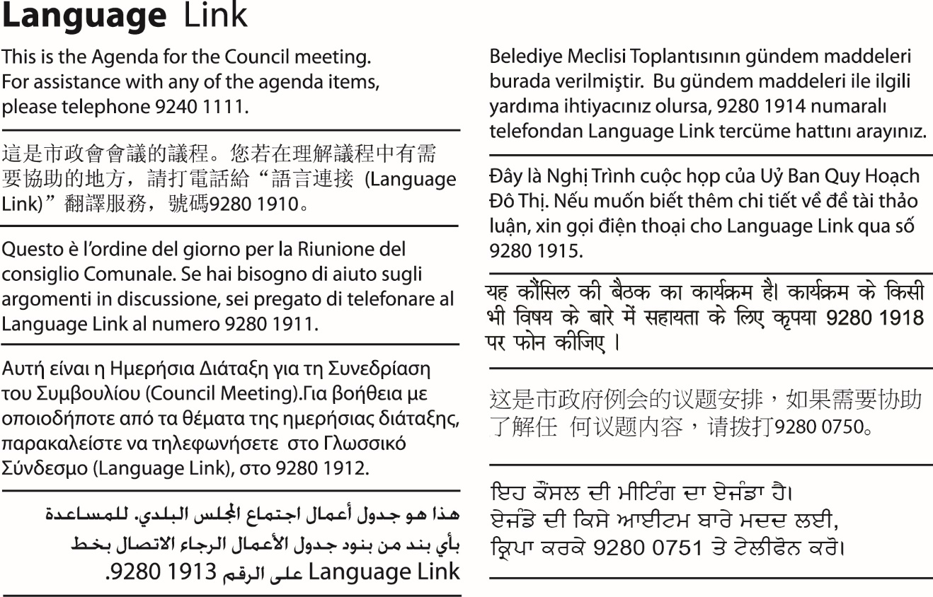

1. WELCOME
2. APOLOGIES/LEAVE OF ABSENCE
3. DECLARATIONS OF CONFLICTS OF INTERESTS
4. Council Reports
4.1 Contract Award RFT-2022-333 Concrete and Drainage Works 3

4. Council Reports
4.1 Contract Award RFT-2022-333 Concrete and Drainage Works
Director City Infrastructure, Anita Curnow
City Services

Officer Recommendation
That Council:
1. Awards Contract RFT-2022-333 - Provision of Concrete and Drainage works for the period of 3 years, with two further 1-year options, to the following suppliers:
a) AJ Civil Estimation & Construction Pty Ltd ABN: 47 722 115 506
b) S&J Investments (Australia) Pty Ltd trading as ASJ Concrete & Constructions ABN: 92 105 107 355
c) Samson Excavations and Concreting ABN: 66 809 858 712
d) GP Bluestone Pty Ltd ABN: 21 664 700 435
e) Grounds Paving Pty Ltd ABN: 25 105 850 235
f) JNR Civil Pty Ltd ABN: 18 608 122 747
g) Kaizen Civil Pty Ltd ABN: 18 619 423 068
h) Midcity Constructions Group Pty Ltd ABN: 54 282 901 947
i) New Horizon Construction Pty Ltd ABN: 29 360 54 3618
j) Novacon Group Pty Ltd ABN: 23 621 403 076
k) Melbourne Civil Works Pty Ltd ABN: 28 347 242 302
l) S & A Piccirillo Paving Pty Ltd ABN: 97 087 980 489
m) Tompsett Asphalt Pty Ltd ABN: 12 625 912 772
2. Authorises the Chief Executive Officer to do all things necessary to execute the contracts and approve contract extensions or other related variations.

REPORT

Executive Summary
Council is seeking to establish a concrete and drainage works panel to provide a range of civil works across Merri-bek for the period 2023-2028.
Council recently sought suitably qualified and experienced contractors to submit a tender for Contract RFT-2022-333 for inclusion on Council’s Concrete and Drainage Works Panel. The panel will enable contractors to access works across the municipality for 2023-2028 (with a one plus one-year extension). These services are required to assist the City Works Unit in the delivery of road and footpath maintenance and capital projects. The panel members may also be called upon to deliver other relevant Council works.
The Tender was advertised in August 2022, seeking a panel of suitably experienced and qualified contractors to provide materials and services under the Contract RFT-2022-333 - Provision of Concrete and Drainage works.
A total of 15 submissions were received and 13 companies are recommended to provide concrete, and drainage works services. We have selected a greater number of contractors for this panel to tackle the wide variety of concrete and drainage works and maximise opportunities and availability of contractors to carryout specialised works.
The scope of services includes, but is not limited to:
• Footpaths
• Kerb and channel
• Vehicle crossings
• Rights of way
• Pram crossings
• Minor drainage works.
The purpose of this report is to seek approval to enter into contract with various suppliers for the provision of concrete and drainage works. The tender complies with section 109(1) of the Local Government Act 2020.
Previous Council Decisions
Nil

1. Policy Context
This report is in keeping with Council’s commitment to accountability and sound financial management. It also addresses the requirement under Section 109(1) of the Local Government Act 2020 which requires Council to conduct a public tender for goods, services and works where once-off or ongoing cumulative spend over the life of the contract is expected to exceed $300,000 (incl GST) as well as the policy commitments contained in the Procurement Policy.

2. Background
Merri-bek City Council’s City Works Unit maintains and upgrades the road, footpath and associated infrastructure across the municipality. Works range from minor concrete and asphalt footpath and road repairs, drainage works, Right of Way repairs and other similar infrastructure works.
To provide a reliable, efficient, and quality service, a panel of supply contractors is required. This tender was publicly advertised, and tenders invited, via Council’s ‘e-tender’ system, for suitably qualified contractors to deliver the required services.

Procurement Process
In accordance with Council’s Procurement Policy, an open tender for Contract RFT-2022-333 was advertised in The Age newspaper on 27 August 2022 and closed at 3pm on 19 September 2022.
Council officers also emailed all providers that have existing relationships with Merri-bek City Council to advise them of this tender opportunity via the Procurement Portal.
A total of 15 tenders were received from the following companies:
a) AJ Civil Estimation & Construction Pty Ltd ABN: 47 722 115 506
b) S&J Investments (Australia) Pty Ltd trading as
ASJ Concrete & Constructions ABN: 92 105 107 355
c) Civilink Group Pty Ltd ABN: 50 119 219 840
d) Samson Excavations and Concreting ABN: 66 809 858 712
e) GP Bluestone Pty Ltd ABN: 21 664 700 435
f) Grounds Paving Pty Ltd ABN: 25 105 850 235
g) Jeni Construction Pty Ltd ABN: 29 624 326 852
h) JNR Civil Pty Ltd ABN: 18 608 122 747
i) Kaizen Civil Pty Ltd ABN: 18 619 423 068
j) Midcity Constructions Group Pty Ltd ABN: 54 282 901 947
k) New Horizon Construction Pty Ltd ABN: 29 360 543 618
l) Novacon Group Pty Ltd ABN: 23 621 403 076
m) Melbourne Civil Works Pty Ltd ABN: 28 347 242 302
n) S & A Piccirillo Paving Pty Ltd ABN: 97 087 980 489
o) Tompsett Asphalt Pty Ltd ABN: 12 625 912 772
Tenderers were asked 12 questions covering the consideration of capacity, capability, and social / environmental / local aspects.
In assessing the tender, consideration was given to the following aspects of the tender responses:
• Experience - qualifications, skills and experience
• Capability and resources – background and proof of other similar work
• Resources – number of employees and resources and their availability
• Credibility:
− Financial interests/viability
− Quality Assurance Systems
− Referees
− Occupation Health and Safety
− Equal Employment Opportunity
− Environmental Management
− Risk Management
− Insurance level
• Compliance to conditions of contract
• Conflict of interest.
The evaluation criteria and weighting are provided in the following table:
Criteria | Weighting
Capability, Experience & Past Performance and Capacity | 15%
OHS | 8%
Traffic Management and works program | 12%
Quality System | 6%
Customer Service | 6%
Social Sustainability | 4%
Environmental Sustainability | 4%
Economic Sustainability | 5%
Price | 40%
The membership of the tender evaluation panel was as follows:
Title | Project Manager/ Generalist or Nominated Speciality | Full Voting / Advisory Member
Acting Unit Manager City Works | Project Manager (Chair) | Full
Unit Manager Engineering Services | Generalist | Full
Senior Construction Engineer, Engineering Services | Generalist | Full
Contracts and Procurement Officer | Procurement | Advisory

3. Issues
The tenders were evaluated in accordance with Council’s Procurement Policy. Tenders were assessed by an assessment panel against set criteria. A summary report of the assessments is provided in the Confidential Attachment 1.

Social / Environmental / Local Implications
The tenders were evaluated against the relevant social policies of Council. The areas covered as part of the evaluation were Environmental Management and Equal Opportunity policies and performance and consideration were given to the location of the business.

Human Rights Consideration
The implications of this report have been assessed in accordance with the requirements of the Charter of Human Rights and Responsibilities.

4. Community consultation and engagement
Engineering Services, procurement and independent probity advisor were consulted during the tender evaluation.

5. Probity and Declaration of Conflict of Interest
Council officers involved in the preparation of this report signed the conflict of interest forms and no conflict was noted. As this tender is above $10 million O’Connor Marsden & Associates Pty Limited was appointed as Probity Advisor and their Probity Report and is attached in Confidential Attachment 2.

6. Financial and Resources Implications
The anticipated expenditure for this contract over the 5-year contract term is $19,000,000.00 excluding GST. As such, the total value of the contract will exceed Chief Executive Officer delegation and requires Council approval to award.
All expenditure against this contract is covered from existing Base and Capital budget allocations. The Panel covers the following types of activities:
• Concrete footpath maintenance
• Kerb and channel maintenance
• Drainage maintenance (including pits and drains repairs)
• Stormwater drainage repairs
• Retaining walls
• Concrete grinding
• Footpath and bike path renewals
• Minor improvement works – transport
• Minor improvement works – engineering services

7. Implementation
It is proposed that the Chief Executive Officer be authorised to do all things necessary to execute the contracts and any other required documentation, including authorising contract extension options in the future up to two by one-year extensions.
The contracts will commence as soon as possible following Council approval to award and every effort will be made to achieve this by end February 2023.

Attachment/s
1 | Tender Assessment Matrix Panel Contract RFT-2022-333  Pursuant to section 3(1)(g(ii)) of the Local Government Act 2020 this attachment has been designated as confidential because it relates to private commercial information, being information provided by a business, commercial or financial undertaking that if released, would unreasonably expose the business, commercial or financial undertaking to disadvantage. | D23/40267
2 | MCC Concrete and Drainage OCM Probity Advisors Report Final  Pursuant to section 3(1)(g(ii)) of the Local Government Act 2020 this attachment has been designated as confidential because it relates to private commercial information, being information provided by a business, commercial or financial undertaking that if released, would unreasonably expose the business, commercial or financial undertaking to disadvantage. | D23/72188

