Council AGENDA

Planning and Related Matters

Wednesday 22 June 2022

Commencing 6.30 pm

Council Chamber, Moreland Civic Centre, 90 Bell Street, Coburg

Acknowledgement of the traditional custodians of the City of Moreland
Moreland City Council acknowledges the Wurundjeri Woi Wurrung people as the Traditional Custodians of the lands and waterways in the area now known as Moreland, and pays respect to their elders past, present, and emerging, as well as to all First Nations communities who significantly contribute to the life of the area.

1. WELCOME
2. APOLOGIES
Leave of absence has been granted to:
Cr Tapinos – 23 May 2022 to 25 June 2022 inclusive.
3. DISCLOSURES OF CONFLICTS OF INTEREST
4. MINUTE CONFIRMATION
The minutes of the Planning and Related Matters Meeting held on 25 May 2022 be confirmed.
5. Council Reports
5.1 38 Harrison Street, Brunswick East - Planning Application MPS/2020/799 4
5.2 105-107 Harding Street, Coburg - Amended Planning Permit Application - MPS/1994/4651/C 26
5.3 942-944 Sydney Road, COBURG NORTH - MPS/2021/661 43
6. URGENT BUSINESS

5. Council Reports
5.1 38 Harrison Street, Brunswick East - Planning Application MPS/2020/799
Director Place and Environment, Joseph Tabacco
City Development

Executive Summary

Property: | 38 Harrison Street, BRUNSWICK EAST VIC 3057
Proposal: | Partial demolition and external alteration to the existing dwelling, construction of seven dwellings, reduction to the car parking requirement and removal of vegetation
Zoning and Overlay/s: | • Neighbourhood Residential Zone Schedule 1 (NRZ1)  • Environmental Significance Overlay Schedule 1 (ESO1)  • Heritage Overlay Schedule 90 (HO90)  • Design and Development Overlay Schedule 1 (DDO1)  • Land Subject to Inundation Overlay (LSIO)  • Development Contributions Plan Overlay (DCPO)
Strategic setting:
Objections: | • 135 objections  • Key issues:  • Amenity impacts including walls on boundary, overshadowing, overlooking and daylight access to existing windows.  • Parking and traffic impacts.  • Loss of vegetation and impact of development on Merri Creek environs.  • Impact on heritage dwelling and demolition of outbuildings.
Planning Information and Discussion (PID) Meeting: | First PID - 16 August 2021  • Attendees: 12 objectors, the applicant, Council officers, Deputy Mayor Cr Mark Riley and Cr James Conlan  Following the PID, amended plans were lodged to address some of the concerns including increased setbacks and landscaping.  Second PID - 28 February 2022  • Attendees: 18 objectors, the applicant, Council officers, Cr Sue Bolton and Cr James Conlan.  Following the second PID, the applicant agreed to retain an additional tree on site.
ESD: | • Minimum average NatHERS rating of 6.8 stars.  • 22.8kW PV panel capacity.  • Environmentally friendly material choices.
Key reasons for support | • Restoration and retention of the heritage dwelling on site, and retention of two of the four outbuildings.  • No unreasonable off-site amenity impacts.  • Acceptable response to the Merri Creek corridor and retention of indigenous tree species on site.  • Bicycle parking provision in excess of planning scheme requirements.  • Trees to be removed are not considered to be of heritage significance
Recommendation: | Notice of Decision to Grant a Planning Permit

Officer Recommendation
That a Notice of Decision to Grant a Planning Permit No. MPS/2020/799 be issued for the partial demolition and external alteration to the existing dwelling, construction of seven multi storey dwellings, reduction to the car parking requirement and removal of vegetation at 38 Harrison Street, Brunswick East, subject to the following conditions:
Amended Plans
1. Before the development commences, amended plans to the satisfaction of the Responsible Authority must be submitted to and approved by the Responsible Authority. When approved, the plans will be endorsed and will then form part of the permit. The plans must be drawn to scale with dimensions and must be generally in accordance with the plans advertised on 7 December 2021 but modified to show:
a) The garage doors of the six rear dwellings as 4 metres wide.
b) The rear boundary fencing to be shown on elevations plans at a scale of 1:50 and modified as follows:
i. be set atop the driveway brickwork wall commencing at 34.4m to AHD;
ii. be an open style of construction (50 per cent open style) for the passage of overland flows;
iii. be a maximum height of 1.2 metres from a level of 34.4m AHD; and
iv. be black palisade fence.
c) A full set of demolition plans.
d) The heritage outbuilding (kitchen) to be shown on elevations plans at a scale of 1:50 and detail:
i. a schedule of repairs;
ii. all conservation and interpretation works; and
iii. a small permanent plaque to be incorporated into the Kitchen to record the date of the alterations.
e) Any changes to the layout and elevation plans, arising from the re-construction plan (cool room) in accordance with condition 4 of this permit.
f) The location of a small permanent plaque to be incorporated into the relocated Cool Room to record the date of its reconstruction.
g) Notation on the plans to confirm that the proposed landscaped buffer along the eastern boundary will provide an internal soil dimension of at least 1.1 metres.
h) Any changes to Townhouse 1 arising from the Landscape Plan and Tree Management Plan in accordance with Condition 7 and 10 of this permit.
i) The tree protection zones of Trees 4 and 7, and any tree located off-site within 3 metres of the boundary.
j) The Environmentally Sustainable Design initiatives that are required to be shown on plans, as contained within Condition 11 of this permit.
k) Any practical changes as required by conditions 24 to 36 (Melbourne Water) of this permit.
Compliance with Endorsed Plans
2. The development as shown on the endorsed plans must not be altered without the written consent of the Responsible Authority. This does not apply to any exemption specified in Clauses 62.02-1 and 62.02-2 of the Moreland Planning Scheme unless specifically noted as a permit condition.
Heritage
3. Prior to the commencement of the development a comprehensive photographic record is to be made of the cool room. The record is to be undertaken and documented according to the Heritage Victoria technical note for Photographic Recording for Heritage Places and Objects. The output is to be three copies of all material including:
a) Archival quality disc/s of all images in high resolution JPG format as well as either TIFF or RAW format,
b) A brief descriptive catalogue of all images,
c) A photographic plan (such as existing conditions plans provided by the architect) showing the view points of all images,
d) Referenced contact sheets and referenced printed black and white images of selected viewpoints printed on proper archival quality photographic paper.
All contained in appropriately labelled archival folders or boxes and all to the satisfaction of the Responsible Authority. The record is to be lodged with the Responsible Authority and approved prior to commencement of development.
4. Prior to the endorsement of plans a detailed set of plans must be submitted to and approved by the Responsible Authority showing the reconstruction of the cool room to its original heritage specifications.
5. All reconstruction works referred to in Condition 4 must be undertaken under the supervision of an expert heritage consultant.
6. Prior to the occupation of the development hereby approved, a report from a suitably qualified heritage consultant must be submitted to the satisfaction of the Responsible Authority confirming that the reconstruction works referred to in condition 4 and the repair, conservation and interpretation works to the kitchen have been satisfactorily completed to the original design, specification and standards of the original building.
Landscaping
7. Prior to the endorsement of plans, an amended landscape plan must be submitted to the Responsible Authority. The landscape plan must be generally in accordance with the plan prepared by The Sustainable Landscape Company dated 5 October 2021 but amended to clearly show:
a) Any changes required to align with the plans for endorsement.
b) Rear landscaping buffer amended to reflect the location and size as shown on the ground floor plan.
c) Retention of Tree No.4 and Tree No. 7 (as per the Arboricultural Assessment dated 16 November 2020).
d) An irrigation plan with notes on landscape and irrigation maintenance to ensure all plants are established and remain healthy.
e) Landscape Legend updated to reflect 6 plants per square metres as noted in the Plant Schedule.

When submitted and approved to the satisfaction of the Responsible Authority, the landscape plan will be endorsed to form part of this permit. No alterations to the plan may occur without the written consent of the Responsible Authority.
8. Prior to the issue of an Occupancy Permit or issue of a Statement of Compliance, whichever comes first, all landscaping works must be completed in accordance with the endorsed landscape plan to the satisfaction of the Responsible Authority.
9. All landscaping must be maintained to the satisfaction of the Responsible Authority in accordance with the endorsed landscape plans. Any dead, diseased or damaged plants must be replaced with a suitable species to the satisfaction of the Responsible Authority.
Tree Protection
10. Prior to the endorsement of plans, a Tree Management Plan (TMP) must be submitted to the satisfaction of the Responsible Authority. The TMP must be prepared by a suitably qualified Arborist and make specific recommendations in accordance with the Australian Standard AS4970: 2009 - Protection of Trees on Development Sites to ensure that Tree No. 4 and 7 (as per the arboricultural assessment dated 16 November 2020) and the trees located within 3 metres of the site remain healthy and viable during construction. The TMP must include the following to the satisfaction of the Responsible Authority:
a) A tree protection plan to scale that shows:
i. All Tree Protection Zones and Structural Root Zones
ii. All Tree Protection Fencing
iii. Areas where ground protection systems will be used
iv. The type of footings within any Tree Protection Zone
v. The location of services within any Tree Protection Zone
b) The location and design of Tree Protection Fencing.
c) Details of appropriate footings within the Tree Protection Zone.
d) The method of installing any services through the Tree Protection Zone.
e) Details of how the root zone within the Tree Protection Zone will be managed throughout the project.
f) A timetable outlining works requiring supervision by the Project Arborist.
g) The results of any exploratory trenching where there is encroachment (construction or excavation) greater than 10 per cent into the Tree Protection Zone (in accordance with Australian Standard AS4970:2009 - Protection of Trees on Development Sites) of any tree to be retained. This must include photographic evidence of any trenching/ excavation undertaken.
h) All remedial pruning works that are required to be performed on the tree during the development of the site. The pruning comments must reference Australian Standards 4373:2007, Pruning of Amenity Trees and a detailed photographic diagram specifying what pruning will occur.
When submitted and approved to the satisfaction of the Responsible Authority, the TMP will be endorsed to form part of this permit. The recommendations of the endorsed TMP must be implemented to the satisfaction of the Responsible Authority.
Environmentally Sustainable Design (ESD)
11. Prior to the endorsement of plans, an amended Sustainable Design Assessment (SDA) and plans must be submitted to the satisfaction by the Responsible Authority. The SDA must demonstrate a best practice standard of environmentally sustainable design and be generally in accordance with the SDA prepared by Low Impact Development Consulting advertised 22 June 2021, but modified to include the following changes:
a) Show the following ESD initiatives on the development plans:
i. Double glazing annotated on each window on both the floor plans and elevations.
ii. A stormwater catchment plan.
iii. Details of the permeable paving.
iv. Details of the proposed operable shutters.
v. An amended material and colours schedule with reference to materials within the SDA (as per pages 10-13), including:
• Cement to contain supplementary materials such as geopolymer.
• All timber to be Forest Stewardship Council (FSC) or Programme Endorsement of Forest Certification ((PEFC) /Australian Forestry Standard (AFS) & no use of tropical hardwoods such as Merbau, Teak, etc.
• Glasswool insulation (if used) with 50 per cent recycled glass and no formaldehyde.
• Polyester (if used) with recycled content.
• Carpet (if installed) to contain recycled content / be a Good Environmental Choice Australia (GECA) certified product.
Where alternative ESD initiatives are proposed to those specified in the condition above, the Responsible Authority may vary the requirements of this condition at its discretion, subject to the development achieving equivalent (or greater) ESD outcomes in association with the development.
When submitted and approved to the satisfaction of the Responsible Authority, the Sustainable Design Assessment and associated notated plans will be endorsed to form part of this permit. No alterations to the plan may occur without the written consent of the Responsible Authority.
12. Prior to the issue of an Occupancy Permit or issue of a Statement of Compliance, whichever comes first, all works must be undertaken in accordance with the endorsed Sustainable Design Assessment (including any BESS and STORM reports) to the satisfaction of the Responsible Authority.
13. Prior to the issuing of a Certificate of Occupancy or Statement of Compliance, whichever comes first, of any dwelling approved under this permit, a report/checklist must be submitted to the Responsible Authority. The report/checklist must be to the satisfaction of the Responsible Authority and must confirm (with suitable evidence) that measures specified in the endorsed Sustainable Design Assessment have been implemented in accordance with the approved plans.
14. All stormwater treatment devices (e.g, raingardens, rainwater tanks etc.) must be maintained, to ensure water quality discharged from the site complies with the performance standard in the endorsed Sustainable Design Assessment.
Development Contributions
15. Prior to the issue of a Building Permit in relation to the development approved by this permit, a Development Infrastructure Levy and Community Infrastructure Levy must be paid to Moreland City Council in accordance with the approved Development Contributions Plan. The Development Infrastructure Levy and Community Infrastructure Levy is charged per dwelling.
If an application for subdivision of the land in accordance with the development approved by this permit is submitted to Council, payment of the Development Infrastructure Levy can be delayed to a date being whichever is the sooner of the following:
• a maximum of 12 months from the date of issue of the Building Permit; or
• prior to the issue of a Statement of Compliance for the subdivision;
When a staged subdivision is sought, the Development Infrastructure Levy must be paid prior to the issue of a Statement of Compliance for each stage of subdivision in accordance with a Schedule of Development Contributions approved as part of the subdivision.
Car Parking and Vehicle Access
16. Prior to the occupation of the development, a vehicle crossing must be constructed in every location shown on the endorsed plans to a standard satisfactory to the Responsible Authority (Moreland City Council, City Infrastructure Department).
17. Prior to the occupation of the development, any existing vehicle crossing not to be used in this use or development must be removed and the kerb and channel, footpath and nature strip reinstated to the satisfaction of the Responsible Authority (Moreland City Council, City Infrastructure Department).
18. Prior to the issue of an Occupancy Permit or issue of a Statement of Compliance, whichever comes first, any Council or service authority pole or pit within 1 metre of a proposed vehicle crossing must be relocated or modified at the expense of the permit holder to the satisfaction of the Responsible Authority and the relevant service authority.
Underground Cables
19. Prior to the occupation of the development all telecommunications and power connections (where by means of a cable) and associated infrastructure to the land must be underground to the satisfaction of the Responsible Authority.

Lighting
20. All external lighting, other than balcony lighting, must be no higher than 1.2 metres above ground level with automatic or sensor-controlled lighting installed and maintained on the land to illuminate pedestrian access between dusk and dawn with no direct light emitted onto adjoining property to the satisfaction of the Responsible Authority.
21. Lighting on each balcony must be designed to not emit light direct onto adjoining property to the satisfaction of the Responsible Authority.
22. A letterbox must be provided for each of the premises at the street frontage. The dimensions, placement and numbering must comply with the Australia Post – Letterbox Security and Specification as published on its website to the satisfaction of the Responsible Authority.
Stormwater
23. All stormwater from the land, where it is not collected in rainwater tanks for re-use, must be collected by an underground pipe drain approved by and to the satisfaction of the Responsible Authority (Note: Please contact Moreland City Council, City Infrastructure Department).
Melbourne Water
24. Prior to the endorsement of plans, amended plans must be submitted to Council and Melbourne Water addressing Melbourne Water's conditions. Plans must be submitted with surface and floor levels to Australian Height Datum (AHD) and must be modified to show:
a) All dwellings individually shown to have finished floor levels no lower than 35.35m to AHD.
b) All garages individually shown to have finished floor levels no lower than 34.75m to AHD.
c) The levels within the rear (eastern) driveway shown to be consistent with the report prepared by Rain Consulting at 34.45m to 34.75m to AHD for the safe egress of vehicles.
25. The dwellings must be constructed with finished floor levels set no lower than 35.35 metres to Australian Height Datum (AHD), which is 600mm above the applicable flood level of 34.75m to AHD.
26. The garages must be constructed with finished floor levels set no lower than the applicable flood level of 34.75m to AHD.
27. The 5-metre-wide driveway at the eastern property boundary must be constructed with finished surface levels of between 34.45 metres to Australian Height Datum (AHD), to 34.75m to AHD to allow for safe egress for vehicles entering and exiting the property.
28. Cut and fill undertaken within the site, must be in accordance with Rain Consulting letter and ‘Site Masterplan Concept’ prepared by Walter & Walter both dated 16.09.2020, to ensure the safety of pedestrian and vehicular users of the site.
29. The 3 metre setback/driveway at the southern boundary must be maintained in accordance with the ‘Site Masterplan Concept 16.09.2020’ and must not be altered unless with the prior written consent of Melbourne Water, for conveyance of local catchment overland flows.
30. Prior to the issue of an Occupancy Permit, a certified survey plan, showing finished floor and driveway/fill levels (as constructed) reduced to the Australian Height Datum must be submitted to Melbourne Water to demonstrate that the floor and surface fil levels have been constructed in accordance with Melbourne Water's requirements.
31. The boundary fence abutting the reserve at the eastern boundary must be set atop the driveway brickwork wall commencing at 34.4m to AHD, in an open style of construction (50 per cent open style) for the passage of overland flows.
32. Any new boundary fencing or gates at the northern or southern boundaries must be constructed in an open style of construction (50 per cent open style) or timber paling style for the passage of overland flows.
33. All internal and new western boundary fences and gates must be constructed in an open style of construction (50 per cent open style) for the passage of overland flows.
34. Prior to the commencement of works, a Site Environmental Management Plan (SEMP) detailing pollution and sediment control measures, must be submitted to Melbourne Water for approval. The SEMP must include a detailed plan showing the location of sediment fencing at the shared waterway boundary and must be adopted on site for the duration of the construction phase of the development.
35. Prior to the commencement of works a separate application direct to Melbourne Water, must be made and approved of any new or modified storm water connection to Melbourne Water's drains or watercourses. Prior to accepting an application, evidence must be provided demonstrating that Council considers that it is not feasible to connect to the local drainage system.
36. No access for machinery or storage of materials is permitted through the waterway reserve unless with the prior written consent of Melbourne Water. A separate application must be made via the Melbourne Water website prior to the commencement of works.
Permit Expiry
37. This permit will expire if one of the following circumstances applies:
a) the development is not commenced within two (2) years from the date of issue of this permit;
b) the development is not completed within four (4) years from the date of issue of this permit.
The Responsible Authority may extend the period referred to if a request is made in writing before the permit expires or;
• within six months after the permit expires to extend the commencement date.
• within 12 months after the permit expires to extend the completion date of the development if the development has lawfully commenced.
Notes: These notes are for information only and do not constitute part of this Notice of Decision.
Note 1: This permit does not authorise the removal of, damage to or pruning of any Council tree. Further written consent must be obtained from Council’s Open Space Unit. The Open Space Unit can be contacted on 8311 4300.
Note 2: Should Council impose car parking restrictions in this street, the owners and/or occupiers of the dwellings would not be eligible for resident parking permits to park on the street. Occupiers are eligible for the resident A parking permit which only permits parking in limited areas. The resident parking permits are subject to future reviews and change.
Note 3: A Cultural Heritage Management Plan has been approved in relation to the permitted high impact activity on the land in accordance with the requirements of the Aboriginal Heritage Act 2006. Activity on the land must comply with the approved Cultural Heritage Management Plan. The Aboriginal Heritage Act 2006 details offences and penalties that apply when a person knowingly does an act that harms or is likely to harm Aboriginal cultural heritage which is not in accordance with an approved cultural heritage management plan or other listed exemptions. Aboriginal cultural heritage is defined as Aboriginal places, Aboriginal objects and Aboriginal human remains.
Note 4: This permit contains a condition requiring payment of Development Contributions. The applicable development contribution levies are indexed annually. To calculate the approximate once off levy amount, please visit http://www.moreland.vic.gov.au/planning-building/ and click on ‘Moreland Development Contributions Plan (DCP)’. Alternatively, please contact Moreland City Council on 9240 1111 and ask to speak to the DCP Officer.
Note 5: Moreland City Council is committed to increasing the amount of affordable housing in the municipality. One way to do this, is through Homes for Homes, a social enterprise founded by the Big Issue that aims to raise new funds via voluntary tax-deductible donations on property transactions and invest those funds in building and managing new social and affordable dwellings. If you would like to help build homes for those in need, visit Homes for Homes and register your commitment to donate 0.1 per cent of the sale price of your dwelling(s).

REPORT

1. Background

Subject site
The subject site is located on the east side of Harrison Street, approximately 65 metres north of Albion Street, Brunswick East.
The site is irregular in shape with a frontage of 33.7 metres to Harrison Street, a rear interface of 36.5 metres to the Merri Creek Corridor, and a depth of 47.2 metres to the north and 33.5 metres to the south. The site has a total area of 1,362 square metres.
The site is currently occupied by a single storey weatherboard dwelling and four outbuildings. Several trees are scattered across the site. These include a large mature Moreton Bay Fig Tree and a Drooping Sheoak Tree.
There are no restrictive covenants or easements that affect the site.

Surrounds
The immediate context includes:
• A four-storey apartment building to the immediate north of the site. Several habitable room windows and balconies have an outlook towards the subject site.
• A place of worship to the immediate south of the site. A large open car parking area is provided to the front of the place of worship, adjacent to Harrison Street.
• To the west is Harrison Street. Harrison Street runs in a north-south direction and is accessed via Albion Street to the south. Unrestricted car parking is available along the western side of Harrison Street. Jones Park is directly opposite the site, across Harrison Street.
• To the east of the site is the Merri Creek Corridor.
A location plan forms Attachment 1.

The proposal
The proposal includes:
• Partial demolition and refurbishment of the existing heritage dwelling.
• Construction of seven dwellings (one double storey and six triple storey) with roof terraces. Six of the dwellings are located at the rear of the site and one is located to the north east part of the site fronting Harrison Street.
• Demolition and reconstruction of one outbuilding, retention of another and demolition of the two other outbuildings.
• Removal of six trees.
• 7 car parking spaces and 16 bicycle spaces.
• Timber construction in a natural finish.
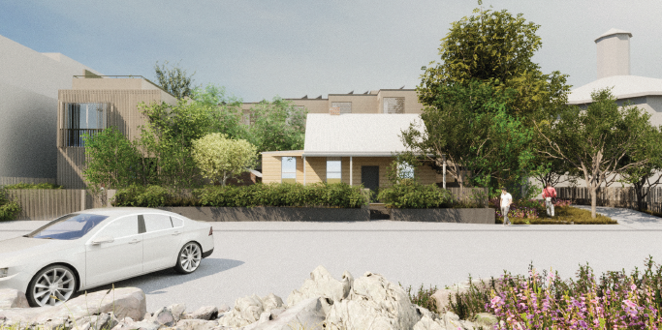
Figure 1: Render of Proposed Development, as seen from Harrison Street
The development plans form Attachment 2.

Statutory Controls – why is a planning permit required?
Control | Permit Requirement
Neighbourhood Residential Zone Schedule 1 | Clause 32.09-6: a permit is required to construct two or more dwellings on a lot.
Environmental Significance Overlay Schedule 1 | Clause 42.01-3: a permit is required to construct a building or construct or carry out works and to remove, destroy or lop any vegetation, including dead vegetation.
Heritage Overlay  Schedule 90 | Clause 43.01-1: a permit is required to demolish or remove a building, to construct a building or construct or carry out works, to externally alter a building by structural work, rendering, sandblasting or in any other way,  to externally paint a building, and to remove, destroy or lop a tree.
Design and Development Overlay - Schedule 1 | Clause 43.02-1: a permit is required to construct a building or carry out works.
Land Subject to Inundation Overlay | Clause 44.04-2: a permit is required to construct a building or construct or carry out works.
Particular Provisions | Clause 52.06-3: a permit is required to reduce the car parking requirement
The following Particular Provisions of the Moreland Planning Scheme are also relevant to the consideration of the proposal:
• Clause 45.06: Development Contributions Plan Overlay
• Clause 53.18: Stormwater Management in Urban Development
• Clause 55: Two or More Dwellings on a lot and Residential Buildings
The Heritage Overlay Schedule 90 and Design and Development Overlay Schedule 1 only affect part of the site, as seen in Figures 2 and 3 below.
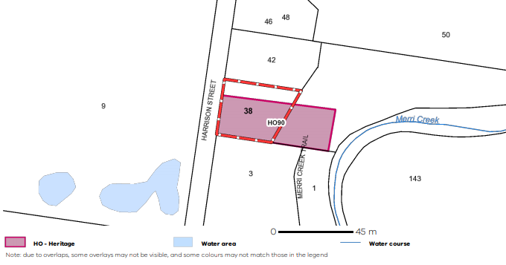
Figure 2: Extent of Heritage Overlay Schedule 90 (VicPlan 2020)
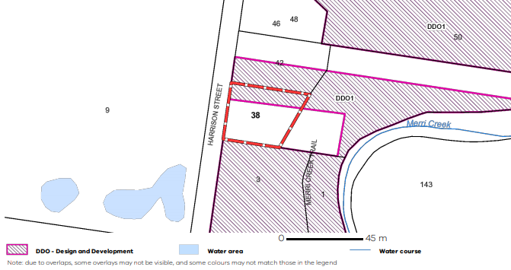
Figure 3: Extent of Design and Development Overlay Schedule 1 (VicPlan 2020)

Aboriginal Heritage
The Aboriginal Heritage Act 2006 and Aboriginal Heritage Regulations 2007 provide for the protection of Aboriginal places, objects and human remains in Victoria.
A Cultural Heritage Management Plan approved by the Wurundjeri Tribe Land Council has been provided in accordance with the requirements of the Aboriginal Heritage Act 2006.

2. Internal/External Consultation

Public notification
Notification of the application has been undertaken pursuant to Section 52 of the Planning and Environment Act 1987 by:
• Sending notices to the owners and occupiers of adjoining and nearby land.
• Placing a sign on the Harrison Street frontage of the site and a sign facing the Merri Creek corridor.
Council received 54 objections following the notice period.
The key issues raised in objections were:
• Building height
• Walls on boundary, overshadowing, overlooking and daylight access to existing windows
• Parking and traffic impacts
• Loss of vegetation and impact of development on Merri Creek environs and natural habitats
• Impact of development on trees proposed to be retained (on and off-site)
• Impact on heritage dwelling and demolition of outbuildings
• Drainage, flooding and inundation impacts
• Construction impacts
• Loss of view
• Overdevelopment
A Planning Information and Discussion meeting was held on 16 August 2021 and attended by the then Deputy Mayor Cr Mark Riley and Cr James Conlan two Council Planning Officers, the applicant and 12 objectors. The meeting provided an opportunity to explain the application, for the objectors to elaborate on their concerns, and for the applicant to respond. Following the meeting, the applicant amended the plans to respond to some of the concerns raised (see below).

Amendment to the application and re-notification
The application was amended on 23 November 2021 pursuant to Section 57A of the Planning and Environment Act 1987. The changes proposed include:
• Amendments to Townhouses 1 and 2 to achieve Standard B19 (Daylight to Existing Windows Objective) compliance
• Reduction in on-site car parking provision from nine on-site spaces to seven on-site spaces.
• Demolition of existing Cool Room and relocation and reconstruction on site.
• Retention of existing Kitchen.
• Additional screening via canopy tree planting along eastern side of driveway.
Re-notification of the application was given on 15 December 2021. Council received a further 81 objections (135 objections total). No new concerns were raised. An objector location map forms Attachment 3.
A second Planning Information and Discussion meeting was held on 28 February 2022 and attended by Cr Sue Bolton and Cr James Conlan, two Council Planning Officers, the applicant and approximately 18 objectors

Internal/external referrals
The proposal was referred to the following external agencies and internal branches:
External Agency | Objection/No objection
Melbourne Water | No objection subject to conditions.

Internal Branch | Comments
Urban Design Unit | Supportive of the proposal, suggesting no carparking for Townhouse 1 to allow for greater vegetation and ground level activation.
Transport - Development Engineering Team | Supportive of the proposal subject to conditions.
Sustainable Built Environment - ESD Team | Supportive of the proposal subject to conditions.
Heritage Advisor | Supportive of the proposed changes to the existing dwelling and relocation of the existing cool room, retention of the existing kitchen and demolition of the remaining outbuildings.  Recommended that Townhouse 1 be redesigned to present with windows and doors of traditional fenestration to the street, with the garage setback.  Does not object to the removal of trees, 1, 2 3, 5 and 6, noting the existing dwelling will remain in a landscaped context.
Open Space Design and Development Unit | Supportive of the removal of Trees 1-3 and 4-6. Recommended that Tree 7 be retained.  Supportive of the development of a driveway, pedestrian path and part of the building footprint within the Tree Protection Zone (TPZ) of Tree 4 subject to the preparation and implementation of a tree protection management plan.  Recommended conditions be included regarding the eastern boundary fence height and materiality and further details/notations included on the Landscape Plan.

3. Policy Implications

Planning Policy Framework (PPF):
The following policies are of most relevance to this application:
• Municipal Planning Strategy (Clause 2), including:
− Vision (Clause 2.02)
− Settlement (Clause 2.03-1)
− Environmental and Landscape Values (Clause 2.03-2)
− Environmental Risks and Amenity (Clause 2.03-3)
− Built Environment and Heritage (Clause 2.03-4)
− Housing (Clause 2.03-5)
− Economic Development (Clause 2.03-6)
− Transport (Clause 2.03-7)
− Infrastructure (Clause 2.03-8)
• Settlement (Clause 11)
• Environmental and Landscape Values (Clause 12), including:
− Biodiversity in Moreland (12.01-1L)
− River Corridors, Waterways, Lakes and Wetlands (Clause 12.03-1S)
− Environmentally Sensitive Areas (Clause 12.05-1S)
• Built Environment (Clause 15.01), including:
− Urban Design (Clause 15.01-1S, 15.01-1R & 15.01-1L)
− Vehicle Access Design in Moreland (Clause 15.01-1L)
− Building Design (Clause 15.01-2S & 15.01-2L)
− Building Design in Neighbourhood and Local Centres (Clause 15.01-2L)
− Healthy Neighbourhoods (Clause 15.01-4S and 15.01-4R)
− Neighbourhood Character (Clause 15.01-5S)
− Minimal and Incremental Change Areas (Clause 15.01-5L)
• Sustainable Development (Clause 15.02), including:
− Energy and resource efficiency (Clause 15.02-1S)
− Environmentally Sustainable Development (Clause 15.02-1L)
− Energy efficiency in Moreland (Clause 15.02-1L)
• Heritage (Clause 15.03), including:
− Heritage conservation (Clause 15.03-1S)
− Heritage in Moreland (Clause 15.03-1L)
− Aboriginal cultural heritage (Clause 15.03-2S)
• Residential Development (Clause 16.01), including:
− Housing Supply (Clause 16.01-1S and 16.01-1R)
− Homes in Moreland (Clause 16.01-2L)
• Transport (Clause 18), including:
− Movement Networks (Clause 18.02-1S & 18.02-2S)
− Sustainable Transport in Moreland (Clause 18.02-1L)
− Car parking in Moreland (Clause 18.02-4L)
• Community Infrastructure (Clause 19.02), including:
− Open Space (Clause 19.02-6S & 19.02-6R)
− Open Space in Moreland (Clause 19.02-6L)
• Development Infrastructure (Clause 19.03), including:
− Development infrastructure (Clause 19.03)
− Integrated Water Management (Clause 19.03-3S)

Human Rights Consideration
This application has been processed in accordance with the requirements of the Planning and Environment Act 1987 (including the Moreland Planning Scheme) reviewed by the State Government and which complies with the Victorian Charter of Human Rights and Responsibilities Act 2006, including Section 18 (Taking part in public life). In addition, the assessment of the application has had particular regard to:
• Section 13: Privacy and Reputation. An assessment of whether there is any potential for unreasonable overlooking has been undertaken in section 4 of this report.
• Section 20: Property rights. The right of the landowner to develop and use their land has been considered against and is generally in accordance with the Moreland Planning Scheme.

4. Issues
In considering this application, regard has been given to the Planning Policy Framework, the provisions of the Moreland Planning Scheme, objections received and the merits of the application.

Does the proposal have strategic policy support?
The subject site is located within the Neighbourhood Residential Zone. The purposes of this zone include recognising areas of single and double storey residential development and ensuring that development respects the identified neighbourhood character.
Clause 16.01-1R (Housing supply – Metropolitan Melbourne) allows for a range of minimal, incremental and high change residential areas that balance the need to protect valued areas with the need to ensure choice and growth in housing. Council’s Housing Framework Plan at Clause 2.04 designates this location for minimal housing growth. In these areas, Clause 16.01-2L encourages a mix of single dwellings and lower density multi-dwelling developments that contribute to a low density, open and landscaped character.
The proposal will be located on a street which currently features two large four-storey apartment complexes, a place of worship and a park. The proposal is of a comparable, if not lesser intensity than that which already exists within the streetscape. In this context, the proposed town houses are with retention of the single storey detached heritage dwelling considered to represent an acceptable level of change.

Does the proposal affect the environmental significance of the Merri Creek environs?
Schedule 1 to the Environmental Significance Overlay relates to the Merri Creek and Environs. Environmental objectives to be achieved include the protection and enhancement of the natural and visual character of the waterway corridor, and to ensure that the scenic qualities and visual character of the waterway corridor are not compromised by the inappropriate siting of buildings, the placement of fill or lack of screening vegetation.
The Development Guidelines for the Merri Creek, Merri Creek and Environs Strategy Streering Committee, 1999 (‘Guidelines’) is a relevant reference document and must be taken into consideration before deciding on an application.
The Guidelines state that buildings should be predominantly screened from open space areas by planting or topography, and site layout should place semi-public areas such as shared open space, driveways or carparks next to the creek in preference to private open space.
The proposed development seeks to locate the car park entrances and driveway along the eastern boundary, adjacent the Merri Creek Corridor. The driveway will be permeable with a 1.1-metre-wide landscaping buffer provided along the eastern boundary. Trees proposed within the buffer will have mature heights ranging from 8 to 12 metres. This is an appropriate response and is supported.
As outlined above, the development appropriately sites the shared driveway at the interface with the creek corridor and provides for a landscaping buffer to assist in mitigating the bulk of the proposed three storey form. This landscaping buffer was reviewed by Council’s Open Space Unit who noted that the area proposed would be suitable to allow for the establishment of trees which would adequately screen the development. Figure 4 below depicts the presentation of the development as seen from the shared path within the creek. The existing vegetation within the creek corridor at this location and proposed landscaping buffer will appropriately screen the development.
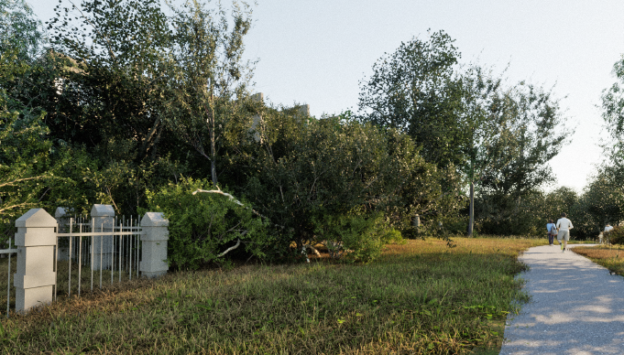
Figure 4: Render of Proposed Development, as seen from Merri Creek Corridor

Concern was raised by objectors having regard to the impact of the development upon the Merri Creek Corridor and loss of vegetated connection between the corridor and Jones Park to the east. Clauses 2.04 and 19.02-6L (Open space in Moreland) do not designate this site as being within a priority open space area. The site is also not considered large enough to require the provision of new public space. Council’s Open Space Officer has also confirmed that there is no requirement for the provision of an open space link in this location, noting existing pedestrian links to the Merri Creek Corridor to the north and south of the site (Brunswick Velodrome and Albion Street).
Is the proposed tree removal acceptable?
Concern was raised by objectors in relation to the loss of vegetation.
There are seven mature trees located on site. The proposal seeks to remove six trees (Trees 1-3 and 5-7), all of which trigger a requirement for a permit for their removal under the Environmental Significance Overlay Schedule 1 and the Heritage Overlay Schedule 90. Additionally, development is proposed in proximity to an existing mature Moreton Bay Fig Tree (Tree 4).
The applicant’s Heritage Impact Assessment states that the proposed development will maintain much of the open green space of the site, an original and significant feature of the site. This is echoed in the Statement of Significance for the site, which notes that the site is representative of tradesmen’s residence in the 1880s and retains a relatively large tract of land beside the Merri Creek.
The statement of heritage significance does not refer to any of the specific trees as having heritage significance. An independent Landscape Heritage Assessment by John Patrick Landscape Architects was commissioned by Council to assess the heritage significance of the trees within the site.
This report notes the trees were considered to be standard species found within the area and were not particularly large or unusual for their species. Having regard to the Heritage Victoria significance criteria as set out in ‘Planning Practice Note 1, Applying the Heritage Overlay’ (DELWP, August 2018) the trees, whilst contributing to the character of the property, were not considered to be of heritage significance.
The Landscape Heritage Assessment forms Attachment 4.
Council’s Open Space Unit did not object to the removal of Trees 1-3 and 5-6 as they are species considered as weeds within the greater Melbourne area. Weeds have the potential to be detrimental to stream flow and the environmental objectives listed within Schedule 1 to the Environmental Significance Overlay. Given the tree species and potential impact upon the Merri Creek Corridor, the removal of these trees is supported subject to appropriate replacement tree planting.
Tree 7 is a relatively large, indigenous tree of 15 metres. At the second PID meeting the applicant agreed to retain this tree. A permit condition in the officer recommendation is for the retention of this tree with any subsequent modifications to Townhouse 1 as required.
The Landscape Heritage assessment does not reference Tree 7. However, this is inconsequential as agreement has been reached with the applicant to retain this tree.
It is considered that the retention of two trees on site, implementation of a Tree Management Plan and in combination with the replacement planting of native and indigenous species will allow for the re-vegetation of the site in line with the guidelines of the Environmental Significance Overlay. This will also ensure that the site maintains an open and landscaped appearance as per the Heritage Overlay and Statement of Significance whilst allowing for the redevelopment of the site.
In relation to the loss of habitat, the Environmental Significance Overlay provides decision guidelines which requires consideration of the significance of the native vegetation area (including the significance of plant communities or animal species supported). The decision guidelines also include consideration of the reasons for removing the vegetation and the practicality of alternative options which do not require the removal of native vegetation.
A question was also raised by objectors in relation to the need to provide an Ecological Report. Council’s Open Space Unit have confirmed that they do not require an ecological report given there are unlikely to be any significant benefits from the survey, and instead recommended that focus be placed upon the planting of indigenous vegetation on site.
As discussed above, the removal of the non-native tree species is supported by Council’s Open Space Unit. The development will retain two mature trees and will provide an additional 6 plants per square metre of landscaping. On balance this is an acceptable response and is supported.
Is the extent of demolition acceptable?
The proposal seeks to partially demolish the rear of the existing dwelling and two out of four outbuildings. These two outbuildings have been referred to as the storage/workshop/stables and a large studio in the applicant’s Heritage Impact Statement, dated 30 April 2021.
Council’s Heritage Advisor was supportive of the removal of the rear portion of the existing dwelling to allow for the adaptation of the building.
The Heritage Impact Statement confirms that the storage/workshop/stables have existed on site since at least 1909. Council’s Heritage Advisor noted that the building, whilst considered to be of contributory value, features numerous alterations and does not provide any distinct insight on the way that the heritage property was used.
It is considered that the demolition of the storage/workshop/stables is acceptable on the balance of the retention of the original dwelling and two of the three heritage outbuildings. The removal of the storage/workshop/stables will allow for the redevelopment of the site, and the subsequent restoration of the remaining buildings on site.
The large studio is a more recent construction and is not of any historical significance. Council’s Heritage Advisor agrees with this assessment. Its demolition is therefore supported.
The application also proposes to relocate the existing coolroom on site. The property is subject to flooding from Merri Creek, with a flood level of 34.75 metres (AHD). The cool room currently sits below this level. As a result, the building is not able to be adapted and/or repurposed or reused. For this reason, it is considered appropriate to allow for the removal and reconstruction of the cool room elsewhere on site. This proposal has been reviewed by Council’s Heritage Advisor who was supportive subject to conditions requiring a photographic record and measured drawings professionally prepared to ensure accuracy of the reconstructed structure.
Are the proposed new buildings and alterations an appropriate response to the heritage overlay?
The existing dwelling currently needs repairs and restoration. The proposed works will facilitate the ongoing functioning of the building without unreasonably impacting upon the appearance of the heritage place. The works are supported.
The works to the kitchen will allow for the ongoing use of the building, whilst allowing for the redevelopment of the site. The primary form of the building is proposed to be retained. A condition of permit will be included requiring the provision of detailed plans to confirm which parts will be retained. This response was supported by Council’s Heritage Advisor.
The proposed new townhouses, apart from Townhouse 1, will be well setback at the rear of the site. They will not be readily visible from the street. The heritage dwelling will continue to be a modest free-standing tradesmen’s residence, within a landscaped context. As such, the construction of the rear townhouses is supported.
As mentioned in Section 1 of this Report, the Heritage Overlay does not extend to the northern edge of the site. Townhouse 1 will be located outside of the extent of the Heritage Overlay and therefore the relevant heritage policy does not apply.
Despite this, the Design and Development Overlay Schedule 1 (which applies to this section of the site) seeks to ensure that the character and appearance of heritage places is not adversely affected by the design of new buildings on adjoining land.
Council’s Heritage Advisor recommended that the garage to Townhouse 1 be setback behind the alignment of the front wall and to the side of the dwelling. This would result in the garage sitting in proximity to the existing heritage dwelling on site, reducing the overall separation between new and old fabric.
Townhouse 1 will be timber in construction and two storeys in scale. The overall height and setback of the building is considered acceptable. It is not considered necessary to require the relocation of the garage to the side of the dwelling, noting the loss of landscaping and reduced building separation which would result from this change.

Does the proposal result in any unreasonable off-site amenity impacts?
Side and Rear Setbacks
The proposed development will feature a 3.45-metre setback from the southern boundary. Given the three-storey height of the development, the 3.45-metre setback falls short of the requirement by 3.34 metres at the second-floor level. The neighbouring site to the south is a non-sensitive interface, being a place of worship. Therefore, the variation is considered acceptable.
To the north, Townhouse 1 will be setback 500mm and Townhouse 2 will be setback 2.05 metres from the boundary. The extent of non-compliance is demonstrated in Figures 5 and 6 below.
Figure 5: Townhouse 1 Non-Compliance (Yellow Highlight)
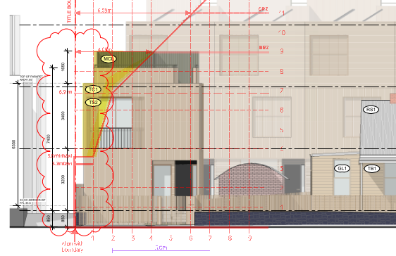
Figure 6: Townhouse 2 Non-Compliance (Yellow Highlight)
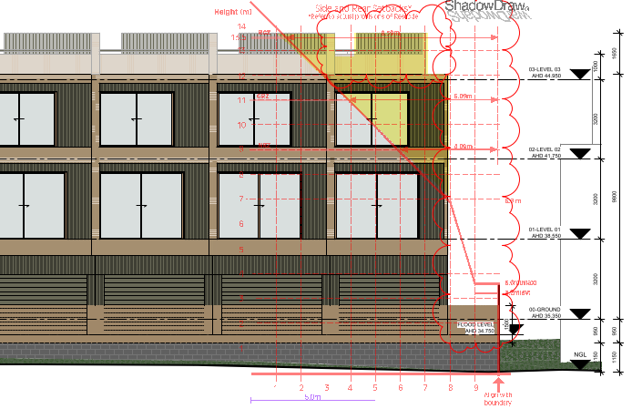
The variation to the Standard is acceptable, with the development adjacent to a neighbouring four-storey apartment complex with comparable setbacks of 2.65-2.95 metres. Windows and balconies with an outlook towards the site are screened with a mix of obscure glazing, external fixed louvres and raised sill heights. It is not considered that the variation to the setback requirement will result in unreasonable building bulk having regard to the surrounding area and location of adjoining secluded private open space. It is also recognised that the primary outlook from the centralised dwellings at 42-44 Harrison Street are located next to the break between Townhouse 1 and 2.
Daylight to Existing Windows
Concern was raised by objectors in relation to daylight access to their habitable room windows and balconies fronting the subject site.
The proposal has been re-designed in the amended plans to respond to the sensitive interface with these neighbours to the north, with setbacks of 3.175 metres to Townhouse 1 and 5.6 metres to Townhouse 2. This complies with the Standard and is supported.

Has adequate car and bicycle parking been provided?
Clause 52.06 (Car Parking) of the planning scheme requires a total of 14 car parking spaces for the dwellings and 1 visitor space. The development provides 7 on-site spaces with one space provided for each new dwelling. No space will be provided for the existing heritage dwelling.
Planning policy at Clause 52.06 (Car Parking) and Clause 18.02-4L (Car parking in Moreland) seek to support reduced car parking rates in developments within and close to activity centres, with excellent access based on frequency and location to a range or public transport options and within increased provision of bicycle parking above the rates specified in Clause 52.34 (Bicycle Facilities).
Clause 52.34 (Bicycle Facilities), while not applicable to a development of less than four storeys, would generate a requirement to provide 3 bicycle spaces.
The reduction to one space per new dwelling is supported in consideration of the availability of alternative transport options in proximity to the site (560m walk to the tram, 270m and 620m walk to two bus routes, and a 650m, 800m or 900m walk to the three closest car share vehicles) and a generous supply of bicycle parking (16 spaces).
The applicant’s Traffic Impact Assessment notes the Australian Bureau of Statistics data indicates that the average car ownership across Brunswick East for a 2-bedroom dwelling is 1.26 cars, and a 3-bedroom dwelling is 1.41 cars. The Traffic Impact assessment concludes that it is expected that the level of parking provided will cater for car ownership levels of the occupiers.
Council’s traffic engineers are supportive of the car parking reduction noting the excellent provision of bicycle parking, existing on-street car parking and access to alternative transport options.
Having regard to the above, the proposed car parking reduction is supported.

Does the proposal incorporate adequate Environmentally Sustainable Design (ESD) features?
The proposal will include many positive energy efficiency aspects including a total 22.8kW solar PV system size across the new 7 dwellings, NatHERS performance of an average 6.8 stars and an all-electric build with no gas connection. The new dwellings will have excellent internal amenity, including all new dwellings with cross ventilation, excellent natural daylight access, lack of screening and improved energy performance. In addition, each garage will have a 30-32 amp EV circuit box/insulator inside to allow for the installation of the selected EV charger for future owners.
Council’s Sustainable Built Environment Unit are supportive of the ESD features proposed.

Does the proposal maintain free passage of floodwaters and protect water quality?
The application has been referred to Council’s Development Advisor who has recommended specific drainage conditions be included on any planning permit that is issued.
The proposal has adequately responded to the constraints of the site imposed by its susceptibility to flooding. Melbourne Water have not objected to the application and conditions of any permit that may issue can ensure that all of Melbourne Water’s and Council’s drainage requirements are met.
Does the proposal meet the mandatory requirements of the zone?
Garden Area
As the lot is 1362 square metres, 35 per cent minimum garden area is required. This equates to 476.7 square metres. The proposal exceeds the requirement with 491 square metres of garden area (36 per cent).
Building Height
The proposal has a maximum height of 10.65 metres and is three storey.
Clause 32.09-10 states ‘a building may exceed the applicable maximum building height or contain more than the applicable maximum number of storeys if there are existing buildings on both abutting allotments that face the same street and the new building does not exceed the building height or contain a greater number of storeys than the lower of the existing buildings on the abutting allotments’.
There are existing buildings on the lots abutting the subject site to the north and south which both face Harrison Street.
The apartment building at 42-44 Harrison Street is four storeys in scale and features a building height of 13.18 metres, while the place of worship at 3-7 Albion Street contains two storeys and is approximately 16 metres in height. The lower of the existing buildings abutting the site is the apartment building. The proposal has less storeys and is lower than the apartment building and can therefore be considered.
The proposed three storey height is considered acceptable in the context of the street and will provide for an appropriate transition between the place of worship and the apartment building. In addition, the height of the rear townhouses will not result in a dominant impact as seen from the Merri Creek, or the street due to the setbacks provided and landscaping screening from the creek corridor.

5. Response to Objector Concerns
The following issues raised by objectors are addressed in section 4 of this report:
• Building height
• Amenity impacts including walls on boundary and daylight access to existing windows
• Parking.
• Loss of vegetation and impact of development on Merri Creek environs
• Impact of development on trees proposed to be retained (on-site)
• Impact on heritage dwelling and demolition of outbuildings
• Drainage, flooding and inundation concerns
Other issues raised by objectors are addressed below.
Overshadowing and overlooking
Shadows cast by the development will be largely contained within the development site itself and will not fall onto adjoining residential land. The shadowing complies with Standard B21 of Clause 55.04-5.
Townhouses 1 and 2 will feature 1.65-metre-high screening along the northern edge of the proposed rooftop terraces. This will adequately prevent downward views into neighbouring windows and secluded private open space and is in accordance with the Standard B22 of Clause 55.04-6.
Traffic
In relation to traffic impacts, Council’s Development Engineers have assessed the proposal and consider that the development will result in 36 additional vehicle movements per day on Harrison Street. This remains within the street’s design capacity and is not expected to cause traffic problems or unreasonable congestion at nearby intersections.
Impact of development on trees proposed to be retained (off-site)
Concern was raised by objectors in relation to the impact on the development on existing trees located to the north of the site at 42-44 Harrison Street. There are seven trees located on the neighbouring site in proximity to the proposed development.
Five of the seven trees will be located adjacent the communal open space area, and Townhouse 2 which features a 2.05 metre setback from the boundary. The applicant’s Arborist reviewed the trees on, and off-site, and did not believe that the proposed development would unreasonably impact on the health and on-going viability of the trees. A permit condition in the officer recommendation will require a Tree Management Plan which will ensure the protection of these trees through the construction phase of the development.

Construction related concerns
Concern has been raised in relation to damage of the adjoining buildings during construction.
Protection of adjoining properties during construction is a matter that can be appropriately addressed through the building permit process rather than the planning permit process. The owners of the land proposing to build have obligations under the Building Act 1993 to protect adjoining properties from potential damage. It is the responsibility of the relevant Building Surveyor to require protection work, as appropriate.

Loss of views
The Victorian Civil and Administrative Tribunal has consistently found that although impact upon views can be considered amongst the amenity impacts of a proposal, there cannot be considered a right to any particular view. The loss of views in this instance are not considered to warrant the refusal or modification of the development

Overdevelopment
The Victorian State Government has provided a clear policy imperative of urban consolidation as a way of providing housing for Melbourne’s growing population. Any over development is determined from a quantitative assessment of a development’s compliance with a series of criteria set out in the Moreland Planning Scheme (for example, a site coverage of 35 per cent). This includes an assessment of the design’s ability to provide for the amenity of future residents, protect the amenity of existing residents and respond to the attributes and constraints of the site. The number of dwellings and associated pedestrian and vehicle movements account for the site’s accessibility and location. The assessment in section 4 of this report does not support a conclusion that the proposal is an overdevelopment of the site.

6. Officer Declaration of Conflict of Interest
Council Officers involved in the preparation of this report do not have a conflict of interest in this matter.

7. Financial and Resources Implications
There are no financial or resource implications.

8. Conclusion
On the balance of policies and controls within the Moreland Planning Scheme and objections received, it is considered that application No MPS/2020/799 should be supported subject to conditions included in the recommendation of this report.

Attachment/s
1 | Zoning and Location Plan - 38 Harrison Street, Brunswick East | D22/86883
2 | Development Plans - 38 Harrison Street, Brunswick East | D22/86913
3 | Objector Location Map - 38 Harrison Street, Brunswick East | D21/351312
4 | Landscape Heritage Assessment - 38 Harrison Street, Brunswick East | D22/211910

5.2 105-107 Harding Street, Coburg - Amended Planning Permit Application - MPS/1994/4651/C
Director Place and Environment, Joseph Tabacco
City Development

Executive Summary

Property: | 105-107 Harding Street, COBURG
Proposal: | Amendment to the permit to allow for buildings and works to construct an extension to the existing restaurant and changes to the approved licenced area.
Zoning and Overlay/s: | • Commercial 1 Zone, with a strip of land 2.5m deep along the rear (northern) elevation zoned Neighbourhood Residential Zone – Schedule 1.  • Parking Overlay – Schedule 1  • Development Contributions Plan Overlay
Strategic setting:
Objections: | 28 objections received which raises the following key issues:  • Acoustic treatment  • Car parking  • Waste management  • Neighbourhood character  • Incompatible with adjoining residential uses  • Hours of operation  • Patron numbers  • Street trading  • Non-compliance with existing permit conditions
Planning Information and Discussion (PID) Meeting: | Date: 22 December 2021  Attendees: 7 objectors, the applicant, two Council officers, Mayor Riley and Councillor Bolton.  The following agreements were reached at the PID meeting:  • Submission of an acoustic report prepared by a suitably qualified engineer, and amended plans to incorporate any recommendations of the report;  • Provision of a Waste Management Plan and Venue Patron Management Plan via permit conditions
ESD: | The proposal will incorporate measures (via conditions) to mitigate the impacts of stormwater on the environment
Key reasons for support | • There are no changes to hours or patron numbers, with the internalising of the existing outdoor dining area reducing the amenity impacts.  • Buildings and works improve the existing building.  • Appropriate noise attenuation measures to be incorporated  • Changes to the licenced area are inconsequential to the operation of the business
Recommendation: | Notice of Decision to Grant an amended Planning Permit be issued for the proposal

Officer Recommendation
That a Notice of Decision to Grant an Amended Planning Permit No. MPS/1994/4651/C be issued for the use of the land for the sale and consumption of liquor, a reduction of the standard car parking requirement, buildings and works associated with a restaurant at 105-107 Harding Street, COBURG, subject to the following conditions (new conditions in bold):
1A. Before the development approved by Amendment C to this permit commences, amended plans to the satisfaction of the Responsible Authority must be submitted to and approved by the Responsible Authority. When approved, the plans will form part of the permit. The plans must be drawn to scale with dimensions and must be generally in accordance with the plans prepared by Urban Workroom (advertised 28 March 2022) but modified to show:
a) The bicycle parking shown as located undercover or relocated into an easily accessible indoor area, with parking spaces dimensioned in accordance with Clause 52.34 of the Moreland Planning Scheme.
b) Details of any patron management measures shown on the plans, in accordance with the Venue and Patron Management Plan required by Condition 12 of this permit.
c) Details of waste storage and collection measures shown on the plans, in accordance with the Waste Management Plan required by Condition 18 of this permit.
d) The stormwater initiatives that are required to be shown on plans, as contained within Condition 21 of this permit.
2. Prior to the commencement of the development hereby permitted, three copies of plans drawn to scale and dimensioned shall be submitted to and approved by the Responsible Authority. Such plan shall be generally in accordance with the plan submitted with the application but modified to show:
a) The removal of the red line area from the tables and chairs located outside of the building along Harding Street.
An endorsed copy of the plans shall form part of this permit.
3. This permit shall have no force or effect until Public Liability Insurance has been provided by the applicant to the satisfaction of the Responsible Authority.
4. All umbrellas used at approved tables shall have a minimum clearance above the footway of two metres from the lowest point of the extended arms (spokes) of the umbrella.
5. All fixtures and umbrellas shall be securely anchored so that they will not be displaced by wind otherwise, to satisfaction of the Responsible Authority.
6. All tables and chairs shall be located:
a) at least 5 metres from kerbing;
b) at least 3 metres from any street fixture or fitting;
c) at least 9 metres from any intersection or pedestrian crossing unless safety aspects warrant a reduced distance;
d) allowing a minimum clearance of 1.5m pavement with
All to the satisfaction of the Responsible Authority.
7. The proprietor shall at all times be responsible for the cleanliness of the footpath area and immediate surrounds used for the placing of tables and chairs.
8. Tables and chairs be kept clean and tidy at all times and must be removed from the footpath whilst the premises are closed.
9. Adequate fly proofing provided for the restaurant doors.
10. Siting, dimensions, appearance and design of all buildings and works and the use of all buildings and areas must accord with the endorsed plans and must not be changed without the written consent of the Responsible Authority.
11. The loading and unloading of vehicles in association with the use of the land must only be carried out within the boundaries of the land.
12. The operation must not adversely affect the amenity of the surrounding area by way of noise, smell, dust, fumes, litter or untidy appearance.
13. Prior to the endorsement of plans under Amendment C to this permit, a Venue Patron Management Plan (VPMP) must be submitted to the Responsible Authority. The Plan must be to the satisfaction of the Responsible Authority and must include details of:
a) Hours of operation of all parts of the premises (i.e. including the closing times of the new covered dining area)
b) Patron capacity limits within each dining area
c) How the venue will manage patrons entering and leaving the venue, including security and queuing
d) Complaint handling processes, including a contact number available to nearby residents and a process for immediate issue rectification.
e) Staff training for patron management
f) Patron smoking areas
When submitted and approved to the satisfaction of the Responsible Authority, the VPMP will be endorsed to form part of this permit. No alterations to the VPMP may occur without the written consent of the Responsible Authority.
14. The Venue and Patron Management Plan endorsed under this permit must be implemented and complied with at all times, to the satisfaction of the Responsible Authority.
15. The Acoustic Report prepared by Clarity Acoustics (advertised 28 March 2022) will be endorsed to form part of this permit. The building and works, approved under Amendment C to this permit, must be constructed and thereafter maintained in accordance with the recommendations contained within this report to the satisfaction of the Responsible Authority, unless with the further written approval of the Responsible Authority.
16. The venue must not be used for live music and no music other than of a type and volume appropriate to background music may be emitted from external speakers in these areas. Background music is defined as any music played at a level that enables patrons to conduct a conversation at a distance of 600 millimetres without having to raise their voice to a substantial degree. It is not background music if it is played at a level which requires patrons to shout, or use a stage voice such as that used by an actor in the theatre, in order to carry out a conversation at such a distance.
17. Prior to the issue of an Occupancy Permit or issue of a Certificate of Final Inspection, whichever comes first, a report from the author of the Acoustic Report approved pursuant to this permit or similarly qualified person or company must be submitted to the Responsible Authority. The report must be to the satisfaction of the Responsible Authority and must confirm that all measures specified in the Acoustic Report have been implemented in accordance with the approved Acoustic Report.
18. Noise levels associated with the use must at all times comply with the Environment Protection Regulations under the Environment Protection Act 2017 and the incorporated Noise Protocol (Publication 1826.2, Noise Limit and Assessment Protocol for the Control of Noise from Commercial, Industrial and Trade Premises and Entertainment Venues, Environmental Protection authority, March 2021), or any other superseding regulation.
Should the Responsible Authority deem it necessary, the owner and/or occupier of the land must submit an amended Acoustic Report to the satisfaction of the Responsible Authority which demonstrates compliance, or which outlines any measures considered necessary to achieve compliance.
The recommendations of the amended Acoustic Report must be implemented no later than three (3) months after the date that the Responsible Authority advises in writing that it is satisfied with the report, or as otherwise agreed in writing by the Responsible Authority. The endorsed plans must also be amended within three (3) months, or as otherwise agreed in writing by the Responsible Authority, to accord with the recommendations contained in the Acoustic Report to the satisfaction of the Responsible Authority.
19. Prior to the endorsement of plans under Amendment C to this permit, a Waste Management Plan (WMP) must be submitted to the satisfaction of the Responsible Authority. The WMP must include, but not limited to the following:
a) A description of ease of disposal for occupier that does not disadvantage recycling;
b) Confirmation that educational material will be displayed in the waste bin storage area explaining what material can be recycled;
c) Calculations showing the amount of garbage, recycling, food organics and garden organics expected to be generated;
d) A statement of whether the garbage, hard waste, recycling (glass and general recycling), food organics and garden organics will be collected by Council or a private collection, stating the size of bins, frequency of collection and hours of collection;
e) Include a plan showing the location of the bin storage area on the site and details of screening from public view;
f) Include a dimensioned plan showing the storage area is sufficient to store the required number of bins in a manner that allows easy access to every bin;
g) Detail the ventilation to prevent garbage odours impacting nearby dwellings;
h) Detail the ease of taking the fully loaded waste bins to the point of waste collection;
i) State where and when the bins will be placed for waste collection;
j) Waste collection must only occur during the following hours:
i. 6.30 am and 8.00 pm Monday to Saturday; or
ii. 9.00 am and 8.00 pm Sundays and Public Holidays.
k) Confirm that the bins will be removed from the street promptly after collection; and
l) Include a plan showing where the waste trucks will stop to service the waste bins and state whether No Parking restrictions will be required for the waste trucks to access that space (e.g. 6am-midday, Wed).
When submitted and approved to the satisfaction of the Responsible Authority, the WMP will be endorsed to form part of this permit. No alterations to the WMP may occur without the written consent of the Responsible Authority.
20. The Waste Management Plan approved under this permit must be implemented and complied with at all times to the satisfaction of the Responsible Authority unless with the further written approval of the Responsible Authority.
21. The operator of the premises must make satisfactory arrangements for all litter including food wrappings and containers to be cleared away from the land on a regular basis to the satisfaction of the Responsible Authority.
22. Prior to the endorsement of plans, a Stormwater Management System Report must be submitted to the Responsible Authority. The report must describe how the stormwater management system is designed to meet Clause 53.18 of the Moreland Planning Scheme and the Urban Stormwater – Best Practice Environmental Management Guidelines (Victorian Stormwater Committee, 1999). The report must be to the satisfaction of the Responsible Authority and include:
a) A STORM report that maintains a minimum score of 100 per cent. It must not use proprietary products, buffer strips, swales or large areas of hard surface draining to in-ground raingardens. It must include the following details:
i. The site area associated with the proposed extension, including all pervious and impervious area.
ii. The size of rainwater tanks proposed, and their reliability details as being a minimum of 80 per cent.
b) A confirmation that the overflow system for any rainwater tanks are to be gravity fed to the legal point of discharge (LPOD). Pumps are not acceptable.
c) A stormwater catchment plan. It must not use proprietary products, buffer strips, swales or large areas of hard surface draining to in-ground raingardens. It must not include charged pipes that run under building slabs. It must show:
i. All pervious and impervious areas (dimensioned in square metres).
ii. The proposed stormwater treatment measures, consistent with the STORM report.
iii. Where all stormwater will drain, with downpipes marked and the direction of water flow shown with arrows.
iv. All water tanks and WSUD features, including dimensions, sections, etc.
v. Any proposed permeable paving for the treatment of any driveways. A section and details of any permeable paving must be provided.
Where alternative stormwater initiatives are proposed to those specified in this condition, the Responsible Authority may vary the requirements of this condition at its discretion, subject to the development achieving equivalent (or greater) stormwater outcomes in association with the development.
When submitted and approved to the satisfaction of the Responsible Authority, the amended Stormwater Management System Report and associated notated plans will be endorsed to form part of this permit. No alterations to the Stormwater Management System Report may occur without the written consent of the Responsible Authority.
23. Prior to the issue of an Occupancy Permit or issue of a Certificate of Final Inspection whichever comes first, the development must be constructed in accordance with the endorsed Stormwater Management System Report to the satisfaction of the Responsible Authority. No alterations to these plans may occur without the written consent of the Responsible Authority.
24. The area set aside for the parking of vehicles together with the access lanes shown on the endorsed plan must:
• Be completed prior to the commencement of the use to the satisfaction of the Responsible Authority.
• Be maintained to the satisfaction of the Responsible Authority.
• Be properly formed to such levels that it can be used according to the plan.
• Be drained and surfaced with an all weather seal coat to the satisfaction of the Responsible Authority.
• Have the boundaries of all vehicle spaces clearly marked on the ground to accord with the endorsed plan.
• Not be used without the permission of the Responsible Authority for any purpose other than the parking of vehicles.
25. Prior to the issue of an Occupancy Permit or issue of a Certificate of Final Inspection, whichever comes first, a vehicle crossing must be constructed in every location shown on the endorsed plans to a standard satisfactory to the Responsible Authority (Moreland City Council, City Infrastructure Department).
26. Prior to the issue of an Occupancy Permit or issue of a Certificate of Final Inspection, whichever comes first, any existing vehicle crossing not to be used in this use or development must be removed and the kerb and channel, footpath and nature strip reinstated to the satisfaction of the Responsible Authority (Moreland City Council, City Infrastructure Department).
27. Front windows may only be used for promotion and display of goods and must not be painted in or blocked out in any way.
28. All external light fittings must be provided with suitable baffles so that direct light is not emitted outside the site.
29. The use permitted must only operate during the following hours:
• Monday – Thursday 5.00pm to 11.00pm
• Friday, Saturday, Sunday 10.00am to 11.00pm
30. No more than 120 patrons shall be on the premises at any one time.
31. All signs on the site must be maintained in good condition to the satisfaction of the Responsible Authority.
32. Flashing; running or intermittent lights must not be displayed on the land.
33. This permit expires if development is not commenced within 12 months from the date of issue or the buildings and works are not completed within 24 months of the date of issue unless either of these dates are extended by the Responsible Authority in writing. An application for extension of time may be made in writing within 3 months after the expiry date.
34. The use and development approved by Amendment C to this permit will expire if one of the following circumstances applies:
• the use and development is not commenced within two (2) years from the date of issue of Amendment C;
• the development is not completed within four (4) years from the date of issue of Amendment C;
The responsible authority may extend the periods referred to if a request is made in writing before the permit expires or:
• within six months after the permit expires to extend the commencement date.
• within 12 months after the permit expires to extend the completion date of the development if the development has lawfully commenced.
NOTE 1:
This permit is issued under the provisions of the Planning and Environment Act 1987. The Health Act, Victoria Building Regulations and all other relevant legislation must be complied with.
NOTE 2:
This permit has been amended to correct the address of land under the provision of Section 71 of the Planning and Environment Act 1987.

REPORT

1. Background

Subject site
The subject site is located at 105-107 Harding Street, Coburg. The site is located on the northern side of Harding Street, approximately 125 metres west of Nicholson Street, and forms a corner lot at the intersection of Harding and Gladstone Streets.
The site is made up of two commercial tenancies, which results in an ‘L’ shaped lot, with a combined frontage to Harding Street of 11.46 metres, a depth along Gladstone Street of 32.7 metres and a rear boundary of approximately 28 metres.
The site is used as a licensed pizza restaurant which operates from 5 pm to 11 pm Monday to Thursday, and from 10 am to 11 pm Friday to Sunday. The restaurant can accommodate a maximum of 120 patrons.
There is an outdoor dining area and a shed located to the rear of the site. Part of the rear is also used for services (e.g. bin storage).
There are currently two vehicle crossovers to the site via Gladstone Street, however at present only one is utilised.
There are no restrictive covenants indicated on the Certificate of Title.
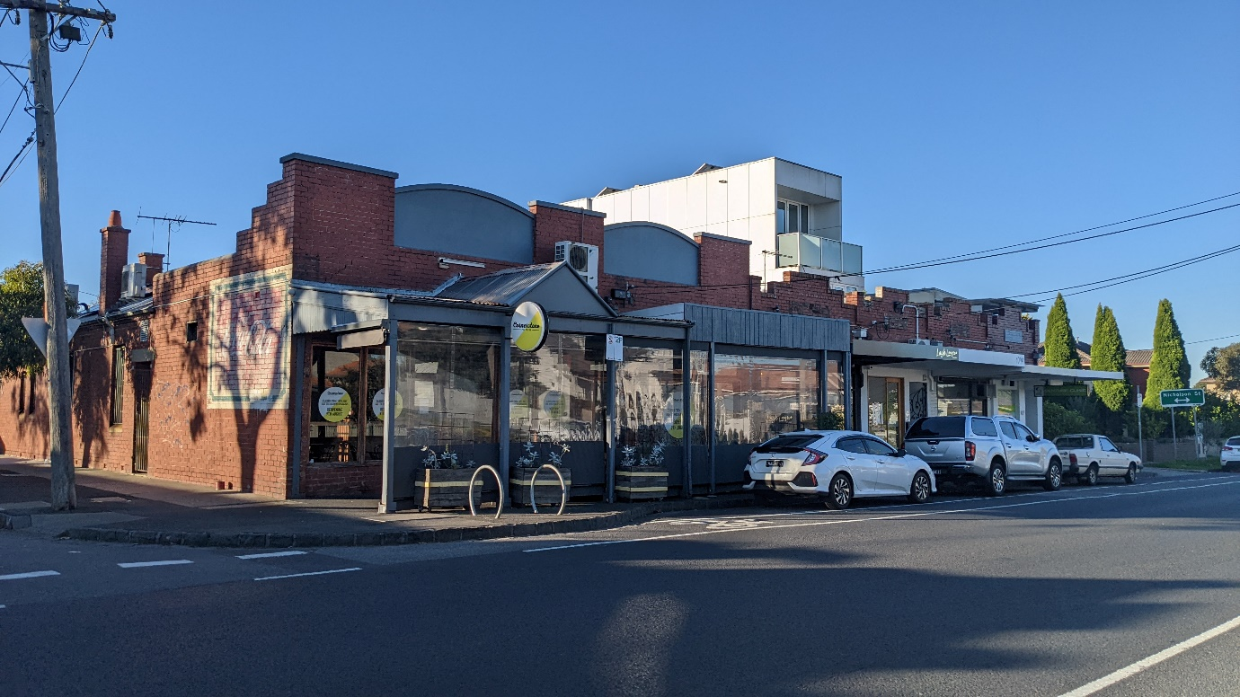
Fig. 1: 105-107 Harding Street, Coburg (subject site) as viewed looking north from Harding Street (taken by planning officer, May 2022)

Surrounds
The surrounding area is characterised by a mix of residential and commercial uses.
The subject site forms part of the Harding/Gladstone Streets Coburg Local Centre. This is reflected in the zoning of the surrounding area, and other local centres further west of the site on the corners of Belgrave and Salisbury Streets.
Immediately adjoining the subject site to the east and west along Harding Street are other commercial tenancies which includes a local grocer, beauty salons, office and dental practice. The neighbouring building to the east at 109A Harding Street is developed with a three-storey building containing commercial on ground level and two dwellings above.
The areas to the north along Gladstone Street, and opposite the subject site to the south are residential mainly comprising of single, detached dwellings. There are some examples of infill development that have occurred further north along Gladstone Street and to the east and west of the subject site
A location plan forms Attachment 1 and a zoning map forms Attachment 2.

The proposal
The proposal seeks to amend planning permit MPS/1994/4651/C which is summarised as follows:
• Removal of the existing storage shed located to the rear along the northern boundary.
• Removal of the shade cloth that covered the existing outdoor dining area.
• Construction of a single storey extension to the rear to accommodate new dining area.
• Reconfiguration of the existing licenced area to reflect changes to the site as a result of the proposed buildings and works.
• Works to provide for three (3) staff car parking spaces, four (4) bicycle parking spaces, and a bin storage area within the site.
The amendment does not propose any changes to the hours of operation or to the number of patrons that can be accommodated on the premises.
The development plans form Attachment 3.

Planning Permit and Site History
Planning permit no: MPS/1994/4651 was issued on 12 January 1994 and allowed for an extension of the existing restaurant at 107 Harding Street to incorporate 105 Harding Street. The use within the site has commenced and continues to operate today.
The planning permit has been amended twice; Amendment A and B.
Amendment A was approved on 5 May 2015 and amended the following aspects of the permit:
• Varied the operating hours (Condition 16) to:
o Monday – Thursday 5:00pm – 11:00pm
o Friday – Sunday 10:00am – 11:00pm
These are the current operating hours.
• Allowed for sale and consumption of liquor on the premises at the above hours.
• A new condition allowing a total of 80 patrons.
• Reduction of three (3) car parking spaces.
• Construction of a storage shed at the rear of the site.
Amendment B was approved on 12 April 2016 and amended Condition 18 to allow for an increase in patron numbers from 80 to 120.

Statutory Controls – why is a planning permit required?
Control | Permit Requirement
Commercial 1 Zone  Neighbourhood Residential Zone – Schedule 1 | Clause 34.01-4: A permit is required to construct a building or construct or carry out works in the C1Z  Clause 32.09-9: A permit is required to construct a building or construct or carry out works associated with a Section 2 use (i.e. restaurant) of 32.09-2
Particular Provisions | Clause 52.27: A permit is required to use land to sell or consume liquor if the area the liquor is allowed to be consumed or supplied under a licence is to be increased.
The following Particular Provisions of the Moreland Planning Scheme are also relevant to the consideration of the proposal:
• Clause 45.06: Development Contributions Plan Overlay: The leasable floor area of the premises decreases from 343sqm to 320sqm. Therefore, the works are exempt from the DCP levy as detailed in Schedule 1.
• Clause 45.09: Parking Overlay
• Clause 53.18: Stormwater Management in Urban Development

2. Internal/External Consultation

Public notification
Notification of the application has been undertaken pursuant to Section 52 of the Planning and Environment Act 1987 by:
• Sending notices to the owners and occupiers of adjoining and nearby land
• Placing 3 signs on the Harding and Gladstone Street frontages of the site
Council has received 28 objections, including nine (9) proforma objections and nine (9) objections from the same property. A map identifying the location of objectors forms Attachment 5.
The key issues raised in objections are:
• Acoustic treatment
• Car parking
• Waste management
• Neighbourhood character
• Incompatible with adjoining residential uses
• Hours of operation
• Patron numbers
• Street trading
• Non-compliance with existing permit conditions
A Planning Information and Discussion (PID) meeting was held on 22 December 2021 and attended by Mayor Riley and Councillor Bolton, two Council Planning Officers, the applicant and seven objectors. The meeting provided an opportunity to explain the application, for the objectors to elaborate on their concerns, and for the applicant to respond.
As a result of the PID, a Section 57A amendment was received which included the provision of an acoustic report to assist in understanding potential noise impacts to adjoining residential properties, noise attenuation measures to be included as part of the new built form and amended plans reflecting those measures. This amendment was advertised to the same properties as the original application, including any existing objectors. One (1) additional objection was received from a party that had already submitted an objection.

Internal referrals
The proposal was referred to the following internal branch:
Internal Branch/Business Unit | Comments
Transport - Development Engineering Team | Supports the proposal.  The proposed car parking arrangement allows for efficient vehicle movements to and from the site, and the removal of the unused vehicle crossing from the Gladstone Street frontage results in a positive streetscape outcome. The provision of staff bicycle parking is supported but must be relocated to be out of the weather.  The suggested changes are addressed by conditions of the recommendation and are considered further in Section 4 of this report.
Sustainable Built Environment – Environmentally Sustainable Development | Supports the proposal.  An SDA is not required given the scale and scope of the amendment.  The application has been discussed with Council’s ESD team who have provided guidance on how to address the stormwater management required under Clause 53.18.  Suggested changes are addressed by conditions of the recommendation.

3. Policy Implications

Planning Policy Framework (PPF):
The following policies are of most relevance to this application:
• Municipal Planning Strategy (Clause 2), including:
− Vision (Clause 2.02)
− Settlement (Clause 2.03-1)
− Environmental and Landscape Values (Clause 2.03-2)
− Environmental Risks and Amenity (Clause 2.03-3)
− Built Environment and Heritage (Clause 2.03-4)
− Housing (Clause 2.03-5)
− Economic Development (Clause 2.03-6)
− Transport (Clause 2.03-7)
− Infrastructure (Clause 2.03-8)
• Settlement (Clause 11)
• Environmental Risks and Amenity (Clause 13):
− Noise Abatement (Clause 13.05-1S and 13.05-1L)
− Discretionary Uses in Residential Zones (Clause 13.07-1L)
− Entertainment Venues and Licensed Premises (Clause 13.07-1L)
• Built Environment (Clause 15.01), including:
− Urban Design (Clause 15.01-1S, 15.01-1R & 15.01-1L)
− Vehicle Access Design in Moreland (Clause 15.01-1L)
− Building Design (Clause 15.01-2S & 15.01-2L)
− Building Design in Neighbourhood and Local Centres (Clause 15.01-2L)
− Healthy Neighbourhoods (Clause 15.01-4S and 15.01-4R)
− Neighbourhood Character (Clause 15.01-5S)
• Economic Development (Clause 17), including:
− Diversified economy (Clause 17.01-1S & 17.01-1R)
− Business (Clause 17.02-1S)

Human Rights Consideration
This application has been processed in accordance with the requirements of the Planning and Environment Act 1987 (including the Moreland Planning Scheme) reviewed by the State Government and which complies with the Victorian Charter of Human Rights and Responsibilities Act 2006, including Section 18 (Taking part in public life). In addition, the assessment of the application has had particular regard to:
• Section 12: Freedom of movement
• Section 13: Privacy and Reputation
• Section 16: Right to peaceful assembly and freedom of association
• Section 18: Right to take part in public life
• Section 20: Property rights
This application does not limit human rights. The impact of the proposed amendments on the users of the premises, visitors and other associated systems have been considered.

4. Issues
In considering this application, regard has been given to the State and Local Planning Policy frameworks, the provisions of the Moreland Planning Scheme, objections received and the merits of the application.
The subject site is mostly located in the Commercial 1 Zone and forms part of the Local Centre where the existing use contributes to serving the daily convenience needs of the local community.
The licensed pizza restaurant has been operating on site since 1994. The proposed amendment does not seek to change the hours of operation or increase the number of patrons that can be accommodated on site.
Therefore, the key consideration of the proposal relates to the appropriateness of the proposed buildings and works having regards to the character of the area, and whether the changes to the licenced area result in any potential amenity impacts.

Do the buildings and works respond to neighbourhood character, positively contribute to the local context and enhance the public realm?
The policies at Clause 15.01-2L (Building design in Neighbourhood and Local centre) and Clause 13.07-1L (Discretionary uses in Residential Zones) seeks to ensure that new developments are designed and sited to be respectful and compatible with the scale and character of the residential area.
The proposal seeks to remove the shed located to the rear boundary and the shade cloth located above the existing outdoor dining area to construct a new single storey extension to accommodate a new dining area and carry out works to allow for on-site car parking spaces. Refer to the photo in Figure 2 below.
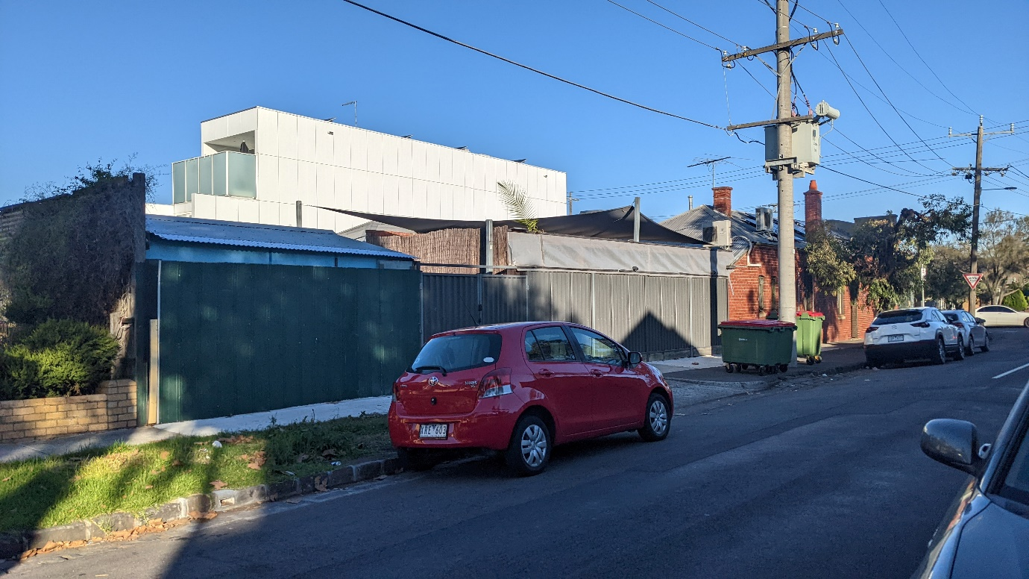
Fig. 2: Photograph showing the subject site as viewed from Gladstone Street, looking east. Photograph shows the end of the building (red brick on the right), and current outdoor dining arrangement including the shadecloth and shed located on the northern boundary. Portion to be removed highlighted in red (photo taken by Planning Officer, May 2022).
The new extension will be single storey in height with a gabled roof form and will incorporate walls on the western side boundary, adjacent to the pedestrian footpath on Gladstone Street. This is considered to be context responsive in light of the surrounding character, which has large walls on boundary opposite the site associated with another commercial tenancy (Figs. 3 below), and the gable roof responds to the traditional housing forms that are found throughout Gladstone Street and Harding Street. While the new structure does result in an increase in height of built form both within the site and on the boundary, the overall improvement in design and quality of the new works are considered to be a positive contribution to the streetscape.
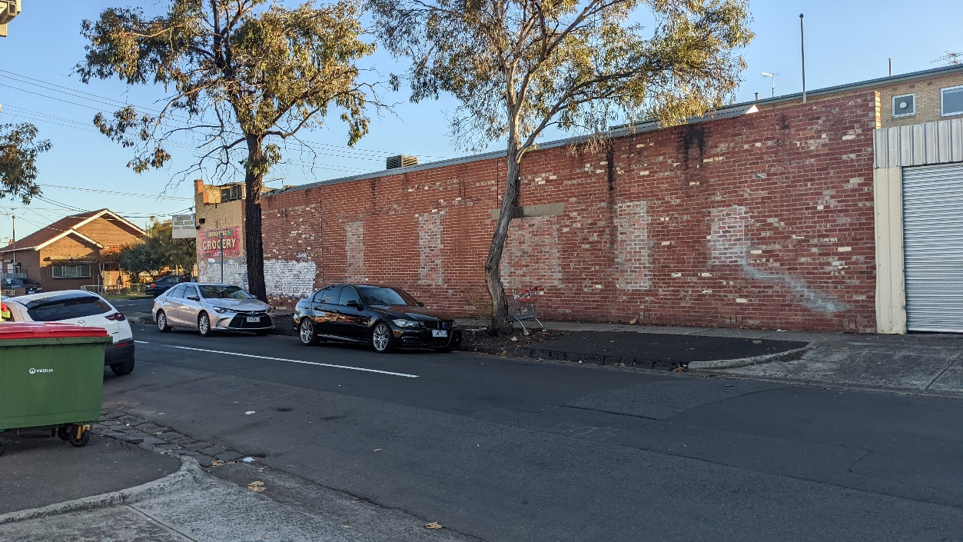
Fig. 3: Wall on boundary opposite the subject site along Gladstone Street, looking west (photo taken by Planning Officer, May 2022)

Does the proposal result in any unreasonable off-site amenity impacts?
Noise
Objectors have raised concerns regarding the noise impacts on residential properties as a result of the use and proposal. As mentioned, the scope of considerations are confined to the buildings and works and changes to the licenced area, and that the proposal does not result in an increase in patron numbers or hours of operation.
The proposal will result in removal of the outdoor dining area and creation of a new dining area which will confined within a new building. An acoustic report has been submitted which details acoustic attenuation measures to be incorporated into the building. These measures have been detailed on the plans. This will ensure that the noise emission from patron movements and dining are minimised and are an improvement on the existing unenclosed conditions of the outdoor dining area. A condition of the recommendation will require that only background music be played in this new dining area. Further, the new extension will be setback 3.6 metres from the northern boundary shared with the residence at 39 Gladstone Street.
The construction of a 3 metre high concrete sheet fence along the northern boundary will also assist with reducing acoustic impacts to any adjoining habitable rooms along this elevation. The new fence, which will replace an ‘ad-hoc’ structure currently located on the northern boundary, will also incorporate ‘green wall’ landscaping. This will result in an overall improvement to the streetscape, as well as providing improved acoustic attenuation to the residents of 39 Gladstone Street. A condition of the recommendation will require the building to be constructed and thereafter maintained in accordance with the acoustic report.
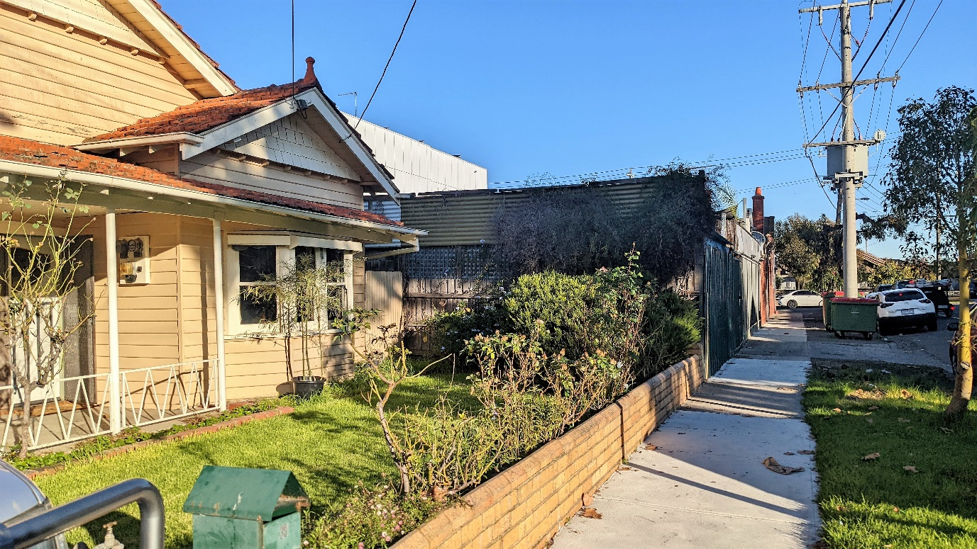
Fig. 6: Image showing ‘ad-hoc’ fence currently constructed along shared boundary between subject site and 39 Gladstone Street, highlighted in red.
Licenced Area
The application seeks to increase the area where liquor can be served within the site. The approved red line plan forms Attachment 4. The new areas to be included comprise of the kitchen, office, toilets, and a general realignment to include the new dining area.
The changes sought to the red line plan are inconsequential as they only seek to include areas within the existing restaurant and does not increase the available dining area where patrons can consume alcohol. At present, liquor can be consumed in the existing outdoor area and the proposed amendment does not seek to change this situation. The change is sought to provide consistency in where liquor can be sold and consumed throughout the venue and is appropriate.
Waste
The site currently has a private waste arrangement, and bins are stored within the rear services area of the lot in an informal manner. This area is unpaved and there is no designated bin storage area within the site, at present. Although the proposal does not seek to change the location of bin storage from this rear services area of the site, a dedicated bin storage area of 18sqm is set aside in the south-eastern corner of the rear portion of the site.
Although the use of the site as a restaurant is outside the scope of consideration for this application, the permit applicant has agreed to the provision of a Waste Management Plan (WMP) as a permit condition to ensure that waste is collected on a regular schedule within appropriate hours so as not to result in additional amenity impacts to the adjoining properties. Conditions relating to the enforcement of the WMP have also been included as part of the recommendation.
Patron Management
The number of patrons is not proposed to increase as a result of the proposal, however as a result of discussions at the PID it is clear that patron behaviour and management is a concern for the surrounding community.
Condition 11 of the permit requires that ‘the operation must not adversely affect the amenity of the surrounding area by way of noise, smell, dust, fumes litter or untidy appearance’.
The permit applicant has agreed to provide a Venue and Patron Management Plan to assist with improving the management of patrons both within the site and when they leave. Conditions have been included to require the provision of the plan. This will provide greater certainty for surrounding residents as to an anticipated level of amenity, and will provide for a framework to facilitate complaints should patron behaviour be unacceptable.

Has adequate car and bicycle parking been provided?
A reduction of three staff car parking spaces associated with the restaurant was approved under Amendment A to the permit. At present there is technically the provision of one staff car space within the site, in between the existing outdoor dining area and rear shed, as shown on the endorsed red line plan. No patron parking is provided.
The proposal results in an overall reduction in the floor area of the building, therefore there is no requirement pursuant to Clause 52.06 to provide additional on-site parking as a result of the proposal.
This amended proposal seeks to return the provision of those three (3) staff parking spaces within the rear services portion of the site. The existing staff car space is proposed as an ‘after hours’ space within the vehicle access way, which is proposed to be relocated along the northern boundary. The provision of the three spaces is supported as the provision of staff car parking spaces within the site will reduce demand for on-street parking throughout Gladstone and Harding Streets. Standard conditions have been recommended requiring the construction of the vehicle crossover to be in accordance with Council’s Vehicle Crossings Policy. Removal of the redundant vehicle crossings will also increase on street parking.
Additionally, the proposal provides for four (4) staff bicycle parking spaces, which is in excess of the two required by Clause 52.34 of the Moreland Planning Scheme. Conditions have been included at the recommendation of Council’s development engineers for these to be provided in an area sheltered from the weather. Council officers are satisfied this can be accommodated within the existing footprint of the building. The proposal seeks to rely on the public bicycle rack located on Harding Street for patron bicycle parking. This has been referred to Council’s Development Engineers who support this arrangement.
Objectors have raised concerns regarding patrons of the restaurant parking on-street throughout the local area. Vehicles, whether related to this or other developments in the street, can only park on the street in accordance with any parking regulations. The number of vehicles that can park on the street and at what time will be dictated by the parking restrictions and the availability of on-street car spaces.

Does the proposal incorporate adequate Environmentally Sustainable Design (ESD) features?
A Sustainable Design Assessment (SDA) is not required when the new floor area is less than 100sqm. The new buildings and works are 66sqm. However, the proposal is required to respond to the requirements of Clause 53.18 (Stormwater management urban development) as the new works exceed 50sqm in area. Conditions have been included as part of the recommendation requiring details to be shown on the plans of how the proposal responds to the relevant requirements of Clause 53.18.

5. Response to Objector Concerns
The following issues raised by objectors have been addressed in section 4 of this report:
• Acoustic treatment
• Car parking
• Waste management
• Neighbourhood character
Other issues raised by objectors are addressed below:
Incompatibility with adjoining residential uses, hours of operation and patron numbers
The original permit and previous amendments allow for the use of the land as a restaurant with the current hours of operation and patron numbers. As this is an amendment to an existing permit and the use, patron numbers and hours of operation are not proposed to be changed, they are outside the scope of consideration of this application. However, the acoustic report, VPMP and WMP agreed to by the applicant will assist in providing additional measures to improve management of amenity impacts to the adjoining residential uses.
Street trading not included as part of the proposal
Clause 62.01 of the Planning Scheme removes the need for a planning permit for footpath trading, as this is regulated under the local law.
There is currently a Footpath Trading Permit issued that allows for six (6) tables, 21 chairs, and a footpath liquor trading area (subject to approval from VCGLR) in front of properties specified in [the] approved permit. The consideration of on-street trading is not a planning consideration, as it is authorised under a local law. No planning approval is sought or required.
Non-compliance with existing permit conditions
Planning permits set out requirements via permit conditions that must be complied with. Council’s Planning Enforcement Unit has investigated this venue in the past and has resolved any non-compliance or found complaints to be unfounded. The proposal also seeks to address previous complaints related to the premises. Should Council receive complaints about non-compliance with permit conditions in the future, these will be investigated by Council’s Planning Enforcement Unit who will be assisted by the additional Venue and Patron Management and noise conditions included in the recommendation.

6. Officer Declaration of Conflict of Interest
Council Officers involved in the preparation of this report do not have a conflict of interest in this matter.

7. Financial and Resources Implications
There are no financial or resource implications.

8. Conclusion
It is considered that the proposed buildings and works and changes to the licenced area and increases in on-site and on-street parking are appropriate having regards to the character of the area, will not result in an intensification of the existing use, will provide for an improvement in the visual appearance of the premises and a reduction in potential amenity impacts through the enclosure of current outdoor dining area. Subject to conditions, the proposed changes will ensure that the amenity impacts to adjoining residential properties are appropriately managed and are not unreasonable.
On the balance of policies and controls within the Moreland Planning Scheme and objections received, it is considered that Notice of Decision to Grant an Amended Planning Permit No MPS/1994/4651/C should be issued subject to the conditions included in the recommendation of this report.

Attachment/s
1 | Location Map | D22/217588
2 | Zoning Map | D22/217592
3 | Advertised Plans | D22/217601
4 | Endorsed Red Line Plan | D22/223385
5 | Objector Map | D22/217604

5.3 942-944 Sydney Road, COBURG NORTH - MPS/2021/661
Director Place and Environment, Joseph Tabacco
City Development

Executive Summary

Property: | 942-944 Sydney Road, COBURG NORTH
Proposal: | Use of the existing building for an indoor recreation facility (Music Studio and Rehearsal Rooms), signage and alterations of access to a Transport Zone
Zoning and Overlay/s: | • General Residential Zone (GRZ1)  • Development Contributions Plan Overlay (DCPO1)  • Public Acquisition Overlay (PAO1)
Strategic setting: | A purpose of the GRZ is to allow educational, recreational, religious, community and a limited range of other non-residential uses to serve local community needs in appropriate locations.
Objections: | • Ten objections  • Key issues:  • Amenity impact of noise emissions  • Hours of operation  • Anti-social behaviour
Planning Information and Discussion (PID) Meeting: | • Date: Thursday 5 May 2022  • Attendees: The applicant, the business owner, 2 Council officers. No objectors or councillors attended.
Key reasons for support. | • The inclusion of a venue to foster music and artistic expression will provide economic, social and cultural benefits to the community.  • Noise impacts to the surrounding dwellings has been demonstrated to be reasonable and can be further mitigated through the adoption of recommendations included in the acoustic report  • The proposed signage is modest and does not face residential properties. The signage illumination can be limited by a condition of the planning permit.  • The provision of 11 car parking spaces and one loading bay will adequately service the proposed use.
Recommendation: | Notice of Decision to Grant a Planning Permit.

Officer Recommendation
Recommendation A:
That a Notice of Decision to Grant a Planning Permit No. MPS/2021/661 be issued for the use of the existing building for an indoor recreation facility (Music Studio and Rehearsal Rooms), business identification signage and alterations of access to a Transport Zone at 942-944 Sydney Road, COBURG NORTH, subject to the following conditions:
Amended Plans
1. Within two months of the date of this permit, amended plans to the satisfaction of the Responsible Authority must be submitted to and approved by the Responsible Authority. When approved, the plans will be endorsed and will then form part of the permit. The plans must be drawn to scale with dimensions and must be generally in accordance with the plans (advertised 10 February 2022) and Acoustic Report (dated 1 June 2022) but modified to show:
a) The provision of secure parking for at least two bicycles in accordance with the Australian Standard for Bicycle Parking (AS2890.3).
b) Details of proposed signage illumination that does not exceed the levels prescribed by AS 4282-1997 Control of the Obtrusive Effects of Outdoor Lighting or any updated version that is released.
c) The southern vehicle crossing to Sydney Road removed, with the kerb and footpath reinstated.
d) The existing vehicle crossings modified to match the location and width of the accessway.
Secondary Consent
2. The use and development as shown on the endorsed plans must not be altered without the written consent of the Responsible Authority. This does not apply to any exemption specified in Clauses 62.01, 62.02-1 and 62.02-2 of the Moreland Planning Scheme unless specifically noted as a permit condition.
Acoustics
3. Within two months of the date of this permit the provisions, recommendations and requirements of the endorsed Acoustic Report must be implemented and complied with to the satisfaction of the Responsible Authority. This includes:
a) The works as described at section 7.1.1 of the acoustic report must be completed and maintained.
b) Source noise level for each room must not exceed 95dB L10,T.
c) All rehearsal room doors must be closed while any music is played.
d) External doors to the building must remain closed at all times other than when entering/exiting the building.
e) Noise limiters for each rehearsal room. All equipment must operate with limiter controls.
f) Prominent signage at all entry/exit points instructing patrons to be conscious and respectful of the neighbouring residents when arriving and leaving.
g) Prominent signage at all entry/exit points instructing patrons to keep the external door closed at all times.
h) The telephone contact details of the venue manager to be made available to neighbouring residents and Council officers to enable potential resolution of noise of other amenity concerns at the time of a complaint is raised;
4. Within three (3) months of the date of this permit, or as otherwise agreed in writing by the Responsible Authority, a Post Commencement Acoustic Report is to be submitted to the Responsible Authority. The report must detail the following matters to the satisfaction of the Responsible Authority:
a) Confirmation that all of the recommendations of the endorsed Acoustic Report have been implemented.
b) Further testing to ascertain whether the use complies with:
i. The maximum noise levels prescribed by the Environment Protection Regulations under the Environment Protection Act 2017 and the incorporated Noise Protocol (Publication 1826.2, Noise Limit and Assessment Protocol for the Control of Noise from Commercial, Industrial and Trade Premises and Entertainment Venues, Environmental Protection Authority, March 2021) or any other superseding regulation.
c) If non-compliance is measured, recommendations for additional acoustic measures to ensure compliance with the endorsed Acoustic Report must be submitted to and approved by the Responsible Authority. The report and additional acoustic measures will then be endorsed to form part of the permit.
d) Confirmation that all acoustic testing has been carried out during a busy period with all four rehearsal rooms being used and by a suitably qualified acoustic engineer.
5. Noise levels associated with the use must at all times comply with the Environment Protection Regulations under the Environment Protection Act 2017 and the incorporated Noise Protocol (Publication 1826.2, Noise Limit and Assessment Protocol for the Control of Noise from Commercial, Industrial and Trade Premises and Entertainment Venues, Environmental Protection Authority, March 2021), or any other superseding regulation.
Should the Responsible Authority deem it necessary, the owner and/or occupier of the land must submit an Acoustic Report to the satisfaction of the Responsible Authority which demonstrates compliance, or which outlines any measures considered necessary to achieve compliance.
Use
6. The use allowed by this permit must operate only between the following hours;
• Monday to Sunday 10:00 a.m. to 11:00 p.m.
7. The maximum number of patrons permitted on the premises must not exceed 35 at any one time.
Signage
8. Every sign on the land must be maintained in good condition to the satisfaction of the Responsible Authority.
9. The approval of the business identification signage forming part of this permit expires 15 years from the date of issue, at which time the sign and all supporting structures must be removed and the site made good to the satisfaction of the Responsible Authority.
Engineering
10. All parking spaces and accessway must be delineated from the concrete footpath by kerbing at the property boundary, to ensure that vehicles are not driving over the footpath unless at the vehicle crossing.
11. Prior to the occupation of the development, any existing vehicle crossing not to be used in this use or development must be removed and the kerb and channel and footpath reinstated to the satisfaction of the relevant authority.
Permit expiry
12. This permit will expire if one of the following circumstances applies:
a) the development is not commenced within two (2) years from the date of issue of this permit;
b) the development is not completed within four (4) years from the date of issue of this permit;
c) the use is not commenced within four (4) years from the date of issue of this permit.
The Responsible Authority may extend the period referred to if a request is made in writing before the permit expires or;
• within six months after the permit expires to extend the commencement date.
• within 12 months after the permit expires to extend the completion date of the development if the development has lawfully commenced.

Notes: These notes are for information only and do not constitute part of this permit or conditions of this permit.
Note 1: It may be necessary to obtain a building permit prior to the commencement of any demolition, building works or occupation of the building. It is strongly recommended that you consult with a registered building surveyor to advise on any requirements under the Building Act, the Building Regulations and any other subordinate legislation. Further information can be sought from the Victorian Building Authority, Phone 1300 815 127 or www.vba.vic.gov.au. Council's building services branch can also assist you in the provision of this service and can be contacted on 9240 1111 or http://www.moreland.vic.gov.au/planning-building/building-renovations-and-extensions/.
Recommendation B:
Pursuant to Clause 52.06-6 (car parking) of the Moreland Planning Scheme, the 11 on site car parking spaces for a music studio and rehearsal rooms) at 942-944 Sydney Road, COBURG NORTH is to the satisfaction of the Responsible Authority.

REPORT

1. Background

Subject site
The subject site is located on the eastern side of Sydney Road and the northern side of Keady Street in Coburg North. The site is an irregular in shape with an angled frontage to Sydney Road. The site has a total area of 957sqm and is relatively level.
The site is currently occupied by a single storey commercial building that covers an area of 255sqm. The existing building is clad in brick, render and metal sheeting and has parapet walls with a flat roof. The main entrance to the building faces Sydney Road and includes glass sliding doors and two single car width roller doors. At the rear of the building on the eastern side is a lean-to covered storage and loading bay with a width of 6 metres and a length of approximately 15 metres. The building abuts the northern boundary at the closest point, and the lean-to structure runs along the eastern boundary.
The proposed use is currently operating on the site prior to being granted a permit. There is an existing food services van on the site. This use would require a planning permit. This has not been applied for by the permit applicant and is therefore not within the scope of this permit application. This is the subject of a current planning enforcement investigation.
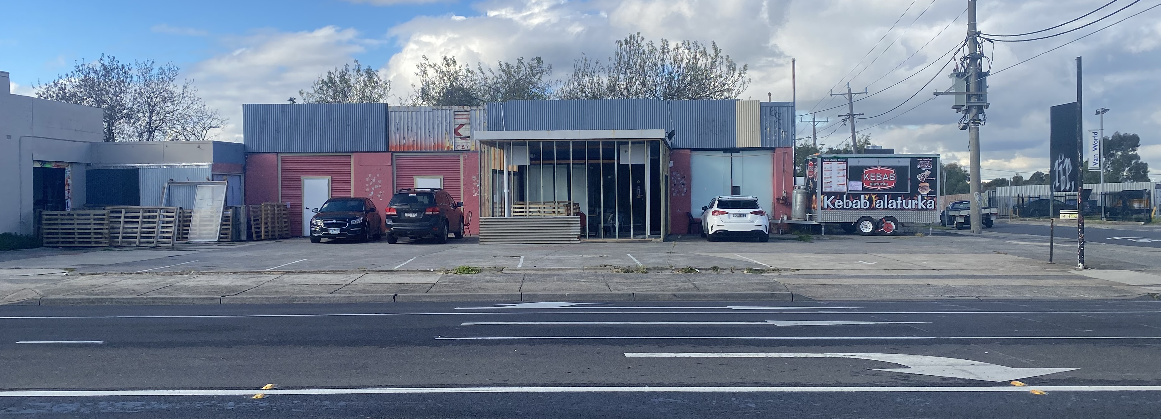
Photo 1: View of premises from Sydney Road. Source: Planning Officer Photo - May 2022.
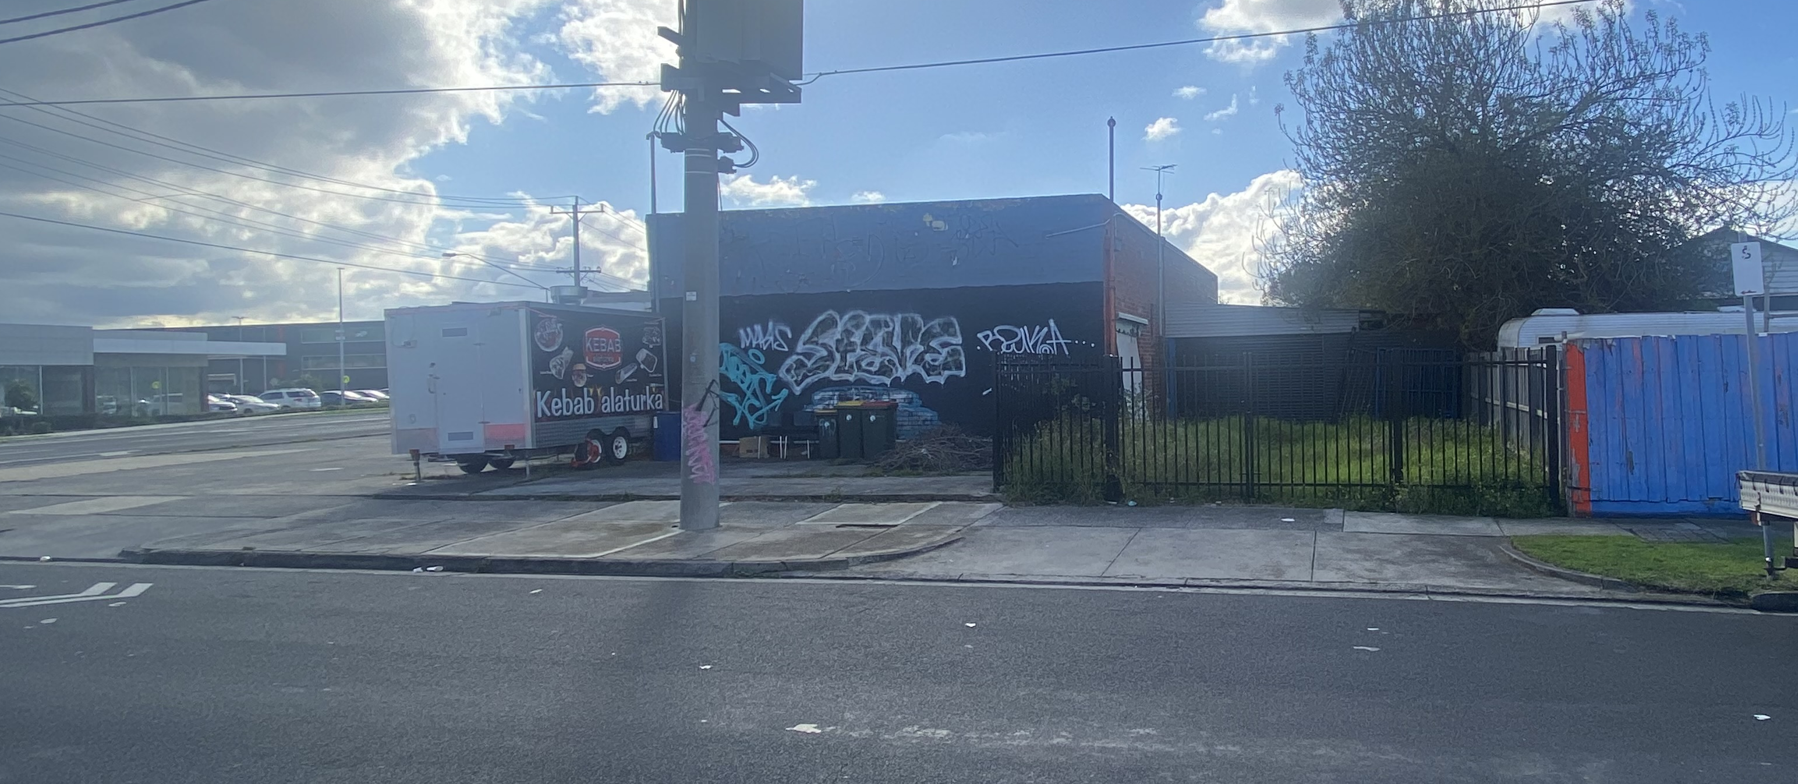
Photo 2: View of premises from Keady Street. Source: Planning Officer Photo - May 2022.
There are no restrictive covenants indicated on the Certificate of Title.

Surrounds
The surrounding area is characterised as a mix of residential uses with commercial and industrial uses along Sydney Road. The industrial zoned land to the south and north west are comprise a range of uses including storage, vehicle sales, service stations, shops and some take away food premises. The land directly to the north and east of the site is zoned General Residential. Dawson Reserve is to the south east with Parker Reserve further east.
The site adjoining to the north is occupied by a restaurant and take away food premises and to the east is a motor repair use. The nearest residential use is the dwelling at 44 Keady Street which is located one lot to the east of the auto repairs.
A location map forms Attachment 1.
A zoning map forms Attachment 2.

The proposal
The proposal is for the use of the land as a music studio and associated rehearsal room. This use fits the definition of ‘indoor recreational facility’ at Clause 73.03 of the Moreland Planning Scheme, which is described as ‘A building used for indoor leisure, recreation, or sport’.
The use is summarised as follows:
• Operating hours from 10am to 11pm, seven days per week.
• Up to 4 staff members and 35 patrons at any one time, utilising booked timeslots to monitor patron numbers.
• Utilisation of the existing parking area and establishment of one additional parking space for a total of 11 parking spaces and one loading area.
• Three business identification signs including a 3 metre x 1.4 metre internally illuminated sign on the existing canopy, a non-illuminated sign above the entrance to the office and a sign on the existing signage structure located at the southern crossover to Sydney Road. The existing sign structure has been on site for over 20 years however there are no previous permits for the structure in council records. The permit application would therefore provide retrospective approval of the structure.
• Internal cladding work for noise attenuation.
• Replacement of an external door
The internal and site layout plans form Attachment 3.

Statutory Controls – why is a planning permit required?
Control | Permit Requirement
General Residential Zone (Schedule 1) | “Indoor recreational facility” is a Section 2 use in the zone, meaning that a permit is required for the use.
Public Acquisition Overlay (Schedule 1) | Clause 45.01-1: A permit is required to use land for any Section 1 or Section 2 use in the zone
Particular Provisions | Clause 52.05: A permit is required to display business identification signage and to display internally illuminated signage in a Category 3 area.  Clause 52.29: A permit is required to create/alter access to a Road in a Transport Zone. The proposal alters access by removing one crossing (via condition) and changing the frequency of the use of the car parking areas.
The following Particular Provisions of the Moreland Planning Scheme are also relevant to the consideration of the proposal:
• Clause 45.06: Development Contributions Plan Overlay. A Development Contribution is not required to be paid as there is no increase in floor area proposed.
• Clause 52.06: Car Parking, provision must be to the satisfaction of Council.
• Clause 52.34: Bicycle facilities

2. Internal/External Consultation

Public notification
Notification of the application has been undertaken pursuant to Section 52 of the Planning and Environment Act 1987 by:
• Sending notices to the owners and occupiers of adjoining and nearby land; and,
• Placing signs on the two frontages of the site.
Council has received ten objections to date. A map identifying the location of objectors forms Attachment 4.
The key issues raised in objections are:
• Impact of noise emissions
• Music impacting ability to sleep
• Insufficient sound proofing
• Use operated too late
• Acoustic report insufficient – sound testing during COVID-19
• Anti-social behaviour of patrons and visitors
• Insufficient parking provision on site
• Use of the site for outdoor events
• Use commencing prior to approval or notice
A Planning Information and Discussion meeting was organised to be held on 5 May 2022. The meeting was attended by Council Planning Officers, the applicant and the owner. No objectors attended the meeting. One objector provided an additional written submission as they were unavailable to attend the meeting.
Internal/external referrals
The proposal was referred to the following external agencies or internal branches/business units:
External Agency | Objection/No objection
Transport for Victoria | No objection to the application and no conditions to be included in the recommendation.  The recommended condition to remove an access to Sydney Road was subsequently referred to Transport for Victoria. There was no objection to the imposition of such a condition.

Internal Branch/Business Unit | Comments
City Infrastructure - Development Engineering Team | Supports the proposal.  The provision of car parking is considered sufficient, bicycle parking should be provided and the existing accesses require some modification.  The southern access to Sydney Road is in proximity to the traffic lights and intersection at Keady Street. Conditions have been imposed to remove this crossover as it is in an unsafe location and there is an access at Keady Street that can be used as an alternative.  Recommended changes are addressed by conditions of the recommendation.

3. Policy Implications

Planning Policy Framework (PPF):
The following policies are of most relevance to this application:
• Municipal Planning Strategy (Clause 2), including:
− Vision (Clause 2.02)
− Environmental Risks and Amenity (Clause 2.03-3)
− Economic Development (Clause 2.03-6)
− Transport (Clause 2.03-7)
• Environmental Risks and Amenity (Clause 13):
− Noise Abatement (Clause 13.05-1S and 13.05-1L)
− Discretionary uses in Residential Zones (Clause 13.07-1L)
− Live music (Clause 13.07-3S)
• Economic Development (Clause 17), including:
− Diversified economy (Clause 17.01-1S & 17.01-1R)
− Core Industry and Employment Areas (Clause 17.01-1L)
− Employment Areas (Clause 17.01-1L)
− Business (Clause 17.02-1S)
− Out-of-centre development (Clause 17.02-2S)
− Industry (Clause 17.03)
• Transport (Clause 18), including:
− Sustainable Personal Transport (Clause 18.02-1S & 18.08-1R)
− Sustainable Transport in Moreland (Clause 18.02-1L)
− Car parking (Clause 18.02-4S & 18.02-4L)

Human Rights Consideration
This application has been processed in accordance with the requirements of the Planning and Environment Act 1987 (including the Moreland Planning Scheme) reviewed by the State Government and which complies with the Victorian Charter of Human Rights and Responsibilities Act 2006, including Section 18 (Taking part in public life). In addition, the assessment of the application has had particular regard to:
• Section 12: Freedom of movement
• Section 15: Freedom of expression
• Section 18: Taking part in public life.
• Section 20: Property rights
The proposed use of private land does not present any physical barrier preventing freedom of movement. The freedom of expression through artistic expression has been considered against the responsibility to protect rights and reputation of other people. The right of the landowner to develop and use their land has been considered in accordance with the Moreland Planning Scheme.

4. Issues
In considering this application, regard has been given to the State and Local Planning Policy frameworks, the provisions of the Moreland Planning Scheme, objections received and the merits of the application.

Does the proposal have strategic policy support?
Both state and local planning policies support the establishment of businesses and commercial activities within diverse industries, including the music industry, at appropriate locations.
Clause 13.07-3S of the Planning Policy Framework concerns live music and has the objective “To encourage, create and protect opportunities for the enjoyment of live music.” The proposal will provide a location for the fostering of musicians, bands and live music through the ability to rehearse and record. This will encourage the growth of the arts and music in Moreland which is important for the cultural expression of the residents of the municipality.
Clause 13.05-1S of the Planning Policy Framework concerns noise abatement and has the objective “To assist the management of noise effects on sensitive land uses”. The objectives is achieved through the following strategies:
• Ensure that development is not prejudiced and community amenity and human health is not adversely impacted by noise emissions.
• Minimise the impact on human health from noise exposure to occupants of sensitive land uses (residential use, child care centre, school, education centre, residential aged care centre or hospital) near the transport system and other noise emission sources through suitable building siting and design (including orientation and internal layout), urban design and land use separation techniques as appropriate to the land use functions and character of the area.
As demonstrated in the assessment of the noise emissions below, the impacts on the nearby sensitive uses are considered acceptable.
Clause 17.02-1S of the Planning Policy Framework includes the following strategy:
Ensure commercial facilities are aggregated and provide net community benefit in relation to their viability, accessibility and efficient use of infrastructure.
The proposed indoor recreation facility is in a location adjoining and opposite industrially zoned land within a Core Industry and Employment Area. The commercial use will be aggregated with a range of existing uses in the area and will have good access to transport infrastructure in the Principal Public Transport Network. The clause also includes a strategy to:
Locate commercial facilities in existing or planned activity centres.
The site is not located in an existing or planned activity centre. While the planning scheme encourages locating facilities in activity centres, the planning scheme also provides guidance to determine whether it is acceptable for these uses to be located within residential areas.
The subject site is located within the General Residential Zone. The proposed use is a discretionary use in the zone. Clause 13.07-1L ‘Discretionary Uses in Residential Zones’ includes the following location strategies and policy guidelines:
Encourage discretionary uses in residential areas to locate on sites that:
• Have frontage to a road in a Transport Zone 2 or a Transport Zone 3 or a Collector Road to reduce generation of extra traffic on the local street network.
• Abut land used for non-residential (commercial or industrial) purpose.
• Will have minimal impact on the residential amenity of the surrounding area.
The site has frontage to Sydney Road in the Transport 2 Zone, will not immediately abut residential uses and is located on a site that has previously been used for non-residential purposes. The impact on the residential amenity of the surrounding area is reasonable. This is assessed below.
The proposal enjoys strategic planning policy support.

Does the proposal result in any unreasonable off-site amenity impacts?

Noise Impacts
The relevant purposes of Clause 53.06 (Live Music and Entertainment Noise) is ‘To ensure that noise sensitive residential uses are satisfactorily protected from unreasonable levels of live music and entertainment noise’.
An acoustic report was provided with the application. The O’Callaghan Consulting Engineers Acoustic Assessment Report dated November 2021 (‘Acoustic Report’) assessed the impact of the combined noise of amplified music from rehearsal rooms. The Acoustic Report has considered the relevant EPA Noise Protocol (publication 1826.4). The key consideration is the amplified music to be played during the latest opening hours of the night period (10pm – 11pm). The Acoustic Report assessed the impact of that amplified music at the point of the nearest sensitive receivers, being the habitable rooms of dwellings in proximity. The two sensitive receivers were identified as;
• Receiver 1: 1 & 3 McCoy Street and 44 Keady Street – single-storey residential dwellings to the east.
• Receiver 2: 954 Sydney Road and 5 McCoy Street – single storey residential dwellings to the north.
If compliance is achieved at these sensitive receivers, then all receivers beyond those points would also comply.
The decibel levels expected to be generated by the use was assessed against the background noise at the point of the receivers. This assessment was across a range of frequencies to reflect the different frequencies generated by the use. Based on the assessment of the Acoustic Report the impact of the music noise predicted to be generated by the use will comply with the Noise Protocol set out by the Environmental Protection Regulation.
The Acoustic Report was based on modelled noise and was undertaken prior to the completion of an internal fit-out of the site to improve sound proofing. The assessment was compliant despite an incomplete fit-out. However, the acoustic expert has detailed the typical fit-out and noted that it would result in a significant improvement of acoustic performance. The fit-out construction outlined in the Acoustic Report will be required by condition to minimise the impact on nearby sensitive uses. To ensure that the impact of the amplified music is appropriate when the fit-out is complete, and once the use is fully operational, an updated acoustic report will be required. This forms a condition of the recommendation.
In addition to the impacts of amplified music noise the Acoustic Report also assessed the impacts of car park noise, loading and unloading noise, waste collection noise and mechanical plant and equipment noise. The noise impacts of these activities were not expected to be unreasonable and all relevant EPA standards will be able to be met.
The Acoustic Report included recommendations to ensure that the use complies with regulations and that amenity impacts are minimised. These form part of the recommended permit conditions.
The Acoustic Assessment Report by O’Callaghan Consulting Engineers forms Attachment 5

Hours of Operation
The proposed hours of operation are 10am to 11pm Monday to Sunday. Subject to ongoing compliance with the Noise Protocols, the proposed hours are considered acceptable. Council’s local entertainment policy (Clause 13.07-1L), does not technically apply, however usefully notes 11pm as an appropriate closing time for venues outside Activity Centres.

Patron Numbers
The proposal is for a maximum of 35 patrons/visitors to be present on the site at any given time. Visitors are spread across the 4 rehearsal rooms and the recording studio. The impacts of voices or the moving of equipment inside will be negligible in the context of the music being played. Whilst noise impacts can occur when visitors are outside the studio (i.e. unloading equipment), these impacts are not considered unreasonable. A condition of the recommendation requires signs be installed to remind people to be respectful of neighbours when entering and leaving the building.

Has adequate car parking been provided?
An indoor recreation facility does not have a specified parking requirement in Table 1 of Clause 52.06 (Car parking). As such, under Clause 52.06-6, the number of car parking spaces must be provided to the satisfaction of the responsible authority. The proposal provides one additional parking space, for a total of 11 on-site car parking spaces for the use.
As the use consists of four rehearsal rooms and a performance/recording room, there are more than two car parking spaces for each of these rooms. There are also alternative transport options as the site is within 500m of Merlynston Train station, Sydney Road tram line and the Upfield shared path. Council’s Development Engineers are satisfied that car parking provision is sufficient for the use.
A “place of assembly” requires 0.3 parking spaces for each patron under Clause 52.06-5. In relation to car parking demand a “place of assembly” may be likened to the proposed “indoor recreation” use in terms of visitation. If that requirement was applied to the proposal, the 35-patrons would require 10 parking spaces. The provision of 11 spaces would satisfy the requirement for a place of assembly use.
The number of car parking spaces proposed is to the satisfaction of the responsible authority.

Has adequate bicycle parking been provided?
Under Table 1 of Clause 52.34-5 (Bicycle Facilities) an ‘indoor recreational facility’ is nested under a ‘minor sports and recreation facility’, which requires a total of one bicycle space for each four employees and one bicycle space for each 200sqm floor area for patrons. The use therefore requires a total of two bicycle parking spaces. The development does not provide on-site bicycle parking spaces. However, there is ample room on the site to provide bicycle parking spaces. The proximity to the Upfield Shared path will also likely result in the use of bicycles as a method of accessing the site. A condition has been recommended that requires the provision of two bicycle parking spaces to satisfy the Moreland Planning Scheme with respect to the provision of bicycle parking.

Are adequate loading/unloading facilities provided?
Clause 65.01 requires consideration of the adequacy of loading and unloading facilities. The proposal includes the provision of a loading bay to allow easy access for the loading and unloading of instruments and musical equipment. This will minimise any potential impacts on the surrounding roads or on the on-site parking spaces. The provision of one loading bay is sufficient to satisfy the needs of the use.

Do the signs respond to the preferred appearance and character of the area?
The subject site is zoned General Residential (GRZ1), which is in Category 3 - High Amenity Areas (medium limitation) of Clause 52.05 (Signs). The purpose of Category 3 is to ensure that signs in high-amenity areas are orderly, of good design and do not detract from the appearance of the building on which a sign is displayed or the surrounding area.
The appearance and character objective at Clause 15.01-1L (Signs) is:
To strike a balance between the reasonable identification of businesses and the need to ensure that advertising signs are complementary to built-form and streetscapes.
To achieve the above objective, Clause 15.01-1L (Signs) provides a range of appearance and character strategies and guidelines.
The appearance and character of the proposed signs are compatible with the strategies and policy guidelines of the clause. The proposed signs do not obscure important architectural features of the building or associated structures and does not include any window signage. The proposed signage will not project above the walls of the building.
The proposed business identification sign is illuminated, however details of the illumination has not been provided. The location facing Sydney Road is appropriate for illuminated signage and will not impact nearby dwellings. To ensure the level of illumination is not distracting for drivers, details of the illumination to the satisfaction of the responsible authority will be required by condition.
The proposal is for two signs in addition to retrospective approval and refacing of an existing free-standing sign structure at the southern crossover to Sydney Road. The number of signs is reasonable in the context of the use and associated building.

5. Response to Objector Concerns
The following issues raised by objectors are addressed in section 4 of this report:
• Impact of noise emissions
• Insufficient parking provision on site
Other issues raised by objectors are addressed below.
Anti-social behaviour of patrons and visitors
Concerns have been raised regarding the potential anti-social behaviour of patrons and visitors to the site including drinking of alcohol, fighting and illegal disposal of rubbish. The proposal does not include a liquor licence and is not an entertainment venue or place of assembly where such behaviours are often found. The absence of alcohol, limited patron numbers and the management measures contained within the acoustic report are factors that will limit amenity impacts.
Use of the site for outdoor events
The proposal does not include the use of the site as a place of assembly or an event space. If the site were to be used in future as a place of assembly, or for a similar use, then further approvals must be sought, or enforcement action could be pursued.
Use commencing prior to approval or notice
The use has commenced prior to the issuing of a decision on this planning application. The retrospective nature of the application is noted, however this should not be a determining factor in assessing the application under the provisions of the Planning and Environment Act 1987, or the Moreland Planning Scheme and deciding whether a permit should or should not be granted.
Acoustic report insufficient – sound testing during COVID-19
The recommended conditions include a requirement for a subsequent acoustic report to be submitted. The additional report will be based on assessment of the use while it is operating and sound testing outside of COVID-19 lockdowns.

6. Officer Declaration of Conflict of Interest
Council Officers involved in the preparation of this report do not have a conflict of interest in this matter.

7. Financial and Resources Implications
There are no financial or resource implications.

8. Conclusion
It is considered that the proposed use of the existing building for an indoor recreation facility (Music Studio and Rehearsal Rooms), business identification signage and alterations of access to a Transport Zone will not have an unreasonable amenity impact and is appropriate in the location.
On the balance of policies and controls within the Moreland Planning Scheme and objections received, it is considered that Notice of Decision to Grant a Planning Permit MPS/2021/661 should be issued subject to the conditions included in the recommendation of this report.

Attachment/s
1 | 942-944 Sydney Road, COBURG NORTH - Location Map | D22/224106
2 | 942-944 Sydney Road, COBURG NORTH - Zoning Map | D22/224107
3 | 942-944 Sydney Road, COBURG NORTH - Advertised plans | D22/224108
4 | 942-944 Sydney Road, COBURG NORTH - Objector Map | D22/224110
5 | 942-944 Sydney Road, COBURG NORTH - Acoustic Report | D22/224109

