Council AGENDA

Planning and Related Matters

Wednesday 27 April 2022

Commencing 7.00 pm

Council Chamber, Moreland Civic Centre, 90 Bell Street, Coburg

Acknowledgement of the traditional custodians of the City of Moreland
Moreland City Council acknowledges the Wurundjeri Woi Wurrung people as the Traditional Custodians of the lands and waterways in the area now known as Moreland, and pays respect to their elders past, present, and emerging, as well as to all First Nations communities who significantly contribute to the life of the area.

1. WELCOME
2. APOLOGIES
3. DISCLOSURES OF CONFLICTS OF INTEREST
4. MINUTE CONFIRMATION
The minutes of the Planning and Related Matters Meeting held on 23 March 2022 be confirmed.
5. Council Reports
5.1 392-394 Moreland Road, BRUNSWICK WEST VIC 3055 - PLANNING APPLICATION MPS/2021/197 4
5.2 699-701 PARK STREET, 182-192 BRUNSWICK ROAD AND 2-4 SYDNEY ROAD, BRUNSWICK - NOTICE OF MINISTERIAL PLANNING SCHEME AMENDMENT C218more AND PERMIT APPLICATION NO. PA2201559 62
6. URGENT BUSINESS

5. Council Reports
5.1 392-394 Moreland Road, BRUNSWICK WEST VIC 3055 - PLANNING APPLICATION MPS/2021/197
Director Place and Environment Joseph Tabacco
City Development

Executive Summary

Property: | 392-394 Moreland Road, BRUNSWICK WEST
Proposal: | Construction of 12 dwellings (9 x four storey dwellings and 3 x three storey dwellings) and to alter access to a road in a Transport Zone 2
Zoning and Overlay/s: | • Residential Growth Zone – Schedule 2  • Development Contributions Plan Overlay  • Parking Overlay – Schedule 1  • Design and Development Overlay – Schedule 24
Strategic setting:
Objections: | • Fourteen (14)  • Key issues:  • Overshadowing  • Neighbourhood character, bulk and scale  • Car parking  • Laneway impacts  • Impacts on trees  • Overlooking  • Rescode compliance  • Landscaping  • Property prices  • Construction disturbance
Planning Information and Discussion (PID) Meeting: | • Date: 18 October 2021  • Attendees: Four objectors, the applicant, two Council officers, Cr Mark Riley, Cr Sue Bolton, Cr James Conlan, Cr Oscar Yildiz, and former Cr El Halabi.  • The applicant was agreeable to removal of an arbour due to concerns of one of the objectors In addition, draft revised plans were submitted showing reduction in built form to improve shadow impacts. These built form reductions form part of the recommendation.
ESD: | • Minimum average NatHERS rating of 6.5 stars.
Accessibility | • A ramp will be provided to Moreland Road in accordance with DDA requirements. This is secured by a condition on the recommendation.
Key reasons for support | • The building height and scale of the proposal is appropriate within a residential growth zone.  • The proposal limits off site amenity impacts.  • The car parking and traffic impacts are acceptable in this location.  • Proposal almost identical to the proposal previously supported as a mediated outcome with objector parties as part of a VCAT process.
Recommendation: | Notice of Decision to Grant a Planning Permit

Officer Recommendation
That a Notice of Decision to Grant a Planning Permit MPS/2021/197 be issued for the construction of 12 dwellings with roof terraces (9 x four storey dwellings and 3 x three storey dwellings) and to alter access to a road in a Transport Zone 2 at 392-394 Moreland Road, Brunswick West, subject to the following conditions:
Amended Plans
1. Before the development commences, amended plans to the satisfaction of the Responsible Authority must be submitted to and approved by the Responsible Authority. When approved, the plans will be endorsed and will then form part of the permit. The plans must be drawn to scale with dimensions and must be generally in accordance with the plans advertised on 29 July 2021 but modified to show:
a) A ramped access from Moreland Road generally in accordance with sketch plan received 14 April 2022 and any alterations required to ensure compliance with DDA standards.
b) Deletion of Unit 6 and 7 roof terraces.
c) The second-floor eastern setback of Unit 2’s ensuite and bathroom to comply with Standard A12 of Clause 55.04-3 (Daylight to existing windows). This could be achieved by increasing the east setback to a minimum of 4.41 metres.
d) The third-floor eastern setback of Unit 2’s alfresco room to comply with Standard A12 of Clause 55.04-3 (Daylight to existing windows). This could be achieved by increasing the east setback to a minimum of 5.78 metres.
e) The second-floor western setback of Unit 12’s Bed 4 to comply with Standard A12 of Clause 55.04-3 (Daylight to existing windows). This could be achieved by increasing the west setback to a minimum of 4.42 metres.
f) Deletion of the Dwelling 2 arbour.
g) All elevations of the ground floor clad with stacked brick, except for architectural features such as porch elements
h) The garage doors of all double garages to be 5.2m wide.
i) The garage doors of all single garages to be 3.2m wide.
j) The length, width and height of all storage areas to ensure 6m3 is achieved for each dwelling.
k) A landscape plan in accordance with condition 3 of this permit.
l) The Environmentally Sustainable Design initiatives that are required to be shown on plans, as contained within Condition 6 of this permit.
m) Tree protection zone(s) in accordance with Condition 8 of this permit, to the Council street tree.
n) Any modifications that may be required to address noise impacts, as identified in the Acoustic Report required by condition 9 of this permit.
Secondary Consent
2. The development as shown on the endorsed plans must not be altered without the written consent of the Responsible Authority. This does not apply to any exemption specified in Clauses 62.02-1 and 62.02-2 of the Moreland Planning Scheme unless specifically noted as a permit condition.
Landscaping
3. Prior to the endorsement of plans, an amended landscape plan must be submitted to the Responsible Authority. The landscape plan must be generally in accordance with the plan prepared by Planning and Design advertised 29 July 2021 but amended to show:
a) Any changes required to align with the plans for endorsement as required by Condition 1 of this permit.
Once submitted to and approved by the Responsible Authority, the landscape plan will be endorsed to form part of the permit. The endorsed landscape plan must not be modified without the written consent of the Responsible Authority.
4. Prior to the issue of an Occupancy Permit or issue of a Statement of Compliance, whichever comes first, all landscaping works must be completed in accordance with the endorsed landscape plan to the satisfaction of the Responsible Authority.
5. All landscaping must be maintained to the satisfaction of the Responsible Authority in accordance with the endorsed landscape plans. Any dead, diseased or damaged plants must be replaced with a suitable species to the satisfaction of the Responsible Authority.
Environmentally Sustainable Development
6. Prior to the endorsement of plans, an amended Sustainable Design Assessment (SDA) and plans must be submitted to the satisfaction by the Responsible Authority. The SDA must demonstrate a best practice standard of environmentally sustainable design and be generally in accordance with the SDA 24 June 2021, prepared by Ayden Frigerio, received 1/7/2021 but modified to include the following changes:
a) The SDA amended:
i. So that Page 1 refers to the correct address.
b) Include a commitment to a solar PV system of at least 4kW for dwellings 1, 2, 3, 4, 5, 6, 7, 10, 11 and 12 (or justify a smaller system).Show the following ESD initiatives on the development plans:
i. The raingardens relocated to within the future title boundaries of the dwellings they are serving (not within common property areas). Place the raingardens close to the downpipes draining the catchment areas. The raingardens dimensioned as being at least 300mm from building footings.
ii. Double glazing annotated on each individual glazing unit (windows and sliding glazed doors) on elevations and included in the Materials and Finishes Schedule.
iii. Adjustable shading devices (ASD) to east- and west-facing habitable room glazing. To be illustrated with a product diagram on Elevation plans, and ‘ASD’ annotations to each glazing unit on Elevation plans.
iv. Fixed shading devices (FSD) to north-facing habitable room glazing (windows and glazed doors), with a depth of at least 25% of the height of the glazing. All North facing horizontal shading devices extending to both sides of the window by a distance equal to the depth of the device. To be illustrated with representative diagrams including the depth of the shading device on Elevation plans, and ‘FSD’ annotations to each glazing unit on Elevation plans.
c) An amended stormwater catchment plan that is consistent with the STORM report, clearly showing:
i. How water captured for treatment by raingardens tanks will reach the raingardens. Illustrate the connection from the downpipes to the raingardens.
d) Amend the plans to show a minimum 4kW solar photovoltaic (PV) system, individual panels minimum 400W for dwellings 1, 2, 3, 4, 5, 6, 7, 10, 11 and 12 (or justify a smaller system). Include the proposed location, size and number of individual panels, orientation and tilt angle.
Where alternative ESD initiatives are proposed to those specified in this condition, the Responsible Authority may vary the requirements of this condition at its discretion, subject to the development achieving equivalent (or greater) ESD outcomes in association with the development.
When submitted and approved to the satisfaction of the Responsible Authority, the amended SDA and associated notated plans will be endorsed to form part of this permit. No alterations to the SDA may occur without the written consent of the Responsible Authority.
7. Prior to the issue of a Statement of Compliance or Certificate(s) of Occupancy whichever occurs first, all works must be undertaken in accordance with the endorsed Sustainable Design Assessment report to the satisfaction of the Responsible Authority. No alterations to these plans may occur without the written consent of the Responsible Authority.
Tree Protection
8. Prior to development commencing (including any demolition, excavations, tree removal, delivery of building/construction materials and/or temporary buildings), all Council trees and trees 3, 4, 6, 7, 9 and 10 of the Arborist report by treemap arboriculture must have a Tree Protection Zone (TPZ) in accordance with AS4970 Protection of Trees on Development Sites to the satisfaction of the Responsible Authority. The TPZ must meet the following requirements:
a) Tree Protection Fencing
Tree Protection Fencing (TPF) is to be provided to the extent of the TPZ, calculated as being a radius of 12 x Diameter at Breast Height (DBH – measured at 1.4 metres above ground level as defined by the Australian Standard AS 4970.2009). The TPF may be aligned with roadways, footpaths and boundary fences where they intersect the TPZ.
If works are shown on any endorsed plan of this permit within the confines of the calculated TPZ, then the TPF must be taken in to only the minimum amount necessary to allow the works to be completed.
The TPF must be erected to form a visual and physical barrier, be a minimum height of 1.5 metres above ground level and of mesh panels, chain mesh or similar material. A top line of high visibility plastic tape must be erected around the perimeter of the fence.

b) Signage
Fixed signs are to be provided on all visible sides of the TPF clearly stating “Tree Protection Zone – No entry. No excavation or trenching. No storage of materials or waste.”. The TPF signage must be complied with at all times.
c) Irrigation
The area within the TPZ and TPF must be irrigated during the summer months with 1 litre of clean water for every 1cm of trunk girth measured at the soil/trunk interface on a weekly basis.
d) Provision of Services
All services (including water, electricity, gas and telephone) must be installed underground, and located outside of any TPZ, wherever practically possible. If underground services are to be routed within an established TPZ, this must occur in accordance with Australian Standard AS4970.
Noise attenuation
9. Prior to the endorsement of plans, an acoustic report prepared by a qualified Acoustic Engineer must be submitted and approved to the satisfaction of the Responsible Authority. The report must include recommendations of acoustic attenuation measures to ensure that the amenity of future residents is protected from noise generated by traffic on Moreland Road.
When submitted and approved to the satisfaction of the Responsible Authority, the acoustic report will be endorsed to form part of this permit.
Development Contributions
10. Prior to the issue of a Building Permit in relation to the development approved by this permit, a Development Infrastructure Levy and Community Infrastructure Levy must be paid to Moreland City Council in accordance with the approved Development Contributions Plan.
If an application for subdivision of the land in accordance with the development approved by this permit is submitted to Council, payment of the Development Infrastructure Levy can be delayed to a date being whichever is the sooner of the following:
a) For a maximum of 12 months from the date of issue of the Building Permit for the development hereby approved; or
b) Prior to the issue of a Statement of Compliance for the subdivision;
When a staged subdivision is sought, the Development Infrastructure Levy must be paid prior to the issue of a Statement of Compliance for each stage of subdivision in accordance with a Schedule of Development Contributions approved as part of the subdivision.
Public Works Plan
11. Prior to the commencement of development, a Public Works Plan and associated construction drawing specifications detailing the works to the land must be submitted and approved to the satisfaction of the Responsible Authority. The Plan must detail works in front of the approved building along Moreland Road and include:
a) All construction details in accordance with the Moreland City Council Technical Notes July 2019 (or any updated version).
b) A detailed level and feature survey of the footpaths and roads.
c) The upgrade of the footpath adjacent to the site. Public footpaths are to be reinstated to the previous levels with a maximum cross fall slope of 1 in 40 (2.5 per cent).
d) For any vehicle crossing not being used, the kerb, channel and footpath reinstated in accordance with condition 14 of this permit
e) Any necessary parking signs, in consultation with the Responsible Authority.
f) Any necessary drainage works.
g) Any other works to the public land adjacent to the development.
h) The provision of at least two additional street trees along Moreland Road to the satisfaction of the Responsible Authority. Street trees are to be planted in tree pits, per Council’s technote ‘Tree Pit with Grate Cover C100.06’.
When submitted and approved to the satisfaction of the Responsible Authority, the Public Works Plan will be endorsed to form part of the permit. No alterations to the Public Works Plan may occur without the written consent of the Responsible Authority.
12. Prior to the issue of an Occupancy Permit or issue of a Statement of Compliance, whichever comes first, all public works shown on the endorsed public works plan must be implemented to the satisfaction of the Responsible Authority at the expense of the owner of the land, unless otherwise agreed with prior written consent of the Responsible Authority
General Conditions
13. Prior to the issuing of a Statement of Compliance or occupation of the development, whichever occurs first, all visual screening measures shown on the endorsed plans must be installed to the satisfaction of the Responsible Authority. All visual screening and measures to prevent overlooking must be maintained to the satisfaction of the Responsible Authority. Any screening measure that is removed or unsatisfactorily maintained must be replaced to the satisfaction of the Responsible Authority.
14. Prior to the commencement of use, all disused or redundant vehicle crossings must be removed, and the area reinstated kerb and channel to the satisfaction of the Responsible Authority and at no cost to the Head, Transport for Victoria.
15. Any ramp from common accessway to the laneway must be contained entirely within the site leaving the laneway levels unaltered.
16. All stormwater from the land, where it is not collected in rainwater tanks for re-use, must be collected by an underground pipe drain approved by and to the satisfaction of the Responsible Authority (Note: Please contact Moreland City Council, City Infrastructure Department).
17. Before the occupation of the development, automatic or sensor-controlled lighting no higher than 1.2 metres above ground level is to be installed and maintained on the land to automatically illuminate pedestrian access to the rear dwelling(s) between dusk and dawn with no direct light emitted onto adjoining property to the satisfaction of the Responsible Authority.
18. Lighting on each balcony and terrace must be designed to not emit light direct onto adjoining property to the satisfaction of the Responsible Authority.
19. Prior to the occupation of the development, all boundary walls must be constructed, cleaned and finished to the satisfaction of the Responsible Authority.
20. Stormwater from the land must not be directed to the surface of the laneway to the satisfaction of the Responsible Authority.
21. Prior to the occupation of the development all telecommunications and power connections (where by means of a cable) and associated infrastructure to the land (including all existing and new buildings) must be underground to the satisfaction of the Responsible Authority.

22. This permit will expire if one of the following circumstances applies:
a) The development is not commenced within two (2) years from the date of issue of this permit;
b) The development is not completed within four (4) years from the date of issue of this permit.
The Responsible Authority may extend the period referred to if a request is made in writing before the permit expires or;
• within six months after the permit expires to extend the commencement date.
• within 12 months after the permit expires to extend the completion date of the development if the development has lawfully commenced.
Notes
Note 1: This permit contains a condition requiring payment of Development Contributions. The applicable development contribution levies are indexed annually. To calculate the approximate once off levy amount, please visit http://www.moreland.vic.gov.au/planning-building/ and click on ‘Moreland Development Contributions Plan (DCP)’. Alternatively, please contact Moreland City Council on 9240 1111 and ask to speak to the DCP Officer.
Note 2: Should Council impose car parking restrictions in this street, the owners and/or occupiers of the dwellings would not be eligible for resident parking permits to park on the street. Occupiers are eligible for the resident A parking permit which only permits parking in limited areas. The resident parking permits and Resident A parking permit are subject to future reviews and change. See Council’s website for more information: https://www.moreland.vic.gov.au/parking-roads/parking-permits/residential-parking-permits/.
Note 3: Further approvals are required from Council’s City Infrastructure Department who can be contacted on 8311 4300 for any works beyond the boundaries of the property. Planting and other vegetative works proposed on road reserves can be discussed with Council’s Open Space Unit on 8311 4300.
Note 4: Moreland City Council is committed to increasing the amount of affordable housing in the municipality. One way to do this, is through Homes for Homes, a social enterprise founded by the Big Issue that aims to raise new funds via voluntary tax-deductible donations on property transactions and invest those funds in building and managing new social and affordable dwellings. If you would like to help build homes for those in need, visit Homes for Homes and register your commitment to donate 0.1% of the sale price of your dwelling(s).
Department of Transport Notes
Note 1: The proposed development requires reinstatement of disused crossovers to kerb and channel. Separate approval under the Road Management Act 2004 for this activity may be required from the Head, Transport for Victoria. Please contact DoT (Roads) prior to commencing any works.

REPORT

1. Background

Subject site
The subject site comprises 392 and 394 Moreland Road, Brunswick West.
The application includes land covered by three individual Certificates of Title and is affected by two restrictive covenants relating to quarrying and advertising signage. The proposal does not breach these covenants.
The site slopes steeply from the northern boundary to the Moreland Road footpath, with a one metre rise at the north of the site towards Moreland Road, levelling over the length of the site. This topography results in retaining walls to Moreland Road along the site and adjoining properties.
The site has a combined frontage of 28.5 metres to Moreland Road, average depth of 51.4 metres, 28.6 metre rear laneway frontage, and approximate site area of 1461 square metres.
The subject site contains two single storey dwellings. To the rear of the site is a 3.96 metre laneway.

Surrounds
The site is located within the Moreland/Melville Road Neighbourhood Centre. Surrounding sites along Moreland Road predominantly contain single storey detached dwellings, with some examples of more modern infill development.
To the west of the site are a number of Californian bungalow style single storey detached dwellings, with generous landscaped front setbacks. A steep incline from Moreland Road has resulted in retaining walls within front setbacks with minimal examples of vehicle access to Moreland Road.
The east of the site is more varied, including two double storey dwellings to the rear of 390 Moreland Road and five double storey dwellings at 388 Moreland Road. Further east is the Moreland Road Baptist Church, a car repairs business and a small strip of commercial businesses.
On the opposite side of Moreland Road are further examples of Californian bungalow style single storey detached dwellings and some examples of infill development. Further west along Moreland Road is a commercial precinct.
To the south of the laneway abutting the site are properties fronting Irvine Crescent.
A location and zone plan forms Attachment 1.

The proposal
The proposal is summarised as follows:
• Construction of 12 dwellings with roof terraces (9 triple storey and 3 four storey)
• Ten dwellings contain 4 bedrooms, one contains 3 bedrooms, and one has 2 bedrooms.
• 11 dwellings contain a double car garage and one dwelling has a single garage. These are all accessed via a central shared access way from the right-of-way.
• The first floor balconies of Dwellings 8, 9, 10 and 11 are located on the eastern side of the dwellings overlooking the shared access way. Dwellings 1 and 12 have balconies that address the street. Dwellings 2, 3, 4, 5 and 6 have balconies on the eastern side.
• All dwellings have a roof terrace with Dwellings 1, 2, 3, 4, 5, 6, 10, 11 and 12 also having a rooftop alfresco room, which results in the development being four storeys.
• Ground floor secluded private open space is also provided for all dwellings.
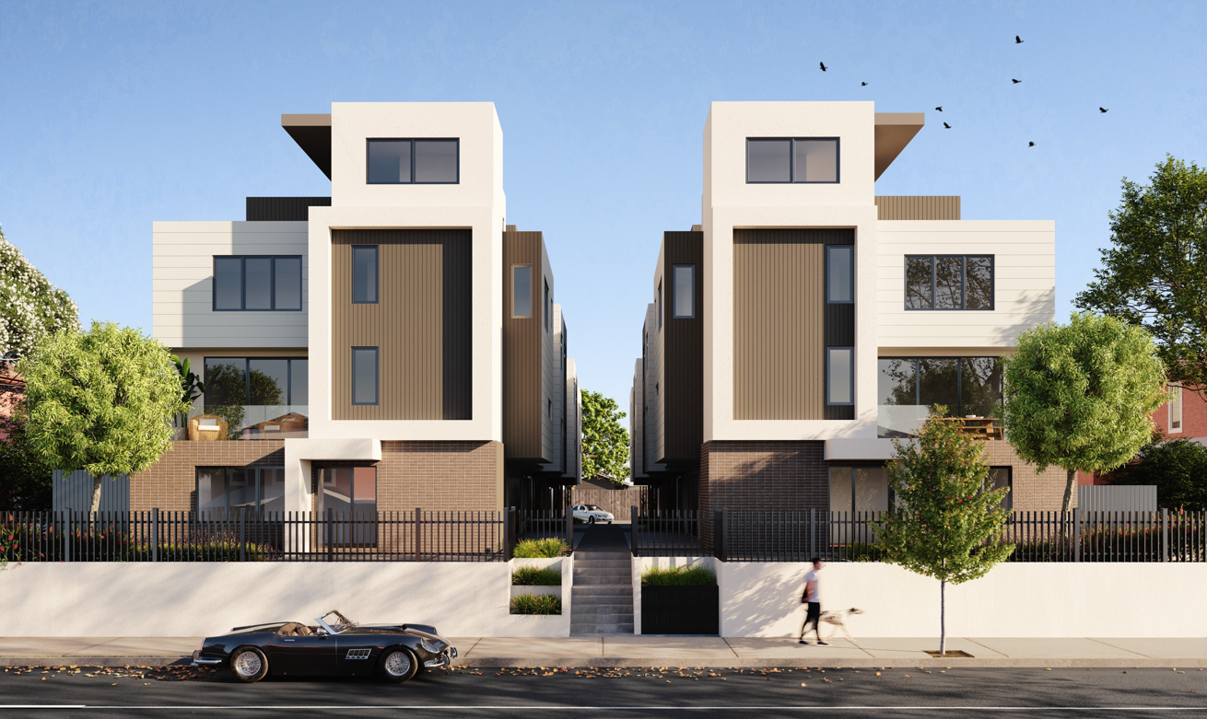
Figure 1: 3D image of proposal.
The development plans form Attachment 2.

Planning Permit and site history
• Application MPS/2016/633 sought approval for the construction of 16 x 3 storey dwellings and 2 x 2 storey dwelling at 392-394 Moreland Road, Brunswick West.
• Council issued a Notice of Refusal to grant a permit on 3 August 2017. Following this refusal, an application for review under Section 77 of the Planning and Environment Act 1987 (the ‘Act’) was lodged with VCAT (P2288/2017). The matter proceeded to a compulsory conference attended by Council, the permit applicant and objectors on 28 January 2018 where several changes to the plans were made. These plans were presented to the then Urban Planning Committee in February 2018 where it was resolved that a planning permit be issued.
• Permit MPS/2016/633 has since expired. The current proposal is the same as the expired permit with the exception of the following changes:
o Permeable internal accessway
o Improved pedestrian access to Moreland Road
o Arbours replacing trees in some SPOS areas
o Façade changes to Moreland Road (reduction of materials)

Statutory Controls – why is a planning permit required?
Control | Permit Requirement
Residential Growth Zone – Schedule 2 | A permit is required to construct more than one dwelling on a lot pursuant to Clause 32.07-5.  Dwelling is a Section 1 use in the Residential Growth Zone, meaning that a permit is not required for the use.
Design and Development Overlay - Schedule 24 | Clause 43-02-1: A permit is required to construct a building or construct or carry out works, in accordance with the requirements of Schedule 24.
Land Adjacent to the Principal Road Network | Clause 52.29-2: A permit is required to create or alter access to a road in a Transport Zone 2.
The following Particular Provisions of the Moreland Planning Scheme are also relevant to the consideration of the proposal:
• Clause 45.06: Development Contributions Plan Overlay
• Clause 45.09: Parking Overlay
• Clause 53.18: Stormwater Management in Urban Development

2. Internal/External Consultation

Public notification
Notification of the application has been undertaken pursuant to Section 52 of the Act by:
• Sending notices to the owners and occupiers of adjoining and nearby land; and
• Placing two signs on the Moreland Road frontage of the site and two signs in the rear right of way (four signs total)
Council has received fourteen (14) objections to date. A map identifying the location of objectors forms Attachment 5.
The key issues raised in objections are:
• Overshadowing
• Neighbourhood character, bulk and scale
• Car parking
• Laneway impacts
• Impacts on trees
• Overlooking
• Rescode non-compliance
• Landscaping
• Property prices
• Construction disturbance
A Planning Information and Discussion meeting was held on 18 October 2021 and attended by Mayor Cr Riley, Cr Bolton, Cr Conlan, Cr Yildiz, (former) Cr El-Halabi, Council Planning Officers, the applicant and four objectors. The meeting provided an opportunity to explain the application, for the objectors to elaborate on their concerns, and for the applicant to respond.
One objector was concerned about the Dwelling 2 arbour restricting light to their window. The applicant was agreeable to having this element removed which forms a permit condition of the officer recommendation. In addition, draft revised plans were submitted showing the removal of the roof terraces for units 6 and 7 to improve shadow impacts. These built form reductions form part of the recommendation.

Internal/external referrals
The proposal was referred to the following external agencies and internal branches/business units:
External Agency | Objection/No objection
Department of Transport | No objection subject to a condition included in the recommendation which is for removal of the redundant crossover to Moreland Road.

Internal Branch/Business Unit | Comments
Urban Design Unit | Suggested changes to improve material pallette, particularly use of reduced cement sheeting. The degree of screening for upper levels was a concern along with the ‘top heavy’ upper levels.  Recommended changes are addressed by conditions of the recommendation or are considered further in Section 4 of this report
Sustainable Built Environment - Development Engineering Team | Supports the proposal. Recommended changes including garage door dimensions, size of storage areas and automatic lighting are addressed by conditions of the recommendation or as otherwise detailed in Section 4 of this report.
Sustainable Built Environment - ESD Team | Supports the proposal subject to modifications including relocated raingardens, double glazing and shading devices which are addressed by conditions detailed in the recommendation. Subject to these conditions, the proposal will satisfy the objectives of Environmentally Sustainable Development policy.
Open Space Design and Development Unit | Concern was raised regarding the viability of trees to be planted in Units 2, 4, 8, 9 and 11 due to limited space. It was recommended that open timber or steel arbors replace the trees in these private open spaces and grow a deciduous vine. The applicant amended plans to achieve this.  Open Space agreed with an updated arborist findings noting that neighbouring vegetation is unlikely to be impacted by the development.  A copy of this Arborist Report was provided to the objector at 396 Moreland Road and is found at Attachment 4.

3. Policy Implications

Planning Policy Framework (PPF):
The following policies are of most relevance to this application:
• Municipal Planning Strategy (Clause 2), including:
− Vision (Clause 2.02)
− Settlement (Clause 2.03-1)
− Environmental and Landscape Values (Clause 2.03-2)
− Environmental Risks and Amenity (Clause 2.03-3)
− Built Environment and Heritage (Clause 2.03-4)
− Housing (Clause 2.03-5)
− Economic Development (Clause 2.03-6)
− Transport (Clause 2.03-7)
− Infrastructure (Clause 2.03-8)
• Settlement (Clause 11)
• Environmental Risks and Amenity (Clause 13):
− Noise Abatement (Clause 13.05-1S and 13.05-1L)
• Built Environment (Clause 15.01), including:
− Urban Design (Clause 15.01-1S, 15.01-1R & 15.01-1L)
− Vehicle Access Design in Moreland (Clause 15.01-1L)
− Building Design (Clause 15.01-2S & 15.01-2L)
− Building Design in Neighbourhood and Local Centres (Clause 15.01-2L)
− Healthy Neighbourhoods (Clause 15.01-4S and 15.01-4R)
• Sustainable Development (Clause 15.02), including:
− Energy and resource efficiency (Clause 15.02-1S)
− Environmentally Sustainable Development (Clause 15.02-1L)
− Energy efficiency in Moreland (Clause 15.02-1L)
• Residential Development (Clause 16.01), including:
− Housing Supply (Clause 16.01-1S and 16.01-1R)
− Homes in Moreland (Clause 16.01-2L)
− Housing for People with Limited Mobility (Clause 16.01-1L)
− Housing Affordability (Clause 16.01-2S & 16.01-2L)
• Transport (Clause 18), including:
− Sustainable Personal Transport (Clause 18.02-1S & 18.08-1R)
− Sustainable Transport in Moreland (Clause 18.02-1L)
− Car parking (Clause 18.02-4S & 18.02-4L)
• Infrastructure (Clause 19.02), including:
− Energy supply (Clause 19.01-1S & 19.01-1L)
− Open Space (Clause 19.02-6S, 19.02-6R & 19.02-6L)
− Development infrastructure (Clause 19.03)

Human Rights Consideration
This application has been processed in accordance with the requirements of the Act (including the Moreland Planning Scheme) reviewed by the State Government and which complies with the Victorian Charter of Human Rights and Responsibilities Act 2006, including Section 18 (Taking part in public life). In addition, the assessment of the application has had particular regard to:
• Section 12: Freedom of movement
• Section 13: Privacy and reputation
• Section 20: Property rights
An assessment of whether there is any potential for unreasonable overlooking has been undertaken in section 4 of this report. The proposed redevelopment of private land does not present any physical barrier preventing freedom of movement. The right of the landowner to develop and use their land has been considered in accordance with the Moreland Planning Scheme.

4. Issues
In considering this application, regard has been given to the State and Local Planning Policy frameworks, the provisions of the Moreland Planning Scheme, objections received, the previous planning permit and the merits of the application.

Does the proposal have strategic policy support?
Both State and local planning policies support increased residential densities in Activity Centres, to take advantage of the excellent access to public transport and other services within these locations.
The subject site is located within the Moreland Road/Melville Road Neighbourhood Activity Centre. In this centre a substantial change towards a new character to accommodate buildings up to and including four storeys is supported.
The scale and density proposed in the advertised plans is consistent with the anticipated level of change for the size and role of this Activity Centre. The proposal enjoys strong strategic policy support.

Does the proposal respond to the preferred height and character of the area?
Clause 15.01-2L (Building Design in Neighbourhood and Local Centres) seeks that the design of developments does not exceed four storeys except in certain circumstances. Schedule 24 of the Design and Development Overlay nominates the site as a focus area for change where building heights must not exceed 13.5 metres, 4 storeys. The proposed development is four storeys in height for nine of the dwellings and three storeys in height for three of the dwellings. It has a maximum height of 12.2 metres. The proposed building height is consistent with policy.
The RGZ encourages a change to a new more intensified character, rather than respecting the existing character. The heights are also identical to those approved in 2018 under the previous permit. On this basis the proposed height is acceptable.
The building has been appropriately articulated with varied setbacks at all levels on all facades. It also uses different materials to break up the mass. As recommended by Council’s Urban Design Unit, a recommended condition of permit is to make the entire ground floor stacked brick. The recommendations also included a refinement of the portal frame element to address the Urban Design Unit’s concerns. Whilst the Urban Design Unit would prefer greater upper level setbacks, the proposal is considered an acceptable response given the previous approval and the Residential Growth zoning of the land.
The development is similar to the previously approved development at this site. The material palette has been simplified and the large portal frame element of the eastern block has been reduced, which has improved the development’s presentation to Moreland Road.
Landscaping
Within the RGZ, the development should promote a preferred neighbourhood character where the design and siting of new dwellings include generous landscaping through the retention of existing canopy trees (where practicable) and the planting of new canopy trees and vegetation by providing:
• At least one canopy tree located within the front setback that meets the following requirements:
▪ Located in a permeable area within the site of at least 10 square metres and 4.5 metres wide.
▪ Reach a height of 6 metres - 8 metres at maturity.
▪ Achieve a canopy width of at least 5 metres at maturity.
• At least one canopy tree located elsewhere on the site that meets the following requirements:
▪ Located in a permeable area within the site of at least 4.5 metres x 4.5 metres.
▪ Reach a height of 6 metres - 8 metres at maturity.
▪ Achieve a canopy width of at least 5 metres at maturity.
The landscape plan illustrates that two Lucious Wattle Gums are being planted in the front setback which reach 8m x 5m (HxW) at maturity. These are located in a permeable area at least 10 square metres and 4.5 metres wide.
Four more Lucious Wattle Gums are being planted elsewhere on the site which reach 8m x 5m (HxW) at maturity. As requested by Council’s Open Space team, these have been located in larger garden beds on the edges of the SPOS areas to ensure their retention by future residents.
Additional planting has also been provided within the vehicle accessway adjacent to the front doors of dwellings to improve the amenity of these spaces.
The proposed landscape arrangement exceeds the standard and is acceptable.
The above landscaping provisions are the only significant change to medium density planning policy since consideration of the previous approved application.
The Landscaping Objective of Clause 55 requires consideration to be given to the retention of existing trees and protection of any predominant landscape features of the neighbourhood. However, the land is zoned for residential growth purposes and there are no specific vegetation protection overlays applicable to the site. Open Space have confirmed that the Leylandii on the site is an undesirable species not worthy of retention.

Does the proposal result in any unreasonable off-site amenity impacts?

Privacy /overlooking
Clause 55.04-6 (Overlooking) of the Moreland Planning Scheme does not aim to eliminate all overlooking, but rather seeks to prevent unreasonable overlooking. Up to 9 metres is the standard accepted by state-wide provisions as being a reasonable distance where screening is required to minimise overlooking.
The proposal has all balconies for Units 1, 8, 9, 10, 11 and 12 either facing Moreland Road or east towards the internal accessway. This removes overlooking opportunity from these balconies.
To the east, west and south, all necessary windows are obscured to at least 1.7 metres above floor level. To the east, balconies have 1.7 metre high screens.
At the roof terrace level, dwellings containing the alfresco room are shown with highlight windows. To prevent overlooking from the roof terraces, planter boxes measuring 690mm deep by 1 metre high have been proposed, with section diagrams demonstrating how the planter boxes will address overlooking while maintaining an outlook for future residents.
The proposal demonstrates compliance with overlooking standards and objectives to ensure the overlooking impacts are not unreasonable.

Overshadowing
Where sunlight to the secluded private open space of an existing dwelling is reduced, at least 75 per cent, or 40 square metres with minimum dimension of 3 metres, whichever is the lesser area, of the secluded private open space should receive a minimum of five hours of sunlight between 9 am and 3 pm on 22 September.
If existing sunlight to the secluded private open space of an existing dwelling is less than the requirements of this standard, the amount of sunlight should not be further reduced.
Based on amended shadow diagrams, it was determined that overshadowing to the following properties would not comply with the standard:
• 6/26 Irvine Crescent, Brunswick West
• 6/28 Irvine Crescent, Brunswick West
• 5/30 Irvine Crescent, Brunswick West
To address this, the applicant provided further informal amended shadow diagrams based on removal of the roof terraces from Unit’s 6 and 7. These are found at Attachment 3 and have been circulated to objectors.
With respect to the properties listed above, this would result in all proposed shadows falling within the existing fence shadow or on the roof of the existing dwellings. The only exception to this is a 0.55m2 shadow placed upon the SPOS of 5/30 Irvine Crescent, Brunswick West at 9am. This is considered negligible.
A condition has been placed in the recommended conditions to delete the roof terraces of Unit’s 6 and 7. This will result in an improved outcome in relation to visual bulk and shadow impacts.
The shadow diagrams illustrate that neighbouring properties to the east and west retain access to sunlight in accordance with the standard.

Daylight to Existing Windows
All neighbouring windows are provided with a light court that has a minimum area of 3 square metres and minimum dimension of 1 metre clear to the sky at ground floor.
Walls or carports more than 3 metres in height opposite an existing habitable room window should be set back from the window at least 50 per cent of the height of the new wall if the wall is within a 55 degree arc from the centre of the existing window.
The dwelling at 1/390 Moreland Road has a ground floor west facing habitable room window. The required and proposed setbacks are detailed below:
Floor | Wall Height | Required Setback to window | Proposed setback to window
First floor | 5.76 metres | 2.88 metres | 3.19 metres
Second floor | 8.82 metres | 4.41 metres | 3.20 metres
Third floor | 11.56 metres | 5.78 metres | 5.73 metres
The second floor setback does not comply by 1.21 metres. Given the extent of non-compliance, a condition on the permit will require that this setback is increased to comply with the standard. The minor non-compliance of the third floor can also be addressed via a condition of the recommendation.
Concern was raised by one neighbouring objector on the impact that one of the arbours would have on access to daylight. The applicant advised that they would accept removal of the relevant arbour. This forms a condition of the recommendation.
396 Moreland Road has a ground floor east facing habitable room window which would not be provided the necessary setback at the second floor of Unit 12 as follows:
Floor | Wall Height | Required Setback to window | Proposed setback to window
Second floor | 8.85 metres | 4.42 metres | 4.21 metres
A condition on the recommendation will require that this setback is increased to comply with the standard.

Side and Rear Setbacks
A variation to the side setbacks standard of DDO24 is sought at ground floor where 8 bedrooms of 8 separate units are setback 1.4 metres from side boundaries. The standard requires that 2 metres is provided.
The bedrooms of Unit’s 4 and 6 along the eastern side are adjacent to boundary walls of the eastern property that has already been developed. The bedroom of Unit 1 is not opposite a window and will not impact that adjacent property. While the bedroom window of Unit 2 is opposite a window at 1/390 Moreland Road, this window has been identified as frosted which impacts the outlook from this window. The wall also achieves a setback of 2.56 metres from that window which allows adequate daylight penetration.
The western setbacks at ground floor are adjacent to the following areas at 396 Moreland Road:
• Unit 8, Bed 1 opposite the SPOS area
• Unit 9, Bed 1 opposite an area of blank wall
• Unit 11, Bed 1 opposite two frosted windows
• Unit 12, Bed 1 opposite two narrow habitable room windows at the front of the dwelling
As discussed above in the daylight to windows objective, these front habitable room windows will retain access to daylight.
While not an ideal outcome in achieving the design outcomes sought by DDO24, the reduced setbacks still retain adequate levels of amenity for neighbouring dwellings and allows an acceptable landscaped outcome for the development. Of note is that the same setbacks were approved in the previous proposal.
The DDO24 standard for rear setbacks is a minimum 3 metre setback at ground level from the property boundary and 6 metre setback for all levels above 4 metres in height. The setbacks aim to achieve quality built form outcomes and improve amenity outcomes for adjoining properties.
The proposal satisfies part of the DDO24 as all levels above ground have a setback greater than 6 metres. However the ground level is built to the boundary.
While this limits landscaping opportunities along the rear boundary, it is accepted due to the landscaping outcome for the balance of the site which includes adequate front and side setback planting. The upper setback provisions are such that the development potential of adjacent sites is not prejudiced. To the rear of the site are at 26, 28 and 30 Irvine Crescent, Brunswick West are existing multi-unit developments which are subdivided and held under private ownership. These are located within the Residential Growth Zone.
The proposal is also consistent with the previous application (MPS/2016/633) which was supported by the Urban Planning Committee and represented a mediated outcome between all objector parties which had addressed the majority of planning concerns. The provisions DDO24 were a consideration at this time. On balance, this non-compliance is supported.

What impact does the proposal have on car congestion and traffic in the local area and does it meet the statutory car parking rate?
Council’s Development Engineering Unit consider that the development will result in approximately 78 additional vehicle movements per day, with vehicles likely to enter and exit via Cornwall Road and Irvine Crescent. The additional vehicles will not result in the street exceeding the maximum volumes as permitted under the Moreland Integrated Transport Strategy.
23 car spaces are provided. This meets the Planning Scheme requirement at Clause 52.06.The site is located within the Parking Overlay. Therefore, the ‘Column B’ rates in the table to Clause 52.06 apply. As a result, no visitor car parking is required.
The dwellings will not be eligible for parking permits in the event that parking restrictions are imposed by Council on the street. This is included as a note on the planning permit in the recommendation.

What impact does the proposal have on cycling, bike paths and pedestrian safety, amenity and access in the surrounding area?
The proposal encourages bicycle usage and maximises pedestrian safety through the following:
• Utilises the rear laneway for vehicle access to allow street frontages to prioritise pedestrian movement and safety and to create active frontages.
• Removes the existing vehicle crossing to Moreland Road.
• No removal of on-street public parking spaces, removal of street trees, and encroachment into landscaped front setbacks.
• Provides three external bicycle spaces to comply with Clause 52.34 (Bicycle Facilities).

Does the proposal incorporate adequate Environmental Sustainable Design (ESD) features?
ESD features of the development are adequate and include:
• NatHERS 6.0-star rating and 6.5 star rating average
• The BESS assessment concludes that the proposed development achieves the minimum BESS score of 50%.
• The Melbourne Water storm calculator demonstrates the development meets the minimum 100% required water quality objective.
Conditions on the permit require additional measures to be shown on the plans such as shading and double glazing. The development achieves all requisite ESD targets. Further and through agreement with the applicant, a condition is imposed to require solar PV to the dwellings. Council’s export ESD team support the proposal.

5. Response to Objector Concerns
The following issues raised by objectors are addressed in section 4 of this report:
• Overshadowing
• Neighbourhood character and bulk and scale
• Car parking
• Overlooking
• Landscaping
• Rescode compliance
Other issues raised by objectors are addressed below.
Impacts on trees
Impacts on neighbouring vegetation was raised as an issue in objections. An arborist report was submitted by the applicant after the notice period which found that no harm would be caused to neighbouring trees. Council’s Open Space Unit reviewed the Arborist Report and agreed with its findings. Further a condition is included requiring the these trees are protected during the construction phase of the development.

Property values
The Victorian Civil and Administrative Tribunal and its predecessors have generally found claims that a proposal will reduce property values are difficult, if not impossible, to gauge and of no assistance to the determination of a planning permit application. It is considered the impacts of a proposal are best assessed through an assessment of the amenity implications rather than any impact upon property values. This report provides a detailed assessment of the amenity impact of this proposal.

Construction disturbance
The Environment Protection Authority (EPA) provide guidelines and regulations that specify times for construction, to limit noise impacts. Noise and amenity impacts during the construction process are also regulated through Council’s General Local Law, 2018.
Concern has been raised in relation to potential closure of roads and footpaths during construction. Closure or occupation of public spaces requires a Public Occupation Permit under Council’s General Local Law 2018. Council’s Environmental and Civic Assets Local Law 2018 requires an Asset Protection Permit to be obtained to ensure infrastructure assets within the road reserve are protected or repaired if damaged.
A range of other approvals are required from Council’s transport, engineering and asset protection teams related to construction impacts on public space. Consideration of such closure and public notice, as required, is undertaken through these processes.

Impacts to the laneway
Concern has been raised in relation to the capacity of the laneway to support additional development. The proposal has been reviewed by Council’s Development Engineer who noted laneway access was acceptable and could cater for traffic volumes. The engineer noted:
‘A turning area has been provided to allow cars to enter and egress the garages.
The right-of-way allows vehicles to both enter and egress the Melville Road and Cornwall Street travelling in a forward direction, which can be accepted. It is not clear however if vehicles are able to negotiate the (almost) 90-degree corner in the laneway in order to enter and egress Moreland Road and Irvine Crescent. Although access from Moreland Road and Irvine Crescent would also be ideal, it is not critical.
The accessway (public laneway) is at least 3m wide as required by Clause 52.06-8 of the Moreland Planning Scheme.’
Numerous new and old developments benefit from the laneway access and it is therefore considered both acceptable and preferable to access from Moreland Road.

6. Officer Declaration of Conflict of Interest
Council Officers involved in the preparation of this report do not have a conflict of interest in this matter.

7. Financial and Resources Implications
There are no financial or resource implications.

8. Conclusion
The proposal strikes an acceptable balance between providing an increase in residential density on a consolidated lot while achieving an acceptable response to the preferred future character for the area, limiting off-site amenity impacts and providing an acceptable level of internal amenity.
The proposal is also largely consistent with the previous application (MPS/2016/633) which was supported by the Urban Planning Committee and represented a mediated outcome between objector parties at the time.
On the balance of policies and controls within the Moreland Planning Scheme and objections received, it is considered that a Notice of Decision to Grant a Planning Permit No MPS/2021/197 should be issued subject to the conditions included in the recommendation of this report.

Attachment/s
1 | Location and Zone Plan - 392-394 Moreland Road, BRUNSWICK WEST | D22/129148
2 | Advertised Plans - 392-394 Moreland Road, BRUNSWICK WEST | D22/129150
3 | Sketch Shadow Plans - 392-394 Moreland Road, BRUNSWICK WEST | D22/129152
4 | Arborist Report - 392-394 Moreland Road, BRUNSWICK WEST | D22/129153
5 | Objector Location Map - 392-394 Moreland Road, BRUNSWICK WEST | D22/132002

5.2 699-701 PARK STREET, 182-192 BRUNSWICK ROAD AND 2-4 SYDNEY ROAD, BRUNSWICK - NOTICE OF MINISTERIAL PLANNING SCHEME AMENDMENT C218more AND PERMIT APPLICATION NO. PA2201559
Director Place and Environment Joseph Tabacco
City Development

Executive Summary
The Minister for Planning is considering whether to prepare, adopt and approve Moreland Planning Scheme Amendment C218more and grant a planning permit. The draft amendment proposes to make the Minister for Planning the responsible authority for administering the planning permit, which allows a mixed-use multi-storey development, use of the land for a food and drink premises and office, partial demolition and alterations to the heritage building, a reduction to the standard car parking requirement and to alter access to a Road in a Transport Zone Category 2.
To inform the Ministers decision, consultation is being undertaken under section 20(5) of the Planning and Environment Act 1987 (the ‘Act’) about the draft amendment and the draft planning permit.
This report recommends that Council’s submission to the Minister should be that the amendment to the planning scheme should only proceed subject to changes to the plans reflected in the officers recommended draft planning permit conditions. Key changes sought include:
• Ensuring ESD targets are achieved
• Improved affordable housing offer
• Gaps introduced into the Park Street built form with height reduced to the east, allowing a better ‘marking’ of the Park Street/Sydney Road corner and reduced shadowing to Princes Park
• Front setbacks and deep soil planting introduced for townhouses facing Park Street
• The sheer walls flanking the heritage substation avoided with recessed upper levels
• Daylight to apartments improved
• Shadow impacts to 180 Brunswick Road reduced
• The ground floor interface to Brunswick Road improved by relocating building services
• The material palette to incorporate greater use of high-quality fine grain materials

Property: | 699- 701 Park Street, 182 – 192 Brunswick Road and 2 – 4 Sydney Road, Brunswick
Proposal: | Mixed-use multi-storey development, use of the land for a food and drink premises and office, partial demolition and alterations to the heritage building and reduction to the standard car parking requirement and to alter access to a Road in a Transport Zone Category 2.
Zoning and Overlay/s: | • Mixed Use Zone  • Heritage Overlay (part of site)  • Design and Development Overlay Schedule 18  • Environmental Audit Overlay  • Development Contribution Plan Overlay
Strategic setting:
Objections: | State Government consultation concludes 2 May 2022
ESD: | Application is targeting minimum average NatHERS rating of 7 stars and BESS score of 73%
Affordable Housing | 10% of dwellings (17) subsidised at 35% of market value and the entering into the Homes for Homes scheme (0.1% of sale price gifted to affordable housing schemes).
Accessibility: | 120 of the 168 (72%) apartments meet accessibility standards of Clause 58 of the Moreland Planning Scheme.
Key reasons for support | • Maintains most of the positive aspects of previous proposal.  • Addresses most of the key concerns of previous VCAT decision.  • Conditions of permit can address remaining areas of concern.

Officer Recommendation
1. That Council’s submission to the Minister for Planning be that:
a. The planning permit contained at Attachment 5 be adopted in place of the draft planning permit PA2201559 exhibited as part of the amendment package.
b. The matter proceed to a Standing Advisory Committee to enable Council and any submitters the opportunity to present their views.
That the Group Manager City Development be provided with delegated authority to amend the recommended planning permit conditions as appropriate, including as a result of any Standing Advisory Committee process, the consideration of expert witness recommendations or any further variations to plans.

REPORT

1. Background

Subject site
The subject site is located at the intersection of Park Street and Sydney Road on the east side of Sydney Road and south of Brunswick Road. The site is comprised of 9 parcels known as 182-192 Brunswick Road, 2 and 4 Sydney Road and 699-701 Park Street, Brunswick. The site is 6463 sqm.
The land is occupied by the Princes Park Motor Inn on the southern side of the site. The northern portion of the site has been cleared and levelled with the exception of the former Brunswick Electricity Supply Transformer Station in the north west corner of the site. There are no restrictive covenants indicated on the Certificate of Title.

Surrounds
The surrounding area is characterised by properties within commercial and residential zones with land generally to the north and west used for commercial purposes. The site immediately to the west is a 7 Eleven store on the corner of Sydney Road and Brunswick Road. The land to the south of this is a two storey apartment building. To the east is a single storey dwelling at 180 Brunswick Road and land at 697 Park Street contains a three storey apartment building. Princes Park is to the south within the City of Melbourne. Further to the south east are low scale dwellings within the City of Yarra.
A location plan forms Attachment 1.

The proposal
Draft amendment C218more proposes to make the Minister for Planning the responsible authority for administering the planning permit, including endorsement of plans and documents pursuant to the permit. The amendment package includes a draft planning permit with conditions.
The permit would allow for the construction of multi-storey buildings including a:
• six storey street wall with eight storeys behind, reducing to four storeys to the east along Brunswick Road along
• retention of the heritage substation
• ten storey building central to the site with communal open spaces and an east – west ‘mews style’ private pedestrian link
• six storey building facing Park Street, reducing to four storey townhouses to the east.
• north-south publicly accessible pedestrian link that connects Brunswick Road to Park Street
• two levels of basement car parking for 223 cars and 210 bicycles, accessed from Park Street
• 168 dwellings, comprising:
− 37 x one bedroom (22%)
− 76 x two bedroom (45%)
− 47 x three bedroom (23%)
− 8 x four bedroom (5%)
• The proposed use is entirely residential apart from 272 sqm of commercial use at ground floor facing Brunswick Road and a 199 sqm café on the corner of Park Street and Sydney Road.
• commitment to 10% (17) affordable dwellings

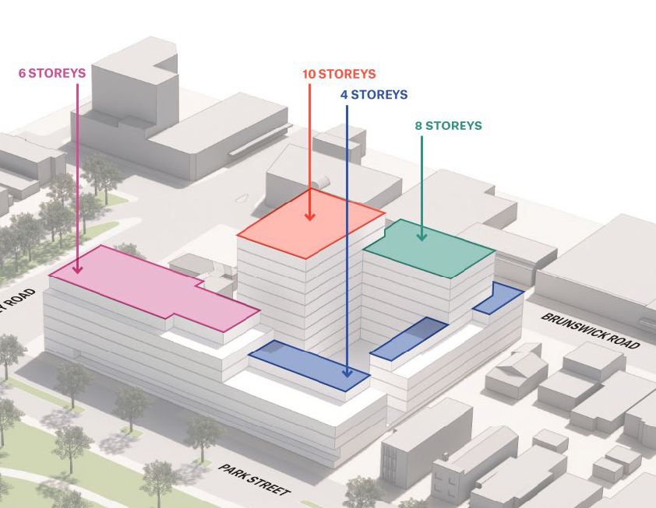
Figure 1: Massing diagram showing built form and heights. (Planning Report, Urbis December 2021)
The development plans and draft Planning Permit that form part of the advertised amendment package form Attachment 2.

Planning Permit and site history
In 2016, Planning Permit Application MPS/2016/985 was lodged with Council. The proposal included buildings of varying heights. The tallest central building was 14 storeys. 255 dwellings and a 1300 sqm childcare centre were proposed along with demolition of the heritage substation. 220 objections were received.
In May 2018, a review pursuant to section 79 (failure to determine the application within statutory time) of the Act was lodged with the Victorian Civil and Administrative Tribunal (VCAT). At its then Urban Planning Committee, Council resolved that if a review had not been lodged, Council would have refused the application. Key concerns included:
• Excessive height of central tower and buildings to Sydney Road and Park Street
• Demolition of the heritage substation
• Poor activation along Brunswick Road due to excessive services
• Inadequate building setbacks to the west.
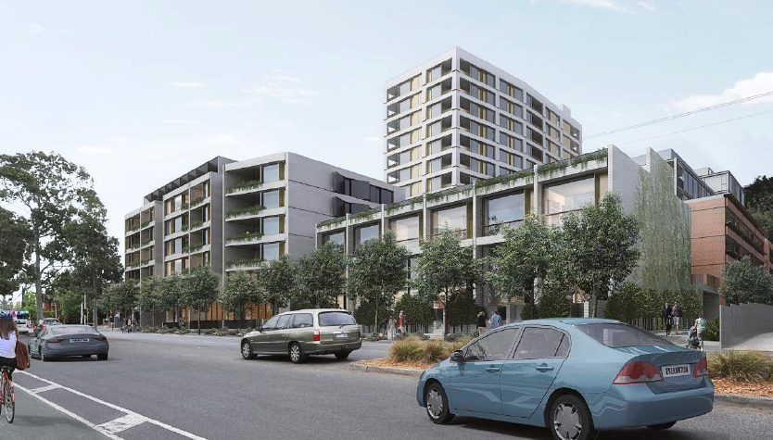
Figure 2: Park Street view of proposal not supported by Urban Planning Committee June 2018.
Prior to the VCAT hearing, the applicant amended the plans. A key change was a reduction in height of the tallest central building to 12 storeys. Council maintained its opposition to the amended plans.
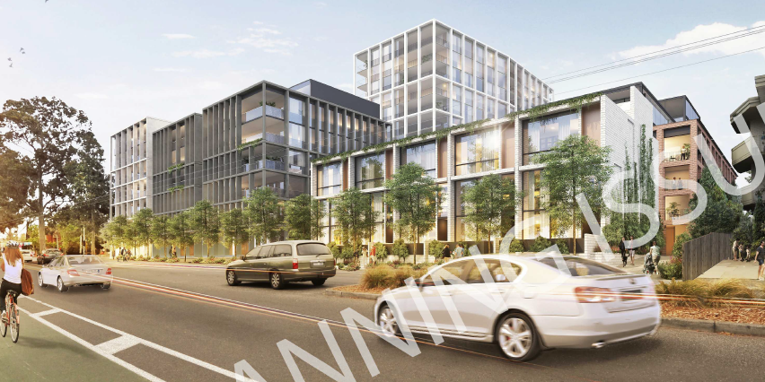
Figure 3: Amended plans substituted prior to VCAT hearing.
On 30 April 2019 an interim order was issued by VCAT. The order identified unacceptable elements and allowed the applicant an opportunity to amend the plans to address concerns.
VCAT noted ‘As an overall concept, we find the site layout is a positive response to context with many well resolved design features’. VCAT noted the following positive attributes:
• Location of the tallest element centrally to the site.
• Strong street wall to Brunswick Road.
• Distinctive building marking the corner of Sydney Road and Park Street.
• Lower built form to the sensitive interface to the east.
• Gaps between buildings providing permeability and a sense of space.
• Connectivity at ground level.
• Basement car parking that limits visual and access impacts of vehicle accommodation.
• Good provision of communal open space.
• Positive presentation to the public realm with only one vehicle crossing, removal of numerous vehicle crossings and, for the most part, active interfaces with the street frontages.
Despite the above, VCAT noted the following concerns were unacceptable:
• Demolition of the heritage substation
• Excessive height of the central tower (VCAT concluded a ten storey height would be acceptable) and the building on the corner of Sydney Road and Park Street
• Inappropriate shared vehicle and pedestrian accessway
• Unacceptable setback (equitable development opportunities) to the west.
In response to the interim order, the applicant amended the plans in July 2019. Key changes included reduction in height of the central building to 10 storeys and retention of the substation enclosed within a building.
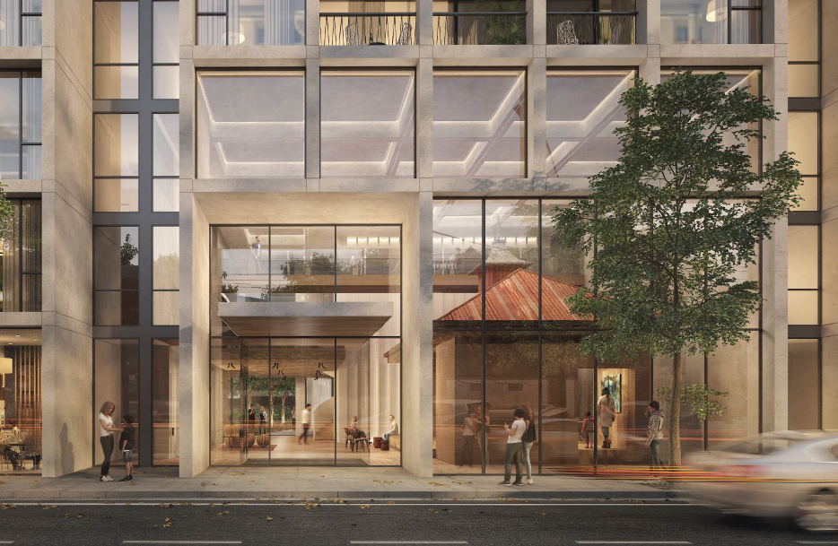
Figure 4: Enclosure of the heritage substation; part of plans amended in response to VCAT interim order.
At its August 2019 meeting, Council considered the July 2019 amended plans. Council accepted the ten storey height complied with the direction of VCAT. However, Council maintained its opposition to the proposal based on:
• Inappropriate response to the heritage substation
• Unacceptable setback (equitable development opportunities) to the west.
• Poor amenity for future occupants due to apartment design
• Unacceptable narrow public pedestrian path along the east boundary
Following a further hearing in February 2020, VCAT’s order of 2 April 2020 determined that the July 2019 amended plans remained unacceptable. In summary VCAT found the following elements unacceptable:
• The enclosure of the heritage substation.
• Non-compliances with apartment design standards
• The shared vehicle and public pedestrian path to east
• Unacceptable length of blank services to Brunswick Road
VCAT found building heights, shadowing impacts to Princes Park and impacts on equitable development to the west acceptable. The July 2019 amended plans upon which VCAT made its final determination are referred to as the ‘previous proposal’ for the remainder of this report.
The interim and final VCAT orders form Attachment 3.
Application to the State Government Development Facilitation Program (DFP)
The DFP has been established by the Minister for Planning to speed up the assessment and determination of identified priority projects that deliver investment into the Victorian economy, keep people in jobs and provide a substantial public benefit.
On 20 January 2022 the Department of Environment, Land, Water and Planning (DELWP) advised Moreland City Council that an application had been lodged for consideration by the DFP.
DELWP invited Moreland City Council to comment on an amended proposal.
There was inadequate time to present the initial comments on an amended proposal to a Planning and Related Matters (PARM) meeting. Following an assessment of the proposal Council officers responded to DELWP on 14 February 2022. In summary, the response noted:
• Concerns with the proposal including the continuous built form on Park Street, built form surrounding the heritage substation and lack of information relating to ESD.
• That the proposal was not suitable for the DFP and should proceed under a standard planning application process with Moreland City Council.
Despite the above, the proposal has been recommended for accelerated assessment and determination by the DFP. This is on the basis that it will deliver significant short to medium term economic outcomes and public benefit, aligns with government policy and priorities, is shovel ready, and has sufficiently addressed probity considerations. The project involves an estimated capital expenditure of $146,950 million with the creation of approximately 300 short term construction jobs and 35 ongoing jobs.
The proposal now undergoing public notice under section 20(5) of the Act and considered in this report is almost identical to the proposal officers commented on in their 14 February 2022 advice.

Statutory Controls – why is a planning permit required?
Control | Permit Requirement
Mixed Use Zone (Clause 32.04) | Food and Drink premises is a Section 2 use in the zone as the leasable floor area would exceed 150 square metre, meaning that a permit is required for the use.  A permit is required to construct a building or construct or carry out works for a use in Section 2 (Food and Drink Premise).  A Permit is required to use the site for an office exceeding 250 square metres in leasable floor area.  A permit is required to construct more than one dwelling on a lot. No permit is required to use the land for a dwelling.
Overlays | Clause 43.01 - Heritage Overlay (Schedule 279) affects 188 Brunswick Rd and Schedule 149 affects part of the Sydney Road/Park Street frontage) A permit is required for partial demolition and to construct a building or construct or carry out works.  Clause 43.02 - Design and Development Overlay Schedule 18 (DDO18) – A permit is required to construct a building or construct or carry out works.
Particular Provisions | Clause 52.06 - A permit is required to reduce the standard car parking rate.  Clause 52.29 - A permit is required to alter the access to a Road in a Transport Zone Category 1.
The following Particular Provisions of the Moreland Planning Scheme are also relevant to the consideration of the proposal:
• Clause 45.03: Environment Audit Overlay.
• Clause 45.06: Development Contributions Plan Overlay
• Clause 45.09: Parking Overlay
• Clause 53.18: Stormwater Management in Urban Development

2 Public consultation
The Minister for Planning is undertaking exhibition of a planning scheme amendment in accordance with Section 20(5) of the Planning & Environment Act, 1987 to understand the views of affected parties and to inform the drafting of both the amendment and combined planning permit. Exhibition commenced on the 11 April and will conclude 2 May 2022. The consideration of this report during the exhibition period will enable Council’s submission to the amendment to be received and considered as part of this process.
Details of the proposed amendment are included on the DELWP website. In addition to notifying Council, letters have been sent to surrounding property owners and occupiers as well as previous objectors to planning permit application MPS/2016/985.
Following the exhibition period, the Minister for Planning may decide to refer this matter to the Priority Projects Standing Advisory Committee for further advice before making a decision about whether to prepare, adopt and approve the planning scheme amendment and combined planning permit. Submitters will be informed if the matter is referred to the Priority Projects Standing Advisory Committee.

3. Internal referrals
The proposal was referred to the following internal branches/business units:
Internal Branch/Business Unit | Comments
Urban Design Unit | Generally supportive of the overall concept. However, does not support changes to the Park Street façade that dilute the corner of Sydney Road and removes deep soil planting in front of the townhouses.  Concern also raised with the materials selected that emphasise a corporate/commercial expression that is not appropriate in the context.
Transport - Development Engineering Team | Supports the proposal, including the supply of car parking, traffic impacts and vehicle access. Recommends minor changes that could be readily addressed through permit conditions.
Sustainable Built Environment - ESD Team | Supports the identified ESD targets of minimum 70% BESS score and 7-star NatHERS rating. However, the plans and ESD reports do not provide evidence to support the targets. Key concerns related to daylight, ventilation and Water Sensitive Urban Design.
City Development - Heritage Advisor | Supports the retention and ground level spacing around the substation. Considers the sheer six storey walls that flank the substation will inappropriately dominate building and recommends recessed upper levels to resolve this issue.  Recommends reduced openings to the substation.
Open Space Design and Development Unit | Generally supportive of the approach to landscaping. Recommended some changes and additional information that could be resolved through permit conditions. Issues raised relate to impacts on a mature street tree on Sydney Road, increasing the width of the pedestrian path at the north and south entrances of the eastern link and improving street tree plantings around the site.
Council’s Principal Advisor Social and Affordable Housing | Supports the proposal, including the 10% of dwellings as affordable homes, subject to:  • the level of contribution increased from 35% to 45% of the market value.  • the donation in the proposed commitment to the ‘Homes for Homes’ scheme include the first sales of the development (being 0.1% of the sale price of the dwellings).

3. Policy Implications

Planning Policy Framework (PPF):
The following policies are of most relevance to this application:
Municipal Planning Strategy (Clause 2), including:
− Vision (Clause 2.02)
− Settlement (Clause 2.03-1)
− Environmental and Landscape Values (Clause 2.03-2)
− Environmental Risks and Amenity (Clause 2.03-3)
− Built Environment and Heritage (Clause 2.03-4)
− Housing (Clause 2.03-5)
− Economic Development (Clause 2.03-6)
− Transport (Clause 2.03-7)
− Infrastructure (Clause 2.03-8)
• Settlement (Clause 11)
• Environmental and Landscape Values (Clause 12)
• Environmental Risks and Amenity (Clause 13):
− Contaminated and Potentially Contaminated Land (Clause 13.04-1S)
− Noise Abatement (Clause 13.05-1S and 13.05-1L)
• Built Environment (Clause 15.01), including:
− Urban Design (Clause 15.01-1S, 15.01-1R & 15.01-1L)
− Vehicle Access Design in Moreland (Clause 15.01-1L)
− Building Design (Clause 15.01-2S & 15.01-2L)
− Apartment developments in Moreland (Clause 15.01-2L)
− Building Design in Neighbourhood and Local Centres (Clause 15.01-2L)
− Healthy Neighbourhoods (Clause 15.01-4S and 15.01-4R)
− Neighbourhood Character (Clause 15.01-5S)
• Sustainable Development (Clause 15.02), including:
− Energy and resource efficiency (Clause 15.02-1S)
− Environmentally Sustainable Development (Clause 15.02-1L)
− Energy efficiency in Moreland (Clause 15.02-1L)
• Heritage (Clause 15.03), including:
− Heritage conservation (Clause 15.03-1S)
− Heritage in Moreland (Clause 15.03-1L)
• Residential Development (Clause 16.01), including:
− Housing Supply (Clause 16.01-1S and 16.01-1R)
− Homes in Moreland (Clause 16.01-2L)
− Housing for People with Limited Mobility (Clause 16.01-1L)
− Housing Affordability (Clause 16.01-2S & 16.01-2L)
• Economic Development (Clause 17), including:
− Diversified economy (Clause 17.01-1S & 17.01-1R)
− Employment Areas (Clause 17.01-1L)
− Business (Clause 17.02-1S)
• Transport (Clause 18), including:
− Land Use and Transport (Clause 18.01)
− Movement Networks (Clause 18.02)
• Infrastructure (Clause 19.02), including:
− Open Space (Clause 19.02-6S, 19.02-6R & 19.02-6L)
− Development infrastructure (Clause 19.03)

Human Rights Consideration
The implications of this report have been assessed in accordance with the requirements of the Charter of Human Rights and Responsibilities including Section 18 (Taking part in public life) and Section 20 (Property Rights). By making a submission in relation to this matter, Council is not limiting the ability for any member of the public to make their own submission. This report also recommends that the Minister should refer the matter to a Priority Projects Standing Advisory Committee to allow for a public hearing on the matter.

4. Issues
In considering this application, regard has been given to the State and Local Planning Policy frameworks, the provisions of the Moreland Planning Scheme, previous VCAT orders on this site and the merits of the proposal.
The VCAT orders provide direction on both the acceptable and unacceptable elements of the previous proposal. The current proposal retains the same concept design, however key changes have been made.
Significant weight should be given to the previous VCAT decision in the consideration of this proposal. The assessment below focuses on the response to key issues identified in that decision.

Does the proposal have strategic policy support?
The site is a large, relatively unconstrained parcel of land located within a Mixed-Use Zone in the Brunswick Activity Centre. Numerous policy directives within the Planning Scheme provide support for a major residential development on the site. Clause 16.01-1L (Homes in Moreland) states:
Encourage increased density housing in the form of apartments and townhouses in areas identified as ‘Significant Housing Growth’ on the Strategic Framework Plan: Housing at Clause 02.04.
The site is located in an identified area for Significant Housing Growth at Clause 2.04.
VCAT noted that the site is suitable for a major residential development. Further, the Order noted that ‘no party disputed the Planning Scheme support for substantial change and a new built form character on the review site’.
Is the height of the ten-storey central tower acceptable?
DDO18 contains three differing preferred heights for the subject site. The central tower element is largely located within an area with a preferred 25 metre height (8 storeys).
In its interim Order, VCAT noted the then 12 storey central tower element would result in a visually dominant building when viewed from key vantage points such as Princes Park. VCAT were not satisfied it met the design objective of the DDO18 that seeks to ensure height above the street wall is visually recessive. VCAT noted that the tower should be reduced to ten storeys, noting also there would be public benefit in doing so to reduce shadowing to Princes Park. VCAT noted that the site is large enough to accommodate the additional two storeys above the preferred 8 storeys of the DDO18.
The plans were amended to include a ten storey central tower in the previous proposal. In its final Order, VCAT accepted the ten storey central tower.
The proposed central tower of the current proposal is in a similar location and of similar height to the previous proposal. The proposed height above natural ground level on Brunswick Road is approximately 32.9 metres. This is 0.45 metres higher than the 32.45 metres (excluding plant) of the previous proposal. The differential is considered negligible.
The central tower has a 22 metre width as it faces Park Street. This is 5 metres wider than the previous proposal. Whilst this change will be perceivable when viewed from Princes Park and does increase shadow impacts to Princes Park, the total length of the central tower has been reduced by approximately 7 metres to 34 metres. In terms of visual impact, the reduction in length helps alleviate the additional width, especially from oblique views from Park Street, Sydney Road and Princes Park. The setback of the central tower to Park Street remains unchanged at 30 metres.
The central tower has been setback 17.2 metre from the Brunswick Road frontage. This is 7 metres more than 10.2 metre setback to Brunswick Road of the previous proposal. The additional setback is a positive aspect of the current design. It will result in the tower reading as more recessive from Brunswick Road than what was accepted by VCAT.
Are the alterations to the heritage substation acceptable?
VCAT determined the substation should be retained and did not accept the enclosure of the building in the previous proposal. The VCAT orders were silent on the extent of alterations to the substation.
The substation at 188 Brunswick Road is covered by an individual heritage control, Heritage Overlay Schedule 279.
The Statement of Significance in the Victorian Heritage Database notes the building as:
‘of historical significance as a representative example of an intact and functioning part of the infrastructure supplying Brunswick with electricity c1914’.
and;
‘Of aesthetic significance as a representative and intact example of a public utility building that assists in demonstrating the range of architectural styles used in the construction of substations and similar buildings in Brunswick, and regionally, across Melbourne.
Amendment C208more by Moreland City Council proposes to replace the individual heritage control HO279 from the site with a ‘serial listing’ that includes all the historically significant substations under one HO, HO600 ‘Brunswick Electricity Supply Substations’. Amendment C208 was recently considered by a Planning Panel and is considered a seriously entertained planning proposal. Both the current HO279 and Amendment C208more consider the transformer substation as ‘significant’.
Clause 15.03-1L is Council’s local heritage policy. The policy encourages alterations that ‘Avoid alterations to the contributory or significant buildings (including new windows or door openings).’ The policy also acknowledges that adaptive re-use of heritage places can support on-going use of a heritage place. In relation to adaptive re-use the policy encourages ‘the retention of as much contributory or significant fabric as possible where a change of use requires alterations to the heritage fabric’.
New openings to the substation are proposed in the form of bi-fold doors to the east elevation and windows on all other elevations.’
Council’s Heritage Advisor supports the concept of creating additional openings to support the buildings ongoing use. However, the scale and size of the new openings were considered excessive.
It is submitted that more modest openings would still facilitate adaptive re-use of the building whilst respecting the aesthetic heritage significance of the building. This includes reduction of the east facing bi-fold doors and changing to metal shutter type openings more in keeping with the industrial character of the substation. Council’s Heritage Advisor also recommended deletion of the proposed new north facing window. Whilst this would be a preferable heritage outcome, the addition of this window provides greater activation of the street and enables provision of north sunlight into the building. On balance, it is submitted that the proposed new north facing window should be retained.
These changes form part of the officers recommended draft conditions.
Is the setting an acceptable response to the heritage transformer substation?
VCAT did not provide specific numerical guidance in relation to appropriate height and setbacks of buildings to the substation. Commenting on the inappropriateness of the previous proposal’s enclosure of the building VCAT noted:
‘The enclosure will result in loss of setting. We acknowledge there is no specific reference to setting in the statement of significance for the transformer station and that the context of the building has changed over time. Nevertheless, we consider those circumstances do not obviate consideration of the environment within which the heritage place exists’.
and
‘The Burra Charter says that conservation requires the retention of an appropriate setting and new construction that would adversely affect the setting is not appropriate.’
Clause 15.03-1L of the Moreland Planning Scheme states it is policy to ‘Respect the existing siting (amongst other things) of contributory or significant elements and do not dominate the heritage place or precinct.’ In relation to scale and height the policy states ‘Respect the existing scale, massing, form and siting of contributory or significant elements and do not dominate the heritage place or precinct.’
It is proposed to setback new buildings 4.3 to 4.5 metres from all sides of the substation at ground level. Six storey sheer walls are proposed to the east and west flanks of the substation with the ten storey tower to the rear.
The ground level setbacks are considered acceptable and are supported by Council’s Heritage Advisor.
In terms of the proposed surrounding buildings it is accepted that the substation will sit in the context of substantially higher buildings. This is inevitable if the site is to achieve urban consolidation objectives. However, the proposed six storey sheer walls that flank the substation will dominate the heritage building.
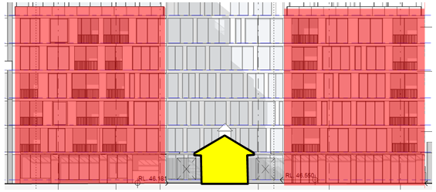
Figure 5: Proposed buildings that surround the heritage substation. The red highlights the six storey sheer walls that flank the substation.
Council’s Heritage Advisor noted:
Simply creating a buffer around the heritage building and then surrounding it with walls of six stories and greater does not create a sensitive response to the setting of the heritage building. The remaining building will be dominated and overwhelmed by the overall scale of the surrounding development. It is considered that the dramatic change of scale between the old and the new should be managed by some degree of height transition. The aim should be to ensure that the heritage building is the focus of this elevation – not just a building left in the middle.
In the figure below, Council’s Heritage Advisor outlined an alternative that would provide an acceptable transition to the heritage substation.
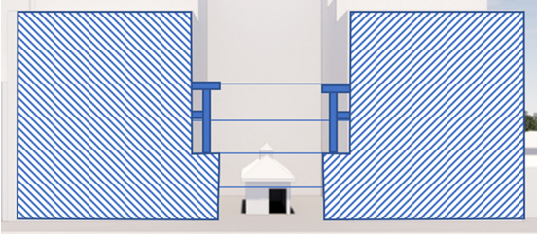
Figure 6: Suggested approach to massing of the two side buildings which is more respectful to the scale of the heritage building.
These changes form part of the officers recommended draft conditions.
Presentation to Brunswick Road
Apart from the 6 storey sheer walls that flank the heritage substation, the height and scale of the built form along Brunswick Road is considered acceptable. VCAT’s interim Order notes ‘we are satisfied that the design and setback of the upper levels will result in an appropriate balance between a sense of enclosure and the openness sought in the design objectives of DDO18’.
The current design adopts a similar approach to the previous proposal. A six storey street wall is adopted with a minimum 6.5 metre setback for the levels above. The built form drops to four storeys closest to the east, adjacent to the existing single storey dwelling facing Brunswick Road. A six metre setback to 180 Brunswick Road was considered appropriate by VCAT and is maintained with the current proposal.
The commercial frontage for most of the Brunswick Road, along with the forecourt and the north south pedestrian link to the east is supported. The inclusion of canopies over part of the frontage is also supported. Multiple entry points are recommended to future proof the commercial space.
Over 16 metres of services on Brunswick Road is a poor outcome. The Planning Report (Urbis, December 2021) states in relation to the services that ‘the location and size is a requirement of the relevant service authority’. No evidence has been provided to support this claim.
VCAT noted in its interim order that the extent of services on Brunswick Road was not acceptable. VCAT stated ‘the detailed design direction in DDO18 specifically seeks service cabinets to be located away from the front façade wherever possible. We think on a site of this size; these services can be better placed.’
This issue is addressed as part of the officers recommended draft conditions.
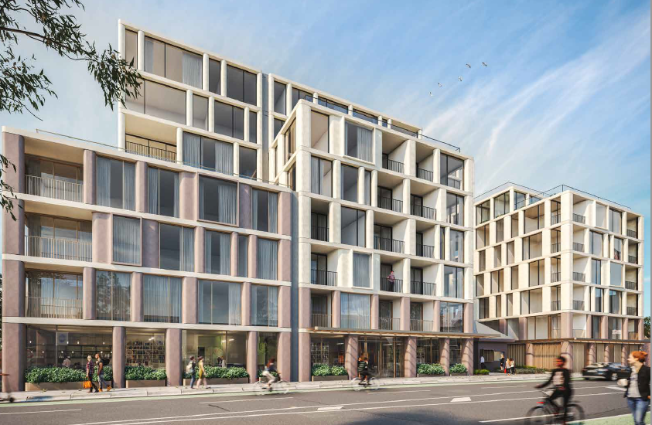
Figure 7: Render of the Brunswick Road interface, Bates Smart Urban Context Report 25 March 2022.
Park Street/Sydney Road corner
This part of the site is covered by both the Heritage Overlay (HO149) and DDO18. The heritage Statement of Significance refers to the intact late 19th century and early 20th century retail and commercial strip. A separate Statement of Significance for Hopper Reserve refers to the numerous memorials and mature street trees that continue the avenue of trees of Royal Parade to Brunswick Road. At this part of the site, the DDO18 specifies a six-storey height with an 8-11 metre street wall.
VCAT’s interim order notes that due to its highly visible and prominent corner location, ‘it performs a ‘gateway’ role’ that ‘justifies a strong built form to mark and hold this corner’. VCAT concluded that the 8-11 metre street wall sought by the DDO18 was not appropriate for this corner. VCAT further determined that a six-storey height at this corner was appropriate ‘to provide a clear marker on this highly visible corner, whilst not overwhelming the Hooper Reserve’ as well as to reduce shadow impacts to Princes Park.
Whilst the current proposal retains six storeys at this corner, it includes a recessed upper level, and removes the stepping down of the built form along Park Street. Council’s Urban Design Unit note that this exacerbates the singular mass along the Park St façade, and dilutes the strength of the corner. It is submitted that this results in a building that does not adequately mark or ‘hold’ the corner.
This is contrary to the VCAT order that noted ‘the stepping down of the massing of the composition along Park Street is entirely appropriate. We consider that it should be retained in any future iteration of the proposal.’
The corner apartment building should be a solid six-storey built form without a recessed upper level, stepping down to a maximum of five storeys facing Park Street. This will require deletion of Apartment 5-15 and the built form associated with the living area and master bedroom of Apartment 5-14. The applicant has submitted an analysis showing without a recessed level at the corner of Park Street and Sydney Road that there will be shadowing of the running track on Princes Park. However, the previous plans show a six storey building without a recessed level that avoids shadowing to the running track. The current proposal is 0.1 metres higher than the previous proposal. This would only account for a small part of additional shadow. Further detailed shadow analysis may be required to clarify the discrepancy. This could result in refinement of the proposal (i.e. potential further reduction building height) to achieve the dual objective of bolder marking of the corner whilst not increasing shadow impacts to Princes Park.
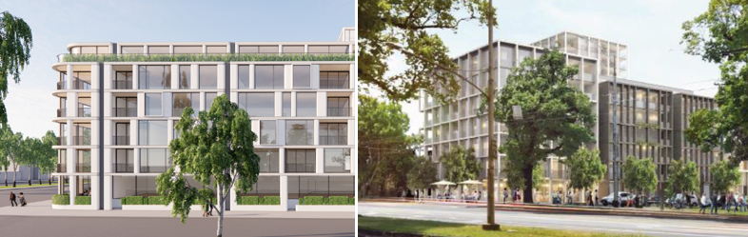
Figure 8: Current proposal (left) failing to adequately mark the corner unlike the previous proposal (right) which included a ‘step down’ of the built form along Park Street
This issue is addressed as part of the officers recommended draft conditions.
The food and drink premise (café) at the corner is supported.
Presentation to Park Street
The current proposal includes a six-storey apartment building facing Park Street that steps down to four storey townhouses towards the east. Both the apartment building and townhouses have a recessed upper level.
Important positives elements of the Park Street interface have been lost or diminished in the current design.
VCAT noted that for Park Street:
‘the six storey street wall should be lowered to five storeys with no recessed level above. This would provide a transition to the three storey townhouses, add interest to the Park Street presentation and delete the solid section of recessed upper level... It would also result in a building that is more closely aligned with the 10.5 metre height that DDO18 applies to that part of the site occupied by the eastern end of Building B’.
The current proposal includes a recessed sixth level contrary to the VCAT direction.
The interim VCAT order noted the gaps between built form provided ‘access and permeability into the site’ and avoided ‘a continuous façade to the street’. The current design provides no gap between the apartment building and the townhouses, removes rebates that were included in the apartment building and reduces the gap between the townhouses and the eastern boundary from 8 metres to 6 metres. This results in a continuous façade of approximately 90 metres without physical break. The continuous built form and lack of setback for the townhouses is inconsistent with the character of built form on Park Street and not considered acceptable.

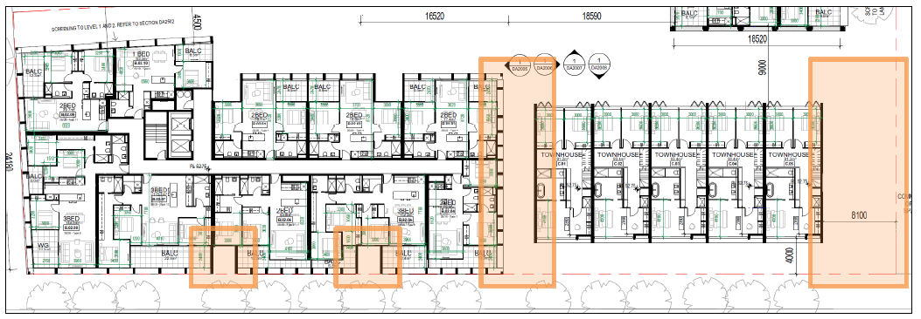
Figure 9: Previous proposal showing (in orange) rebates, a gap between the apartment building and the greater gap to the eastern boundary
The previous proposal included 4 metre setbacks for the townhouses with deep soil planting. VCAT noted this as a positive aspect of the design that responded well to development to the east on Park Street. This has now been lost with a zero setback building to Park Street and no deep soil planting. Removal of the zero setback for the townhouses enables privacy through a front setback, rather than a raised ground level and stairs. This improves accessibility and enables reduction of the height of the townhouses from approximately 11.0 -11.7 metres to approximately 10.0 - 10.7 metres The reduced height would largely comply with the 10.5 metre preferred height for this part of the site in the DDO18 and reduce shadow impacts to Princes Park. It would also provide an improved response to the existing dwellings further east which are predominantly single and double storey in height and have a longstanding mandatory 9 metre height control.
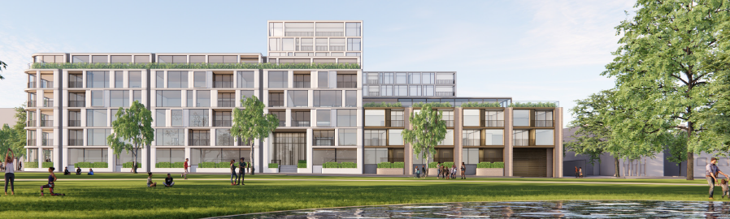
Figure 10: Render of the Park Street elevation viewed from Princes Park, Bates Smart Urban Context Report 25 March 2022.
This lack of physical breaks and deep soil planting in front of the townhouses is addressed as part of the officers recommended draft conditions. It is acknowledged that such changes will have other consequential changes to the design. These include changes to other dwellings, the potential loss of approximately 11-22 car spaces in the basement and the need to provide a greater landscaping buffer between the Park Street entrance to the north/south link and the accessway. However, with such a large site, these changes can be appropriately addressed and managed.
The 10.7 m setback of the fourth level above the townhouses are considered acceptable. Sightline diagrams show that this level will not be readily visible from the opposite side of Park Street. Council officer analysis confirms the fourth level also has no impact on shadowing to Park Street at the winter solstice.
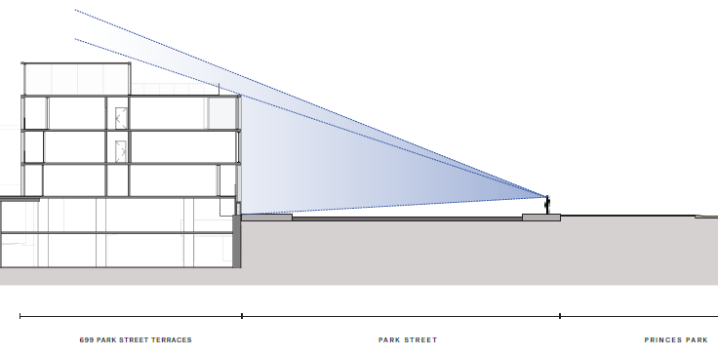
Figure 11: Sightline diagram showing visibility of fourth storey from Park Street, Bates Smart Urban Context Report 25 March 2022.
There will be oblique views of the fourth level from the east. However, the 5 metre setback of the third storey on the east elevation will ensure the built form is recessive.
Overshadowing of Princes Park
Part of the reason VCAT directed a reduction in the height of the central tower and Park Street buildings was to reduce shadows to Princes Park. A key factor was to eliminate winter shadowing to the highly utilised running track. The amended plans that formed the previous proposal achieved this and resulted in the City of Melbourne excluding itself from the latter stages of the VCAT proceedings.
At the time of the VCAT proceeding Amendment C278 to the Melbourne Planning Scheme had been prepared by Melbourne City Council to apply DDO8 to Princes Park. While not directly applicable to the subject site which lies within the area of the Moreland Planning Scheme, Amendment C278 to the Melbourne Planning Scheme would prohibit additional shadow to Princes Park between 10am and 3pm at the winter solstice. At the time of writing this report, the amendment (now known as Amendment C415) has been submitted to the Minister for Planning for approval. Whilst the amendment has progressed, both the VCAT order and the independent panel that considered Amendment C278 noted that it would not apply to land in Moreland. Specifically, VCAT noted:
‘…the provisions of DDO8 would not apply to the review site as Amendment C278 applies only to land covered by the Melbourne Planning Scheme. We agree with the applicant that there are mechanisms for planning scheme amendments to apply to more than one municipality. This has not been sought in relation to Amendment C278.’

VCAT ultimately accepted the extent of overshadowing to Princes Park of the previous proposal.
The current proposal maintains solar access to the running track at the winter solstice. However, the current proposal causes additional shadows to both the central median landscape strip, Park Street and Princes Park compared to the previous proposal throughout the day (see Figure 12 and Figure 13 below)
This appears to be due to:
• The sixth level of the apartment building on Park Street extending further east,
• the lack of front setback of the townhouses
• reduction and removal of gaps and built form rebates
All three factors above were considered positive aspects of the proposal by VCAT, as outlined in this report.
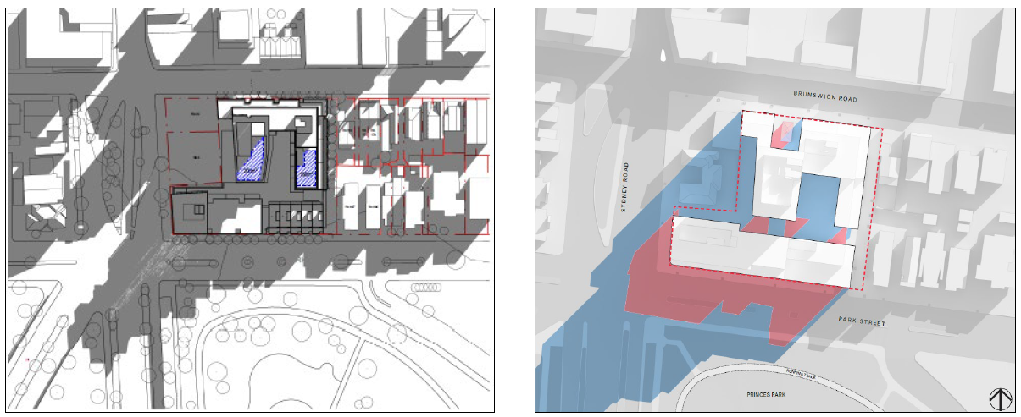
Figure 12: 9am winter solstice shadows of previous proposal (right) and current proposal in blue (left). The red represents the 9am shadow of existing buildings.
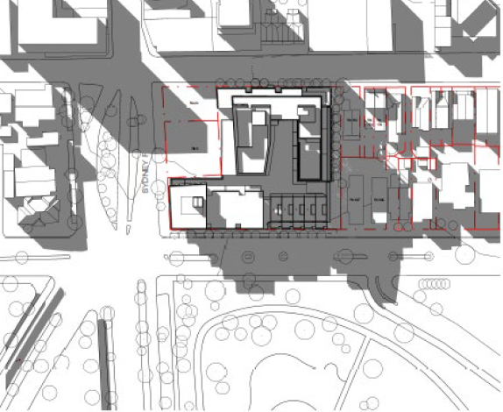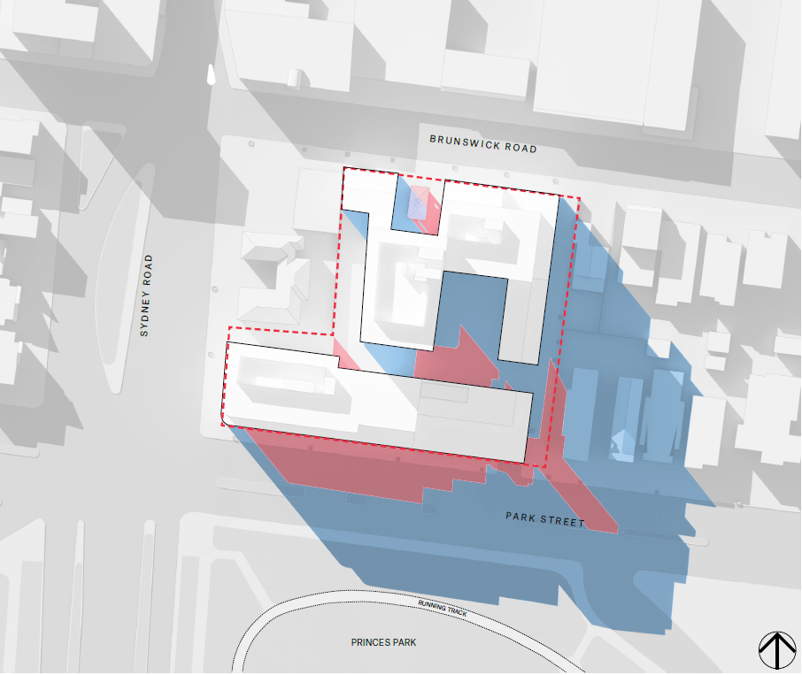
Figure 13: 3pm winter solstice shadows of previous proposal (right) and current proposal in blue (left). The red represents the 3pm shadow of existing buildings.
A full winter shadowing comparison between the previous proposal and current proposal for each hour between 9am and 3pm is contained at Attachment 4.
The DDO18 includes standards of acceptable shadowing to public spaces at the equinox. However as noted by VCAT, ‘the rationale for including that guidance, as set out in the Sydney Road and Upfield Corridor Strategic Framework Plan, 25 refers to protecting sunlight to public space in the fine-grain part of the activity centre north of Brunswick Road and makes no reference to Princes Park’.
VCAT further noted:
“there is sound rationale for important public spaces, especially inner metropolitan parkland, to be protected from shadow in winter. Support for avoiding shadow to Princes Park is found in the public realm design objectives of DDO18 that say solar access to existing public open space is to be maintained. The UDGV (Urban Design Guidelines Victoria) support this view seeking buildings that are located and arranged in activity centres in a way that allows winter sun to penetrate key public spaces. At a higher level, the Planning Scheme requires the balancing of conflicting objectives in favour of net community benefit and sustainable development for the benefit of present and future generations. The public realm of the site, in this location at one edge of the municipality, includes Princes Park and the design must respond appropriately to that context.”
It is submitted that the additional shadow cast by the current proposal compared to the previous proposal will result in a poor outcome. It is an additional reason why the additional height, lack of setbacks and gaps in the built form along Park Street should not be supported.
Shadow impacts will be appropriately reduced if the officers recommended conditions related to the Park Street built form and setbacks are implemented.
Interface with the eastern boundary
The site adjoins two properties to the east which are in the General Residential Zone. To the north-east is a single storey dwelling at 180 Brunswick Road. This dwelling contains solar panels on its roof. To the south-east, the site adjoins a three storey apartment building at 697 Park Street. This building has habitable room windows and balconies facing the site.
The Mixed Use Zone states ‘Any buildings or works constructed on a lot that abuts land which is in a General Residential Zone, Neighbourhood Residential Zone, Residential Growth Zone, or Township Zone must meet the requirements of Clauses 55.03-5, 55.04-1, 55.04-2, 55.04-3, 55.04-5 and 55.04-6 along that boundary’
The DDO18 also has requirements for setbacks to land in a residential zone. The DDO18 states ‘Any part of a building adjacent to residentially zoned land outside the activity centre (including across a lane) should be set back from the residential boundary at that interface by a dimension equivalent to its height above 5 metres, up to a maximum setback of 10 metres’
VCAT accepted variations to Clause 55 standards and considered the presentation of the previous proposal to these properties as acceptable, including impacts of shadowing secluded private open space, solar panels and visual bulk.
However, the current proposal increases the shadow impacts to 180 Brunswick Road compared to the previous proposal.
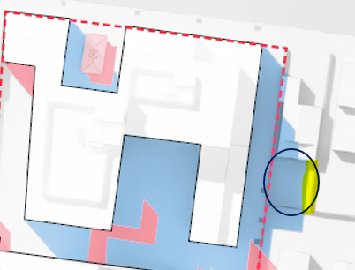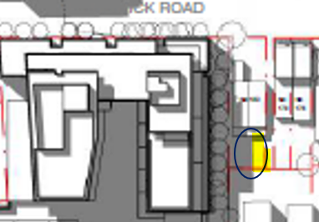
Figure 14: Current proposal (Left) and previous proposal (right). Yellow shows area with access to sunlight at 2 pm at the equinox
It appears the additional shadow is cast by the additional 0.9 metre height of the eight storey building facing east. Conditions of the officer recommendation requires the shadow impacts to be no greater than the shadows cast by the previous proposal. This will require a reduction in height and/or greater setback of the eight storey building closest to 180 Brunswick Road.
There are other differences between the current proposal and the previous proposal. However, it is submitted that, subject to no additional shadows to 180 Brunswick Road compared to the previous proposal, the interface is acceptable for the following reasons:
• The 6 metre landscaped pedestrian path is maintained as a buffer.
• Whilst the fourth storey extends deeper south into the site than the previous proposal, it does not extend to the secluded private open space of 180 Brunswick Road.
• An 11 metre setback for the levels above the fourth storey is maintained.
• A 9 metre gap between the rear of the townhouses and the building facing the pedestrian link is maintained.
• The fifth and sixth storey elements have been significantly reduced compared to the previous proposal.
• Apart from a minor 0.2 metre encroachment of a balustrade at the fourth level, the proposal complies with the required DDO18 setbacks where it interfaces the secluded open space of 180 Brunswick Road. The encroachment is addressed via permit conditions in the officer recommendation.
• Whilst there is a reduction in the gap between the townhouses and the eastern boundary from 8 metres to 6 metres, the proposal complies with the setback requirements of the DDO18, except for a minor 0.2 metre encroachment at the Park Street frontage. The encroachment is addressed via permit conditions of the officer recommendation.
Measures to prevent overlooking have not been detailed on the plans. These details form part of the officers recommended permit conditions.
Response to adjoining Sydney Road properties
The site has a western interface with a two-storey apartment building at 6 Sydney Road and a 7 Eleven at 20 Sydney Road. Both these properties are in the Residential Growth Zone.
VCAT noted that a 9 metre setback to the western boundary would result in an acceptable response, in terms of impacts to existing dwellings and ensuring equitable development for 6 Sydney Road. This has been maintained in the current proposal. The 4.5 metre setback to the south of 6 Sydney Road was accepted by VCAT and has been increased to 5 metres in the current proposal. The six storey building built to the west boundary of the 7 Eleven was accepted by VCAT and is maintained.
Vehicle access and traffic impacts
The previous proposal had vehicle access in a similar location as currently proposed via Park Street. Park street is the preferred location for vehicle access and supported by Council’s Development Engineer and VCAT. VCAT also accepted that the level of traffic generation of the previous proposal (209 dwellings and a childcare centre) could be accommodated by the existing road network. Given the current proposal contains less dwellings and no childcare centre, traffic impacts are considered acceptable. VCAT did recommend that access be confined to left in/left out movements, as has the Transport Impact Report by Ratio. Council’s Development engineers also supports this arrangement, which forms part of the officers recommended permit conditions.
Car parking and loading/unloading provision
As the car parking in the previous proposal met the requirements of Clause 52.06, VCAT did not have to consider the quantum of car parking.
223 car spaces are proposed within two levels of basement. One car spaces is designated for retail as noted in the Transport Impact Report by Ratio. The remaining 222 spaces are for residents. No visitor car parking is proposed.
Clause 52.06 (Car parking) of the Moreland Planning Scheme sets out car parking requirements. For the residential component, 223 car spaces are required, meaning a one car space reduction is sought. As the site is within the Principal Public Transport Network, there is no requirement to provide visitor car parking.
No car spaces are proposed for the commercial use, identified as an ‘office’ in the submitted Transport Report. The food and drink premises has a car parking requirement of 6 spaces and commercial office 8 spaces. Combined this equates to 14 spaces. A reduction of 13 car spaces is proposed for these uses.
The site is located in a Major Activity Centre and has excellent alternative modes of transport available including trains, trams, buses, car share options and bicycle routes. Clause 18.02-4L (Car parking in Moreland) supports reduced car parking rates in such locations. Whilst a reduction is supported, Council’s Development Engineer has raised concerns that the 272 sqm office has been provided no spaces. This increases the risks of high vacancy rates for the office. Given 2016 ABS data suggests there is a residential oversupply of 66 spaces Council’s Development Engineer recommends at least 5 residential spaces be re-allocated to the office. This view is supported. In addition the recommended condition to include 4 metres of deep soil planting for the townhouses may result in the loss of 11-22 car spaces within the basement. This reduction is accepted given the analysis above.
Two ‘small parking bays’ are proposed. As noted by Council’s Development Engineer these spaces are sub-standard and should be re-purposed as ‘motorcycle spaces’ on common land.
These matters are addressed in the officers recommended permit conditions.
A loading bay was not provided in the previous proposal. A loading bay is provided within the basement of the current proposal. This will cater for loading/unloading requirements for the dwellings and the café. Loading/unloading for the commercial use may also occur kerbside on Brunswick Road.
It is further noted by Council’s transport engineers that on-street parking in both Brunswick Road and Park Street is currently unrestricted and heavily utilised. It is noted that the developer or future owners or occupiers may seek the inclusion of parking restrictions to better manage on-street parking demands into the future.

Bicycle parking provision
The current proposal provides 210 bicycle spaces, significantly exceeding the 52 spaces required by Clause 52.34 (Bicycle parking). The spaces are provided in the basement and at ground level. 28 visitor spaces and 8 office spaces are provided. Whilst not required by the Moreland Planning Scheme, two shower facilities are provided for the office, encouraging bicycle use.
Waste collection
The Waste Management Plan (WMP) details anticipated waste generation, waste storage area size, design and location, bins and collection, and ongoing management. The WMP includes:
• Office tenancy waste collected once a week via Council collection from Brunswick Road.
• Garbage and recycling bins for the residents and food and drink premise collected by a private waste collection service multiple times per week via the basement.
The private waste contractor will be responsible for transferring bins from the bin store to the waste collection vehicle within the basement and returning the bins to the bin store immediately after collection.
North/South public pedestrian link
The Planning Scheme does not require a public link through the site. However, the north-south pedestrian link was a positive public benefit of the previous proposal that is maintained in the current design.
The 6 metre wide space includes a 2 metre pedestrian pathway and deep soil landscaping. VCAT was critical of the shared vehicle and pedestrian arrangement of the previous proposal. The shared arrangement has been removed. However, with the recommended condition to setback the built from surrounding the vehicle entrance by 4 metres, there will be no physical barrier between the pedestrian link and the vehicle access point for the first 4 metres. To address this, a recommended condition is to provide an additional 1 metre of landscaping along this edge requiring a setback of the vehicle accessway to be increased to 7 metres.
Council’s Open Space Unit and Urban Design Unit support the proposed link with some minor alterations. These include widening the pedestrian path to 3.5 metres at the north and south entry points and ensuring plant understorey is limited in height to ensure sightlines for safety. A lighting plan would also be required.
These form part of the officers recommended permit conditions, including the public benefit of the pedestrian link being assured in perpetuity through a Section 173 Agreement between the owners and Council.
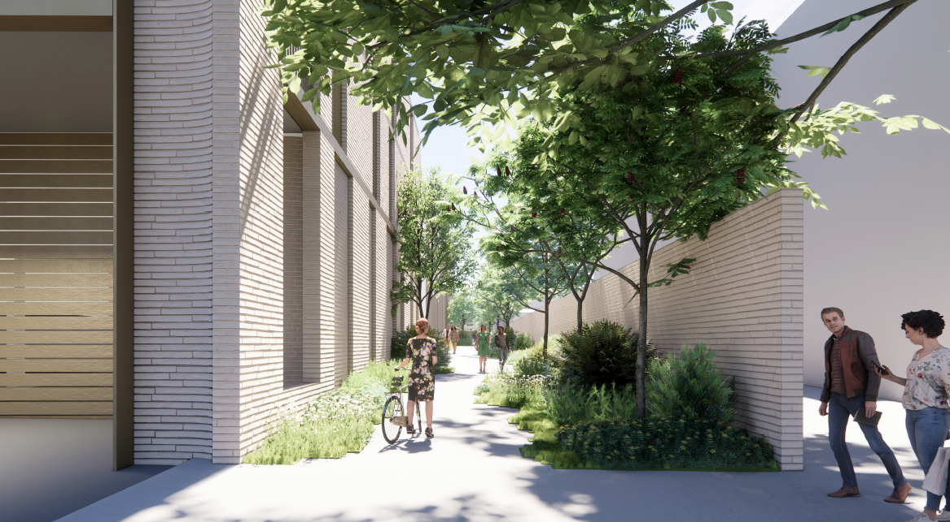
Figure 15: North-south public pedestrian link, Bates Smart Urban Context Report 25 March 2022.
Building separation
All building separation distance standards of Clause 15.01-2L (Apartments in Moreland) are met or are exceeded, except the 9 metre western setback of the ten-storey tower. To comply with Clause 15.01-2L the setback would need to be 12 metres for the top two levels. VCAT previously accepted the variation to the west boundary.
Central Courtyard and communal open spaces
A central courtyard is proposed with a width of 12 metres, depth of 21 metres and an area of 254 sqm. This is approximately half the size of the central courtyard of the previous proposal which had an 11 metre width, 41 metres depth and an area of approximately 530 sqm.
Both the previous and current proposal had the central space in the same location flanked by built form to the north, east and west. Council’s Open Space Design and Development Unit noted that the central courtyard ‘won’t be a functional communal open space area due to the shadow impacts on the north and western sides and the enclosed nature of the space’.
In relation to the central courtyard of the previous plans, VCAT noted:
Although the courtyard will be subject to shadow, we think the inclusion of two large roof top terraces offer useable alternative spaces with good solar access. We do not agree that the ground level spaces serve only for transit purposes. The communal part of the central courtyard has a minimum width of 11 metres and extends for over 40 metres in length. The landscape plans show several seating ‘nooks’ and significant planting in this area.
The previous proposal included two roof top terraces, when combined equated to 594 sqm. The current proposal has one roof terrace of 76 sqm surrounded by a 136 sqm landscape setting.
Clause 58.03-2 (Communal open space) Standard D7 requires 250 sqm of communal open space for a development of this size. Combining all the communal open spaces including the north/south and east/west pedestrian links, the roof terrace and space around the substation a total of 643 sqm is provided. Whilst the proposed central courtyard and roof terraces are significantly smaller than the previous proposal, the proposal still significantly exceeds Standard D7.
In addition, a relevant decision guideline of Clause 58.03-2 is ‘the availability of and access to public open space’. Given the access to Princes Park, the proposed communal open space is arguably acceptable while it is recognised that even greater amenity and urban heat island benefits are capable of being achieved through greater utilisation of the rooftop spaces. The development now submitted to the Minister for consideration is therefore a lesser proposal in this respect than that considered and supported on balance by VCAT. Conditions to increase rooftop spaces to enhance the amenity for future residents forms part of the officer recommendation.
Amenity for future occupants - Compliance with Clause 58
The previous VCAT decision noted that the proposal should comply with the Victorian Apartment Design Guidelines 2017 (VADG) a policy document referred to in Clause 15.01-2S. Clause 58 (Apartment developments) sets out standards and objectives to ensure acceptable amenity for existing and future occupants. For the most part, Clause 58 standards are the same as the VADG.
The proposal has a high level of compliance with the standards of Clause 58. Balconies meet or exceed size requirements, room sizes of the apartments meet requirements and apartments have good outlooks due to generous building separation. No apartments rely on light courts for daylight.
In addition, adequate storage areas are provided, corridors have access to natural light and cross ventilation standards are met.
However, 11 apartments fail to meet Standard D26 (Room depth). The room depth objective is to ‘To allow adequate daylight into single aspect habitable rooms’. The standard requires room depth to be no more than 9 metres where ceiling height is at least 2.7 metres, which is the ceiling height proposed. Council officer assessment shows that 16 apartments fail this standard. Room depths for these 11 apartments range between 10.05 to 10.5 metres. All but one of these apartments (except G-06) are south facing, further impacting amenity given they will never receive sunlight. Three of the apartments (2-26, 2-27 and 3-19) will be extremely dark given daylight is further compromised by the overhanging built form above their balconies.
The Urban Context Report (pg 140) notes ‘A limited number of apartments (10%) marginally exceed room depth of 9m to improve size of living space and access, a deviation is sort. These apartments are generally park facing benefitting from improved amenity.’
Whilst it is acknowledged that views to the park improve general amenity, it is important that dark apartments are avoided. It is acknowledged that standards are not mandatory and can be varied. However, this is a large unconstrained site. There is no apparent reason why the standard should not be met, nor have the room depth non-compliances offsite by higher floor to ceiling heights or generous glazing.
These substandard apartment designs are contrary to Section 4.4 ‘Public Realm and Benefit’ of the Planning Report by Urbis which claims the proposal ‘delivers best practice apartment design outcomes’.
A recommended condition of permit is for compliance with Standard D26 for all apartments.
What is the affordable housing offering?
The Planning and Environment Act, 1987 has as an objective to ‘facilitate the provision of affordable housing’. Clause 16.01-1L (Homes in Moreland) objective is ‘To deliver more affordable housing closer to jobs, transport and services’.
Whilst provision of affordable housing is not a mandatory requirement, a criteria for any proposal going through the streamlined DFP process include a substantial public benefit. The DFP eligibility criteria notes ‘A public benefit must provide significant environmental, commercial, recreational, educational, health and essential services to the community, and/or support vulnerable communities, regions, industries or sectors’ (emphasis added).
The application material indicates that the affordable housing offering will be:
• 10% of dwellings (17 in total and anticipated to be 14 one-bedroom dwellings and 3 two-bedroom dwellings) provided as affordable homes to eligible households;
• Facilitated through a Shared Equity Home Ownership Program, where the purchaser’s shortfall in funds needed to purchase the dwelling, are contributed to through an ‘Affordable Housing Contribution’.
• Mirvac’s Affordable Housing Contribution will be equivalent to an average 35% of the market value of the affordable dwelling and will be made to ‘BuyAssist Australia’ an established Registered Housing Provider
• Through legal arrangements BuyAssist Australia uses Mirvac’s Affordable Housing Contribution which is held as equity in the affordable dwellings. The purchaser retains 100% legal interest in the home for an agreed percentage of the purchase price.
• A Section 173 legal agreement is use to secure the parameters of Mirvac’s Affordable Housing Contribution and reinvestment of these funds
• Homes for Homes caveat on Title. The Planning Report by Urbis notes this will deliver ‘future cashflow projection benefit $1,000,000 for affordable / social housing provision.’
BuyAssist Australia is an established model, operating in Victoria including some developments in Moreland. This model provides the affordable housing offering as a ‘rolling fund’ whereby the Affordable Housing Contribution will be repaid when a household refinances or sells the apartment (this is calculated as a pre-defined proportion of the future market value). This means that the original purchaser does not achieve a windfall gain to be the only beneficiary of a reduced purchase price. Repaid funds are then reinvested by BuyAssist Australia in further shared equity Affordable Housing projects, with priority given to new arrangements in Moreland and if unsuitable elsewhere in Victoria.
A Home in Moreland research undertaken by Council in 2016 about unmet housing need and housing affordability in Moreland, indicates that in 2016 there were 713 moderate income households in rental stress in Moreland (compared to 6463 low and very low income households) particularly singles and couples.
The proposed 35% discount to the market value will only assist households at the highest income of the moderate income bracket. Single person households will not be able to afford to purchase a one or two bedroom home. Couples will only be able to afford to purchase a one bedroom home.
The draft Explanatory Report in justifying the community benefit refers to the proposal providing affordable housing for ‘low to moderate income households’. As explained above, the offering does not assist people on low incomes. It is therefore an unfortunate missed opportunity that the affordable housing offering does not cater for people most in need with low to very low incomes.
At a minimum, the offering should be increased to 45% of the market value. Whilst this continues to only benefit households within the moderate income bracket, the increased financial contribution allows a single person to purchase a one bedroom dwelling and couples to purchase two bedroom dwellings. Council’s analysis of this increase to 45 per cent, indicates that the financial contribution by Mirvac will be approximately $4,794,000. This is proximate to the $4,500,000 commitment claimed in the planning application material.
As recommended by Council’s Principal Advisor Social and Affordable Housing the commitment that dwellings created by this development be signed up to the ‘Homes for Homes’ scheme should include the developer providing the donation from the first sales of the development after separate titles are created (being 0.1% of the sale price of the dwellings).
This level of benefit to the community, arising from the affordable housing offering, would be appropriate given the accelerated assessment and determination of the proposal that is being sought, including reducing or limiting third party rights. Affordable housing improvements noted above are addressed in the officers recommended permit conditions.

Does the proposal incorporate adequate Environmental Sustainable Design (ESD) features?
The draft explanatory report notes that the applicant ‘is targeting a 70% rating under the Built Environment Sustainability Scorecard (BESS) and building fabric NatHERS performance to meeting a minimum average of 7 stars and various water sensitive urban design measures’.
Council’s ESD Team have noted that whilst the targets are excellent, the information submitted with the application does not support achievement of such targets. The ESD Team noted ‘the development has a fairly standard level of ESD and has no solar PV panels which is highly unusual for a site of this scale and not acceptable. The BESS score is 73%, however there is limited evidence to support this score and more information is required’’.
Key concerns of Council’s ESD Team relate to daylight to apartments, ventilation, excessive west facing glazing and south facing apartments and inadequate Water Sensitive Urban Design (WSUD) response. The ESD Team have recommended that these matters should be addressed prior to issue of permit (i.e. not as a permit condition) because significant changes may be required to the design and layout.
The officers recommendation includes conditions to ensure ESD performance targets are achieved.

Is the proposal accessible to people with limited mobility?
Clause 16.01-3L (Housing diversity in Moreland) encourages the provision of housing that can be lived in by people with limited mobility (or easily adapted to be lived in). Clause 58.05-1 (Accessibility) has standards related to accessibility and requires at least 50% of dwellings to meet these standards. The proposal includes 72% of dwellings that meet the accessibility standards. These include an adaptable bathroom and, a clear path with a minimum width of 1.2 metres connecting the dwelling entrance to the main bedroom, an adaptable bathroom and the living area.
Whilst there is no requirement for disabled car parking spaces within the Planning Scheme, one disabled car space is provided.
Surfaces appear flat without stairs within common areas at ground level, apart from the Park Street lobby that contains stairs. It is unclear if the Park Street entrance contains a disabled lift. The officer recommendation includes a requirement that the main Park Street entrance be DDA compliant. The officer recommendation to remove the raised entries for the Park Street townhouses will also improve accessibility.
For a site of this size, an expert accessibility report should be provided to confirm the development meets appropriate standards. This forms part of the officers recommended conditions.
Contaminated Land
A Statement of Environmental Audit was issued for the land based on the previous proposal under the Environment Protection Act 1970 (‘old act’). A letter dated 14 December 2021 from the Environmental Auditor has been supplied which states that the Statement of Environmental Audit would be equally as applicable to the current proposal as it would be the previous proposal. However, the audit has not been issued under the new act. The letter by the auditor notes ‘This document does not purport to be an environmental audit prepared pursuant to the Environment Protection Act 2017’. Whilst there are transitional provisions in the new act (s 479), it appears these do not apply in this circumstance. Therefore, the officer recommendation includes a permit condition requiring an audit pursuant to the new act.

6. Officer Declaration of Conflict of Interest
Council Officers involved in the preparation of this report do not have a conflict of interest in this matter.

7. Financial and Resources Implications
If the matter proceeds to a Priority Projects Standing Advisory Committee, resources from the City Development Branch, as well as internal referral expertise will be used. Financial expenditure will be required for legal representation and independent expert witnesses. This could be met within Council’s existing budget.

8. Conclusion
Subject to conditions contained in the officers recommended draft planning permit, it is considered that the proposal satisfactorily addresses the VCAT concerns of the previous proposal. In addition, the proposal will provide for affordable housing and the public benefit of a pedestrian through link.

Attachment/s
1 | Aerial and Zoning Map - 699 Park Street, Brunswick | D22/158407
2 | Development Plans and Draft Permit - 699 Park Street, Brunswick | D22/158412
3 | Previous VCAT Decisions (Interim and Final Order) - 699 Park Street, Brunswick | D22/158415
4 | Shadowing Princes Park - comparison previous proposal with current proposal | D22/162073
5 | Draft Planning Permit PA2201559 Moreland City Council officer recommended track changes April 2022 | D22/162357

