Council AGENDA

Election of the Mayor

Wednesday 17 November 2021
Commencing 7 pm

Council Chamber, Moreland Civic Centre, 90 Bell Street, Coburg

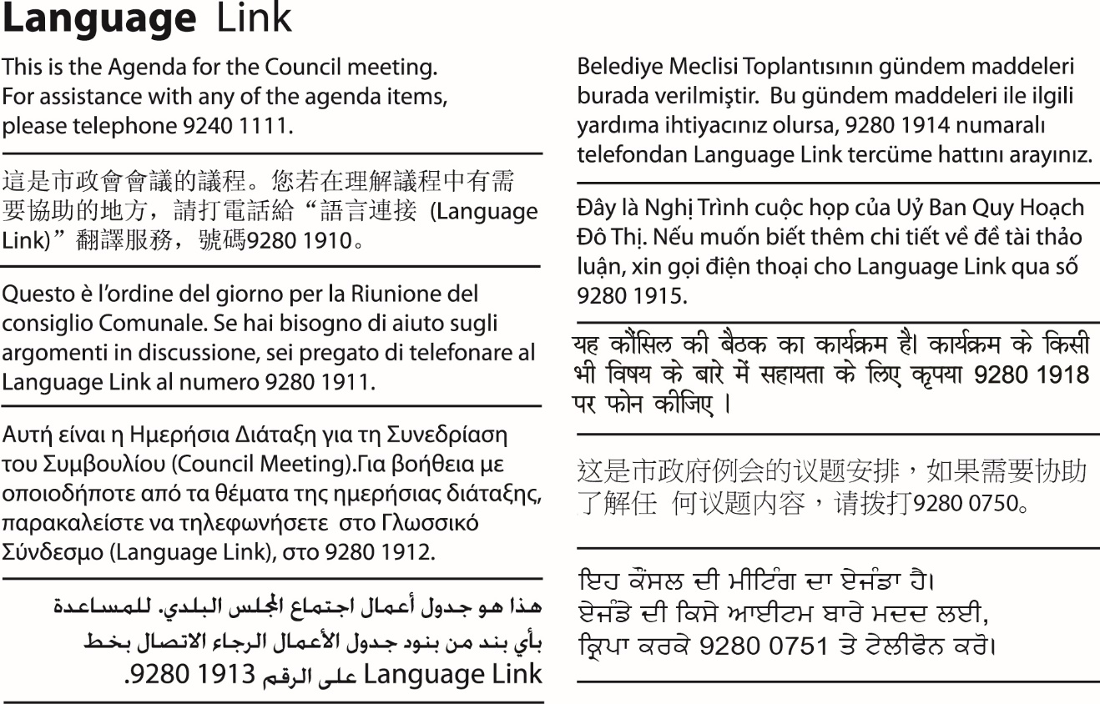

Acknowledgement of the traditional custodians of the City of Moreland
Moreland City Council acknowledges the Wurundjeri Woi Wurrung people as the Traditional Custodians of the lands and waterways in the area now known as Moreland, and pays respect to their elders past, present, and emerging, as well as to all First Nations communities who significantly contribute to the life of the area.

Councillors
Cr Adam Pulford
Cr Angelica Panopoulos
Cr Annalivia Carli Hannan
Cr Helen Davidson
Cr Helen Pavlidis
Cr James Conlan
Cr Lambros Tapinos
Cr Mark Riley
Cr Milad El-Halabi
Cr Oscar Yildiz
Cr Sue Bolton

Table of Contents
1. Welcome and Appointment of Interim Chair 5
2. Apologies 5
3. Declaration of Interests and/or Conflict of Interests 5
4. Term of Mayor 5
5. Election of Mayor 5
6. Newly Elected Mayor – Mayoral Chains and Assuming of the Chair 6
7. Ceremonial Mayoral Speech 6
8. Presentation to Outgoing Mayor 6
9. Election of Deputy Mayor 6
10. Adoption of Council Meeting Dates For 2022 6
11. Councillor Appointments to Portfolios, Internal Committees, Advisory Committees and other External Bodies 7
12. Meeting Close 11

Welcome and Appointment of Interim Chair

Apologies

Declaration of Interests and/or Conflict of Interests

Term of Mayor
To fulfil the statutory obligations of section 26(3) of the Local Government Act 2020 (the Act), before the election of the Mayor, a Council must determine by resolution whether the Mayor is to be elected for a 1 year or a 2 year term.
Historically, Moreland has elected a Mayor for a 1 year term only. The recommendation is that Council continues this precedent and sets a 1 year term for the 2021/22 Mayoral year. However, it is open to the Council to determine a two year term instead.
In accordance with Council’s Governance Rules, the Mayoral term determined by Council will also apply to a Deputy Mayor
In accordance with section 26(4) the Act, the next election of the Mayor and any Deputy Mayor will be held as close as possible to the end of the 1 year term as possible.
Recommendation
That Council:
- Elects a Mayor for a one year term.
- Notes the term of any Deputy Mayor is identical to the term of the Mayor.

Election of Mayor
The election of the Mayor is conducted by the Chief Executive Officer (CEO) in accordance with section 25 of the Local Government Act 2020 and Moreland’s Governance Rules.
The CEO will invite nominations for the office of the Mayor and confirm acceptance of each nomination with the nominee.
The Mayor must be elected by an absolute majority of Councillors. Moreland has 11 Councillors and an absolute majority of Councillors is 6.
If only 1 Councillor is a candidate for Mayor, the CEO must declare that Councillor to be duly elected as Mayor. Where 2 or more candidates are nominated the CEO will conduct a series of votes until such time as a candidate receives an absolute majority of votes.

Newly Elected Mayor – Mayoral Chains and Assuming of the Chair
The Chief Executive Officer invites the newly elected Mayor to receive the Mayoral Chains and to assume the Chair.

Ceremonial Mayoral Speech
In accordance with sub-rule 3.5.4 of the Governance Rules, upon being elected, the Mayor may make a ceremonial speech, outlining the priorities of the year ahead based on the previously adopted Council Plan.

Presentation to Outgoing Mayor
A presentation will be made to the outgoing Mayor, Cr Annalivia Carli Hannan. Cr Carli Hannan will have an opportunity to make a brief statement.

Election of Deputy Mayor
The election of the Deputy Mayor is conducted by the Chief Executive Officer in accordance with section 27 of the Local Government Act 2020 and the Governance Rules. The same provisions apply to the election of the Deputy Mayor as to the election of the Mayor with all necessary modifications and adaptations.
The CEO will invite nominations for the office of the Deputy Mayor and confirm acceptance of each nomination with the nominee.

Adoption of Council Meeting Dates For 2022
Council’s Governance Rules provide that Council fixes the date, time and place of all Council meetings for the following calendar year, including meetings designated for Planning and Related Matters.
Council by resolution, or the Chief Executive Officer, may change the date, time or place of, or cancel, any Ordinary meeting which has been fixed, or schedule an additional ordinary meeting and must provide notice of the change to the public.
The proposed Council Meeting Schedule (Schedule) for the period January to December 2022 has been drafted to enable Council to effectively carry out its decision-making functions for the year. The Schedule includes the times and dates for Council meetings and Council meetings designated for consideration of Planning and Related Matters.
Meetings are generally held on a Wednesday evening in the Council Chamber at the Moreland Civic Centre.
The election of the Mayor must be held on a day that is as close to the end of the one year term as is reasonably practicable. It is proposed that the next meeting to elect the Mayor be held Tuesday, 29 November 2022.

Date | Time | Meeting type
27 January 2022 | 6.30 pm | Council Meeting - Planning and Related Matters
9 February 2022 | 7 pm | Council Meeting
23 February 2022 | 6.30 pm | Council Meeting - Planning and Related Matters
9 March 2022 | 7 pm | Council Meeting
23 March 2022 | 6.30 pm | Council Meeting - Planning and Related Matters
13 April 2022 | 7 pm | Council Meeting
27 April 2022 | 6.30 pm | Council Meeting - Planning and Related Matters
11 May 2022 | 7 pm | Council Meeting
25 May 2022 | 6.30 pm | Council Meeting - Planning and Related Matters
8 June 2022 | 7 pm | Council Meeting
22 June 2022 | 6.45 pm | Council Meeting - Planning and Related Matters
13 July 2022 | 7 pm | Council Meeting
27 July 2022 | 6.30 pm | Council Meeting - Planning and Related Matters
10 August 2022 | 7 pm | Council Meeting
24 August 2022 | 6.30 pm | Council Meeting - Planning and Related Matters
14 September 2022 | 7 pm | Council Meeting
28 September 2022 | 6.30 pm | Council Meeting - Planning and Related Matters
12 October 2022 | 7 pm | Council Meeting
26 October 2022 | 6.30 pm | Council Meeting - Planning and Related Matters
9 November 2022 | 7 pm | Council Meeting
23 November 2022 | 6.30 pm | Council Meeting - Planning and Related Matters
29 November 2022 | 7 pm | Ceremonial Meeting to elect the Mayor
7 December 2022 | 7 pm | Council Meeting
14 December 2022 | 6.30 pm | Council Meeting - Planning and Related Matters

The adopted schedule of Council meeting dates will be published on Council’s website and made available at Council’s Customer Service Centres.
Recommendation
That Council:
- Sets the dates and times for Council meetings in 2022 as printed in the agenda and designates those meetings indicated for consideration of Planning and Related Matters in accordance with the Governance Rules.
- Sets the date and time for the election of the Mayor for 2022/23 as Tuesday, 29 November 2022 at 7 pm.
- Appends the schedule of Council meetings to the minutes, publishes it on the Council website and makes it available at Customer Service Centres.

Councillor Appointments to Portfolios, Internal Committees, Advisory Committees and other External Bodies
Each year, Council reviews Councillor appointments to the roles of ‘Councillor Responsible For…’ and to Council convened networks, internal, advisory and external committees, and networks and external boards who have sought a Council representative for the Mayoral year.
This report seeks appointments of those roles and representatives for the 2021/2022 Mayoral Year.
This report also seeks to extend the operation the Coburg Square - Oversight Committee for a further 12 months until December 2022 and adjusts the Terms of Reference to reflect the extension.
If required, Council may resolve to change the appointments during the year.
‘Councillors Responsible For …’
The role of a Councillor Responsible For is outlined in the Governance Rules and includes:
- Liaising with the members of the relevant advisory committee to ensure effective coordination of individual issues and projects;
- Facilitating good Council/Councillor/Administration coordination and communication on key issues;
- Advising and reporting to Councillor colleagues on project issues;
- Providing input from Councillors to the Chief Executive Officer on relevant projects.
The areas for ‘Councillors Responsible For …’ in the 2020/2021 Mayoral year were:
- Arts and Culture
- Climate and Nature
- Early Years
- Economic Development
- Human Rights
- Multiculturalism
- Older Persons
- Sport and Recreation
- Transport and Getting Around
- Urban Planning
- Women
- Young People
Audit and Risk Committee
The Audit and Risk Committee is a requirement of the Local Government Act 2020 and governed by the Audit and Risk Committee Charter, adopted in July 2021. It comprises 3 Councillor members and 4 independent, external members. The next meeting of the Audit and Risk Committee is scheduled for 14 December 2021 and requires the appointment of Councillor representatives to ensure the continued operation of the Committee.

Internal Committees
Internal Committees provide advice to Council or Council officers acting under delegation and are comprised only of Councillors and, on rare occasions, Council staff.
The established committees for Councillor appointments are:
- CEO Employment and Remuneration Matters Committee
- Communications and Engagement Councillor Group
- Coburg Square Oversight Committee
- Saxon Street Oversight Committee
- Glenroy Advisory Group
- Brunswick Advisory Group
- Coburg Advisory Group
- Moreland Community Recognition Committee (Moreland Awards)

Advisory Committees
Council’s Advisory Committees have been established to provide advice to Council on their area of focus. Council’s Advisory Committees include community and partner organisation members or representatives and play an important role in contributing to Council’s decision-making.
At its meeting held 11 August 2021 Council endorsed to establish the following Advisory Committees to support Council during its term:
a) Sustainable Transport Advisory Committee
b) Environmental Sustainability Advisory Committee
c) Human Rights and Inclusion Advisory Committee
d) Moreland Arts Advisory Committee

External Committees
External Committees are formed by other organisations and have a Councillor appointed as Council’s representative.
The established committees for Councillor appointments are:
- CERES (Board)
- Friends of Aileu Community Committee
- Merri Creek Management Committee
- Metropolitan Local Governments’ Waste Forum
- Metropolitan Transport Forum
- Municipal Association of Victoria
- Northern Alliance for Greenhouse Action Executive.
- Northern Councils Alliance

Recommendation
That Council:
- Extends the operation the Coburg Square - Oversight Committee for a further 12 months until December 2022 and updates the Terms of Reference accordingly.
- Appoints Portfolio Councillors, known as ‘Councillors Responsible For…’, for the 2021/2022 Mayoral year as follows:
Arts and Culture | Cr
Climate and Nature | Cr
Early Years | Cr
Economic Development | Cr
Human Rights | Cr
Multiculturalism | Cr
Older Persons | Cr
Sport and Recreation | Cr
Transport and Getting Around | Cr
Urban Planning | Cr
Women | Cr
Young People | Cr

- Appoints Councillors to internal, advisory, network and external committees for the 2021/2022 Mayoral year as follows:
- Internal Committees
Audit and Risk Committee | Cr  Cr  Cr
CEO Employment and Remuneration Matters Committee | All Councillors
Communications and Engagement Councillor Group | Mayor and Councillors
Coburg Square Oversight Committee | Mayor (Chair)  Cr  Cr  Cr  Cr to fill any vacancies that arise
Saxon Street Oversight Committee | Mayor and South Ward Councillors
Glenroy Advisory Group | North-West Ward Councillors

Brunswick Advisory Group | South Ward Councillors
Coburg Advisory Group | North-East Ward Councillors
Moreland Community Recognition Committee (Moreland Awards) | Cr  Cr  Cr
- Advisory Committees
Sustainable Transport Advisory Committee | Cr
Environmental Sustainability Advisory Committee | Cr
Human Rights and Inclusion Advisory Committee | Cr
Moreland Arts Advisory Committee | Cr
- External Committees
CERES (Board) | Cr
Friends of Aileu Community Committee | Cr
Merri Creek Management Committee | Cr  Cr (substitute)
Metropolitan Local Governments’ Waste Forum | Cr
Metropolitan Transport Forum | Cr  Cr
Municipal Association of Victoria (Representative) | Cr  Cr (substitute)
Northern Alliance for Greenhouse Action (NAGA) Executive | Cr
Northern Councils Alliance | Mayor; and  Cr (substitute)

Meeting Close

