special Council MEETING AGENDA

Monday 20 July 2026

Commencing 6.00 pm

Bunjil (Council Chamber), Merri-bek Civic Centre,
90 Bell Street, Coburg

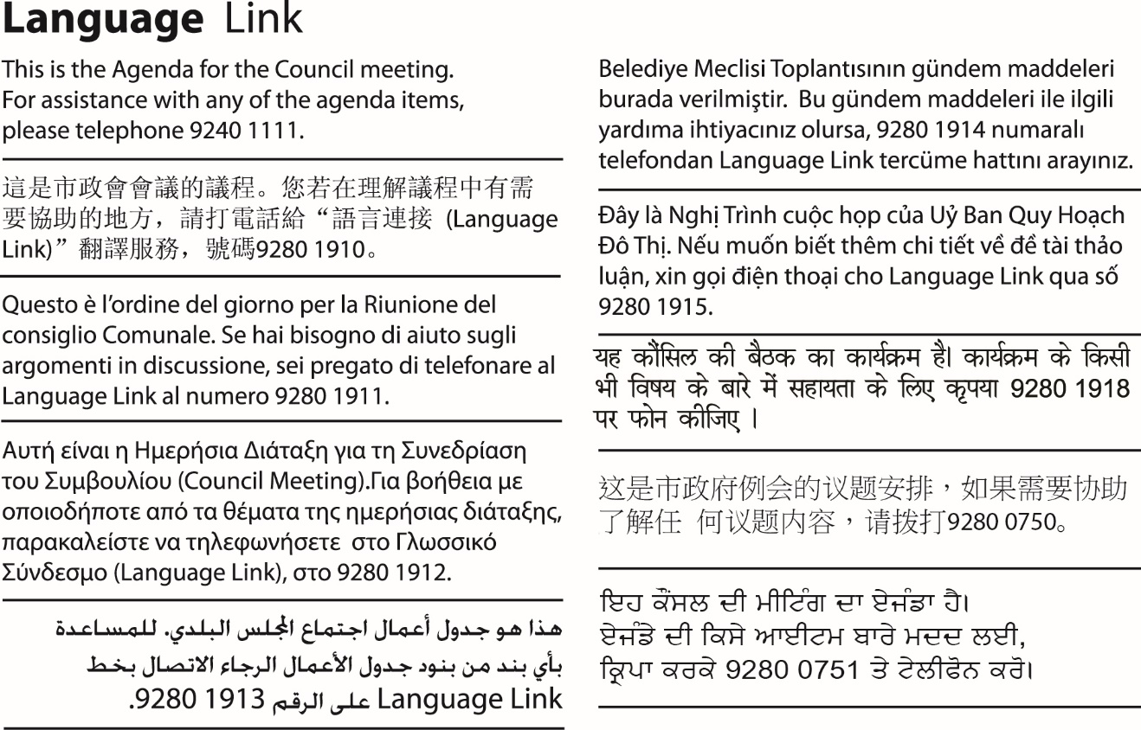

1. WELCOME
2. APOLOGIES/LEAVE OF ABSENCE
3. DECLARATIONS OF CONFLICTS OF INTERESTS
4. COUNCIL REPORTS
4.1 Notice of Native Title Determination Application 3

4. Council Reports
4.1 Notice of Native Title Determination Application
Director Community, Eamonn Fennessy
Director Place and Environment, Pene Winslade
Community Wellbeing; and Property

Officer Recommendation

That Council:
1. Becomes a respondent to the application for determination of native title in Victoria known as "Perry James Wandin & Ors on behalf of the Wurundjeri Woi-Wurrung People and State of Victoria & Ors" (Federal Court Proceeding VID1466/2025).
2. Authorises the Chief Executive Officer to engage legal representation to:
a) take steps on behalf of Council to become a respondent;
b) provide legal advice to Council regarding the application, and
c) to otherwise act on behalf of Council throughout the application process.

REPORT

Executive Summary

The Wurundjeri Woi-wurrung People have lodged a Native Title Determination Application in the Federal Court seeking recognition of native title over approximately 10,424 square kilometres across metropolitan Melbourne and surrounding municipalities, including the City of Merri-bek.

The application applies to Crown land only and excludes freehold land, private property and public works. As a result, Council-owned freehold land is not affected. Council's interest relates to Crown land where it is appointed as Committee of Management or has statutory land management responsibilities.

Under the Native Title Act 1993 (Cth), Council has been invited to become a respondent party to the proceeding. If Council elects to do so, a Notice of Intention to Become a Party must be filed with the Federal Court by 21 July 2026.

Becoming a respondent does not mean Council opposes or supports the Native Title claim. Rather, it enables Council to protect its legal interests, remain informed throughout the proceedings and participate where matters affect Crown land under Council's management.

Officers have obtained legal advice which recommends Council become a respondent party to preserve its legal interests while participating proportionately in what is expected to be a lengthy court process. It is important to note that State and territory governments are the lead respondents in Federal Court Native Title claims because they legally own and manage unallocated Crown land, public infrastructure, and natural resources.

It is therefore recommended that Council become a respondent party and consider participating in a joint legal representation arrangement with other affected councils which, among other benefits, has the potential advantage of mitigating legal costs.

Previous Council Decisions
No previous Council decisions.

1. Policy Context

This report has been prepared having regard to:

• Native Title Act 1993 (Cth)

• Local Government Act 2020 (Vic)

• Traditional Owner Settlement Act 2010 (Vic)

• Crown land (Reserves) Act 1978 (Vic)

• Merri-bek Council Plan 2025-2029

• Merri-bek Statement of Commitment to Aboriginal and Torres Strait Islander Peoples

• Merri-bek's commitments to reconciliation, self-determination and meaningful engagement with Traditional Owners.

2. Background
On 30 October 2025, the Wurundjeri Woi-wurrung People lodged a Native Title Determination Application in the Federal Court (VID1466/2025). The application was accepted for registration by the National Native Title Tribunal and covers approximately 10,424 square kilometres across metropolitan Melbourne and surrounding municipalities, including Merri-bek.
Councils named in the application are Banyule City, Baw Baw Shire, Bayside City, Boroondara City, Brimbank City, Cardinia Shire, Casey City, Darebin City, Frankston City, Glen Eira City, Greater Dandenong City, Hepburn Shire, Hobsons Bay City, Hume City, Kingston City, Knox City, Lake Mountain Alpine Resort (Unincorporated), Macedon Ranges Shire, Manningham City, Maribyrnong City, Maroondah City, Melbourne City, Melton City, Mitchell Shire, Monash City, Moonee Valley City, Moorabool Shire, Murrindindi Shire, Nillumbik Shire, Port Phillip City, Stonnington City, Whitehorse City, Whittlesea City, Wyndham City, Yarra City, Yarra Ranges Shire, and Merri-bek City Council.
The application seeks legal recognition of native title over Crown land within the claim area. It does not apply to freehold land, private property or existing public works and infrastructure.
Council has received formal notice of the proceeding as a relevant local government authority under the Native Title Act 1993 (Cth) and has until 21 July 2026 to elect to become a respondent party. After this date, Council would require leave of the Federal Court to participate in the proceeding.
Within Merri-bek, Council's primary interest relates to Crown land where it has statutory land management responsibilities, including land for which it acts as Committee of Management. Becoming a respondent ensures Council can appropriately consider any implications for these land interests as the proceedings progress.
It is important to note that State and territory governments are the lead respondents in Federal Court Native Title claims because they legally own and manage unallocated Crown land, public infrastructure, and natural resources. Under Australian law, native title determinations are fundamentally a legal dispute between the traditional owners and the Crown. In contrast, local governments (councils) have the status of "interested parties" and are not mandatory respondents, though they can choose to join proceedings.

3. Issues
The principal decision for Council is whether to become a respondent to the proceedings. Respondent status enables Council to:
• protect its legal interests in Crown land it manages
• receive court documents and updates
• participate in mediation and negotiations where Council interests are affected
• understand implications for future land management and infrastructure delivery
• contribute to any negotiated consent determination affecting Council-managed Crown land.
Becoming a respondent does not require Council to oppose the Native Title claim. It enables Council to participate in the proceedings to ensure its statutory responsibilities and community interests are appropriately recognised.
If Council elects not to become a respondent, it would rely primarily on the State Government and other parties for information and representation and would have limited opportunity to influence any negotiated outcome affecting Crown land under Council management.
Joint Representation
Multiple Councils are currently in the same position as Merri-bek, in that they are considering whether to become a respondent to the application, with Melbourne City Council and Banyule City Council having already resolved to become a respondent.
Given this, there is likely to be opportunity to engage in joint representation with other respondent Councils. This carries several advantages for Council including:
- Minimising solicitor costs for attendances over the course of proceedings
- Ensuring we understand the approach being taken across the sector and remaining consistent across the sector
- Collaborative approach to addressing the legalities and risks of the situation
Although Council would be participating in joint representation, its solicitors would provide individual advice and services relating to items specifically relating to Merri-bek, including claims over individual Crown land parcels.
Council could opt out of joint representation at any time if it feels its interests are not being best represented through this approach.

Community impact

There is no immediate impact on Council services, public access to parks or reserves, or Council-owned land arising from the Native Title claim.

If native title is ultimately recognised, Council will continue to perform its statutory functions and manage land in accordance with relevant legislation. Some future activities on affected Crown land may require additional consultation or procedural steps.

Respondent status ensures Council is well positioned to understand and respond to any future implications for the community.

Climate emergency and environmental sustainability implications

There are no direct climate emergency implications associated with this report.

Should native title be recognised, future land management practices may provide opportunities for greater collaboration with Traditional Owners in Caring for Country initiatives and environmental stewardship.

Economic sustainability implications
There are no direct economic sustainability implications arising from the recommendation.
Participation as a respondent assists Council in managing potential future legal, operational and asset management risks associated with Crown land under Council management.

Legal and risk considerations

Council has obtained preliminary legal advice from Maddocks.

The advice recommends Council become a respondent party as the most appropriate mechanism to preserve Council's legal interests in Crown land while allowing Council to monitor proceedings and participate where required.

The advice further notes that respondent status does not require Council to actively contest the application.

Human Rights Consideration
The implications of this report have been assessed in accordance with the Charter of Human Rights and Responsibilities Act 2006.
The recommendation is considered compatible with the Charter. Becoming a respondent party does not affect the human rights of any person and does not represent opposition to the Native Title application. Rather, it enables Council to fulfil its statutory responsibilities while recognising the legal processes established under the Native Title Act 1993 (Cth).

4. Community consultation and engagement
As this report relates to Council's participation in Federal Court proceedings, no public consultation has been undertaken.
Council officers have obtained legal advice and have engaged with other affected Victorian councils regarding the proposed joint legal representation.
Should Council resolve to become a respondent, a communications plan will be prepared to respond to community enquiries and provide clear information regarding the purpose of Council's participation.
Affected persons rights and interests

The application has been made by and on behalf of the Wurundjeri Woi-Wurrung people.

Merri-bek City Council has maintained a strong relationship with its First Peoples stakeholders and residents and aims to uphold and reflect the principles outlined in its Statement of Commitment.

Officers have contacted representatives from the Wurundjeri Woi Wurrung Cultural Heritage Aboriginal Corporation and the Merri-bek First Peoples Advisory Committee to advise Council would be considering becoming a respondent to the proceedings.

5. Officer Declaration of Conflict of Interest
Council officers involved in the preparation of this report have no conflict of interest in this matter.

6. Financial and Resources Implications

The funds required to implement this recommendation, estimated at $50,000, are available within the current Corporate Legal cost centre budget over a multi-year process. The native title legal process is expected to continue over several years, potentially up to or even above 10 years. Council will also consider participation through a joint legal representation arrangement with other affected councils, which may minimise legal costs over time.

7. Implementation

Should Council elect to become a respondent to the application, officers will:

• Instruct Council’s solicitors to lodge required forms with the Federal Court to become a respondent.

• File the necessary documentation before the statutory deadline of 21 July 2026; and provide future reports to Council as the proceedings progress or where decisions are required.

• Through Council’s solicitors, seek to participate in a joint representation arrangement with other councils.

Attachment/s
1 | Crown Land Parcels Merri-bek | D26/312127

