Council AGENDA

Planning and Related Matters

Wednesday 26 August 2026

Commencing 6.30 pm

Bunjil (Council Chamber), Merri-bek Civic Centre,
90 Bell Street, Coburg



Acknowledgement of the traditional custodians of the City of Merri-bek
Merri-bek City Council acknowledges the Wurundjeri Woi Wurrung people as the Traditional Custodians of the lands and waterways in the area now known as Merri-bek, and pays respect to their elders past, present, and emerging, as well as to all First Nations communities who significantly contribute to the life of the area.

1. WELCOME
2. APOLOGIES
Leave of absence has been granted to:
Cr Pulford - 10 August 2026 to 28 August 2026 inclusive.
3. DISCLOSURES OF CONFLICTS OF INTEREST
4. MINUTE CONFIRMATION
The minutes of the Planning and Related Matters Meeting held on 22 July 2026 be confirmed.
5. Council Reports
5.1 City Development Activity Report - June Quarter 4
5.2 Amendment to Approved East Brunswick Village Development Plan 13
6. URGENT BUSINESS

5. Council Reports
5.1 City Development Activity Report - June Quarter
Director Place and Environment, Pene Winslade
City Development

Officer Recommendation
That Council notes the City Development Activity Report – June Quarter 2026.

REPORT

Executive Summary
The City Development Urban Planning Unit has continued to produce positive results with the overall application caseload remaining at manageable levels. Having addressed the higher caseloads that resulted from pandemic years the Unit has maintained decision-making timeframes that continue to be better than the metropolitan average.
The 1,336 applications received in the past 12 months (2025/26 financial year) was a 15 per cent increase compared to the previous 12 months, although notably lower than the pre-pandemic years. The caseload of planning applications awaiting determination continues to be at an ideal level to enable timely decision-making and great customer service.
The focus for the Urban Planning Unit is to influence high quality planning outcomes, while maintaining the timeliness of planning permit decisions. The June quarter saw a return to higher performance of timely decision-making above the current State average of 68 per cent, with 78 per cent of decisions being made within 60 statutory days at Merri-bek. The Vic Smart performance has reduced slightly this quarter, with performance now matching the State average of 83 per cent of decisions made within 10 statutory days at Merri-bek. In 2025 State planning reform expanded Vic Smart to include two dwelling proposals. Merri-bek receives a notably higher number of applications for two dwellings in comparison to many other Councils which may be contributing factor to timelines now dipping to only slightly exceed State average for the 2025/26 financial year.
Victorian Civil and Administrative Tribunal (VCAT) activity remains at a lower level when compared to the pre-pandemic case numbers. When decisions including consent orders are included, Council won or its concerns were addressed, with agreement reached by revised plans, in 87 per cent of cases in the 2025/26 financial year.
The Planning Enforcement Unit has also had a productive quarter. The overall performance of the reactive enforcement service has continued to improve this year, with 486 cases closed this year, despite a 17 percent increase in cases received, helping to maintain the overall backlog of cases at now manageable levels. The proactive enforcement program met its target of 90 proactive audits being commenced in 2025/2026. The team were able to close 36 per cent of cases without the need to escalate to formal enforcement actions.

Previous Council Decisions
City Development Activity Report – March Quarter 2025-26 FY – 27 May 2026
That Council notes the City Development Activity Report – March Quarter 2026.

1. Policy Context
The City Development Branch administers Council’s town planning, building and environmental health decision-making and compliance responsibilities under the Merri-bek Planning Scheme, Planning and Environment Act 1987, Building Act 1993, Building Regulations 2018, Building Code of Australia 2006, Food Act 1984, and Public Health and Wellbeing Regulations 2009. This report has a focus on the Urban Planning and Planning Enforcement services within the Branch.

2. Background
This report shows the key operational performance and activity of the Urban Planning Unit and Planning Enforcement Unit within the City Development Branch.
This includes analysis of:
• Planning applications received, determined and outstanding.
• Planning application decision-making.
• Streamlined planning services.
• Ministerial and Heritage Victoria applications.
• Retrospective planning applications.
• Planning applications with affordable housing.
• Council’s performance at the VCAT.
• Proactive and reactive planning enforcement activity.
• Planning investment activity.

3. Issues

Urban Planning

Planning Permit Activity
A total of 337 planning applications were received for the June quarter. This compared with 297 for the same quarter in 2025. A total of 356 planning applications were decided in the June quarter compared to 262 for the same quarter in 2025.
In the past 12 months (2025/26 financial year), there have been 1,336 planning applications received by Council, in comparison to 1,147 applications being received in the previous 12 months. This reflects a 15 per cent increase (or 189 extra applications) compared to the previous 12 months.
The number of planning permit decisions made in the past 12 months was 1,332 in comparison to 1,112 being determined by Council in the previous 12 months. Manageable officer caseloads have been maintained despite the increased workload. See Figures 1 and 2 at Attachment 1.
Figure 2 at Attachment 1, continues to demonstrate the positive improvements in the reduction of the outstanding planning application caseloads, achieved following the disruptions of the pandemic years.
Most applications lodged for the quarter were multi-unit development with 83 applications received. Alterations and additions to buildings comprised 49 applications received. See Figure 3 at Attachment 1, for a complete breakdown of the different application types received.
The percentage of applications determined within the 60 day statutory timeframes for all Councils averaged 68 per cent in the 2025/26 financial year. Merri-bek’s average for the 2025/26 financial year was also 68 per cent, although a higher 78 per cent for the final June quarter. It is noted that there has been a significant amount of planning reform, which has resulted in a need to change the way we work, whilst continuing to process applications. It is pleasing to see an uptick in performance for the June quarter, which suggests adaption to the new way of working from planning reform has progressed well with a return to higher level of process efficiency. See Figure 4 at Attachment 1.

Streamlined Planning Services
Council’s streamlined planning services include the Vic Smart and Fast Track streams (being minor permit applications that do not qualify as Vic Smart), as well as the Commercial Priority Planning Permit Service, which is a service to assist businesses setting up or expanding in Merri-bek.
Figure 5, in Attachment 1, shows the good performance of the Vic Smart application timeframes in the 2025/2026 financial year, with 85 per cent (or 83 per cent for the June quarter) of Vic Smart planning permit applications determined within 10 days, compared to the State average in 2025/2026 financial year of 83 per cent. In 2024/25 financial year, 94 per cent of Vic Smart planning permit applications were determined within 10 days. In 2025 State planning reform expanded Vic Smart to include two dwelling proposals, which may have contributed to the slight dip in timeliness to now only slightly exceed the State average.
The Commercial Priority Planning Service is a longstanding initiative, developed by the Urban Planning Unit, to provide dedicated senior planning officer support to new or expanding local businesses and reward well prepared applications with a more expedient assessment and decision. In the 2025/2026 financial year, there have been 35 new or expanding businesses processed as Commercial Priority planning permit applications, with 80 per cent of these applications determined within 60 statutory days. This exceed the Urban Planning Unit’s target of 70 per cent. It is pleasing also to record that Council received 8 more applications through the Commercial Priority Planning Service, compared to 2024/25 financial year, which processed 27 applications.
The Urban Planning Unit also supports the Better Approvals Merri-bek business concierge service, by providing planning advice to between 12 to 23 businesses a month. Some of the planning advice confirms no planning permit is needed, with others serving as the first point of contact for the Commercial Priority Planning Service.

Planning Proposals Under Consideration by the Minister for Planning
Increasingly the Minister, rather than Council, is the responsible authority for major developments, private schools and social or affordable housing proposals across the State of Victoria. The Victorian Planning System also provides the ability for the Minister for Planning to intervene in VCAT or Council decisions.
All Victorian Planning Schemes include provisions to facilitate developments that provide a significant level of housing, including affordable housing, make a significant contribution to Victoria’s economy, including new jobs or represents design excellence. These developments must meet requirements specified in Clauses 52.22, 52.23 and 52.35 of Victorian Planning Schemes. Applications made under these provisions will be determined by the Minister, rather than Councils and will continue to be subject to public notice requirements, including notice to Council. However, the Minister’s decision on these proposals is exempt from VCAT reviews by objectors, including any objection that might be made by Council.
While the Planning and Environment Act 1987 has always enabled the Minister to ‘call-in’ and decide applications of state significance, these new provisions provide the Minister with the responsible authority status to decide the applications without the need to use Ministerial powers of intervention.
The following Ministerial applications (excluding amendments) were received in 2025/26 financial year:
11-19 Harding Street, Coburg
This application seeks to develop and use land as a non-government secondary school (Aspire Institute of Sport). The site is a former bowls club. Public notice of this application has been delayed as it is understood that further information was required to allow full assessment.
45 Pentridge Boulevard, Coburg
This application seeks to construct a 16-storey mixed-use building. This site has partly acted on a Council issued planning permit which has facilitated the construction of townhouses and allowed a 16 storey building. Public notice is exempt for proposals that are generally in accordance with the Pentridge Master Plan, approved by the Minister for Planning. Council is yet to form a position on this application.
35 William Street, Glenroy
A planning permit issued for buildings and works to upgrade Penola Catholic College’s existing Junior Campus. Council did not object to this upgrade which did not propose to increase student or staff numbers.
33 Hilda Street and 88 Isla Avenue, Glenroy
A planning permit issued for the construction of a three storey apartment building containing 19 social housing dwellings. Council did not object to the proposal subject to conditions such as overlooking treatment which were mostly incorporated into the planning permit.
46, 50 and 52 Breese Street, Brunswick
A planning permit issued for the use and development of the land for 43 dwellings. The Minister for Planning resolved to grant a permit for the development despite Council’s objections related to under development, insufficient affordable housing and poor internal amenity.

Heritage Permit Applications before Heritage Victoria
In the last quarter, the Executive Director, Heritage Victoria sought Council’s views on one heritage permit application. This application related to internal changes, a single storey rear extension and landscaping at the former Wesleyan Church, 340-350 Sydney Road, Brunswick. No objections were made by Council.

Retrospective Planning Permits
Retrospective planning applications seek approval for a use or development that has already taken place without the necessary planning approval. These applications are usually a result of action by Council’s Planning Enforcement Unit. The planning compliance practice, encouraged by VCAT and the Magistrates Court, is to firstly pursue retrospective approval, when this may be possible, before occupying VCAT and Magistrates Court time on planning enforcement matters.
In the June 2026 quarter, Council determined 12 retrospective planning applications, which related to the following matters:
• Demolition and construction of a front fence in a Heritage Overlay. This application was refused.
• Display of a promotional sign.
• Reconstruction of a second storey verandah.
• Use of land as an art gallery.
• Use of land for motor repairs and panel beating.
• Use of land as a film and photography studio, including business identification signage in a Heritage Overlay.
• Amendment of a permit to construct a verandah to an existing dwelling in a Heritage Overlay.
• Amendment of plans to replace a rear fence with a roller door.
• Amendment of a permit for internal layout and design changes, altered bedroom windows and revised permit conditions.
• Amendment of a permit to add a garage door to a carport.
• Amendment of permit to reconstruct a chimney.
• Amendment of a permit to increase the height of an internal fence associated with two dwellings.
Social and Affordable Housing
The Victorian Planning and Environment Act, 1987 defines affordable housing as housing that is appropriate to the needs of very low, low, and moderate income households. An annually updated Governor in Council order sets the income thresholds for affordable housing. Social housing is a distinct type of affordable housing which has specific eligibility requirements defined under the Housing Act, 1983. Social housing includes public housing which is owned and usually managed by the State Government, or which is owned and/or managed by a registered housing agency.
Council has undertaken significant research to estimate the need for social and affordable housing, projecting up to 2036. In 2025, an estimated 6,873 households in Merri-bek needed housing at an affordable cost to avoid housing stress. If current housing supply conditions prevail, this figure will grow to over 9,100 households by 2051. The Council Plan 2025-2029 includes a number of strategies to advocate for more social and affordable housing in Merri-bek, including crisis, transitional and permanent housing options, through planning policy.
In February 2025, Council endorsed an updated 4 year Affordable Housing Action Plan 2022-26. This Plan includes an action to facilitate affordable housing provision in planning permit applications. The provision of social and affordable housing in new development is not currently mandated in the Merri-bek Planning Scheme and has to be negotiated on a voluntary basis through the planning permit application process. All Victorian Planning Schemes contain specific statewide provisions whereby the Minister for Planning can be the Responsible Authority for certain types of developments, and an affordable housing contribution is normally required.
In the financial year 2025/26, planning permits were issued on the following addresses that included a requirement to provide social or affordable housing
• 4 Sheppard Street, Coburg North – Planning Permit MPS/2008/737/A issued by VCAT on 10 September 2025, included a cash contribution of $18,600 to Women’s Property Initiatives.
• 251-265 Lygon Street, Brunswick East – Planning Permit PA2403218 (amendment) issued by Minister for Planning on 5 September 2025 with 134 affordable rentals (100 per cent).
• 33 Hilda Street and 88 Isla Avenue, Glenroy – Planning Permit PA250376 issued by Minister for Planning 9 September 2025 for 19 social housing dwellings (100 per cent).
• 511-537 Sydney Road, Coburg – Planning Permit (amendment) PA2402798 issued by Minister for Planning 22 April 2026, with 68 affordable rental dwellings (20 per cent)
• 342-348 Victoria Street, Brunswick – Planning Permit (amendment) PA2403363 issued by Minister for Planning 22 April 2026 with 57 affordable rental dwellings (20 per cent)
• 29-31 Urquhart Street Coburg – Planning Permit MPS/2024/414 issued by Council on 5 May 2026, including 106 affordable dwellings (100 per cent).

Council’s performance at the Victorian Civil and Administrative Tribunal
In the June quarter, 5 applications for review of planning decisions were lodged at VCAT, being:
• Two against a refusal to grant a planning permit;
• Two lodged by objectors against a notice of decision to grant a planning permit; and
• One by a resident to cancel a planning permit which was later withdrawn.
Only 21 applications for review to VCAT were lodged in the 2025/26 financial year. Pleasingly there was only one VCAT review lodged because the decision was not made within 60 days. The following table breaks down the VCAT reviews by type for the 2025/26 financial year:
Number | Percentage | VCAT review type
8 | 38% | Objector against decision to grant a planning permit
4 | 19% | Applicant against refusal to grant a planning permit
2 | 10% | Applicant against conditions of a planning permit
1 | 5% | Applicant review as decision not made within 60 statutory days
6 | 29% | Other includes amending permits through VCAT and general application
The number of VCAT reviews is still well below averages of the pre-pandemic years. Figures 6, 7 and 8 in Attachment 1 provide further details of the trend of reduced VCAT reviews lodged and determined over the last 5 years.
In respect to success at VCAT, this is represented in Figures 9 and 10 in Attachment 1.
Figure 10 indicates that of the total VCAT decisions made in the 2025/26 financial year, when including decisions that were resolved by consent of all parties as a win, Council won, 13 cases and lost 2 cases
Table 1, in Attachment 2 is a more detailed list of all VCAT reviews lodged in the June quarter.
There were 4 decisions made by VCAT in the June quarter. Details of these decisions are provided in Table 2, in Attachment 2.
The State Planning Permit Activity Reporting System (PPARS) indicates that Council’s VCAT success rate is slightly higher than the rest of the State at 79 per cent, compared to 69 per cent State-wide. Importantly, however PPARS does not include cases resolved by consent of all parties, often following the circulation of revised plans. In the 2025/26 financial year, 12 (63 per cent) of VCAT decisions were resolved by consent of all parties.
When decisions including consent orders are included, Council won or its concerns were addressed, and agreement reached by revised plans in 87 per cent of cases in the 2025/26 financial year.
VCAT Outcomes from Planning and Related Matters Council Meeting Decisions
There was 1 VCAT determination in the 2025/26 financial year that relate to a planning decision made at the Planning and Related Matters Council meeting. This matter was lodged by an objector, against Council's decision to support the development of a six-storey mixed-use building, comprising dwellings, ground-floor commercial uses and a reduction in the standard car parking requirements, at 27 Ballarat Street, Brunswick.The review was resolved by consent of all parties and included changes to permit conditions and acoustic treatment requirements.
Planning Enforcement Activity
Planning enforcement activity includes both reactive and proactive enforcement. Reactive enforcement is investigating complaints about land use and development that may have occurred without a planning permit or may not accord with a planning permit.
Proactive enforcement is proactively checking compliance with a planning permit as the construction and preparation for the new use or development is occurring.

Reactive enforcement activity
Figure 1, in Attachment 3 shows that a total of 131 complaints were received in the three months that make up the June quarter of 2026. This compared with 101 for the same quarter in 2025. The team were able to close 136 cases this quarter which is more than the number of cases received. This compared to 126 cases closed for the same quarter in 2025.
In the past 2025/26 financial year, there have been 482 cases received by Council, compared to 411 cases being received by Council in the 2024/25 financial year. This reflects a 17 per cent increase (or 71 more cases) in the previous 12 months. The number of cases determined by Council in the 2025/2026 financial year was 486 cases compared to 463 cases determined in 2024/2025. This is a 5 per cent increase in cases determined, despite the 17 per cent increase in cases received.
Figure 2, in Attachment 3 shows how the outstanding reactive enforcement caseload is tracking. From a peak in January 2025 of 177 active cases, the number has reduced to 136 cases at the end of the June 2026 quarter. Pleasingly, Figure 2 shows that the team are tracking well and have been able to get on top of the backlog, with individual officer caseloads now returning to more ideal levels.
Figure 3, in Attachment 3 shows the outcome of investigations over the June 2026 quarter. The most common outcome was that the investigation found the complaint to be unfounded (no planning breach identified) in 57 cases, followed by 55 cases where compliance was achieved without the need to escalate to fines or other formal enforcement proceedings.
In 10 cases, a minor breach was identified but no action was warranted, reflecting a proportionate response to the seriousness of the breach. Breaches are categorised into three categories, and where a breach is determined to be ‘negligible impact and/or risk’, it is not an efficient use of Council resources to require rectification of the breach. For transparency, all negligible breaches are recorded with an accompanying explanation as to why the breach is considered negligible and therefore further action will not be pursued.
Proactive enforcement activity
Each year the proactive planning enforcement program aims to audit at least 80 medium density developments and 10 developments where the planning permit was issued following a Planning and Related Matters (PARM) Council meeting, or after a refusal was overturned at VCAT.
The team also proactively audit all sites with a planning permit requirement to undertake an environmental audit.
All planning permits that have a requirement to enter into a legal agreement with Council, for matters of particular importance or agreed community benefits, such as affordable housing, or new publicly accessible links/open space, are also proactively audited.
In the June 2026 quarter, 32 new proactive audits were commenced bringing the 2025/26 year total to 90 proactive audits commenced as shown in Figure 4, in Attachment 3, meeting the proactive enforcement program target for 2025/26.
Figure 5, in Attachment 3 shows a total of 5 out of 14 cases were closed in the June 2026 quarter through the proactive enforcement program without needing to be escalated to enforcement action. This represents 36 per cent of the total number of cases closed this quarter, demonstrating the value of the proactive enforcement program. The remaining 9 cases required escalation of action, to achieve compliance.
In total 15 planning breaches were rectified this quarter through the proactive enforcement program. These are breaches that would otherwise have been undetected and passed on to the new owners of developments in Merri-bek. The types of breaches resolved are shown in Figure 6, in Attachment 3 which indicates that ‘Environmentally Sustainable Design’ (ESD) breaches and ‘Other’ breaches continue to be the most common. ESD breaches include requirements such as the provision of solar panels, passive ESD features like double glazing, external shading to windows, while the Other category of breaches, includes things like bollard lighting, colours and material changes to buildings These are followed by a failure to provide Adjustable Shading Devices (ASD), tree protection zones and landscaping breaches.

Human Rights Consideration
The implications of this report have been assessed in accordance with the requirements of the Charter of Human Rights and Responsibilities, and it was found that it does not contravene any of these sections and supports the following rights:
• Section 18: Taking part in Public Life
• Section 13: Privacy and Reputation

4. Community consultation and engagement
No consultation was required to inform the preparation of this report

5. Officer Declaration of Conflict of Interest
Council officers involved in the preparation of this report have no conflict of interest in this matter.

6. Financial and Resources Implications
There are no financial or resource implications as a result of this report.
The ongoing operation of the Urban Planning Unit and Planning Enforcement Unit can be met within the existing base budget.
In terms of overall development in Merri-bek during the June 2026 quarter, developments to the value of $146 million have been approved by planning permits issued by the Urban Planning Unit, compared to $82 million during the same quarter in 2024/25. Notably, following changes to all Victorian Planning Schemes many of the more significant developments in Merri-bek are now being decided by the Minister for Planning, rather than Council.
A total of $2.1 million in Public Open Space Contributions was collected from the subdivision of new development in Merri-bek during the June 2026 quarter, to help fund the provision of new or enhanced parkland.

7. Implementation
The performance of the Urban Planning and Planning Enforcement Units within Council’s City Development Branch will continue to be monitored with the activity report for the next quarter to be presented to the October 2026 Planning and Related Matters Council meeting.

Attachment/s
1 | Planning Activity Report - June quarter 2026 | D26/335675
2 | VCAT data - June quarter 2026 | D26/331993
3 | Planning Enforcement - June quarter 2026 | D26/354860

5.2 Amendment to Approved East Brunswick Village Development Plan
Director Place and Environment, Pene Winslade
City Development

Executive Summary

Property: | 127-137, 139 and 149 Nicholson Street, 3 Elm Grove and 98 John Street, Brunswick East
Proposal: | Amend the Approved Development Plan
Zoning and Overlays: | • Mixed Use Zone (MUZ) (Part)  • Commercial Zone – Schedule 1 (C1Z)  • Development Plan Overlay – Schedule 11 (DPO11)  • Design and Development Overlay – Schedule 20 (DDO20)  • Special Building Overlay – Schedule 2 (SBO2)  • Parking Overlay – Schedule 1 (PO1)  • Development Contributions Plan Overlay (DCPO)  • Environmental Audit Overlay (EAO)
Strategic setting:
Submissions: | • Seventeen (17) submissions received to date  • Key issues:  • Visual bulk  • Overshadowing  • Combined impacts of building setback changes
Key reasons for support: | The proposal is generally in accordance with the Development Plan Overlay, subject to the condition of the recommendation to increase the upper-level setback to John Street to 18 metres
Recommendation: | Council resolves to amend the approved development plan subject to a condition to increase the level 6 setback to John Street to eighteen (18) metres.

Officer Recommendation
That Council resolves to approve the amended development plans prepared by Jam Architects revision W, dated 15 April 2026 (Drawing numbers 1050_DA.4, 1050_DA.9 - 1050_DA.12, 1050_DA.17 – 1050_DA.19, 1050_DA.23), subject to the following changes:
1. An increase in the upper-level setback to John Street to a minimum of 18 metres.

REPORT

1. Background

Subject site
The site is the East Brunswick Village (EBV) precinct, which is around 3 hectares of land located between Nicholson Street and John Street, south of Albert Street in Brunswick East. The EBV precinct is under construction, in line with the vision set by the Development Plan outlined below. Several of the buildings are already complete and the western half of the site remains to be developed. Buildings are between 5 and 6 storeys in height, and many include ground floor shops. Vehicles enter the site from Nicholson Street via a private road. Pedestrian access will be provided through to John Street as part of future development.
This report relates to an area of the site facing John Street, in the south-west corner. This part of the site is currently vacant.

Surrounds
EBV is the largest development in the nearby area. Outside the EBV precinct the area includes some other 5 storey apartment developments and some older warehouses. The rest of the surrounding area is mainly one and two-storey homes, unlikely to change in the short to medium term. Nicholson Street is to the east of the site and has tram routes that run north-south into the city. Albert Street and Glenlyon Road connect the site to Lygon Street, which is approximately 540 metres to the west.
The immediate interfaces to the site of relevance to this report are:
• 80 John Street, located to the immediate south, which is vacant but has approval for three storey townhouses;
• Single storey homes on the west side of John Street, in the Neighbourhood Residential Zone;
• Single storey homes in Gamble Street, also in the Neighbourhood Residential Zone.
• Land to the east and north is part of EBV.
A location plan forms Attachment 1.

Policy Context

Amendment C92
Amendment C92 to the Merri-bek Planning Scheme took effect on 20 January 2011 to rezone industrial land to create a new Activity Centre at the site.
As part of Amendment C92, Schedule 11 to the Development Plan Overlay (DPO11) was introduced.

Clause 43.04 - Development Plan Overlay 11 (DPO11)
The Development Plan Overlay (DPO) requires a ‘Development Plan’ to show how the land will be developed before a permit can be granted to use or develop the land.
The DPO exempts future planning permit applications from public notice and VCAT reviews. However, planning permit applications must be generally in accordance with an approved Development Plan.
Schedule 11 to the DPO (DPO11) sets out specific requirements for the land. The ‘Concept Plan’ at section 6.0 of DPO11 sets out a framework for development.
East Brunswick Village Development Plan
The EBV Development Plan has been amended several times. The latest version was approved on 25 July 2018.

Planning Permit History
MPS/2013/979 was issued on 8 April 2015 for the staged construction of 10 buildings and a mix of uses within EBV. The Planning Permit has been amended several times, most recently on 9 May 2024. Planning permit applications within the EBV precinct have been assessed as being ‘generally in accordance’ with the Approved Development Plan.

Statutory Controls – why is an Amendment to the Approved Development Plan required?
A planning permit issued by Council must be generally in accordance with the Approved Development Plan in Clause 43.04-2 of the Planning Scheme.
Council has received an application to amend Planning Permit MPS/2013/979. The amendment seeks to change the upper-level design of the south-western building, which does not comply with the setbacks shown in the Approved Development Plan.
Clause 43.04-4 of the Planning Scheme allows an Approved Development Plan to be amended. The proposed amendment to the Approved Development Plan is required before the detailed building plans for EBV under the Planning Permit can be changed.

The proposal
The proposal seeks to amend the Approved East Brunswick Village Development Plan by making the following changes to the building in the south-west corner of the site:
• Modify the 6th storey to:
− Reduce the western setback from 40.8 metres to 9.2 metres.
− Make the southern setback adjacent to 9 Gamble Street, 15 metres consistently.
− Increase the setback adjacent to 80 John Street from 8 metres to 12.2 metres.
• Increase the southern ground floor setback adjacent to 80 John Street from 1 metre to 3 metres.
• Reduce the southern setback of level 3 from 8 metres to 7.4 metres.
• Increase the southern setback of level 4 from 8 metres to 9.3 metres
Except for the change to the reduced John Street setback of the 6th storey, all other changes have already been approved on Endorsed Plans. The changes were previously assessed as being ‘generally in accordance’ with the Approved Development Plan. In essence, these changes align the Development Plan and the architectural drawings. The key issue for consideration is the reduced setback to John Street of the 6th storey.
The changes are shown below:
Approved – South-western building: | Proposed – South-Western building: | Legend
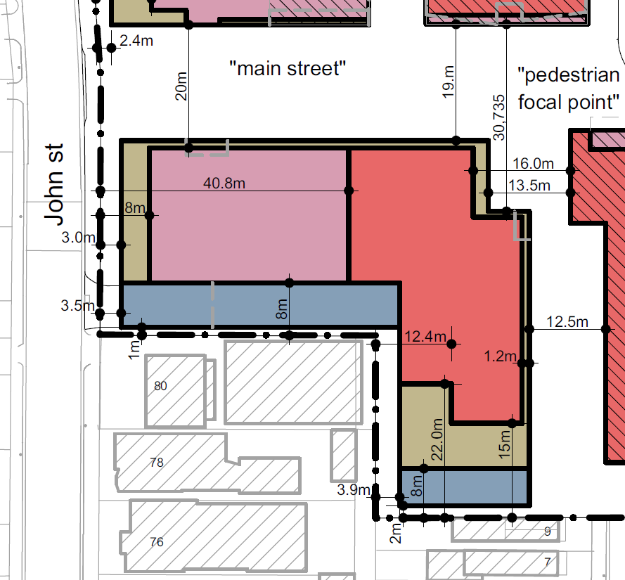 | 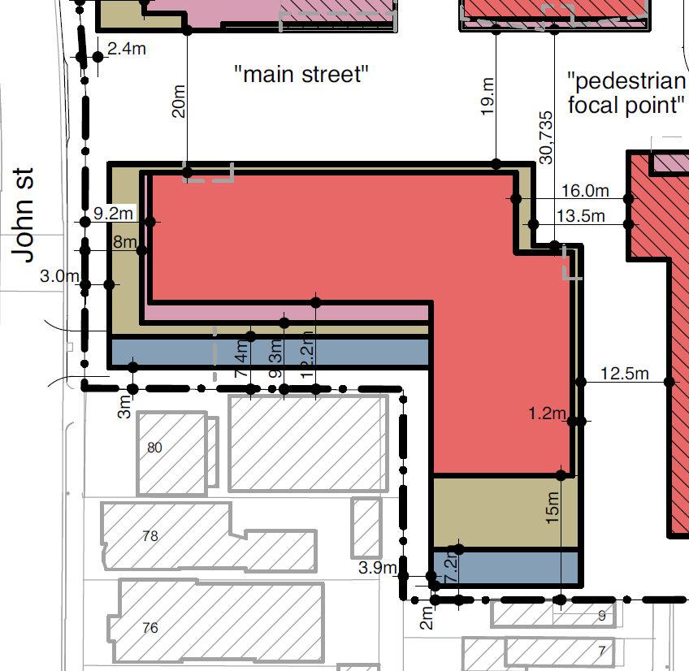 | 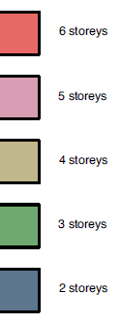
The current Approved Development Plan forms Attachment 2.
The proposed amendments to the Approved Development Plan forms Attachment 3.

2. Internal/External Consultation

Public Consultation
DPO11 includes that Council may authorise the display of a Development Plan, or an amendment to a Development Plan.
The amended EBV Development Plan was placed on display for 28 days from 14 July 2026 to 11 August 2026.
Letters were sent to owners and occupiers of nearby properties, and one sign was displayed on John Street where the change is proposed to occur.

At the conclusion of public consultation, seventeen (17) submissions have been received. Key issues are:
• Visual bulk of the proposed change
• Combined impact of the setback changes in relation to the original approved Development Plan
• Amenity impacts from overshadowing
• Limited detail of the future design
• Lack of community benefit proposed alongside the amendment
Submitters were contacted directly to discuss the proposal and the concerns with the development. Concerns with the visual bulk and appearance of the proposed amendment has in part informed the recommendation to seek additional setbacks of the upper level from John Street. Submitter concerns are discussed later in this report.
The extent of notice and location of submitters is shown in Attachment 4.

Internal/external referrals
The proposed Amendment to the Approved Development Plan was referred to the following internal unit:
Internal Branch/Business Unit | Comments
Urban Design Unit | Council’s Urban Design Unit does not support the proposed amendment, on the basis that it does not retain the intention of the Development Plan Overlay (DPO11), to have the higher 6 storey elements in the centre of the EBV precinct.  Urban Design also does not support an increased upper-level setback to John Street, as it may result in a tiered ‘wedding cake’ appearance, but acknowledges that this assessment will occur in more detail when the amendment to the planning application is assessed.  The Urban Design concerns are acknowledged, but increased setbacks are recommended regardless to achieve an acceptable response to the DPO11.

3. Policy Implications
The following policies are of most relevance to this application:
• Municipal Planning Strategy (Clause 2), including:
− Vision (Clause 2.02)
− Settlement (Clause 2.03-1)
− Built Environment and Heritage (Clause 2.03-4)
− Housing (Clause 2.03-5)
• Settlement (Clause 11), including:
− Clause 11.02-1S (Development Capacity)
− Clause 11.02-2S (Structure Planning)
• Built Environment (Clause 15.01), including:
− Urban Design (Clause 15.01-1S, 15.01-1R and 15.01-1L)
− Building Design (Clause 15.01-2S and 15.01-2L)
− Healthy Neighbourhoods (Clause 15.01-4S and 15.01-4R)
− Neighbourhood Character (Clause 15.01-5S)
− Environmentally Sustainable Development (Clause 15.01-2L-05)
− Energy efficiency in Merri-bek (Clause 15.01-2L-04)
• Residential Development (Clause 16.01), including:
− Housing Supply (Clause 16.01-1S and 16.01-1R)
− Homes in Merri-bek (Clause 16.01-1L)
− Housing Affordability (Clause 16.01-2S and 16.01-2L)

Human Rights Consideration
This application has been processed in accordance with the requirements of the Planning and Environment Act 1987 (including the Merri-bek Planning Scheme) reviewed by the State Government and which complies with the Victorian Charter of Human Rights and Responsibilities Act 2006, including Section 18 (Taking part in public life). In addition, the assessment of the application has had particular regard to:
• Section 12: Freedom of movement
• Section 13: Privacy and Reputation
• Section 20: Property rights

4. Issues
The key change proposed to the Approved Development Plan is the reduction in setback of the sixth storey of the south-western building to John Street.
Other changes are included in the proposed amendment, but these reflect the detailed architectural drawings approved for the site. A rejection of these elements would not alter the constructed building.
This proposal must be considered against the requirements of the Development Plan Overlay – Schedule 11 (DPO11).
The DPO11 includes a ‘Concept Plan’, which informs the design of the Approved Development Plan. Section 4.0 of the DPO11 states “any development plan must be generally in accordance with the Concept Plan for the Precinct at Section 6.0”.
The Concept Plan is shown below with the accompanying Legend (the red box shows the area where changes to the Development Plan are proposed):
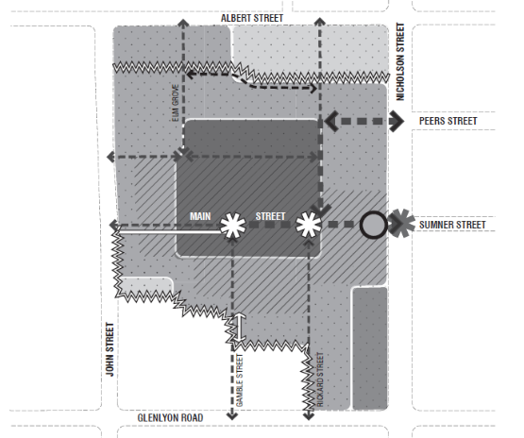
Figure 1: DPO11 Concept Plan (Source: Development Plan Overlay – Schedule 11)
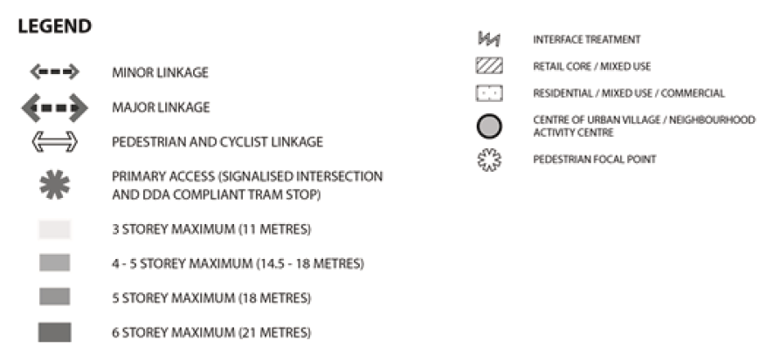
Figure 2: DPO11 Legend (Source: Development Plan Overlay - Schedule 11)
How is ‘Generally in Accordance’ tested?
‘Generally in Accordance’ means checking if a proposal meets the overall purposes of the planning control, rather than needing to meet a Concept Plan exactly.
Past Victorian Civil and Administrative Tribunal (VCAT) decisions give useful guidance on how to decide whether something is ‘Generally in Accordance’. Relevant questions include:
• What level of flexibility is afforded by the Planning Control?
• How important to the planning purpose is the element of the Development Plan being varied?
• Does the proposal achieve the fundamental planning purpose of the approved plan?
• What is the cumulative impact of departures from the Approved Development Plan?
• What are the changes in circumstance since the original approval?

Is the proposed Amendment Generally in Accordance with the DPO11?
Key considerations in understanding whether the change is ‘Generally in Accordance’ are explored below.

What level of flexibility is afforded by the Planning Control?
The Concept Plan in the DPO11 does not include building setbacks. Instead, it shows slightly taller six storey buildings in the centre of the site, stepping down to four and five storey buildings at the edges. The specific delivery of this is flexible as the Concept Plan does not include specific dimensioned setbacks or a high level of detail.

How important to the planning purpose is the element of the Development Plan being varied?
Collectively, building heights are key to the purpose of the Development Plan. Increasing all heights across the EBV precinct would transform the precinct and depart from the Concept Plan. Furthermore, the objective of the Concept Plan is to allow taller buildings in the centre of the site, with a transition to lower heights at the lower scale edges. The south-western building is already approved in the Development Plan to have a maximum height of six storeys. The key issue is therefore whether the reduced setbacks of the sixth storey to John Street is acceptable and how the height relationship to the built form of John Street.

Does the proposal achieve the fundamental planning purpose of the approved plan?
The DPO11 seeks the following relevant outcomes:
• Graduated building heights in accordance with the Concept Plan at Section 6.0.
• Articulated facades to the public realm utilising a diversity of materials and finishes whilst providing active and passive surveillance.
• Active frontages to the public realm and a high level of pedestrian amenity.
• Design responses that ensure buildings are appropriately articulated and recessed at upper levels to minimise mass and bulk from interface areas (shown as ‘Interface Treatment’ on the Concept Plan at Section 6.0).
A four-storey street wall along John Street is maintained, with the sixth storey sitting 6.2 metres behind the street wall and 9.2m from the frontage. When viewed from John Street, the pattern of four-storey street walls will be maintained, however the proposed sixth storey will have greater visibility from John Street.
This is highlighted by perspective massing:
Approved Massing | Proposed Massing
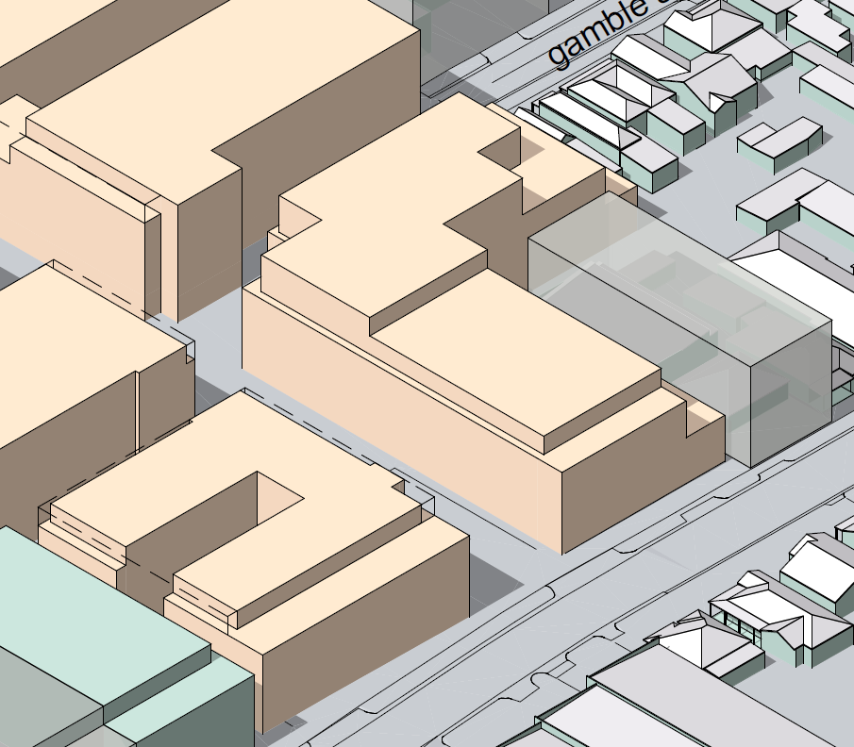 | 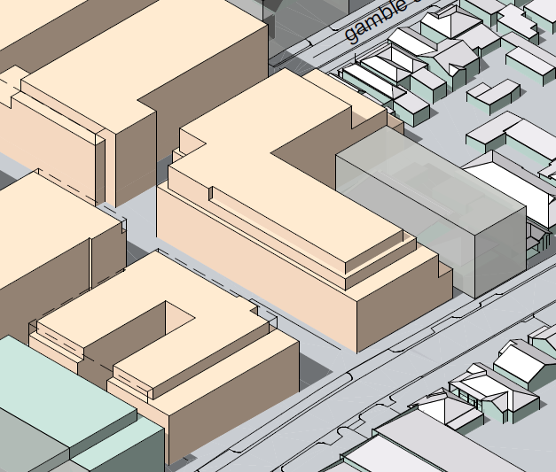
This does not achieve the objective of the DPO11 in achieving graduated building heights and being appropriately articulated and recessed at upper levels to minimise mass and bulk from interface areas.
Although the change only affects one of the buildings fronting onto John Street, this visible change will depart from the intended outcome of the Development Plan to provide a transition from the intense core of EBV to the lower homes to the west.
A greater setback from John Street would improve the response to the DPO11 and allow for recessive upper levels. This will retain the key objective of articulated and graduated building heights. The recommendation requires the setback from John Street to be increased from 9.2 metres to 18 metres to achieve a balanced outcome, that allows some increase to the sixth storey, while ensuring that it remains recessed at upper levels, particularly when viewed from John Street.
Detailed design, to achieve good articulation while minimising a ‘wedding cake’ form, can be resolved as part of an amendment to the planning permit application.
Notably, an increase to the sixth storey does not unreasonably impact land to the south:
• Impacts to low-scale one and two storey homes to the south are managed by the three-storey development at 80 John Street.
• Amenity impacts from overshadowing are managed and fall onto the existing building, or onto spaces to the south that were already shadowed by the approved development form. No shadows created by the extended sixth storey has impacts to sensitive areas to the south.

What is the combined or cumulative impact of departures from the Concept Plan?
The current Approved Development Plan retains the central six storey core, with a step down to five storey buildings on John Street and Nicholson Street. The building in the south-west corner is a mix of five and six storeys. Internal streets allow for north-south and east-west movement, with ‘pedestrian focal points’ in internal intersections. A signalised intersection controls traffic entry from the east. These aspects of the Approved Development Plan are all consistent with the DPO11 ‘Concept Plan’.
Some elements of the current approved Development Plan have changed however, and do not exactly match the Concept Plan. In summary:
• The urban village is located east of where it is shown on the concept plan.
• Internal roads are different to the locations shown on the concept plan.
• The building at 4 Elm Grove is five storeys on the concept plan and has been approved as a six-storey building.
• Indicative setbacks on the concept plan for six storey form have been reduced on the Approved Development Plan.
The changes described above have each been assessed as being Generally in Accordance with the Concept Plan in the DPO11. The sum of the changes does not alter the intended purpose of the DPO11.
In considering impacts of changes to the sixth storey, the Approved Development Plan shows six storey heights closer to the southern, eastern and northern boundaries of EBV compared to the Concept Plan. This is most significant in the south with six storey buildings setback nine metres from the edge of the precinct. To the east and north, six storey buildings also extend beyond the central core, although in those locations there are five storey buildings between the precinct boundary and the six storey elements, which reduces their visual impact. The northernmost building in EBV next to Elm Grove is a good example of this, with level 6 areas setback 17.6 metres from the edge of EBV.
The proposed change to the west seeks a similar outcome to the southern interface. The setback is similar (with setbacks of around 9 metres for both interfaces) but the western change would have a greater impact because it would be more visible from public areas, particularly along John Street.
Additionally, if the proposed amendment is approved and further changes are later sought along John Street, the intended transition from taller buildings in the centre of the site to lower buildings near the edge of the precinct (i.e. graduated building height) would be lost. This would not be appropriate having regard to the DPO11.
The cumulative impacts of the increase in six storey form through the EBV precinct is moderate when compared to the Concept Plan in the DPO11 but can be appropriate, subject to improved setbacks, given the building that is being amended has a narrow frontage to John Street.
What are the changes in circumstance since the original approval?
Since the approval of the Development Plan in 2012, State planning policy has shifted to expect more homes in well serviced areas.
Strategic Framework Plans in the Planning Scheme identify EBV as an area of ‘Significant Change’. Local Policy encourages increased density housing in ‘Significant Change’ areas. Similar expectations apply to activity centres along Sydney Road, and planning controls seek increased density.
As an example of this, controls in the Brunswick and Coburg activity centres now encourage development with minimum heights of 27 metres (9 storeys). At the time the DPO11 was applied to EBV, built form controls along Sydney Road encouraged development with a maximum height of 18 metres (5 storeys). From the time the DPO11 was created, expectations for building heights along Sydney Road have increased from a 5 storey maximum to a 9 storey minimum.
Given the role of EBV in delivering significant change, if the DPO was created today the expectation for development may be significantly higher than what was adopted in 2012.

Overall assessment
On balance of the considerations above the proposed changes to the design of the south-western building are not Generally in Accordance with the Concept Plan contained within the Development Plan Overlay – Schedule 11. Targeted modifications to the design of the amendment can achieve an appropriate outcome however, by making sure that additional setbacks to John Street preserve the objective of the DPO11 in having graduated building heights and recessed upper levels.

5. Response to Submissions
The following issues raised by objectors are addressed in section 4 of this report:
• Visual Bulk
• Overshadowing impacts
• Combined impact of the changes
Other issues raised by objectors are addressed below.

Limited detail of the future design
The purpose of a Development Plan is not to provide the same level of detail as a full architectural drawing in a future planning permit application. Its role is to establish the key planning and built form framework for the site.

Lack of community benefit
The DPO11 contemplates public and community benefit through various means, including affordable housing, publicly accessible spaces and upgrades to roads and intersections. Delivery of these public realm upgrades is a requirement of the DPO11 and is resolved in the current version of the Development Plan. The proposed amendments do not reverse or weaken any of the approved community benefits.

6. Officer Declaration of Conflict of Interest
Council Officers involved in the preparation of this report do not have a conflict of interest in this matter.

7. Financial and Resources Implications
There are no financial or resource implications.

8. Conclusion
It is considered that the proposed changes to the Approved Development Plan are acceptable and are Generally in Accordance with the Concept Plan in the Development Plan Overlay – Schedule 11, subject to an increase in the setback of the sixth storey of the south-western building to John Street.

Attachment/s
1 | Location and Zoning Map | D26/345831
2 | Approved Development Plan | D26/345832
3 | Proposed Development Plan Amendments | D26/345833
4 | Location of Submitters | D26/345835

