Council AGENDA

Planning and Related Matters

Wednesday 23 September 2026

Commencing 6.30 pm

Bunjil (Council Chamber), Merri-bek Civic Centre,
90 Bell Street, Coburg



Acknowledgement of the traditional custodians of the City of Merri-bek
Merri-bek City Council acknowledges the Wurundjeri Woi Wurrung people as the Traditional Custodians of the lands and waterways in the area now known as Merri-bek, and pays respect to their elders past, present, and emerging, as well as to all First Nations communities who significantly contribute to the life of the area.

1. WELCOME
2. APOLOGIES
3. DISCLOSURES OF CONFLICTS OF INTEREST
4. MINUTE CONFIRMATION
The minutes of the Planning and Related Matters Meeting held on 26 August 2026 be confirmed.
5. Council Reports
5.1 74 Lygon Street, BRUNSWICK EAST - Application MPS/2012/138/D 4
5.2 2-4 Dale Avenue, PASCOE VALE VIC 3044 - Planning Permit Application MPS/2026/72 26
5.3 45 Pentridge Boulevard, Coburg- Ministerial Referral of Planning Application- MIN/2026/3 61
6. URGENT BUSINESS

5. Council Reports
5.1 74 Lygon Street, BRUNSWICK EAST - Application MPS/2012/138/D
Director Place and Environment, Pene Winslade
City Development

Executive Summary

Property: | 74-76 Lygon Street, Brunswick East
Proposal: | Retrospective application to amend an existing planning permit for new buildings and works, alternative bin storage arrangements and partial demolition to construct kitchen exhaust ducts and a retractable awning, and to construct and display an illuminated sign.
Zoning and Overlays: | • Commercial 1 Zone (C1Z)  • Heritage Overlay – Schedule 439 (HO439) – Non-contributory building  • Parking Overlay – Schedule 1 (PO1)  • Special Building Overlay – Schedule 2 (SBO2)  • Design and Development Overlay – Schedule 19 (DDO19)  • Development Contributions Plan Overlay – Schedule 1 (DCPO1)
Strategic setting: | Brunswick Activity Centre
Objections: | • 49 objections  • Key issues:  - Smoke, odour, pollution and appearance of flues.  - Waste management.  - Effects of litter and rubbish on surrounds.  - Patron management, car parking and congestion impacts.  - Queuing on public land.
Planning Information and Discussion (PID) Meeting: | • Held on: 27 August 2026.  • Attendees: 13 objectors and 2 Council officers.  • Prior to the meeting the applicant circulated a sketch plan showing a new flue arrangement and electrostatic precipitator (ESP) system to address smoke concerns. The meeting provided a further opportunity for the objectors concerns to be discussed and helped inform the preparation of this report.
Key reasons for support: | • The takeaway food use does not need a planning permit in the Commercial 1 Zone.  • Impacts relating to smoke, odour, pollution and appearance of flues can be managed by conditions.  • Waste can be managed by conditions.  • Planning policies and controls encourage retail uses and employment within the Brunswick Activity Centre and Commercial 1 Zones.
Recommendation: | Notice of Decision to Grant a Planning Permit be issued for the proposal.

Officer Recommendation
That a Notice of Decision to Grant an amended Planning Permit No. MPS/2012/138/D be issued for the land at 74-76 Lygon Street, Brunswick East.
The Amended Permit would allow:
A waiver of the car parking requirement, the sale and consumption of liquor, building and works, and the display of internally illuminated signage and business identification signage.
Permit for which amendment was sought:
A waiver of the car parking requirement, the sale and consumption of liquor, building and works to construct a canopy, and the display of internally illuminated signage and business identification signage.
Planning Scheme Clause | Matters for which permit is required
Clause 34.01-4 (C1Z) | To construct a building or construct or carry out works
Clause 43.01-1 (HO439) | Partial demolition, to construct a building or construct or carry out works, and to construct or display a sign
Clause 43.02-2 (DDO19) | Construct a building or construct or carry out works
Clause 52.05-2 (Signs) | Construct or display an internally illuminated sign
Clause 52.06-3 (Car parking) | To reduce the car parking requirement
The following conditions would apply to this Amended Permit (amendments bolded):

Amended plans
1. Within 60 days from when the amended planning permit (MPS/2012/138/D) is issued, amended plans to the satisfaction of the Responsible Authority must be submitted to and approved by the Responsible Authority. When approved, the plans will be endorsed and will then form part of the permit. The plans must be drawn to scale with dimensions and must be generally in accordance with the plans prepared by Mavi Design, Revision 1, dated 12/06/2026, sheets WD-01 – WD-04 but modified to show:
a) All changes shown on plans prepared by Mavi Design, Revision 2, dated 05/08/2026, sheets WD-01 – WD-04 which include:
i. The as built condition of the most recently installed stainless steel kitchen exhaust flues.
ii. Removal of an existing air-conditioning unit and glass windows on St Phillip Street and replacement with new metal grills.
b) An annotation on the elevation drawing confirming the flues are to be painted to match the colours of the existing bricks.
c) Deletion of the tables, chairs and associated footpath structures.
d) Any changes required to align with the following:
i. The Acoustic Report required by Condition 5.
ii. The Waste Management Plan required by Condition 8.
iii. The Air Quality and Odour Assessment Report required by Condition 10.
e) The ground floor layout of 76 Lygon Street, Brunswick, generally consistent with sheet 2 of plans endorsed on 16/05/2012 without the openings in the common wall.
f) The exhaust flues, canopy and ‘Charrd’ advertisement sign dimensioned at least 2.7 metres above the footpath.
g) The internal layout amended to clearly show an internal garbage storage area.

Compliance with endorsed plans
2. The development as shown on the endorsed plans must not be altered without the written consent of the Responsible Authority.
Hours of operation
3. The uses allowed by this permit must operate only between the following hours:
a) Sunday to Thursday 7.00 a.m. to 12.00 a.m.
b) Friday to Saturday 7.00 a.m. to 1.00 a.m.
Patron capacity
4. No more than 102 seats shall be made available to patrons at any one time.
Noise
5. Within 60 days from when the amended planning permit (MPS/2012/138/D) is issued, an Acoustic report prepared by an acoustic engineer or similarly qualified individual must be submitted to and approved to the satisfaction of the Responsible Authority. The report must include:
a) An assessment against the Noise Limit and Assessment Protocol for the Control of Noise from Commercial, Industrial and Trade Premises and Entertainment Venues (Publication 1826, Environment Protection Authority, May 2021) of likely noise impacts resulting from the kitchen exhausts, air make-up vents and other components of the kitchen utilities; and
b) Any recommendations for measures required to achieve compliance against the Noise Limit and Assessment Protocol for the Control of Noise from Commercial, Industrial and Trade Premises and Entertainment Venues (Publication 1826, Environment Protection Authority, May 2021).
Once approved, the report will be endorsed to form part of the planning permit. The provisions, recommendations and requirements of the Acoustic Report must be implemented and complied with, to the satisfaction of the Responsible Authority.
6. Within 30 days from the approval of the endorsed Acoustic Report, the recommendations and requirements of the Acoustic Report must be installed and completed, to the satisfaction of the Responsible Authority.
7. Noise levels associated with the use must at all times comply with the Environment Protection Regulations under the Environment Protection Act 2017 and the incorporated Noise Protocol (Publication 1826.2, Noise Limit and Assessment Protocol for the Control of Noise from Commercial, Industrial and Trade Premises and Entertainment Venues, Environmental Protection Authority, May 2021), or any other superseding regulation.
Should the Responsible Authority deem it necessary, the owner and/or occupier of the land must submit a further Acoustic Report to the satisfaction of the Responsible Authority which demonstrates compliance, or which outlines any measures considered necessary to achieve compliance.
The recommendations of the Acoustic Report must be implemented no later than three (3) months after the date that the Responsible Authority advises in writing that it is satisfied with the report, or as otherwise agreed in writing by the Responsible Authority. The endorsed plans must also be amended within three (3) months, or as otherwise agreed in writing by the Responsible Authority, to accord with the recommendations contained in the Acoustic Report to the satisfaction of the Responsible Authority.
Waste management
8. Within 60 days from when the amended planning permit (MPS/2012/138/D) is issued, a Waste Management Plan must be submitted to the satisfaction of the Responsible Authority. The plan must:
a) Align with the architectural plans submitted for endorsement;
b) Include a dimensioned plan, to scale, showing an on-site waste bin room or area large enough to provide a 1 metre wide path for persons of all abilities to access every bin without moving bins (i.e. no bin placed behind another bin);
c) Not include any off-site location for bin storage;
d) Include weekly waste generation volume and capacity calculations of the four main waste streams (recycled glass, general recycling; organics and garbage), size and number of bins;
e) Include discussion on the reference source of the waste generation rates;
f) Provide best practice food disposal by providing no incinerators or bio-digesters;
g) Provide a collection frequency of no more than three times per week;
h) Include discussion of the other waste streams; and
i) State the waste collection times, which must align with Condition 10 of this permit.
When submitted and approved to the satisfaction of the Responsible Authority, the waste management plan will be endorsed to form part of this permit. No alterations to the waste management plan may occur without the written consent of the Responsible Authority.
Within 30 days from the approval of the endorsed Waste Management Plan, the recommendations and requirements of the Waste Management Plan must be implemented, to the satisfaction of the Responsible Authority.
9. At all times, except when bins are left for collection, waste bins must be stored on-site, and in accordance with the Waste Management Plan, and bins must be returned to the on-site waste bin storage area as soon as possible following collection, to the satisfaction of the Responsible Authority.
Odour report
10. Within 60 days from when the amended planning permit (MPS/2012/138/D) is issued, a commissioning assessment report for air quality and odour must be submitted to the Responsible Authority. The report must:
a) Be prepared to the satisfaction of the Responsible Authority;
b) Be prepared by a suitably qualified and experienced environmental consultant or similar in odour and smoke;
c) Be in accordance with the EPA Publication 1883: Guidance for assessing odour and EPA Publication 1961: Guidance for assessing and minimising air pollution (and conducting the correct level of assessment);
d) Account for all odour and smoke sources;
e) Verify whether the pollution controls (including the electrostatic precipitator, flues, exhausts) have been installed and are operating correctly and whether it is minimising smoke and odour emissions as required by the publications listed in part (c) above;
f) Inform whether there is a residual risk of odour and smoke from the premises following (b) to (e) of the above;
g) Including recommendations for modifications of the buildings and any works (e.g. additional controls and measures such as an ozone generator and carbon filters) to further ensure emissions from the premises are minimised, if the assessment reveals that the installed controls (the electrostatic precipitator, flues, exhausts) are not effective.
When submitted and approved to the satisfaction of the Responsible Authority, the air quality and odour assessment report will be endorsed to form part of this permit. No alterations to the report may occur without the written consent of the Responsible Authority.
11. Within 30 days from the approval of the air quality and odour assessment report the permit holder must undertake any works required to implement and maintain the mitigation measures identified in the report (including by obtaining any required approvals) to the satisfaction of the Responsible Authority.
Flue maintenance schedule
12. Within 60 days from when the amended planning permit (MPS/2012/138/D) is issued, or as otherwise agreed in writing by the Responsible Authority, a Flue Maintenance Schedule must be prepared and implemented to the satisfaction of the Responsible Authority. The operator must keep an ongoing Maintenance Record to demonstrate compliance with this schedule. This must be provided to the Responsible Authority within five (5) business days of a written request. The Flue Maintenance Record must:
a) Include records every six (6) months confirming the inspection, cleaning, and removal of grease, oil, and atmospheric deposits from all kitchen flues, exhaust hoods, and associated extraction systems, alongside empirical evidence such as service invoices, photos, contractor receipts, or maintenance logs to validate completion;
b) Be date and time stamped to show the exact time of service or inspection; and
c) Be retained for a minimum of 24 months on an ongoing basis to ensure the visual appearance, structural integrity, and clean operation of the flue system are maintained.
Signage
13. The signage approved by this permit must not be animated or contain any flashing or intermittent lights.
14. Every sign on the land must be maintained in good condition to the satisfaction of the Responsible Authority.
15. Any illuminated sign must be designed, baffled and located to the satisfaction of the Responsible Authority to prevent any adverse amenity impact on any adjoining property.
16. The maximum luminance of all internally illuminated signs must not exceed the levels prescribed by AS 4282:2023 Control of the Obtrusive Effects of Outdoor Lighting or any updated version that is released. Upon request, the applicant must provide to the Responsible Authority records of the signs luminance levels to show compliance with this standard.
17. The signage approved by this permit must only be illuminated during the hours of operation of the business.
Permit Expiry
18. This permit will expire if one of the following circumstances applies:
a) the development is not commenced within two (2) years from the date of issue of this permit;
b) the development is not completed within four (4) years from the date of issue of this permit;
c) the use is not commenced within four (4) years from the date of issue of this permit.
The Responsible Authority may extend the periods referred to if a request is made in writing before the permit expires or within three months afterwards.
19. The development approved by the amendment to this permit will expire if one of the following circumstances applies:
a) the amended development is not commenced within three (3) years from the amendment date of issue of this permit (MPS/2012/138/D); or
b) the amended development is not completed within five (5) years from the amendment date of issue of this permit (MPS/2012/138/D).
The Responsible Authority may extend the period referred to if a request is made in writing before the permit expires or;
i. within six months after the permit expires to extend the commencement date.
ii. within 12 months after the permit expires to extend the completion date of the development if the development has lawfully commenced.
Notes: These notes are for information only and do not constitute part of this permit or conditions of this permit.
Note 1: It may be necessary to obtain a building permit prior to the commencement of any demolition, building works or occupation of the building. It is strongly recommended that you consult with a registered building surveyor to advise on any requirements under the Building Act, the Building Regulations and any other subordinate legislation. Further information can be sought from the Building and Plumbing Commission, Phone 1300 067 088 or www.bpc.vic.gov.au/. Council's building services branch can also assist you in the provision of this service and can be contacted on 9240 1111 or http://www.Merri-bek.vic.gov.au/planning-building/building-renovations-and-extensions/.
Note 2: This permit is for the use of the land and/or buildings and does not constitute any authority to conduct a business requiring Health Act/Food Act registration without prior approval in writing from the Responsible Authority.
Note 3: Unless no permit is required under the Merri-bek Planning Scheme, no further sign(s) must be constructed or displayed on the land without a further planning permit.
Note 4: Further approvals are required from Council for any works beyond the boundaries of the property (including kerbside tables and chairs, guard rails, wind barriers, permanent screens, etc.). For more information in relation to footpath trading permits, please contact Council on 9240 1111. Planting and other vegetative works proposed on road reserves can be discussed with Council’s Open Space Unit on 8311 4300.
Note 5: This permit does not override the provisions of the Building Regulations 2018 in respect of the siting of projections beyond the street alignment. It is the responsibility of the relevant building surveyor who has accepted the appointment for the purpose of issuing the building permit to determine and obtain any necessary consent and report(s) of Council for a building if the building projects beyond the street alignment and/or above or below certain public facilities.
Note 6: The Environment Protection Act 2017 introduced the general environmental duty (GED) and it applies to all Victorians. If your business engages in activities that may give rise to a risk to human health or the environment from pollution or waste, you must understand those risks and take action to minimise them as far as reasonably practicable.
This involves a continuous, preventative approach and should be undertaken with the understanding that where an operation presents low-level risks, or already has appropriate risk mitigation measures in place, further mitigation measures may still be necessary at a future point.
For further information on what the laws mean for Victorian businesses and community go to: https://www.epa.vic.gov.au/general-environmental-duty.
THIS PERMIT HAS BEEN AMENDED AS FOLLOWS:
Date of amendment | Brief description of amendment | Name of responsible authority that approved the amendment | Section of the Act under which the permit has been amended
5 February 2016 | Open up the stairwell wall in the south-west of the building to allow access to the stairwell and the stairs leading to the first floor, alterations to the ground floor layout including locating a fridge, freezer and cool room where tables and chairs for 16 seats were located, and relocate the tables and chairs for 16 seats to the first floor. | Merri-bek City Council | Section 72
12 January 2024 | Extend the closing time by one hour on Fridays, to allow the sale and consumption of liquor until 1 a.m. | Merri-bek City Council | Section 72

REPORT

1. Background

Subject site
The site is located on the eastern side of Lygon Street at the rear ground floor of the double storey building that occupies the entire site. The ground floor contains two partially separate restaurants including Yakamoz which faces Lygon Street, and Charrd which faces St Phillip Street. This application relates to Charrd who occupy approximately 60 square metres of floor space within the rear (eastern) section of the building, including a shared kitchen and storage areas within Yakamoz. Charrd is accessed by a side door and contains a small counter for placing food orders and kitchen access. The first floor of the building is used as a pilates studio and there is no car parking provided on-site for the two restaurants.

Surrounds
Properties to the north, south and west of the site are within the Commercial 1 Zone and accommodate various commercial services. The southern adjacent property contains first floor residential living above a ground floor commercial space. The eastern adjoining property is within the Industrial 3 Zone and faces Weston Street, containing a gym. St Phillip Street contains residential land uses further east of the site which transitions between a Mixed Use Zone to the Neighbourhood Residential Zone.
A location plan forms Attachment 1.

The proposal
This retrospective application relates to a takeaway food premises operating at 74 Lygon Street which has been established within the previously approved restaurant, sharing the same kitchen and follows a planning enforcement investigation which was initiated from complaints regarding the permanent waste and bin storage on the footpath outside the site in St. Phillips Street. During the planning enforcement investigation, it was identified that other building works had been completed without the necessary planning approval including:
• Removal of the existing air-conditioner and windows from the St Phillip Street window.
• Construction of kitchen flues, associated with a charcoal grill from the ground floor on St Phillip Street to the roof of the building. Replace remaining glass panels with steel grills for air make up.
• Construction of a retractable awning above the Charrd entry door on St Phillip Street.
• Installation of an illuminated light box sign near the existing Charrd entry door.
The development plans form Attachment 2.

Planning Permit and Site History
Planning Permit MPS/2012/138 was approved on 16 May 2012 and allowed ‘a waiver of the car parking requirement associated with a restaurant and shop in addition to the existing take away food premises, the sale of liquor from the premises for consumption on and off the premises, buildings and works to construct a canopy, and the display of internally illuminated signage and business identification signage’. The permit relates to the properties 74 and 76 Lygon Street. The permit has been amended as follows:
- Amendment part A was approved on 5 February 2016 and allowed changes to the ground floor including new access to an internal stairwell and relocating the fridge, freezer and cool room.
- Amendment part B was approved on 12 January 2024 and allowed an extended closing time by one hour on Fridays in relation to sale and consumption of liquor.
- Amendment C application lapsed.
Planning Permit MPS/2023/53 was approved on 11/05/2023 and allowed ‘use of the land for the sale and consumption of liquor associated with a restaurant’. This permit is no longer considered to have force and effect for the following reasons:
• Planning Scheme Amendment VC286 removed permit requirements for the sale and consumption of liquor with no transitional provisions.
• In Ballarat Cinemas Pty Ltd v Ballarat CC [2025] VCAT 1029 the Victorian Civil and Administrative Tribunal concluded; VC286 does not have any savings provisions for permits issued under clause 52.27 before it was removed. The implication is that a permit issued only under clause 52.27 has no continuing effect even though it has not expired.

Statutory Controls – why is a planning permit required?
Control | Permit Requirement
Commercial 1 Zone (C1Z) | Land use  Clause 34.01-1 (C1Z) a planning permit is not required to use the land for the purpose of a takeaway food premises.  Buildings and works  Clause 34.04-4 (C1Z) a planning permit is required to construct a building or construct or carry out works.  The external door shutter and entry door benefit from a previous approval.
Heritage Overlay – Schedule 439 (HO439) | Clause 43.01-1 (HO439) – a planning permit is required to:  • Demolish or remove a building.  • Construct a building or construct or carry out works.  • Construct or display a sign.
Special Building Overlay – Schedule 2 (SBO2) | Works are not proposed within the area of the SBO.
Design and Development Overlay – Schedule 19 (DDO19) | Clause 43.02-2 (DDO19) – a planning permit is required to construct a building or construct or carry out works.
Clause 52.05 (Signs) | Clause 52.05-2 a planning permit is required to construct or put up for display an illuminated sign within 30 metres of a residential zone.
The following Clauses of the Merri-bek Planning Scheme are relevant to the consideration of the proposal:
• Clause 45.06: Development Contributions Plan Overlay (Schedule 1). The Development Contribution Plans have expired and therefore not relevant to this application. The original permit was implemented before the DCP was implemented.
• Clause 45.09: Parking Overlay (Schedule 1). The Parking Overlay means that the ‘Column B’ rates in the table to Clause 52.06 apply.
• Clause 52.06: Car Parking. The proposal does not seek to increase the building’s floor area therefore car parking is not a relevant consideration of this application.
• Clause 52.34: Bicycle Parking. There are no further requirements for the provision of bicycle parking in this proposal as the application does not increase the building’s floor area.
• Clause 62.02-1 exempts typical building services, including flues, from needing a buildings and works planning permit. In this case, the flues are larger than a typical flue and therefore require a permit under the Zone.

2. Internal/External Consultation

Public notification
Notification of the application has been undertaken pursuant to Section 52 of the Planning and Environment Act 1987 by:
• Sending notices to the owners and occupiers of adjoining and surrounding properties.
• Placing a sign on the side of the site near the Charrd entrance.
Council has received forty-nine (49) objections to date. A map identifying the location of objectors forms Attachment 3.
The key issues raised in objections are:
• Smoke, odour, pollution and appearance of flues.
• Waste management.
• Effects of litter and rubbish on surrounds.
• Patron management, car parking and congestion impacts.
• Queuing on public land.
A Planning Information and Discussion meeting was held on 27 August 2026 and attended by two Council Planning Officers and thirteen (13) objectors. Whilst the permit applicant was unable to attend the meeting, a discussion plan showing a new flue arrangement and additional information on smoke management including an ‘ESP’ (Electrostatic Precipitator) was circulated before the meeting. The meeting provided an opportunity to explain the application and for the objectors to elaborate on their concerns.
Acknowledging the discussion plan has not been formally introduced into the application via an amendment, it will be conditioned as part of the recommendation, alongside further material to demonstrate that odour, smoke and pollution will be resolved through its implementation.

Referrals
The proposal was referred to the following internal branches/business units:
Branch or business unit | Response
Development Engineering | Unsupportive of waste bin location, however supportive of the proposal subject to conditions which require the submission of a full waste management plan and bins to be stored on-site. Conditions are reflected in the recommendation.
Heritage Advisor | Supportive of the proposed window removal, however unsupportive of the flue locations given their orientation to the street. The Heritage Advisor seeks a more sensitive heritage outcome, preferably through relocation, or alternatively reduced in size and painted to match the colour of the bricks to reduce their appearance to the streetscape. The latter has been reflected in the recommended conditions.

Environmental Protection Authority (EPA)
The use of the land for a takeaway food premises is not identified within the ‘uses and activities with potential adverse impacts’ (Clause 53.10) and therefore does not require a formal referral or notice to the EPA.
Notwithstanding this, the EPA have been consulted as part of the application, given their past involvement in complaints about the flues. Upon review, the EPA are unsure that the proposed ESP filtration system will fully remove smoke and pollution issues, particularly without expert evidence, and have recommended an environmental consultant with experience in both smoke and odour be engaged to review the works and provide recommendations.
A condition has been included in the recommendation which requires the permit applicant to provide a smoke and odour report which demonstrates that the ESP system is capable of managing smoke and odour, or alternatively provide recommendations to ensure compliance with the EPA regulations. The condition requires any recommendations from this report to be implemented within 30 days of the date of approval.

3. Policy Implications

Planning Policy Framework (PPF):
The following policies are of most relevance to this application:
• Municipal Planning Strategy (Clause 2), including:
− Vision (Clause 2.02)
− Settlement (Clause 2.03-1)
− Built Environment and Heritage (Clause 2.03-4)
− Economic Development (Clause 2.03-6)
• Settlement (Clause 11)
• Built Environment (Clause 15.01), including:
− Urban Design (Clause 15.01-1S, 15.01-1R and 15.01-1L)
− Building Design (Clause 15.01-2S and 15.01-2L)
• Heritage (Clause 15.03), including:
− Heritage conservation (Clause 15.03-1S)
− Heritage in Merri-bek (Clause 15.03-1L)

Human Rights Consideration
This application has been processed in accordance with the requirements of the Planning and Environment Act 1987 (including the Merri-bek Planning Scheme) reviewed by the State Government and which complies with the Victorian Charter of Human Rights and Responsibilities Act 2006, including Section 18 (Taking part in public life). In addition, the assessment of the application has had particular regard to:
• Section 12: Freedom of movement
• Section 13: Privacy and Reputation
• Section 16: Right to peaceful assembly and freedom of association
• Section 18: Right to take part in public life
• Section 20: Property rights
This application does not limit human rights. The impact of the proposal on the surrounding residents have been considered.

4. Assessment
In considering this application, regard has been given to the Planning Policy Framework (PPF), the provisions of the Merri-bek Planning Scheme, objections received and the merits of the application.

Are the buildings and works appropriate in the Commercial 1 Zone?
The site is in the Commercial 1 Zone where the purpose is to create vibrant mixed use commercial centres. A planning permit is not needed to use the land for a takeaway food shop. However, the proposed building works need to meet zone provisions about streetscape appearance, emission, pedestrian movement and rubbish storage.
In relation to appearance, the proposed flues are positioned on the side of the building alongside other existing utilities and air-conditioning units which are visible to St Phillip Street. The site fronts both Lygon Street and St Phillip Street with the flues unable to be routed behind or on the northern side of the building. Additionally, a first-floor tenancy is located above the takeaway food shop and therefore the flues cannot be routed internally through the ceiling and roof of the building.
Council’s urban design policy seeks to ensure buildings have a good interface with the public spaces (Clause 15.01-1L – Urban Design in Merri-bek). The flues shown on the application plans detract from the appearance of the area due to their projection and stained appearance. The applicant’s discussion plans show an improved flue design. Despite not yet being granted a planning permit, these flues have recently been installed on site to replace the previous flues shown in the application plans. The flues are stainless steel, even in shape, and mounted flush with the building facade, which is an improved response. Recommended conditions seek to show the updated flues on the plans for endorsement and require the flues to be painted to match the building, as recommended by Council’s Heritage Advisor.
Acknowledging the flues have been installed over a footpath, it is noted that building regulations require consideration of protrusions over a road. A condition has been included in the recommendation for the flues and canopy to be shown 2.7m or higher above the footpath on the elevation drawing, which ensures that the projection will not impact public safety. A building permit would be required for the flues and as part of this process the Report and Consent of Council would be required under the Building Regulations to allow the projection of the flues over the public footpath. This is not a relevant consideration under the Planning Scheme but has been included as a note in the recommendation.
The flues are acceptable in supporting the ongoing commercial use of the building given the absence of another more suitable location of these services.

Do the works result in unreasonable off-site impacts?
The site fronts St Phillip Street which contains residential properties east of the site. Objections have been received which raise concern about the smoke, pollution and odour caused by the current flues and charcoal grill.
In response to the concerns the permit applicant has committed to installing an electrostatic precipitator (ESP), together with new stainless steel flues which will reduce smoke and emissions. The new information was given to the EPA who have previously reviewed the site. The EPA have reinforced that without a proper odour and smoke assessment, they cannot guarantee the ESP will result in a compliant outcome.
The recommendation includes conditions that require a report to be provided by an environmental consultant to verify smoke, odour and emissions are compliant with the relevant EPA regulations.
As part of the EPA’s advice, concerns have been identified that the changes to the exhaust fan may increase the noise emission from the exhaust. Planning policy framework allows consideration to the management of off-site noise effects on residential land use. The recommendation includes conditions to require an acoustic report be completed to demonstrate the proposed flues are compliant with noise regulations.
As this application has been made retrospectively, the smoke, odour and acoustic reports will be required within 60 days of the date of issue of the amended permit to ensure that these issues are appropriately resolved.
Are the works supportable in the Heritage Overlay?
The site is within the Lygon Street Heritage Precinct. The building is listed as a non-contributory building, which means it does not contribute to or form part of the heritage value of the area. The proposal would remove glass windows and replace them with flues and metal grilles. Council’s Heritage Advisor has reviewed the proposed flues and would prefer them to be concealed, as sought by heritage policy. However, as noted previously, there is no other practical location for them. As the building is non-contributory, to the heritage precinct the flues would have limited impact on the heritage significance of the precinct. The Heritage Advisor also recommended the flues be painted to match the colour of the buildings bricks, in order to reduce their appearance in the heritage precinct. A condition requiring the painting of the flues is included in the recommendation.
Is the proposed sign acceptable?
As the sign is located on a non-contributory heritage building it will not unreasonably impact any heritage features of the building. Whilst the Heritage in Merri-bek Policy at Clause 15.03-1L discourages signs which project from a wall, the proposed sign is modest in size and generally reflects the same style and appearance of other signs located along Lygon Street, including projecting wall signs.
Council’s local planning policy directs signage to be installed at least 2.7 metres above the footpath. The current sign is installed approximately 2.7 metres above the footpath, and a condition is recommended to have this confirmed and shown on the elevation drawing.
Regarding illumination, the recommendation includes a condition to have the sign switched off while the business is closed which avoids light spill during late night hours.

Can waste be appropriately managed?
The current planning permit requires that bins must be stored on site. However, it appears that the internal changes to the restaurant to accommodate the operations of the Charrd takeaway food business has created greater demand on internal storage space, which resulted in bins being stored off-site.
The site plans show 4x 1,100 litre waste bins to be stored in the car park/landscaping area of the adjoining commercial property to the east, through private agreement with the adjoining business owner. This was a recent pragmatic arrangement to address the community complaints regarding the bins being permanently stored on the street.
Council’s Development Engineer has reviewed the proposed location and raised concerns about the long-term reliability of the agreement, noting that circumstances may change in the future, such as a change in ownership, which may result in the business no longer being able to store the bins in this location. Furthermore, the bins occupy a landscaping bed and are readily visible from the street which is a poor visual outcome that may not accord with the original planning approval for the adjoining site which would require the area to be maintained as landscaping.
The Commercial 1 Zone also include provisions that;
“Any use must not detrimentally affect the amenity of the neighbourhood, including through the:
• Transport of materials, goods or commodities to or from the land.
• Appearance of any building, works or materials.
• Emission of noise, artificial light, vibration, smell, fumes, smoke, vapour, steam, soot, ash, dust, waste water, waste products, grit or oil.”
The offsite storage of the waste bins is in contravention of the existing planning permit and the current solution of storing the bins within the landscaping area of the neighbouring commercial use, accessed via an area designated as a car parking space, is not considered an acceptable planning outcome in this residential/commercial street. The recommendation therefore includes amendments to the current conditions of the planning permit to provide greater clarity that the bins are to be stored on-site and returned to the storage area immediately following collection. This will ensure the waste can be appropriately accommodated and managed into the future. A condition of the recommendation also requires the on-site waste bin storage area to be clearly indicated on the floor plans in alignment with an amended Waste Management Plan, given the change in circumstances and additional waste demands that have arisen from the introduction of the takeaway food business.

5. Response to Objector Concerns
The following issues raised by objectors are addressed in section 4 of this report:
• Smoke, odour, pollution and appearance of flues.
• Waste management.
Other issues raised by objectors are addressed below.
• Effects of litter and rubbish on surrounds.
While the planning regulatory system is not directly responsible for the control of litter it is acknowledged as a key and reoccurring objection theme, and in response Council have increased the number of public bins at the intersection with St Phillip Street and Lygon Street to minimise the issue.
Acknowledging the use of the land for a takeaway food premises does not require planning permission, this planning application cannot regulate litter or patron behaviours.
• Patron management, car parking and congestion impacts.
Concerns have been raised regarding the management of patrons of the business which include car parking congestion, speeding, and idling vehicles while food is consumed. The existing planning permit allowed for a car parking reduction in association with a restaurant which shares the same car parking requirements as a takeaway food premises (food and drink premises). The business is not required to provide any on-site car parking and meets the requirements of car parking policy (Clause 52.06). Undoubtedly the success of the business has changed the car parking and traffic congestion within the surrounding streets, however this matter sits outside the scope of consideration for this current application for an amendment to the planning permit, as a further car parking reduction is not required.
Similarly, as the use of the land as a takeaway food premises does not require a planning permit, Council has limited ability to regulate the number of patrons through the planning process. The concerns raised by objectors in relation to patronage are acknowledged, however these matters cannot be addressed in the circumstances of an amendment to the current permit which is only sought for the changes to the garbage storage and the construction of the flues, a canopy and sign.
Queuing on public land.
No servery window is proposed as part of this application, as customers enter a small space within the building and order meals from a counter inside the site from St Phillip Street. It is acknowledged that the space is not large enough to accommodate the volume of customers the business experiences at any one time resulting in queuing on the street. There are no planning controls which restrict queuing in public spaces.

6. Officer Declaration of Conflict of Interest
Council Officers involved in the preparation of this report do not have a conflict of interest in this matter.

7. Financial and Resources Implications
There are no financial or resource implications.

8. Conclusion
It is considered that the proposed buildings and works, together with the associated signage, represent an appropriate and balanced response to the objectives of the Planning Scheme. The proposal supports economic development and contributes to the vibrancy of the Commercial 1 Zone and Brunswick Activity Centre, while incorporating conditions to protect the amenity of nearby residential properties.
Subject to the recommended conditions, the proposal will provide appropriate safeguards to manage potential impacts associated with noise, smoke, odour, signage illumination and waste management. These measures will bring the proposal into conformity with the Planning Scheme and provide an appropriate balance between supporting an active and vibrant Activity Centre and protecting the amenity of surrounding properties.
On the balance of policies and controls within the Merri-bek Planning Scheme and objections received, it is recommended that Notice of Decision to Grant an amended Planning Permit No MPS/2012/138/D be issued subject to the conditions included in the recommendation of this report.

Attachment/s
1 | Zoning and Location Plan | D26/392625
2 | Development Plans | D26/392649
3 | Objector Location Plan | D26/393814

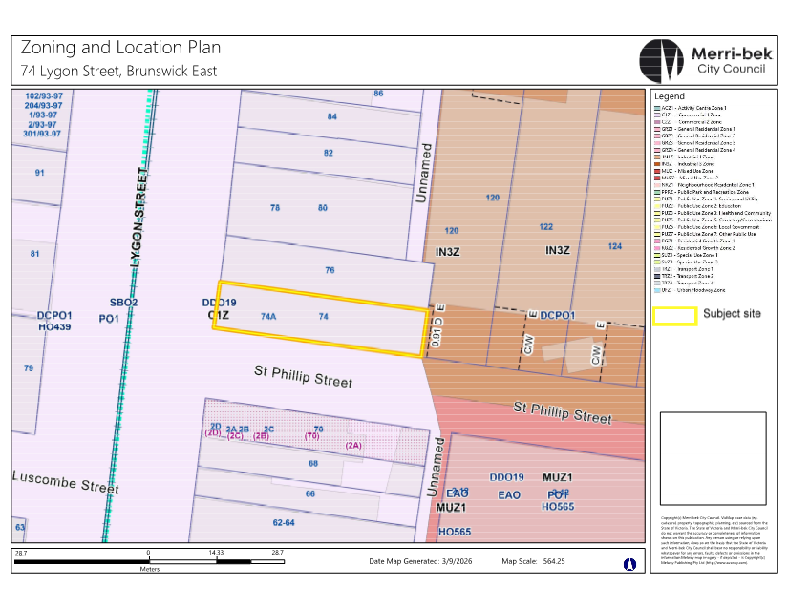

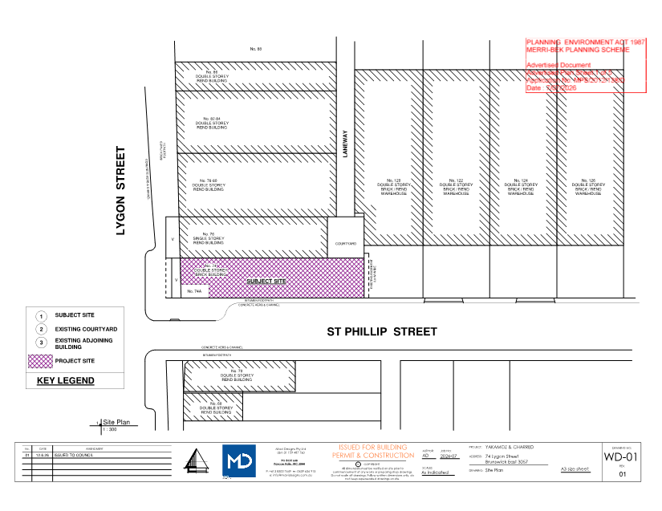
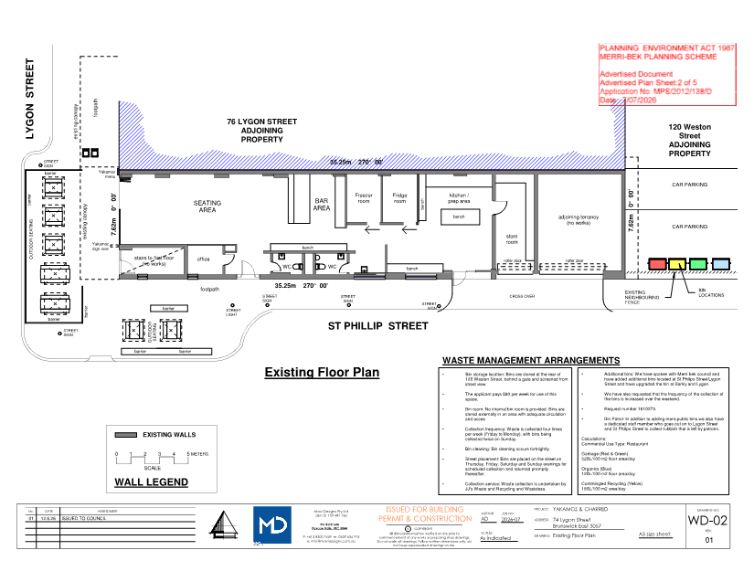
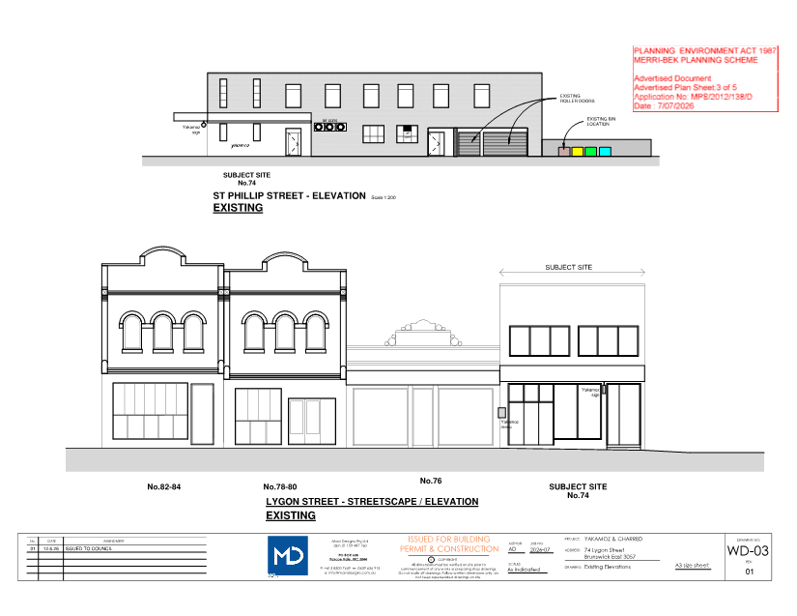
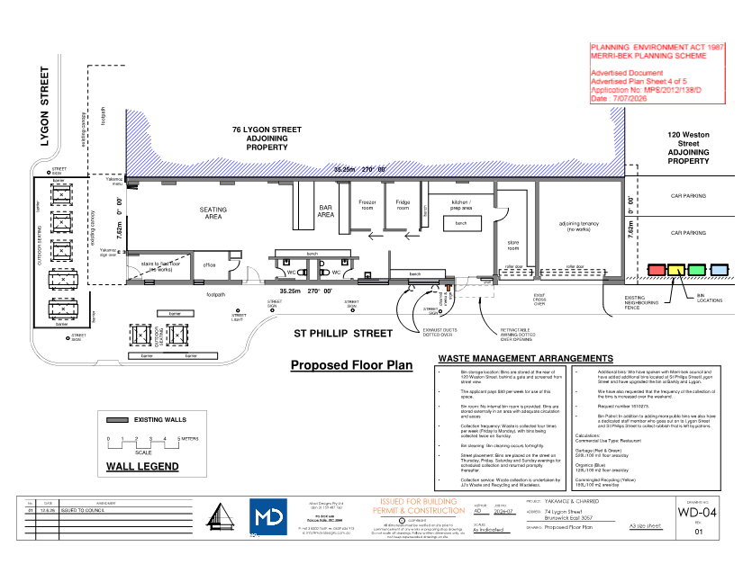
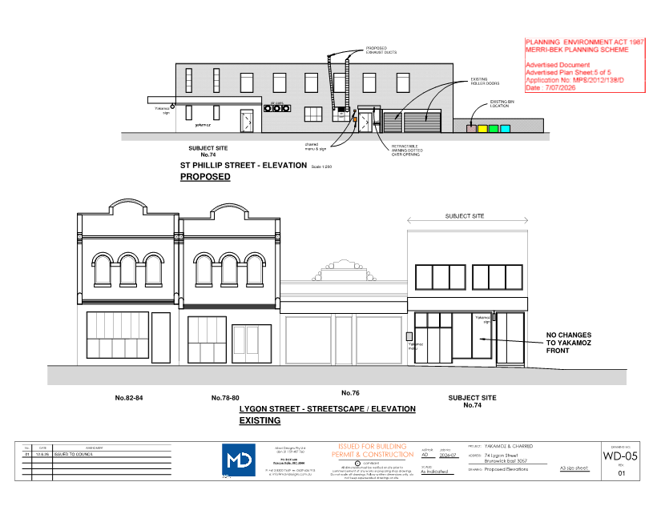

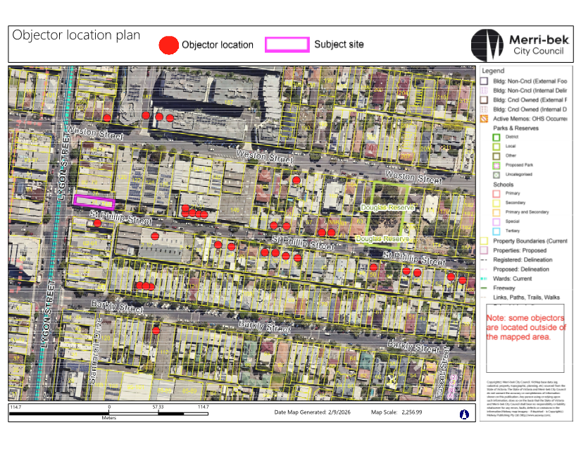

5.2 2-4 Dale Avenue, PASCOE VALE VIC 3044 - Planning Permit Application MPS/2026/72
Director Place and Environment, Pene Winslade
City Development

Executive Summary

Property: | 2-4 Dale Avenue, Pascoe Vale
Proposal: | Construction of six double-storey dwellings
Zoning and Overlay/s: | • General Residential Zone – Schedule 1  • Development Contribution Plan Overlay  • Special Building Overlay – Schedule 2
Strategic setting:
Objections: | • Eleven Objections  • Key issues:  - Car parking and traffic  - Neighbourhood character  - Overdevelopment of the site
Planning Information and Discussion (PID) Meeting: | • Date held: Tuesday 1 September 2026  • Attendees: 6 objectors, the applicant, 2 Council officers  • No changes were agreed to, however the meeting provided an opportunity for the objectors concerns to be discussed and helped inform the preparation of this report.
ESD: | With conditions the proposal is compliant with the ESD requirements, noting:  • Shading devices on all north facing windows.  • Conditions require a minimum 100 per cent Blue Factor score (stormwater management)  • 2500L rainwater tanks provided for all dwellings.  • Installation of solar panels for all dwellings, which goes beyond current Planning Scheme requirements.
Key reasons for support | • The proposal meets all neighbourhood character and external amenity standards of the Planning Scheme  • The proposal consolidates two sites to ensure reasonable liveability and internal amenity is provided and minimises impacts on its neighbours.  • The proposal exceeds the minimum car parking requirements.
Recommendation: | That a Notice of Decision to Grant a planning permit be issued for the proposal.

Officer Recommendation
That a Notice of Decision to Grant a Planning Permit No. MPS/2026/72 be issued for the land at 2-4 Dale Avenue, Pascoe Vale.
The Permit would allow:
Construction of six double storey dwellings in a Special Building Overlay
Planning Scheme Clause | Matters for which permit is required
Clause 32.08-7 | Construct two or more dwellings on a lot
Clause 44.05-2 | Construct a building or construct or carry out works
The following conditions would apply to this permit:
Amended Plans
1. Before the development commences, amended plans to the satisfaction of the Responsible Authority must be submitted to and approved by the Responsible Authority. When approved, the plans will be endorsed and will then form part of the permit. The plans must be drawn to scale with dimensions and must be generally in accordance with the plans prepared by Wardle Design, Sheets TP01-TP12, Revision C, dated 20 July 2026, but modified to show:
a) The first floor above the garage of Dwellings 3 to 6 (excluding the stair) to be setback at least 8.1 metres from the southern boundary of the ground floor secluded private open space in accordance with Standard B3-6 Solar access to open space.
b) The first floor north facing habitable room windows of Dwelling 3 to 6 (excluding bedrooms) as fixed shut obscure glazing, through a clear notation.
c) The sill height of the first floor east facing master bedroom and bedroom 3 windows of Dwelling 6 increased to at least 1.7 metres from finished floor level.
d) Replace ‘Applied Render’ on first floor walls above the garages of Dwelling 3 to 6 with vertical cladding.
e) Replace ‘Applied Render’ on all remaining first floor walls with composite look concrete board, such as Cemintel Territory Quarry, Barestone or similar.
f) Mullions on first floor master bedroom windows of Dwelling 1 and 2 to match the window pane proportions on the ground floor.
g) The lighting to all external accessways and paths in accordance with Standard B3-3 Street integration.
h) Compliance with Standard B5-6 Clause 55.05-6 (noise impacts objective) by:
i. Including all mechanical plant, including any air conditioning units for the first floors.
ii. Ensuring all mechanical plant is not immediately adjacent to bedrooms of new or existing dwellings unless a solid barrier is in place.
iii. Providing a solid barrier screen to all hot water and air conditioning units.
iv. Providing the material details for the screening to the hot water and air conditioning units. The material must be a solid and illustrated with a product diagram, dimensions and any relevant details.
i) Any changes to the plans arising from the Landscape Plan in accordance with Condition 3 of this permit.
j) Tree protection zone(s) in accordance with Condition 6 of this permit, to street trees on Dale Avenue.
k) The Environmentally Sustainable Design initiatives that are required to be shown on plans, as contained within Condition 8 of this permit.
l) A Waste Management Plan submitted for endorsement in accordance with Condition 10 of this permit.
m) Any changes to the plans required by Melbourne Water in accordance with Conditions 23 to 36.
Compliance with Endorsed Plans
2. The development as shown on the endorsed plans must not be altered without the written consent of the Responsible Authority, except where no permit is required under the Merri-bek Planning Scheme, provided the minimum garden area requirement under the Scheme continues to be met and the alteration is not contrary to any specific condition of this permit.
Landscaping
3. Concurrent with the submission of plans for endorsement under Condition 1, an amended landscape plan must be submitted to the Responsible Authority. The landscape plan must be generally in accordance with the plan prepared by Adaptive Landscape Design, Sheets LP01-LP02, Revision C, dated 21 July 2026 but amended to show:
a) Any changes required to align with the plans for endorsement.
b) Identification of any existing tree(s) and vegetation on site and adjoining land proposed to be removed and retained, including the tree protection zone(s) of trees to be retained and protected.
c) Strategies for the retainment of vegetation (i.e. barriers and signage during the construction process) consistent with any conditions of this permit.
d) Details of the location and type of all paved and sealed areas. Porous/permeable paving, rain gardens and other water sensitive urban design features must be in accordance with the Water Sensitive Urban Design strategy.
When submitted and approved to the satisfaction of the Responsible Authority, the landscape plan will be endorsed to form part of this permit. No alterations to the plan may occur without the written consent of the Responsible Authority.
4. Prior to the issue of an Occupancy Permit or issue of a Statement of Compliance, whichever comes first, all landscaping works must be completed in accordance with the endorsed landscape plan to the satisfaction of the Responsible Authority.
5. All landscaping must be maintained to the satisfaction of the Responsible Authority in accordance with the endorsed landscape plans. Any dead, diseased or damaged plants must be replaced with a suitable species to the satisfaction of the Responsible Authority.
Tree Protection
6. Prior to development commencing (including any demolition, excavations, tree removal, delivery of building/construction materials and/or temporary buildings), the following trees must have a Tree Protection Zone (TPZ) in accordance with AS4970-2025 Protection of Trees on Development Sites to the satisfaction of the Responsible Authority:
a) All Council trees located within 3 metres of the site boundary or a vehicle crossing;
b) the trees marked on the endorsed plans as being retained and protected
The TPZ must meet the following requirements:
i. Tree Protection Fencing
Tree Protection Fencing (TPF) is to be provided to the extent of the TPZ, calculated as being a radius of 12 x Diameter at Standard Height (DSH) as defined by the Australian Standard AS 4970.2025). The TPF may be aligned with roadways, footpaths and boundary fences where they intersect the TPZ.
The TPF must be erected to form a visual and physical barrier, be a minimum height of 1.5 metres above ground level and of mesh panels, chain mesh or similar material. A top line of high visibility plastic tape must be erected around the perimeter of the fence.
ii. Signage
Fixed signs are to be provided on all visible sides of the TPF clearly stating “Tree Protection Zone – No entry. No excavation or trenching. No storage of materials or waste.”. The TPF signage must be complied with at all times.
iii. Irrigation
The area within the TPZ and TPF must be irrigated during the summer months with 1 litre of clean water for every 1cm of trunk girth measured at the soil/trunk interface on a weekly basis.
iv. Provision of Services
All services (including water, electricity, gas and telephone) must be installed underground, and located outside of any TPZ, wherever practically possible. If underground services are to be routed within an established TPZ, this must occur in accordance with Australian Standard AS4970-2025.
v. Access to TPF
The TPF once erected, must be maintained and not altered, tampered or moved. If any works are proposed within the TPZ or require the TPF to be moved or altered, then such works must only be carried out with the prior written approval of, and under the direction of, a suitably qualified Arborist (minimum Level 5 Diploma of Arboriculture). A copy of the approval must be provided to Council upon request.
Tree Removal
7. Prior to the issue of an Occupancy Permit or issue of a Statement of Compliance, whichever comes first, the owner must pay Council the amenity value, removal, replacement and establishment costs in accordance with the Merri-bek Urban Forest Strategy 2017 for any of the three existing street trees removed or damaged through the building works, to the satisfaction of the Responsible Authority.
Environmentally Sustainable Design (ESD)
8. Prior to the endorsement of plans, an amended sustainable design response must be submitted to the satisfaction of the Responsible Authority. The sustainable design response must be generally in accordance with the sustainable design response prepared by Wardle Design, dated 20 July 2026, but modified to include the following changes:
a) The roof plan annotated to install minimum 6 kilowatt solar panels to each dwelling.
b) Plans modified to show compliance with Standard B5-1 Clause 55.05-1 (permeability and stormwater objective) by:
i. On the ground floor plan, correcting the plan key/legend so that the rainwater tank section is titled ‘2500 litre rainwater tank’, and the corresponding image also says ‘2500LT RWT’
ii. Providing a Blue Factor report and stormwater management response that maintains a minimum score of 100 per cent but is modified so that:
(1) The Blue Factor report is complete, finalised and published (not ‘draft’).
(2) The number of toilets each dwelling has is correct.
(3) If ‘dwelling rainwater tanks are connected to washing machines’ is selected, then at every mention of a rainwater tank on the ground floor plan, annotate: ‘The rainwater collected from the roof will service all toilets and be connected to the washing machines. Ensure gutter guards, first flush diverters and filters to the water tanks are installed.’
iii. Providing an amended WSUD (Water Sensitive Urban Design) catchment plan that is consistent with the Blue Factor report, clearly showing:
(1) Roof details including location of parapet walls, box gutters, roof fall direction, downpipes (either charged, gravity or internal) to demonstrate how stormwater catchments drain to the rainwater tanks without charged pipes running under building slabs.
(2) Reference to Enviss pits deleted from the plan legend.
c) Plans modified to show compliance with Standard B5-4 Clause 55.05-4 (solar protection to new north-facing windows objective) by:
i. On the north elevation plans, dimensioning the heights of all windows, and annotating ‘FSD’ to the dwelling 1 and 2 north-facing kitchen doors.
ii. Amending the fixed shading drawn for dwellings 3 – 6 on floor and elevation plans. The elevation plans show markings which look like louvred shading devices. These are not shown on the ground floor plan. All plans must match.
iii. If louvered fixed horizontal shading devices are proposed: Provide a dimensioned section diagram of the louvred slatted fixed shade devices. The section diagram must show the widths and thicknesses of the louvres and the distance between them to establish how shading will be provided by the devices.
Where an alternative response is proposed to those specified in this condition, the Responsible Authority may vary the requirements of this condition at its discretion, subject to the development achieving equivalent (or greater) sustainability design response outcomes in association with the development.
When submitted and approved to the satisfaction of the Responsible Authority, the amended sustainable design response and associated notated plans will be endorsed to form part of this permit. No alterations to the sustainable design response may occur without the written consent of the Responsible Authority.
9. Prior to the issue of a Statement of Compliance or Certificate(s) of Occupancy whichever occurs first, all works must be undertaken in accordance with the endorsed sustainable design response to the satisfaction of the Responsible Authority. No alterations to these plans may occur without the written consent of the Responsible Authority.
Waste Management
10. Prior to the endorsement of plans, a Waste Management Plan must be submitted to the satisfaction of the Responsible Authority. The plan must:
a) Align with the architectural plans submitted for endorsement;
b) Include calculations of the four main waste streams (recycled glass, general recycling; organics and garbage), size and number of bins;
c) Show the bins stored out of sight and any enclosed room manually ventilated;
d) Include a dimensioned plan, to scale that complies with Standard B5-5 (Clause 55.05-5) showing the waste bin room or area large enough to provide a 1-metre-wide path for persons of all abilities to access every bin without moving bins (i.e. no bin placed behind another bin);
e) Show the bins in the plan, to scale, colour coded to each waste stream;
f) Show a dimensioned area for Hard Waste;
g) Provide a collection frequency of no more than twice per week;
h) Include discussion of the other waste streams; and
i) Identify private contractor collection service.
When submitted and approved to the satisfaction of the Responsible Authority, the Waste Management Plan will be endorsed to form part of this permit. No alterations to the Waste Management Plan may occur without the written consent of the Responsible Authority.
11. The Waste Management Plan approved under this permit must be implemented and complied with at all times to the satisfaction of the Responsible Authority unless with the further written approval of the Responsible Authority.
Residential reticulated gas service connection
12. Any new dwelling allowed by this permit must not be connected to a reticulated gas service (within the meaning of Clause 53.03 of the Merri-bek Planning Scheme). This condition continues to have force and effect after the development authorised by this permit has been completed.
Car Parking and Vehicle Access
13. Prior to the issue of an Occupancy Permit or issue of a Statement of Compliance, whichever comes first, a vehicle crossing must be constructed in every location shown on the endorsed plans to a standard satisfactory to the Responsible Authority (Merri-bek City Council, City Infrastructure Department).
14. Prior to the issue of an Occupancy Permit or issue of a Statement of Compliance, whichever comes first, any existing vehicle crossing not to be used in this use or development must be removed and the kerb and channel, footpath and nature strip reinstated to the satisfaction of the Responsible Authority (Merri-bek City Council, City Infrastructure Department).
15. Prior to the issue of an Occupancy Permit or issue of a Statement of Compliance, whichever comes first, any Council or service authority pole or pit within 1 metre of a proposed vehicle crossing must be relocated or modified at the expense of the permit holder to the satisfaction of the Responsible Authority and the relevant service authority.
16. Prior to the issue of an Occupancy Permit or issue of a Statement of Compliance, whichever comes first, the garage roller doors must be automatic and remote controlled.
Undergrounding cables
17. Prior to the issue of an Occupancy Permit or issue of a Statement of Compliance, whichever comes first, all telecommunications and power connections (where by means of a cable) and associated infrastructure to the land (including all existing and new buildings) must be underground to the satisfaction of the Responsible Authority.
Stormwater
18. All stormwater from the land, where it is not collected in rainwater tanks for re-use, must be collected by an underground pipe drain approved by and to the satisfaction of the Responsible Authority (Note: Please contact Merri-bek City Council, City Infrastructure Department).
General Amenity
19. Unless with the prior written consent of the Responsible Authority, any plumbing pipe, ducting and plant equipment must be concealed from external views. This does not include external guttering or associated rainwater down pipes.
20. Prior to the issue of an Occupancy Permit or issue of a Statement of Compliance, whichever comes first, all boundary walls must be constructed, cleaned and finished to the satisfaction of the Responsible Authority.
21. Prior to the issue of an Occupancy Permit or issue of a Statement of Compliance, whichever comes first, bollard lighting standing no higher than 1.2 metres above ground level is to be installed and maintained on the land to automatically illuminate pedestrian access to the dwelling(s) between dusk and dawn with no direct light emitted onto adjoining property to the satisfaction of the Responsible Authority.
22. Prior to the issue of an Occupancy Permit or issue of a Statement of Compliance, whichever comes first, all visual screening measures shown on the endorsed plans must be installed to the satisfaction of the Responsible Authority. All visual screening and measures to prevent overlooking must be maintained to the satisfaction of the Responsible Authority. Any screening measure that is removed or unsatisfactorily maintained must be replaced to the satisfaction of the Responsible Authority.
Melbourne Water Conditions
23. Prior to the endorsement of plans under this permit, amended plans to the satisfaction of Melbourne Water and Council must be submitted to and approved by Melbourne Water and Council. The plans must be generally in accordance with the plans submitted with the application but modified to include:
a) Any new fence and gate within the flood extent must be of an open style of construction (minimum 50 per cent open) or timber paling unless with the written consent of Melbourne Water, to allow for the passage of floodwaters/ overland flows.
24. Dwelling 1 must be constructed with finished floor levels set no lower than 66.44 metres to Australian Height Datum (AHD), which is 300mm above the applicable flood level of 66.14 metres to AHD.
25. The garage of Dwelling 1 must be constructed with finished floor levels set no lower than 66.14 metres to AHD, which is at the applicable flood level.
26. Dwelling 2 must be constructed with finished floor levels set no lower than 66.45 metres to Australian Height Datum (AHD), which is 300mm above the applicable flood level of 66.15 metres to AHD.
27. The garage of Dwelling 2 must be constructed with finished floor levels set no lower than 66.15 metres to AHD, which is at the applicable flood level.
28. Dwelling 3 must be constructed with finished floor levels set no lower than 66.30 metres to Australian Height Datum (AHD), which is 300mm above the applicable flood level of 66.00 metres to AHD.
29. The garage of Dwelling 3 must be constructed with finished floor levels set no lower than 66.13 metres to AHD, which is at the applicable flood level.
30. Dwelling 4 must be constructed with finished floor levels set no lower than 66.28 metres to Australian Height Datum (AHD), which is 300mm above the applicable flood level of 65.98 metres to AHD.
31. The garage of Dwelling 4 must be constructed with finished floor levels set no lower than 66.00 metres to AHD, which is at the applicable flood level.
32. Dwellings 5 and 6 must be constructed with finished floor levels set no lower than 66.25 metres to Australian Height Datum (AHD), which is 300mm above the applicable flood level of 65.95 metres to AHD.
33. The garages of Dwelling 5 and 6 must be constructed with finished floor levels set no lower than 65.95 metres to AHD, which is at the applicable flood level.
34. The building setbacks shown to site boundaries must not be further reduced without the review and written approval of Melbourne Water, to ensure adequate open space areas to allow for the passage of overland flood flow.
35. Imported fill within the flood extent must be kept to a minimum on the property and only be used for the sub floor areas of the dwellings, garages and driveway ramps.
36. The open space areas within the property must be maintained at natural surface levels.
Permit Expiry
37. This permit will expire if one of the following circumstances applies:
a) the development is not commenced within three (3) years from the date of issue of this permit;
b) the development is not completed within five (5) years from the date of issue of this permit.
The Responsible Authority may extend the period referred to if a request is made in writing before the permit expires or;
• within six months after the permit expires to extend the commencement date.
• within 12 months after the permit expires to extend the completion date of the development if the development has lawfully commenced.
Notes: These notes are for information only and do not constitute part of this permit or conditions of this permit.
Note 1: Should Council impose car parking restrictions in this street, the owners and/or occupiers of the land would generally not be eligible for residential or visitor parking permits to allow for on street parking. See Council’s website for more information: https://www.merri-bek.vic.gov.au/residential-parking-permits
Note 2: Further approvals are required from Council’s City Infrastructure Department who can be contacted on 9240 1111 for any works beyond the boundaries of the property. Planting and other vegetative works proposed on road reserves can be discussed with Council’s Open Space Unit on 9240 1111.
Note 3: Merri-bek City Council is committed to increasing the amount of affordable housing in the municipality. One way to do this, is through Homes for Homes, a social enterprise founded by the Big Issue that aims to raise new funds via voluntary tax-deductible donations on property transactions and invest those funds in building and managing new social and affordable dwellings. If you would like to help build homes for those in need, visit Homes for Homes and register your commitment to donate 0.1 per cent of the sale price of your dwelling(s).
Note 4: Council allocates new street addressing to the street that the frontage/main access faces. Should a development abut a suburb boundary, the street addressing will reflect the suburb of that street. In some instances a suburb boundary realignment may be required, should the land be at the suburb boundary.

REPORT

1. Background

Subject site
The site combines two lots located at 2 and 4 Dale Avenue, Pascoe Vale. It has a total frontage width of 30.5 metres, and a site depth of 49.5 metres for a total combined site area of approximately 1,511.6 square metres.
Both lots are occupied by single storey weatherboard dwellings with low level landscaping located throughout the site. Existing vehicle access is provided via single width crossovers for both lots. Three juvenile Council street trees are located along the front nature strip.

Surrounds
The site is located within an established residential area with a mix of housing types including single and double-storey houses and more recent multi-unit developments.
The properties to the north and east are occupied by single-storey detached houses. The properties to the south are occupied by single-storey detached houses including a double storey house that is part of a three-unit development. The properties to the west are occupied by single-storey detached houses and unit developments.
A location plan forms Attachment 1.

The proposal
The proposal seeks to construct six double storey semi-detached townhouses, summarised as follows:
• Dwellings 1-2 have pedestrian entries and vehicle access directly from Dale Avenue, each containing four bedrooms.
• Dwellings 3-6 will have dwelling entries to the side (south) boundary and vehicle access from the shared driveway along the side (north) boundary each containing four bedrooms. These dwellings have a detached double garage with a one bedroom and living room above.
• A total of twelve (12) car spaces are provided for the development, with two (2) spaces allocated per dwelling.
The development plans form Attachment 2.

Statutory Controls – why is a planning permit required?
Control | Permit Requirement
General Residential Zone – Schedule 1 | Clause 32.08-7: A permit is required to construct two or more dwellings on a lot.  A permit is not required to use land for a dwelling.
Special Building Overlay – Schedule 2 | Clause 44.05-2 - A permit is required to construct a building or construct or carry out works in the Special Building Overlay.
The following Particular Provisions of the Merri-bek Planning Scheme are also relevant to the consideration of the proposal:
• Clause 45.06: Development Contributions Plan Overlay. The Development Contributions Plan has expired and is therefore not relevant to applications determined on or after 1 July 2023.
• Clause 52.06: Car Parking
• Clause 53.18: Stormwater Management in Urban Development
• Clause 53.03: Residential Reticulated Gas Service Connection
• Clause 55: Two or More Dwellings on a Lot and Residential Buildings of Three Storeys or Less

2. Internal/External Consultation

Public notification
Notification of the application has been undertaken pursuant to Section 52 of the Planning and Environment Act 1987 by:
• Sending notices to the owners and occupiers of adjoining and nearby land
• Placing one sign on 2 Dale Avenue frontage and one sign on 4 Dale Avenue frontage.
Council has received 11 objections from 10 properties to date. A map identifying the location of objectors forms Attachment 3.
The key issues raised in objections are:
• Car parking and traffic concerns
• Neighbourhood character
• Overdevelopment of the site
• Amenity impacts (overlooking, overshadowing, visual bulk)
• Flooding impacts
• Waste management
• Poor design
• Potential damage to property during construction
A Planning Information and Discussion meeting was held on 1 September 2026 and attended by Council Planning Officers, the applicant and 6 objectors. The meeting provided an opportunity to explain the application, for the objectors to elaborate on their concerns, and for the applicant to respond.
Following this meeting, the applicant agreed to conditions requiring compliance with the solar access to open space standard, reducing some bedroom windows to highlight windows, nominating higher quality materials, commitment to installing solar panels and inclusion of a waste management plan.

Internal/external referrals
The proposal was referred to the following external agencies or internal branches/business units:
External Agency | Objection/No objection
Melbourne Water | Melbourne Water had no objection to the application, subject to conditions included in the recommendation.

Internal Branch/Business Unit | Comments
Transport - Development Engineering | Supports the proposal.  Notations on the plans for car parking spaces and accessways have been shown on the plans.  A condition included to provide a Waste Management Plan as Council does not provide individual waste collection for development of more than three dwellings.
Sustainable Built Environment - ESD Team | Supports the proposal. Recommended changes to the Blue Factor report and Water Sensitive Urban Design (WSUD) plans have been addressed through conditions in the recommendation.
City Infrastructure - Arborist | Supports the removal of one street tree to facilitate the vehicle crossovers of Dwellings 2, with the remaining two trees to be retained and protected.  No concerns raised with the modest encroachment of the crossover to the existing street tree next to the shared vehicle crossover used by Dwellings 3-6.  The recommendation will include conditions requiring removal of the Dale Avenue street tree, with applicant required to pay for a replacement tree with appropriate planting locations to be determined by Council’s Urban Forest Unit.
Urban Design Unit | Supports the internal layout, architectural language and streetscape presentation. Urban Design recommended some minor changes to further improve the design, which go beyond Planning Scheme requirements. Where possible and as agreed to by the applicant, these have been included as conditions of the recommendation. This is further discussed in Section 5 of this report.

3. Policy Implications

Planning Policy Framework (PPF):
On 6 March 2025, the rules for multi dwelling development changed, through the introduction of the Townhouse and Low-Rise Code (Clause 55).
When a standard is met, Council also cannot consider any other policy or decision guidelines in the Planning Scheme and broader considerations of the Planning and Environment Act, 1987.
The proposal has been assessed against the new Clause 55 requirements and is compliant with all the new deemed to comply standards, except for the overlooking standard.
The site is also within the Special Building Overlay which identifies land subject to potential flooding from the overflowing drainage systems. The following policies are of most relevance to this component of the application:
- Floodplain (Clause 13.03-1S)

Human Rights Consideration
This application has been processed in accordance with the requirements of the Planning and Environment Act 1987 (including the Merri-bek Planning Scheme) reviewed by the State Government and which complies with the Victorian Charter of Human Rights and Responsibilities Act 2006, including Section 18 (Taking part in public life). In addition, the assessment of the application has had particular regard to:
• Section 12: Freedom of movement
• Section 13: Privacy and Reputation
• Section 20: Property rights
An assessment of whether there is any potential for unreasonable overlooking has been undertaken in Section 4 of this report. The proposed redevelopment of private land does not present any physical barrier preventing freedom of movement. The right of the landowner to develop and use their land has been considered in accordance with the Merri-bek Planning Scheme.

4. Issues
In considering this application, regard has been given to the Planning Policy Framework (PPF), the provisions of the Merri-bek Planning Scheme, objections received and the merits of the application.

Does the proposal have strategic policy support?
The application to construct six double storey dwellings meets the purpose of the General Residential Zone, which seeks to encourage a range of housing types in locations offering good access to services and transport.
The proposed increase in units over two blocks is supported by state planning scheme policy and controls in an established urban area due to:
• The proposal covering two properties to maximise the efficiency of new houses on the land and reduce impacts to neighbouring properties.
• Multi-dwelling developments being common within the street and surrounding area.
• The development maintaining compliant setbacks, building height, site coverage and garden area, ensuring the proposal is responsive to the neighbourhood character.

Does the proposal respond to neighbourhood character and the street?
The proposal has been assessed against the neighbourhood character standards in the Townhouse and Low-Rise Code, including street setbacks, building height, side and rear setbacks, walls on boundaries, site coverage, vehicle access, tree canopy and front fences. The development complies with all relevant standards with the key standards discussed below.

Building height
The development has a maximum height of 8.02 metres and is double storey, ensuring that the proposal complies with the maximum building height of 11 metres and three storeys allowed in the zone.

Side and rear setbacks
The development exceeds the minimum side and rear setbacks required by the relevant standard (B2-3). Notably, the maximum wall height of 7.3 metres at the side and rear requires a minimum 2.39 metre setback from the boundary. The 2.7 metre upper-level setbacks exceed the minimum requirement.

Site coverage
The development has a site coverage of 53.4 per cent which is within the maximum site coverage of 65 per cent allowed in the zone.

Access
Three single width vehicle crossovers are proposed along the Dale Avenue frontage. The access standard (B2-6) allows vehicle crossovers to occupy up to one third of the street frontage. The combined width of the three vehicle crossovers does not exceed that measure.

Tree Canopy
The development is required to provide a minimum 20 per cent canopy cover for the site. There are 15 canopy trees proposed throughout the site, resulting in 21 per cent canopy coverage for the site ensuring that adequate tree canopy cover is provided.

Does the proposal result in any unreasonable off-site impacts?
The proposal has been assessed against the external amenity standards in the Townhouse and Low-Rise Code, including daylight to windows, overshadowing and overlooking. The development complies with all relevant standards, except for overlooking, with the key standards discussed below.

Overlooking
The overlooking standard specifies that additional screening is not required where ground floor habitable room windows face a boundary with a visual barrier at least 1.8 metres high and the floor level is less than 0.8 metres above ground level at the boundary. The proposed ground floor levels are approximately 750 millimetres above ground level and face existing side and rear boundary fences of 1.8 to 2 metres high; these measures ensure no unreasonable overlooking of neighbouring sensitive spaces and complies with the standard.
The first floor north-facing retreat windows have a sill height of 900mm measured from the finished floor level, therefore can overlook into 6 Dale Avenue. The windows are annotated with ‘OBS’. However, the plans do not define what ‘OBS’ stands for. Therefore, it is unclear if the windows have been nominated with a screening method. A condition is included in the recommendation to have the retreat windows to be fixed and obscure glazed to comply with the standard and prevent unreasonable overlooking.
The requirements of the overlooking standard do not require bedroom windows to provide screening. In addition, the first-floor bathroom and stairwell windows are not habitable room windows that are required to be screened. Nonetheless, the applicant is agreeable to a condition of recommendation for the east facing master bedroom and bedroom 3 windows of Dwelling 6 to be changed to highlight windows to address objector concerns regarding overlooking. This agreed outcome has been included as a condition in the recommendation.

Overshadowing
The amount of shadowing produced by the development meets the requirements of the overshadowing standard, as outlined in the table below:
Property | Orientation from subject site | Extent of shadows
2A Dale Avenue | South | The property already has less than 25sqm of unshadowed backyard area throughout the day, therefore the amount of unshadowed backyard area should not be further reduced. The amount of shadowing from the development falls within the existing shadows produced by the boundary fence. The development does not produce any additional shadow that further reduces the amount of sunlight to the backyard to with the overshadowing standard.
306 O’Hea Street | South | The development produces new shadowing to the backyard from 9am to 3pm. However, the property will receive over 25 square metres of unshadowed backyard throughout the day, therefore exceeding the minimum requirements with the overshadowing standard.
304 O’Hea Street | South | The development produces new shadowing to the backyard from 9am to 3pm. However, the property will receive over 25 square metres of unshadowed backyard throughout the day, therefore exceeding the minimum requirements with the overshadowing standard.
302 O’Hea Street | South east | The development produces new shadowing to the backyard from 2pm onwards. However, the property will receive over 25 square metres of unshadowed backyard throughout the day, therefore exceeding the minimum requirements with the overshadowing standard.
1A Kinross Street | East | The development does not produce new shadowing between 9am and 3pm, which complies with the standard.
3 Kinross Street | East | The development produces new shadowing to the backyard from 2pm onwards. However, property will receive over 25 square metres of unshadowed backyard throughout the day, therefore exceeding the minimum requirements with the overshadowing standard.

Daylight to Existing windows
The side and rear setbacks of the development from any habitable room windows to the north, east and south of neighbouring properties ensures that the proposal meets the minimum requirements of the daylight to existing windows standard. Notably, the proposed 7.09m wall height to the north requires a 3.55m setback from the windows of 6 Dale Avenue with the proposed 6.74m first floor setback exceeding the requirement. The proposed 7.29m wall height to the east requires a 3.65m setback from the windows of 1A Kinross Street with the proposed 4.38m first floor setback exceeding the requirement. The proposed 7.2m wall height to the south requires a 3.6m setback from the windows of 2A Dale Avenue with the proposed 6.91m first floor setback exceeding the requirement.

Overshadowing domestic solar energy systems
The roof of 2 Dale Avenue contains solar panels and is located south of the site which can be overshadowed by the development. The amount of shadowing from the development falls within the existing shadows produced by the boundary fence. The development does not produce new shadows over the existing solar panels of 2 Dale Avenue. The solar panels will continue to receive the same amount of sunlight.

Noise impacts
The noise impact standard encourages mechanical plant (e.g. air conditioning units), to be located away from sensitive spaces such as neighbouring habitable room windows. The recommendation includes conditions to show all mechanical plant and, where needed, provide a solid barrier to prevent unreasonable noise impacts.
Does the proposal provide appropriate onsite amenity and facilities?
The proposal has been assessed against the liveability and sustainability standards in the Townhouse and Low-Rise Code, including bedroom sizes, functional layouts and opportunity for natural ventilation of the dwellings. The proposal meets most of these standards, except for the solar access to open space and waste and recycling requirements, which are discussed below.

Solar access to open space
The 6.8 metre high first-floor walls of Dwellings 3–6 to the north of the dwellings’ backyards require an 8.1 metre setback from the southern backyard boundary to comply with the standard. The proposed 7.7 metre setback falls short by 400 millimetres. The submitted shadow diagrams indicate that these backyards are unreasonably overshadowed which results in poor internal amenity. The recommendation includes a condition to achieve compliance with the solar access to open space standard.

Waste and recycling
The development proposes individual waste storage areas for each dwelling instead of the required shared bin storage area. Council does not provide individual waste collection services for developments of more than three dwellings. Therefore, a condition is included in the recommendation to require a Waste Management Plan to detail how individual waste storage will be reasonably managed for the development.

Has adequate car parking been provided?
The site is within a Category 2 car parking requirement, which sets a minimum of 1 car parking space for each dwelling. For a 6 dwelling development, the minimum car parking requirement is 6 car spaces. The development provides 12 on-site spaces, totalling two spaces per dwelling which exceeds the minimum car parking requirement.
Objectors have raised concerns regarding a potential increased demand in on street parking associated with the development. However, given that the proposal provides double the required number of car parking spaces, the level of car parking proposed is considered appropriate and is not expected to result in any unreasonable demand on on-street car parking.
The dwellings will not be eligible for parking permits in the event that on street parking restrictions are imposed by Council. This is included as a note on the planning permit in the recommendation.
Vehicles, whether related to this or other developments in the street, can only park on the street in accordance with any parking regulations. The number of vehicles that can park on the street and at what time will be dictated by the parking restrictions and the availability of on-street car spaces. It is expected that the level of parking provided will cater for car ownership levels of the occupiers.

What impact does the proposal have on traffic and safety in the local area?
In relation to any traffic impacts resulting from the development, Council’s Development Engineers have assessed the proposal and consider that the development will result in 32 additional vehicle movements per day on Dale Avenue. This increase remains within the street’s designed capacity and is not expected to cause traffic problems.

Does the proposal incorporate adequate Environmental Sustainable Design (ESD) features?
The proposal meets the ESD requirements of the Merri-bek Planning Scheme, subject to conditions in the recommendation which:
• Seek to ensure that the proposal achieves the minimum Blue Factor score of 100 per cent.
• Require shading devices to be labelled and dimensioned.
• Require internal waste and recycling storage spaces to be annotated on plans.
In addition, the applicant has agreed to the installation of a minimum 6 kilowatt solar system for each dwelling. This exceeds the requirements of the Planning Scheme, which only requires that space be provided on the roof for these services.

Does the proposal result in loss of street trees?
There are three juvenile street trees on the Dale Avenue nature strip: one in front of 2 Dale Avenue and two in front of 4 Dale Avenue. One street tree in front of 4 Dale Avenue is proposed to be removed to accommodate the vehicle crossover for Dwelling 2. Council’s Planning Arborist supports the removal of one juvenile street tree subject to conditions including the recommendation requiring the landowner to pay Council the amenity value, removal, replacement and establishment costs. The retention of the other two street trees is also supported subject to conditions including the recommendation that require tree protection.

Does the proposal address flooding impacts?
The site is within the Special Building Overlay which identifies land that is subject to potential flooding impacts from the overflowing drainage systems. The relevant floodplain management authority under the Special Building Overlay is Melbourne Water. Melbourne Water objected to the initial proposal as it was not an appropriate response to the floodplain management policies. The proposed finished floor levels were not considered appropriate to manage flood overflow into the site. However, amended plans were submitted to Council with raised finished floor levels in response to the concerns raised. Melbourne Water did not object to the amended plans subject to conditions requiring minimum finished floor levels of the dwellings and garages, minimum permeability of new fences and gates. The permit conditions required by Melbourne Water are included in the recommendation to address flooding impacts.

5. Response to Objector Concerns
The following issues raised by objectors are addressed in Section 4 of this report:
• Car parking and traffic concerns
• Neighbourhood character
• Amenity impacts (overlooking, overshadowing)
• Flooding impacts
• Waste management
• Potential damage to property during construction
Other issues raised by objectors are addressed below.

Overdevelopment of the site
The Victorian Civil and Administrative Tribunal has commonly determined that whether or not a proposal is an overdevelopment is best determined from a quantitative assessment of a development’s compliance with the criteria set out in the Merri-bek Planning Scheme.
The proposal satisfies the requirements of Clause 55 in respect to site coverage, setbacks, permeability, car parking, and open space provision and therefore the proposal is not considered to be an overdevelopment of the site.

Visual bulk
The development meets the neighbourhood character standards (building height, side and rear setbacks, walls on boundaries, site coverage and tree canopy). Although the zoning allows a maximum building height limit of 11 metres the proposal has a maximum height of 8.02 metres. The proposed siting and massing of the development meets the relevant deem-to-comply standards and is not considered unreasonably bulky.

Building Design
Objectors have raised concerns about the design, including the quality of materials and way the buildings present to the street. Council’s assessment of the proposal is limited to an assessment of the Standards and Objectives contained in Clause 55 of the Merri-bek Planning Scheme. As detailed in Section 4 of this report, the proposal is largely compliant with these standards.
Council’s Urban Design Unit has assessed the proposal and considers internal layout, architectural language and streetscape presentation a reasonable design response. Some suggestions were made to further improve the development. The applicant is agreeable to the conditions of recommendation for the applied render for the first floor walls above the garage of Dwelling 3 to 6 to be replaced with higher quality vertical cladding and also replace all the first floor applied render to a higher quality concrete cladding. Another condition in the recommendation will also be included to nominate mullions on the first floor master bedroom windows of Dwelling 1 and 2 to demonstrate window operability and improve facade detailing by matching the proportions of the ground-floor windows. All the above conditions seek to improve the way the dwellings present to the street. Following recent State Planning reforms which introduce deemed to comply provisions as part of the new Town House and Low-rise Code at Clause 55, these conditions now go beyond the requirements of Victorian Planning Schemes.

Construction issues
Traffic, noise, dust, construction times and other impacts associated with the construction of a development are not considered as part of a planning application.
A Construction Management Plan is required to be approved under the General Local Law by Council’s Amenity and Compliance Branch before construction starts. A Construction Management Plan outlines how the impact of the construction will be minimised.

Damage to adjoining property
Protection of adjoining properties during construction is not a matter that can be addressed through the planning permit process, however the owners of the land proposing to build have obligations under the Building Act 1993 to protect adjoining property from potential damage. It is the responsibility of the relevant Building Surveyor to require protection work as appropriate.

6. Officer Declaration of Conflict of Interest
Council Officers involved in the preparation of this report do not have a conflict of interest in this matter.

7. Financial and Resources Implications
There are no financial or resource implications.

8. Conclusion
The proposal to construct six dwellings has strong strategic policy support particularly having regards to the purpose of the zone, encouraging more housing in well located areas. The proposal has been assessed against the Townhouse and Low-rise Code requirements and is mostly compliant with deemed-to comply standards.
Conditions will be included in the recommendation to ensure the proposal fully meets all Clause 55 requirements, notably for the overlooking and solar access to open space standard. In addition, changes agreed to by the applicant seeking to address neighbours’ concerns will also be included as conditions of the recommendation. These changes include providing a waste management plan, highlight windows to address overlooking, nominating higher quality materials and commitment to installing solar panels beyond what is now required by Victorian Planning Schemes.
As the lodged application does not comply with the overlooking standard, there is a right of review available to objectors at the Victorian Civil and Administrative Tribunal.
On the balance of policies and controls within the Merri-bek Planning Scheme and objections received, it is recommended that a Notice of Decision to Grant Planning Permit MPS/2026/72 be issued subject to the conditions included in the recommendation of this report.

Attachment/s
1 | Zoning and Location Map | D26/372416
2 | Development Plans | D26/372414
3 | Objector Location Map | D26/372412

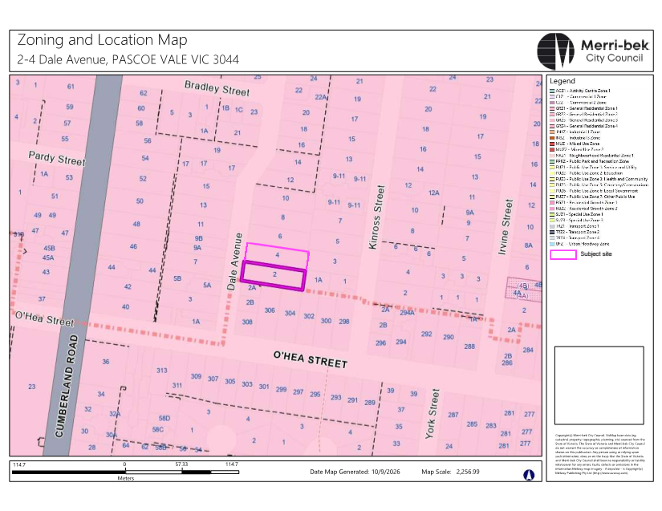

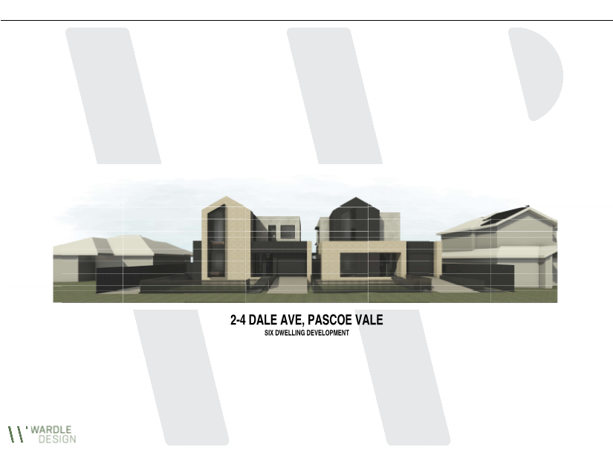
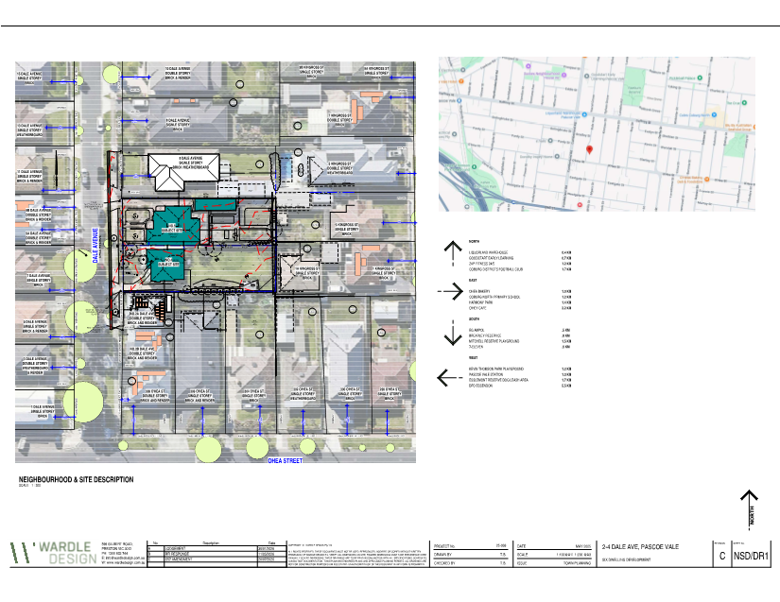
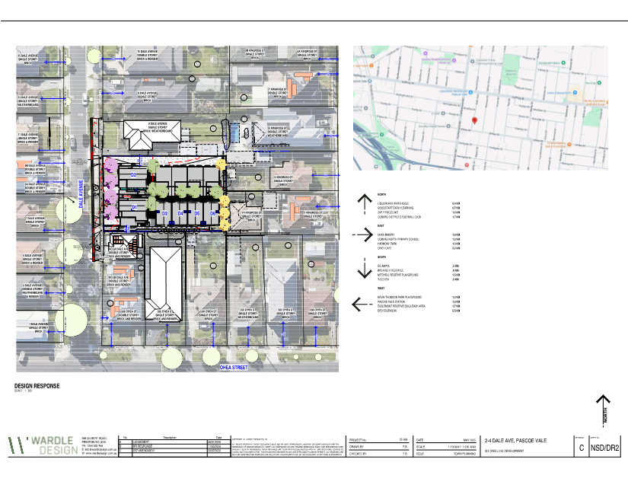
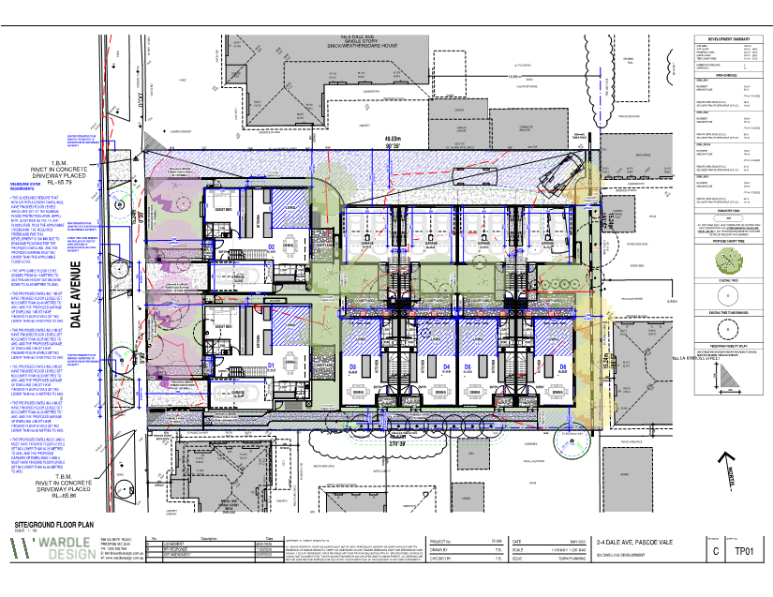
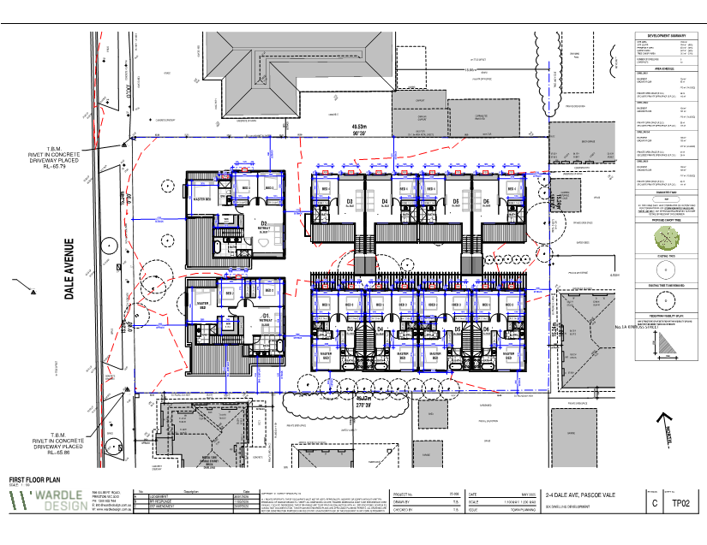
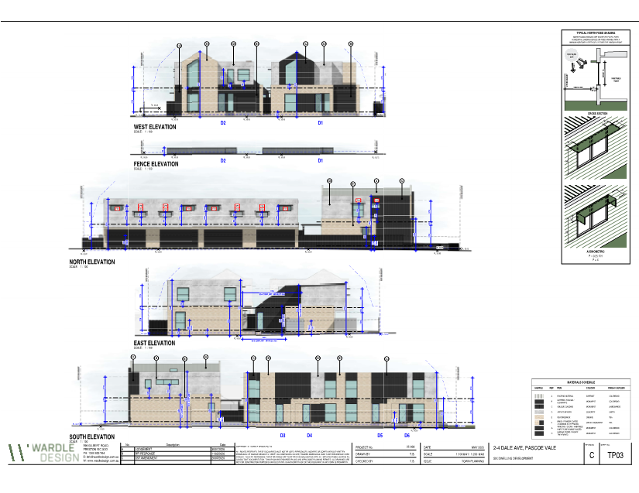
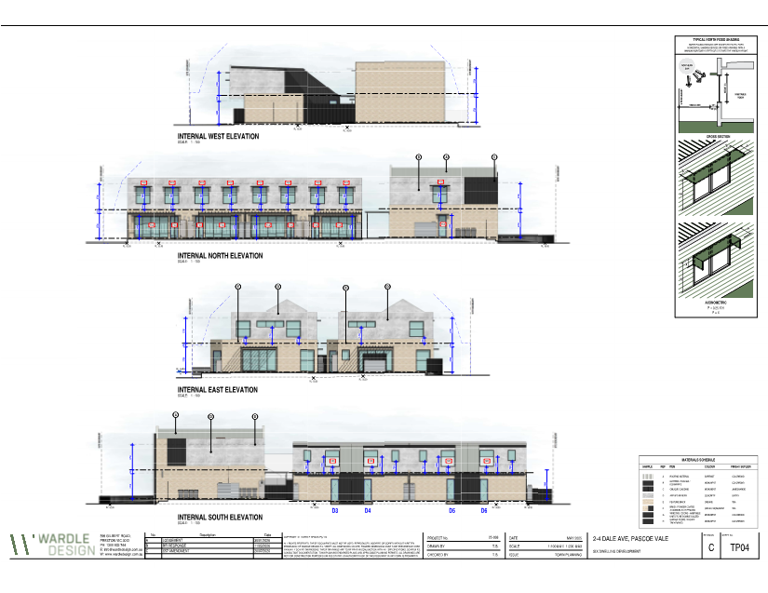
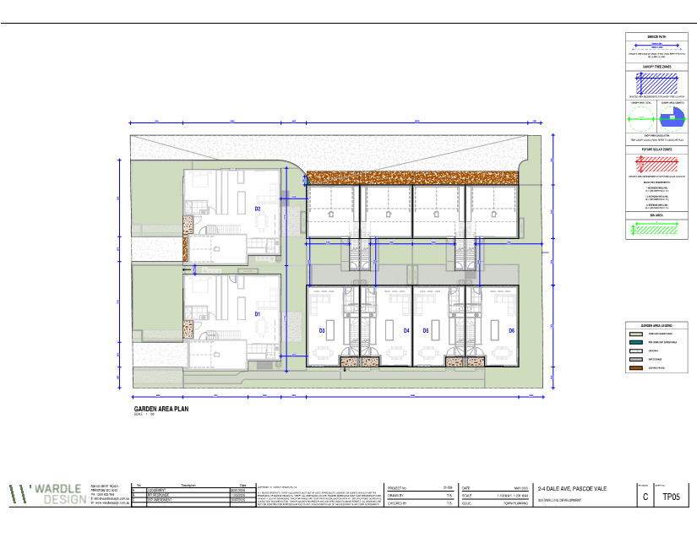
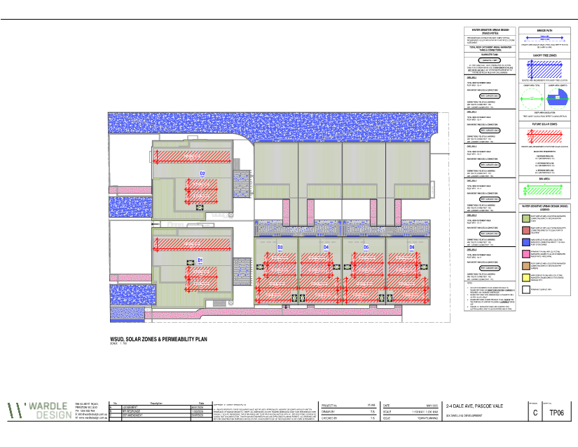
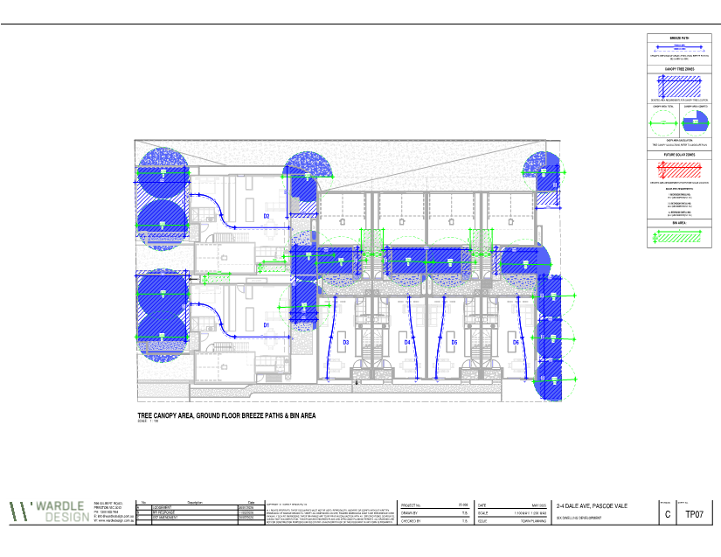
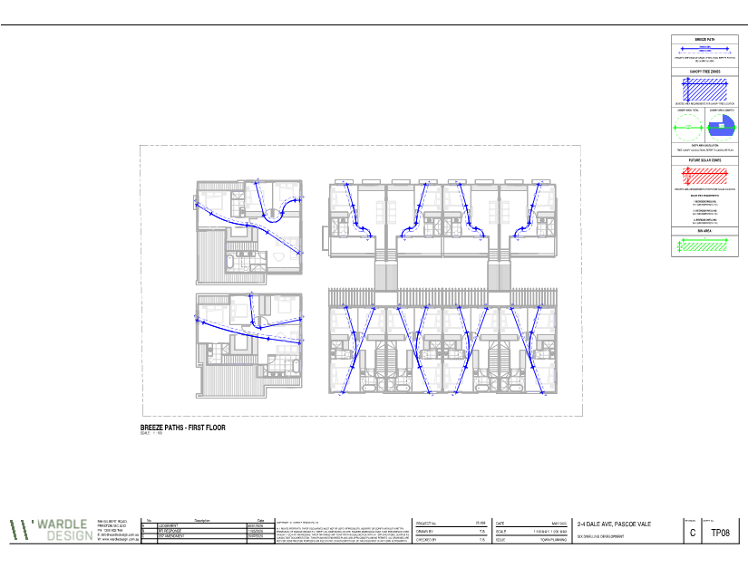
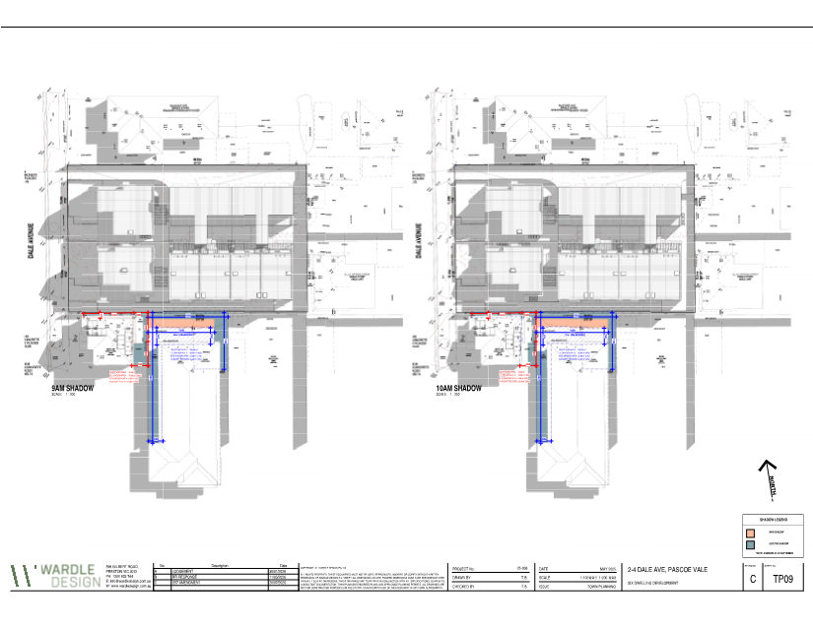
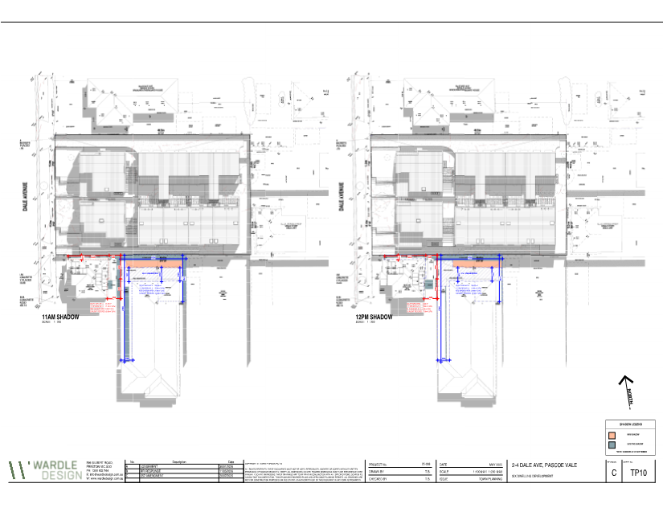
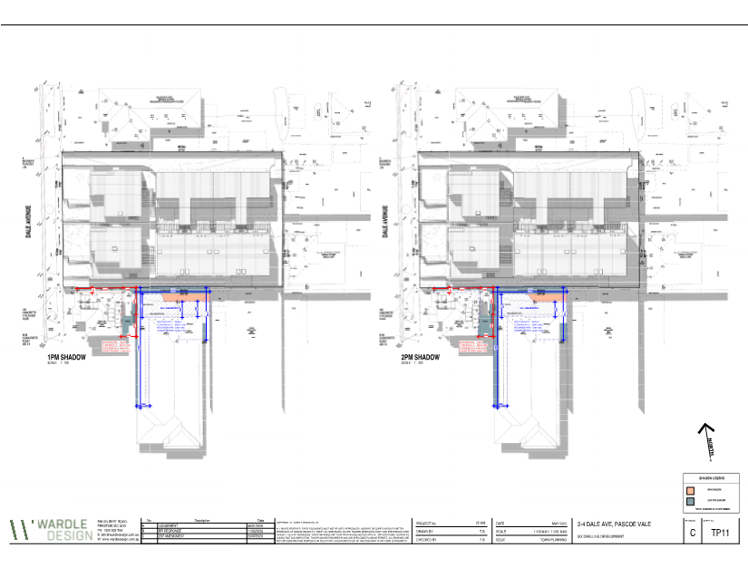
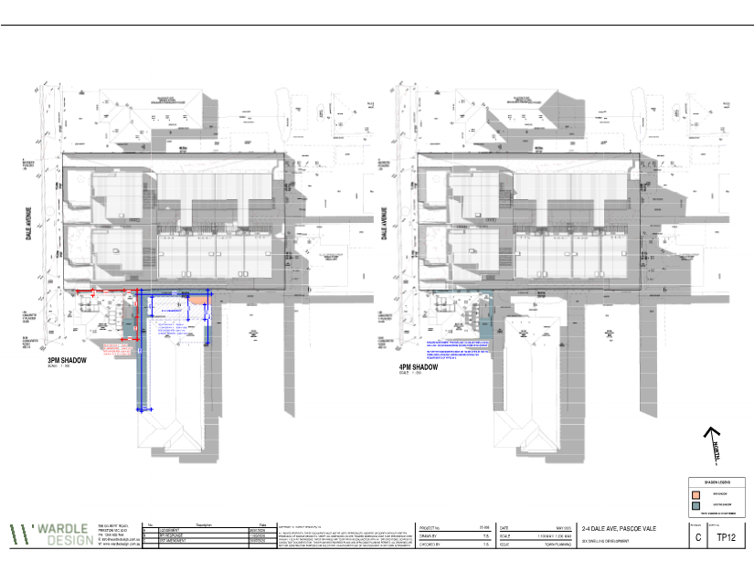

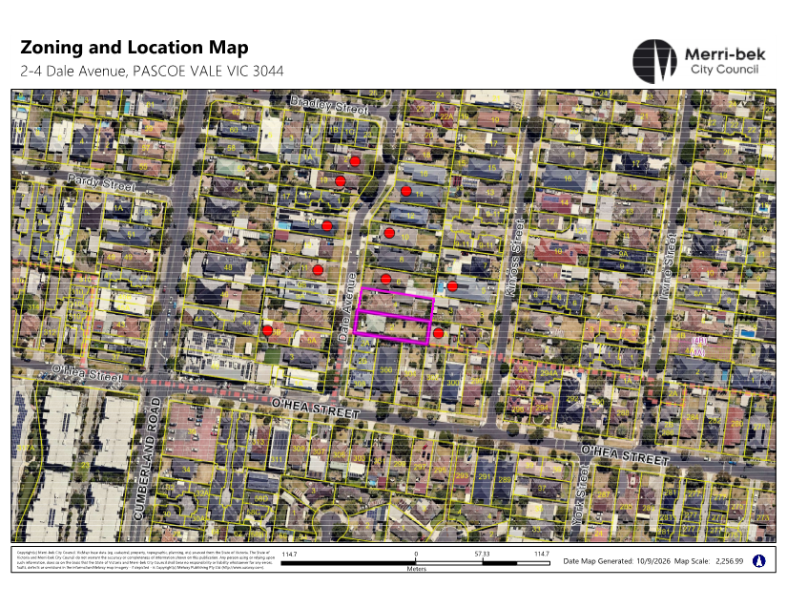

5.3 45 Pentridge Boulevard, Coburg- Ministerial Referral of Planning Application- MIN/2026/3
Director Place and Environment, Pene Winslade
City Development

Executive Summary

Property: | 45 Pentridge Boulevard, Coburg
Proposal: | Construction of a 16 storey building containing retail and commercial uses on ground floor and dwellings above, and reduction of car parking requirements
Zoning and Overlay/s: | • Activity Centre Zone, Schedule 1, Precinct 10 – Pentridge Village (ACZ1)  • Environmental Audit Overlay (EAO)  • Parking Overlay – Schedule 1 (PO1)  • Special Building Overlay – Schedule 2 (SBO2)  • Development Contributions Plan Overlay (DCPO1)
Strategic setting:
Public consultation: | Public notice was not undertaken by the Minister as the application is exempt from public notification and there is no VCAT review rights in the Activity Centre Zone.
ESD: | • Minimum average NatHERS rating of 7.5 stars.  • 43kWp solar photovoltaic systems  • 67 per cent BESS Score
Accessibility: | Adaptable apartments comprise 54 per cent of the proposal.
Key reasons for support: | • Height remains consistent with the 16 storey height sought previously supported by Council.  • Architecture is of high quality, providing a “marker” building as sought under the ACZ1  • Continued commitment to provision of affordable housing. Conditions require that this be provided in the development, or any alternative contribution be made to the Merri-bek Social and Affordable Housing Strategy Reserve of at least 3 per cent of the total development costs.  • Site is well located with access to multiple public transport options and services and provides ample bicycle parking to support the additional car parking reduction.
Recommendation: | Council’s submission to the Minister for Planning be one of support for the development with conditions

Officer Recommendation
That Council advises the Minister for Planning its support of a planning permit being issued for the construction of a 16-storey mixed-use building, comprising retail and commercial uses at ground floor and dwellings above, and a reduction in car parking requirements at 45 Pentridge Boulevard, Coburg, subject to the conditions set out below:
The Permit would allow:
Construction of a 16 storey mixed-use building, with retail and commercial uses on the ground floor and dwellings above and reduction of car parking requirements.
Planning Scheme Clause | Matters for which permit is required
37.08-5 | Construct a building or construct or carry out works
44.05-2 | Construct a building or construct or carry out works
52.06-3 | Reduce the number of car parking spaces required
Amended Plans
1. Before the development commences, amended plans to the satisfaction of the Responsible Authority must be submitted to and approved by the Responsible Authority in consultation with Merri-bek City Council. When approved, the plans will be endorsed and will then form part of the permit. The plans must be drawn to scale with dimensions and must be generally in accordance with the plans prepared by LIFE Architecture and Urban Design, revision TP05 dated 03 June 2026 but modified to show:
a) The awning design on the southern elevation modified to provide a solid form integrated with the facade design language.
b) Fire booster/service cupboards at the street interface reduced to the minimum extent allowable and finished with materials integrated into the hardscape design.
c) Street facing public seating opportunities integrated into the forecourt hardscape design.
d) Dimension each bicycle parking device 500 mm wide, the horizontal bike spaces 1800 mm long and the vertical bicycle spaces 1200 mm long, with every space accessed from a 1500 mm wide access aisle as required by the Australian Standard for Parking Facilities – Bicycle Parking (AS2890.3).
e) Annotate the model of the two-tier bicycle racks.
f) Lift internal dimensions and swept path/maneuvering diagrams demonstrating that the lifts can accommodate two cyclists with bicycles while maintaining safe and convenient access for other lift users.
g) Any changes to the plans arising from the:
i. Landscape Plan in accordance with Condition 3 of this permit.
ii. Facade Strategy in accordance with Condition 8 of this permit.
iii. Public Works Plan in accordance with Condition 9 of this permit.
iv. Lighting Plan in accordance with Condition 12 of this permit.
v. Environmentally Sustainable Design requirements in accordance with Condition 14 of this permit.
vi. Wind Assessment in accordance with Condition 18 of this permit.
vii. Accessibility Report in accordance with Condition 19 of this permit.
viii. Acoustic Report in accordance with Condition 21 of this permit.
ix. Waste Management Plan in accordance with Condition 24 of this permit.
Compliance with Endorsed Plans
2. The development as shown on the endorsed plans must not be altered without the written consent of the Responsible Authority. This does not apply to any exemption specified in Clauses 62.02-1 and 62.02-2 of the Merri-bek Planning Scheme unless specifically noted as a permit condition.
Landscaping
3. Prior to the endorsement of plans under Condition 1, an amended landscape plan must be submitted to the Responsible Authority in consultation with Merri-bek City Council. The landscape plan must be generally in accordance with the plan prepared by Ground Landscape Studio, revision 04 dated 26/05/2026 but amended to show:
a) Bluestone paving to publicly accessible areas.
b) Any changes to be consistent with the Development Plans in accordance with Condition 1 of this permit.
When submitted and approved to the satisfaction of the Responsible Authority, the landscape plan will be endorsed to form part of this permit. No alterations to the plan may occur without the written consent of the Responsible Authority.
4. Prior to the issue of an Occupancy Permit or issue of a Statement of Compliance, whichever comes first, all landscaping works, including installation of automatic irrigation, must be completed in accordance with the endorsed landscape plan to the satisfaction of the Merri-bek City Council.
5. All landscaping and irrigation systems must be maintained to the satisfaction of the Merri-bek City Council in accordance with the endorsed landscape plans. Any dead, diseased or damaged plants must be replaced with a suitable species to the satisfaction of the Merri-bek City Council.
Tree Protection
6. Prior to development commencing (including any demolition, excavations, tree removal, delivery of building/construction materials and/or temporary buildings), all Council trees located within 3 metres of the site boundary or a vehicle crossing must have a Tree Protection Zone (TPZ) in accordance with AS4970 Protection of Trees on Development Sites to the satisfaction of the Merri-bek City Council.
The TPZ must meet the following requirements:
a) Tree Protection Fencing
Tree Protection Fencing (TPF) is to be provided to the extent of the TPZ, calculated as being a radius of 12 x Diameter at Breast Height (DBH – measured at 1.4 metres above ground level as defined by the Australian Standard AS 4970.2009). The TPF may be aligned with roadways, footpaths and boundary fences where they intersect the TPZ.
The TPF must be erected to form a visual and physical barrier, be a minimum height of 1.5 metres above ground level and of mesh panels, chain mesh or similar material. A top line of high visibility plastic tape must be erected around the perimeter of the fence.
b) Signage
Fixed signs are to be provided on all visible sides of the TPF clearly stating “Tree Protection Zone – No entry. No excavation or trenching. No storage of materials or waste.”. The TPF signage must be complied with at all times.
c) Irrigation
The area within the TPZ and TPF must be irrigated during the summer months with 1 litre of clean water for every 1cm of trunk girth measured at the soil/trunk interface on a weekly basis.
d) Provision of Services
All services (including water, electricity, gas and telephone) must be installed underground, and located outside of any TPZ, wherever practically possible. If underground services are to be routed within an established TPZ, this must occur in accordance with Australian Standard AS4970.
e) Access to TPZ
The TPF once erected, must be maintained and not altered, tampered, or moved. If any works are proposed within the TPZ or require the TPF to be moved or altered, then such works must only be carried out with the prior written approval of, and under the direction of, a suitably qualified Arborist (minimum Level 5 Diploma of Arboriculture). A copy of the approval must be provided to Council upon request.
Tree Removal
7. Prior to the issue of an Occupancy Permit or issue of a Statement of Compliance, whichever comes first, the owner must pay Merri-bek City Council the amenity value, removal, replacement and establishment costs in accordance with the Merri-bek Urban Forest Strategy 2017 for each street tree removed or damaged through the building works, to the satisfaction of the Merri-bek City Council.
Facade Strategy
8. Concurrent with the endorsement of plans, a facade strategy must be approved and endorsed by the Responsible Authority. The facade strategy must be prepared to the satisfaction of the Responsible Authority, be drawn to scale, and must include the following details:
a) A concise description by the architect of the building design concept and how the facade works to achieve this.
b) A schedule of colours, materials and finishes, including the colour, type and quality of materials showing their application and appearance. This can be demonstrated in coloured elevations or renders from key viewpoints, to show the materials and finishes, and linking them to a physical sample board with clear coding.
c) Elevation details generally at a scale of 1:50, or other suitable scale agreed by the responsible authority, illustrating typical building details, entries and doors, utilities, and any special features which are important to the building’s presentation.
d) Cross sections or other method of demonstrating the facade systems, including fixing details indicating junctions between materials and significant changes in form and/or material.
e) Information about how the facade will be accessed, maintained, and cleaned.
f) Confirmation external glazing and cladding reflects no more than 20 per cent visible light at 90 degrees to the surface of the material, except with the written consent of the responsible authority.
Public Works Plan
9. Prior to the endorsement of plans, a Public Works Plan and associated construction drawing specifications detailing the works to the land must be submitted and approved to the satisfaction of the Merri-bek City Council. When approved, the plans will be endorsed and will then form part of the permit. The plan must detail works in front of the approved building along Pentridge Boulevard and Urquhart Street and include:
a) A detailed level and feature survey of the footpaths and roads.
b) The provision of new street tree planting and landscaping along Pentridge Boulevard and Urquhart Street adjacent to the site, where feasible, to the satisfaction of the Merri-bek City Council. Any required tree pits are to be constructed by the developer in accordance with the relevant Technical Notes with temporary capping if required. Public realm tree planting will be undertaken by Merri-bek City Council at the expense of the developer.
c) The provision of additional street trees and lower-level planting to the nature strip on the northern side of Urquhart Street
d) The provision of additional lower-level planting to the nature strip along the Pentridge Boulevard frontage of the site
e) The paving to the south and west of the apartment building extended to include the footpath along Pentridge Boulevard and Urquhart Street to create a continuous, larger forecourt area as part of footpath rectification work, using Merri-bek City Council Technical Notes A110.06 Bluestone Footpath or other high-quality materials as approved by Merri-bek City Council. The use of steel inlay or expansion joints can be used to delineate the site boundary.
f) The relocation or replacement of existing and installation of new street furniture and infrastructure (in a graffiti-proof finish), such as parking and traffic signs, public seating, bicycle parking and similar.
g) All construction details in accordance with the Merri-bek City Council Technical Notes.
h) The public footpath to be reinstated with the standard crossfall slope of 1 in 40 from the top of the roadside kerb to the property boundary, with any level difference made up within the site using ramps or steps.
i) Annotate each pedestrian entrance and garage doors to state that ““Floor to be ramped down to match the level of the public footpath that will be reinstated at 1 in 40 from top of roadside kerb”.
j) Any changes to be consistent with the Landscape Plan in accordance with Condition 3 of this permit.
k) Any other works to the public land adjacent to the development.
When submitted and approved to the satisfaction of the Merri-bek City Council, the Public Works Plan will be endorsed to form part of the permit. No alterations to the Public Works Plan may occur without the written consent of the Merri-bek City Council.
10. The approved Public Works Plan will form part of the endorsed plans under the permit and must be implemented to the satisfaction of the Merri-bek City Council at the expense of the owner of the land, prior to the occupation of the development unless otherwise agreed with prior written consent of the Merri-bek City Council.
11. Prior to the issue of an Occupancy Permit or issue of a Statement of Compliance, whichever comes first, the owner must pay Council’s costs and fees associated with Street tree planting.
Lighting
12. Prior to commencement of works, a lighting plan showing all external lighting associated with that stage must be submitted and approved to the satisfaction of the Responsible Authority. The plan must detail:
a) Bollard lighting no higher than 1.2 metres above ground level for all ground level communal open spaces and pedestrian accessways. The bollard lighting must automatically illuminate communal open spaces and pedestrian accessways between dusk and dawn.
b) Any other proposed external lighting.
13. All external lighting must be installed and operate as specified in the endorsed lighting plan to the satisfaction of the Merri-bek City Council prior to the occupation of the development, unless otherwise agreed with prior written consent of the Responsible Authority. All external lighting must be maintained to the satisfaction of the Merri-bek City Council.
Environmentally Sustainable Design (ESD)
14. Prior to the endorsement of plans, an amended Sustainability Management Plan (SMP) and plans must be submitted to the satisfaction by the Responsible Authority in consultation with Merri-bek City Council. The SMP must demonstrate a best practice standard of environmentally sustainable design and be generally in accordance with the SMP prepared by Sustainable Development Consultants, v2 dated March 2026, but modified to include the following changes:
a) An amended daylight modelling report that includes:
i. A clear comparison between the previous and current daylight modelling results, including an explanation for any significant changes in daylight performance where there has been no corresponding change to the architectural layout.
ii. Specific clarification of the reported improvement to Apartment 317 Bedroom 1 and Apartment 417 Bedroom 1, noting that these rooms were previously identified as poorly performing and appear to have significantly improved without a corresponding layout change.
b) Internal layout changes including but not limited to increasing window sizes, modifying glazing arrangements to Bedroom 1 of Apartments 317 and Apartment 417 should the amended daylight modelling confirm that these rooms continue to perform below the best practice targets.
c) Commit to achieving an average NatHERS rating of at least 7.5 Stars for all dwellings.
Where alternative ESD initiatives are proposed to those specified in the conditions above, the Responsible Authority may vary the requirements of this condition at its discretion, subject to the development achieving equivalent (or greater) ESD outcomes in association with the development.
When submitted and approved to the satisfaction of the Responsible Authority, the amended Sustainability Management Plan and associated notated plans will be endorsed to form part of this permit. No alterations to the plan may occur without the written consent of the Responsible Authority.
15. Prior to the issue of a Statement of Compliance or Certificate(s) of Occupancy whichever occurs first, all works must be undertaken in accordance with the endorsed Sustainable Management Plan report to the satisfaction of the Merri-bek City Council. No alterations to these plans may occur without the written consent of the Merri-bek City Council.
16. Prior to the issue of an Occupancy Permit or issue of a Statement of Compliance, whichever comes first, a report from the author of the Sustainability Management Plan (SMP) approved pursuant to this permit, or similarly qualified person or company, must be submitted to the Responsible Authority in consultation with Merri-bek City Council. The report must be to the satisfaction of the Responsible Authority and must confirm (with documented evidence) that all measures specified in the SMP have been implemented in accordance with the approved plan.
17. All stormwater treatment devices (e.g. raingardens, rainwater tanks etc.) must be maintained to the satisfaction of the Merri-bek City Council to ensure water quality discharged from the site complies with the performance standard in the endorsed Sustainability Management Plan.
Wind Assessment Report
18. Prior to the endorsement of plans, an amended Wind Assessment Report must be submitted to and approved by the Responsible Authority. When approved, the report will be endorsed and will then form part of the permit. The report must be generally in accordance with the Wind Assessment Report, prepared by MEL Consultants, dated June 2025, but must be modified to:
a) Assess and identify any changes to wind conditions arising from the changes required under Condition 1, and provide any additional mitigation measures required to achieve compliance with the relevant wind comfort and criteria.
b) Confirm the design of the awning/canopy to south elevation is an appropriate wind mitigation measure.
The provisions, recommendations and requirements of the endorsed Wind Assessment Report must be implemented and complied with to the satisfaction of the Merri-bek City Council.
Accessibility
19. Prior to the endorsement of plans, an amended Accessibility Report prepared by a suitably qualified person must be submitted to the satisfaction of the Responsible Authority. The report must be generally in accordance with the report prepared by Jensen Hughes, revision ADR 1.1 dated 18 August 2025 but modified to align with the plans for endorsement.
When submitted and approved to the satisfaction of the Responsible Authority, the Accessibility Report will be endorsed to form part of this permit. No alterations to the plan may occur without the written consent of the Responsible Authority. The recommendations of the report must be implemented to the satisfaction of the Merri-bek City Council prior to the occupation of the development.
20. Prior to the issue of an Occupancy Permit or issue of a Statement of Compliance, whichever comes first, a report from the author of the Accessibility Report, approved pursuant to this permit, or similarly qualified person or company, must be submitted to the Responsible Authority. The report must be to the satisfaction of the Responsible Authority and must confirm that all measures specified in the Accessibility Report have been implemented in accordance with the approved report.
Acoustic Attenuation
21. Prior to the endorsement of plans, an amended Acoustic Report prepared by a qualified Acoustic Engineer must be submitted to the satisfaction of the Responsible Authority. The Report must be generally in accordance with the Acoustic Report prepared by Octave Acoustics, revision 3 dated 30 July 2025 but modified to align with the plans for endorsement.
When submitted and approved to the satisfaction of the Responsible Authority, the Acoustic Report will be endorsed to form part of this permit. No alterations to the Acoustic Report may occur without the written consent of the Responsible Authority.
22. The building must be constructed and thereafter maintained in accordance with the recommendations contained within the approved Acoustic Report to the satisfaction of the Responsible Authority, unless with the further written approval of the Responsible Authority.
23. Prior to the issue of an Occupancy Permit or issue of a Statement of Compliance, whichever comes first, a report from the author of the Acoustic Report approved pursuant to this permit or similarly qualified person or company must be submitted to the Responsible Authority. The report must be to the satisfaction of the Responsible Authority and must confirm that all measures specified in the Acoustic Report have been implemented in accordance with the approved Acoustic Report.
Waste Management
24. Prior to the endorsement of plans, an amended Waste Management Plan (WMP) must be submitted to the satisfaction of the Merri-bek City Council. The plan must be generally in accordance with the report prepared by Traffix Group, revision A dated June 2026 but modified to align with the plans for endorsement.
When submitted and approved to the satisfaction of the Merri-bek City Council, the WMP will be endorsed to form part of this permit. No alterations to the WMP may occur without the written consent of the Merri-bek City Council
25. The Waste Management Plan approved under this permit must be implemented and complied with at all times to the satisfaction of the Merri-bek City Council unless with the further written approval of the Merri-bek City Council.
Environmental Audit
26. Before the construction or carrying out of buildings and works, the owner(s) must provide:
a) A preliminary risk screen assessment statement in accordance with the Environment Protection Act 2017 stating that an environmental audit is not required for the use or, if this permit authorises the construction or carrying out of buildings or works, is not required for the use for which the buildings or works are constructed or carried out; or,
b) An environmental audit statement under Part 8.3 of the Environment Protection Act stating that the land is suitable for the use or, if this permit authorises the construction or carrying out of buildings or works, is suitable for the use for which the buildings or works are constructed or carried out; or.
c) An environmental audit statement under Part 8.3 of the Environment Protection Act 2017 stating that the land is suitable for the use or, if this permit authorises the construction or carrying out of buildings or works, is suitable for the use for which the buildings or works are constructed or carried out, if the recommendations made in the statement are complied with.
27. Where an environmental audit statement is issued for the land, and any recommendation of that environmental audit statement requires any maintenance and/or monitoring of an ongoing nature, the Responsible Authority may require the Owner(s) to enter into an Agreement with the Responsible Authority and Merri-bek City Council pursuant to Section 173 of the Planning and Environment Act 1987 that provides for the undertaking of the ongoing maintenance and/or monitoring as required by the environmental audit statement.
Where a Section 173 Agreement is required, the Agreement must be executed prior to the commencement of the permitted use, the issue of an Occupancy Permit under the Building Act 1993 or the issue of a Statement of Compliance under the Subdivision Act 1988 (whichever occurs first). All expenses involved in the drafting, negotiating, lodging, registering and execution of the Agreement, including those incurred by the Responsible Authority, and Merri-bek City Council, must be met by the Owner(s).
28. Prior to any remediation works (if required) being undertaken in association with the environmental audit, a ‘remediation works’ plan to the satisfaction of the Merri-bek City Council Responsible Authority must be submitted to and approved by the Merri-bek City Council Responsible Authority. The plan must detail all excavation works as well as any proposed structures such as retaining walls required to facilitate the remediation works. Only those works detailed in the approved remediation works plan are permitted to be carried out prior to the issue of an environmental audit statement.
29. Prior to commencement of the use, the issue of an Occupancy Permit under the Building Act 1993 or the issue of a Statement of Compliance under the Subdivision Act 1988 (whichever occurs first), written confirmation of compliance with all the recommendations of the environmental audit statement must be provided by an environmental auditor appointed under the Environment Protection Act 2017, including confirming that any requirements in the environmental audit statement recommendations regarding verification of works have been complied with. All the recommendations of the environmental audit statement must be complied with to the satisfaction of the Merri-bek City Council.
30. Where a preliminary risk screen assessment has satisfied Condition 26 (that an environmental audit is not required), the development and use must not deviate from the assumptions or limitations contained in the preliminary risk screen assessment, including but not limited to the- layout and design of the development and use of the land without the written consent of the Responsible Authority. The development and use must accord with any requirements and recommendations of the preliminary risk screen assessment to the satisfaction of the Merri-bek City Council.
Section 173 Agreement – Affordable Housing
31. Before the use or development of the land begins, excluding demolition, excavation, piling, site preparation works, and works to remediate contaminated land, the owner of the land must enter into an agreement with the Responsible Authority under section 173 of the Act, in a form to the satisfaction of the Merri-bek City Council and the Responsible Authority, that provides for a contribution towards affordable housing (affordable housing contribution) by way of either of the following options:
a) At least 10 per cent of the total number of dwellings in the development must be provided as affordable housing for sale or lease to a registered housing agency or to Homes Victoria. The details of when and how the affordable housing will be delivered, and the total value of the affordable housing contribution must be set out in the agreement. The affordable housing dwellings provided should be representative of the approved dwelling mix to the satisfaction of the Responsible Authority.
b) An alternative contribution to the Merri-bek Social and Affordable Housing Strategy Reserve of at least 3 per cent of the total development cost towards the provision of affordable housing must be provided to the satisfaction of the Responsible Authority. The details of when and how the alternative contribution is to be made, and the total value of the affordable housing contribution must be set out in the agreement to the satisfaction of the Responsible Authority.
The landowner must pay the Responsible Authority’s reasonable costs of the preparation, execution, registration and ending of the section 173 agreement (where applicable).
The landowner must do all things necessary to enable the Responsible Authority to register the agreement with the Registrar of Titles in accordance with section 181 of the Act.
Section 173 Agreement – Privately owned public spaces/links
32. Prior to the issue of Certificate of Occupancy or Statement of Compliance, whichever comes first, the owner of the land must enter into an agreement pursuant to Section 173 of the Planning and Environment Act 1987 with Responsible Authority, in a form to the satisfaction of Merri-bek City Council and the Responsible Authority. The agreement must provide the following:
a) The pedestrian link between Pentridge Boulevard and Sacramento Way will remain privately owned and controlled;
b) Require the owner of the land to maintain unobstructed public access to the pedestrian link 24 hours a day, 7 days a week, except where temporary closure is required for maintenance, repairs, emergency works, or public safety reasons;
c) Installation of appropriate lighting to ensure that the pedestrian link provides convenient and safe public access;
d) Provide that the owner of the land is solely responsible for the maintenance and management of the pedestrian link at the owner’s cost and to the satisfaction of Responsible Authority; and
e) Provide that the design, materiality, lighting, including the ongoing operation and maintenance of the pedestrian link be to the satisfaction of Merri-bek City Council.
The landowner must pay the Merri-bek City Council and the Responsible Authority reasonable costs of the preparation, execution, registration and ending of the section 173 agreement (where applicable).
The landowner must do all things necessary to enable the Responsible Authority to register the agreement with the Registrar of Titles in accordance with section 181 of the Act.
3D model
33. Prior to the commencement of the development, a 3D digital model of the approved development which is compatible for use on Merri-bek City Council’s Virtual Merri-bek tools and software for Council and community must be submitted to the satisfaction of the Merri-bek City Council. The model should be prepared in accordance with Merri-bek City Council’s 3D model submission guidelines. A copy of the 3D model submission guidelines and further information on the Virtual Merri-bek Project can be found at Virtual Merri-bek. In the event that substantial modifications to the building envelope are approved under an amendment to this planning permit, a revised 3D digital model must be submitted to, and be to the satisfaction of the Merri-bek City Council.
Engineering Matters
34. Prior to commencement of the development hereby approved, a Construction Management Plan must be submitted to, and approved by Merri-bek City Council under Council’s General Local Law. Guidance on how to prepare a Construction Management Plan can be found on Council’s website.
35. Prior to the issue of an Occupancy Permit or issue of a Statement of Compliance, whichever comes first, a vehicle crossing must be constructed in every location shown on the endorsed plans to a standard satisfactory to the Merri-bek City Council (Merri-bek City Council, City Infrastructure Department).
36. Prior to the issue of an Occupancy Permit or issue of a Statement of Compliance, whichever comes first, any existing vehicle crossing not to be used in this use or development must be removed and the kerb and channel, footpath and nature strip reinstated to the satisfaction of the Merri-bek City Council (Merri-bek City Council, City Infrastructure Department).
37. Prior to the issue of an Occupancy Permit or issue of a Statement of Compliance, whichever comes first, access to the site, any vehicle crossover and any ancillary road and road drainage works must be constructed in accordance with any requirement of the Merri-bek City Council (Merri-bek City Council, City Infrastructure Department).
38. At all times the area marked as a loading zone on the endorsed plan must not be used for any other purpose.
39. Prior to the issue of an Occupancy Permit or issue of a Statement of Compliance, whichever comes first, all telecommunications and power connections (where by means of a cable) and associated infrastructure to the land (including all existing and new buildings) must be underground to the satisfaction of the Merri-bek City Council.
40. Prior to the issue of an Occupancy Permit or issue of a Statement of Compliance, whichever comes first, the bicycle storage room must have self-closing and self-locking doors or gates that are only accessible using keys, codes, or swipe cards in accordance with the Australian Standard for Bicycle Parking (AS2890.3).
41. Prior to the issue of an Occupancy Permit or issue of a Statement of Compliance, whichever comes first, bicycle signage that directs the cyclists to the bicycle facilities must be provided to the satisfaction of the . Bicycle signage should be at least 0.3 metres wide and 0.45 metres high; display a white bicycle on a blue background on the top half of the sign and display information about the direction of facilities on the bottom half of the sign.
Stormwater
42. All stormwater from the land, where it is not collected in rainwater tanks for re-use, must be collected by an underground pipe drain approved by and to the satisfaction of the Merri-bek City Council (Note: Please contact Merri-bek City Council, City Infrastructure Department).
Car Parking
43. The area set aside for the parking of vehicles and access lanes shown on the endorsed plan must, to the satisfaction of the Merri-bek City Council:
a) Be completed prior to issue of an Occupancy Permit or issue of a Statement of Compliance, whichever occurs first.
b) Be maintained.
c) Be properly formed to such levels that it can be used according to the endorsed plan.
d) Have the boundaries of all vehicle parking spaces clearly marked on the ground to accord with the endorsed plan.
e) Not be used for any other purpose other than the parking of vehicles, unless with the prior written consent of the Responsible Authority.
f) Be numbered to facilitate management of the car park, including for retail tenancies and car share (locate in common property).
General
44. At all times the ground floor windows which adjoin the pedestrian walkway on the north edge of the site that connects to the existing townhouses, must remain unobscured to continue to provide passive surveillance, to the satisfaction of the Merri-bek City Council.
45. Prior to the issue of an Occupancy Permit or issue of a Statement of Compliance, whichever comes first, all boundary walls must be constructed, cleaned, and finished to the satisfaction of the Merri-bek City Council.
46. Unless with the prior written consent of the Responsible Authority, any plumbing pipe, ducting and plant equipment must be concealed from external views. This does not include external guttering or associated rainwater down pipes.
47. All lighting of external areas must be designed not to emit direct light onto adjoining property to the satisfaction of the Merri-bek City Council.
48. The new apartment development allowed by this permit must not be connected to a reticulated gas service (within the meaning of clause 53.03 of the relevant planning scheme). This condition continues to have force and effect after the development authorised by this permit has been completed.
Easements
49. Prior to the commencement of development, the owner must obtain the consent of all relevant authorities to remove or vary all easements within the footprint of the approved buildings to the satisfaction of the Responsible Authority.
Privacy screens to be installed and maintained
50. Prior to the issue of an Occupancy Permit or issue of a Statement of Compliance, whichever comes first, all privacy screens and privacy measures shown on the endorsed plans must be installed to the satisfaction of the Merri-bek City Council. All privacy screens and privacy measures to prevent overlooking must be maintained to the satisfaction of the Merri-bek City Council. Any privacy screen or privacy measure that is removed or unsatisfactorily maintained must be replaced to the satisfaction of the Merri-bek City Council.
Retention of Architect
51. LIFE Architecture and Urban Design or an equivalent Architect must be retained to complete and provide architectural oversight during construction of the detailed design as shown on the endorsed plans, to the satisfaction of the Responsible Authority.
Permit Expiry
52. This permit will expire if one of the following circumstances applies:
a) the development is not commenced within three (3) years from the date of issue of this permit;
b) the development is not completed within five (5) years from the date of issue of this permit.
The Responsible Authority may extend the period referred to if a request is made in writing before the permit expires or;
i. within six months after the permit expires to extend the commencement date.
ii. within 12 months after the permit expires to extend the completion date of the development if the development has lawfully commenced.
Notes: These notes are for information only and do not constitute part of this permit or conditions of this permit.
Note 1: Should Council impose car parking restrictions in this street, the owners and/or occupiers of the land would not be eligible for any Council parking permits to allow for on street parking.
Note 2: Further approvals are required from Council’s City Infrastructure Department who can be contacted on 9240 1143 for any works beyond the boundaries of the property. Planting and other vegetative works proposed on road reserves can be discussed with Council’s Open Space Unit on 8311 4300.
Note 3: This permit does not authorise the removal of damage to or pruning of any street tree. Further written consent must be obtained from Council’s Open Space Unit. The Open Space Unit can be contacted on 8311 4300.
Note 4: The permit holder is advised to contact Council's Property Unit on 9240 2208 for allocation of street numbers associated with the development.

REPORT

1. Background

Subject site
The site is located on the corner of Pentridge Boulevard and Urquhart Street, Coburg and has an area of 9,485 square metres. The site is currently vacant and is the remaining land to be developed as part of a larger development, approved under Planning Permit no: MPS/2017/1006/D.
A location plan forms Attachment 1.

Surrounds
The immediate surrounding land contains townhouses. The wider area is a developing mixed-use area. The site is located on the eastern edge of the Pentridge Masterplan precinct and is identified as being the location for a landmark building.
A location plan forms Attachment 1.

The proposal
Whilst the current proposal has been submitted as a new application, the design is largely based on a design that was previously approved by Council under Planning Permit MPS/2017/1006/D which was considered at the 27 September 2023 Planning and Related Matters Council meeting. The main changes proposed are:
• External material changes
• Increase in housing numbers and change to the housing types
• Changes to floor areas including less retail and communal spaces
The table below summarises the key changes from the approved development:
 | Approved | Proposed
Levels: | 16 | 16
Height: | 56.2 metres | 55.52 metres
Gross floor area: | 18,153 sqm | 18,030 sqm
Retail space floor area: | 308 sqm | 241 sqm
Apartment no: | 201  - 45 x one bedroom  - 148 x two bedroom  - 8 x three bedroom | 252  - 72 x one bedroom  - 180 x two bedroom  - 0 x three bedroom
Communal space floor area (gym, co-working/home office, roof terrace): | 949 sqm | 939 sqm
Car spaces | 161 | 136  (reduction of 25 spaces)  No new car parking provision for the 51 additional apartments proposed
Bicycle spaces | 364  (352 resident spaces and 12 spaces for retail/visitors) | 436 (increase by 72 spaces)  (434 resident spaces and 2 spaces for retail employees)
Proposed perspectives
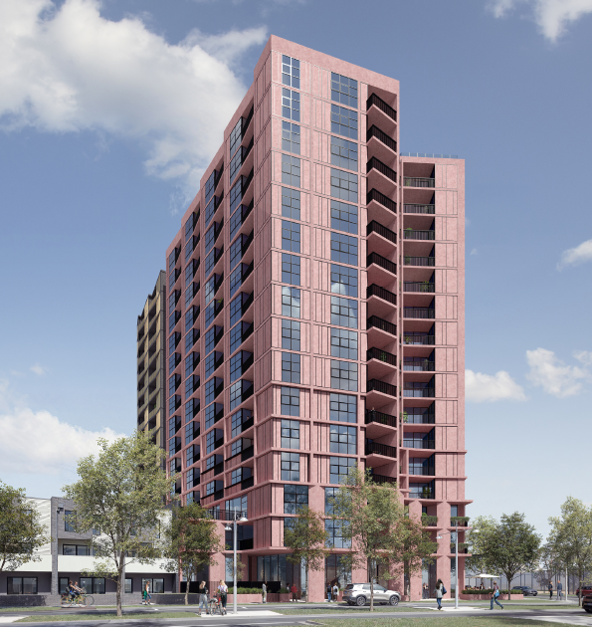 | 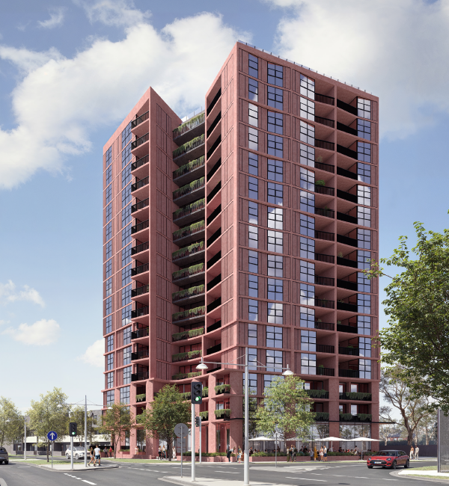
Figure 1: Pentridge Boulevard view | Figure 4: Urqhart Street (intersection with Pentridge Boulevard view
The development plans form Attachment 2.

Application Process and Responsible Authority
The application has been lodged with the Minister for Planning under Clause 53.23 (Significant Residential Development with Affordable Housing) of the Merri-bek Planning Scheme. Clause 53.23 has a requirement to provide at least 10 per cent of the total number of dwellings in the development as affordable housing, or an alternative contribution be made towards the provision of affordable housing.
Clause 72.01 of the Scheme sets out that the Minister for Planning, not Council, is the Responsible Authority in relation to the use and development of land to which Clause 53.23 applies.
Council’s role is limited to providing comments. There is no right to apply to the Victorian Civil and Administrative Tribunal for a review of the Minister’s decision on this application.

Planning Permits and Site History
MPS/2017/1006/D
The site has an existing planning approval for a similar development. Planning Permit MPS/2017/1006/D was issued on 8 October 2018 and allows a 16 storey mixed-use building, townhouses and a reduction in car parking requirements.
The permit was amended on 28 May 2019 to allow the development to be built into stages. The townhouse component and most of the basement car parking have been completed. Overall, the permit allows 201 apartments and 48 townhouses.
The permit was extended on 2 May 2024 to allow completion of the development by 8 October 2028.
The most recent amendment to this permit was considered at the 27 September 2023 Planning and Related Matters Council meeting.
The images below show the development that was approved under this permit.
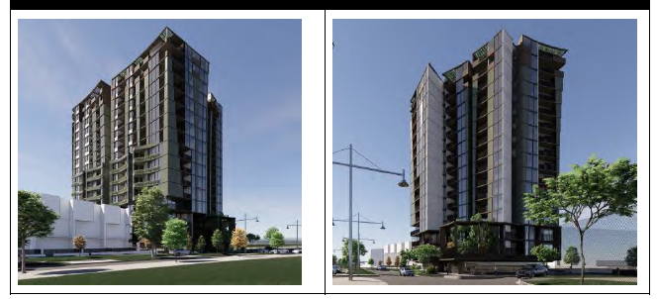
Figure 5 and 6: Perspective views from Pentridge Boulevard, and from intersection with Urquhart Street.
SP/2021/56
A subdivision permit no SP/2021/56 was issued on 11 August 2021 to divide the lots into 50 lots. The subdivision has since been completed, creating, among other lots, Lot S2, where the 16 storey building is to be built. A Statement of Compliance was issued on 13 May 2022, confirming that all requirements of the subdivision permit had been met.
Legal agreement
Condition 35 of the planning permit (MPS/2017/1006/D) required the landowner to enter into a legal agreement (under Section 173 of the Planning and Environment Act 1987) with Council requiring the provision of affordable housing.
The agreement has been entered into with Council on 21 September 2021 and continues to have legal effect should planning permit MPS/2017/1006/D be acted upon. No affordable housing contribution has been delivered to date.

Statutory Controls – why is a planning permit required?
Control | Permit Requirement
Activity Centre Zone | Dwelling, Office, Shop are Section 1 uses that do not require a permit A permit is required to construct a building or construct or carry out works.
Special Building Overlay | A permit is required to construct a building or construct or carry out works
Particular Provisions | A permit is required to reduce the car parking requirement from 260 spaces to 136 spaces (124 space reduction). As the previous permit allowed a reduction of 76 car spaces, the current proposal seeks an additional reduction of 48 car spaces.
The following Particular Provisions of the Merri-bek Planning Scheme are also relevant to the consideration of the proposal:
• Clause 45.03: Environment Audit Overlay. A condition of the recommendation requires an Environmental Audit to be undertaken before the development commences, to ensure that the site is remediated to the Environmental Protection Agency (EPA) required standard.
• Clause 45.09: Parking Overlay. The Parking Overlay means that the reduced ‘Column B’ car parking rates in the table to Clause 52.06 apply.
• Clause 52.29: Land Adjacent to the Principal Road Network. Urquhart Street is in a Transport Zone; however, the basement car park and ramp are existing and do not trigger a permit under this provision.
• Clause 53.18: Stormwater Management in Urban Development.
• Clause 52.34: Bicycle Facilities. The requirements of this Clause have been met.
• Clause 53.23: Significant Residential Development with Affordable Housing.
• Clause 58: Apartment Developments.

2. Internal/External Consultation

Public notification
In Schedule 1 of the Activity Centre Zone (ACZ), the application is exempt from public notification if it is generally in accordance with the Pentridge Coburg Masterplan. The Minister for Planning is the Responsible Authority for determining the application, including whether the proposal is generally in accordance with the masterplan, and as such does not require public notice of the application to be undertaken.
This approach is consistent with the assessment of the planning application MPS/2017/1006/D by Council, which approved the 16 storey mixed-use building and adjoining townhouses. However, despite this application being exempt from public notification, Council undertook informal notice by sending notices to the owners and occupiers of adjoining and nearby land. On the previous amendment application, the informal noticed resulted in 8 submissions being received.

External/ internal referrals
The Minister for Planning as the Responsible Authority for the application must undertake the following external referrals:
• Melbourne Water because the land is within a Special Building Overlay; and
• Transport for Victoria because the proposal is for more than 60 dwellings.
The proposal was referred to the following internal branches/business units:
Internal Branch/Business Unit | Comments
Urban Design Unit | Supports the proposal but recommends addressing matters relating to improving public realm interface via providing public seating in the proposed forecourt area, bluestone paving, improved shading design on the southern elevation and reducing the visual impact of fire booster cabinets. They have raised concern with the location of the communal areas being close to adjacent townhouses resulting in overlooking and noise transfer. The comments have been provided to the Minister’s Department (DTP) for their consideration and are recommended as conditions should a permit be issued.
Transport - Development Engineering | Supports the proposal but recommends addressing matters relating to details of bicycle, car parking layouts and waste management particularly in relation to seeking evidence that garbage and recycling chutes do not lead to poor waste separation and contamination. The comments have been provided to the Minister’s Department (DTP) for their consideration. As the basement car parking has been largely constructed, there is potential that some of the non-compliances cannot be corrected. Refer to Section 4 of the report for detailed comments on this matter. Comments in regards to bicycle parking has been recommended as conditions should a permit be issued.
Sustainable Built Environment - ESD Team | Supports the proposal noting the 7.5 star NatHERS commitment. Raised concerns with daylight modelling with some of the dwellings. The comments have been provided to the Minister’s Department (DTP) for their consideration and has been recommended as conditions should a permit be issued.
Principal Advisor Social and Affordable Housing | Does not support the proposal to provide affordable housing contribution to the State Government Social Housing Growth Fund. Officer assessment found that the cash contribution currently offered is equal to or greater than the affordable housing contribution required under the existing planning permit (MPS/2017/1006/D). However, it is recommended that the affordable housing contribution be provided within the development itself, or paid into Merri-bek's Social and Affordable Housing Strategy Reserve. This would help ensure the contribution benefits the Merri-bek community. A condition requiring this has been recommended should a permit be issued.

3. Policy Implications

Planning Policy Framework (PPF):
The following policies are of most relevance to this application:
• Municipal Planning Strategy (Clause 2), including:
− Vision (Clause 2.02)
− Settlement (Clause 2.03-1)
− Housing (Clause 2.03-5)
− Transport (Clause 2.03-7)
• Settlement (Clause 11)
• Environmental Risks and Amenity (Clause 13):
− Contaminated and Potentially Contaminated Land (Clause 13.04-1S)
• Built Environment (Clause 15.01), including:
− Urban Design (Clause 15.01-1S, 15.01-1R and 15.01-1L)
− Building Design (Clause 15.01-2S and 15.01-2L)
− Apartment developments in Merri-bek (Clause 15.01-2L)
− Environmentally Sustainable Development (Clause 15.01-2L-05)
− Energy efficiency in Merri-bek (Clause 15.01-2L-04)
• Residential Development (Clause 16.01), including:
− Housing Supply (Clause 16.01-1S and 16.01-1R)
− Homes in Merri-bek (Clause 16.01-1L)
− Housing for People with Limited Mobility (Clause 16.01-1L)
− Housing Affordability (Clause 16.01-2S and 16.01-2L)

Planning Scheme Amendments
Amendment VC277
On 18 December 2025, new statewide rules changed how car parking is calculated under Amendment VC277. These new rules use the Public Transport Accessibility Level (PTAL), which measures how easy it is to reach public transport. Under these rules, locations across Victoria are grouped into four categories. Each category has different minimum and maximum car parking requirements based on access to public transport.
This site is in Category 2 and is also in a Parking Overlay. Because of the Parking Overlay, the old car parking rates continue to apply.

Human Rights Consideration
This application has been processed in accordance with the requirements of the Planning and Environment Act 1987 (including the Merri-bek Planning Scheme) reviewed by the State Government and which complies with the Victorian Charter of Human Rights and Responsibilities Act 2006, including Section 18 (Taking part in public life). In addition, the assessment of the application has had particular regard to:
• Section 12: Freedom of movement
• Section 13: Privacy and Reputation
• Section 20: Property rights
The proposed redevelopment of private land does not present any physical barrier preventing freedom of movement. The right of the landowner to develop and use their land has been considered in accordance with the Merri-bek Planning Scheme.

4. Issues
In considering this application, regard has been given to the Planning Policy Framework (PPF), the provisions of the Merri-bek Planning Scheme, and the merits of the application.

Does the proposal have strategic policy support?
The site is located within the Coburg Activity Centre, where the strategic direction is
to accommodate substantial residential growth and densities, to take advantage of the excellent access to public transport and other services within these locations. Therefore, the development of this land continues to have strong strategic policy support.
The proposed 16 storey height complies with the discretionary height controls for Precinct 10 within the Activity Centre Zone (see figure 2). The building is also similar in scale to the development approved under Planning Permit MPS/2017/1006/D, which Council supported at the Planning and Related Matters meeting on 27 September 2023.

Does the proposal respond to Merri-bek Planning Scheme policy for Affordable Housing provision?
The Merri-bek Planning Scheme supports increasing the supply of affordable housing. These policies encourage new developments to include affordable homes that are close to jobs, public transport, and services. They also support affordable housing being owned and managed by registered housing providers.
Council's policies note that rising housing costs are making it more difficult for people to afford housing in Merri-bek. Housing stress and homelessness are expected to increase in the coming years, creating a greater need for affordable housing.
As part of the existing planning permit (MPS/2017/1006/D), the developer agreed to provide an affordable housing contribution. This was secured through Condition 35 of the permit and a legal agreement with Council. The agreement required at least 3 percent of the total number of dwellings to be constructed, which equates to eight dwellings, to be offered for purchase by a registered housing provider.
The delivery of the affordable housing contribution secured through the existing permit is dependent on the construction of the 16-storey building approved under the permit. If this development does not proceed, the affordable housing contribution may not be realised.
The current application includes an affordable housing contribution of a similar value. However, instead of providing affordable homes within the development, the contribution would be paid into the State Government's Social Housing Growth Fund.
While the proposed contribution is comparable in value to the existing requirement, it would not guarantee that affordable housing is delivered in Merri-bek. For this reason, the proposal is not consistent with the Merri-bek Planning Scheme policies, which seek to increase the supply of affordable housing within Merri-bek, in activity centres, and support delivery through registered housing providers. Condition 31 of the recommendation seeks to ensure that any affordable housing contribution is made within the development, or alternatively at least 3 per cent of the total development costs is contributed to the Merri-bek Social and Affordable Housing Strategy Reserve.

Does the proposal positively contribute to the local context and enhance the public space?
The proposed design response has made improvements from the previous design approved under Planning Permit MPS/2017/1006/D, which are supported. Broadly these improvements are:
• The ground floor layout and interfaces with Pentridge Boulevard and Urquhart Street have been improved, making it easier for people with limited mobility to access the site. The open forecourt to the building entry and the outdoor cafe area, identified as being the ‘cafe spill out’ area in the plans, continues to provide an inviting space for visitors and residents and will encourage activity and interaction at street level.
• The approved design includes a pedestrian walkway on the north edge of the site that connects to the existing townhouses. The walkway has been retained and improved by increasing its height and width, making it safer and easier to move through. Large windows facing the walkway improve passive surveillance and make the space feel safer for pedestrians. A condition will be recommended to ensure the windows remain unobscured so they continue to provide passive surveillance.
• Above ground floor, the overall design response has been refined with materials and architectural details that add visual interest. The design responds to the Pentridge Masterplan's vision for a landmark building at this location. The building uses durable materials and has a residential appearance that is consistent with other larger buildings in the surrounding area.
Council’s Urban Design Unit are generally supportive subject to improving the public interface via providing public seating, bluestone paving, improved shading design on the southern elevation and reducing the visual prominence of fire booster cabinets. Recommended changes could be addressed by conditions should a planning permit be issued.

Does the proposal result in any unreasonable impacts on neighbouring properties?
The proposal has generally retained the same building envelope as approved by MPS/2017/1006/D. As such, consideration of amenity impacts to neighbouring properties is limited to areas that have changed in the current proposal.
The majority of the apartments have an outlook onto Pentridge Boulevard, Urquhart Street, or the shared walkway next to the townhouses. Some apartment balconies and windows, such as Apartments 111 and 112, are located adjacent to neighbouring townhouses and incorporates overlooking treatments, such as, overlooking shelves and solid panels, to prevent views into neighbouring private open spaces and living spaces. The recommendations include conditions that seeks to maintain this overlooking treatment.
The communal areas on level 1 and 2 face the shared walkway next to the neighbouring townhouses. The rooftop communal area is oriented towards Pentridge Boulevard and Urquhart Street.
The proposal will cast shadows into the adjoining open space areas of McDonald Reserve and tennis facilities. It is however noted that the shadows cast will not be greater than those cast by the previous development.

Does the proposal provide appropriate onsite amenity and facilities?
In relation to the provision of on-site amenity and facilities, Council officers note that:
• The proposal continues to provide substantial communal areas for residents, including provision of additional roof terrace area.
• Resident spaces of car parking, bicycle parking, and storage facilities are appropriately provided.
• Some apartment balcony sizes do not meet the Planning Scheme requirements. However, this is balanced by the provision of resident communal facilities (e.g. Gym/wellness) and the close location to substantial open space and community infrastructure of McDonald Reserve, Bridges Reserve and Coburg Leisure Centre.
• The proposal provides an increase in dwelling numbers with the typology revised to only include 1 and 2 bed layouts, with all 3 bedroom layouts deleted. While this reduces the variety of housing types available within the development, it is considered acceptable because the surrounding area includes a mix of three and four-bedroom townhouses.
• 136 of the 252 apartments (54 per cent) are designed to be accessible. This complies with the Planning Scheme requirement which seeks to ensure at least 50 per cent accessible dwellings are provided.
Does the proposal incorporate adequate Environmental Sustainable Design (ESD) features?
The submitted Sustainability Management Plan indicates that the development can achieve a NatHERS rating of 7.5 Star. The recommendation includes conditions that require this commitment to be met.
Council’s Environmental Sustainable Development (ESD) officer has reviewed the proposal including the daylight modelling reports submitted as part of the application. While the reports indicate that the development meets best practice standards for access to daylight, the ESD Officer has raised concerns about the accuracy of the daylight modelling results. Concerns were also raised about the level of daylight to the bedroom 1 of Apartments 317 and 417, which do not meet best practice targets and are the poor performing apartments in the development.
The recommendation includes conditions that seek to address these concerns including if required, making changes to the internal layout of Apartments 317 and Apartments 417 bedroom 1, increasing window sizes, or modifying window glazing arrangements to improve daylight access.

Is the car and bicycle parking and vehicle access appropriate?

The current development provides for 161 car spaces in the partially constructed basement level, some of these are for the townhouses.

Pursuant to the car parking requirement at Clause 52.06 of the Planning Scheme, the proposal with additional housing has a requirement to provide 260 car spaces. The proposal provides for 136 car spaces. This is a reduction of 124 car spaces. As the previous permit allowed a reduction of 76 car spaces, the current proposal therefore seeks an additional reduction of 48 car spaces.

In considering the matters at Clause 52.06-7, the additional reduction of 48 car spaces is considered acceptable for the following reasons:

• The site is located in the Coburg Activity Centre with excellent access to a range of public transport options

• The submitted Traffic Impact Assessment Report (prepared by One Mile Grid dated 18 March 2026) indicate that suitable on-street car parking is available to accommodate the short-term parking demands of visitors and customers to the retail premises.

• The development provides 436 bicycle spaces, exceeding the requirements of Clause 52.34-5 (requires 342 spaces).

• Clause 18.02-4L seeks to support reduced car parking rates in developments within activity centres as it encourages people to walk, cycle and use public transport.
Council’s Development Engineers have reviewed the proposal and is supportive of the additional car parking reduction. They have reviewed the car park and bicycle layout. The bicycle parking and access details can be confirmed via conditions should a permit be issued. With regards to car park layout concerns, it is noted that the basement is almost completely constructed and as such there is potential that some of the non-compliances cannot be corrected. The non-compliances are minor and do not significantly impact the proposed use of the space by occupants.
The assessment has found the additional houses are not expected to create significant traffic impacts. The surrounding road network is able to accommodate the increase in vehicle movements.

Are adequate loading/unloading facilities provided?
Clause 65.01 of the Merri-bek Planning Scheme requires consideration of the adequacy of loading and unloading facilities and any associated amenity, traffic flow and road safety impacts. The new proposal has introduced a loading bay for the delivery of goods to the commercial tenancies and collection of residential and commercial waste. The loading bay is appropriately located adjacent to the basement vehicle accessway and is an improvement as the previous development did not include this. This will ensure that these activities are undertaken in a controlled environment, off street from the traffic network.

Is the site potentially contaminated?
The land is affected by an Environmental Audit Overlay, with investigation and audit having been conducted prior to the current approval. Works on the townhouse portion of the site were undertaken in accordance with the audit requirements.
The apartment site was not significantly disturbed during the townhouse development process, and as such it is considered prudent to identify to the developer that further investigation/confirmation of appropriateness under the Environmental Auditing framework should be followed to ensure the construction (and use) remain compliant.
The matter has been identified to DTP and it is expected that they will gain written advice from the relevant auditor for the site prior to proceeding to issue a permit.
In the absence of a written statement from the auditor, Council officer’s suggest standard conditions for a Preliminary Risk Screen Assessment (PRSA) or review of the current audit statement to the apartment site be applied in accordance with the guidance provided in the Potentially Contaminated Land Practice Note.

5. Officer Declaration of Conflict of Interest
Council Officers involved in the preparation of this report do not have a conflict of interest in this matter.

6. Financial and Resources Implications
There are no financial or resource implications.

7. Conclusion
The proposed new building design can be supported as it is generally consistent with the building form that was previously approved by Council.
The development continues to commit to provision of affordable housing. Conditions of the recommendation require that this be provided in the development, or any alternative contribution be made to the Merri-bek Social and Affordable Housing Strategy Reserve of at least 3 per cent of the total development costs. This is consistent with Planning Scheme policies which requires the provision of affordable housing with the development or within the Activity Centre.
It is therefore recommended that Council advises the Minister for Planning its support of a planning permit being issued for the construction of a 16-storey mixed-use building, comprising retail and commercial uses at ground floor and dwellings above, and a reduction in car parking requirements at 45 Pentridge Boulevard, Coburg, subject to the conditions in the recommendation.

Attachment/s
1 | Zoning and Location Map | D26/372236
2 | Architectural Plans | D26/372203

