Council MEETING AGENDA

Wednesday 12 August 2026

Commencing 6.30 pm

Bunjil (Council Chamber), Merri-bek Civic Centre,
90 Bell Street, Coburg



Acknowledgement of the traditional custodians of the City of Merri-bek
Merri-bek City Council acknowledges the Wurundjeri Woi Wurrung people as the Traditional Custodians of the lands and waterways in the area now known as Merri-bek, and pays respect to their elders past, present, and emerging, as well as to all First Nations communities who significantly contribute to the life of the area.

Information about Council Meetings
These notes have been developed to help people better understand Council meetings. All meetings are conducted in accordance with Council’s Governance Rules.
WELCOME The Mayor, who chairs the meeting, formally opens the meeting.
APOLOGIES Where a Councillor is not present, their absence is noted in the minutes of the meeting. Council may also approve leaves of absence in this part of the meeting.
DISCLOSURES OF CONFLICTS INTERESTS A Councillor has a duty to disclose any direct or indirect financial or other interests, they may have in any matter to be considered by Council that evening.
CONFIRMATION OF MINUTES The minutes of the previous meeting are put before Council to confirm the accuracy and completeness of the record.
ACKNOWLEDGEMENTS AND OTHER MATTERS At each Council Meeting provision of 10 minutes will be made in the Agenda for the Mayor and Councillors to acknowledge and recognise achievements of local individuals and organisations; and raise matters considered important to Council.
PETITIONS Council receives petitions from citizens on various issues. Council formally accepts petitions at Council meetings.
PUBLIC QUESTION TIME This is an opportunity (30 minutes), for citizens of Merri-bek to raise questions with Councillors.
COUNCIL REPORTS Council officers prepare detailed reports, which are considered by Councillors and a Council position is adopted on the matters considered. The Mayor can invite firstly Councillors, secondly Officers, and then citizens in attendance to identify Council reports which should be given priority by the meeting and considered in the early part of the meeting.
NOTICES OF MOTION A motion which has been submitted to the Chief Executive Officer no later than 12 pm (noon) 10 business days prior to the meeting which is intended to be included in the agenda. The motion should outline the policy, financial and resourcing implications.
NOTICE OF RESCISSION A Councillor may propose a motion to rescind a resolution of the Council, provided the previous resolution has not been acted on, and a notice is delivered to the CEO or delegate setting out the resolution to be rescinded and the meeting and date when the resolution was carried. If a motion for rescission is lost, a similar motion may not be put before the Council for at least one month from the date it was last lost, unless the Council resolves that the notice of motion be re-listed at a future meeting.
FORESHADOWED ITEMS This is an opportunity for Councillors to raise items proposed to be submitted as Notices of Motion at future meetings.
URGENT BUSINESS The Chief Executive Officer or Councillors, with the approval of the meeting, may submit items of Urgent Business (being a matter not listed on the agenda) but requiring a prompt decision by Council.
CONFIDENTIAL BUSINESS Whilst all Council meetings of Council are open to the public, Council has the power under the Local Government Act 2020 to close its meeting to the public in certain circumstances which are noted where appropriate on the Council Agenda. Where this occurs, members of the public leave the Council Chamber or Meeting room while the matter is being discussed.
CLOSE OF MEETING The Mayor will formally close the meeting and thank all present.
NEXT MEETING DATE The next Council meeting will be held on Wednesday 9 September 2026 commencing at 6.30 pm, in the Bunjil (Council Chamber), Merri-bek Civic Centre, 90 Bell Street, Coburg. The next Planning and Related Matters meeting will be held on Wednesday 26 August 2026 commencing at 6.30 pm.

WELCOME
1. APOLOGIES/LEAVE OF ABSENCE
Cr Theodosis has requested a leave of absence from 22 July to 25 July 2026 inclusive.
2. DISCLOSURES OF CONFLICTS OF INTEREST
3. MINUTE CONFIRMATION
The minutes of the Council Meeting held on 8 July 2026 and the Special Council Meeting held on 20 July 2026 be confirmed.
4. ACKNOWLEDGEMENTS AND OTHER MATTERS
5. Petitions
Nil
6. PUBLIC QUESTION TIME
7. Council Reports
7.1 Don Bosco Hostel and Youth Centre Brunswick - Advocacy 6
7.2 Tate Reserve - Conflict Resolution Outcome 12
7.3 C236mbek - Gateway 2 - DCP 2.0 Consideration of Submissions and Request for a Planning Panel 18
7.4 Suburb Boundary Realignment Coburg North/Fawkner - Between Sydney Road and Merri-Creek. 26
7.5 Year 1 Council Action Plan 2025-26 - Fourth Quarter Performance Report 32
7.6 Open Council Resolutions Report 40
7.7 Governance Report - August 2026 - Cyclical Report 43
7.8 Contract Award: RFT-2026-10 - Balfe Park, Brunswick West - Sports Ground Upgrade works 52
8. Notices of Motion
8.1 Data Centres 58
8.2 Support for access to Justices of the Peace 61
9. Notice of Rescission
Nil
10. Foreshadowed Items
11. URGENT BUSINESS
12. Confidential Business
12.1 Contract Award: RFT-2026-11: Retaining Wall Rehabilitation at Wheeler Street, Pascoe Vale South
Pursuant to section 3(1)(g(ii)) of the Local Government Act 2020 this report has been designated as confidential because it relates to private commercial information, being information provided by a business, commercial or financial undertaking that if released, would unreasonably expose the business, commercial or financial undertaking to disadvantage.

7. Council Reports
7.1 Don Bosco Hostel and Youth Centre Brunswick - Advocacy
Director Community, Eamonn Fennessy
Early Years and Youth

Officer Recommendation
That Council:
1. Acknowledges the Salesians of Don Bosco Hostel and Youth Centre’s role as a valued place providing activities and programs for children and young people over many years.
2. Notes the significant community interest in the Salesians of Don Bosco religious order’s proposed sale of the Don Bosco Hostel and Youth Centre in Brunswick.
3. Writes to the Salesians of Don Bosco requesting that they reconsider the proposed sale of the Don Bosco Hostel and Youth Centre in Brunswick and explore options to continue operating the facility in its current location.
4. Writes to the relevant State and Federal Government Ministers encouraging them to engage with the Salesians of Don Bosco about grant opportunities and funding programs that could support the continued delivery of programs for children and young people from the Don Bosco Hostel and Youth Centre in Brunswick.

REPORT

Executive Summary
The Don Bosco Hostel and Youth Centre in Brunswick has been a valued place for children, young people and families since 1939.
The Don Bosco Hostel and Youth Centre is wholly owned and operated by the Catholic Church’s Salesian Society (Salesians), and delivers programs and activities from its Sydney Road, Brunswick site. These include a 30-room hostel for young men aged 18 to 24, and a popular Youth Centre operating after school, on weekends and during school holidays. Activities include in-ground trampolines, table tennis, pool tables, a swimming pool and basketball courts. Don Bosco Hostel and Youth Centre is also a well-known and affordable venue for children’s birthday parties.
The Salesian Society has recently determined that the Don Bosco Hostel and Youth Centre is underutilised and surplus to its requirements. The 2,871 square metre site is being offered for sale through an Expression of Interest process closing on 20 August 2026. The proposed sale and potential closure has generated significant community concern about the loss of valued services and programs. Community members have requested, through a petition with more than 5,500 signatures, that Council and the Victorian Government urgently work together to “keep the centre open and in community hands”.
This report considers whether Council should purchase and operate the Don Bosco Hostel and Youth Centre and concludes this is not recommended, given the significant and unbudgeted acquisition, renewal and operating costs, the absence of a current policy direction, and Council’s existing obligations and required investment in community infrastructure, programs and services in Brunswick and across Merri-bek.
The report recommends that Council write to the Salesians of Don Bosco requesting they reconsider the proposed sale and explore options to continue operating the facility. It also recommends writing to relevant State and Federal Government Ministers encouraging them to engage with the Salesians about grant and funding opportunities that could support continued programs for children and young people from the Don Bosco Hostel and Youth Centre in Brunswick.

Previous Council Decisions
There are no previous Council decisions relevant to this matter.

1. Policy Context
The Merri-bek Children, Young People and Families Strategy 2026-2029 guides how agencies, governments, families, and the community will work together to create opportunities, strengthen wellbeing, and support children and families in Merri-bek.

2. Background
The Don Bosco Hostel and Youth Centre in Brunswick
The Don Bosco Hostel and Youth Centre in Sydney Road, Brunswick has been operated by the Catholic Church’s Salesian Society for 87 years. For many decades, the Don Bosco Hostel and Youth Centre has provided accommodation for young men through its hostel, as well as a range of free after-school, weekend and school holiday programs for children and young people through its Youth Centre.
The Don Bosco Youth Centre offers activities including table tennis, pool tables, trampolines, a swimming pool and basketball courts. It is also a popular and affordable venue for children’s birthday parties. The Don Bosco Hostel and Youth Centre is well known and highly valued by many members of the community in Brunswick and beyond.
The Don Bosco Hostel and Youth Centre is located on land that was originally a pasta factory operated by Sebastian Danelli, one of the earliest Italian immigrants to Brunswick, who arrived in the area in the early 1850s. The Danelli family later bequeathed the property to the Catholic Church, which opened the historically significant Spanish Mission-style Don Bosco Hostel in the early 1940s.
The hostel originally functioned as a home for Catholic boys and young men from rural Victoria who had come to Melbourne to work or study. The current Youth Centre, which hosts a range of popular and accessible programs, was constructed in the late 1970s after the original building was impacted by fire.
In recent weeks, the Salesian Society has advertised the Don Bosco Hostel and Youth Centre for sale by Expression of Interest, closing on 20 August. The property is being offered with vacant possession for occupation or development. It is understood the sale follows a review of the Salesian Society’s property holdings, which identified the Don Bosco Hostel and Youth Centre as an underutilised facility.
An indicative valuation for the site is above $10 million, although the final sale price could be considerably higher depending on market interest. The 2,871 square metre site has a 74-metre frontage to Sydney Road, with additional frontages to Tinning Street and Prowse Street. The property includes a 30-room hostel and other residential facilities, including a commercial kitchen, dining hall, offices, chapel, indoor and outdoor recreation areas, a multipurpose basketball court and swimming pool. Three retail tenancies are also included as part of the property.
There is strong community interest in the future of the Don Bosco Hostel and Youth Centre and the highly valued programs offered by the Salesians through the Youth Centre. On 21 July, community members commenced a petition titled ‘Save Don Bosco Youth Centre, Brunswick – 87 years of Community History’.
The petition has more than 5,500 signatures and describes the Don Bosco Hostel and Youth Centre as a unique, low-cost or free place for young people. It argues that the loss of the facility would particularly affect disadvantaged and low-income families, children and young people, and that Brunswick’s growing population increases the need for facilities of this kind. The petition calls on Council and the Victorian Government to urgently work together to “keep the centre open and in community hands”.

3. Issues

Purchase and operation of the Don Bosco Hostel and Youth Centre
The Don Bosco Hostel and Youth Centre is wholly owned and operated by the Catholic Church’s Salesian Society.
Council funds and operates a broad range of services and programs for children, young people and families across Merri-bek. This includes youth-specific and youth-accessible third spaces, such as Oxygen Youth Space and the Glenroy Library Youth Lounge. The new Coburg Library and Piazza, which is due to open in 2030, will also include a strong focus on children, young people and families, with dedicated spaces to support these groups.
Current work is also underway to support youth-initiated spaces and programs in Fawkner. Council is also considering ‘third space’ activation programs for young people in existing community facilities in Brunswick, including Brunswick Library, Brunswick Baths and Gym, Balum Balum Place and Brunswick Town Hall.
Suggestions have been made that Council should consider purchasing and operating the Don Bosco Hostel and Youth Centre. Council has no current policy, strategic framework or direction that supports purchasing this site or making an investment of this scale. If Council were to consider acquiring and operating the Don Bosco Hostel and Youth Centre, it would involve a significant and unbudgeted up-front and on-going capital and operational cost.
The current program offering and service model at the Don Bosco Youth Centre is not a model Council could operate without significant additional operational funding, or without ceasing other programs or services. Operating these programs and services under Council management would require the creation of a new staff team and additional operating expenditure estimated to be in the order of $1-3 million per year (depending on the operating model and level of service).
Some aspects of the facility, including the 30-room hostel accommodation for young men aged 18 to 24 and the outdoor swimming pool, are not services Council is currently equipped to operate.
The site value is likely to exceed $10 million. The condition of the building infrastructure is currently unknown. However, substantial investment is likely to be required to upgrade the Don Bosco Hostel and Youth Centre’s ageing, heritage-listed buildings to contemporary standards.
Council already funds and provides a wide range of community infrastructure, venues, programs and services in Brunswick and across Merri-bek.
Examples of these investments are outlined below, including completed project costs and projects budgeted in Council’s 2026–2031 Capital Works Program. Costs are presented in today’s dollars and are subject to change.
Investment Area | Examples and Timing | Value
Major civic and community infrastructure | Completed: Balum Balum Place construction, delivered, plus ongoing operating costs | $30,000,000
Major civic and community infrastructure | Proposed / under development:  Coburg Library and Piazza, to be completed by 2030 | $60,000,000
Major civic and community infrastructure | Balum Balum Place northwest building renewal in 2027-28 | $1,189,000
Major civic and community infrastructure | Coburg Bluestone Cottage Complex redevelopment | $4,000,000
Major civic and community infrastructure | Coburg Town Hall works | $1,970,000
Brunswick community infrastructure | Completed: Brunswick Baths and Gym recent works, | $2,245,000
Brunswick community infrastructure | Dunstan Reserve Childcare upgrade | $1,600,000
Brunswick community infrastructure | Proposed / under development:  Brunswick Early Years Hub construction in 2026-27 | $12,500,000
Brunswick community infrastructure | Brunswick Library refresh/meeting rooms in 2028-30 | $1,740,000
Brunswick community infrastructure | Brunswick Baths gym expansion in 2030-31 | $8,750,000
Brunswick community infrastructure | Dawson Street Child Care upgrade | $3,090,000
Early years and childcare facilities | Proposed / under development:  Hadfield Early Years Centre redevelopment in 2027-29 | $9,650,000
Early years and childcare facilities | Lake Park Kinder Upgrade in 2030-31 | $1,850,000
Sports fields and active recreation | Proposed / under development:  AG Gillon Oval improvement works in 2027-28 | $3,325,000
Sports fields and active recreation | Balfe Park drainage and irrigation upgrade in 2026-27 | $1,050,000
Sports fields and active recreation | Coburg Athletics Track resurfacing | $1,450,000
Sports fields and active recreation | Coburg Basketball Stadium changerooms in 2029-30 | $900,000
Sports fields and active recreation | De Chene Reserve Coburg lighting upgrades in 2029-30 | $400,000
Sports fields and active recreation | Dunstan Reserve Brunswick sports field redevelopment in 2027-28 | $3,045,000
Sports fields and active recreation | Dunstan Reserve sports field lighting | $790,000
Sports fields and active recreation | East Coburg Tennis Club surface renewal in 2030-31 | $1,100,000
Sports fields and active recreation | JP Fawkner West and East sports field upgrade in 2027-28 | $4,500,000
Sports fields and active recreation | McDonald Reserve hockey pitch | $3,890,000
Sports fields and active recreation | Parker Reserve lighting upgrade in 2030-31 | $1,100,000
Sports fields and active recreation | Raeburn Reserve sports field upgrade in 2030-31 | $2,800,000
Sports fields and active recreation | Ray Kibby Table Tennis Centre in 2030-31 | $1,850,000
Sports fields and active recreation | Shore Reserve lighting and sports field upgrade in 2028-29 | $2,900,000
Sports fields and active recreation | Sports field upgrades and renewals | $3,780,000
Sports fields and active recreation | Wallace Reserve sports field lighting upgrade | $1,400,000
Sports fields and active recreation | Oak Park East sport field lighting in 2027-28 | $350,000
Total |  | $173,214,000
Other significant community infrastructure commitments and future needs include the management, maintenance and renewal of Council’s six aquatic and leisure centres; addressing an 18-court shortfall in basketball facilities for the thousands of residents who play the sport; renewing numerous community halls and venues, maternal and child health centres, and; expansion of kindergartens to meet the need of an additional 900 places by 2036, driven by Victorian Government early years policy reforms.
Given the scale of this existing and committed investment, and Council’s significant community infrastructure assets, programs and services in Brunswick and across Merri-bek, it is not recommended that Council purchase and operate the Don Bosco site. If Council were to determine to purchase and operate the site, it would need to consider difficult trade-offs, including which of the infrastructure, services or programs listed above could be reduced or ceased, and which planned projects could be deferred.
Advocacy to the Salesian Society, State and Federal Government
This report acknowledges the strong community sentiment about the future of the Don Bosco Hostel and Youth Centre and the positive impact it has had on generations of children, young people and families in Brunswick and beyond. It recommends that Council write to the Salesians of Don Bosco requesting that they reconsider the proposed sale of the Don Bosco Hostel and Youth Centre and explore options to continue operating the facility.
The report also recommends that Council write to relevant State and Federal Government Ministers encouraging them to engage with the Salesians of Don Bosco about grant opportunities and funding programs that could support the continued delivery of programs for children and young people from the Don Bosco Hostel and Youth Centre in Brunswick.

Climate emergency and environmental sustainability implications
There are no climate emergency implications associated with this report.

Economic sustainability implications
There are no economic sustainability implications associated with this report.

Legal and risk considerations
There are no legal or risk considerations arising from this report.

Human Rights Consideration
The implications of this report have been assessed in accordance with the requirements of the Charter of Human Rights and Responsibilities, and this report is relevant to the right to take part in public life.

4. Community consultation and engagement
Council has not undertaken community consultation and engagement on this matter given the issue relates to the sale of land held by another organisation. Councillors have been briefed on the proposed sale of the Don Bosco Hostel and Youth Centre and are aware of community sentiment through correspondence and media reporting.
Affected persons rights and interests
Before making a decision that affects a person’s rights, Council must identify whose rights may be directly affected and provide an opportunity for that person (or persons) to convey those views regarding the effect on their rights and consider those views.
The proposed sale of the Don Bosco Hostel and Youth Centre in Brunswick will affect local community members, children, youth and families. The matter and current sentiment will also be of interest and importance the Catholic Church and the Salesian Society. There are no individual rights or interests affected by this report.
Communications
A public statement will be made available on the Merri-bek website following Council consideration of this report.

5. Officer Declaration of Conflict of Interest
Council officers involved in the preparation of this report have no conflict of interest in this matter.

6. Financial and Resources Implications
The recommendations of this report have no financial implications and advocacy in the form of correspondence can be undertaken as proposed within existing budgets and resource allocations.
As addressed in the report, there would be significant cost and budget considerations and likely impacts to existing programs, services and planned projects if Council were to consider acquiring and operating the Don Bosco Hostel and Youth Centre. This is not a recommendation of this report.

7. Implementation
Subject to Council’s decision, the next steps would be:
1. Writing to the Salesians of Don Bosco requesting them to reconsider the proposed sale of the Don Bosco Hostel and Youth Centre in Brunswick and to find ways to continue operating the facility and programs delivered from it.
2. Writing to the relevant State and Federal Government Ministers encouraging them to engage with the Salesians of Don Bosco about grant opportunities and funding programs that could allow them to continue to deliver programs for children and youth from the Don Bosco Hostel and Youth Centre in Brunswick.
3. Communicating Council’s position publicly through a statement on Council’s website.

Attachment/s
There are no attachments for this report.

7.2 Tate Reserve - Conflict Resolution Outcome
Director City Infrastructure, Greg Rodwell
Open Space and Environment

Officer Recommendation
That Council:
1. Notes the proposed activities and improved amenities recommendations from the Tate Reserve Conflict Resolution Process outlined in section 3 of this report.
2. Adopts the Council Order at Attachment 1 (Dog Off-Leash and Dog Prohibited Areas) with tracked changes accepted, for publication in the Victorian Government Gazette, with an effective date of 29 August 2026, noting that the Order makes a change to the Off Leash area for Tate Reserve.
3. Refers the allocation of $122,850 from the Public Resort and Recreation Land Fund to the Q1 2026/27 budget process for improved amenities and signage.
4. Acknowledges and thanks the Tate Reserve community, Friends of Merri Creek and the Merri Creek Management Committee for their participation in the Tate Reserve Conflict Resolution Process and continued engagement through 2026/27.

REPORT

Executive Summary
This report outlines the results arising from the Tate Reserve conflict resolution process. The process has resulted in proposed changes to the permanent interventions for Tate Reserve compared with what was trialled during Stage 1 of the Dog Walking Merri-bek project. The changes represent a compromise outcome which aims to address the needs of key stakeholders in a fair and balanced manner.
The changes, when compared to the trial interventions, include increasing the dog on leash area to the western side of the reserve, realigning of the fencing and installing additional amenities and signage.
The proposed works and initiatives are expected to cost $122,850 and are not currently budgeted for. It is proposed to refer this budget request to the Q1 2026/27 budget forecast process.
Council officers will continue to engage with the local community, including with the Tate Reserve Working Group for 2026/27, which has been established as part of the conflict resolution process. This project continues to represent an important opportunity to better manage and ensure our open spaces remain safe, inclusive, and sustainable for all members of the Merri-bek community.
Previous Council Decisions
Dog walking in Merri-bek Project – 8 April 2026
That Council:
1. Notes the community engagement outcomes of the Stage 1 pilot Dog Walking in Merri-bek project summarised in Attachment 1 of this report and thanks the community for their significant contributions throughout the six-month pilot period of engagement.
2. Endorses the recommendations arising from the six-month pilot program across seven of eight identified parks (Attachment 2) including interventions for improved amenities and signage.
3. Acknowledges that recommendations arising from the Tate Reserve pilot will be deferred to enable specific site issues to be worked through.
4. Allocates $220,000 from the Public Resort and Recreation Land Fund in 2026/27 in the draft budget to provide for improved amenities and signage related to the recommendations in Stage 1.
5. Receives a report by mid-2027 outlining a proposed stage 2.
Dog walking in Merri-bek - Consultation Summary and Stage 1 Pilot Implementation – 9 July 2025
That Council:
1. Revises Attachment 1 and Attachment 2 so that they reflect changes to Tate Reserve to increase the area zoned as No Dogs, still retaining a corridor for Dog Off-Leash along the western side of the No Dogs area.
2. Adopts the Council Order at Revised Attachment 1 (Dog Off-Leash and Dog Prohibited Areas) and directs for it to be published with tracked changes accepted in the Victorian Government Gazette with an effective date of 28 July 2025.
3. Endorses the implementation of the Stage 1 pilot program across eight identified parks the support the Council Order to trial draft principles and interventions for improved management of dog access (Revised Attachment 2) for a minimum of six months, utilising capital funding of $150,000 set aside in 2025/26 for this purpose.
4. Notes that the community has participated significantly in consultation on Stage 1 of the Dog Walking in Merri-bek project summarised in Attachment 3 of this report and that officers will continue to engage with the community during the pilot.
5. Receives a future report at the conclusion of the Stage 1 pilot on outcomes, learnings and future recommendations as part of the preparation of Stage 2 of the Dog Walking in Merri-bek project (remaining off leash reserves).

1. Policy Context

Community Vision
The Council Plan 2025 to 2029 sets out Council's and our community's vision for the future in Merri-bek. Key objectives and strategies related to this report include:
• 1.1: Greening and beautifying our public and open spaces
• 1.2: Restore and renature open spaces, creek corridors and waterways that create a vibrant network of interconnected green corridors, enhance wildlife habitats and promote biodiversity.
• 1.3: Inspire and activate community connection and care for nature, ecological sustainability
• 1.5: Work closely with Traditional Owners and local First Nations People to care for Country
• 3.1: Build new and revitalised local parks that promote access to open space close to home, catering for all needs and abilities.
• 5.3: Coordinate advocacy efforts to pursue funding, policy changes and projects that achieve positive community outcomes, by collaborating with community members, peak bodies, and other levels of government.
• 5.5: Strengthen engagement through greater use of inclusive communications catering to Merri-bek's diverse audiences; and through education, targeted consultations, storytelling, and closing the loop to community.
• 5.7: Co-design meaningful consultation of local place initiatives.
Open Space Strategy
Council adopted its current Open Space Strategy in 2024. The following strategic directions are relevant to this report:
• Ensuring our open space network is adaptive, biodiverse, cooling, healthy and resilient.
• Providing open space for everyone.
Planning Scheme
Merri-bek’s waterway parklands are covered by both the Environmental Significance Overlay (ESO) and Significant Landscape Overlay (SLO) which provide the statutory, environmental, and visual justification for Council decisions regarding dog access, such as creating fenced "no-go" zones, maintaining riparian buffers, and managing the overall intensity of recreation in waterway corridors. The objectives of the planning scheme, specifically the ESO and SLO, provide a framework for Councils to manage waterways by controlling land use in sensitive riparian areas. These overlays protect waterway health—and, by extension, manage the impacts of dogs—by maintaining vegetative buffers, preventing erosion, and managing public access to sensitive habitat areas.
Other strategic plans
Council has identified opportunities to improve dog walking in open spaces through area-specific planning processes and wider policy initiatives, including the Merri Creek Environs Strategy and the Domestic Animal Management Plan.

2. Background
Merri-bek currently provides 57 designated dog off-leash reserves and 8 fenced dog parks, supporting a wide range of recreational users. The 2024 Open Space Strategy identified the need to balance the sometimes-competing demands of dog walkers, families, cyclists, sporting clubs, other park users and broader environmental outcomes. Community feedback indicated that open spaces are an important finite resource and are required to meet a multitude of needs, highlighting the need for improved management to ensure safe and respectful use by everyone.
Following extensive community engagement and temporary changes at eight reserves as part of the Dog Walking in Merri-bek Stage 1 pilot project, Council considered the outcomes at its 8 April 2026 meeting. Council endorsed permanent recommendations for seven of the eight pilot reserves, while recognising that Tate Reserve required further investigation to identify a proposal that would achieve broader community support. The Stage 1 outcomes for the seven of the eight pilot reserves were supported through committed funding for the delivery of the approved recommendations through the 2026/27 budget process.

3. Issues
Community Feedback
Community feedback from Stage 1 of the Dog Walking Project reinforced many of the issues previously identified through engagement on the Open Space Strategy. Dog walking is one of the most common uses of open space and provides significant physical and mental health benefits, while also contributing to a greater sense of safety and activity in parks. However, both dog owners and non-dog owners expressed growing concern about the behaviour of a minority of dog owners, particularly dogs being off leash in designated on-leash areas, on shared paths, and around playgrounds and picnic areas. Concerns were also raised about responsible pet ownership, including dog waste, inadequate control of dogs, and poor recall.
Residents, particularly those who are uncomfortable around dogs, highlighted the need for better management of dogs in public spaces. Environmental groups also raised concerns about the impacts of dogs on biodiversity and wildlife in sensitive creek and parkland environments. As a result, the community called for increased education and enforcement of dog owner responsibilities, clearer signage and communication regarding leash requirements, more fenced and purpose-built dog parks, and improved provision of dog waste bags and bins. While only 14% of households have registered dogs, dog walkers remain among the most frequent users of parks, reinforcing the need for Council to balance the needs of all park users, improve perceptions of safety and inclusiveness, and protect important environmental values.
Tate Reserve Conflict Resolution
External facilitators were engaged to support a conflict resolution process between key stakeholders relating to use and management of Tate Reserve in Coburg. The facilitator’s role was to be independent and neutral, and to support all parties to find both:
• a lasting resolution for how Tate Reserve is used, and
• some steps that may heal the relational rift that has impacted all stakeholders and other users of Tate Reserve.
The facilitator conducted an initial workshop with Council officers, several stakeholder interviews and facilitated two constructive stakeholder workshops. Key recommendations as a result of this process included:
• The establishment of a stakeholder working group.
• Additional works to the reserve including a new nature-based resting place, nature and educational signage, a drinking fountain, erosion management works, and rock beaching.
• Development of a staged approach to the works, supported by the Tate Reserve Working Group.
• Realignment of the habitat fencing (dog prohibited area) (Figure 2) resulting in a reduction to the habitat area than originally proposed during the trial (Figure 1).
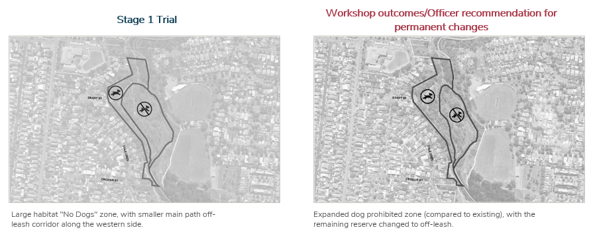
Figure1 Figure 2

Climate emergency and environmental sustainability implications
There are no specific climate emergency implications associated with this report.
Legal and risk considerations
Local Government Act 2020
The Local Government Act 2020 and Merri-bek's Local Laws provide requirements and guidance for how Merri-bek plans, delivers and manages our open space. The Local Government Act articulates that "the role of a Council is to provide good governance in its municipal district for the benefit and wellbeing of the municipal community" (section 8 (1)). The Local Laws provide clarity about responsibilities in our open spaces, including on-leash dog areas in our parks and playgrounds and protection of our natural environment in open spaces.
Domestic Animals Act 1994
Section 26 of the Domestic Animals Act 1994 allows Victorian Councils to prohibit dogs from certain public places within the municipality and a requirement for dogs to be on leash at all times, unless in a designated off-leash area as named by the Council.
Merri-bek Council has an existing Order that was amended in July 2025 to include the changes outlined in the Stage 1 pilot and this Order is proposed to be further amended as a result of the further community engagement activities and review of the Stage 1 pilot.
Human Rights Consideration
The implications of this report have given consideration to the requirements of the Charter of Human Rights and Responsibilities and there are no relevant implications for the proposed interventions of Stage 1. It is noted that Council has conducted extensive community engagement as part of this process, ensuring the views of the community have been considered in the proposals outlined in this report.
Affected persons rights and interests
Before making a decision that affects a person’s rights, Council must identify whose rights may be directly affected and provide an opportunity for that person (or persons) to convey those views regarding the effect on their rights and consider those views. Council has engaged directly with local community groups and users of Tate Reserve as part of both the Stage 1 Pilot project and conflict resolution process.

4. Officer Declaration of Conflict of Interest
Council officers involved in the preparation of this report have no conflict of interest in this matter.

5. Financial and Resources Implications
The proposed permanent interventions for Tate Reserve, following the conflict resolution process include:
• Nature based resting place with seating and drinking fountain
• Educational and nature signage
• Fencing
• Rock beaching on the creek (subject to Melbourne Water approval)
The cost to deliver these outcomes has been estimated to cost $122,850. This is currently unbudgeted and is proposed to be referred to the 26/27 Q1 Budget Forecast process for consideration.

6. Implementation
Subject to endorsement by Council and following Q1 2026-27 Budget Forecast Review process, officers will begin the implementation of the Tate Reserve changes. The changes will be staged, and information will be provided to the community, including through the Tate Reserve working group to ensure a smooth implementation process. Works will be subject to normal procurement processes.

Attachment/s
1 | Council Order - Dog off leash areas - August 2026 - Track Changed version | D26/333498
2 | Executive Summary - Tate Reserve Resolution process May 2026 | D26/335211

7.3 C236mbek - Gateway 2 - DCP 2.0 Consideration of Submissions and Request for a Planning Panel
Director Place and Environment, Pene Winslade
City Design and Economy

Officer Recommendation
That Council:
1. Notes and considers all submissions made on or before the last date of exhibition of Amendment C236mbek to the Merri-bek Planning Scheme (Amendment), in accordance with section 22(1) of the Planning and Environment Act 1987 (Vic) (Act).
2. Notes and considers late submissions made after the last date of exhibition of the Amendment in accordance with section 22(2) of the Act.
3. In relation to all submissions which were considered by Council, refers those submissions to an independent Planning Panel appointed by the Minister for Planning (Minister) under Part 8 of the Act in accordance with section 23 of the Act.
4. Endorses the response to submissions and the recommendations as set out in the C236mbek Engagement Report at Attachment 1 to form the basis of Council’s submission to the independent Planning Panel.
5. Authorises the Director Place and Environment to make administrative changes to the Amendment and to give directions on issues which arise in the course of the Panel hearing in response to expert evidence and submissions consistent with Council’s endorsed position in Attachment 1.

REPORT

Executive Summary
As Merri-bek grows, demand for new and upgraded roads, drainage and community facilities will increase. To ensure new development continues to contribute to this infrastructure need, Council has prepared a new 15-year Development Contributions Plan (DCP 2.0) to replace the previous plan, which expired earlier this year.
Planning Scheme Amendment C236mbek (the Amendment) proposes to introduce DCP 2.0 into the Merri-bek Planning Scheme by:
• Applying Schedule 2 to the Development Contributions Overlay (DCPO2) to all land within the municipality.
• Incorporating the Development Contributions Plan (Hill PDA, March 2026).
If approved, the Amendment will enable Council to continue collecting contributions from new development (DCP levy) to help fund essential infrastructure.
The Amendment was publicly exhibited for four weeks from 11 May to 17 June 2026. Four submissions were received, with the majority supporting the Amendment:
• The three supportive submissions welcomed the continuation of Merri-bek's development contributions program and recognised DCP 2.0 as an equitable mechanism to help fund essential infrastructure, including drainage upgrades.
• The one non-supportive submission raised concerns about the proposed transitional arrangements and the relationship between DCP 2.0 and the future Infrastructure Contributions Plan (ICP).
Officers have considered the submissions and issues raised and do not propose any changes to the Amendment. As such, this report recommends that Council endorses the Amendment as exhibited and request the Minister for Planning appoint an Independent Planning Panel to consider the Amendment and submissions received during exhibition.

Previous Council Decisions
C236mbek – Development Contributions Plan 2.0 – Gateway 1 – Authorisation & Exhibition – 14 May 2025
That Council:
1. Endorses the report Merri-bek Development Contributions Plan (April 2025) as shown in Attachment 1 as part of Amendment C236mbek.
2. Seeks authorisation from the Minister for Planning to prepare Merri-bek Planning Scheme Amendment C236mbek in accordance with section 8A of the Planning and Environment Act 1987.
3. Subject to the Minister’s authorisation, prepares Amendment C236mbek, generally in accordance with the documentation provided at Attachments 1 and 2.
4. Exhibits Amendment C236mbek in accordance with section 19 of the Planning and Environment Act 1987 and as outlined in the Consultation section of this report.
5. Authorises the Director Place and Environment to make changes to the Amendment prior to exhibition based on any conditions imposed in the authorisation granted by the Minister for Planning and to make administrative changes to correct errors and grammatical changes.

1. Policy Context
Council Plan 2025-2029
The Council Plan 2025-2029 (Council Plan) aims to create a healthy and inclusive municipality that cares for nature, is climate‑resilient, and provides beautiful, liveable spaces and places that support a vibrant community and a thriving economy and culture
The Council Plan identifies a DCP 2.0 as a key supporting strategy and policy to help achieve Theme 3 - Beautiful and Liveable City strategic objective:
Create safe, accessible streets and public spaces that support vibrant communities, active travel, rest and relaxation, and community pride, while ensuring development and growth are well managed and local character is celebrated, ensuring Merri-bek is a welcoming, liveable, and connected place for all.
Budget and Capital Works Program
Council’s adopted 4-Year Budget 2025-2029 (the Budget) sets out what Council will deliver in terms of services, infrastructure and projects over four years and how these activities will be funded. The Budget also contains Council’s 4-year Capital Works Program (CWP) that includes a detailed breakdown of project spending over the four-year budget period.
The 4-year Budget and CWP have informed the project list for the new DCP 2.0, with projects commencing in the 2026/27 financial year and onwards considered for inclusion in the DCP project list.
Planning and Environment Act 1987 and Ministerial direction
The Planning and Environment Act 1987 (the Act) provides the legal basis for a DCP by setting out the statutory framework that allows Council to collect development contributions to help fund identified infrastructure. This collection requires Council to deliver all the infrastructure projects listed in the DCP before its expiry and to apply collected funds solely to those identified projects.
The Ministerial Direction on the Preparation and Content of Development Contributions Plans (Ministerial Direction) provides direction to Councils on the preparation and content of a DCP, including where a DCP can be applied, what development can be exempt, and what can be funded from collected levies. It also sets out specific reporting requirements Councils must follow when they have a DCP.
Development Contributions Guidelines
The Development Contributions Guidelines, March 2007 (DCP Guidelines) prepared by the Victorian Government also guide the preparation of a DCP. They provide a clear and detailed direction on key concepts and required tasks in preparing a full cost apportionment DCP. They are also recognised by Planning Panels Victoria as the appropriate guide to the development of DCPs.
The proposed DCP 2.0 has been prepared in accordance with these guidelines.
Merri-bek Planning Scheme
Municipal Planning Strategy
Merri-bek’s Municipal Planning Strategy (MPS) at Clause 02.03-8 (Infrastructure – Community Infrastructure) includes the following strategic direction focused on providing infrastructure to support a growing and changing population:
In planning and delivering community infrastructure, Council supports:
• Providing accessible community infrastructure (e.g. health, education, social, leisure and cultural facilities) in different locations suited to the local community’s needs.
Planning Policy Framework
The Planning Policy Framework (PPF) includes state planning policies that apply in all planning schemes across the state. This includes existing policy related to development and infrastructure contributions at Clause 19.03-1S (Development and infrastructure contributions plans). This clause includes an objective to facilitate the timely provision of planned infrastructure to communities through the preparation and implementation of development contributions plans and infrastructure plans.
Strategies to support this objective include:
• Prepare development contributions plans and infrastructure contributions plans, under the Planning and Environment Act 1987, to manage contributions towards infrastructure.
• Collect development contributions.

2. Background

Development Contribution Plan Overlay
The Development Contributions Plan Overlay (DCPO) is a planning tool that enables councils to implement a DCP. The schedule to the DCPO sets out areas where development contributions are required to fund infrastructure, services, and works prior to development.
The DCPO does not itself trigger the need for a planning permit. Instead, it applies to planning permit applications for subdivision and for buildings and works within the overlay area, with requirements typically implemented through permit conditions. In addition, the levy is collected at defined points in the development process, including prior to the issue of a building permit or statement of compliance. This ensures that new development contributes to the infrastructure identified in the DCP.

Schedule 1 to the Development Contributions Plan Overlay
In 2015, Amendment C133 introduced Merri-bek’s first DCP the Moreland Development Contributions Plan 2015 (DCP 1.0) into the scheme and applied Schedule 1 to the Development Contributions Plan Overlay (DCPO1) to all land in the municipality. This DCP has played a key role in supporting the delivery of essential infrastructure since its introduction, delivery of 842 projects that had a total cost of approximately $115 million.
DCP 1.0 is no longer imposing levies on new development and expired on 30 June 2026.

Proposed Schedule 2 to the Development Contributions Plan Overlay

Amendment C236mbek proposes to introduce DCP 2.0, a 15-year Development Contributions Plan, into the Merri-bek Planning Scheme by applying Schedule 2 to the Development Contributions Plan Overlay (DCPO2) across the municipality. The proposed DCP 2.0 identifies road, streetscape, drainage and community infrastructure projects to be funded through development contributions required to support Merri-bek's projected growth. The Amendment was authorised by the Minister for Planning on 3 March 2026 and publicly exhibited from 11 May to 17 June 2026.

Infrastructure Contribution Plan levy
An Infrastructure Contribution Plan (ICP) and Infrastructure Contribution Plan Overlay (ICPO) is set to apply to the Brunswick and Coburg Activity Centres and their catchment (as defined by the Housing Choice and Transport Zone) as part of the Victorian Governments Activity Centre Program.
Similar to the DCP, the ICP is a contribution mechanism that will impose a levy on new development to help fund essential infrastructure. However, unlike the DCP, the ICP will not include a specific list of projects. Instead, it establishes a list of essential infrastructure categories for which collected contributions may be used.
The rates of the ICP are set by the Victorian Government and will be substantially higher than the DCP at:
• $11,350 per dwelling.
• $114 per sqm of commercial floor area over 100sqm.
• $57 per sqm of commercial floor area over 200sqm.
Council will likely be responsible for collecting the levies, keeping 2/3 to help fund Merri-bek’s local infrastructure and transferring 1/3 to the state to go towards state infrastructure.
It is anticipated that an amendment to introduce the ICP and ICPO into the Merri-bek Planning Scheme mid 2026 with collections to commence in July 2027.

3. Issues
The C236mbek Engagement Report at Attachment 1 includes a summary of all the submissions received during the exhibition period. It documents the key themes raised in each submission, along with a recommended response and proposed direction on each submission.
A total of four submissions were received, summarised in Table 1.
Table 1 – summary of submissions
Submission | Submission type | Summary of submission
Submission 1 | Supportive | The DCP 2.0 includes a suitable exemption for the types of works undertaken by the submitter.
Submission 2 | Supportive | With the expiry of Merri-bek’s current DCP, the proposed DCP 2.0 will support the ongoing collection of DCP levies.
Submission 3 | Supportive | The DCP 2.0 is an appropriate mechanism to equitably fund and deliver drainage infrastructure required to manage flood risk and support sustainable development.
Submission 4 | Not supportive and requesting changes | Opposes the DCP 2.0 being applied to current planning permit applications, requesting:  • Exclude any planning permits lodged prior to the gazettal of C236mbek from a DCP liability.  • Ensure the DCP liability is coordinated with the proposed state government ICP to ensure a development is not subject to duplicated or excessive infrastructure contributions.

Key Themes
The three supportive submissions are noted and do not raise any matters requiring changes to the Amendment. The only submission that did not support the Amendment, relating to land at 20 Leinster Grove, Brunswick East, raised two key issues, which are discussed below.
Issue 1 - Exemptions for current planning applications and financial implications
Planning applications lodged prior to the gazettal of C236mbek should be excluded from a DCP liability on the basis the additional levy creates an additional cost that has not been considered in the design and financially modelling at the time of lodgement.

Officer response
The DCP provides a fair and consistent method for new developments to contribute to the essential infrastructure required to support population growth. It uses population and development projections from 2026-2041 to inform the DCP levy rates and projected income.
The DCP is proposed to apply to developments that occur following gazettal of C236mbek, regardless of when a planning permit application was lodged. This approach is consistent in all current and past DCPs in Victoria. It is important that this approach is retained, as these developments will trigger a demand for infrastructure and were included in the demand assumptions used in the DCP. Excluding them would undermine the integrity and equitable distribution of the contribution framework underpinning the DCP.
The proposed DCP does include exemptions, and these exemptions are consistent with the directions in The Act and the DCP Guidelines, as well as DCP’s currently operating across Victoria.
No changes are recommended to the Amendment.

Issue 2 – DCP levy relationship with the ICP levy
Ensure that any new DCP liability is appropriately managed with the proposed state government ICP so that contributions are not duplicated or excessive.
Officer response
Both the DCP and the ICP are proposed to apply to the Brunswick and Coburg Activity Centres and their catchments, meaning a single development may be subject to two levies. The site 20 Leinster Grove Brunswick East is not within any of these areas where the ICP is currently proposed to apply.
However, there will be properties in the Merri-bek municipality where the proposed DCP and ICP will apply, meaning that a property will be subject to two different levies. The state government have outlined that to avoid an unreasonable financial burden on development, the calculated ICP levy operates as a cap on total contributions, with the ICP levy reduced by the calculated DCP levy payable for the same development
For example – a development generates the following levies from the addition of one dwelling:
• Calculated DCP levy = $284
• Calculated ICP levy = $11,350
The ICP levy is then adjusted to address the levy cap.
• DCP levy = $284
• ICP levy = $11,066
No changes are required or recommended to the Amendment.

Legal and risk considerations
DCP 2.0 is a legal instrument that obligates Council to deliver the infrastructure projects listed in the DCP before the DCP expiry date and to use the collected levies solely to fund the specified projects.
If Council resolves to not proceed with any of the infrastructure projects listed in the DCP, the funds collected for these projects can be reallocated to new projects with the Minister for Planning’s approval or refund the levies collected to affected landowners.
To address this risk, DCP 2.0 includes a four yearly review process to ensure that the DCP remains consistent with expected future development and infrastructure projects needs and costs.

Human Rights Consideration
The implications of this report have been assessed in accordance with the requirements of the Charter of Human Rights and Responsibilities and there are no adverse impacts. The human rights considered as part of the preparation of this report relate specifically to freedom, dignity, and equity.
The notification carried out as part of the Amendment does not limit or interfere with any Human Rights, in particular ‘Section 13: The right to privacy and reputation’, ‘Section 18: The right to take part in public life’, and ‘Section 20: Property rights’, with the following is noted:
• Any person may elect to take part in the process by providing a submission to the Responsible Authority.
• No parties are deprived of any legal or proprietary interest in land, or the ability to use and develop that land in accordance with the planning regulatory framework.
• A person is considered to be deprived of their property rights if a regulation has the effect of substantially depriving a property owner of the ability to use his or her property or part of that property. Amendment C236mbek implements existing planning scheme policy.
It is also considered that the proposed changes to the Merri-bek Planning Scheme by C236mbek will not have a direct or significant impact on gender equality.

4. Community consultation and engagement
Amendment C236mbek was publicly exhibited from 11 May 2026 to 17 June 2026. To support the public exhibition, direct notice was given to:
• Prescribed Ministers, relevant state government departments and authorities.
• Adjoining local Councils.
• Industry bodies with a development focus.
• Planning permit applicants (for development and subdivision) across a 26-month period (1 January 2024 to 5 March 2026).
• Building surveyors who registered permits across a 26-month period (1 January 2024 to 5 March 2026).
To reach the wider community and ensure the community had an opportunity to learn about the Amendment, the following notification was also undertaken:
• Public notice in the Government Gazette on the 14 May 2026.
• Public notice in the Herald Sun and The Age newspapers on 18 May 2026.
• Focussed Facebook post on 18 May 2026.
• A dedicated C236mbek webpage that provides information about the Amendment, including access to all the supporting documents, and a series of FAQs. The website also contains information on how to make a submission, including an online form to make it easy for people to make a submission.
Strategic Planning Officers were available for phone calls to talk about the Amendment with any member of the community.
Affected persons rights and interests
Before making a decision that affects a person’s rights, Council must identify whose rights may be directly affected and provide an opportunity for that person (or persons) to convey those views regarding the effect on their rights and consider those views.
Under section 19(1A) of the Act, it is considered impractical to individually notify every property owner throughout the municipality of the C236mbek proposed changes. Directly notifying the development industry, and specifically those who manage planning applications in Merri-bek for both development and subdivision (the type of applications relevant to a DCP) ensures that those who design new development in collaboration with owners are aware of the proposed DCP.
If resolved by Council, all submitters will also be invited to be part of an independent planning Panel Hearing. Here, interested submitters will have an opportunity to present their view on the Amendment to an independent panel of experts and can ask questions directly to the expert consultants.

5. Officer Declaration of Conflict of Interest
Council officers involved in the preparation of this report have no conflict of interest in this matter.

6. Financial and Resources Implications

Financial
Administrative costs associated with the processing of the Amendment will be met within the base budget of the Strategic Planning Unit.
Once implemented into the Merri-bek Planning Scheme, DCP 2.0 will generate a significant income stream for Council and assist in delivering Council’s CWP, particularly those infrastructure items forming part of DCP 2.0.
Based on a full development scenario, Council would collect approximately $24 million over the life of the DCP towards the delivery of identified infrastructure items. However, if development occurs at a slower rate than predicted in DCP 2.0, Council will collect fewer contributions and will have to cover the funding gap through its general rates budget to deliver the specified infrastructure projects.
One of the key principles in compiling the project list for DCP 2.0 was to avoid over-commitment and this was done by selecting projects from Council’s CWP and current road audit program. Community infrastructure projects have been included where there is a high degree of certainty that the project will be delivered.
This level of commitment also allows Council to manage any risks associated with a potential shortfall in development contributions due to a lower than anticipated rate of development, as Council will not over-commit to the delivery of infrastructure projects on an annual basis.

Resources
Council currently has an administrative policy in place which sets out the administrative processes to be followed when implementing DCP 1.0. An update to this policy is anticipated to ensure it aligns with DCP 2.0 and current best practice.
The administration of the DCP will have resourcing implications on several Council Branches and Units, who will oversee the levying of the DCP, receipt of payments and oversight of project delivery.

7. Implementation
The following timeline for the Amendment is broken down into the key ‘decision gateways’ for Council. The timeline is approximate and subject to not only Council’s continual approval at key decision gateways but also Ministerial approval timelines and Planning Panels Victoria reporting:
Decision Gateway 1 - Authorisation and exhibition (Completed).
Decision Gateway 2 - Submission Review and Panel Request:
• August 2026 - Consider submissions and seek the Ministers appointment of Panel.
• September 2026 - Panel Directions Hearing.
• October 2026 - Panel Hearing.
• December 2026 - Panel Report is provided to Council.
Decision Gateway 3 - Review Panel report and final decision:
• February 2027 - Report on the Panel’s recommendations and consider adoption. of final version of the Amendment.
• March 2027 - Submit the Amendment to the Minister of Planning for approval.
• Mid to late 2027 - Anticipated approval by the Minister of Planning.

Attachment/s
1 | C236mbek Engagement Report | D26/290999

7.4 Suburb Boundary Realignment Coburg North/Fawkner - Between Sydney Road and Merri-Creek.
Acting Director Business Transformation, Yvonne Callanan
Financial Services

Officer Recommendation
That Council endorses the realignment of the Coburg North and Fawkner suburb boundary to encompass properties at 90A Mathieson Street, 92 Mathieson Street, 12 Manly Court, 14 Borang Street, and 18 Albert Street Fawkner, into Coburg North as outlined in this report.

REPORT

Executive Summary
Development activity has created the need for a minor realignment of the Fawkner/Coburg North suburb boundary to ensure affected properties are addressed consistently with their road access and the Naming Rules for Places in Victoria.
The proposal would transfer 90A and 92 Mathieson Street, 12 Manly Court, 14 Borang Street and 18 Albert Street from Fawkner to Coburg North, resolving current mapping and addressing inconsistencies arising from recent development.
The impacted properties currently have ongoing issues with mail and service deliveries. In addition, inconsistencies with Vicmap create a risk for emergency services if there is a need to attend the property promptly. Realigning the suburb boundary will address these issues.
Consultation with directly affected owners who responded indicated support for the change. While no objections were received, some adjacent owners requested a broader boundary shift to the centreline of Queens Parade. This option is inconsistent with the current boundary and would affect a further 63 properties without the same demonstrated need.
A targeted realignment is recommended as the most appropriate response, supporting accurate addressing, service delivery and compliance with State naming requirements while avoiding unnecessary changes to established suburb boundaries.

Previous Council Decisions
Nil.

1. Policy Context
Merri-bek Council is a Naming Authority under the Geographic Place Names Act 1998 (the Act) and is the first point of contact for adding or changing names for places, features and roads within the municipality.
The Naming rules for places in Victoria 2022 (The Naming Rules), are the statutory guidelines provided for under section 5 of The Act that provide standardised naming conventions and clear naming procedures. Any naming proposal must conform to these guidelines.
Proposals are assessed for compliance with the ‘The Naming Rules’ including, Australian Standards AS NZS 4819-2011 Rural and Urban Addressing (The Standards). Once endorsed by Council the proposal is forwarded to the Registrar of Geographic Names for consideration.
The relevant sections of the ‘The Standards’ and ‘The Naming Rules’ are as follows:
• Section 3.4.2 of the Standards requires that boundaries of localities in areas that are subject to development should be reviewed and amended where appropriate.
• Section 5.2.1 of the Naming Rules requires the suburb boundary to wrap around properties at the end of the road in dead-end roads and cul-de-sacs, to ensure that all properties accessed from the same road are addressed to the same locality.
• Section 1.3 of the Naming Rules also require applications to assess and address any impact to the United Nations Group of Experts on Geographical Names resolutions, Sustainable Development Goals and Victorian Aboriginal Affairs Framework goals, where relevant.

2. Background
The Coburg North/Fawkner locality boundary sits at the rear of properties facing Queens Parade between Sydney Road and Merri Creek, encompassing all Queens Parade into Fawkner (See figure 1).
While locality boundaries are intended to be enduring, in areas subject to development, boundaries need to be reviewed and amended where appropriate. Several Queens Parade properties have been subdivided, creating properties that front onto streets attributed to Coburg North (affected properties shown in figures 1 & 2).
The proposed realignment would place properties accessed from Coburg North streets within Coburg North. This change is required to comply with state naming rules, meet addressing standards and prevent mapping anomalies (See figure 2).
Figure 1. Current boundary
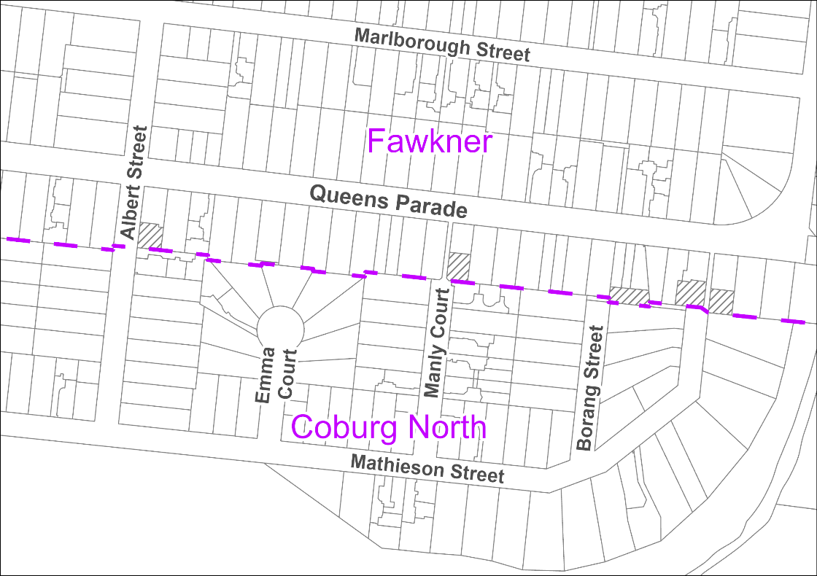
Figure 2. Proposed Boundary
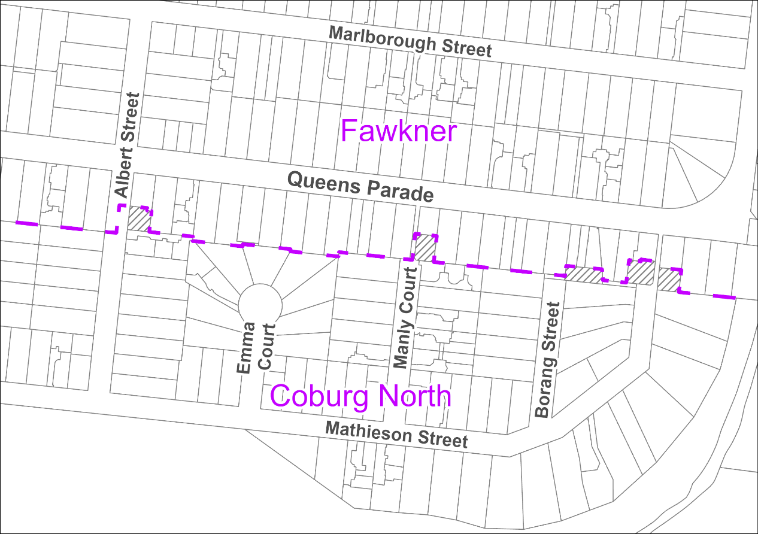
Figures 3 – 6 below and on the following pages, show the five affected properties in greater detail.
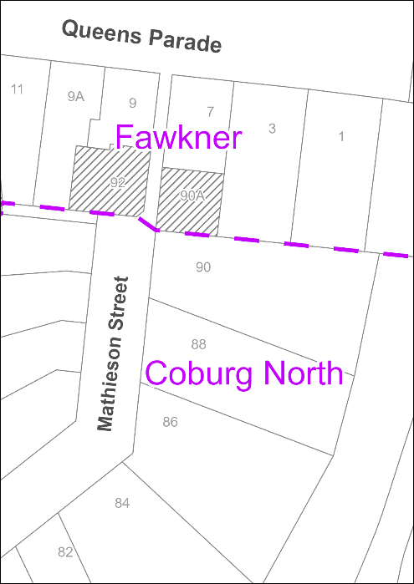
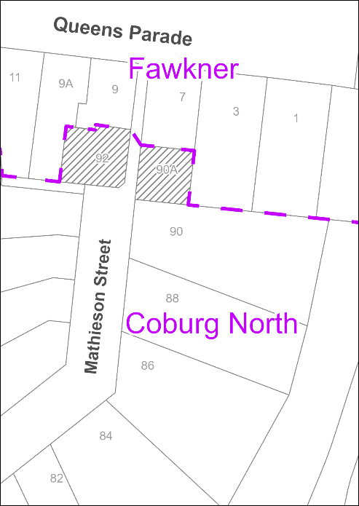
Figure 3. Mathieson Street current and proposed

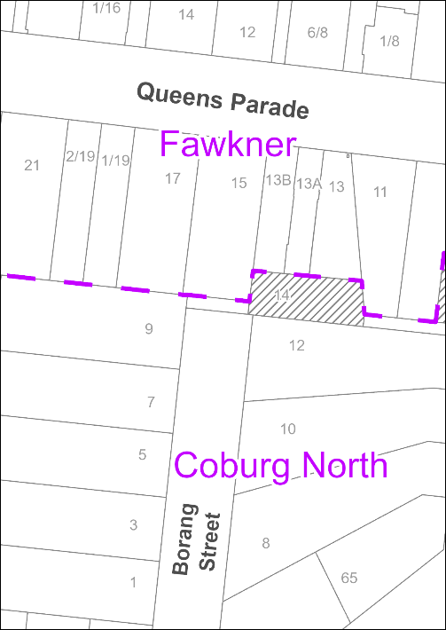
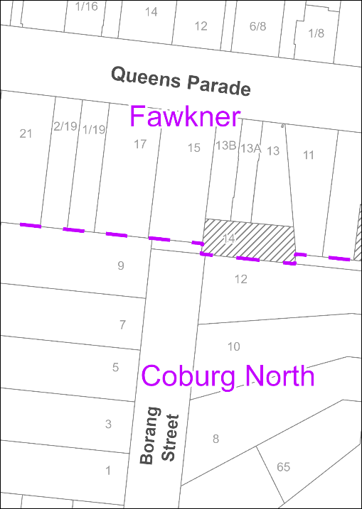
Figure 4. Borang Street current and proposed
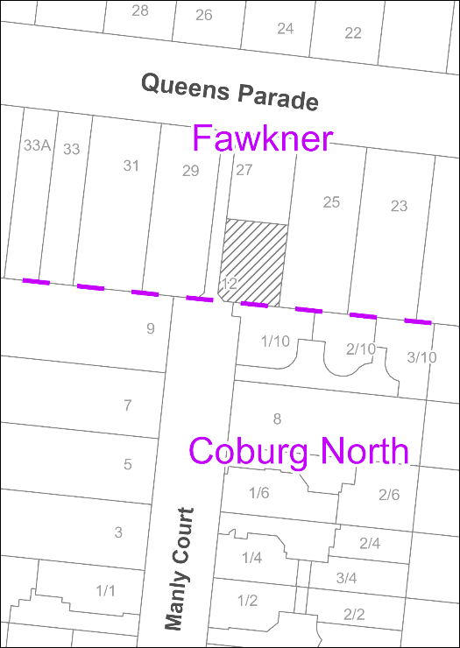
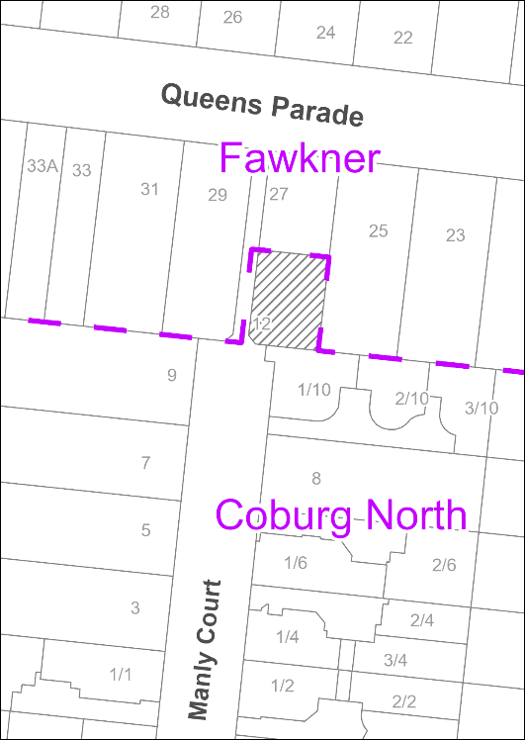
Figure 5. Manly Court current and proposed
Figure 6. Albert Street current and proposed
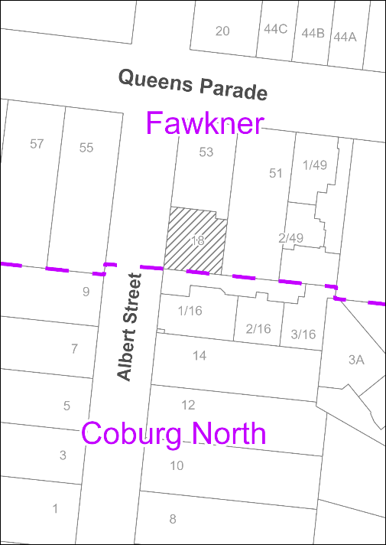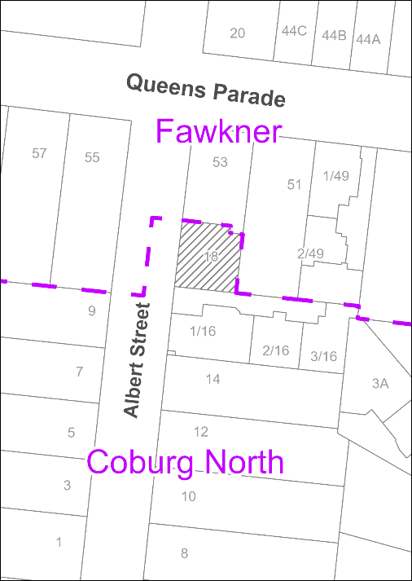
In accordance with Section 5.2.1 of ‘The Naming Rules’ it is recommended is to amend the locality boundary to incorporate the properties into the Coburg North suburb. Council officers have assessed that this proposal meets all relevant statutory requirements including the following:
• Conforms to the statutory requirements in Section 5.2 of ‘The Naming Rules’.
• All naming conventions are being properly followed due to locality names remaining unchanged.
• The locality boundaries sit wholly within Merri-bek municipality therefore Council does not need to consult with neighbouring municipalities.
• The amendment is a small realignment with no impact to United Nations Group of Experts on Geographical Names resolutions, Sustainable Development Goals, or Victorian Aboriginal Affairs Framework goals.
Once Council resolves to realign the boundary, it is submitted the Geographic Names Victoria Registrar for finalisation and gazettal whereby the Land Victoria maps are amended. After this occurs addressing can then be changed to the impacted properties.

3. Issues
The impacted properties currently have ongoing issues with mail and service deliveries. In addition, inconsistencies with Vicmap create a risk for emergency services if there is a need to attend the property promptly. Realigning the suburb boundary will address these issues.

Community impact
The proposed change has a positive community impact in terms of addressing risk for emergency services and addressing mail and service delivery issues.

Climate emergency and environmental sustainability implications
There are no climate emergency implications associated with this report.

Economic sustainability implications
There are no economic sustainability implications related this matter.

Legal and risk considerations
The recommendations in this report comply with the requirements of the Geographic Place Names Act 1998 and the Naming rules for places in Victoria 2022.

Human Rights Consideration
The implications of this report have been assessed in accordance with the requirements of the Charter of Human Rights and Responsibilities and there are no implications associated with this report.

4. Community consultation and engagement
Council's Community Engagement Policy 2024 requires community engagement when community impact is anticipated. As the proposed boundary realignment has negligible community impact and limited scope for community influence, directly affected persons were contacted directly.
A public notice was published on the Conversations Merri-bek page, inviting submissions for 40 days and exceeding the minimum 30-day requirement under the Naming Rules.
Affected persons rights and interests
Before making a decision that affects a person’s rights, Council must identify whose rights may be directly affected and provide an opportunity for that person (or persons) to convey those views regarding the effect on their rights and consider those views.
Letters were sent to ratepayers and residents of directly impacted properties, and properties adjacent to the proposed boundary change inviting submissions. A public notice was also published on the Conversations Merri-Bek Page, inviting submissions for 40 days meeting the minimum 30 days as per the Naming Rules.
All directly affected owners that responded indicated support for the change. While no objections were received, two submissions were received from adjacent owners requesting the boundary instead shift to the centreline of Queens Parade. This option would have the effect of incorporating their properties into Coburg North.
While this approach is an option under the Naming Rules it is inconsistent to the historical boundary and would require a broader consultation involving 63 directly affected properties and an undetermined number of indirectly affected properties. The impact would affect a substantially larger area without the same demonstrated need.
The proposed boundary realignment outlined in this report has been assessed as necessary due to the risks affecting the directly impacted properties. Given the support of the directly impacted owners, the proposed targeted realignment is recommended.

5. Officer Declaration of Conflict of Interest
Council officers involved in the preparation of this report have no conflict of interest in this matter.

6. Financial and Resources Implications
There are no financial implications of this report. The lodgement to Geographic Names Victoria and issuing of addressing reflecting the suburb boundary change can be completed with the current resources in the Financial Services budget.

7. Implementation
Should Council support the recommendation of this report, Council officers will submit the resolution to Geographic Names Victoria Registrar for finalisation and gazettal whereby the Land Victoria maps are amended.
Once complete, the address of the impacted properties will be updated and other relevant government departments, Yarra Valley Water and Australia Post will be notified.

Attachment/s
There are no attachments for this report.

7.5 Year 1 Council Action Plan 2025-26 - Fourth Quarter Performance Report
Acting Director Business Transformation, Yvonne Callanan
Governance and Strategy

Officer Recommendation
That Council:
1. Receives and notes the Year 1 Council Action Plan 2025-26 – Fourth Quarter Performance Report (provided as Attachment 1).
2. Endorses the proposed withdrawal of Action 68 – ‘Redesign grants program to support more opportunities to create, learn and connect,’ noting that this action is proposed to be included in the Merri-bek Council Action Plan 2026-2027.

REPORT

Executive Summary

The Fourth Quarter Performance Report (Attachment 1) provides an overview of Council's performance in delivering the Council Plan 2025–2029, with a specific focus on implementation of the Year 1 Council Action Plan 2025–26.
The report highlights key achievements and progress across initiatives supporting Council's strategic objectives and provides a status update on the 79 adopted actions, as follows:
• 25% (20 actions) concluded and achieved
• 71% (56 actions) are in progress and on track
• 3% (2 actions) were endorsed by Council to be placed on hold or withdrawn
• 1% (1 action) is proposed to be placed on hold or withdrawn.
Overall, 96% of Council Action Plan actions were completed or remain on track for delivery, reflecting strong implementation of the first year of the Council Plan 2025–2029. The majority of actions in progress are multi-year initiatives that will continue through the remaining years of the Council Plan.
A further action (Action 68 – Redesign grants program to support more opportunities to create, learn and connect) is proposed to be withdrawn from the Year 1 Council Action Plan 2025–26 and considered for inclusion in the Year 2 Council Action Plan 2026–27, as outlined in the issues section of this report.
Previous Council Decisions
Year 1 Council Action Plan 2025–26 – Third Quarter Performance Report – 13 May 2026
That Council:
1. Received and notes the Year 1 Council Action Plan 2025-26 – Third Quarter Performance Report (provided as Attachment 1).
2. Noted that Action 68 - Redesign grants program to support more opportunities to create, learn and connect is currently behind schedule.
3. Endorsed withdrawal of Action 12, (relating to expanding Council's practice to ensure Council buildings and infrastructure are environmentally sustainable) noting that this action is proposed to be replaced by two specific actions in the proposed Merri-bek Council Action Plan 2026-2027 to improve clarity and strengthen intended outcomes.
Year 1 Council Action Plan 2025–26 - Second Quarter Performance Report – 11 February 2026
That Council:
1. Receives and notes the Year 1 Council Action Plan 2025-26 – Second Quarter Performance Report (provided as Attachment 1).
2. Endorses to place on hold Action 53 - Deliver the Wheatsheaf Road Glenroy streetscape improvement project.
Adoption of the Merri-bek Community Vision 2025–2035, Merri-bek Council Plan 2025–2029 and Merri-bek Council Action Plan 2025–2026 – 10 September 2025
That Council:
1. Adopted the Merri-bek Community Vision 2025-2035 (provided as Attachment 1) in accordance with legislative requirements of the Local Government Act 2020.
2. Adopted the Merri-bek Council Plan 2025–2029 (provided as Attachment 1) in accordance with legislative requirements of the Local Government Act 2020 and the Public Health and Wellbeing Act 2008, noting that it incorporates the Municipal Public Health and Wellbeing Plan 2025-2029.
3. Adopted Merri-bek Council Action Plan 2025-2026 (provided as Attachment 2) as the first year of actions to deliver against the Merri-bek Council Plan 2025-2029, with an additional action to be added under Theme 2: Healthy and Inclusive Communities, at initiative 2.9. to read: “Explore, including though partnership arrangements, ways to improve health, access and inclusiveness in public & private spaces for people in precarious housing such as access to toilets and bathrooms, seating under shelter, showers, lockers and a place to heat food as well as improved access to services.”
4. Authorised the Director Business Transformation to finalise the Merri-bek Community Vision 2025-2035, Merri-bek Council Plan 2025-2029 and Merri-bek Council Action Plan 2025-2026, including any minor administrative changes, professional design of the documents and online versions, for distribution and implementation.
5. Advised submitters that Council has considered their submissions relating to the Draft Council Plan 2025-2029 and that the submitters be advised of the outcome of the consideration, as it relates to their specific submission through this council report (provided as Attachment 3), and they be thanked for their contributions.
6. Thanked, the members of the Community Panel and Community Youth Panel for their contribution and advise them in writing of the outcome of Council’s decision.

1. Policy Context
In accordance with sections 88 and 90 of the Local Government Act 2020, Council adopted its revised Community Vision 2025-2035 and a new Council Plan 2025-2029 in September 2025.
The Year 1 Council Action Plan 2025-26 supports the implementation of the Council Plan 2025-2029 for the first financial year of the 4-year period and includes specific actions to be undertaken, resourced through the 2025-26 annual budget (included in the 2025-2029 budget).
This report demonstrates Council’s continuing commitment to manage funds sustainably, equitably and transparently on behalf of ratepayers, key stakeholders and the broader community.

2. Background
This report presents the fourth quarter performance results for the Year 1 Council Action Plan 2025–26, providing a year-end assessment of Council's progress in delivering the first year of the Council Plan 2025–2029.

3. Issues
Overall, 96% of actions have been completed or remain on track for delivery, with a majority of actions in progress representing multi-year initiatives that continue into the Year 2 Council Action Plan 2026–27.
One action, Action 68 – ‘Redesign grants program to support more opportunities to create, learn and connect,’ is proposed to be withdrawn from the Year 1 Council Action Plan 2025–26. If endorsed, will be included in the Year 2 Council Action Plan 2026–27, increasing the total number of actions from 82 to 83 for the adopted plan.
A summary of key highlights is provided below, with detailed fourth-quarter performance updates included in Attachment 1.
Theme 1: Care for nature and climate resilience:
Council continued to implement a broad range of initiatives that support climate resilience, biodiversity, and environmental sustainability throughout Merri-bek. The annual tree planting season commenced with a target of planting 2,800 trees, while the Tree for Me pilot program was established to support tree planting in schools, retirement villages, and residential backyards. Initial engagement commenced with community partners, including a retirement village and a local primary school, to support future planting opportunities and community participation.
Integrated water management and biodiversity outcomes also advanced, including completion of the native understorey planting trial across five locations, progression of major stormwater harvesting and wetland projects, and embedding water-sensitive urban design principles into strategic planning for Coburg and Brunswick. Council also successfully delivered the Community Budget Ideas-funded Lizards with Bikes project, transforming the Coburg Velodrome underpass through a new mural and landscaping, celebrated with a community planting day and official opening.
Throughout the year, Council continued to support community climate action through sustainability, energy efficiency, and circular economy initiatives. The Home Energy Subsidy Program delivered thermal upgrades for 12 low-income households and solar photovoltaic systems for a further three households, with an additional 33 households progressing through the program. The Solar Savers program also supported 136 households seeking quotes for all-electric home energy upgrades.
Theme 2: Healthy and inclusive communities:
Council continued to strengthen community wellbeing, inclusion and participation through targeted programs, strategic partnerships, and investment in community services. Extensive engagement with young people helped shape the future provision of free third spaces across Merri-bek, with more than 400 survey responses and a Youth Summit informing a feasibility study that will guide future Council decision-making. Council also successfully delivered the Community Budget Ideas-funded Take the Lead program, empowering young women to challenge gender stereotypes and co-design campaigns promoting respectful relationships.
Support for older residents and vulnerable community members expanded through personalised assistance, outreach programs, and community-based services. The Outdoor Help Program supported 427 older residents, representing a 63% increase in participation compared with the previous year, while the Age Well Program provided personalised support to 275 residents and engaged a further 883 community members through 60 outreach events. Progress also continued on key community infrastructure projects, including the Brunswick Early Years Hub.
Partnerships with First Peoples, community organisations and service providers continued to grow through progress on the First Peoples Self-Determination Strategy, expanded homelessness and Library Social Work support, and affordable housing initiatives. More than 250 people attended Ballerrt Mooroop Day, celebrating the return of the site to Wurundjeri ownership and an important milestone in First Peoples self-determination.
Theme 3: Beautiful and liveable city:
Council continued to enhance safe, accessible, and vibrant public spaces across Merri-bek through investment in parks, streets, and sustainable transport initiatives. During the year, Council delivered upgrades to Gervase Reserve and H.M. Dowd Reserve, completed a new local park in Pascoe Vale through the Park Close to Home Program, and delivered the Community Budget Ideas-funded Gilpin Dog Park upgrade, including a new enclosed area for small dogs.
Amenity and safety improvements were also delivered across Merri-bek's public spaces, including the installation of 16 new in-ground market umbrellas in Victoria Mall in partnership with local businesses to increase shade and enhance the visitor experience. Hooning prevention measures were also implemented across reserve car parks in Glenroy and Hadfield, with detailed design work progressing to incorporate increased tree canopy, integrated water management, and water-sensitive urban design into future upgrades.
Active and sustainable transport initiatives continued to expand across the municipality, with the largest Ride & Stride e-bike subsidy program to date supporting more than 119 families. Active travel initiatives continued across 16 schools, Open Streets programs were delivered at five schools, and more than 20 Home-to-Street electric vehicle charging installations were completed to support the transition to lower-emission transport options.
Theme 4: Thriving economy and culture:
Investment in local businesses, activity centres, and creative industries reinforced Merri-bek's position as a vibrant destination to live, work and visit. During the year, Council delivered 36 business skills workshops and networking events, facilitated 66 business permit concierge services, progressed revitalisation projects across Coburg and Glenroy, and partnered with RMIT University and Creative Victoria to deliver Melbourne Design Week as part of the Brunswick Design District. The Brunswick Design District's digital presence was also enhanced through a new online directory showcasing more than 100 creative businesses and spaces.
Key placemaking initiatives advanced across Merri-bek's activity centres, with streetscape improvements progressing in West Street, Hadfield, and the detailed design for the Belair Avenue streetscape project completed. Council also endorsed the Places for People Plan, establishing a long-term vision for creating high-quality public spaces that support vibrant shopping strips and activity centres.
Art and culture continued to enrich Merri-bek's public spaces, with five new public art projects delivered across the municipality. These projects showcased local and First Peoples artists while celebrating creativity, strengthening local identity and creating welcoming places for the community.
Theme 5: Engaging and responsible council:
Advocacy remained a key focus throughout the year, with Council working alongside State and Federal Governments, regional alliances, and sector partners to progress shared priorities. Council published its 2026 Victorian State Election Advocacy Priorities, made submissions on matters including anti-LGBTIQA+ hate crimes and social cohesion, and secured more than $4.1 million in external funding to deliver priority community infrastructure projects.
The Community Connectors Program expanded Council's reach and engagement with Merri-bek's diverse communities, with 20 Community Connectors representing more than 11 communities and languages sharing Council information through trusted local networks. During the year, the program shared more than 180 multilingual Council messages, reached an audience of more than 65,000 community members, and contributed to increased participation across Council initiatives, including a 42% increase in multicultural participation in the Community Budget Ideas process and a 45% increase in kindergarten enrolments from multicultural families through targeted in-language communications.
Organisational resilience and long-term planning also advanced through climate risk management and financial sustainability initiatives that will inform future investment and decision-making. Detailed design and delivery planning for the Breese Street precinct improvements also progressed following Council's endorsement of the preferred concept design.
Detailed updates for fourth quarter performance are shown in Attachment 1.
Completed actions (Achieved)
Since the Third Quarter Report presented in May 2026, 20 actions have been completed. These actions were intended for delivery within the 2025–26 financial year and have now achieved their intended outcomes.
Notably, the completed actions include delivery of the 2025–26 Community Budget Ideas, demonstrating Council's commitment to implementing community-prioritised initiatives.
These included:
• Facilitating the Lizards with Bikes: Revitalising the Coburg Velodrome Underpass project
• Delivering youth-led initiatives to challenge gender-based violence
• Completing improvements to the Gilpin Dog Park, as part of the broader Dog Walking in Merri-bek initiative.
These outcomes demonstrate the Council Action Plan's contribution to delivering priorities identified by both the community and Councillors, with transparent reporting of progress and outcomes. Detailed performance updates for all completed actions are provided in Attachment 1.
In Progress (On Track)
A total of 56 actions (71%) were on track to deliver against the outcomes of the Year 1 Council Action Plan 2025–26. These are multi-year actions that will continue into the Year 2 Council Action Plan 2026-27, reflecting Council's ongoing commitment to delivering long-term strategic priorities over the four-year Council Plan period. Detailed performance updates are provided in Attachment 1.
Endorsed withdrawn
Two actions (3%) were endorsed for withdrawal from the Year 1 Council Action Plan 2025–26 to enable a revised approach to delivery. Both actions have been incorporated into the Year 2 Council Action Plan 2026–27, as outlined in the table 1 below.
Table 1: Actions incorporated into the Year 2 Council Action Plan 2026-27
Action # | Action Description and Update | Directorate
12 | Expand Council's practice to ensure Council buildings and infrastructure are environmentally sustainable in their planning, design, and implementation. In the first year, focus on tangible increases to recycled content.  Over four years work towards new buildings and infrastructure that is 100% renewably powered, lower carbon, reflect circular economy principles, consider ways to be more climate resilient and adapted and work is prioritised to reflect greatest need.  Action Update:  This action was endorsed to be withdrawn from further reporting at the May 2026 Council meeting and were adopted in the 2026-27 Action Plan as:  Action 84: Deliver climate vulnerability improvements to the following Council owned facilities; Fawkner Maternal Child Health, Yooralla Community Hub and Newlands Senior Citizens Centre.  Action 85: Develop and implement a whole-of-program capital works prioritisation framework that integrates asset condition, service need, climate vulnerability, social, economic, disability, inclusion and environmental considerations. | City Infrastructure
53 | Deliver the Wheatsheaf Road Glenroy streetscape improvement project (over two years)  Action Update:  This action has been placed on hold for the remainder of the financial year, with Council endorsing this position at its February 2026 Council meeting due to external factors impacting delivery. As a multi-year initiative, the action has been included in the Year 2 Council Action Plan 2026-27. | Place and Environment
Proposed Withdrawn
One action (1%) is currently classified as 'Proposed Withdrawn' under the Year 1 Council Action Plan 2025–26. Further detail is provided in the table 2 below. Subject to endorsement, this action will also be included in the Year 2 Council Action Plan 2026–27.
Table 2: Proposed to be withdrawn action
Action # | Action Description and Update: | Directorate
68 | Redesign grants program to support more opportunities to create, learn and connect  Action Update:  The review and redesign of the Community Grants Program has been deferred to enable a more comprehensive program review and redesign process. Subject to Council endorsement, this work will be progressed through the Year 2 Council Action Plan during the 2026/27 financial year. | Community

Community impact
Community impact is addressed throughout the Council Plan 2025-2029 but primarily under strategic objective 5: Engaging and Responsible Council - A responsive and engaged Merri-bek that prioritises excellent service, embraces engaging communication methods, advocates community needs, and continues to uphold sustainable financial management and accountable governance that builds trust and collaboration with the community.
Climate emergency and environmental sustainability implications
Climate emergency and environmental sustainability considerations are embedded throughout the Council Plan 2025–29. These objectives are proactively addressed under strategic objective 1: Care for Nature and Climate Resilience - To create a flourishing and climate resilient Merri-bek by improving wildlife and nature connectivity, greening and cooling for healthier streets and public realm, and engaging the community in meaningful climate action. In addition, there are broader climate, health and environmental implications reflected across the plan as a whole.

Economic sustainability implications
Economic sustainability is addressed across the Council Plan 2025–29, with key focus under strategic objective 4: Thriving Economy and Culture - A lively and inclusive Merri-bek where the economy supports local business and industry growth, celebrates artistic and creative expression, and connects the community through vibrant cultural experiences; and strategic objective 5: Engaging and Responsible Council. These objectives together promote economic resilience by supporting local economic activity while maintaining strong governance, financial sustainability, and accountability in Council decision-making.

Legal and risk considerations
The Merri-bek Community Vision 2025-35 and Merri-bek Council Plan 2025-2029 and processes associated with the development of these documents have been undertaken in accordance with the requirements of the Local Government Act 2020 and the Public Health and Wellbeing Act 2008.

Human Rights Consideration
The implications of this report have been assessed in accordance with the requirements of the Charter of Human Rights and Responsibilities.

4. Community consultation and engagement
Community consultation and engagement was not required for this report as it reflects the performance against the Council Plan 2025-2029.
Affected persons rights and interests
Before making a decision that affects a person’s rights, Council must identify whose rights may be directly affected and provide an opportunity for that person (or persons) to convey those views regarding the effect on their rights and consider those views. There are no individual rights or interests affected.

5. Officer Declaration of Conflict of Interest
Council officers involved in the preparation of this report have no conflict of interest in this matter.

6. Financial and Resources Implications
All actions documented in the Council Action Plan 2025-26 are resourced through the 2025-26 annual budget (included in the 2025-2029 Budget).

7. Implementation
The fourth quarter Council Action Plan 2025–26 performance results will be:
• published on Council’s website;
• reported through the Report of Operations in Council’s 2025–26 Annual Report; and
• presented to the Audit and Risk Committee in November 2026 as part of the Council Plan 2025–2029 – First Year Implementation Report.

Attachment/s
1 | Council Action Plan Report 2025-26 - Progress Report - Quarter 4 | D26/308238

7.6 Open Council Resolutions Report
Acting Director Business Transformation, Yvonne Callanan
Governance and Strategy

Officer Recommendation
That Council receives and notes the Open Council Resolutions Report provided as Attachment 1 to this report.

REPORT

Executive Summary
The Open Council Resolutions Report provided as Attachment 1 has been prepared to inform Councillors and the community of the actions taken to date to implement Council resolutions that are currently open and not yet finalised.
There are currently 39 open Council resolutions, with 2 of these relating to Petitions, 19 relating to Council officer reports and 18 relating to Notices of Motion.

Previous Council Decisions
Open Council Resolutions Report – 13 May 2026
That Council receives and notes the Open Council Resolutions Report provided as Attachment 1 to this report.

1. Policy Context
Section 46(2) of the Local Government Act 2020 states:
(a) That Chief Executive Officer has responsibility for ensuring that the decisions of the Council are implemented without undue delay.
(e) When requested by the Mayor, reporting to the Council in respect of the implementation of a Council decision.
This report also supports Council’s continuing commitment to transparent management of resources on behalf of ratepayers, key stakeholders and the broader community.

2. Background
The purpose of the Open Council Resolutions Report, provided as Attachment 1, is to inform Councillors and the community of the actions taken to date to implement the Council resolutions that are currently open.

3. Issues
The Open Council Resolutions Report (shown at Attachment 1) outlines the open resolutions and indicates that there is a total of 39 Open Resolutions, with 2 of these relating to Petitions, 19 relating to Council officer reports and 18 relating to Notices of Motion. Each open resolution in Attachment 1, includes a target date for completion.
The table below details the allocation of open items - Petitions, Council Reports, Notices of Motion, and Urgent Business—across each Directorate and the CEO Executive Office:
Directorate | Petitions | Council Reports | Notices of Motion | Urgent Business
Chief Executive Office | - | - | - | -
Business Transformation | - | 1 | - | -
City Infrastructure | - | - | 1 | -
Community | - | 2 | 9 | -
Place and Environment | 2 | 16 | 8 | -
 | 2 | 19 | 18 | 0
Attachment 1 excludes resolutions relating to Confidential Items and items relating to Planning and Related Matters.
An Open Council Resolutions report is presented to Council on an ongoing basis, to promote the transparency of how Council resolutions are implemented.

Community impact
Community impact is addressed through the Council Plan 2025-2029 under strategic objective 4: Act with transparency and accountability in all financial and governance practices, setting the standard for integrity and building trust within the community.

Climate emergency and environmental sustainability implications
Some open resolutions may, once completed, deliver benefits that support climate emergency and environmental sustainability outcomes.

Economic sustainability implications
There are no economic sustainability implications associated with the preparation of this report.

Legal and risk considerations
There are no legal and risk implications associated with the preparation of this report.

Human Rights Consideration
The implications of this report have been assessed in accordance with the requirements of the Charter of Human Rights and Responsibilities.

4. Community consultation and engagement
Community consultation and engagement is not required for this report as it reflects the status of the implementation of Council Decisions that have been previously made.
Affected persons rights and interests
Before making a decision that affects a person’s rights, Council must identify whose rights may be directly affected and provide an opportunity for that person (or persons) to convey those views regarding the effect on their rights and consider those views. There are no individual rights or interests affected.

5. Officer Declaration of Conflict of Interest
Council officers involved in the preparation of this report have no conflict of interest in this matter.

6. Financial and Resources Implications
Any financial implications associated with the preparation of this report have been met within existing resource and budget allocations.

7. Implementation
The reporting of the Open Council Resolutions will continue on an ongoing basis, with the next report to be presented to Council in November 2026.

Attachment/s
1 | Open Council Resolutions Report for the period ending 30 June 2026 | D26/327250

7.7 Governance Report - August 2026 - Cyclical Report
Acting Director Business Transformation, Yvonne Callanan
Governance and Strategy

Officer Recommendation
That Council:
1. Notes the summary of minutes from Advisory Committees at Attachment 1 to this report, as follows:
a) Friends of Aileu Community Committee held 16 June 2026.
b) Environmental Sustainability and Climate Resilience Advisory Committee held 23 June 2026.
2. Notes the Records of Meetings, at Attachment 2 to this report.
3. Notes responses to questions taken on notice during Public Question Time at the 13 May, 10 June and 8 July 2026 Council meetings, provided at Attachment 3 to this report.
4. In the exercise of the powers conferred by section 147(4) of the Planning and Environment Act 1987 and section 313 of the Local Government Act 2020:
a) Appoints and authorises Council staff referred to in the Instrument at Attachment 4 to this report, as set out in the instrument.
b) Determines the instrument comes into force immediately, the common seal of Council is affixed to the instrument, remains in force until Council determines to vary or revoke it, and revokes the previous instrument executed on 26 February 2026.
c) Authorises the affixing of Council’s common seal.
5. Endorses the following motions (provided at Attachment 5) for submission to the next Municipal Association of Victoria State Council meeting:
a) Advocating for the continuation of the Commonwealth Home Support Program
b) Increase Living Libraries funding.
6. Notes the regional advocacy activities undertaken through the Northern Councils Alliance and Melbourne 9.
7. Endorses the regional advocacy priorities and advocacy actions undertaken by the Northern Councils Alliance and Melbourne 9.

REPORT

Executive Summary
The Governance report is prepared as a monthly standing report to Council which provides a single reporting platform for a range of statutory compliance, transparency, and governance related matters. This report includes:
• A summary of the minutes of Advisory Committees.
• Records of Meetings, with a recommendation that Council notes the records.
• Responses to Public Question Time items taken on notice at the 13 May, 10 June and 8 July 2026 Council meetings, with a recommendation that Council notes the responses.
• A recommendation that Council appoints and authorises the Council officers referred to in the Instrument of Appointment and Authorisation (Planning and Environment Act 1987).
• Councillor initiated proposed motions for Council’s consideration and endorsement to the Municipal Association of Victoria State Council meeting, on the following topics:
- Advocating for the continuation of the Commonwealth Home Support Program
- Increase Living Libraries funding.
• An update of regional advocacy activity undertaken through the Northern Councils Alliance and Melbourne 9, and an update of formal advocacy priorities of the Northern Councils Alliance and Melbourne 9.

Previous Council Decisions
Governance Report – February 2026 – Cyclical Report – 11 February 2026
That Council:
…
10. In the exercise of the powers conferred by section 147(4) of the Planning and Environment Act 1987 and section 313 of the Local Government Act 2020:
a) Appoints and authorises Council staff referred to in the Instrument at Attachment 4 to this report, as set out in the instrument.
b) Determines the instrument comes into force immediately, the common seal of Council is affixed to the instrument, remains in force until Council determines to vary or revoke it, and revokes the previous Instrument executed on 1 December 2025.
c) Authorises the affixing of Council’s common seal.
…
Governance Report – August 2025 – Cyclical Report – 13 August 2025
That Council:
…
4. Endorses the following motions (provided as Attachment 4) for submission to the next Municipal Association of Victoria State Council meeting:
a) Emergency Services and Volunteer Fund
b) Keep in-home aged care services in Council hands
c) Protect the future of our public pools.
…

1. Policy Context
The Local Government Act 2020 (the Act) and the Governance Rules set out the requirements for keeping and reporting records of meetings held under the auspices of Council.
Council’s Governance Rules contains provision which enable the Chairperson to take a questions On Notice, with a considered written response being provided to the questioner, in circumstances including where the question requires information that is either not available or accessible at the time of that meeting, or where the time allowed for Public Question Time has elapsed.
Authorisation of planning officers under the Planning and Environment Act 1987 is done in accordance with said Act.
The Municipal Association of Victoria (MAV) is the legislated peak body for local government in Victoria. Council appoints a representative to the MAV to participate at, amongst other things, the two State Council Meetings held annually, and vote in accordance with Council’s policy positions.
The Merri-bek Council Plan 2025-29 identifies advocacy as a core function of Council. Key advocacy priorities include:
• securing investment in community infrastructure and services
• addressing the social determinants of health
• increasing social and affordable housing
• influencing planning reform
• supporting arts and cultural development
• advancing climate action
• promoting community safety and inclusion.
The Plan commits Council to coordinating advocacy efforts with community members, peak bodies and other levels of government to pursue funding, policy change and projects that deliver positive community outcomes.
Under Section 9 of the Local Government Act 2020 (Vic), councils must give effect to the overarching governance principles, including seeking collaboration with other councils, governments and statutory bodies. The Act further requires councils to consider regional, state and national plans and policies in strategic planning and decision-making. Regional advocacy activities support Council's compliance with these governance principles.

2. Background
The Governance report is prepared as a monthly report to Council to provide a single reporting platform for a range of statutory compliance, transparency, and governance related matters.
In accordance with best practice principles and good governance practice, and to ensure compliance with the requirements of the Act, this report incorporates matters including reporting of Advisory Committees, records of meetings held under the auspices of Council, items relating to the delegation of Council powers and duties, and policy and strategy reporting.

3. Issues
Advisory Committee minutes
A summary of the minutes of Advisory Committees is provided at Attachment 1 for Council’s information:
• Friends of Aileu Community Committee held 16 June 2026
• Environmental Sustainability and Climate Resilience Advisory Committee held 23 June 2026.
Records of Meetings held under the auspices of Council
Records of matters discussed at meetings organised or hosted by Merri-bek that involve Councillors and Council officers are kept in accordance with the Governance Rules.
Meeting Records must include meeting attendees, including organisations represented by external presenters; the title of matters discussed; and any conflicts of interests disclosed and whether the declarant of a conflict of interests recused themselves from the meeting.
Some examples include Councillor Briefings, meetings with residents/developers/ clients/organisations/Government departments/statutory authorities and consultations.
Records of Meetings received since the previous Council Meeting are presented at Attachment 2 as follows:
• Central Coburg Oversight Committee – 1 July 2026
• Councillor Briefing – 6 July 2026
• Councillor Briefing – 13 July 2026
• Planning Briefing – 20 July 2026
• Councillor Briefing – 27 July 2026

Responses to Questions taken On Notice at Council meetings
At Council Meetings, questions are taken On Notice during Public Question Time, where persons submitting questions are not in attendance or where the maximum allowable time for public questions has elapsed.
Questions taken On Notice are provided with a written response following the meeting for which they are submitted and reported to Council at the next practicable meeting. The questions are recorded in the meeting minutes.
The responses to questions taken On Notice at Attachment 3 to this report relate to questions from 13 May, 10 June and 8 July 2026 Council meetings regarding:
• Festivals Refresh
• Kerbside Waste Reform–Fortnightly Rubbish
• Coburg High School Site.

Appointment and Authorisation to enforce the Planning and Environment Act 1987
The appointment of Authorised Officers facilitates the administration and enforcement of any Act, regulations or local laws which relate to the functions and powers of the Council. Authorisations are made to specific Council officers in accordance with their roles and responsibilities.
In accordance with the Planning and Environment Act 1987, Authorised Officers can only be appointed by the Council as the Act prohibits delegation of the power to appoint Authorised Officers.
Council staff can only take action to enforce provisions of legislation where they have been properly and lawfully authorised. The authorisation proposed appoints the staff member as an Authorised Officer which will enable that Officer to take action and commence proceedings against people who have breached permit conditions or otherwise not complied with the Planning and Environment Act 1987 or regulations.

The Instrument of Appointment and Authorisation at Attachment 4 is a routine, administrative update to ensure all Planning staff have a correct and up-to-date authorisation. Updates are reviewed internally each quarter to ensure staff are authorised. The most recent update was presented to Council at its February 2026 meeting. Since the last update, one additional officer has been added to the authorisation. Two officers no longer employed at Council have been removed.
On the updated Instrument coming into force, the previous Instrument executed 26 February 2026 will be revoked.
Municipal Association of Victoria State Council Meeting
The Municipal Association of Victoria (MAV) State Council meets twice a year to consider matters of state-wide significance.
At its meeting in December 2025, Council appointed the Mayor Cr Abboud, with Cr Pulford as substitute, as Merri-bek’s representative to the MAV.
Motions
Motions must have state-wide significance or relevance across the Victorian local government sector and be related to current issues within the City of Merri-bek. Motions already adopted by the State Council remain active until they are completed, and the MAV has advised motions seeking the same outcomes as have been previously adopted will not be considered as complying with the criteria.
The State Council Meeting is scheduled to be held on 23 October 2026. Councils must submit motions no later than midnight on Monday 24 August 2026.
The proposed motions have been prepared based on suggestions from Councillors and are provided in Attachment 5, for Council’s consideration and endorsement in relation to:
• Advocating for the continuation of the Commonwealth Home Support Program
• Increase Living Libraries funding.
Regional Advocacy Update
Northern Councils Alliance
The Northern Councils Alliance (NCA), which includes the Councils of Banyule, Darebin, Hume, Merri-bek, Mitchell, Nillumbik and Whittlesea, continued to coordinate regional advocacy and collaboration across Melbourne's north throughout 2026. A key focus was the development and endorsement of a unified advocacy agenda ahead of the 2026 State Election. NCA Mayor and CEO meetings were held on:
• 26 February 2026
• 30 April 2026
• 23 July 2026.
At the February 2026 Mayors and CEOs meeting, members endorsed the NCA's state election advocacy priorities and discussed the NCA's broader advocacy campaign activities for 2026. The alliance also resolved not to undertake its traditional Canberra delegation in 2026 and endorsed sending correspondence to relevant Members of Parliament regarding the status of the Northern Rail Plan.
In April 2026, the meeting highlighted the strategic importance of growth area planning, particularly the Cloverton Metropolitan Activity Centre and surrounding growth corridor, noting the significant infrastructure and service demands associated with projected population growth.
The April meeting recognised the contribution of the City of Whittlesea in leading regional work on both the Bus Network Review and Electric Vehicle Transition Report, which were acknowledged as important pieces of work supporting NCA advocacy objectives.
At the July 2026 meeting, members received a presentation from RedBridge on analysis relating to the 2026 State Election, supporting the NCA's election advocacy activities and strategic positioning. Councils also continued to share information about regional challenges and opportunities, including transport, health and human services planning.
NCA Advocacy Priorities
The NCA's advocacy program is centred on addressing the significant infrastructure, transport, health and economic challenges associated with rapid population growth across Melbourne's north. The NCA's current advocacy priorities are:
• Upfield Rail Line Improvements: duplication of the line between Gowrie and Upfield, extension and electrification to Wallan, and improved connectivity to support growing outer northern communities.
• Improved Bus Services and Connectivity: a comprehensive review of the bus network, stronger east-west connections, improved SmartBus services and better links to employment, education and health precincts.
• Planning for an Outer North Hospital: commencement of planning and land acquisition for a new major hospital at Cloverton to meet increasing healthcare demand across the region.
• Hume Freeway Upgrades: triplication of the freeway and targeted improvements at key congestion points to support commuters, freight movement and economic growth.
• Outer Metropolitan Ring Road (OMR/E6): planning, corridor protection and future delivery of the OMR/E6 transport corridor to support freight, growth and regional connectivity.
• Northern Trails Network: implementation of a 10-year program to complete more than 25 connected walking, cycling and riding trails across the north.
• Expansion of the Inclusive Employment Program (IEP): investment to expand employment opportunities for people experiencing barriers to workforce participation.
Advocacy actions undertaken included:
• Endorsing a coordinated advocacy platform for the 2026 State Election.
• Undertaking a regional advocacy campaign focused on transport, health and growth infrastructure priorities.
• Preparing and updating regional advocacy materials and key messages for use with governments, stakeholders and candidates.
• Advocating for progress on the Northern Rail Plan, including endorsement of correspondence to state and federal MPs.
• Promoting evidence-based advocacy through regional research and strategic projects, including the Bus Network Review, Electric Vehicle Transition Report and community engagement on transport and infrastructure needs.
• Supporting regional collaboration on major growth-area planning initiatives, particularly Cloverton and the outer north growth corridor, to strengthen future transport, health and service investment outcomes.
Melbourne 9
The Melbourne 9 council group (the M9) includes the councils of Melbourne, Darebin, Hobsons Bay, Maribyrnong, Merri-bek, Moonee Valley, Port Phillip, Stonnington and Yarra. The M9 has focused on advancing a coordinated advocacy program ahead of the Victorian State Election, centred on community safety, infrastructure for growth and transport connectivity. Recent M9 Mayor and CEO Meetings were held on:
• 13 March 2026
• 23 July 2026.
Key work included the delivery of the M9 Safer Communities Roundtable, which brought together councils, Victoria Police and community service organisations to identify shared responses to community safety challenges and inform regional advocacy priorities. A dedicated Safer Communities Working Group was established to progress this work.
M9 also progressed its Infrastructure for Growth agenda, seeking formal recognition of inner Melbourne as a growth region. The nine inner-city councils are experiencing rapid and sustained population growth- the average growth rate for the M9 region is 3.22%, well above the State average of 2.14% in the same period. While traditionally viewed as ‘established areas’, M9 is set to take on a quarter of the State’s projected growth by 2051. This is equal to the anticipated growth for councils currently identified as ‘growth areas’. To support this objective, M9 commissioned an independent Funding, Growth and Liveability Gap Analysis to examine future growth pressures, infrastructure requirements and funding gaps across the region.
Throughout the year, M9 engaged with key stakeholders including State Government Ministers, the Department of Transport and Planning, the Department of Treasury and Finance, Infrastructure Victoria and other advocacy organisations. Discussions focused on growth planning, infrastructure funding, planning reform, transport connectivity and service delivery. M9 also participated in the Federal Inquiry into Local Government Funding and Fiscal Sustainability, advocating for funding arrangements that better reflect councils’ growing responsibilities.
Additional work included advocacy on:
• Circular economy and waste issues, including regional collaboration on waste reform, resource recovery and implementation challenges affecting councils.
• Nitrous oxide regulation and disposal, including calls for clearer controls, education and safe disposal pathways to reduce community harms and council waste impacts.
• Community safety partnerships, including stronger coordination between councils, Victoria Police, health agencies and community services to respond to complex local safety issues.
• Planning frameworks for data centres, including advocacy for clearer policy settings and greater local government input into siting, infrastructure and amenity impacts and ensuring local government is formally included in planning and consultation processes.
M9 Advocacy Priorities
M9's 2025-26 Advocacy Roadmap identified three primary advocacy priorities designed to influence State Government policy and funding decisions ahead of the 2026 Victorian State Election.
• Community Safety
M9 is advocating for a collaborative approach between local government, Victoria Police, health agencies and community service providers to address issues including mental health, homelessness, alcohol and other drugs, crime prevention and community resilience. M9 seeks stronger partnerships, improved coordination and increased investment in preventative and early-intervention services.
• Infrastructure for Growth
M9 is advocating for formal recognition of the region as an inner-metropolitan growth area. The alliance argues that while the region will accommodate a significant share of Victoria's future population growth, it does not currently receive access to growth-area funding streams. M9 is seeking dedicated infrastructure funding and stronger partnerships with government to support planning, housing growth, transport links and community infrastructure.
• Better Transport and Connectivity
M9 is advocating for a more coordinated approach to transport planning and investment that improves network accessibility and connectivity across inner Melbourne. The focus is on ensuring local government is involved in transport planning decisions, identifying priority transport gaps and securing investment in projects that support growth, accessibility and liveability.
Other emerging areas of advocacy:
• circular economy and waste issues
• nitrous oxide regulation and disposal
• community safety partnerships
• planning frameworks for data centres.
Advocacy Actions Undertaken
Advocacy actions undertaken during 2026 included:
• Hosting the M9 Safer Communities Roundtable and establishing a dedicated Safer Communities Working Group to develop and progress regional advocacy asks.
• Commissioning an independent Funding, Growth and Liveability Gap Analysis to provide an evidence base for recognition of M9 as a growth region and support future funding advocacy.
• Engaging directly with the Department of Transport and Planning, Department of Treasury and Finance, Infrastructure Victoria and other key agencies regarding growth, planning reform, approvals and infrastructure funding.
• Advocating for streamlined planning and approval processes through engagement with DTP and DTF.
• Participating in the Federal Inquiry into Local Government Funding and Fiscal Sustainability to advocate for improved funding arrangements for councils.
• Meeting with the Minister for Local Government, Youth Justice and Corrections to promote M9's growth, transport and community safety priorities.
• Resolving to write to the Minister seeking consideration of M9 as a recognised growth area.
• Developing and progressing advocacy relating to nitrous oxide regulation, disposal and education, including correspondence to the Therapeutic Goods Administration and relevant Ministers.
• Commencing advocacy regarding data centre planning, including preparation of a submission to the Federal inquiry into data centres and advocating for greater local government involvement in planning processes.
• Working collaboratively with sector partners, including the Municipal Association of Victoria, Metropolitan Transport Forum and other regional alliances, to strengthen and align advocacy efforts.

Climate emergency and environmental sustainability implications
There are no climate emergency implications associated with this report.

Human Rights Consideration
The implications of this report have been assessed in accordance with the requirements of the Charter of Human Rights and Responsibilities. This report does not contravene or limit any of the 20 fundamental human rights as set out in the Charter.

4. Community consultation and engagement
Advisory committees provide a valuable communication and consultation link between the organisation, Councillors, Council and the community.
Affected persons rights and interests
This report and its recommended decision do not affect any person’s rights.

5. Officer Declaration of Conflict of Interest
Council officers involved in the preparation of this report have no conflict of interest in the matters listed.

6. Financial and Resources Implications
There are no financial implications associated with this report.

7. Implementation
Governance activity, including reports of Committees to Council, Records of Meetings and Community Question Time items will continue to be reported to Council monthly.
Subject to Council’s decision, the next steps include:
• Executing the Instrument of Appointment and Authorisation at Attachment 4 to enforce the Planning and Environment Act 1987 and updating the Register of Authorisations for publishing on Council’s website.
• Proposed motions will be submitted for the MAV State Council meeting in October 2026.

Attachment/s
1 | Reports from Advisory Committees to Council - August 2026 | D26/325493
2 | Records of Meetings - August 2026 | D26/337187
3 | Responses to questions taken On Notice - August 2026 | D26/325190
4 | Instrument of Appointment and Authorisation - Planning and Environment Act 1987 - August 2026 | D26/279228
5 | Proposed Motions - MAV State Council - October 2026 | D26/340205

7.8 Contract Award: RFT-2026-10 - Balfe Park, Brunswick West - Sports Ground Upgrade works
Director City Infrastructure, Greg Rodwell
Capital Works Planning and Delivery

Officer Recommendation
That Council:
1. Awards the Contract RFT-2026-10, Balfe Park, Brunswick West - Sports Ground Upgrade Works (the Contract), to Global Turf Projects Pty Ltd (the Contractor) for a fixed lump sum amount of $1,046,337.47 (excluding GST) plus a provisional sum(s) of $20,845.00 (excluding GST), totalling $1,067,182.47 (excluding GST), and otherwise subject to and in accordance with paragraph 2 of this Resolution:
2. Authorises the Chief Executive Officer to:
a) Do all things necessary to execute the Contract and any required documentation for the Contract, including:
i. Negotiate and finalise the terms of the Contract between Council and the Contractor provided that the terms specified in paragraph 1 of this Resolution shall not be altered without a further Resolution of Council;
ii. Ensure that, other than terms referred to in paragraph 1 of this Resolution, the terms of the Contract are acceptable to the Chief Executive Officer;
iii. Advise all tenderers of Council's decision in relation to the Contract (conditional on acceptance of the Contract RFT-2026-10 by the Contractor in accordance with the terms of this Resolution).
3. Refers Contract RFT-2026-10 budget shortfall of $49,461.47 to the first quarterly forecast process.

REPORT

Executive Summary
This report seeks Council approval to award Contract RFT-2026-10 – Balfe Park, Brunswick West Sports Ground Upgrade to the preferred contractor Global Turf Projects Pty Ltd.
The Balfe Park Sports Ground Upgrade forms part of Council's commitment to improving sporting infrastructure across Merri-bek and supporting the increasing demand for quality outdoor recreation facilities. The project will deliver upgrades to the existing soccer field, including drainage, irrigation and field regrading works, to improve playing conditions, increase field availability and enhance the long-term performance of the facility for the Brunswick Zebras Football Club and the broader community.
Seven conforming tenders were received and assessed in accordance with Council’s Procurement Policy against weighted evaluation criteria including cost, capability, capacity, methodology, program and sustainability considerations.
Following the tender evaluation process, Global Turf Projects Pty Ltd has been identified as the preferred contractor, who have a strong track record of completing comparable sports field upgrade projects for local government clients. The contract award results in a budget shortfall of approximately $102,820 which will be referred to in the quarterly forecast process.
The procurement process complies with section109(1) of the Local Government Act 2020 and Council’s Procurement Policy.

Previous Council Decisions
There have been no previous Council decisions in relation to this specific project.

1. Policy Context
This report is in keeping with Council’s commitment to accountability and sound financial management. It also addresses the requirement under section 109(1) of the Local Government Act 2020 which requires Council to adhere to its Procurement Policy when entering into contracts for the purchasing of goods or services, or the carrying out of works. Council adopted the Procurement Policy on 11 June 2025 which sets the threshold for conducting a public tender for goods, services and works where once-off or ongoing cumulative spend over the life of the contract is expected to exceed $350,000 (incl GST).

2. Background
The redevelopment of Balfe Park, Brunswick Soccer pitch is part of Council’s commitment to upgrade sporting facilities across Merri-bek to support the growth of outdoor recreation.
The scope of the tender is to renew the existing ground to meet today’s sport playing field standards. The upgrade will include but not limited to the following:
• Shape the ground to best surface shape to improve the drainage of the ground, remove existing undulation and increase its hours of use and usability.
• Import a 100mm rootzone sand profile with a drainage gravel subgrade that will improve the drainage and overall hours of usage to 30 hours.
• Install a network of subsurface stormwater drains resulting in better management of excess irrigation and rainwater.
• Installation of a new automated irrigation system.
• 6m high behind-goal netting and mobile soccer goals.
• Installation of soccer pitch line marking
• Installation of 300mm wide concrete edge strip under fence alignment to eliminate foreign grass infiltration into the ground.
• Vehicular and Pedestrian Access and Gates to sport ground
• Modify existing perimeter fence to suit new ground levels.
• Formalising 1.5m wide granitic sand path with timber plinths edge around the perimeter of the soccer pitch.
• Sod with washed Santa Ana Turf maxi rolls
• Synthetic Turf pad at entry/ exit points to and from the ground
The detailed design was finalised and approved by key stakeholder in 2025-26.

Community impact
The sports ground upgrade will align the facility with modern ground standards, and current environmental sustainability practices, while meeting the needs of the community and growing demand for sports.
Upgrading the Balfe Park soccer ground will make it available to be allocated for training and games and reduce reliance on use of other grounds. This will reduce wear and tear on the condition of these other grounds.
The redevelopment of this sportsground will not impact the ability for events to hosted at Balfe Park. Amenities to make this possible such as removable fencing have been incorporated into scope of works.
Public Tender
A request for tender was released on 28 April 2026 and closed on 28 May 2026 with seven (7) tenders received:
Tenderers Name | ABN
BIS Infrastructure Pty Ltd. | 37 604 485 501
Global Turf Projects Pty Ltd | 53 608 443 670
Green Turf Pty Ltd | 26 138 977 349
Native Space Pty Ltd | 33 672 336 828
Quantum Civil Pty Ltd | 41 653 806 430
SJM Turf and Civil Pty Ltd | 23 624 750 018
Victorian Sports Group Pty Ltd | 13 167 480 748
Tender Evaluation
Tenders were evaluated in accordance with Council’s Procurement Policy and in accordance with the approved Procurement Evaluation and Probity Plan for this contract
The tender evaluation was based on the following the evaluation criteria:
Criteria | Weighting
Cost | 40%
Capability of the tenderer to provide the works | 15%
Capacity of the tenderer to provide the goods and/or services and/or works | 10%
Methodology and task appreciation | 15%
Tender Program/ Works Program | 10%
Social Sustainability | 3%
Economic Sustainability | 3%
Environmental Sustainability | 4%
Total | 100%
The membership of the tender evaluation panel was as follows.
Title and/or company | Project Manager/ Generalist or Nominated Speciality | Full Voting / Advisory Member
Senior Project Manager | Project Manager (Chair) | Full
Acting Manager Recreation Services | Generalist | Full
Team Leader West and Sportsfields | Generalist | Full
Head of Building Projects | Generalists | Advisory
Acting Unit Manager Procurement | Procurement | Advisory
Further details of tender evaluation are shown in the Tender Recommendation Report (Confidential Attachment 1).

3. Issues
Collaboration
Note that section 109(2) of the Local Government Act 2020 requires that any report to the Council that recommends entering into a procurement agreement must include information in relation to any opportunities for collaboration with other councils or public bodies which may be available.
Under this contract there are no opportunities to collaborate with other Councils or public bodies, because it is a local, stand-alone sports field construction project with specific timing requirements.
Interviews
An interview was conducted with the preferred contractor on 18 June 2026 via Microsoft Teams to confirm their capacity and capability to deliver the project. The discussion focused on the proposed construction program, subcontractor availability, current workload and resource commitments including sourcing material, and the contractor's ability to prioritise and resource the project to achieve the key milestone of establishing grass cover prior to Christmas 2026. The contractor provided satisfactory responses to all matters raised, giving the evaluation panel confidence in their ability to deliver the project in accordance with the proposed program.

Social/Environmental/Local Implications
The recommended tenderer demonstrated a strong commitment to delivering positive social, environmental and local participation outcomes through the project, supported by measurable initiatives, targets and demonstrated sustainability practices.
Key commitments and outcomes include:
• Social procurement and inclusion: Commitment to employment opportunities for disadvantaged groups, inclusive recruitment practices, Equal Employment Opportunity principles, and partnerships supporting employment and training outcomes.
• Workforce development: Established apprenticeship and training programs, delivered over 100 hours of professional development in the past year, and committed to local employment and student internship opportunities.
• Community benefits: Proposed community engagement initiatives including sustainability sessions, school site tours, community training, and ongoing feedback opportunities.
• Local economic participation: Commitment to sourcing at least 30% of project materials from local suppliers and prioritising local businesses and subcontractors where practical.
• Indigenous and social participation: Commitment to engaging Indigenous-owned businesses, achieving a 5% Indigenous workforce target across projects, supporting disability employment pathways and engaging social enterprises where practical.
• Environmental sustainability: Demonstrated a 30% reduction in company-wide carbon emissions over three years and achieved 75% diversion of office and construction waste from landfill through improved waste management practices.
• Sustainable delivery and circular economy: Applied circular economy principles through recycling and repurposing materials, including removed turf, and committed to sustainable materials, resource efficiency and waste reduction.
• Environmental legacy: Proposed sustainability education initiatives including environmental signage, community education on sustainable sports field management and ongoing sustainability monitoring.
Overall, the preferred contractor provided clear and measurable commitments that align with Council’s social procurement, environmental sustainability and local participation objectives. The proposed initiatives demonstrate the tenderer’s ability to deliver broader community, environmental and economic benefits throughout the project lifecycle.

Human Rights Consideration
The implications of this report have been assessed in accordance with the requirements of the Charter of Human Rights and Responsibilities.

4. Consultation / Recommendation from Management
Extensive internal and external stakeholder engagement was undertaken throughout the project development to inform the concept design and implementation approach. The engagement process was designed to ensure the proposed outcomes reflected stakeholder expectations, community needs and project objectives.
Engagement activities included:
• Consultation with internal Council departments and external stakeholders.
• Formal community consultation on the concept design and proposed implementation approach, including letterbox drops and opportunities for community feedback.
• A pop-up information session held at the Balfe Park Sports Pavilion on Thursday, 30 April 2026 (5:30 pm – 7:00 pm), where community members were invited to discuss the project with the project team, ask questions and provide feedback.
• An active Merri-bek Conversations project webpage, which was maintained throughout the project to provide updates on project progress, consultation opportunities, key milestones and outcomes.
Feedback received through these engagement activities was considered in the development and refinement of the final concept design and implementation approach.

5. Declaration of Conflict of Interest
Council Officers, external consultants and all other parties involved in the preparation of this report have no conflict of interest in this matter.

6. Financial and Resources Implications
The adopted budget has the below figures included in the capital works program for Balfe Park Brunswick West - Sports Ground Upgrade works:
Description | Allocated Budget Amount (excl. GST) | Project costs | Net  (Allocated budget minus expected project cost)
2025-26 carry forward into 2026-27 | $50,000
2026-27 approved budget | $1,000,000
Project expenditure to date |  | $32,279
Recommended fixed lump sum amount RFT-2026-10 - Balfe Park, Brunswick West - Sports Ground Upgrade Works |  | $1,046,337.47
Recommended Provisional Sum amount RFT-2026-10 - Balfe Park, Brunswick West - Sports Ground Upgrade Works |  | $20,845.00
Totals | $1,050,000 | $1,099,461.47 | $49,461.47
The total anticipated cost to deliver this project is $$1,099,461.47 (excluding GST). Council budget in 2026/2027 for delivery of this contract is $1,050,000 excluding GST). The budget shortfall of $49,461.47 will be referred to the first quarterly budget forecast process.
In some cases, there may be contract variations required due to latent conditions outside of Council’s and Contractor’s control. In these instances, the delegated Council representative will have the authority to approve variations up to the percentage 15% (as at the time of writing this report) of the contract.

7. Implementation and timeline
It is proposed that the CEO be authorised to do all things necessary to execute the contract and any other required documentation.
The contracts will commence as soon as possible following Council endorsement.
Works on site are planned to commence in mid to late August 2026. Weather permitting, the ground is expected to be available for use in April 2027, accounting for the construction period and time needed for turf establishment.

Attachment/s
1 | RFT-2026-10 Balfe Park, Brunswick West - Sports Ground Upgrade works -Tender Recommendation Report  Pursuant to section 3(1)(g)(ii) of the Local Government Act 2020 this attachment has been designated as confidential because it relates to private commercial information, being information provided by a business, commercial or financial undertaking that if released, would unreasonably expose the business, commercial or financial undertaking to disadvantage. | D26/275831

8. Notices of Motion
8.1 Data Centres
Cr Sue Bolton

Motion
That Council:
1. Notes the rapidly increasing electricity and water demand associated with the surge in data centre builds in Victoria.
2. Notes the surge in energy demand from data centre builds may potentially impact Victoria's decarbonisation objectives and increase pressure on energy infrastructure.
3. Notes the potential impact of data centres on local communities, including noise pollution (waterways and noise), strain on electricity provision, potential fire hazards, and impact on water supplies and waterways pollution.
4. Notes the M9 Councils’ (including Melbourne, Merri-bek, Darebin, Hobsons Bay, Maribyrnong, Moonee Valley, Port Phillip, Stonnington, and Yarra) advocacy in train in relation to data centres, which includes:
a) Preparing an M9 Councils’ submission to the Federal Parliamentary Inquiry examining the opportunities, impacts and regulatory settings associated with the growth of data centre infrastructure across Australia.
b) Writing to the relevant Minister calling for greater Council involvement in planning decisions relating to data centres.
5. Complementing the M9 work, writes to the Victorian Premier, the Victorian Minister for Artificial Intelligence and the Digital Economy, the Prime Minister, the Federal Minister for Industry and Innovation, and the Federal Minister for Environment, asking for urgent consideration of climate, environmental, construction and amenity impacts, and request they ensure policy and regulation of data centres that:
i) is informed by community interest, evidence and input from relevant scientific experts, as well as cities, eco-systems and communities impacted by the establishment of data centres;
ii) Are enforceable and ensures strong safeguards are legislated for people, the community, cultural heritage and the environment; and
iii) There is transparency for the community about the different types of data centres, their impacts on the community, and how the federal and state governments are mitigating these impacts.

1. Background
Cr Bolton’s background:
There is rising community concern with the flood of applications for mega-data centres. Close to 30 are mega data centres are proposed for Victoria. The data centre proposed for Plumpton would be the largest in the country at 350 hectares or 175 MCGs.
A mega data centre is proposed for the old Ford Broadmeadows site with 6 huge data centre buildings, just 180 metres from residential homes.
These data centres are being approved at break-neck speed with a giant data centre being passed in around 75 days, one in Tullamarine being approved in 44 days and one in Geelong being approved in 28 days.
These fast-tracked approvals do not give local communities enough time to understand the likely impact of these developments.
In contrast, most other industrial permits take around 173 days to get approved.
Australian Energy Market Operator (AEMO) has revealed connection inquiries for large industrial loads – mostly data centres in Melbourne’s north and west – have increased to more than 18 gigawatts. If these projects proceeded, peak demand would “more than double” and not be possible to support.
Fire Rescue Victoria has called for greater oversight over the significant volumes of diesel and lithium-ion batteries, which are used to run data centres.
Communities are only just starting to understand the implications of the rapid expansion of mega-data centres.
There are many risks associated with the development of all these data centres:
• A massive drain of scarce water supplies
• Massive climate pollution impacts
• Growing pressure on existing energy distribution networks, which already often struggle under peak load situations such as heat waves
• The likelihood that development without a similar expansion of renewables will extend the life of carbon polluting coal and fossil gas
• The creation of localised heat impacts on the host communities
• Potential for increases in energy prices which will flow on to local household consumers
• Industrialisation of residential areas
With the roll out of data centres being largely unregulated by state, territory and federal governments, there is a need to pause the data centres to allow communities to understand the risks and what is necessary for regulation.

2. Policy context
Officer’s comments:
Data centres are a rapidly emerging issue for communities in Australia. To date there have been no planning permit applications in Merri-bek. However, the potential impact of data centres on amenity, climate and services means they are of interest to many councils.
As a member of the M9 group of Councils, Merri-bek will be party to a joint submission to the federal government on data centres. That submission will cover topics of mutual concern to the M9 Councils including requesting of Federal and State governments that:
• Data centre planning permit approvals involve Councils and community (rather than going through the Ministerial fast track process).
• Environmental impacts (including carbon emissions, water usage, and energy transition targets) are mitigated;
• The impact of data centres on amenity is managed; and
• There is transparency for the community about the impacts of data centres how federal and state governments are managing them.
From a Merri-bek perspective, an interest in the environmental and amenity impacts of data centres aligns with three of the Council Plan 2025-29 themes, actions within our Climate Emergency Action Plan 2025-2030 relating to reducing community emissions and supporting the renewable energy transition, and the Merri-bek Planning Scheme.

3. Financial Implications
Officer’s comments:
An advocacy letter can be prepared without the need for additional budget.

4. Resources Implications
Officer’s comments:
An advocacy letter can be written within existing staffing resources.

8.2 Support for access to Justices of the Peace
Cr Sue Bolton

Motion
That Council supports the call from the Royal Victorian Association of Honorary Justices by writing to the Attorney General to immediately address the shortage of Justices of the Peace in Victoria, including:
• measures to stop the burnout and retirement of Justices of the Peace could include the request from the Royal Victorian Association of Honorary Justices for the immediate recruitment of 5000 new Justices of the Peace to support the Victorian community; and
• an ongoing commitment to train 500 new Justices of the Peace each year to increase the number available for the community.

1. Background
Cr Bolton’s background:
Justices of the Peace provide an essential public service with an increasing demand for document witnessing and certification across Victoria.
The numbers of JPs is continuing to decline with no extra money in the 2026 State Budget to recruit more JPs. Victoria only has around 3500 JPs in contrast to Queensland with 80,000 JPs.
Only around 2000 of the Victorian JPs are active by volunteering to be in police stations, libraries, shopping centres and community centres.
The number of JPs is shrinking as JPs age and begin to retire, without active recruitment of new JPs occurring.
The JPs who are able to actively volunteer, are not paid for this role.
JPs are so worried about the shortage of JPs that the Royal Victorian Association of Honorary Justices (RVAHJ) has gone public to call on the State Government to immediately recruit 5000 new JPs to support the Victorian community; and an ongoing commitment to train 500 new JPs each year. increase the number of the JPs who are available for the community.

2. Policy Context
Officer’s comments:

The motion is consistent with Council’s role in advocating for equitable access to essential community services. Increased access to Justices of the Peace would support residents who require witnessing and certification services, including those who may experience barriers to accessing private or paid services. The proposal also aligns with Council objectives relating to community wellbeing, inclusion and social equity.

3. Financial Implications
Officer’s comments:
The motion can be actioned within existing council budget.

4. Resources Implications
Officer’s comments:
The motion can be delivered within existing council resources.

