
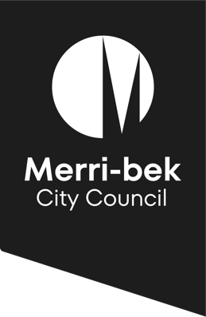
Program Model
2025 Children’s Reference Group

Aims of the Children’s Reference Group (CRG) | - To provide an opportunity for children to provide advice and input into Council’s plans, projects and strategies  - Promote children’s civic engagement and increase their understanding of the role of local government  - Build children’s leadership, group work and problem-solving skills
Meeting frequency | - 1 meeting per term, 1.5 hours in length
Member involvement length | - 1 calendar year
Nomination process | - Participating primary schools distribute student nomination forms and a parent information sheet (provided by Council) to interested students to complete  - Schools determine the successful two students who will take part in the CRG  - Schools ensure inclusion and diversity principles in student selection  - Students are in upper primary school, Year 5 and/or Year 6  - Council supports the nomination and selection process by an officer attending schools and speaking with students about the CRG and discussing nominations with schools, where requested
Student information and consent | - Student information sheet and consent form is provided prior to commencement of the CRG
Parent information and consent | - Parent information sheet and consent form is provided prior to the commencement of the CRG
Facilitation | - The CRG is facilitated by experienced Council staff
Child safety | - Council completes a Risk Assessment with relevant mitigation strategies prior to the commencement of the CRG  - All regular CRG facilitators and accompanying school staff are required to have a valid Working with Children’s Check or current registration with the Victorian Institute of Teaching (VIT)  - Students are advised at the commencement of each CRG meeting who they can speak with if they feel unsafe during meetings
Feedback and review | - Feedback form is completed by students at the end of the each CRG meeting  - Short meeting held with accompanying school staff following each CRG meeting for reflection and feedback

