
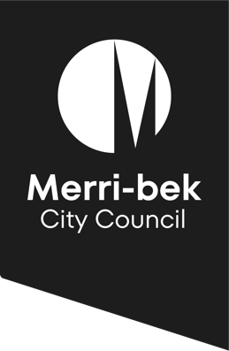
Parent Information Sheet
2025 Children’s Reference Group

What is the Children’s Reference Group?

The Merri-bek Children’s Reference Group has been established in 2023 and aims to empower children to create better connections with local government and have a say in decision-making on matters that impact them. The Children’s Reference Group members will have the opportunity to provide direct input into Council’s projects, plans and strategies. At each Children’s Reference Group meeting different areas within Council will present information and seek input and feedback from the children in interactive and engaging ways.

What are the benefits for children?
Children will have the opportunity to learn about the role of Council and how decisions are made. They will learn group skills and develop their leadership capabilities. Children will build confidence, learn about civic rights and responsibilities, and increase their community connections.

How are children selected?

Nominations for the Children’s Reference Group are made through children’s participating primary school. Schools will determine the successful two students and advise Merri-bek City Council. Once selected, the children will be members of the Children’s Reference Group for one calendar year, February – December 2025.

What is required of members?

There will be four Children’s Reference Group meetings per year for 90 minutes, held at Merri-bek City Council, 90 Bell Street, Coburg. All participating children will be accompanied and supervised by a staff member from their primary school during meetings. The meetings will be facilitated by experienced Council staff members. There will be an online meeting option available for children at their primary school if they cannot attend in-person.

Where can I find out more information?

Please contact Teneha Greco, Early Years Planning and Development Officer on 9240 1195 or TGreco@merri-bek.vic.gov.au

