
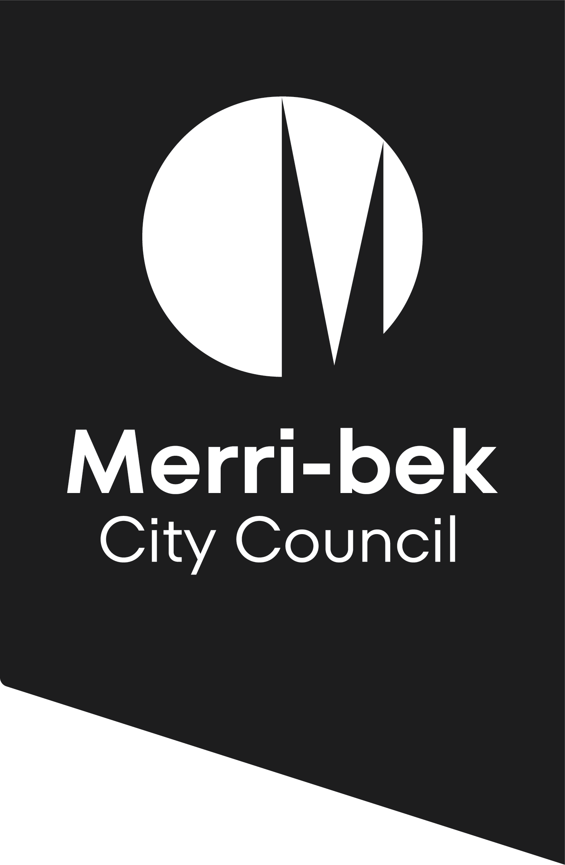
Postal Address
Locked Bag 10
Merri-bek Victoria 3058

Phone:9240 1111
Fax:9240 1205

Request For

Point of discharge report

ENGINEERING SERVICES 2024 / 2025
(Regulation 133(2) Building Regulations 2018)
For faster service, apply online. Visit https://www.merri-bek.vic.gov.au/legal-point-of-discharge

PROPERTY DETAILS
Lot No ………… (if street number not known)

PROPERTY No …..…… STREET …….…………………………………………………… SUBURB .…….……………..……

PLANNING PERMIT:
Has a planning permit been applied for, or issued? Yes No If Yes, Permit No …………………………

APPLICANT DETAILS

YOUR NAME ………………………………………….………… COMPANY NAME ………………….…………………………………...

POSTAL ADDRESS …………………………………………………………………………………………………………………………………….

TELEPHONE Nos: (Work/Home) ………………….……………… (Mobile) ………………….………………

EMAIL: ........................................................................................................................................................................

PROPOSED DEVELOPMENT DETAILS (please tick)
Type New Alteration Extension
(No increase in floor area) (Increase in floor area)
Category
Residential | Commercial only | Industrial only |  | Public Building
House  Outbuilding (Garage, Verandah)  Dual Occupancy (1 new unit at rear)  Multi Units - How many? …………………. | Shops  Offices  How many? …….. | Warehouses  Factories  How many? ….….. |  | School  Hospital  Hall

Mixed Residential/Commercial development - How many occupancies? ………………….

DETAILS OF EXISTING BUILDINGS / STRUCTURES ON THE PROPERTY (please tick)
Vacant Land There are existing buildings on the property

FEES
 | FEE |  | Office Use Only  MNEMONIC
Fee for Report (as per Regulation 133(2) Building Regulations 2018) | $ 158.50 |  | RC 9291

I, the applicant, agree that the information provided herein is true, and accurately describes the development proposal for the subject site and that I have read and fully understand all pertinent text on this form (front and back). | SIGNATURE…………………………………………….…  DATE: / /

PLEASE REFER TO FURTHER INFORMATION PROVIDED ON THE BACK OF THIS FORM.
Citizens Service Office Use Only:
DISTRIBUTION: | Receipt No.:
 | Date:
Engineering Services | CSO name:

INFORMATION TO APPLICANTS

- The department will respond to the applicant, normally within 10 working days, or 5 working days if the application is received on-line at https://www.merri-bek.vic.gov.au/legal-point-of-discharge
- Where an email address is provided, the department will send the response to the email address for faster service. Where the applicant chooses to pick up the information (from the Coburg Civic Centre), Council will notify the applicant by phone when it is ready.
- The application will not be processed until payment is made in full.
- Council will provide the ‘point of discharge’ report required by Regulation 133(2) of the Building Regulations 2018. Council will also specify the ‘connection point’, the point to which the development must be drained by underground pipes. Council will use the provisions of Section 21 of the Subdivision Act 1988 to ensure the owner constructs the drainage to the connection point in the manner specified, or where that is not applicable, Section 200 of the Local Government Act 1989.
- This information is provided only as a guide as Council records may contain errors. The applicant must VERIFY the existence of the existing drain, including its size, offset and depth. The applicant must then check that the pipe is located to allow stormwater from the allotment to discharge freely into it.
- Works undertaken in the Road Reserve or Council Easement require the appropriate permits to be obtained from Council at the relevant fees.
- The applicant (or his/her representatives, assessors or assigns) shall be responsible to communicate and coordinate all proposed constructed works with the applicable private property owner(s) located directly adjacent to the nature strip areas and/or other Council road reserve areas such that compatible land uses are achieved by all parties (i.e. – future driveway crossovers, ingress-egress, proposed utility easements, etc.)

HOW TO PAY

Online
- You can apply and pay for a legal point of discharge report online, using VISA or MasterCard.
Visit https://www.merri-bek.vic.gov.au/legal-point-of-discharge

In person
- Payments can be made between the hours of 8.30 am and 5.00 pm Monday to Friday, at Citizens Service Centres by cash, cheque or money order, EFTPOS, VISA, MasterCard, or Bankcard.
- Citizens Service Centres are located at:

Merri-bek Civic Centre
90 Bell Street, Coburg

Brunswick Customer Service Centre
233 Sydney Road, Brunswick

Glenroy Customer Service Centre
50 Wheatsheaf Road, Glenroy

By mail
- Cheques or money orders, made payable to “ Merri-bek City Council” can be sent to:-

Merri-bek City Council
Locked Bag 10
Merri-bek 3058

