

*Drainage design criteria for* developments

City Infrastructure – Engineering Services Unit March 2009

|  |  |
| --- | --- |
| **Drainage design criteria flowchart** | **1** |
| **Adopted Council policy (1999) for desirable legal point of discharge** | **2** |
| **Step 1: Supplying information to Council** | **2** |
| **Step 2: Drainage information – internal drainage plan** | **3** |
| **Step 3: On-site detention** | **3** |
| **Step 4: Council design parameters for rainfall runoff**  . | **3** |
| **Step 5: Stormwater control outlet – Design requirements** | **4** |
| **Step 6: External drainage plan – Design requirements** | **5** |
| **Step 7: Utilizing storage tanks** | **6** |
| **LPOD Checklist** | **7** |
| **Council Standards**: |  |
| SD128 – OSD Baffle wall pit arrangement. | **8** |
| SD128a –External drainage design. (Example) | **9** |
| SD110 – Junction Pit. | **10** |
| SD131 – Drainage bedding & backfill requirements. | **11** |
| SD150 – House drain connection details. | **12** |
| SD190 – Mild steel step iron. | **13** |
| SD128b –Dual purpose detention/ storage tank | **14** |

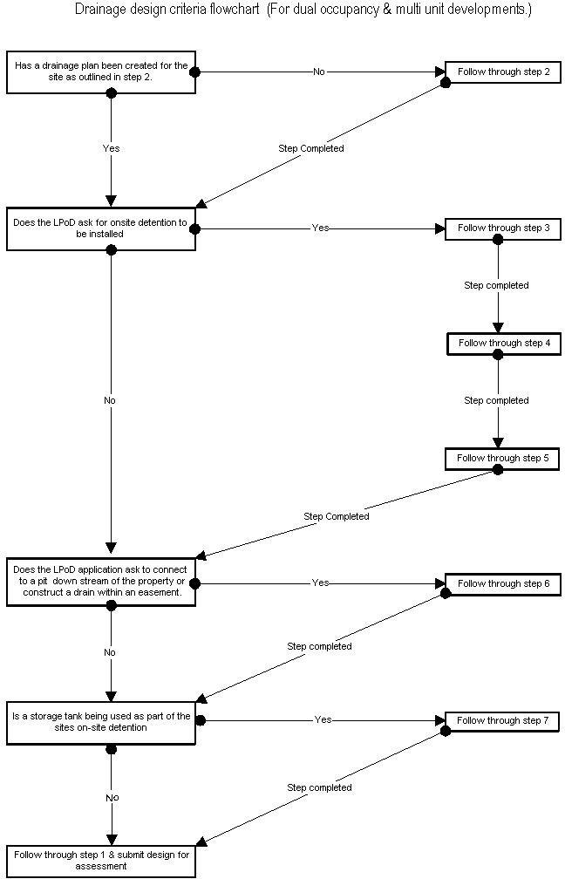

# Adopted Council policy (1999) for desirable legal point of discharge for Dual Occupancy and Multi Unit development:

|  |  |
| --- | --- |
| **Dual Occupancy and Multi Unit Development** | 1. Detention of stormwater on the property so that any discharge is restricted to a determined number of litres per second (request owner/developer for external consultancy calculation). 2. To an existing drain/pit in the nature strip directly in front of the property or to a drain/pit in an easement within the property. 3. To existing Council drainage and or pit in a street within 100 metres of the property (include location of such drain across a roadway) or drainage or pit in an easement in an adjoining property (whether at the rear or at the side).   Note i) Any drainage within the road reservation to be a minimum size 225mm.Developers to submit design plans and computations and receive approval before continuation of works. |

**What you need to know?**

This document **forms part of the application process and is a condition of applying for a LPOD within Merri-bek City Council.** The criteria has been set to both protect the existing and future viability of Council’s drainage assets and to ensure a uniform design standard when supplying plans for assessment.

Plans falling outside this criteria will be deemed incomplete and the onus will be on the applicant to ensure changes are undertaken for designs to comply. A checklist is provided to assist in your application.

**The following 7 steps outline the design criteria required when submitting drainage designs for developments within the City of Merri-bek.**

# Step 1: Supplying information to Council

Council requires the following information to be submitted when checking onsite detention and external drainage (if applicable.)

1. Three (3) copies of the site plan including all design information outlined in the following steps. Plans are to be @ A3 or A1.
2. Plans are to be to scaled @ 1:100, 1:200 or 1:250.
3. A Set of Engineers Calculations
4. Supply contact details. (Phone, fax, email and postal address)

Plans are deemed to be incomplete if marked Preliminary and/or Steps 1 to 4 are not fulfilled.

# Step 2: Drainage information – Internal drainage plan

For a site comprising of onsite detention (temporary storage) the applicant will need to demonstrate on a plan that the internal drainage is acting as a detention system slowing stormwater to an acceptable level. (Predevelopment flows.)

Information required on the plan:

1. Overall block size, (catchment area), roof and driveway areas.
2. Location of internal drainage, pipe size, materials & grades.
3. Pit details, showing dimensions, surface & invert levels.
4. Location of your stormwater control outlet. (See step 4)
5. All internal connections are to connect up to the OSD system before leaving the site.
6. Pipe connections into the Council outfall drain or kerb/channel to be as per to Council Standard SD150, must be stated.
7. Any external drainage details (if applicable) as set out in LPoD requirement Plans are deemed to be incomplete if any of the above points 1 to 7 are not shown on the plan.

# Step 3: On-site detention

On-site detention includes pits and pipes that will hold a volume of water underground whilst stormwater feeds slowly through the sites stormwater control outlet.

1. The plan will need to show pipes and/or pits used to temporarily detain stormwater.

# Step 4: Council design parameters for rainfall runoff

The following Council Design parameters are to be used when determining pre and post runoff from a site for stormwater detention.

## Pre development:

* 1. Design storm period 5yr ARI.
  2. Time of concentration (Tc) 12min
  3. Coefficient runoff (Pre) Pervious area 0.4, Impervious area 0.6
  4. Predevelopment (OSD calculation) 0.4

## Post development:

1. Design storm period 5yr ARI.
2. Time of concentration (Tc) 7.5min.
3. Rainfall Intensity (I) to be based upon Australian Rainfall and runoff (ARR) 1987.
4. Coefficient runoff (Post) Pervious area 0.3, Impervious area 0.9

## For commercial and factory developments:

1. Design storm period is 10yr ARI.
2. Rainfall Intensity (I) to be based upon Australian Rainfall and runoff (ARR) 1987.
3. Coefficient runoff Pervious area 0.1, Impervious area 0.9

# Step 5: Stormwater control outlet – Design requirements.

A stormwater control outlet is a unit that slows the flow of water to an acceptable level, positioned at the outlet of your internal drainage system before stormwater leaves the property.

The device can either be a manufactured unit or designed from first principles. The decision on the type and size of control outlet is determined by the applicants Engineer and is based upon hydraulic calculations to prove that the device will discharge at predevelopment flow rates.

## Manufactured Unit:

The following design Information that needs to be shown on the plan:

1. Supply all manufacture design details, including dimensions, model ID and product code.
2. Supply all supporting calculations, if computer modeling used supply a copy of inputs parameters and reports.
3. Supply the design discharge rate from the system.
4. Provide Invert level of unit at the centre.
5. Pit details, showing dimensions, surface & invert levels.
6. Overall block size, (catchment area), roof and driveway areas.
7. Supply supporting charts and calculations.

Plans are deemed to be incomplete if any of the above points 1 to 7 are not fulfilled and/or the overall volume of discharge detained is too small.

## Baffle pit (Engineered designed):

The following design information is required on the plan, an example of this design is shown on page 10 of this document.

1. Supply all manufacture design details, including dimensions, model id and product code.
2. Supply all supporting calculations including orifice calculations.
3. Supply the design discharge rate from the system.
4. Overall block size, (catchment area), roof and driveway areas.
5. The control outlet is to comprise of a baffle wall and orifice.
6. Detail design of the pit is to show, plan, cross and side elevations of the pit including all dimensions and orifice size.

Plans are deemed to be incomplete if any of the above points 1 to 7 are not fulfilled and/or the overall volume of discharge detained is too small.

# Step 6: External drainage plan- Design requirements (If applicable)

External drainage design comprises both a plan and longitudinal section of the proposed drainage layout. An example required for submission is presented on page 11 of this document.

Note that additional requirements may apply when a proposed drainage alignment is to be installed within another authorities easement or along an arterial road.

## It is the applicant’s responsibility to:

1. Communicate, follow up and obtain approval from relevant authorities, regarding utilising an easement for a proposed drainage alignment. (Including undertaking & supplying any additional design requirements requested by the authority.)
2. Undertake all surveys.
3. Undertake a one call (Dial Before You Dig) and ensure all service information is present on the plans.
4. Determine all pit invert levels; (Note pits within road reserve are considered as confined spaces, all precautions should be undertaken when undertaking Invert levels.)
5. Designs ideally should be drawn using a computer application or professionally drafted.

## All plans are to show:

1. All existing site conditions and the proposed works.
2. Minimum pipe diameter of 225mm, pipe to be class 2, rubber ring jointed, either steel reinforced or fibre reinforced concrete. (UPVC pipe not accepted within road reserves.)
3. North point and scale
4. Backfilling details are to be stated on the plan as meeting Council’s standard (SD131).
5. Junction Pits are to be constructed to Council’s standard (SD110).

## Drainage Plan to include:

1. Existing drains and proposed drainage alignment.
2. Scaled plan drawings @ 1:100, 1:200 or 1:250.
3. All above and underground services including, offsets from the nearest building line and a brief description of the service.

## Longitudinal section to include:

1. The drawing/s shall include a layout plan and longitudinal section/s of the drain/s, drawn to scale.
2. Pit details, showing dimensions, surface & invert levels.
3. Longitudinal section Horizontal scale is 1:250, Vertical scale is 1:50.
4. Existing surface level, pit invert levels, pipe grade and materials.
5. Longitudinal section to show location and level of underground services that cross the proposed drainage alignment.

# Step 7: Utilising storage tanks

Rainwater tanks are encouraged for on site water reuse however will only be accepted as part of the detention design where the applicant can demonstrate, through the provision of detail designs and calculations, that the use of storage tank(s) can achieve the detention objectives of this criteria.

Volume stored in these tanks **is considered as additional storage** for the site **on top of any designed storage system,** regardless of the intended use of the tanks.

If storage tanks are to become part of the site’s overall storage volume for detention then the following design details will need to be submitted.

## All plans are to show:

1. Manufacture design details, including dimensions & tank size.
2. Location of tank(s) and tank size.
3. Contributing roof area into the tank.
4. All design details as outlined in the details below.

## Design to include:

1. A cross section of the tank, comprising dimensions of tank (length & height), tank volume, location and height of inlet and overflow outlets, slow flow release valve (orifice), and reuse connection if applicable.
2. Roof catchment area contributing to the tank.
3. Orifice calculations.

These criteria were last updated on: 4 March 2009.

**LPOD Checklist:**

|  |  |
| --- | --- |
| **Step 1: Supply information to Council:** | ✓ |
| Submit 3 copies of site plans @ A3 or A1. | ○ |
| Scale plans @ 1:100, 1:200 or 1:250. | ○ |
| Supply contact details. (Phone, fax, postal and email) | ○ |
| Supply a set of Engineers calculations | ○ |
|  |  |
| **Internal drainage design:** |  |
| Supply a plan showing:  Proposed location of internal drainage. Pipe size, material and grade.  Location of pits, pit size and depth. | ○ |
| Show all catchment areas (Roof, paving etc). | ○ |
| Reference made to Council connection standard SD150. | ○ |
|  |  |
| **Step 3: On-Site detention:** |  |
| Show onsite detention on drainage plan | ○ |
|  |  |
| **Step 4: Council design parameters for rainfall runoff** |  |
| Apply Council’s runoff parameters to hydrology calculations | ○ |
|  |  |
| **Step 5: Stormwater control outlet – Design requirements** |  |
| **Manufactured unit:** |  |
| Supply all manufacture design details, including dimensions, model id and product code. | ○ |
| Supply the design discharge rate from the system. | ○ |
|  |  |
| **Engineered Designed: Baffle Pit:** |  |
| Supply design showing:  A plan of the baffle pit. Cross-section of the pit. Dimensions and depth of pit.  Orifice size. | ○ |
| Supply hydraulic calculations. | ○ |
| Supply orifice calculations. | ○ |
|  |  |
| **Step 6: External drainage design- Plan:** |  |
| All existing site conditions and proposed works. Including location and pipe offset. | ○ |
| Plans show pipe diameter, class and type of pipe. | ○ |
| Reference made to Council standards SD131 and SD110. | ○ |
| Show all above and underground services, trees to scale. | ○ |
|  |  |
| **External drainage design- Longitudinal section:** |  |
| Supply a longitudinal plan showing:  Design pipe grade.  Pit surface and invert levels.  Pipe diameter, class & type of pipe. | ○ |

