

Merri-bek Council Parking Permits
  - Residential parking & visitor’s ePermits
  - Application process and FAQs

  - October 2026

Contents
Overview 3
How to check your eligibility for a Residential Parking ePermit 4
How to apply for a Residential Parking ePermit 5
ePermit Registration Update via Web Browser 12
ePermit Registration Update via PayStay App 15
How to Renew Your Residential Parking ePermit 18
Residential Parking ePermit FAQ’S 21
Residential Parking ePermit processing timeframes 21
Are my personal information and PayStay payments secure? 21
Why do parking officers mark tyres in time restricted parking areas? 21
Where can I park with a residential parking permit? 21
How many residential parking permits can I apply for? 22
How much do residential parking permits cost? 22
When can I expect to receive my residential parking ePermit? 22
I have bought a new car; how do I update the registration on my permit? 22
My property doesn't appear to be eligible. What do I do? 22
Visitor Parking ePermit 23
How to apply for Visitor ePermit Book 24
How to use a Single Use Visitor ePermit 27
Visitor ePermit Book – processing timeframes 29
Visitor ePermit Book FAQs 29
Who can apply for visitor parking permits? 29
Where can I park with a visitor parking permit? 30
Visitor ePermit Book processing timeframes 30
Can I apply for a Visitor ePermit for a future date? 30
Can I select multiple dates if I have guests that plan to stay-over? 30
Can I can cancel an approved Single Use Visitor ePermit if my plans change? 31
Can I transfer the Single Use Visitor ePermit to a different vehicle? 31

Overview

Merri-bek City Council uses a digital parking permit system called ePermits.
The ePermits system is an easy way to apply for a Residential Parking Permit and Single Use Permit (previously known as Scratchy Permits).
ePermits is powered by PayStay – an electronic system that manages resident accounts online and links the digital ePermit to the registration plate of the registered vehicle. Permits are no longer displayed on the vehicle.
This guide has been created for Merri-bek residents to help you understand the online application process and ePermit system.
The online portal allows Merri-bek Council staff to quickly review, approve and activate residential parking ePermits.

How to check your eligibility for a Residential Parking ePermit

Enter your address in the eligibility section on our website: https://epermits-merri-bek.orikan.tech/eligibility/
If you live in a unit, apartment or townhouse enter the address in the following format:
- Unit 1 20 Sample Street.

- If your property has a driveway/crossover, you are only eligible for 1 residential parking permit
- If your property does not appear as eligible but you believe that you are eligible because you have previously had a residential parking permit or your property has not been subdivided after 30 August 2011, please contact us: please email citysafety@merri-bek.vic.gov.au and provide your name, address and contact number and we will respond to your enquiry within 3 business days.

If your property is eligible for residential parking permits you will need the following to apply:
- An email address
- A credit/debit card (VISA or Mastercard)
- 1 Proof of residency document. This can be a rates notice, drivers licence, rental agreement, utility bill (excluding mobile phone bills).

Your property will auto populate in the dropdown menu, select the property and it will state 1st Residential Parking Permit if your property is eligible. If eligible select ‘Sign up or Login’ at the bottom of the page to start the application process.
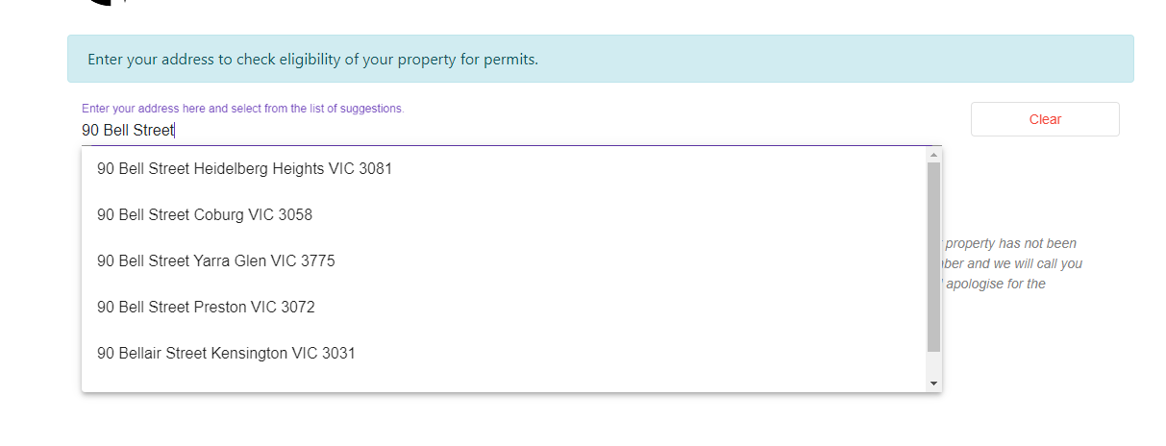
Start typing your address and select from drop-down menu.

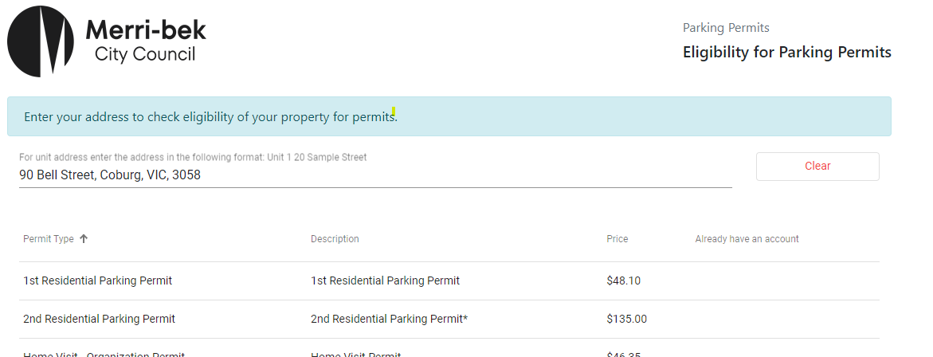
Click SIGN UP or LOG IN to apply for Residential 1 and/or Residential 2 (if eligible).
Permit/s eligible for your property

How to apply for a Residential Parking ePermit

Step 1 - To apply for a permit, select Sign up or Log in on the eligibility page or via https://epermits-merri-bek.orikan.tech/ssp.
Step 2 - Create a PayStay account by clicking on ‘Sign up’. If you already have a PayStay account, login using your current PayStay username and password.

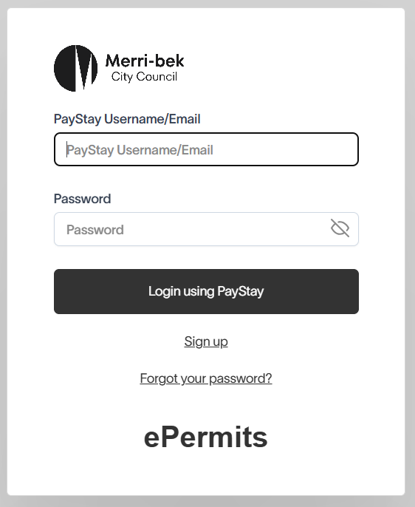
If you are new to PayStay sign up for an account by clicking on ‘Sign up’

If you already have a PayStay account, login using your PayStay username/email and password

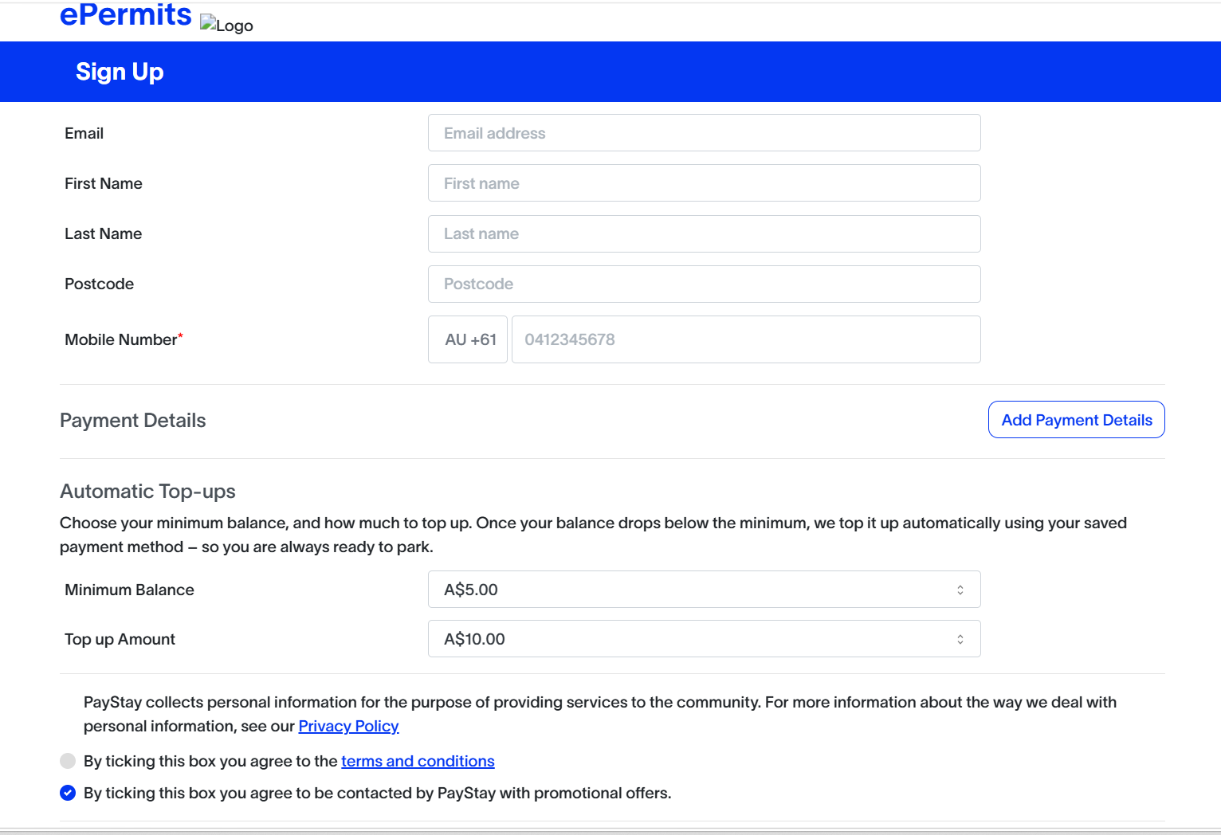
Select ‘0’ for Low Balance Threshold.
Select ‘0’ for Top-up Amount.
You may choose to select a different Low Balance amount and Top up amount. This may come handy if you use PayStay to pay for parking meters.
For ePermits, both the balance and top-up amounts can remain 0 (zero) as only the permit fee is deducted when the permit is approved.
Read the terms and condition and tick the box if you agree.
Click Sign Up to create your PayStay account
Fill out the application form and Select add Payment Details
Add Payment Details button and fill in your Credit Card/Debit card details.

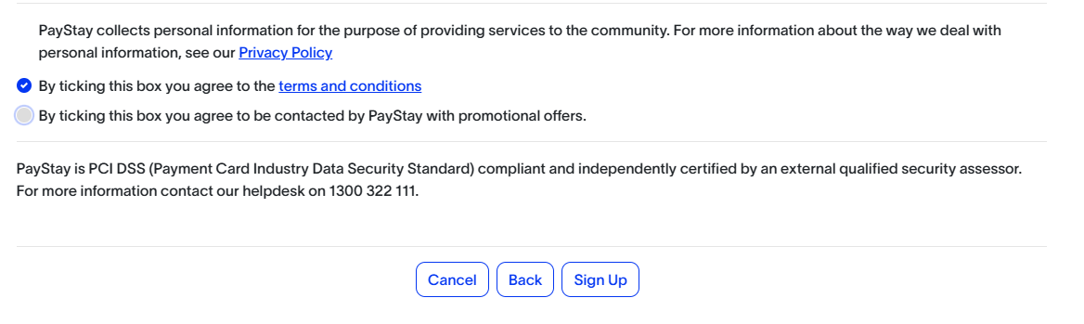

Step 3 – Verify Contact Details. You will receive an email from PayStay. Click the VERIFY EMAIL button to verify your contact details.

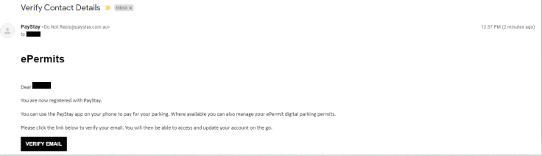

Step 4 - Once your account is verified, you will be asked to login using your email and password.

Step 5 - The first time you log in to the portal, you’ll be asked to fill in your ‘User profile.’ Some information will be prefilled. Enter the remaining required information and then scroll down and select ‘save’.
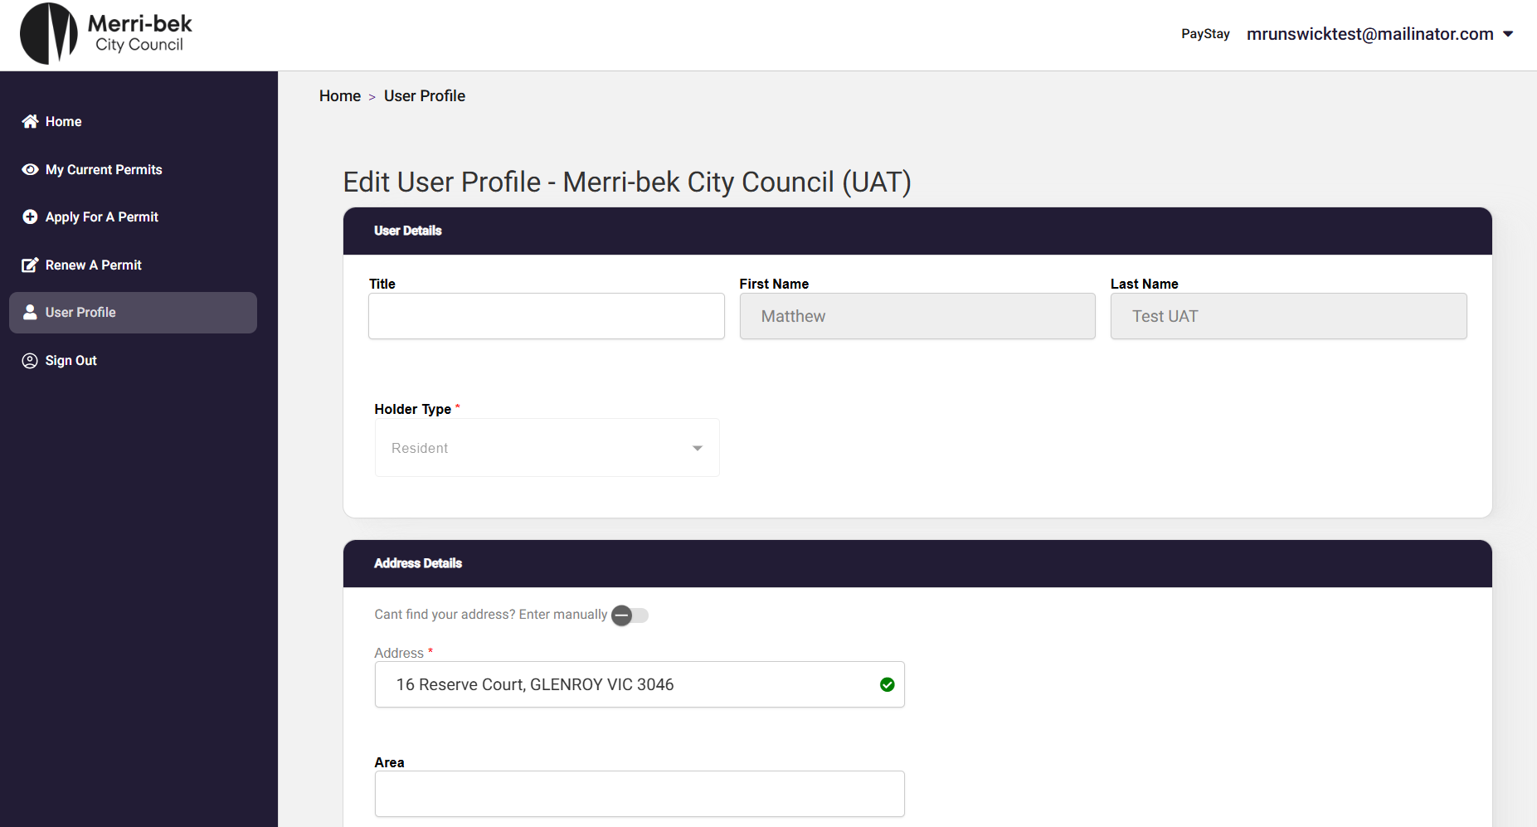
Select the Holder type – Resident or Business, fill the rest of the user profile.
Add your address.
IMPORTANT - Start typing your address and then select the correct address from the drop-down box.

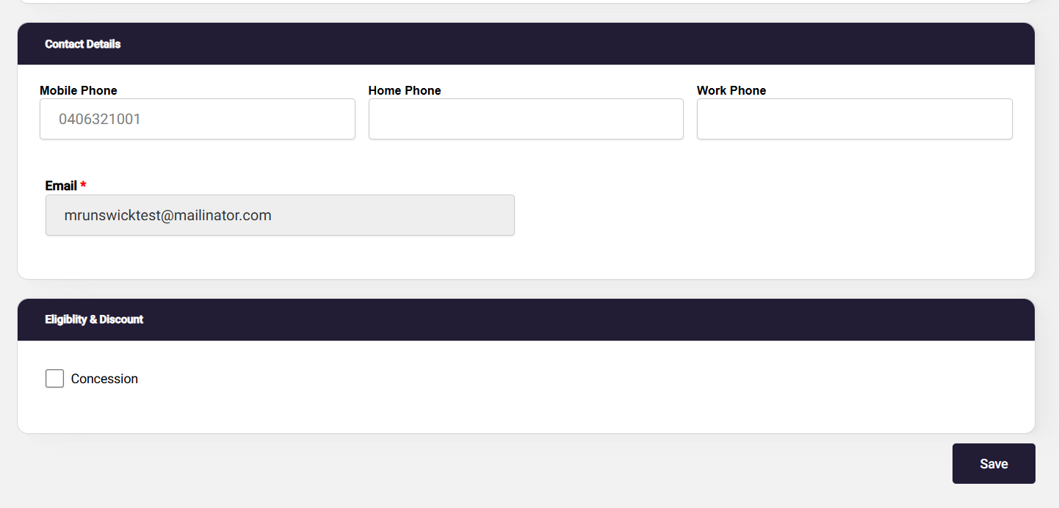
Once your profile is completed click SAVE.
Select Concession, if you hold a valid concession card.

This will take you to the Home Page.
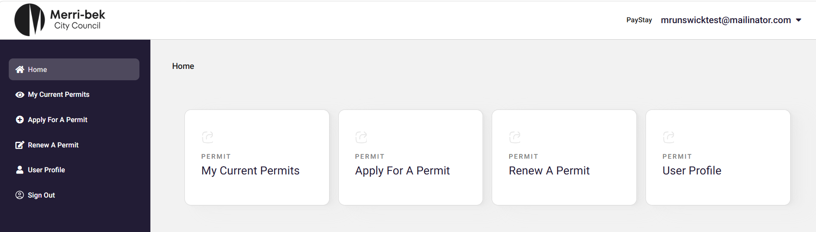
Step 6 - Click on ‘Apply For a Permit’ in the left hand side and then click ‘Residential’ to fill out the Residential Parking application form.

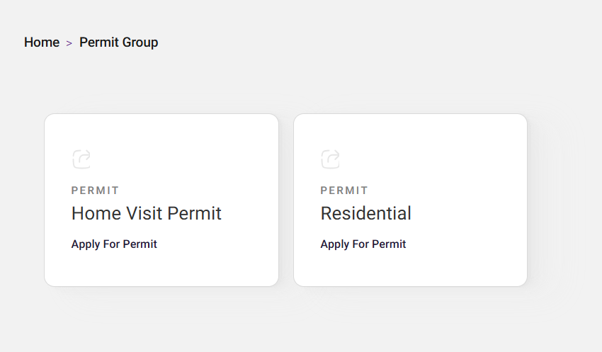

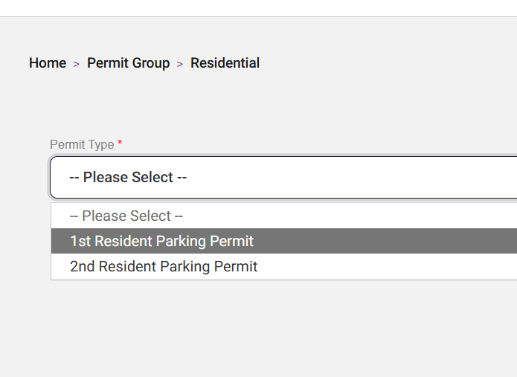
Select whether you are applying for a 1st Resdential, 2nd Residential or Visitor Parking Pemits.

Step 6 – Fill in the application form and attach your Proof of Residency. Accept the Terms and Conditions and click the Submit button.

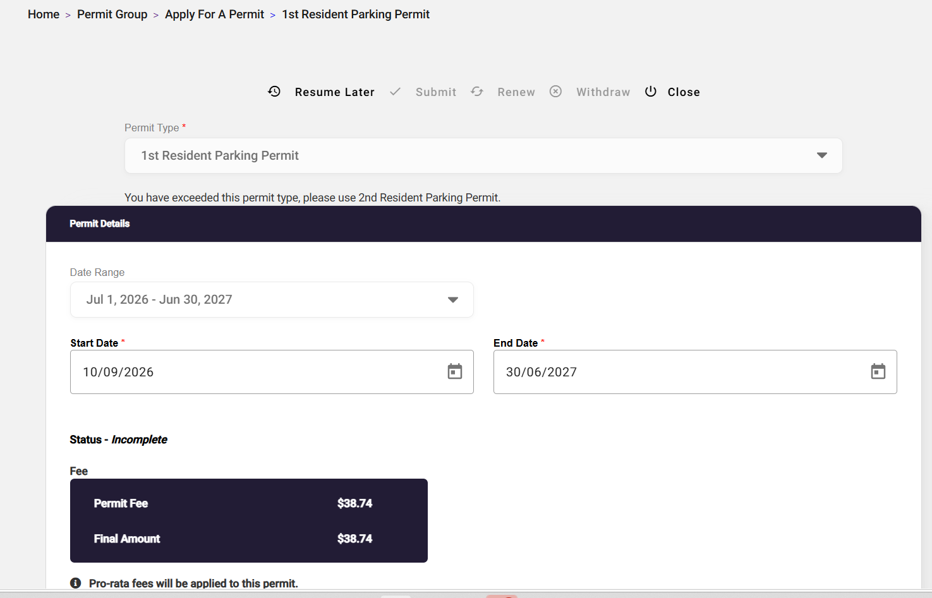
Ensure PayStay is the preferred payment option.
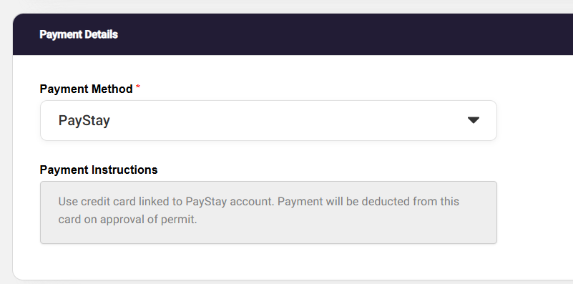
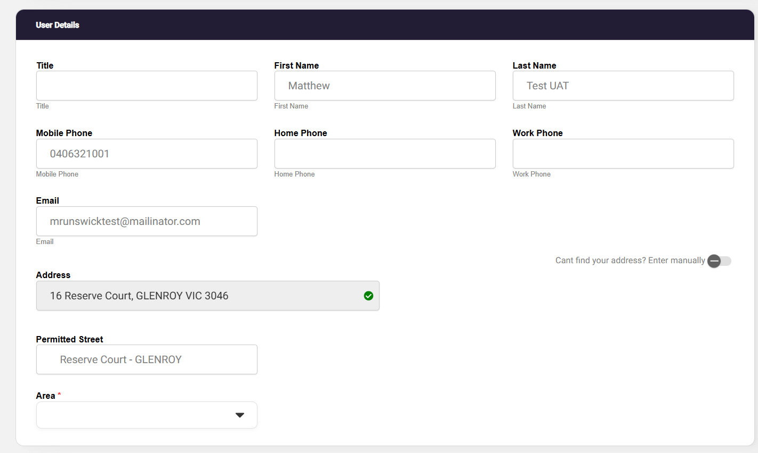

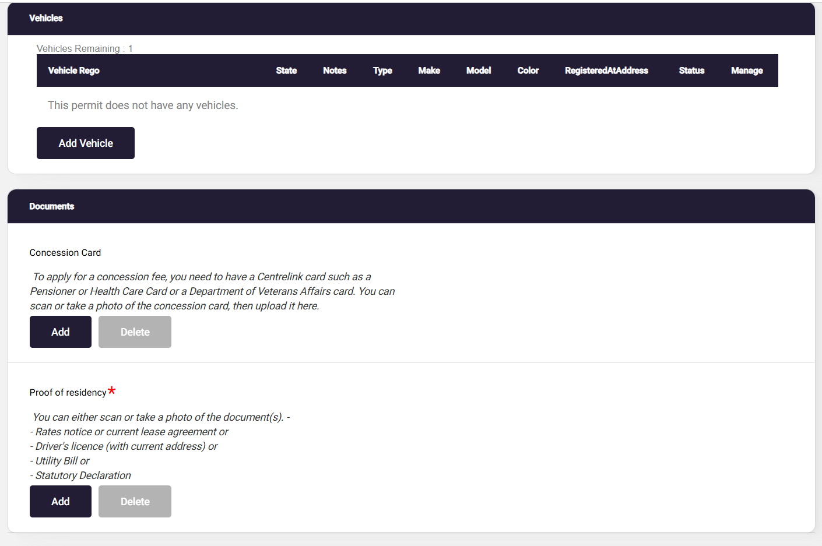
Attach proof of residency documents.
Attach proof of Concession card.

Add vehicle registration details

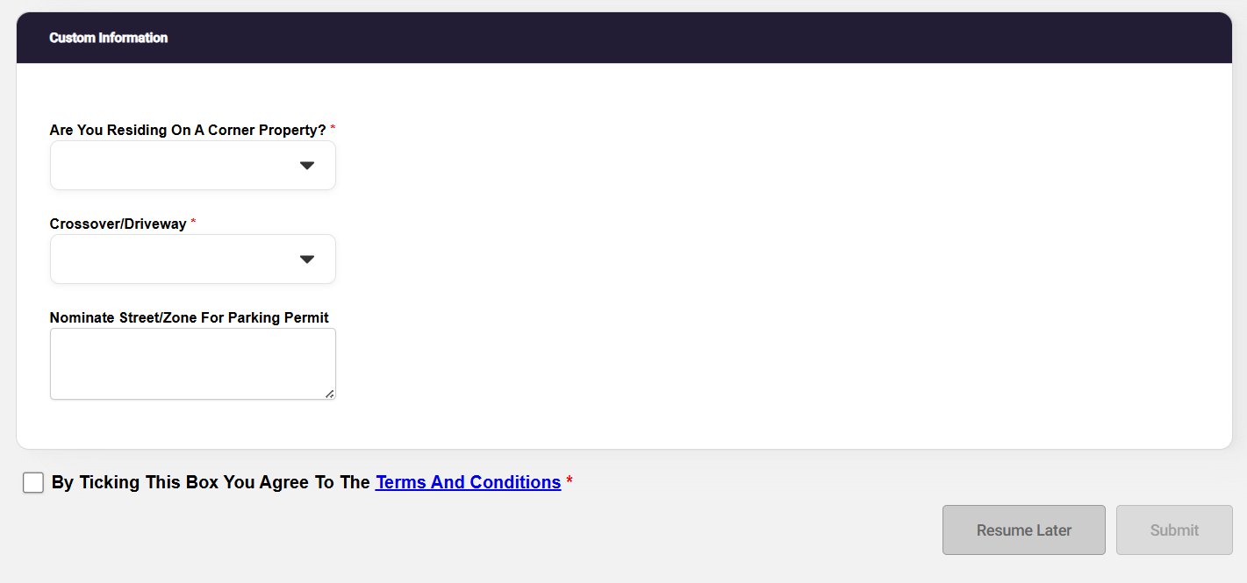
Answer the Customer Information questions.

Read T&C. Tick the box to confirm you understand T&C and click Submit to apply for your ePermit.
If you require a 2nd Residential ePermit, Repeat Step 6 only.

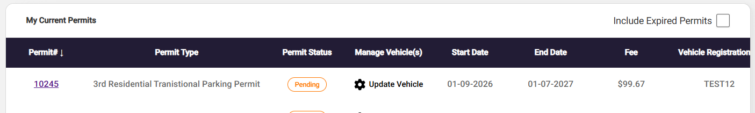
ePermit Registration Update via Web Browser

Permit holder can update vehicle registration details of their active permits via a Web Browser.

Pre-Requisites
- Permit holders have to login into PayStay using same login credentials from which they have applied for permits via Merri-bek ePermit webpage.
Step 1 - Login to your PayStay account: https://epermits-merri-bek.orikan.tech/ssp

Step 2: On the permit that you want to change the registration, click Update Vehicle:

Step 3: On the drop-down box that will show, Select the Option Edit Vehicle

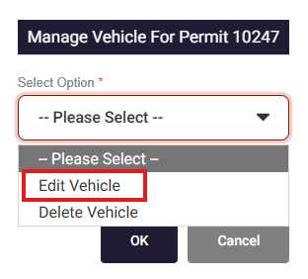
Select Edit Vehicle

Step 4: Select the vehicle on the drop-down option. Change the vehicle registration on the Vehicle Registration field and choose the State on the State field. Click OK.

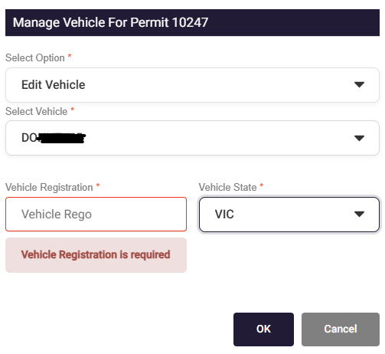
Select Vehicle to be changed.

Enter new vehicle details and vehicle state.

Select ok

The window will automatically close once it is saved and you will find that the updated vehicle registration number is showing on the Vehicle Registration field on the My Current Permits page.

ePermit Registration Update via PayStay App

Permit holder can update vehicle registration details of their active permits via PayStay

Pre-Requisites
- Permit holders can download the PayStay app via the App Store (iOS) or Play Store (Android).
- Permit holders have to login into PayStay using same login credentials from which they have applied for permits via Merri-bek ePermit webpage.
- Only active permits will be visible in PayStay. Pending or Approved or over the counter issued permits will not be visible in PayStay.
Registration Update Process
- Click PayStay icon on the mobile phone.
- Wait for default screen to open
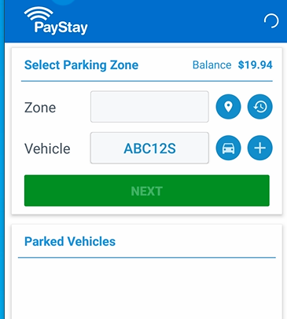

- Click Permits Icon from bottom bar for PayStay to load the active permits.


- Active permits will be displayed.
- Click Pencil icon to update the Vehicle Registration.
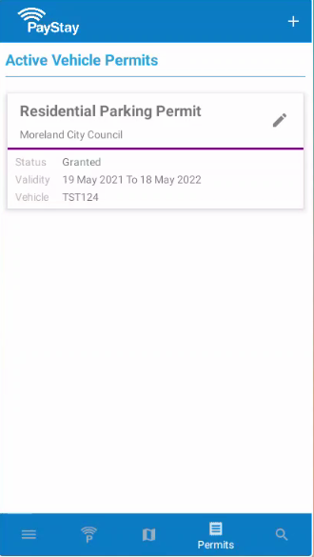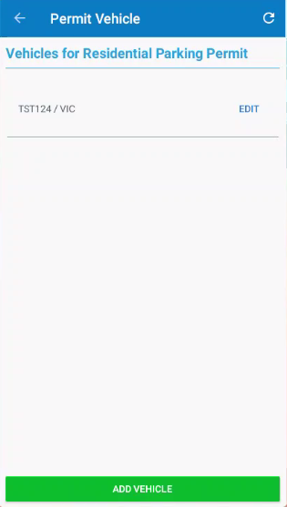

- Click EDIT option to update the Vehicle Registration details.
- Click ADD VEHICLE option only if the permit allows to add more vehicles in it.
- Update the Vehicle Registration details and State if applicable.
- Click UPDATE button once completed
. 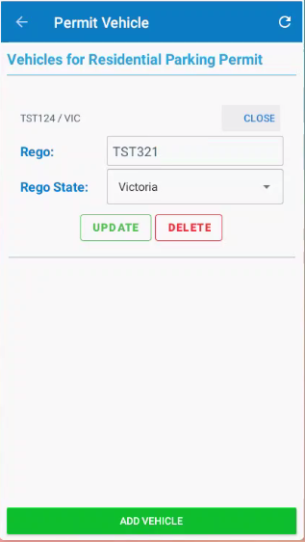
- Message will appear to confirm the Vehicle registration details are updated.
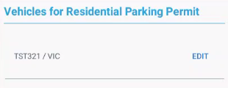
- The Vehicle details are updated and reflecting in the permit.
- The update will happen in real time.
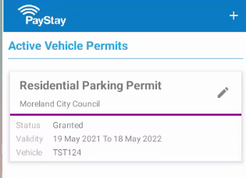

How to Renew Your Residential Parking ePermit

Step 1 - Login to your PayStay account: hhttps://epermits-merri-bek.orikan.tech/ssp

Step 2 – Click on Renew a Permit your renewable permits will then be listed and select the permit number to be renewed.
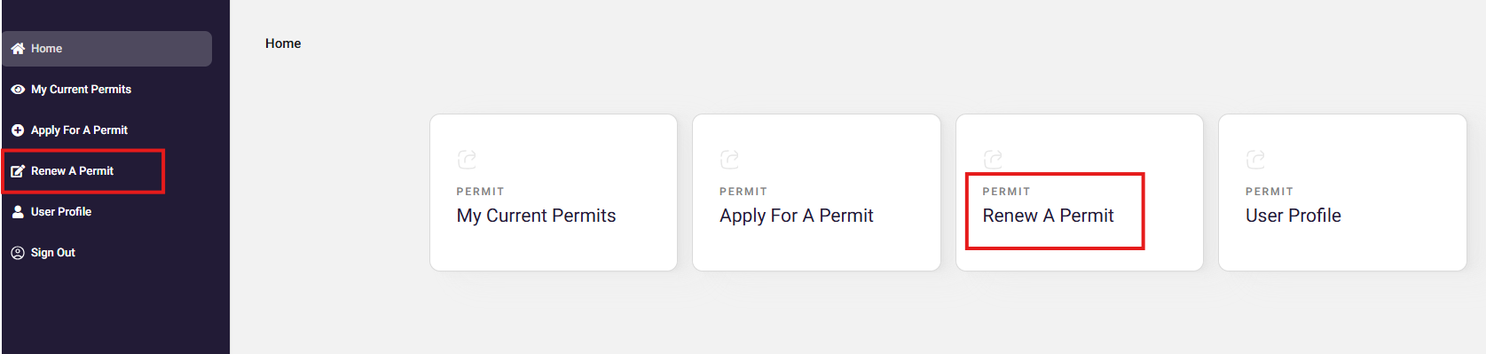
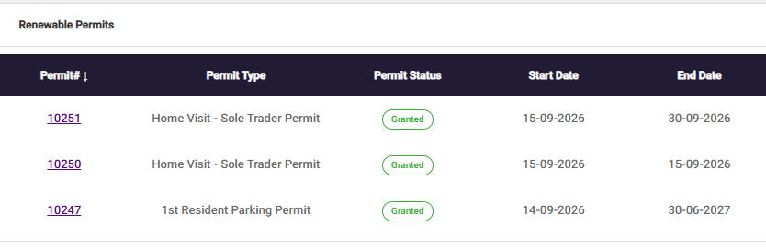

Step 3 – Check the details of the permit you are renewing. All permits commence 1 December to 30 November.
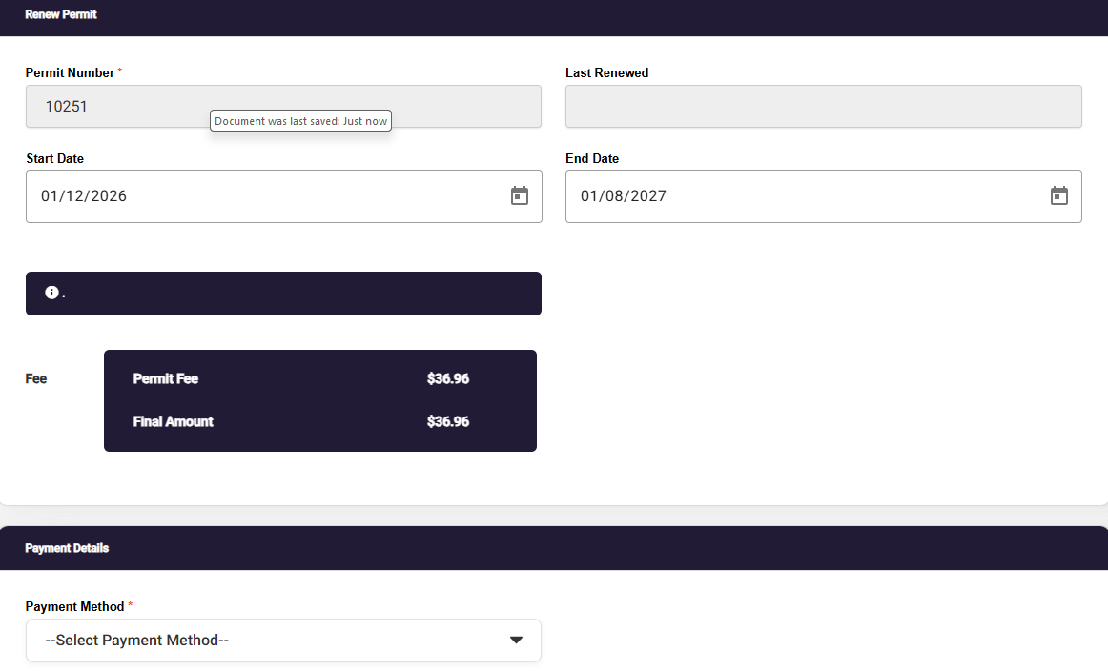
Check the date 1 December and End Date 30 November.

Payment details should be PayStay.

Step 4 – Attach your proof of residency and concession card if applicable. Then select ok to submit your renewal application.

Step 5 – Review the terms and conditions, select the tick box and submit your renewal application.

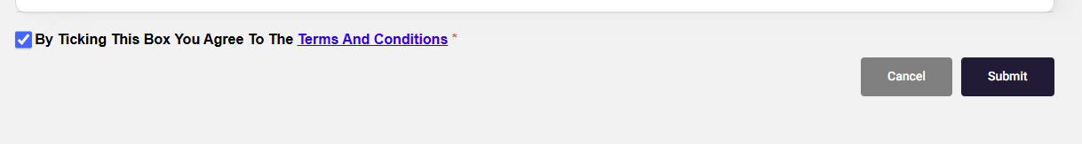
Step 6 – Once you have completed your application when you go to your My Current Permits you will see a pending application.

Please note you will receive a confirmation email that your renewal is pending and then again once your renewal has been granted (approved and paid).
If you hold a second residential parking permit you will need to repeat the steps for your other permit.

Residential Parking ePermit FAQ’S

Residential Parking ePermit processing timeframes
ePermits submitted on will be assessed by our Business Support Team within 3 business days. You will receive email updates about your application progress.
A Business Support Officer will contact you by email if we require further information. This might be for additional proof of residency or if we are unable to deduct payment from your PayStay account.
Once your ePermit has been granted, you will get a confirmation email.
ePermits are digital permits. You no longer need to display a physical permit on your vehicle.
For visitor parking permits, please apply for a digital Coupon ePermit. Instructions begin on page 28. You can also apply for a physical scratchy permit.

Are my personal information and PayStay payments secure?
The personal information you provided when registering with PayStay is handled in accordance with current industry standards. Your details can only be accessed by securely logging in with your username and password. All personal information is stored in an encrypted secure database and handled in accordance with current industry standards.
Your payments made via PayStay are processed in line with Payment Card Industry Data Security Standards. The PayStay website (and mobile application) is protected by a digital certificate which can be verified by viewing the certificate details in your browser. PayStay is Payment Card Industry Data Security Standard compliant and independently certified by an external security assessor.

Why do parking officers mark tyres in time restricted parking areas?
Parking officer’s mark-up tyres of all vehicles when patrolling a street with time restricted parking.
Parking officers return to the street once the allowed parking time has passed (for example, 2 hours later if the area has 2P parking). If a vehicle with a marked-up tyre is still in the street, the parking officer will check if the vehicle has an ePermit.
If the vehicle has an ePermit, they will not issue a parking infringement. Only vehicles that are parked for longer than the time allowed without a parking permit will receive a parking infringement.

Where can I park with a residential parking permit?
With a residential parking permit, you can park all-day in timed parking in your street except where restrictions are under 30 minutes and in prohibited areas such as ‘no stopping’ and ‘loading zones’. This permit also allows you to park in areas on your street marked as residential permit zones.
If you live on a corner property, a permit can be issued for either the front street or side street.
A permit does not guarantee there will be a parking space available in your street.
A permit is only valid for the street of issue on your parking permit and in your application form.

How many residential parking permits can I apply for?
You can have either 1 or 2 residential parking permits depending on your property.
If your property has a driveway crossover, you can only get 1 residential parking permit.
If your property does not have a driveway crossover, you can get 2 residential parking permits.
A driveway crossover is an access point where cars can travel from a road, usually across a nature strip and/or footpath, to a property. If you have a private driveway, it usually indicates you have a driveway crossover.
Properties with more than one driveway crossover are not eligible for any residential parking permits.
If you are unsure whether you have a driveway crossover or not, please contact us.

How much do residential parking permits cost?
For permit fees, please visit our website: www.merri-bek.vic.gov.au/residential-parking-permits

When can I expect to receive my residential parking ePermit?
Residential Parking ePermits are linked to your vehicle’s registration number. Our officers will see your valid residential parking permit when they enter your vehicle registration number into our system.
Your Residential Parking ePermit becomes valid and active as soon as it is processed by our Business Support Team. You will receive an email when your application is complete.
You do not need to display your permit on your dashboard to park in time restricted areas.
Please apply for your permit before the date that you need it.

I have bought a new car; how do I update the registration on my permit?
You can change the vehicle registration on your ePermit by logging into your PayStay account. Select the Residential 1 or 2 permit and click on Update Vehicle Registration. Type new Registration number and click Save. Instructions begin on page 12.

My property doesn't appear to be eligible. What do I do?
If your property has been sub-divided after August 2011, you are not eligible for a Residential Parking Permit
If your property does not appear as eligible but you believe that you are eligible because you have previously had a residential permit or your property has not been subdivided after 30 August 2011, please contact us: please email citysafety@merri-bek.vic.gov.au and provide your name, address and contact number and we will call you within 3 business days.

Visitor Parking ePermit

A Single Use Visitor ePermit is a single use permit that can be linked to a vehicle. Single Use Visitor ePermit (Visitors ePermit) come in a “book” or set of 10 ePermits known as Visitor ePermit Book. This Visitors ePermit is a digital version of Scratchy Permits.

Eligibility
Visitors ePermits may only be purchased by residents who are eligible for a Residential Parking ePermit (this does not Include residents of a property subdivided after August 2011). You do not need to hold a current residential parking permit to purchase visitor permits, but you will need an ePermit Account and a PayStay Account.

What you need for your application
As part of the Visitor ePermit Book online application process, you need to provide a photo or scanned copies of:
- Proof of residency (rates, drivers licence, rental agreement, utility bill excluding mobile phone bills).
- Proof of concession (if you are receiving concession and for the concession fee to apply)

All documentation must be in the applicant’s name and for an address within the restricted parking area.

How to apply for Visitor ePermit Book

Single use Digital Coupons must be purchased in a "book" of 10.
Step 1 - Login to your PayStay account: https://mcc.data.com.au/SSP/Home

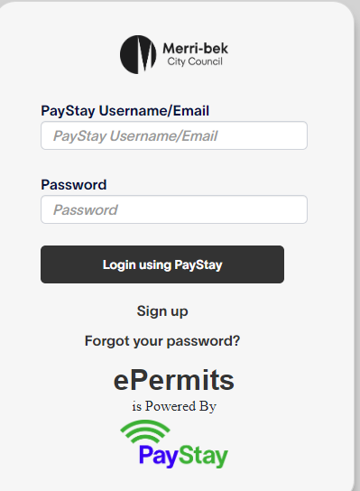

Step 2 – On the left-hand side, click on Apply for Residential
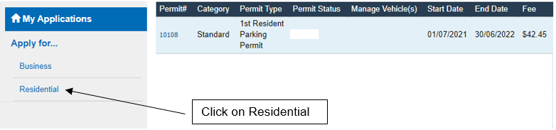

Step 3 – Click on the drop-down Menu and select Visitor ePermit Book.
Note: The Singe Use Visitor ePermit option will not appear until you have purchased a Visitor ePermit Book.

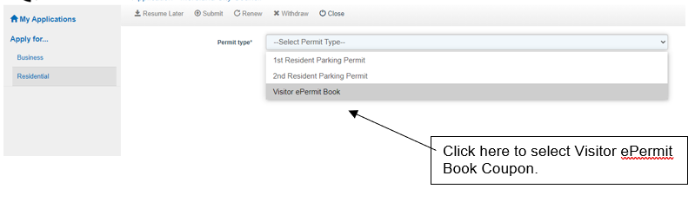

Step 4 – Complete all the required information on the application.
Note - The date and fees displayed in the example form are a sample only.

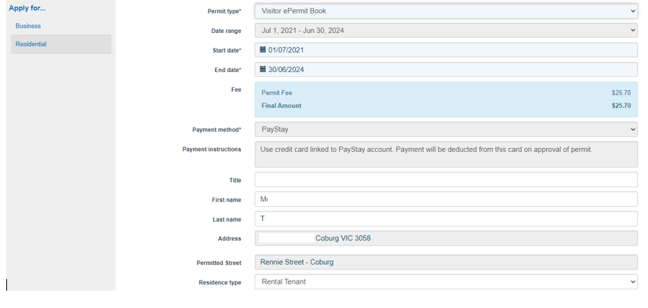

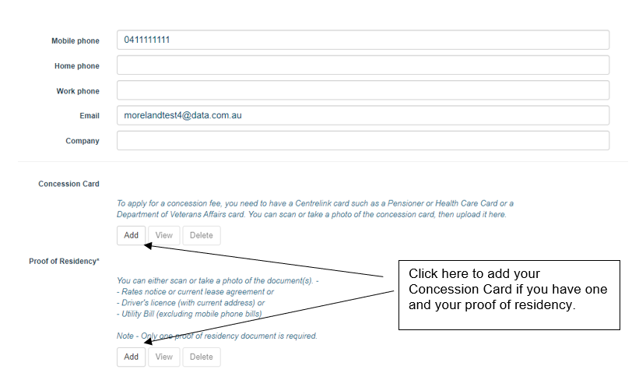

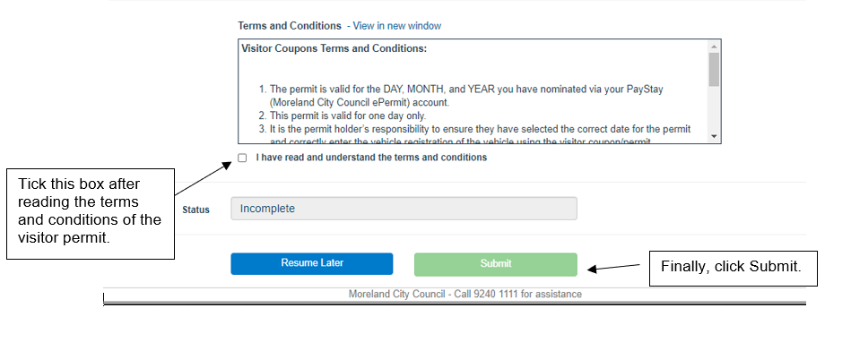

Your application will then appear on My Applications and it looks like the below:
Your application will be reviewed, and a response will be emailed to you within 3 business days. Once approved, you can start using Singe Use Visitor ePermit and assigning different registrations numbers to them.
Instructions on how to use a Single Use Visitor ePermit is on the following pages.

How to use a Single Use Visitor ePermit

Step 1 – Return to My Applications but this time, select Singe Use Visitor ePermit from the drop-down menu:
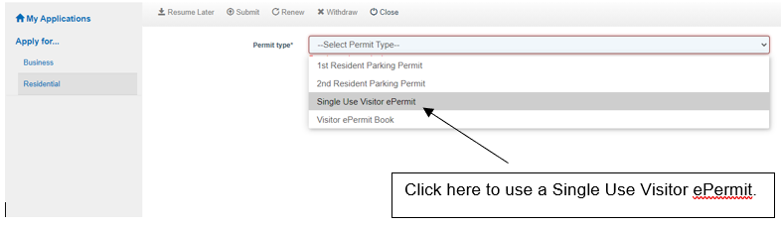

Step 2 – Complete the form as shown below:
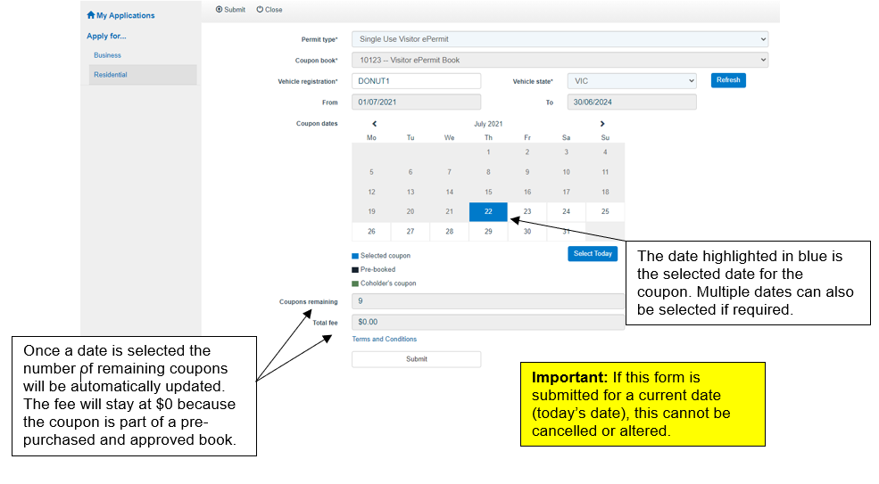
If you need to deselect a date (marked with blue), just click on the date again and it will be selected. You will know the date has been deselected is it is not marked blue.
Important: If this form is submitted for a current date (today’s date), this cannot be cancelled or altered.
The date highlighted in blue is the selected date for the coupon. Multiple dates can also be selected if required.

Once the form is submitted, a summary like this will be shown:
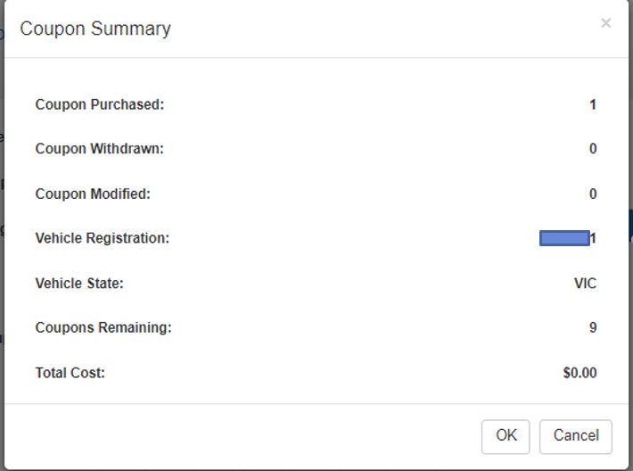

The Single Use Visitor ePermit is approved immediately, and the details of the coupon will be available on the home page of your account. Here is an example:

If a Single Use Visitor ePermit has been created for a future date, the vehicle registration and the date of use can still be updated. To do this, click on the permit number to open the details.

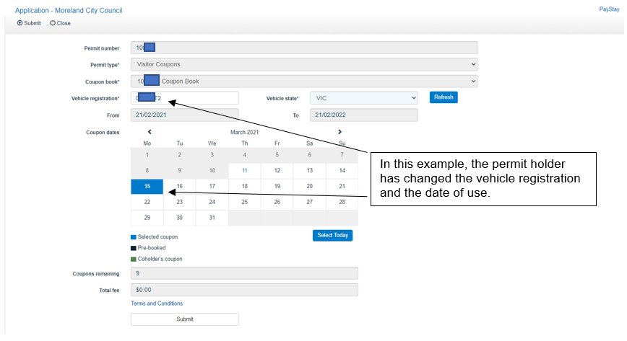

Please note that multiple dates can be selected which means multiple coupons are going to be used. For example, if 2 dates are selected, 2 Single Use Visitor ePermit will be used.

Visitor ePermit Book – processing timeframes
Visitor ePermit Books submitted on weekdays will be assessed by our Business Support Team within 3 business working days. Applications submitted over the weekend will be assessed the following business working day.
You will receive email updates about your application progress.
A Business Support Officer will contact you by email if we require further information. This might be for additional proof of residency or if we are unable to deduct payment from your PayStay account.
Once your ePermit has been approved, you will get a confirmation email.
ePermits are digital permits. You no longer need to display a physical permit on your vehicle.

Visitor ePermit Book FAQs

Who can apply for visitor parking permits?
Residents can apply for visitor parking permits (book of 10 Digital Coupons) if:
- They live in a street with timed parking restrictions; and
- They live in a property which has not been subdivided after August 2011
(Including newer townhouses and apartments).
This is due to the Parking Management Policy adopted by Council in 2011, which sought to provide protection for existing residents in older properties who rely on on-street parking. Find out more about our parking policy.

Where can I park with a visitor parking permit?
With a visitor parking permit, you can park in timed parking areas in your street except where restrictions are under 30 minutes and in prohibited areas such as ‘no stopping’ and ‘loading zones’.
If you live on a corner property, a permit can be issued for either the front street or side street.
A permit does not guarantee there will be a parking space available in your street.
A permit is only valid for the street of issue on your parking permit and in your application form.
For more information, see our Parking Management Policy .

Visitor ePermit Book processing timeframes
Visitor ePermits Book submitted will be assessed by our Business Support Team within 3 business days. You will receive email updates about your application progress.
A Business Support Officer will contact you by email if we require further information. This might be for additional proof of residency or if we are unable to deduct payment from your PayStay account.
Once your Visitor ePermit Book has been granted, you will get a confirmation email.

Can I apply for a Visitor ePermit for a future date?
Yes. To apply for a Visitor ePermit for a future date, select the date you need it for in the Coupon Dates calendar.

Can I select multiple dates if I have guests that plan to stay-over?
Yes. When applying for a Visitor Coupon, you can choose multiple dates in the Coupon dates calendar.
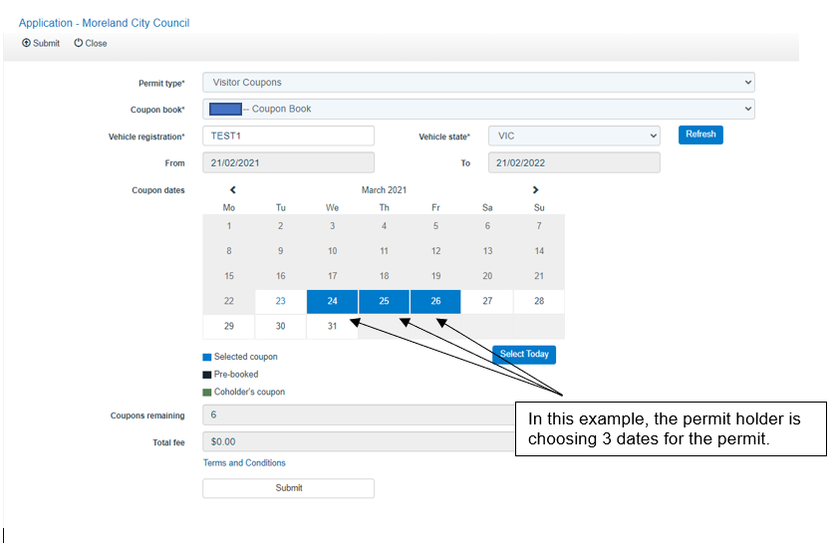

Can I can cancel an approved Single Use Visitor ePermit if my plans change?
Yes, if it is for a future date. For example, if a permit holder entered details for a Visitor ePermit today for tomorrow’s date, it can still be cancelled or updated if it is done today.
You will be unable to cancel a visitor coupon on the day it is issued for. This prevents any misuse of a permit or changing the date of the permit when it has already been used by a vehicle.

Can I transfer the Single Use Visitor ePermit to a different vehicle?
Yes. A Visitor ePermit can be transferred to a different vehicle if the date it will be used is a future date. You will be unable to transfer a visitor permit on the day it is issued for.

