Merri-bek LGBTIQA+ action plan

2023- 2026

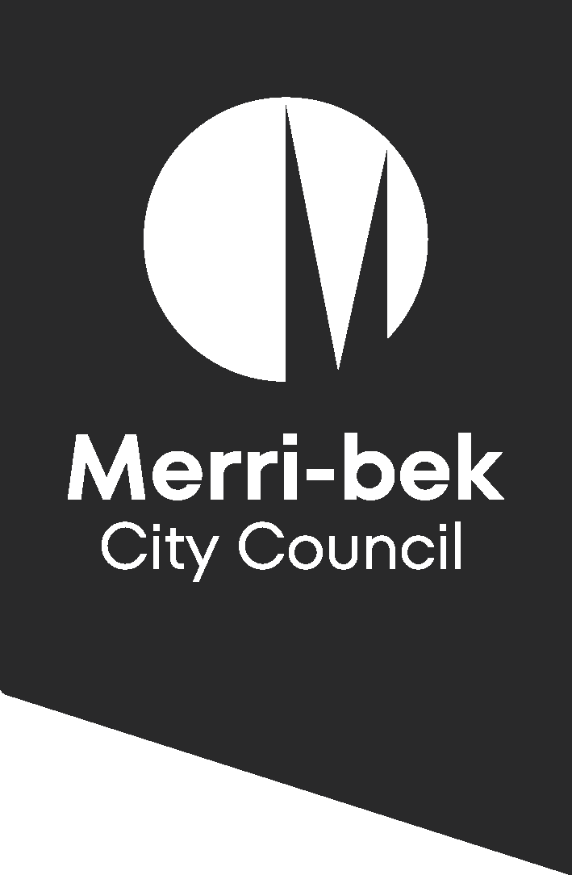

# Acknowledgement of Country

Merri-bek City Council acknowledges the Wurundjeri Woi-wurrung people as the Traditional Custodians of the lands and waterways in the area now known as Merri-bek. We pay respect to their Elders past and present as well as to all First Nations communities who significantly contribute to the life of the area.

We recognise the leading role First Nations people have had in LGBTIQA+ communities. As well as the long-standing connection and understanding of gender and sexual orientation that extends far beyond colonisation.

# Thank you

Council would like to thank the Merri-bek LGBTIQA+ reference group and members of the action plan subgroup for their assistance in developing this plan. Thank you for sharing your knowledge, wisdom and lived experience.

Thank you to the LGBTIQA+ communities and allies who took the time to provide feedback and participate in engagement activities.

We would also like to thank LGBTIQA+ Merri-bek Council staff and allies for your assistance in supporting the action plan and its development.

# Language

We at Merri-bek acknowledge there are numerous acronyms used within LGBTIQA+ communities and that the acronym itself carries its own limitations. Throughout the action plan and at Council we use LGBTIQA+ which represents: Lesbian, Gay, Bisexual plus, Transgender, Intersex, Queer and Questioning and Asexual and Aromantic communities. The *+* represents and acknowledges the restrictions of the acronym and the evolving nature of language that is used to describe and celebrate individuals’ diverse experiences of gender, sexual orientation, and sex characteristics.

We use the term LGBTIQA+ communities, to reflect the distinct and different groups under the umbrella term. We acknowledge that some groups intersect and others overlap, however we recognise there is no singular homogeneous *‘LGBTIQA+ community’* or individual.

# Introduction

Merri-bek City Council is proud of the large LGBTIQA+ communities that live, work, create and play in our city. In Merri-bek we are one community, proudly diverse. A city that is strong, vibrant and committed to equality.

As a Council we have proudly supported programs and services that elevate LGBTIQA+ communities across the organisation and in our community for many years. These programs and those of Merri-bek’s large LGBTIQA+ communities are the foundation for our first LGBTIQA+ action plan.

The action plan formalises our operations across the organisation to ensure that our work is genuine in supporting LGBTIQA+ communities. The action plan is guided by and supports the implementation of the Human Rights Policy to achieve improved outcomes across our city. Activities within the plan have been assigned to different Council branches, who will be responsible for completing these tasks.

Activities and outcomes are broken down into three priority areas:

### Priority area 1 - Advance inclusion and social cohesion in the community

### Priority area 2 - Deliver inclusive and accessible services

### Priority Area 3 - Council is an inclusive organisation

## Human Rights Policy

The Merri-bek Human Rights Policy takes a whole of Council approach to ensure that our services, spaces and workplace are inclusive for everyone. The policy aligns with the Commonwealth, State and local government legislation, with the aim to achieve consistency in Council’s approach to diversity.

The Human Rights Policy gives precedence to specific groups which are recognised as being at greatest risk of exclusion from social, economic and political life because of access barriers and discrimination.

* + LGBTIQA+ communities
  + Aboriginal and Torres Strait Islander Communities
  + People with Disability
  + Migrant, Refugee and Faith Communities
  + Women, Girls and Gender Diverse Communities

The Human Rights Policy takes an intersectional approach, recognising that individuals are complex and shaped by a range of personal attributes such as ethnicity, gender, class, sexuality, age, disability, migration status and religion. This is reflected in the LGBTIQA+ action plan which acknowledges the diversity and lived experiences of all LGBTIQA+ people.

The LGBTIQA+ action plan lays the foundation for the implementation of the Human Rights Policy across Council. By providing practical and measurable activities to meet the goals of the policy.

## Action plan life cycle

The LGBTIQA+ action plan is an operational framework, that has the ability to be flexible and responsive as new and emerging challenges arise.

The action plan will run from 2023 to 2026 over a three-year period. With the final evaluation to coincide with the review of the Human Rights Policy in 2026.

Activities within the action plan include both ongoing tasks or are project based. Work units within Council hold responsibility for delivering assigned activities. Working alongside the action plan implementation group, with the aim of fulfilling the Impact statement and Outcomes contained in the plan.

Actions identified with 🏳‍🌈 indicate a new activity for Council.

## Monitoring, evaluation and review

Council is committed to the ongoing evaluation and review of our work within the LGBTIQA+ space. Continuing monitoring and mid-term evaluation will ensure the action plan is practical, sustainable and genuine in its activities.

This will include the development of a monitoring and evaluation framework as part of the Human Rights Policy to assess the progress and impact of the action plan activities. This monitoring will take place at 12-month intervals against agreed indicators and a report will be provided to the community. Outcomes from these reviews will be used to inform future plans.

The LGBTIQA+ reference group will continue to provide advice to Council and be involved in the evaluation and review process of activities.

# Merri-bek LGBTIQA+ Action plan

## Impact statement

Our impact statement is the aspiration for our city. It underpins the work we do within the LGBTIQA+ space and is central to all outcomes and activities contained in the plan.

*Merri-bek is an inclusive city, where we as LGBTIQA+ communities are visible, safe and celebrated. Council is a leader in providing inclusive and informed services across all life stages, demonstrated by working towards community endorsed standards. We cherish our diversity across LGBTIQA+ communities and amplify all voices of the rainbow.*

## Priority area 1 - Advance inclusion and social cohesion in the community

Working with our communities, Merri-bek City Council will celebrate the strength and diversity of all LGBTIQA+ people, to ensure inclusion and safety for everyone across our city.

|  |  |  |  |  |  |  |
| --- | --- | --- | --- | --- | --- | --- |
|  | Branch | Activities | Year of delivery | | | Outcome |
| **23-24** | **24-25** | **25-26** |
| 1.1 | Community Wellbeing | Deliver community capacity building events that celebrate and build the skills of LGBTIQA+ communities. Alongside key advocacy dates such as IDAHOBIT, Trans Day of Visibility and Intersex Awareness Day. |  |  |  | LGBTIQA+ communities have increased visibility and are celebrated in Merri-bek. |
| 1.2 | Community Wellbeing | Implement and deliver rainbow roadmap community learning forum for local community groups, to develop their own LGBTIQA+ action plans. 🏳‍🌈 |  |  |  |
| 1.3 | Community Wellbeing  Governance and Strategy | Deliver projects that increase signs of support towards LGBTIQA+ communities in Council buildings and infrastructure across Merri-bek. 🏳‍🌈 |  |  |  |
| 1.4 | Community Wellbeing | Develop programs to increase signs of support for LGBTIQA+ communities across businesses and community venues in Merri-bek. 🏳‍🌈 |  |  |  |
| 1.5 | Community Wellbeing | Investigate opportunities to acknowledge and celebrate local LGBTIQA+ community members and/or groups through awards program, Council publications and social media. 🏳‍🌈 |  |  |  |
| 1.6 | Community Wellbeing | Investigate and scope opportunities to support LGBTIQA+ communities from refugee, migrant and multifaith backgrounds. 🏳‍🌈 |  |  |  |
| 1.7 | Community Engagement | Develop and implement image or illustration gallery that reflects the diversity of LGBTIQA+ communities across Merri-bek for use in all Council publications. 🏳‍🌈 |  |  |  |
| 1.8 | Cultural Development | Scope participation opportunities for LGBTIQA+ communities in Council performing and creative arts programs. 🏳‍🌈 |  |  |  |
| 1.9 | Community Wellbeing | Deliver a range of events and programs that promote LGBTIQA+ inclusion, including at aquatic and leisure centres. |  |  |  |
| 1.10 | Community Wellbeing | Support LGBTIQA+ communities to access community grants program. |  |  |  |
| 1.11 | City Strategy and Economy | Support and help to elevate local LGBTIQA+ businesses across Merri-bek. 🏳‍🌈 |  |  |  | LGBTIQA+ owned and operated businesses are supported to succeed, have increased visibility and are celebrated in Merri-bek. |
| 1.12 | Community Wellbeing | Develop partnerships with local sporting organisations to celebrate LGBTIQA+ communities in sport and increase opportunities for trans and gender diverse people’s participation. 🏳‍🌈 |  |  |  | There are more allies in the community advocating for the rights and inclusion of LGBTIQA+ communities. |
| 1.13 | Early Years and Youth | Increase young LGBTIQA+ people’s knowledge of youth services and programs through the Data and Information Project. 🏳‍🌈 |  |  |  | Increased social and cultural connections across LGBTIQA+ communities. |
| 1.14 | Early Years and Youth | Scope the establishment of a social support program for LGBTIQA+ young people. 🏳‍🌈 |  |  |  |
| 1.15 | Aged and Community Support  Community Wellbeing | Explore opportunities for social programs for older people from trans, gender diverse and LGBTIA+ communities. 🏳‍🌈 |  |  |  |

## Priority area 2 - Deliver inclusive and accessible services

Merri-bek City Council will work towards creating safe, accessible and inclusive services, that are informed by evidence and the voices of LGBTIQA+ communities.

|  |  |  |  |  |  |  |
| --- | --- | --- | --- | --- | --- | --- |
|  | Branch | Activities | Year of delivery | | | Outcome |
| **23-24** | **23-25** | **25-26** |
| 2.1 | Council wide | Develop framework to conduct gender, sexual orientation and sex characteristics audit on all systems, forms, letters and programs used within the organisation and make suitable changes if needed. 🏳‍🌈 |  |  |  | **Short term**: Council policies/programs/services are informed by evidence  **Long term**: Council services, programs and spaces are safer and free from discrimination for LGBTIQA+ communities across the whole of life spectrum. |
| 2.2 | Cultural Development | Develop library service LGBTIQA+ action plan. 🏳‍🌈 |  |  |  |
| 2.3 | Community Engagement | Promote and review LGBTIQA+ communications guide to ensure Council communications reflect the diversity of the community in terms of language within the accessible communications policy. |  |  |  |
| 2.4 | City Infrastructure  Community Wellbeing | Develop new public toilet technical guidelines that consider safe and accessible all gender facilities within the new Public Realm Amenity Service Plan. |  |  |  |
| 2.5 | Community Wellbeing | Investigate, accreditation standards across appropriate Council services. 🏳‍🌈 |  |  |  |
| 2.6 | Community Wellbeing | Explore procurement practises and processes to increase awareness by all contractors of the needs of LGBTIQA+ communities. 🏳‍🌈 |  |  |  |
| 2.7 | Early Years and Youth | Facilitate Rainbow Families Group. |  |  |  |
| 2.8 | Community Wellbeing  Community Engagement | Design and produce LGBTIQA+ action plan in accessible formats for people with a disability, children and young people. 🏳‍🌈 |  |  |  |
| 2.9 | Community Wellbeing  Governance and Strategy | Facilitate the meeting of the LGBTIQA+ reference group. |  |  |  | LGBTIQA+ communities lived experience is listened to and actively engaged in decision-making processes (voices are heard) |
| 2.10 | City Strategy and Economy | Implement guidelines for the safe and accurate collection of LGBTIQA+ data in Council research in collaboration with the LGBTIQA+ reference group. 🏳‍🌈 |  |  |  |
| 2.11 | City Services | Collaborate with LGBTIQA+ communities to scope and embed suitable actions within emergency response centre framework. 🏳‍🌈 |  |  |  |
| 2.12 | Aged and Community Support | Conduct training and education programs in LGBTIQA+ cultural safety in aged and community support. |  |  |  | Improved staff response to LGBTIQA+ communities need in a culturally responsive and sensitive manner. |
| 2.13 | Early years and youth | Provide an annual professional development session on LGBTIQA+ inclusion to early years professionals. 🏳‍🌈 |  |  |  |
| 2.14 | Community Wellbeing | Convene Merri-bek LGBTIQA+ service provider network to support local organisations working in the area. 🏳‍🌈 |  |  |  | Improve networks and partnerships with local service providers in the LGBTIQA+ space to direct priorities. |
| 2.15 | Community Wellbeing | Attend *Melbourne’s North is Coming Out* network. |  |  |  |
| 2.16 | Community Wellbeing | Attend *Queer Refugee and Asylum seeker* network. |  |  |  |
| 2.17 | Community Engagement | Scope opportunities to utilise LGBTIQA+ media organisations to promote Council information. 🏳‍🌈 |  |  |  |
| 2.18 | Community wellbeing | Design information finding resource for LGBTIQA+ communities within Merri-bek. 🏳‍🌈 |  |  |  |

## Priority Area 3 - Council an inclusive organisation

Council will be a leader in advocacy and in workplace culture in the Merri-bek community.

|  |  |  |  |  |  |  |
| --- | --- | --- | --- | --- | --- | --- |
|  | Branch | Activities | Year of delivery | | | Outcome |
| **23-24** | **24-25** | **25-26** |
| 3.1 | Community wellbeing  Executive team | Attend and represent Council at Midsumma festival events such as Carnival and Pride march. |  |  |  | Council increases its advocacy role, reaffirming its support to LGBTIQA+ communities. |
| 3.2 | Community engagement  Community wellbeing | Promote LGBTIQA+ advocacy days for all LGBTIQA+ communities on Council’s social media platforms. |  |  |  |
| 3.3 | Governance and Strategy | Fly associated flags at Council chambers on advocacy days throughout the year. Including the Progress Rainbow flag, Transgender flag and Intersex flag. |  |  |  |
| 3.4 | Community Wellbeing | Provide recommendations to Council to affirm Darlington Statement in support of Intersex Communities. 🏳‍🌈 |  |  |  |
| 3.5 | People and Safety | Promote and deliver LGBTIQA+ training opportunities for all staff across Council. |  |  |  | Increased staff knowledge and understanding of access and inclusion needs and barriers for LGBTIQA+ communities. |
| 3.6 | Executive team  Organisational Performance | Increase LGBTIQA+ knowledge across all leadership cohorts.  🏳‍🌈 |  |  |  |
| 3.7 | People and Safety | Review recruitment procedures to ensure they support inclusive employment for LGBTIQA+ communities. 🏳‍🌈 |  |  |  | Increased employment of LGBTIQA+ people at Council. |