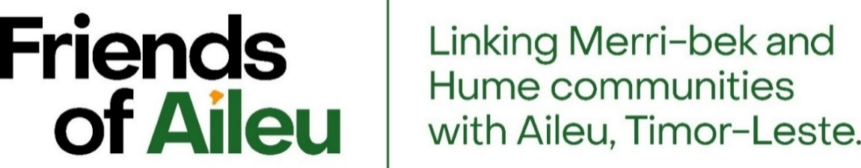

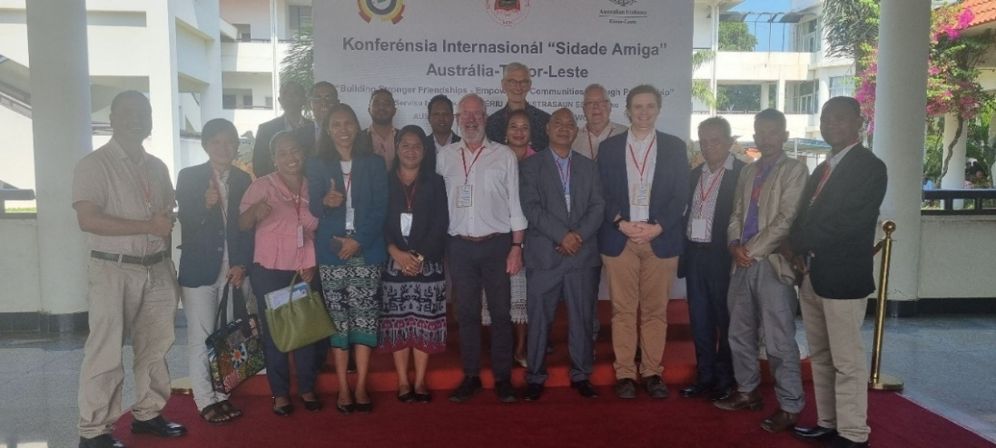

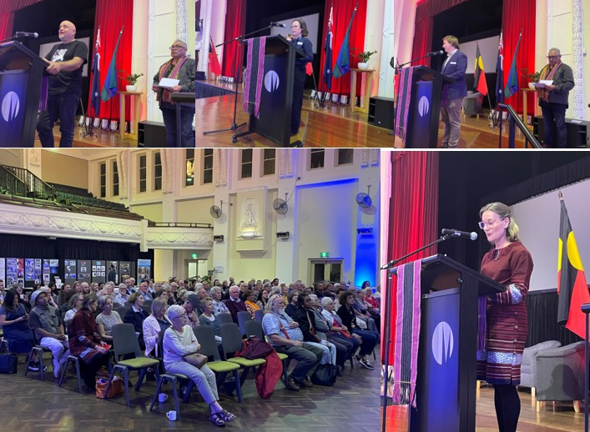

Friends of Aileu Annual Report 2025
Activities and Outcomes in 2025 and an Outlook for 2026

Prepared by the East Timor Project Team and the Friends of Aileu Community Committee



Bemvindu ba Relatoriu Anual tinan 2025 Belun Aileu nian

/

Welcome to Friends of Aileu Annual Report for 2025

Acknowledgements:
Friends of Aileu Community Committee, Merri-bek City Council and Hume City Council acknowledge the Wurundjeri Woi-wurrung people, including the Gunung-Willam-Balluk clan in Hume, as the Traditional Owners and Custodians of the lands and waterways in the areas now known as Merri-bek and Hume.
We pay respect to their Elders, past and present, as well as to other First Nations people and communities and acknowledge their Care for Country and the significant contributions they make to the life of our communities.
The Friends of Aileu Community Committee also acknowledges the support of the Merri-bek and Hume City Councils and their communities for the friendship relationship, which has flourished since its establishment in May 2000, and the support and involvement of the Municipality and people of Aileu.
We acknowledge the Government of the Democratic Republic of Timor-Leste and its agents, including the Aileu Municipal Authority, and their efforts and achievements, together with the people of Aileu, to develop their local democracy and work towards a more prosperous and sustainable future.
We acknowledge with respect the traditional leaders and elders of Aileu and the civil society organisations and citizens that supported the armed, diplomatic and clandestine fronts during the resistance period including youth, who participated in the UN Referendum of August 1999 and the subsequent restoration of independence in May 2002.
We also acknowledge the many others who continue to contribute friendship between our communities and to the political, social and economic development of Aileu and Timor-Leste.

Contents
Section |  | Title | Page
Cover photos |  | Aileu Friendship Conference delegates: Friends of Aileu, Aileu Municipal Authority and Ailey non-government partners, Dili, July 2025
 |  | Friends of Aileu hosting Friends of Baucau and Suai, and other friends of Timor-Leste, to celebrate 25 years of friendship, Coburg Town Hall, May 2025
Acknowledgements |  |  | 1
Contents |  |  | 3
Maps | Timor-Leste, one of Australia’s nearest neighbours |  | 6
Maps | Aileu Municipality |  | 6
Photos | Signing of Friendship Agreement (Merri-bek - Hume - Aileu) 2025-2030 in Coburg, Aileu and Dili |  | 7
Photos | Aileu Scholarship Program beneficiaries, Aileu, July 2025 |  | 7
Photos | 50th Anniversary of 1975 Proclamation of Independence |  | 7
1 | Introduction |  | 9
1.1 | This report |  | 9
1.2 | The project and its governance |  | 9
1.2.1 | Friends of Aileu Community Committee |  | 9
1.2.2 | Merri-bek and Hume City Councils: Friends of Aileu Strategy Plan |  | 10
1.2.3 | Merri-bek and Hume City Councils’ Project Liaison Group |  | 10
1.2.4 | Friendship Agreement 2025-2030 |  | 10
1.2.5 | Friends of Aileu Community Committee’s Project Reference Group |  | 10
1.2.6 | Merri-bek and Hume City Councils’ East Timor Project Team |  | 10
1.2.7 | Communications |  | 11
1.2.8 | Fundraising and donations |  | 12
1.2.9 | Financial management and reporting |  | 12
2 | Community Development, information sharing and fundraising activities and outcomes in Merri-bek and Hume:  Working together as a community to sustain and develop our friendship with Aileu |  | 15
2.1 | Collaborating with the Timorese Association in Victoria: 50 years of East Timorese community life in Victoria |  | 15
2.2 | Australia Timor-Leste Friendship Network and Friendship Conference, Dili, July 2025 |  | 16
2.3 | Oral Health Promotion Working Group |  | 16
2.4 | Grassroots Gathering for Aileu 2025 |  | 16
2.5 | Councils Connecting Communities: 25 years of friendship with Aileu, Baucau and Suai, Timor-Leste |  | 17
2.6 | Collaborating with the Melbourne East Timorese Activity Centre |  | 18
2.7 | Trivia Quiz 2025 for Aileu Scholarship Program |  | 19
2.8 | Award of Medal of the Oder of Timor-Leste |  | 19
2.9 | New initiatives for 2025: Library Talks and Movie Night |  | 20
2.10 | Participation in Council Festivals |  | 21
2.11 | Participation in activities of the Australia East Timor Association |  | 21
2.12 | Victoria University Dr Jean McLean Oration: 50th anniversary of the Balibo 5 Murders |  | 22
2.13 | Flag raising for 50th anniversary of Timor-Leste Declaration of Independence |  | 22
2.14 | Passing of John Martinkus and Rae Kingsbury |  | 23
3 | Community Development activities in Timor-Leste and Aileu:  Working together in friendship for a more just, prosperous and sustainable future for Aileu |  | 25
3.1 | Friends of Aileu activities and outcomes |  | 25
3.1.1 | Friends of Aileu - Council Delegation to Timor-Leste, July 2025 |  | 25
3.1.2 | Oral Health Promotion Project Coordinator visit to Timor-Leste, October 2025 |  | 26
3.1.3 | Friends of Aileu - Friends of Baucau - Future Collective engagement visit to Timor-Leste, October 2025 |  | 26
3.2 | Aileu and Timor-Leste partner organisation activities and outcomes |  | 27
3.2.1 | Aileu Municipal Authority - delivering services, developing capacities and preparing for elected responsible local government |  | 27
3.2.2 | Aileu Friendship Commission - overseeing friendship relationship activities |  | 28
3.2.3 | Aileu Municipal Youth Centre - promoting youth as active healthy citizens |  | 29
3.2.4 | Cr Andy Ingham Aileu University Scholarship Program - helping address Aileu’s human resource needs |  | 29
3.2.5 | Hume City Council Teacher Education Scholarships - improving the quality of school education |  | 31
3.2.6 | Aileu Resource and Training Centre - local decision making and strengths-based community development in action |  | 33
3.2.7 | Aileu Anan Association and Aileu PermaYouth Centre - planting water, growing communities |  | 36
4 | Financial Summary 2025 |  | 39
5 | Outlook for 2026 |  | 41
Attachments
1 | Friends of Aileu Governance and Relationships, June 2025 |  | 43
2 | Friends of Aileu Strategy Plan 2025-2030 |  | 45
3 | Friends of Aileu Community Committee Terms of Reference, May 2025 |  | 51
4 | Friends of Aileu Community Committee membership, November 2025 |  | 59
5 | Friendship Agreement (Merri-bek - Hume - Aileu) 2025-2030 |  | 61
6 | Councils Connecting Communities: 25 years of friendship  6a: Message from Rae Kingsbury  6b: Transcript of address by Kirsty Sword Gusmão |  | 63
7 | Report on the Friends of Aileu - Council delegation to Timor-Leste, July 2025 |  | 69
8 | Report on the Oral Health Promotion Project field visit to Timor-Leste, October 2025 |  | 99
9 | Report on the Friends of Aileu - Friends of Baucau - Future Collective engagement visit to Timor-Leste, October 2025 |  | 101
10 | Financial Summary 2025 Calendar Year |  | 107
Timor-Leste: one of Australia’s nearest neighbours
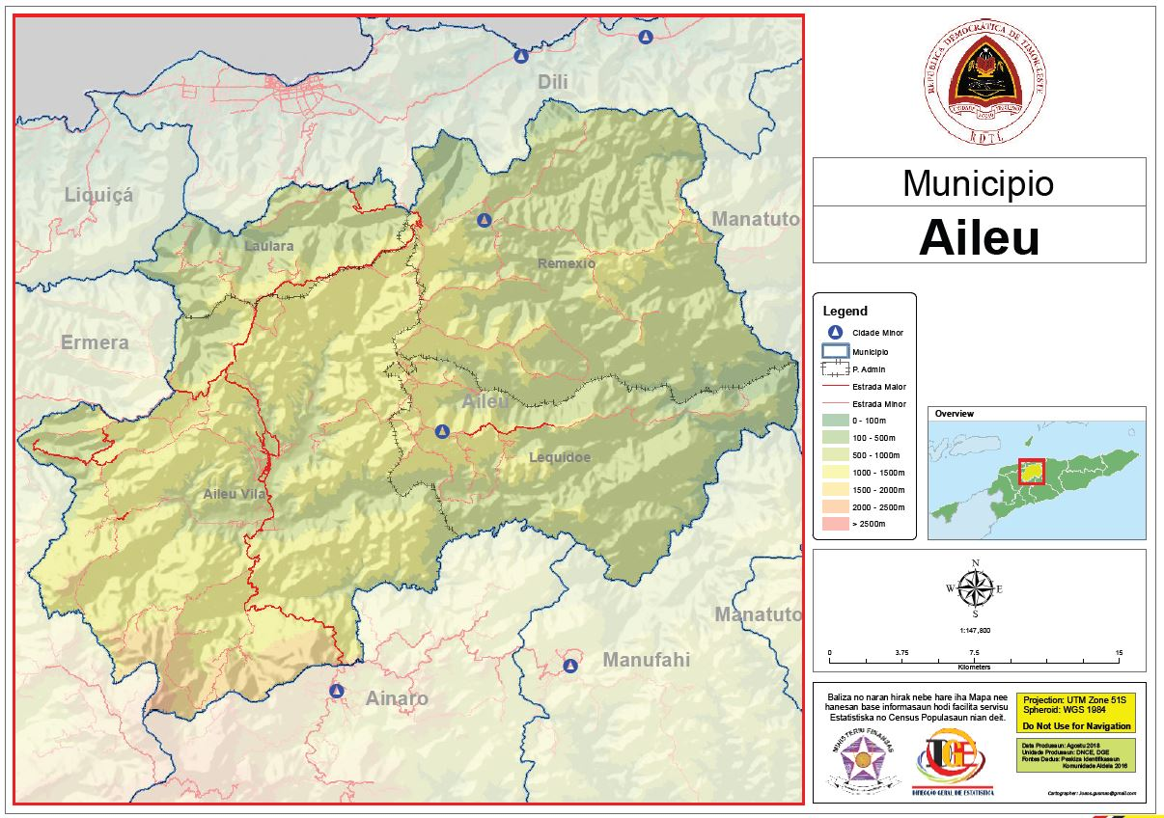
Aileu Municipality: A largely mountainous, partly forested area of 790 km² with significant areas of agricultural use, is home to some 54,300 people (in around 9,400 households),
most of whom live in 139 Aldeias (small hamlets) that are administered as 35 Sucos (villages),
grouped into 4 Administrative Posts (Aileu Vila, Laulara, Lequidoe and Remexio)
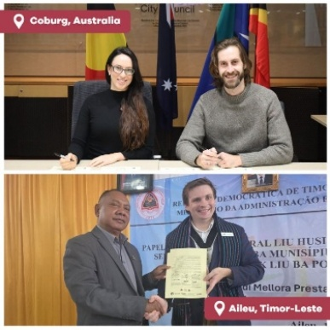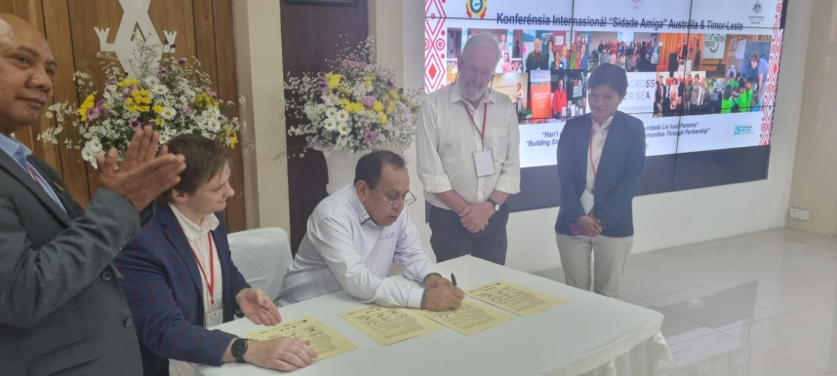
Signing Friendship Agreement (Merri-bek – Hume – Aileu) 2025-2030
Upper left: Merri-bek Mayor Cr Helen Davidson with Friends of Aileu Chair Cr Adam Pulford
Lower left: Aileu Municipal President Mr João Bosco dos Santos with Hume Mayor Cr Jarod Bell
Right: Timor-Leste Minister for State Administration Mr Tomas Cabrál, with Mr João, Cr Bell, Richard Brown, Friends of Aileu, and Quida Pereira, Uma Ita Nian Clinic

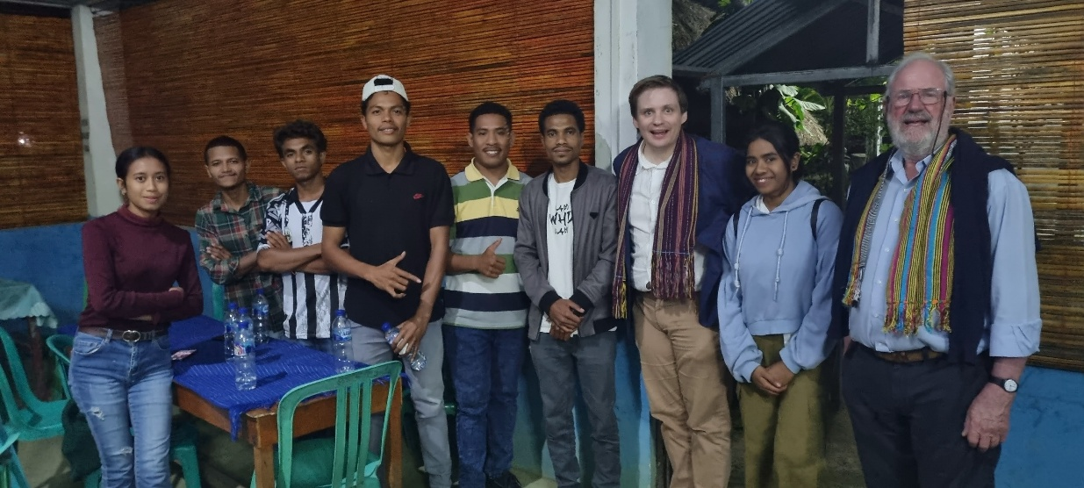
Aileu Scholarship Program beneficiaries with Cr Bell and Richard Brown, Aileu, July 2025
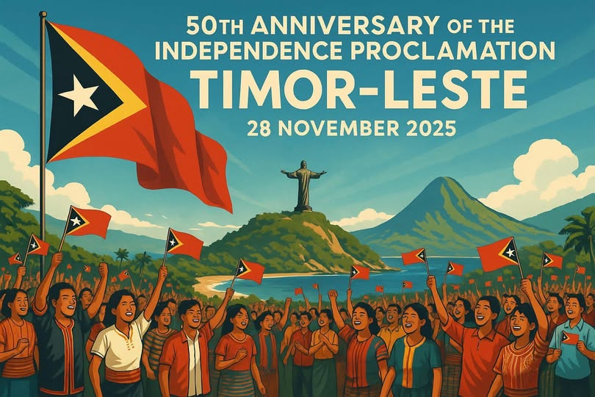
50th anniversary of 1975 Proclamation of Independence

- Introduction
1.1 This report
The Friends of Aileu Annual Report 2025 highlights the main community development, fundraising and information sharing activities undertaken during the calendar year.
This report has been prepared by the East Timor Project Team with input from the Friends of Aileu Community Committee.
The report is to be presented to Merri-bek and Hume City Councils and made available to Friends of Aileu’s partner organisations in Australia, Aileu and Timor-Leste, to our donors and supporters, and to the broader communities of Merri-bek, Hume and Aileu.
1.2 The project and its governance
The Friends of Aileu is the East Timor Partnership Project of Merri-bek and Hume City Councils and their communities, engaged in a friendship relationship with the Municipality and people of Aileu.
The aspirations and commitments of the friendship relationship are outlined in the Friendship Agreement (Merri-bek - Hume - Aileu) 2025-2030 and in separate and complementary Municipal Cooperation Agreements (Moreland - Aileu and Hume - Aileu) with the Timor-Leste Ministry of State Administration, that were established by each Council in 2016.
For an illustration of friendship relationship and links between various parties, see Friends of Aileu Governance and Relationships, June 2025 (Attachment 1).
1.2.1 Friends of Aileu Community Committee
The Friends of Aileu Community Committee (a joint Working Group of the Merri-bek and Hume City Councils) met bi-monthly during 2025 (in February, April, June, August, October and December), providing guidance and support for project activities, including bringing community perspectives to the fore and helping the Project Team to implement priority activities that are aligned with the Friends of Aileu Strategy Plan.
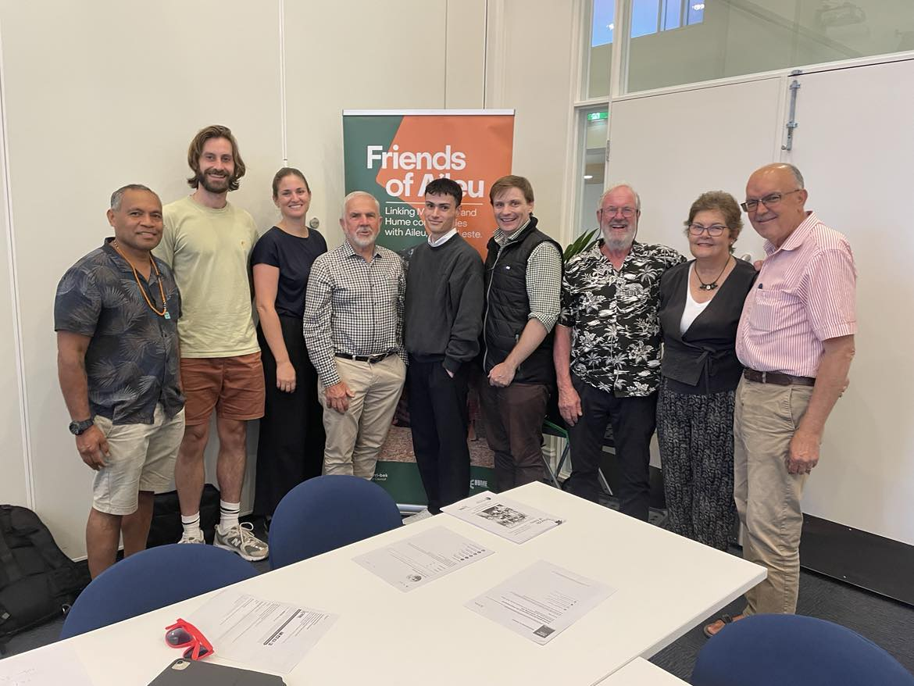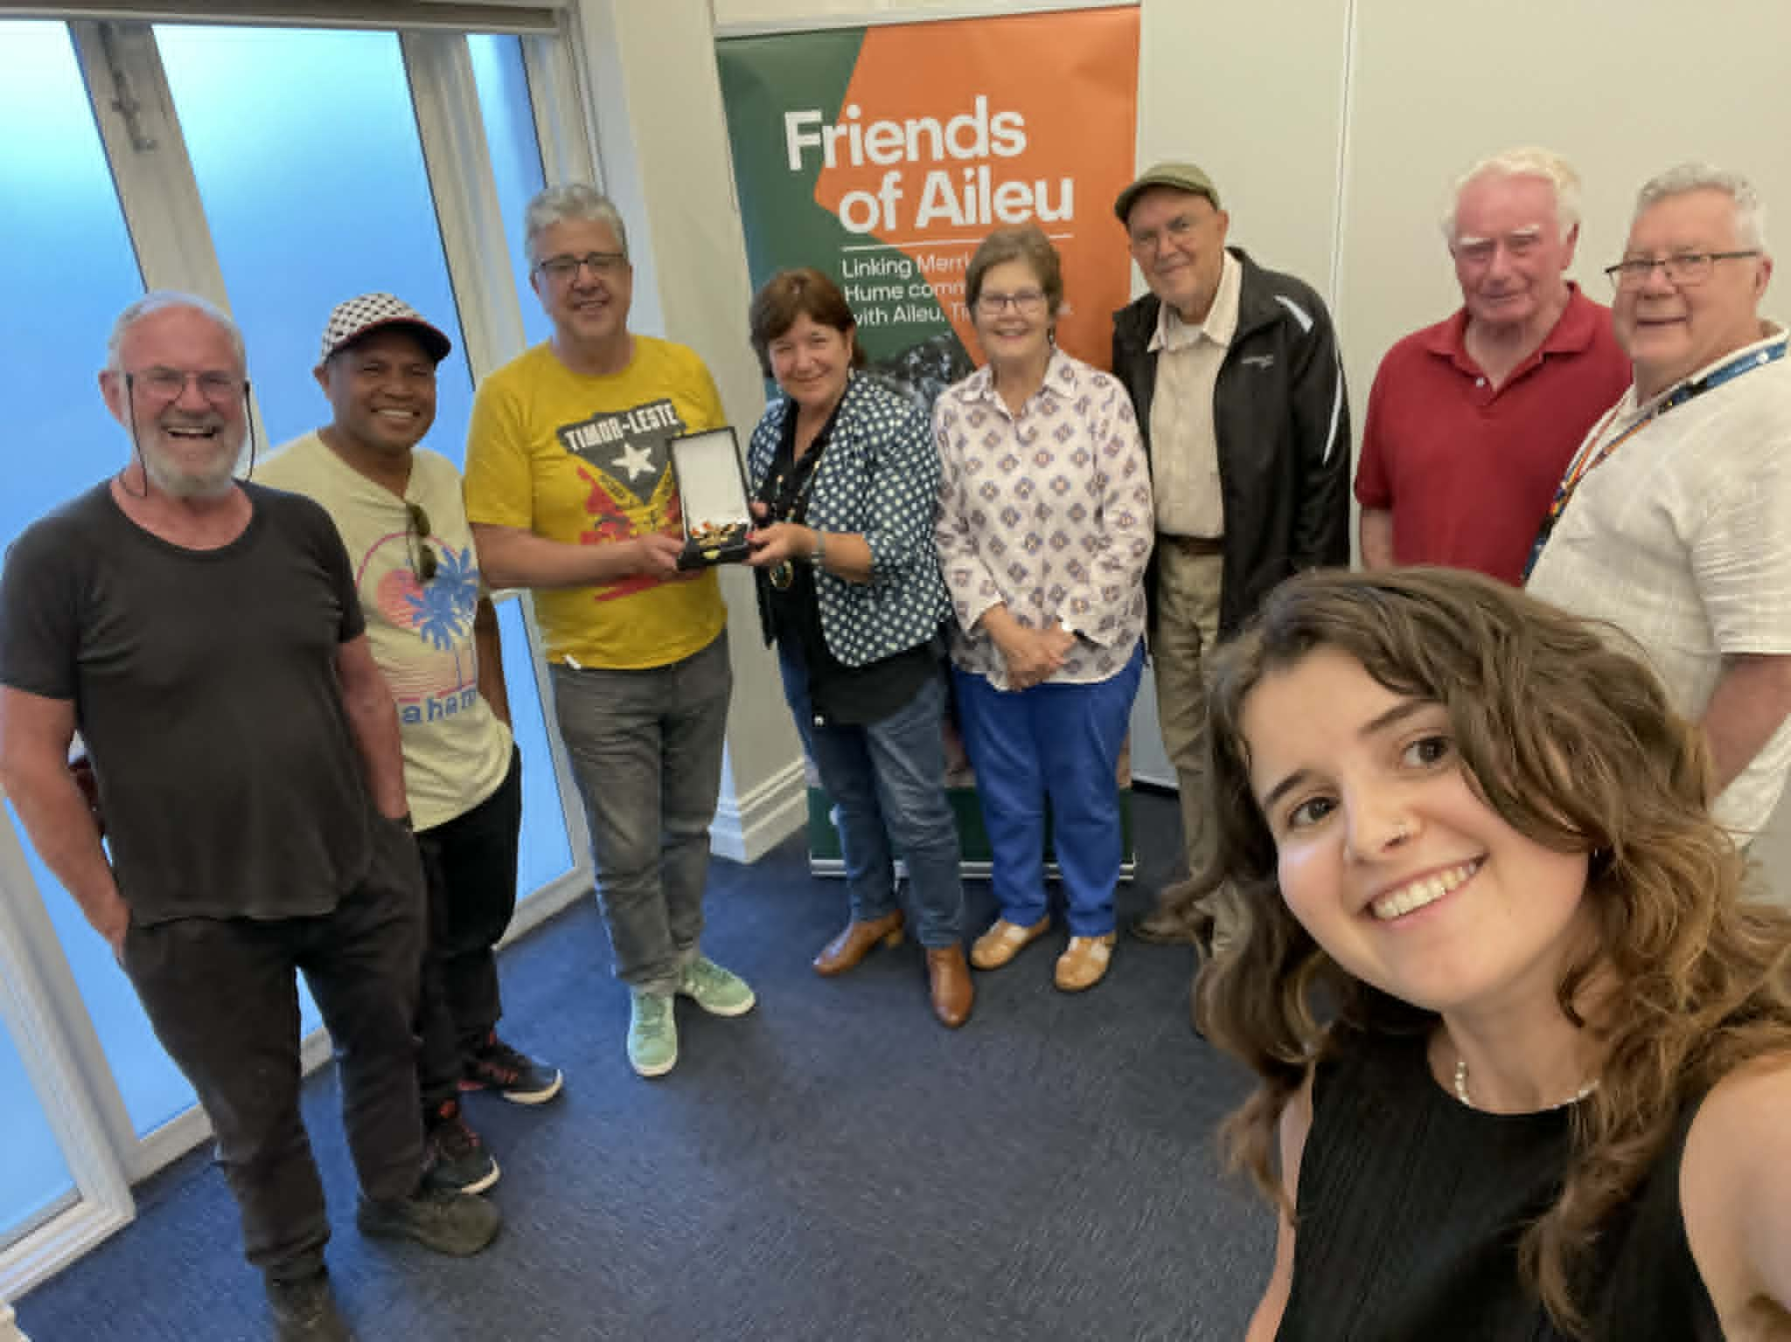
At its February 2025 meeting, the Friends of Aileu Community Committee heard from Chris Dureau on strength-based community development principles and practice and endorsed:
- Minor changes to its Terms of Reference
- The Friends of Aileu Annual Report 2024
- A news Friends of Aileu Strategy Plan 2025-2030
- The Friendship Agreement (Merri-bek - Hume - Aileu) 2025-2030, for renewal of the friendship relationship.
The Committee noted that minor refinements may be made to these drafts following the Committee’s Project Reference Group meeting on 20 February 2025.
At its December meeting the Committee heard from Ben Rogers, CEO Inner North Community Foundation, about the Foundation, its management of Trust Funds, how a Friends of Aileu MyFund (or an Friends of Timor-Leste MyFund in conjunction with the Friends of Baucau and the Timorese Association in Victoria ) might be established and the benefits of such a move, including access to new sources of donations and the ability to provide DGR tax deductibility. The Committee agreed to further consider establishing a MyFund with the Inner North Community Foundation early in 2026.
1.2.2 Merri-bek and Hume City Councils: Friends of Aileu Annual Report and Strategy Plan
In April 2025, Merri-bek and Hume City Councils noted the Friends of Aileu Annual Report 2024 and endorsed the Friends of Aileu Strategy Plan 2025-2030 (Attachment 2).
1.2.3 Merri-bek and Hume City Councils’ East Timor Project Liaison Group
The East Timor Project Liaison Group (Director Community Merri-bek, and Director City Services and Living Hume, the Councils’ respective Managers and the Project Teams’ Unit Manager Merri-bek and Coordinator Hume) met on 21 May:
- Endorsing an amended Friends of Aileu Community Committee Terms of Reference (Attachment 3)
- Noting the updated Community Committee membership (Attachment 4).
1.2.4 Friendship Agreement 2025-2030
Subsequently, the mayors of Merri-bek and Hume City Councils, the Aileu Municipal President and the Timor-Leste Minister for State Administration signed the Friendship Agreement (Merri-bek - Hume - Aileu) 2025-2030 (Attachment 5), renewing the friendship relationship for a further 5 years.
The new Friendship Agreement was uploaded to the DFAT Foreign Arrangements portal.
1.2.5 Friends of Aileu Community Committee’s Project Reference Group
The Project Reference Group, a sub-committee of the Friends of Aileu Community Committee, whose members are Anne Jungwirth, Glenyys Romanes, Richard Brown, Carlo Carli and Joe Caputo, met four times during the year (in February and June and twice in November), continuing to provide the Project Team with valuable additional guidance between Committee meetings.
1.2.6 Merri-bek and Hume City Council East Timor Project Team
The East Timor Project Team comprised the Project Officer (Christopher Adams) and the Project Administration Support Officer (Aoife Carli Hannan), each employed by Merri-bek City Council at 0.5 EFT.
During the year the Project Team provided a 200-hour Industry Placement for Eric Kioria, a Victoria University Community Development student, who:
- Assisted in planning and executing the Trivia Quiz fundraiser, including soliciting donations for prizes and auction items from local businesses for this large fundraising event
- Contributed to further developing Friends of Aileu volunteer engagement guidelines.
In late 2025, Aoife Carli Hannan, Project Administration Support Officer, advised that she would be resigning in January 2026 to travel overseas for an extended period. The Position Description was reviewed prior to the role being advertised. 106 applications were received and, after shortlisting, 6 candidates were selected for interview. Interviews were completed in December 2025 and a preferred candidate selected. It is expected that an appointment will be finalised in time for the new person to start in February 2026.
Aoife commenced volunteering with the Friends of Aileu in 2017, including coordinating the annual Grassroots Gathering for Aileu from that year and taking part in several visits to Timor-Leste.
Aoife was engaged by Merri-bek City Council to backfill for the Project Officer during a period of leave in 2022, including organising the Trivia Quiz fundraiser that year. Following the return to work of the Project Officer in late 2022 (at 0.5 EFT rather than the previous 0.8 EFT), the role of Project Administration Support Officer (0.5 EFT) was created and advertised. Aoife was appointed following a competitive interview process in early 2023.
Aoife made a significant impact over 3 years in the Project Support role, bringing new skills and experiences to the Project Team, including strengthening connections to younger members of the community, and enthusiastically tackling the varied aspects of the Project Team’s responsibilities.
1.2.7 Communications
Work continued on changes to the layout and content of the Friends of Aileu page on the Merri-bek City Council website to better emphasise key messages, calls to action and information on current news and events.
Friends of Aileu Facebook page was used to provide information on upcoming activities and events and news from Aileu.
The Community Committee identified the need for more sophisticated and varied use of Social Media as an important improvement to achieve better communication, considering both the broad community and more targeted audiences, taking into consideration their media and style preferences. The Committee supported a proposal by the Project Team to investigate creating an Instagram account.
The Friends of Aileu digital newsletter was published 4 times during 2025, in March, June, September and December, providing more detailed news of events and activities in Merri-bek and Hume, and in Aileu.
These newsletters can be accessed on the Merri-bek website at Friends of Aileu under Friends of Aileu News, and have been shared on the Friends of Aileu Facebook page.
Subscriber numbers have grown from an initial 70 to the current 347.
Campaign Monitor, the platform for the newsletter, was also used throughout the year to help circulate event information and invitations.
Response to the eNewsletter has been good, with numerous compliments from readers, and engagement statistics (opening of the newsletter or notice/invitation):
- The four eNewsletters, ranging from 39.1% to 46.4% (average 43%)
- The 13 event information notices, ranging from 50.6% to 66% (average 57.6%).
1.2.8 Fundraising and donations
Friends of Aileu purchases Wild Timor Coffee, sourced from small holdings near Belumhato, Aileu Vila, and processed in Timor-Leste and Melbourne, for fundraising at a discounted wholesale price.
The Wild Timor Coffee Company operates as a Social Enterprise (defined as a business that trades to intentionally tackle social problems, improve communities, provide people access to employment and training, or help the environment) and feeds back a proportion of profits to its help its supplier community improve their coffee quality and livelihoods, and for other community development projects in Aileu and elsewhere in Timor-Leste.
Friends of Aileu also purchases traditional woven tais cloth handcraft, sourced by the Rotary Club of Kew Fair Trade and Gift Shop from the not-for-profit women’s social enterprise Kor Timor (Colours of Timor), based in Taibesi, Dili, Timor-Leste, for fundraising at a discounted wholesale price.
Sales of these products provide a small regular income to the Friends of Aileu, with 100% of the profit used to support community development activities in Aileu.
The generosity of Friends of Aileu Community Committee and Working Group members and supporters was in evidence during 2025, with individual donations totalling a record $11,186, due in large part to specific campaigns for funding for the Oral Health Promotion Project (see Section 2.3 below).
1.2.9 Financial management and reporting
Merri-bek City Council manages the East Timor Project Cost Centre (the budget for employee salaries and materials and services), with Hume City Council reimbursing Merri-bek for 50% of actual expenses on a quarterly basis.
Expenditure from the Cost Centre budget and the Balance Sheet Accounts is managed according to Merri-bek City Council line management and financial delegations, policies and procedures, where appropriate as agreed with Hume City Council line management and/or with endorsement from the Friends of Aileu Community Committee.
The total Cost Centre expenditure (salaries and materials and services) for calendar year 2024 (2nd half of 2024/25 and 1st half of 2025/26) was $129,031, shared 50/50 by the two Councils.
Merri-bek City Council also manages two separate Balance Sheet Accounts:
- Friends of Aileu Donations & Fundraising
- Friends of Aileu Fundraising Sales).
These accounts receive donations and fundraising managed by the Project Team with the assistance of the Community Committee.
These publicly raised funds are used by Friends of Aileu with 100% going to support community development activities in Aileu (see details at Section 4 below).
The Project Officer lodged an on-line return of the 2024 fundraising activities and expenditure with Consumer Affairs Victoria (CAV), as part of the compliance requirements of Merri-bek City Council – Friends of Aileu, which is a registered fundraiser with CAV.

- Community Development, information sharing and fundraising activities and outcomes in Merri-bek and Hume:
Working together as a community to sustain and develop our friendship with Aileu
2.1 Collaborating with the Timorese Association in Victoria: 50 years of East Timorese community life in Victoria
Collaboration with the Timorese community got off to a strong start with the Project Officer convening a series of monthly on-line meetings with the Timorese Association in Victoria (TAV) commencing in February.
The meetings brought together representatives of other friendship groups and related organisations and individuals, to coordinate plans for events to celebrate both 50 years of the Timorese Community’s presence in Victoria and 25 years of friendship between Victorian and Timor-Leste municipalities and communities.
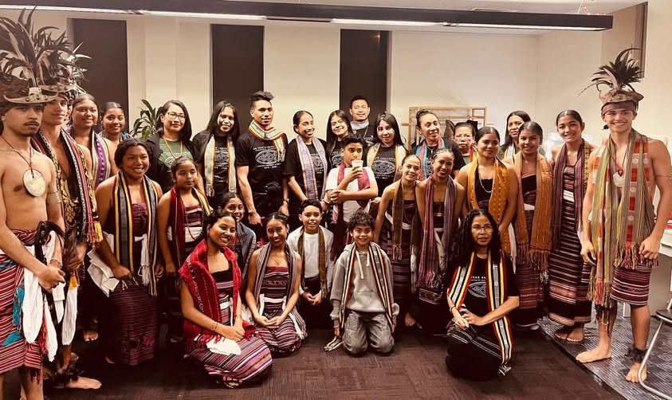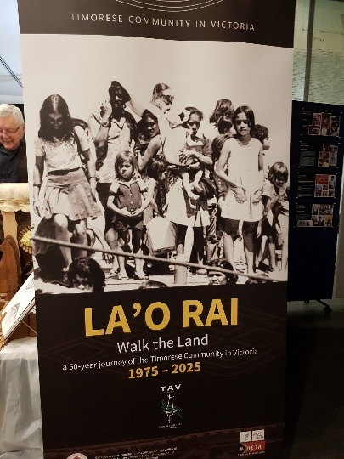
Friends of Aileu members and the Project Officer participated in the Timorese Association’s 50-year celebrations held at Collingwood Town Hall in August, which attracted over 500 guests. At this event the Timorese community’s photographic exhibition Lao Rai (Walking the Land)- Honouring the Past Shaping the Future, was launched.
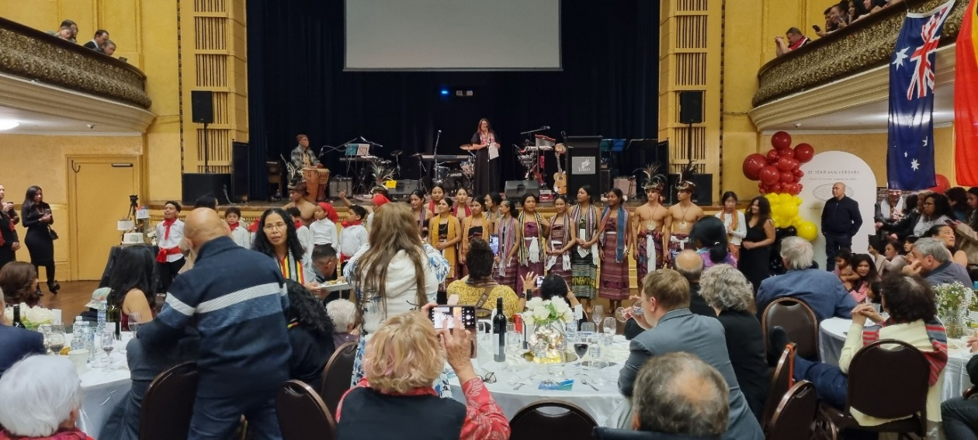
2.2 Australia Timor-Leste Friendship Network and Friendship Conference, Dili, July 2025
Commencing in February, the Project Officer also met regularly on-line with the National and Victorian coordinators of the Australia Timor-Leste Friendship Network, and representatives of the Timor-Leste Ministry of State Administration, to plan for the Friendship Conference Building Stronger Friendships - Empowering Communities Through Partnerships, held in Dili, Timor-Leste in July (see Section 3.1.1 below).
Friends of Aileu Community Committee members participated in an on-line post-conference members forum held in August.
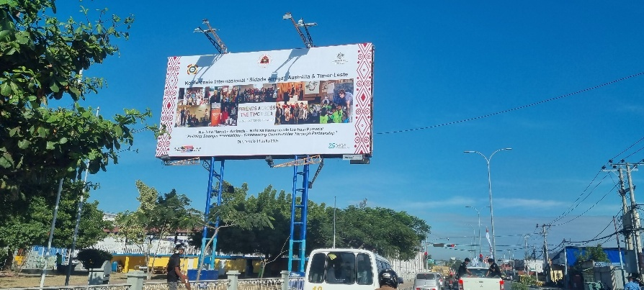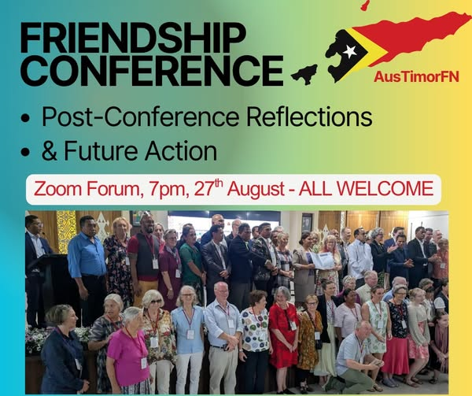
2.3 Oral Health Promotion Working Group
Friends of Aileu Oral Health Promotion Working Group, established in late 2024 resumed its monthly meetings in February.
Working Group members, Glenyys Romanes, Natalie Savin, Dr John Rogers, Dr Jamie Roberston, Dr Jinal Prajapti and Dr Sandra Frans (Volunteer Project Coordinator, Oral Health Promotion Project), collectively brought a high level of public health and oral health and community development experience and expertise to planning the next steps following the successful Kose Nehan (Tooth Brushing) pilot project.
Dr John Rogers participated in the Friends of Aileu - Council delegation to Timor-Leste in July (see Section 3.1.1 below), while Dr Sandra Frans made a separate visit to Timor-Leste in October (see Section 3.1.2 below).
2.4 Grassroots Gathering for Aileu 2025
The Grassroots Gathering fundraiser for Aileu, again organised by Grassroots Gatherings Inc, was held for the first time at the newly upgraded Yubup Park, Brunswick, in March.
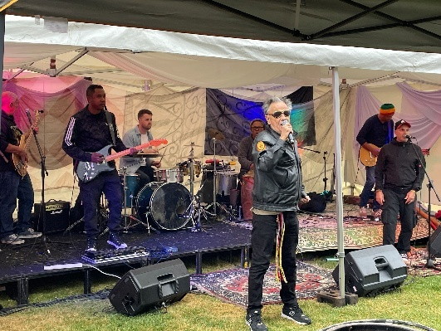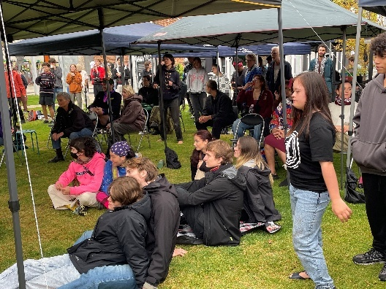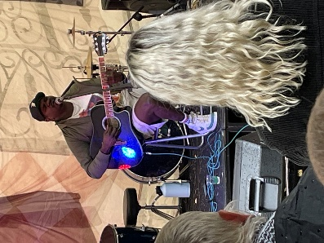
Despite heat wave conditions in the lead up days and during the morning, followed by drenching storms through the afternoon, the event was an enjoyable get-together, attracting some 200 people and raising $3,400 for youth-led environmental activities in Aileu.
Performers included Chico and Xavi, Waiata Takatāpui, Yirrmal, Dili All Stars, The Black Sistaz and Waka Viti with special guest Koteka Wenda, with a Welcome to Country by Uncle Colin Hunter.
2.5 Councils Connecting Communities: 25 years of friendship with Aileu, Baucau and Suai, Timor-Leste
Friends of Aileu and Merri-bek and Hume City Councils hosted Councils Connecting Communities, a celebration of 25 years of friendship with Aileu, Baucau and Suai, at Coburg Town Hall in May.
The event brought together:
- Local Members of the Victorian Parliament, Ryan Batchelor and Kathleen Matthews-Ward
- Members of the Victorian public service and DFAT
- Members and supporters of Friends of Aileu, Friends of Baucau and Friends of Suai Cova Lima
- Councillors, CEO’s and staff of Port Phillip, Yarra and Darebin City Councils
- Members of the East Timorese community
- Other friends and supporters of Timor-Leste

The evening featured:
- José Pires, Vice-president of the Timorese Association in Victoria as MC
- A Welcome to Country delivered by Uncle Bill Nicholson
- A welcome address by Merri-bek Cr Liz Irvin and response by Hume Mayor Cr Jarrod Bell
- Recorded video messages from Xanana Gusmão, Prime Minister of Timor-Leste, and Abel Guterres (see these messages on Merri-bek website at Friends of Aileu <Past Events <25 Years of friendship with Aileu, Baucau and Suai
- The reading of a message from Rae Kingsbury (see Attachment 6 a)
- Kirsty Sword Gusmão as keynote speaker (see a transcript of the address at Attachment 6 b)
- Panel members Glenyys Romanes (Friends of Aileu), Glenda Lasslett (Friends of Baucau) and Megs Alston (Friends of Suai), responding to Kirsty Sword Gusmão’s address.
The event attracted some 175 people, raising $6,800 to support the work of the Aileu Friendship Commission, the Aileu Municipal Youth Centre and the Aileu Resource and Training Centre.
2.6 Collaborating with the Melbourne East Timorese Activity Centre
Friends of Aileu hosted the Melbourne East Timorese Activity Centre (METAC) June welcome dinner in Richmond, with guest speakers Dr Vanessa Hearman of Curtain University and Jose da Costa, one of the 18 refugees who arrived in Australia in 1995 aboard the Tasi Diak, the only successful maritime escape from occupied East Timor.
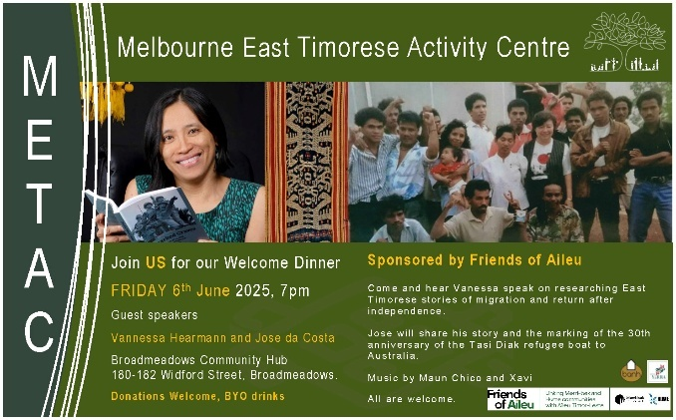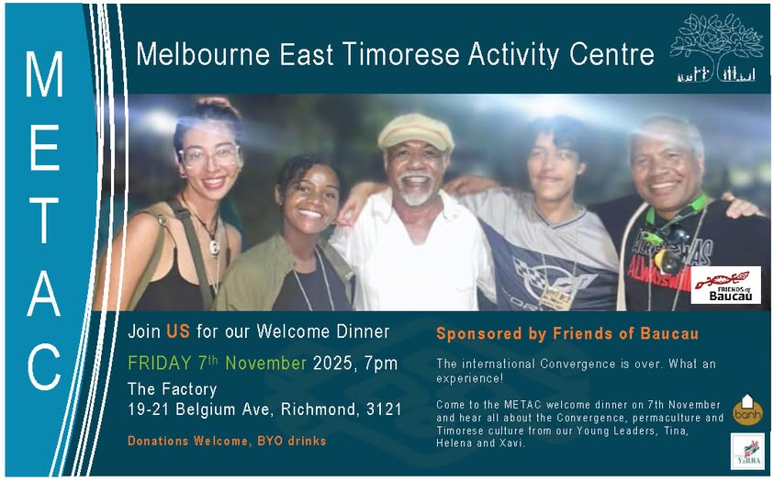
The Project Officer and members of the Community Committee also attended other METAC welcome dinners throughout the year, including in:
- August, when Timor-Leste students currently in Melbourne and several PALM scheme workers were welcomed and introduced themselves
- November, when two of the Friends of Aileu - Friends of Baucau Youth Leadership Award recipients (Tina De Melo and Xavi dos Santos) gave a presentation on their participation in the engagement visit to Timor-Leste facilitated by Future Collective for the 1st International PermaYouth Convergence (see Section 3.1.3 below).

2.7 Trivia Quiz 2025 for Aileu Scholarship Program
The annual Trivia Quiz fundraiser for the Aileu Scholarship Program was held at Coburg Town Hall in November, with Rusty Berther as MC.
The event attracted over 125 people and raising $10,700 (Tickets $5,900 plus Live & Silent Auctions and Coin Toss $4,800) supporting continuation of the Scholarship Program in 2026 – see Section 3.2.4 below.
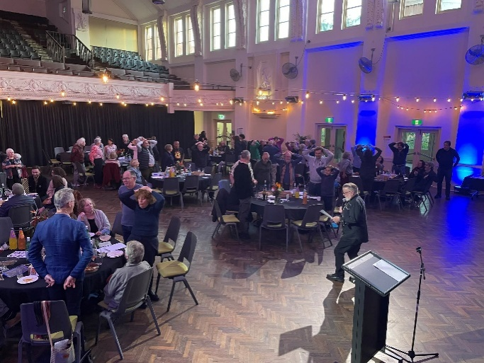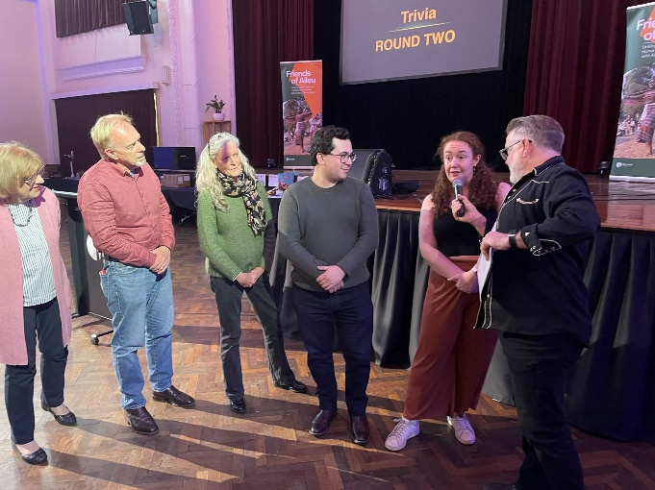
2.8 Award of Medal of the Order of Timor-Leste
Dr José Ramos Horta, President of Timor-Leste, visited Melbourne in August, conferring Medals of the Order of Timor-Leste to 17 Australian friendship groups, including Friends of Aileu.
The award recognised the groups’ promotion of friendship between Australian and Timor-Leste municipalities and communities and their support for Timor-Leste commencing from the time of the August 1999 Popular Consultation.
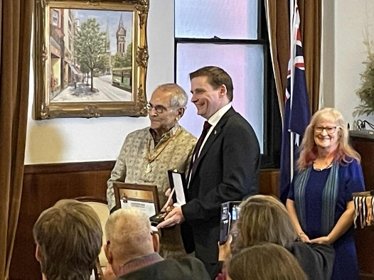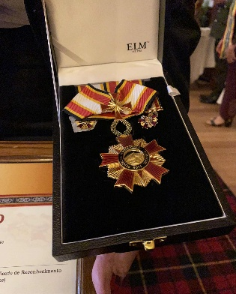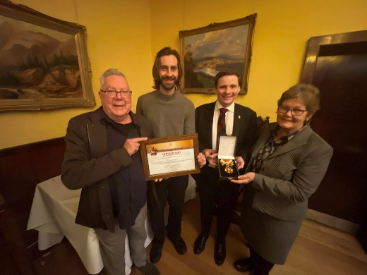
Hume Mayor Cr Jarrod Bell accepted the award on behalf of the Friends of Aileu. Also attending were Merri-bek Cr Adam Pulford, Community Committee members Anne Jungwirh, Glenyys Romanes and Richard Brown, and Project Officer Chris Adams.

2.9 New initiatives for 2025: Library Talks and Movie Night
A new Friends of Aileu initiative for 2025 was the hosting of two Library Talks on Timor-Leste:
- At Broadmeadows Library in July, with:
  - Pat Walsh speaking on Reflecting on Truth Telling, including comments on the continuing relevance of Chega!, the report of Timor-Leste’s Truth and Reconciliation Commission (CAVR)
  - Carla Chung speaking on the difficult situations some PALM scheme workers are experiencing
- At Glenroy Library and Community Hub in October, with:
  - Paulie Stewart, speaking on the Balibo 5 Killings (50th anniversary on 16 October) and his biographical book All The Rage!
  - A display of the Timorese Association’s 50-year exhibition of community photographs Lao Rai (Walking the Land): Honouring the Past – Shaping the Future.
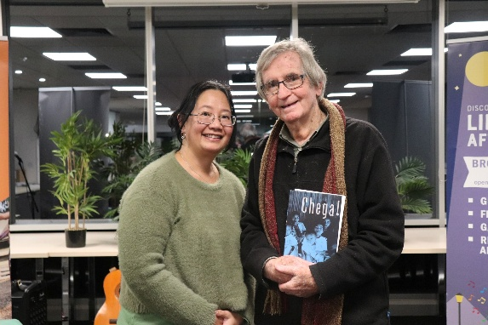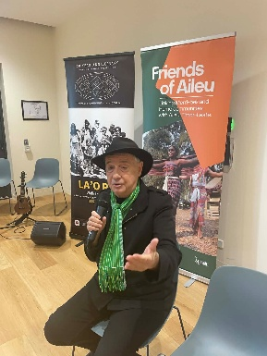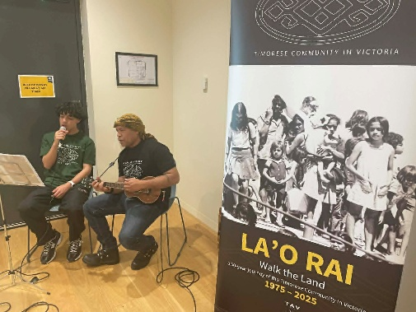
These talks attracted over 30 people each, about half of them being new participants in Friends of Aileu activities.
Thanks to staff of the Broadmeadows Library and Glenroy library and Community Hub for their support for these events.
Another new initiative was a climate change themed Movie Night at Merlynston Progress Hall in August, which attracted an audience of 30 people, raised $1,300, and included:
- Screening the film Anote’s Ark
- A discussion and Q & A with:
  - Taulogomai Aii, of Pacific Climate Warriors
  - Sticks XO, of PermaQueer.
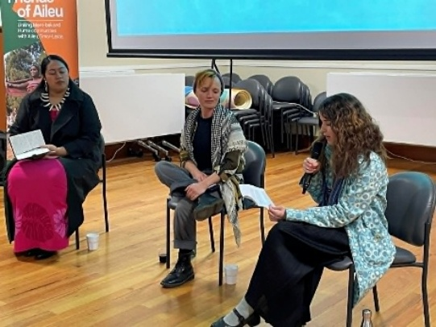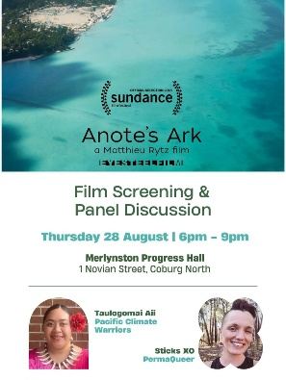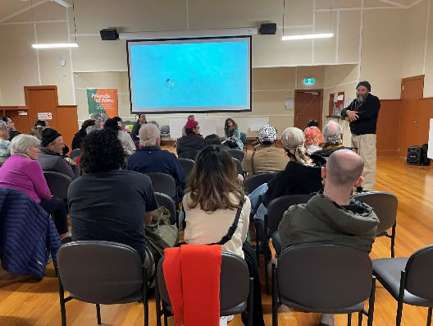

2.10 Participation in Council Festivals
Friends of Aileu Community Committee members, Friends of Aileu supporters and the Project Team participated in three of Merri-bek’s 2025 festival events, sharing information with festival goers and selling fundraising Wild Timor Coffee and Kor Timor craft.
The events attended in 2025 were:
- Sydney Road Street Party (March),
- Glenroy Festival (May)
- Coburg Night Markets (December).
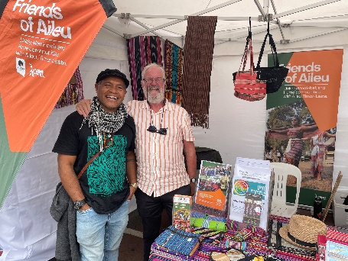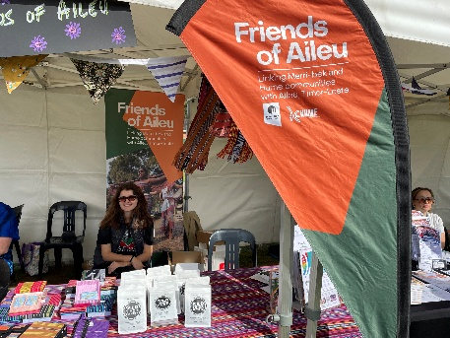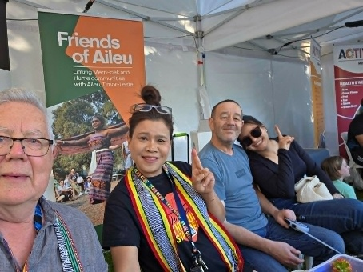
2.11 Participation in activities of the Australia East Timor Association
Friends of Aileu Community Committee members and supporters, and Project Team members, participated in the 2 main annual activities of the Australia East Timor Association (AETA):
- The annual dinner at William Angliss Centre in May, celebrating the anniversary of Timor-Leste’s Restoration of Independence on 20 May 2002, with:
  - Guest speakers Kirsty Sword Gusmão, Teresa Fraga, Febe Gomes and Ann Wigglesworth, giving brief reflections of the achievements of Timor-Leste women’s solidarity, challenges and future directions
  - Tiu Chico Lakadou (Chico and Xavi dos Santos) giving a musical performance.
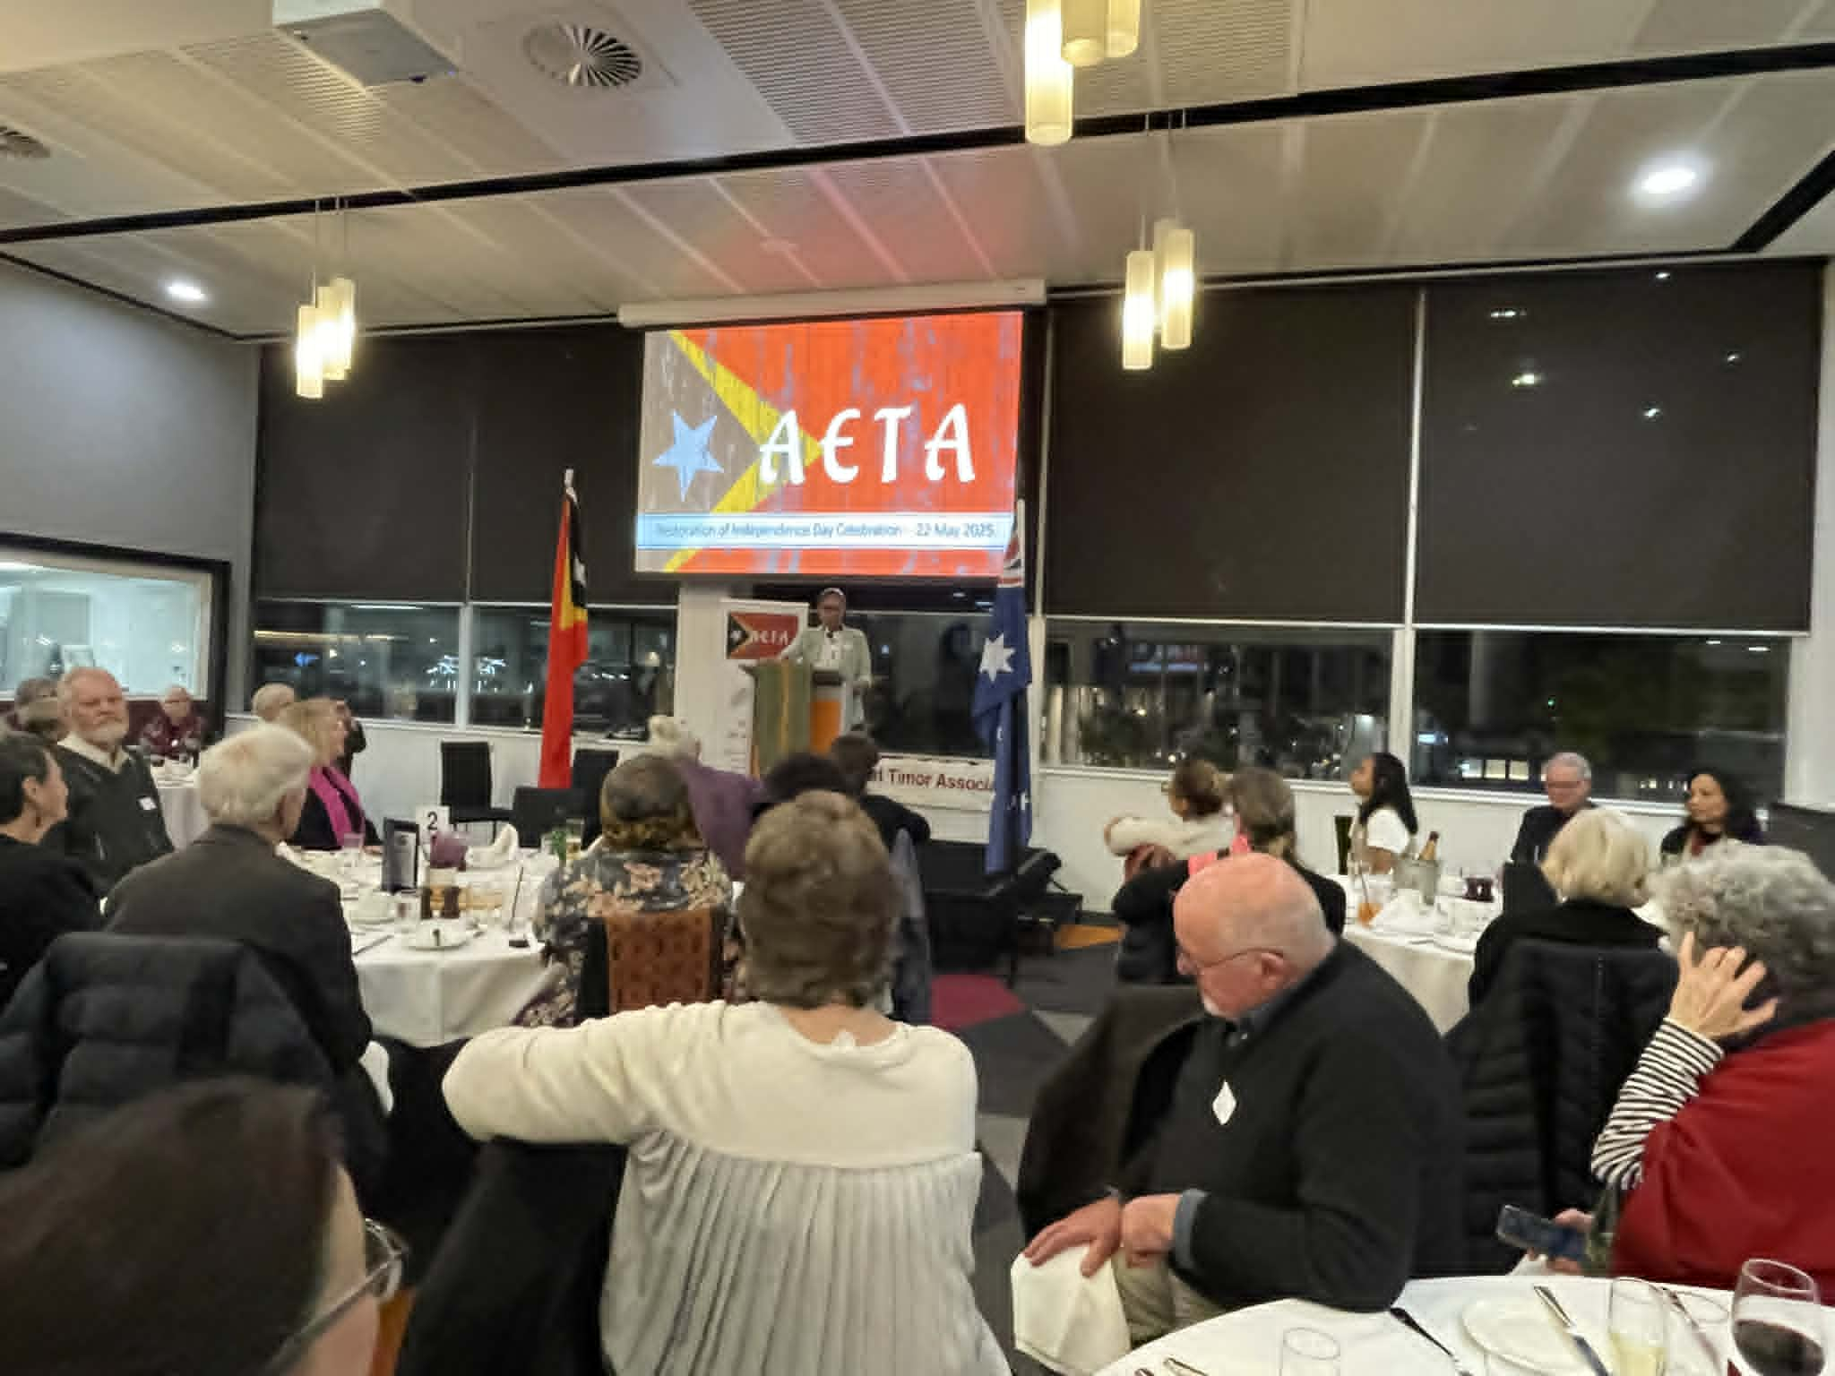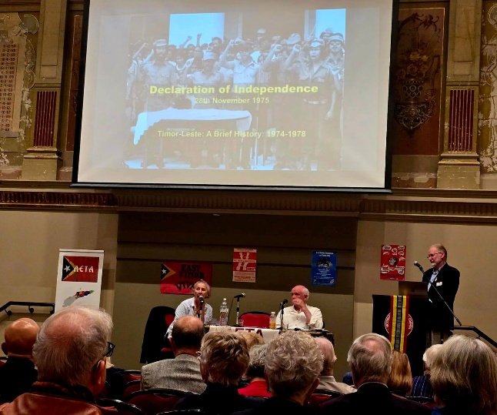
- The Honouring The Struggle: Remembering 1975 seminar and historic poster exhibition, in November at the Victorian Trades Hall, commemorating the 50th anniversaries of Timor-Leste’s unilateral Declaration of Independence and The East Timor Solidarity movement and the formation of AETA, with guest speakers:
- John Waddingham, East Timor activist and archivist manager CHART - Clearing House for Archival Records on Timor
- Richard Tranter, Academic, author and activist.
2.12 Victoria University Dr Jean McLean Oration: 50th anniversary of the Balibo 5 Murders
Friends of Aileu Community Committee members and supporters, and the Project Officer, attended the Victoria University Jean McLean Oration delivered by Dr José Ramos Horta. The event was held in collaboration with the Balibo House Trust on 20 October, just days after the 50th anniversary of the journalists’ deaths on 16 October 1975.
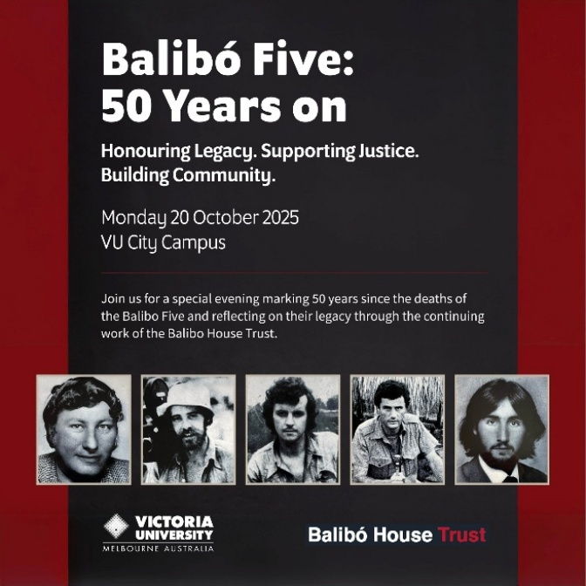
2.13 Flag raising for 50th anniversary of Timor-Leste Declaration of Independence
Cr Adam Pulford, Friends of Aileu Community Committee members and supporters and Council staff, gathered in front of Coburg Town Hall on 28 November, to raise the Timor-Leste flag on the occasion of the 50th anniversary of Timor-Leste’s unilateral Declaration of Independence from Portugal on 28 November 1975.
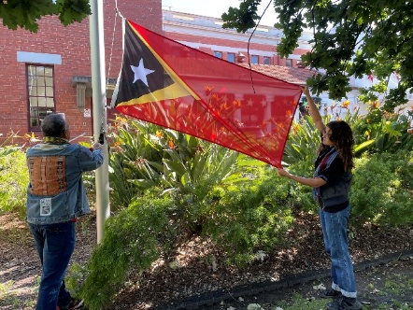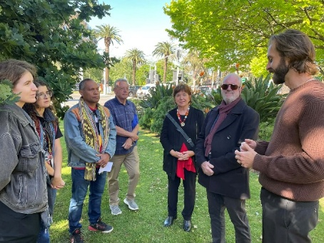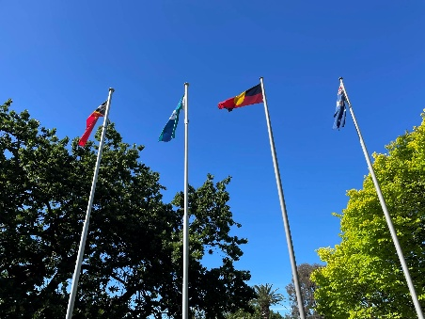

2.14 Vale John Martinkus and Rae Kingsbury
Two longstanding champions of truth, solidarity and friendship with the people of East Timor / Timor-Leste passed away in 2025, with Friends of Aileu Community Committee members and the Project Officer attending the funeral services of:
- John Martinkus, war correspondent, journalist educator and author (including of A Dirty Little War, at St Mary’s Catholic Church, Williamstown, in September
- Rae Kingsbury, former Councillor and Mayor City of Darebin, Friends of Aileu Project Officer (2002-2004) and co-founder of the Australia Timor-Leste Friendship Network, at Studley Park Boat House in December.
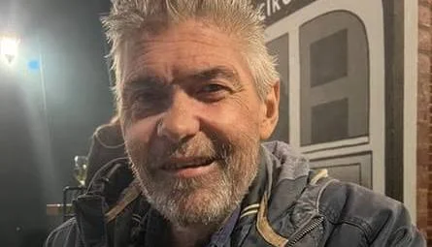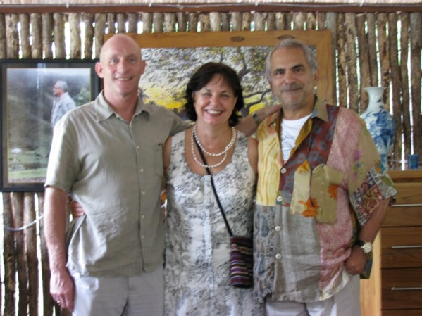
John Martinkus: Journalism Education and Research Association of Australia Tribute
John Martinkus’s career was defined by his commitment to truth and justice in some of the world’s most dangerous conflict zones. Born in Melbourne, he studied international relations and began reporting from Indonesian-occupied East Timor in the mid-1990s, often working under extreme conditions and evading military surveillance.
His early articles, published in outlets such as Green Left Weekly, The Sydney Morning Herald, and The Age, helped expose the actions of the Indonesian military and the plight of the Timorese people. Martinkus was the only journalist to travel to Alas to investigate reports of a massacre in 1998 and later reported on the militia violence surrounding the 1999 independence referendum. His front-page article in The New York Times on September 9, 1999, coincided with U.S. pressure on Indonesia to allow peacekeepers into Timor-Leste. He chronicled these events in his acclaimed book A Dirty Little War (2001) and continued to report on Timor-Leste’s political developments for decades.
Beyond Timor, Martinkus reported from West Papua, Aceh, Afghanistan, and Iraq, where he was kidnapped in 2004 and released after his captors verified his identity online. In 2011, he was commissioned as the Official Australian War Cinematographer in Afghanistan. He also taught journalism at the University of Tasmania and authored several books, including Travels in American Iraq and The Road: Uprising in West Papua.
In 2024, he was awarded the Order of Timor-Leste for his contributions to the country’s liberation. Martinkus died unexpectedly in Melbourne on September 14, 2025, at the age of 56. He is remembered as a journalist whose work gave voice to the oppressed and helped shape international responses to injustice.
Martinkus was a lecturer in journalism and communications at University of Tasmania from 2009 to 2015, winning a Vice-Chancellor’s Award for Outstanding Community Engagement in 2013.

Rae Kingsbury: Darebin mourns the loss of former Councillor and Mayor, Rae Kingsbury AM
Rae Kingsbury (formerly Perry) served the Darebin community as Councillor from 1998 to 2004 and as Mayor in 2004. This followed a distinguished career as a nurse, midwife, Oxfam campaigner and union organiser.
Her leadership at Darebin is marked by her passion for community engagement, good governance and democracy. During her time at Council, she founded the Darebin Women’s Advisory Committee which has since paved the way for many women in leadership.
Rae’s dedication to the Darebin community was truly extraordinary, and her impact on Darebin and beyond will be felt for generations. Her work championing women in leadership and fostering international friendships is a legacy we will proudly uphold.
Her commitment to community politics saw Rae serve on the boards of the Australian Local Government Association (ALGA), the Municipal Association of Australia and the Victorian Local Governance Association (VLGA). In 2004, Rae was the first woman elected as national president of the ALGA.
In 2020, Rae was recognised in the Australia Day Honours List as a Member of the Order of Australia (AM) for her incredible work in Victorian Local Government and our community while a Councillor at City of Darebin.
Rae is well known for her work with overseas communities including Timor-Leste, where following the vote for independence she co-founded the community-based Australia Timor-Leste Friendship Network. In 2012, she was appointed Honorary Consul for Timor-Leste Victoria.

- Community Development activities in Aileu and Timor-Leste:
Working together in friendship for a more just, prosperous and sustainable future for Aileu
3.1 Friends of Aileu activities and outcomes
3.1.1 Friends of Aileu - Council Delegation to Timor-Leste
A Friends of Aileu - Council delegation (Hume Mayor Cr Jarod Bell, Community Committee member Richard Brown, Oral Health Promotion Project Working Group member Dr John Rogers), all travelling at their own expense, and Project Officer Chris Adams, visited Timor-Leste in July:
- Meeting with Aileu partners and visit some government and non-government entities, project activities, health facilities and schools, with Cr Jarrod Bell signing the renewed Friendship Agreement 2025-2030 alongside Mr João Bosco dos Santos, President Aileu Municipal Authority
- Participating in the Friendship Conference held in Dili, obtaining the signature of Mr Tomás Cabrál, Timor-Leste Minister for State Administration, on the renewed Friendship Agreement 2025-2030
- Building relationships with relevant health authorities and organisations and gather information on oral health services, initiatives and needs in Aileu and elsewhere to help develop the project proposal for Friends of Aileu’s Oral Health Promotion project.
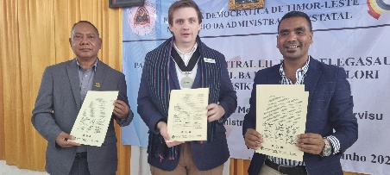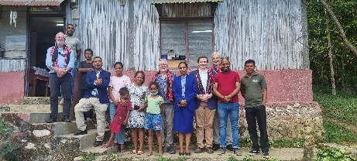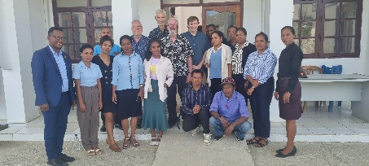
A key member of the Ministry of State Administration organising committee for the Friendship Conference was Abilio de Araujo, Deputy Team Leader Partisipa Program, President of Aileu Anan Association (AILA) and former Aileu scholarship beneficiary.
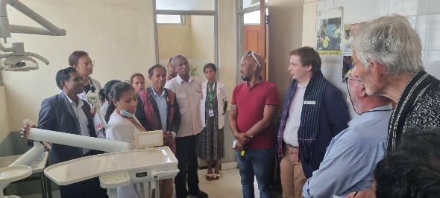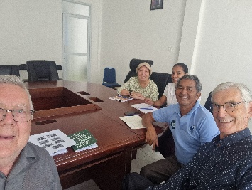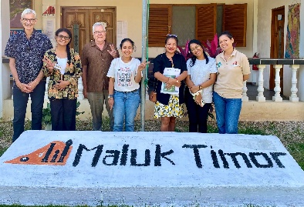
While the conference was valuable exercise in bringing friendship group representatives together, even more importantly it provided the opportunity for Timor-Leste partner organisations, including in the case of the Friends of Aileu, the Aileu Friendship Commission, the Aileu Municipal Youth Centre, the Aileu Resource and Training Centre and the Uma Ita Nian Clinic, to showcase their work.
For more details see Attachment 7: Report of Friends of Aileu - Council delegation to Timor-Leste, July 2025.

3.1.2 Oral Health Promotion Project Coordinator visit to Timor-Leste
Dr Sandra Olivia Frans, Oral Health Promotion Working Group member and volunteer Project Coordinator, visited Timor-Leste in October to strengthen relationships and gather further information in Aileu and elsewhere in Timor-Leste.
Dr Frans met with a range of oral health professionals including at the Aileu Municipal Dental Clinic, the Ministry of Health, Maluk Timor and Balibo Houe Dental Clinic, building relationships and helping refine the focus of Friends of Aileu’s Oral Health Promotion Project.
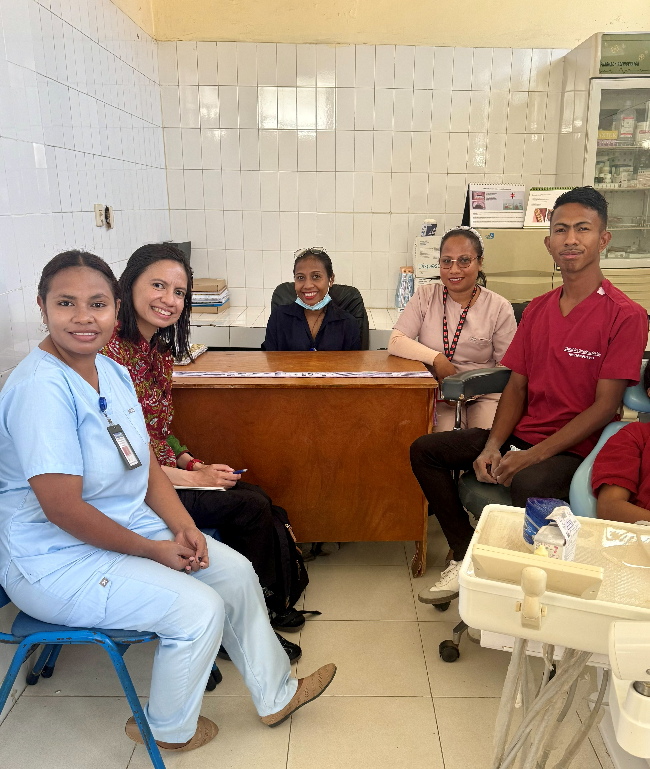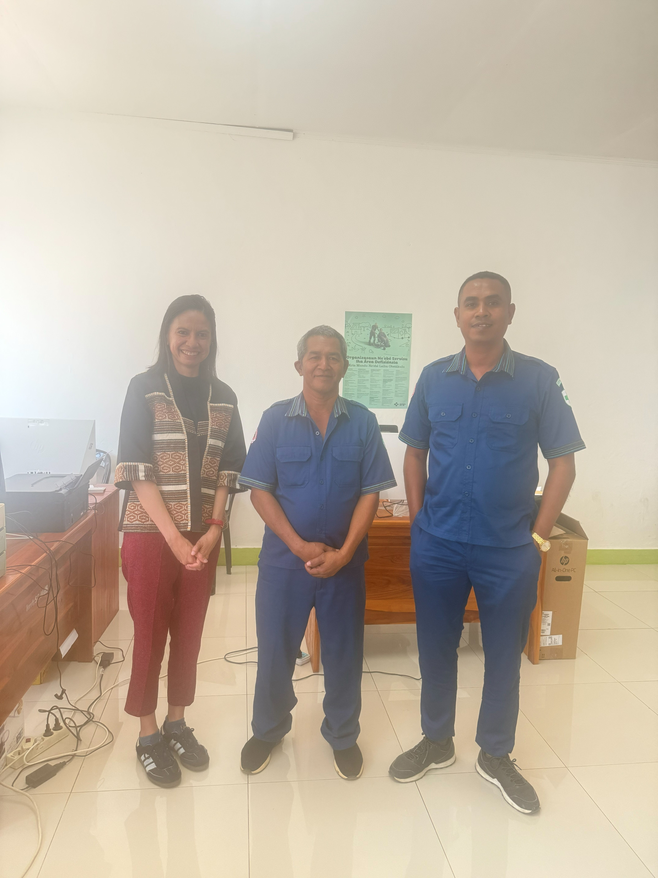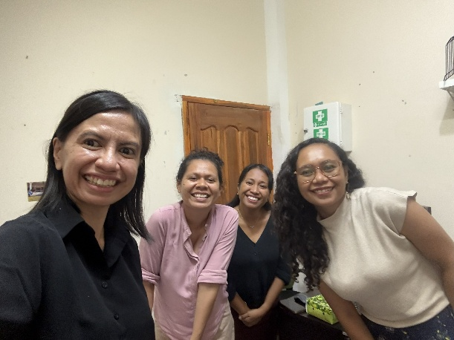
Another outcome of the visit was the signing of an MOU between Friends of Aileu and Maluk Timor NGO, with the Oral Health Promotion Working Group assisting with preparation of a Maluk Timor project proposal and funding application to the UK Borrow Foundation, for a 3-year project to build on current efforts in oral health promotion in Aileu, Manatuto and Bobonaro, with advice on the success or otherwise expected by the end of March 2026.
Funding for Dr Frans travel was covered by 2 generous private donations for this purpose. One of the donations was routed via Balibo House Trust for DGR tax-deductibility purposes, and this led to the signing of an MOU between Friends of Aileu and Balibo House Trust, covering the donation and future collaboration, including on the Maluk Timor proposal.
For more details see Attachment 8: Report on Oral Health Promotion Project field visit to Timor-Leste, October 2025.
3.1.3 Friends of Aileu – Friends of Baucau – Future Collective engagement visit to Timor-Leste
Friends of Aileu, Friends of Baucau and Future Collective collaborated for an engagement visit to Timor-Leste in October for the 1st International PermaYouth Convergence, also spending a few days with NaTerra NGO and the Atekru community of Atauro Island, and visiting Friends of Aileu partners, including the Municipal Youth Centre and the Resource and Training Centre.
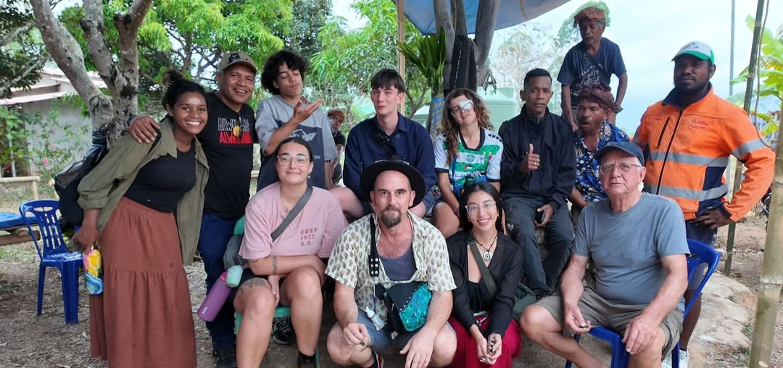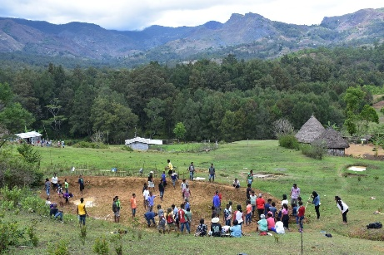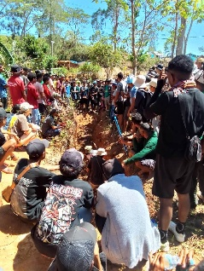
A unique aspect of the collaboration was the sponsored participation of 3 young East Timorese Australians Youth Leaders (2 funded by Friends of Baucau and 1 by Friends of Aileu). The 3 sponsored participants made a start to their commitment to share their experiences and learnings with Friends of Aileu and Friends of Baucau and with their peers in their local communities, through presentations at the November METAC welcome dinner, and at the December meetings of the Friends of Aileu and the Friends of Baucau.
For more details see Attachment 9: Report on the Friends of Aileu - Friends of Baucau - Future Collective engagement visit to Timor-Leste, October 2025.
3.2 Aileu and Timor-Leste partner organisation activities and outcomes
    - Aileu Municipal Authority – delivering services, developing capacities and preparing for elected responsible local government
The Aileu Municipal Authority continues to deliver services to the community, develop its organisational and staff capacities and progress through the planned processes for administrative decentralisation and local power, with municipal elections potentially as early as 2027, including through regular meetings of:
- The Municipal Coordination Committee (Municipal and Departmental Officers and Village Chiefs) for planning and overseeing the delivery of the overall municipal budget, capital works, municipal services and organisational and staff development.
- The Municipal Consultative Committee, providing a forum for dialogue between the Municipal Administration and community organisations and representatives, relating to municipal governance and services.
The DFAT-funded Partisipa Program (Partnership to Strengthen Village Development and Municipal Administration) has deployed a National Advisor, Mr Alfonso Sarmento Mendonça, within the Municipal Administration.
The Municipal Administration has applied to Australian Volunteers for a Decentralisation Specialist assignment starting in 2026.
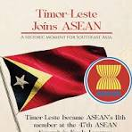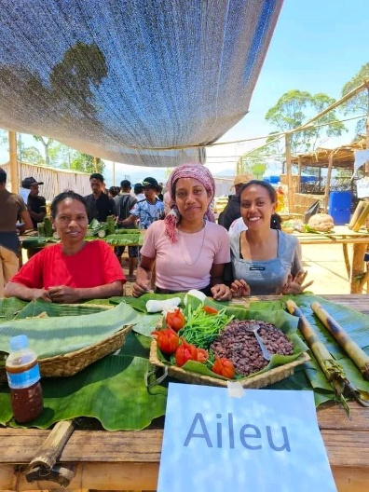
The Municipal Administration and civil society groups, including the Aileu Resource and Training Centre, took part in local and national celebrations, including for:
- Timor-Leste’s accession to full membership of ASEAN in October
- National Youth Day (Santa Cruz massacre commemoration), in November, for which the national celebrations were held in Aileu in 2025
- The 50th Anniversary of the unilateral Declaration of Independence in November, including a National Fair of municipal exhibitions at Tasi Tolu.
A major event for Aileu was the inauguration of the new St Peter and St Paul Church in June, which involved a visit by Cardinal Virgilio do Carmo da Silva SDB.
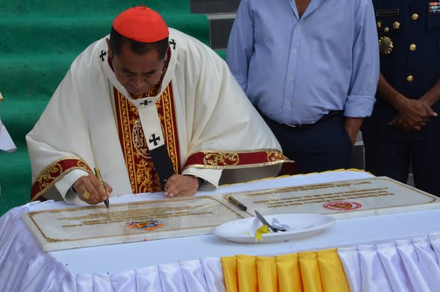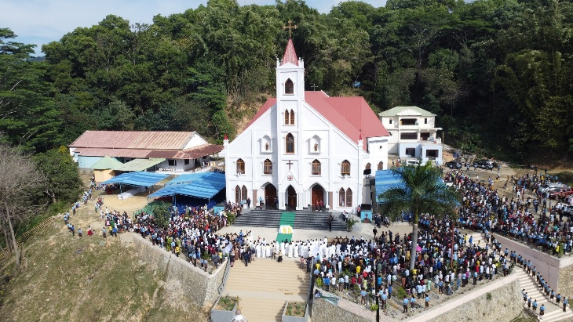
    - Aileu Friendship Commission - overseeing friendship relationship activities
The Aileu Friendship Commission, convened by the Municipal President or delegate, continues to meet regularly to oversee friendship relationship activities, including the work of Friends of Aileu partner organisations supported by funds or other resources from Friends of Aileu.
The Commission Secretary, Mr José Valente, Director Aileu Technical and Vocational High School and General Manager Aileu Municipal Youth Centre, is the principal liaison with Friends of Aileu and the Project Team, keeping the Municipal Administrator and the Commission abreast of activities supported by Friends of Aileu, relevant grants and the execution and reporting of projects and outcomes.
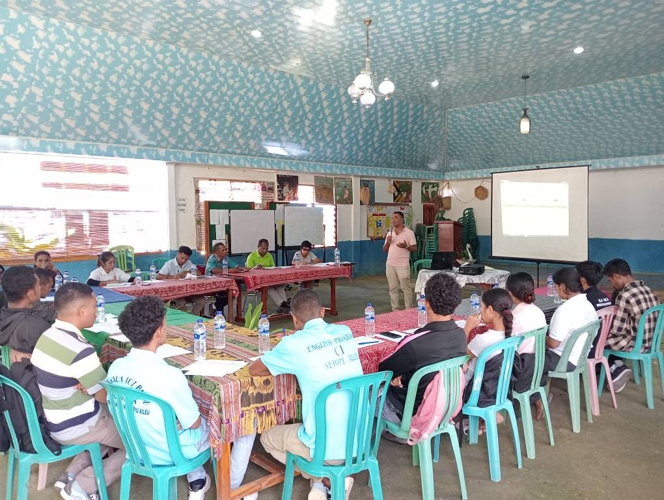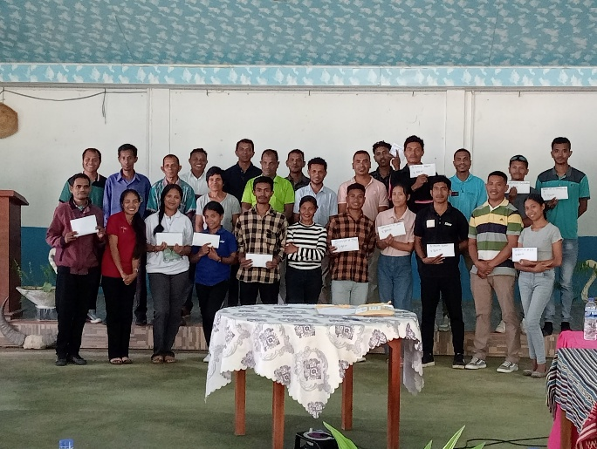
The Friendship Commission Secretary and Youth Centre staff and volunteers provide invaluable support to the Commission and Friends of Aileu by managing day to day aspects of the Aileu Scholarship Program (see 3.2.4 below).
Friends of Aileu has provided a small measure of untied funding ($1,500 per annum) to assist with meeting costs and consumables for reporting on friendship activities including the Aileu Scholarship Program.
    - Aileu Municipal Youth Centre - promoting youth as active healthy citizens
The Aileu Municipal Youth Centre runs a broad range of programs for youth development, including boarding facilities and a productive community garden, alongside computer and language courses, The Yuoth Centre also assists the Aileu Friendship Commission with management of the Aileu Scholarship Program and receiving visits from Friends of Aileu and partners.
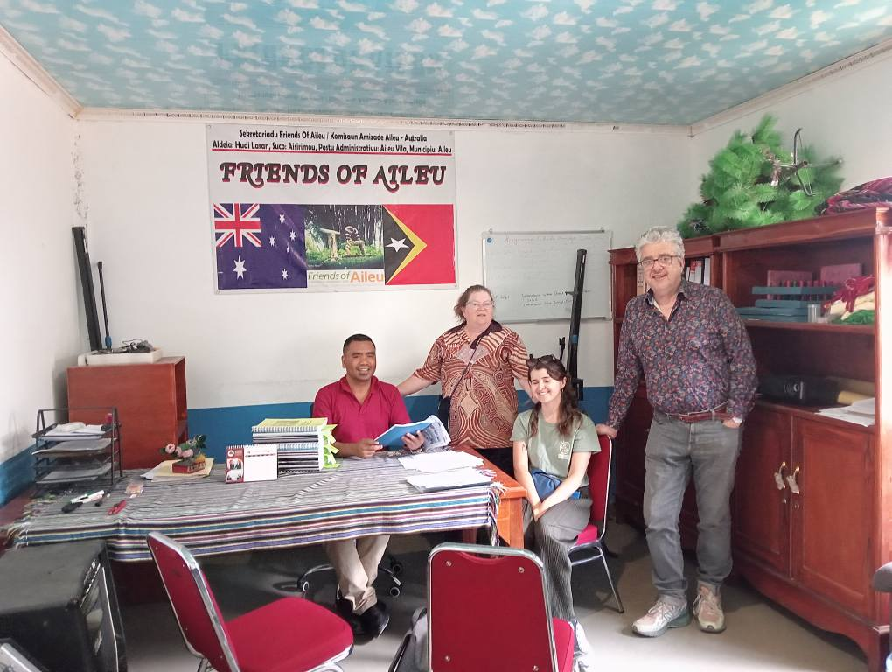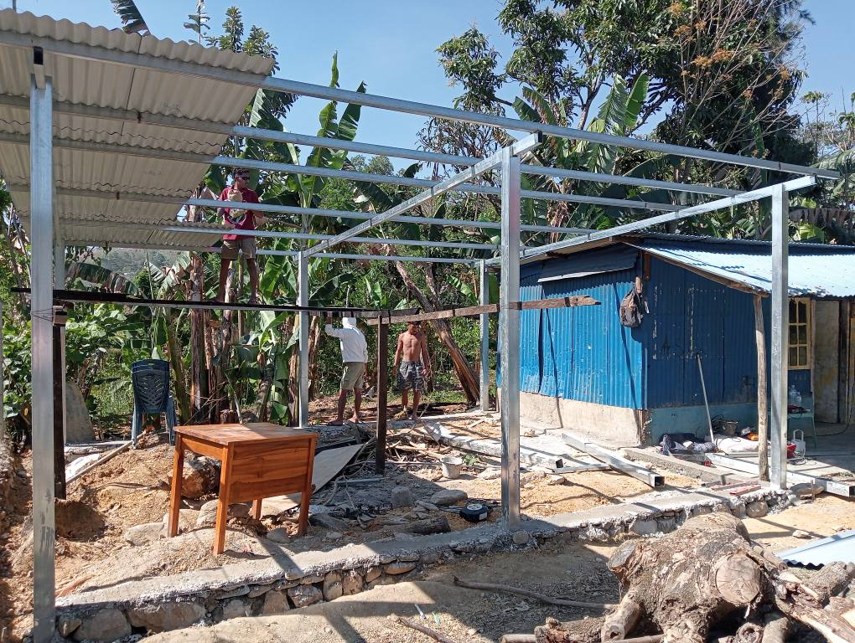
The Youth Centre manages successful partnerships with a range of funding organisations, including the Timor-Leste Ministry of Youth, Arts and Sport, JICA (Japanese Cooperation) and KOIKA (Korean Cooperation), Jape Kong Su Foundation, Dili Development Centre, Timor Plaza.
Institutional support funding is understood to no longer be available through the Timor-Leste Government. Over recent years Friends of Aileu has been able to provide a small amount of untied funding ($1,500 per annum) to assist with office costs and consumables.
    - Cr Andy Inghm Aileu University Scholarship Program - help address Aileu’s human resource needs
In 2025, the Cr Andy Ingham Aileu Scholarship Program paid the tuition fees of 22 young people (14 male, 8 female) at tertiary institutes in Dili, at a total cost of $11,800 ($11,100 from the 2024 Trivia Quiz fundraiser, plus $700 from the $5,200 Hume City Council education donation).
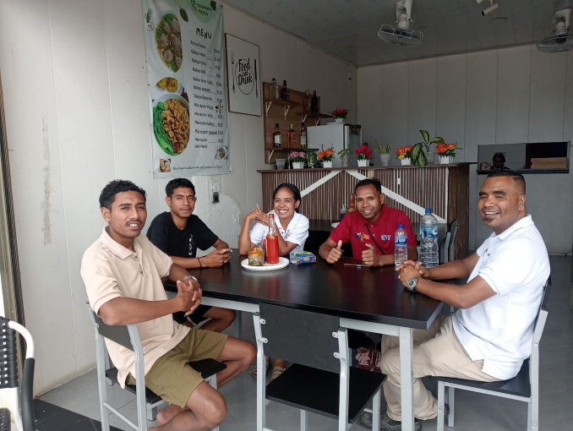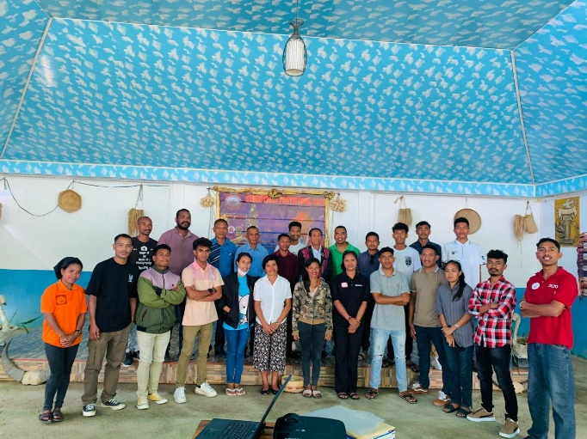
By the end of the year the 22 beneficiary students for 2025 had progressed as below and as shown in the following Table:
- 2 continuing beneficiary students completed a 4-year Bachelor of Engineering (Eduardo and Agostinho)
- 3 new beneficiary students completed 4-year Bachelors of ICT (Tome), Engineering (Billygrem) and Mathematics (Jonio)
- 6 other continuing beneficiary students continued studies in Engineering (Hermenegildo and Arcanzu) and ICT (Flaviana, Dionisio, Feliciana and Saturninho)
- 4 other new beneficiary students continued studies in ICT (Filomena), Accounting (Dometilia), Science & Engineering (Joia) and Engineering (Adão)
- 5 other new beneficiary students commenced studies in ICT (Pedro Filo, Elionora, Abril and Armindo), and Finance Management (Teofilia)
- 2 other new beneficiary students completed a Certificate IV Training & Assessment (Pedro Pinheiro) and a Certificate I Culinary (Anamira).
Cr Andy Ingham Aileu University Scholarship Program
Scholarship recipients for the 2025 academic year
Name | Course  (semesters studied) | Institution
Eduardo S. Caldeira | Graduated Bachelor Engineering (VIII) | National University of Timor-Leste (UNTL)
Agostinho de Jesus Alves | Graduated Bachelor Engineering (VIII) | Dili Institute of Technology (DIT)
Billygrem Antonio Piara de Oliveira | Graduated Bachelor  Engineering (VII & VIII) | UNPAZ
Jonio Gonsalves | Graduated Bachelor  Mathematics (VII & VIII) | Sao Joao Brito
Tome Fernandes | Graduated Bachelor  ICT (VII & VIII) | Cristal Institute (ISC)
Feliçiana Tersa Martins | Graduated Diploma  ICT (V & VI) | Cristal Institute (ISC)  Student with a disability
Saturnino Mendonça | Graduated Diploma  ICT (VI & VII) | Cristal Institute (ISC)
Adão da Costa Araujo dos Reis | Graduated Diploma  Engineering (V & VI) | National University of Timor-Leste (UNTL)
Hermenegildo Burbara Ximenes | Graduated Diploma  Engineering (V & VI) | Cristal Institute (ISC)
Arcanzu Maria | Engineering (III & IV) | Cristal Institute (ISC)
Joia Maesalda M. T. O. | Science & Engineering (III & IV) | Dili Institute of Technology (DIT)
Dionísio de Jesus | ICT (III & IV) | Cristal Institute (ISC)
Flaviana Elisa | ICT (III & IV) | Cristal Institute (ISC)
Filomema do Rego Martins | ICT (III & IV) | Cristal Institute (ISC)
Dometilia Maria Jose | Accounting (III & IV) | Catholic University, Dili
Pedro Felo Araujo | ICT (I & II) | Cristal Institute (ISC)
Elionora Soares da Silva | ICT (I & II) | Cristal Institute (ISC)
Abríl José Tilman | ICT (I & II) | Cristal Institute (ISC)
Armindo Bere de Araujo | ICT (I & II) | Cristal Institute (ISC)
Teofilia Maria de Jesus Fatima | Finance & Management (I & II) | Dili Institute of Technology (DIT)
Pedro Pinheiro de Jesus | Graduated Certificate VI  Training & Assessment (I & II) | STVJ Comoro
Anamira da Conceicao | Graduated (Certificate I)  Culinary (I) | STVJ Comoro
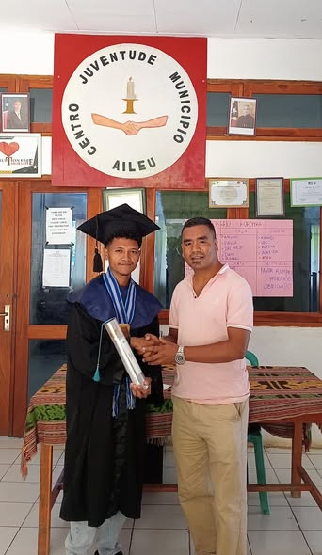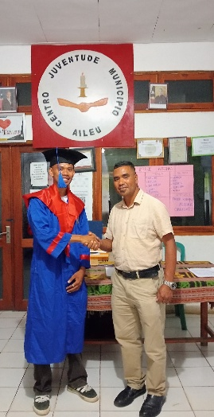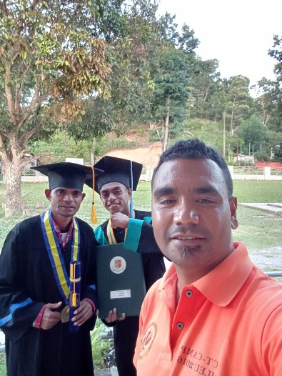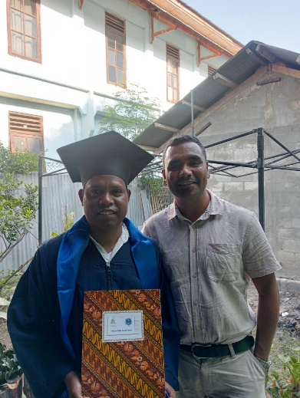
Five of the 2025 graduates: Eduardo, Billygrem Jonio & Santos, and Pedro (with José Valente)
Over the 5 years from 2021, when the Aileu Scholarship Program was reintroduced after a temporary suspension while the previous program was reviewed, Friends of Aileu has provided $53,000 which has assisted 44 young people (25 male, 19 female) to undertake post-secondary studies, with:
- 1 having graduated with a Master degree (2 years study post-Bachelor)
- 17 having graduated with a Bachelor degree (4 years study)
- Several others completing a Diploma level qualification (3 years study)
- 3 others completing Certificate level qualifications.
    - Hume City Council Teacher Education Scholarships - improving the quality of school education
In 2025, Friends of Aileu covered the tuition fees of 8 young people (4 male, 4 male) at the Baucau Teachers College, at a total cost of $4,500 from the annual Hume City Council education donation of $5,200.
By the end of the year the 8 beneficiary students for 2025 had progressed as below and as shown in the following Table:
- 3 continuing beneficiary students (Angela, Aniceto and Agapito) completed the 4-year Bachelor of Education
- 2 continuing beneficiary students (Louisa and Zelita) continued studies for the initial 3-year Bachelor of Teaching
- 1 new beneficiary students (Federisio) continued studies for the initial 3-year Bachelor of Teaching
- 2 new beneficiary students (Frederico and Betjeba) commenced studies for the initial 3-year Bachelor of Teaching.
Hume City Council Teacher Education Scholarships
at Baucau Teachers’ College (ICFP)
Scholarship recipients for the 2025 academic year
Name | Qualification  (semesters studied) | Progress, with initial employment or placement school, and results where available (GPA = Grade Point Average)
Angela Mendonça | Bachelor of Education (VII & VIII) | Graduating 14 March 2026  Yet to complete thesis
Aniçeto Fátima Martins | Bachelor of Education (VII & VIII) | Graduating 14 March 2026  Teaching at Santa Ursula school in Via Nova, Baucau  Wants to commence Master of Education at Crystal Institute
Agapito Bere Xavier | Bachelor of Education (VII & VIII) | Graduating 14 March 2026  Teaching at Santa Ursula school in Via Nova, Baucau
Luisa Isobél de Jesus | Bachelor of Teaching (V & VI) | On leave
Zelita Doutál Sarmento | Bachelor of Teaching (II & IV) | GPA 3.50 (Very good)  Will continue to Year 3 in 2026
Federisio P. Xavier | Bachelor of Teaching (III & IV) | GPA 3.63 (Excellent)  Will continue to Year 3 in 2026
Frederico Mouzinho | Bachelor of Teaching (I & II) | GPA 3.17 (Good)  Will continue to Year 2 in 2026
Betjeba Mesquita | Bachelor of Teaching (I & II) | GPA 3.10 (Good)  Will continue to Year 2 in 2026
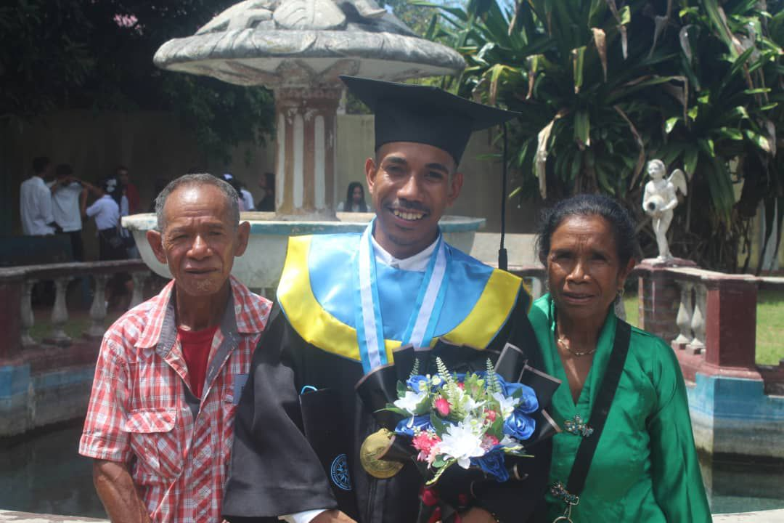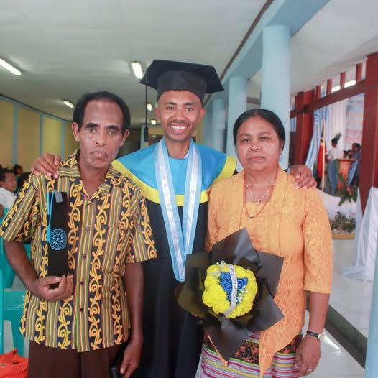
2025 graduates Agapito and Aniceto, with their parents
Over the 9 years from 2017 when Friends of Aileu commenced providing fee support for Aileu students at Baucau Teachers College, $38,100 has been paid via Marist Solidarity Australia and has assisted 18 young people (9 male, 9 female) to undertake teacher education studies.
Since 2018, 12 beneficiary students have completed their studies, with:
- 11 having graduated with a Bachelor of Education (4 years of study)
- 1 having graduated with a Bachelor of Teaching (3 years of study), prior to the introduction of the 4th year of studies for Bachelor of Education.
Most of the graduates obtained teaching positions soon after graduating, with 2 of the 2025 graduates (Aniceto and Agapito) employed at the Santa Ursula school in Via Nova, Baucau, and the other (Angela) yet to complete her thesis.
    - Aileu Resource and Training Centre - local decision making and strengths-based community development in action
The Aileu Resource and Training Centre (ARTC) has had another successful year, despite the difficulties associated with their office, computer laboratory and library being relocated on a temporary basis to a sub-standard disused government building. This move followed the Municipal Administration requiring ARTC to vacate their main office in the historic Aileu Biblioteka so it could be used for a new one-stop-shop municipal service centre.
ARTC has maintained continuity in delivery of their programs, including their basic Administration and computer training course, English language course and children’s education.
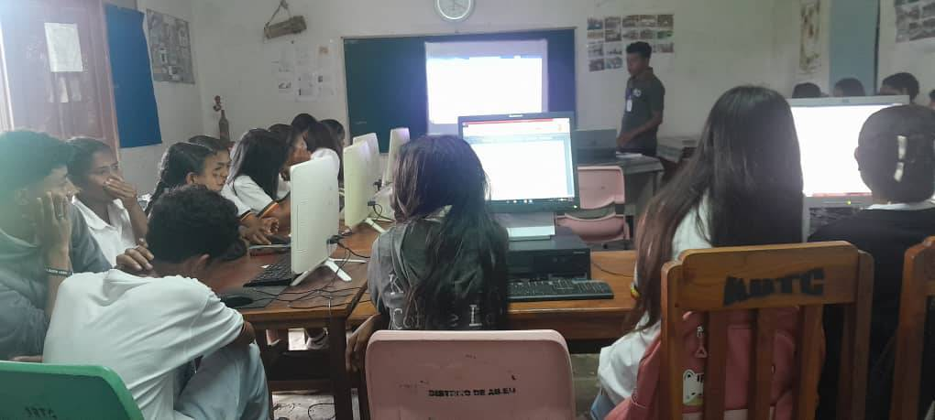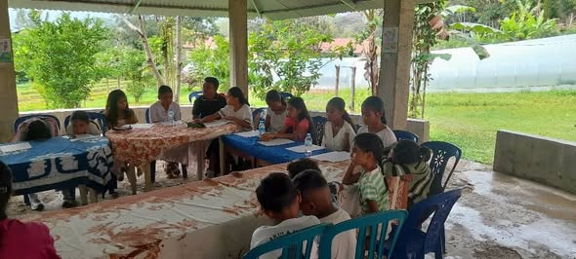
Also continuing was ARTC’s support for the satellite Manu Casa Resource and Training Centre in Lequidoe and a range of education and training, and agriculture and environmental community programs there, which were however, made more difficult due to lack of access to a reliable motor vehicle and the ageing condition of the ARTC motorcycle.
One of the Manu Casa community coffee producers won a major prize at the annual Festival Café Timor run by ACTL (the Timor-Leste Coffee Association) together with Kinta Portugal, Aileu, while ARTC’s Kadalak Dame won 2nd prize at a fair in Aileu celebrating Timor-Leste’s of National Youth Day (Santa Cruz Massacre Day).
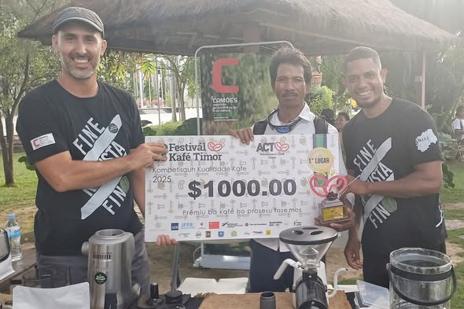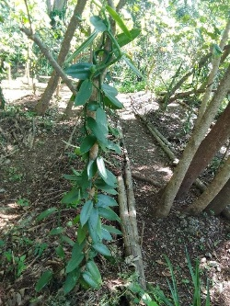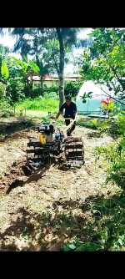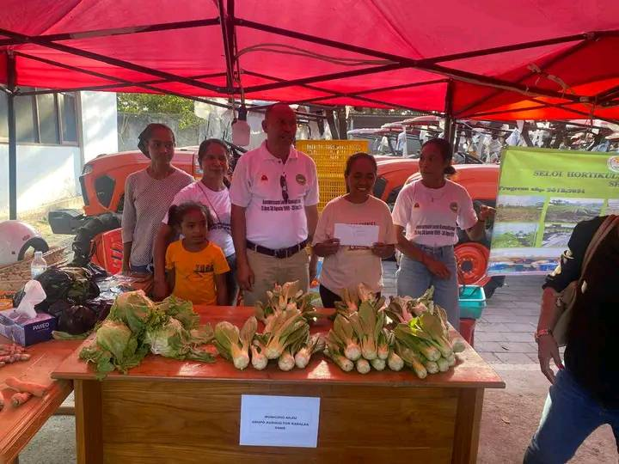
ARTC continued to develop the Kadalak Dame Garden Project in Aileu, including the reconstruction of the covered meeting space there, working towards a more sustainable income from supplying produce to local and Dili markets.
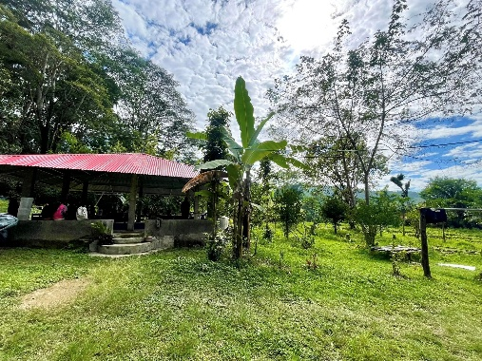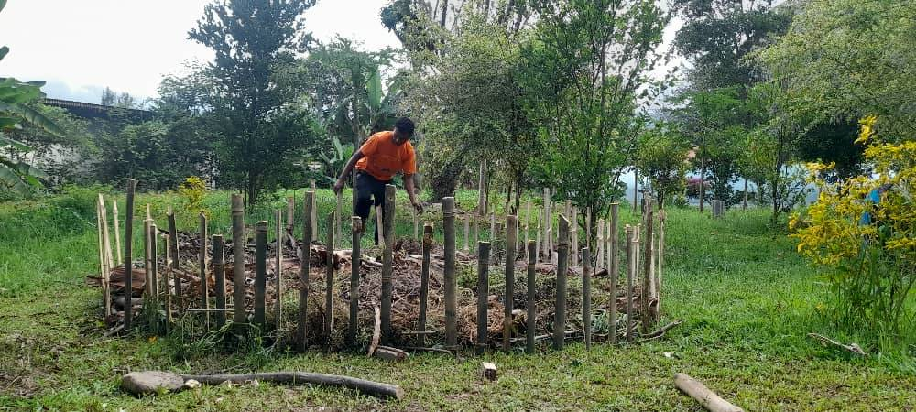
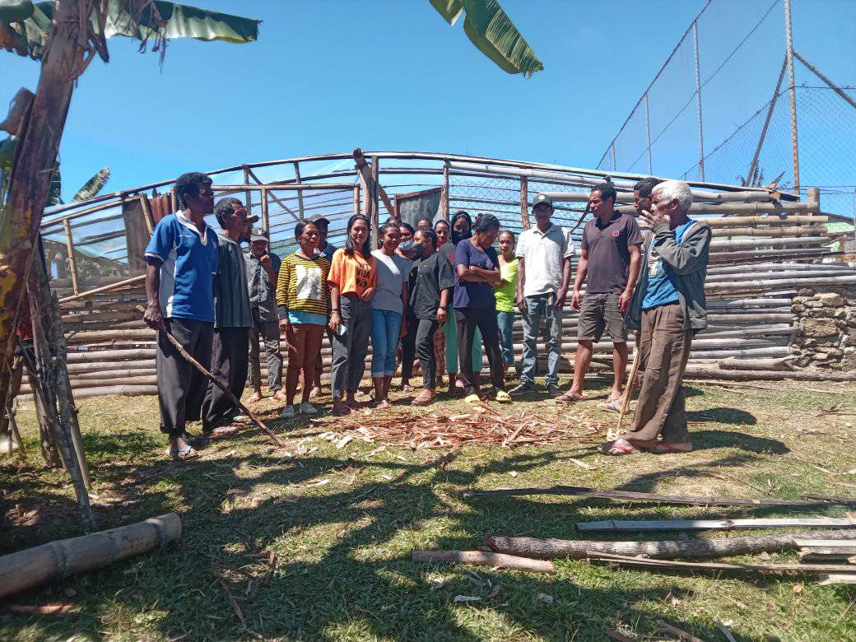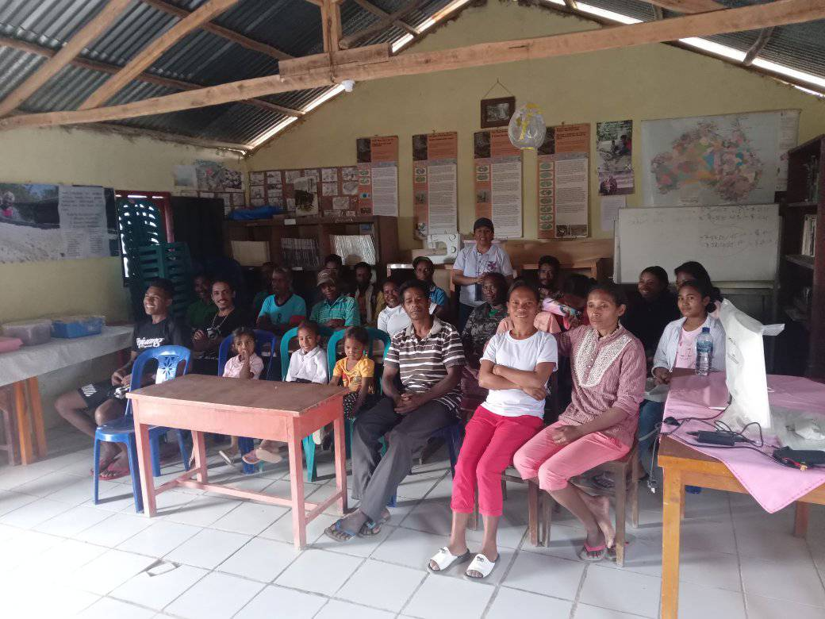
Friends of Aileu’s collaboration with and support for the ARTC during 2025 included:
- Financial support totalling $7,100 (a $3,000 contribution towards operating expenses and a $4,100 contribution for materials and coordination for ARTC’s management of the annual Aileu Expo)
- Guidance and support for ARTC Program Manager Joaninho dos Reis in the successful proposal to Permaculture Australia for a $3,100 Permafund grant (celebrated as the 100th Permafund grant) to provide additional permaculture-oriented training for 4 staff, 3 rural farmers and 3 young volunteers at Kadalak Dame, associated with their participation in the Timor-Leste’s 1st International PermaYouth Convergence, in Fatuqueru, Ermera, over 5 days in October 2025
- Funding of $1,395 for Joaninho dos Reis to participate as a co-facilitator in the 11-day Friends of Aileu - Friends of Baucau - Future Collective engagement visit to Timor-Leste (see 3.1.3 above), which included participation in the PermaYouth Convergence and several days with the Na Terra NGO and the Atekru community on Atauro Island
- Funding of $1,000 for the participation of the 10 ARTC staff members, rural farmers and youth volunteers (6 male, 4 female) in the 5-day PermaYouth Convergence alongside the 40 other young people facilitated by the Aileu Anan Association (see Section 3.2.7 below).

Following the PermaYouth Convergence, ARTC provided follow up training and hands-on experience for young people at Kadalak Dame, including building water conservation ponds and implementing various permaculture practices.
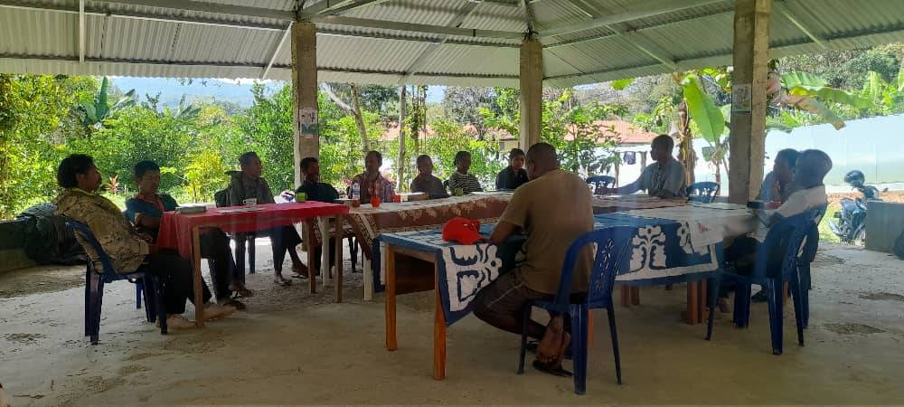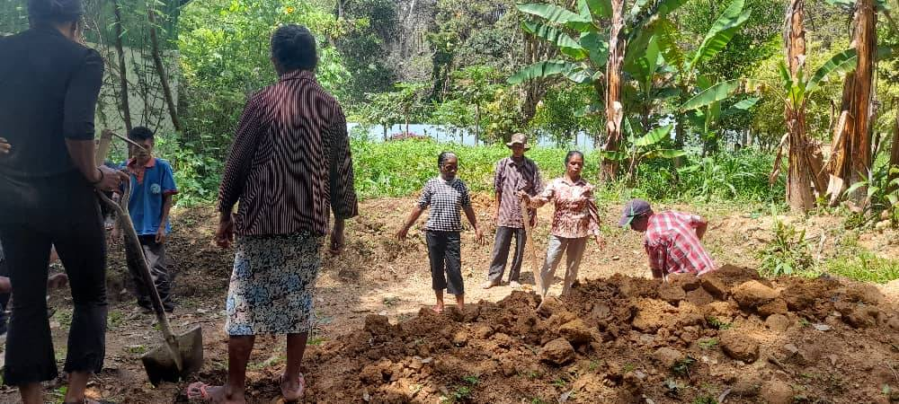
ARTC successfully organised the 19th annual Aileu Expo in November, celebrating the 50th anniversary of the 1975 Proclamation of Independence.
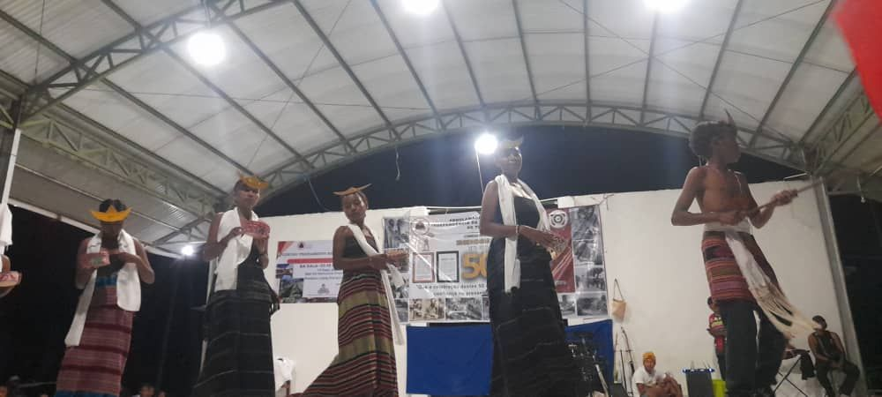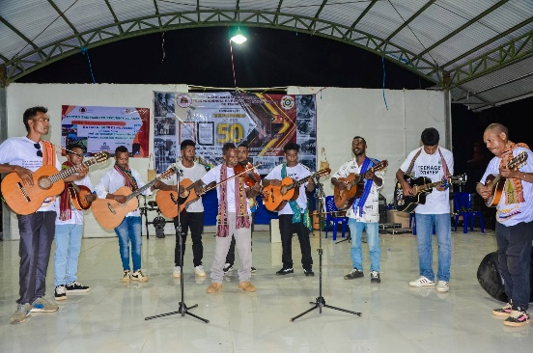
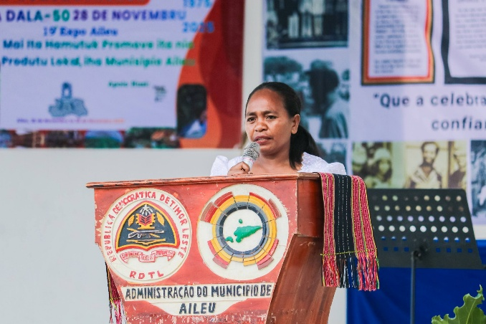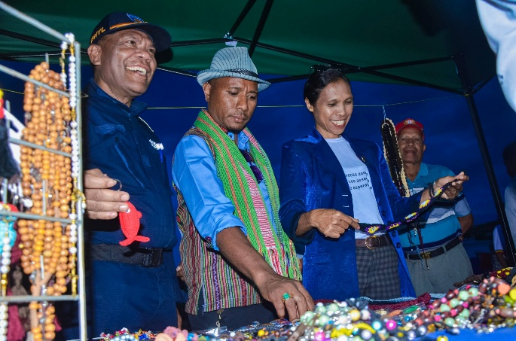
Throughout the year ARTC hosted many visits at Kadalak Dame garden, including by:
- The Municipal Agriculture Service and project Hadalak, about Cooperatives access to markets and the school feeding program
- A team from the Secretariat of State for Vocational Training and Employment (SEFOPE)
- World Vision Timor-Leste for an assessment of Kadalak Dame
- Students of the Gleno Technical School for Coffee Industry (ETCI)
- 150 members of youth group Juventude Hadomi Natureza (JHN) and representatives of the Ministry of Youth, Sport, Arts and Culture planting trees at Kadalak Dame
- Xanana Reading Room children’s activities on 50th anniversary of Declaration of Independence
- Vice-minister for Institutional Strengthening, Vice-minister of Health, Aileu Municipal President, Commander PNTL Aileu and others planting trees on 50th anniversary of Declaration of Independence
- A Ministry of Health delegation
- Aileu Department of Agriculture, delivering new mini tractor.
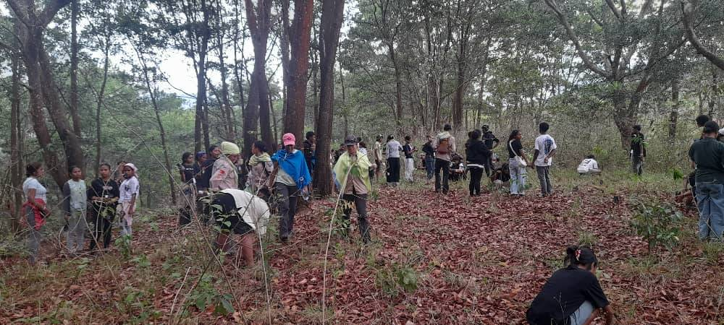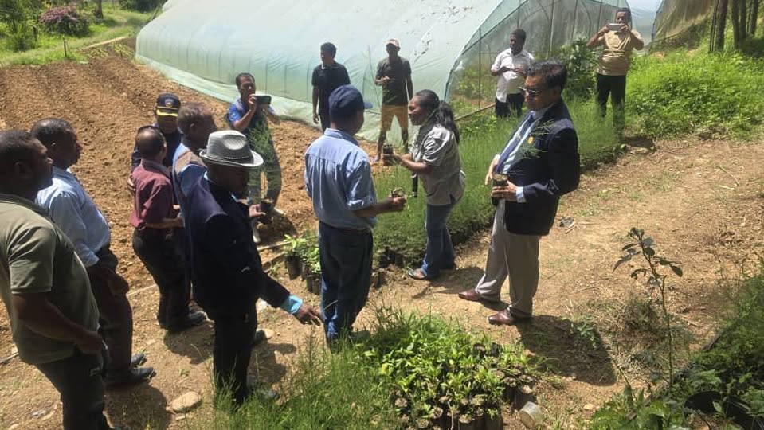
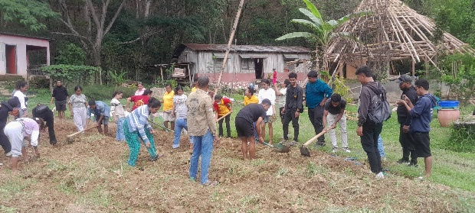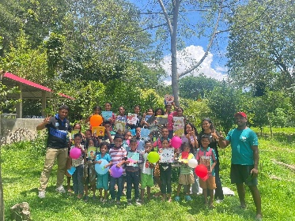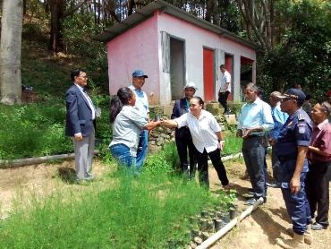
In August Natalia was among a group of 8 participants who completed 4 days training as part of the Guidelines for Business Program (KPNI) by the Institute for Business Development Support (IADE), Aileu.
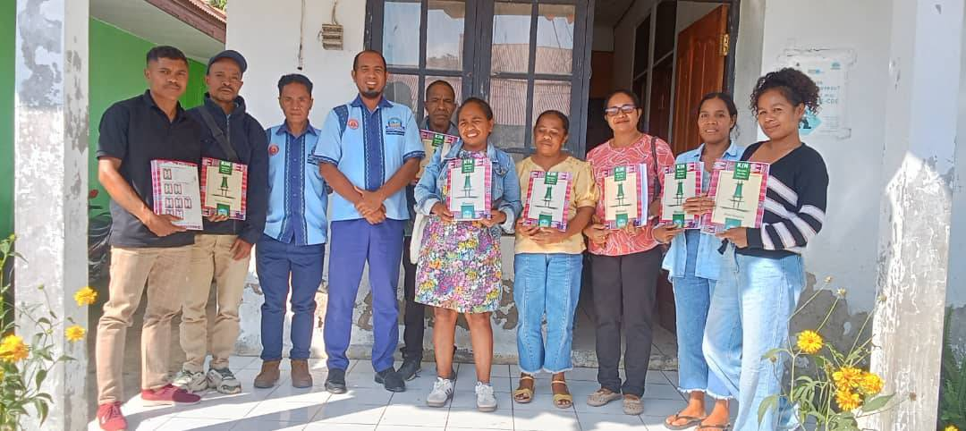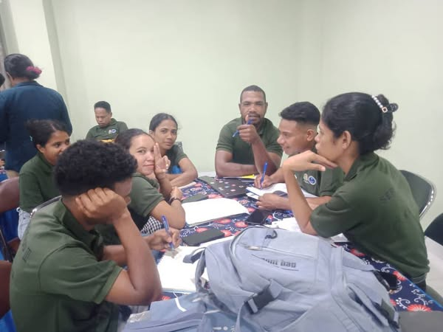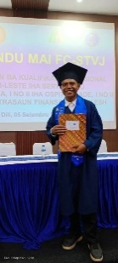
In September, Joaninho dos Reis and Quintão Alves Mendonca graduated with a Certificate III Training & Assessment from STVJ Comoro, following training facilitated by the Secretariat of State for Vocational Training and Employment (SEFOPE).
    - Aileu Anan Association and Aileu PermaYouth Centre - planting water, growing communities
The Aileu Anan Association (AILA) managed the participation in the 1st International PermaYouth Convergence (IPYC–2025 - Permatil Global), October 2025, of a total of 40 participants from 14 rural villages, the 10 Kadalak Dame workers (6 male, 4 female), 26 other young people (23 male, 3 female), 4 AILA facilitators (3 male, 1 female).
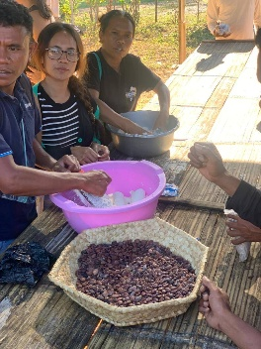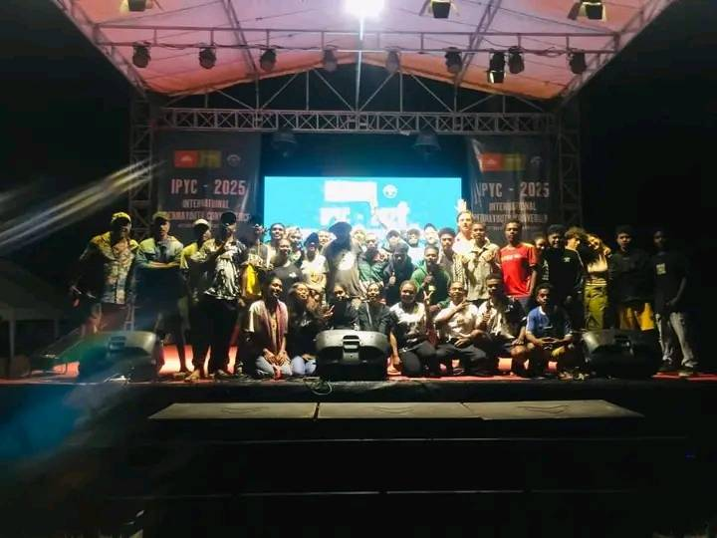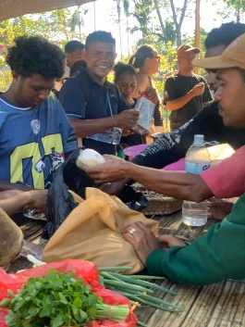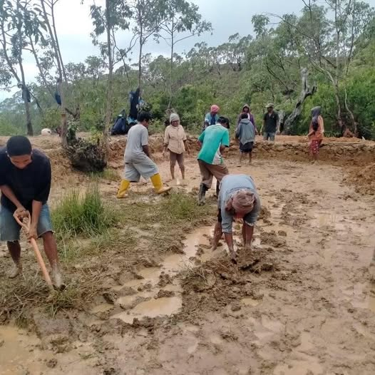
To support this effort Friends of Aileu provided a total of $4,000 to cover PermaYouth Convergence fee and travel and camping materials for the Aileu participants.
The funding comprised:
- The $1,000 for the 10 Kadalak Dame workers (see 3.2.6 above)
- An additional $3,000 for the other 30 participants (24 youth and 4 AILA volunteer facilitators).
AILA, together with the Aileu PermaYouth Centre, Remexio (CPY Aileu Facebook), continued to mentor and monitor the PermaYouth Convergence alumni, and other alumni from previous PermaYouth Camps, as they implement water resource conservation, reforestation and permaculture garden projects in their home villages.
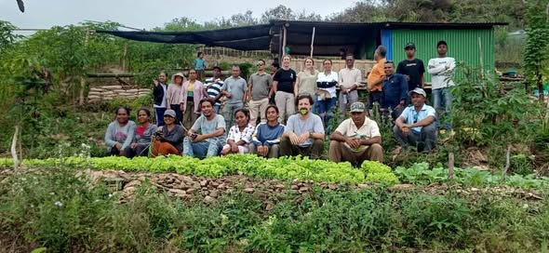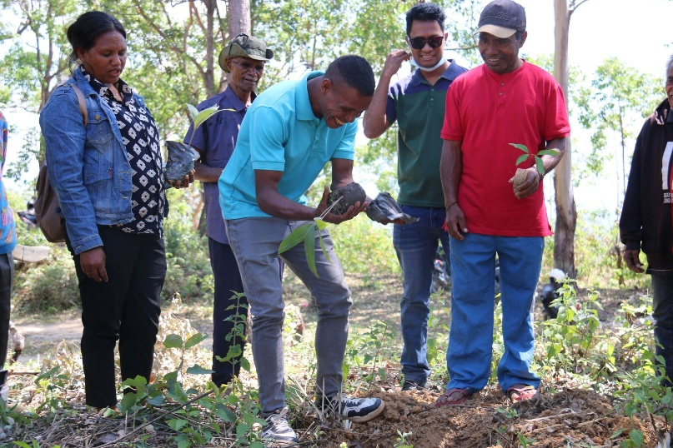 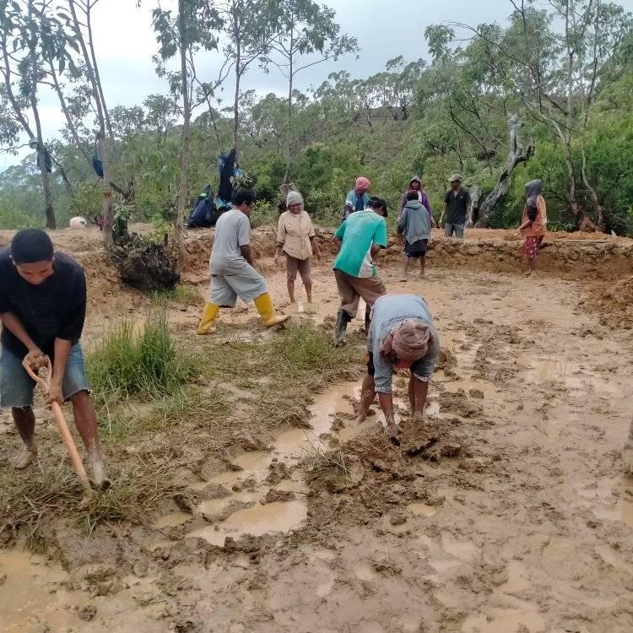
4 Financial Summary 2025
The activities outlined in Section 2 , Section 3.1 and Section 3.2 above have been made possible by the strong partnership between Merri-bek and Hume City Councils, the contributions of members of the Friends of Aileu Community Committee, other supporters of Friends of Aileu, community members, donors, and local organisations and businesses, that have assisted with fundraising efforts.
See Attachment 10 (Financial Summary for calendar year 2025) comprising:
  - Income and expenditure totals, Friends of Aileu Donation and Fundraising accounts, 1 January to 31 December 2025
  - Income by activity, calendar year 2025 - Donations & Fundraising including sales
  - Expenditure by project, calendar year 2025
  - Financial Outlook for 2026

5 Outlook for 2026
Guided by Friends of Aileu Strategy Plan 2025-2030, the Project Team and the Community Committee will continue to:
- Develop and diversify Friends of Aileu’s relationships with local supporters, donors, businesses and community organisation, the East Timorese community and their organisations
- Collaborate with Friends of Aileu’s partner organisations in Aileu and Timor-Leste, working in support of agreed priority projects in education and training, community health and sustainable agriculture and environment protection and their progress to a greater degree of more self-sustainability in their operations
- Support the Aileu Scholarship Program and its management by the Aileu Municipal Administration and Aileu Friendship Commission
- Support for the studies at the Baucau Teachers College of those Aileu students most in need.
Priority actions for 2026 and beyond include:
- Developing and implementing the next phase of the Oral Health Promotion Project, including sourcing support for the Aileu Municipal dental service and the building of relationships, and where appropriate, partnerships with others operating in the oral health field in Aileu and elsewhere in Timor-Leste
- Continued support for the work of the Aileu Resource and Training Centre, and the PermaYouth movement
- Reactivating relationships with educational and community organisations including in the health sector
- A decision on opening a MyFund with Inner North Foundation, potentially in partnership with Friends of Baucau and the Timorese Association in Victoria.

Attachment 1
Friends of Aileu - Governance and Relationships, June 2025
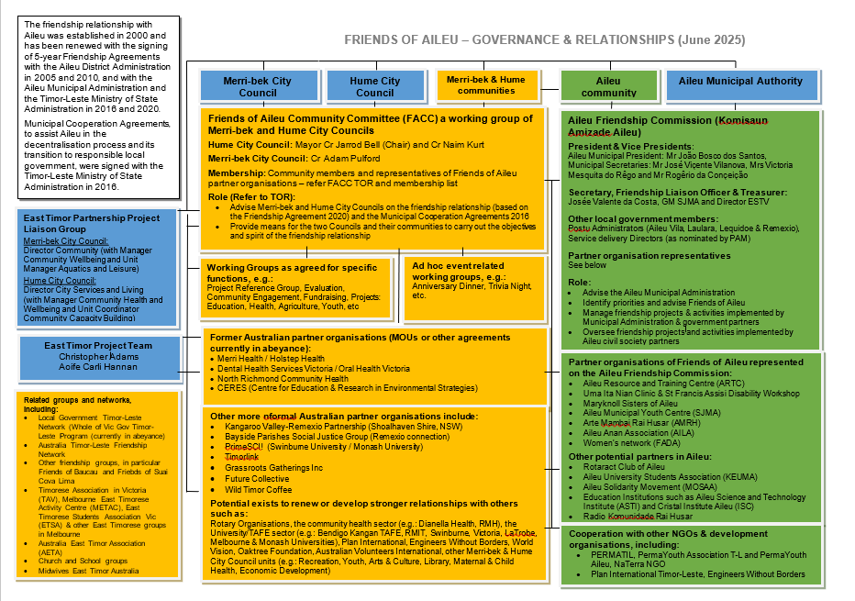

Attachment 2 (page 1 of 5)
Friends of Aileu Strategy Plan 2025-2030
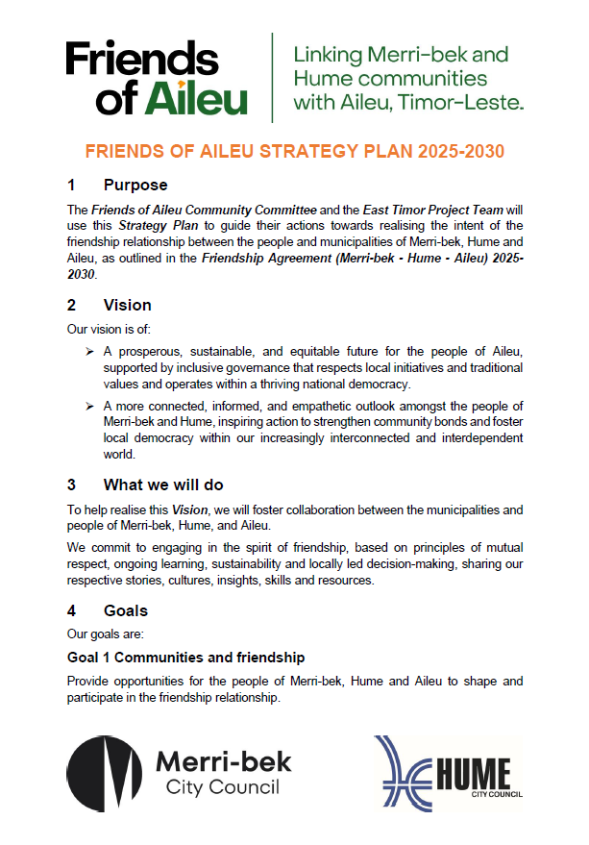
Attachment 2 (page 2 of 5)
Friends of Aileu Strategy Plan 2025-2030
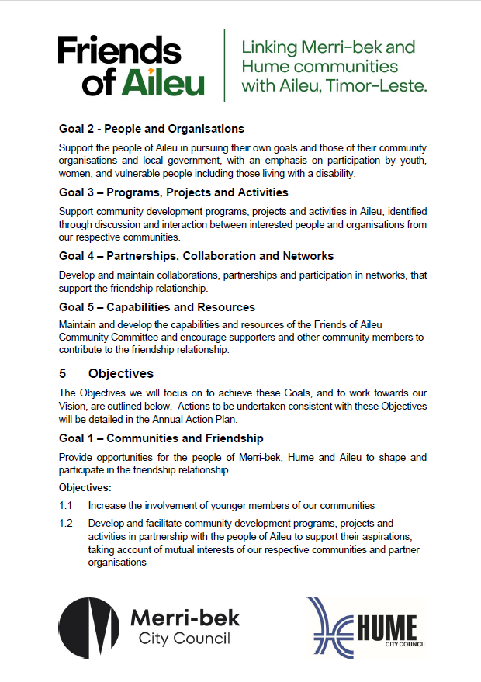
Attachment 2 (page 3 of 5)
Friends of Aileu Strategy Plan 2025-2030
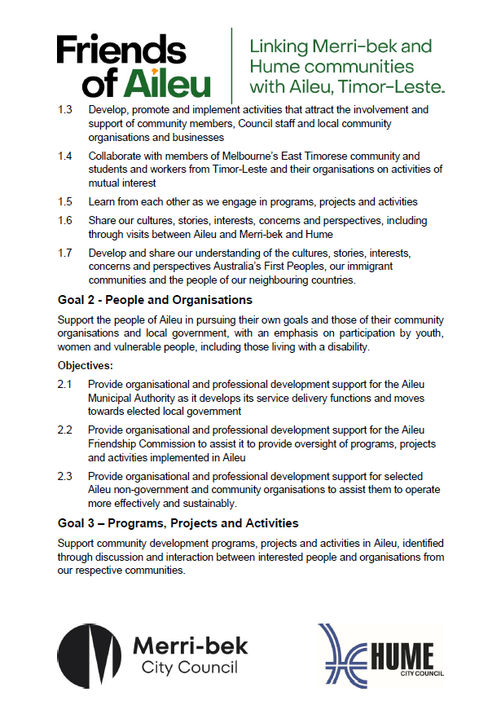
Attachment 2 (page 4 of 5)
Friends of Aileu Strategy Plan 2025-2030
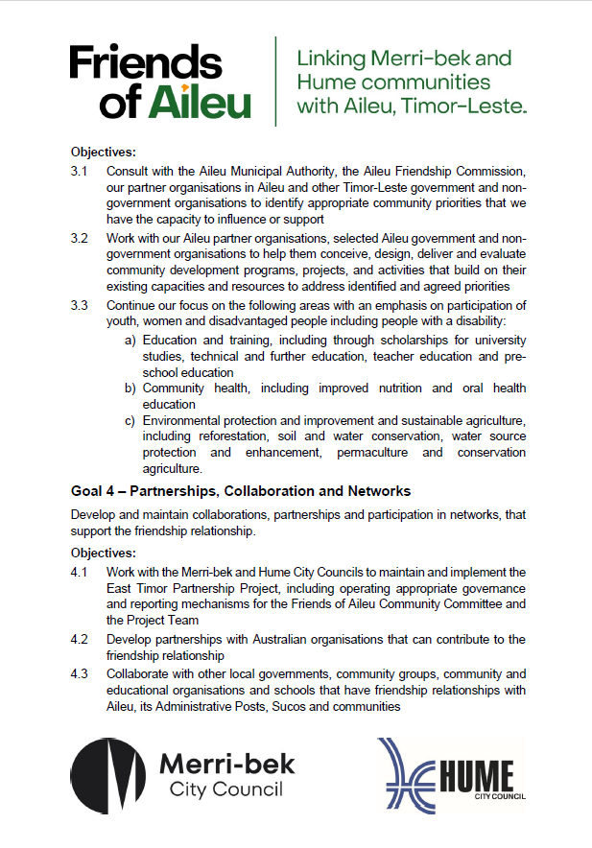
Attachment 2 (page 5 of 5)
Friends of Aileu Strategy Plan 2025-2030
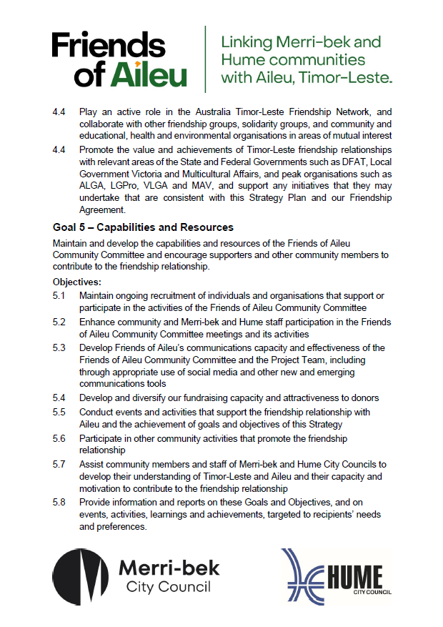

Attachment 3 (page 1 of 7)
Terms of Reference – Friends of Aileu Community Committee, 2023 (revised 2025)
Background
The friendship relationship with Aileu was established on 4 May 2000, with the signing of an MOU by the Mayors of Moreland City Council (now Merri-bek City Council) and Hume City Council and Xanana Gusmão (then President of the National Council of Timorese Resistance), on behalf of Aileu.
The rationale for the establishment of the relationship was the desire by the two Councils, and members of their communities to:
- express solidarity with the people of Aileu, and
- assist in the re-building of Aileu and the restoration of local democracy following the end of the Indonesian occupation of East Timor in 1999.
The friendship relationship has evolved over time in response to the interests, needs, capacities and aspirations of our respective local governments, and of the community organisations and community members involved. The relationship, however, remains rooted in a commitment to the principles and values on which it is based, including sustainability, mutual respect, mutual understanding and Timorese-led decision making.
The friendship relationship was reaffirmed by the signing of a Friendship Agreement between the two Councils and the Aileu District Administration in 2005. The friendship relationship has been renewed periodically, most recently in 2025 with the signing of an updated Friendship Agreement 2025-2030 by the 2 Councils, Timor-Leste Government’s Minister of State Administration, the Aileu Municipal President and the Secretary of the Aileu Friendship Commission (Attachment 1).
Following a request from the Timor-Leste Government’s Ministry of State Administration to the Government of Victoria, in 2016 Moreland City Council (now Merri-bek City Council) and Hume City Council each signed a Municipal Cooperation Agreement with respect to Aileu (Attachments 2 and 3), which provides a framework for provision of support during the transition to responsible local government.
The friendship relationship is supported by MOU’s or other agreements with various local community organisations and businesses and friendship partner organisations in Aileu and Timor-Leste.
The friendship relationship is underpinned by the existence of:
- The Friends of Aileu Community Committee (these Terms of Reference), and
- The Aileu Friendship Commission, which is convened by the Aileu Municipal President, and which includes representatives of the Aileu Municipal Administration, including the 4 Administration Posts, nominated Service Delivery Directorates and Aileu NGOs, community organisations and community members, and which supports and monitors activities in Timor-Leste implemented as part of the friendship relationship and provides advice to the Municipal President.

Attachment 3 (page 2 of 7)
Terms of Reference – Friends of Aileu Community Committee

Type of Committee | Joint Working Group of Merri-bek and Hume City Councils
Purpose of the Committee | The purpose of the Friends of Aileu Community Committee is to help Merri-bek City Council and Hume City Council mobilise community perspectives, knowledge, skills and resources to contribute to the friendship relationship with the Municipality and people of Aileu, Timor-Leste.
Role of the Committee | The role of the Committee is to:  - Work with and make recommendations to the two Councils, principally via the Project Officer East Timor (Friends of Aileu), to support the development and implementation of the Friendship Agreement (Merri-bek – Hume – Aileu) 2025-2030, the Municipal Cooperation Agreements 2016, and the Friends of Aileu Strategy Plan 2025-2030 (Attachment 4).  - Advise and assist with the conduct of awareness raising and fundraising activities and events in Australia  - Advise and assist with the design, implementation, monitoring and evaluation of programs, projects and activities undertaken with or by partner organisations in Aileu and Timor-Leste.
Scope of the Committee’s activities | The scope of the activities of the Friends of Aileu Community Committee includes but is not limited to:  - Providing information and advice to inform Council decision making in relation to the friendship relationship  - Providing information and advice to the Project Officer on the development, review and implementation of the Friends of Aileu Strategy Plan  - Helping to identify, prioritise, design, implement, monitor, evaluate and report on activities that contribute to achieving the Goals and Objectives of the Friends of Aileu Strategy Plan  - Helping to identify interests, skills, knowledge and resources that may be applied to support community development priorities agreed with the Aileu Municipal Administration and the Aileu Friendship Commission, in collaboration with government, non-government and community organisations in Aileu  - Promoting friendship, mutual respect and understanding with the people of Aileu through the sharing of experiences, culture, stories, perspectives, knowledge, skills and resources  - Contributing to communications, activities and events that:  - Raise awareness about the friendship relationship  - Build networks and partnerships to support the relationship  - Helping raise funds to support community development activities in Aileu.
Committee Structure | The Committee will consist of Councillor representatives, Community members, Special Interest members, Partner Organisation representatives and Co-opted members.  Merri-bek City Council and Hume City Council will each appoint at least 1 Councillor representative to the Committee.  Appointments of Community members (Merri-bek community, Hume community, Special interest and Co-opted members and Partner organisation representatives) will be made following responses to a call for Expressions of Interest or to invitations to nominate for vacant positions.  Appointment of Community members will be made following agreement of the 2 Directors.
Accountability | The Community Committee is accountable to the two Councils through the Convenor, the Council officer responsible for coordinating the committee, which is usually the Project Officer East Timor (Friends of Aileu).
Term | The term of the Community Committee term will align with the nominal 5-year duration of the Friendship Agreement and Strategy Plan.  The Directors may, by their agreement, extend or renew the term of the Committee or of some or all Community members, with each member’s term being of up to 5 years duration from appointment.
Roles and Responsibility | Community members (see definitions below)  Role: To contribute respectfully to discussion and recommendations and to assist with agreed activities according to the interests, knowledge, skills and availability of Committee members.  Responsibility: Responsible for seeking and considering relevant information, including through:  - Reading reports and papers distributed for Committee meetings and any sub-committees or working groups  - Listening to and considering the contributions of other Committee Members  - Where relevant bringing community perspectives to such meetings.  Partner Organisation representatives:  As above for Community members, but additionally:  Responsibility: Also responsible for representing the views of their organisation, informing their organisation of relevant Committee decisions and facilitating the involvement of their organisation in relevant activities.
Councillor representatives, Chair and Deputy Chair (up to 4) | Merri-bek City Council and Hume City Council will each appoint a Councillor representative to the Committee.  Councillor representatives are usually appointed at the start of each term of Council and may be confirmed or varied annually or otherwise as determined by each Council.  Each Council may also appoint an additional Councillor as an alternate representative.  The Councillor representatives shall allocate the roles of Committee Chair and Deputy Committee Chair amongst themselves by agreement.  The roles of Chair and Deputy Chair may be rotated between a Merri-bek and a Hume Councillor on an annual basis or as otherwise agreed.  If neither the Chair nor Deputy Chair are available for a given meeting another Councillor or a Community member will chair the meeting as agreed with the Project Officer/Convenor.
Community members (up to 12 in total,  6 each from Merri-bek and Hume) | Persons who live, work, volunteer or study within the areas of the Merri-bek or Hume City Councils are eligible for appointment as Community members.
Special interest members (up to 4) | Persons who have personal or professional affiliation or connection to Aileu or Timor-Leste, or relevant specialist knowledge, skills or experience, are eligible for appointment as Special Interest members, whether or not they live, work, volunteer or study within the areas of the Merri-bek or Hume City Councils.
Co-opted members (up to 4) | The Committee may appoint up to four co-opted members with interests, knowledge, skills or networks that complement those of other committee members
Partner Organisation members  (up to 10) | Community organisations or enterprises that actively support the friendship relationship may become a Partner Organisations based on an MOU or other form of agreement.  Each Partner Organisation will be invited to nominate a representative and may also nominate an alternate representative.
Role of Staff Members | Council Officers who provide support for the Committee and for the implementation of the Friendship Agreement include:  - The Project Officer East Timor (Friends of Aileu), the Convenor, and the Project Administration Support Officer who is are employed as agreed between the Merri-bek and Hume City Councils, and whose role is funded jointly by the two councils  - The relevant Unit Manager Merri-bek City Council and Coordinator Hume City Council, to whom the Project Officer reports.
Committee Meetings | Times and dates and locations of meetings shall be determined at the discretion of the Chairperson and or Convenor, after seeking input of all other members of the Community Committee.  Generally, committee meetings will be held, as far as practicable:  - Bi-monthly  - From 6:00 pm (for 6:30pm start and generally of up to 2 hours duration) on the second Tuesday or Thursday of the nominated month as agreed by Committee members  - Generally alternating at Merri-bek and Hume City Council premises or venues, with meetings also being held on-line or as hybrid meetings as necessary or as agreed.  The Chairperson or the Committee may establish a Project Reference Group of Community Members to provide advice and assistance to the Project Officer between Committee meetings, and other sub-committees or working groups for particular purposes.  The Reference Group and any other such sub-committees or working groups shall:  - As far as practicable be chaired by a Committee member with agreed support being provided by the Project Officer  - Operate in the manner determined by the Committee, or in the absence of a Committee determination as the group sees fit.  The Reference Group and all other sub-committees or working groups are accountable to the Committee and shall report to the Committee at the next Committee meeting or as otherwise agreed.
Notice and attendance of Meetings | As far as practicable:  - Meeting Agenda and Reports will be distributed at least one (1) week prior to each meeting  - Meeting Minutes will be distributed within two (2) weeks following each meeting.  Members may request items to be included on the agenda by advising the Project Officer/Convenor at least two (two) weeks prior to the scheduled meeting.  Members should endeavour to advise the Project Officer/Convenor of their attendance or non-attendance at least two (2) days prior to any scheduled meeting.  Guests or other persons may also be invited to participate in Committee or other meetings in a non-voting capacity.
Decision making | Recommendations of the Committee will usually be taken on a consensus basis as determined by the Chairperson.  Any Committee member may request the Chairperson to call for a vote, with the determination to endorse a Committee recommendation, to be made by a simple majority.
Quorum | A quorum for a meeting of the Committee is three (3) persons including:  - The Chair or an Acting Chairperson  - The Project Officer/Convenor or their Unit Manager/coordinator  - A community member  Members who attend on-line will also be counted for the purposes of quorum.
Code of Conduct | All Members of the Committee are expected to comply with the following expectations to ensure safe, respectful and effective conduct of meetings:  - Prepare for each meeting and be active participants  - Contribute to discussions during meetings, providing advice and opinions on topics of discussion  - Always treat others with respect, dignity and courtesy.
Conflicts of interest | All members of the Committee must avoid any conflict of interest in relation to their participation in discussion, provision of advice or contribution to the making of recommendations.  This includes the requirement to declare any real, potential or perceived conflict of interest, absent oneself from the part of any meeting considering any relevant matter and not attempt outside the meeting to influence the decision or the action to be taken following it.  Further guidance on managing conflicts of interest will be made available as needed or requested.
Financial management | Funds raised by or donated to or in the name of the Friends of Aileu shall be held in the Merri-bek City Council bank account and managed according to Council’s policies, procedures and delegations.  Such funds will be expended to support agreed programs, projects or activities, consistent with the Friends of Aileu Strategy Plan, considering recommendations by the Project Officer and approvals in accordance with Merri-bek City Council delegations, policies and procedures.  The Project Officer’s recommendations shall take into account:  - Input from the Friends of Aileu Community Committee  - Alignment of the proposal with priorities for Aileu identified in consultation with the Aileu Municipal Administration and Aileu Friendship Commission, in collaboration with relevant government, non-government and community organisations in Aileu and Timor-Leste  - An assessment of the project plan and budget submission prepared by the implementing organisation, e.g.: government, non-government or community organisation based in or working in Aileu, or providing services for the benefit of Aileu  - Information available on the implementing organisation’s capacity to deliver value for money in a transparent and accountable way  - Endorsement of the project plan and budget submission by the Aileu Municipal Administration or Aileu Friendship Commission  - Any general or specific purpose for which funds were raised or donated, including as defined or requested by local partner organisations.  The Project Officer will manage a budget of income and expenditure relating to fundraising and donations and will provide regular reports to the Committee.  The Friends of Aileu Annual Report will also include a financial statement.  Merri-bek City Council – Friends of Aileu is registered as a fundraiser with Consumer Affairs Victoria, and the Annual Report’s financial statement will form the basis of the financial return required to be lodged annually with Consumer Affairs Victoria.  Local partner organisations may manage and report on their own funding contributions, donations and other resources, which are used to support programs, projects or activities consistent with the Friends of Aileu Strategy Plan, in accordance with the relevant partnership agreement or project brief.  The Project Officer may seek input from the Committee on priorities for the use of funds allocated in each Council’s East Timor Project Cost Centre budget, for instance in relation to communications, awareness raising and fundraising activities and events, strategy planning and travel between Australia and Timor-Leste.
Reporting requirements | Meeting minutes and reports, or summaries thereof, will be made available to all Councillors in a timely fashion in accordance with each Council’s requirements.  Councillors, with support from the Convenor and/or Community members, will report back to their respective councils on their activities on the Committee following Committee meetings.  The Committee, through the Council Representatives and the Project Officer, will be available to present the Friends of Aileu Annual Report to a briefing or meeting of each Council, involving Committee members or Reference Group members where practicable, with a decision on whether to offer this opportunity being up to each Council.
Other Publications | Other publications include periodic Friends of Aileu newsletters, information on Councils’ websites and social media accounts and the Friends of Aileu social media account(s).  Other project information will be prepared by the Project Officer, considering input from the Committee where applicable, and will be made available to:  - Committee members and local partner organisations  - The Aileu Municipal Administration, the Aileu Friendship Commission, the Timor-Leste Ministry of State Administration and other Aileu and Timor-Leste government and civil society partner organisations where applicable.
Relevant information and references | Attachment 1: Friendship Agreement (Merri-bek – Hume – Aileu) 2025-2030  Attachment 2: Moreland-Aileu Municipal Cooperation Agreement 2016  Attachment 3: Hume-Aileu Municipal Cooperation Agreement 2016  Attachment 4: Friends of Aileu Strategy Plan 2025-2030  Council websites:  Friends of Aileu (merri-bek.vic.gov.au)  https://www.hume.vic.gov.au/Your-Council/Governance/Information-for-Public-Inspection/Special-Committees  Friends of Aileu Facebook page:  https://www.facebook.com/friendsofaileu/
TOR adopted and endorsed | Initially by A/CEO, Merri-bek City Council 11/01/2023, and Director City Services and Living, Hume City Council: 24/02/2023  This version TOR 2023 (Revised 2025) endorsed following Liaison Group meeting 21.05.2025, by:  - Merri-bek Director Community / /  - Hume Director City Services and Living / /
Review | These Terms of Reference will be reviewed and be refreshed as required or as otherwise decided by the 2 Directors, or as directed by Council.

Attachment 4
Friends of Aileu Community Committee membership, Nov. 2025
Qualification: Live, work, study or volunteer in Merri-bek or Hume
Name | Organisation and/or City (Suburb) | Comments
Cr Jarrod Bell | Hume City Council | Hume representative and Committee Co-Chair | Appointed Dec 2024 for 2025 calendar year
Cr Naim Kurt | Hume City Council | Hume representative | Appointed Dec 2024 for 2025 calendar year
Cr Adam Pulford | Merri-bek City Council | Merri-bek representative and Committee Co-Chair | Appointed Dec 2024 for 2025 calendar year
Cr Chris Miles | Merri-bek City Council | Resigned from the Committee July 2025 | Appointed Dec 2024 for 2025 calendar year
Anne Jungwirth | Holstep Health (Brunswick West) | Holstep Health Board representative | Appointed Dec 2024 for 2025 calendar year
John Rutherford | Hume (Broadmeadows) | Community member | Hume Community member continuing from 2023  5 vacancies into 2026
Heather Bridges | Merri-bek  (Coburg North) | Resigned December 2025 | Merri-bek Community members continuing from 2023  5 vacancies into 2026
Paul O’Sullivan | Merri-bek (Brunswick)
Dominique Wiehahn | Merri-bek (Brunswick West) | Resigned December 2025
Joe Caputo | Merri-bek (Brunswick) | Persons with strong knowledge of and special connections to Aileu and Timor-Leste | Special interest members continuing from 2023  No vacancies into 2026
Carlo Carli | Merri-bek (Brunswick)
Glenyys Romanes | Merri-bek (Brunswick)
Richard Brown | Merri-bek (Brunswick West)
Heather McGrath | Bayside | Persons with strong knowledge of and special connections to Aileu and Timor-Leste | Members co-opted by the Committee continuing from 2023  1 vacancy into 2026
Chico dos Santos | Maribyrnong
Mark Higginbotham | Maribyrnong
Tiernan Nile Ali | Resigned | Resigned December 2025

Attachment 5 (page 1 of 2)
Friendship Agreement 2025-2030
Attachment 5 (page 2 of 2)
Friendship Agreement 2025-2030
Attachment 6 (page 1 of 5)
Councils Connecting Communities:
25 years of friendship with Aileu, Baucau and Suai
Attachment 6a
Message from Rae Kingsbury, May 2025
Good evening, friends and colleagues,
It gives me great joy to warmly congratulate you on the 25th anniversary of walking beside the people of Aileu, Baucau and Cova Lima.
And I apologise for ill-health preventing me from joining you on this happy occasion.
Over the past 25 years, the Friends of Aileu, Baucau and Cova Lima have continued to stand for friendship, collegiality and solidarity that has exemplified the Australia-Timor-Leste friendship groups and the very best of Australia’s bilateral relationship.
Over the years, I have personally been honoured to work with you and the people of Timor-Leste in various capacities, all of which remains my happiest, most rewarding and most treasured period.
We are all familiar with Timor-Leste’s UN-supervised ballot for independence in 1999 and the terrible price paid for this vote.
The Friends of Aileu, Baucau and Cova Lima were formed in the ashes of that destruction, as rebuilding was just beginning.
The needs of our Timorese friends were great, and you reached out to build people to people links, to let them know that they were not alone.
Like all good friendships, ours with the people of Timor-Leste has evolved and matured and, like all good friendships, it has stood the test of time.
At times when Timor-Leste’s relationship with Australia was otherwise sorely tested, you led the most positive aspect of that relationship.
Together we showed what it meant to be genuine friends, as equals in a partnership, walking side by side.
Your role was acknowledged by the Australian Embassy in Dili as the most positive element of the bilateral relationship.
So positive was it that the Australian government then formalised the idea of ‘friendship’ through a grants program, hoping to replicate the successes of the Friendship groups.
As laudable as this has been, it remains a truism that money cannot buy friendship.
And the relationship you have built with your friends in Timor-Leste – a relationship of trust, honesty and equality - has proven that point.
It is also important to reflect on the benefits of this relationship to its Australian friends.
We have grown stronger and richer in spirit and community for our coming together in our friendship with the people of Timor-Leste. We are, in short, better people for our shared friendship.
I would like to close by again warmly congratulating the Friends of Aileu, Baucau and Cova Lima on the occasion of your 25th anniversary and wish you every success for the next 25 years.
Rae Kingsbury, AM.
Attachment 6 (page 2 of 5)
Councils Connecting Communities:
25 years of friendship with Aileu, Baucau and Suai
Attachment 6b
Transcript of address by Kirsty Sword Gusmao

Keynote address by Kirsty Sword Gusmão
On the occasion of the commemoration of
25 years of friendship: Australia – Timor-Leste
Coburg Town Hall, 6 May 2025

Good evening, friends. Boa noite. Thank you for inviting me to speak tonight.
This year marks some important milestones in the relationship between the Victorian community and our brave little neighbour, Timor-Leste. For 50 years Victoria has offered a refuge and a home to our brothers and sisters from Timor-Leste with the largest wave of migration happening in the lead up to and immediately following the Indonesian invasion of December 1975. A photographic exhibition documenting the history of the Timorese community in Victoria will be launched in August and the occasion celebrated in the way the Timorese are famed for – with a huge party. I hope you will all be there.
Today, however, we are gathered to reflect on the incredible achievements of three of some 32 friendship associations that were established 25 years ago in response to the vast challenge presented by Timor-Leste’s becoming the newest nation of the new Millennium. Many of the people in this room have walked the journey alongside Timor-Leste dating back to the days of protest marches and a range of community actions designed to draw public attention to the horrors unfolding on our doorstep due to the Indonesian invasion and the complicity of western powers, including our own governments.
Bill Armstrong, a resident of the City of Port Philip which established its Friends of Suai friendship association in March 2000 was a staunch advocate of Timor-Leste and its right to self-determination dating right back to the time of the invasion and beyond.
Chris Dureau and Christine Perkins, long-time residents of Darebin and old colleagues and friends of mine from the Overseas Service Bureau, were instrumental in setting up Friends of Baucau, alongside Northcote residents and my friends, Pat Walsh and Annie Keogh. Pat and Annie were part of an exploratory visit made to Baucau and Venilale at the invitation of Xanana Gusmão back in December 1999. I remember fondly greeting them off their Hercules jet from Darwin and hosting their group in our very modest lodgings in Dili. There were no ceiling fans, only mozzie domes, and the only item on the menu was tinned sardines. Dili was still smouldering, but there was peace and there was hope. And there were friends! And that was all that mattered.
The drive, persistence and passion for social justice of the early founders of the friendship groups was matched by their commitment to best practice in international development and a sound understanding of the principles of community development. Glenys and Graham Romanes brought their decades of experience of overseas development and local government to the establishment of Friends of Aileu and the partnership with Hume and Moreland City Councils, now Merri-Bek, that we celebrate today.

Attachment 6 (page 3 of 5)
Attachment 6b contd.
For the past ten years I have been a happy and proud resident of Merri-Bek where we find ourselves today. Little did I know when I stood alongside Xanana as he delivered the Maurice Blackburn Oration in May 2000 in this very town hall that, a decade and a half later, I would be living up the road with my kids, albeit with my heart and soul still firmly ensconced in Timor-Leste.
I also could never have imagined how the fragile new nation I had made my new home would be transformed in the space of the next two decades. Nor did I have the slightest inkling of the role of First Lady I was to assume or of the incredible lessons I would learn from my East Timorese friends and colleagues about community development and the central role of family, community and friendship in the nation building process.
So, what I would like to share with you today is a bit of a selective snapshot of some of the tremendous progress Timor-Leste has made over the past 25 years in terms of its national development. A gargantuan task that many of you who are here present tonight will have contributed to with your hard work and persistence … and more than a few quiz nights.
I’d also like to reflect with you on some of the challenges and opportunities that lie ahead for Victorian communities and their engagement with Timor-Leste in the next 25 years.
I will focus my remarks concerning Timor-Leste’s achievements on some of the sectors that are particularly close to my heart, specifically health, women’s empowerment, and education.
At the time that I gave birth to my sons at Dili National Hospital, starting in September 2000, the average fertility rate was 5.9. This has dropped to 3.3 as women’s access to reproductive health services and education standards overall have improved. When my eldest son, Alex, was born there was no obstetrician in attendance at Dili National Hospital, only midwives. Today, largely thanks to cooperation with the government of Cuba, Timor-Leste’s numbers of qualified health professionals has more than tripled. Whilst it will be many decades before Timor-Leste enjoys the breadth and quality of medical care that we do here in Australia, in the meantime we can all continue to play our part to bolster health services – and many friendship groups are doing that already through refurbishing health facilities, financing scholarships for nurses and midwives, supporting dental health initiatives and much more.
Thanks in part to the work of the Alola Foundation which I established in 2001, rates of exclusive breastfeeding and maternal and infant mortality have improved drastically, as have the numbers of women opting to give birth in a clinic or hospital. In 2000 only 12% of women gave birth in a health facility whilst data from the Demographic and Health Survey indicates that this figure has today jumped to around 50%. This, of course, means that far fewer women are dying of preventable causes in childbirth.
When I was bringing up my first son, I was obsessed with protecting him from mosquito bites given that we lived in a mozzie infested area of Dili and malaria and dengue were rife. Since 2020 malaria has been all but eradicated from Timor-Leste and this is a major win for the country given that prior to that at the time of independence hundreds of people died annually from the disease.
Dengue fever cases continue to impose a risk and a burden on the health system, however. But having said that, the Menzies Institute has recently assisted the Ministry of Health in Dili to institute a program whereby Wolbachia mosquitoes are released in Dili's dengue hotspots. The releases are scheduled to begin in July 2025, covering an area of approximately 20 km², protecting around 240,000 people in the Dili municipality. This initiative is expected to save dozens of lives annually.
Malnutrition and stunting figures continue to be amongst the highest in Asia and are, of course, linked to food insecurity in addition to poor nutrition education. I know that a number of friendship groups

Attachment 6 (page 4 of 5)
Appendix 6b contd.
have focussed their efforts on feeding programs, sustainable agriculture and permaculture and it is vital that these continue.
When it comes to female political participation, Timor has cause for pride and celebration, as well as ongoing hard work to ensure that the high percentage of female members of parliament at the national level is matched at the level of local government. Over many electoral cycles, the percentage of amazing Timorese women representing their constituencies in the nation’s Uma Fukun or parliament has been world-leading at around 38% and the quota system requiring parties to nominate at least 30% women candidates on their electoral lists has certainly helped.
Women are increasingly moving into traditionally male-dominated spheres and are proving their mettle. Rates of girls’ enrolment in basic education which is years 1-9 is higher than boys and the gap has been steadily growing since 2011 when there was gender parity.
I can’t speak highly enough of the skills, smarts and potential of Timorese women and I truly believe in Alola’s slogan of “Feto Forte, Nasaun Forte.” My experience of working in Timor-Leste for close to two decades has taught me that women are team players, problem solvers, are humble and therefore anxious to learn and better themselves, are values rather than ego-driven and simply get the job done.
As President JRH declared on IWD 2025, women are “Warriors, peacemakers, entrepreneurs, educators, healthcare providers and guardians of our cultural Heritage.”
Just a few reflections on the strengths of the friendship model of development, the most salient being, I believe, the strong commitment to best practice principles of community development including mutual understanding, respect, a focus on strengths and the Timorese-led determination of priorities. These things are not to be taken for granted. All too often the traditional international aid and development machinery undermines local ownership and is not targeted to the specific needs of particular groups or local communities. And they most often fail to take into account traditional ancestral knowledge and indigenous belief systems which continue to be vitally important in Timorese society and the key to unlocking sustainable solutions to development challenges. I have seen so many big aid dollars wasted over the years as a result of these shortcomings.
In his oration of 2000, Xanana appealed to the international community to respect and be guided by the East Timorese leadership in allocating aid dollars. The local commissions established to oversee and guide the work of the friendship groups is evidence that this appeal has been heeded.
And then there is the flexibility and agility of the friendship model, the ability to deviate from strategic plans and priorities and to respond to urgent needs as they arise, whether it be to natural disasters, pandemics or simply unforeseen circumstances.
I recall back in the early 2000s that Moreland City Councillors Andy Ingham and Gary Jungwirth were asked by the Alola Foundation to support a small income-generating initiative which would involve hiring out wedding dresses. Andy and Gary dutifully hunted for second-hand wedding dresses and undertook to personally deliver them to Alola. You can image the look of shock and disbelief on the faces of the custom officials in Dili when Andy and Gary opened case after case full of frilly dresses at Dili airport.
Finally, a few thoughts on the next 25 years for groups like Friends of Aileu, Suai and Baucau. How do we ensure that the friendships and progress made to date can continue to thrive? An issue that is often raised relates to the need to attract younger people and leaders into the friendship networks. With hundreds of students and volunteers visiting and falling in love with Timor-Leste each year as part of school partnerships, university research collaborations and programs such as Australian
Attachment 6 (page 5 of 5)
Appendix 6b contd.
Volunteers, this shouldn’t be an insurmountable problem. The question is how to harness this passion
and drive to make a difference, and that’s where the role of the Friendship Network comes in. Derarca and Lorraine, along with the other state facilitators, do an incredible job and are amazing networkers and advocates, but how can we resource the Network better to enable them to do more, including regularly updating the register of activities of various friendship groups which is so important for coordination. Should the Network become membership based and charge fees?
Now that the maritime boundary issue has been resolved, what other issues of importance to Timor-Leste’s future can the network and members advocate on? Would it be important for friendship groups to push for the inclusion of a unit of work on Timor-Leste in our Victorian high school curriculum? Would this potentially draw more new recruits into the friendship network in the long term, as well as drive greater understanding and interest in Timor-Leste, not to mention tourist numbers?
How can friendship groups boost their partnerships with other organisations, including NGOs and philanthropy, the private sector? I know that Friends of Baguia has been receiving funds for a number of years for educational activities from the Noel and Carmel O’Brien Family Foundation, a private philanthropic foundation. Spend It Well, a small Australian-based charity, has built or rehabilitated over 20 schools all over Timor-Leste, including in Baucau. How can we better harness and learn from the experiences, highs and lows, frustrations and ah-ha moments we have all accumulated over the past quarter of a century?
So many groups and individuals work tirelessly to raise funds each year – film and quiz nights, selling Timorese coffee and handicrafts. How can we reach out not only to more Australian private sector organizations and invite their engagement and contributions to the work of the friendship groups. How, too, might we engage the Timorese private sector? This is in line with the strategic goals of many of the friendship committees which include the objective of developing and diversifying fundraising capacity.
I believe that more private sector organisations within Timor-Leste itself would gladly partner with friendship committees if they were aware of the tremendous work that has been done to date and how they might share in these successes. Perhaps the forthcoming July friendship conference is an opportunity to get these new partnerships underway.
Whilst so many other global crises have stolen the spotlight from Timor-Leste in terms of international attention and funding commitments, Timor’s story continues to inspire and to be relevant. Timor’s lessons to the world on courage, unity of purpose and resilience in the face of adversity, the power of forgiveness and reconciliation and the determination and belief of a people in itself and its leaders are timeless lessons. And a priceless gift. And they are particularly powerful and important in the present moment. So, let’s keep teaching the lessons, sharing the stories, listening and continuing to be the very best friends and neighbours we can be to brave little Timor-Leste.
In closing, some of you may be aware that Nandy Gurr of Spend It Well and I run an annual Study Tour to Timor-Leste. We raise funds each year for a particular organisation or cause.
Thank you for listening to me today. Obrigada barak!

Attachment 7 (page 1 of 30)
Report on the Friends of Aileu - Council delegation to Timor-Leste, July 2025
1 Introduction
This report summarises activities undertaken as part of the Friends of Aileu – Council Delegation visit to Timor-Leste in July 2025.
Key aspects to note are:
- The success of the Friendship Conference 2025: Building Stronger Friendships – Empowering Communities Through Partnerships’, which was:
- Co-sponsored by the Timor-Leste Ministry of State Administration and the Australia Timor-Leste Friendship Network (AusTimorFN)
- Supported by the Australian Embassy to Timor-Leste (including with $US 20,000 funding)
- Organised by the DFAT-funded PARTISIPA municipal development project team and AusTimorFN
- The signing of the Conference’s Dili Declaration – Appendix 1
- The signing of the Friendship Agreement (Merri-bek - Hume - Aileu) 2025-2030
- In Aileu by the Municipal President and the Friendship Commission Secretary
- In Dili at the friendship Conference by the Minister for State Administration, following it signing by the Mayor Cr Davidson and Cr Pulford on 23 June
- The desire expressed the Timor-Leste Minister for State Administration, supported by the Australian Ambassador to Timor-Leste, for a resumption of the previous support from the Victorian Government for Timor-Leste, particularly in relation to:
- Decentralisation and the development of local governance (Municipal elections are planned to be held in the next couple of years)
- The local government and community friendship relationships.
- The potential for enhanced engagement between the Victorian State Government, Peak local government bodies and other Councils with Timor-Leste and member groups of the Australia Timor-Leste Friendship Network
- The high value that our Timor-Leste and Aileu partners and community members place on the Friendship Relationship with Aileu and its achievements to date, in terms of support for Aileu and the building of enduring friendship between our communities
- The strong support for continuation of the Friendship Relationships including with Aileu directly expressed by:
  - The Australian Ambassador to Timor-Leste
  - The President and Prime Minister of Timor-Leste, the President of the Timor-Leste Council of Ministers and the Timor-Leste Minister for State Administration
  - The Aileu Municipal President, including in his address on 8 July – Appendix 2
  - Representatives of Friends of Aileu’s Timor-Leste and Aileu civil society partners, including PERMATIL, the PermaYouth Association, the Aileu Municipal Youth Centre, the Aileu Resource and Training Centre, the Uma Ita Nian Clinic and the Maryknoll Sisters
- The strong support for continuing and developing the Friends of Aileu’s Kose Nehan oral health education project at all levels of government and amongst potential partners, including:
    - The Oral Health Manager Ministry of Health, and the Secretary of the Timor-Leste
Attachment 7 (page 2 of 30)
Dental Association
    - The Aileu Municipal Authority and its Education and Health Directors, The Aileu Health Centre and Municipal Hospital and Aileu’s Uma Ita Nian Clinic
    - The Alola Foundation, Balibo House Trust and Maluk Timor (a Timor-Leste NGO focussed on community health and supporting improvements in resources of locally managed services including for oral health), each of which has an MOU with the Ministry of Health
- The Mayor of Hume’s interest in facilitating connections between local scouts and Aileu scouts
- The situation of the Aileu Resource and Training Centre:
- Who have recently been required to vacate their long-term office in a historic public building (that Friends of Aileu helped fund repairs and renovations over the past 20 years) now earmarked for a One-Stop-Shop Municipal Customer Service Centre, for unsatisfactory temporary accommodation in a semi-derelict government building, with an offer from the Municipal President of land but not a building
- Who are facing other resource challenges, including funding a replacement motorbike and staff salary cover
- That the Aileu Municipal Authority has submitted an application to Australian Volunteers for a 12-month in-country assignment of a Decentralisation Specialist Advisor
- That the Aileu Municipal Youth Centre has submitted:
- An application to Australian Volunteers for a 13-month in-country assignment of a Youth Training and Business Advisor
- An application to Palms Australia for an assignment of an English language training advisor.
- BACKGROUND
Travel approval, dates and accommodation
- Travel for the Project Officer East Timor (Friends of Aileu) was approved by CEO Merri-bek, with the Project Officer being in Timor-Leste from 2 July to 20 July
- The Mayor of Hume, Co-Chair of the Friends of Aileu Community Committee, participated in the delegation at his own cost, and was in Timor-Leste from 4 July to 12 July
- The other delegation members, who also participated at their own cost, were
  - Richard Brown, Friends of Aileu Community Committee member, in Timor-Leste from 5 July to 12 July
  - Dr John Rogers, Kose Nehan Working Group member, in Timor-Leste from 4 July to 20 July
- The delegation members stayed at the Sunset Inn Pro Ema Hotel and the Plaza Hotel in Dili, the Dili Vanilli Farm Homestay in Aileu and the Balibo Fort Hotel in Balibo.

Relevant Council Plan action, strategy, policy or resolution
- Friends of Aileu Strategy Plan 2025-2030
- Friendship Agreement (Merri-bek - Hume – Aileu) 2025-2030
- Municipal Cooperation Agreements (Moreland – Aileu) and (Hume – Aileu) 2016

Attachment 7 (page 3 of 30)
- DISCUSSION
A detailed program was developed by the Project Officer, with input from the Secretary of the Aileu Friendship Commission and others. The delegation met with a wide range of organisations and individuals in Dili, Aileu and elsewhere who play a part in the friendship relationship, may be future partners or are beneficiaries of activities supported by Friends of Aileu.
Significant activities included:
- The Friendship Conference:
Presentations were given on:
- The Aileu Friendship relationship and partner organization projects by the Project Officer and non-government partner organization representatives, Secretary Friendship Commission José Valente, Program Manager Aileu Municipal Youth Centre Pedro Pereira, Director Aileu Resource and Training Centre Natalia Ximenes and Director Uma Ita Nian Clinic Guida Pereira
- The Kose Nehan oral health education project by Dr John Rogers and Ana Tilman.
The Friends of Aileu delegation members, Aileu local government officials and partner organization representatives worked together in Discussion Groups, and met many delegates from other Friendship Groups, Timor-Leste municipalities and non-government partner organisations.
Aileu local government participants in the Conference included the Municipal President Mr João Bosco dos Santos, Secretary Mrs Victória Mesquita do Rȇgo, Postu Administrators, several Directors and Partisipa National Advisor Mr Alfonso Sarmento.
While Timor-Leste has made significant progress in rebuilding its institutions and economy, it now faces new challenges, such as:
- The Transition to decentralization and the introduction of responsible elected municipal-level government
- The country has become less visible in Australian public discourse
- Many founding members of the Friendship Groups are aging
- There is a pressing need to engage younger generations
- Friendship activities need to align with global priorities such as climate change, sustainability, digital innovation and regional cooperation.
Objectives of the conference, which were largely achieved, included to:
- Leverage the relationships between friendship groups and communities in Australia and municipalities, administrative posts and communities in Timor-Leste
- Strengthen the bonds between Australian and Timor-Leste municipalities and between the peoples of both countries
- Contribute to stronger government-to government friendship ties between the Governments of Australia, its States and the Democratic Republic of Timor-Leste.
- Meetings and visits in Aileu, concerning the friendship relationship, with:
  - Mr João Bosco dos Santos, President Aileu Municipal Authority
  - Municipal Secretaries (3):
    - Mr Rogȇrio da Conçeição, Social Affairs and NGOs
    - Mrs Victória Mesquita do Rȇgo, Planning, Investment and Development
    - Mr José Viçente Vilanova, Secretary Administration and Finance (former beneficiary Aileu Scholarship Program)
Attachment 7 (page 4 of 30)
  - Directors (19) and Managers including:
- Mr Laurenço Alves Falção, Director SEFOPE (Secretariat of State for Vocational Training and Employment) which helps prepare and assess young people applying for the PALM scheme (former beneficiary Aileu Scholarship Program)
- The Manager Aileu Health Centre Mrs Alda Falcão and Municipal Hospital and Dental Clinic staff including Mr Manuel and dentist Dr Calmelita
- Mrs Beatriz, Director Education Department, and staff, and the Directors and teachers of 2 rural Primary Schools (Cotabaru and Daisoli schools, participants in the Kose Nehan project)
- The Director Agriculture Department office staff
- Mr Laurenço Alves Falcão, Director SEFOPE
  - The Aileu Friendship Commission, counterpart to the Friends of Aileu Community Committee, with:
- Mr Pedro Pereira, Program Manager Aileu Municipal Youth Centre, staff and volunteers
- Friends of Aileu scholarship graduates and current beneficiaries, including a group who have established the Aileu Friendship Alumni Association
- National and Catholic Scouts leaders and members
  - Mrs Natalia Ximenes, Director Aileu Resource and Training Centre (former beneficiary ARTC Staff Development Program), Mr Joaninho dos Reis Program Manager and staff, including at ARTC’s Kadalak Dame Garden project
  - Ms Quida Pereira, Director Uma Ita Nian Clinic (former beneficiary ARTC Staff Development Program) and Judit Matins, Public Health Nurse
  - Maryknoll Sisters Susan and Rolande and the women’s sewing group members
  - Remexio PermaYouth Training Centre and permaculture garden, Remexio Postu, Aileu
  - Martin Hardie and Mrs Nolya Mesquita (former beneficiary Aileu Scholarship Program), Dili Vanilli Farm and Homestay, Aileu
- Meetings and visits in Dili, concerning the Kose Nehan oral health education project, with:
  - Mr Vitorino da Costa Araujo Department Head, Oral Health, Timor-Leste Ministry of Health, and Dr Teresa Antonio Madeira Soares (Dr Nina), Secretary of the Timor-Leste Dental Association
  - Mrs Maria Imaculada Guterres (Macu), Director Alola Foundation and Mr Jose Health Program Manager
  - Mrs Dillyana Ximenes, Director Maluk Timor, and Mrs Flaviana da Silva, Oral Health Program Manager, Dentist Dr Jenifer Martins Ximenes, Nurse Efigenia Pereira dos Santos and staff
  - Mrs Teresa, Director Municipal Health Centre, Formosa, Dili, and Oral Health Clinic Dentist Dr Guilda and staff
  - Dr José, Dentist Bairo Pite Oral Health Clinic and nurse Donny
  - Karen Champlin, Menzies Research Centre Timor-Leste.
- Meetings and visits out of Dili, about the Kose Nehan oral health education project, with:
  - Dr Octavia, Dentist Balibo House Trust Oral Health Clinic and staff, Balibo Postu, Bobonaro municipality
Attachment 7 (page 5 of 30)
  - Ms Ana Martins, Dental nurse Timor-Leste Dental Program, Maubara Postu, Liquisa municipality
  - Mr Joaquim Soares, Director Klibur Domin, Tibar, Liquisa municipality, Oral Health Clinic Dentist Dr Jenifer Martins Ximenes and Nurse Efigenia Pereira dos Santos Dentist (seconded from Maluk Timor) and staff
- Other less formal meetings and visits in Dili and nearby with:
  - Two Hume Education Scholarship beneficiaries for study at the Baucau Teachers’ College (ICFP) Alarico Matus and Zachárias Pereira da Conçeição (both employed in Primary Schools) and ICFP administrator Mrs Margie Beck
  - Former Aileu Scholarship Program beneficiary Hermenegildo A. Mesquita (working at the Timorese Resistance Archive and Museum)
  - Timor-Leste Students formerly studying in Melbourne (Australia Awards and others), including Abilio de Araujo and Tony Castro (PARTISIPA Team), Isidoro Correia (Palladium PALM scheme advice for SEFOPE), João Ximenes Soares (private consulting and contracting business) and his wife Livia, João Cardoso (Technical Specialist Bee Timor-Leste, the government water company), Joél da Lima (Media and Comms for Australia Awards, Australian Embassy)
  - João Veigas da Costa, former Administration Manager, NGO Forum (FONGTIL), and now Technical Specialist Civil Society Fund, office of Vice Prime-Minister Asanami
  - Ego Lemos, Founder-Director PERMATIL and his wife Yanti, and Isidoro Pereira Founder-Director PermaYouth Association
  - Betti Goreti, Kor Timor
  - The Xanana Gusmão Reading Room library and museum
  - The Timorese Resistance Archive and Museum
- Memoria Viva, the Jose Ramo Horta Presidential Museum and Archive
- Dili’s Immaculate Conception Cathedral, An Nur Masjid and Pura Giri Natha Balinese Temple
- The Dare WWII Museum and Café
- Mr Gotys and Mrs Dina, Managers Corner Store Network and Café, Metinaro Postu, Dili municipality
- The Balibo Flab House Museum, Balibo Postu, Bobonaro municipality.
- ENGAGEMENT & COMMUNICATION
Past Community and Stakeholder Engagement
- The Friends of Aileu Community Committee, the Timor-Leste Ministry of State Administration, the Aileu Municipal President and the Aileu Friendship Commission were consulted prior to the delegation proceeding, and all supported the visit and provided input to the delegation’s program
- Photos and notes on the delegation’s activities were posted on the Friends of Aileu Facebook Page and delegation members’ own Facebook profiles during the visit.

Future Council, Community, Stakeholder and Staff Engagement
- The delegation and its outcomes, including the Friendship Conference, were reported on:
  - Via the 2 Councils’ Councilor Newsletters
  - In the Project Officer’s overseas travel reports to the 2 Councils’ Executive Teams
  - At meetings of the Kose Nehan Working Group (including 29 July, 11 and 19 August)
  - At the meeting of the Friends of Aileu Community Committee (7 August)
  - In the next edition of the Friends of Aileu newsletter (August)
  - Via the 2 Councils’ websites and social media as agreed with Communications team
  - Attachment 7 (page 6 of 30)
Via the 2 Councils’ intranet and at possible staff information and engagement sessions
  - At a planned forum of the Australia Timor-Leste Friendship Network (August-September Date TBC), expected to be followed up with formation of a Working Group to build on the outcomes of the Friendship Conference
  - In the Friends of Aileu Annual Report 2025.
- HUMAN RIGHTS & GENDER EQUALITY
The community development activities in Aileu supported by the Friends of Aileu are decided upon, developed and implemented taking account of their positive contributions to human rights and gender equality, e.g.: participation of girls, young and mature aged women in the scholarship programs, training and skills development, income generation activities and other project activities.
- CLIMATE ACTION
The community development activities in Aileu supported by the Friends of Aileu are decided upon, developed and implemented taking account of their positive contributions to climate action, e.g.: water conservation, reforestation, conservation agriculture and permaculture projects.
7 Activities undertaken following conclusion of the visit
- The Project Officer:
  - Prepared reports and media as outlined in Section 3 above
  - Followed up with Timor-Leste and Aileu partners on relevant aspects of the friendship relationship and supported project activities.
  - Followed up with the Australia Timor-Leste Friendship Network on a forum to process outcomes and actions from the Friendship Conference.
- The Kose Nehan Working Group:
  - Prepared a report for the Friends of Aileu Community Committee
  - Discussed with Ministry of Health and the Aileu Municipal Administration the future of the Kose Nehan (Tooth Brushing) pilot project in the 6 participating Aileu schools
  - Made arrangements for a follow-up visit to Timor-Leste by Dr Sandra Olivia Frans, the volunteer Kose Nehan Project Coordinator, who could not participate in the July delegation due to an in-person PhD presentation commitment.
- The Friends of Aileu Community Committee considered reports from the Project Officer and other delegation members, providing advice and recommendations, including the potential for:
  - Engagement with other Local Government Councils, peak bodies and the Victorian State Government
  - Greater collaboration with the Australia Timor-Leste Friendship Network and other Friendship Groups.

ATTACHMENTS
Appendix 1: Dili Declaration
Appendix 2: Aileu Municipal President’s address on 8 July
Appendix 3: Photos: Some key moments in the delegation’s program

Attachment 7 (page 7 of 30)
Appendix 1
DILI FRIENDSHIP CONFERENCE AGREEMENT (July 2025)
Australia - Timor-Leste Friendship Network Conference with the theme “Building Stronger Friendships: Empowering Communities through Partnership” held in Dili on 10 and 11 July 2025.
The conference gathered representatives of Australian friendship groups, Timor-Leste national and municipal government officials and friendship groups from different municipalities in Timor-Leste met to celebrate 25 years anniversary of Friendship Network and reaffirm the long-standing bonds between the people of Australia and Timor-Leste.
The conference is jointly organized by the Ministry of State Administration, the Australia Timor-Leste Friendship Network and the Embassy of Australia in Timor-Leste.
Recognizing the rich history of solidarity and shared goals to peace, mutual respect, and inclusive development, participants have agreed to the following declaration to guide future collaboration and strengthen partnerships at national, municipal and community levels.
As the participants of the Australia – Timor-Leste Friendship Network Conference, we state that:
- Reaffirming Friendship and Solidarity
We reaffirm our enduring friendship and solidarity between the friendship groups of Australia and Timor-Leste, and our shared goals to maintaining and strengthening this relationship.
- Strengthening Collaboration
We support the expanding of collaboration among friendship groups, municipal governments, and community organizations, to contribute to:
- Strengthening local governance processes.
- Promoting inclusive development, especially in rural communities.
- Empowering Communities
We acknowledge that genuine partnerships empower communities. We intend to:
- Support community-driven development initiatives.
- Promote participation of women, young people, and people with disabilities.
- Share tools, resources, and innovative practices to improve community wellbeing.
- Fostering Learning and Exchange
We will:
- Facilitate mutual learning visits between Australian friendship groups and Timorese communities.
- Share experiences in local governance, service delivery, and community resilience.
- Promote English and Tatum language exchanges to enhance communication and cultural understanding.
- Strengthening Organizational Structures
The Australia–Timor-Leste Friendship Network will continue to strengthen the friendship groups, which will:
- Coordinate collaboration activities and communication among members.
- Serve as a platform for mobilizing resources and sharing information.
- Act as a representative body to engage with governments and stakeholders in both countries.

Attachment 7 (page 8 of 30)
Appendix 1 contd.
- Collaboration with Municipal Government
We encourage continued collaboration to:
- Coordinate with municipal authorities and relevant government departments at municipalities that have the mandate to support local NGOs and community organizations at sub-national level.
- Contribute to community resilience and social inclusion.
- Promote transparency, accountability, and sustainability in all activities.
- Shared Actions
We intend to develop a shared work plan outlining priority activities for the coming years, including:
- Strengthening organizational capacities of friendship groups.
- Supporting local economic development initiatives.
- Enhancing education, health, and cultural exchange programs.
We, the participants of the Australia – Timor-Leste Friendship Network Conference, adopt this Dili Declaration as a shared expression of our shared goals to building stronger friendships and empowering communities through partnership.
We look forward to working together to transform the aspirations of our people into practical actions that bring lasting benefits and deepen the bonds between our two nations. Align friendship initiatives with the municipal priorities and community needs.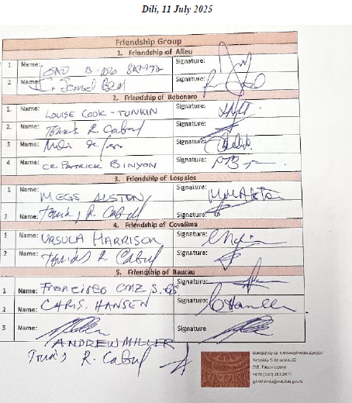
Attachment 7 (page 9 of 30)
Appendix 2
Aileu Municipal President’s address in Aileu on 8 July
Your excellencies
Distinguished guests, friends from Merri-bek and Hume,
Today is a very special day for us to welcome our friends from Merri-bek and Hume. Welcome to Aileu.
Today the renewal of the Memorandum of Understanding (Friendship Agreement) between Aileu and the Friends of Aileu will be discussed and signed. It marks a renewal – not just of a document, but of a shared journey. Since the first agreement in 2000, our friendship has grown from a gesture of solidarity into a living partnership rooted in mutual respect, learning and community empowerment.
This new agreement for 2025-2030 reaffirms our commitment to work together in building strong, resilient communities. It reflects our shared values: sustainability, inclusion, and locally led decision making. It is a promise to continue exchanging knowledge, culture, and support – not as donors and recipients, but as friends in the same journey.
We are very proud of the progress that we have made together – in education, youth development, health, and local governance. And we are excited for what lies ahead. With this renewed partnership, we will continue to respond to the aspirations of our people and strengthen the democratic foundations of our municipality.
To our friends in Merri-bek and Hume: thank you for walking beside us. May this agreement be a beacon of what communities can achieve when they choose friendship over distance, and collaboration over isolation.
Together, we build not only projects – but hope, dignity, and a better future for all.
Obrigadu barak. Thank you very much.

João Bosco dos Santos
President Aileu Municipal Authority

Attachment 7 (page 10 of 30)
Appendix 3
Photos: Some key moments in the delegation’s program
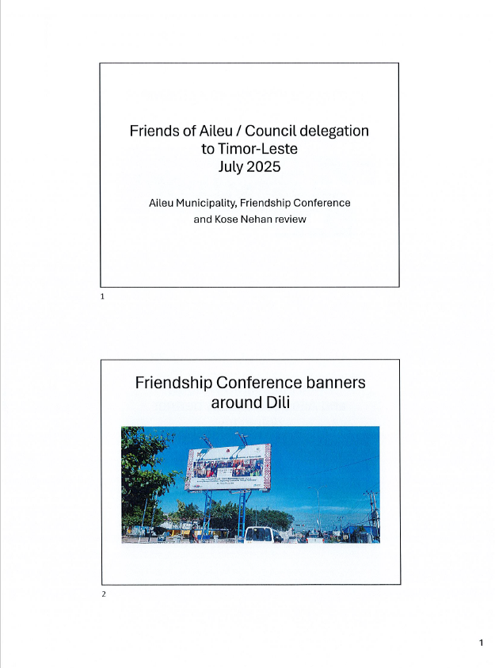
Attachment 7 (page 11 of 30)
Appendix 3 contd.

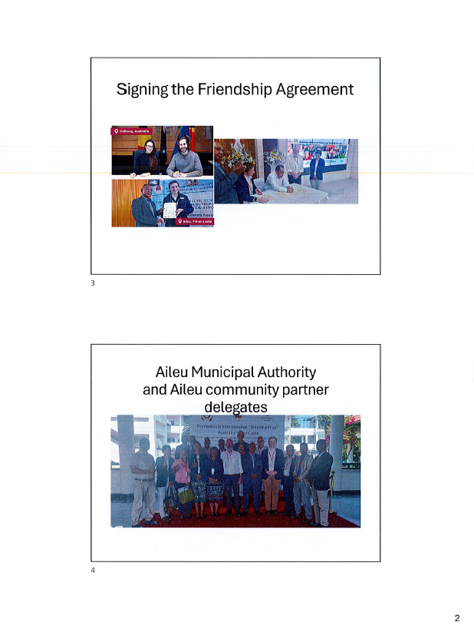
Attachment 7 (page 12 of 30)
Appendix 3 contd.
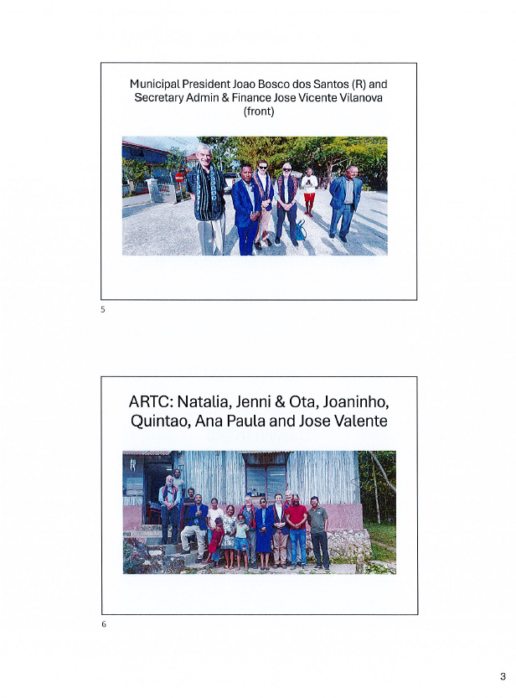
Attachment 7 (page 13 of 30)
Appendix 3 contd.
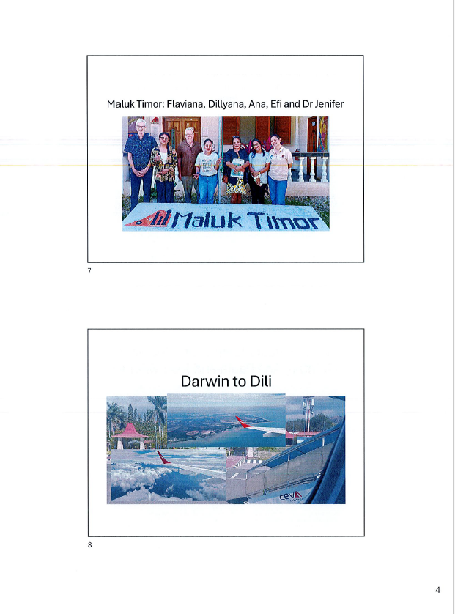
Attachment 7 (page 14 of 30)
Appendix 3 contd.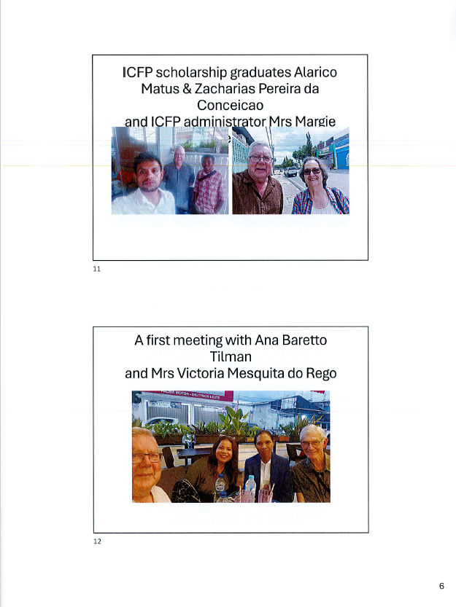

Attachment 7 (page 15 of 30)
Appendix 3 contd.
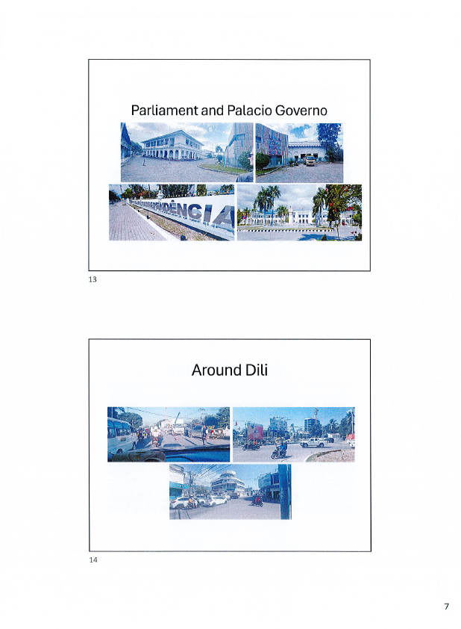

Attachment 7 (page 16 of 30)
Appendix 3 contd.
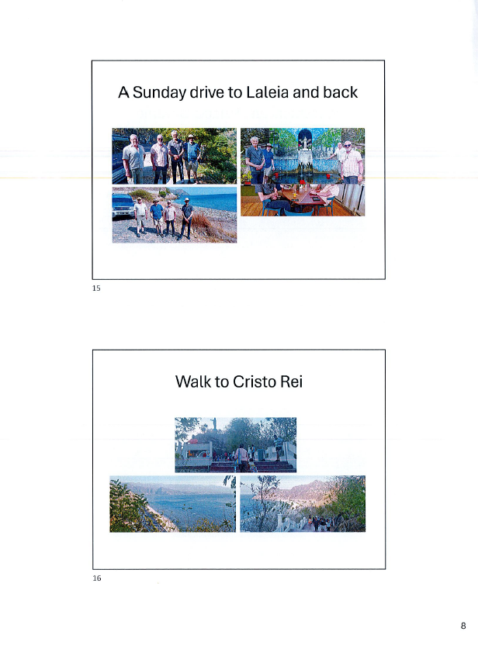

Attachment 7 (page 17 of 30)
Appendix 3 contd.
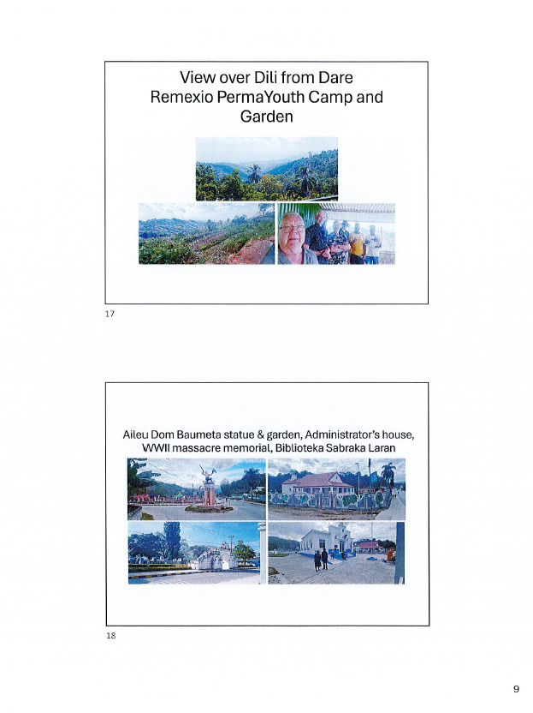

Attachment 7 (page 18 of 30)
Appendix 3 contd.
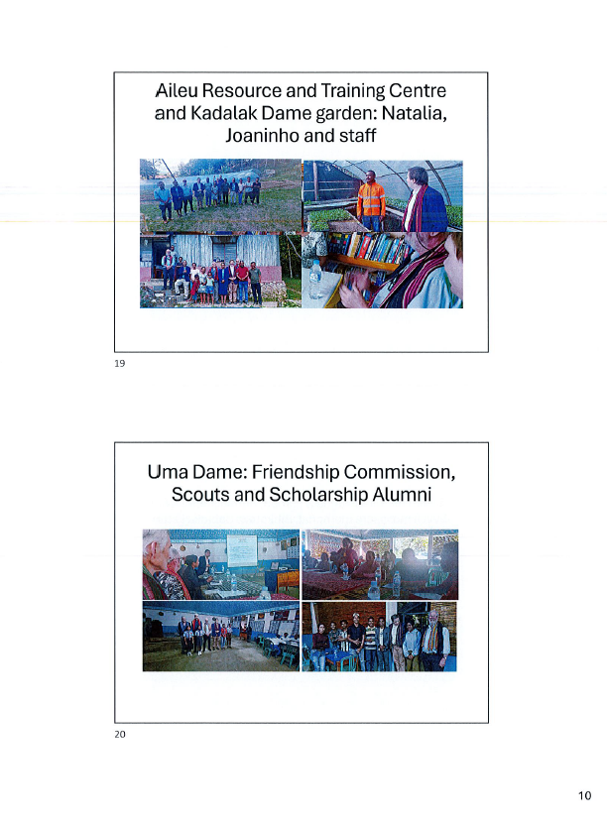

Attachment 7 (page 19 of 30)
Appendix 3 contd.
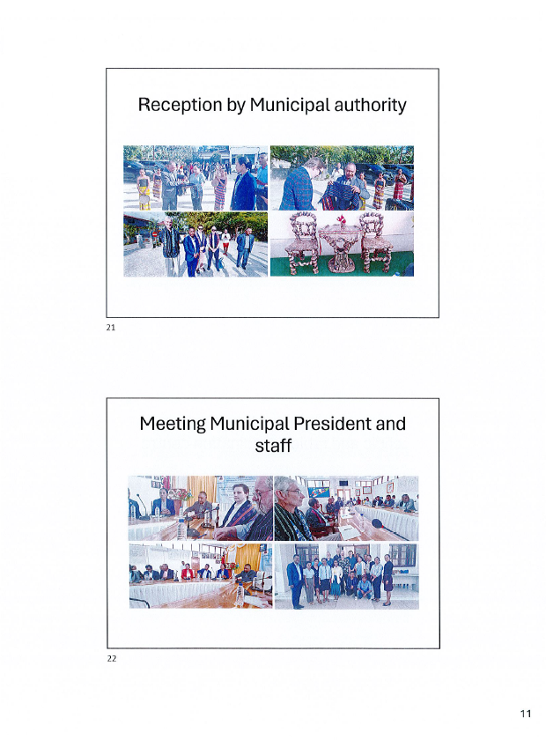

Attachment 7 (page 20 of 30)
Appendix 3 contd.


Attachment 7 (page 21 of 30)
Appendix 3 contd.
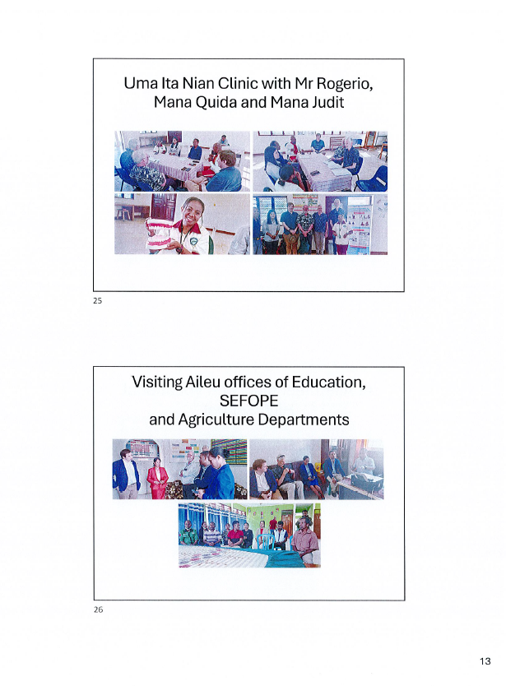

Attachment 7 (page 22 of 30)
Appendix 3 contd.
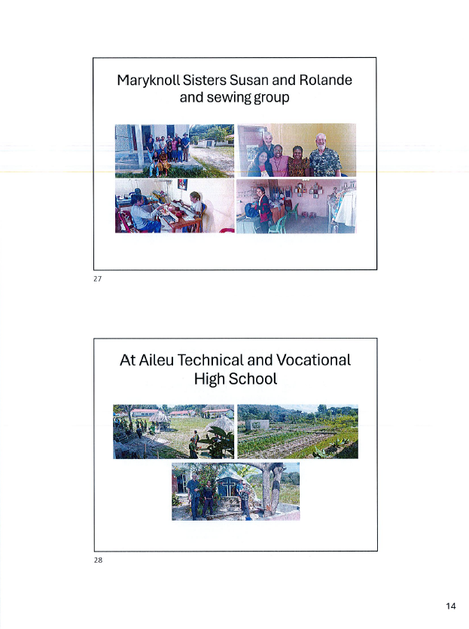

Attachment 7 (page 23 of 30)
Appendix 3 contd.
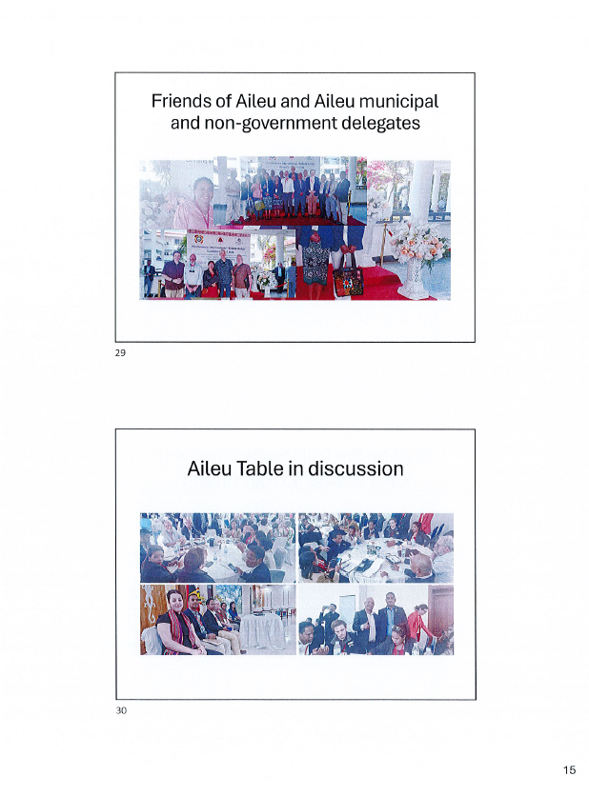

Attachment 7 (page 24 of 30)
Appendix 3 contd.
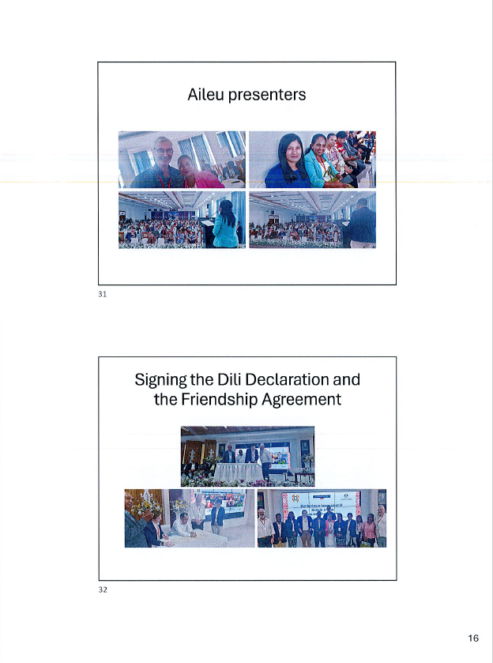

Attachment 7 (page 25 of 30)
Appendix 3 contd.
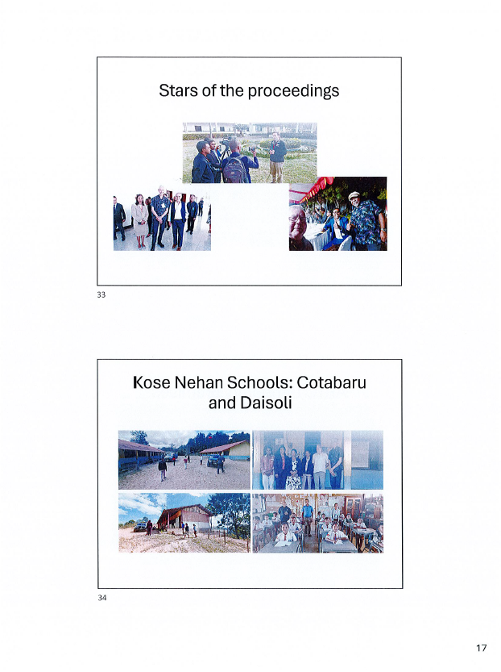

Attachment 7 (page 26 of 30)
Appendix 3 contd.
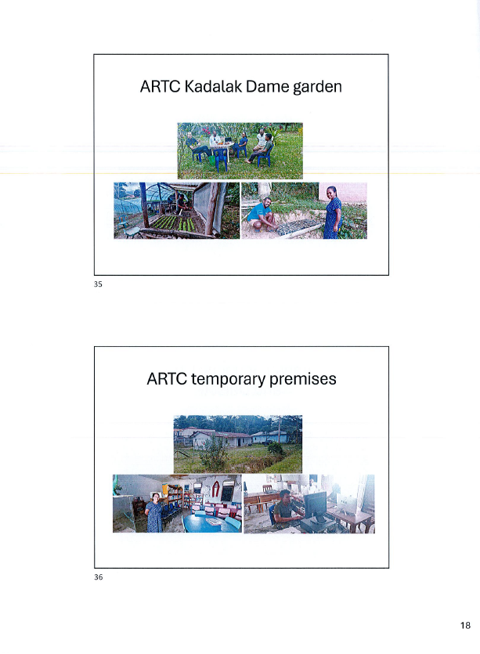

Attachment 7 (page 27 of 30)
Appendix 3 contd.
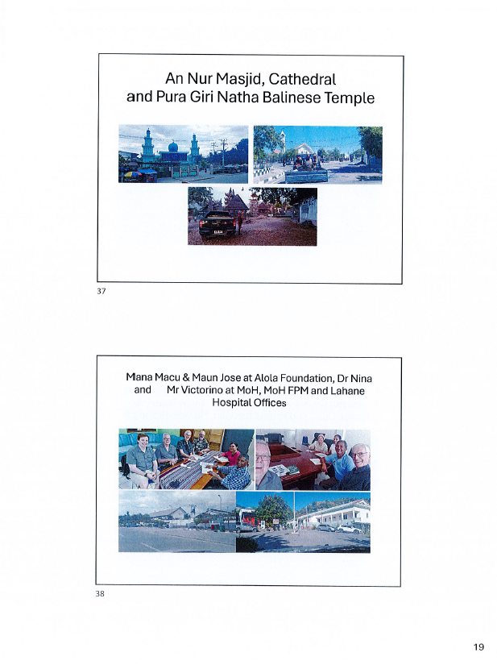

Attachment 7 (page 28 of 30)
Appendix 3 contd.

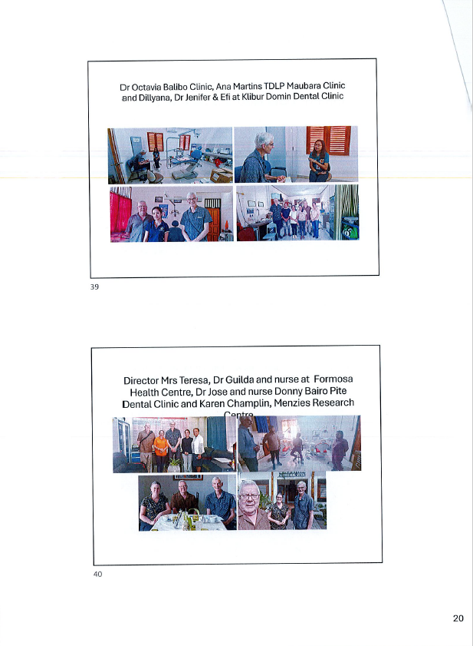

Attachment 7 (page 29 of 30)
Appendix 3 contd.
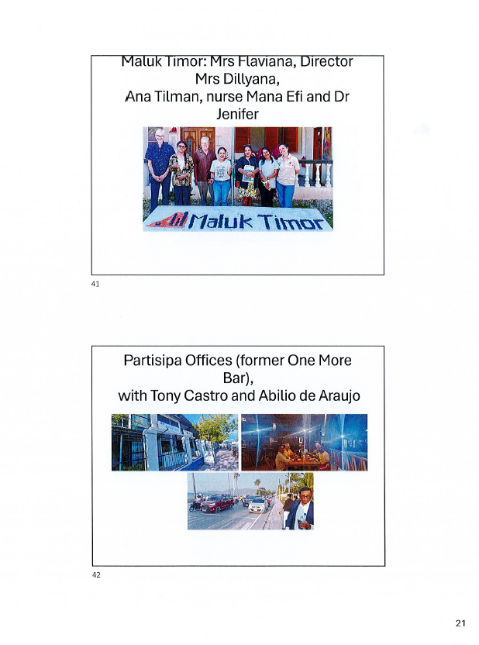

Attachment 7 (page 30 of 30)
Appendix 3 contd.
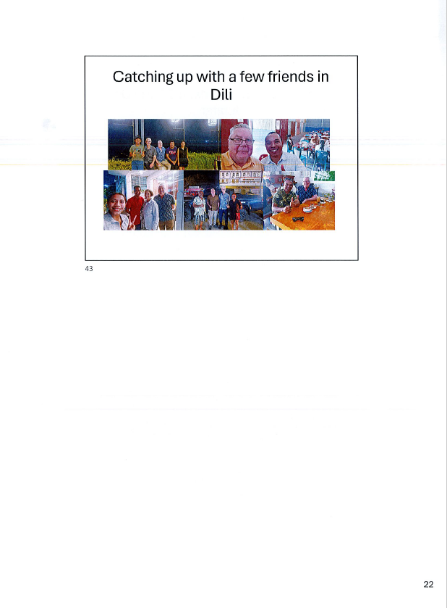
Attachment 8 (page 1 of 2)
Report on the Oral Health Promotion Project field visit to Timor-Leste, October 2025
Field Visit Summary Report – Timor-Leste
Friends of Aileu Oral Health Promotion Working Group
Dr Sandra Frans: 20 – 31 October 2025
- Background
The visit was undertaken to strengthen oral health promotion in Timor-Leste to look at the opportunity to scale up the previous oral health project by Friends of Aileu (FoA). The visit was also to follow up on the July 2025 visit. The main objectives of the visit were to understand the current context of organisations working in oral health and explore opportunities for collaboration to support the implementation of the National Oral Health Prevention Strategic Plan 2025 – 2030.
- Stakeholders engaged
Over the course of the field visit, discussions were held with government, health service providers in Aileu and in Balibo, NGOs in Dili, community-based organisations in Aileu. Meetings were conducted in Dili, Aileu and Balibo
Key stakeholders engaged included:
- Ministry of Health
- Maluk Timor
- Alola Foundation
- Aileu Municipality Secretary
- Aileu Vila Health Centre Dental Team and the Chief of Health Centre
- Aileu Youth Centre
- Uma Ita Nian Clinic
- Aileu Resource and Training Centre
- Balibo Dental Clinic
- An independent dental nurse in Dili.
- Key Findings
  - Governance
There is a strong priority to formalise the initiative from the Oral Health promotion FoA with the Ministry of Health through a Memorandum of Intent for any future activities. Even though FoA already has the agreement with the Aileu Municipality, FoA is expected to develop the agreement with the Ministry of Health, so future activities can be more accountable.
  - Service Delivery, including existing initiatives
Aileu Vila Dental Clinic provides a range of routine services—including extractions, fillings, scaling, and simple gingivectomy. However, there are significant equipment limitations, such as non-functional composite tools, an ageing drill, and a dental chair that cannot be adjusted. The clinic has one dentist, four dental nurses, and one dental hygienist, with only two out of six staff being civil servant workers. The dental staff also participates in outreach through monthly SISCA (Serviço Integrado de Saúde Comunitária) in villages in the Aileu Vila area, to deliver basic oral health promotion.
The clinic previously implemented school-based SDF (Silver Diamine Fluoride) applications from March to October 2024 with Maluk Timor’s support, reaching multiple sub-districts, but this program cannot continue without additional SDF supplies, PPE (Personal Protective Equipment), and transport resources.

Attachment 8 (page 2 of 2)
During our visit to the Balibo Dental Clinic, we learned how a well-equipped facility enables the team to deliver a broad range of services—scaling, fillings, restorations, and extractions (to about 10–13 patients a day), allowing staff to work more effectively than in many nearby clinics. We also observed how the outreach school program and collaborations with the health centre extend their preventive and educational outreach across the community. Importantly, the clinic benefits from routine visits by senior dentists from Australia and Singapore, whose mentorship and hands-on guidance significantly strengthen staff skills and overall service quality.
Across Maluk Timor, the Ministry of Health and the Aileu Dental Clinic, there is strong alignment on the value of school-based SDF implementation, with MT’s MoH-approved program already training dental staff in half of Timor-Leste’s municipalities, including Aileu. All parties recognise that MT currently provides the essential materials, transport, and training while government health workers carry out the service, and they agree that sustaining and scaling the training to other districts is a priority. Staff in Aileu reported clear benefits for children and parents but highlighted the need for adequate SDF supplies, PPE, transport, and proper portable equipment to expand and improve school-based follow-up activities.
  - Community engagement
There are several opportunities for community-involvement activities, including leveraging the existing government SISCA program, and could integrate oral health education for children. The mother support group initiated by Alola also could be used here. Dental staff could be trained to deliver these messages and further support community health volunteers. Additionally, organisations such as Uma Ita Nian have village motivators who are closely connected to communities and already active in disability-related work, presenting another strong channel for outreach.
During the discussion with the community organisations in Aileu, we learned that oral health practices in the villages remain limited, often children have untreated caries and often lack their own toothbrushes or toothpaste. Access to clean water is a major barrier, with women and children needing to fetch water, making regular toothbrushing difficult.
- Opportunities for future collaboration
  - At the Governance level
    - Establish a Memorandum with the Ministry of Health.
    - Align the collaboration with the National Oral Health Strategic Plan, with the main focus on prevention.
  - Program Opportunities and model of collaboration
    - Provision of IEC (Information, Education and Communication) printing materials that have been developed by the Ministry of Health
    - Provide advisory support to Maluk Timor in scaling up the SDF implementation program and more.
    - Support the community-based health promotion activities in schools and outreach activities such as SISCA, potentially by supporting technical capacity building for dental staff
    - Fundraising for future activities and support for oral health promotion in Aileu and beyond, including dental equipment maintenance
- Conclusion
The field visit highlighted readiness and enthusiasm for strengthening oral health prevention across multiple levels of the health system and community. With formalised governance arrangements and targeted resource support, there are strong opportunities to scale preventive oral health activities in Aileu and beyond.
Attachment 9 (page 1 of 6)
Report on the Friends of Aileu - Friends of Baucau - Future Collective community engagement visit to Timor-Leste, October 2025

The visit involved collaborations with:
- Future Collective and Friends of Baucau for the PermaYouth Convergence, Fatuqueru, Ermera, and visits to Atekru, Atauro Island, and Aileu
- Victoria University for Pre-School Education fact finding
Highlights reported to the Friends of Aileu Community Committee meeting of 9 December 2025, included the following (refer also to Appendix 1 photographs of the visit):
- The reception provided by Mr José Viçente, Vilanova, Aileu Municipal Administration’s Secretary for Admin and Finance, a former scholarship recipient, for Aoife, Carlo and Siobhan
- Kindergarten exploratory visit taking in discussions and/or trial lessons with managers, teachers and students including:
  - Meeting with the Education Advisors to the President and the Minister for Education
  - Visiting the kindergarten at the ISHMAIK Centre in Aileu, with José Valente’s mother Mrs Mafalda
  - Visiting the Kindergarten at the Aileu CAFÉ (Portuguese) Primary School
  - Visiting the SEFOPE English language course for PALM Scheme applicants, with Henrique Rodrigues
  - Visiting
    - Aileu Resource and Training Centre
    - Aileu Municipal Youth Centre, donating some soccer balls
  - Meeting with Kirsty Sword Gusmão and a 2-day Train The Trainer session with her Mother Tongue Project volunteers
- The Future Collective trip, involving:
  - A group of 9, including Tina, Lena and Xavi as Youth Leadership Awardees (sponsored by Foa (1) and FoB (2) and Joaninho from ARTC (sponsored by FoA)
  - A couple of days at the Atecru, Atauro Island, with the local community at the Na Terra NGO’s environmental education and permaculture centre
  - A visit to the Bridging Peoples NGO in Dili
  - An overnight stay at Aileu including visits to:
    - The Aileu Resource and Training Centre and its Kadalak Dame garden project
    - The Aileu Municipal Youth Centre, who were engaged in a Japanese language course, with José Valente
  - Several days at the PermaYouth Convergence, connecting with many foreign and Timorese participants, including:
  - The 10 Kadalak Dame workers (as part of the ARTC’s Permafund funded project) whose participation was funded by Friends of Aileu
  - The 26 other young PermaYouth Camp alumni and local community leaders from Aileu’s rural villages, organised by Aileu Anan Association (AILA) and whose participation was funded by Friends of Aileu.
Aoife also noted, regarding the:
- Kindergarten trip, that the opportunities for future support being considered by Siobhan at VU
- PermaYouth trip, that follow up activities for 2026 being organised with Tina, Lena and Xavi in collaboration with Friends of Baucau.
Attachment 9 (page 2 of 6)
Appendix 1 contd.
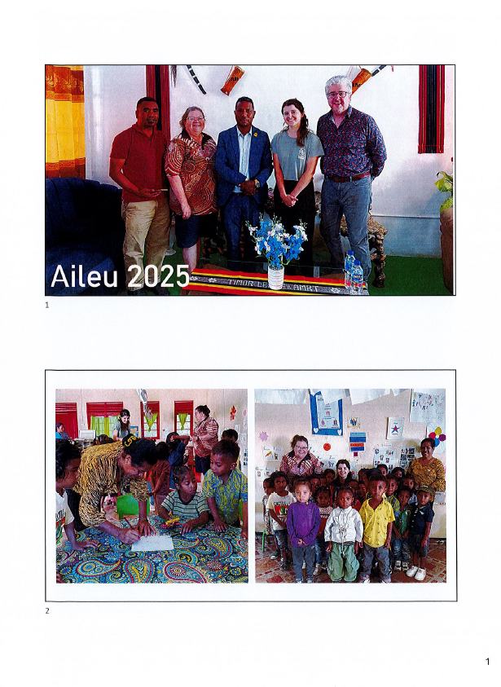

Attachment 9 (page 3 of 6)
Appendix 1 contd.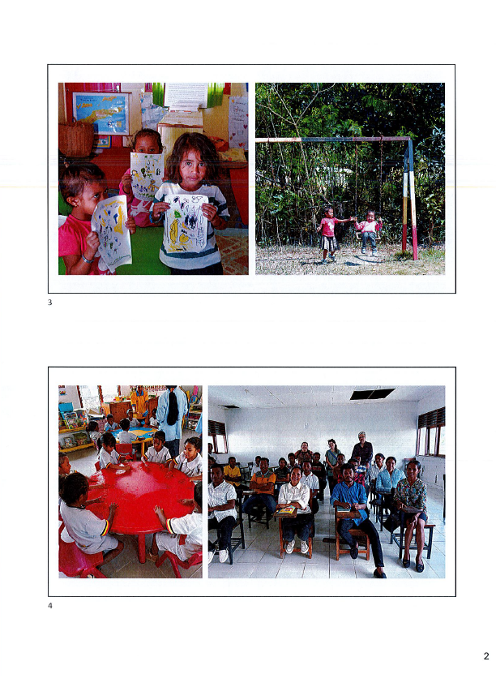

Attachment 9 (page 4 of 6)
Appendix 1 contd.
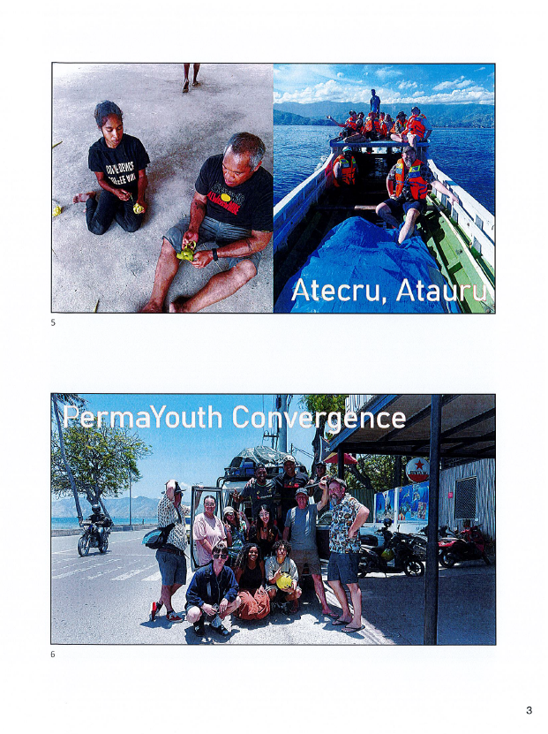

Attachment 9 (page 5 of 6)
Appendix 1 contd.
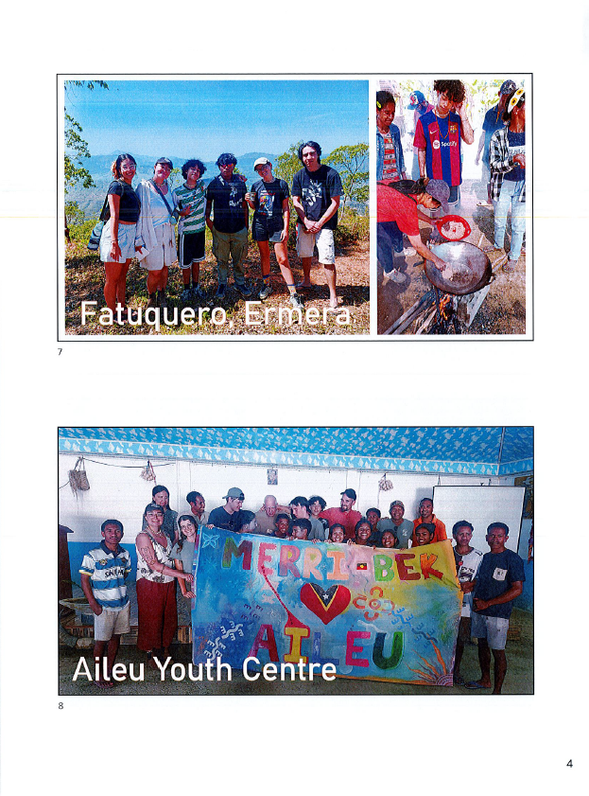

Attachment 9 (page 6 of 6)
Appendix 1 contd.
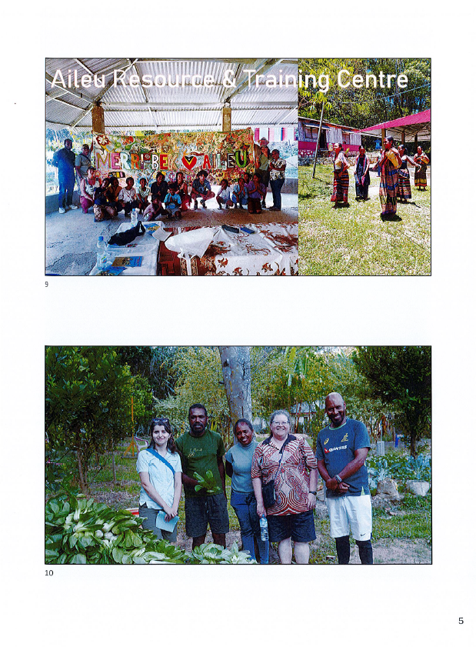

Attachment 10 (page 1 of 3)
Financial Summary for calendar year 2025
10.1 Friends of Aileu donations and fundraising accounts 2025 ($AU)
Account | Balance 01/01/25 | Income Jan-Dec | Expenditure Jan-Dec | Movement Jan-Dec | Balance 31/12/25
1.3159  Donations and Fundraising | 17,299.10 | 38,635.63 | 45,045.53 | (6,409.90) | 10,889.20
1.3160  Fundraising Sales | 1,964.00 | 3,899.65 | 1,700.00 | 2,199.65 | 4,163.65
Totals | 19,263.10 | 42,535.28 | 46,745.53 | (4,210.25) | 15,052.85
Balance at 31/12/25 |  |  |  |  | $15,052.85
10.2 Income from fundraising and donations 2025
Source | Amount $AU | Allocated for
G&GR donation | 2,600 | OHP 2026
Jamie R donation | 2,500 | OHP 2025 & 26
GiveNow donations | 336 | OHP 2026
Oral Health donation via Balibo House Trust | 4,000 | OHP 2025
Mark H donation | 500 | ARTC 2026
Hume City Council donation | 5,200 | ICFP 2025
Other donations | 1,250 | PermaYouth 2025
Grassroots Gathering, February 2025 | 3,415 | PermaYouth 2025
25th anniversary event, May 2025 | 6,812 | Friendship Commission, Aileu Youth Centre & ARTC
Merlynston movie night, August 2025 | 1,323 | Friendship Commission, Aileu Youth Centre & ARTC
Trivia Quiz fundraiser, November 2025 | 10,700 | Scholarships 2026
Sub-total donations and fundraising | 38,636
Fundraising sales (nett) | 2,200 | Coffee and craft items
Total Income 2025 | $40,836

Attachment 10 (page 2 of 3)
10.3 Expenditure on Projects and Activities 2025
Recipient | Amount $AU | Project or Activity
Australian Marist Solidarity | 4,125 | Baucau Teachers College scholarships 2024
Australian Marist Solidarity | 4,505 | Baucau Teachers College scholarships 2025
Aileu Municipal Youth Centre, for Aileu Municipal Administration | 11,797 | Aileu Scholarship Program 2025
Aileu Municipal Youth Centre, for Aileu Municipal Administration | 1693 | Aileu Friendship Commission operations
Aileu Municipal Youth Centre (ANYC) | 1693 | AMYC operations
Aileu Resource and Training Centre (ARTC) | 2,948 | ARTC operations
Aileu Resource and Training Centre (ARTC) | 4,113 | Aileu Expo
Aileu Anan Association (AILA) | 3,947 | Village youth and ARTC Kadalak Dame workers participation costs 2025 PermaYouth Convergence
Sandra Frans | 1,691 | Oral Health Promotion field visit, air fare
Sandra Frans | 4,794 | Oral Health Promotion field visit, T-L costs
Xavi dos Santos | 1,790 | PermaYouth Convergence, air fare
Xavi dos Santos | 1,950 | PermaYouth Convergence, Future Collective fee
Total Expenditure 2025 | 45,046

Attachment 10 (page 3 of 3)
8 Financial Summary for calendar year 2025
8.4 Financial Outlook for 2026
8.4.1 Income Jan 2026
Give Now OHP $148.49
Coffee Uncommitted $60.00
$208.49
8.4.2 Funds available at 31/01/26
Balance 31/12/25 $15,053
Income Jan 2026 $208
To be invoiced Balibo House Trust $2,150
To be invoiced Hume City Council $5,200
Total funds available $22,611
8.4.3 Committed funds
Scholarship program $10,700
Baucau Teachers College scholarships $5,200
Oral Health Promotion $5,125
(G&GR 2,600 + JRob 809 + NS friend 1,356 + GiveNow 360)
ARTC operations (MH donation) $500
Sub-total committed funds $21,525
8.4.4 Current uncommitted funds $1,086
8.4.5 Priorities for 2026 fundraising
(subject to OHPWG and FoA Community Committee deliberations)
Potential 2026 fundraising
Project Amount Source
Additional OHP target 7,000 March Giving Circle
Aileu Friendship Commission operations 1,500 Uncommitted funds and
Aileu Youth Centre operations 1,500 2026 Coffee/Craft sales
Additional ARTC operations 4,500 Possible August
ARTC Expo 4,000 fundraiser and/or ATLFN
AILA PermaYouth 5,000 Possible April-June event
Maryknoll sewing group 1,250 and/or ATLFN
2027 Scholarship Program $12,500 2026 Trivia Quiz
Sub-total fundraising priorities $37,250
ARTC replacement motorcycle $3,000
Total additional fundraising priorities $40,250
This $40,250 fundraising target:
- compares to 2025 income of $40,836 ($38,636 plus nett coffee & craft sales of $2,200)
- if fully achieved and expended would leave carry over to 2027 of only the estimated $12,500 from the 2026 Trivia Quiz for the 2027 Scholarships

