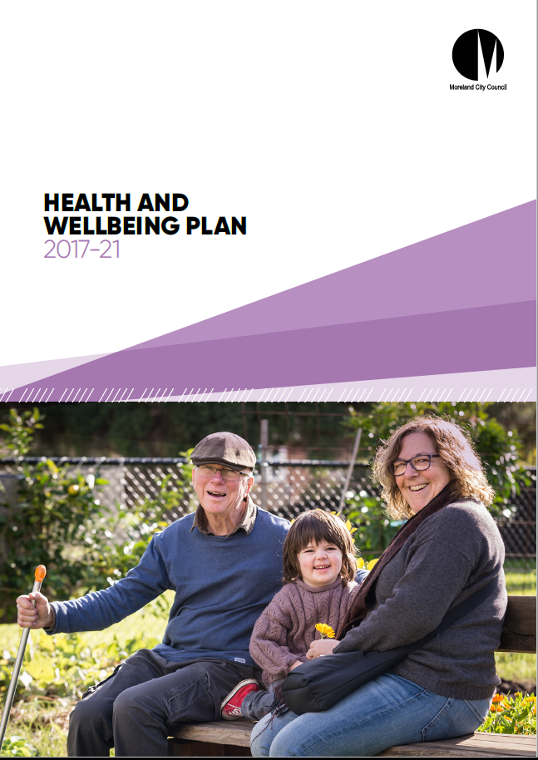

Version Control | Date | Approved by | Position
v1 | 23 June 2017 | Barry Hahn | Project Executive
v1.1 | 03 July 2017 | Arden Joseph | Director, Social Development
v1.2 | 12 July 2017 | Council Resolution | Council
v2 | 22 September 2017 | Barry Hahn | Project Executive
v2.1 | 27 September 2017 | Arden Joseph | Director, Social Development
v2.2 | 11 October 2017 | Council Resolution | Council

FOREWORD BY MAYOR

I am very pleased to introduce the Moreland Municipal Public Health and Wellbeing Plan 2017 - 21. The vision is for Moreland is to be a healthy, liveable and sustainable city.
This aligns with the overarching vision in the Council Plan that Moreland will be known for its proud diversity, and for being a connected, progressive and sustainable city in which to live, work and play.

The Moreland Municipal Public Health and Wellbeing Plan has two focus areas – Healthy Communities and Liveable Neighbourhoods – which align with two of the strategic objectives in the Council Plan, that Moreland is a Connected Community and a Progressive City.

Moreland City Council is committed to improving the health and wellbeing of residents by maintaining and creating supportive environments. This enables residents to access services, housing and employment, to connect with others, to get around the city and to adapt to changes in climate.

We want to increase access to fresh food, along with drinking water in public places. We also envisage that the community’s participation in physical activity will continue to decrease overweight and obesity rates. 43 % of Moreland’s population are overweight or obese – which is below the state average of 50 %, yet still a major concern.

One quarter of Moreland’s population have been diagnosed with depression or anxiety. We want to improve people’s mental health by providing opportunities to learn new skills, join groups, volunteer, and provide spaces to relax and play. Gambling harm is a social issue of a similar magnitude to major depressive disorders. Council will continue to lobby for controls on pokies and other gambling products that protect consumers and reduce the social costs of the gambling industry on our community.

While 92% of the population surveyed felt safe during the day this dropped to 71% at night. Council will continue to install lighting in areas of concern, to enforce local laws and to work with Victoria Police to address crime. Moreland police identify family violence as a critical issue and although there has been a decrease of 61 incidents reported in the last year we will continue working to prevent family violence before it occurs by addressing its underlying cause: gender inequality.

Moreland will continue to approach land-use planning and neighbourhood design to develop 20 minute neighbourhoods – allowing residents to walk to access their everyday needs. Along with more open spaces, and increased tree planting to provide more shade, our residents will have a healthier environment to stay active and connected.

Local government is the tier of government closest to the people and it is vital that Council shows leadership, provides support and works alongside key partners and community members to combine efforts to enhance our community.

I would like to thank everyone involved in the development of this Plan throughout 2017 and I look forward to working with the Moreland community, local groups and agencies to achieve improved health, safety and wellbeing for our community.

Cr Helen Davidson
Mayor, Moreland City Council.

Introduction

The Moreland City Council Municipal Public Health and Wellbeing Plan (MPHWP) 2017-21 is a whole-of-Council plan that outlines the strategic health and wellbeing priorities for the municipality. Based on evidence of the health needs of the community, it identifies goals and strategies for creating a local community in which people can maximise their own health. The Plan is underpinned by a partnership approach, which aims to create effective processes to support its objectives. The Plan is focused on delivering long-term health outcomes. It brings together the key objectives of existing Council policies, plans, strategies and external partnerships, which contribute to improving the health and wellbeing of the Moreland community.

The Public Health and Wellbeing Act 2008 (PHWA) requires local government to develop a MPHWP every 4 years. It is a legislative requirement for councils to play a role in protecting and promoting the health and wellbeing of its community members, including the following objectives:

- Protecting public health and preventing disease, illness, injury, disability or premature death;
- Promoting conditions in which persons can be healthy; and
- Reducing inequalities in the state of public health and wellbeing.

Council plays a central role in shaping a healthy and liveable city that promotes and supports healthy lifestyles. The Moreland MPHWP takes a population-level approach and supports residents to make choices that lead to healthy behaviours. Enhancing liveability is also a key focus of the Plan to make sure that Moreland continues to be a city that people want to live in now and into the future.

The vision of the MPHWP 2017-21 is that “Moreland is a healthy, liveable and sustainable city”, and the Plan’s implementation is guided by the following principles:

- Whole-of-Council Approach;
- Partnerships Approach;
- Human Rights Approach;
- Life-Course Approach;
- Health Equity Focus; and
- Place-based Approaches.

The application of these principles will ensure that the benefits of population-level health planning extend to all members of the community.

Background

Where we are
The City of Moreland covers Melbourne’s inner and mid-northern suburbs and is located between 4 and 14 kilometres north of central Melbourne. It is bordered by the Moonee Ponds Creek to the west, Merri Creek to the east, Park Street to the south and the Western Ring Road to the north.

The City encompasses a total land area of 50.9 square kilometres and includes the suburbs of Brunswick, Brunswick East, Brunswick West, Pascoe Vale, Pascoe Vale South, Coburg, Coburg North, Hadfield, Fawkner, Glenroy, Oak Park and Gowanbrae. Small sections of Fitzroy North and Tullamarine are also part of Moreland.

Who we are: An overview of our diverse community
Reference: ABS Census of population and housing 2011, exception being population projections from ID consulting May 2017
The Social Determinants of Health

There are many factors that affect an individual’s health outcomes. They include the personal choices that we make on a daily basis about what we eat, whether we exercise, our preferred active modes of transport rather than driving a car, whether we choose to smoke tobacco or drink excessive amounts of alcohol, and whether we proactively maintain our personal health. We all have the ability to make choices but, often, factors beyond our control and our life circumstances impact on those choices.

The World Health Organization (WHO) states that the conditions in which people live and die are, in turn, shaped by political, social, and economic forces. The social determinants of health are the “social conditions in which people are born, grow, live, work, play and age – that influence their health”. These determinants are the foundations from which we are able to experience the world, and they can lead to broad health inequalities. These varying circumstances can be accumulative over a lifetime, they can alter health across the life course, and they can be intergenerational. The social determinants of health include:

- Socio-economic status;  - Early life circumstances;  - Social support networks;  - Education;  - Employment; | - Housing;  - Access to fresh and healthy food;  - Race, Ethnicity, Gender and Sexuality;  - Access to and use of health services; and  - The liveability of the area.

These circumstances can affect people’s health, their ability to access necessary health services, their ability to make informed choices and their life opportunities. The picture below represents a social model of health and attempts to map the relationships between an individual, the environment and the influences on
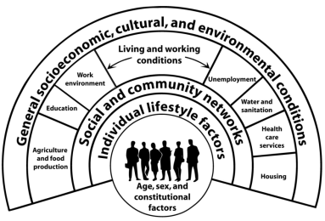

health outcomes. Dahlgren and Whitehead (1991) refer to the different layers of influence that can affect the health and wellbeing of individuals. The diagram represents the individual at the centre with a fixed set of genes. The layers surrounding them are factors that can be modified and can promote or damage a person’s health. Individual lifestyle choices that can affect us include the choice of eating healthy foods, undertaking physical exercise, whether we choose to smoke tobacco or drink excessive amounts of alcohol. Social and community networks can have a positive effect by providing emotional support, but can also provide no support to people and have a negative effect. The third layer includes the political, social, cultural and environmental factors known as the social determinants of health that can dramatically influence health outcomes of individuals and the broader community.

Through the design of the Moreland City Council Municipal Public Health and Wellbeing Plan (MPHWP) 2017-21, Council is committed to addressing the factors and conditions that create inequalities. Underpinned by the 6 guiding principles, Moreland will work together with residents, communities and organisations to create supportive environments that enable people to lead healthy lives.

Health Planning and the Policy Context

Health planning is a complex endeavour, requiring the analysis of data and the identification of key priorities that will affect the health and wellbeing of the Moreland community. Council works with a wide variety of stakeholders in identifying and negotiating these priorities. Our actions are informed and shaped by State and Federal Government policies. Drawing on relevant research, evidence and best practice knowledge, these policies provide guidance in our health and wellbeing planning.

This is an overview of the interrelated systems, policies and organisations that have influenced the development of the Moreland MPHWP 17-21, and will influence its implementation over the next 4 years.

Local Context
The Public Health and Wellbeing Act 2008 (PHWA) requires local government to develop an MPHWP every 4 years, which must be completed within 12 months of the general election of a new Council. According to the Department of Health and Human Services (DHHS), the MPHWP must:

- Include an examination of data about health status and health determinants in the municipal district;
- Identify goals and strategies based on available evidence for creating a local community in which people can achieve maximum health and wellbeing;
- Provide for the involvement of people in the local community in its development, implementation and evaluation;
- Specify how Council will work in partnership with the department and relevant agencies to accomplish the goals and strategies identified in the public health and wellbeing plan; and
- Be consistent with the Council Plan (s125 of the Local Government Act 1989) and Municipal Strategic Statement (MSS) (s12A of the Planning and Environment Act 1987).

Council works closely with and is accountable to DHHS for the design, implementation and reporting of the MPHWP, which is closely aligned to the Council Plan 2017-21 and integrates key elements of Council’s MSS related to the concept of liveability.

Council’s key community health partner Merri Health works to create healthy, connected communities through the provision of health services and programs for people at every age and stage of life. Merri Health has been the trusted health service of Moreland’s local community for over 40 years. As a not-for-profit organisation, the focus of Merri Health is partnering with people, responding to local needs, and strengthening the health of entire communities.

DHHS requires community health organisations to develop a 4-year Integrated Health promotion (IHP) plan that aligns with the MPHWP planning cycle. Council and Merri Health have worked closely to ensure that priorities and responsibilities are clear and aligned where needed. This planning will improve our joint capacity to influence local and system-level change.

Regional Context
Primary Care Partnerships (PCPs)
DHHS funds 28 Primary Care Partnerships (PCPs) across Victoria that connect more than 800 organisations across many different sectors. PCPs collaborate by sharing skills and expertise, and aligning effort. They improve the health and wellbeing of communities by finding ways to make the health and community sector system work better.

The Inner North West Primary Care Partnership (INWPCP) brings together nearly 40 health and human services operating in the inner north-west region of metropolitan Melbourne. The partnership aims to improve community health and wellbeing by building a stronger, more integrated service system through a collective impact approach. Moreland City Council is a member of INWPCP along with the City of Melbourne, Moonee Valley City Council and the City of Yarra. Council is an active participant in the work of the INWPCP and will continue to work collaboratively with members of the partnership on projects and initiatives relevant to the Moreland community.

Metropolitan Partnerships
Metropolitan Partnerships have recently replaced the former Regional Management Forums, and Moreland City Council is a member of the Northern Region. According to the Department of Land, Water, Environment and Planning (DELWP), Metropolitan Partnerships are “a new and coordinated way for communities to advise government on what matters in their region”. The membership includes representatives from each tier of government, local business and community members from varying backgrounds.

The partnership will identify local priorities across the social, health, wellbeing, and liveability outcome areas and inform government decision-making processes. These partnerships will strengthen collaboration across the government system and with the community.

State Context
The Victorian State Government has significant statewide investment in preventative health and population health level planning. The state government documents that guide preventative health efforts in Victoria are:

Victorian Health and Wellbeing Plan 2015-2019 (State Health and Wellbeing Plan)
The Victorian Public Health and Wellbeing Plan (VPHWP) 2015-2019 outlines the high-level strategic directions of the Government that will help to improve the health and wellbeing of Victorians.

The vision is “a Victoria free of the avoidable burden of disease and injury, so that all Victorians can enjoy the highest attainable standards of health, wellbeing, and participation at every age”. The Plan includes the following 6 priorities:

- Healthier eating and active living;
- Tobacco-free living;
- Reducing harmful alcohol and drug use;
- Improving mental health;
- Preventing violence and injury; and
- Improving sexual and reproductive health.

The VPHWP 2015-19 has informed the outcome areas of the Moreland MPHWP 17-21 and Council has used the VPHWP Outcomes Framework as a guide on how to develop indicators and measures to understand the longer-term impact of this Plan.

VicHealth Action Agenda for Health Promotion (2016 update)
The 2016 Action Agenda update sets out VicHealth priorities for 2016-2019. The five strategic imperatives include:

- Promoting healthy eating;
- Encouraging regular physical activity;
- Preventing tobacco use;
- Preventing harm from alcohol; and
- Improving mental wellbeing.

VicHealth priorities and strategies are consistent with National and State health promotion priorities and prevention frameworks. Council has utilised the VicHealth local government action guides when considering the priority action areas across the 15 outcome areas of the MPHWP 17-21, and will continue to seek guidance from VicHealth over the next 4 years.

Federal Context
There are considerable reforms and challenges that will affect our community. This impact will become clearer over the next 2 years in relation to changes with the implementation of the National Disability Insurance Scheme and changes in the delivery of the Commonwealth Home Support Program.

Primary Health Networks (PHNs)
Primary Health Networks (PHNs) were established in 2015 to “increase the efficiency and effectiveness of medical services for patients, particularly those at risk of poor health outcomes, and improve coordination of care to ensure patients receive the right care in the right place, at the right time”.

The City of Moreland sits within the North Western Melbourne Primary Health Network’s (NWMPHN) catchment. Their mission is to “strengthen primary health care and connect services across the system by responding to national and local priorities; improving quality of care and individual outcomes, and improving care integration and coordination across the continuum”. The NWMPHN’s strategic objectives include to:

- Improve the prevention and management of chronic disease;
- Improve access to care and coordination of care across settings;
- Effectively engage stakeholders;
- Enhance the mental and emotional health and wellbeing of the community;
- Improve health outcomes for vulnerable populations;
- Engage and support General Practice and other care providers;
- Undertake effective, evidence based commissioning; and
- Achieve robust governance and stewardship.

Moreland City Council will continue to work with the NWMPHN to enhance the impact of their objectives and work collaboratively on joint priorities.

Moreland Council’s Planning Framework

This section outlines the Moreland Council Planning Framework and demonstrates the relationship between key strategies that shape Council-wide planning and services.

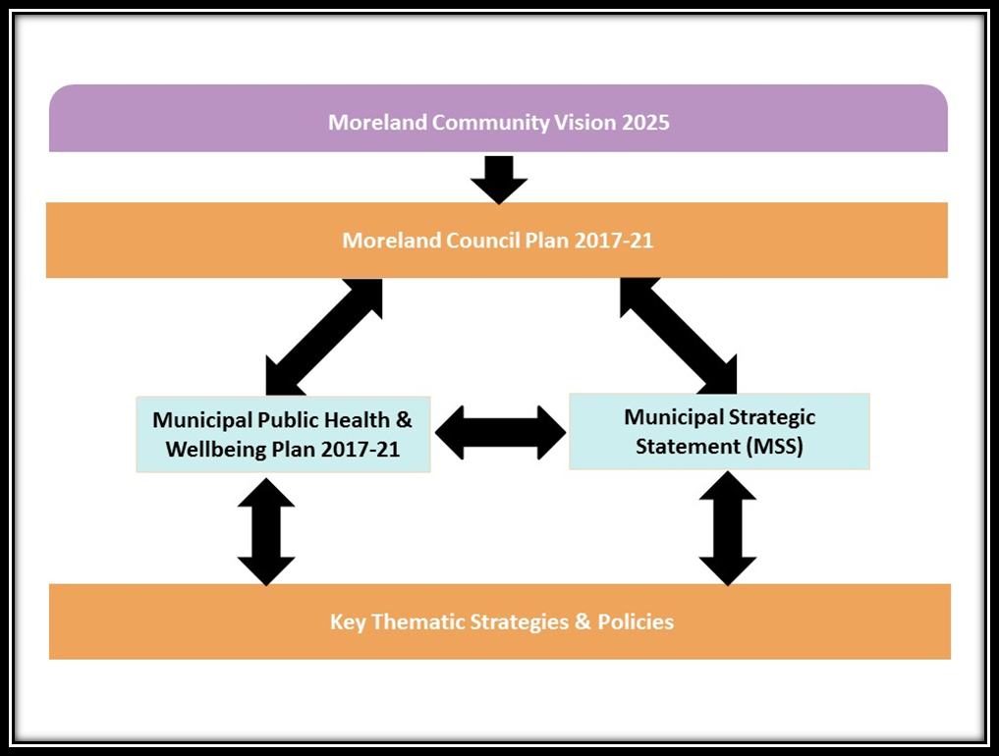

The Moreland Community Vision 2025 contains the combined aspirations from over 1,500 Moreland citizens from all backgrounds, ages and suburbs, and representatives from 30 partner organisations. The vision was formed through a consultative process to develop shared priorities for the city, and underpins the outcome areas of the MPHWP 2017-21.

It is a legislative requirement that Council produces a Council Plan every 4 years and the Moreland Council Plan 2017-21 establishes priorities and sets an agenda for this council term while keeping sight of long-term future challenges and opportunities. The 3 strategic objectives of the Plan are:

- Connected Community
- Progressive City
- Responsible Council.

These 3 strategic objectives guide a range of priority actions that Council will implement during this term. This Plan demonstrates that Council is actively planning for the future while addressing the current health and wellbeing needs of the community through the Moreland MPHWP 2017-21.

Closely related to the Council Plan 2017-21 and the MPHWP 2017-21 is the Moreland Planning Scheme, which sets out policies and provisions for the use, development and protection of land in the municipality. The Moreland Planning Scheme also includes Council’s vision and strategies for planning and development. This section is known as the Municipal Strategic Statement (MSS). The MSS closely relates to the MPHWP and the Council Plan and is an integrated approach to land use planning and neighbourhood design that creates environments that support active, engaged and conscious living. Council’s aspirations cover the areas of local living, the economy, housing, provision of community facilities, access to parks and open spaces, transport, and ways to address sustainability.

Developing the Moreland Plan

“Engagement is at the heart of what a Council is designed to do”

Meaningful engagement and participation has been essential in shaping the MPHWP 2017-21, which aims to enable people to maximise their own health. The planning process began in October 2016 and has included:

- A thorough review of the previous MPHWP 2013-2017 and the Community Vision 2025;
- An update of the Health and Wellbeing Profile, which informed the identification of population-level health issues. The Health and Wellbeing Profile can be accessed via the Moreland website at: http://www.moreland.vic.gov.au/globalassets/areas/social-policy/health-and-wellbeing-profile-april-2017.pdf;
- Extensive consultation with internal and external stakeholders who are involved in the implementation of the MPHWP and its partnership approach;
- Seeking regular guidance from partners including DHHS, the Inner North West Primary Care Partnership (INWPCP), Merri Health and relevant staff from neighbouring Councils;
- Feedback from the Moreland Council Plan 2017-21 consultation process that included:
  - 3 Moreland staff foresight workshops held in November 2016 and run by a futurist.
  - 3 community consultation workshops held in February and March 2017 with 100 community members in attendance. These workshops explored the themes of Sustainable Environment and Climate Change; Healthy, Diverse and Connected Communities; Planning for a Sustainable Local Economy and Population Growth; and Your Council.
  - Online feedback from residents via the community engagement platform OurSay that included 107 ideas posted, 3,732 votes placed and 320 comments made. This engagement also covered the themes of Sustainable Environment and Climate Change; Healthy, Diverse and Connected Communities; Planning for a Sustainable Local Economy and Population Growth; and Your Council.
- 2 workshops with internal and external stakeholders to increase understanding of the concepts of health and wellbeing, and to review, define and refine the priorities for the MPHWP 2017-2021.
- Public exhibition of the draft Plan for a month, in which we received 9 submissions, including:
  - 4 from organisations including DHHS, Merri Health, Women’s Health in the North (WHIN) and North West Mental Health Services;
  - 4 from individual community members; and
  - 1 from the Moreland Housing Advisory Committee.
- Review and finalisation of the MPHWP 2017-2021 based on feedback received during the public exhibition period.

This planning process was underpinned by a collaborative approach informed by Council’s Engagement Strategy. Throughout the process, there were a variety of approaches taken to engaging stakeholders, all of which involved a commitment to the relationship between stakeholders and the health and wellbeing cause.

The Plan

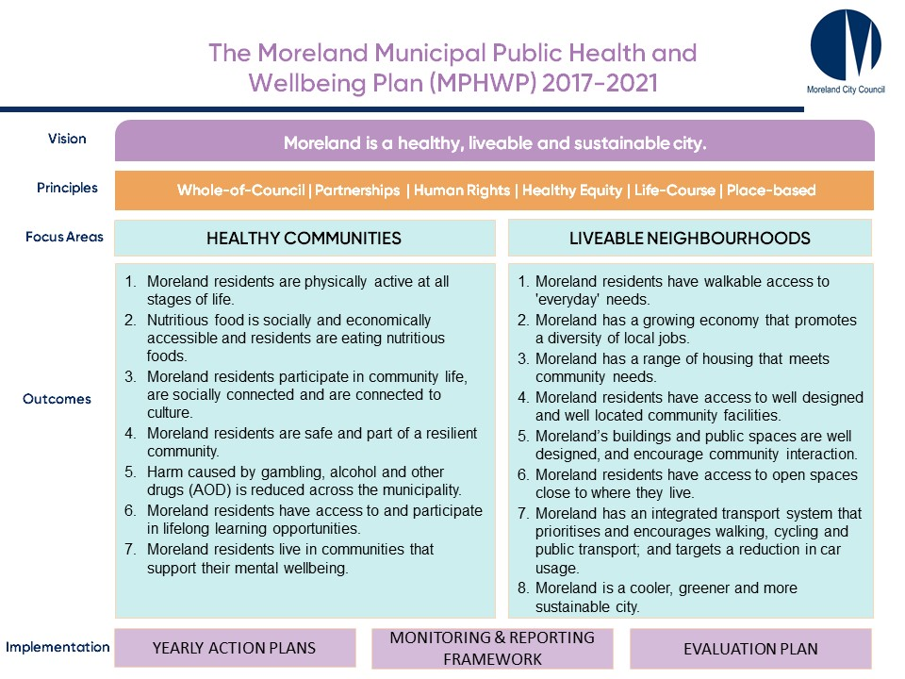

Guiding Principles of the Municipal Public Health
and Wellbeing Plan (MPHWP) 2017-21

Moreland City Council will use 6 guiding principles to implement the Municipal Public Health and Wellbeing Plan (MPHWP):

- Whole-of-Council Approach;
- Partnerships Approach;
- Human Rights Approach;
- Life-Course Approach;
- Health Equity Focus; and
- Place-based Solutions.

Council commits to working together with partners to improve the health and wellbeing outcomes of the Moreland community; and these principles recognise the complexity of the environments the MPHWP is focused on.

Whole-of-Council Approach
The MPHWP brings together all the work done within the municipality that impacts on the health and wellbeing of residents. This plan embraces a collaborative approach and informs, aligns with or complements a number of other Council policies, plans and strategies. Recognising these intersections, Council is also committed to working in partnership with a range of health, human services and other organisations and community members to identify initiatives that will enable an integrated and multi-sectoral approach.

Sharing of knowledge across Council and developing a common health and wellbeing language have been identified as priorities, to ensure that the ultimate benefits are realised at the community level.

Partnerships
The development of the MPHWP 2017-21 has been underpinned by collaboration and embracing an integrated multi-sectoral approach to addressing complex population-level health issues. Partnerships are integral to the implementation, monitoring, reporting and evaluation of the Plan in the future and Moreland City Council is committed to nurturing effective partnerships with a variety of stakeholders.

Across Council, there are many existing partnerships connected to the MPHWP and they can be generally classified as:

- Partnerships that connect directly to the Community Wellbeing Officer and the coordination of the MPHWP. An example of this would be the direct connection to the Population Health Unit at Merri Health. This partnership is based around regular meetings to align strategic planning and identifying opportunities to collaborate on projects and initiatives.
- Partnerships that connect to the MPHWP through a policy. For example, Prevention of Violence Against Women (PVAW) work is enabled through the Preventing Family Violence in Moreland Strategy 2016-2020 and there is an existing partnership with Women’s Health in the North (WHIN). This partnership is actively managed by the Community Development and Social Policy Unit and the relevant Council officer. Actions are implemented together based on the agreement of the parties.

“If partnerships are to be successful they must have a clear purpose, add value to the work of the partners, and be carefully planned and monitored.”

Across the variety of partnerships, Moreland City Council is committed to:

- Actively collaborating to address identified health and wellbeing needs.
- Reflecting on current established partnerships and their effectiveness.
- Clarifying roles and responsibilities in partnerships.
- Developing a clearer understanding of the range of collaborations available.
- Focusing on strengthening new and existing partnerships.
- Identifying new partnerships that can strengthen accountability, governance and evaluation of the MPHWP 2017-21.

Human Rights Approach
Implementation of the MPHWP will be guided by the Moreland Human Rights Policy 2016-26 and the vision that Council plays “an important role in protecting and promoting human rights by ensuring that all people in our community are supported to fully participate in the life of the city and enjoy self-determination in decisions that affect them. All people should have dignified and equitable access to information, goods, services and life opportunities as a result of good governance and democracy”.

This MPHWP holds the human rights of our citizens as a key principle in ensuring that all members of the population are able to participate in and benefit from the key priorities of this Plan. The MPHWP works for the health and wellbeing of all community members and will ensure that all people are recognised, are fully able to participate in activities and receive appropriate services. The Moreland Human Rights Policy outlines a statement of commitment to the following groups:

- Aboriginal and Torres Strait Islander Communities;
- Migrants and Refugees;
- People with Disability;
- GLBTIQ communities - Gay, Lesbian, Bisexual, Transgender, Intersex and Queer; and
- Women.

Council and partner organisations will work to ensure that all population groups have access to facilities, services and programs and are engaged in the decision-making processes that affect their health outcomes.

Life-Course Approach
The individual health journey is not constant; it has specific needs and particularly important moments. Council recognises the different needs of its residents at different times in their lives and aims to provide the right support at the right time throughout the life-course.

Consistent with the VPHWP 2015-19, Council utilises a life-course approach to improving the population-level health and wellbeing outcomes of its community and has targeted priorities across the following stages of life:

- Early childhood;
- Young people;
- Adults;
- Families; and
- Older Adults.

The MPHWP has a prevention focus; providing support and facilitating empowerment for the community to realise improved health outcomes at the individual and population level.

Council provides a range of services and programs for infants and families, including maternal and child health services and childhood immunisations. These services support and strengthen families. Council works alongside youth in relation to all aspects of health and wellbeing to provide support in these crucial developmental years, to provide youth-friendly spaces and to assist with referrals to relevant services as needed.

Council recognises that health interventions in the early stages of life are a key determinant of positive health outcomes in the later part of the life-course. This prevention focus also continues in the later years through holistic approaches to healthy and active aging. The MPHWP will be implemented through the development of yearly action plans. These action plans will consider these age groups and the transitions between these stages of life when outlining tangible deliverables across the 15 outcome areas.

A focus on Health Equity
Health equity is “the notion that everyone should have a fair opportunity to attain their full health potential and that no one should be disadvantaged from achieving this potential if it can be avoided”. Health equity is about enabling all residents to access services, opportunities and resources without discrimination, and creating settings of daily life that can be supportive of residents’ health and enable them to make choices that can improve their physical health and emotional wellbeing.

The MPHWP applies a health equity lens to projects, initiatives and services. Aligned with Council’s Human Rights Policy and through taking a life-course approach, the MPHWP aims to support all residents in accessing life opportunities and appropriate health services. This is complemented by the Liveable Neighbourhoods focus that aims to improve the liveability of the municipality and to improve places and spaces where people come together.

Place-based Solutions
Location and context play a key role in the way Council and the community plan health promotion efforts and DHHS has a policy focus towards place-based initiatives. According to DHHS, a place-based approach “recognises that people and places are inter-related and that the places where people spend their time play an important role in shaping their health and wellbeing. Local context is critical. A place-based approach focuses on local needs and local priorities, engages the community as an active partner in developing solutions, and maximises value by leveraging multiple networks, investments and activities to deliver the best outcomes for communities”.

Place can be defined as the whole of the municipality, it can be a suburb, it can be a specific community or it can be a specific space. How we define place can depend on the situation and the priorities in that local area. Research about the most successful place-based initiatives is still emerging, yet there are already examples of place-based approaches that are evolving within Moreland.

Moreland’s key community health partner, Merri Health, plays a leadership role in local health and wellbeing action. Merri Health’s IHP Plan 2017-2021 will have a distinct place-based focus on Fawkner and Glenroy and will work closely with community and local partners to tackle the underlying determinants of 3 main priorities areas: prevention of violence against women, social inclusion and food security. Merri Health has a long history of partnering with Council, other agencies and community members to deliver successful health promotion interventions throughout Moreland, with established strong connections to the Fawkner and Glenroy communities.

Merri Health’s current successful interventions in northern Moreland include Ready Set Prep, a 4-year project to improve school-readiness for migrant children and families; the Community Grocer, a social enterprise providing a fresh fruit and vegetable market to tackle food insecurity in Fawkner; the Urdu-Speaking Women’s Group, a social, information and leadership development network for over 200 migrant women from Pakistan; and Count Me In, a research partnership project with the University of Melbourne to link migrant children and families into mainstream sports. Merri Health’s 2017-2021 IHP Plan will build upon and add value to the success of these current projects and will focus all resources specifically towards the suburbs of Glenroy and Fawkner. These two communities in Moreland have the highest level of disadvantage on a number of different indicators including socio-economic status.

In preparation for the development of their 2017-2021 IHP Plan, Merri Health is conducting a series of community consultations with local residents via door knocking. The responses to these interviews will help shape the direction of their plan by highlighting the key priorities for the community. Merri Health will take an innovative and community-driven approach to their plan. Additionally they intend to work closely with as many key settings within Glenroy and Fawkner as possible, including primary and secondary schools and sporting clubs, taking a place-based approach to health promotion intervention where possible.

Council will support Merri Health to achieve the place-based objectives of their 2017-2021 IHP Plan by helping to facilitate community engagement, community action and partnership development with local agencies. Council will partner with Merri Health on health interventions and initiatives where appropriate, to assist and support them to obtain funding for their projects and to reduce barriers to their interventions as they arise.

Focus Area: Healthy Communities

THE PLAN

Healthy Communities

Moreland City Council is committed to improving the health and wellbeing of residents by influencing the conditions needed for good health. Creating these supportive environments is a key driver of Council work and this occurs through population-level planning which aims to enable residents to make healthy lifestyle choices.

Lifestyle related diseases such as cardiovascular disease and diabetes are complex challenges and need to be addressed in a variety of ways. Individuals who are overweight or obese have a higher risk of poor health outcomes and Council promotes active lifestyles across all life stages. Food related initiatives educate residents about food and nutrition, food growing and increasing connections to our food cultures. Healthy eating can also help in maintaining a healthy weight and the prevention of lifestyle related diseases.

Creating social connection with friends, family, neighbours and the community is important for enhancing social cohesion in the wider community. Council is committed to fostering opportunities for events and celebrations, meaningful forums to participate in civic life, and providing life-long learning in various settings. This enhanced social cohesion can lead to increased safety, respect, inclusion and build resilience within our communities. This Plan includes a focus on respectful relationships, gender equity, prevention of violence against women (PVAW), and reducing harm on families from the impact of drugs, alcohol and gambling. Council is committed to creating a healthy city that supports the varying needs of all people, at different stages in life.

All of these aspects of health combine to impact on the mental health and wellbeing of individuals, with each factor affecting people in different ways. Housing, employment and access to life opportunities can also have a positive or negative impact on people’s mental wellbeing. It is therefore essential that Council, partner organisations and the community are open and supportive of mental health initiatives to ensure that people who are at-risk or experiencing issues can have them addressed effectively.

The following 7 outcome areas outline how Moreland City Council will continue to support residents to make healthy lifestyle choices, manage their own health effectively and enhance their own wellbeing.

Focus Area: Healthy Communities

Outcome #1: Moreland residents are physically active at all stages of life.

The health benefits of being physically active are distinct and include improved physical health, reduced risk of developing major chronic diseases, managing body weight, developing social connections and helping to prevent and manage mental health problems.

According to the Victorian Population Health Survey, there has been a dramatic decrease from 63.2% to 38.5% in the proportion of Moreland residents undertaking sufficient exercise. A further 5.1% stated they are ‘sedentary’ and 25% report that they sit for more than 8 hours per weekday. These concerning trends indicate that finding time for exercise and making exercise a priority appears to be a big barrier to increasing physical activity for Moreland residents.

Council’s role in promoting physical activity primarily occurs through its partnership with the YMCA and the Active Moreland initiative, and is complemented by a focus on promoting informal participation in sport and recreation activities across all settings. Council also works across the municipality to encourage residents to walk, cycle and utilise public transport to increase their physical activity on a daily basis.

We will work towards this outcome by focusing on the following 4-year priorities:

- Council will provide a variety of high quality aquatic, leisure and sporting facilities to meet community needs.
- Council will encourage a diverse range of active and passive recreation activities that reflect the priorities of our diverse community.
- Council will promote the ongoing benefits of formal and informal forms of physical activity.
- Council will promote the benefits of incidental exercise and of choosing sustainable modes of transport where possible.
- Council will support inclusive sports environments that promote the participation of women, juniors and priority groups, outlined in the Moreland Active Women and Girls Strategy, Allocation of Sporting Grounds and Pavilions Policy, and the Human Rights Policy.
- Council will develop and maintain partnerships with sporting clubs, associations, health agencies, and service providers to enhance residents’ participation in physical activities.

Focus Area: Healthy Communities

Outcome #2: Nutritious food is socially and economically accessible to everyone in the community and residents are eating nutritious foods.

It is important for residents to understand the health implications of their individual food and drink choices as “a healthy diet is vital for optimal growth, development and health throughout life and contributes to physical vitality, mental health and social wellbeing”. Maintaining healthy eating habits can be difficult and is influenced by access to nutritious food, affordability of food, safe food provision, and our understanding of nutrition.

The Australian Dietary Guidelines recommend that adults aged 18 years and over should consume 2 servings of fruit and 5 of vegetables on a daily basis. A serve of vegetables equates to ½ cup of cooked vegetables or 1 cup of salad. A serve of fruit is 1 medium piece or 2 small pieces of fresh fruit, or one cup of chopped or canned fruit (no added sugar). There are significant differences between men and women in Moreland for fruit and vegetable consumption, with men eating significantly lower amounts of both fruit and vegetables. Women fare slightly better, particularly for fruit consumption, although the majority still do not eat the recommended quantity of vegetables. Food access and food security have increasingly become an issue with 4.3% of Moreland households in 2015 stating that they ran out of food and could not afford to buy more during the previous 12 months. Results showed significant differences between suburbs across Moreland, with Coburg North having the highest level of food insecurity at 7.3%. This figure is more pronounced for residents who are unemployed or on low incomes, those suffering disadvantage and people who are homeless, or at risk of becoming homeless.

The Moreland Food System Strategy (2017–2020) is a key driver in improving access to and consumption of healthy food, and Council is committed to working in partnership with the community to focus on health literacy, food access, food security, food production and maintaining diverse food cultures.

We will work towards this outcome by focusing on the following 4-year priorities:

- Council will support the community’s ability to achieve better food outcomes through the implementation of the Moreland Food System Strategy 2017-20.
- Council will improve food literacy, knowledge and skills across the municipality.
- Council will increase access to nutritious food and the opportunity for people to produce, exchange, sell and buy local food.
- Council will promote healthy eating across all life stages and settings.
- Council will advocate to State and Federal Government for improved frameworks for healthy eating and associated activities and priorities.
- Council will ensure effective governance of food safety and hygiene preparation practices across Moreland and according to the requirements of the Food Act 1984.

Focus Area: Healthy Communities

Outcome #3: Moreland residents participate in community life, are socially connected and are connected to culture.

Social connection and participation are important for the development and maintenance of mental health and wellbeing. Connecting with people around you, being inclusive to others and being active in your community will lead to feelings of belonging and fulfillment, while fostering a sense of social cohesion within the municipality. Connection to culture, maintaining cultural practices and feeling safe to identify and connect with their communities are also important priorities for many of our residents.

The Moreland Community Indicators survey examined social cohesion and reported that in 2016:

- 84% of residents agreed they feel part of their community;
- 92% agree that cultural diversity enriches community life;
- 90% agree that people from different ethnic backgrounds are made welcome in their neighbourhood;
- 87% agree they can get to know their neighbours;
- 91% can get help from family, friends and neighbours when they need it;
- 74% believe there is an opportunity to have a say about important issues;
- 66% believe people have an opportunity to participate in the decisions made by their local government;
- 41% had attended a local community event within the past 6 months;
- 83% believe people with disabilities are included in community life;
- 13% are on a decision-making board or committee; and
- 74% agree that all people in Moreland are treated with respect and dignity.

Fostering a sense of community is important and Council is committed to creating environments for social interaction and enabling residents to develop supportive relationships at the individual level, across population groups and between all age groups. Community infrastructure such as neighbourhood houses, senior citizen centres, libraries, leisure centres and schools are important sites that support the promotion of social cohesion. The Moreland Arts and Culture Strategy 2017-2022 will also play a pivotal role in providing social opportunities through the Festival and Arts Program and various cultural projects and activities.

We will work towards this outcome by focusing on the following 4-year priorities:

- Council will plan, develop and deliver a range of leisure, cultural and recreation opportunities and events that allow all people to participate in community activities.
- Council will support and promote community led initiatives that encourage social interaction, community engagement, connection to culture and civic participation.
- Council will increase the capacity of residents through initiatives that develop and promote local leadership and civic participation.
- Council will provide funding and support local groups to build a more connected and engaged community through community grants.
- Council will create meaningful opportunities for volunteers to participate in Council events, activities and services.
- Council will promote and encourage the positive impacts of social interaction, community engagement, connection to culture and civic participation.

Focus Area: Healthy Communities

Outcome #4: Moreland residents are safe and part of a resilient community.

Council plays a key contributing role to a range of community safety measures, which are paramount to promoting healthy communities including crime prevention strategies, personal safety, environmental health and safety, and preparedness to respond to emergencies/disasters.

In 2016, Moreland residents were asked to respond to statements relating to their feelings of personal safety. 92% of respondents agreed that they felt safe during the day; however, this agreement dropped to 71% when asked if they feel safe at night. Moreland residents generally feel safe but crime statistics show a 10.2% increase in total crime between 2015 and 2016. The biggest increases were in “Other Offences” at 118.2% and “Drug Offences” at 33.3%. Property offences, theft and assaults were also prevalent. Family violence has been identified by Moreland Police as one of the most critical issues affecting Moreland, as there has been a steady increase in the rate of reported family violence incidents over the past decade.

Council is committed to making our neighbourhoods safer and the Preventing Family Violence in Moreland Strategy 2016-2020 plays a leading role in fostering a safe community for our residents. Gender equity is a key focus of this Strategy and educating people about respectful relationships at all stages of life is integral to reducing the rates of family violence across the municipality. Council has demonstrated its commitment to gender equity, respectful relationships and PVAW through the strong partnership with Women’s Health in the North (WHIN) and support of the recently developed Building a Respectful Community Strategy 2017–2021.

In September 2014, Council installed a Public Safety Closed Circuit TV System comprising 9 cameras on or near Sydney Rd, between Brunswick Road and Victoria Street. The system is accessible to Victoria Police (Brunswick) and is a useful tool for the investigation of criminal activity within the precinct.

Council also focuses on community resilience by assessing and investigating public health concerns, and preparing Council staff and the community to respond to and effectively cope with the consequences of disasters and emergencies.

We will work towards this outcome by focusing on the following 4-year priorities:

- Council will ensure that buildings and public spaces are designed considering public safety through the application of Crime Prevention through Environmental Design (CPTED) principles.
- Council will increase community awareness of safety in public places, and crime prevention strategies.
- Council will ensure that footpaths and cycling tracks have adequate lighting.
- Council will continue to support equal participation and social inclusion in the community.
- Council will continue to promote gender equality, respectful relationships and the reduction of violence through implementation of the Preventing Family Violence in Moreland Strategy (2016-2020) and support of WHIN and their implementation of the Building a Respectful Community Strategy 2017-21.
- Council will ensure effective governance of environmental health protection measures including accommodation and premises inspections, swimming pool inspections, nuisance investigations, and conducting disease/outbreak investigations.
- Council will prepare Council staff and the community to respond to future emergencies and disasters within the municipality.

Focus Area: Healthy Communities

Outcome #5: Harm caused by gambling, alcohol and other drugs (AOD) is reduced across the municipality.

The social and health impacts of excessive alcohol, tobacco and drug use is central to the public health focus of Council. Moreland has a much higher proportion of residents who abstain from alcohol (29.2%) than the Victorian average of 20.8%. However, there is a similar proportion of risky or high risk drinkers in Moreland (57.3%) compared with the Victorian average of 59.2%.

Tobacco use trends are concerning as data shows the rate for current smokers (15.1%) has increased and Moreland’s proportion of non-smokers (56.9%) is at its lowest level since 2008.

In 2013-14, Moreland had higher than average levels of drug overdose, with Moreland recording the 8th highest number of drug-related incidences attended by an ambulance of all metropolitan Melbourne Local Government Areas (LGAs). While most drug-related ambulance attendances have been decreasing, other drugs have shown an increase in the number of attendances. These include those related to other amphetamines, cannabis, heroin (non-overdoses), antipsychotics and opioid analgesics.

Council will continue to work in partnership with organisations in relation to the social costs caused through excessive alcohol consumption and other drug use, with a focus on behaviour change that challenges social norms, attitudes and beliefs. Alcohol and drug use are among factors that are known to increase the frequency and severity of violence in relationships. Gambling is another activity strongly associated with family violence and the nature of this association is complex. The harmful effects of gambling, particularly from electronic gaming machines, is now recognised as a distinct public health issue. It is “a social issue on a similar order of magnitude to major depressive disorder and alcohol misuse and dependence”. The harm from gambling is prevalent, serious and preventable and this will continue to be addressed through the National Alliance for Gambling Reform, of which Council is a founding partner.

We will work towards this outcome by focusing on the following 4-year priorities:

- Council will exercise leadership through advocacy for gambling policy reform in partnership with the National Alliance for Gambling Reform.
- Council will promote a deeper and wider understanding of the local impacts of gambling and its intersections with alcohol, drug use and family violence.
- Council will improve the availability of information on the social and economic impacts of problem gambling.
- Council will examine emerging trends in alcohol and other drug use as appropriate and respond to issues through working with community health organisations and application of liquor licensing and planning laws.
- Council will ensure effective governance of the Tobacco Act 1987 across Moreland through the delivery of education programs and conducting complaint investigations that promote health and preventing illness, and delivering the sales to minors program to encourage non-smokers, particularly young people, not to start smoking and limit exposure of children and young people to the persuasion to smoke.

Focus Area: Healthy Communities

Outcome #6: Moreland residents have access to and participate in lifelong learning opportunities.

The opportunity to learn throughout our lives contributes to people’s mental health and wellbeing. Learning may be formal or informal and can take place in settings as wide as child care and kindergartens, schools, universities, neighbourhood houses, libraries, community spaces or in our homes. The important thing is to remain mentally active and this learning can give people a sense of achievement, create social connections and build confidence.

Learning may occur by trying something new, rediscovering a past interest, reading, attending a workshop or discussion, accessing important information, pursuing education and employment pathways, or sharing cultural insights or intergenerational learnings with others. Council is committed to enabling lifelong learning for our residents where possible.

We will work towards this outcome by focusing on the following 4-year priorities:

- Council will provide and promote flexible lifelong learning opportunities in the municipality through libraries, arts facilities, neighbourhood houses, learning centres, early years services and at aquatic and leisure facilities.
- Council will develop and maintain a selection of physical and virtual resources to enable access to learning and development opportunities for residents.
- Council will support local organisations to deliver learning and development programs at Council venues where possible.
- Council will foster community led learning by supporting community members and groups to develop and deliver learning opportunities for others.
- Council will facilitate the provision of intercultural and intergenerational learning opportunities in various settings.
- Council will partner with community organisations and training providers to deliver education and employment pathway programs for disadvantaged, at-risk or vulnerable residents.
- Council will provide free access to the internet and Wi-Fi in community places and spaces.

Focus Area: Healthy Communities

Outcome #7: Moreland residents live in communities that support their mental wellbeing.

Mental health is a complex area and is defined as “a state of well-being in which every individual realises his or her own potential, can cope with the normal stresses of life, can work productively and fruitfully, and is able to make a contribution to her or his community”. For our purposes, we will use the term mental wellbeing to discuss the concept of mental health.

A mental illness is a health problem that significantly affects how a person thinks, behaves and interacts with others. A mental illness is diagnosed according to standardised criteria and results from complex interactions between the mind, body and environment. A mental health problem also affects how a person thinks, feels and behaves, but to a lesser extent than a mental illness. Mental wellbeing and mental illness are distinct concepts, but are often perceived along a continuum. Many factors that promote wellbeing are also know to protect you against the occurrence of mental illness. These “protective factors” include employment, education opportunities, housing, resilience, social connection and physical health.

In 2015, residents were asked about their subjective wellbeing and Moreland residents reported a slightly lower sense of wellbeing than the Victorian average (76.1% compared with 77.3%), however this is only marginal. These results show that three-quarters of Moreland adults feel satisfied with their quality of life, which bodes well for their overall mental health.

Moreland received an average score for resilience; however, the detailed analysis of the demographics indicate that Moreland’s most vulnerable communities are likely to have lower resilience to stress and unexpected life events. This is something that needs attention, as anxiety, stress and depression appear to be a growing problem across the municipality.

Council is committed to supporting the mental wellbeing of all individuals, families and communities at all stages of life.

We will work towards this outcome by focusing on the following 4-year priorities:

- Council will strengthen organisational understanding of the concepts of mental health and wellbeing, the factors that protect individuals from mental illness and how the social determinants of health can affect population-level health.
- Council will endeavor to influence the social determinants of health at the population level through regional partnerships in order to support the mental health and wellbeing of residents.
- Council will support residents to understand the factors that affect their own mental health and wellbeing, and support them to access relevant services.
- Council will continue to collaborate with partner organisations on projects and campaigns that promote the mental health and wellbeing of residents.
- Where relevant, Council programs will measure mental wellbeing and provide support to project participants to build their own mental wellbeing.

Focus Area: Liveable Neighbourhoods
Liveable Neighbourhoods

Moreland City Council is committed to improving the health and wellbeing of residents through integrated planning that delivers liveable neighbourhoods.

Liveability is a concept that sums up what makes a place that people want to live now and in the future. It considers “the quality of life of a place, including its economy, amenity, accessibility, environmental sustainability, health and wellbeing, equity, education and learning, and leadership”. DHHS adds that liveability refers to the degree to which communities are safe, attractive, environmentally stable and socially cohesive and inclusive.

Council’s vision of liveability underpins the way we will plan for and manage population growth and associated development requirements into the future. Moreland’s approach is based on the concepts of the 20-minute neighbourhood, aligned with Plan Melbourne 2017-2050 and the Victorian Public Health and Wellbeing Plan (VPHWP) 2015-19 and is activated through implementation of the Moreland Planning Scheme, the Municipal Strategic Statement (MSS) and numerous intersectional strategies, policies and plans.

It is an integrated approach to land use planning and neighbourhood design to create environments that support active, engaged and conscious living. Council’s aspirations cover the areas of local living, the economy, housing, provision of community facilities, access to parks and open spaces, transport and ways to address sustainability.

The following 8 outcome areas outline how Moreland City Council will continue to increase the liveability of the city and support the health and wellbeing aspirations of the community.

Focus Area: Liveable Neighbourhoods

Outcome #1: Moreland residents have walkable access to 'everyday' needs.

Living locally is central to how Moreland designs its neighbourhoods and Council has an ambition for residents to meet most of their everyday needs within a 20-minute walk, cycle or short public transport trip from their home. These ‘everyday’ needs include shops and services, employment, schools, public transport, parks and community services. This concept is aligned with the ambitions of Plan Melbourne 2017-2050, and supported by the integration of the Healthy by Design principles into our planning processes.

Council is committed to creating these compact, walkable neighbourhoods. This is driven by the implementation of the MSS, the Moreland Activity Centre Framework (2014) and the Moreland Neighbourhood Centres Strategy (2017).

A series of different sized activity centres have been identified across the municipality that are central to community activity and the creation of 20-minute neighbourhoods. Activity centres are clusters of shops, businesses and community facilities which, together with the availability of public transport, provide for the daily and weekly shopping and service needs of the local community. They generally include, or have the potential to include: shops; a supermarket; small service businesses; health services and limited community services.

These activity centres play an important role in providing a place to meet and socialise within the local area and they are locations where Council will continue to encourage housing growth and nearby built form intensification.

We will work towards this outcome by focusing on the following 4-year priorities:

- Council will support a network of activity and neighbourhood centres (shopping strips) across Moreland that provides residents with walkable access to their daily and weekly shopping and service needs, and community interaction.
- Council will respond to population growth and the community's need for a range of housing choices by encouraging medium and high density housing to be located with good access to activity and neighbourhood centres.
- Council will encourage the renewal of activity and neighbourhood centres (shopping strips) in order to support increased retail activity and local economic growth.
- Council will encourage the renewal of activity and neighbourhood centres (including the beautification of streetscapes), in order to support increased retail activity and local economic growth, improve the pedestrian experience and provide pleasant spaces for community interaction.

Focus Area: Liveable Neighbourhoods

Outcome #2: Moreland has a growing economy that promotes a diversity of local jobs.

A strong local economy is important to the health and wellbeing of the community and contributes to the liveability of the municipality. While Moreland overall is experiencing a growing economy and population, the SEIFA Index of Disadvantage which measures the relative level of socio-economic disadvantage, rates Moreland (998.1) as the 8th most disadvantaged municipality out of 32 within the Greater Melbourne area.

With suburbs located between 4 and 14km from the Melbourne CBD, Moreland includes a diverse demography and geographic span that includes areas and groups that are experiencing considerably more disadvantage than others.

A north/south disparity has also become clearer in the past decade with significantly higher levels of disadvantage and unemployment in the northern suburbs. March 2017 figures show Moreland’s overall unemployment rate at 6.4% is the same as Victoria, and previous figures indicated that there were wide-ranging differences across suburbs with Fawkner (8.7%), Coburg (7.3%) and Glenroy, Hadfield and Coburg North all at 7.0%. These figures do not include the growing population of people experiencing under-employment, where although employed, their employment is less than full-time and does not include enough hours or remuneration to meet their needs.

Council is committed to facilitating the growth and diversity of local jobs, supporting pathways to employment and job readiness of residents. It also plays an important role in retaining land for employment uses and supporting industry innovation and investment. Supporting the growth of an economy that promotes a diversity of local jobs requires a whole of Council approach. The key policy guiding the delivery of this work is Moreland’s Economic Development Strategy 2016-2021. This Strategy contains key initiatives to support a strong and vibrant economy, but participation from the broader community is critical, including investors and policy-makers working together to achieve sustainable economic development goals.

Alignment of this Strategy with other Council strategies, including the MSS, Moreland Industrial Land Strategy 2015-30 (MILS), the Moreland Activity Centre Framework (2014), the Moreland Neighbourhood Centre’s Strategy (2017) and Structure Plans for the Brunswick, Coburg and Glenroy Activity Centres is also essential.

We will work towards this outcome by focusing on the following 4-year priorities:

- Council will work to create new opportunities for sustainable investment and jobs, building on local strengths and encouraging innovation.
- Council will work in partnership with business and the community to support enterprise, to develop the skills of the local workforce, and promote Moreland as a place to work, live, play and invest.
- A whole-of-Council approach involving external partners will continue to improve economic development outcomes in the wider region, ensuring that Moreland residents have access to a broad range of employment opportunities.
- Council will continue working with external partners to develop and implement projects that assist jobseekers facing barriers to enter the labour market.
- Council will support the economic viability and growth of activity centres to provide a range of locally accessible services (shopping, commercial, cultural activities, administrative and civic centre functions), grow jobs and encourage investment in activity centres.
- Council will retain employment areas identified in the Moreland Industrial Land Use Strategy (MILS) to support employment and economic growth across the municipality.
- As a large employer, Council will ensure its employment opportunities are promoted to the Moreland community.

Focus Area: Liveable Neighbourhoods

Outcome #3: Moreland has a range of housing that meets community needs.

The meaning of a "home" is diverse across age groups, beliefs and cultures in Moreland, and these housing circumstances are a major influence on the health and wellbeing of residents.

Access to appropriate housing in locations close to services is important, and the freedom to make choices about where you live is fundamental to creating a healthy lifestyle. The housing supply does not always reflect the needs of the community and this has been recognised by all levels of government. Housing costs impact negatively on many in the community, affecting people within both the rental and home ownership markets. Furthermore, it has the most significant socially determined impact for those on low incomes, those suffering disadvantage and people who are homeless, or at risk of becoming homeless.

Council is committed to addressing these issues and recognises that “access to safe and secure housing is a basic human right for all’. A resident focus is integral to Council planning for current and future needs, and is targeted at increasing housing stock; increasing housing density in various locations to promote greater choice; reducing the financial stress on residents by influencing housing costs; influencing the design of new housing to promote increased liveability; and advocating to government for policy reform and for greater investment in social and affordable housing.

A key driver of this work is the Moreland Affordable Housing Strategy (MAHS) 2014–2018, which aims to maximise the supply of affordable housing in the municipality. A key aim of the MAHS is to broker effective partnerships with both the private sector and the not-for-profit sector to achieve the greatest impact.

We will work towards this outcome by focusing on the following 4-year priorities:

- Council will ensure that policies and practices support maximum access to high quality and appropriate housing options for its residents.
- Recognising that housing is a fundamental human right, Council will continue to advocate on behalf of the community with all levels of government, the not-for-profit and private sectors, to increase the numbers of affordable and public housing stock.
- Council will endeavor to reduce housing stress for residents on low incomes in the municipality by supporting programs and actions that enhance tenure security and reduce overall living costs.
- Council will facilitate increased density housing in accordance with growth areas identified in the planning scheme to support the viability of activity centres.
- Council will continue to advocate for and apply enhanced apartment design standards where possible for new developments.
- Council will establish Moreland Affordable Housing Ltd. to increase the provision of social and affordable housing options in the municipality.
- Council will continue to increase the supply of housing that is visitable, accessible and adaptable to meet the needs of different sectors of the community.
- Council will work with our partners, the State Government and the community to monitor and respond to homelessness in the municipality.

Focus Area: Liveable Neighbourhoods

Outcome #4: Moreland residents have access to well designed and well located community facilities.

“Social infrastructure is an incubator of social capital which is both
a driver and indicator of inclusive and cohesive communities”

Community infrastructure, including health, education, social, leisure and cultural facilities is an essential component of a progressive community and needs to meet the needs of different local communities and neighbourhoods.

Council is committed to maintaining and matching our infrastructure to meet community needs and population growth. The population and demographic profile of Moreland is changing fast and it is expected that the population will increase to 228,807 by 2036. This is a forecasted 28.11% increase between 2017 and 2036. Integrating social infrastructure planning with activity centre planning will ensure facilities and services are aligned with the needs of a changing population.

In cooperation with other investment partners, Council will maintain and develop a network of well-located facilities that support and connect our community in diverse areas that include arts and culture, libraries, meeting spaces, neighbourhood centres, leisure and aquatic centres and early years facilities. In order to meet the needs of people at all stages of the life cycle, flexible and multi-purpose requirements will drive planning for new and upgraded facilities.

Council is planning to build a new integrated community hub in Glenroy with a focus on education, lifelong learning and health. The Wheatsheaf Community Hub will be built on the site of the former Glenroy Primary School located at the edge of one of Moreland’s three major activity centres. The Hub will feature a new expanded library at the heart of a cluster of integrated community health and education facilities, alongside a new district level park.

We will work towards this outcome by focusing on the following 4-year priorities:

- Council community infrastructure planning will consider a growing and changing population and prioritise local access to health, education, social, leisure and cultural facilities.
- Council will ensure that the provision of community infrastructure is based on strong evidence of community need and value.
- Council will ensure the design of community facilities allows for multi-purpose use by different groups, with the flexibility to adapt to changing needs over time.
- Council will ensure the design and location of community infrastructure contributes to a sense of place and opportunities for social connections.
- Council will explore investment partnerships for the development of consolidated community facilities that enable a variety of services at the one location.

Focus Area: Liveable Neighbourhoods

Outcome #5: Moreland’s buildings and public spaces are well designed, and encourage community interaction.

The design of the built environment is intrinsically linked to community safety, health and wellbeing, and environmental sustainability. Council designs and delivers streetscapes and public space improvement projects that make connections between people and places. This is achieved by improving the way individual buildings and outdoor spaces can be safe, accessible and attractive places, squares and streets. Guidance is provided through key Moreland policies including the Streetscape Masterplans for Activity Centres, the Parklets Program, and the Small Shopping Strip Public Domain Manual.

Council provides urban design expertise to guide the development of quality built form across the city and improve the amenity of the public domain. Guidance is set out in the Moreland Apartment Design Code and the Planning Scheme, which includes supporting design principles associated with: Crime Prevention through Environmental Design (CPTED); Healthy by Design; Food Sensitive Urban Design; Child Friendly Cities; Liveable Design; and Environmentally Sustainable Development (ESD).

Council embraces the concept of place-making and takes a multi-faceted approach to the planning, design, management, maintenance and activation of public spaces that can be used for different types of planned and unplanned community interaction and with an aim to provide for intrinsic beauty, pleasure and delight simply by just being in these places.

We will work towards this outcome by focusing on the following 4-year priorities:

- Council will encourage the design of high quality buildings and public places that are accessible for all, safe, comfortable and welcoming for a variety of activities.
- Council will encourage all new development to be integrated into the local context, conserving and enhancing the heritage significance of the area.
- Council will encourage all new development to be integrated with landscape design to improve aesthetic quality and encourage public use.
- Council will ensure that all new developments consider energy efficiency (solar access, natural ventilation) and provide quality living and working environments.
- Council will complement vibrant activity centres with an improved public realm of streets and public spaces that provides formal and informal opportunities for community interaction.
- Council will encourage stewardship and care for public places in partnership with communities.

Focus Area: Liveable Neighbourhoods

Outcome #6: Moreland residents have access to open spaces close to where they live.

Public open space is “public land that has a leisure, sport, landscape value, habitat conservation, environmental or visual amenity function and/or is zoned or reserved for public parks or conservation purposes”. These spaces include sports fields, conservation areas, playgrounds, recreation trails, civic spaces and public land.

The principal objective of Moreland’s open space network is optimising access to, and use of, all practically available publicly owned land for net community benefit. The goal is to achieve an integrated and accessible open space network that maximises the community benefit of all available public land and underpins and strengthens Moreland’s liveability, resilience and biodiversity.

“Open space is not only for recreation and conservation of environmental and cultural values; it is the foundation of urban liveability. It underpins many social, ecological, and economic benefits that are essential to the healthy functioning of the urban environment”.

The Moreland Open Space Strategy (MOSS) 2012-2022 is the key driver for this work and Council is committed to increasing the liveability of the city through increasing access to high quality and well-maintained open spaces. The MOSS recommends that “open space is provided within 500m of all residential properties, and 300m of all activity centres”. This ambition will allow adequate access to open spaces for residents across the municipality.

We will work towards this outcome by focusing on the following 4-year priorities:

- Council will ensure that every household has safe and convenient access to parkland for passive recreation, quiet contemplation, sport and access to nature.
- Council will provide and protect quality open space that provides a range of experiences and accessible recreational opportunities, natural and cultural heritage features, and high quality park facilities and landscape settings.
- Council will identify, acquire and develop open spaces in areas where there is a lack of open space.
- Council will encourage participation and recreational use of open spaces.

Focus Area: Liveable Neighbourhoods

Outcome #7: Moreland has an integrated transport system that prioritises and encourages walking, cycling and public transport and targets a reduction in car usage.

Access to active transport infrastructure is an essential aspect of liveability. Council is committed to maximising people’s opportunities to walk, cycle or use public transport across the municipality. The Moreland Integrated Transport Strategy (MITS) 2010-2019 is the key driver of this and is supported by the MSS to integrate transport and land use planning and decision-making. The key principles of the MITS are:

- Walking and cycling are the preferred modes of transport;
- Good public transport services in all areas;
- Streets are community spaces; and
- Local access to everyday services, education and employment.

The MITS also interacts closely with the Pedestrian Strategy, the Bicycle Strategy and the Principal Pedestrian Network (PPN). The MITS will be reviewed in the 2017/18 Financial Year, with specific focus on enabling mode shift to more sustainable options and a long-term reduction in car use.

Where there are issues beyond Council’s jurisdiction, such as public transport service frequency and stop location, Council advocates through various platforms to promote a shift toward more sustainable communities.

We will work towards this outcome by focusing on the following 4-year priorities:

- Council will continue to encourage people to walk, cycle or use public transport to travel to and from work, and around the municipality.
- Council will continue to advocate for better public transport access, service frequency and increased hours.
- Council will continue to enhance and connect activity centres, and promote walkable access to 'everyday' shopping needs and services.
- Council will continue to promote and develop walking and cycling tracks that connect activity centres, shopping strips, schools, and services.
- Council will continue to work with the Level Crossing Removal Authority (LXRA) to maximize community benefit from level crossing removals, and maximise transport connectivity across the municipality.

Focus Area: Liveable Neighbourhoods

Outcome #8: Moreland is a cooler, greener and more sustainable city.

Climate change is having a large impact on the health and wellbeing of residents and Council is committed to transforming Moreland into a cooler, greener and more sustainable city. To meet this challenge, continued commitment is also required from residents, community groups, businesses, research institutions and other stakeholders. Critical to its success will be building the capacity to act and respond.

Council works in partnership with the Moreland Energy Foundation (MEFL) to implement the Moreland Zero Carbon Evolution Strategy (ZCE), which sets an ambitious plan to reduce carbon emissions across the community by 22 % by 2020. Moreland is becoming increasingly hotter due to heat production, heat absorption and air pollution. The community is extremely vulnerable to heatwaves and the most affected are the elderly, the very young, those with pre-existing medical conditions and those who are socially disadvantaged. Council is addressing this through implementation of the Urban Heat Island Effect Action Plan 2016-2026.

The Urban Forest Strategy 2017-2027 will deliver practical measures that guide the planning and protection of vegetation across Moreland, where trees and vegetation are a core part of a healthy urban environment. Moreland’s 'urban forest' will include vegetation in both public and private spaces. This urban greening will assist heat reduction, provide connections with nature and contribute to liveability, health and wellbeing.

Water Map 2014-2020 sets the strategic direction that will guide Moreland in becoming a water sensitive city, and maintain water security essential for community health and economic prosperity. Integrated water management goes beyond a water security focused approach and focusses on liveability.

Higher levels of consumption and greater rates of disposal of waste to landfill add to greenhouse gas emissions, and increased energy and water use across the municipality. Council works together with the community to increase environmental awareness. This will be supported by the development and implementation of the Waste and Litter Strategy 2018 – 2023 that will identify the most effective ways to reduce waste and litter and encourage waste avoidance.

We will work towards this outcome by focusing on the following 4-year priorities:

- Council will prepare and respond to the impacts of the extreme heat events through implementation of the Urban Heat Island Effect (UHIE) Action Plan 2016-26, which includes an increase in the tree canopy cover in public and private spaces.
- Council will undertake actions (including advocacy) for the transition to a water sensitive city through initiatives that support: efficient use of water; water security; enhancing/protecting the health of watercourses/wetlands; mitigation flood risk and damage; and creation of high quality green public spaces and landscapes.
- Council (working in partnership with Moreland Energy Foundation and the Centre for Education and Research in Environmental Strategies - CERES), will work with the community to support households, businesses, schools and community groups to consume less energy, be powered by renewable energy and become resource smart.
- Through the implementation of the Waste and Litter Strategy 2018 – 2023, Council will support residents to be environmentally aware, to use fewer resources and to produce less waste.

Implementation, Monitoring, Reporting and Evaluation
Implementation, Monitoring,
Reporting and Evaluation

This Plan outlines the strategic health and wellbeing outcomes that Council will work towards over the next 4 years. Monitoring, reporting and evaluation are required to understand effectiveness, identify areas for improvement and learning and enhancing the evidence-base for current and future work in this space.

Council’s approach will be to develop an annual Action Plan and support staff and partner organisations through ongoing monitoring and advice for initiatives related to health and wellbeing. As agreed with the Department of Health and Human Services (DHHS), Council will develop a Monitoring and Reporting Framework and an Evaluation Plan by the end of January 2018.

The Monitoring and Reporting Framework will outline the outcomes, measures, baseline data, monitoring and reporting processes and deliverables over the 4-year period. The baseline data will establish the current situation across the broad outcome areas, and provide Council a starting point from which to compare future achievements.

The Evaluation Plan will detail what we would like to evaluate, the process of how we will evaluate and explain why we are undertaking this evaluation. Council will take a learning approach and the intention of the evaluation will be to learn about and understand what has or has not worked over the life of the MPHWP 2017-21. It will be important to understand the process of how work is undertaken, its impact on the community at the population level and to assess the effectiveness of collaboration of partnerships.

A learning focus will be applied to the MPHWP, and Council will endeavour to provide learning opportunities over the 4-year period. These opportunities could include sharing of information and best practice, and workshops to share experiences of projects related to health and wellbeing.

Council is committed to effective implementation of the MPHWP and ensuring that the health and wellbeing benefits are realised at the individual and community level.

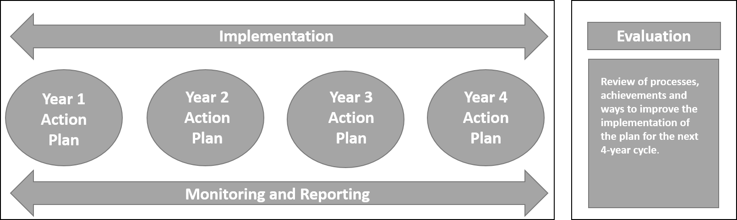

Victorian Government, 2008, Public Health and Wellbeing Act 2008, Melbourne: Victorian State Government.
Commission on Social Determinants of Health (CSDH), 2008, Closing the gap in a generation: health equity through action on the social determinants of health. Final report of the Commission on Social Determinants of Health. Geneva: WHO
VicHealth, 2015, VicHealth Framework for Health Equity.
Department of Health and Human Services (DHHS), 2015, Victorian Public Health and Wellbeing Plan 2015–19, State of Victoria, Melbourne.
Dahlgren G., & Whitehead M, 1991, Policies and Strategies to Promote Social Equity in Health, Stockholm, Sweden: Institute for Future Studies.
The Moreland Planning Scheme includes a local policy section that sets out Council’s long-term vision and strategies to manage future growth. It guides Council’s decisions about land use and development. The MSS integrates Council’s planning policies for shopping centres, business and industrial areas, residential zones, affordable housing, open space network, transport network, and environmentally sustainable design.
Department of Environment, Land, Water and Planning (DEWLP), 2017. https://www.suburbandevelopment.vic.gov.au/partnerships/metropolitan-partnerships, viewed on 21 June 2017.
Department of Health and Human Services (DHHS), 2015, Victorian public health and wellbeing plan 2015–19, State of Victoria, Melbourne.
Department of Health and Human Services (DHHS), 2017, Victorian Public Health and Wellbeing Outcomes Framework.
VicHealth, 2013, Agenda for Action 2013-2023.
Primary Health Network (PHN), 2017, http://www.health.gov.au/PHN, viewed on 21/07/2017.
Melbourne Primary Care Network (MPCN), 2016, Strategic Plan.
Herriman, J, 2011, Local Government and Community Engagement in Australia, Australian Centre of Excellence for Local Government.
VicHealth, 2016, The Partnership Analysis Tool: A resource for establishing, developing, and maintaining partnerships for health promotion.
Moreland City Council, 2016, pg. 4, Moreland Human Rights Policy 2016-26.
Moreland City Council, 2016, pg. 5, Moreland Human Rights Policy 2016-26.
VicHealth, 2016, Mental Wellbeing (MWB) LGA Action Guide.
Department of Health and Human Services (DHHS), 2016, pg.1, For Discussion: Delivering Place-Based Primary Prevention in Victorian Communities.
VicHealth, 2016, Physical Activity LGA guide.
Department of Health and Human Services (DHHS), 2014, Victorian Population Health Survey.
http://www.activemoreland.com.au/
VicHealth, 2016, Healthy Eating LGA Action Guide.
National Health and Medical Research Council, 2013, Australian Dietary Guidelines Summary.
Moreland City Council, 2015, Moreland Household Survey.
Moreland City Council, 2015 Moreland Household Survey.
VicHealth, 2016, Mental Wellbeing (MWB) LGA Action Guide.
Moreland City Council, 2016, Moreland Community Indicators Survey.
Moreland City Council, 2016, Moreland Community Indicators Survey.
Victoria Police, 2016, Victoria Police Crime Statistics Agency, 2016), https://www.crimestatistics.vic.gov.au/
Moreland City Council, 2017, Health and Wellbeing profile.
Resilient Melbourne and 100 Resilient Cities define urban (community) resilience as “the capacity of individuals, institutions, businesses and systems within a city to adapt, survive and thrive no matter what kind of chronic stresses and acute shocks they experience”, Resilient Melbourne Strategy, City of Melbourne, May 2016.
Department of Health and Human Services (DHHS), 2014, Victorian Population Health Survey.
Department of Health and Human Services (DHHS), 2014, Victorian Population Health Survey.
Department of Health and Human Services (DHHS), 2014, Victorian Population Health Survey.
Lloyd et al, Turning Point, 2015, Trends in Alcohol and Drug Related Ambulance Attendances in Victoria 2013-14.
Victorian Responsible Gambling Foundation, 2016, Assessing Gambling Related Harm in Victoria: A Public Health Perspective.
World Health Organization, 2014, Mental Health: A state of well-being.
Department of Health, 2016 “What is Mental Illness?”, http://www.health.gov.au, viewed on 21/06/2017.
VicHealth, 2016, Mental Wellbeing (MWB) LGA Action Guide.
VicHealth, 2015, VicHealth Indicators Survey.
Fensham, P., 2017, SGS Economics and Planning, Ensuring a liveability dividend from growth: A new Urban Renewal Community Compact.
Department of Health and Human Services (DHHS), 2015, Victorian public health and wellbeing plan 2015–19, State of Victoria, Melbourne.
Department of Environment, Land, Water and Planning (DEWLP), 2017, Plan Melbourne 2017-2050.
Moreland City Council, 2015, Municipal Strategic Statement (MSS) Amendment C152.
Department of Environment, Land, Water and Planning (DEWLP), 2017, Plan Melbourne 2017-2050.
Heart Foundation, 2012, Healthy by Design: A Guide to Planning for Environments for Active Living in Victoria.
Moreland City Council, Moreland Neighbourhood Centres Strategy, 2014. pg. 2.
Australian Bureau of Statistics (ABS), 2011, SEIFA Index 2011, http://www.abs.gov.au/websitedbs/censushome.nsf/home/seifa
Moreland City Council, 2017, Health and Wellbeing Profile.
REMPLAN, 2017, accessed on 20/06/17, http://www.economyprofile.com.au/moreland/trends/unemployment#table
Department of Employment, Australian Government, 2016, Small Area Labour Market data https://www.employment.gov.au/small-area-labour-markets-publication.
Moreland City Council, 2016, Economic Development Strategy 2016-21.
Moreland City Council, 2014, pg. 8, Moreland Affordable Housing Strategy (MAHS) 2014–2018.
Moreland City Council, 2015, Community Infrastructure Framework.
Moreland City Council, 2015, Municipal Strategic Statement (MSS) Amendment C152.
Id Consulting, 2017, City of Moreland Population Forecast, http://forecast.id.com.au/moreland
Id Consulting, 2017, City of Moreland Population Forecast, http://forecast.id.com.au/moreland
Moreland City Council, 2012, pg. 5, Moreland Open Space Strategy (MOSS) 2012-2022.
Parks Victoria, 2002, pg.7, Linking People and Spaces: A Strategy for Melbourne’s Open Space Network.
Moreland City Council, 2012, pg. 38, Moreland Open Space Strategy (MOSS) 2012-2022.
Moreland City Council, 2010, Moreland Integrated Transport Strategy 2010-2019.
Moreland City Council, 2014, Moreland Zero Carbon Evolution Strategy (ZCE) 2014/15-2020/21.
Moreland City Council, 2016, Urban Heat Island Effect Action Plan 2016-2026.
Moreland City Council, 2017, Urban Forest Strategy 2017-2027.
Moreland City Council, 2014, Water Map 2014-2020.

