Council Order – 12 August 2026 Council meeting

DOGS OFF LEASH AREAS

Order of the Merri-bek City Council
Section 26(2) Domestic (Feral and Nuisance) Animals Act 1994 Dogs must be under effective control
The owner of any dog must keep the dog in effective control by means of a chain, cord or leash held by the owner and attached to the dog while the dog is in any public place, other than designated off-leash areas.
Designated off-leash areas.
A dog may be exercised off a chain, cord or leash in designated off-leash areas, subject to the following conditions:
  - The owner must carry a chain, cord or leash sufficient to bring the dog under effective control if the dog behaves in a manner which threatens any person or animal;
  - The owner must remain in effective voice or hand control of the dog so as to be able to promptly bring the dog under effective control by placing the dog on a chain, cord or leash if that becomes necessary; and
  - The owner must not allow the dog to worry, attack, rush at or threaten any person or animal.
If a dog is not restrained by means of a chain, cord or leash in a designated off-leash area, the owner must bring the dog under effective control by means of a chain, cord or leash at all times when the dog is within:
  - 15 metres of:
    - any playground or children’s play equipment;
    - the principal location of an organised sporting or community event or festival;
    - the principal location of an organised public meeting; or
    - a permanent barbecue or picnic area when in use.
  - 1 metre of:
    - a shared pathway (and at all times while on the shared pathway).

List of Designated off-leash areas

Name of Park/Reserve | Street | Suburb | Melways Reference
Clifton Park | Victoria St | Brunswick | 29 E7
Joyce Reserve | Northumberland Rd | Pascoe Vale | 17 A6
McDonald Reserve | Bell St | Coburg | 17 K12
DeChene Reserve | Bell St | Coburg | 18 A12
Jackson Reserve | Golf Rd | Coburg North | 17 K9
Cash Reserve | Livingstone St | Coburg North | 18 A8
Sheils Reserve | Duggan St | Brunswick West | 29 B5
Holbrook Reserve | Moonee Pde | Brunswick West | 29 A8
Egan Reserve | Rennie St | Coburg | 30 B3
Jones Park | Albion St | Brunswick East | 30 A5
Braddy Reserve | Victoria St | Brunswick West | 29 B6
Phillips Reserve | Weigall St | Brunswick East | 30 B8
Sumner Park | Alister St | Brunswick East | 30 C9
Abrahams Reserve | Clara St | Brunswick East | 30 A5
Bowden Reserve | Nicholson St | Coburg | 30 A1
Bridges Reserve | Bell St | Coburg | 29 J1
Richards Reserve | Charles St | Coburg North | 17 F9
Martin Reserve | Epping St | Hadfield | 17 E2
Mommson Reserve | North Street | Hadfield | 17 C2
Moomba Park Reserve | McBryde St | Fawkner | 8 A12
Sewell Reserve | Glenroy Rd | Glenroy | 17 A3
Wallace Reserve | Justin Ave | Glenroy | 7 A12
Anderson Reserve | Linda St | Coburg | 29 G3
Esselemont Reserve | Somerset St | Pascoe Vale Sth | 16 J9
Gervase Ave Reserve | Gervase Ave | Glenroy | 6 F12
J P Fawkner | Francis St | Oak Park | 16 F6
Jacana Valley | Fran St | Glenroy | 16 D2
Kingsford Smith Ulm Reserve | Pengana Ave | Glenroy | 16 D4
A G Gillon Oval | Hope St | Brunswick | 29 E6
Gilpin Park* | Albert St | Brunswick | 29 E7
Reaburn Reserve | Pearson St | Brunswick | 29 E7
Wylie Reserve | South Daly St | Brunswick West | 29 C8
Hosken Reserve | Pallett St | Coburg North | 17 F8
Raeburn Reserve | Raeburn St | Pascoe Vale | 17 C9
Balfe Park | John St | Brunswick | 30 A9
Fleming Park* | Victoria St | Brunswick | 30 A8
Kirkdale Park | Kirkdale St | Brunswick East | 30 B8
Methven Park | Methven St | Brunswick | 29 K8
Campbell Reserve | Moreland Rd | Coburg | 30 A4
Brearly Reserve | Heliopolis St | Pascoe Vale Sth | 17 A11
Dunstan reserve | Peacock St | Brunswick West | 29 B4
Fraser Reserve | Hopetoun Ave | Brunswick West | 29 A4
Morris Reserve | Wadham St | Pascoe Vale Sth | 29 A2
Shore Reserve | Reynard St | Coburg | 29 C2
Charles Mutton Reserve | Mutton Rd | Fawkner | 17 J5
Parker Reserve | Mathieson St | Coburg North | 17 J7
Austin Crescent Reserve | Austin Cres | Pascoe Vale | 16 K8
Cole Reserve | Kent Rd | Pascoe Vale | 17 B7

Hallam Reserve | Landells Rd | Pascoe Vale | 17 D6
Rayner Reserve | Devon Rd | Pascoe Vale | 16 J7
Roberts Reserve | Harrison St | Brunswick | 30 B6
GE Clarke Reserve* | Kalang Road | Glenroy | N/A
Robinson Reserve* | McPherson St | Coburg | N/A
Lorne Street Reserve* | Lorne St | Fawkner | N/A
Harmony Park* | Gaffney St | Coburg | N/A
Tate Reserve* | Grant St | Coburg | N/A

*Off Leash areas in these parks are designated by the mapped areas and specific restrictions shown in Schedule 1.

Prohibition
Playgrounds
Dogs are prohibited within the immediate perimeter of any playground at all times. Creeks & Waterways
Dogs are prohibited within any Creeks & Waterways at all times.
Review
Council may, by order of resolution:
- Remove a reserve or part of a reserve; and /or
- Add a reserve or part of a reserve to the list of designated off-leash areas. Definitions
- “chain, cord or leash” means a chain, cord or leash which effectively restraints the dog;
- “designated off-leash area” means a park or reserve or other place which has been designated by an order of Council under Section 26 of the Domestic (Feral and Nuisance) Animals Act 1994, as contained in the list above;
- “owner” has the same meaning as in the Domestic (Feral and Nuisance) Animals Act 1994;
- “public place” has the same meaning as in section 3 of the Summary Offences Act 1966;
- “shared path” has the same meaning as in Road Rule 242 of the Road Rules – Victoria

SCHEDULE 1 – Zoned Dog Off Leash Areas and Specific Restrictions
Gilpin Park - Albert St, Brunswick
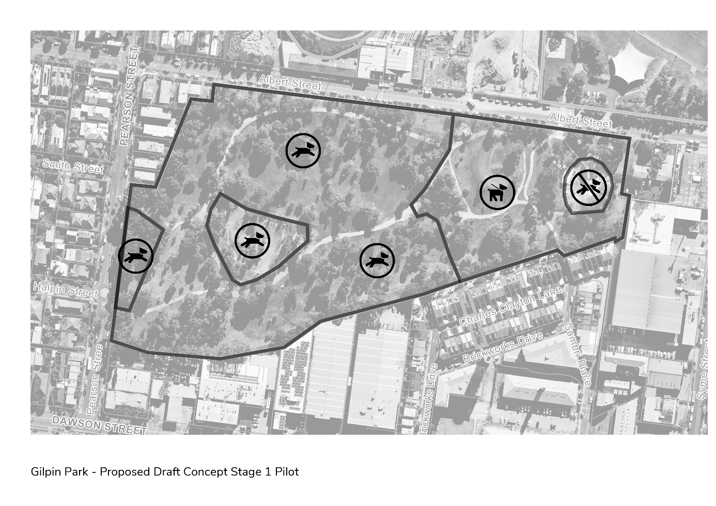
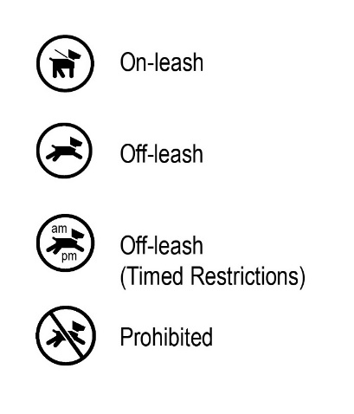

Fleming Park - Albert St, Brunswick East
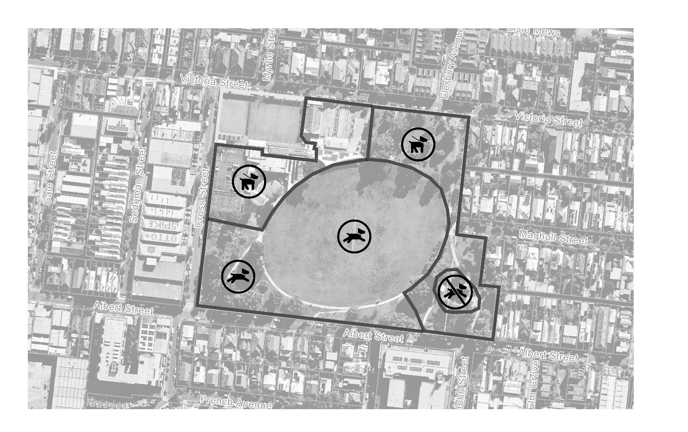

Harmony Park - Gaffney St, Coburg
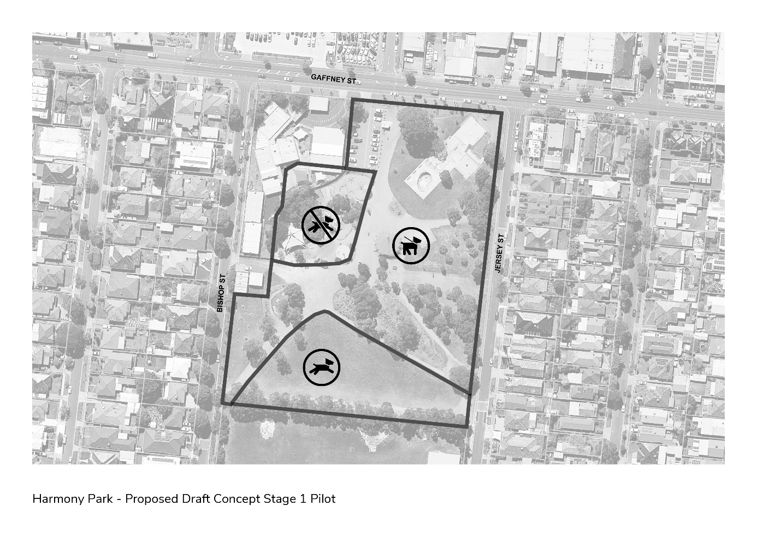

Robinson Reserve – McPherson St, Coburg
Additional Restrictions: the designated Off Leash Area only operates before 9:00am and after 5:00pm. This area is On Leash at all other times.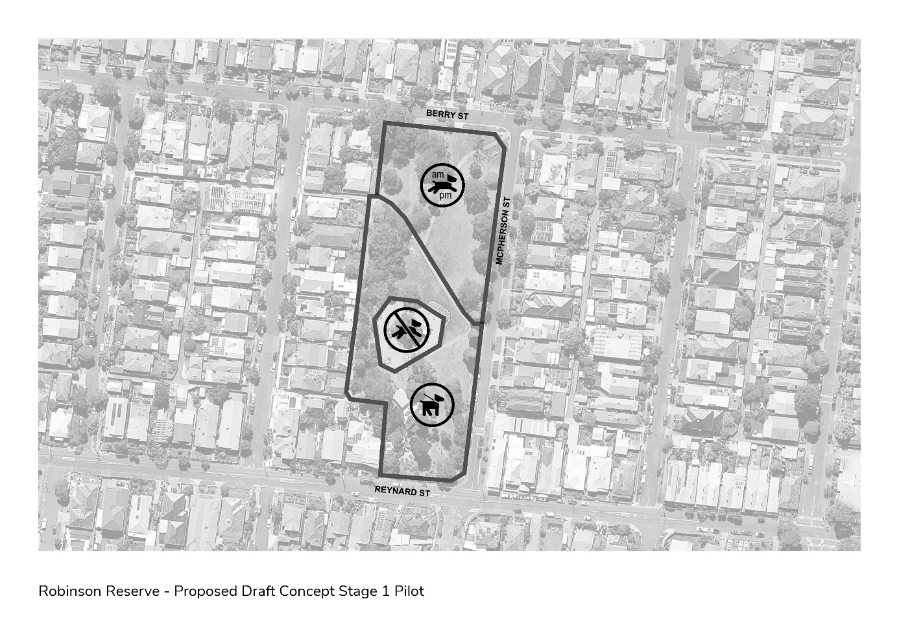

Tate Reserve - Grant St, Coburg

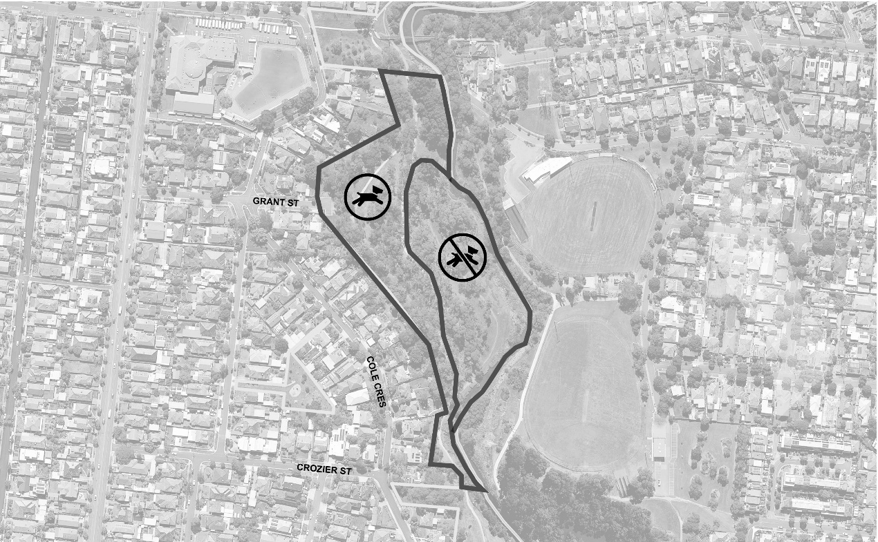

Lorne Street Reserve - Lorne St, Fawkner
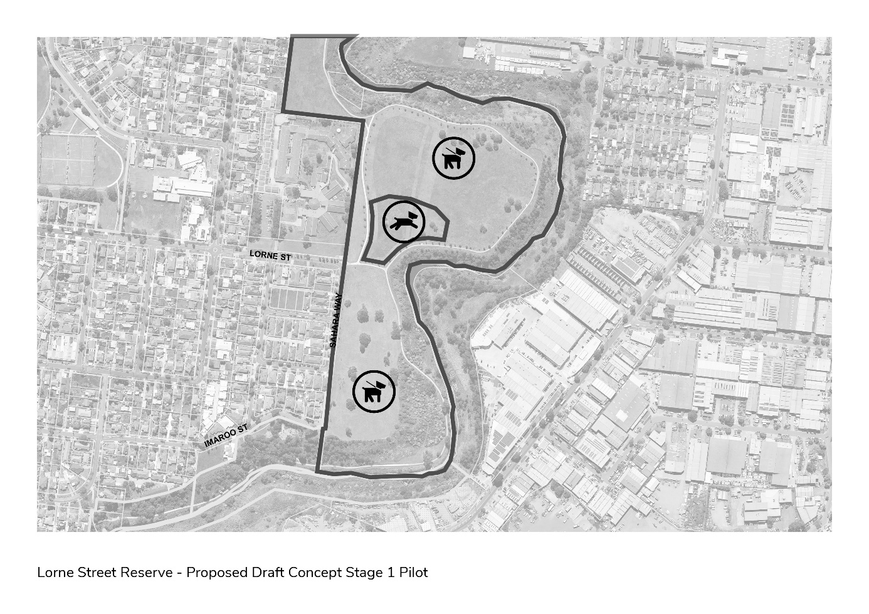

GE Clarke Reserve – Kalang Rd, Glenroy


