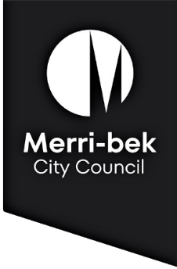

**Merri-bek Home Library Service**

**Membership Form**

**Personal details:**

|  |  |  |  |
| --- | --- | --- | --- |
| First Name: |  | | |
| Surname: |  | | |
| Library card no: |  | | |
| Date of birth: |  | | |
| Street address: |  | | |
|  |  | | |
|  | Suburb: | | Postcode: |
| Phone number: |  | | |
| Email address: |  | | |
| Which language(s) do you prefer to read in? | |  | |

I am applying to access the home library service (tick **one**):

|  |  |
| --- | --- |
|  | On a **long-term** basis – eg. age, frailty, disability or chronic illness prevents me from visiting the library. |
|  | On a **temporary** basis - eg. pregnancy, short-term illness, or recovering from surgery means I am temporarily unable to visit the library. |

**Emergency contact details:**

|  |  |
| --- | --- |
| Name & relation: |  |
| Phone number: |  |
| Email address: |  |

**Terms and Conditions**

* To best manage and plan resources we have a 12-month limit on temporary use of our Home Library Service. This can be reviewed on request at the end of the service period.
* I agree to abide by the policies and conditions of Merri-bek Libraries, and to pay for all damages or replacement costs of library materials.
* I, the owner/occupier of the above address, give permission for any duly authorised library representative to enter these premises for the purpose of delivering library services.

|  |  |
| --- | --- |
| **Signature of applicant:** |  |
| **Date:** |  |

**Privacy statement:** Merri-bek City Council is committed to protecting your privacy in accordance with the Privacy and Data Protection Act 2014 (Vic) and the Health Records Act 2001 (Vic).  The personal information requested on this form is being collected by Merri-bek City Council to add you as a Library Member and may also be used to update your personal information otherwise held by Council (for example, contact details including email address, phone number).  It will not be disclosed to a third party without your consent, unless required and authorised by law.  If the personal information is not provided, you will not be added as a home library service member. You can gain access to your personal information you have provided to Merri-bek City Council and if you wish to alter it, please contact Council’s Privacy Officer via telephone on 9240 1111 or email at [privacyofficer@merri-bek.vic.gov.au](mailto:privacyofficer@merri-bek.vic.gov.au)