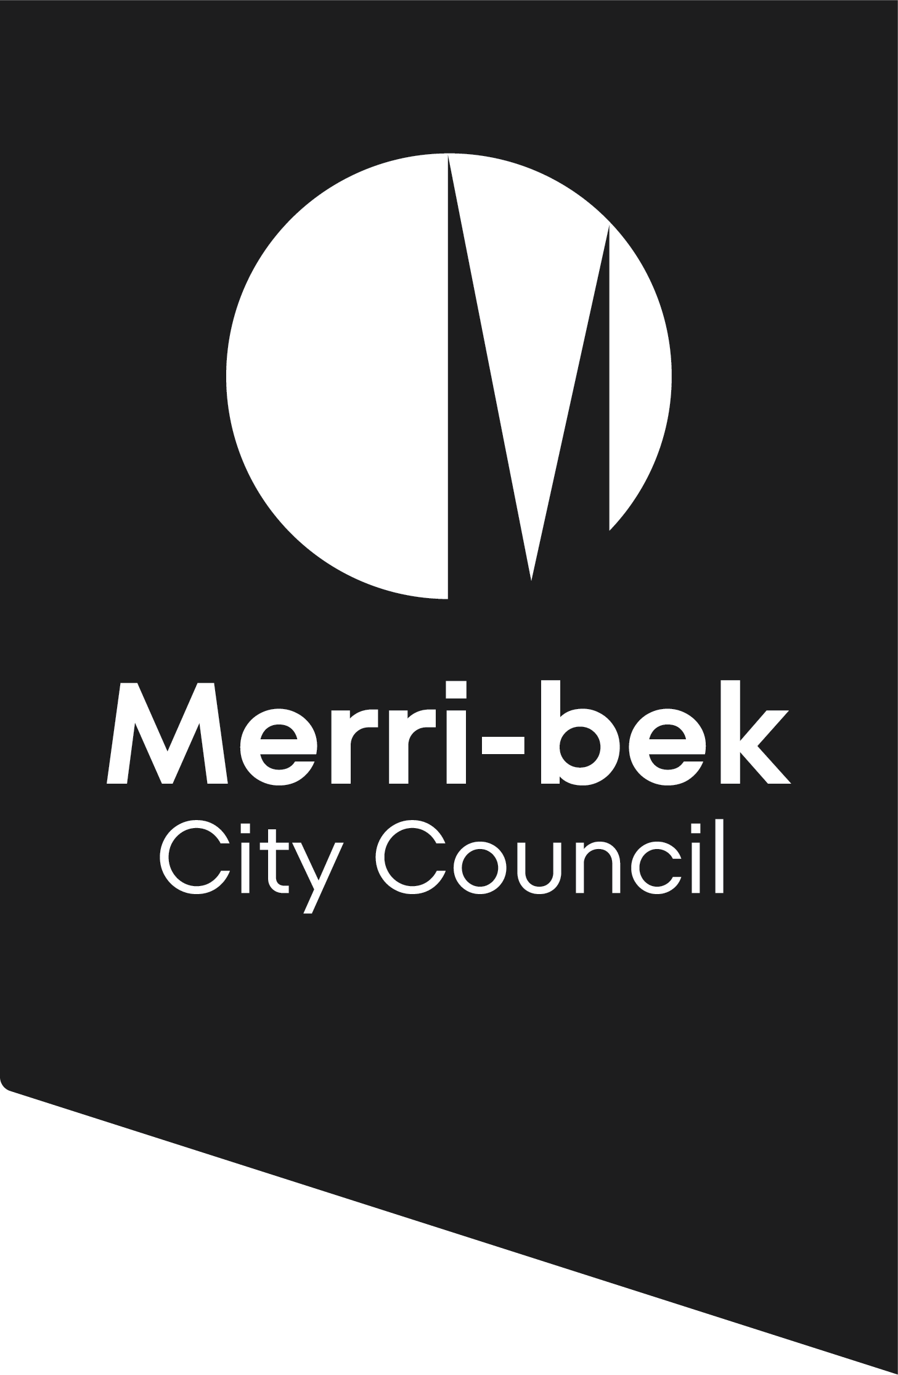
Community Venues Hire Agreement

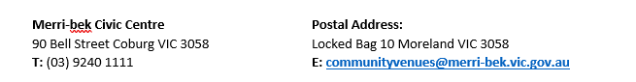

PART A – HIRER DETAILS Tentative Booking ID Number:
First Name: |  |  | Surname:
Organisation /
Community Name:
Address:
Suburb: |  |  | State: Postcode:
Email: |  |  | Mobile:
PART B – ACCOUNT DETAILS FOR BOND REFUND
Please nominate your preferred account for bond refund:
Booking ID:
Account Name
BSB |  |  | Account No.
PART D – FUNCTION DETAILS
Number of people attending:
Birthday age | Baby shower | Engagement party |  | Wedding
Meeting/seminar/  workshop | Artist Use | Educational class |  | School event
Community event | Seniors’ group | Dinner |  | Political campaign
Religious | Worship | Exercise/sporting class |  | Other
Tell us about your booking:
Is there a membership/participation/entry fee? NO YES - amount $

Do you receive financial support/funding? NO YES - amount $

Please provide information about the type of financial support/funding:
Is this a multiple booking? NO – Complete Section G YES – Complete Section H

PART E – VENUE SELECTION - (*DA represents Disability Accessible)
Coburg Senior Citizen Centre* |  | 60 seated | 80 standing
Fleming Park Hall and Meeting Room* |  | 80 seated | 80 standing
Glenroy Senior Citizen Centre* |  | 90 seated | 100 standing
Gowanbrae Community Centre* |  | 60 seated | 80 standing
Harry Atkinson Art Craft Centre |  | 80 seated  (maximum 40 per room) | 100 standing  (maximum 50 per room)
Merlynston Progress Hall* |  | 80 seated | 100 standing
Newland Senior Citizen Centre* |  | 60 seated | 80 standing
Pascoe Vale Senior Citizen Centre* |  | 80 seated | 100 standing
Richard Lynch Senior Citizen Centre* |  | 60 seated | 80 standing
Temple Park Senior Citizen Centre |  | 60 seated | 80 standing
Fawkner Senior Citizen Centre (Hall only)*** |  | 60 seated | 80 standing
Fawkner Community Sports Hall (Hall only)*** |  | 150 seated | 150 standing
**BOOKINGS FOR FAWKNER SENIOR CITIZENS HALL AND FAWKNER COMMUNITY SPORTS HALL**
Does your booking require kitchen access? Yes No
Please be advised kitchen access is not guaranteed and is subject to availability
PART F – ADDITIONAL INFORMATION
Are you a commercial business/sole trader? YES NO
Are you applying for the community rate? YES NO
To be considered for this rate, you must provide the below information
Is your organisation a community group or club? YES NO
Are the majority of members Merri-bek residents? YES NO
Total number of members:
ABN:
Incorporated Number:
Are you, or your Organisation publicly listed with YES NO
Australian Charities and Not-for-Profit Commission?
Please explain how your booking meets a broader community need and/or encourages community participation:

If your function is for artist use, provide a detailed description of the activity or program intended for the venue hire. Include any tools/equipment that will be used in the hall.

PART G – SINGLE BOOKING **Your booking times must include your set up and pack down**
Date | Set Up Time | Event Start | Vacate Time

PART H – MULTIPLE BOOKINGS **Your booking times must include your set up and pack down**
Date | Set Up Time | Event Time | Vacate Time

PART I – FOOD & BEVERAGE
 |  | YES | NO
Will food be provided at the function?
If yes – will food be sold and/or included in entry fee?
Will alcohol be provided?
If yes – will alcohol be sold and/or included in entry fee?
If food is to be sold during your event, Attachment 1 must be completed and submitted with this application.
If alcohol is to be sold during your event, a ‘Limited Licence’ must be obtained and submitted.

PART J – DECLARATION
NOT PERMITTED
Single use plastic, balloons, jumping castles, smoke machines, open flames, gas bottles, pyrotechnics and animals with the exception of Guide Dogs.

Please view our Venue Hire Terms and Conditions before signing.

I have read and agree with the conditions detailed in the Community Venues Hire
Agreement and Terms and Conditions

I am over the age of 21 years and agree that the above information is true and correct and
the booking is tentative until confirmed by Merri-bek City Council in writing and paid in full.

I accept full responsibility for any damage to the venue and/or additional fees incurred as outlined in the Community Venues Hire Agreement

NAME:
(Please print)

SIGNATURE: | DATE: / /

Please ensure all sections are complete as failure to do so will result in your booking being declined.

Via Email: (preferred method)
communityvenues@merri-bek.vic.gov.au
In person: Coburg Civic Centre, 90 Bell St, Coburg

APPLICANT DETAILS
Applicant/Group Name:
Applicant/Group Contact Name:
Contact Phone: |  |  | Function Venue:
Applicant/Group Postal Address:
FUNCTION DETAILS
Function Type: |  | (please specify):
Function Date(s): |  | / / |  | Function Start/Finish Time: |  |  | -
Number of People Attending Event: (approximate)
EVENT FOOD DETAILS |  |  |  |  |  |  |  | Yes | No
1 | Will the applicant be providing food at the event?
2 | Will the applicant be selling food at the event?
3 | Will any food and/or alcohol be provided as part of a fee charged for entry to the event?
4 | Will alcohol be provided at the event?
 | Will the alcohol be offered for sale?
5 | Will people attending the function be bringing BYO food and/or alcohol?
 | If yes, detail the type of BYO food:
6 | Is the applicant a Community Group or Not for Profit Organisation?  If yes, please attach not-for-profit status or incorporated certificate
7 | Is the applicant/group’s place of business based within Merri-bek City Council?
8 | Does the applicant have a current Food Act registration with Merri-bek City Council?
9 | Does the applicant have a current Food Act registration with another Victorian Council?
10 | Will the event be catered for by a Registered Catering Business?
10 | Trading Name:
10 | Food Act Registering Council:
10 | Food Act Registration No:
10 | Contact Person: |  |  |  |  | Phone:
10 | Address: |  |  |  |  | Suburb:
Merri-bek City Council Food Premises Checklist Food Act 1984 CLICK HERE

11 | WHAT TYPES OF FOOD PRODUCTS WILL BE:  PREPARED/SOLD AT THE EVENT? (tick all appropriate) | Yes | No
11 | Fruit salad and salads
11 | Fruit/vegetables cut/sliced
11 | BBQs (e.g. hamburgers, sausages, other meats, cooked eggs, cooked/raw vegetables, bread)
11 | Deep fried foods (e.g. chips, dim sims, spring rolls, dumplings)
11 | Desserts (e.g. cheese cakes, custard tarts or any dessert that contains fresh cream, raw eggs or custard)
11 | Fruit juices/smoothies
11 | Soft serve ice cream
11 | Rice dishes
11 | Casseroles or curries
11 | Noodles/pasta/lasagne
11 | Sandwiches (e.g. containing smallgoods, vegetables/salads, meat or cheese)
11 | Pies/sausage rolls/pasties
11 | Packaged low risk foods (e.g. packaged chips, lollies, chocolates and drinks)
11 | Raw egg products (e.g. tiramisu/homemade mayonnaise)
11 | Soup
11 | Packaged drinks (e.g. soft drink, packaged alcohol)
11 | Unpackaged drinks (e.g. unpackaged alcohol, tea, coffee)
OTHER FOODS
Please detail any additional food products prepared/sold at the event/function:

PLEASE NOTE: If you plan to alter the type of food you will be selling/serving (additional to the food activities listed on this form) you must notify Merri-bek City Council immediately, complete this form again and provide any other relevant details.
I, the undersigned, hereby agree the information provided above is true and correct.

Signed: Date: / /

