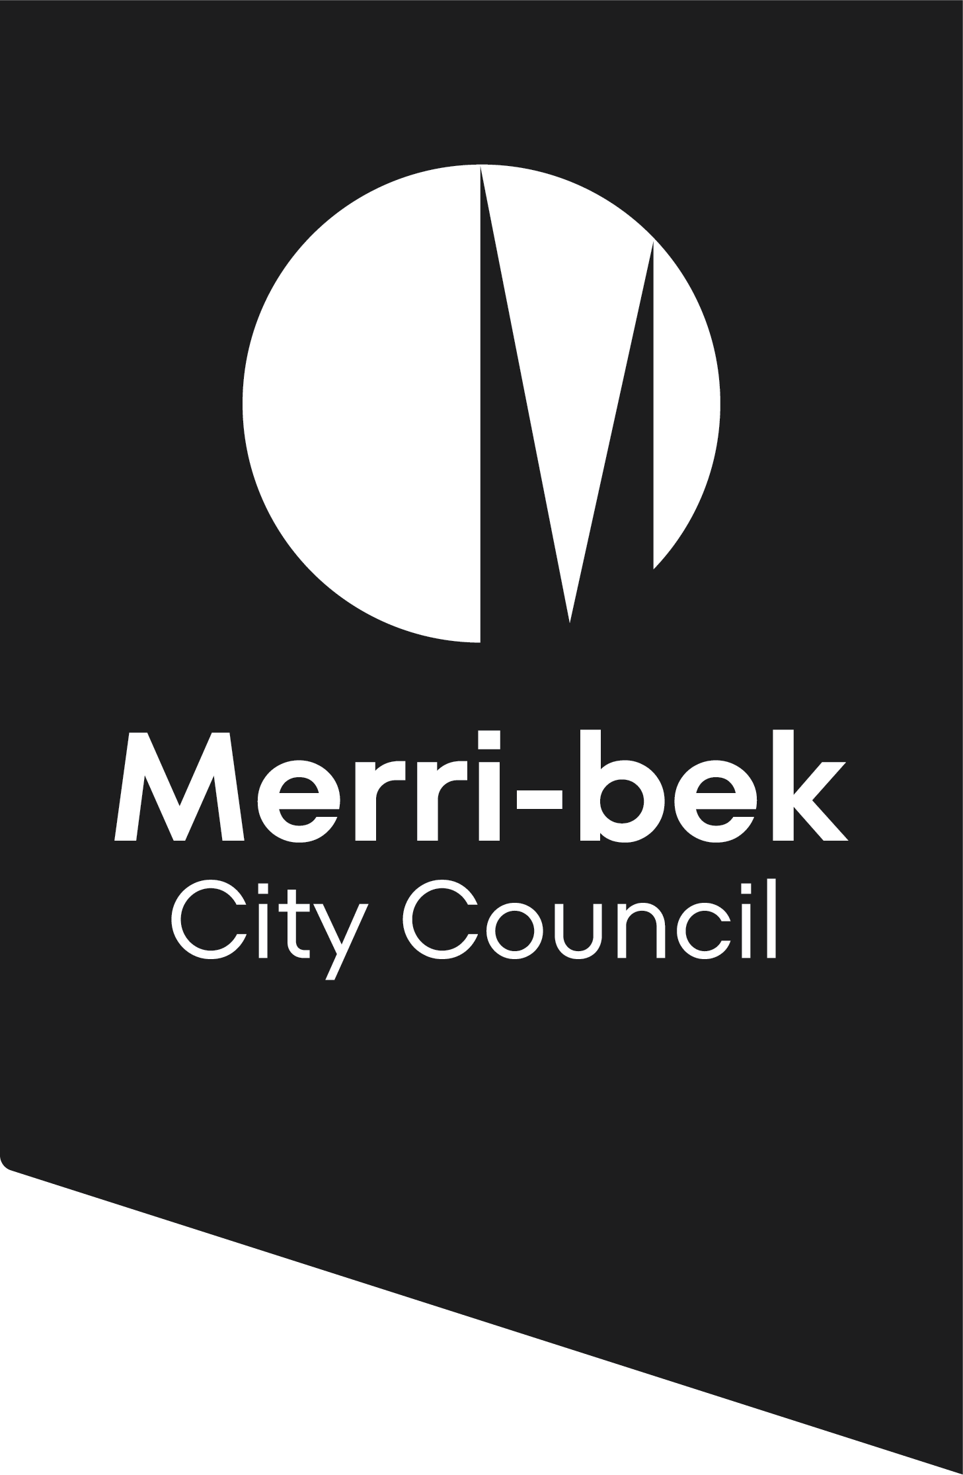
Community Venues Meeting Room Hire Agreement

Please ensure all sections are completed.
Incomplete forms will result in your booking being declined.
PART A – HIRER DETAILS Tentative Booking ID Number:
First name: |  | Surname:
Organisation /
Community group name:
Address:
Suburb: |  | State: Postcode:
Email: |  | Mobile:
PART C – FUNCTION DETAILS
Number of people attending:
Meeting | Seminar | Workshop | Educational class
Community group | Hobby club | Body Corporate | Political campaign
Other – specify:
Tell us about your meeting:
Is there a participation/entry fee? NO YES - amount $............
Do you receive financial support/funding? NO YES - amount $............
If YES, please provide information about the type of financial support/funding:

PART D – VENUE SELECTION - (*represents Disability Accessible)
Campbell Turnbull Library Meeting Room |  |  | 24 seated |  | 30 standing
Coburg North Meeting Room (COLES complex) * |  |  | 24 seated |  | 30 standing
Coburg Library Meeting Room* |  |  | 24 seated |  | 30 standing
Fawkner Meeting Room |  |  | 24 seated |  | 30 standing
PART F – ADDITIONAL INFORMATION
Are you a commercial business/sole trader? YES NO
If YES, please attach a copy of your public liability insurance certificate with this application
Are you applying for the community rate? YES NO
To be considered for this rate, you must provide the below information:
Is your organisation a community group or club? YES NO
Are the majority of members Merri-bek residents? YES NO
Are members charged a yearly membership fee? NO YES - amount $............
Can Merri-bek residents join your group or club? YES NO
Organisation’s ABN:
Incorporated Number:
Is your organisation publicly listed with YES NO
Australian Charities and Not-for-Profit Commission?
Please explain how your booking meets a broader community need and/or encourages community participation:

PART G – SINGLE BOOKING - your booking times must include your set up and pack down
Date: | Set Up Time |  | Event Start |  | Vacate Time
PART H – MULTIPLE BOOKINGS - your booking times must include your set up and pack down
Frequency of Booking: Daily Weekly Fortnightly Monthly

DATE |  | ENTRY TIME |  | VACATE TIME
PART I – FOOD & BEVERAGE
 |  |  |  |  | YES | NO
Will food be provided at the function?
Will food be sold and/or included as part of the entry fee? *
*If YES, please complete the Merri-bek City Council Food Premises Checklist Food Act 1984 Click Here
Will alcohol be provided?
Will alcohol be sold and/or included as part of the entry fee? *
*If YES, a Liquor Licence must be obtained and submitted with this application.
PART J – DECLARATION
NOT PERMITTED
Single use plastic, balloons, jumping castles, smoke machines, open flames, gas bottles, pyrotechnics and animals (with the exception of Assistance/Guide Dogs).

Please view our Venue Hire Terms and Conditions before signing.

I have read and agree with the conditions detailed in the Community Venues Hire
Agreement and Terms and Conditions.

I am over the age of 21 years and agree that the above information is true and correct and
the booking is tentative until confirmed by Merri-bek City Council in writing and paid in full.

I accept full responsibility for any damage to the Centre and/or additional fees incurred as
outlined in the Community Venues Hire Agreement.

NAME:
(Please print)

SIGNATURE: |  |  | DATE: / /

Please ensure all sections are complete as failure to do so will result in your booking being declined.

Via email: preferred method - communityvenues@merri-bek.vic.gov.au

In person: Coburg Civic Centre, 90 Bell St, Coburg 3058
Monday to Friday 8.30am – 5pm

Or By post: Merri-bek City Council.
c/o Community Venues,
Locked Bag 10, Brunswick VIC 3056

