
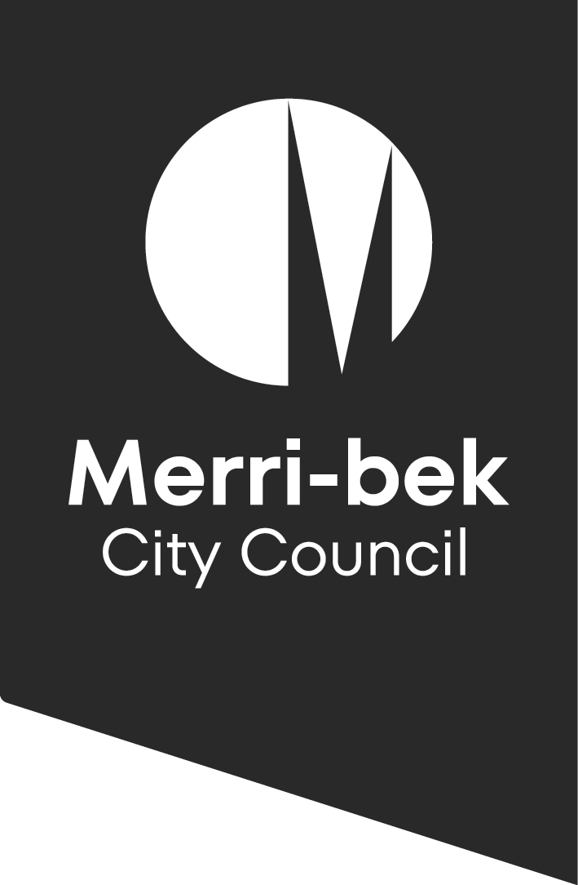

Community Venues Hire
  - Terms and conditions

Merri-bek City Council offers the community access to facilities to ensure fair and equitable use, encourage social cohesion, celebrate diversity and promote a safe environment for all.

Council reserves the right to refuse any bookings that do not align with Merri-bek’s community vision, values and policies.

Application for hire
Hirers must complete an application form stating the purpose of use and signed by an applicant over 21 years of age (photo ID may be requested). Applicants hiring on behalf of an organisation must provide the organisation’s name, demonstrate their authority to apply, and supply both private and business contact details. The applicant is responsible for ensuring compliance with all conditions of hire and must actively supervise any minors present.

Fees and Charges
Fees and charges for facilities are set annually by Council. The fee will be that which applies at time of processing, noting that the charge may have altered since the date on which the booking was made.
Keys must be returned to Council the next business day. In the event of a Council venue key is lost or returned late, the hirer shall be liable to pay a lost key fee of $200.

Tentative Bookings
A tentative booking is not an official booking. Tentative requests may be held for up to 14 days. If a completed application form is not received within a 14-day period, the tentative booking will be cancelled.

Confirmed Bookings
A booking will be confirmed only upon receipt of:
- a completed application form including required supporting documentation
- evidence of satisfactory insurance (if applicable)
- full payment of a security bond and hall hire fees
- a Council issued confirmation letter.

Hire Times
Under no circumstances is the hirer to access the facility other than for the approved use and time. The times booked must include set up time, including caterer’s time, and last person out. Any use of the facility after the engaged time will be charged at the commercial rate. Such charges must be paid within 5 business days from the invoice date.

Hire Fees
The hire fee is determined by Council in line with the Community Use of Council Managed Venues Policy. Fees must be paid within 14 days from the invoice date. Bookings with less than 7 days lead time must pay the invoice immediately. If the full amount is not paid within 14 days, the booking will be cancelled. Only approved non-for-profit, community groups and senior citizen groups may be eligible for discounted hire. Discounted bookings that exceed agreed time limits will be charged at the commercial rate.

Security Bond
Council may require a security bond. The hirer is responsible for any damage or cleaning costs, whether or not a bond is paid. If extra cleaning or repairs are needed, the hirer will be invoiced and must pay within 5 business days. If charged, the bond will be refunded within 30 days after inspection. Bookings deemed high risk must pay a bond. Please visit the council website for hire fees.

Cancellation by hirer
The hirer may cancel a booking. Written notification of cancellations must be received 14 days prior to the booking date or full fees shall apply.

Cancellation by Council
Council may cancel any booking for council functions, elections, or emergencies, even if the hire fee is paid and the agreement signed. The hirer agrees to accept this cancellation without legal claim for loss or damage. Any refund is at the sole discretion of the Council's Chief Executive Officer, whose decision is final.

Amendment of conditions of hire
Hirers are advised that Council may amend these conditions of hire without notice at any time. When conditions are amended every effort will be made to inform hirers.

Facility conditions

Hours of use
Community venues must be vacated and secured by 10pm sharp unless otherwise stated. Please visit the council website for hire times.

Noise levels
Amplified music and public-address systems must not be audible outside the building and are not permitted for use under any circumstance before 10am or after 10pm, in accordance with the Environmental Protection Residential Noise Regulations 2008.

Alcohol
Hirers proposing that liquor be sold either at a bar or by way of inclusion in catering costs associated with the use of the facility, require a “Limited Licence” from Liquor Licensing Victoria. Applicants for such a licence should allow for at least 4 weeks for this body to process their application. A copy of this licence must be presented to Council 14 days prior to the function. The liquor licence must be displayed where the alcohol is being sold for the duration of the event. It is the responsibility of the hirer to ensure compliance with liquor licensing legislation.
Gambling and Smoking
Gambling is not allowed on Council property, except for one-off charitable fundraising events like raffles or bingo, which require permits from the Victorian Gambling and Casino Control Commission. Smoking is prohibited inside the facility. If smoking outside, the hirer must advise guests to stay at least 3 meters away from the building and dispose of cigarette butts in designated bins.
Disorderly Behaviour and Damage
Obscene language, disorderly behaviour, or damage to property is not permitted anywhere in the facility. Council officers have the right to remove offenders, and any costs for removal must be paid by the hirer.

Not permitted on council property
- Single use plastic crockery and cutlery
- Balloons, including helium
- Sticky tape, masking tape, tacks, nails, adhesives
- Smoke machines
- Pyrotechnics
- Confetti
- BBQ’s, open flames, gas bottles
- Jumping castles
- Animals and animal farms, except for guide dogs and assistance animals

Lecture/Entertainment Content
If hiring the facility for lectures or entertainment, provide details of the subject and a program for the event.

Additional Equipment
The hirer must get written approval before bringing any extra equipment into the venue.

Decorations, Fittings, and Equipment

Do not use screws, nails, tacks, adhesive tapes, or similar on floors, walls, or ceilings.

Use only blu-tac or white-tack for wall decorations.

Remove all your property, decorations, and catering equipment by the end of your booking.

All furniture and equipment belong to Merri-bek City Council and must not be removed or relocated.

You are responsible for any cleaning or repairs needed due to damage.

Kitchen facilities & appliances
The hirer, or caterer, must not bring to the facility any gas or electrical appliances not supplied by Council. The hirer must ensure that when leaving the facility all appliances are turned off, the kitchen is clean, and all utensils are in good condition. If the kitchen is left in an unsatisfactory condition, the hirer agrees to pay Council for any associated damage or cleaning costs.

Kitchen
A hirer using the kitchen must comply with all legal requirements, including without limitation the Health Act 1958 and the Food Act 1982. The hirer must submit a completed Food Premises Checklist (Attachment 1) in accordance with Council requirements prior to the function
NB. Professional Caterers are not permitted to use the facility under the section below.
Section 35 of the Food Act 1984, Part VI –Registration of a Food Premises
Food business premises to be registered with Council
- The proprietor of a food business must not allow the business to operate from any food premises
  - That is not registered in accordance with this Part of the Council of the municipal district in which the premises are located; or
  - During any time that the registration of the premises under this Part is suspended
- This section does not apply –
  - To the Crown; or
  - In respect to any food business being operated on behalf of the crown; or
  - To any premises that is on land that is not part of a municipal district.

First aid kits
The hirer is responsible for ensuring a personal first aid kit is available during their booking. Council does not provide first aid equipment or supplies at the centre.

Post function cleaning
The hirer must leave all areas of the facility in a tidy condition, all fixtures in good working order and use bin liners to dispose of all waste matter in the garbage bins provided. If the facility is left in a unsatisfactory condition, the hirer will be liable for the full cost of cleaning and/or repairs to any furniture, fittings and equipment.

Waste
Rubbish should be placed in the correct external waste bins provided. If the bins are full, all excess rubbish must be taken with you.

Sub-letting and assignment
The hirer shall only be entitled to use the part or parts of the facility hired. No portion of the facility hired may be sub-let or any booking transferred or assigned without the prior consent of Council. Council reserves the right to let any other portion of the facility for any other purpose or purposes at the same time.

Right of free access
The right of free access to any part of the facility is reserved to members of Council staff at all times.
The hirer and guests must obey all directions or orders given by the Council officer as to the management of the facility and functions being conducted therein. The hirer shall be held responsible for the actions of all and every person attending the function.

Security
All lighting and appliances are to be switched off and all windows and doors are to be locked securely when leaving premises. Please check parking restrictions as several community venues carparks are locked nightly. All cars must be removed before then or be locked in until the next day.

Legal and other conditions

Release & indemnity
The hirer is responsible for any accident, loss, damage sustained to any person or property or any injury sustained by any person using any part of the facility during the currency of the hiring, notwithstanding that such event arose from or by reason of any defect in the furniture, fittings or other accessories of any kind, and the hirer hereby forever releases, discharges, indemnifies, and holds harmless Council, its servants, Councillors, agents and contractors against all claims and demands made or the costs or expenses incurred in connection therewith.
Without limiting the former that includes:
- any legal liability whatsoever arising from the participation or use by the hirer and/or any other persons associated with the hirer, and in the activity of conducting the business operation at, and / or occupying the facility and in all activities in connection therewith, due to any cause.
- all loss, damage, expenses, claims, demands, actions and causes whatsoever which might be made or instituted or suffered or incurred or sustained by any person or body for injury, loss or damage arising in any manner for the said participation or use.
- all loss or damage to any property, buildings, equipment or materials of Council and/or any other persons on or outside the location caused by the hirer and/or any persons associated with the hirer due to the said participation or use; and
- all loss, damage, injury or illness, including death, sustained or incurred by the and/or any person associated with the hirer arising in any manner from the said participation or use/hire or occupation.
- In addition, the hirer must not do or neglect to do or permit to be done or leave undone anything, which will affect Council's insurance policy or policies relative to fire or public risk in connection with the facility. The hirer hereby indemnifies Council to the extent that such policies are affected through any such act of commission or omission.

Emergency call outs
In case of an emergency, call 000, then contact Council on 9240 1111. MCC will provide an incident report which must be returned to Council within 24 hours.
Should Emergency Services be called by fault, or Council deems the call out not to be an emergency, all costs will be incurred by the hirer.
If an emergency door release button is depressed in error, the hirer agrees to pay the call out costs.

Disputes
Council reserves the right to refuse applications for hire that do not align with Merri-bek’s community vision, values and policies. In the event of any dispute or differences arising from the interpretation of these conditions, or of any other matter contained therein, the decision of the Council shall be final.

Privacy
Merri-bek City Council is committed to protecting your privacy in accordance with the Privacy and Data Protection Act 2014 (VIC) and the Health Records Act 2001 (VIC).
The personal information requested for venue hire is collected by Merri-bek City Council for Community Venues and may also be used to update your personal information otherwise held by Council (for example, contact details including email address, phone number). The personal information may be disclosed to debt recovery agencies should hirers be in arrears and may also be used by Council for related purposes. It will not be disclosed to any other external party without your consent, unless required or authorised by law. Hirers must provide personal information to book with Community Venues.
You can gain access to your personal information you have provided to Merri-bek City Council and if you wish to alter it, please contact Council’s Privacy Officer via telephone on 9240 1111 or email at Privacyofficer@merri-bek.vic.gov.au
Merri-bek City Council welcomes the capturing of magical moments on camera, video or mobile phone however the privacy of others must be respected at all times. The use of cameras, mobile phone photos and videos are conditional upon having the consent. You must have of all relevant individuals consent to take and/or use images. It is illegal to broadcast or publish images without consent.
Council expects any hirer, individual or group, entering into an agreement for the use of a council facility to respect and comply with the following guidelines:
- Child Wellbeing and Safety Amendment (Child Safe Standards) Act 2015.
- Equal Opportunity Act 2010 (Victoria)
- The Victorian Charter of Human Rights and Responsibilities Act 2006 (Victoria)
- Racial Discrimination Act 1975 (Commonwealth)
- Sex Discrimination Act 1984 (Commonwealth)
- Disability Discrimination Act 1992 (Commonwealth)
- Racial and Religious Tolerance Act 2001 (Victoria)

