
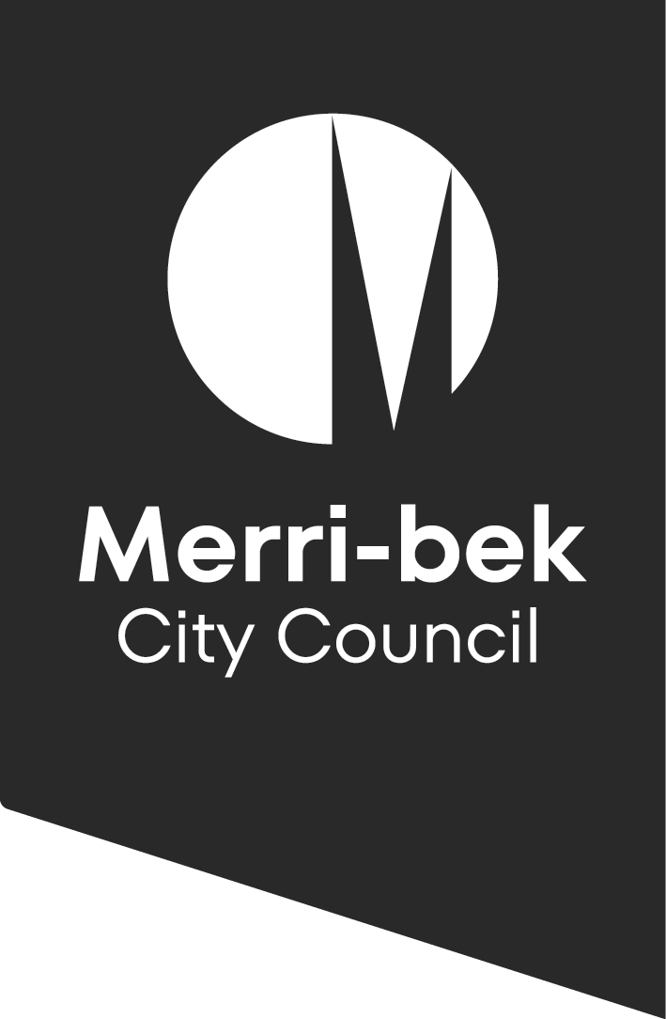

To host a Play Street or Street Party in Merri-bek the event organiser/s must agree to the following:

Terms and Conditions
  - Play Streets and Street Parties

- The nominated event organiser/s have read and understood the process for running a Play Street or Street Party outlined in the Toolkit.
- Merri-bek City Council does not take responsibility for any negligent acts of a Play Streets or Street Party organiser.
- Nominated traffic marshals are not, under any circumstances, to consume alcohol for the duration of the event. For other eventgoers that choose to drink alcohol, responsible consumption of alcohol is required.
- The Temporary Road Occupancy (TRO) Permit is only valid for the date and time mentioned on the permit and for the nominated location included in the permit.
- All residents affected by the street closure must be informed of the proposed street closure at least 3 days (72 hours) before the event.
- The event must not contain sports, games or activities that may be considered high risk by a Council Authorised Officer. Prohibited activities include things such as, but not limited to:
- Use of fireworks or pyrotechnics
- Jumping castles, inflatable play equipment or other inflatable entertainment or amusement devices
- Amusement rides and devices or
- Animal rides or experiences.
Name: _______________________________________
Date: ________________________________________
Signature: ____________________________________
- The following activities are not permitted at street parties:
- Performances or live music
- Any advertisements that invite non-residents of the street to attend the street party

- Food and alcohol must not be sold at Play Streets or Street Party events.
- The event organiser/s assumes responsibility for ensuring that the street/s and surrounds are left in a clean and safe manner.
- Noise, including amplified noise, must be kept at a reasonable level so as not to cause a nuisance.
- The Play Street/ Street Party must be a single-day event.
- Pedestrians must be able to use the footpath as usual during the event. Resident vehicles that require access must be able to enter or exit safely.
- The event organiser must make sure the event complies with all Local Laws and obtain any necessary permits.
- Council reserves the right to revoke the TRO permit at any time.
- Victoria Police or other emergency services may suspend the event at any time.
- The event organiser agrees to be contacted and invited to provide feedback for evaluation of the Program.

