
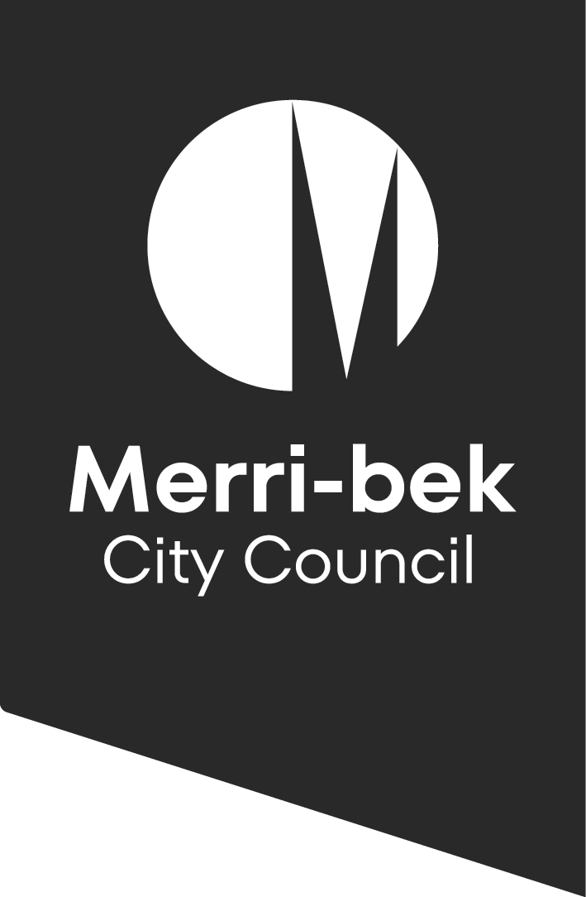

Roles and Running Sheet
  - Play Streets and Street Parties
Time | What needs doing | Who will do it | Contact phone
 | Organisers and helpers meet on site  Undertake a site assessment and review hazards/risks. Does anything need  to be added to the risks register and responsibilities?  Agree to risks and roles. | Organisers / marshals
 | Site set up  - set up traffic signs to close the street | Traffic marshals
 | Put Play Box on street  Organisers Box to be kept at one barrier  Marshals to man the closures at each end of the road wearing hi-vis vests. | Organisers / traffic marshals
 | Play Street event begins  A range of on street play activities self directed by participants. | Organisers / traffic marshals
 | Play Street event ends  - pack up Play Box  - clean up any street rubbish  - move participants out of area  - Remove Play Street signs | Organisers / traffic marshals
 | Remove traffic management signage and street reopened to traffic. | Traffic marshals









Contact List
Name | Role | Contact details
 | Organiser
 | Organiser
 | Traffic Marshal
 | Traffic Marshal
 | Traffic Marshal responsible for picking up road equipment and dropping it off
 | Merri-bek Council | playstreets@merri-bek.vic.gov.au
 | Emergency | 000

