
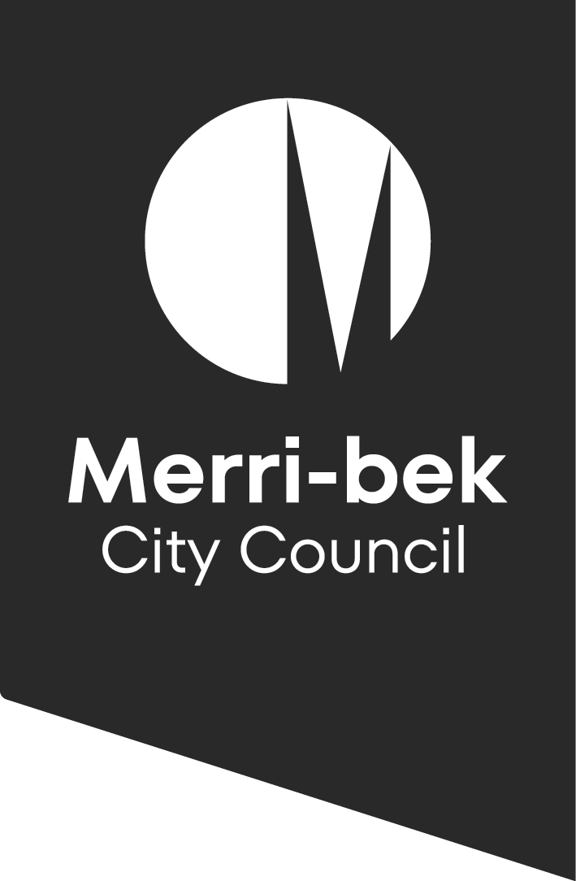
What is the danger? | What will we do to reduce the risk? | Who is going to do it?
A car could enter the street during the event and harm somebody | Follow the Traffic Management Plan (TMP) (This will help to clearly indicate the road closure for the Play Street) | Write in the name of the person responsible
 | Let parents know to keep an eye on their children (they are still responsible for them during the event)
 | Make sure drivers entering the street are asked to travel at walking speed behind a marshal with hazards lights on
 | Ask organisers to wear something that makes them easily identifiable
 | Make sure there is no one still playing on the street before removing the closure barriers
Children or adults could become dehydrated, sunburnt or be injured by other weather conditions on the street | Helpers will bring water bottles and hats
 | Make sure the Organisers Box has sunscreen available for everyone
 | Remind kids and adults to stay hydrated and appropriately dressed. Being locals they will have access to their own homes or neighbours’ if needed
 | If the weather becomes dangerous (i.e. extreme heat, high winds or lightning) postpone or cancel the event
Helpers could be injured during set up by carrying heavy things | Brief the team on how to safely set up and pack down games and street furniture
Somebody could trip over something in the street and injure themselves | Brief the team on monitoring tripping hazards around any furniture or activities; secure any loose cables or cords
Any other particular hazards on your street?

Injury or illness | Organisers should call 000 if any participants become seriously ill or injured.

Risk and Safety Plan
  - Play Streets and Street Parties

