
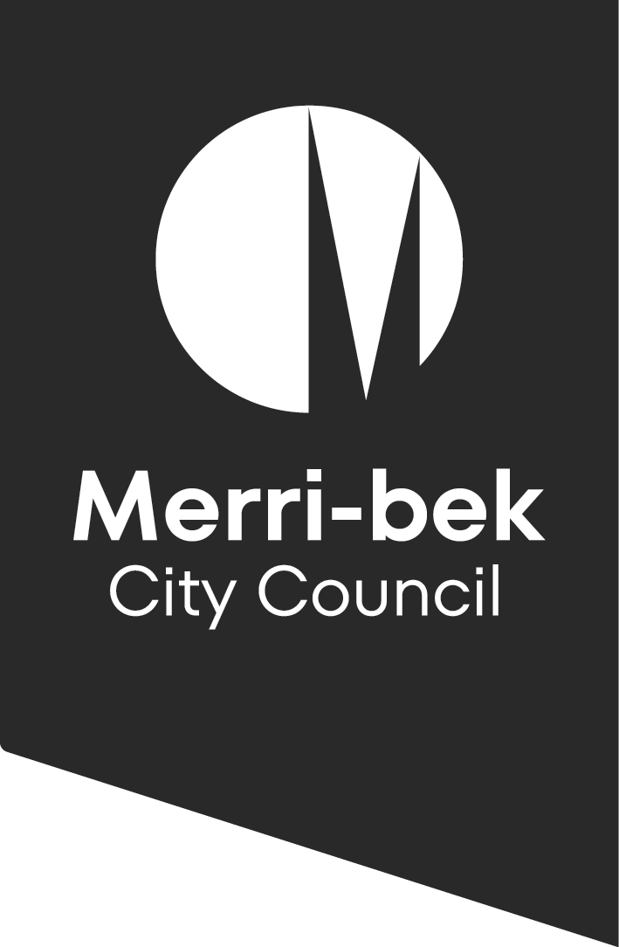
Merri-bek Art Collection Policy
2024 to 2029
Merri-bek Art Collection Policy
2024 to 2029

Date Authorised by Council: Wednesday 8 May 2024
Commencement Date: Wednesday 8 May 2024
Review Date: Wednesday 9 May 2029
Responsible Department: Arts and Culture Unit

This policy has been authorised.
Chief Executive Officer
Cathy Henderson

Introduction
This policy provides a framework for the acquisition, care and disposal of artworks that form Council’s municipal art collection, known as the Merri-bek Art Collection.
This does not include public art commissions, or other acquisitions that have specific processes depending on each individual commission.

Context
The Merri-bek Art Collection Policy is informed by the vision, objectives and priorities of the following policies, plans, strategies and statements:
- Merri-bek Council Plan 2021-2025
- Merri-bek Arts and Culture Strategy 2023-2030
- Merri-bek Asset Management Policy 2023-2027
- Merri-bek Human Rights Policy 2016-2026
- Merri-bek Information Privacy and Health Records Policy 2022-2026
- Merri-bek Statement of Commitment to Wurundjeri Woi-wurrung People and Aboriginal and Torres Strait Islander Communities
- National Cultural Policy 2023
The Merri-bek Art Collection Policy adheres to the following documents in guiding best practice in the collection sector:
- International Council of Museums (ICOM) Code of Ethics for Museums 2017
- AMAGA First Peoples: A Roadmap for Enhancing Indigenous Engagement in Museums and Galleries 2018
- National Standards for Australian Museums and Galleries 2023
- National Copyright Act 1968
- Charter of Human Rights and Responsibilities Act 2006
The Merri-bek Art Collection Policy adheres to legislative requirements related to Indigenous (including Aboriginal and Torres Strait Islander) culture, content and artefacts as follows:
- Creative Australia, Protocols for using First Nations Cultural and Intellectual Property in the Arts, 2007
- Archaeological and Aboriginal Relics Preservation Act 1972
- Indigenous Cultural Protocols and the Arts 2015 by Terri Janke
- United Nations Declaration on the Rights of Indigenous Peoples (UNDRIP)
Merri-bek City Council acknowledges its mandatory obligation under the Aboriginal Heritage Act 2006 to register Victorian Aboriginal cultural artefacts in its possession with Aboriginal Affairs Victoria and that human remains and secret and sacred material legally belonging to the Traditional Owners should be repatriated.

Objectives
The objectives of the Merri-bek Art Collection Policy are to:
- Provide guidance with regard to the care and conservation of the Merri-bek Art Collection;
- Outline the process for acquiring artworks for the Merri-bek Art Collection through purchase, commission, donation or bequest;
- Provide key selection criteria for acquiring new artworks for the Merri-bek Art Collection;
- Provide guidance with regard to the de-accessioning and disposal of artworks; and
- Develop and extend a collection of artworks with cultural and/or historic value to the City of Merri-bek.

Policy Details

Aims of the Merri-bek Art Collection
The Merri-bek Art Collection aims to:
- Reflect the artistic, cultural and social diversity of the City of Merri-bek;
- Recognise artists who live, work, exhibit or contribute to the creative culture of the City of Merri-bek;
- Build the cultural, historical and economic value of the Collection as an asset of the City of Merri-bek;
- Generate discussion and debate about art, culture, social and environmental issues;
- Provide Merri-bek’s community with opportunities to engage with artworks in public spaces;
- Enhance the Merri-bek community’s awareness, understanding and appreciation of art; and
- Enhance public spaces through the exhibition of art.

Care of the Merri-bek Art Collection
Merri-bek City Council owns, manages and cares for the Merri-bek Art Collection on behalf of the Merri-bek community. Merri-bek City Council will endeavour to conserve the Collection in accordance with best practice. Merri-bek City Council will provide a safe environment for the Collection, with effective storage, security and environmental controls, for the benefit of current and future generations.

Artwork handling
Only Counihan Gallery staff and contracted art technicians and couriers with appropriate professional training and experience are authorised to handle and transport Collection artworks.
However, in emergencies when objects are in danger of loss, damage, or destruction, it is acceptable for any Merri-bek staff member, or member of the public under staff supervision, to help save the Collection from harm.

Documentation and record keeping
All records created or received are the property of the City of Merri-bek and must not be dispersed or destroyed except in accordance with the City of Merri-bek’s Record Policy.
The creation and maintenance of up-to-date and accurate records on the history, identification, location and condition of Collection objects are imperative. Collection documentation is the responsibility of Counihan Gallery staff.
The following information is privileged and will not be divulged to third parties unless under legal obligation:
- Names of lenders, donors and prior holders who have requested anonymity;
- Contact details of artists, donors, lenders or prior holders; and
- Valuation of objects.

Artwork condition reports and treatment
Gallery staff must complete an audit of all Collection works on display annually, to conduct condition reports to assess their continued suitability for display. Definitions of what constitutes excellent, good, fair and poor conditions can be found in the Victorian Collections Cataloguing Manual.
The Team Leader Gallery and Arts Programs will recommend works for conservation as needed.
Untrained staff must never attempt to clean, treat or restore works from the Collection. Where appropriate, an artist may be appointed to treat their own artwork but, in most cases, a suitably qualified conservation agency will be engaged.

Access to the Merri-bek Art Collection
Council aims to provide public access to the Merri-bek Art Collection to enhance the Merri-bek community’s awareness, understanding and appreciation of art and culture.
The Merri-bek Art Collection will be made accessible to the community through:
- Displays in Council buildings, such as meeting rooms, libraries, community centres and offices;
- Exhibitions at Merri-bek City Council’s public gallery (Counihan Gallery);
- Loans to external galleries, museums and organisations;
- Online access via the Victorian Collections website, where permission has been granted by the artist to digitally reproduce their work;
- Education or public programs in which Collection items are displayed, or tours of the Collection store are provided; and
- Access to the Collection on request.
Some artworks in the Collection are not fit for long-term display in public areas due to their fragility or the high risk of theft, damage or deterioration.

Artwork display and loans
Merri-bek City Council lends and borrows artworks through outward and inward loan processes. On a case-by-case basis, Merri-bek City Council will lend artworks to other museums, galleries and organisations.
The Team Leader Gallery and Arts Programs is responsible for approving an object for installation or loan. The Team Leader Gallery and Arts Programs will consider an object's conservation history and vulnerabilities when making loan, handling, packing, transport and installation decisions.
The physical and cultural safety of people and art objects must always take priority over aesthetic considerations regarding both the work and its display. This applies to all artworks, including artworks on loan.

Artwork acquisition
Acquisition is the process by which Council legally and formally accepts artworks into its municipal art collection. It can refer to artworks that are purchased by Council, donated or bequeathed to Council, or commissioned by Council for the Merri-bek Art Collection.
Items purchased for the Merri-bek Art Collection are procured through the Municipal Art Collection budget, which is reviewed annually.
Following a selection of proposals from the Team Leader Gallery and Arts Programs, the Merri-bek Arts Advisory Committee will make recommendations about art acquisitions to Council for endorsement at a Council meeting. Following this, the artworks are included on Merri-bek’s asset register and on the Victorian Collections database.

Role of the Merri-bek Arts Advisory Committee
The Merri-bek Arts Advisory Committee will continue to function under its established Terms of Reference.
For works in specialised fields of art, the Merri-bek Arts Advisory Committee may invite recommendations from specialists with expertise in the area when deemed beneficial.
Conflicts of interest by sitting members of the Merri-bek Arts Advisory Committee must be declared prior to the consideration of an item for acquisition.
At Merri-bek Arts Advisory Committee meetings, the Team Leader Gallery and Arts Programs will recommend a selection of items for purchase according to the Key Acquisition Criteria. Support materials will also be provided to panel members for consideration.
The Merri-bek Arts Advisory Committee will meet as required to:
- Make decisions on the recommendations of the Curator for the allocation of the Municipal Art Collection Budget towards the purchase or commissioning of one or more works of art; and
- Provide consultation on the recommendations of the Curator to the Director of Community Development for the de-accessioning of artworks in the Merri-bek Art Collection.

Standard Requirements for the Collection
For an artwork to be considered for the Merri-bek Art Collection, the item must meet the following standards. It must be or have:
- In good condition;
- A durable artwork that is appropriate for the space it is intended to be displayed in;
- An unconditional donation or purchase which has valid and clearly verifiable legal title;
- An artwork with a clearly established and verifiable provenance;
- The capacity to be placed on display in Council buildings or in public spaces without hindering public access or safety; and
- The capacity to be placed on display without breaching the artist’s moral rights.
When considering an artwork, Gallery staff and the Advisory Committee must also consider the necessary resources required to resolve all foreseeable issues relating to the long-term conservation, framing, presentation and storage of the artwork.

Key acquisition criteria
To be eligible for acquisition into the Merri-bek Art Collection, artworks must meet the Standard Requirements for the Collection as well as one or more of the Key Acquisition Criteria relevant to the Collection category to which it belongs (contemporary or historical).
Contemporary visual arts:
An item of contemporary art is eligible for acquisition if it meets one or more of the following criteria.
The artwork must:
- Show a distinctive and verifiable connection with the City of Merri-bek, such as being a work of art by an artist who has lived, worked, exhibited or contributed to the creative culture of Merri-bek;
- Enhances the status and diversity of the Merri-bek Art Collection;
- Engages with important social, cultural and/or environmental issues in a considered and creative manner;
- Demonstrates innovation or reflects current trends within a broader context of contemporary Australian art; and/or
- Builds upon and strengthens the Indigenous art component of the Collection, as per Council’s Reconciliation Policy.
Historical visual arts:
An item of art is eligible for acquisition if it is considered to meet the following criteria.
The artwork must be:
- A quality work of art identifiably associated with the cultural history of Merri-bek;
- A work of art by a significant artist who lived, worked or exhibited in the City of Merri-bek; and
- An important historical work of art that relates to the ongoing ethics and cultural policies of Council.

Copyright, moral rights and cultural rights
For the Collection to meet its moral and legal obligations under national standards relating to copyright, moral rights and cultural rights, the following standards apply to acquiring works.
They must not:
- Impinge on the intellectual, moral or cultural rights of another person or community;
- Contravene the National Copyright Act 1968;
- Contravene Article 31 of the United Nations Declaration on the Rights of Indigenous Peoples (UNDRIP); and
- Contravene the Charter of Human Rights and Responsibilities Act 2006 (Victoria).

De-accessioning and Disposal
The Team Leader Gallery and Arts Programs may nominate a registered Merri-bek Art Collection artwork for de-accession and disposal.
The Team Leader Gallery and Arts Programs will report on the de-accession recommendation to the Director of Community Development. The report will evaluate the item against the de-accession criteria and recommend appropriate methods for disposal options.

De-accession criteria
An item may be nominated for de-accessioning if it adheres to any of the following categories.
The item:
- Is in poor condition and is of insufficient merit to allocate the resources to ensure its conservation;
- Cannot be displayed due to its properties, and is not suitable for research;
- Is a forgery that serves no specific cultural function;
- Is irreparably damaged or destroyed;
- Is a lesser quality duplicate of an object the Gallery already owns;
- It lacks supporting information to enable proper identification or to establish its relevance to the Collection;
- A substantiated request for the return of the object to its original owner/donor is received. This could be the return of sacred material to Indigenous peoples;
- Falls under the jurisdiction of an act that determines alternative placement, such as the Public Records Act 1973 and the Archaeological and Aboriginal Relics Preservation Act 1972;
- Is missing or stolen without hope of return; or
- Does not align sufficiently with any of the Key Acquisition Criteria for contemporary or historical visual arts.

Disposal methods
This disposal procedure for an item identified to be de-accessioned will adhere to the following order of options. The option for disposal in order of priority is that the item:
- May be offered for sale or donation, as appropriate, to its creator or the donor;
- May be offered to its creator or another collecting institution as a swap, on the condition that the new work is approved for acquisition as per this policy;
- May be offered to a more appropriate collecting agency or institution;
- May be resold on the public market; or
- May be dismantled and/or destroyed in the event of no other options being suitable. Where possible, works will be recycled or composted, if appropriate.
Councillors, Council Officers, Gallery volunteers, Merri-bek Arts Advisory Committee members and their families are prohibited from obtaining an item de-accessioned from the Collection by any means as this can be interpreted as a conflict of interest.
A record of all items de-accessioned, and their method of disposal must be kept and Merri-bek’s asset register and collection database updated accordingly.

Income from disposal of Collection items
All monies received by Council from the disposal of an item should be applied solely to the upgrading of the Merri-bek Art Collection either by purchase of items or by the conservation of existing items held in the Collection. This is in accordance with the International Council of Museums (ICOM) Code of Professional Ethics.

Definitions
Term | Definition
Accessioning | Accessioning refers to the receiving or adding of objects or materials into a permanent art collection.
Conflicts of interest | A conflict of interest is a situation in which someone in a position of trust or authority finds themselves with competing professional and personal interests. Such competing interests may make it difficult for the individual to be objective or impartial. If they were not to declare their potential conflict of interest, or remove themselves from this situation, it may be interpreted as an act of impropriety or unethical behaviour.
Condition | An artwork condition refers to its state. For the purposes of the Merri-bek Art Collection, a work may be in excellent, good, fair or poor condition. Gallery staff refer to the Victorian Collections Cataloguing Manual for definitions of these terms when assessing an artwork’s condition.
Conservation | Art conservation denotes the maintenance and preservation of works of art and their protection from future damage and deterioration.
Contemporary visual art | Contemporary visual art refers to recent artworks across a range of media and styles. It usually refers to new works engaging with current artistic, cultural and social developments and trends. Contemporary visual artworks often utilize the materials and techniques of their time.
Curator | The term refers to the person in charge of a museum or art collection and who organizes temporary exhibitions. In this document it is used to refer to the Curator of the Counihan Gallery, who is responsible for the Gallery and the Merri-bek Art Collection.
De-accessioning | De-accessioning refers to the process by which materials or objects are formally removed from a permanent art collection.
Exhibition | This refers to the public display of objects or artworks.
Indigenous | For the purposes of this policy, Merri-bek refers to the United Nations’ definition of Indigenous peoples and culture.
Aboriginal and Torres Strait Islander | Aboriginal and Torres Strait Islander people are the Indigenous people of Australia.
Provenance | As it relates to artwork, provenance means the history of ownership of an object. It is important to know the history of the object when acquiring art to ensure that it is not stolen and that it has been created and offered for sale, donation or bequest in an ethically sound manner.

