Eliminating single-use plastics
Single-use plastic is used on average for less than 12 minutes and then discarded, accounting for 50% of global pollution. This has devastating long term impact on our waterways and marine environment.
Merri-bek City Council has committed to reducing single-use plastic at our events and festivals, as part of our Plastic Wise Policy, adopted in April 2019.
What items are not permitted at our events and festivals?
- Plastic bags
- Single-use plastic bottled water and bottled soft drinks
- Single-use plastic cups, plates, bowls, cutlery, straws and stirring sticks
    - Made from standard or compostable plastic
- Plastic takeaway containers
- Paper cups
    - Most paper cups are lined with plastic or compostable plastic
    - Noting an exemption can be provided if needed (see below)
- Balloons
Selling coffee or hot beverages?
- You will need an exemption letter from the Festivals Team. There are currently very few plastic-free single-use alternatives for hot beverages.
What alternatives can I use?
- See overleaf for a list of commonly used alternatives to single-use plastic.

How long does plastic remain in the ocean?
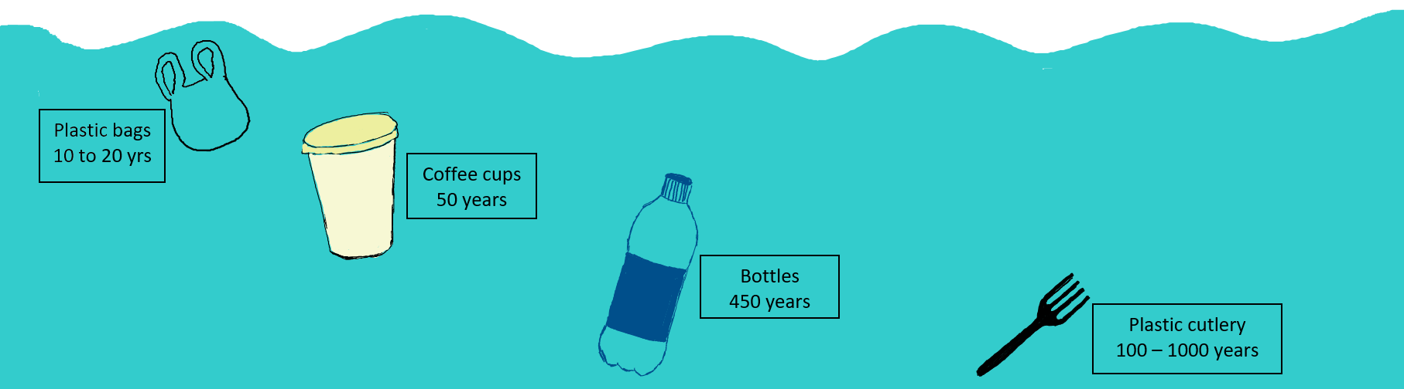

What can I use instead of single-use plastic?

Product | Best option | Next best option | Tips for success
Bottled water | - Drinking water available on site (e.g., taps, bench top water dispensers, portable water stations)  - Customers BYO reusable bottles | Drinks in  - Aluminium cans (recyclable) | - Direct people to taps and/or hydration stations  - Sell water in aluminium cans
Drinks in plastic bottles (e.g.: soft drinks) | Drinks in  - Aluminium cans (recyclable)
Plastic cups and coffee cups (including paper, compostable and biodegradable) | - Customers BYO reusable cups  - Provide reusable cups with a refundable deposit | - Cold drinks – use paper cups. Very few single-use plastic-free alternative exist. A policy exemption can be granted for cups if no ‘best option’ solution can be found.  - Hot drinks – Use paper cups. very few single-use alternatives currently exist. A policy exemption can be granted. | - Only provide lids when requested
Plates and bowls | - Customers BYO plate/bowl/container | - Serviette, square of cardboard, cabbage leaf or similar  - Paper bowls/plates (recyclable - when scraped clean)  - Bamboo or Areca palm plates (commercially compostable*) | - If using disposables, avoid products with plastic lining
Cutlery | - Consider serving foods that doesn’t need cutlery  - Customers BYO cutlery | - Bamboo cutlery (commercially compostable*)  - Wooden cutlery (commercially compostable*) | - Ask customers if they need cutlery rather than providing automatically
Stirring sticks | - Provide several teaspoons which can be washed and reused | - Wooden stirring sticks (commercially compostable*) | - Plastic stirring sticks were banned in Victoria in Feb 2023.  - Provide metal teaspoons or wooden sticks
Straws | - No straw  - Customers BYO reusable straws  - Sell reusable straws | - Paper straw (commercially compostable*)  - Bamboo straw (commercially compostable*) | - Plastic straws were banned in Victoria in Feb 2023, aside from for medical reasons  - Only provide paper straws if requested by a customer  - Quality paper straws last longer and the dye doesn’t run
Plastic bags | - Customers BYO bags  - Sell reusable bags (for the event or as a stallholder) | - 100% recycled paper bags  - FSC certified paper bags | - Consider adding a small charge to cover any cost impact, if customers choose to take a paper bag  - There is a State Government ban on thin single-use shopping bags
Single serve condiments | - Provide condiments in large refillable containers (e.g., large tomato and soy sauce bottles) |  | - Ensure any large serving containers such as bottles or pump packs, are cleaned and sanitised before refilling
Balloons | - Replace with paper lanterns, bunting, flags, banners or colourful streamers  - Blow bubbles |  | - For stall decoration avoid the use of balloons  - For promotional materials at events avoid balloons, promote re-use items
Bubble wrap | - Replace with corrugated cardboard or brown packing paper mesh (e.g., GreenWrap etc) |  | - Use suggested alternatives (or similar) for vendor transport of goods  - Ask customers if they need the product wrapped, rather than providing automatically
* A commercial composting facility is required to process these products. The composting facility used by Merrri-bek City Council does not accept these items. They need to be disposed of in general waste and cannot be recycled.

