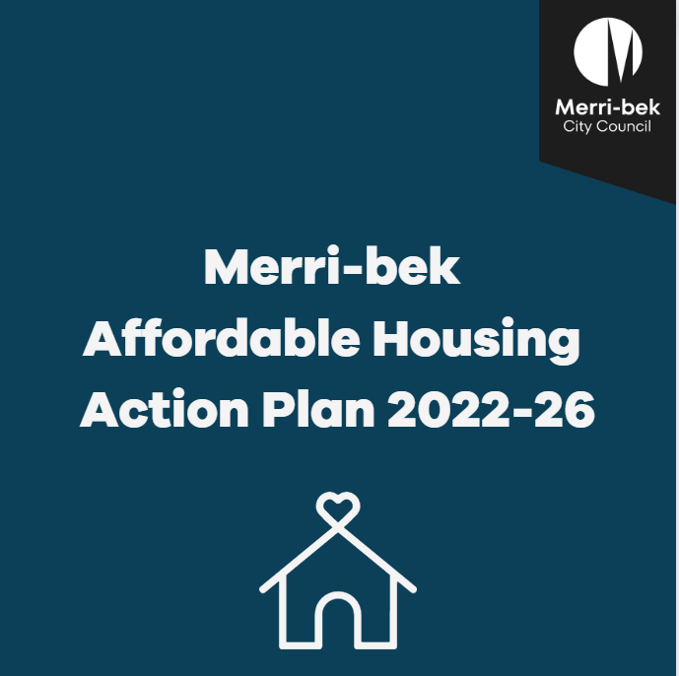

|  |
| --- |
| Endorsed 7 December 2022  Update endorsed by Council 12 February 2025  Merri-bek City Council 90 Bell Street Coburg, Victoria, 3058 T: (03) 9240 1111 |
|  |

Contents

1. Introduction 3

2. Context 3

3. Strategic Context and Alignment 4

4. Affordable Housing in Merri-bek 7

5. Council’s Role 10

6. Affordable Housing Action Plan 12

Focus Area 1 – Planning 12

Focus Area 2 – Partnerships 15

Focus Area 3 – Research and Advocacy 18

Focus Area 4 - Support service coordination, information provision and advocacy for people who are experiencing or at risk of homelessness. 21

7. Monitoring, Evaluating and Review 23

|  |
| --- |
| Note:  Further to the adoption by Council in March 2024 of the *Merri-bek Homelessness Strategy* and *Action Plan*:   * Actions 2.2 and 2.3 are amended to include consideration of the types of   accommodation and housing that specifically respond to homelessness   * Actions under Focus Area 4 are to be progressed and reported on through the   Homelessness Strategy. |

ACKNOWLEDGEMENT OF COUNTRY

Merri-bek City Council acknowledges the Wurundjeri Woi-wurrung people as the Traditional Custodians of the lands and waterways in the area now known as Merri-bek. We pay respect to their Elders past and present as well as to all First Nations communities who significantly contribute to the life of the area.

# Introduction

The Affordable Housing Action Plan outlines Council’s work to increase the supply of affordable homes in Merri-bek. The Action Plan considers current organisational and external policy settings, improved practice, the views of key stakeholders and Merri-bek’s communities.

The objective of the Affordable Housing Action Plan is to increase the provision of affordable housing in Merri-bek through policy, advocacy, applied skills and investment. To achieve this objective the Action Plan has four focus areas:

1. Facilitate the supply of the affordable housing in new developments
2. Partnerships to develop affordable housing, particularly on council land
3. Research and advocacy for increased investment
4. Support service coordination, information provision and advocacy for people who are experiencing, or at risk of, homelessness.

# Context

***Defining Affordable Housing***

The *Victorian Planning and Environment Act (VIC) 1987* defines affordable housing as housing that is appropriate to the needs of very low-, low- and moderate-income households. An annually updated Governor in Council order sets the income thresholds for affordable housing. The supporting Ministerial Notice lists principles that must be considered, including:

* allocation (affordable housing to be allocated to eligible households),
* affordability and longevity (the housing should be retained as affordable housing over time).

The most used measure of whether housing is considered affordable is the 30:40 indicator which identifies a household as being in housing affordability stress when it has an income level in the lower 40 per cent of Australia's income distribution and is paying more than 30 per cent of its income in housing costs.

Social housing is a distinct type of affordable housing which has specific eligibility requirements defined under the *Housing Act (VIC) 1983*. Social housing includes public housing which is owned and usually managed by the state government and community housing which is owned and/or managed by a registered housing agency. Of the 46 registered housing agencies in Victoria, about one-third provide operate in Merri-bek.

***Housing Continuum***

Affordable Housing is a term that covers a range of different housing situations which can vary over time and dependent on circumstances. Across the Housing Continuum there are options to support many life situations such as young people leaving care, older people on fixed incomes in insecure rentals, women and children escaping family violence, for which affordable housing is required. These situations may affect a person’s level of income and requirement for different kinds of temporary housing options such as emergency accommodation or transitional housing before moving into secure long-term housing such as social housing, affordable rental or home ownership. Clearly the most urgent need is among those at the left-side of the Housing Continuum experiencing or at risk of homelessness. However, if action is not taken across the whole continuum the scale of need at the left of the Continuum will continue to escalate faster than delivery of social housing.[1]

This Plan has actions which assist improved outcomes across the *affordable housing* and *supportive/social housing* parts of the Housing Continuum, shown in Figure 1.

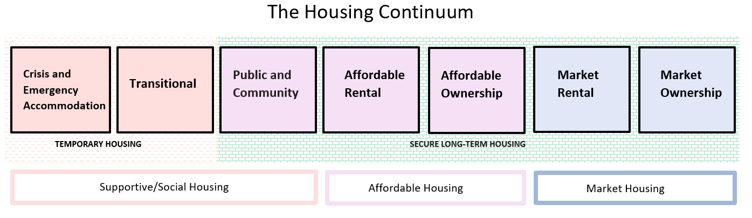

Figure 1 Housing Continuum and Housing Options

# Strategic Context and Alignment

***Community Vision***

1. The Community Vision was developed by an Imagine Moreland Community Panel through deliberative engagement. The panel comprised 44 members of the local community that included diversity relating to household status (rental and home ownership) as well as educational attainment and income levels. The Community Vision (finalised prior to the renaming of the municipality) is:

*“Moreland is our home. We respect and look after our land, air, waterways and animals.*

*We care for our people and celebrate our diverse stories, cultures, and identities.*

*Moreland is enhanced by all of us supporting our local businesses, arts communities and social organisations. We work together proactively and transparently to continue to create a vibrant, safe, healthy, resilient, innovative, and regenerative community. Many faces, one Moreland.”*

***Council Plan 2021 – 2025***

The Council Plan has been integrated with the Municipal Public Health and Wellbeing Plan (MPHWP) and is a key document which sets out Council’s and community’s vision for the future. The Affordable Housing Action Plan supports the delivery of the Council Plan through the following themes and strategies:

**Theme 4: Vibrant spaces and places in Moreland**

* Strategy 4.7: To increase local affordable housing outcomes by continuing to support the activities of Moreland Affordable Housing Ltd, advocating for and facilitating developers to contribute to affordable housing and attracting State-funded and not for profit public, social and affordable housing investment to Moreland
* Strategy 4.9: To revitalise Moreland’s major activity centres to deliver new integrated community facilities and services, enable new cultural spaces, create jobs and improve local accessibility and amenity, while protecting the special character that each centre is known for and advocating for affordable housing outcomes
* Major initiative 4.7: To review and implement the Affordable Housing Action Plan including the development of affordable housing on council land

**Theme 3: Healthy and Caring Moreland**

* Strategy 3.11: To support service coordination, information provision and community advocacy for people experiencing insecure housing

The Council Plan has a strategic indicator to increase the number of affordable housing projects delivered. The 2021/22 Annual Report noted one development containing 32 affordable housing dwellings was completed in 2021/22. Eight planning permits containing 373 affordable housing dwellings were issued for 2021/22 for future delivery

***Integrated planning framework***

The Plan is part of Council’s Integrated Planning and Reporting Framework Figure 2 shows where the Plan sits within the Framework. This Affordable Housing Action Plan is placed within 4-year strategic plans that supports the delivery of the Community Vision and Council Plan.

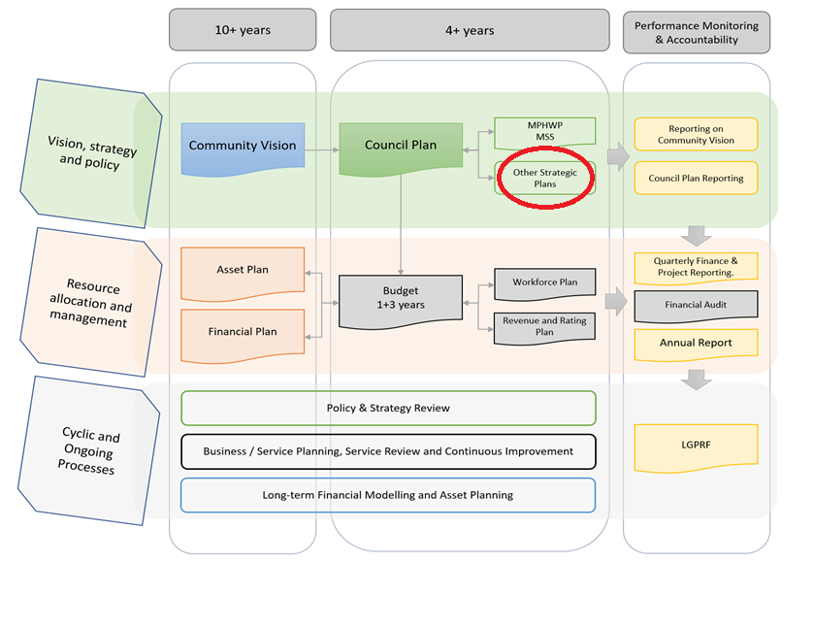

Figure 2 Merri-bek Integrated Planning and Reporting Framework

**The Planning Scheme *– Planning Policy Framework***

*The Planning Scheme* aims to facilitate the increase in the supply of affordable housing in Merri-bek through the following provisions.

**VPP16.01-1S Housing Supply**

* To facilitate well-located, integrated and diverse housing that meets community needs

**VPP16.01-2S Housing affordability**

* To deliver more affordable housing closer to jobs, transport and services

**LPP16.01-2L Housing affordability Moreland**

* Encourage developments to include affordable housing to be owned and managed by a registered housing association, registered housing provider or the Director of Housing

***State Government***

In November 2020 the State Government announced a $5.3 billion investment in social and affordable housing, the *Big Housing Build (BHB)*, and the creation of Homes Victoria as a dedicated agency. A key commitment of the BHB is the creation of a Social and Affordable Housing Compact with local government. The Compact is intended to give councils a ‘seat at the table’ in identifying priorities for social and affordable housing growth in their municipalities and will be implemented through Local Area Agreements between councils and Homes Victoria. As of June 2022, Homes Victoria have committed a total of $112.9m in BHB funding in Merri-bek. This is made up of a $23.5m 70-unit development in Pascoe Vale to be developed and operated by Housing Choices Australia, and $89.4m to purchase 189 dwellings from its spot purchase program. A further $86m has been invested in the redevelopment of the former Gronn Place public housing estate under the Public Housing Renewal Program.

***Federal Government***

The creation of a $10 billion Housing Australia Future Fund and an expansion of the National Housing Infrastructure Facility and other initiatives may provide expanded opportunities for Council to facilitate new social and affordable housing developments. Furthermore, in October 2022 the Federal Government announced a National Housing Accord which includes a role for local government to participate in and support the development of the National Housing and Homelessness Plan. While the policy focus is on much-needed new housing, it remains an ongoing concern that the state government has not had sufficient transfers from Canberra under the existing national agreement to maintain existing public housing stock and adequate emergency and transitional housing.

# Affordable Housing in Merri-bek

***Housing Need***

The housing system is failing to provide enough safe, affordable and appropriate homes for our Merri-bek community. Council has undertaken significant research to estimate the need for social and affordable housing currently and projecting up to 2036. The shortfall in affordable housing in Merri-bek was at least 4,000 in 2016.[2] This shortfall will rise to between 7,000 and 10,500 by 2036. The shortfall cannot entirely be met by local government intervention and requires a range of government actions including mandatory planning measures and substantial investment from state and federal government.[3]

**Figure 3: Number of Affordable Housing Dwellings Needed in Merri-bek**

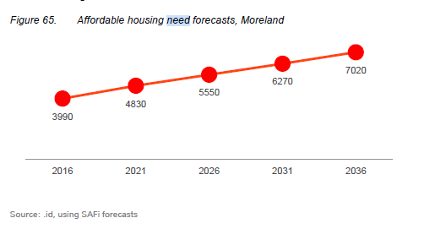

*Source: A Home in Moreland report, ID Consulting 2018*

***Homelessness in Merri-bek***

There is a higher than metropolitan average number of people who are unhoused, with no safe shelter to call their own in Merri-bek. Council acknowledges the deplorable state of homelessness in Merri-bek and recognises that it exists in many forms including: overcrowded, insecure, and inappropriate housing. Rough sleeping is the most visible form of homelessness. It can take many forms including people sleeping in cars, tents, abandoned buildings and other locations. According to the 2016 ABS homelessness estimates for Merri-bek, there were 770 people experiencing homelessness in 2016, however this is likely an undercount considering data from services such as Vincent Care data.

Council officers are active in discharging responsibilities under building and health legislation to ensure the wellbeing of people living in rooming houses, hotels and unsafe buildings.

Prevention of homelessness for women and children who have experienced family violence is an important part of the remit of the Merri-bek Family Violence Network which Council convenes.

In looking to achieve better long-term outcomes, particularly for people who are sleeping rough, Council is exploring the potential of Functional Zero- a partnership approach involving service organisations, local government and community which has been initiated in a number of metropolitan council areas and across Australia. This uses real-time data to provide individualised support over time to get appropriate long-term homes for people to break the commonly experienced cycle people experience of rough sleeping, emergency accommodation, unsustainable tenancies and back on the streets.

***Impact of COVID-19***

The COVID-19 pandemic has drawn attention to the inequalities in the housing system that already existed pre-2020. The pandemic disproportionally effected lower socio-economic groups who were required to work in community facing roles or unable to work, latterly without government subsidy. This has subsequently led to an increase in reported levels of housing stress.[4] The COVID-19 pandemic has also highlighted the need for Emergency Housing, both in terms of gaps in supply and the provision of wraparound supports.

***Key workers***

An emerging housing affordability issue in Merri-bek is businesses being unable to attract and retain workers who do essential jobs that service the Merri-bek resident community. These people are known as key workers.

Key workers are in Merri-bek’s shops and hospitality businesses, in healthcare, education and aged care. Many of these workers are in lower paid jobs and cannot afford housing in Merri-Bek. They live in locations that are not well serviced by public transport and predominantly travel to work by car. However, they are often not eligible for social housing. Further research is required to understand what type of affordable housing could provide for better outcomes for key workers, business and our diverse communities.

***Moreland Affordable Housing Ltd***

In 2018 Council established an arms-length entity, Moreland Affordable Housing Ltd (MAH) to address the lack of secure and affordable housing options available to residents across the Municipality. Using seed funding over 4 years of $865,000 from the Housing Strategy Reserve, MAH is focused on developing appropriate Council-owned land sites for social and affordable housing developments.

In September 2021 Council agreed to sell land at 2-12 Wilkinson Street, Brunswick to MAH for the purposes of developing affordable housing. MAH have partnered with Haven Home Safe to deliver social housing on the site.

***Housing Strategy Reserve***

Council established a Housing Strategy Reserve in 1997-1998, following the forced sale of the Coburg and Brunswick electricity wholesaling businesses as part of the privatisation of the SEC (State Electricity Commission) in 1996-1997. A total of $1.5 million was allocated to the Reserve to help increase supply of affordable housing. In addition to its current financial support for MAH, the reserve has supported the development of four projects by community housing and charitable agencies in Coburg, Coburg North and Fawkner. These 22 homes all sit on council land under a long term (40 or 50 year) leasehold arrangement. Since 2015 Council has allocated $50,000 a year to the reserve as well as 50% of revenue from the sale of abandoned cars.

***Climate Emergency***

Climate change impacts affordable housing at different levels of the Housing Continuum. When a person is sleeping rough, they can be at greater risk of violence, and extreme weather, both of which can have significant impacts on their physical and mental health. While many new affordable homes are needed, there is an urgent need to upgrade existing ageing public and low-income community owned housing stock for it to be healthy and safe for its residents. The sector needs to consider the effects of climate change when managing, renewing and in planning new builds across all social and affordable housing. Council has advocated for the Social and Affordable Housing Compact to include a commitment to increase efficiency and comfort of buildings and decrease operating costs aiming to achieve a transition to net zero carbon in operation and reduction in the cost of living for residents.

Council has existing environmental sustainability requirements in its planning scheme to make sure that new development is environmentally sustainable. It has also partnered with 23 other Councils to submit a request to the Minister for Planning to amend the planning schemes of the 23 Councils to introduce elevated environmental sustainability targets. If supported, these sustainability targets will apply to all types of developments.

***Gender Equality* and Human Rights**

The Victorian Housing Register and 2016 censuses indicate the fastest growing cohort in housing crisis and needing assistance are single women over the age of 55, in addition three in five older lone person households, and 41% of older couples in Merri-bek are in rental stress. There is also data to suggest that people with disability struggle to find affordable housing and are vulnerable to housing stress[5]. Further examination of diverse cohorts is needed in Merri-bek and to help understand these needs and what intervention measures can be adopted across all four focus areas.

Council has for a long time advocated for better accessibility standards in building regulations and planning schemes so that new dwellings are more accessible. People who need affordable housing are more likely to have a disability than the general population. The National Construction Code will change in 2023 to require new livable housing requirements. In addition, through its planning scheme review, Council has resolved to investigate how planning can influence better accessibility outcomes, including advocating for elevated accessibly standards of ResCode as part of ResCode reform program and considering. imbedding LHA gold level principles in new design policy.

# Council’s Role

The delivery of affordable housing and supporting people in housing crisis sits primarily with state and Commonwealth governments. However, the lack of adequate provision of social and affordable housing is recognised as an urgent issue that all levels of government as well as the private and not-for-profit sectors should address. Local Government has several ways it can influence an increase in the supply of social and affordable housing in the municipality and support people needing social and affordable housing. This is summarised in Figure 3.

In its planning role, Council endeavours to use the Planning and Environment Act which recognises affordable housing as one of its objectives and specific provisions of the Planning Scheme to facilitate affordable housing outcomes at scale and of high quality. The requirement to negotiate voluntary agreements rather than following mandatory requirements is a limitation which requires a focus on skill and capacity building for Council officers and key stakeholders.

As a partner, Council can create new value by, for example, the contribution of under-utilised land assets. The intangible value of local knowledge and established stakeholder and community relationships can also be critical in bringing benefits to the Merri-bek area.

Research on housing need and supply as well as related population and health impacts are a powerful influencing tool in the provision of social and affordable housing. Council influence as an advocate is amplified by its active contribution to wider forums such an the M9 Group of Councils.

As the incidence of homelessness is on the rise, Council’s engagement with the lead community agencies on the frontline has identified the unique position it holds to assist with improved coordination and improved outcomes for our most vulnerable community members.

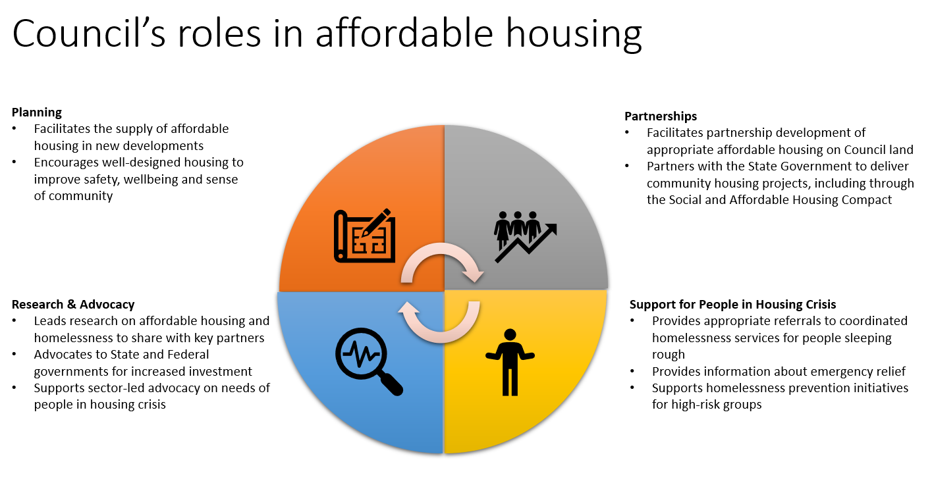

Figure 3 The roles of Council in affordable housing

# 6. Affordable Housing Action Plan

## Focus Area 1 – Planning

| **Action** | **Activities** | **Lead Unit/ Supporting Unit(s)** | **Timing**  **Y1 Y2 Y3 Y4** | | | | **Resources** |
| --- | --- | --- | --- | --- | --- | --- | --- |
| **1.1 Facilitate affordable housing provision in planning permit applications** | Negotiate affordable housing to be provided as part of large development projects | Urban Planning  Affordable Housing | X | X | X | X | Existing staff and unit budget |
| Revise affordable housing internal referral protocol to include   * triggers for expert internal and external advice in affordable housing negotiations * Updated toolkit resource that provides technical and policy guidance to officers and applicants on affordable housing contributions | Affordable Housing  Urban Planning | X |  |  |  | Existing staff and unit budget |
| Develop a database to track affordable housing agreements and monitor outcomes  Establish a mechanism for M9Councils to share information about agreements and outcomes | Affordable Housing  Urban Planning, Strategic Planning | X | X |  |  | Existing staff and unit budget |
| **1.2 Promote excellence in affordable housing** | Develop and promote guidance for good design outcomes for social and affordable housing informed by the specific needs of residents (e.g., older women, First Nations, People living with mental illness). | Urban Design  Affordable Housing  Urban Planning  Strategic Planning |  |  | X | X | Existing staff and unit budget |
| **1.3 Promote**  **accessibility requirements in new dwellings** | Implement National Construction Code requirements | Urban Design  Affordable Housing  Urban Planning  Strategic Planning |  | X | X | X | Existing staff and unit budget |
| **1.4 Promote affordable housing opportunities in strategic land use planning** | Investigate opportunities to support growth of affordable housing provision in activity centres | Strategic Planning | X | X |  |  | Existing staff and unit budget |
| Negotiate agreements for affordable housing from proponent-led rezoning | Strategic Planning | X | X | X | X | Existing staff and unit budget |
| ***1.5* Support registered housing providers and other non-profit housing projects** | Assist registered housing agencies and non-profit affordable housing in navigating their projects through the planning system | Urban Planning | X | X | X | X | Existing staff and unit budget |
| Explore statutory fees refunds for registered housing agencies and non-profit affordable housing led developments including:   * Reimbursement of Planning fees and waiving of other construction related application fees or charges for registered housing provider- led development * public open space contribution and developer contribution plans in future planning scheme amendment processes | Affordable Housing  Strategy Planning  Urban Planning | X | X | X | X | Existing staff and unit budget |
| **1.6 Build Councillor, officer and stakeholder capacity, especially with new development models** | * Support ongoing training for staff to facilitate affordable housing outcomes * Specific induction for new Council group * Affordable Housing section of Council website to include examples of agreements and outcomes to improve information sharing with housing providers and developers | Affordable Housing  Urban Planning  Strategic Planning | X | X | X | X | Existing staff and unit budget |

## Focus Area 2 – Partnerships

| **Action** | **Activities** | **Lead Unit / Supporting Unit(s)** | **Timing**  **Y1 Y2 Y3 Y4** | | | | **Resources** |
| --- | --- | --- | --- | --- | --- | --- | --- |
| **2.1 Support Moreland Affordable Housing Ltd (MAH) to develop affordable housing** | Support MAH and partners in achieving requirements for development of land at 2-12 Wilkinson St (planning approval and funding confirmed) | Affordable Housing  Property, Urban Planning | X | X |  |  | Existing staff and unit budget |
| Undertake an options analysis to inform new Memorandum of Understanding (MOU) with MAH. | Affordable Housing  Governance | X |  |  |  | Existing staff and unit budget Housing Reserve |
| Work with MAH to support its sustainable growth and strategic direction including establishing a new MOU from 2023/24 | Affordable Housing |  | X |  |  | Base |
| Support MAH in developing future proposals for affordable housing on council land sites. This includes community support, consultation on governance, priority needs and development models. | Affordable Housing |  | X | X | X | Existing staff and unit budget Housing Reserve |
| **2.2 Consider suitability for affordable housing as a use during strategic assessment of land or property that is undergoing change of use or potential sale** | Development of an affordable housing assessment tool to measure appropriateness of potential affordable housing outcome to support Strategic Property Framework | Affordable Housing | X | X |  |  | Existing staff and unit budget |
| Provide strategic advice on suitability for affordable housing when there are opportunities for change of use, lease, sale and purchase of land | Affordable Housing  Property | X | X | X | X | Existing staff and unit budget |
| Explore opportunities for affordable housing within community infrastructure and place revitalisation projects (e.g., Coburg) | Affordable Housing  Place Revitalisation  Property | X | X | X | X | Existing staff and unit budget |
| Consider suitability of Crisis/Emergency Accommodation and Transitional housing as a use during strategic assessment of land or property that is undergoing change of use or potential sale | Affordable Housing  Community Wellbeing  Property |  |  | X | X | Existing staff and unit budget |
| **2.3 Explore partnership opportunities with Homes Victoria, other state agencies, residential developers and housing providers** | Work with Homes Victoria, registered housing providers, Not For Profit organisations, philanthropy and private organisations to partner on affordable housing developments and renewal projects, including Crisis/Emergency Accommodation, Transitional Housing and Housing First housing models. | Affordable Housing  Place Revitalisation  Community Wellbeing | X | X | X | X | Existing staff and unit budget |
| **2.4 Partner with the Homes Victoria to implement the Social and Affordable Housing Compact and Local Agreements** | Establish a Local Agreement with Homes Victoria (in conjunction with M9 Councils If determined appropriate)  An agreement may include:   * agreed local priorities for social and affordable housing * place-based responses to local housing issues and challenges * set out the specific roles and responsibilities of each party to the agreement * establish agreed planning, information sharing, consultation and communication protocols | Affordable Housing | X | X |  |  | Existing staff and unit budget |
| * Monitor and implement the Local Agreement with Homes Victoria | Affordable Housing,  Strategic Planning  Urban Planning  Property, Places |  | X | X | X | Existing staff and unit budget |
| **2.5 Strategically use the Merri-bek Housing Strategy Reserve** | Update the Housing Reserve guidelines to reflect strategic context and current priorities | Affordable Housing |  | X |  |  | Existing staff and unit budget, Housing Reserve |

## Focus Area 3 – Research and Advocacy

| **Action** | **Activities** | **Lead Unit / Supporting Unit(s)** | **Timing** | | | | **Resources** |
| --- | --- | --- | --- | --- | --- | --- | --- |
| **Y1** | **Y2** | **Y3** | **Y4** |
| **3.1 Collect data and undertake research to support future policy development** | Update *A Home in Moreland with new data and* include targeted research into housing cohorts and geographical areas | Affordable Housing | X | X |  |  | Existing staff and unit budget |
| Develop plain English and materials in languages other than English of housing need for different cohorts and publish for future advocacy and community education. | Affordable Housing  Communications  Community Engagement |  | X |  |  | Existing staff and unit budget |
| Undertake data collection and analysis of housing affordability through the lens of 20-minute neighbourhoods and make recommendations about how the planning scheme could deliver more key worker housing. | Strategic Planning  Affordable Housing |  | X |  |  | Base; scope subject to additional funding |
| Support the use of Post Occupancy and place-based research to improve long-term housing outcomes | Affordable Housing  Places |  |  | X | X | Existing staff and unit budget. scope subject to additional funding |
| Collect and share data and research on homelessness | Affordable Housing  Community Wellbeing | X | X | X | X | Existing staff and unit budget |
| **Action** | Activities | **Lead Unit / Supporting Unit(s)** | Y1 | Y2 | Y3 | Y4 | **Resources** |
| **3.2 Consult the Affordable Housing Reference Group as key community voice on affordable housing matters** | Facilitate the meeting of the Affordable Housing Reference Group at least 4 x times per year and promote active participation | Affordable Housing | X | X | X | X | Existing staff and unit budget |
| **3.3 Work with M9 Group of Councils, Inter-Council Affordable Housing Forum (ICAHF), Municipal Association Victoria (MAV) on relevant campaigns and advocacy** | Lead Affordable Housing Advocacy with the M9 Group of Councils to advocate to the State Government the following priorities:   * Introduce mandatory affordable housing controls in the Victorian Planning System to deliver social and affordable housing with certainty and at scale. * Establish sustained and diverse funding streams to enable long-term social and affordable housing delivery. * Deliver new supported social housing and resourcing for assertive outreach to address the homelessness and rough sleeping need across the M9 region. | Affordable Housing | X | X | X | X | Existing staff and unit budget |
| Provide input into public submissions, attend industry forums and stakeholder events to build relationships and alliances that promote increased affordable housing provision and:   * Existing and renewed public housing * The accelerated roll-out of thermal comfort / energy efficiency upgrades for public and community housing * Introducing mandatory disclosure of energy performance at point of sale or lease for residential properties, and mandatory standards for heating and cooling. | Affordable Housing | X | X | X | X | Existing staff and unit budget |
| **3.4 Promote initiatives by community and philanthropic organisations** | Use council’s communication channels and networks to inform relevant stakeholders and community members of initiatives that assist in creating new affordable housing or enhances housing affordability. | Affordable Housing  Communications | X | X | X | X | Existing staff and unit budget |

## Focus Area 4 - Support service coordination, information provision and advocacy for people who are experiencing or at risk of homelessness.

|  |
| --- |
| Update February 2025  Council endorsed the *Homelessness Strategy* and *Action Plan* on 13 March 2024. It aims to address the multi-faceted issue of homelessness in Merri-bek, encompassing identifying needs and gaps, direct Council responses, and early intervention and prevention measures.  As **Focus Area 4** of this *Affordable Housing Action Plan* is duplicated and expanded upon in the *Homelessness Strategy* and *Action Plan* (except for ‘Convene Merri-bek Family Violence Network’ which is captured in the *Gender Equality Commitment Action Plan*), actions under Focus Area 4 are to be progressed and reported on through the *Homelessness Strategy* and *Action Plan.* |

| **Action** | **Activities** | **Lead Unit / Supporting Unit(s)** | **Timing**  **Y1 Y2 Y3 Y4** | | | | **Resources** |
| --- | --- | --- | --- | --- | --- | --- | --- |
| **4.1 Employ best practice service coordination to reduce rough sleeping in Merri-bek** | Scope partnership opportunities with local homelessness and community service providers to establish a Merri-bek Functional Zero approach. | Community Wellbeing | X |  |  |  | Existing staff and unit budget; scope subject to additional funding |
| Implement Service coordination improvements | Community Wellbeing |  | X | X | X | Existing staff and unit budget; scope subject to additional funding |
| **4.2 Active engagement and advocacy with organisations and networks that support rough sleepers** | Membership of Council to Homeless Persons | Community Wellbeing | X | X | X | X | Existing staff and unit budget |
| Join National Alliance to End Homelessness | Community Wellbeing | X |  |  |  | Existing staff and unit budget |
| Participation in the Northern Local Area Service Network | Community Wellbeing | X | X | X | X | Existing staff and unit budget |
| Convene Moreland Family Violence Network | Community Wellbeing | X | X | X | X |  |
| **4.3 Build internal capacity across council units to respond to rough sleepers in a manner that is consistent with respecting their human rights** | Finalise internal guidance document | Community Wellbeing | X |  |  |  | Existing staff and unit budget |
| Implement internal guidance document in partnership with relevant Council business units | Community Wellbeing | X | X | X | X | Existing staff and unit budget |

# 7. Monitoring, Evaluating and Review

**Monitoring and Evaluation**

Monitoring and evaluation of the Plan is an important part of understanding its impact and how it is tracking towards its intended outcomes. A monitoring and evaluation framework will support this and include a range of measures and reporting timeframes. The Plan will be guided by an internal Project Board/working group with management representation from the key delivery units. The Affordable Housing Reference Group which includes community members and representatives from housing organisations, will be a key forum for external feedback on the progress of the plan and updates to Council.

1. AHURI Brief Understanding the housing continuum (2017)
2. *Source: id Consulting, A Home in Moreland 2018*
3. Source: SGS Economics and Planning, *Supplying Homes in Moreland 2019*
4. Moreland Health and Wellbeing Profile 2020
5. Australian Institute of Housing and Welfare report, ‘People with Disability in Australia’ 2022.