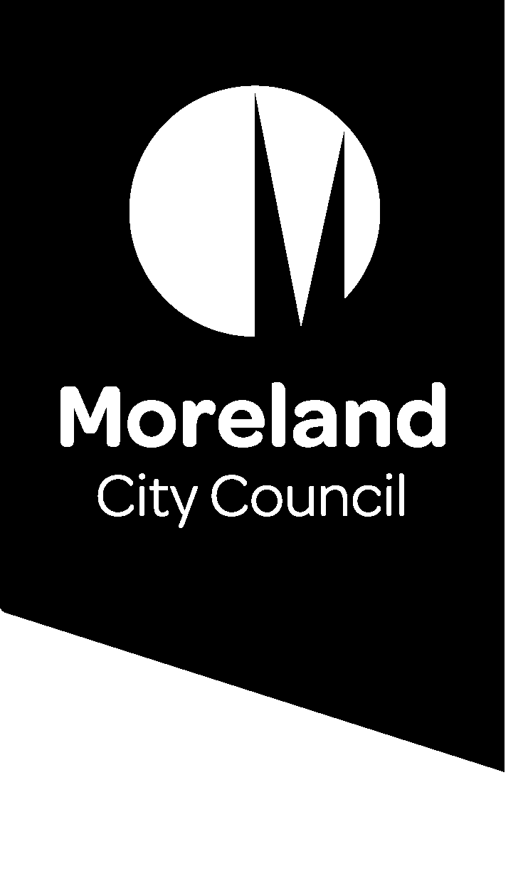

Moreland City Council

90 Bell Street

Coburg Victoria 3058

Telephone 61 3 9240 1111

Facsimile 61 3 9240 1212

info@moreland.vic.gov.au

www.moreland.vic.gov.au

Part C (1) - Submission by the Planning Authority Moreland City Council

Right of reply

Planning Scheme Amendment C208more

Implementation of the Moreland Heritage Nominations Study

**3 March 2022**

**TRIM: D22/66181**

# **Introduction**

1. This Part C submission is Council’s right of reply to issues and points of clarification that have been raised during the hearing as follows:

* Local Heritage Study alignment with Practice Note
* Social Significance
* Internal Controls
* Nominations process
* Nomination of Lorreto
* Consultation
* HO172 The Grove/Sydney Road Precinct and 31 The Avenue, Coburg
* Extension to HO85 - Glenmorgan Street Precinct
* Response to Submission 3: 26 Walsh Street, Coburg
* 28 McMahons Road, Coburg North Paint Controls
* Approach for CERES Park and Joe’s Market Garden

# **Response to issues raised by the Panel**

**Local Heritage Study alignment with Practice Note**

1. Planning Practice Note 1 sets out the requirements for the application of a heritage overlay. Of relevance is point four which states that:

Places identified in a local heritage study, provided the significance of the place can be shown to justify the application of the overlay.

1. The Practice Note further states that:

*The heritage process leading to the identification of the place needs to clearly justify the significance of the place as a basis for its inclusion in the Heritage Overlay. The documentation for each place shall include a statement of significance that clearly establishes the importance of the place and addresses the heritage criteria.*

1. The Practice Note also recognises heritage criteria (HERCON) shall be used for the assessment of the heritage value of the heritage place and that a comparative analysis methodology is used to apply a threshold and substantiate the significance of each place.
2. It is important to note that the level of expertise, length of experience of consultants engaged to prepare local heritage studies are not explicitly set out in the Practice Note nor the *Planning Panels Guide to Expert Evidence*.
3. Council is satisfied that the methodology employed by Extent Heritage to recommend application of a Heritage Overlay conforms with the requirements of Planning Practice Note 1 – Applying the Heritage Overlay and met all the requirements of the project brief to prepare a heritage study for the purpose of local heritage statutory protection.

**Social Significance**

1. The scope of the Moreland Heritage Nomination Study (MHNS) is outlined in the project brief at **Attachment 1**. This brief is consistent with the recommended Heritage Victoria guidance for Councils included at **Attachment 2**. This guidance does not specify any particular methodology in relation to criterion G and social significance.
2. The MHNS Stage 2 project brief sets out specific tasks for the heritage consultant which included; undertaking historical research and comparative analysis, and a detailed assessment of significance. A full assessment of the heritage significance of all identified places against the HERCON criteria was required to establish their significance including the preparation of a citation for each precinct/place. The brief required that assessment to include the following tasks:

Assessment Criteria

Assess the places against the HERCON model Criteria to establish, affirm or dismiss their cultural significance. The thresholds to be applied in the assessment shall be ‘State Significance’ and ‘Local Significance’. Places of Local Significance’ includes those places that are important to a particular community or locality. Letter or number grading (eg. “A”, “B”, “1”, “2” etc.) is not to be used. The significant components of each place should be identified. This will usually occur as a brief mention in the Statement of Significance.

Each heritage place linked to a theme and sub-theme as identified in the City of Moreland Thematic History. Any gaps identified in the thematical history through this process should be documented.

Architectural analysis of each place, including visual inspection from the street of all properties documented with photographs to clearly depict each place, evaluate the level of integrity and identify contributory and non-contributory elements.

In the assessment of heritage areas (precincts) the following must be identified:

* Individually significant buildings/places with a recommendation on whether the building should be included in an individual Heritage Overlay in addition to a precinct wide Heritage Overlay
* Contributory buildings/places.
* Non-contributory buildings/places.
* Other contributory elements within the precinct (eg. buildings/structures/trees /components such as bluestone that contribute to the heritage area). These other contributory elements should have a basic HERMES entry but do not need to be researched and documented. However, the Statement of Significance for the heritage area will need to acknowledge the contributory elements.

1. The assessment of a place against the HERCON model Criteria to establish, affirm or dismiss their cultural significance would have included an assessment of social significance if it was found to meet criterion G.
2. The key objective of the Stage 2 Study was to undertake a detailed heritage assessment of places identified in the Stage 1 Heritage Assessment of the 2016 public nominated places. Further work that was recommended by the study was beyond the scope of the project and required separate Council approval and the allocation of further funds.

**Internal Controls**

1. The application of internal controls was guided by Planning Practice Note 1 – Applying the Heritage Overlay. The project brief required that:

For those places recommended for a Heritage Overlay, the consultant shall complete a draft Schedule to the Heritage Overlay and Incorporated Document. The drafting of the schedule and Incorporated Document shall accord with the requirements of the Ministerial Direction - Form and Content of Planning Schemes and **VPP Practice Note 1 – Applying the Heritage Overlay** and Practice Note 13 – Incorporated and Background Documents. (emphasis added)

1. The assessment of internal controls provided to Council was considered to be applied selectively to the brutalist building at 31 The Avenue, Coburg. Specific reference to what is significant, as required by the practice note, states that the exposed concrete detailing to walls and ceilings within the building is significant, as well as the lightwell in the hallway.
2. Similarly, the reason for its significance is the same for the exterior and interior and is detailed in the statement as exhibiting high-quality aesthetic characteristics reflective of Late Twentieth- Century Brutalist design, with regards to the scale, geometric building form and use of off-form concrete. Furthermore, the exterior and interior represent a high degree of technical achievement, as related to the Brutalist era.
3. Council was satisfied that the assessment was based on photographic evidence of the interior of the building. The standard Heritage Victoria brief for local heritage studies does not require internal inspection. As such the fact that the Extent Heritage had not inspected the interior of the buildings was not questioned.
4. During the exhibition period, the owners of the site did not present evidence that would provide contrary evidence of any extensively modified features.

**Nominations Process**

1. As outlined in Council’s Part A submission, a public nomination process was conducted following the completion of Stage 1 of the MHGS in November 2016.
2. This nomination process included direct notification to community groups, heritage societies, church groups, rotary clubs. Posters inviting nominations to the heritage study were displayed at all Council facilities and libraries. Hard copy nomination forms were also made available at these locations and on request. An example of a completed nomination form is included in **Attachment 3**. In addition, nominations were collected via an online form and were also received via Councils corporate and strategic planning email accounts.
3. Additional nominations were received through various channels (email, telephone, letters and councillor requests) between the nomination period (November 2016) and the commencement of the Stage 1 nomination study (December 2018) when the heritage consultants were engaged.

**Nomination of Lorreto**

1. In Council’s experience, often additional places are identified whilst consultants are undertaking field work to ground truth places as part of the preparation of Local Heritage Studies. In addition, included in the project brief for the Stage 2 study, included this note:

Any additional places identified during research must be discussed with Council prior to their inclusion within the heritage study.

1. In the case of Lorreto the consultants that prepared the Stage 1 - Preliminary Assessment for the Moreland Heritage Nomination Study – Context Pty Ltd. identified that the place had potential for local heritage significance and included it in the Stage 1 Study and recommended further assessment.

**Consultation**

Consultation of the Moreland Heritage Nominations Study

1. Consultation of the Moreland Heritage Nomination Study was undertaken in accordance with section 19 of the planning and environment act as part of the exhibition of Amendment C208more. This is a common approach undertaken by Moreland with their previous studies as well as by other Councils.
2. As outlined in Council’s Part A submission, exhibition of the amendment included direct notification to:

* Relevant state government departments and Ministers
* All abutting Municipal Councils
* Statutory referral authorities operating within Moreland
* Owners and Occupiers of affected properties
* Owners and Occupiers of properties adjoining places proposed to be in a new HO
* Community members who nominated places in 2016
* Relevant community groups

1. To reach the wider community and ensure the community had an opportunity to learn about the Amendment, the following notification was also undertaken:

* Public notice in the Herald Sun and The Age on 23 August 2021
* Public notice in the Government Gazette on 26 August 2021
* C208more focused Facebook post on 31 August 2021
* C208more project page on Council’s website describing the Amendment and providing access to all the Amendment documentation and an online form to lodge a submission.

1. This process ensured that key historical groups and all owner and occupiers of the heritage places had an opportunity to review the study and provide additional historical information to improve and update the study.
2. As can be shown in the number of changes Council has made to the Amendment in response to submission, this consultation approach has enabled the study to be refined.

Interim Heritage Protection

1. The Moreland Nominations Heritage Study was completed in June 2020. Council endorsed the Study and a commitment to implement the recommendations of the Study by applying the Heritage Overlay to these properties on a permanent basis in August 2020.
2. Council is committed in the Heritage Action Plan 2017 to implement permanent heritage controls over all sites which are identified to be significant and at threat of demolition. An amendment made under the Minister’s prescribed powers was considered to be the best course of action to ensure the identified sites were protected on an interim basis while a separate amendment to introduce the same controls on a permanent basis was being processed. This assisted Council to adhere to its obligations under Section 4(1) of the Planning and Environment Act 1987 in relation to conserving places of local values.
3. At the time of the finalisation of the study, Moreland was experiencing an exceptional level of development pressure. This demonstrated an increased chance of threat to the loss of local heritage and subsequent resourcing pressure to seek interim protection for separate places. Council considered it most effective to apply interim heritage controls to the places identified as being locally significant by the Moreland Heritage Nominations Study to avoid the threat of demolition. Interim heritage controls also ensured that the community and developers were informed of the significance of a property prior to preparing costly development applications.

**HO172 The Grove/Sydney Road Precinct and 31 The Avenue, Coburg**

Changes to HO172 (The Grove/Sydney Road Precinct) based on Dr James recommendations

1. The Statement of Significance for HO172 – The Grove/Sydney Road Precinct does not include any reference to 31 The Avenue Coburg. This omission in the statement is a key reason for the additional research to understand what, if any, contribution 31 The Avenue Coburg has to HO172.
2. Dr James findings have concluded that 31 The Avenue Coburg contains no fabric that contributes to The Grove/Sydney Road Precinct. As the statement of significance does not reference 31 The Avenue Coburg, no changes are required to the statement.
3. The following documents as requested by Panel have been included as Attachments:

* **Attachment 4** –Heritage Assessment 31 The Avenue Coburg by Diahnn Sullivan - June 2012
* **Attachment 5** - Council’s brief to Extent Heritage for this additional analysis on relationship of 31 The Grove Coburg to HO172
* **Attachment 6** - HO172 The Grove Sydney Road Precinct Heritage Citation

**Extension to HO85 - Glenmorgan Street Precinct**

1. The citation prepared by Extent Heritage for the extension to HO85 – Glenmorgan Street Precinct renames this precinct to incorporate the additional street names of properties proposed to be included in this precinct – Albion and Clarence Streets. The proposed Statement of Significance also combines these additional streets into the one citation.

*The following statement of significance is an amendment to the existing statement of significance for the Glenmorgan Street Precinct (HO85) (see Hermes ID 56060) to include 26-78 Albion Street and 11-45 & 20-46 Clarence Street, Brunswick East. New or updated text is shown underlined.*

1. It is Council’s position that the Statement of Significance for HO85 is supported as per the exhibited version with the changes proposed by Dr James in his Expert Evidence Statement. A full copy of the citation for the proposed extended HO85 has been included at **Attachment 7**.

**Response to Submitter 3 – 26 Walsh Street Coburg**

1. Submitter 3 was concerned that Amendment C208more would result in the removal of the existing HO444 to 26 Walsh Street Coburg with the inclusion of the Walsh Street Precinct.
2. 26 Walsh Street Coburg is locally significant to Moreland in its own right and is currently protected by the Moreland heritage overlay (HO444). Heritage protection for this place was introduced into the Moreland Planning Scheme by Amendment C174more on 5 January 2021.
3. Due to the significance of 26 Walsh Street Coburg, it was communicated that it was appropriate for the property to retain its individually significant place listing rather than being included in the proposed HO599 - Walsh Street Precinct. As such, Amendment C208more proposes no changes to 26 Walsh Street’s heritage significance or its status in the Moreland Heritage Overlay.

**Paint Controls to 28 McMahons Road Coburg North**

1. In preparation of the Moreland Heritage Nominations Study, Extent Heritage included a draft Schedule to Clause 43.01 for the study places and precincts. This included including “Yes” in ‘External Paint Controls’ column of the proposed listing for 28 McMahons Road Coburg North. Below is an extract of this recommendation that was intended to be exhibited (full document included at **Attachment 8**).

What was intended to be exhibited

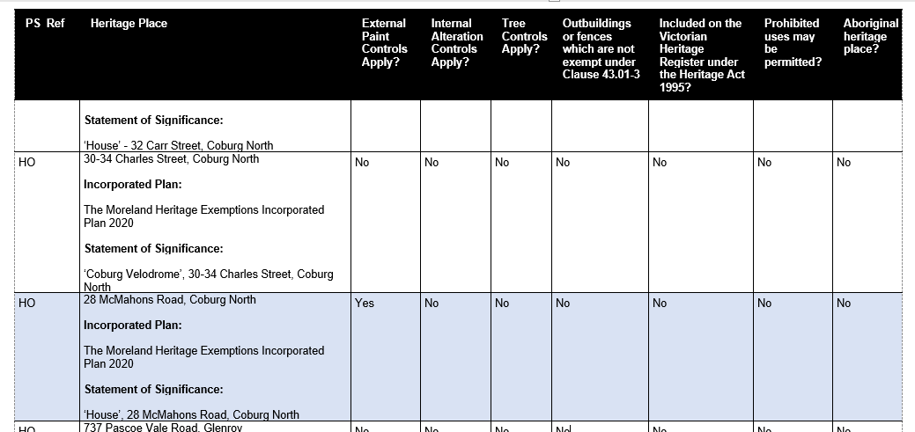

1. Council used the DELWP’s Amendment Tracking System (ATS) to draft the formal Amendment documentation, including the Schedule to Clause 43.01. The ATS operates by requiring updates to provisions when affected by other active amendments. At the time of authorising this drafting, the MHGS was being processed and caused confusion in the drafting of this provision. Version control within the ATS to integrate gazetted and proposed provisions can be problematic and has resulted in a clerical error. In particular, the clerical error that occurred in translating the recommendations of the Moreland Heritage Gap Study, with an omission of ‘Yes’ being applied to ‘External Paint Controls Apply?’ cell in the proposed Schedule to Clause 43.01 - Heritage Overlay to the proposed HO583 (28 McMahons Road Coburg North) listing.
2. Below is a extract of what was exhibited in the Schedule to Clause 43.01 in relation to 28 McMahons Road Coburg and what was intended to be exhibited:

What was exhibited

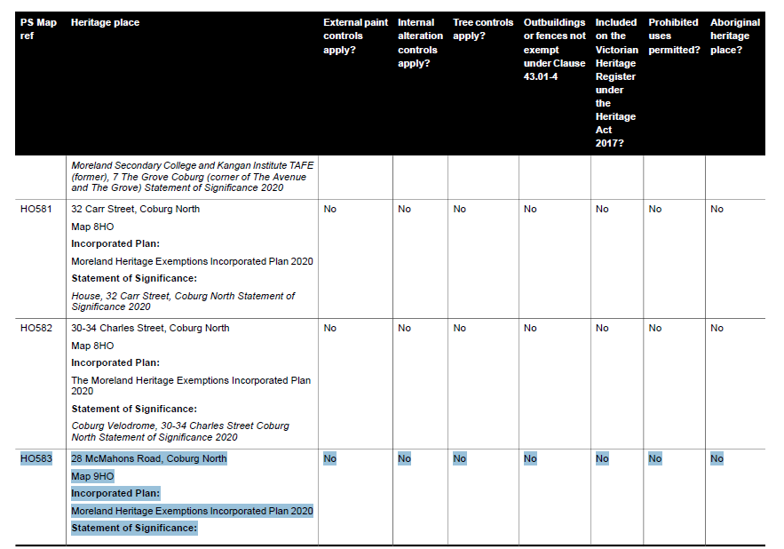

1. Council’s current position is based on Dr James recommendation that 28 McMahons Road Coburg should not have ‘External Paint Controls’ apply (a no in the cell).
2. Clause 43.01 (Heritage Overlay) outlines that a planning permit is required to ‘Externally paint an unpainted surface’. These permit requirements are adequate to ensure that any painting to the facebrick of 28 McMahons Road Coburg is considered through a planning permit process to ensure the heritage values of the place is maintained. Therefore additional conditions relating to external paint controls are not considered necessary.

**Approach for CERES Park and Joe’s Market Garden**

1. The heritage value of CERES Park and Joe’s Market Garden have not been disputed and Council Officers agree with Mr Duncan that a Conservation Management Plan (CMP) is beneficial for these sites.
2. The Moreland Heritage Action Plan 2017 sets out the work plan for heritage related work across Council under four key themes Knowing, Protecting, Supporting and Communicating. The current plan is close to completion and new actions are currently being prepared to create a new heritage work plan for the next cycle. It is anticipated that this updated plan will be presented to Council mid year to endorse. As outlined in Council’s Part B (1) submission, new actions to prepare CMPs for both CERES Park and Joe’s Market Garden will be included in this updated workplan presented to Council.
3. It is Council’s view that a two-step approach to recognising and managing the heritage of CERES Park and Joe’s Market Garden is an appropriate approach, being:

* First Step - Applying the Heritage Overlay to these two sites to recognise the local significance of both CERES Park and Joe’s Market Garden
* Second Step – Preparation of a CMP for each to help with the ongoing management of the heritage values of the site.

1. Council does not see any implications with this approach. In fact, the application of the Heritage Overlay will provide greater strength for the preparation of a CMP for each place.

# **Conclusion**

1. Amendment C208more seeks to implement the recommendations from the MHNS prepared for Council by expert heritage consultants Extent Heritage.
2. Implementation of the recommendation of this study is part of Council’s ongoing commitment to identify and protect the municipality’s heritage fabric for current and future generations.
3. It further fulfils Council’s statutory obligations as a responsible authority to implement the objectives of the Planning and Environment Act 1987, and to implement State and Local objectives, strategies in the Planning Policy Framework, Plan Melbourne and Municipal Planning Strategy as well as relevant guidelines and practice notes.
4. In Council’s view, the MHNS provides a comprehensive and robust analysis of the identified heritage significance of buildings and precincts within the municipality. In undertaking that exercise, a rigorous assessment of the identified heritage elements of each place has been very carefully documented.
5. Council appreciates the submissions that contest the heritage significance of the places recommended to be included in the HO. These submissions have assisted Council and its heritage consultants in providing a further assessment of the various sites and more rigorously applying the criteria of heritage significance.
6. In a number of cases it has resulted in the review of citations which further support and highlight the heritage value of the various buildings, the removal of some properties from the Amendment or a change in the heritage grading of others.
7. It is respectfully submitted that the Panel recommend adoption of Amendment C208more with the changes supported by Council and proposed in this submission.
8. This concludes Council’s Part C (1) Submission.

**END OF PART C (1) SUBMISSION**

# **Attachments**

Attachment 1 - Brief for Stage 2 of the Moreland Heritage Nominations Study

Attachment 2 – Heritage Victoria Model Consultants Brief for Heritage Consultants

Attachment 3 – Moreland Heritage Gap Study Place Nomination Form

Attachment 4 – Heritage Assessment of 31 The Avenue Coburg by Diahnn Sullivan

Attachment 5 – Brief for further assessment of 31 The Avenue Coburg relationship with HO172

Attachment 6 - HO172 The Grove Sydney Road Precinct Heritage Citation

Attachment 7 – HO85, Glenmorgan, Albion and Clarence Streets Precinct Citation

Attachment 8 – Moreland Heritage Nominations Study recommended Schedule to Clause 43.01 by Extent Heritage