SCHEDULE 20 TO THE DESIGN AND DEVELOPMENT OVERLAY
11/08/2016
Proposed C164
Shown on the planning scheme map as DDO20.
Brunswick Activity Centre – Nicholson Street Local Area
1.0 Design objectives
11/08/2016
Proposed C164

Built form
- To create a new mid-rise built form character that accommodates buildings generally ranging from 3 to 6 storeys.
- To ensure highly visible development is limited to key redevelopment sites and responds to specific design objectives.
- To ensure development does not dominate and obstruct sightlines to existing key churches and iconic sites.
- To establish a consistent street wall along the western side of Nicholson Street between Miller Street and Albert Street.
- To provide a built form transition from the Nicholson Street Activity Corridor to adjoining low-rise residential areas.
- To ensure building design incorporates best practice environmentally sustainable design initiatives.
- To ensure development is designed to respect the form and design of civic buildings and heritage places.
- To create accessible, adaptable and visitable housing within the activity to ensure housing caters for all residents’ needs.
Moreland Industrial Land Strategy - Category 2 Employment Areas
- To encourage development to provide residential accommodation only where it is located above ground floor and first floor employment spaces.
- To encourage commercial design built forms at ground and first floor of development.
- To encourage commercial activation at the ground level of development.

Public realm
- To create an inviting, safe and vibrant public realm.
- To protect and enhance the amenity of existing public open spaces.
- To maintain solar access to key pedestrian streets and existing and proposed public open space
Amenity
- To maintain reasonable amenity for residential properties adjacent to and within the activity centre.
2.0 Permit requirement
11/08/2016
C134

A permit is not required if the subject site forms part of a development plan approved in accordance with Schedule 11 to the Development Plan Overlay (DPO11).
3.0 Buildings and works
11/08/2016
Proposed C164

Exemptions
No permit is required to:
- Install an automatic teller machine.
- Alter an existing building facade provided that:
- The alteration does not include the installation of an external roller shutter.
- At least 80 per cent of the building facade at ground floor level is maintained as an entry or window with clear glazing.
- Construct or extend one dwelling on a lot of more than 300 square metres. This exemption does not apply to:
- Construct a dwelling if there is at least one dwelling existing on the lot.
- Construct or extend a dwelling if there are two or more dwellings on the lot.
- Construct or extend a dwelling if it is on common property.
- Construct or extend a front fence within 3 metres of a street if the fence is associated with 1 or more dwellings on a lot or a residential building, and the fence exceeds the maximum height specified in Clause 55.06-2.
- Construct or carry out works normal to a dwelling.
- Construct or extend an outbuilding (other than a garage or carport) on a lot provided the gross floor area of the outbuilding does not exceed 10 square metres and the maximum building height is not more than 3 metres above ground level.
Building height
- Building height should not exceed the preferred maximum building heights as shown in Nicholson Street Local Area Built Form Controls, Map 1A (North) and Map 1B (South).
- Building height is the vertical distance between the footpath or natural surface level at the centre of the site frontage and the highest point of the building. This does not include architectural features and service equipment including plant rooms, lift overruns, structures associated with green roof areas and other such equipment provided that the following criteria are met:
- Not more than 50% of the roof area is occupied by the equipment (other than solar panels);
- The equipment is located in a position on the roof so as to minimise additional overshadowing or neighbouring properties and public spaces;
- The equipment does not extend higher than 3.6 metres above the maximum building height; and
- The equipment and screening is integrated into the design of the building to the satisfaction of the responsible authority.
- Development on sites where no maximum building height is detailed in Map 1A (North) and Map 1B (South) should demonstrate:
- How the proposed overall building height responds to its context including any identified heritage places; and
- How the design objectives and requirements of this schedule have been met.
- The height of any building (including services) on 120, 122 and 124 Nicholson must not impact on the Fresnel Zone associated with radio transmissions from 221 Nicholson Street, Brunswick East. A permit cannot be granted to vary this requirement.
Street walls
- Street wall heights should not exceed the preferred maximum height specified in Map 1A (North), Map 1B (South) and Diagram 1: Nicholson Street Local Area Section Diagrams.
- Development that seeks to vary the upper storey setbacks detailed in Map 1A (North), Map 1B (South) and Diagram 1 should demonstrate how the design objectives and requirements of this schedule will be met.
Upper levels
- Development above the street wall height or behind an existing parapet should be:
- Set back at least the minimum distance specified in Map 1A (North), Map 1B (South) and Diagram 1. Balconies must not intrude into this setback.
- Designed to differentiate it from the building’s street wall component through façade articulation; and materials.
- Materials at the upper levels of the building should be distinct from materials of the lower levels of the building.
- The architectural expression of the upper level and lower building components should be complementary and upper levels should be visually recessive.
- Development that seeks to reduce the upper level setback specified on Map 1A (North), Map 1B (South) and Diagram 1 should demonstrate how the design objectives will be met.
Setbacks to residential land
- Any part of a building adjacent to residentially-zoned land outside the activity centre (including across a lane) should be set back from the residential boundary at that interface by a dimension equivalent to its height above 5 metres, up to a maximum setback of 10 metres as shown in Figure 1 below. This equates to:
- A maximum height of 5 metres at the common boundary.
- A maximum height of 8 metres where the site is separated from the adjacent residential property by a 3 metre wide lane.
- A maximum height of 11 metres where existing lanes are widened to 6 metres.
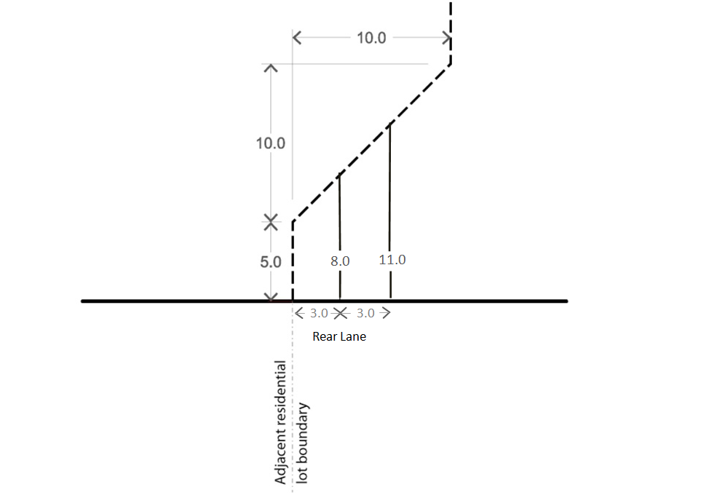

Figure 1: Setbacks adjacent to residentially zoned land outside the activity centre
Buildings layout and detailed design
- Development should incorporate active edges at street level fronting all streets (except rear access lanes) in accordance with Map 12: Precinct 3A, Map 14 Precinct 3B and Map 14: Precinct 3C as shown in the Brunswick Structure Plan Local Area Three – Nicholson Street to invigorate street life and contribute to a safe and pedestrian friendly environment. The frontages are as follows:
- Frontage Type A: Retail (shown in the Brunswick Structure Plan as Type A) A display window and/or entrance, measuring at least 80% of the width of the street frontage of each individual premises.
- Frontage Type B: Commercial (shown in the Brunswick Structure Plan as Type B) A display window and/or entrance, measuring at least 60% of the width of the street frontage of each individual premise.
- Frontage Type C: Residential (this requirement applies to property adjacent to other streets laneways or public land not covered by active frontages type A and B) Individual entry doors to ground floor dwellings. Privacy is to be provided by elevating the ground floor approximately 0.5 to 1 metre above the street level and/or provide a landscaped front setback.
- Development should incorporate windows in all upper level facades facing streets.
- Development should minimise the impact of vehicle access and car parking on the public realm by:
- Locating vehicle access at the rear of buildings where possible;
- On secondary frontages, rear access is preferred but where vehicle access is not possible, it should be provided to the side of corner properties away from the front facade; and
- Locating car parking where it cannot be seen from the public realm.
- In commercial and mixed use zones, development should have a ground floor ceiling height that allows for a range of appropriate uses.
- In commercial zones, development should incorporate awnings over the footpath for the full width of the building frontage.
- Services cabinets should be located at the rear of buildings wherever possible, or the side of corner buildings away from the front façade where rear access is not available. Where they can only be located in the front façade, the size of services cabinets should be minimised and they should be integrated with the overall façade design.
- Building facades on the street boundaries of Nicholson Street should incorporate vertical articulation to reinforce the prevailing pattern of subdivision and buildings.
Moreland Industrial Land Strategy - Category 2 Employment Areas
- Development within Category 2 – Employment Areas should achieve commercial built form outcomes, including increased floor to ceiling heights and flexible floor plates, at ground and first floor to facilitate opportunities for employment uses.
- Ground floor commercial spaces should provide for activation, for example through entrances, transparent glazing and architectural features which encourage interaction and visual interest.

4.0 Subdivision
11/08/2016
C134

Subdivision of existing sites not associated with a development proposal that achieves the design objectives and requirements of this schedule is discouraged.
5.0 Exemption from notice and review
11/08/2016
C134

An application to construct a building or construct or carry out works is exempt from the notice requirements of Section 52(1) (a), (b) and (d), the decision requirements of Section 64(1), (2) and (3) and the review rights of Section 82(1) of the Planning and Environment Act 1987 (the Act) unless the proposal seeks to do any of the following:
- Exceed the preferred maximum building height specified in section 3.0 of this schedule, or
- Exceed the preferred maximum street wall height specified in section 3.0 of this schedule, or
- Reduce the setbacks above the street wall specified in section 3.0 of this schedule, or
- Reduce the rear setback requirements specified in section 3.0 of this schedule.
An application to subdivide land is exempt from the notice requirements of Section 52 (1) (a), (b) and (d), the decision requirements of Section 64 (1), (2) and (3) and the review rights of Section 82 (1) of the Act.
6.0 Decision Guidelines
11/08/2016
Proposed C164

Before deciding on an application, the responsible authority must consider, as appropriate:
- The Brunswick Structure Plan (Local Area Three – Nicholson Street).
- The Moreland Industrial Land Strategy 2015-2030
- Whether any proposal seeking to vary the upper level setbacks meet the design objectives of the schedule.
- The opportunities and constraints of the site, including whether the maximum building height is achievable having regard to lot size, dimensions (width and depth) and/or those sites within or adjoining the Heritage Overlay or any other relevant consideration.
7.0 References
11/08/2016
Proposed C164

Brunswick Structure Plan, Moreland City Council, August 2010
Addendum to Brunswick Structure Plan, Moreland City Council, June 2012
Moreland Industrial Land Strategy 2015-2030, Moreland City Council
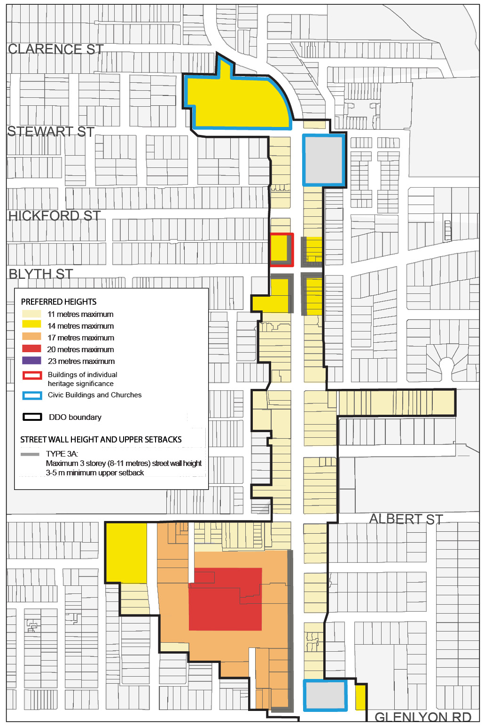
Map 1A: Nicholson Street Local Area Built Form Controls (North)
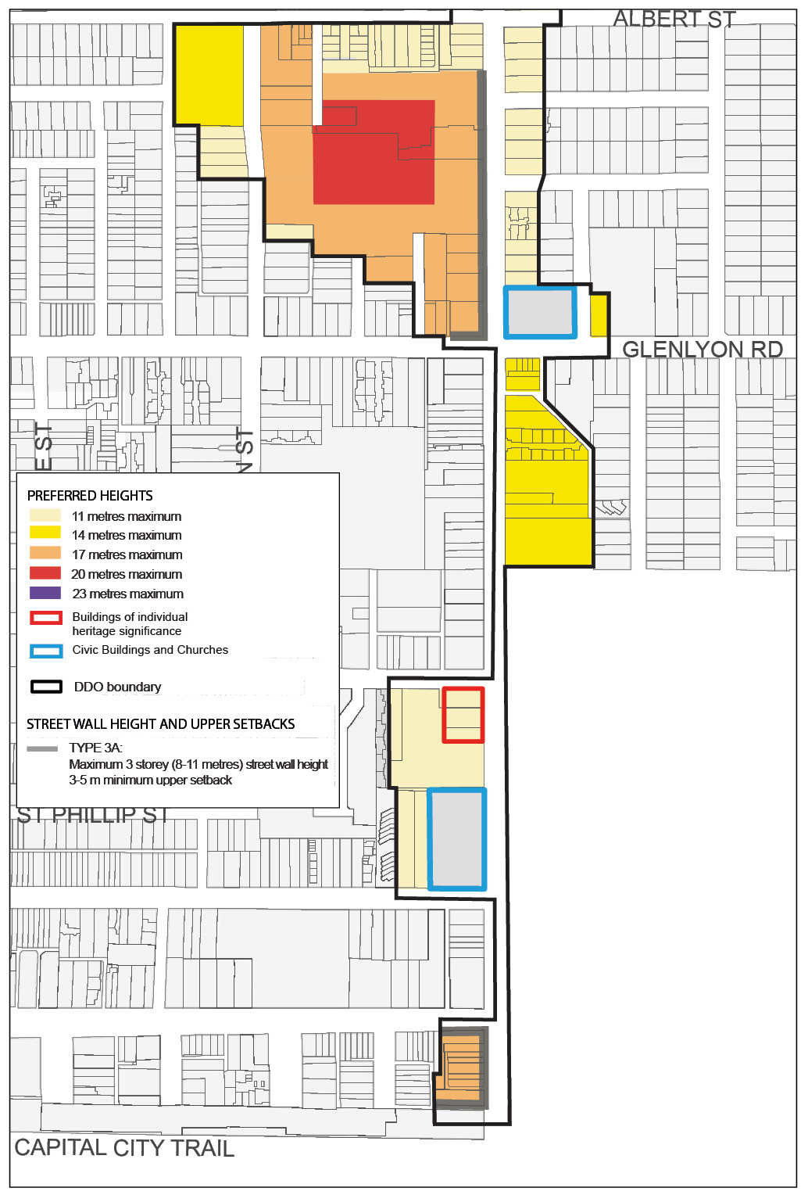
Map 1B: Nicholson Street Local Area Built Form Controls (South)
Diagram 1: Nicholson Street Local Area Section Diagrams

