SCHEDULE 19 TO THE DESIGN AND DEVELOPMENT OVERLAY
11/08/2016
Proposed C164
Shown on the planning scheme map as DDO19.
Brunswick Activity Centre – Lygon Street Local Area
1.0 Design objectives
11/08/2016
Proposed C164

Built form
- To create a new mid rise built form character that accommodates buildings generally ranging from 3 to 9 storeys.
- To reinforce the fine grain character of Lygon Street.
- To ensure highly visible development is limited to identified key redevelopment sites and responds to specific design objectives.
- To retain views along Lygon Street to buildings of individual heritage significance.
- To ensure the street wall remains the visually dominant element of all development in Lygon Street and that any height above the street wall is visually recessive, subservient and does not dominate the streetscape appearance.
- To provide a built form transition between the Lygon Street Activity Corridor and adjoining low-rise residential areas.
- To ensure building design incorporates best practice environmentally sustainable design initiatives.
- To ensure development is designed to respect the form, design and context of buildings of individual heritage significance.
- To create accessible, adaptable and visitable housing within the activity centre to ensure housing caters for all residents’ needs.
Moreland Industrial Land Strategy - Category 2 Employment Areas
- To encourage development to provide residential accommodation only where it is located above ground floor and first floor employment spaces.
- To encourage commercial design built forms at ground and first floor of development.
- To encourage commercial activation at the ground level of development.

Public realm
- To create an inviting, safe and vibrant public realm.
- To protect and enhance the amenity of existing public open spaces.
- To maintain solar access to key pedestrian streets and existing and proposed public open space.
Amenity
- To maintain reasonable amenity for residential properties adjacent to and within the activity centre.
2.0 Buildings and works
11/08/2016
Proposed C164
Exemptions
No permit is required to:
- Install an automatic teller machine.
- Alter an existing building facade provided that:
- The alteration does not include the installation of an external roller shutter.
- At least 80 per cent of the building facade at ground floor level is maintained as an entry or window with clear glazing.
- Construct or extend one dwelling on a lot of more than 300 square metres. This exemption does not apply to:
- Construct a dwelling if there is at least one dwelling existing on the lot.
- Construct or extend a dwelling if there are two or more dwellings on the lot.
- Construct or extend a dwelling if it is on common property.
- Construct or extend a front fence within 3 metres of a street if the fence is associated with 1 or more dwellings on a lot or a residential building, and the fence exceeds the maximum height specified in Clause 55.06-2.
- Construct or carry out works normal to a dwelling.
- Construct or extend an outbuilding (other than a garage or carport) on a lot provided the gross floor area of the outbuilding does not exceed 10 square metres and the maximum building height is not more than 3 metres above ground level.
Building height
- Building height should not exceed the preferred maximum building heights as shown in Lygon Street Local Area Built Form Controls, Map 1A (North) and Map 1B (South).
- Building height is the vertical distance between the footpath or natural surface level at the centre of the site frontage and the highest point of the building. This does not include architectural features and service equipment including plant rooms, lift overruns, structures associated with green roof areas and other such equipment provided that the following criteria are met:
- Not more than 50% of the roof area is occupied by the equipment (other than solar panels);
- The equipment is located in a position on the roof so as to minimise additional overshadowing or neighbouring properties and public spaces;
- The equipment does not extend higher than 3.6 metres above the maximum building height; and
- The equipment and screening is integrated into the design of the building to the satisfaction of the responsible authority.
Buildings of individual heritage significance
- Development on sites containing buildings of individual heritage significance shown on Map 1A (North) and Map 1B (South) should demonstrate:
- How the proposed building height responds to the heritage significance of the site and its context; and
How the design objectives have been met.
Street walls
- Street wall heights should not exceed the street wall heights specified on Map 1A (North), Map 1B (South) and Diagram 1: Lygon Street Local Area Section Diagrams.
- Development on key redevelopment sites identified in Map 1 should demonstrate how the specific design objectives set out in Table 1 have been met.
- Development on sites containing buildings of individual heritage significance shown on Map 1A (North) and Map 1B (South) where no preferred maximum street wall height is specified should demonstrate:
- Whether a street wall is appropriate having regard to the heritage significance of the site and its context;
- How the proposed street wall height responds to the heritage significance of the site and its context; and
- How the design objectives have been met.
- Development that seeks to vary the upper storey setbacks detailed in Map 1A (North), Map 1B (South) and Diagram 1 should demonstrate how the design objectives and requirements of this schedule will be met.
Upper levels
- Development above the street wall height or behind an existing parapet should be:
- Set back at least the minimum distance specified in Map 1A (North), Map 1B (South) and Diagram 1. Balconies must not intrude into this setback.
- Designed to differentiate it from the building’s street wall component through façade articulation and materials.
- Material at the upper levels of buildings should be distinct from materials of the levels of the building.
- The architectural expression of the upper levels and lower level building components should complementary and upper levels should be visually recessive.
- Development that seeks to reduce the upper level setback specified on Map 1A (North), Map 1B (South) and Diagram 1 should demonstrate how the design objectives will be met.
Buildings of individual heritage significance
- Development on sites containing buildings of individual heritage significance shown on Map 1A (North), Map 1B (South) where no preferred maximum upper level setback is specified should demonstrate:
- How the proposed upper level setback responds to the heritage significance of the site and its context; and
- How the design objectives have been met.
Setbacks to residential land
- Any part of a building adjacent to residentially zoned land outside the activity centre (including across a lane) should be set back from the residential boundary at that interface by a dimension equivalent to its height above 5 metres, up to a maximum setback of 10 metres as shown in Figure 1 below. This equates to:
- A maximum height of 5 metres at the common boundary.
- A maximum height of 8 metres where the site is separated from the adjacent residential property by a 3 metre wide lane.
- A maximum height of 11 metres where existing lanes are widened to 6 metres.
Figure 1: Setbacks adjacent to residentially zoned land outside the activity centre
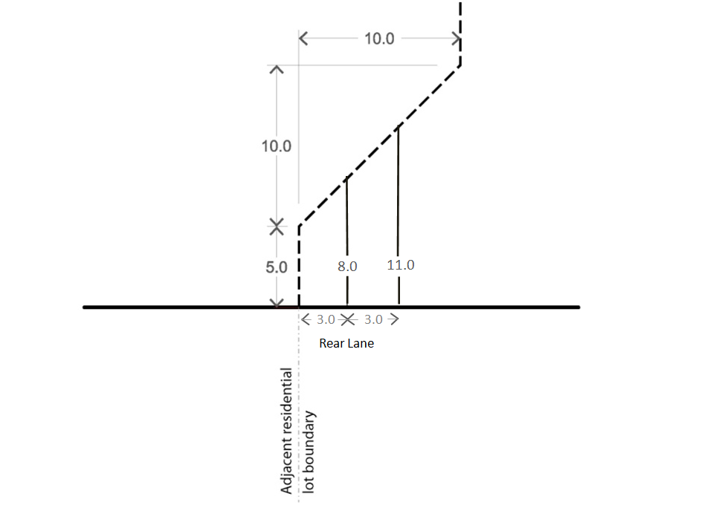
Building layout and detailed design
- Development should incorporate active edges at street level fronting all streets (except rear access lanes) in accordance with Map 12: Precinct 2A, Map 14 Precinct 2B and Map 16: Precinct 2C as shown in the Brunswick Structure Plan, Local Area Two – Lygon Street to invigorate street life and contribute to a safe and pedestrian friendly environment The frontage types are as follows:
- Frontage Type A: Retail (shown in the Brunswick Structure Plan as Type A) A display window and/or entrance, measuring at least 65% - 80% of the width of the street frontage of each individual premises.
- Frontage Type B: Commercial (shown in the Brunswick Structure Plan as Type B) A display window and/or entrance, measuring at least 60% of the width of the street frontage of each individual premise.
- Frontage Type C: Residential (this requirement applies to property adjacent to other streets laneways or public land not covered by active frontages type A and B) Individual entry doors to ground floor dwellings. Privacy is to be provided by elevating the ground floor approximately 0.5 to 1 metre above the street level and/or provide a landscaped front setback.
- Development should incorporate windows in all upper level facades facing streets.
- Development should minimise the impact of vehicle access and car parking on the public realm by:
- Locating vehicle access at the rear of buildings where possible;
- On secondary frontages, rear access is preferred but where vehicle access is not possible should be provided to the side of corner properties away from the front facade; and
- Locating car parking where it cannot be seen from the public realm.
- In commercial and mixed use zones, development should have a ground floor ceiling height that allows for a range of appropriate uses.
- In commercial zones, development should incorporate awnings over the footpath for the full width of the building frontage.
- Services cabinets should be located at the rear of buildings wherever possible, or the side of corner buildings away from the front façade where rear access is not available. Where they can only be located in the front façade, the size of services cabinets should be minimised and they should be integrated with the overall façade design.
- Building facades on the street boundaries of Lygon Street should incorporate vertical articulation to reinforce the fine-grain the prevailing pattern of subdivision and buildings.
Moreland Industrial Land Strategy - Category 2 Employment Areas
- Development within Category 2 – Employment Areas should achieve commercial built form outcomes, including increased floor to ceiling heights and flexible floor plates, at ground and first floor to facilitate opportunities for employment uses.
- Ground floor commercial spaces should provide for activation, for example through entrances, transparent glazing and architectural features which encourage interaction and visual interest.

3.0 Subdivision
11/08/2016
C134
Subdivision of existing sites not associated with a development proposal that achieves the design objectives and requirements of this schedule is discouraged.
4.0 Exemption from Notice and Review
11/08/2016
C134

An application to construct a building or construct or carry out works is exempt from the notice requirements of Section 52(1) (a), (b) and (d), the decision requirements of Section 64(1), (2) and (3) and the review rights of Section 82(1) of the Planning and Environment Act 1987 (the Act) unless the proposal seeks to do any of the following:
- Exceed the preferred maximum building height specified in section 2.0 of this schedule, or
- Exceed the preferred maximum street wall height specified in section 2.0 of this schedule, or
- Reduce the setbacks above the street wall specified in section 2.0 of this schedule, or
- Reduce the rear setback requirements specified in section 2.0 of this schedule.
An application to subdivide land is exempt from the notice requirements of Section 52 (1) (a), (b) and (d), the decision requirements of Section 64 (1), (2) and (3) and the review rights of Section 82 (1) of the Act.
5.0 Decision Guidelines
11/08/2016

Proposed C164

Before deciding on an application, the responsible authority must consider, as appropriate:
- The Brunswick Structure Plan (Local Area Two – Lygon Street).
- The Moreland Indsutrial Land Strategy 2015-2030
- The opportunities and constraints of the site.
- Whether the maximum building height is achievable having regard to the heritage significance of the site or an adjoining site within the Heritage Overlay.
6.0 References
11/08/2016
Proposed C164

Brunswick Structure Plan, Moreland City Council, August 2010
Addendum to Brunswick Structure Plan, Moreland City Council, June 2012
Moreland Industrial Land Strategy 2015-2030, Moreland City Council
Table 1 – Design Objectives for Key Redevelopment Sites
Lygon Street Northern Gateway
Precinct Design Objectives
To ensure new development contributes to the overall legibility of the Lygon Street Local Area and Brunswick Activity Centre as a whole by defining a high quality gateway at the northern end of Lygon Street.
To enhance the character of the precinct with a new high quality, highly visible and accessible open space adjacent the intersection of Lygon and Albion streets.
To enhance the view corridor from Holmes Street on approach from the north.
To enhance the view corridor from Lygon Street on approach from the south.
To ensure new development does not dominate the Lyndhurst Hotel.
To protect identified heritage places to the east side of Lygon Street.
To integrate high quality public open space into the redevelopment of the property at 1 Holmes Street.
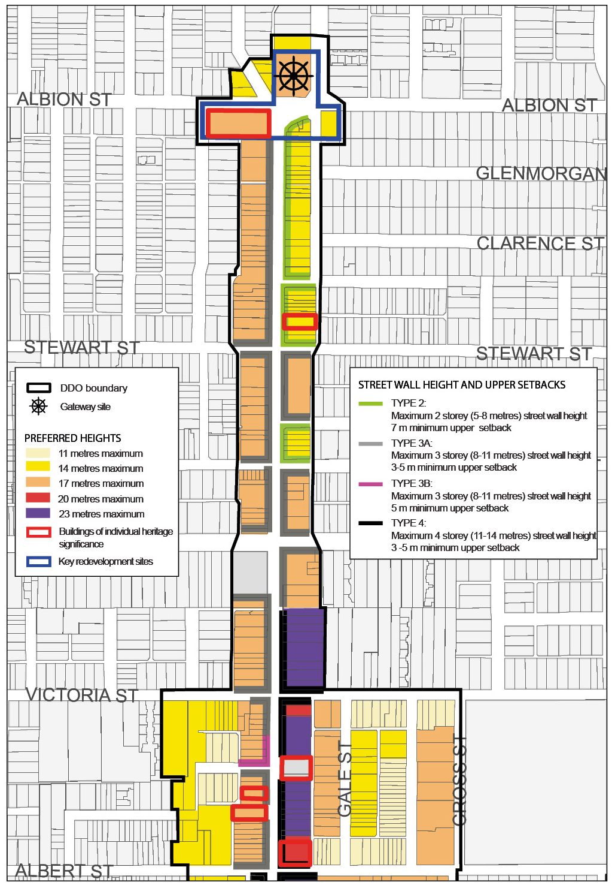
Map 1A: Lygon Street Local Area Built Form Controls (North)
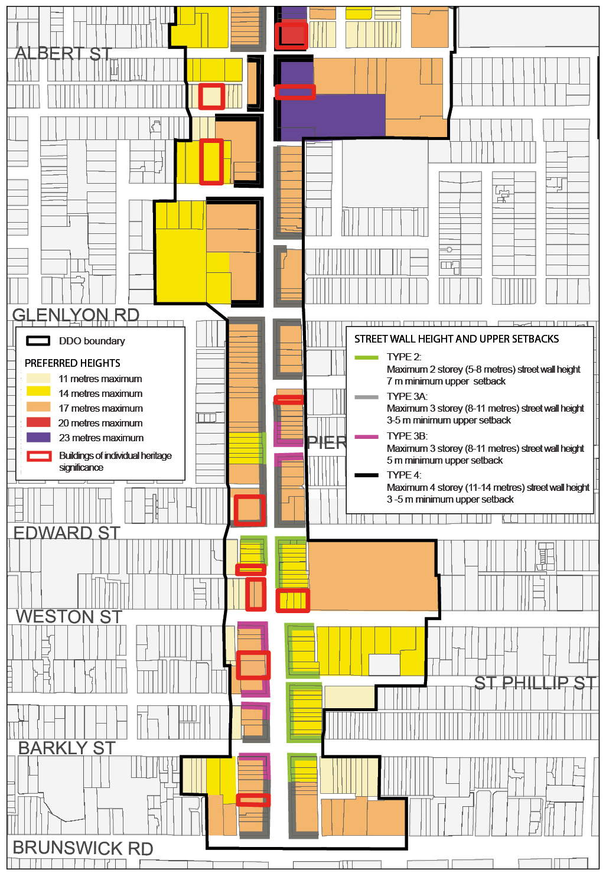
Map 1B: Lygon Street Local Area Built Form Controls (South)
Diagram 1: Lygon Street Local Area Section Diagrams (South)

