SCHEDULE 18 TO THE DESIGN AND DEVELOPMENT OVERLAY
11/08/2016
Proposed C164
Shown on the planning scheme map as DDO18.
Brunswick Activity Centre - Sydney Road and Upfield Corridor
1.0 Design objectives
11/08/2016
Proposed C164
Built form
- To encourage a new mid-rise built form character with buildings generally ranging from 4-10 storeys with lower built form at the interfaces with the adjoining low rise residential areas.
- To complement the valued built form and heritage character along Sydney Road.
- To ensure the street wall remains the visually dominant element of all development in Sydney Road and that any height above the street wall is visually recessive, subservient and does not dominate the streetscape appearance.
- To ensure new street wall heights along Sydney Road complement the prevailing Victorian and Edwardian streetscape character.
- To reinforce the fine grain character of Sydney Road.
- To establish a new built form character in off-corridor locations to the east and west of Sydney Road to achieve an appropriate balance between a sense of enclosure and openness by applying a 1:1 ratio of building height to distance from the opposite side of the street boundary.
- To ensure new street walls reinforce the existing character of street walls in nominated off-corridor streets.
- To ensure building design incorporates best practice environmentally sustainable design initiatives.
- To ensure development is designed to respect the form, design and context of buildings of individual heritage significance.
- To retain views along Sydney Road to landmark buildings of individual heritage significance.
- To create accessible, adaptable and visitable housing within the activity centre to ensure housing caters for all residents’ needs.
Moreland Industrial Land Strategy - Category 2 Employment Areas
- To encourage development to provide residential accommodation only where it is located above ground floor and first floor employment spaces.
- To encourage commercial design built forms at ground and first floor of development.
- To encourage commercial activation at the ground level of development.

Public realm
- To create an inviting, safe and vibrant public realm.
- To ensure new development around the Jewel, Brunswick and Anstey Railway Stations includes the provision of well designed public spaces that integrate with the Upfield Shared Path and improve visibility of and access to the railway station buildings.
- To protect the amenity of existing and proposed public open spaces.
- To maintain solar access to key pedestrian streets and existing and proposed public open space.
Amenity
- To maintain reasonable amenity for residential properties within and adjacent to the activity centre.
2.0 Buildings and works
11/08/2016
Proposed C164
Exemptions
No permit is required to:
- Install an automatic teller machine.
- Alter an existing building facade provided that:
- The alteration does not include the installation of an external roller shutter; and
- At least 80 per cent of the building facade at ground floor level is maintained as an entry or window with clear glazing.
- Construct or extend one dwelling on a lot of more than 300 square metres. This exemption does not apply to:
- Construct a dwelling if there is at least one dwelling existing on the lot;
- Construct or extend a dwelling if there are two or more dwellings on the lot;
- Construct or extend a dwelling if it is on common property; and
- Construct or extend a front fence within 3 metres of a street if the fence is associated with 1 or more dwellings on a lot or a residential building, and the fence exceeds the maximum height specified in Clause 55.06-2.
- Construct or carry out works normal to a dwelling.
- Construct or extend an outbuilding (other than a garage or carport) on a lot provided the gross floor area of the outbuilding does not exceed 10 square metres and the maximum building height is not more than 3 metres above ground level.
Building height
- Building height should not exceed the preferred maximum building heights as shown in the Sydney Road and Upfield Corridor Overall Building Heights, Map 1A (North) and Map 1B (South).
- Building height is the vertical distance between the footpath or natural surface level at the centre of the site frontage and the highest point of the building. This does not include architectural features and service equipment including plant rooms, lift overruns, structures associated with green roof areas and other such equipment provided that the following criteria are met:
- No more than 50% of the roof area is occupied by the equipment (other than solar panels);
- The equipment is located in a position on the roof so as to minimise additional overshadowing on neighbouring properties and public spaces;
- The equipment does not extend higher than 3.6 metres above the maximum building height; and
- The equipment and screening is integrated into the design of the building to the satisfaction of the responsible authority.
Buildings of individual heritage significance
- Development on sites containing buildings of individual heritage significance where no preferred maximum height is specified on Map 1A (North) and Map 1B (South) should demonstrate:
- How the proposed building height responds to the heritage significance of the site and its context; and
- How the design objectives of this schedule have been met.
Street walls
- Buildings within the commercial zone and mixed use zone should be constructed to the street frontage.
- Street wall height on the following streets should be between 5 and 8 metres:
- Barkly Street (west of Sydney Road);
- Union Street;
- Manallack Street, Railway Place (north of Union Street);
- Charles Street; and
- Thomas Street.
- Street wall heights on the following streets should be between 7 and 10 metres:
- Little Gold Street;
- Florence Street;
- Rosser Street;
- Frith Street;
- Beith Street;
- McIver Street;
- Howarth Street;
- Wilkinson Street
- Merri Street; and
- Saxon Street.
- Street wall height on Sydney Road (including parapets) must be between 8 and 11 metres. A permit cannot be granted to construct a building or carry out works which are not in accordance with this requirement. This does not include land on Sydney Road south of Brunswick Street, where the street wall height (including parapets) should be between 8 and 11 metres.
- Street wall height on the following street should be between 8 and 11 metres:
- Dawson Street;
- Victoria Street; and
- Albert Street (east of Sydney Road).
- Street wall heights on the following streets should be between 9 and 12 metres:
- Albion Street;
- Breese Street;
- West Street;
- Duckett Street;
- Hope Street;
- Ovens Street;
- Merrifield Street;
- Ballarat Street;
- Phoenix Street between Sydney Road and the Upfield Rail Line; and
- Lobb Street.
- Street wall heights on Albert Street (west of Sydney Road) should be between 11 and 14 metres.
- Street wall heights on Dods Street should be between 12 and 15 metres.
- Street wall heights on Wilson Avenue should be between 15 and 18 metres.
- Street wall heights on the following streets should be between 17 and 20 metres:
- Brunswick Road;
- Michael Street between Sydney Road and Upfield Rail Line;
- Weston Street;
- Staley Street;
- David Street (West side); and
- Barkly Street (east of Sydney Road).
- On secondary street frontages of corner properties having the primary frontage to Sydney Road, the street wall height requirements on the Sydney Road frontage also apply to the secondary street frontage for the depth of the upper level setback.
- On the following corner properties, the street wall height at the frontage is to apply to the sideage for the depth of the upper level setback:
- Black Street and Barkly Street;
- Black Street and Wilson Avenue;
- Saxon Street and Michael Street;
- Saxon Street and Phoenix Street;
- Henry Street and Albert Street;
- Breese Street and Victoria Street;
- Boase Street and Ballarat Street;
- Boase Street and William Street;
- Staley Street and Blyth Street (south of Blyth);
- Frith Street and McIver Street;
- Frith Street and Howarth Street; and
- Beith Street and Howarth Street.
- Street facades within the Commercial 1 Zone should extend to both sides of the property boundary.
- Development that seeks to vary the street wall heights must demonstrate how the design objectives and requirements of this schedule will be met.
Buildings of individual heritage significance
- Development on sites containing buildings of individual heritage significance where no preferred maximum street wall height is specified on Map 1A (North) and Map 1B (South) should demonstrate:
- Whether a street wall is appropriate having regard to heritage significance of the site and its context;
- How the design objectives of this schedule have been met.
Upper levels (Sydney Road)
- Any part of a building (including balconies but excluding shading devices) above the street wall height should:
- Be set back at least 5 metres from the street boundary.
- On narrow corner lots the upper level setback at the secondary street frontage may be varied. Narrow lots are generally those lots where the depth is greater than fives time the width, and where the lot size is smaller than 750m².
- Be designed to ensure that it occupies no more than one quarter of the vertical angle defined by the whole building in the view from an eye-level of 1.7 metres on the opposite side of the street, as illustrated in Figure 1 below.
- Where an existing building with a street wall height of less than 11 metres is to be retained for heritage reasons new development may occupy more than one quarter of the vertical angle defined by the whole building outlined in Figure 1 above.
- Adopt the same street setback for at least 75% of the height of the upper levels to avoid ‘wedding cake’ built form outcomes.
- Materials at the upper levels of the building should be distinct from materials of the lower levels of the building.
- The architectural expression of the upper and lower building components should be complementary and upper levels should be visually recessive.
- Be designed to respect the form and design of adjacent civic buildings and heritage places.
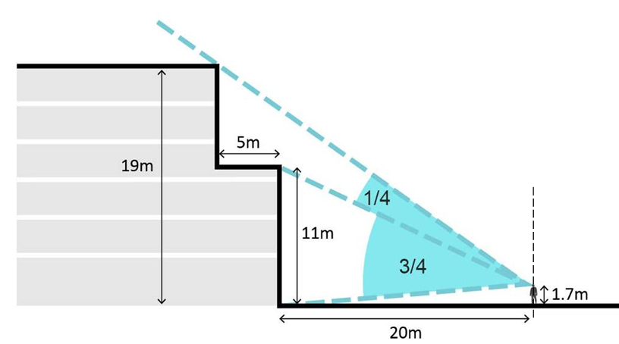
Figure 1: Upper Level Setbacks along Sydney Road
Upper levels (streets other than Sydney Road)
- Any part of a building above the street wall height should:
- Be setback at least 5 metres from the street boundary. Balconies and other architectural features may protrude into the setback by a maximum of 2 metres.
- On narrow corner lots the upper level setback at the secondary street frontage may be varied. Narrow lots are generally those lots where the depth is greater than fives time the width, and where the lot size is smaller than 750m².
- From ground level not exceed the horizontal distance from the opposite street boundary as illustrated in Figure 2 below.
- Adopt the same street setback for at least 75% of the height of the upper levels to avoid ‘wedding cake’ built form outcomes.
- Be designed to respect the form and design of adjacent civic buildings and heritage places.
- Development that seeks to vary the upper level setbacks must demonstrate how the design objectives and requirements of this schedule will be met.
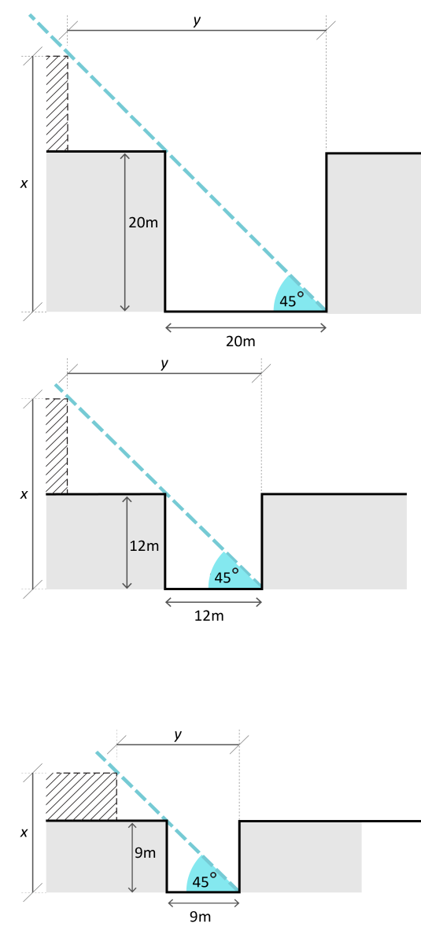
Figure 2: Upper level setbacks and heights (streets other than Sydney Road)
Buildings of individual heritage significance
- Development on sites containing buildings of individual heritage significance where no upper level setback is specified should demonstrate:
- How the proposed upper level setback responds to the heritage significance of the site and its context; and
- How the design objectives of this schedule have been met.
Setbacks to residential land
- Any part of a building adjacent to residentially zoned land outside the activity centre (including across a lane) should be set back from the residential boundary at that interface by a dimension equivalent to its height above 5 metres, up to a maximum setback of 10 metres, as illustrated in Figure 3 below. This equates to:
- A maximum height of 5 metres at the boundary of the adjacent residential property.
- A maximum height of 8 metres where the site is separated from the adjacent residential property by a 3 metre wide lane.
- A maximum height of 11 metres where existing lanes are widened to 6 metres.
Figure 3: Setbacks adjacent to residentially zoned land outside the activity centre
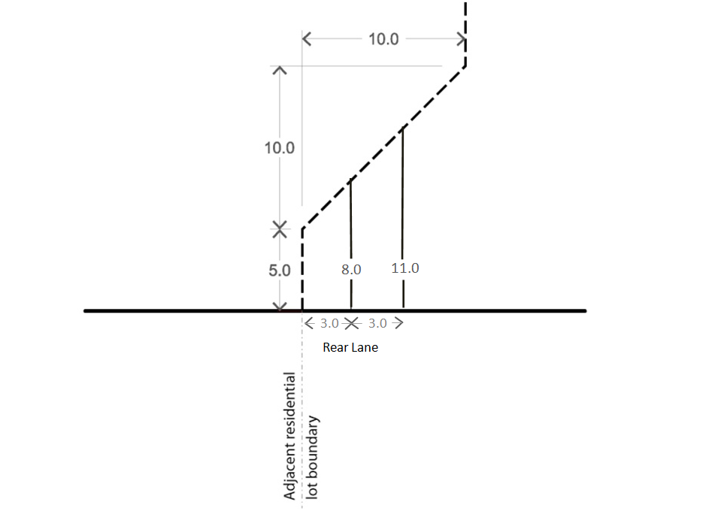
Building layout and detailed design
- Development should incorporate active edges at street level fronting all streets (except rear access lanes) and the Upfield Shared Path in accordance with Map 3: Building Edge Conditions to invigorate street life and contribute to a safe and pedestrian friendly environment. The Frontage types in Map 3 are as follows:
- Frontage Type A: Retail – A display window and/or entrance, measuring 65 - 80% of the width of the street frontage of each individual premise.
- Frontage Type B: Commercial – A display window and/or entrance, measuring at least 60% of the width of the street frontage of each individual premise.
- Frontage Type C: Residential – Individual entry doors to ground floor dwellings. Privacy is to be provided by elevating the ground floor approximately 0.5 to 1 metre above the street level and/or provide a landscaped front setback.
- Development that abuts the Upfield Shared Path should be designed to avoid large areas of blank walls. Where unavoidable, large areas of blank walls should be treated with materials, artwork or in other ways that provide an attractive and visually interesting environment.
- Development should incorporate windows in all upper level facades facing streets and the Upfield Shared Path.
- Development should minimise the impact of vehicle access and car parking on the public realm by:
- Locating vehicle access at the rear of buildings where possible;
- On secondary frontages, rear access is preferred but where not possible, vehicle access should be provided to the side of corner properties away from the front façade; and
- Locating car parking where it cannot be seen from the public realm.
- In commercial and mixed use zones, development should have a ground floor ceiling height that allows for a range of commercial uses.
- Development should incorporate awnings over the footpath for the full width of the building frontage along Sydney Road and Key Pedestrian Streets as set out in Sydney Road and Upfield Corridor Strategic Framework Plan.
- Services cabinets should be located at the rear of buildings wherever possible, or the side of corner buildings away from the front façade where rear access is not available. Where they can only be located in the front façade, the size of services cabinets should be minimised and they should be integrated with the overall façade design.
- Building facades on the street boundaries of Sydney Road should incorporate vertical articulation to reinforce the prevailing fine-grain pattern of subdivision and buildings.
Public realm
- Development adjacent to Jewell, Brunswick and Anstey Railway Stations should maintain or enhance the visibility of and access to railway station buildings.
- Development should incorporate the proposed public linkages indicatively shown on Proposed Public Open Space Network, Map 2A (North) and 2B (South).
- Development should maximise permeability through the Activity Centre and the accessibility to the Upfield Shared Path.
- Development should not overshadow the opposite footpath of Sydney Road and Key Pedestrian Streets (as defined in Sydney Road and Upfield Corridor Strategic Framework Plan, Map 4A(North) and 4B(South)) between 10.00am and 2.00pm at the equinox.
- Development should not overshadow more than 50% of any existing or proposed public space, including parks and plazas, between 10.00am and 2.00pm at the equinox.
Upfield shared path interface
- The ground floor of development abutting the Upfield Shared Path should be set back a minimum of 1 metre.
Moreland Industrial Land Strategy - Category 2 Employment Areas
- Development within Category 2 – Employment Areas should achieve commercial built form outcomes, including increased floor to ceiling heights and flexible floor plates, at ground and first floor to facilitate opportunities for employment uses.
- Ground floor commercial spaces should provide for activation, for example through entrances, transparent glazing and architectural features which encourage interaction and visual interest.

3.0 Exemption from notice and review
11/08/2016
C134
An application to construct a building or construct or carry out works is exempt from the notice requirements of Section 52(1) (a), (b) and (d), the decision requirements of Section 64(1), (2) and (3) and the review rights of Section 82(1) of the Planning and Environment Act 1987 (the Act) unless the proposal seeks to do any of the following:
- Exceed the preferred maximum building height specified in section 2.0 of this schedule, or
- Exceed the preferred maximum street wall height specified in section 2.0 of this schedule, or
- Reduce the setbacks above the street wall specified in section 2.0 of this schedule, or
- Reduce the rear setback requirements specified in section 2.0 of this schedule.
An application to subdivide land is exempt from the notice requirements of Section 52 (1) (a), (b) and (d), the decision requirements of Section 64 (1), (2) and (3) and the review rights of Section 82 (1) of the Act.
4.0 Decision guidelines
11/08/2016
Proposed C164
Before deciding on an application, the responsible authority must consider, as appropriate:
- The Sydney Road and Upfield Corridor Strategic Framework Plan.
- The Moreland Industrial Land Strategy 2015-2030
- The opportunities and constraints of the site.
- Whether the maximum building height is achievable having regard to lot size, dimensions (width and depth) and/or those sites within or adjoining the Heritage Overlay.
- Whether an increased upper level setback is required having regard to the heritage significance of the site or an adjoining site within the Heritage Overlay.
- Whether the preferred maximum street wall height is achievable having regard to the heritage significance of the site or an adjoining site within the Heritage Overlay.
- The extent to which development achieves the design objectives in Part 1.0 of this schedule.
5.0 References
11/08/2016
Proposed C164
Sydney Road and Upfield Corridor Strategic Framework Plan, Moreland City Council, 2014
Moreland Industrial Land Strategy 2015-2030, Moreland City Council
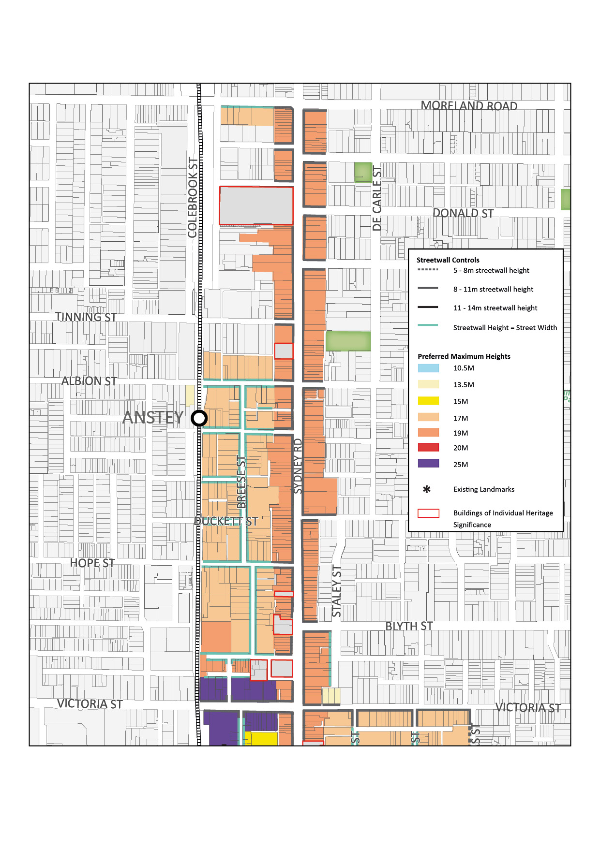
Map 1A: Overall Building and Streetwall Heights (North)
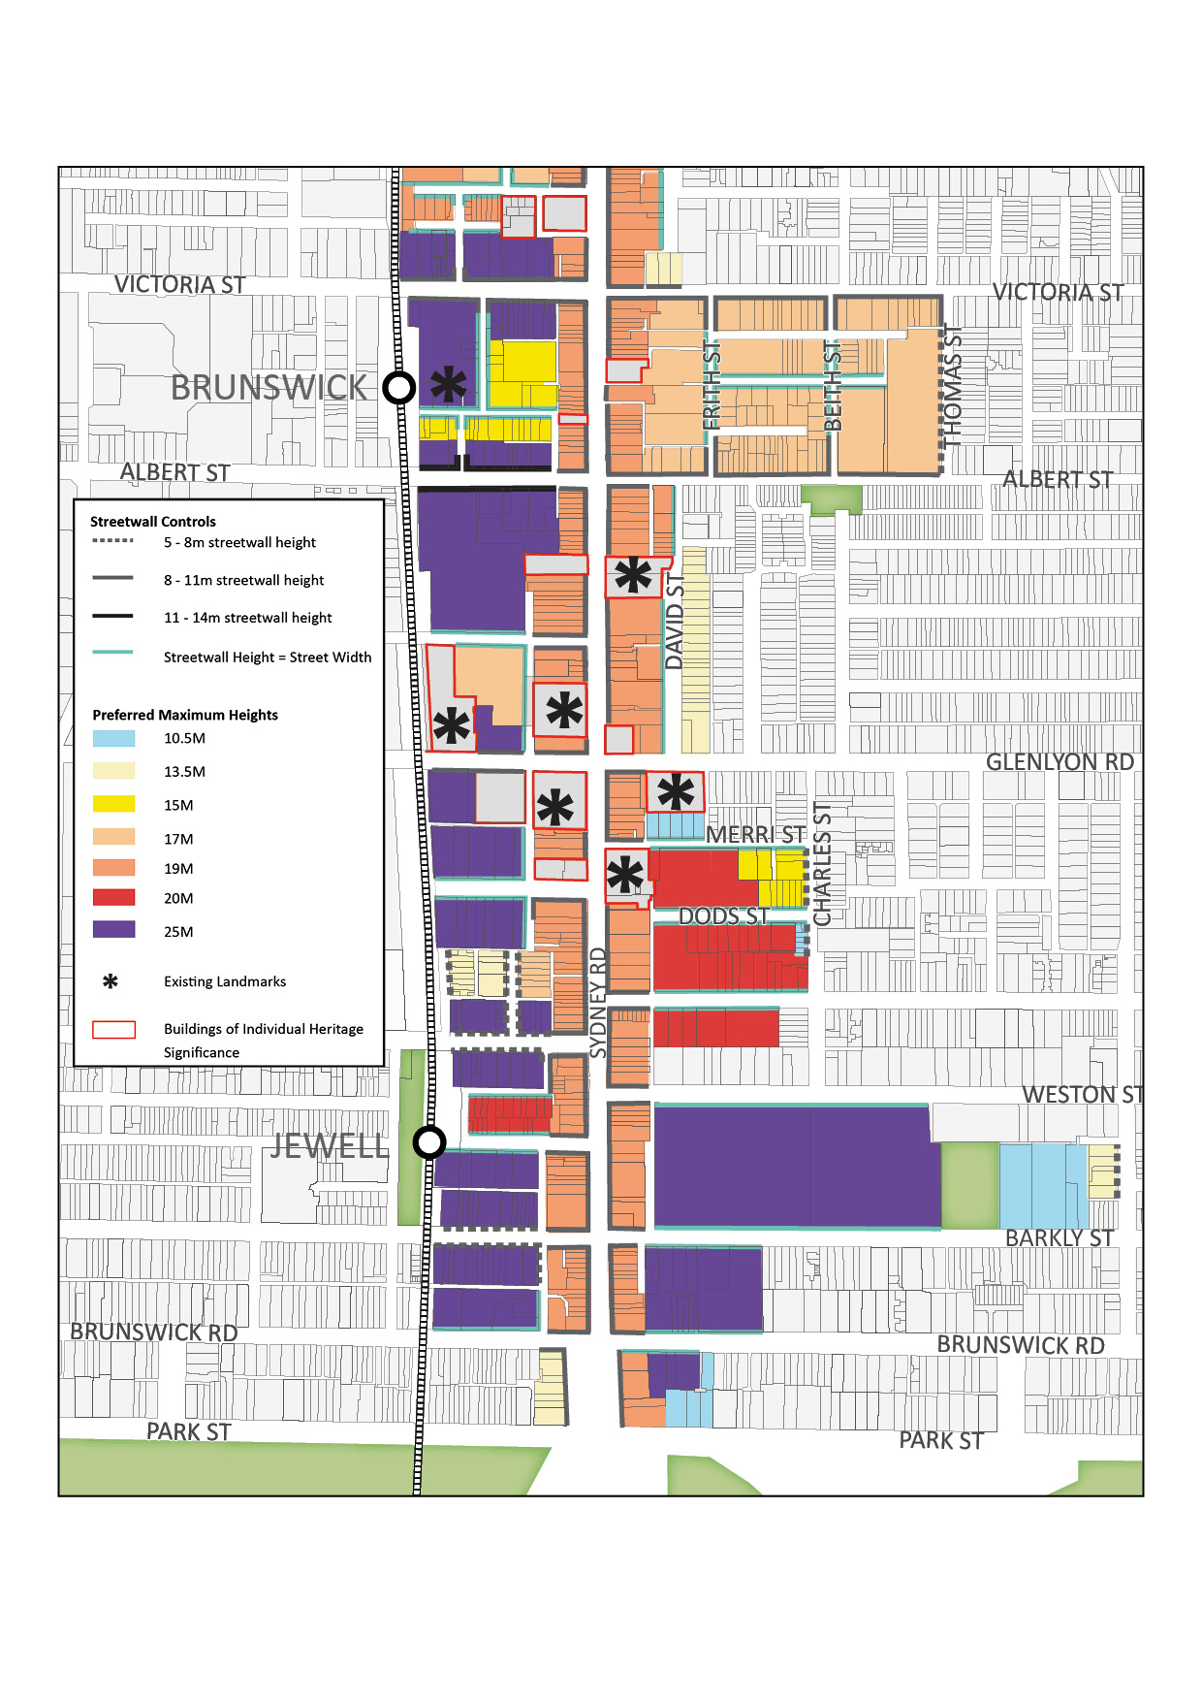
Map 1B: Overall Building and Streetwall Heights (South)
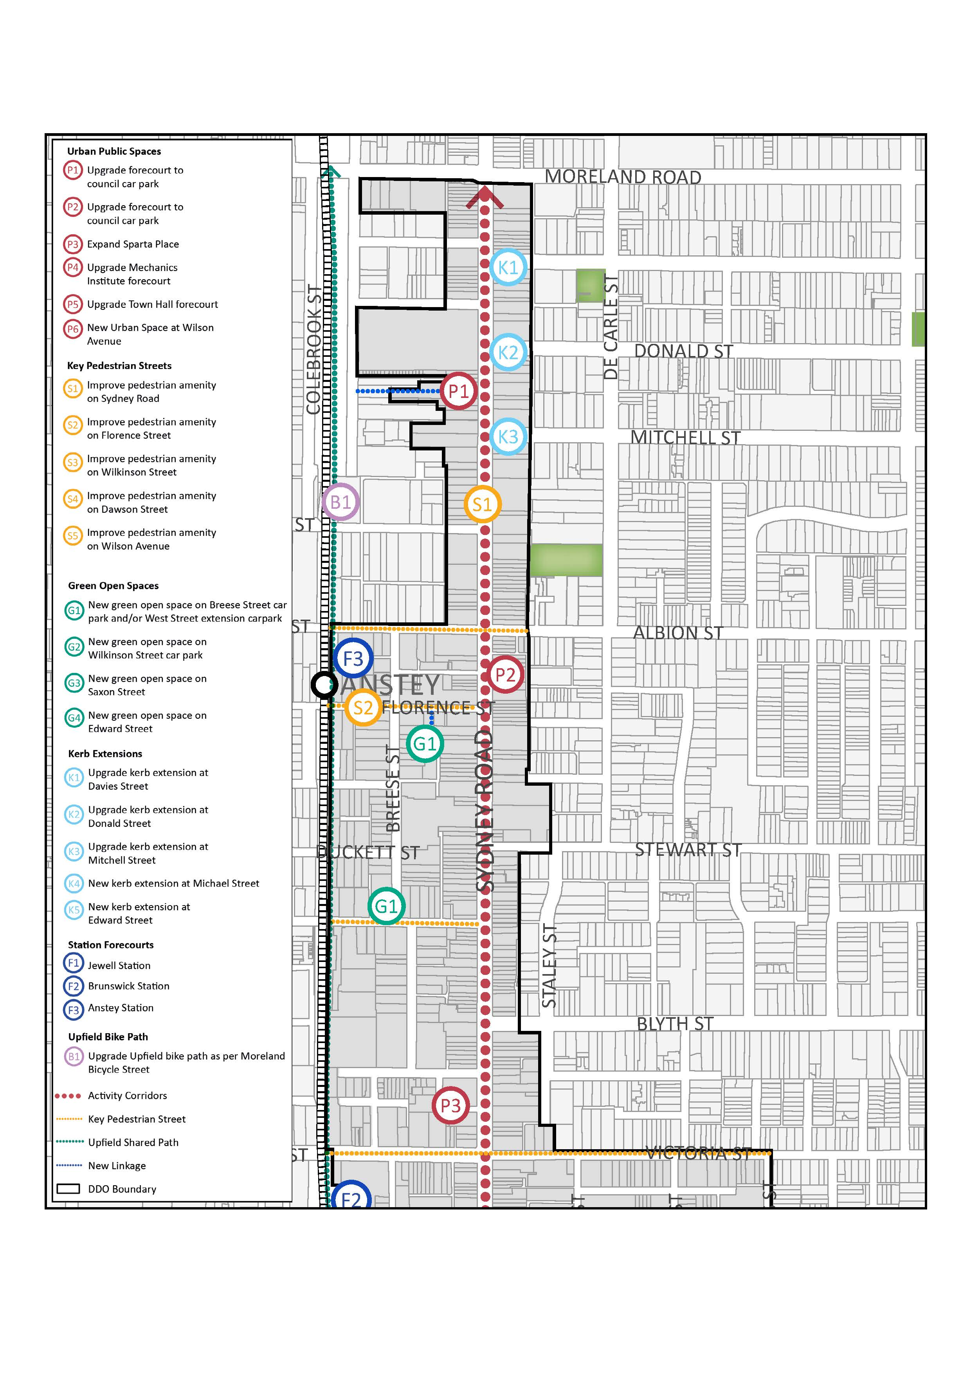Map 2A: Open Space and Public Realm Network (North)
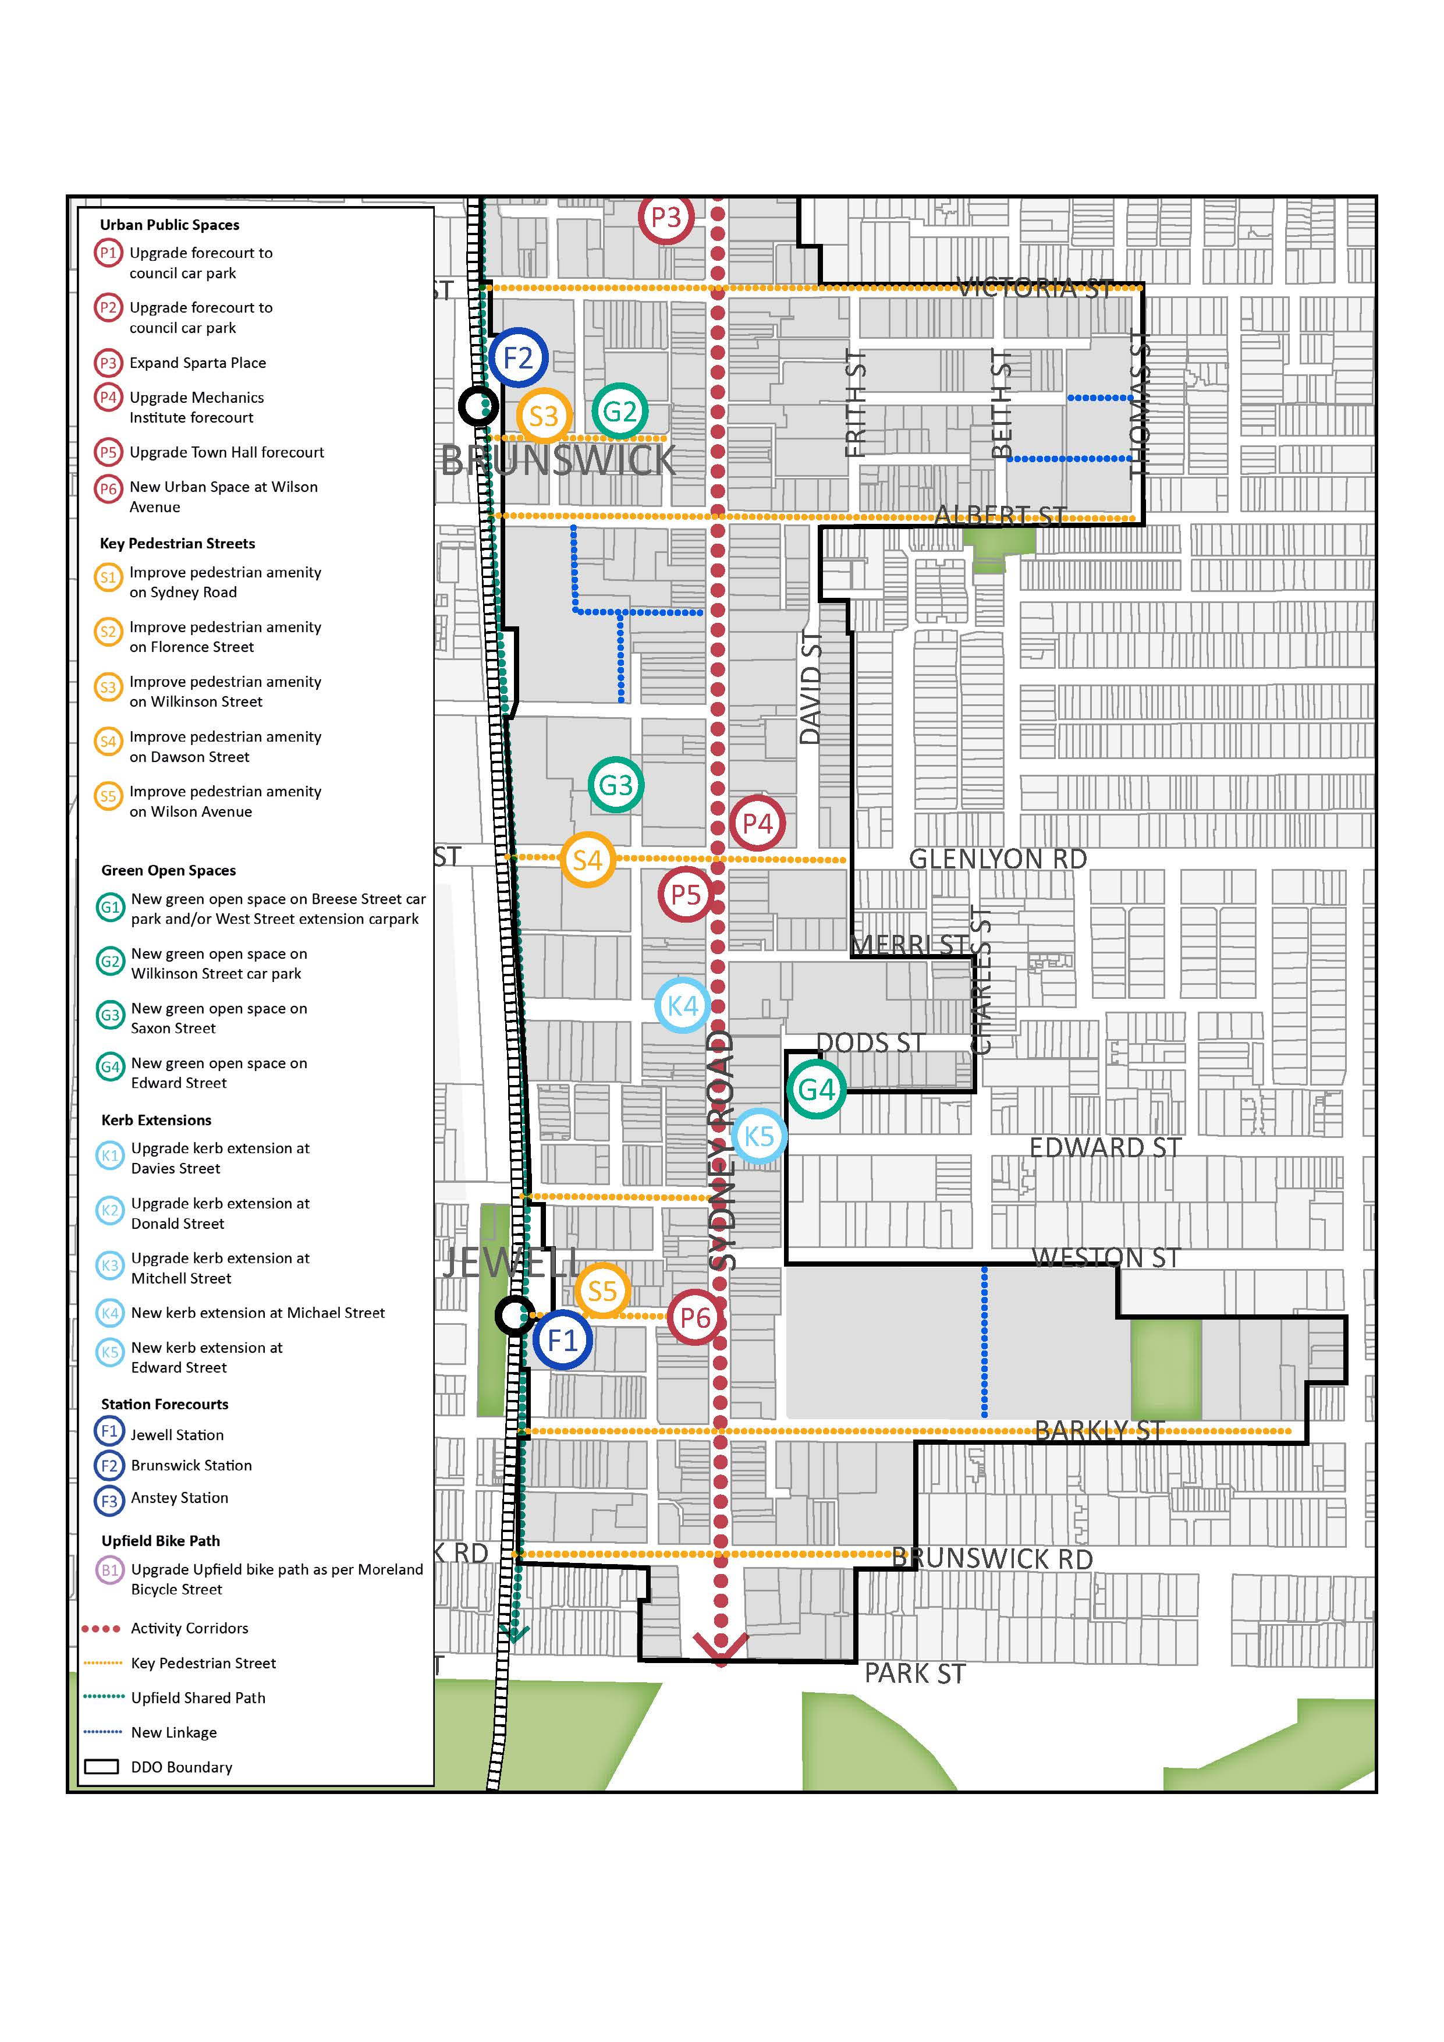Map 2B: Open Space and Public Realm Network (South)
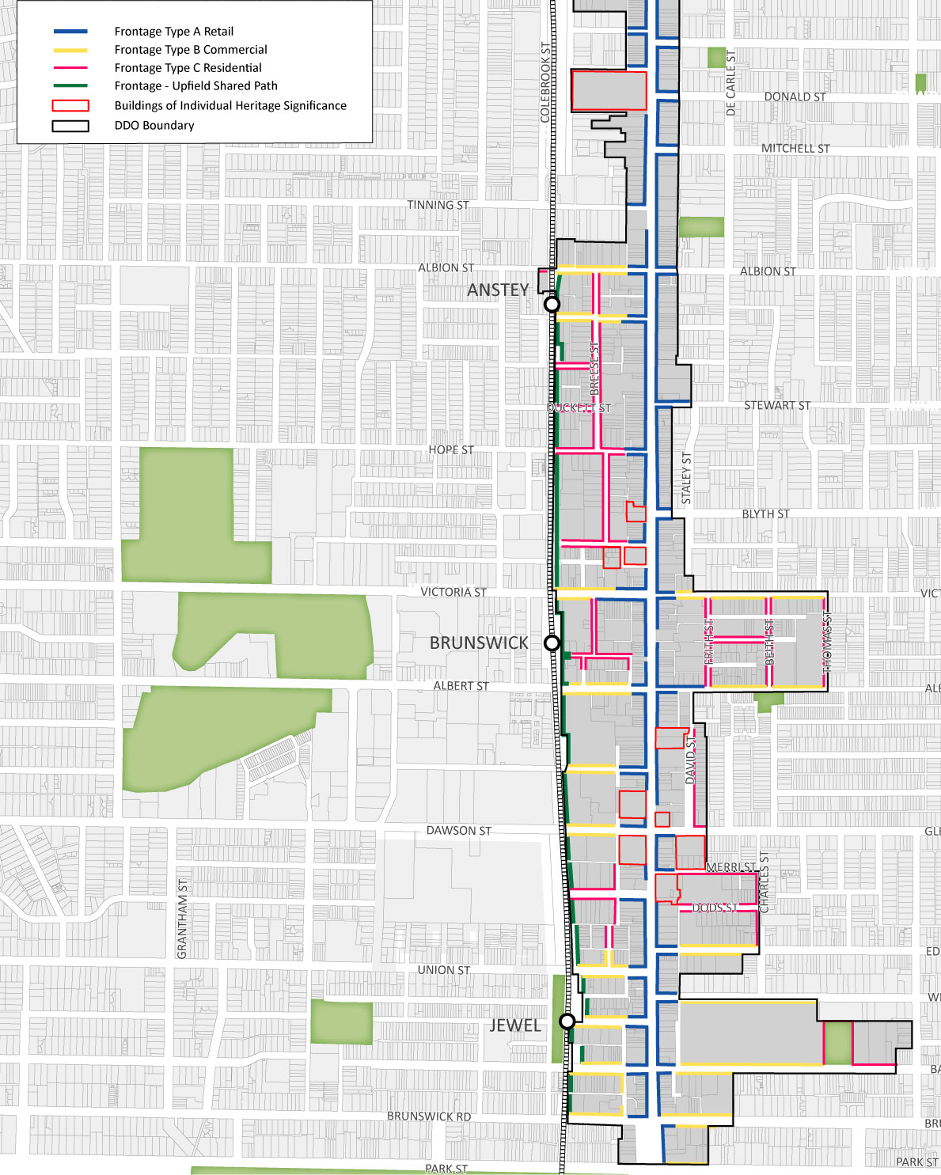Map 3: Building Edge Conditions

