
Heritage guideline 2
Alterations and additions to houses in heritage areas

Assistance on heritage matters
This document is one of a series of Guidelines developed by Merri-bek City Council to assist owners and applicants in preparing planning permit applications for buildings covered by a Heritage Overlay.
Prior to finalising plans or lodging an application, Applicants are encouraged to discuss their ideas with a planning officer in a pre-application meeting. This consultation may help to identify any issues and improve the progress of your application once it’s lodged.

For more information and to lodge a pre application meeting request, please visit Council’s website at: https://www.merri-bek.vic.gov.au/building-and-business/planning-and-building/planning/planning-application-process-overview/

Introduction
For more information phone Merri-bek City Council’s Planning Department on 9240 1111 or visit www.merri-bek.vic.gov.au.

If your property is covered by a Heritage Overlay, a planning permit is required to carry out most works such as construction, alterations or demolition. Permits are usually required for all types of buildings including garages, carports, fences, verandahs, pergolas and decks. Replacing windows or re-roofing with new materials will usually require a permit. Only in some cases will a planning permit be required for external painting or internal alterations. If unsure, contact Council’s Urban Planning Unit to confirm which requirements apply to your property.

The Heritage Policy at Clause 15.03-1L of the Merri-bek Planning Scheme outlines how Council will protect and conserve Merri-bek’s heritage. These Guidelines have been based on the Heritage Policy and provide detailed guidance on appropriate approaches for alterations and additions to houses in areas covered by a Heritage Overlay.

Background

Housing in Merri-bek’s heritage areas generally reflects a variety of architectural styles which existed between the 1850s and 1950s. They range from large houses such as those located on Lobbs Hill, Brunswick to modest timber cottages and workers’ terrace housing. Merri-bek contains a number of housing estates which consist of War Service Homes, Commission houses and the Beaufort Houses in Pascoe Vale South.

The style of housing in some streets of Merri-bek is very consistent because development has occurred within a short period of time, sometimes by the same builder. Other streets are more mixed in style and may feature a two storey Victorian terrace alongside a single storey inter-war cottage.

Development guidelines
The following guidelines and examples are intended to assist when changes to a historic house are being considered. They are based on some common settings but will not be appropriate for every situation. Every house will be approached on a case-by-case basis and there is no ‘one-size-fits-all’ answer to appropriate changes.

Demolition
In most cases the demolition of parts that do not contribute to the historic importance of a property will be acceptable. Council’s Heritage Policy identifies the grounds for approving demolition and the specific application requirements that may apply.

Maintenance, repairs and restoration
Maintenance is the continuous protective care of a property to ensure that it remains in good condition. Maintenance does not require a planning permit.
Repair usually involves the removal of deteriorated material and replacement with new material. When the new material is the same as the old a planning permit is not required however if the proposed material is of different appearance, then planning approval will be required.
Restoration is the process of returning the current appearance of a building or part of a property back to an earlier known appearance. This may involve the removal of non-original wall finishes (i.e. fake bricks, plastic/aluminium weatherboard cladding) or the replacement of non-original aluminium frame windows with new traditional-style timber frame windows. Restoration requires a planning permit.

Alterations
The purposes of Heritage Overlays and Council’s Heritage Policy are to ensure that alterations within heritage areas respect the historical importance, character and appearance of both those places which are individually identified as well as the area as a whole (often referred to as a precinct).
Alterations to properties covered by a Heritage Overlay should involve retaining as much original external building material as possible, especially features at the front of a house which contribute to the historic and architectural importance of the individual building or the precinct as a whole.

Additions
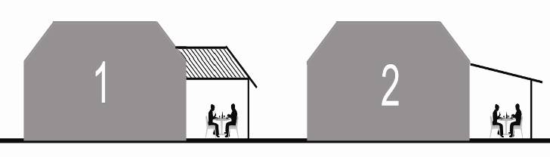
Both conservative and contemporary design approaches to additions may be acceptable, however building forms and materials that draw attention away from the main house should be avoided.

Additions visible from the street
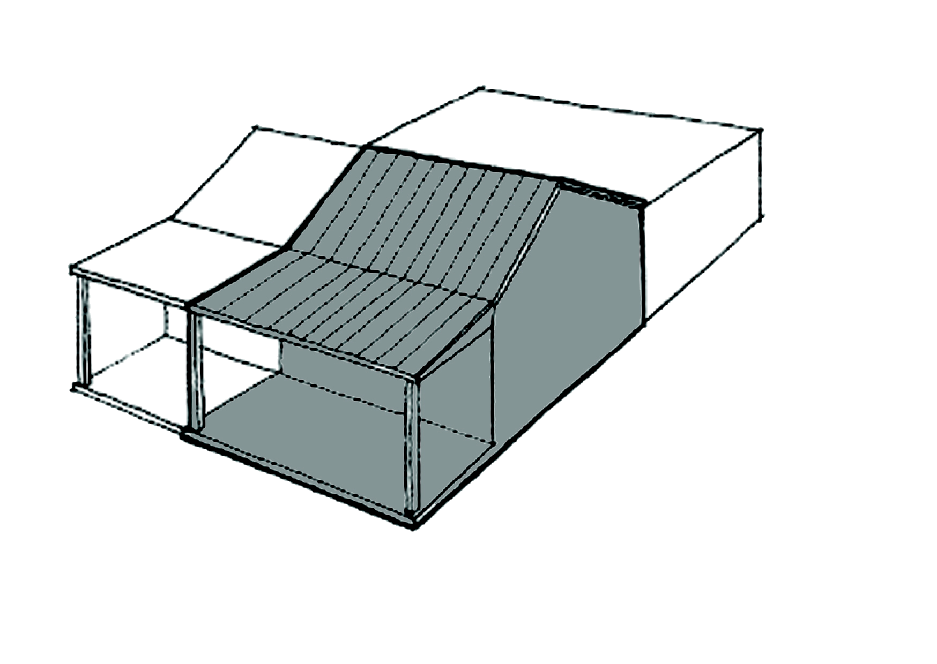
Additions to properties covered by a Heritage Overlay should be positioned, sized and detailed to ensure that the existing prominence and form of the original building is not overwhelmed by the proposed additions.
The original building should not be lost amongst additions
The form of the proposed additions should be of similar scale and proportion and use materials that relate to the property and the precinct as a whole. The reproduction of historic details is not however encouraged as there should be no confusion between old and new building works.
Buildings and houses within a precinct that are clearly not in keeping with the character of the heritage area should not be used as reference for designing inappropriate additions to heritage houses.

Single storey additions
Single storey additions at the rear of an existing house and not visible from a street or other public space will usually be acceptable as they have limited impact on the streetscape and therefore do not dominate the main house.
Side additions should be well set back from the front wall of the main house.
Additions in front of the main house or forward of the front setback will not generally be accepted.
Where space exists, consider designing large additions as smaller units with a connection to the main house so that it is clear where new work starts and finishes.
Covered outdoor areas such verandahs or pergolas at the side or rear of the main house should be roofed with a flat or skillion roof structure. The excessive bulk of substantial roof structures over these areas should be avoided.
The outdoor area to 1 has a bulkier roof form than 2

Roof space additions
Some styles of houses, such as Federation and Californian Bungalows, feature large steeply pitched roofs that may provide an opportunity for an attic storey with minimal change to the exterior elevations.

Upper storey additions
The development of any upper storey additions to an existing house covered by a heritage overlay needs to be designed to ensure that its size, position and appearance do not compete visually with the prominence of the main building.
The key considerations for every proposal will be the setback and height of the proposed additions.
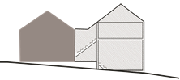
It is a requirement for every application that proposes upper storey additions to be accompanied by a sightline drawing taken from the opposite side of the street at 1.6 metres above ground level. Oblique views from a position two allotments away, on either side, may also be required.
Ways for minimising the visual impact of upper storey additions may include:
- Limiting the number and size of new upper storey rooms;
- Designing upper storey floor layouts that are fully efficient without the creation of dead areas or voids;
- Maximising the potential for ground level accommodation;
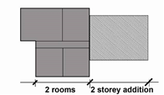
- Locating the addition as far back as reasonably possible from the street frontage. In most instances a setback equivalent to the depth of the front two rooms behind the front wall of the house will be the preferred distance
Preferred setback for two storey rear additions
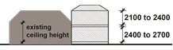
- Designing ceiling heights in proposed additions to be no greater than 2.7 metres high at ground floor, and 2.4 metres high at the upper floor level. Consider the use of raking ceilings at the upper level to further reduce the overall height of new additions.
Preferred ceiling heights for two storey rear additions
- Stepping down the finished level of the ground floor by using slab on ground, partial excavation or by taking advantage of a rear slope on the land.

Using a slope to reduce height of two storey rear additions
- Minimising the roof height at the front of the addition (e.g. a gable roof is higher at the front than a hip roof; a skillion (if used) should rise to the rear). Flat roofs may be lower, but their use may not fit in with the character of your heritage precinct.
- Limiting the span and loading of the first-floor structure to reduce structural depth (i.e. by transferring loads directly onto lower walls, rather than constructing deep new beams).
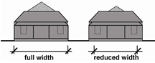
- Minimising the width of the addition so as to reduce the height of a pitched roof form.
Building height reduced by reducing width of addition
- Having greater side setbacks at the upper level.
- Ensuring that upper-level decks, at the front of the addition are not roofed. Generally upper-level decks at the front will not be acceptable unless they cannot be seen from the street.

Alterations and additions at the side
Alterations to the sides of houses can be considered, depending on their closeness to the front and the degree of concealment by adjacent buildings. Generally, maximising the setback from the street is preferred.
The main objective is to preserve the original front as the most prominent element in the streetscape. This means that a setback will be required for any new construction at the side of a dwelling. This will be dependent on its size and height and the degree to which it integrates with the original house and/or does not dominate the original house.
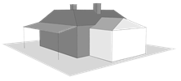
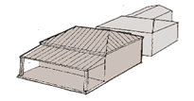
The various heights of an addition at the side should be less than the corresponding heights of the house itself.
The side addition is setback from and lower than the original house
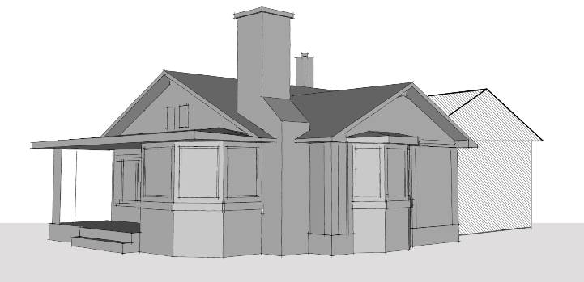
There may be exceptions where the side of the house has special design features such as projecting bays and boxed windows. In these cases, an addition to the side of the dwelling may not be appropriate.
This house has important features at the side that should be protected

Corner sites
The visibility of additions to historic houses located on corner or open sites is inevitable. The setback and heights of proposed additions are especially important because of their ability to dominate side streets.
Additions to corner or open sites should be setback from the street boundary to the same extent as other nearby corner sites which are within the heritage overlay.
Where a building of heritage value in a side street adjoins the subject site, any proposed rear or upper-level additions must be setback to ensure that they do not dominate existing vistas of that street.
The preferred approach for additions on corner and open sites is to create the appearance of separation from the original house and to respond to its architectural characteristics, particularly in the roof form and materials used.

Separate buildings reduce the overall impact of the rear additions

Chimneys
The chimneys on some houses were clearly intended to be seen as an important part of the overall design of the house. This is particularly the case for chimneys that have been finished to the same standard as the main walls of the house and include decorative mouldings or brickwork detailing. These chimneys are significant features of the original house and must be retained.
In comparison some chimneys are of very basic construction, most likely located towards the rear of the house where they were not intended to be seen from the street. In some cases, the retention of these chimneys may be less critical to the heritage character of the original house.
The removal of the internal section of a chimney is sometimes considered unavoidable. When this involves a chimney that is considered a significant feature of the house it is important that the exterior portion be retained so that the original appearance of the house is unchanged. Engineering advice may be required to ensure that adequate bracing of the remaining chimney is achieved.

Carports and garages
Most houses built prior to the 1940s were constructed without garages or carports.
Any proposed garages or carports need to be sensitively designed so that existing views of the house to the street are not hidden, and the architectural character of the house is not altered.
Ideally car accommodation structures should be located at the rear or setback on the side preferably at least 1.5 metres behind the building line of the front wall of the house (not the verandah).
Double garages are not desirable as their width can overwhelm the original house, particularly if it is relatively narrow.
Where required, plain tilt-up doors with a timber finish will be preferred to roller doors which require a structure of greater height and are visually unsympathetic in heritage areas.
Garages and carports in the front garden of a house will usually result in part of the building’s front being covered and will therefore not be supported.

The above guidelines haven’t had regard to any siting requirements under the Building Regulations. It is recommended that you discuss these requirements with a Building Surveyor as the Building Regulations will be considered when you apply for your building permit.

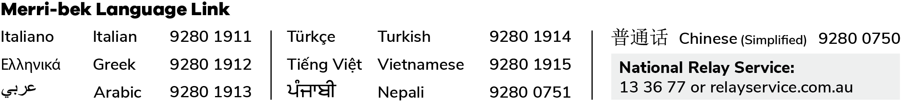
Disclaimer This publication is produced by Merri-bek City Council and is intended for information and communication purposes only. Although the publication may be of assistance to you Merri-bek City Council does not guarantee that it is without flaw or is wholly appropriate for your particular purposes. It and its employees do not accept any responsibility, and indeed expressly disclaim any liability, for any loss or damage, whether direct or inconsequential, suffered by any person as the result of or arising from reliance on any information contained in the publication.
© All applicable copyrights reserved for Merri-bek City Council. Except for any uses permitted under the Copyright Act 1968 (Cth), no part of this publication may be reproduced in any manner or in any medium (whether electronic or otherwise) without the express permission of Merri-bek City Council.

