
Heritage guideline 1
Fences

Assistance on heritage matters
This document is one of a series of Guidelines developed by Merri-bek City Council on all aspects of heritage conservation to assist in preparing planning permit applications.
Prior to finalising plans or lodging an application, Applicants are encouraged to discuss their ideas with a planning officer in a pre-application meeting. This consultation may help to identify any issues and improve the progress of your application once it’s lodged.

For more information and to request a pre application, please visit Council’s eServices page: eservices.moreland.vic.gov.au/ePathway/Production/Web/Default.aspx’

Introduction
For more information please phone Merri-bek City Council’s Planning Department on 9240 1111 or visit www.merri-bek.vic.gov.au.
If your property has a Heritage Overlay, you will require a planning permit if you want to build, alter or demolish a fence on your property, including fencing on side and rear boundaries. Contact Council’s Urban Planning Unit if there is any doubt about permit requirements.
Council has a Local Heritage Policy at Clause 15.03-1L of the Merri-bek Planning Scheme. This Local Policy forms the basis of these Guidelines which have been developed to help property owners understand what type of fencing is suitable for their house. You can arrange to meet with a Planning Officer if you would like further help preparing your planning permit application.

Background
Front fences have always been a fashion accessory to a building and as styles and functional requirements have changed, so have fences. From early settlement, fences were traditionally four feet (1200mm) high as a balance between keeping out livestock roaming the streets and the desire to maintain views of the street from the front gardens.
Front fences have generally been of transparent design in order to display the house and garden behind. This applied through the 19th century to the First World War. By the interwar period, livestock was not such a threat and the height of fences was reduced. In the post war period, often no front fences were built.
In the late 20th century, people became more security and privacy conscious. Traffic noise also became an issue. As a result, high, solid security fences became more common. In some locations, high walls enclosed whole streetscapes.
Front fences are intended to:
- Provide an interface between the street and private property that limits but does not exclude access, surveillance and interaction.
- Reinforce the stylistic character of the building they front and the streetscape they are located in.
- Provide a balance between security and exposure of a private property.
Generally, fences that are high and solid along the street frontage will not be consistent with the character of Merri-bek’s heritage precincts.
General guidelines for front fences
- Front fences should always be located on the property boundary.
- Fences should be of appropriate style and height to the period of construction of the dwelling.
- Fences should not be more elaborate in style or materials than the dwelling itself, and the fence should be in the simplest design for the period.
- Reconstruction of an original fence will be the best heritage outcome for any site.
- Generally, noise reduction will not be accepted as a reason for varying these guidelines.
- Fences can either follow the slope of the land or be stepped. In order to keep the fence simple, following the slope of the land is generally preferable.
- Traditionally, front fence designs return around side street corners to the line of the front of the dwelling. However, on lanes, the side fence continues to the fronting street or has a short slope down to the height of the front fence.
- Fences between properties in the front setback are generally lower versions of the traditional side fence. Occasionally, where dwellings are in groups, the front fence type is used.

Gates in front fences
- Traditionally openings in fences are gated. This pattern should be maintained, and the gate’s location should match the style of the fence proposed.
- Recessed entries were common for large properties with deep setbacks, but not for smaller dwellings. Lych gates (traditionally with a roof and a seat, such as for churches) are rarely appropriate. Recessed entries, entry portals and lych gates will only be appropriate where it is in keeping with the scale of the front garden area and the style of the dwelling.

Reconstruction of original fences
The reconstruction of an original fence will be supported as a first option for any place on the basis of credible documentary or physical evidence (e.g. an early photograph or a remnant portion of the fence).

Side and rear fences (all periods: 1850–current)
Side and rear fences have remained of consistent construction since the mid-19th century. They are usually constructed with either timber palings or corrugated iron, without the intermediate posts exposed. Use of a capping rail is acceptable. Gates should match the fence. Brick and rendered side and rear fences should only be used in special circumstances. Side and rear fences should not exceed 2 metres in height. The high side fence should be returned to the dwelling at the front façade, if additional privacy to a rear yard is required. 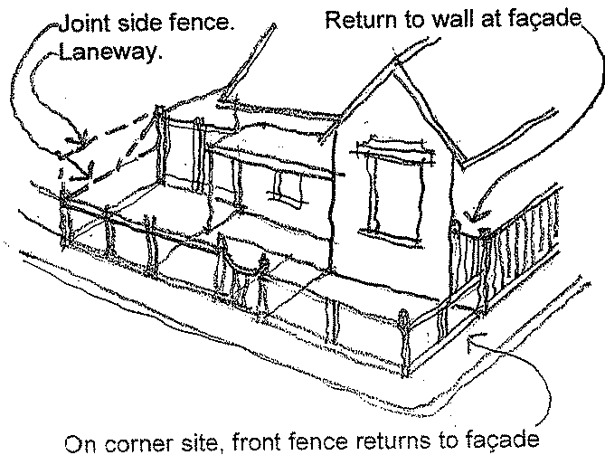

Side and rear fence types
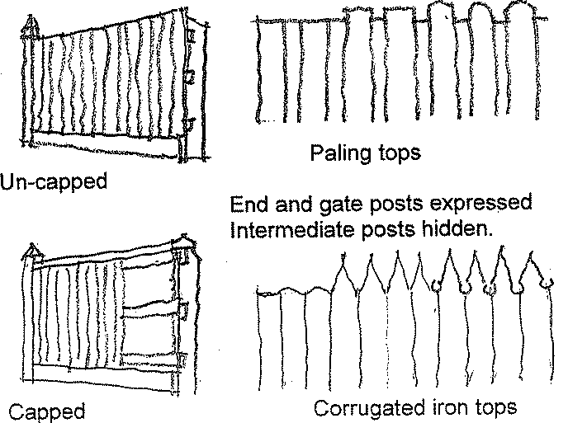

Types of fencing for various periods of construction
These guidelines are accompanied by diagrams showing fencing for specific periods of construction including Victorian, Edwardian and Federation, inter-war and post-war dwellings. Ask a planning officer for assistance if you are unsure of the period of your house.

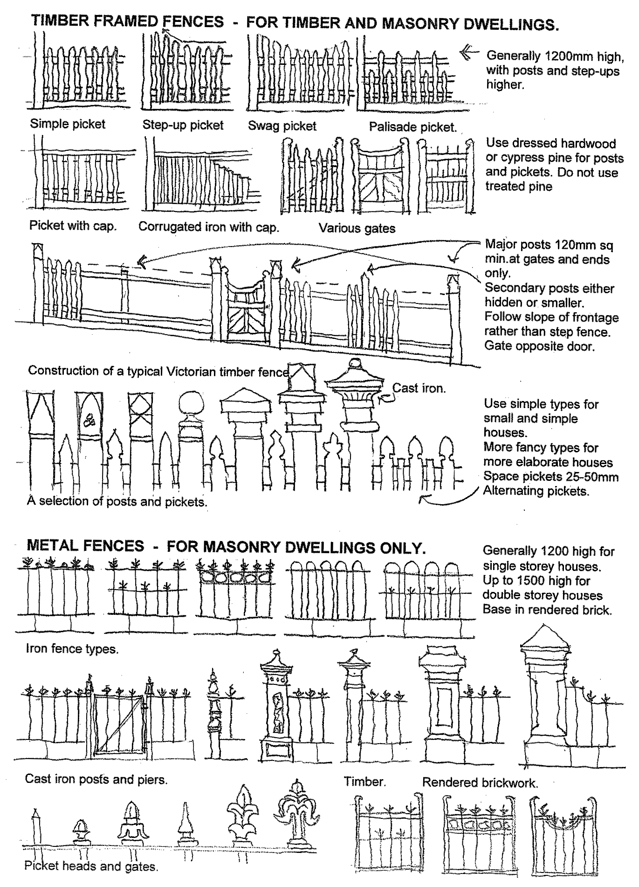
Front fences for Victorian dwellings (mid–late 19th century)

Front fences for Edwardian and Federation dwellings (late 19th century–1914]
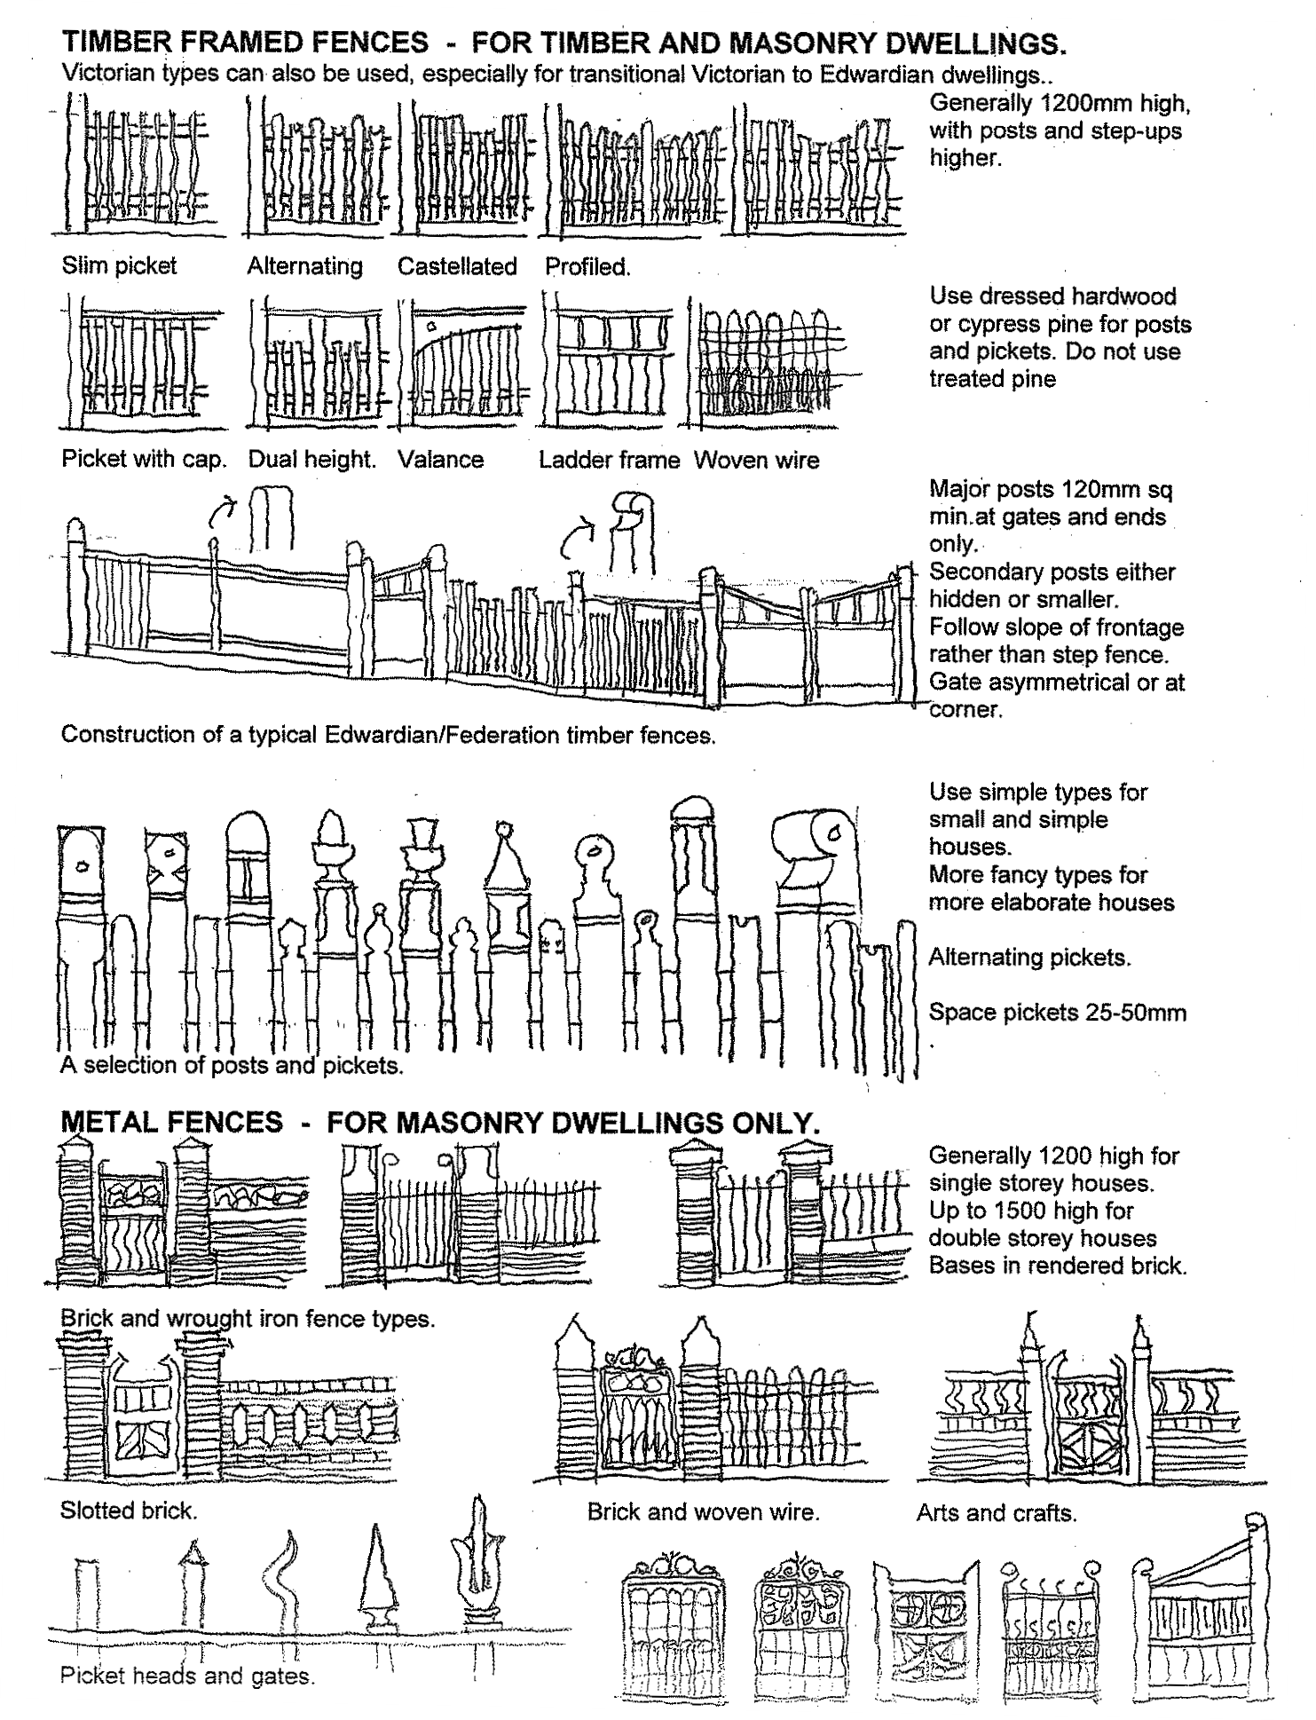

Front fences for inter-war dwellings (1918–1940)
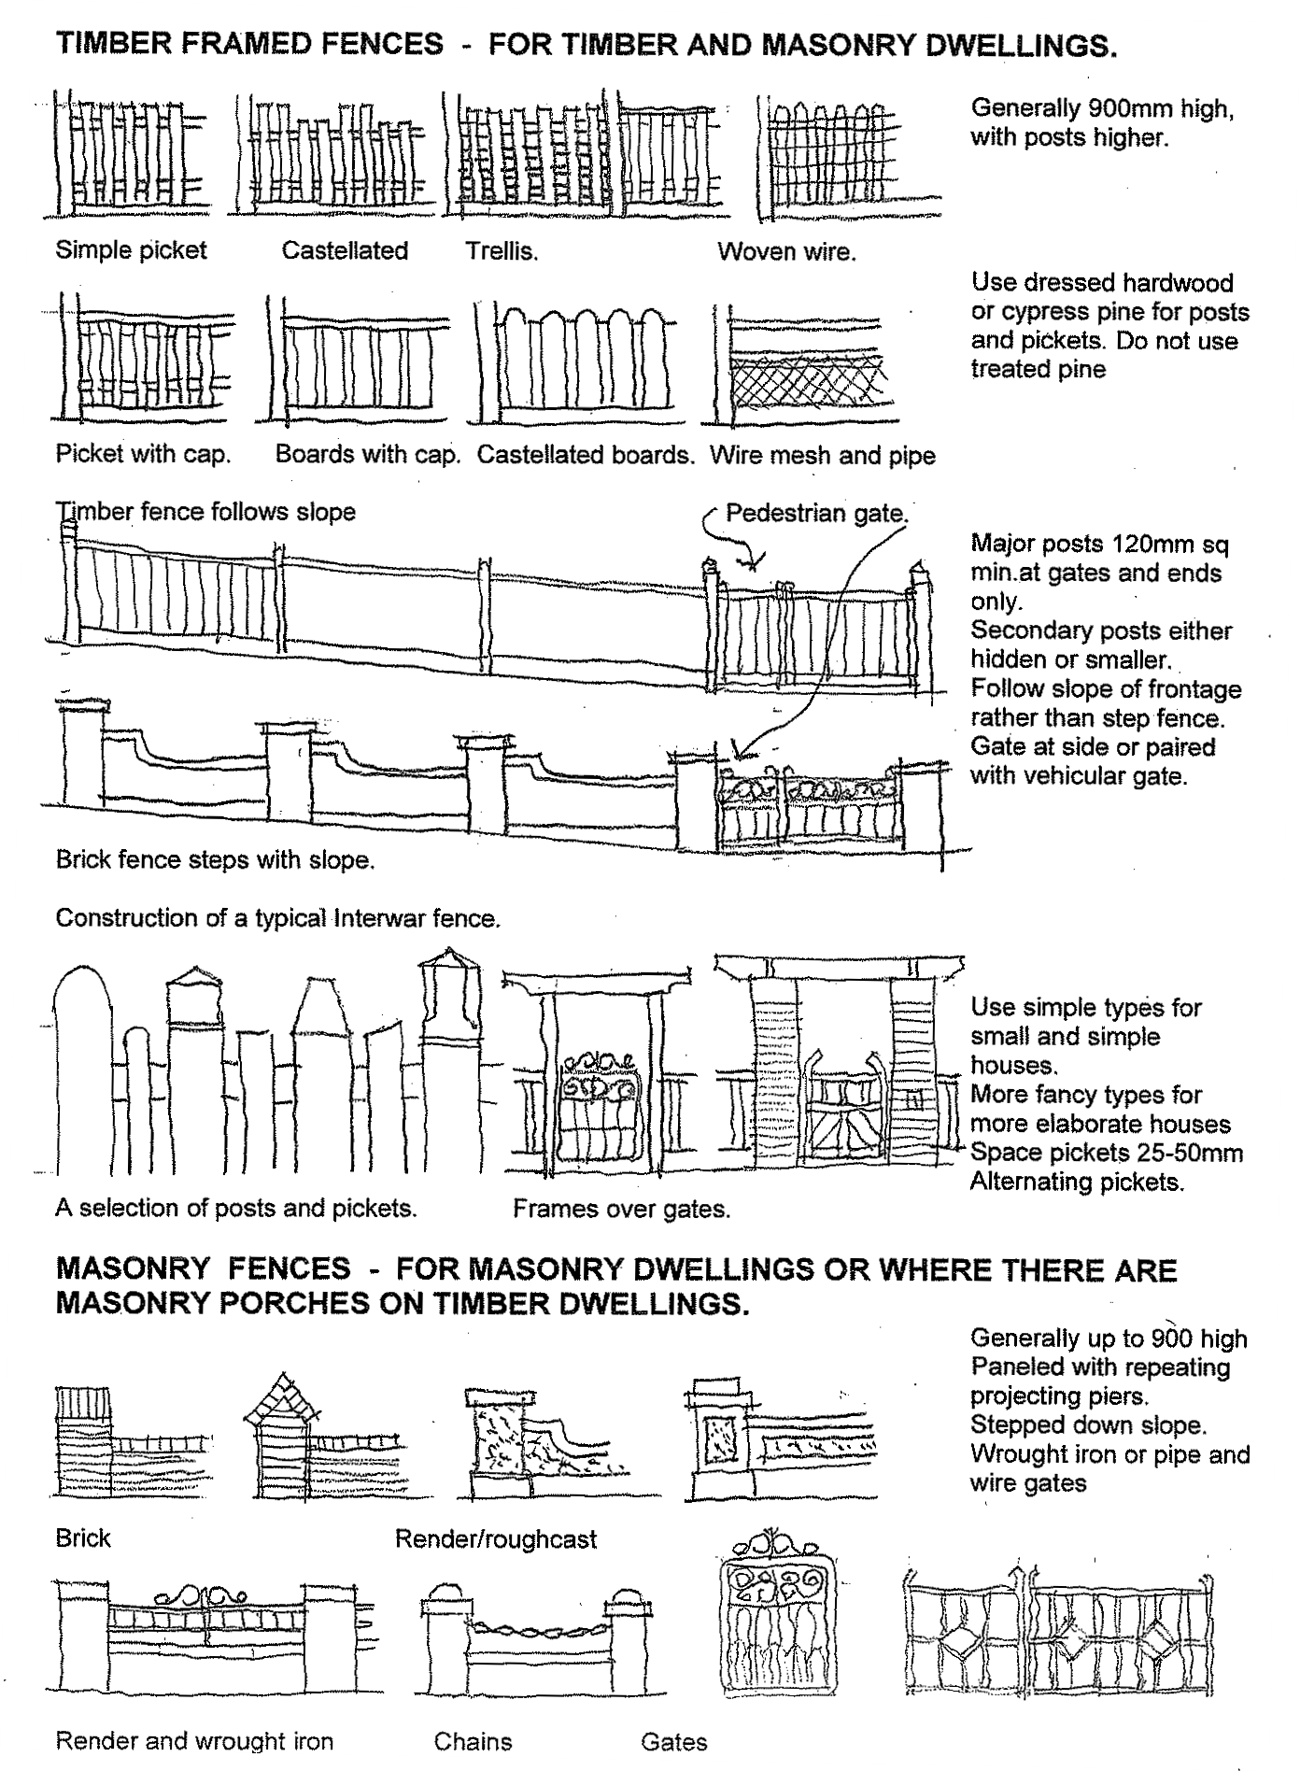

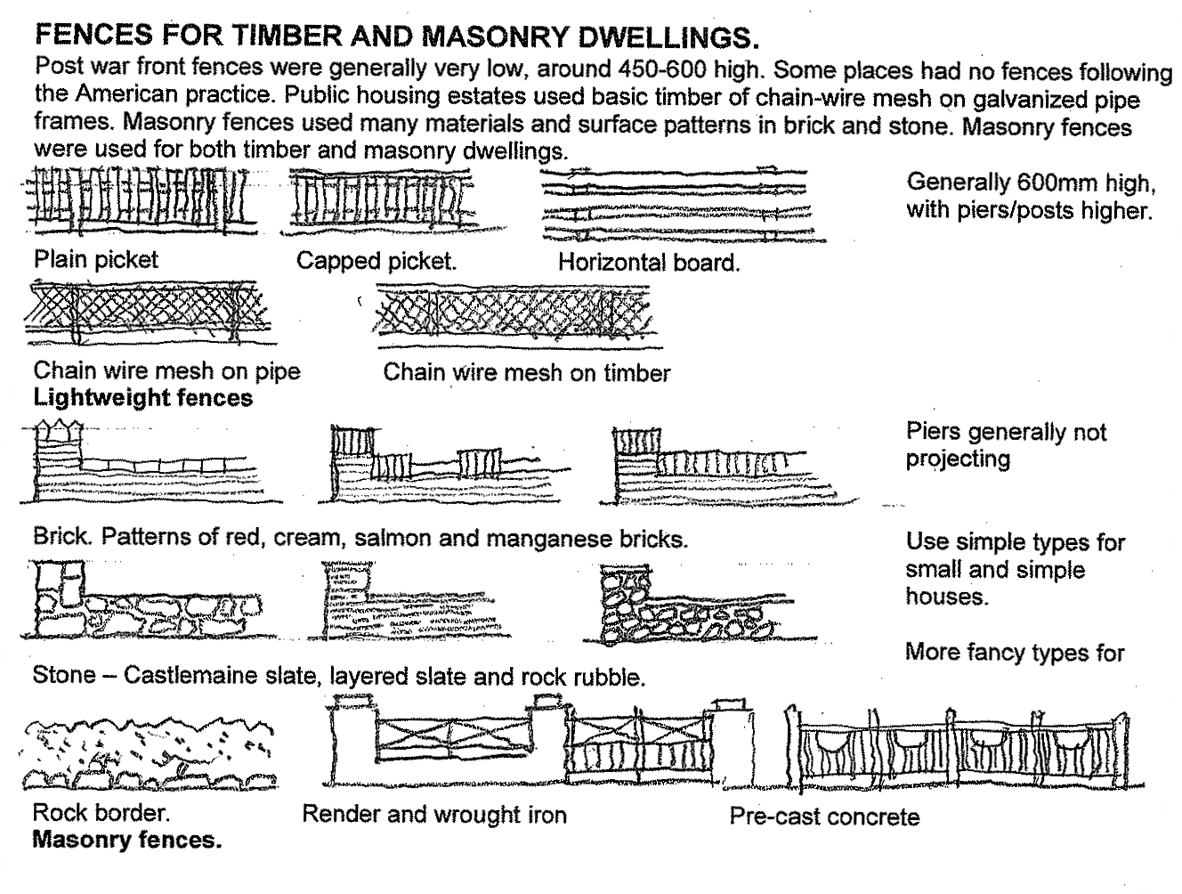

Front fences for post-war dwellings (1940–1960)
Disclaimer This publication is produced by Merri-bek City Council and is intended for information and communication purposes only. Although the publication may be of assistance to you Merri-bek City Council does not guarantee that it is without flaw or is wholly appropriate for your particular purposes. It and its employees do not accept any responsibility, and indeed expressly disclaim any liability, for any loss or damage, whether direct or inconsequential, suffered by any person as the result of or arising from reliance on any information contained in the publication.
© All applicable copyrights reserved for Merri-bek City Council. Except for any uses permitted under the Copyright Act 1968 (Cth), no part of this publication may be reproduced in any manner or in any medium (whether electronic or otherwise) without the express permission of Merri-bek City Council.

