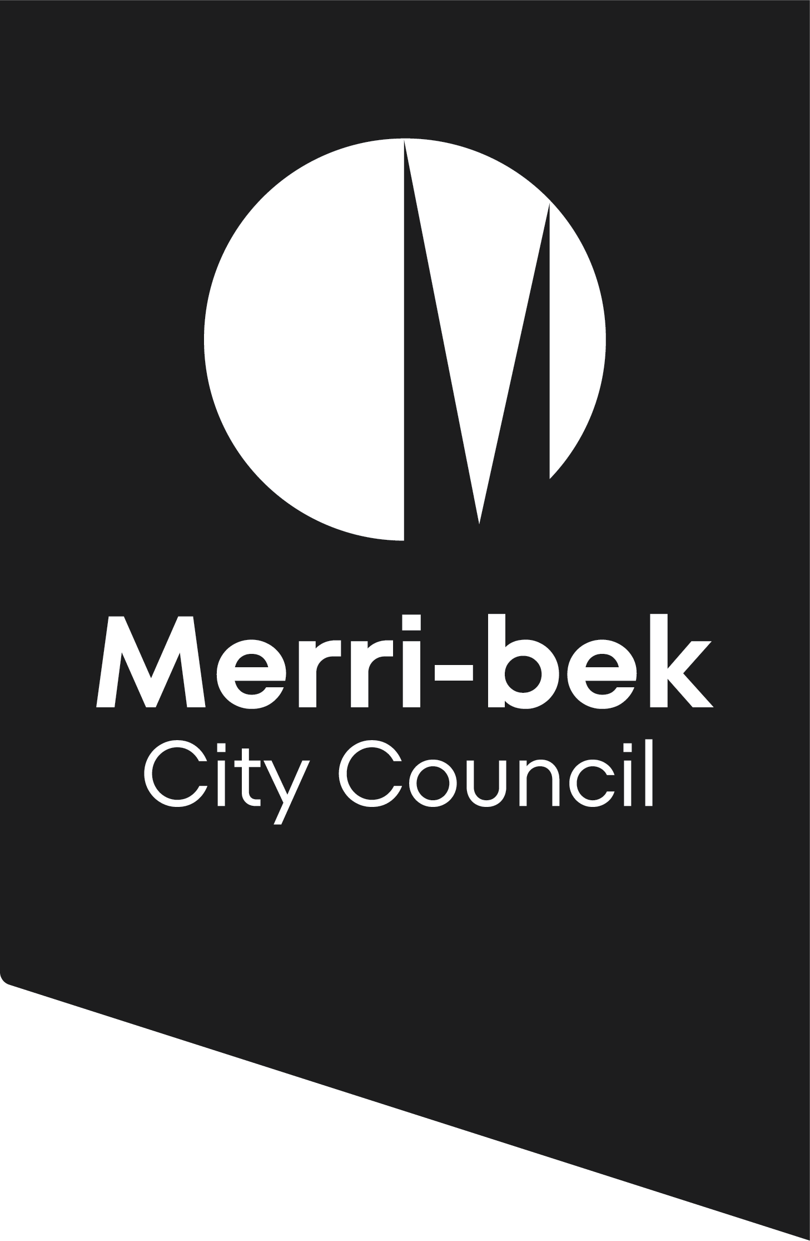
Two or more
dwellings on a lot
Where Clause 55 applies

Other requirements
This checklist applies to applications to construct or extend 2 or more dwellings on a lot, dwellings on common property and residential buildings. A development must, amongst other matters, meet the requirements of Clause 55 (ResCode) of the Merri-bek Planning Scheme. Other planning scheme controls may affect your proposal. Please check the planning scheme requirements before submitting an application by visiting the Department of Transport and Planning website, www.dtp.vic.gov.au, or attending the City Development Branch enquiries counter at Merri-bek Civic Centre.
Please note that the planning officer assessing the application may require additional information, or may need to clarify the information that is provided with an application.

Pre-application meetings
If you’d like to speak to a planning officer, call 9240 1111 or visit the Merri-bek Civic Centre at 90 Bell Street, Coburg.
Council encourages applicants to meet with the City Development Branch before lodging an application. These meetings are designed to advise applicants whether proposals are generally consistent with the Merri-bek Planning Scheme before they are lodged. Planning staff will also aim to assist applicants to become fully aware of the standard and extent of documentation they are required to provide in order to reduce or avoid the need for Council to request further information.
Submitting a planning permit application online
- You need to register as a user with Council Online Services before you can submit a planning permit application online.
- Once you are a registered user, sign in and lodge a planning permit application.
- As part of the online application process, you pay the fee online with Visa or MasterCard.
To know more please visit www.merri-bek.vic.gov.au/building-and-business/planning-and-building/planning/planning-application-process/

What you need to include with your planning permit application
All planning applications for 2 or more dwellings on a lot must include (electronically where possible):
- A completed and signed application form.
- A legible, full and current copy of title showing the search statement including details of any unregistered dealings. The title must be no older than 3 months and show all boundaries, easements and a full copy of any registered restrictive covenants on the land.
- The application fee (refer to fee schedule).

Neighbourhood and Site Description
Under Clause 55.01-1, the application cannot be advertised until a Neighbourhood and Site Description is submitted and approved in writing by the Responsible Authority as being satisfactory. The following information is required to be submitted as part of the Neighbourhood and Site Description Plan:
- A plan reference number, date and north point.
- In relation to the neighbourhood
  - The pattern of development of the neighbourhood.
  - The built form, scale and character of surrounding development including front fencing.
  - Architectural and roof styles.
  - Any other notable features or characteristics of the neighbourhood.
- In relation to the site:
  - Site shape, size, orientation and easements.
  - Levels of the site and the difference in levels between the site and surrounding properties.
  - Location of existing buildings on the site and on surrounding properties, including the location and height of walls built to the boundary of the site.
  - The location of boundary fences where these do not match the title boundaries.
  - The use of surrounding buildings.
  - The location of secluded private open space and habitable room windows of surrounding properties which have an outlook to the site within 9 m.
  - Solar access to the site and to surrounding properties.
  - Location of significant trees existing on the site and any significant trees removed from the site in the 12 months prior to the application being made, where known.
  - Any contaminated soils and filled areas, where known.
  - Views to and from the site.
  - Street frontage features such as poles, service pits, street trees and kerb crossovers.
  - The location of local shops, public transport services and public open spaces within walking distance.
  - Any other notable features or characteristics of the site.

Design Response
A Design Response to the Neighbourhood and Site Description as described by Clause 55.01-2 of the Merri-bek Planning Scheme. The design response must explain how the development’s design:
- Derives from and responds to the Neighbourhood and Site Description.
- Relates to any other dwelling on the site and to surrounding land and development. This must include correctly proportioned street elevations showing the development in the context of adjacent buildings. Generally, this should show at least 2 buildings either side of the proposed development.
- Meets the objectives of Clause 55.
- Responds to any neighbourhood character features for the area identified in a local planning policy or a Neighbourhood Character Overlay.

Set of Plans
A Set of Plans are required. Plans must be fully dimensioned at a scale not less than 1:100. For the Neighbourhood and Site Description and Design Response plan an appropriate scale such as 1:200 must be provided. Plans should show:
- The title boundaries and dimensions of the site.
- Extent of any proposed building demolition and structures to remain.
- Floor plans and all elevations of proposed buildings or works on the site (proposed alterations and additions to existing buildings to be highlighted).
- Floor plans for all levels dimensioning setbacks from all title boundaries, finished floor levels and the location of buildings on adjoining properties.
- All elevations accurately depicting the slope of the land and indicating the differences between natural ground levels compared to proposed floor levels. The elevation plans need to show finished floor levels and the overall building height to Australian Height Datum (AHD) or a Reference Level (RL) that will not be affected during construction.
- A roof plan including details of air conditioning, other plant equipment, including any screening, and the location of buildings on adjoining properties.
- Location and dimensions of existing and proposed crossovers and car parking spaces in accordance with the Merri-bek Planning Scheme.
- Elevations (with dimensions) of any proposed front fences.
- A development summary that details the site area, site coverage, size of each dwelling, hard-surfaced area and percentages and the size of the private open space areas that exceed 3 m in width.
- A schedule of materials, colours and finishes of external surfaces, including roofs, walls, fences and garages.
- Shadow diagrams at 9am, 12 noon and 3pm at the September equinox showing the shadow cast by the proposed development. Please note that additional shadow information may be required to assist in determining whether compliance with ResCode is achieved. Discuss this with the City Development Branch.
- Location of mailboxes and clotheslines.
- Location and capacity of external storage areas, including elevations and materials.
- Location of street frontage features such as poles, service pits and street trees.
- Details of environmentally sustainable design features to be incorporated into the design, this may include, rainwater tanks, stormwater reuse, gas boosted solar hot water systems, and/or any other features.
- A landscape plan. The proposed plantings should be consistent with those within the Merri-bek Landscape Guidelines and Technical Notes.

Clause 52.06
This Clause sets out requirements in relation to car parking. A dwelling is required to have 1 on site car parking space if it is a 1 or 2 bedroom dwelling and 2 spaces if it has 3 or more bedrooms. If you wish to vary these requirements your planning permit application will need to include this request. For more information, please contact the City Development Branch.

Other required information
- Written consent from the relevant authorities to build over any easements.
- Sustainable Design Assessment (SDA) or Sustainability Management Plan (SMP). As required by Clause 22.08 (Environmentally Sustainable Development) of the Merri-bek Planning Scheme.
- A traffic report for larger scale developments.
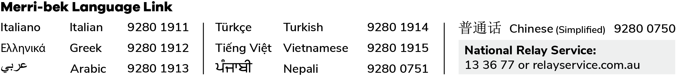
Discuss these requirements with a planning officer.
Disclaimer This publication is produced by Merri-bek City Council and is intended for information and communication purposes only. Although the publication may be of assistance to you Merri-bek City Council does not guarantee that it is without flaw or is wholly appropriate for your particular purposes. It and its employees do not accept any responsibility, and indeed expressly disclaim any liability, for any loss or damage, whether direct or inconsequential, suffered by any person as the result of or arising from reliance on any information contained in the publication.
This document is provided for information purposes only and is a guide to the planning process. Statutory controls and planning processes are subject to change.
© All applicable copyrights reserved for Merri-bek City Council. Except for any uses permitted under the Copyright Act 1968 (Cth), no part of this publication may be reproduced in any manner or in any medium (whether electronic or otherwise) without the express permission of Merri-bek City Council.

