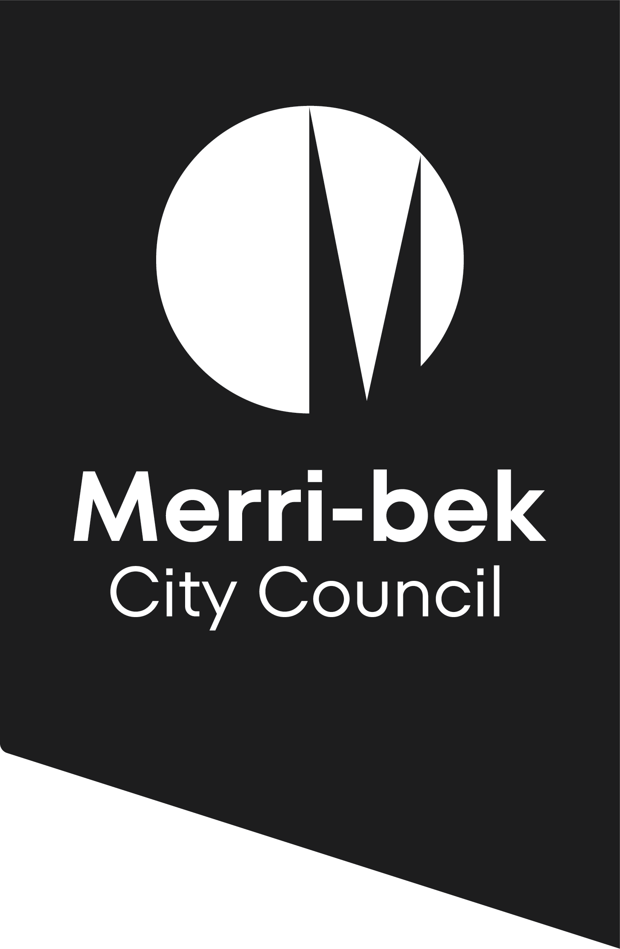
Neighbourhood and Site Description and Design Response

This brochure is designed to assist you when you are preparing a Neighbourhood and Site Description and Design Response required by Clause 54 and 55 of the Merri-bek Planning Scheme.
For more information or to speak with a planning officer, call 9240 1111 or visit the Merri-bek Civic Centre located at 90 Bell Street, Coburg
A pre-application meeting with a Council planner is always recommended to discuss your proposal and ensure the Neighbourhood and Site Description and Design Response is adequate. This will avoid submission of an incomplete application – one of the major causes of delay for planning applications.
For more information or to arrange a pre-application meeting with a Council Planner please call 9240 1111.

What is a Neighbourhood and Site Description (NSD) and Design Response?
The NSD and Design Response are key pieces of information needed for most planning applications where development is proposed. Submission of a planning application without an adequate NSD or Design Response often leads to lengthy delays.
The NSD accurately describes key features of your development site and the surrounding neighbourhood character.
The NSD is submitted in plan form. It is typically accompanied by a written description and photographs. The NSD would typically describe:
- The built form, scale and character of the area, including front fencing (i.e. height of buildings, front and side setback patterns, pattern of crossovers, vegetation, land topography etc)
- Patterns of open space (i.e. degree of openness at the rear of lots)
- Architectural and roof styles
The Design Response demonstrates how your proposed development responds to the characteristics identified in the NSD. The Design Response is submitted in plan form and should include a written evaluation of how the features of the neighbourhood identified in the NSD influence the design.
A streetscape view of your proposed development in the context of adjoining development is also often required.
Example NSD and Design Response plans are shown on the opposite side of this brochure.
See Council’s Checklist for Clause 54 and 55 applications for more information on what needs to be shown on an NSD and Design Response.

How much of the surrounding area should the NSD and Design Response cover?
For most development applications for medium density developments (i.e. more than 1 dwelling on a lot), the NSD and Design Response should show four sites or buildings up and down the street, across the street and behind your development site. For smaller proposals (i.e. single storey addition to a dwelling) a smaller NSD may be adequate. For very large proposals a broader NSD may be required.

Example Neighbourhood & Site Description Plan
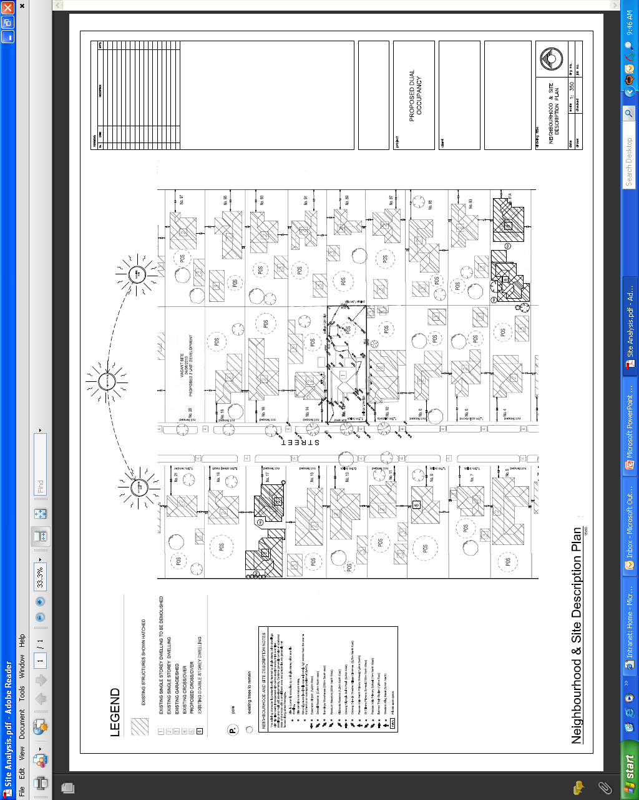

Example Design Response Plan
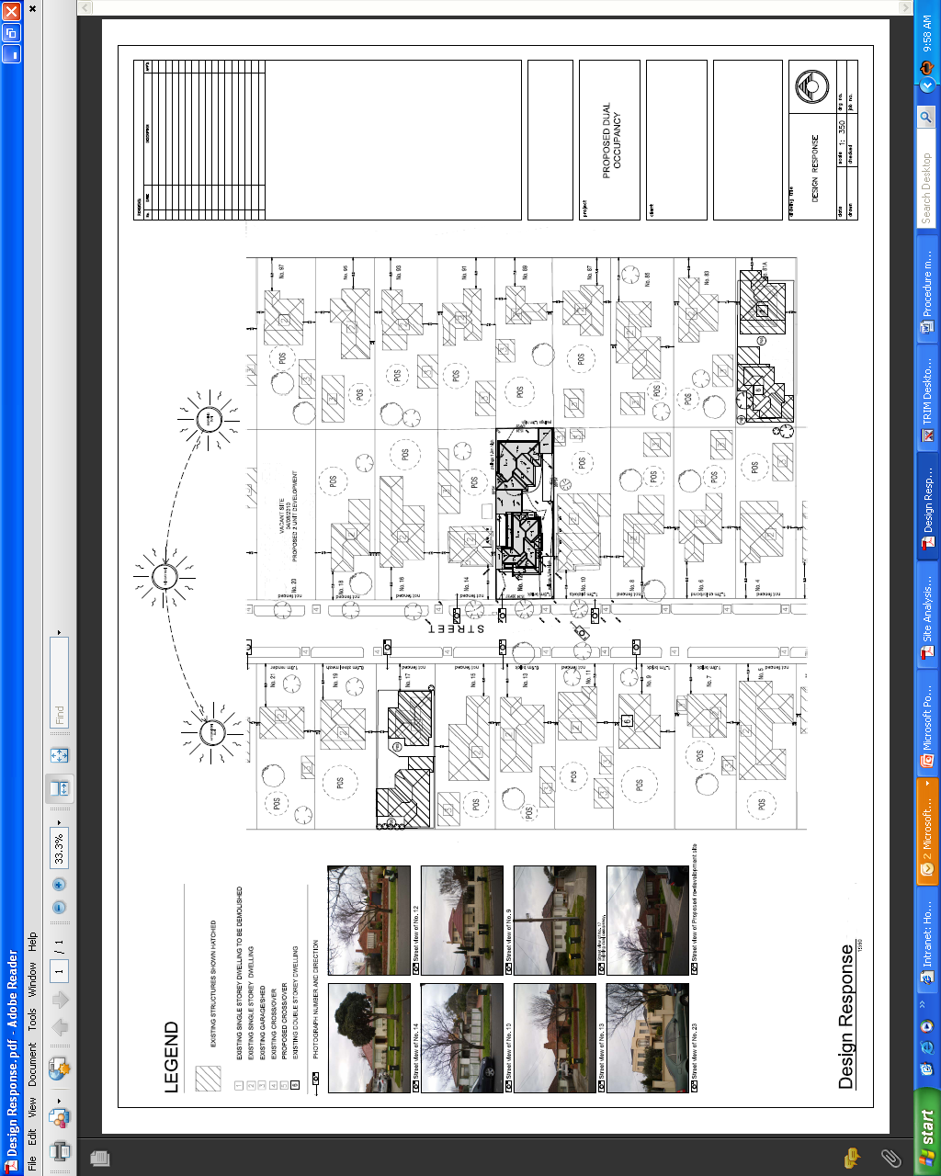

Example Streetscape Elevation
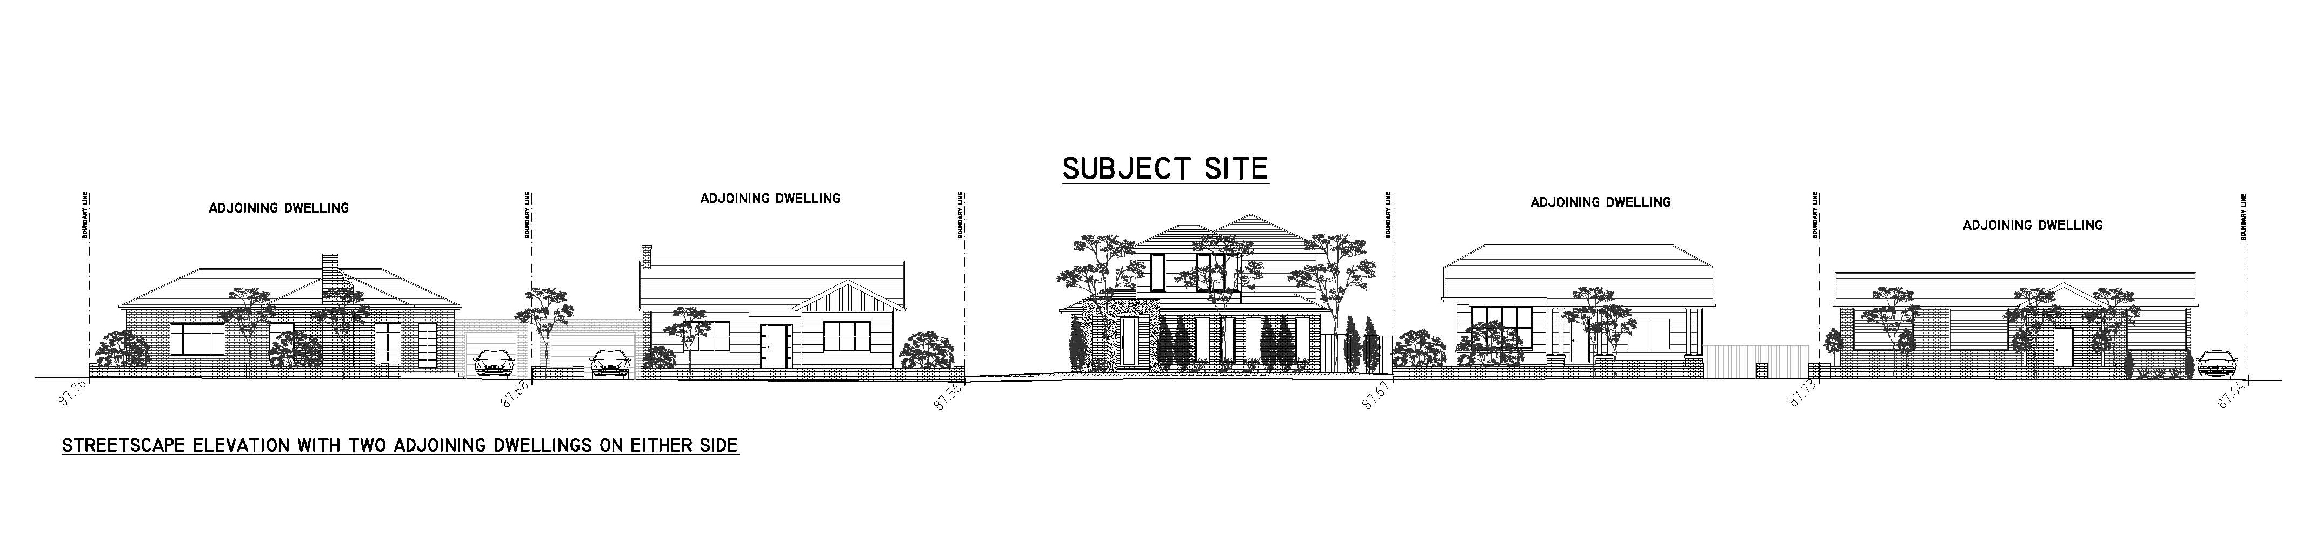
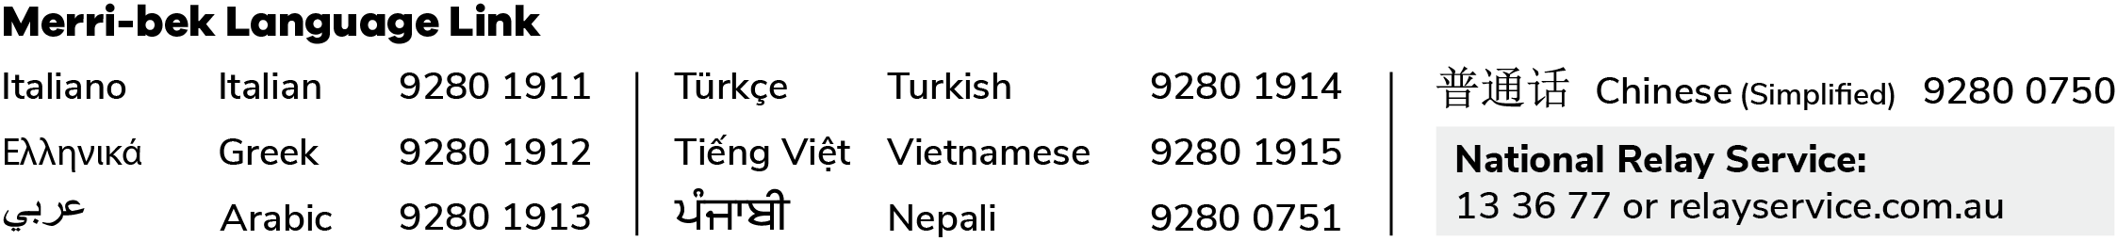
Example Streetscape elevation showing a proposed development in the context of 2 adjoining dwellings.
Disclaimer This publication is produced by Merri-bek City Council and is intended for information and communication purposes only. Although the publication may be of assistance to you Merri-bek City Council does not guarantee that it is without flaw or is wholly appropriate for your particular purposes. It and its employees do not accept any responsibility, and indeed expressly disclaim any liability, for any loss or damage, whether direct or inconsequential, suffered by any person as the result of or arising from reliance on any information contained in the publication.
© All applicable copyrights reserved for Merri-bek City Council. Except for any uses permitted under the Copyright Act 1968 (Cth), no part of this publication may be reproduced in any manner or in any medium (whether electronic or otherwise) without the express permission of Merri-bek City Council.

