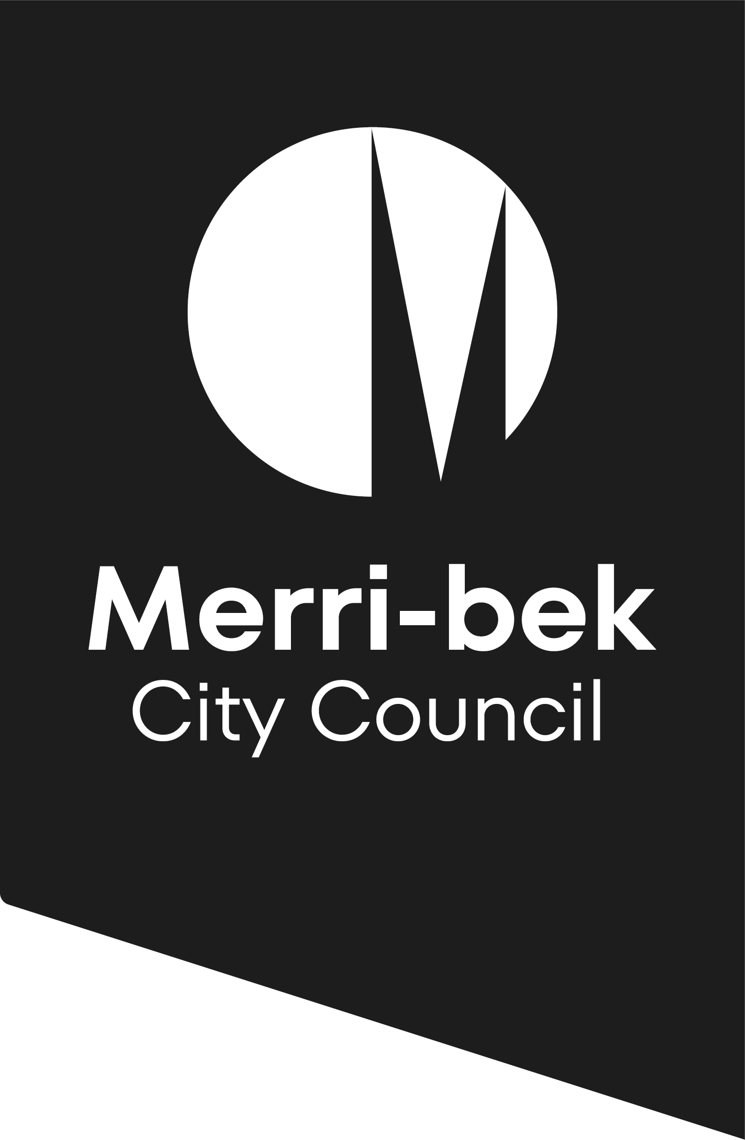

Request for an
Extension of time
to a planning permit

Section 69, Planning and Environment Act 1987

Tell us about the existing planning permit
Planning permit number |  |  |  |  |  |  |  |  |  |  |  | Date of issue
Address of land
Approved use or development
Has the use and/or development commenced? |  |  |  |  |  |  |  |  |  |  |  |  |  |  |  |  | ☐ | Yes |  |  |  |  | ☐ | No
Has an extension of time previously been granted for this planning permit? |  |  |  |  |  |  |  |  |  |  |  |  |  |  |  |  | ☐ | Yes |  |  |  |  | ☐ | No

Applicant details
Given name |  |  |  |  |  |  |  |  |  |  |  |  | Family name
Company (optional)
Email |  |  |  |  |  |  |  |  |  |  |  |  |  |  | Phone
Postal address
Is the applicant the landowner? |  |  |  |  |  | ☐ |  |  | Yes | ☐ | No
- If the applicant is not the land owner, has the applicant obtained the consent of the owner of the land to make this application? |  |  |  |  |  |  |  |  |  |  |  |  |  |  |  |  |  |  |  | ☐ | Yes |  |  | ☐ | No

Tell us about the extension sought
 |  | An extension of time must be applied for:  - to commence the use and/or development:  - before the permit expires; or  - within six months after the permit expires.  - to complete the development or a stage of the development (if the development has lawfully commenced):  - within 12 months after the permit expires.
There is no opportunity to appeal to the Victorian Civil and Administrative Tribunal if an application is made outside of these times.
Which date do you wish to extend? |  |  |  |  |  |  | ☐ | Commencement and completion date
 |  |  |  |  |  |  | ☐ | Completion date only (development has commenced)
Why was the development not completed or commenced within the allotted timeframe?
Have any steps have been taken thus far to develop the land in accordance with the permit (eg application for building permit, demolition on site etc.)? If yes, please detail.
Is the land currently, or soon to be, for sale? |  |  |  |  |  |  |  |  |  |  |  |  |  | ☐ |  | Yes |  |  |  |  |  | ☐ |  | No
Is the application being made to extend the time to complete the development within 12 months after the permit expires? |  |  |  |  |  |  |  |  |  |  |  |  |  | ☐ |  | Yes |  |  |  |  |  | ☐ |  | No
- If yes, please provide evidence (eg a statutory declaration or a dated builders’ invoice) that the development lawfully commenced before the permit expired. Council officers are required to check that all relevant planning permit conditions were satisfied prior to the commencement of works.

Signature and declaration
☐ | I declare that all the information I have given is true.
☐ | I have made payment: see www.merri-bek.vic.gov.au/building-and-business/planning-and-building/planning/planning-fees for fees required and to lodge online.
Signature
Name |  |  |  |  |  |  |  |  |  |  |  |  |  |  |  |  | Date
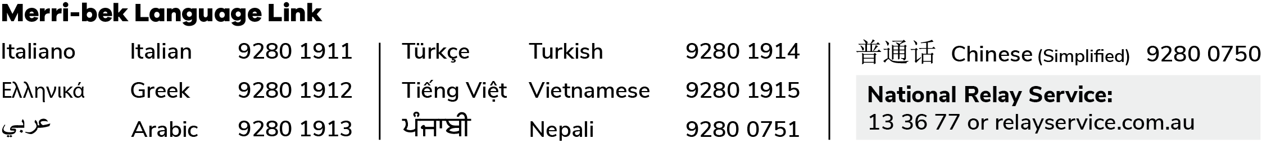
For more information & lodgement
 | Online visit www.merri-bek.vic.gov.au/building-and-business/planning-and-building/planning/planning-application-process/ for more information and to lodge your application online.
 | Mail your application and payment to Merri-bek City Council, Locked Bag 10, Brunswick, Vic 3056.
 | Visit the Merri-bek Civic Centre at 90 Bell Street, Coburg, Vic 3058.
 | Call Merri-bek City Council on 9240 1111.
Privacy notice
Merri-bek City Council is committed to protecting your privacy in accordance with the Privacy and Data Protection Act 2014 (Vic) and the Health Records Act 2001 (Vic). The personal information requested on this form is being collected by Merri-bek City Council to consider and determine this application and may also be used to update your personal information otherwise held by Council (for example, contact details including email address, phone number). Personal information disclosed in this application may be made available for public inspection including on Council’s public website whilst the application is being determined, in accordance with the Planning & Environment Act 1987. If a planning permit is granted, the permit and any endorsed plans or documents under the permit continue to be available for public inspection including on Council’s website permanently and may also be used by Council for related purposes. It will not be disclosed to any other external party without your consent, unless required or authorised by law. If the personal information is not provided in your application, this may result in the application not being accepted, lapsing or being refused. You can gain access to your personal information you have provided to Merri-bek City Council and if you wish to alter it, please contact Council’s Privacy Officer via telephone on 9240 1111 or e-mail at Privacyofficer@merri-bek.vic.gov.au.
PLEASE NOTE: Information associated with this application might be provided electronically and unless otherwise stated, Council takes the completion of this form as consent to use electronic communication. Further Council may use your electronic details for other Council communication.

