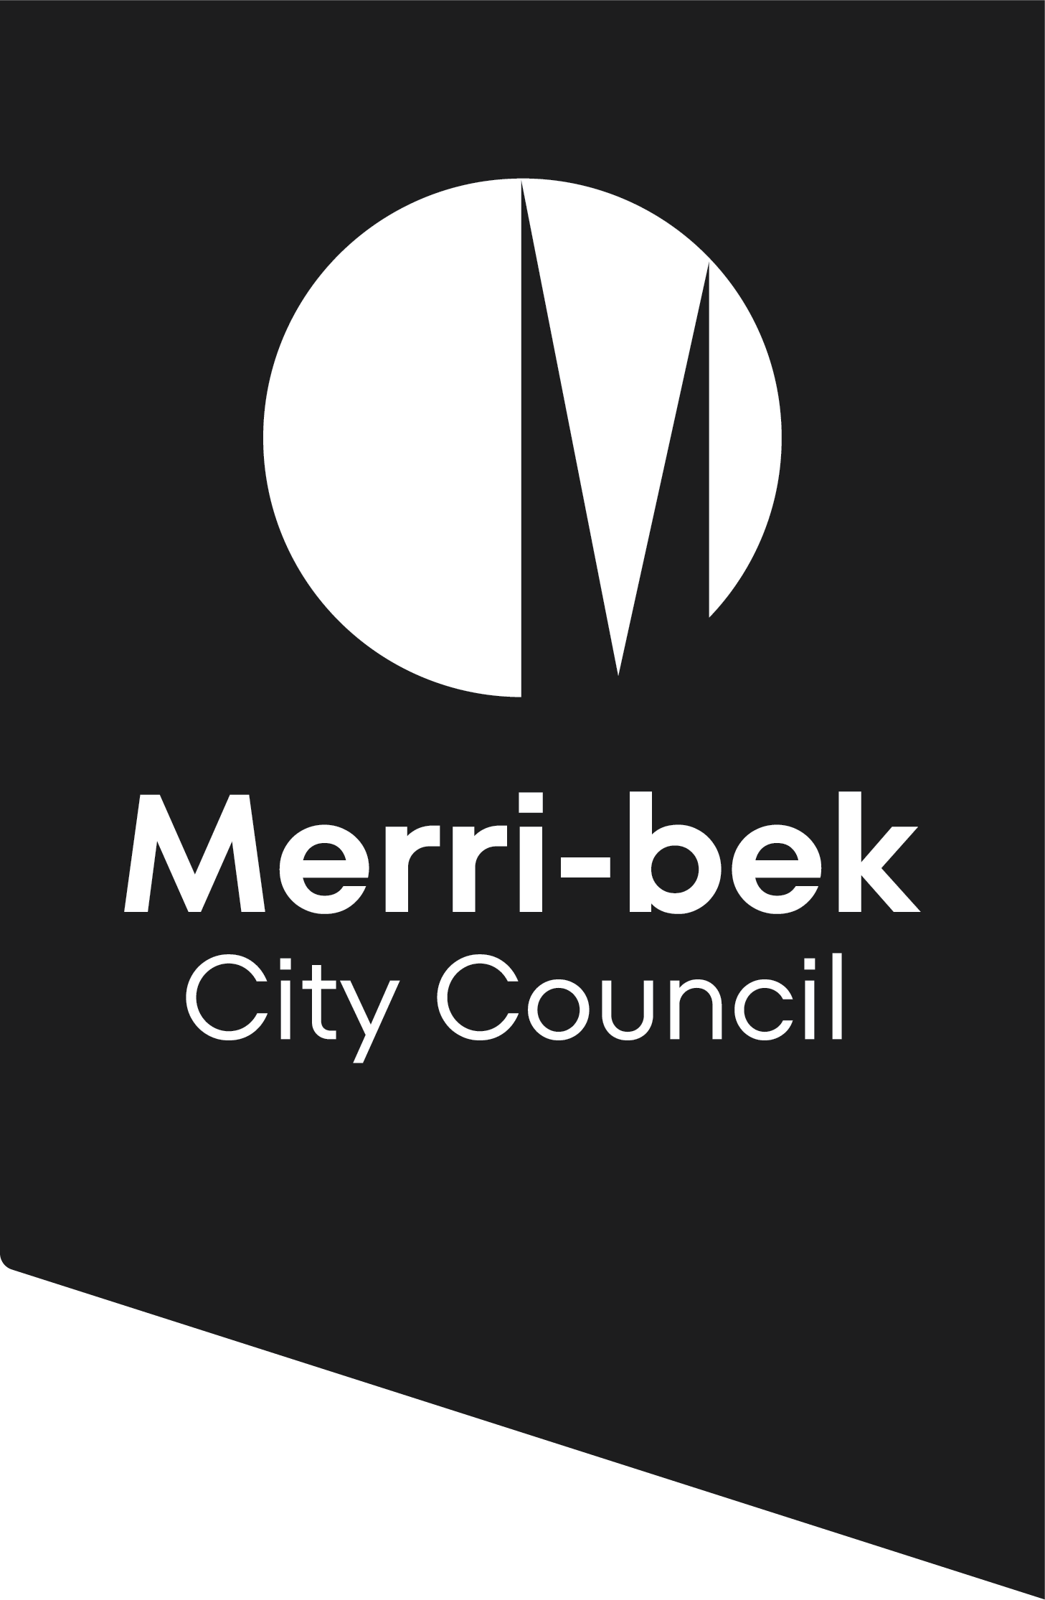
Checklist for development
Planning applications for development (buildings and works)

Planning requirements
This checklist applies to applications where development requires a planning permit under the provisions of the Merri-bek Planning Scheme. In some cases the way the land is ‘used’ will also require a planning permit. It is vital that a planning permit application description describes why a planning permit is sought.
Other planning scheme controls may affect your proposal. Please check the planning scheme requirements before submitting an application by visiting the Department of Transport and Planning website, www.dtp.vic.gov.au, or attending the City Development Branch enquiries counter at the Merri-bek Civic Centre.

Pre-application meetings
For more information or to speak with a planning officer, call 9240 111, visit or visit the Merri-bek Civic Centre located at 90 Bell Street, Coburg.
Council encourages applicants to meet with Planning Officers before lodging an application. These meetings are designed to advise applicants whether proposals are generally consistent with the Merri-bek Planning Scheme before they are lodged. Planning staff will also aim to assist applicants to become fully aware of the standard and extent of documentation they are required to provide in order to reduce or avoid the need for Council to request further information.

Submit a planning permit application online
- You need to register first as a user with Council Online Services before you can submit a planning permit application online.
- Once you are a registered user, sign in and lodge a planning permit application.
- As part of the online application process, pay the fee online with Visa or MasterCard.
To know more please visit the Council website: https://www.merri-bek.vic.gov.au/building-and-business/planning-and-building/planning/planning-application-process/

Documents required with planning permit application
All planning applications for development must include:
- A completed application form.
- A legible, full and current copy of title showing the search statement including details of any unregistered dealings. The title must be no older than 3 months and show all boundaries, easements and a full copy of any registered restrictive covenants on the land.
- The application fee (refer to fee schedule).

All development applications should be accompanied by the following information:
- Fully dimensioned plans at a scale not less than 1:100. The plans should show:
  - The title boundaries and dimensions.
  - Existing conditions detailing buildings, structures and significant trees on the site.
  - The location, height and use of buildings and works on adjoining land.
  - A neighbourhood and site description and design response as described in Clause 54 of the Merri-bek Planning Scheme for applications involving a dwelling on a lot of less than 300 square metres, two or more dwellings on a lot, or a residential building, in a Business 1 Zone, Business 2 Zone or a Business 5 Zone.
  - Any proposed demolition, clearly showing the extent of demolition and structures to be retained.
  - Plans, elevations and sections of existing and proposed buildings or works on the site (proposed alterations and additions to be highlighted).
  - All elevations accurately depicting the slope of the land and indicating the differences between natural ground levels compared to proposed floor levels. The elevation plans need to show finished floor levels and the overall building height to Australian Height Datum (AHD) or a Reference Level (RL) that will not be affected during construction.
  - All building setbacks from property boundaries and projections beyond boundaries fully dimensioned at each level, including the clearance heights from footpaths and/or road surfaces.
  - The internal layout of all existing and proposed buildings and/or works identifying the intended use of the components of the building.
  - A roof plan including details of air conditioning, other plant equipment, including any screening, and the location of buildings on adjoining properties.
  - The location of driveways and vehicle parking and loading areas (fully dimensioned) in accordance with the Merri-bek Planning Scheme.
  - Rubbish storage areas.
  - Where appropriate, how disabled access and facilities have been provided in accordance with the expectations of the Disability Discrimination Act.
  - A landscape plan. The proposed plantings should be consistent with those within the Merri-bek Landscape Guidelines and Technical Notes.
  - A schedule of finishes, detailing materials and colours of external surfaces.
  - Shadow diagrams showing the extent of shadowing caused by the proposal on any adjoining residential properties at 9am, 12noon and 3pm at the equinox.
  - A Sustainable Design Assessment or Sustainable Management Plan. See Council’s ESD Information. Where appropriate, site line drawings indicating visibility from 1.5 m above footpath level at the kerb alignment on the opposite side of the street to demonstrate how the development is viewed in the streetscape.
  - Any proposed signs (refer to the Advertising Signs checklist).

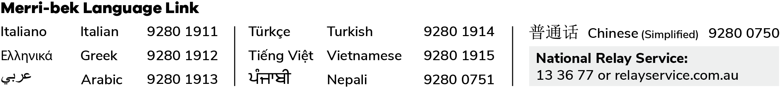
Please note
To enable proper consideration of the application. Council reserves the right to request additional information pursuant to Section 54(1) of the Planning and Environment Act, 1987.
Other planning scheme controls may affect your proposal. Please check the planning scheme requirements before submitting an application by visiting the City of Merri-bek website.
If planning approval is also required for use, advertising signs, liquor licensing and/or for other reasons, the relevant checklists should also be consulted. All approvals being sought should be included in one application.
Information associated with an application should be provided electronically.

