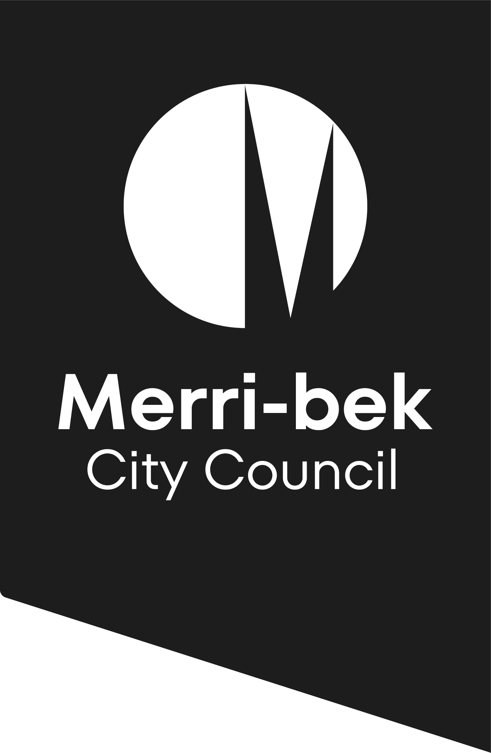
Checklist for
Development of one dwelling (lots greater than 300 square metres)

This checklist applies to applications to construct or extend a dwelling where no assessment is made (by the Planning Authority) under Clause 54 of the Merri-bek Planning Scheme.
This checklist applies to applications to construct or extend a dwelling where the overall land size exceeds 300 square metres and Planning Permit requirements are triggered by Overlay Controls such as Heritage, Environmental Significance or Special Building Overlays etc. It is important that permit applicants obtain a copy of the relevant overlay controls in order to see if there is other information required by these overlays.
Please check the planning scheme requirements before submitting an application by visiting the Department of Transport and Planning website: https://www.planning.vic.gov.au
or attending the City Development Branch enquiries counter at the Merri-bek Civic Centre.

Pre-application meetings
Council encourages applicants to meet with the City Development Branch before lodging an application. These meetings are designed to advise applicants whether proposals are generally consistent with the Merri-bek Planning Scheme before they are lodged. Planning staff will also aim to assist applicants to become fully aware of the standard and extent of documentation they are required to provide in order to reduce or avoid the need for Council to request further information.
Submit a planning permit application online:
- You need to register first as a user with Council Online Services before you can submit a planning permit application online.
- Once you are a registered user, sign in and lodge a planning permit application.

- As part of the online application process, pay the fee online with Visa or MasterCard.
To know more please visit www.Merri-bek.vic.gov.au.

All planning applications for one dwelling on a lot must include(to be provided electronically where possible)
- A completed and signed application form.
- A legible, full and current copy of title showing the search statement including details of any unregistered dealings. The title must be no older than 3 months and show all boundaries, easements and a full copy of any registered restrictive covenants on the land.
For more information, call 9240 1111 to speak to a planning officer, visit Council’s website, www.Merri-bek.vic.gov.au, or visit the Coburg Civic Centre at 90 Bell Street, Coburg.
- The application fee. (refer to fee schedule)

Plans
Plans of the proposed development, with dimensions at a scale not less than 1:100. Plans in electronic form are also encouraged. Plans should show:
- The title boundaries and dimensions of the site
- Extent of any proposed building demolition and structures to remain.
- Floor plans and all elevations of proposed buildings or works on the site (proposed alterations and additions to existing buildings to be highlighted.
- Floor plans for all levels dimensioning setbacks from all the title boundaries, finished floor levels and the location of buildings on adjoining properties.
- All elevations accurately depicting the slope of the land and indicating the differences between natural ground levels compared to proposed floor levels. The elevation plans need to show finished floor levels and the overall building height to Australian Height Datum (AHD) or a Reference Level (RL) that will not be affected during construction.
- A roof plan including details of air conditioning, other plant equipment, including any screening, and the location of buildings on adjoining properties.
- Location and dimensions of existing and proposed crossovers and car parking spaces in accordance with the Merri-bek Planning Scheme.
- Elevations (with dimensions) of any proposed front fences.
- A development summary that details the site area, site coverage, the size of the dwelling and hard-surfaced area and percentages.
- A schedule of materials, colours and finishes of external surfaces, including roofs, walls, fences and garages.
- Location of street frontage features such as poles, service pits and street trees.
- Written consent from the relevant authorities to build over any easements

In Additional information
Please note that the planning officer assessing the application may require additional information, or may need to clarify the information that is provided with an application.
This document is provided for information purposes only and is a guide to the planning process. Statutory controls and planning processes are subject to change.

Disclaimer This publication is produced by Merri-bek City Council and is intended for information and communication purposes only. Although the publication may be of assistance to you Merri-bek City Council does not guarantee that it is without flaw or is wholly appropriate for your particular purposes. It and its employees do not accept any responsibility, and indeed expressly disclaim any liability, for any loss or damage, whether direct or inconsequential, suffered by any person as the result of or arising from reliance on any information contained in the publication.
© All applicable copyrights reserved for Merri-bek City Council. Except for any uses permitted under the Copyright Act 1968 (Cth), no part of this publication may be reproduced in any manner or in any medium (whether electronic or otherwise) without the express permission of Merri-bek City Council.

