
Guidelines for

Green Infrastructure
Integrating green infrastructure onto buildings

Published in partnership by City of Melbourne and Merri‑bek City Council

May 2026

Acknowledgements
Authored by City of Melbourne and Merri-bek City Council.
Acknowledging the significant early contributions from The Urban Greener and BY Projects Architecture

These Guidelines do not supersede any engineering, architectural or building specifications, codes, standards or legislation within Australia or other jurisdictions. This document has been reviewed for alignment with Standards Australia Handbook 214:2023 Urban Green Infrastructure—Planning and decision framework. The typologies outlined within align with those used in City of Melbourne’s Green Factor Tool.
Victorian local government authorities may replicate the design-specific advice within this document, with acknowledgement of the original authors.
This work is licensed under a Creative Commons Attribution-Non Commercial-Share Alike 4.0 International License.


Acknowledgement of Country

City of Melbourne
The City of Melbourne respectfully acknowledges the Traditional Owners of the land we govern, the Wurundjeri Woi-wurrung and Bunurong / Boon Wurrung peoples of the Kulin and pays respect to their Elders past and present. We acknowledge and honour the unbroken spiritual, cultural and political connection they have maintained to this unique place for more than 2000 generations.
We accept the invitation in the Uluru Statement from the Heart and are committed to walking together to build a better future.
Today we are proud to say that Melbourne is a significant gathering place for all Aboriginal and Torres Strait Islander peoples.

Merri‑bek City Council
Merri-bek City Council acknowledges the Wurundjeri Woi-wurrung people as the Traditional Owners and Custodians of the lands and waterways in the area now known as Merri-bek.
We pay respect to their Elders past, present, and emerging, as well as to all First Nations communities, who significantly contribute to the life of the area.

Contents
- Purpose of this document 2
How to use this document 2
- Introduction 3
Benefits of green infrastructure 4
- Defining green infrastructure 5
- Policy and planning context 7
Typical Environmentally Sustainable Design (ESD) planning process 8
- Integrating green infrastructure 9
What green infrastructure is best for your property 9
Site and context 10
Buildings and structures 11
Waterproofing and drainage 13
Irrigation systems 15
Planting 16
- Maintaining and managing green infrastructure 17
Landscape Maintenance Plan 18
Establishment maintenance and monitoring 18
Qualified personnel 19
- Appendices 20
Appendix 1. Common planning permit requirements 21
Appendix 2. Typical maintenance requirements 22
Appendix 3. Risk analysis 24
Appendix 4. Useful links, resources & references 27
References 28

Purpose of this document

City of Melbourne and Merri-bek City Council have prepared this step-by-step resource in response to the welcome increase in property developers, designers and owners integrating green infrastructure (GI) typologies onto their building projects. It will highlight the key considerations for each step in the design process, as well as who you should consult for advice or permissions.
This document is aimed primarily at planning consultants or those disciplines involved in the planning and design process for built developments. This includes building owners, property developers, construction managers, and building and landscape design experts. This document may be useful to you if:
- you are initiating or are mid-way through a planning permit application for a development which involves GI.
- you wish to incorporate GI into your developments but are unsure of the process.
- you are a planning consultant or developer seeking to improve the success of GI outcomes or upgrade existing GI assets.
These guidelines are intended to be a reference document for professionals when developing proposals and should not be considered as direction, legal or regulatory advice. Developers preparing a planning application should also refer to relevant planning processes for the municipality where the property is located.

How to use this document
These Guidelines have been developed to support you in correctly scoping and designing GI, and with identifying relevant materials for your planning application. They are arranged chronologically as you work through the planning process, covering:
- identifying retained and new in-ground vegetation
- scoping appropriate GI for your site context
- design and construction considerations for buildings
- vegetation management and maintenance.
A Green Infrastructure Design Checklist is available as a supplementary document to help your planning and consultation with relevant professionals. The topics covered in this Checklist are expanded upon in further detail in later sections. Additional resources should also be used in the detailed design of your GI; many of these are also listed in the Useful Links, Resources & References (Appendix 4).

Introduction

Greening in new urban developments refers to the incorporation of plants and vegetation into the design. It is an effective tool to help mitigate the effects of climate change and urbanisation, as well as improve the liveability of our cities.
As Victoria experiences warmer summers and excess heat from human activity, impervious surfaces compound the issue by trapping heat, increasing flood risk, and limiting the amount of available space for vegetation. New approaches such as GI are becoming increasingly important for mitigating these impacts and improving human and ecosystem health outcomes. GI can alleviate urban heat through shade, cooling and plant transpiration, while soil profiles retain excess stormwater, lower flood risk and increase ground level permeability for further cooling benefits.
Local governments recognise the need for proper, localised guidance material for this emerging field to ensure quality Environmentally Sustainable Design (ESD) outcomes. While we have seen a range of ratings tools used in the industry to assess energy or stormwater performance, less is known about how to set GI targets and measure performance. As performance measures and rating tools for GI mature, it is expected that planning requirements and incentives will evolve to encourage greening in developments.

To learn more about what green infrastructure is, the Green Factor Tool, and the benefits and value that GI can bring to your development, please see the below resources:
  - City of Melbourne’s Green Infrastructure and Green Factor Tool resources
  - Merri-bek City Council’s Zero Carbon Development Fact Sheets
  - CASBE’s Sustainable Design Fact Sheets - Urban Ecology
The external links and resources in this document are current to February 2026.

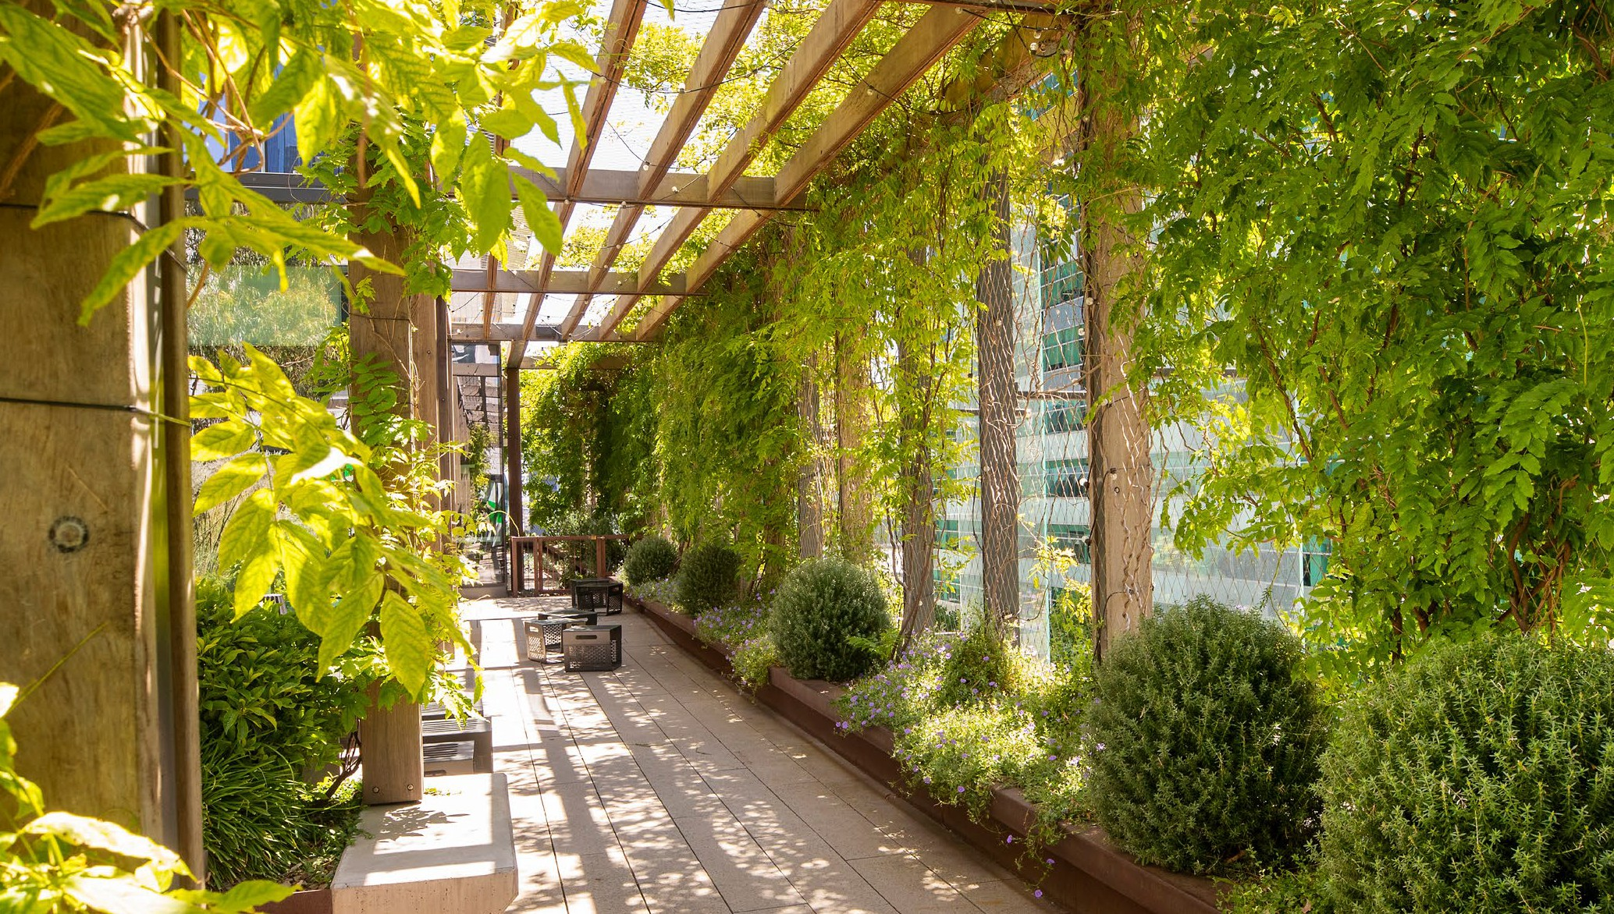

Benefits of green infrastructure
There are many well-documented benefits of GI which support its integration into building design. These benefits are defined in the below graphic.
  - Improved air quality
  - Aesthetic benefits
  - Promotes public health and wellbeing through connection to nature
  - Retention of stormwater in local landscape, benefiting other vegetation
  - Improved energy efficiency and thermal performance of buildings
  - Adapting to future climates with cool, shaded vegetated spaces
  - Improved performance in MUSIC and Blue Factor stormwater assessments
  - Added resale and rental values and increased desirability of properties
  - Improved biodiversity and green space connections
  - Provides habitat for pollinators such as butterflies

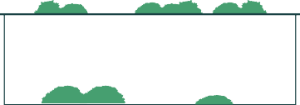






Defining green infrastructure
Standards Australia defines ‘Urban Green Infrastructure’ as a ‘Network of natural, designed or cultivated vegetation spaces in an urban environment’.^{(See ‘References’, page 28)}In a broader urban context, GI may refer to any ‘green’ asset. For these Guidelines the definition adopted incorporates both in-ground vegetation (trees, shrubs, climbers and ground cover as part of a retained or new planting) and on-structure assets (such as a green façade, wall or roof).
When classifying a building or property asset, a ‘GI asset’ typically includes the host structure plus specific elements including waterproofing and drainage, irrigation, growing media and vegetation. Carefully designing each of these elements to consider surrounding contexts is critical to well-integrated, long living and thriving GI on structures and buildings.
There are many ways to incorporate vegetation into a development, each with different benefits, construction and maintenance considerations. Which GI to incorporate will depend on the features of the building, design objective(s) sought, and existing site constraints. Considering which typologies to incorporate early in the design phase will maximise GI opportunities within the building. The tables below outline six GI typologies referred to in these Guidelines - two categories of in-ground planting
and four typologies built on structures. These definitions reflect those recognised by the Green Factor Tool—a tool developed by City of Melbourne and used by Councils to assess the extent and value of greening on proposed developments.

In‑ground vegetation
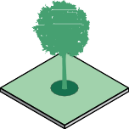  Existing (retained) in‑ground planting | Any in-ground vegetation present before redevelopment, which will be retained as part of the landscape of the new building.  Assumes a soil depth of at least 500mm. Plants which may be retained include small, medium or large trees, shrubs, understorey plants and ground cover including lawns. Existing mature trees are particularly valuable to retain due to long maturation times.
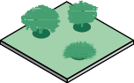  New in‑ground planting | New in-ground vegetation that will be installed and maintained as part of the landscape of the new building.  Assumes a soil depth of at least 500mm and may comprise a combination of small, medium or large trees, shrubs, understorey plants and ground cover including lawns.

On‑structure GI typologies
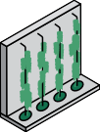  Green façade | A green façade is created by growing climbing plants across the façade of a building, either from plants grown in soil at ground level, or plants in containers installed at height across the building.  The climbing plants may attach directly to a building surface (i.e. self-clinging) or be supported by a structure (e.g. cables/trellis) independent of the building facade.
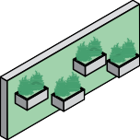  Green wall | A green wall, often called a ‘living wall’, comprises different vertical systems each growing and supporting plants, typically fixed to an internal or external wall (or in some cases freestanding).  Green walls vary in design, but all incorporate vegetation, growing medium, irrigation and drainage into a single system. While most green walls are established on structural walls, they may also be implemented on an internal wall, standalone partition, or even wrap around a structural column.
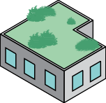  Green roof | A green roof, often called a ‘living roof’, is a vegetated landscape constructed directly on the roof of a building or structure. It includes systems installed in layers—waterproofing, drainage, protection membranes, growing medium and plants—or modular systems that encompass these layers fitted directly on the roof.  Green roofs are often categorised by their depth of growing media into ‘extensive’ (20-150mm depth) or ‘intensive’ (150mm+ depth). However, modern designs may incorporate a range of different zones and soil depths across a single roof.
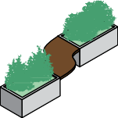  Planters on structure | Planters and elevated garden beds, with or without a solid base, used to introduce vegetation in terraces, on balconies or at roof level. Often also referred to as podium planters. Planters can be incorporated into other furnishings such as bench seating and solid balcony edges, or into an ‘arbour’ design for climbing plants  While smaller than green roofs and more constrained for root space, planters with sufficient soil depth and volume can support small and medium trees at height on a building. Planters must be made from weather resistant materials.

Policy and planning context
In September 2020, the City of Melbourne endorsed draft Amendment C376 to the Melbourne Planning Scheme. Following this, in 2022, 24 Victorian councils lodged a planning scheme amendment with the Council Alliance for a Sustainable Built Environment (CASBE) to elevate sustainability requirements for new developments. Both amendments propose requirements to incorporate urban ecology (including GI) for heat mitigation, improved amenity and increased local habitat. The proposed examples demonstrate how we can set the benchmark for sustainable
development and are backed by a series of council and industry case studies demonstrating these standards are achievable.
To facilitate improved urban ecology in developments, the City of Melbourne developed the Green Factor Tool in 2020—an online tool for assessing developments’ proposed landscape plans. Designed for use by applicants, planners and referral experts, the Green Factor Tool uses a consistent, internationally proven assessment methodology to provide a ‘Green Factor Score’ measuring the value of ecosystem services provided by a development’s GI. Tailored to a Victorian context, the tool aims to increase the quantity and quality of greenery including green roofs, façades and walls into new developments.
Development of the tool included extensive testing and validation against new planning applications. As part of Amendment C376, City of Melbourne encourage the use of the tool to inform landscape planning and endorse a standard ‘Green Factor Score’ of 0.55. The tool is also gradually being used by other councils including Merri-bek, improving the consistency of GI assessment across Victoria.

City of Melbourne has incorporated the Green Factor Tool and associated GI standards into Planning Scheme Amendment C376 for new planning applications. Official changes to the Melbourne Planning Scheme are expected to come following the gazettal of Amendment C376. For more information on planning at City of Melbourne click here.
Merri-bek City Council actively requires the incorporation of environmentally sustainable design information (including Integrated Water Management and Urban Ecology) in new developments. For more information on planning at Merri-bek City Council click here.
Both City of Melbourne and Merri-bek City Council are members of CASBE, an alliance which advocates for broad-scale improvements through built environment standards to deliver liveable Victorian communities. For more information on CASBE click here.

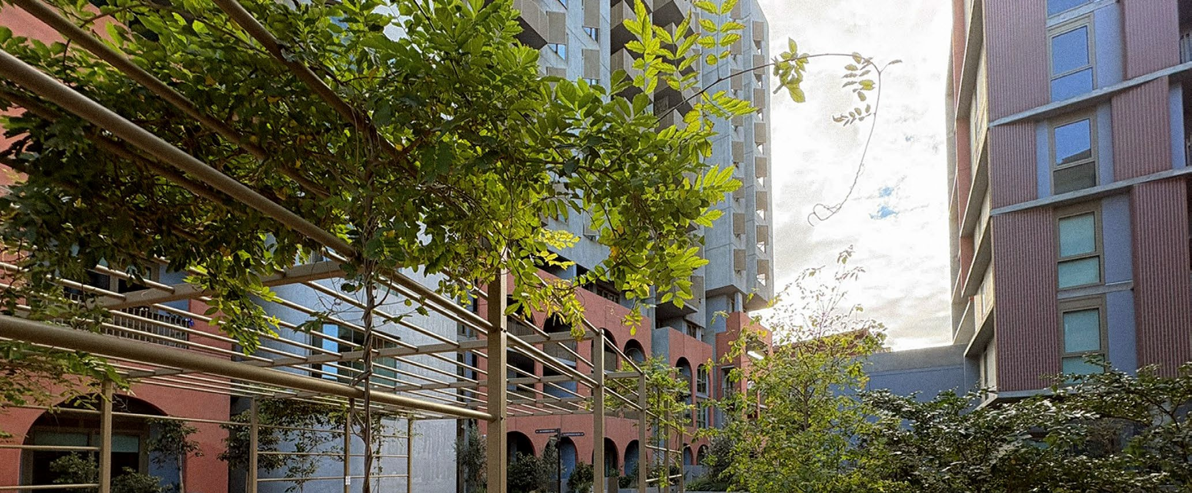

Typical Environmentally Sustainable Design (ESD) planning process
ESD in planning is common across Victoria with many local governments having local and state planning policies that require a response from applicants through the planning process.
This flow chart shows a typical process where the points for enquiry, advice and submission of information is listed and offers opportunity for applicants to ensure GI is best integrated into their developments

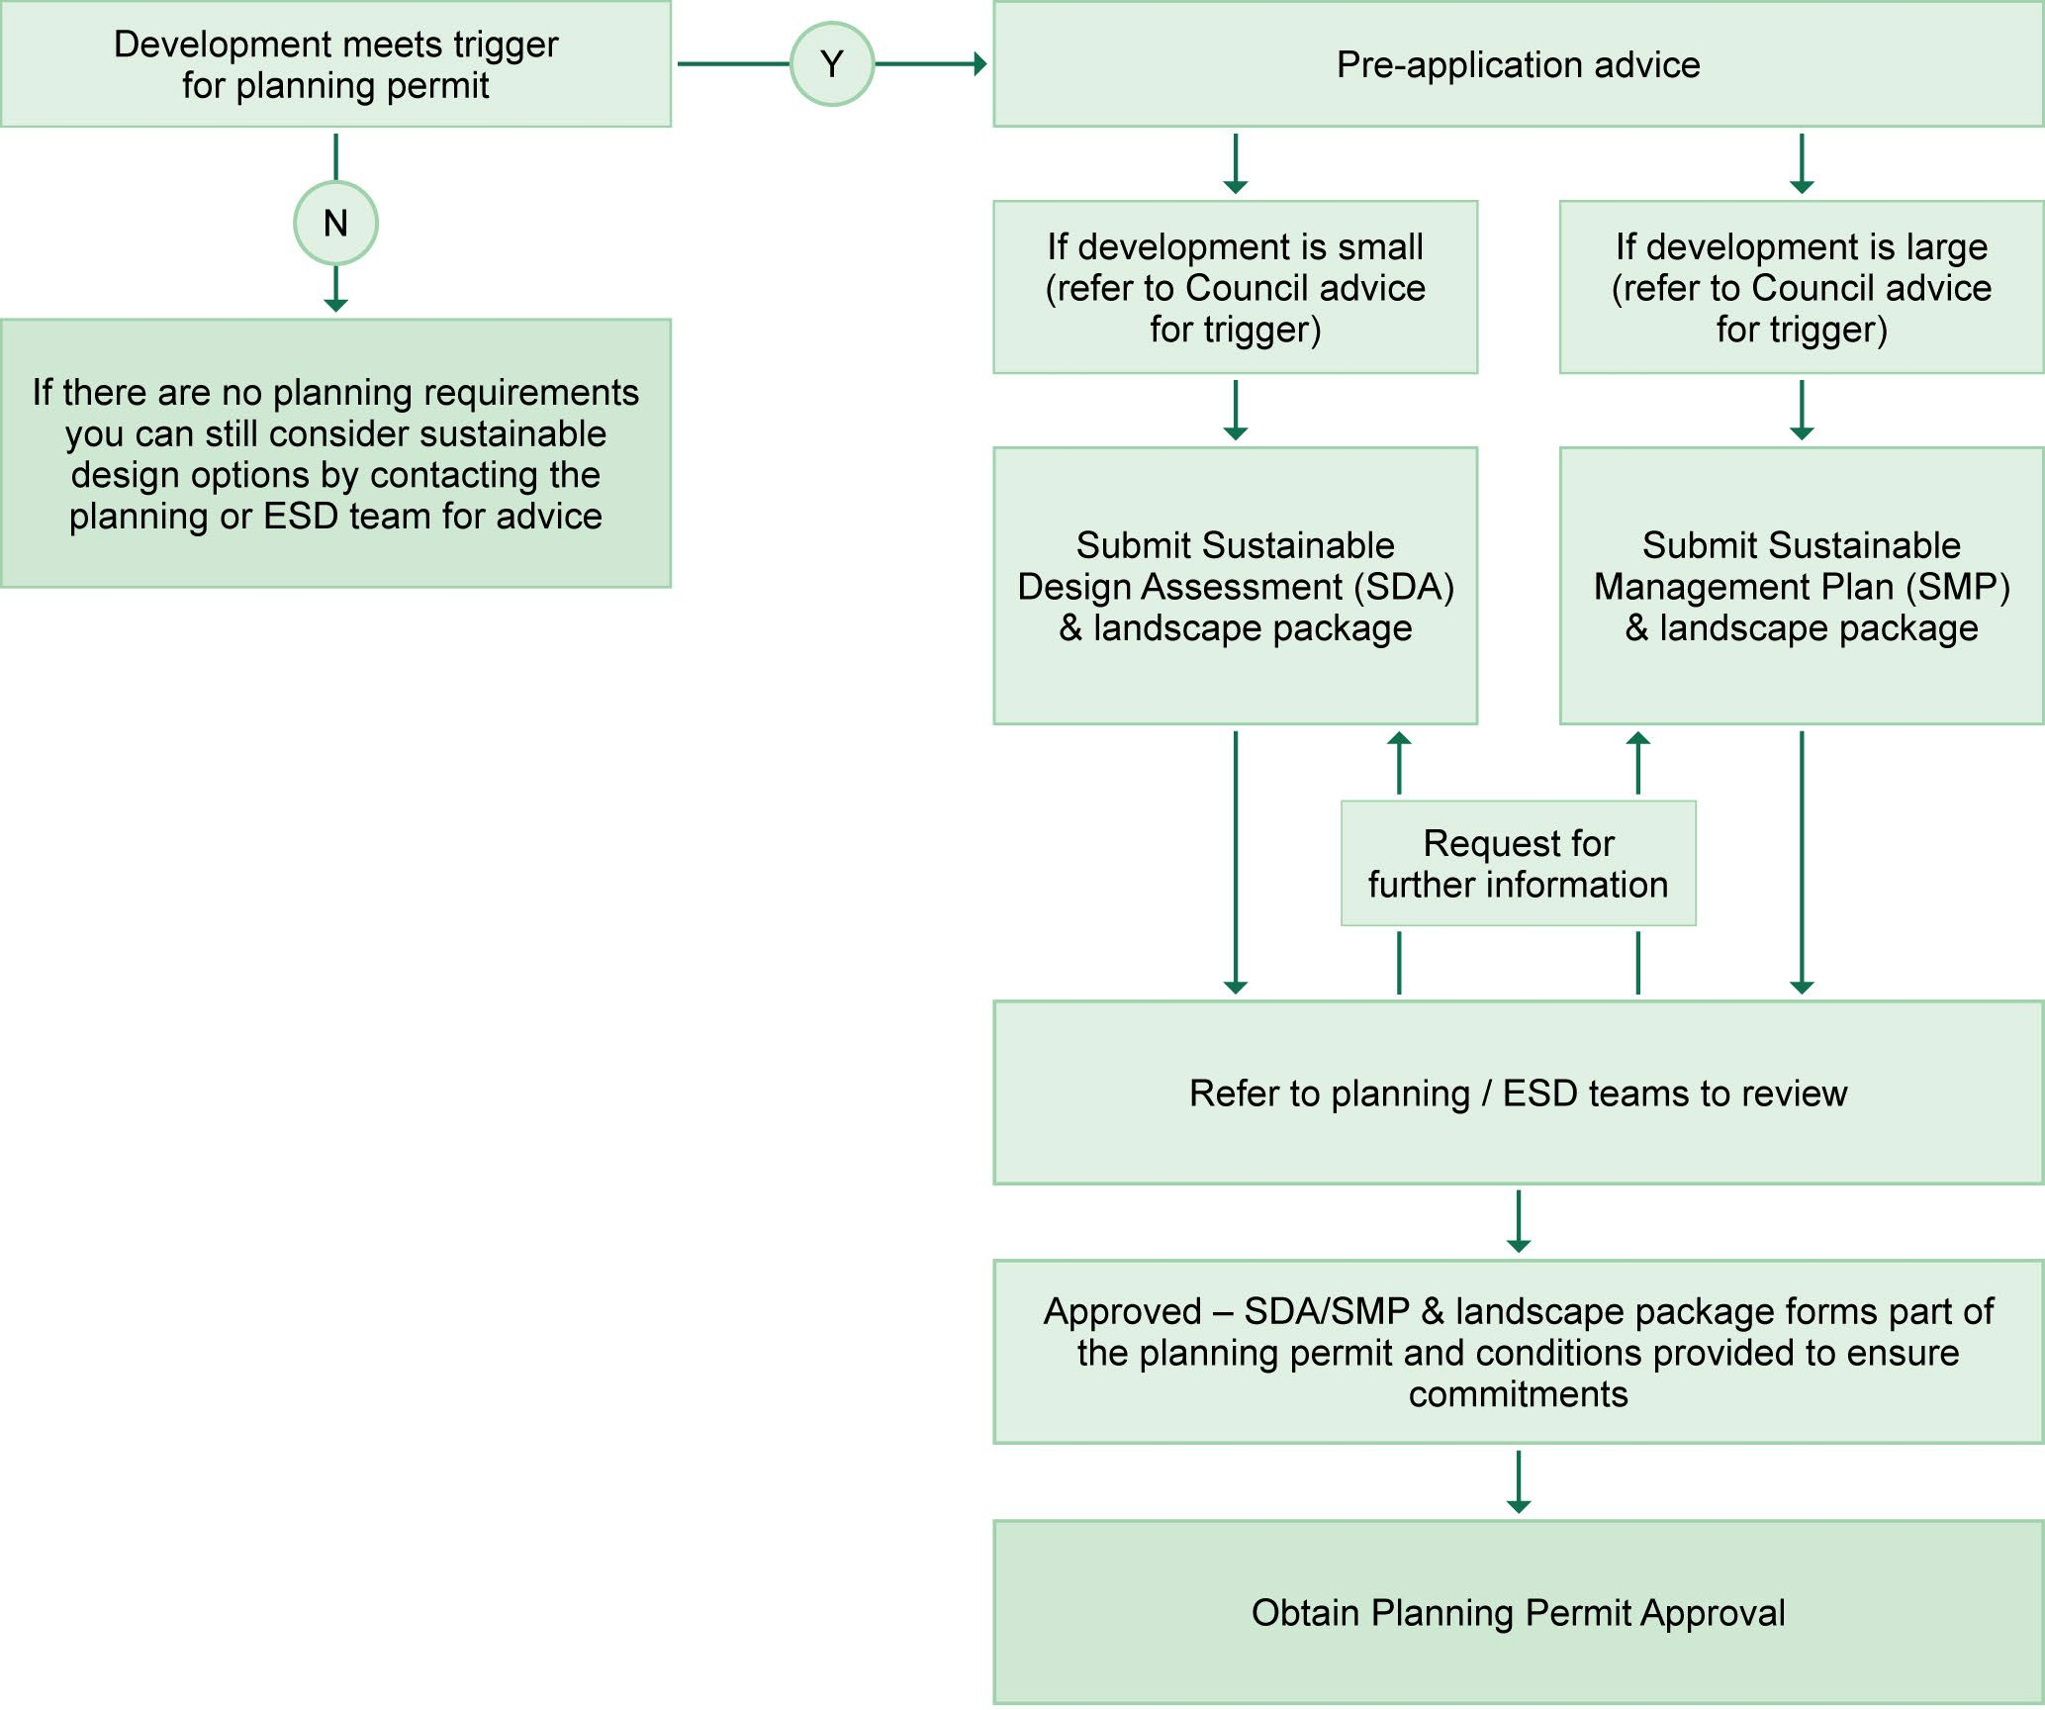

Integrating green infrastructure
The following sections provide step-by-step advice on the key stages of GI development, and considerations to make when designing GI assets for a building at each of these stages. The following sections align with and expand upon the elements summarised in the Green Infrastructure
Design Checklist.

What green infrastructure is best for your property
When considering what types of GI to include in your development, design teams should consider the following hierarchy to maximise the benefits of greening:

Priority 1—retain any existing vegetation possible, particularly mature trees.
In-ground vegetation should be prioritised as it provides significant, immediate benefits and contributes to the existing character of the site.

Priority 2—maximise new, in‑ground vegetation, particularly garden beds and deeper soil profiles (>1m) that support trees.
Large canopy trees provide significant environmental, ecological and human health benefits, but will have long establishment and maturation times before providing full benefits.

Priority 3—consider on‑structure GI assets.
Green facades, green walls, green roofs and planters can be used to meet greening targets and improve the overall ESD performance standard. On-structure GI typically has higher construction costs and lesser environmental benefits but is effective where sufficient in-ground vegetation is not possible.
To maximise greening outcomes, designers should also consider combining on-structure GI assets alongside traditional approaches to landscaping.
Figure 2. Example of green infrastructure typologies as they may occur and co-exist on a development

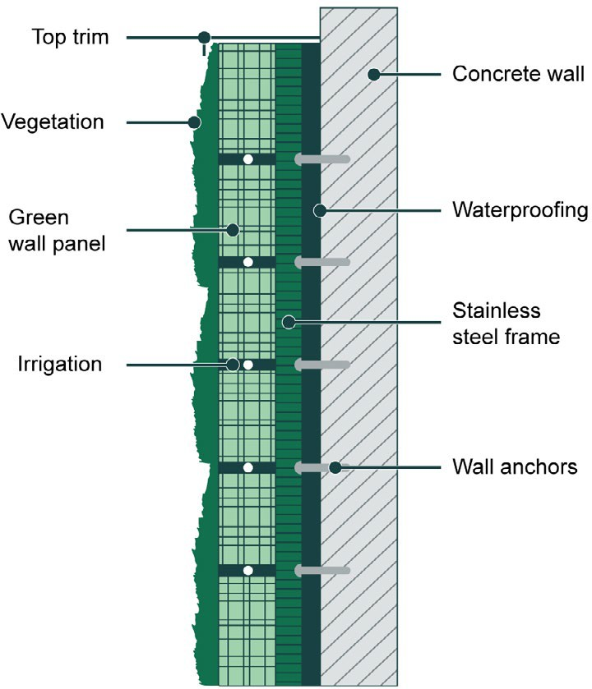
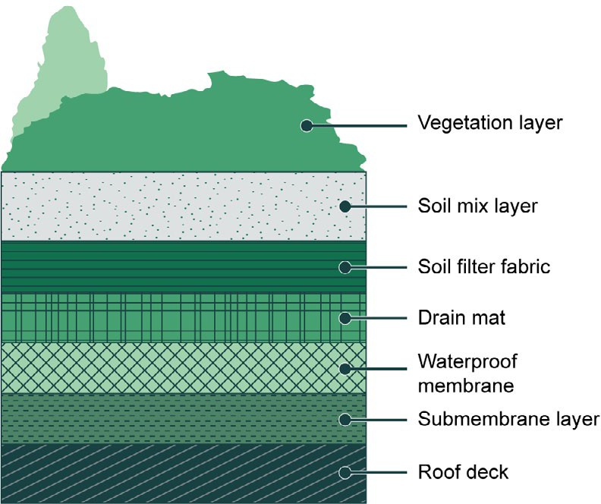
Green walls Green roofs

Site and context

Existing and significant vegetation
Retaining existing vegetation should be prioritised in your development, particularly where mature canopy trees and other significant vegetation (trees, garden beds etc.) are present. Retaining or re-using dead vegetation (logs, fallen trees, stumps) as part of the landscape should also be considered, as it can provide valuable wildlife habitat and improve nature connections for users.

Soils for new in‑ground vegetation
In planning new in-ground vegetation, soil testing is needed to determine the soil profile (ideally 500mm+ depth) and physical and chemical properties such as aeration, drainage, water retention, pH and nutrients, and soil contamination. Understanding these properties is an important step to support your GI designs and plant selection. Depending on your soil analysis results a treatment such as soil amelioration may be required for future plantings. This may also include further improvements post-construction as a result of the construction process.

Site constraints
Development sites have constraints that will impact the choice of GI. Many environmental factors can be overcome through good design but must be considered upfront, such as:
- shading and shadowing (e.g. low versus high light intensity)
- building topography (e.g. orientation, aspect, height, exposure and wind)
- structural load capacity
- accessibility requirements and exit clearances and
- access to water for irrigation including alternative water sources.

Local context
The suitability of GI depends not only on the development site but also on its surroundings—location, orientation and access. Consider nearby open space and public realm vegetation and design on-
site vegetation to connect to these spaces where possible. Creating a network with GI and existing parklands and waterways improves amenity and user experience and may promote better local stewardship of your GI. Plant selection should reflect existing vegetation nearby, including Australian and/or locally indigenous plants where possible.
For developments with little nearby open space, consider implementing accessible green roofs, and planters on balconies and courtyards. Access to ‘green’ recreational areas within dense urban environments is both beneficial to human health and local biodiversity and has been shown to increase the value of properties.

Land tenure and property ownership
Consideration should be given whether the GI is located on private allotments or common property. This will have implications for maintenance costs and long-term quality of the asset. Tenure and maintenance responsibility should be specified in a Maintenance Plan (see Maintaining green infrastructure below) which may be included in the planning permit application process.

Neighbouring properties
Vegetation may extend beyond a property boundary if it does not create a hazard or damage to adjacent landowners and occupiers. Neighbours generally have the right to remove overhanging vegetation extending into their property at their own cost, except where a tree is protected by the local council or may be damaged by branch or root removal.
Property owners may be liable for damage occurring to a neighbour’s property as a result of poorly maintained vegetation. Regular vegetation maintenance such as pruning can reduce the risk of potential hazards beyond the property such as high wind events. Engaging with adjacent landowners early regarding your plans for GI can help to clarify your intentions and resolve any concerns.

For further Information on site context and determining appropriate GI for your site, refer to:
  - Growing Green Guide: Chapter 3.2 Site Analysis
  - CASBE fact sheets on Urban Ecology Design Strategies
  - Victorian State Government resources on Neighbours, the law and you and Trees in Victoria
  - For City of Melbourne specific context refer to Building and development | City of Melbourne
  - For Merri-bek specific context refer to the Good Design Advice Sheets

Buildings and structures

Locating GI assets and adjacent structures
Deciding on the location of your GI will vary depending on the structure itself and the construction process. For example, you should consider how much space is available, where the location can be accessed for ongoing maintenance, as well connections to plant rooms and equipment. It is also
important to note any occupational health and safety concerns that may arise during the construction process.
Green roofs and on-structure planters often share spaces with
- Heating, Ventilation and Air Conditioning (HVAC) units
- elevator overruns
- antennae
- solar PV panels
- hot water systems
- communal laundries or clothes lines.

Green roofs must accommodate these different competing uses, materials and structures in their design, including accessibility for maintenance. Solar panels can also be elevated above the green roof, providing additional shade to the plants. You may also consider incorporating natural or built habitat for insects and birds to enhance biodiversity outcomes.

Weight load
Horizontal and lateral weight loading capacity is key to ensuring a building is structurally fit for purpose for GI. A qualified structural engineer should always be consulted to specify weight loading capacity of walls, balconies, roofs and podiums to inform the design of on-structure GI. This includes assessing point-loading capacity across the roof, both during construction (for materials loading) and design development (i.e. locating deep planters).
While most GI is incorporated in new developments, GI can also be retrofitted on existing buildings. In this case structural engineering advice is essential, as Australian roofs are often not designed for the loadings typically seen in the northern hemisphere. This can sometimes rule out green roofs as a viable option for cost reasons.

Fire risk
The contribution of GI to the spread of fire should always be considered as part of the overall risk assessment of a building. It is recommended to seek expert advice from a Fire Safety Engineer about the proposed design and the potential fire risk.

For further Information on building and structure considerations for GI, refer to:
  - Growing Green Guide: Chapters 3.2 Site Analysis; 3.4 Building and Installation – General Advice
  - City of Melbourne’s resources on building retrofits
  - The Victorian Building Authority’s advice and resources on fire safety
  - For City of Melbourne specific context refer to Building and development in Melbourne
  - For Merri-bek specific context refer to Planning and building in Merri-bek
For further building advice specific to each on-structure GI typology, refer to:
- Growing Green Guide:
  - Chapter 3.5 Building and Installation – Green Roofs
  - Chapter 3.6 Building and Installation – Green Walls
  - Chapter 3.7 Building and Installation – Green Facades

Waterproofing and drainage

Waterproof membranes
In Australia, waterproof membranes for buildings are typically one of two types:
- sheet-based (laid in composite strips, with overlapping edges sealed together)
- liquid applied (painted or sprayed on the surface of the roof, wall or balcony).
Any exposed waterproofing must be ultraviolet (UV) radiation stable to avoid photodegradation. Most membranes are also treated with a root resistant barrier to ensure the material is not penetrated as plant roots grow towards the membrane surface.
Waterproofing systems should be specified, installed and checked alongside the whole drainage system by a suitably qualified and experienced person, such as a specialist roof plumber. Drainage design details should be cross-checked with the building designer to ensure the waterproofing and drainage system together are fit for purpose.

Testing waterproofing
Installation of a waterproof membrane can be tested by either voltage testing or flood testing. Voltage tests, referred to as leak detection systems, pass a low voltage current through wires to determine the presence of any holes in the membrane (including very small holes) that will earth the current.
The system can be permanently installed on flat or moderately sloping roofs and remain in-situ for subsequent testing once other layers are installed. This method is often used for its precision, is safe when undertaken by an appropriately certified contractor, and can also locate leaks accurately following installation.
Flood testing involves partially filling the waterproofed green roof with water, with the roof drains blocked, for 24 hours. Evidence of leaks appears as small bubbles, water levels dropping, or moisture in the building interior. After patching, tests are re-done until leaks are eliminated. This process
is effective when voltage tests cannot be performed and for smaller-scale applications. Consult a waterproofing expert to determine appropriate testing methods for your site.

Drainage
There are three parts to green roof drainage: roof, system and surface drainage.

Roof drainage system
Drainage on a building roof typically includes falls to drainage points, gutters, drainpipes, rain heads, drip trays, tanks, and Legal Point of Discharge. This may also incorporate drainage points penetrating through a concrete roof, podium or balcony slab, or through a balustrade or gutter to a rain head.
Raingardens, ponds, lakes and other receiving waters may also be considered part of the system.

System drainage
Most green roofs and planters incorporate a lightweight, plastic drainage ‘cell’ directly above the waterproof layer, ensuring excess water drains through the growing media and towards the nearest drainage point. In most systems, a non-woven filter fabric or geotextile is placed above the drainage cell to prevent fine particles migrating from the growing media into the underlying roof drainage system. In larger and deeper planters, these cells can also be laid vertically to improve lateral drainage through the growing media or in shallow profiles, this can also be placed to hold water, to be available for plants.

Surface drainage
The third aspect of drainage are surface drains located on the perimeter of the green roof and in pits connected to drainage points on the roof surface. These are important in heavy or sustained rainfall events that can saturate growing media and lead to localised pooling of water on the surface. Installing pits above drainage points provides easy access to visually inspect and clear any obstructions.

Each council may differ in the process relating to Legal Point of Discharge and drainage advice depending on the stage of planning application. For further information:
- City of Melbourne specific context refer to Stormwater | City of Melbourne
- For Merri-bek specific context refer to Stormwater drains and sewerage
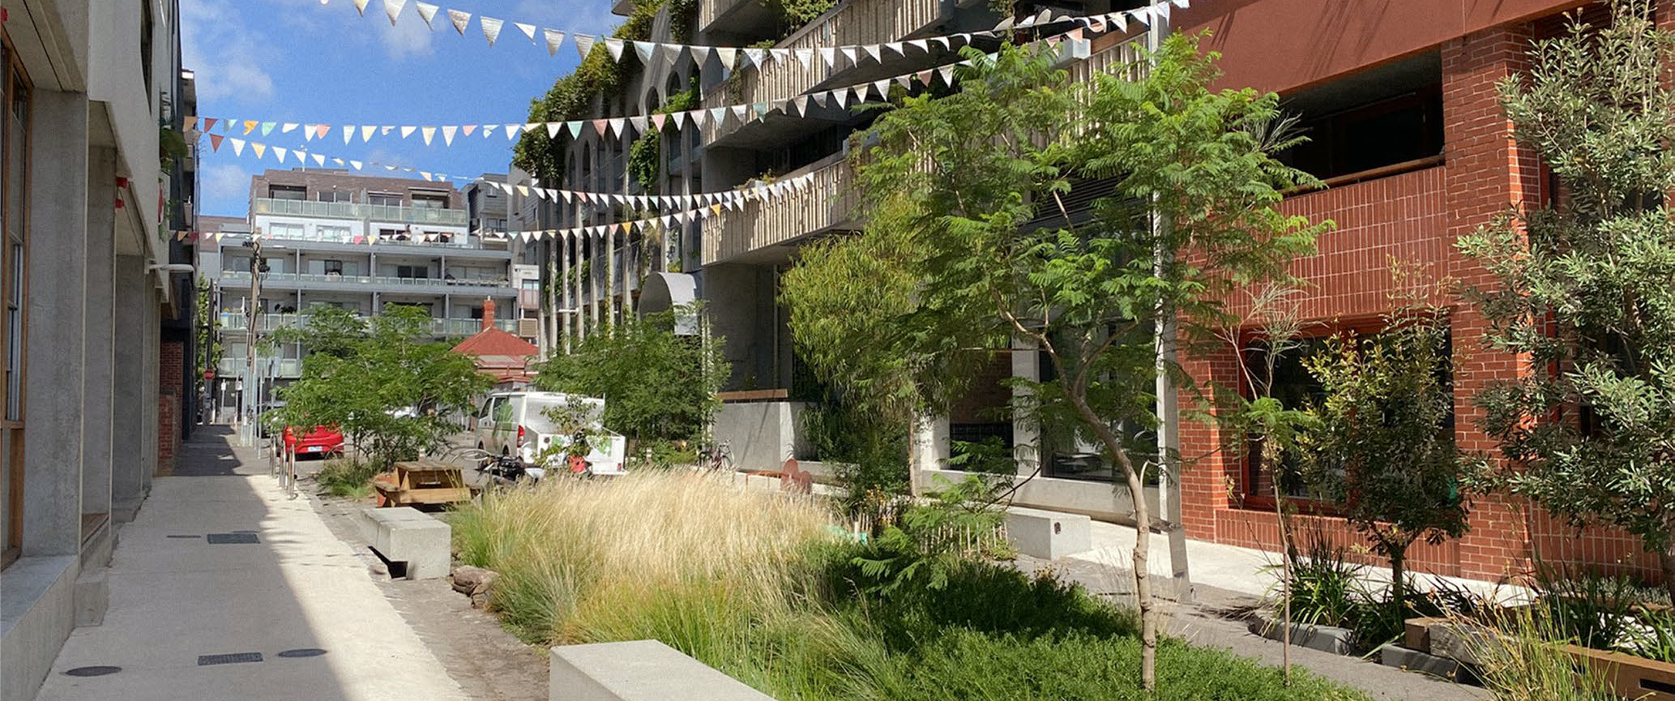

Irrigation systems

Irrigation need and alternative water sources
All on-structure GI assets need irrigation to ensure plant survival, especially given the changing and variable climate and limited volumes for root growth. For in-ground green façades planted in raingardens, emergency or ‘contingent’ irrigation can still be helpful.
Irrigation of GI is ideally suited to non-potable water sources, such as rainwater or third-pipe supply. Alternative water sources are typically filtered to remove any contaminants posing a risk to plant and human health. In some instances, water used for testing fire sprinkler systems may be used for irrigation. Consulting an irrigation specialist at the beginning of your project is recommended.

Green roof irrigation design
Water supply needs for green roofs differ greatly depending on their depth. Extensive (shallow) green roof irrigation requires consistent low-level water coverage to avoid drying out and is best achieved with sprinkler systems. Intensive green roofs can be irrigated via a combination of sub-surface and above surface irrigation to meet higher water demands.
Irrigation control cabinets should be located as close to the GI asset as possible for efficient supply, with any system connected to potable mains water using a backflow prevention device.

Green wall irrigation design
Green wall irrigation depends on the individual system design; systems with plants in pots may supply each individual pot, or to selected pots or rows. Products are typically designed to drip to pots below. Modular panel systems are gravity-fed from the top to drip from panel to panel, or to drip trays at panel bases. Green façade irrigation may be designed as an integral part of each planter or delivered via a separate array adjacent to each planter.
Some green walls may use ‘fertigation’—adding fertiliser directly to the irrigation system via a drum and injector pump—to efficiently deliver water and nutrition to growing media. This is generally compatible with suitable alternative water sources such as rainwater.

Irrigation frequencies
Plants in temperate climates (such as Melbourne) require little water and little to no nutrition during colder months. As daytime temperatures begin to rise in spring, watering should be increased and nutrition provided to encourage new growth. Plant irrigation requirements are likely to change in the future as the climate changes. Longer dry spells between rainfall and more intense rainfall events are currently predicted for Melbourne and rural Victoria.
Irrigation supply and frequency should be monitored through the initial 12 months post-planting by maintenance personnel, to ensure effective irrigation regimes and calibrate any automated watering cycles. Modern setups may use moisture sensors, timers, phone apps and solenoids to remotely determine irrigation requirements, detect supply issues (e.g. leaks), and distribute supply to different areas within the GI system. Integrating the irrigation system with the building management system is another effective way to keep oversight of the irrigation and can help identify issues early.

Planting

Growing media or substrates
Appropriate growing media for GI must account for root space constraints, plant moisture and nutrition needs, shedding of excess rainfall, and external conditions.
When establishing in-ground vegetation, soil amelioration will likely be required post (building) construction and prior to any new planting, to support plants and trees on the site. In many instances, this may be critical to success.
Raingardens are becoming increasingly common in developments for new in-ground plantings and can be considered for garden beds.
Most on-structure GI systems require growing media or ‘substrates’ engineered to support plant growth. GI growing media contains a higher mixture of inorganic materials about 80% (e.g. scoria, perlite, expanded clay) and a relatively low mix no more than 20% of organic materials (e.g. bark, coir) to ensure it is light weight and free draining.
There are many proprietary products for growing media suitable for Australian conditions. Growing media composition and volumes should be specified by a qualified horticulturalist, landscape architect or landscape gardener familiar with the specific GI typology, intended plant species and site conditions.

High‑level plant selection for environmental conditions
On-structure GI will experience different environmental conditions, affecting plant growth and moisture within the growing media, based on the typology and how it is incorporated into the site. Examples include:
- Elevated walls, roofs and balconies can mean hotter and windier microclimates for plants.
- Orientation and aspect influence availability of natural light and exposure to rain and drying winds.
- Presence of tall buildings in dense urban centres can cause overshadowing and influence the direction and strength of winds.
- High sun exposure increases evaporation rates of plants and growing media.
- Low rainfall areas may have additional requirements for irrigation or otherwise may be better suited to native plants and succulents.
For further information regarding species selection advice for various GI typologies, refer to:
- Growing Green Guide: Chapter 3.3.8 Selecting plants
- The University of Melbourne’s Burnley Plant Guide
- City of Melbourne resources for Green roofs, walls and facades, including Guidelines for Biodiversity Green Roofs and Green Our Rooftop project showcase
- Department of Energy, Environment and Climate Action’s future climate change predictions

Maintaining and managing green infrastructure

Sensory and therapeutic considerations
Rooftop and balcony gardens may be designed for accessibility, productivity or sensory experiences. Plants which provide a variety of visual and textural differences can be stimulating for visitors.
Locating planter beds at varying heights can enable people of varied abilities to touch, feel and smell plants and harvest produce.
Perfumed plants can be excellent for therapeutic outcomes and for evoking nostalgia in settings such as aged care. Plants may also be chosen for their ability to attract pollinators or other fauna visitors for an enhanced experience. High pollen plants may however clash with therapeutic settings where respiratory sensitivity is increased.
It is important to consider maintenance requirements from the outset when designing GI. Once constructed, proper maintenance of GI assets is critical for both function and aesthetics. This is especially important during plant establishment to ensure that the landscape develops successfully. As plants mature and age, it is also important to understand when replacement and rejuvenation will be needed. A table summarising typical maintenance requirements for GI can be found in Appendix 2.
Specific requirements and frequency for GI maintenance will depend on the type and size of the GI asset, use and users, plant growth, and seasonal changes. Maintainability should also be a key
consideration throughout the design development process. Failure to consider how an asset will be maintained, under realistic maintenance regimes and budget scenarios, is a common reason for the failure of GI.
Green roofs can be designed for rigid planting (weeds removed as they arrive), succession planting (planting at intervals to regularly refresh the asset) or naturalisation (allowing other plants to arrive and establish over time). A decision should be made early on the long-term approach to determine ongoing maintenance.

For further information on Landscape Maintenance Plan requirements for the local Responsible Authority your development is in, refer to:
  - For Melbourne specific requirements refer to Planning services and permits | City of Melbourne and Maintaining trees and plants on your property | City of Melbourne
  - For Merri-bek specific requirements refer to Planning and building at Merri-bek

Landscape Maintenance Plan
Councils routinely condition Landscape Maintenance Plans as part of the planning process. A Landscape Maintenance Plan prepared by suitably qualified person(s) is an essential component of GI health and performance. As Victoria’s planning system becomes more sophisticated in assessing GI’s merits within a development proposal, it is important that Responsible Authorities hold building owners and occupiers to account in maintaining GI assets long-term.
A Landscape Maintenance Plan should detail:
- a statement to describe how the canopy, vegetation and urban ecology planning provisions required by the development will be successfully maintained in the future.
- maintenance tasks undertaken throughout the establishment period.
- an ongoing maintenance schedule for after the initial 12-month period, detailing weed and pest management, succession planting, mulching, and plant nutrition.
- re-planting timeframes for any poorly performing vegetation.
- Working Safely at Heights equipment and Elevated Work Platforms constructed, operated and serviced to meet or exceed Australian/New Zealand standards.
- access requirements, and agreements where applicable.
- a maintenance schedule for all GI structures.

Establishment maintenance and monitoring
Newly constructed GI assets should be monitored to ensure plants grow and establish in place, and receive the gardening care (water, nutrients and pruning) they need. Establishing and testing a maintenance routine for an asset can save time and resources later. This allows issues to be pro-
actively managed and resolved before plants begin to fail. Maintenance routines should be reviewed on a regular basis to respond to the assets changing needs.
Most modern building management has GI assets included as a part of a specific Building Management System (BMS) to monitor conditions and optimise equipment, such as specific irrigation responses. Connecting the GI asset to a BMS or other external system can make maintenance much easier as it can monitor conditions and respond appropriately. It is important to monitor the system to ensure GI assets are maintained to a high standard.

Qualified personnel
The numerous working parts of a GI system can make planning and construction a complex process, requiring multiple suitably qualified personnel even for individual elements.
The below matrix identifies suitable qualified personnel which you can refer to throughout the development process. Each design team may vary these personnel suggestions to suit skills, experience and particular designs. Qualified personnel must be appropriately licensed (e.g. land surveyor, plumber) where relevant.

Building Component | Relevant Qualified Personnel
Host building structure | Architect, Endorsed Fire Safety Engineer, Horticulturalist, Structural Engineer
Structural walls, supports and cladding | Architect, Endorsed Fire Safety Engineer, Horticulturalist, Product Supplier, Structural Engineer
Tensile wires and wall supports | Architect, Endorsed Fire Safety Engineer, Horticulturalist, Structural Engineer
Waterproofing and drainage system | Architect, Horticulturalist, Licensed Plumber, Product Supplier, Waterproofing Expert
Irrigation and fertigation systems | Architect, Horticulturalist, Irrigation Specialist, Licensed Plumber, Product Supplier
Planting containers and growing media | Architect, Horticulturalist, Product Supplier
Plant species specification | Architect, Horticulturalist, Landscape Architect
Grow lights | Architect, Horticulturalist, Landscape Architect, Product Supplier
Monitoring systems | Facilities Manager, GI Maintenance Coordinator, Owners Corporation Manager
Working Safely at Heights equipment | Architect, Facilities Manager, GI Maintenance Coordinator, Structural Engineer
Maintenance plan | Facilities Manager, GI Maintenance Coordinator, Horticulturalist, Irrigation Specialist, Owners Corporation Manager, Product Supplier
Land tenure and common property | Architect, Licensed Land Surveyor, Owner/Occupier

Appendices

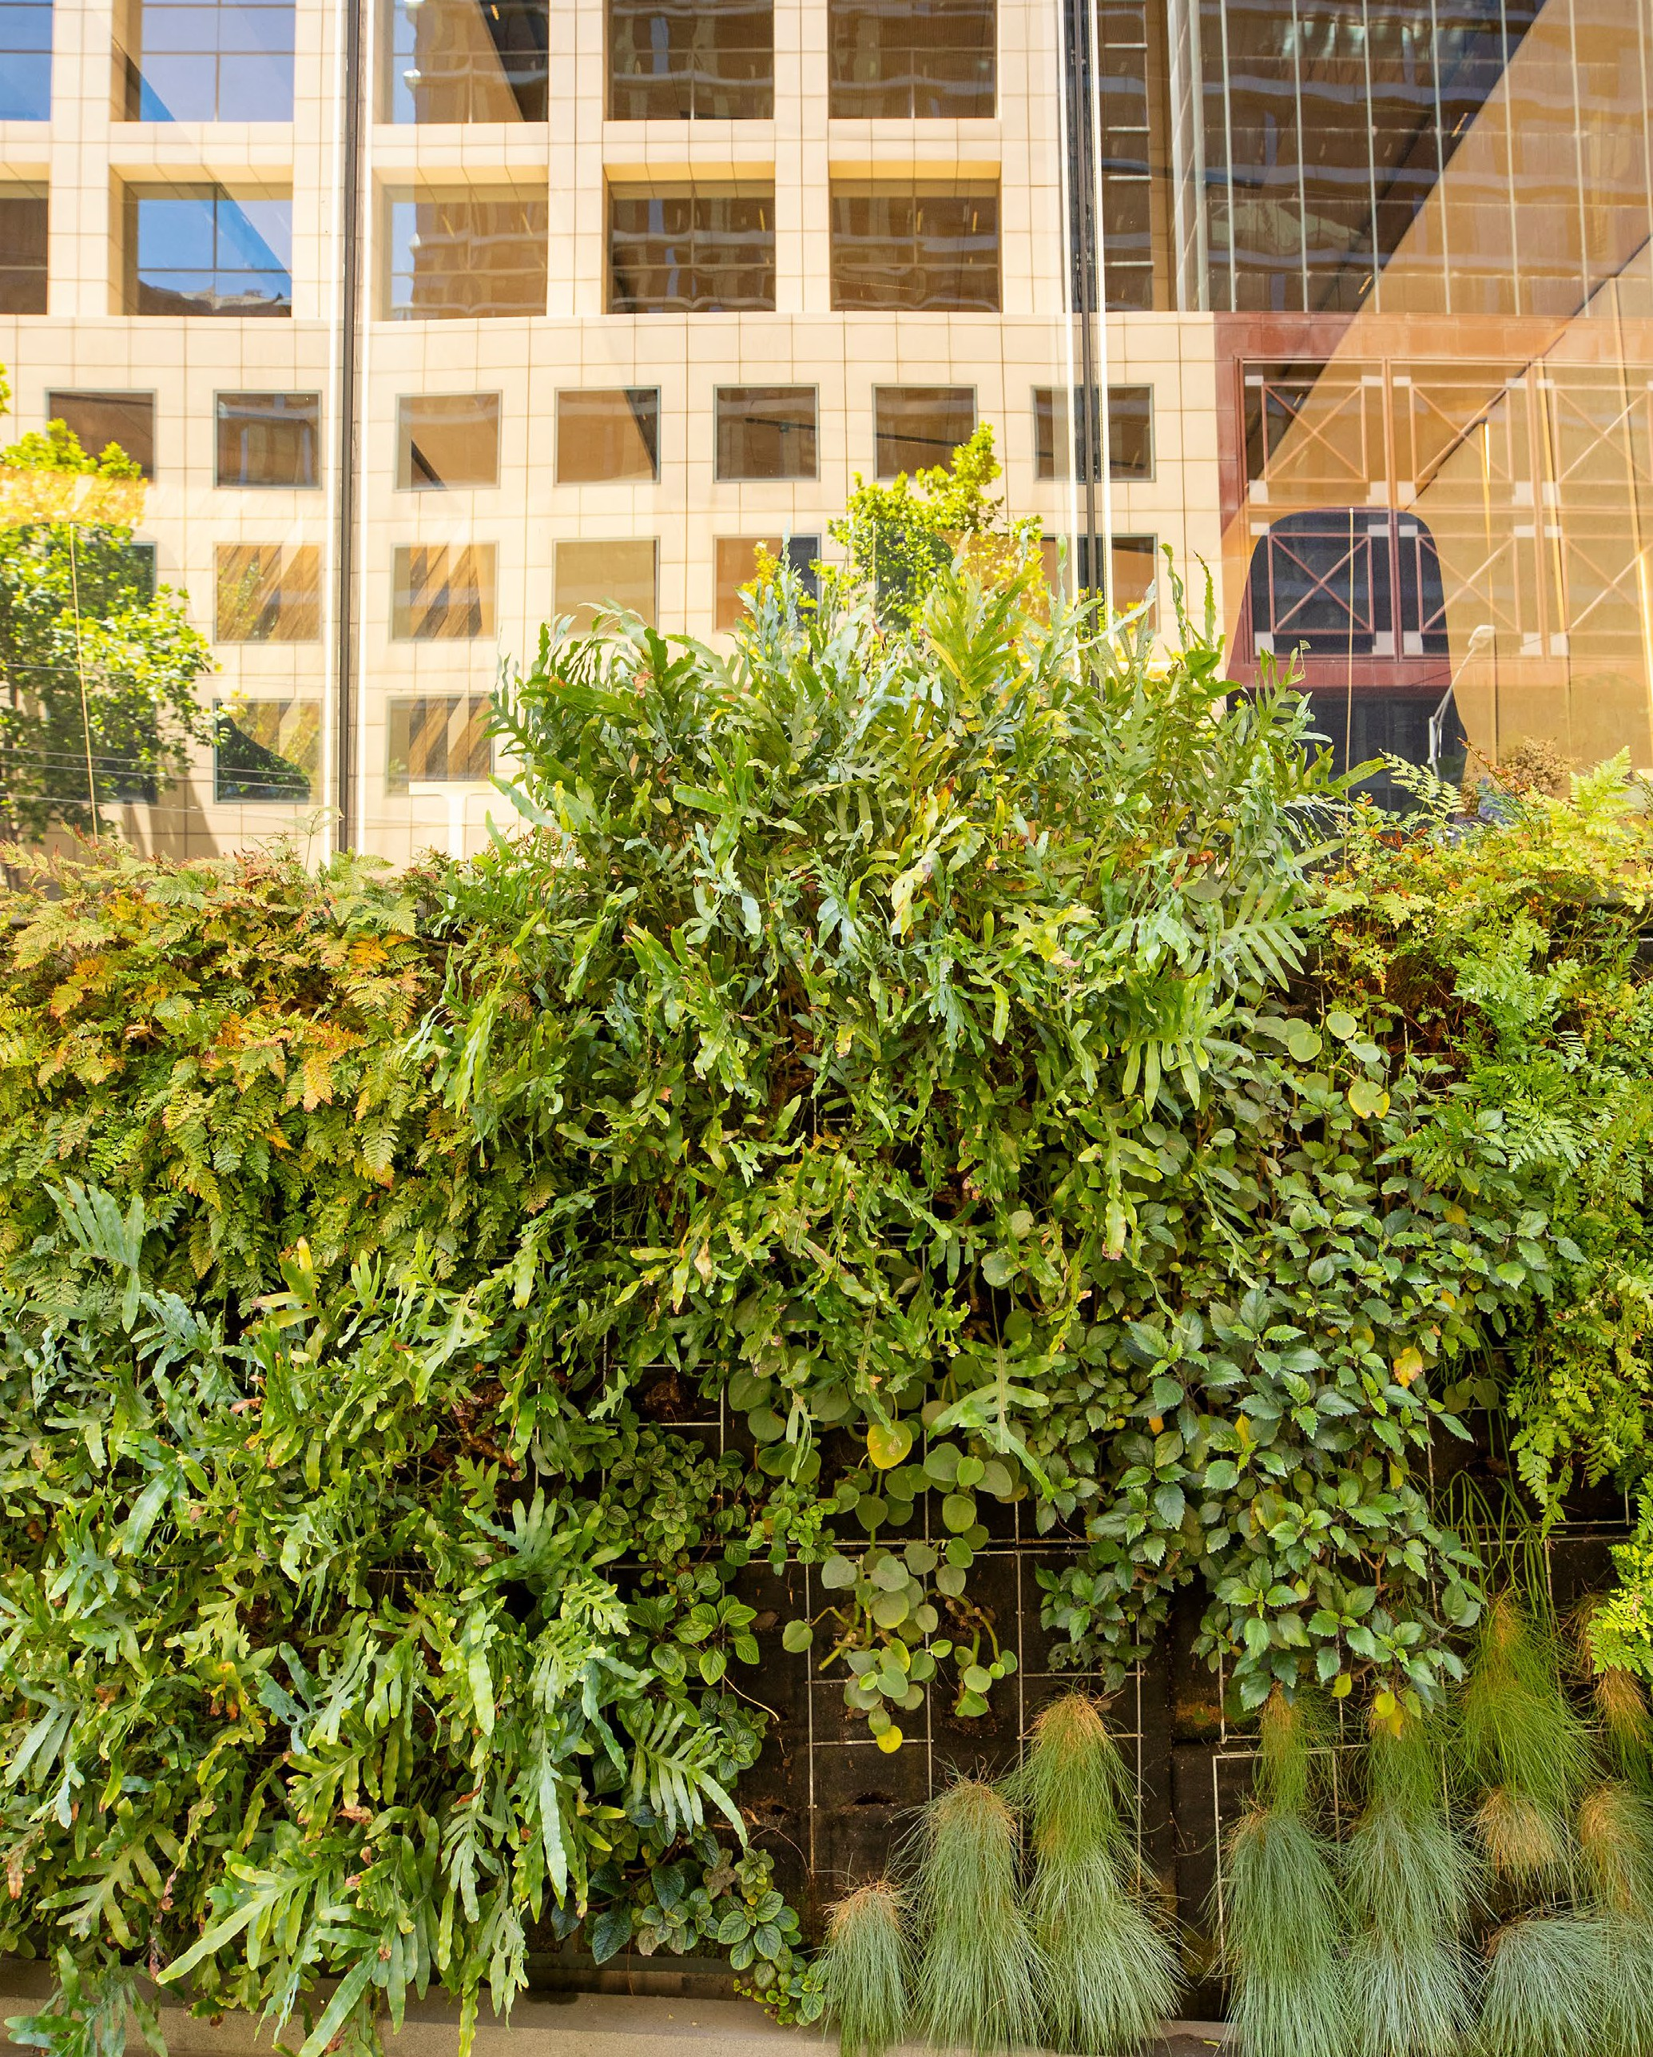

Appendix 1. Common planning permit requirements
Various elements within individual GI typologies are much more likely to achieve good design, construction and maintenance outcomes if considered as part of the development proposal, prior to the issue of a planning permit. The table below provides common information requirements to assist planners in assessing the viability of GI typologies as part of the Further Information Request process.

GI element | Action description
Host building structure | Working safely at heights equipment attached to building Green façades/Green walls – method of fixing to host wall  Green roofs/Rooftop gardens – max weight loading capacity (kg/m2 or kPa)  Rooftop gardens – balustrade details, proximity of planter beds to balustrades to ensure minimum clearance per building regulations  Rooftop gardens – method of affixing permanent furniture to host building
Waterproofing and drainage | Method of waterproofing and testing  Green roofs/Rooftop gardens – evidence of coving to inner corners  Green roofs/Rooftop gardens – whether a voltage testing system is included  Green roofs/Rooftop gardens – whether drainage points are to be in-slab/ through roof penetrations or via rain heads and downpipes  Green walls – location of drip trays  Green roofs/Rooftop gardens – drainage cell and filter fabric
Irrigation system | Location of irrigation control cabinet or solenoid Irrigation control method – timers or sensors  Rooftop gardens – location of tap(s) for manual irrigation  Green walls – location of fertigation drum if applicable
Growing media | Green façades/Rooftop gardens/Balconies – fully dimensioned planters
Plants | Indicative planting plan with botanical name, common name, pot sizes, size at maturity and number  Green roofs/Rooftop gardens – size of each plant species at maturity
Complementary structures and equipment | Presence and type of monitoring system  Presence of other structures, e.g. solar panels, solar hot water systems, other equipment within immediate surrounds of the wall or roof  Rooftop gardens - there may be various components
Maintenance | Evidence the GI asset can be accessed via elevated work platforms or other equipment for performing maintenance  Clear delineation between GI asset located within private property or common property  Landscape or green infrastructure Maintenance Plan

Appendix 2. Typical maintenance requirements
The table below, transcribed from Maintenance Guidelines for Australian Green Roofs (Rayner et al. 2022) , details typical maintenance requirements for a GI system. Undertaking routine maintenance ensures longevity of the system as well as attractive, thriving plants.

GI element | Maintenance task | Minimum frequency
Host building structure | Check and test working at heights equipment in accordance with manufacturer’s instructions and statutory requirements | As required per standards/product information
Waterproofing and drainage | If electronic leak detection installed, test waterproofing integrity | Annually
Waterproofing and drainage | Perform visual check of all in-slab drainage points and clear any blockages or obstructions | Quarterly
Waterproofing and drainage | Perform visual check of all drip trays, remove any obstructions and check and clear drainage point(s) | Quarterly
Irrigation systems | Check for blockages, clear obstructions across irrigation array | Quarterly
Irrigation systems | Check moisture sensors or timers and adjust watering regime in accordance with GI system requirements | Quarterly/as required
Irrigation systems | Replace batteries for sensors or timers | Per product information
Irrigation systems | Replace/recharge fertigation tank with additional fertiliser | Quarterly/as required
Irrigation systems | For irrigated growing media, hand-apply fertiliser to growing media | Quarterly/as required
Growing media | Visually check structure of growing media and replace or recharge | Annually
Plants | Remove dead vegetation, trim excess vegetation and remove unwanted plants/weeds | Quarterly/per maintenance schedule
Plants | Replace dead plants | Quarterly/as required
Plants | Check for fungal infections and/or insect infestation and spot treat with non-toxic fungicide or insecticide | Quarterly/as required

GI element | Maintenance task | Minimum frequency
Allied components | Review sensor data (if using sensors connected to BIM) and adjust light, moisture and/or nutrition levels | Monthly/as required
Allied components | Ensure elevated work platforms are properly serviced and in correct working order, ensure maintenance tools are serviced and fit for purpose | As required per standards/product information
Allied components | For rooftop gardens, check/test all furniture is in working order | Per maintenance schedule
Allied components | For green roofs with perching logs, check to ensure perching logs are securely anchored | Monthly
Allied components | Ensure a list of all products and product warranties is included in the Maintenance Plan, update and review | Quarterly/when products added or replaced
Allied components | Maintain a log of all maintenance performed | Every maintenance visit
Green façades | Train plants to support systems as required | Monthly/as required
Green façades | Ensure plants are not being outcompeted in complex plantings | Every maintenance visit
Accessible green roofs and rooftop gardens | Regular general cleaning, removal of dead or dislodged plant matter to ensure aesthetics | Weekly/daily depending on visitation and usage

Appendix 3. Risk analysis
Some errors in design, construction, and/or maintenance of GI can be easily rectified at little or no cost, while others can cause serious issues. GI assets rely on people to ensure they are designed, constructed and maintained correctly. The table below, while not exhaustive, provides a summary of common mistakes and their likely outcomes.

GI element | Cause of failure | Possible outcome
Host building structure | Point loading of roof beyond structural capacity | Building roof collapse
Host building structure | Green wall too heavy for host wall | Building wall collapse
Host building structure | Green wall not affixed correctly to host wall | Green wall collapse
Waterproofing and drainage | Waterproofing product not fit for purpose | Leaks caused by wear and tear, photodegradation, chemical reactions
Waterproofing and drainage | Waterproofing not installed correctly | Leaks caused by gaps  in seals, holes, wear and tear, etc.
Waterproofing and drainage | Drainage system blocks | Flooding  Plants wilt/die due to waterlogged roots
Irrigation system | Growing media/plants over-irrigated | Wasted water  Plants wilt/die (see above)
Irrigation system | Growing media/plants under-irrigated | Plants wilt/die  Growing media becomes hydrophobic
Irrigation system | Growing media/plants over-fertilised | Plants turn yellow, wilt and may die, roots may start rotting
Irrigation system | Growing media/plants under-fertilised | Slow plant growth, plants may not flower, leaves wilt or turn brown/yellow
Irrigation system | The system is not fit for purpose | Water pressure too high or too low  Growing media/plants receive too much/too little water

GI element | Cause of failure | Possible outcome
 | Drippers or other distribution points become blocked | Plants receive little or no water and die  Water pressure builds, causing blowout
 | Supply is switched off without maintenance personnel being informed | Most or all plants die before anyone notices or acts, all growing media/plants requires replacement
Growing media | Insufficient depth or dimensions (or changes from initial design intent) | Plants are stunted, unable to access sufficient nutrients or water
Growing media | Too much depth | Excessive/unnecessary weight  Unnecessary cost
Growing media | Not fit for purpose | Drains too quickly/not quickly enough  Growing media too heavy/dense for plant growth, or easily blow away  Too much/little nutrition  Insufficient structure for plant roots
Plants | Plant species selection not fit for purpose | Plants die, GI asset looks unsightly  Plants grow too quickly or too slowly
Allied components | Batteries for monitoring system not replaced | Loss of real-time data and accountability  Loss of plants due to too much/little moisture or nutrition

GI element | Cause of failure | Possible outcome
Maintenance | Insufficient maintenance budget | GI asset is not maintained properly, eventually fails and is removed – potentially hazardous, unsightly, wasteful and costly
Maintenance | Unskilled maintenance personnel undertake maintenance | Hazard for maintenance personnel and others  Increased risk of flooding and/or leaks  Frequent plant replacement and cost  Damage to host building structures and to GI assets
Maintenance | Maintenance Plan is poorly written, or not updated | See above
Maintenance | A maintenance log of maintenance performed is not kept up to date | See above

Appendix 4. Useful links, resources & references
There is an ever-expanding body of knowledge and best practice in the design, construction and maintenance of green infrastructure, both within Australia and internationally. The list below, while not exhaustive, contains several typology-specific guidance materials, technical resources, and local advice and observations. Some publications listed are available for download free of charge whereas others are available via purchase only.

Publisher | Title
Australian Government | Your Home – Australia’s guide to environmentally friendly sustainable homes – Green roofs and walls, 2013
Department of Environment and Primary Industries | Growing Green Guide: A guide to green roofs, walls and facades in Melbourne and Victoria, 2014
Council Alliance for a Sustainable Built Environment | BESS & Sustainable Design Assessment Fact Sheets
Forschungsgesellschaft Landschaftsentwicklung Landschaftsbau | FLL Green Roof Guidelines, 2018
City of Melbourne | Green Our City Strategic Action Plan 2017-2021
City of Melbourne | Guidelines for Biodiversity Green Roofs
City of Melbourne | Urban Forest Strategy, 2014
City of Melbourne | Green Factor Tool
City of Sydney | Green Roof Design Resource Manual
Green Roof Organisation | The GRO Green Roof Code, Anniversary Edition, 2021
Master Builders Australia | Balcony Decks Waterproofing (Book 2), 2017
Master Builders Australia | Planter Box Waterproofing (Book 3), 2017
Merri-bek City Council | Better Quality Developments in Merri-bek
Merri-bek City Council | Streetscape WSUD Raingarden & Tree Pit Design Package
Merri-bek City Council | Merri-bek Tree Finder Tool
Minnesota Pollution Control Agency | Design criteria for green roofs
Standards Australia | AS/NZS 1891.4-2009 Industrial fall-arrest systems and devices selection, use and maintenance
Standards Australia | AS/NZS 5532-2013 Manufacturing requirements for single point anchor devices used for harness-based work at height

Publisher | Title
Standards Australia | AS 4654.1-2012 Waterproofing membranes for external above-ground use - Materials
Standards Australia | AS 4654.2-2012 Waterproofing membranes for external above-ground use – Design and Installation
University of Melbourne | Burnley Green Roof Plant Guide
University of Melbourne | Maintenance Guidelines for Australian Green Roofs
University of Melbourne | Roadmap for Green Roof, walls and facades in Australia 2020-2030
University of Melbourne, HIP V. HYPE, City of Melbourne | Integrating Green Infrastructure into Urban Planning: Developing Melbourne’s Green Factor Tool
Victorian State Government | Better Apartments Design Standards

References
i Standards Australia 2022. SA HB 214:2022 Urban Green Infrastructure—Planning and decision framework.

For more information visit: merri‑bek.vic.gov.au/better‑quality‑developments melbourne.vic.gov.au/green‑infrastructure





Typologies included in this document align with the six typologies defined by City of Melbourne and University of Melbourne’s Green Factor Tool
These definitions align with City of Melbourne and University of Melbourne’s Green Factor Tool: ‘Green Infrastructure includes elements related to vegetation, soil, drainage and irrigation (amongst others)’

