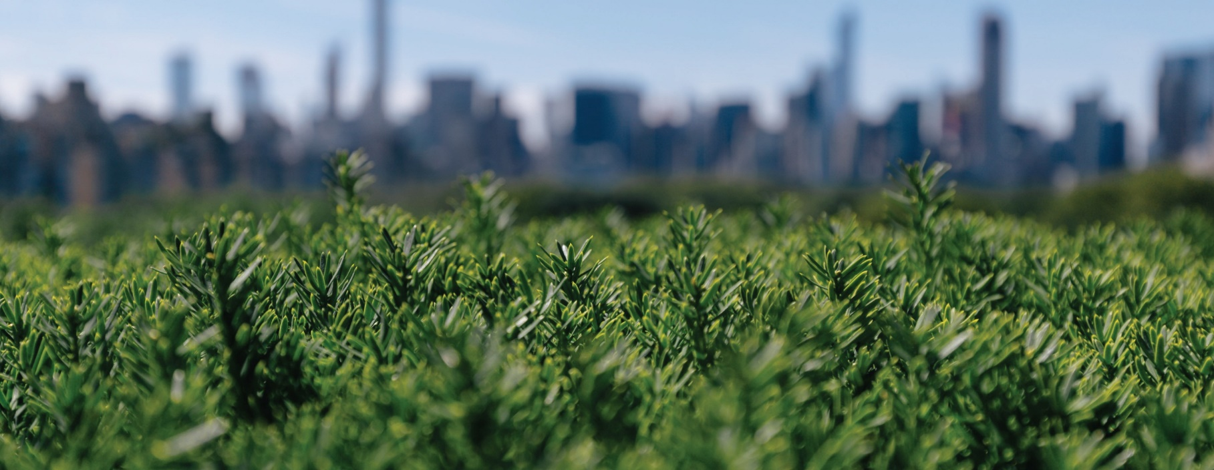

D20/446502

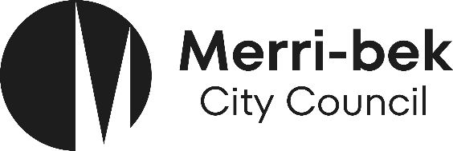

TREE PROTECTION

INFORMATION FOR SERVICE PROVIDERS AND CONTRACTORS UNDERTAKING WORK NEAR COUNCIL TREES

INTRODUCTION

This document provides the requirements for any work, including below ground excavations, in the vicinity of public trees, to ensure their long-term health, condition and structural integrity is maintained. This applies to all trees in the Merri-bek City Council municipality that are either owned or managed by Council, and may be located on nature strips, parks, reserves, community centres, road reserves, etc.

All work near public trees must abide by the protection and retention requirements outlined in this document, in accordance with Merri-bek City Councils Urban Forestry Strategy 2017, Merri-bek Tech Notes, and Australian Standards AS4373—2007 Pruning of Amenity Trees and AS 4970—2009 Protection of Trees on Development Sites.

TREE PROTECTION REQUIREMENTS

All care must be taken to ensure that no damage is caused to the tree’s trunk, roots, branches, or canopy during works. Council does not allow any mechanical (excavator, backhoe, skid-steer, etc) excavation to occur inside the Tree Protection Zone (TPZ) of any Council trees. A TPZ shall be established for the duration of any works near a council tree. Any excavation works within the TPZ will need to be done using non-invasive methods, such as Non-Destructive Digging (NDD)-Hydrovac or hand digging, to ensure no damage occurs to tree roots. A Tree Protection Management Plan is required for all construction related activities. Refer to council’s Urban Forest Strategy 2017.

TREE PROTECTION ZONES

The tree protection distance method outlined in the current Australian Standard AS4970-2009 will be used for the allocation of TPZs. This method provides a TPZ that addresses tree health, condition, and structural integrity requirements.

The radius of the TPZ is calculated by multiplying the tree’s trunk diameter at breast height (DBH) by 12. DBH is measured at 1.4 meters above ground level and TPZ distance is measured as a radius from the centre of the trunk at ground level.

Should the tree canopy extend past the calculated radius then the TPZ will be extended to include all above-ground components of the tree and a TPZ shall be no less than 2 metres. No modification to a TPZ can occur without consent
from Council’s arborist.

Figure 1: Calculating a Tree Protection Zone. The TPZ radius
is equivalent to the trunk diameter at breast height multiplied
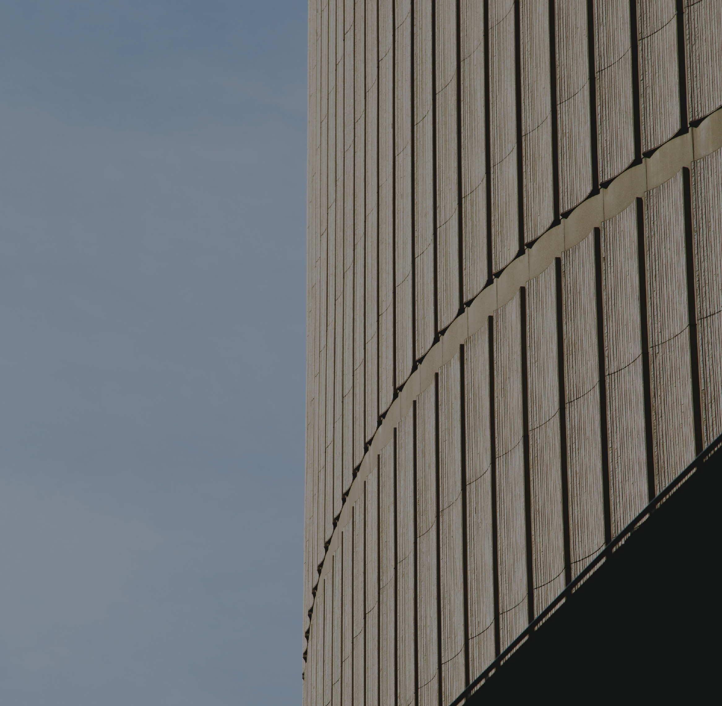

by 12.
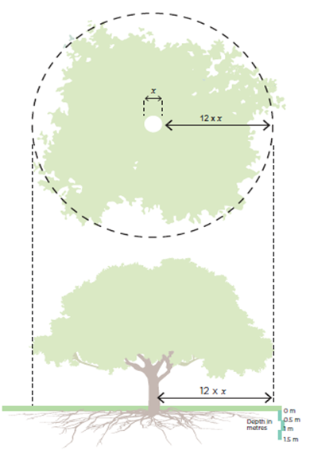

The following is not permitted within a TPZ
- Stockpiling of building materials, debris, or soil
- Storage of equipment, and tools
- Vehicular traffic except on existing paved surfaces
- Installation of service pits or hatches
- Permanent or temporary vehicular crossings
- Severing of tree roots with a diameter greater than 30mm
- Alteration of soil levels and structure
- Refuelling
Excavation within a TPZ
- Boring is the preferred method for installations of underground services within a TPZ.
- Entry and exit pits for boring activities must be positioned outside the designated TPZ of each tree.
- The extent or length of boring in the vicinity of trees will be determined by the TPZ.
- Boring must occur at a depth of at least 1 meter below surface.
- When boring is not possible, excavation shall be by hand or by a non-destructive method such as hydro-excavation at low pressure with consent from Council’s arborist.
Pruning
- No council tree may be pruned, or branches removed by anyone other than those authorized by Council’s Arborist team.
- Pruning of roots and branches will be in accordance with AS 4373-2007 Pruning of Amenity Trees.

For further information please contact Merri-bek City Council on 9240 1111 or email: info@merri-bek.vic.gov.au

