Spendmapp Monthly Report
Local Government Area:
Merri-bek City Council
Spendmapp cleans and analyses bank transaction data by time, geography, Expenditure Category and Type allowing continuous monitoring and analysis of local economic activity.
For the month of August 2026:
- Resident Local Spend was $99.1M. This is a 7.41% increase from the same time last year.
- Visitor Local Spend was $122.8M. This is a 5.62% increase from the same time last year.
- Total Local Spend was $221.9M. This is a 6.41% increase from the same time last year.
- Resident Escape Spend was $184.5M. This is a 3.64% increase from the same time last year.
- Resident Online Spend was $239.0M. This is a 7.71% increase from the same time last year.
- Nighttime Total Local Spend was $43.8M. This is a 3.25% increase from the same time last year.
- Males accounted for $114.9M in Total Local Spend in August, which was 51.8% of Total Local Spend for the month. Females spend $106.9M or 48.2 %.

The 7.71 % increase in Resident Online Spend reflects the growing national trend towards online sales. This emphasises the need for a strategy to support local traders in enhancing their online presence.
Expenditure by Expenditure Type
These expenditure charts show the long-term pattern of expenditure activity by Expenditure Type across the Merri-bek City Council LGA. Typically, we see spending spikes at Easter and Christmas; dips in the post-Christmas period; and a steady climb through winter.
By way of a benchmark, the mean ratio of Resident Online Spend to all resident spending is 0.22. That is, for every dollar spent by resident cardholders anywhere, 22c goes online. Another 34c is in Escape Expenditure and the rest is spent locally.
Over the last few years across most of Australia, total expenditure has been relatively flat, even in fast growing municipalities. The exception to this has often been in Resident Online Spend, which continues to grow relative to Total Local Spend.

Total Local Spend
The total amount spent with merchants within the Merri-bek City Council LGA.
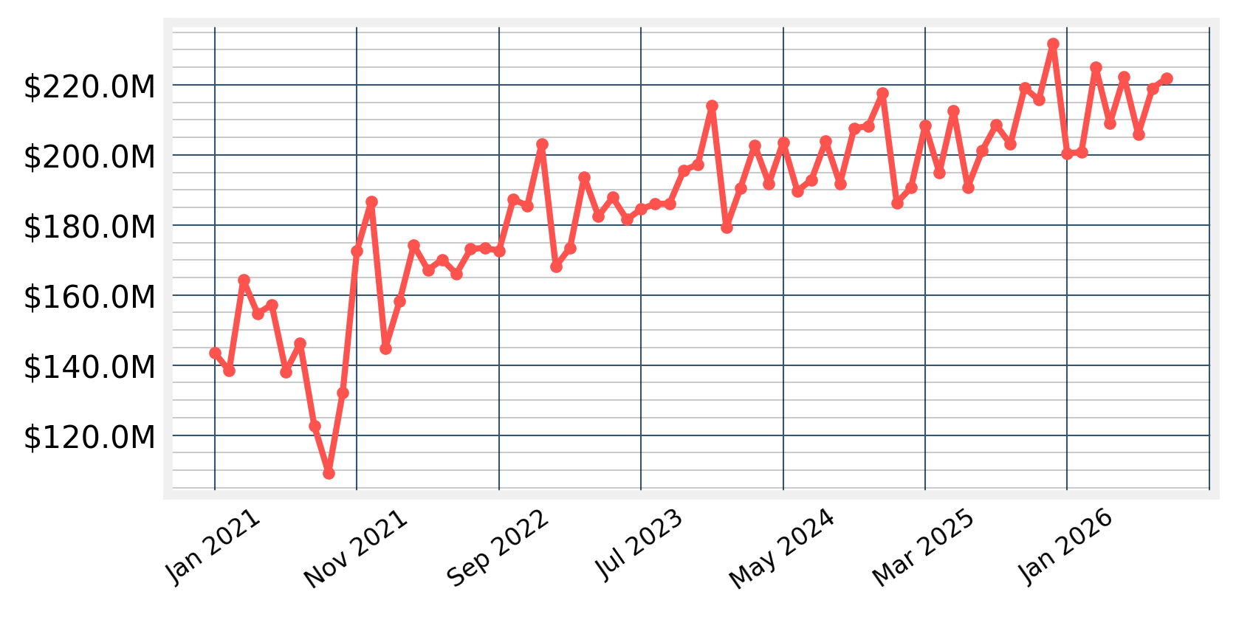
Over the last 68 months, the spending trend (as shown by the trendline in the Spendmapp app) for Total Local Spend has been upwards.

Resident Local Spend
The amount spent by residents and local businesses with merchants inside the Merri-bek City Council LGA.
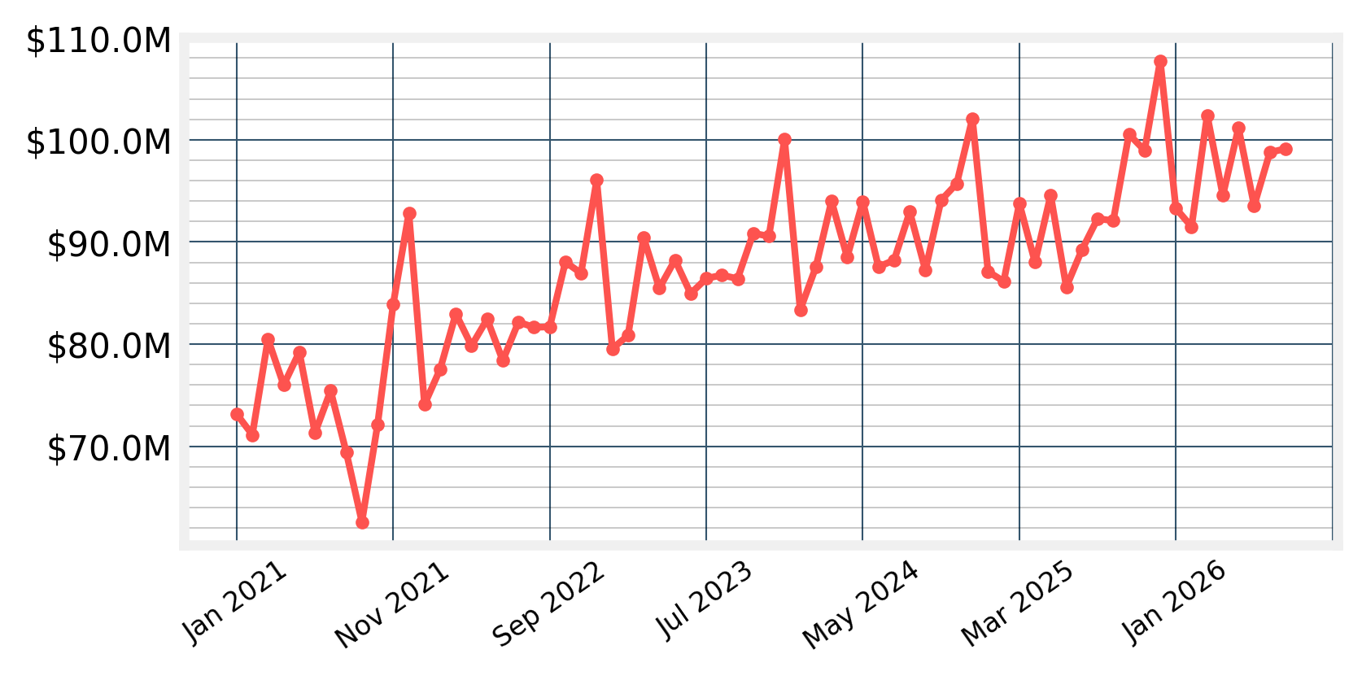
Over the last 68 months, the spending trend (as shown by the trendline in the Spendmapp app) for Resident Local Spend has been upwards.

Visitor Local Spend
The amount spent by non-residents and non-local businesses with merchants inside the Merri-bek City Council LGA.
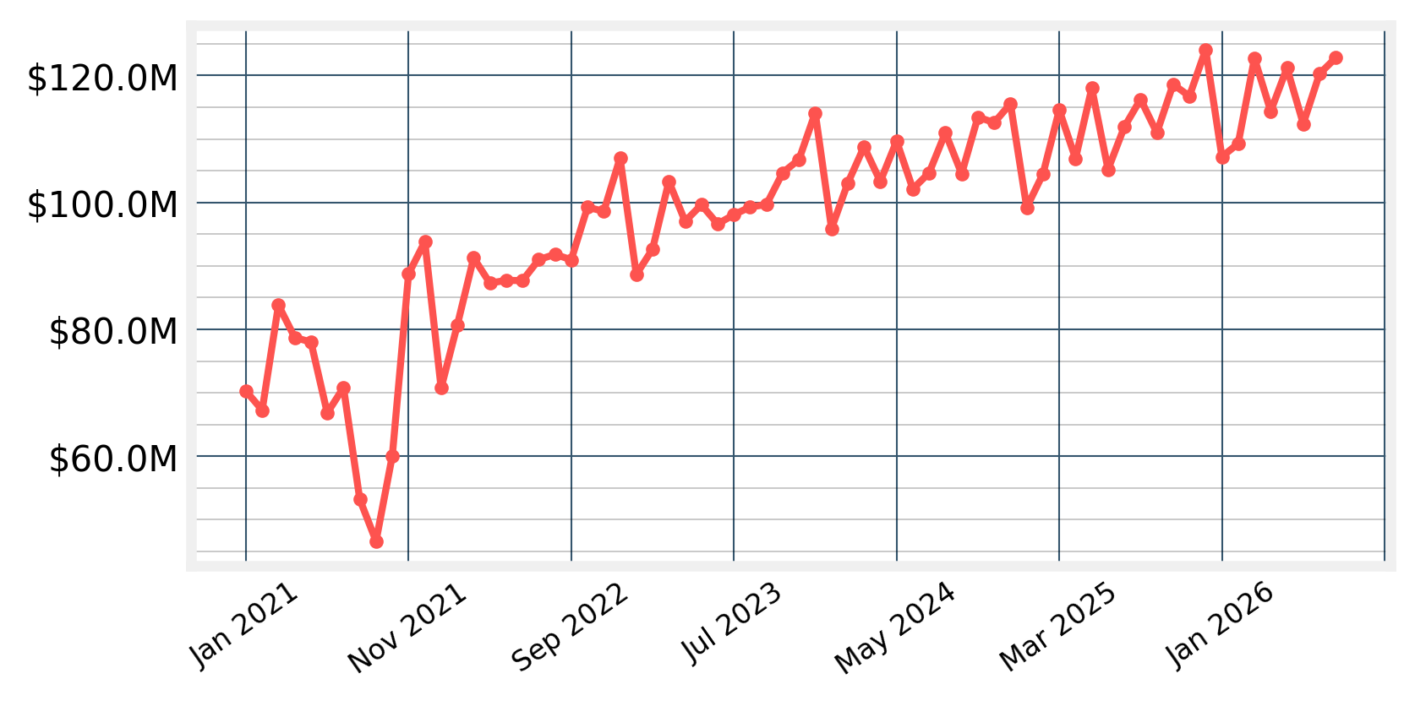
Over the last 68 months, the spending trend (as shown by the trendline in the Spendmapp app) for Visitor Local Spend has been upwards.

Resident Escape Spend
The amount spent by residents and local businesses outside the Merri-bek City Council LGA.
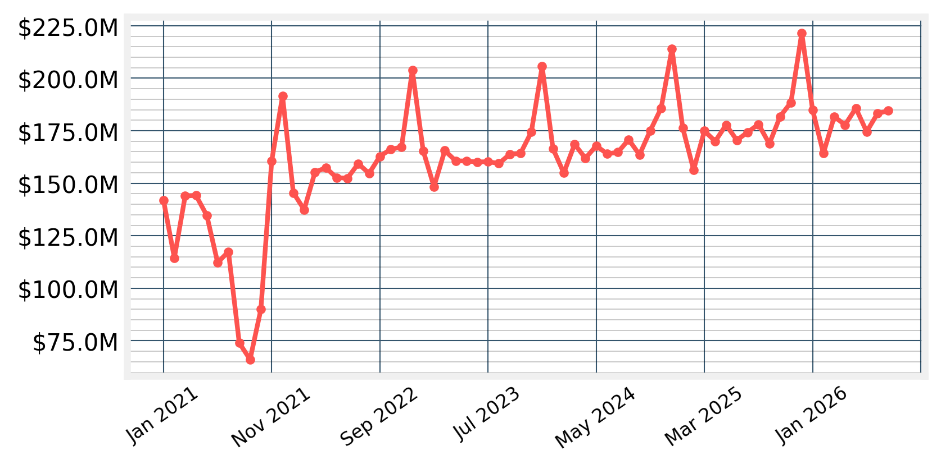
Over the last 68 months, the spending trend (as shown by the trendline in the Spendmapp app) for Resident Escape Spend has been upwards.

Resident Online Spend
The amount spent by Merri-bek City Council LGA residents and local businesses with online merchants.
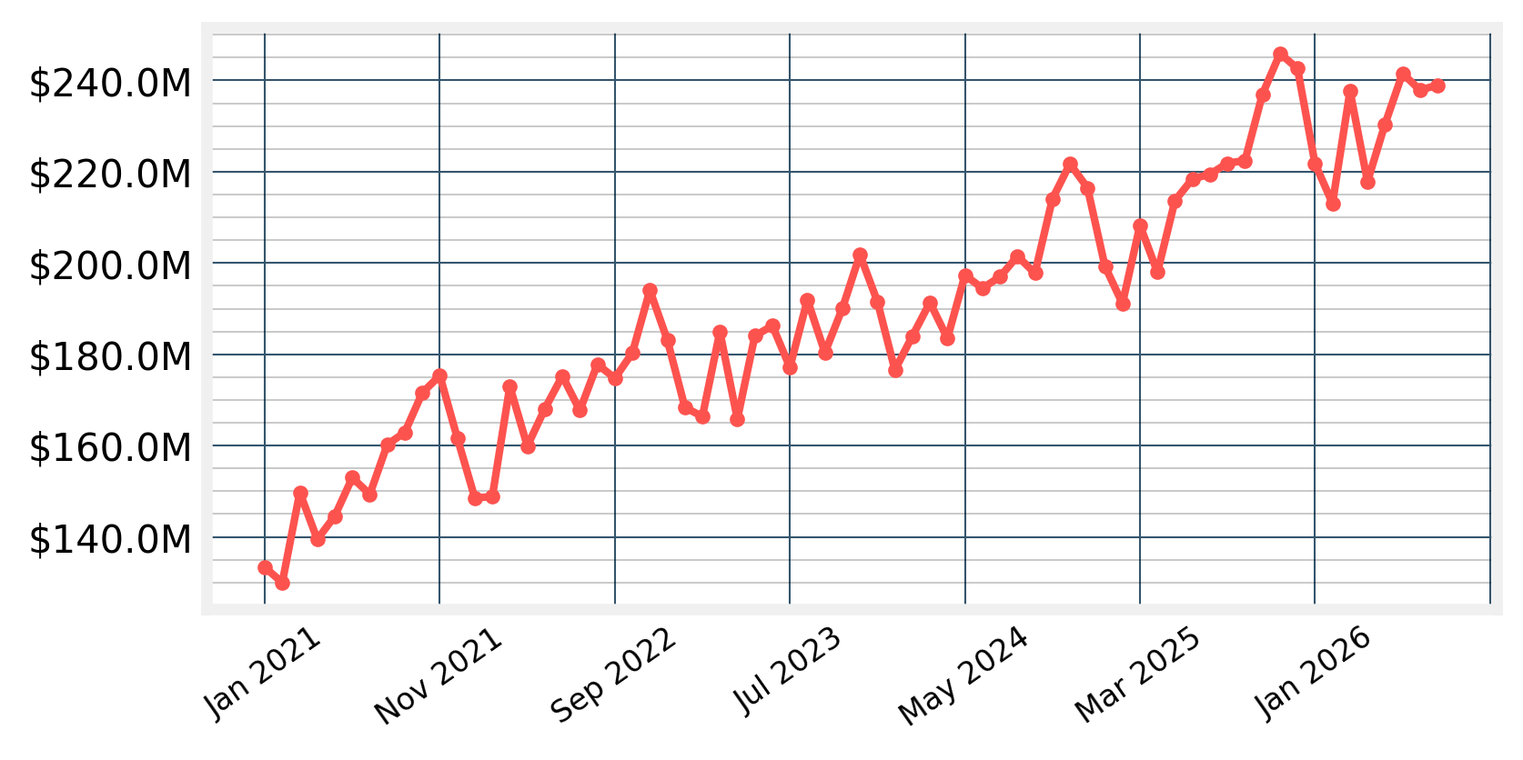
Over the last 68 months, the spending trend (as shown by the trendline in the Spendmapp app) for Resident Online Spend has been upwards.

Expenditure by Expenditure Category
Depending on the subscription there are up to 22 pre-defined expenditure categories built into Spendmapp. The following chart shows the latest monthly spending for the top five.

The Top 5 Spending Categories for August 2026
Total Local Spend split by the top 5 Expenditure Categories.
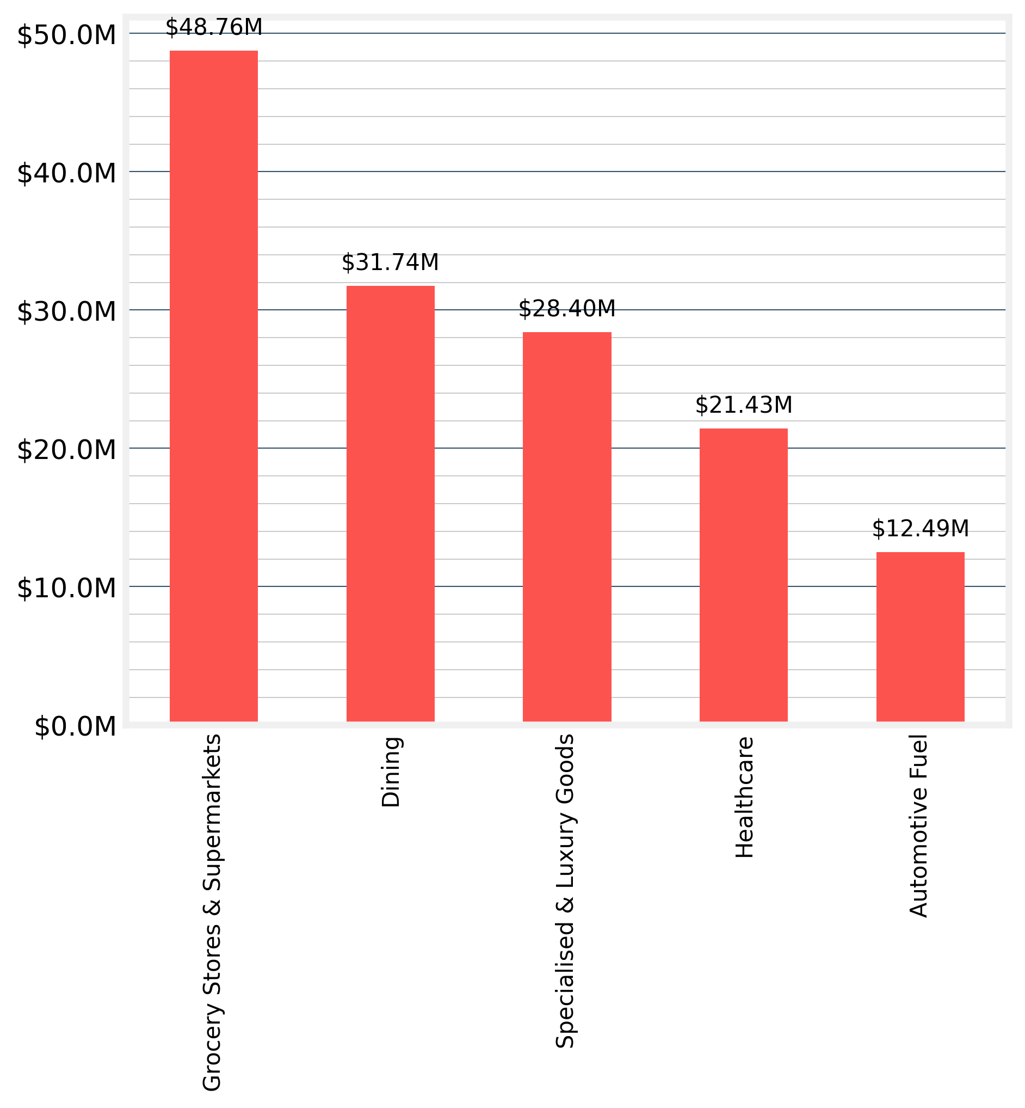

Expenditure by Origin and Destination
The default geographies for Spendmapp data are LGA, SA2 and suburb (formerly SSC and now SAL). The following charts show the three top spending in your LGA in the last month, as well as the top three origins of Visitor Local Spend and destinations for Resident Escape Spend.

The Top 3 Suburbs by Total Local Spend for August 2026
Total Local Spend by Suburbs of destination (i.e. where the spending occurs)
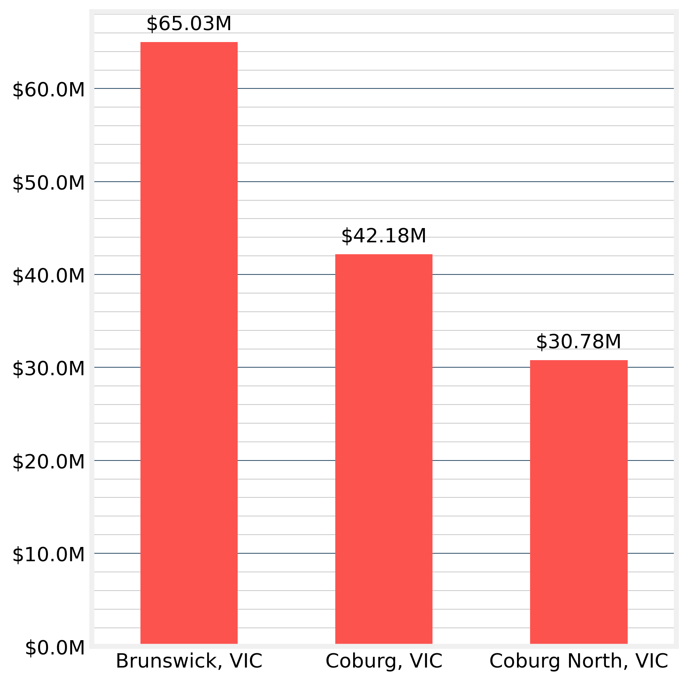

The Top 3 Suburbs by Resident Escape Spend for August 2026
Resident Escape Spend by destination Suburbs (i.e. where the spending goes to).
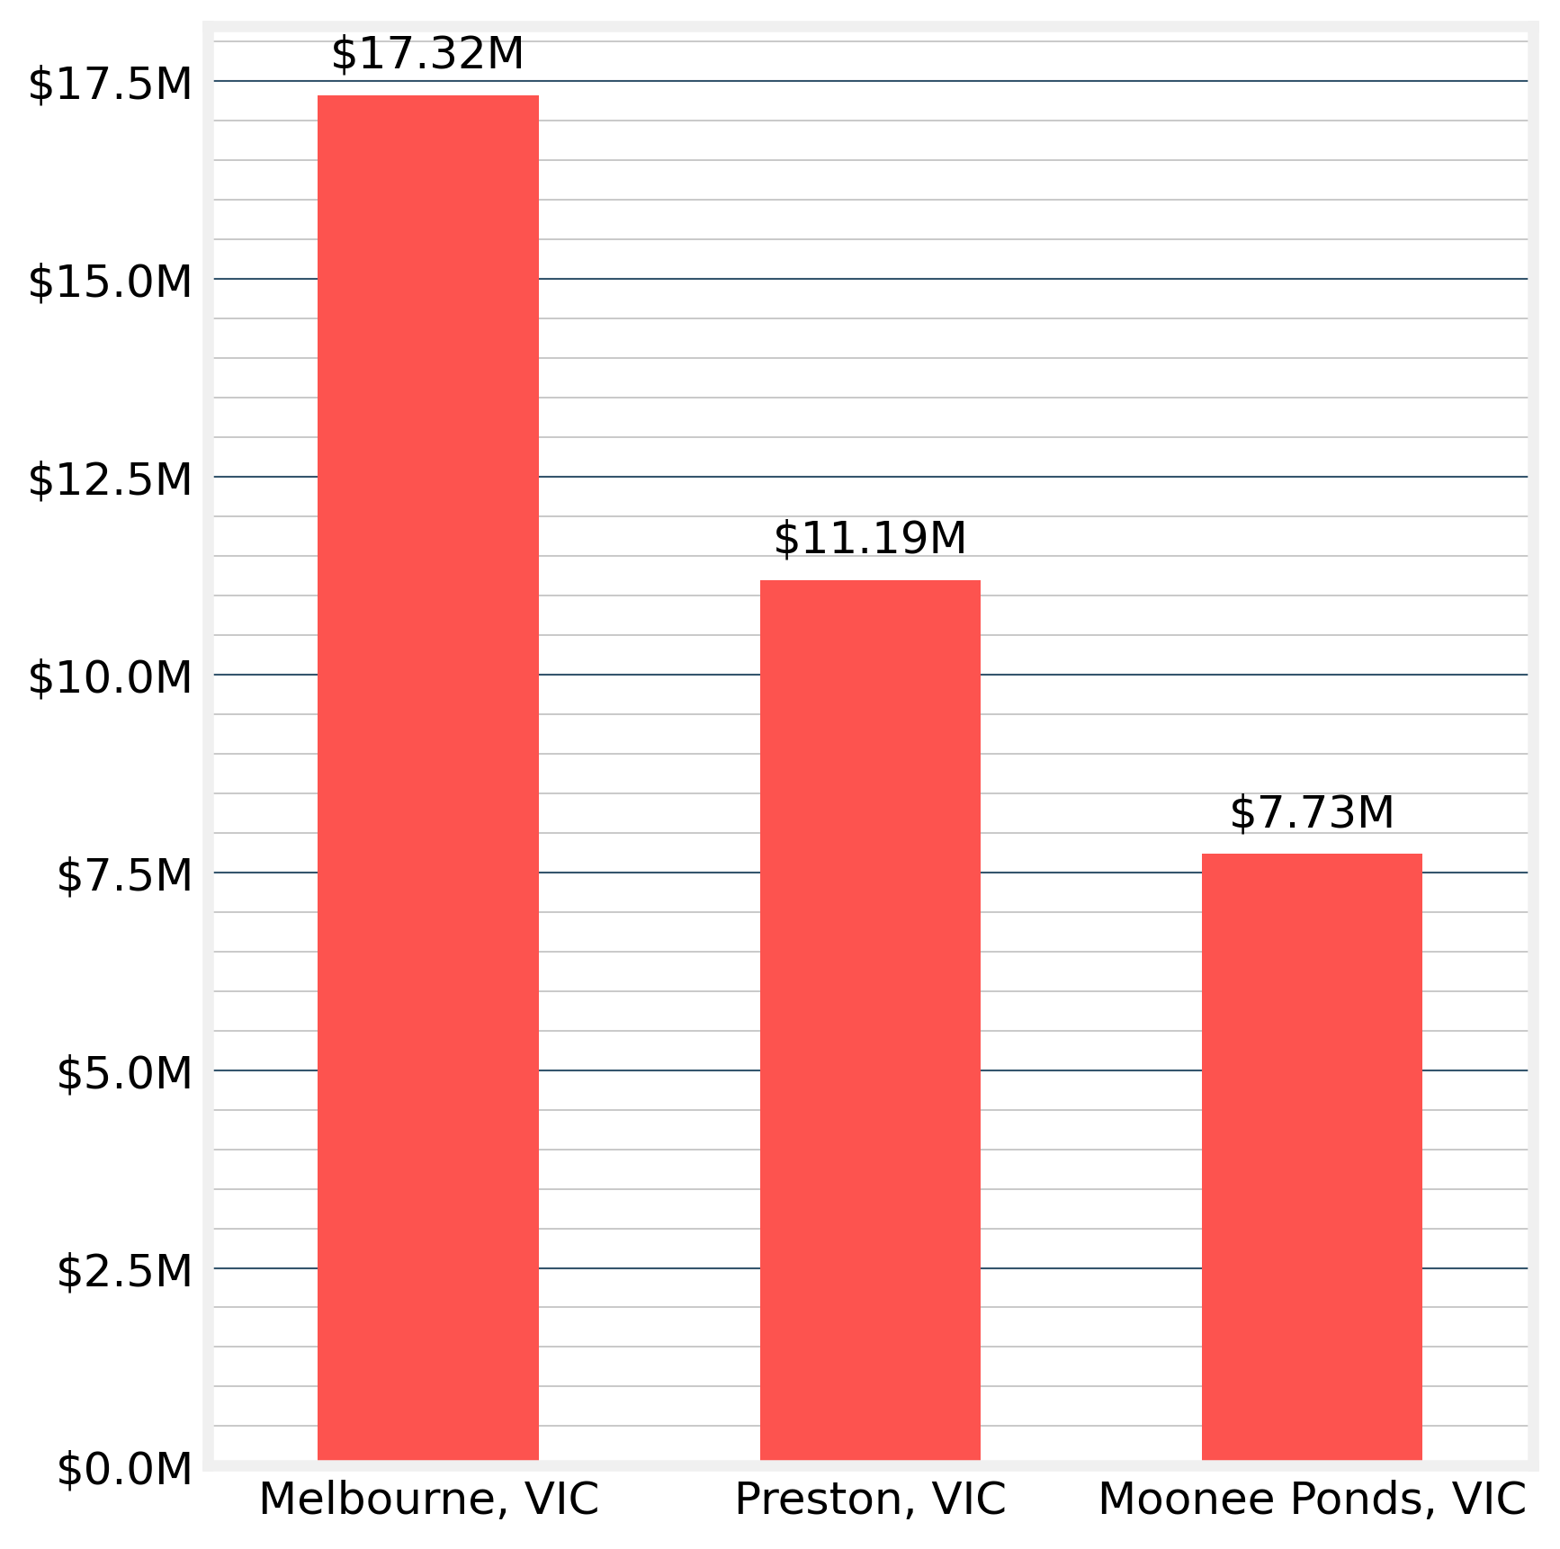

The Top 3 Suburbs by Visitor Local Spend for August 2026
Visitor Local Spend by Suburbs of origin (i.e. where the visitors originate).
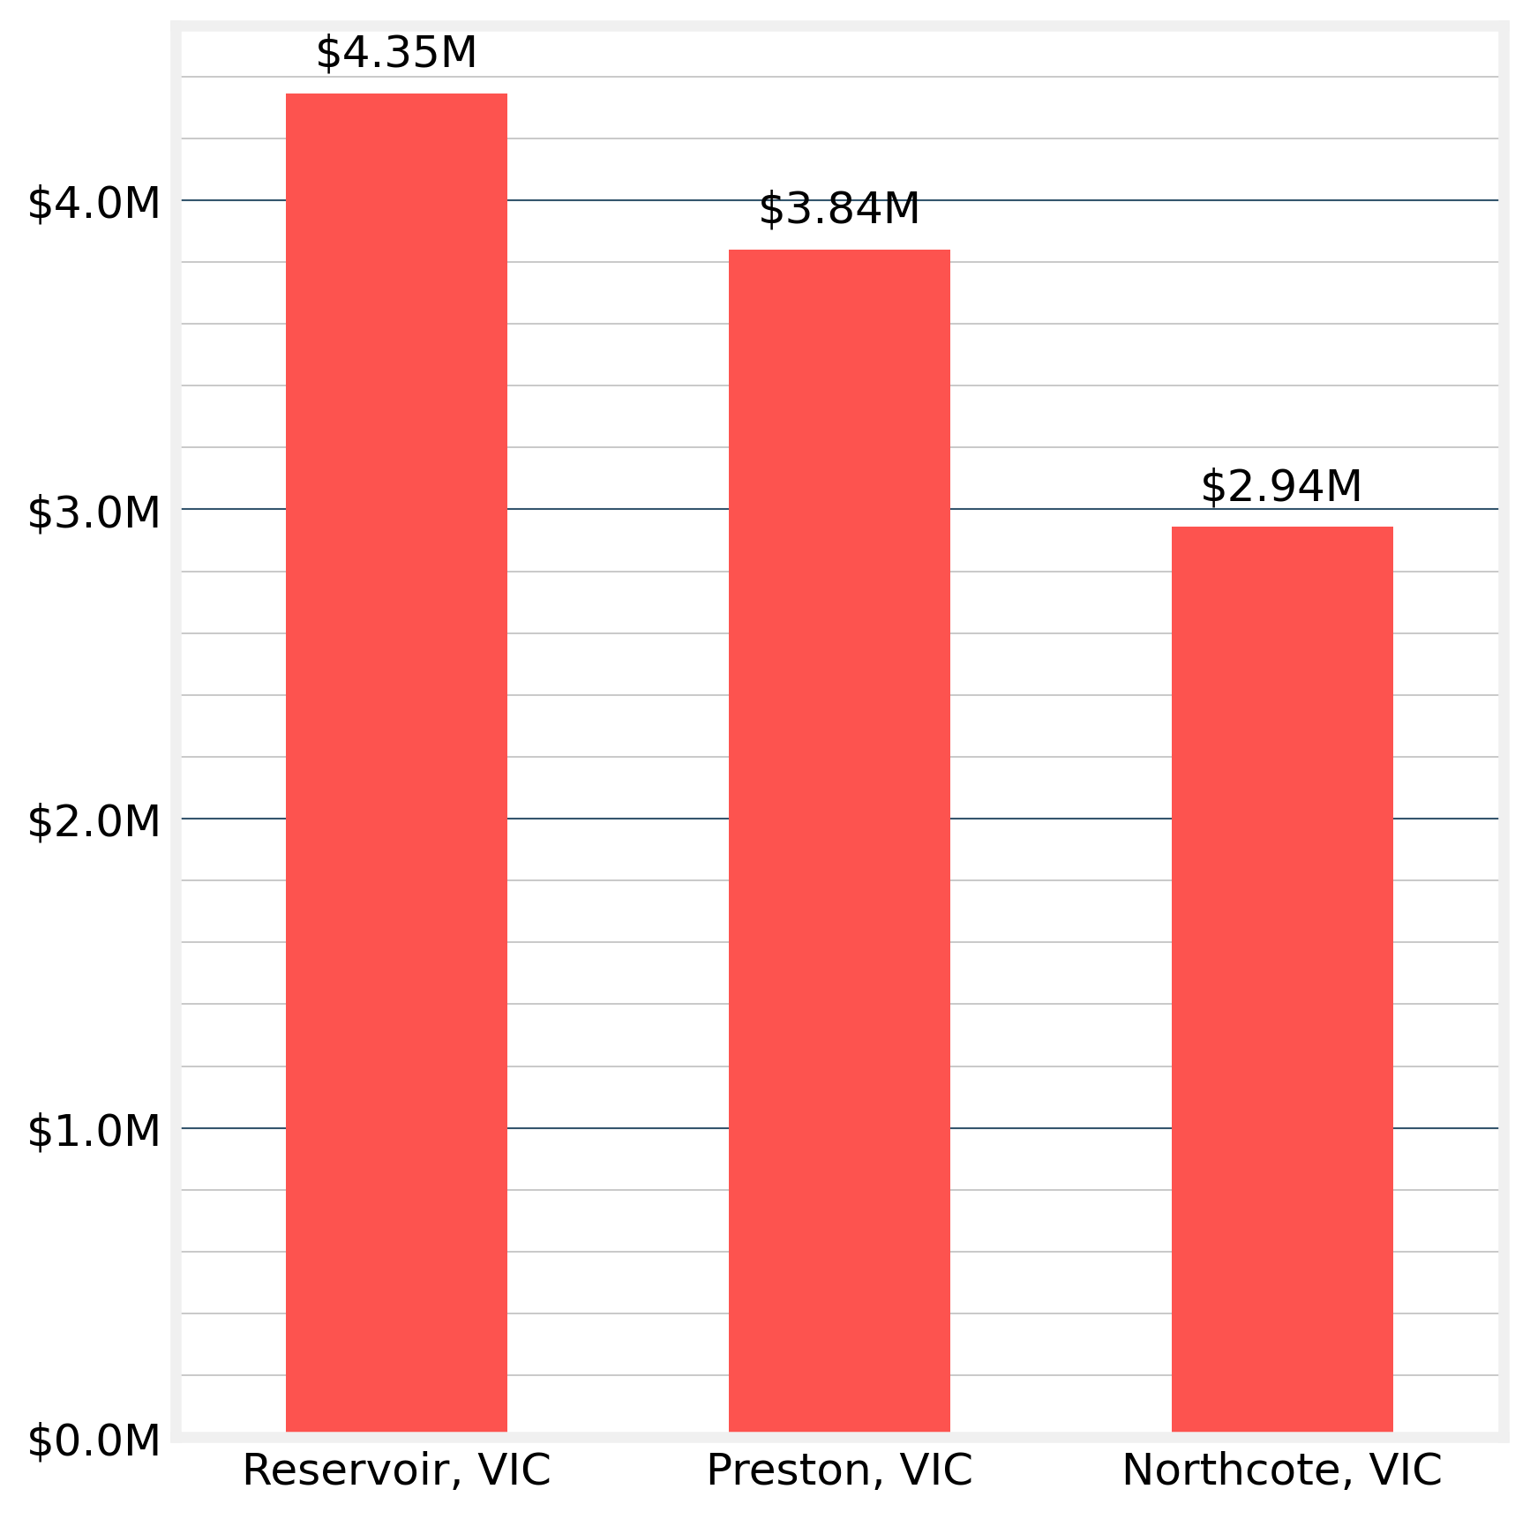

Night Time Economy

Night Time Economy for August 2026
The biggest spending night of the month of August 2026 was Saturday 01 August with Total Local Spend of $2.1M.
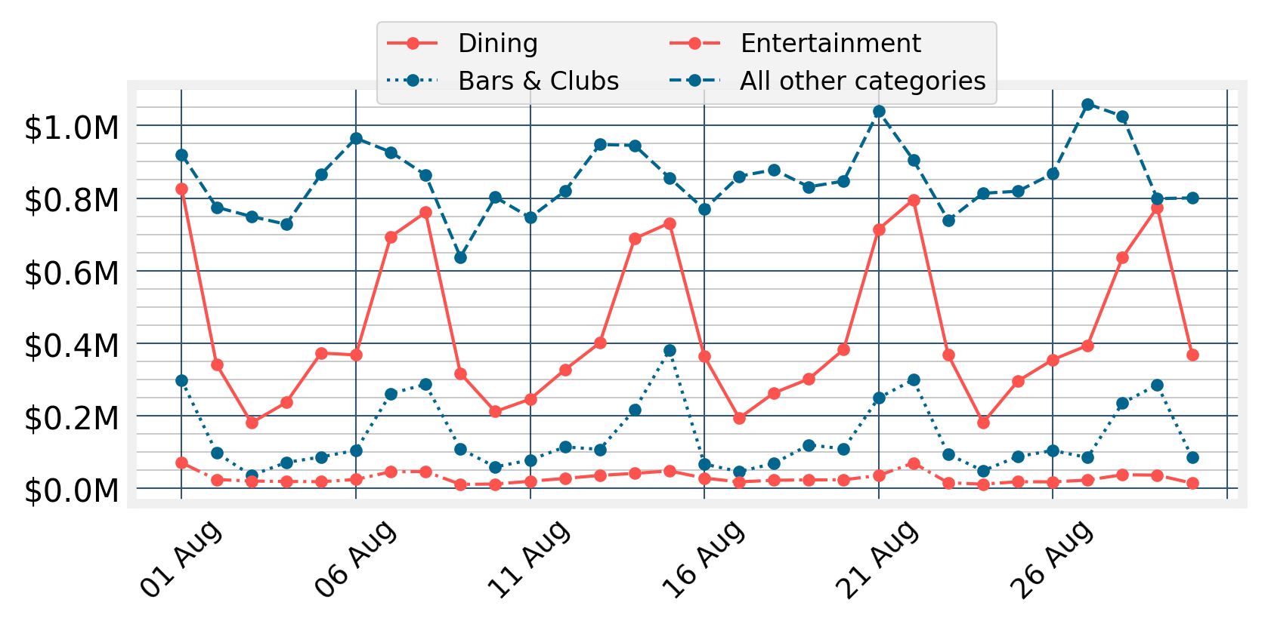
Expenditure by Age and Gender

Age and Gender Expenditure Patterns for August 2026
The total amount spent by age and gender with merchants within the Merri-bek City Council LGA.
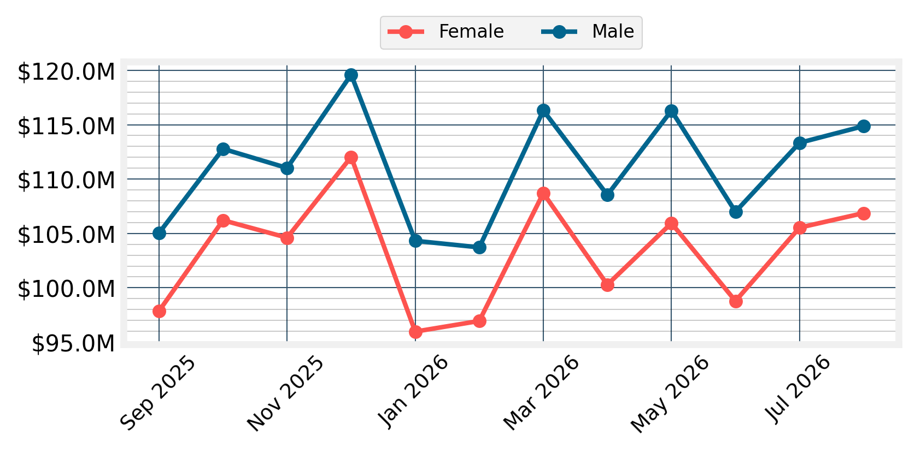
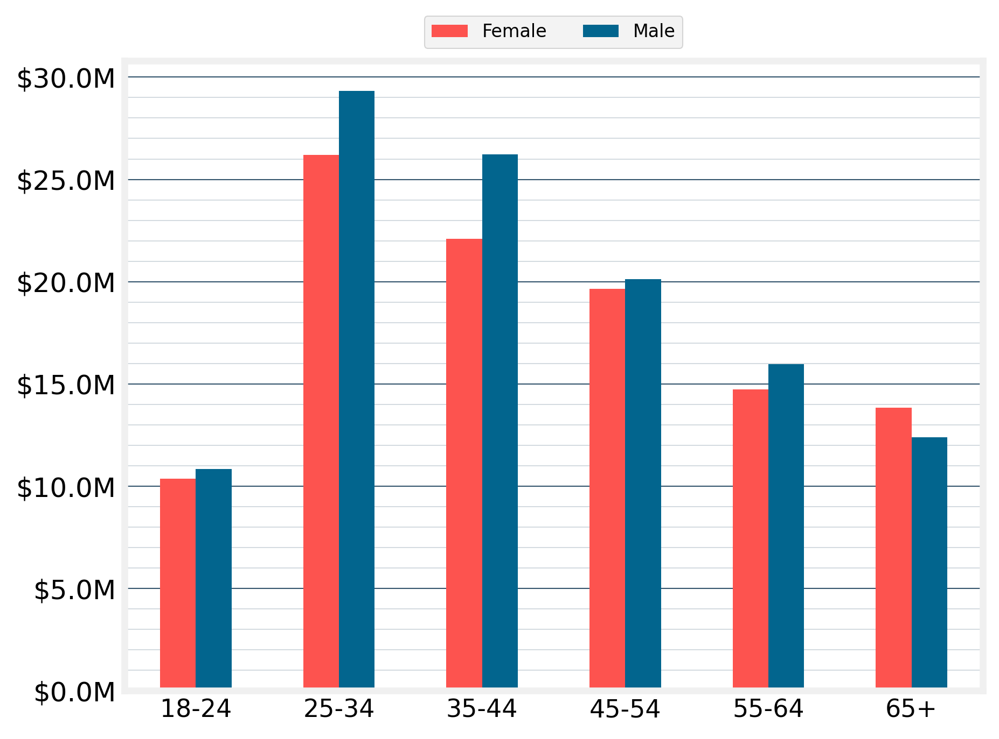
Spending by age and gender shows how the spending patterns for different markets are tracking. Outside of staple spending, which can be quite stable, there can be quite a bit of volatility from month to month in these spend breakdown. Knowing about the volatility is critical information for businesses and economic development staff looking to respond to changing trends.

Disclaimer
This document has been prepared by Geografia Pty Ltd for Merri-bek City Council and is intended for its use only. Any use of material from the report should be appropriately cited (i.e. source: Spendmapp by Geografia). While every effort is made to provide accurate and complete information, Geografia does not warrant or represent that the information contained is free from errors or omissions and accepts no responsibility for any loss, damage, cost or expense (whether direct or indirect) incurred as a result of a person taking action in respect to any representation, statement, or advice referred to in this report.

